Table 2 - Total Household Wealth

2022-03-15

Load the **total household wealth** model variables

**total household wealth**: This is the basic benchmarking model utilizing brm() default, uninformed priors

household wealth model with Lhh_wealth_asinh. This model does not converge due to colinearity issues caused by the Lhh_wealth_asinh variable

hh_wealth_bayesmodel_old <-  
 brm(formula = wealth_asinh | weights(samp_wgt) ~  
 cost_deviation + treat_any + treat_GK +  
 wealth_asinh_R1 + Lhh_wealth_asinh + Lvill_eligible_ratio + Lowndwelling +  
 (1 | block) + (1 | vid),  
 data = hh_wealth_data,  
 family = gaussian("identity"),  
 seed = 1272022,  
 warmup = 1000,  
 iter = 2000,  
 thin = 1,  
 control = list(adapt_delta = .95, max_treedepth = 10),  
 #backend = "cmdstanr",  
 cores = 4, #overrides default 1 core  
 #threads = 3,need to get cmdstanr package working here  
 save_pars = save_pars(all = TRUE), # potentially allows for more post-processing functionality  
 file = "uninformed_prior_outcomes\\hh_wealth_bayes_old")

hh_wealth_bayesmodel <-  
 brm(formula = wealth_asinh | weights(samp_wgt) ~  
 cost_deviation + treat_any + treat_GK +  
 wealth_asinh_R1 + Lvill_eligible_ratio + Lowndwelling +  
 (1 | block) + (1 | vid),  
 data = hh_wealth_data,  
 family = gaussian("identity"),  
 seed = 1272022,  
 warmup = 1000,  
 iter = 2000,  
 thin = 1,  
 control = list(adapt_delta = .95, max_treedepth = 10),  
 #backend = "cmdstanr",  
 cores = 4, #overrides default 1 core  
 #threads = 3,need to get cmdstanr package working here  
 save_pars = save_pars(all = TRUE), # potentially allows for more post-processing functionality  
 file = "uninformed_prior_outcomes\\hh_wealth_bayes")

Model Summaries

summary(hh_wealth_bayesmodel_old)

## Warning: Parts of the model have not converged (some Rhats are > 1.05). Be  
## careful when analysing the results! We recommend running more iterations and/or  
## setting stronger priors.

## Family: gaussian   
## Links: mu = identity; sigma = identity   
## Formula: wealth_asinh | weights(samp_wgt) ~ cost_deviation + treat_any + treat_GK + wealth_asinh_R1 + Lhh_wealth_asinh + Lvill_eligible_ratio + Lowndwelling + (1 | block) + (1 | vid)   
## Data: hh_wealth_data (Number of observations: 1751)   
## Draws: 4 chains, each with iter = 2000; warmup = 1000; thin = 1;  
## total post-warmup draws = 4000  
##   
## Group-Level Effects:   
## ~block (Number of levels: 22)   
## Estimate Est.Error l-95% CI u-95% CI Rhat Bulk_ESS Tail_ESS  
## sd(Intercept) 0.45 0.13 0.30 0.80 1.35 10 22  
##   
## ~vid (Number of levels: 248)   
## Estimate Est.Error l-95% CI u-95% CI Rhat Bulk_ESS Tail_ESS  
## sd(Intercept) 1.00 0.11 0.83 1.24 1.97 6 13  
##   
## Population-Level Effects:   
## Estimate Est.Error l-95% CI u-95% CI Rhat Bulk_ESS  
## Intercept 7.72 0.32 7.11 8.34 1.37 9  
## cost_deviation 0.00 0.00 0.00 0.00 1.15 19  
## treat_any 0.15 0.16 -0.17 0.42 1.63 7  
## treat_GK -0.04 0.18 -0.38 0.33 1.29 11  
## wealth_asinh_R1 -40.44 37.69 -118.63 8.66 1.92 6  
## Lhh_wealth_asinh 40.62 37.69 -8.49 118.81 1.92 6  
## Lvill_eligible_ratio -0.38 0.56 -1.70 0.56 1.35 9  
## Lowndwelling 3.60 0.18 3.22 3.96 1.24 17  
## Tail_ESS  
## Intercept 36  
## cost_deviation 199  
## treat_any 27  
## treat_GK 30  
## wealth_asinh_R1 12  
## Lhh_wealth_asinh 12  
## Lvill_eligible_ratio 40  
## Lowndwelling 17  
##   
## Family Specific Parameters:   
## Estimate Est.Error l-95% CI u-95% CI Rhat Bulk_ESS Tail_ESS  
## sigma 3.42 0.04 3.34 3.48 1.20 15 14  
##   
## Draws were sampled using sampling(NUTS). For each parameter, Bulk_ESS  
## and Tail_ESS are effective sample size measures, and Rhat is the potential  
## scale reduction factor on split chains (at convergence, Rhat = 1).

summary(hh_wealth_bayesmodel)

## Family: gaussian   
## Links: mu = identity; sigma = identity   
## Formula: wealth_asinh | weights(samp_wgt) ~ cost_deviation + treat_any + treat_GK + wealth_asinh_R1 + Lvill_eligible_ratio + Lowndwelling + (1 | block) + (1 | vid)   
## Data: hh_wealth_data (Number of observations: 1751)   
## Draws: 4 chains, each with iter = 2000; warmup = 1000; thin = 1;  
## total post-warmup draws = 4000  
##   
## Group-Level Effects:   
## ~block (Number of levels: 22)   
## Estimate Est.Error l-95% CI u-95% CI Rhat Bulk_ESS Tail_ESS  
## sd(Intercept) 0.51 0.15 0.22 0.82 1.00 1197 1409  
##   
## ~vid (Number of levels: 248)   
## Estimate Est.Error l-95% CI u-95% CI Rhat Bulk_ESS Tail_ESS  
## sd(Intercept) 1.03 0.10 0.85 1.23 1.00 1370 2241  
##   
## Population-Level Effects:   
## Estimate Est.Error l-95% CI u-95% CI Rhat Bulk_ESS  
## Intercept 7.79 0.32 7.16 8.41 1.00 4288  
## cost_deviation 0.00 0.00 -0.00 0.00 1.00 4321  
## treat_any 0.07 0.24 -0.38 0.53 1.00 2942  
## treat_GK 0.01 0.23 -0.45 0.47 1.00 3274  
## wealth_asinh_R1 0.18 0.02 0.15 0.21 1.00 6412  
## Lvill_eligible_ratio -0.11 0.86 -1.75 1.59 1.00 3292  
## Lowndwelling 3.46 0.20 3.07 3.86 1.00 6599  
## Tail_ESS  
## Intercept 3337  
## cost_deviation 3461  
## treat_any 2913  
## treat_GK 3250  
## wealth_asinh_R1 3413  
## Lvill_eligible_ratio 2967  
## Lowndwelling 3218  
##   
## Family Specific Parameters:   
## Estimate Est.Error l-95% CI u-95% CI Rhat Bulk_ESS Tail_ESS  
## sigma 3.43 0.04 3.35 3.51 1.00 5929 2890  
##   
## Draws were sampled using sampling(NUTS). For each parameter, Bulk_ESS  
## and Tail_ESS are effective sample size measures, and Rhat is the potential  
## scale reduction factor on split chains (at convergence, Rhat = 1).

Prior summery - how informative are priors

prior_summary(hh_wealth_bayesmodel_old)

## prior class coef group resp dpar nlpar  
## (flat) b   
## (flat) b cost_deviation   
## (flat) b Lhh_wealth_asinh   
## (flat) b Lowndwelling   
## (flat) b Lvill_eligible_ratio   
## (flat) b treat_any   
## (flat) b treat_GK   
## (flat) b wealth_asinh_R1   
## student_t(3, 13.9, 2.5) Intercept   
## student_t(3, 0, 2.5) sd   
## student_t(3, 0, 2.5) sd block   
## student_t(3, 0, 2.5) sd Intercept block   
## student_t(3, 0, 2.5) sd vid   
## student_t(3, 0, 2.5) sd Intercept vid   
## student_t(3, 0, 2.5) sigma   
## bound source  
## default  
## (vectorized)  
## (vectorized)  
## (vectorized)  
## (vectorized)  
## (vectorized)  
## (vectorized)  
## (vectorized)  
## default  
## default  
## (vectorized)  
## (vectorized)  
## (vectorized)  
## (vectorized)  
## default

check_prior(hh_wealth_bayesmodel_old)

## Warning: Some priors could not be simulated.

## Parameter Prior_Quality  
## 1 b_Intercept uninformative  
## 2 b_cost_deviation not determinable  
## 3 b_treat_any not determinable  
## 4 b_treat_GK not determinable  
## 5 b_wealth_asinh_R1 not determinable  
## 6 b_Lhh_wealth_asinh not determinable  
## 7 b_Lvill_eligible_ratio not determinable  
## 8 b_Lowndwelling not determinable

prior_summary(hh_wealth_bayesmodel)

## prior class coef group resp dpar nlpar  
## (flat) b   
## (flat) b cost_deviation   
## (flat) b Lowndwelling   
## (flat) b Lvill_eligible_ratio   
## (flat) b treat_any   
## (flat) b treat_GK   
## (flat) b wealth_asinh_R1   
## student_t(3, 13.9, 2.5) Intercept   
## student_t(3, 0, 2.5) sd   
## student_t(3, 0, 2.5) sd block   
## student_t(3, 0, 2.5) sd Intercept block   
## student_t(3, 0, 2.5) sd vid   
## student_t(3, 0, 2.5) sd Intercept vid   
## student_t(3, 0, 2.5) sigma   
## bound source  
## default  
## (vectorized)  
## (vectorized)  
## (vectorized)  
## (vectorized)  
## (vectorized)  
## (vectorized)  
## default  
## default  
## (vectorized)  
## (vectorized)  
## (vectorized)  
## (vectorized)  
## default

check_prior(hh_wealth_bayesmodel)

## Warning: Some priors could not be simulated.

## Parameter Prior_Quality  
## 1 b_Intercept uninformative  
## 2 b_cost_deviation not determinable  
## 3 b_treat_any not determinable  
## 4 b_treat_GK not determinable  
## 5 b_wealth_asinh_R1 not determinable  
## 6 b_Lvill_eligible_ratio not determinable  
## 7 b_Lowndwelling not determinable

Diagnostics

# trace diagnostic plot  
mcmc_trace(hh_wealth_bayesmodel_old, n_warmup = 0,  
 pars = c("b_Intercept", "b_cost_deviation", "b_treat_any",   
 "b_treat_GK", "b_wealth_asinh_R1", "b_Lhh_wealth_asinh",  
 "b_Lvill_eligible_ratio", "b_Lowndwelling",  
 "sd_block__Intercept", "sd_vid__Intercept", "sigma"))

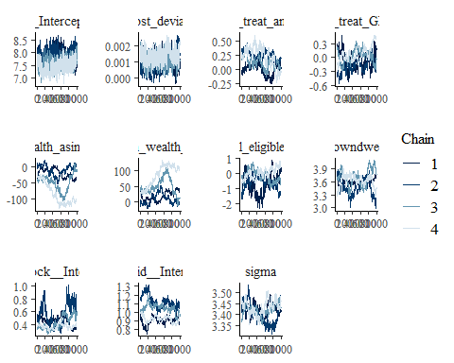

ggsave("table_2_diagnostics\\hh_wealth_trace_old.png", plot = last_plot(), width = 12, height = 5)  
  
mcmc_trace(hh_wealth_bayesmodel, n_warmup = 0,  
 pars = c("b_Intercept", "b_cost_deviation", "b_treat_any",   
 "b_treat_GK", "b_wealth_asinh_R1",  
 "b_Lvill_eligible_ratio", "b_Lowndwelling",  
 "sd_block__Intercept", "sd_vid__Intercept", "sigma"))

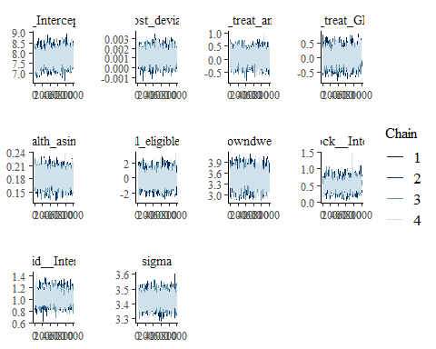

ggsave("table_2_diagnostics\\hh_wealth_trace.png", plot = last_plot(), width = 12, height = 5)  
  
#density diagnostic plot  
mcmc_dens(hh_wealth_bayesmodel_old,  
 pars = c("b_Intercept", "b_cost_deviation", "b_treat_any",   
 "b_treat_GK", "b_wealth_asinh_R1", "b_Lhh_wealth_asinh",  
 "b_Lvill_eligible_ratio", "b_Lowndwelling",  
 "sd_block__Intercept", "sd_vid__Intercept", "sigma"))

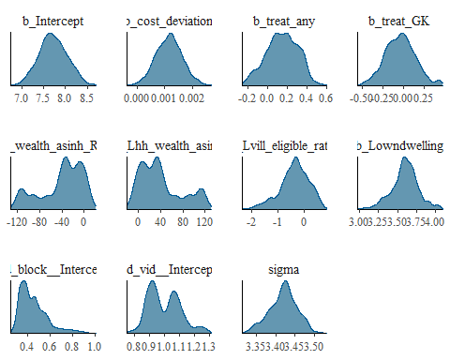

ggsave("table_2_diagnostics\\hh_wealth_dens_old.png", plot = last_plot(), width = 12, height = 5)  
  
mcmc_dens(hh_wealth_bayesmodel,  
 pars = c("b_Intercept", "b_cost_deviation", "b_treat_any",   
 "b_treat_GK", "b_wealth_asinh_R1",  
 "b_Lvill_eligible_ratio", "b_Lowndwelling",  
 "sd_block__Intercept", "sd_vid__Intercept", "sigma"))

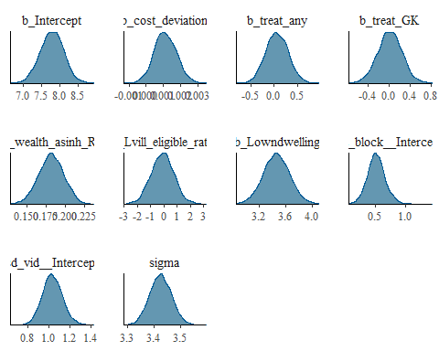

ggsave("table_2_diagnostics\\hh_wealth_dens.png", plot = last_plot(), width = 12, height = 5)  
  
mcmc_dens_overlay(hh_wealth_bayesmodel_old,  
 pars = c("b_Intercept", "b_cost_deviation", "b_treat_any",   
 "b_treat_GK", "b_wealth_asinh_R1", "b_Lhh_wealth_asinh",  
 "b_Lvill_eligible_ratio", "b_Lowndwelling",  
 "sd_block__Intercept", "sd_vid__Intercept", "sigma"))

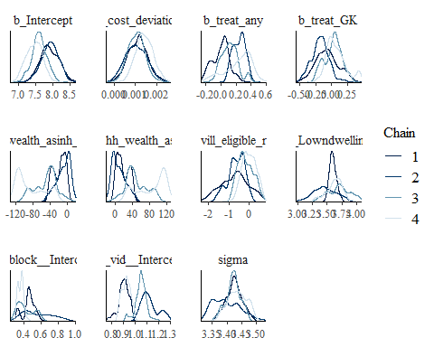

ggsave("table_2_diagnostics\\hh_wealth_dens_overlay_old.png", plot = last_plot(), width = 12, height = 5)  
  
mcmc_dens_overlay(hh_wealth_bayesmodel,  
 pars = c("b_Intercept", "b_cost_deviation", "b_treat_any",   
 "b_treat_GK", "b_wealth_asinh_R1",  
 "b_Lvill_eligible_ratio", "b_Lowndwelling",  
 "sd_block__Intercept", "sd_vid__Intercept", "sigma"))

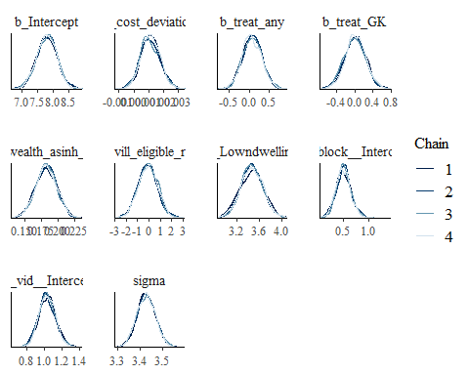

ggsave("table_2_diagnostics\\hh_wealth_dens_overlay.png", plot = last_plot(), width = 12, height = 5)  
  
#acf (auto-correlation) diagnostic plot  
mcmc_acf(hh_wealth_bayesmodel_old,  
 pars = c("b_Intercept", "b_cost_deviation", "b_treat_any",   
 "b_treat_GK", "b_wealth_asinh_R1", "b_Lhh_wealth_asinh",  
 "b_Lvill_eligible_ratio", "b_Lowndwelling",  
 "sd_block__Intercept", "sd_vid__Intercept", "sigma"))

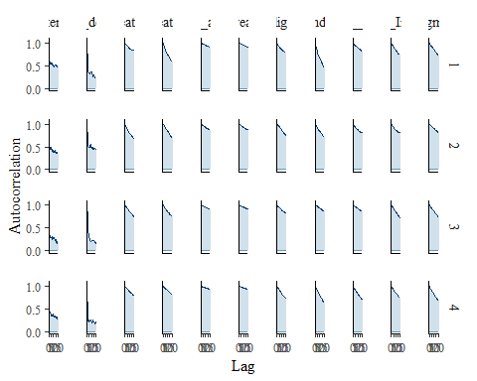

ggsave("table_2_diagnostics\\hh_wealth_acf_old.png", plot = last_plot(), width = 12, height = 5)  
  
mcmc_acf(hh_wealth_bayesmodel,  
 pars = c("b_Intercept", "b_cost_deviation", "b_treat_any",   
 "b_treat_GK", "b_wealth_asinh_R1",  
 "b_Lvill_eligible_ratio", "b_Lowndwelling",  
 "sd_block__Intercept", "sd_vid__Intercept", "sigma"))

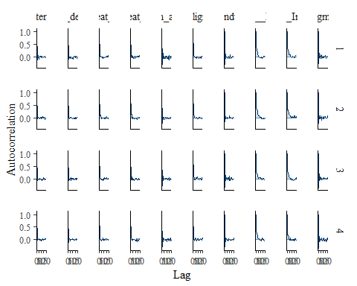

ggsave("table_2_diagnostics\\hh_wealth_acf.png", plot = last_plot(), width = 12, height = 5)

posterior predictive checks

pp_check(hh_wealth_bayesmodel, nsamples = 100)

## Warning: Argument 'nsamples' is deprecated. Please use argument 'ndraws'  
## instead.

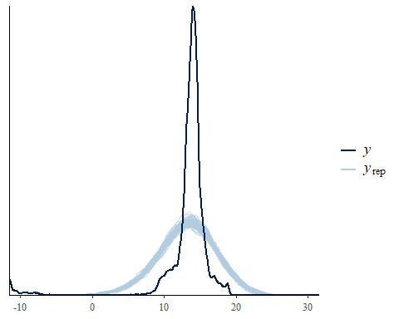

pp_check(hh_wealth_bayesmodel, nsamples = 10, type = 'error_scatter_avg', alpha = .1)

## Warning: Argument 'nsamples' is deprecated. Please use argument 'ndraws'  
## instead.

