Table 2 - Consumption Assets

2022-03-16

Load the **consumption assets** model variables

**consumption assets**: This is the basic benchmarking model utilizing the default, uninformed priors

consumption_assets_bayesmodel <-  
 brm(formula = assetsconsumption_asinh | weights(samp_wgt) ~  
 cost_deviation + treat_any + treat_GK +  
 assetsconsumption_asinh_R1 + Lhh_wealth_asinh + Lvill_eligible_ratio + Lroomsnumb + Ldurablesexpenditure +  
 Ldietarydi_x_Lassetscon + Lproductiv_x_Lassetscon +  
 (1 | block) + (1 | vid),  
 data = consumption_assets_data,  
 family = gaussian("identity"),  
 seed = 1272022,  
 warmup = 1000,  
 iter = 2000,  
 thin = 1,  
 control = list(adapt_delta = .95, max_treedepth = 10),  
 #backend = "cmdstanr",  
 cores = 4, #overrides default 1 core  
 #threads = 3,need to get cmdstanr package working here  
 save_pars = save_pars(all = TRUE), # potentially allows for more post-processing functionality  
 file = "uninformed_prior_outcomes\\consumption_assets_bayes")

Model Summery

summary(consumption_assets_bayesmodel)

## Warning: Parts of the model have not converged (some Rhats are > 1.05). Be  
## careful when analysing the results! We recommend running more iterations and/or  
## setting stronger priors.

## Family: gaussian   
## Links: mu = identity; sigma = identity   
## Formula: assetsconsumption_asinh | weights(samp_wgt) ~ cost_deviation + treat_any + treat_GK + assetsconsumption_asinh_R1 + Lhh_wealth_asinh + Lvill_eligible_ratio + Lroomsnumb + Ldurablesexpenditure + Ldietarydi_x_Lassetscon + Lproductiv_x_Lassetscon + (1 | block) + (1 | vid)   
## Data: consumption_assets_data (Number of observations: 1751)   
## Draws: 4 chains, each with iter = 2000; warmup = 1000; thin = 1;  
## total post-warmup draws = 4000  
##   
## Group-Level Effects:   
## ~block (Number of levels: 22)   
## Estimate Est.Error l-95% CI u-95% CI Rhat Bulk_ESS Tail_ESS  
## sd(Intercept) 0.89 1.09 0.00 2.73 3.55 4 12  
##   
## ~vid (Number of levels: 248)   
## Estimate Est.Error l-95% CI u-95% CI Rhat Bulk_ESS Tail_ESS  
## sd(Intercept) 0.73 0.58 0.30 1.71 2.78 5 11  
##   
## Population-Level Effects:   
## Estimate Est.Error l-95% CI u-95% CI Rhat Bulk_ESS  
## Intercept 0.35 5.63 -15.70 4.75 2.59 5  
## cost_deviation 0.00 0.00 -0.00 0.01 2.15 5  
## treat_any 0.16 1.22 -1.47 1.93 3.61 4  
## treat_GK 0.58 1.27 -1.54 1.79 2.90 5  
## assetsconsumption_asinh_R1 0.12 0.62 -1.32 0.82 3.06 5  
## Lhh_wealth_asinh -0.19 0.22 -0.57 -0.02 2.10 5  
## Lvill_eligible_ratio 0.72 0.61 -0.24 1.56 3.46 4  
## Lroomsnumb -0.09 0.84 -1.49 1.14 4.08 4  
## Ldurablesexpenditure -0.00 0.00 -0.00 0.00 2.02 5  
## Ldietarydi_x_Lassetscon 0.18 0.28 0.01 0.70 1.88 6  
## Lproductiv_x_Lassetscon 0.00 0.08 -0.17 0.12 3.14 5  
## Tail_ESS  
## Intercept 11  
## cost_deviation 30  
## treat_any 11  
## treat_GK 24  
## assetsconsumption_asinh_R1 11  
## Lhh_wealth_asinh 11  
## Lvill_eligible_ratio 14  
## Lroomsnumb 11  
## Ldurablesexpenditure 11  
## Ldietarydi_x_Lassetscon 11  
## Lproductiv_x_Lassetscon 11  
##   
## Family Specific Parameters:   
## Estimate Est.Error l-95% CI u-95% CI Rhat Bulk_ESS Tail_ESS  
## sigma 7.20 6.32 3.34 19.92 2.13 6 12  
##   
## Draws were sampled using sampling(NUTS). For each parameter, Bulk_ESS  
## and Tail_ESS are effective sample size measures, and Rhat is the potential  
## scale reduction factor on split chains (at convergence, Rhat = 1).

Prior summery - how informative are priors

prior_summary(consumption_assets_bayesmodel)

## prior class coef group resp dpar  
## (flat) b   
## (flat) b assetsconsumption_asinh_R1   
## (flat) b cost_deviation   
## (flat) b Ldietarydi_x_Lassetscon   
## (flat) b Ldurablesexpenditure   
## (flat) b Lhh_wealth_asinh   
## (flat) b Lproductiv_x_Lassetscon   
## (flat) b Lroomsnumb   
## (flat) b Lvill_eligible_ratio   
## (flat) b treat_any   
## (flat) b treat_GK   
## student_t(3, 9.8, 2.5) Intercept   
## student_t(3, 0, 2.5) sd   
## student_t(3, 0, 2.5) sd block   
## student_t(3, 0, 2.5) sd Intercept block   
## student_t(3, 0, 2.5) sd vid   
## student_t(3, 0, 2.5) sd Intercept vid   
## student_t(3, 0, 2.5) sigma   
## nlpar bound source  
## default  
## (vectorized)  
## (vectorized)  
## (vectorized)  
## (vectorized)  
## (vectorized)  
## (vectorized)  
## (vectorized)  
## (vectorized)  
## (vectorized)  
## (vectorized)  
## default  
## default  
## (vectorized)  
## (vectorized)  
## (vectorized)  
## (vectorized)  
## default

check_prior(consumption_assets_bayesmodel)

## Warning: Some priors could not be simulated.

## Parameter Prior_Quality  
## 1 b_Intercept informative  
## 2 b_cost_deviation not determinable  
## 3 b_treat_any not determinable  
## 4 b_treat_GK not determinable  
## 5 b_assetsconsumption_asinh_R1 not determinable  
## 6 b_Lhh_wealth_asinh not determinable  
## 7 b_Lvill_eligible_ratio not determinable  
## 8 b_Lroomsnumb not determinable  
## 9 b_Ldurablesexpenditure not determinable  
## 10 b_Ldietarydi_x_Lassetscon not determinable  
## 11 b_Lproductiv_x_Lassetscon not determinable

Diagnostics

# trace diagnostic plot  
mcmc_trace(consumption_assets_bayesmodel, n_warmup = 0,  
 pars = c("b_Intercept", "b_cost_deviation", "b_treat_any", "b_treat_GK",  
 "b_assetsconsumption_asinh_R1", "b_Lhh_wealth_asinh", "b_Lvill_eligible_ratio",   
 "b_Lroomsnumb", "b_Ldurablesexpenditure",  
 "b_Ldietarydi_x_Lassetscon", "b_Lproductiv_x_Lassetscon",  
 "sd_block__Intercept", "sd_vid__Intercept", "sigma"))

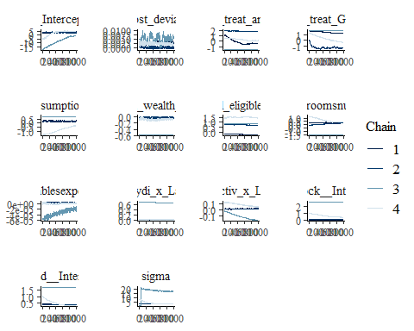

ggsave("table_2_diagnostics\\consumption_assets_trace.png", plot = last_plot(), width = 12, height = 5)  
  
#density diagnostic plots  
mcmc_dens(consumption_assets_bayesmodel,  
 pars = c("b_Intercept", "b_cost_deviation", "b_treat_any", "b_treat_GK",  
 "b_assetsconsumption_asinh_R1", "b_Lhh_wealth_asinh", "b_Lvill_eligible_ratio",   
 "b_Lroomsnumb", "b_Ldurablesexpenditure",  
 "b_Ldietarydi_x_Lassetscon", "b_Lproductiv_x_Lassetscon",  
 "sd_block__Intercept", "sd_vid__Intercept", "sigma"))

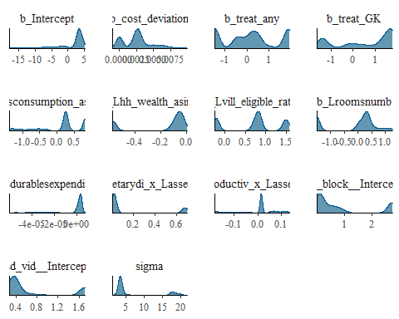

ggsave("table_2_diagnostics\\consumption_assets_dens.png", plot = last_plot(), width = 12, height = 5)  
  
mcmc_dens_overlay(consumption_assets_bayesmodel,  
 pars = c("b_Intercept", "b_cost_deviation", "b_treat_any", "b_treat_GK",  
 "b_assetsconsumption_asinh_R1", "b_Lhh_wealth_asinh", "b_Lvill_eligible_ratio",   
 "b_Lroomsnumb", "b_Ldurablesexpenditure",  
 "b_Ldietarydi_x_Lassetscon", "b_Lproductiv_x_Lassetscon",  
 "sd_block__Intercept", "sd_vid__Intercept", "sigma"))

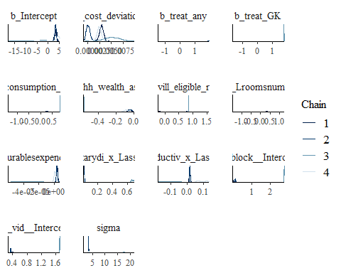

ggsave("table_2_diagnostics\\consumption_assets_dens_overlay.png", plot = last_plot(), width = 12, height = 5)  
  
#acf (auto-correlation) diagnostic plot  
mcmc_acf(consumption_assets_bayesmodel,  
 pars = c("b_Intercept", "b_cost_deviation", "b_treat_any", "b_treat_GK",  
 "b_assetsconsumption_asinh_R1", "b_Lhh_wealth_asinh", "b_Lvill_eligible_ratio",   
 "b_Lroomsnumb", "b_Ldurablesexpenditure",  
 "b_Ldietarydi_x_Lassetscon", "b_Lproductiv_x_Lassetscon",  
 "sd_block__Intercept", "sd_vid__Intercept", "sigma"))

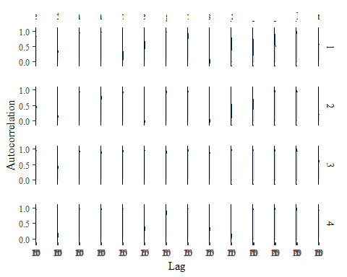

ggsave("table_2_diagnostics\\consumption_assets_assets_acf.png", plot = last_plot(), width = 12, height = 5)

posterior predictive checks

pp_check(consumption_assets_bayesmodel, ndraws = 100)

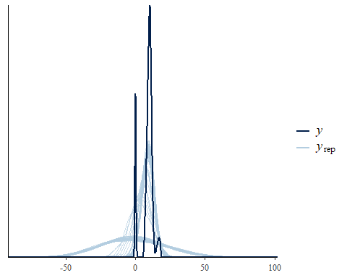

pp_check(consumption_assets_bayesmodel, ndraws = 10, type = 'error_scatter_avg', alpha = .1)

