Table 2 - Health Knowledge

2022-03-16

Load the **health knowledge** model variables

**health knowledge**: This is the basic bechmarking model utilzing brm() default, uninformed priors

health_knowledge_bayesmodel <-  
 brm(formula = health_knowledge | weights(samp_wgt) ~  
 cost_deviation + treat_any + treat_GK +  
 health_knowledge_R1 +   
 Lhh_wealth_asinh + Lvill_eligible_ratio +  
 (1 | block) + (1 | vid),  
 data = health_knowledge_data,  
 family = gaussian("identity"),  
 seed = 1272022,  
 warmup = 1000,  
 iter = 2000,  
 thin = 1,  
 control = list(adapt_delta = .95, max_treedepth = 10),  
 #backend = "cmdstanr",  
 cores = 4, #overrides default 1 core  
 #threads = 3,need to get cmdstanr package working here  
 save_pars = save_pars(all = TRUE), # potentially allows for more post-processing functionality  
 file = "uninformed_prior_outcomes\\health_knowledge_bayes")

Model Summery

summary(health_knowledge_bayesmodel)

## Family: gaussian   
## Links: mu = identity; sigma = identity   
## Formula: health_knowledge | weights(samp_wgt) ~ cost_deviation + treat_any + treat_GK + health_knowledge_R1 + Lhh_wealth_asinh + Lvill_eligible_ratio + (1 | block) + (1 | vid)   
## Data: health_knowledge_data (Number of observations: 1751)   
## Draws: 4 chains, each with iter = 2000; warmup = 1000; thin = 1;  
## total post-warmup draws = 4000  
##   
## Group-Level Effects:   
## ~block (Number of levels: 22)   
## Estimate Est.Error l-95% CI u-95% CI Rhat Bulk_ESS Tail_ESS  
## sd(Intercept) 0.34 0.21 0.02 0.80 1.02 446 1438  
##   
## ~vid (Number of levels: 248)   
## Estimate Est.Error l-95% CI u-95% CI Rhat Bulk_ESS Tail_ESS  
## sd(Intercept) 1.64 0.12 1.41 1.88 1.00 1512 1833  
##   
## Population-Level Effects:   
## Estimate Est.Error l-95% CI u-95% CI Rhat Bulk_ESS  
## Intercept 1.37 0.41 0.56 2.18 1.00 2375  
## cost_deviation 0.00 0.00 -0.00 0.00 1.00 2037  
## treat_any 0.10 0.34 -0.56 0.75 1.00 1604  
## treat_GK -0.08 0.34 -0.74 0.58 1.00 1591  
## health_knowledge_R1 0.06 0.02 0.03 0.09 1.00 3935  
## Lhh_wealth_asinh 0.11 0.02 0.08 0.15 1.00 5848  
## Lvill_eligible_ratio 0.61 1.22 -1.88 2.92 1.00 1447  
## Tail_ESS  
## Intercept 2945  
## cost_deviation 2360  
## treat_any 2078  
## treat_GK 2431  
## health_knowledge_R1 3180  
## Lhh_wealth_asinh 3086  
## Lvill_eligible_ratio 2050  
##   
## Family Specific Parameters:   
## Estimate Est.Error l-95% CI u-95% CI Rhat Bulk_ESS Tail_ESS  
## sigma 4.35 0.05 4.26 4.45 1.00 5578 3091  
##   
## Draws were sampled using sampling(NUTS). For each parameter, Bulk_ESS  
## and Tail_ESS are effective sample size measures, and Rhat is the potential  
## scale reduction factor on split chains (at convergence, Rhat = 1).

Prior summery - how informative are priors

prior_summary(health_knowledge_bayesmodel)

## prior class coef group resp dpar nlpar  
## (flat) b   
## (flat) b cost_deviation   
## (flat) b health_knowledge_R1   
## (flat) b Lhh_wealth_asinh   
## (flat) b Lvill_eligible_ratio   
## (flat) b treat_any   
## (flat) b treat_GK   
## student_t(3, 3.2, 3.8) Intercept   
## student_t(3, 0, 3.8) sd   
## student_t(3, 0, 3.8) sd block   
## student_t(3, 0, 3.8) sd Intercept block   
## student_t(3, 0, 3.8) sd vid   
## student_t(3, 0, 3.8) sd Intercept vid   
## student_t(3, 0, 3.8) sigma   
## bound source  
## default  
## (vectorized)  
## (vectorized)  
## (vectorized)  
## (vectorized)  
## (vectorized)  
## (vectorized)  
## default  
## default  
## (vectorized)  
## (vectorized)  
## (vectorized)  
## (vectorized)  
## default

check_prior(health_knowledge_bayesmodel)

## Warning: Some priors could not be simulated.

## Parameter Prior_Quality  
## 1 b_Intercept informative  
## 2 b_cost_deviation not determinable  
## 3 b_treat_any not determinable  
## 4 b_treat_GK not determinable  
## 5 b_health_knowledge_R1 not determinable  
## 6 b_Lhh_wealth_asinh not determinable  
## 7 b_Lvill_eligible_ratio not determinable

Diagnostics

# trace diagnostic plot  
mcmc_trace(health_knowledge_bayesmodel, n_warmup = 0,  
 pars = c("b_Intercept", "b_cost_deviation", "b_treat_any", "b_treat_GK",  
 "b_health_knowledge_R1", "b_Lhh_wealth_asinh", "b_Lvill_eligible_ratio",  
 "sd_block__Intercept", "sd_vid__Intercept", "sigma"))

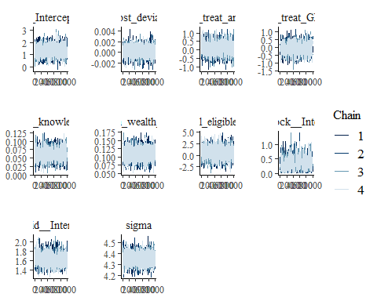

ggsave("table_2_diagnostics\\health_knowledge_trace.png", plot = last_plot(), width = 12, height = 5)  
  
#density diagnostic plots  
mcmc_dens(health_knowledge_bayesmodel,  
 pars = c("b_Intercept", "b_cost_deviation", "b_treat_any", "b_treat_GK",  
 "b_health_knowledge_R1", "b_Lhh_wealth_asinh", "b_Lvill_eligible_ratio",  
 "sd_block__Intercept", "sd_vid__Intercept", "sigma"))

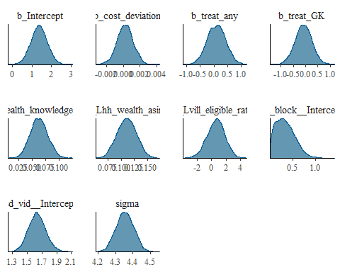

ggsave("table_2_diagnostics\\health_knowledge_dens.png", plot = last_plot(), width = 12, height = 5)  
  
mcmc_dens_overlay(health_knowledge_bayesmodel,  
 pars = c("b_Intercept", "b_cost_deviation", "b_treat_any", "b_treat_GK",  
 "b_health_knowledge_R1", "b_Lhh_wealth_asinh", "b_Lvill_eligible_ratio",  
 "sd_block__Intercept", "sd_vid__Intercept", "sigma"))

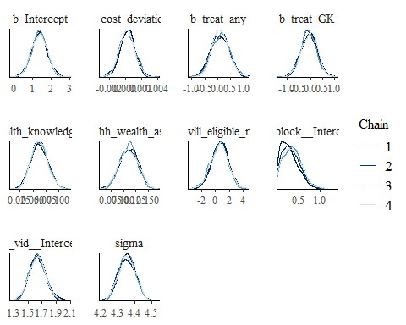

ggsave("table_2_diagnostics\\health_knowledge_dens_overlay.png", plot = last_plot(), width = 12, height = 5)  
  
#acf (auto-correlation) diagnostic plot  
mcmc_acf(health_knowledge_bayesmodel,  
 pars = c("b_Intercept", "b_cost_deviation", "b_treat_any", "b_treat_GK",  
 "b_health_knowledge_R1", "b_Lhh_wealth_asinh", "b_Lvill_eligible_ratio",  
 "sd_block__Intercept", "sd_vid__Intercept", "sigma"))

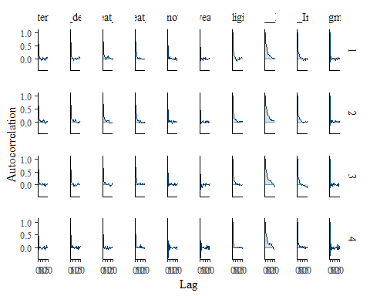

ggsave("table_2_diagnostics\\health_knowledge_acf.png", plot = last_plot(), width = 12, height = 5)

posterior predictive checks

pp_check(health_knowledge_bayesmodel, ndraws = 100)

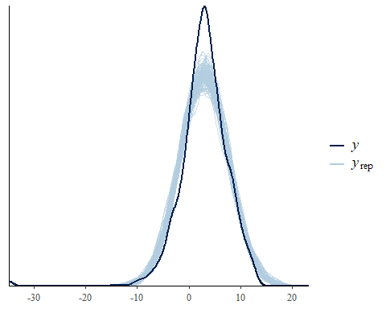

pp_check(health_knowledge_bayesmodel, ndraws = 10, type = 'error_scatter_avg', alpha = .1)

