Table 2 - House Value

2022-03-16

Load the **house value** model variables

**house value**: This is the basic benchmarking model utilizing the default, uninformed priors

dwelling_cost_bayesmodel <-  
 brm(formula = selfcostdwell_asinh | weights(samp_wgt) ~  
 cost_deviation + treat_any + treat_GK +  
 selfcostdwell_asinh_R1 + Lhh_wealth_asinh + Lvill_eligible_ratio + Lroomsnumb + Ldurablesexpenditure +  
 (1 | block) + (1 | vid),  
 data = dwelling_cost_data,  
 family = gaussian("identity"),  
 seed = 1272022,  
 warmup = 1000,  
 iter = 2000,  
 thin = 1,  
 control = list(adapt_delta = .95, max_treedepth = 10),  
 #backend = "cmdstanr",  
 cores = 4, #overrides default 1 core  
 #threads = 3,need to get cmdstanr package working here  
 save_pars = save_pars(all = TRUE), # potentially allows for more post-processing functionality  
 file = "uninformed_prior_outcomes\\dwelling_cost_bayes")

Model Summery

summary(dwelling_cost_bayesmodel)

## Warning: Parts of the model have not converged (some Rhats are > 1.05). Be  
## careful when analysing the results! We recommend running more iterations and/or  
## setting stronger priors.

## Warning: There were 1463 divergent transitions after warmup. Increasing  
## adapt_delta above 0.95 may help. See http://mc-stan.org/misc/  
## warnings.html#divergent-transitions-after-warmup

## Family: gaussian   
## Links: mu = identity; sigma = identity   
## Formula: selfcostdwell_asinh | weights(samp_wgt) ~ cost_deviation + treat_any + treat_GK + selfcostdwell_asinh_R1 + Lhh_wealth_asinh + Lvill_eligible_ratio + Lroomsnumb + Ldurablesexpenditure + (1 | block) + (1 | vid)   
## Data: dwelling_cost_data (Number of observations: 1654)   
## Draws: 4 chains, each with iter = 2000; warmup = 1000; thin = 1;  
## total post-warmup draws = 4000  
##   
## Group-Level Effects:   
## ~block (Number of levels: 22)   
## Estimate Est.Error l-95% CI u-95% CI Rhat Bulk_ESS Tail_ESS  
## sd(Intercept) 0.84 0.39 0.45 1.82 3.26 4 11  
##   
## ~vid (Number of levels: 247)   
## Estimate Est.Error l-95% CI u-95% CI Rhat Bulk_ESS Tail_ESS  
## sd(Intercept) 0.24 0.08 0.16 0.51 3.61 4 11  
##   
## Population-Level Effects:   
## Estimate Est.Error l-95% CI u-95% CI Rhat Bulk_ESS  
## Intercept 8.42 6.66 -3.45 19.51 2.73 5  
## cost_deviation 0.00 0.00 -0.00 0.00 1.78 6  
## treat_any 0.50 1.21 -1.46 1.76 3.25 4  
## treat_GK 0.89 0.96 -0.77 1.78 3.00 5  
## selfcostdwell_asinh_R1 0.09 0.75 -1.28 0.81 2.76 5  
## Lhh_wealth_asinh 0.05 0.06 -0.02 0.19 2.30 5  
## Lvill_eligible_ratio 0.74 0.53 -0.14 1.33 3.18 5  
## Lroomsnumb 0.05 0.95 -1.47 1.27 3.47 4  
## Ldurablesexpenditure 0.00 0.00 0.00 0.00 1.94 6  
## Tail_ESS  
## Intercept 11  
## cost_deviation 17  
## treat_any 11  
## treat_GK 11  
## selfcostdwell_asinh_R1 11  
## Lhh_wealth_asinh 22  
## Lvill_eligible_ratio 15  
## Lroomsnumb 11  
## Ldurablesexpenditure 19  
##   
## Family Specific Parameters:   
## Estimate Est.Error l-95% CI u-95% CI Rhat Bulk_ESS Tail_ESS  
## sigma 3.37 2.49 1.08 10.45 2.94 5 11  
##   
## Draws were sampled using sampling(NUTS). For each parameter, Bulk_ESS  
## and Tail_ESS are effective sample size measures, and Rhat is the potential  
## scale reduction factor on split chains (at convergence, Rhat = 1).

Prior summery - how informative are priors

prior_summary(dwelling_cost_bayesmodel)

## prior class coef group resp dpar nlpar  
## (flat) b   
## (flat) b cost_deviation   
## (flat) b Ldurablesexpenditure   
## (flat) b Lhh_wealth_asinh   
## (flat) b Lroomsnumb   
## (flat) b Lvill_eligible_ratio   
## (flat) b selfcostdwell_asinh_R1   
## (flat) b treat_any   
## (flat) b treat_GK   
## student_t(3, 13.8, 2.5) Intercept   
## student_t(3, 0, 2.5) sd   
## student_t(3, 0, 2.5) sd block   
## student_t(3, 0, 2.5) sd Intercept block   
## student_t(3, 0, 2.5) sd vid   
## student_t(3, 0, 2.5) sd Intercept vid   
## student_t(3, 0, 2.5) sigma   
## bound source  
## default  
## (vectorized)  
## (vectorized)  
## (vectorized)  
## (vectorized)  
## (vectorized)  
## (vectorized)  
## (vectorized)  
## (vectorized)  
## default  
## default  
## (vectorized)  
## (vectorized)  
## (vectorized)  
## (vectorized)  
## default

check_prior(dwelling_cost_bayesmodel)

## Warning: Some priors could not be simulated.

## Parameter Prior_Quality  
## 1 b_Intercept informative  
## 2 b_cost_deviation not determinable  
## 3 b_treat_any not determinable  
## 4 b_treat_GK not determinable  
## 5 b_selfcostdwell_asinh_R1 not determinable  
## 6 b_Lhh_wealth_asinh not determinable  
## 7 b_Lvill_eligible_ratio not determinable  
## 8 b_Lroomsnumb not determinable  
## 9 b_Ldurablesexpenditure not determinable

Diagnostics

# trace diagnostic plot  
mcmc_trace(dwelling_cost_bayesmodel, n_warmup = 0,  
 pars = c("b_Intercept", "b_cost_deviation", "b_treat_any", "b_treat_GK",  
 "b_selfcostdwell_asinh_R1", "b_Lhh_wealth_asinh", "b_Lvill_eligible_ratio",   
 "b_Lroomsnumb", "b_Ldurablesexpenditure",  
 "sd_block__Intercept", "sd_vid__Intercept", "sigma"))

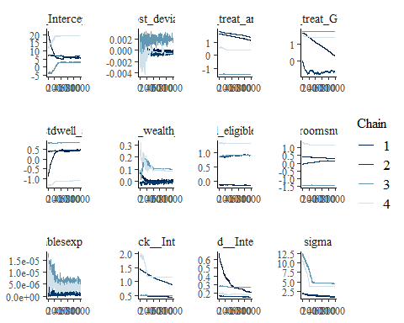

ggsave("table_2_diagnostics\\dwelling_cost_trace.png", plot = last_plot(), width = 12, height = 5)  
  
#density diagnostic plots  
mcmc_dens(dwelling_cost_bayesmodel,  
 pars = c("b_Intercept", "b_cost_deviation", "b_treat_any", "b_treat_GK",  
 "b_selfcostdwell_asinh_R1", "b_Lhh_wealth_asinh", "b_Lvill_eligible_ratio",   
 "b_Lroomsnumb", "b_Ldurablesexpenditure",  
 "sd_block__Intercept", "sd_vid__Intercept", "sigma"))

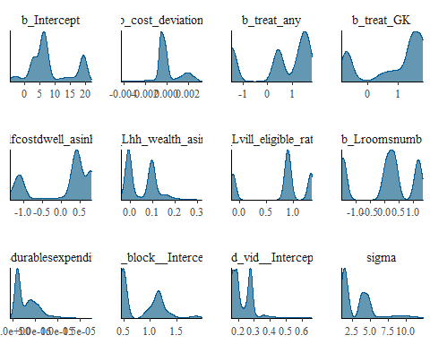

ggsave("table_2_diagnostics\\dwelling_cost_dens.png", plot = last_plot(), width = 12, height = 5)  
  
mcmc_dens_overlay(dwelling_cost_bayesmodel,  
 pars = c("b_Intercept", "b_cost_deviation", "b_treat_any", "b_treat_GK",  
 "b_selfcostdwell_asinh_R1", "b_Lhh_wealth_asinh", "b_Lvill_eligible_ratio",   
 "b_Lroomsnumb", "b_Ldurablesexpenditure",  
 "sd_block__Intercept", "sd_vid__Intercept", "sigma"))

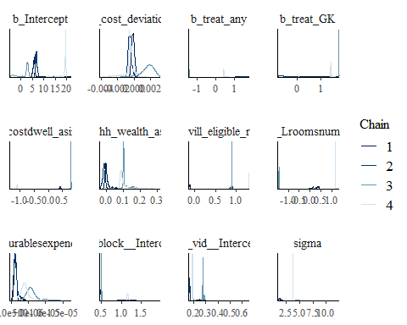

ggsave("table_2_diagnostics\\dwelling_cost_dens_overlay.png", plot = last_plot(), width = 12, height = 5)  
  
#acf (auto-correlation) diagnostic plot  
mcmc_acf(dwelling_cost_bayesmodel,  
 pars = c("b_Intercept", "b_cost_deviation", "b_treat_any", "b_treat_GK",  
 "b_selfcostdwell_asinh_R1", "b_Lhh_wealth_asinh", "b_Lvill_eligible_ratio",   
 "b_Lroomsnumb", "b_Ldurablesexpenditure",  
 "sd_block__Intercept", "sd_vid__Intercept", "sigma"))

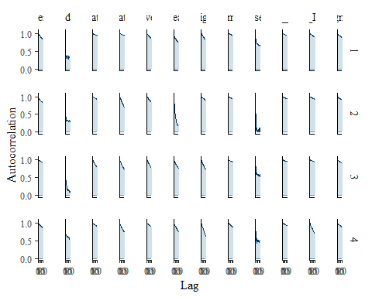

ggsave("table_2_diagnostics\\dwelling_cost_acf.png", plot = last_plot(), width = 12, height = 5)

posterior predictive checks

pp_check(dwelling_cost_bayesmodel, ndraws = 100)

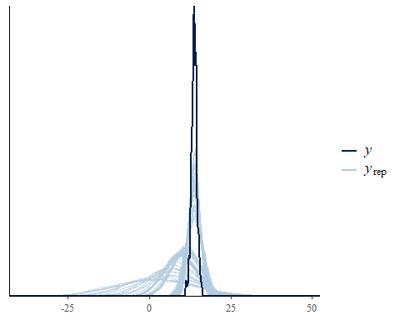

pp_check(dwelling_cost_bayesmodel, ndraws = 10, type = 'error_scatter_avg', alpha = .1)

