Table 2 - Sanitation Practices

2022-03-16

Load the **sanitation practices** model variables

**sanitation practices**: This is the basic benchmarking model utilizing the default, uninformed priors

sanitation_practices_bayesmodel <-  
 brm(formula = sanitation_practices | weights(samp_wgt) ~  
 cost_deviation + treat_any + treat_GK +  
 sanitation_practices_R1 + Lhh_wealth_asinh + Lvill_eligible_ratio +  
 Lproductiv_x_Lassetscon +  
 (1 | block) + (1 | vid),  
 data = sanitation_practices_data,  
 family = gaussian("identity"),  
 seed = 1272022,  
 warmup = 1000,  
 iter = 2000,  
 thin = 1,  
 control = list(adapt_delta = .95, max_treedepth = 10),  
 #backend = "cmdstanr",  
 cores = 4, #overrides default 1 core  
 #threads = 3,need to get cmdstanr package working here  
 save_pars = save_pars(all = TRUE), # potentially allows for more post-processing functionality  
 file = "uninformed_prior_outcomes\\sanitation_practices_bayes")

Model Summery

summary(sanitation_practices_bayesmodel)

## Family: gaussian   
## Links: mu = identity; sigma = identity   
## Formula: sanitation_practices | weights(samp_wgt) ~ cost_deviation + treat_any + treat_GK + sanitation_practices_R1 + Lhh_wealth_asinh + Lvill_eligible_ratio + Lproductiv_x_Lassetscon + (1 | block) + (1 | vid)   
## Data: sanitation_practices_data (Number of observations: 1751)   
## Draws: 4 chains, each with iter = 2000; warmup = 1000; thin = 1;  
## total post-warmup draws = 4000  
##   
## Group-Level Effects:   
## ~block (Number of levels: 22)   
## Estimate Est.Error l-95% CI u-95% CI Rhat Bulk_ESS Tail_ESS  
## sd(Intercept) 0.17 0.12 0.01 0.43 1.01 466 1104  
##   
## ~vid (Number of levels: 248)   
## Estimate Est.Error l-95% CI u-95% CI Rhat Bulk_ESS Tail_ESS  
## sd(Intercept) 0.97 0.07 0.84 1.11 1.00 1128 2505  
##   
## Population-Level Effects:   
## Estimate Est.Error l-95% CI u-95% CI Rhat Bulk_ESS  
## Intercept -2.01 0.24 -2.48 -1.56 1.00 2846  
## cost_deviation 0.00 0.00 -0.00 0.00 1.00 2528  
## treat_any 0.20 0.20 -0.19 0.59 1.00 1750  
## treat_GK -0.30 0.20 -0.69 0.09 1.00 1634  
## sanitation_practices_R1 0.11 0.02 0.07 0.14 1.00 6312  
## Lhh_wealth_asinh 0.04 0.01 0.01 0.06 1.00 7542  
## Lvill_eligible_ratio 0.03 0.69 -1.28 1.40 1.00 1498  
## Lproductiv_x_Lassetscon 0.01 0.00 0.01 0.01 1.00 5108  
## Tail_ESS  
## Intercept 3121  
## cost_deviation 2824  
## treat_any 2796  
## treat_GK 2790  
## sanitation_practices_R1 3065  
## Lhh_wealth_asinh 3298  
## Lvill_eligible_ratio 2464  
## Lproductiv_x_Lassetscon 3746  
##   
## Family Specific Parameters:   
## Estimate Est.Error l-95% CI u-95% CI Rhat Bulk_ESS Tail_ESS  
## sigma 2.63 0.03 2.57 2.69 1.00 7459 2730  
##   
## Draws were sampled using sampling(NUTS). For each parameter, Bulk_ESS  
## and Tail_ESS are effective sample size measures, and Rhat is the potential  
## scale reduction factor on split chains (at convergence, Rhat = 1).

Prior summery - how informative are priors

prior_summary(sanitation_practices_bayesmodel)

## prior class coef group resp dpar nlpar  
## (flat) b   
## (flat) b cost_deviation   
## (flat) b Lhh_wealth_asinh   
## (flat) b Lproductiv_x_Lassetscon   
## (flat) b Lvill_eligible_ratio   
## (flat) b sanitation_practices_R1   
## (flat) b treat_any   
## (flat) b treat_GK   
## student_t(3, 0.1, 3) Intercept   
## student_t(3, 0, 3) sd   
## student_t(3, 0, 3) sd block   
## student_t(3, 0, 3) sd Intercept block   
## student_t(3, 0, 3) sd vid   
## student_t(3, 0, 3) sd Intercept vid   
## student_t(3, 0, 3) sigma   
## bound source  
## default  
## (vectorized)  
## (vectorized)  
## (vectorized)  
## (vectorized)  
## (vectorized)  
## (vectorized)  
## (vectorized)  
## default  
## default  
## (vectorized)  
## (vectorized)  
## (vectorized)  
## (vectorized)  
## default

check_prior(sanitation_practices_bayesmodel)

## Warning: Some priors could not be simulated.

## Parameter Prior_Quality  
## 1 b_Intercept informative  
## 2 b_cost_deviation not determinable  
## 3 b_treat_any not determinable  
## 4 b_treat_GK not determinable  
## 5 b_sanitation_practices_R1 not determinable  
## 6 b_Lhh_wealth_asinh not determinable  
## 7 b_Lvill_eligible_ratio not determinable  
## 8 b_Lproductiv_x_Lassetscon not determinable

Diagnostics

# trace diagnostic plot  
mcmc_trace(sanitation_practices_bayesmodel, n_warmup = 0,  
 pars = c("b_Intercept", "b_cost_deviation", "b_treat_any", "b_treat_GK",  
 "b_sanitation_practices_R1", "b_Lhh_wealth_asinh", "b_Lvill_eligible_ratio",  
 "b_Lproductiv_x_Lassetscon",  
 "sd_block__Intercept", "sd_vid__Intercept", "sigma"))

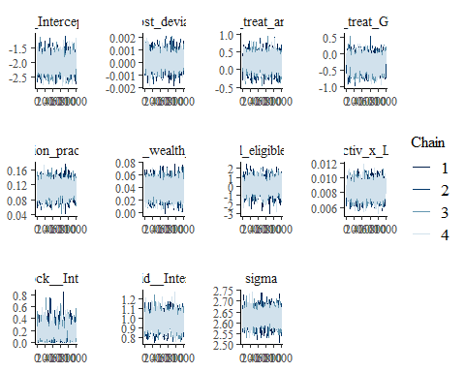

ggsave("table_2_diagnostics\\sanitation_practices_trace.png", plot = last_plot(), width = 12, height = 5)  
  
#density diagnostic plots  
mcmc_dens(sanitation_practices_bayesmodel,  
 pars = c("b_Intercept", "b_cost_deviation", "b_treat_any", "b_treat_GK",  
 "b_sanitation_practices_R1", "b_Lhh_wealth_asinh", "b_Lvill_eligible_ratio",  
 "b_Lproductiv_x_Lassetscon",  
 "sd_block__Intercept", "sd_vid__Intercept", "sigma"))

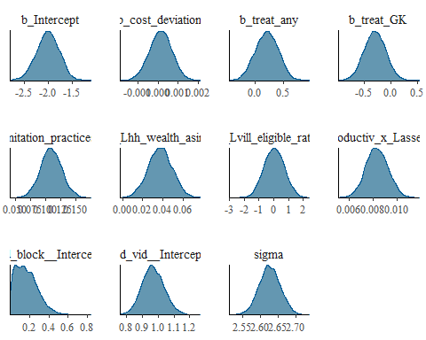

ggsave("table_2_diagnostics\\sanitation_practices_dens.png", plot = last_plot(), width = 12, height = 5)  
  
mcmc_dens_overlay(sanitation_practices_bayesmodel,  
 pars = c("b_Intercept", "b_cost_deviation", "b_treat_any", "b_treat_GK",  
 "b_sanitation_practices_R1", "b_Lhh_wealth_asinh", "b_Lvill_eligible_ratio",  
 "b_Lproductiv_x_Lassetscon",  
 "sd_block__Intercept", "sd_vid__Intercept", "sigma"))

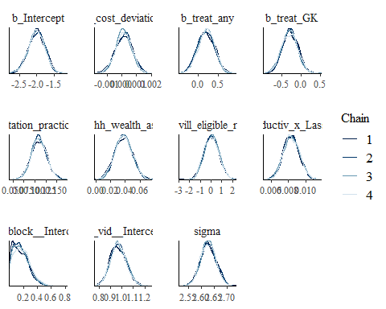

ggsave("table_2_diagnostics\\sanitation_practices_dens_overlay.png", plot = last_plot(), width = 12, height = 5)  
  
#acf (auto-correlation) diagnostic plot  
mcmc_acf(sanitation_practices_bayesmodel,  
 pars = c("b_Intercept", "b_cost_deviation", "b_treat_any", "b_treat_GK",  
 "b_sanitation_practices_R1", "b_Lhh_wealth_asinh", "b_Lvill_eligible_ratio",  
 "b_Lproductiv_x_Lassetscon",  
 "sd_block__Intercept", "sd_vid__Intercept", "sigma"))

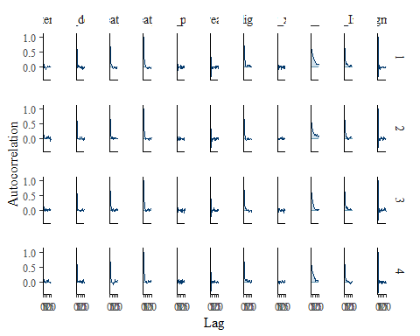

ggsave("table_2_diagnostics\\sanitation_practices_acf.png", plot = last_plot(), width = 12, height = 5)

posterior predictive checks

pp_check(sanitation_practices_bayesmodel, ndraws = 100)

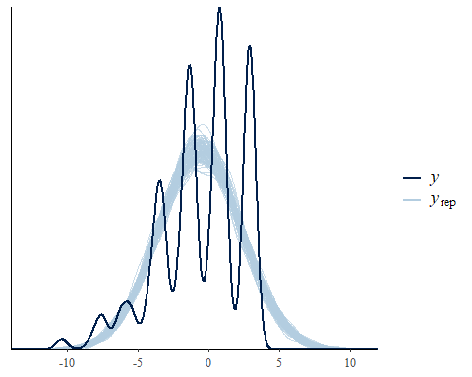

pp_check(sanitation_practices_bayesmodel, ndraws = 10, type = 'error_scatter_avg', alpha = .1)

