Table 2 - Savings Stock

2022-03-16

**savings stock**: This is the basic bechmarking model utilzing brm() default uninformed priors

savings_stock_bayesmodel <-  
 brm(formula = savingsstock_asinh | weights(samp_wgt) ~  
 cost_deviation + treat_any + treat_GK +  
 savingsstock_asinh_R1 + Lhh_wealth_asinh + Lvill_eligible_ratio +   
 Lconsumpti_x_Lproductiv + Lconsumpti_x_Lassetscon +  
 (1 | block) + (1 | vid),  
 data = savings_stock_data,  
 family = gaussian("identity"),  
 seed = 1272022,  
 warmup = 1000,  
 iter = 2000,  
 thin = 1,  
 control = list(adapt_delta = .95, max_treedepth = 10),  
 #backend = "cmdstanr",  
 cores = 4, #overrides default 1 core  
 #threads = 3,need to get cmdstanr package working here  
 save_pars = save_pars(all = TRUE), # potentially allows for more post-processing functionality  
 file = "uninformed_prior_outcomes\\savings_stock_bayes")

Model Summery

summary(savings_stock_bayesmodel)

## Family: gaussian   
## Links: mu = identity; sigma = identity   
## Formula: savingsstock_asinh | weights(samp_wgt) ~ cost_deviation + treat_any + treat_GK + savingsstock_asinh_R1 + Lhh_wealth_asinh + Lvill_eligible_ratio + Lconsumpti_x_Lproductiv + Lconsumpti_x_Lassetscon + (1 | block) + (1 | vid)   
## Data: savings_stock_data (Number of observations: 1751)   
## Draws: 4 chains, each with iter = 2000; warmup = 1000; thin = 1;  
## total post-warmup draws = 4000  
##   
## Group-Level Effects:   
## ~block (Number of levels: 22)   
## Estimate Est.Error l-95% CI u-95% CI Rhat Bulk_ESS Tail_ESS  
## sd(Intercept) 0.70 0.20 0.33 1.11 1.01 659 877  
##   
## ~vid (Number of levels: 248)   
## Estimate Est.Error l-95% CI u-95% CI Rhat Bulk_ESS Tail_ESS  
## sd(Intercept) 1.40 0.11 1.19 1.63 1.00 1396 2232  
##   
## Population-Level Effects:   
## Estimate Est.Error l-95% CI u-95% CI Rhat Bulk_ESS  
## Intercept 1.78 0.46 0.89 2.68 1.00 2256  
## cost_deviation 0.00 0.00 -0.00 0.00 1.00 1752  
## treat_any -0.14 0.30 -0.72 0.46 1.00 1450  
## treat_GK 1.30 0.31 0.73 1.91 1.00 1351  
## savingsstock_asinh_R1 0.17 0.02 0.14 0.20 1.00 4031  
## Lhh_wealth_asinh -0.05 0.02 -0.09 -0.02 1.00 4216  
## Lvill_eligible_ratio 1.61 1.16 -0.65 3.80 1.00 1243  
## Lconsumpti_x_Lproductiv 0.02 0.00 0.02 0.03 1.00 5237  
## Lconsumpti_x_Lassetscon 0.01 0.00 0.01 0.01 1.00 6075  
## Tail_ESS  
## Intercept 3468  
## cost_deviation 2612  
## treat_any 2295  
## treat_GK 2163  
## savingsstock_asinh_R1 2697  
## Lhh_wealth_asinh 3224  
## Lvill_eligible_ratio 2004  
## Lconsumpti_x_Lproductiv 3092  
## Lconsumpti_x_Lassetscon 3724  
##   
## Family Specific Parameters:   
## Estimate Est.Error l-95% CI u-95% CI Rhat Bulk_ESS Tail_ESS  
## sigma 4.15 0.05 4.05 4.25 1.00 4876 2963  
##   
## Draws were sampled using sampling(NUTS). For each parameter, Bulk_ESS  
## and Tail_ESS are effective sample size measures, and Rhat is the potential  
## scale reduction factor on split chains (at convergence, Rhat = 1).

Prior summery - how informative are priors

prior_summary(savings_stock_bayesmodel)

## prior class coef group resp dpar nlpar  
## (flat) b   
## (flat) b cost_deviation   
## (flat) b Lconsumpti_x_Lassetscon   
## (flat) b Lconsumpti_x_Lproductiv   
## (flat) b Lhh_wealth_asinh   
## (flat) b Lvill_eligible_ratio   
## (flat) b savingsstock_asinh_R1   
## (flat) b treat_any   
## (flat) b treat_GK   
## student_t(3, 8.7, 3.1) Intercept   
## student_t(3, 0, 3.1) sd   
## student_t(3, 0, 3.1) sd block   
## student_t(3, 0, 3.1) sd Intercept block   
## student_t(3, 0, 3.1) sd vid   
## student_t(3, 0, 3.1) sd Intercept vid   
## student_t(3, 0, 3.1) sigma   
## bound source  
## default  
## (vectorized)  
## (vectorized)  
## (vectorized)  
## (vectorized)  
## (vectorized)  
## (vectorized)  
## (vectorized)  
## (vectorized)  
## default  
## default  
## (vectorized)  
## (vectorized)  
## (vectorized)  
## (vectorized)  
## default

check_prior(savings_stock_bayesmodel)

## Warning: Some priors could not be simulated.

## Parameter Prior_Quality  
## 1 b_Intercept uninformative  
## 2 b_cost_deviation not determinable  
## 3 b_treat_any not determinable  
## 4 b_treat_GK not determinable  
## 5 b_savingsstock_asinh_R1 not determinable  
## 6 b_Lhh_wealth_asinh not determinable  
## 7 b_Lvill_eligible_ratio not determinable  
## 8 b_Lconsumpti_x_Lproductiv not determinable  
## 9 b_Lconsumpti_x_Lassetscon not determinable

Diagnostics

# trace diagnostic plot  
mcmc_trace(savings_stock_bayesmodel, n_warmup = 0,  
 pars = c("b_Intercept", "b_cost_deviation", "b_treat_any", "b_treat_GK",  
 "b_savingsstock_asinh_R1", "b_Lhh_wealth_asinh", "b_Lvill_eligible_ratio",  
 "b_Lconsumpti_x_Lproductiv", "b_Lconsumpti_x_Lassetscon",  
 "sd_block__Intercept", "sd_vid__Intercept", "sigma"))

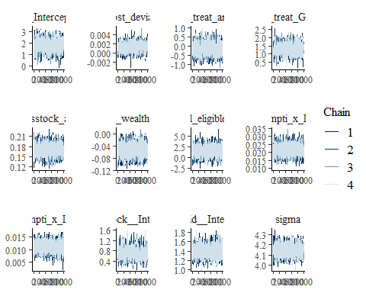

ggsave("table_2_diagnostics\\savings_stock_trace.png", plot = last_plot(), width = 12, height = 5)  
  
#density diagnostic plots  
mcmc_dens(savings_stock_bayesmodel,  
 pars = c("b_Intercept", "b_cost_deviation", "b_treat_any", "b_treat_GK",  
 "b_savingsstock_asinh_R1", "b_Lhh_wealth_asinh", "b_Lvill_eligible_ratio",  
 "b_Lconsumpti_x_Lproductiv", "b_Lconsumpti_x_Lassetscon",  
 "sd_block__Intercept", "sd_vid__Intercept", "sigma"))

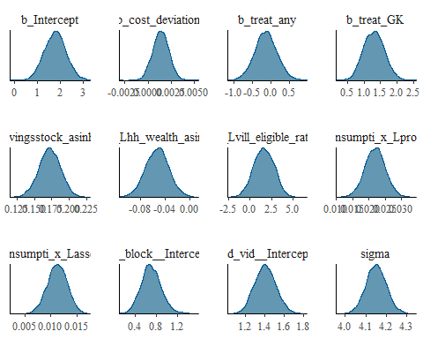

ggsave("table_2_diagnostics\\savings_stock_dens.png", plot = last_plot(), width = 12, height = 5)  
  
mcmc_dens_overlay(savings_stock_bayesmodel,  
 pars = c("b_Intercept", "b_cost_deviation", "b_treat_any", "b_treat_GK",  
 "b_savingsstock_asinh_R1", "b_Lhh_wealth_asinh", "b_Lvill_eligible_ratio",  
 "b_Lconsumpti_x_Lproductiv", "b_Lconsumpti_x_Lassetscon",  
 "sd_block__Intercept", "sd_vid__Intercept", "sigma"))

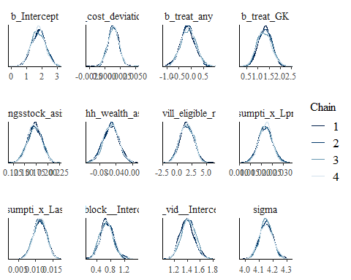

ggsave("table_2_diagnostics\\savings_stock_dens_overlay.png", plot = last_plot(), width = 12, height = 5)  
  
#acf (auto-correlation) diagnostic plot  
mcmc_acf(savings_stock_bayesmodel,  
 pars = c("b_Intercept", "b_cost_deviation", "b_treat_any", "b_treat_GK",  
 "b_savingsstock_asinh_R1", "b_Lhh_wealth_asinh", "b_Lvill_eligible_ratio",  
 "b_Lconsumpti_x_Lproductiv", "b_Lconsumpti_x_Lassetscon",  
 "sd_block__Intercept", "sd_vid__Intercept", "sigma"))

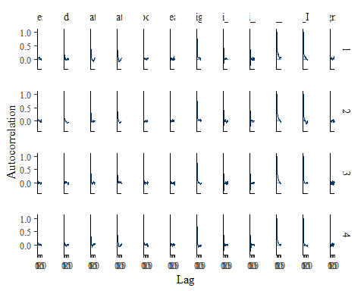

ggsave("table_2_diagnostics\\savings_stock_acf.png", plot = last_plot(), width = 12, height = 5)

posterior predictive checks

pp_check(savings_stock_bayesmodel, nsamples = 100)

## Warning: Argument 'nsamples' is deprecated. Please use argument 'ndraws'  
## instead.

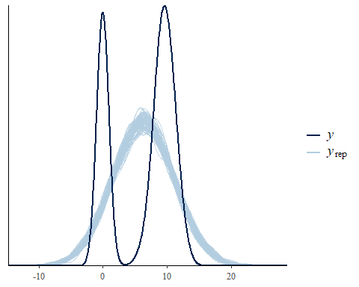

pp_check(savings_stock_bayesmodel, nsamples = 10, type = 'error_scatter_avg', alpha = .1)

## Warning: Argument 'nsamples' is deprecated. Please use argument 'ndraws'  
## instead.

