TP GIT
Zara Zulfiqar Master MLSD 1 FA

Question numéro 1 et 2
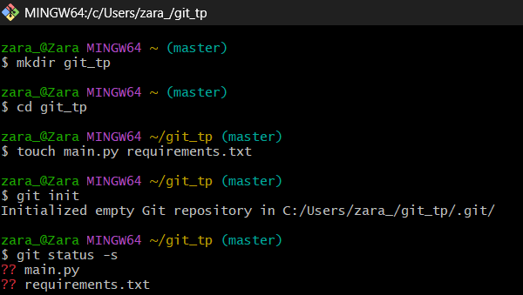
Question 3


Question 3 – 4 – 5 – 6
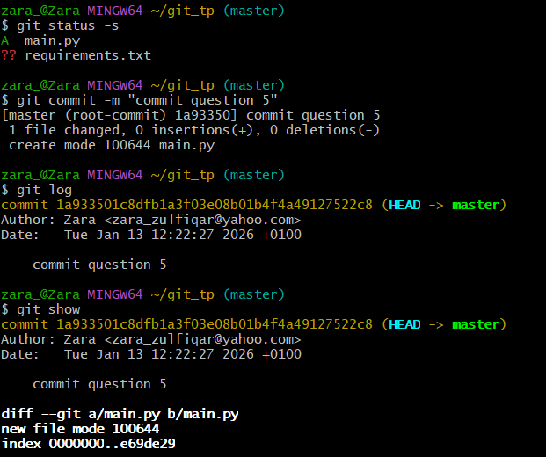

Question 7 – 8 – 9 – 10
