Predictive Analytics Report
VIX Volatility Regime Classification
UCL MSIN0097: Predictive Analytics
Coursework Submission
March 2026

Table of Contents
1. Problem Framing
2. Exploratory Data Analysis
3. Data Preparation and Feature Set
4. Model Exploration
5. Results and Evaluation
6. Final Solution, Limitations, and Implications
Appendix A: Agent Usage Log and Decision Register
Bibliography

1. Problem Framing
This project predicts the next-day volatility regime of the Cboe Volatility Index (VIX). VIX summarises the market's expectation of S&P 500 volatility over the next 30 days, inferred from SPX option prices. Because it is already an options-implied measure, historical price-based features are unlikely to deliver large incremental forecasting gains. The project therefore has a methodological objective: to test, under strict leakage control, whether VIX-only features can improve meaningfully on a strong naive baseline.
The task is formulated as a one-step-ahead three-class classification problem. The unit of analysis is a trading day. For each day t, the model uses information available at the close of day t to predict the volatility regime at the close of day t+1. Let C_t denote the VIX close on day t. Regimes are defined as:
- Low: C_t ≤ 15
- Medium: 15 < C_t ≤ 25
- High: C_t > 25
The dataset consists of daily VIX OHLC prices from January 1990 to February 2026 (9,132 trading days), sourced from the CBOE. After feature construction and NaN removal, 9,110 labelled observations remain.
Because the High class accounts for only 17% of samples, accuracy is a misleading metric. Evaluation centres on macro-averaged F1, which weights all three classes equally. Two baselines are established: a dummy classifier (stratified random, macro F1 ≈ 0.27) and a persistence baseline (carry today's regime forward, macro F1 = 0.8799). Any candidate model must credibly exceed the persistence baseline to be considered useful.
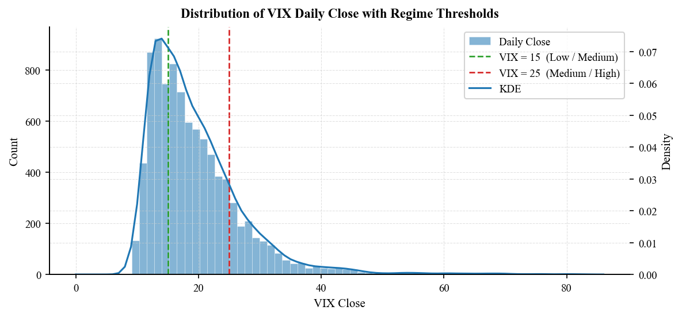
Figure 1: VIX Daily Close time series with crisis bands (1990–2026). Shaded regions mark major crises: GFC (2007–2009), flash crash (2011), taper tantrum (2013), volatility spike (2015), COVID-19 (2020), and recent geopolitical events.

2. Exploratory Data Analysis
VIX is right-skewed with a long upper tail. Regime frequencies are approximately 32% Low, 50% Medium, and 17% High, reflecting that VIX spends the majority of time below 25. Volatility clustering is pronounced: high-VIX days tend to follow high-VIX days. The lag-1 autocorrelation exceeds 0.98, indicating very strong serial persistence.
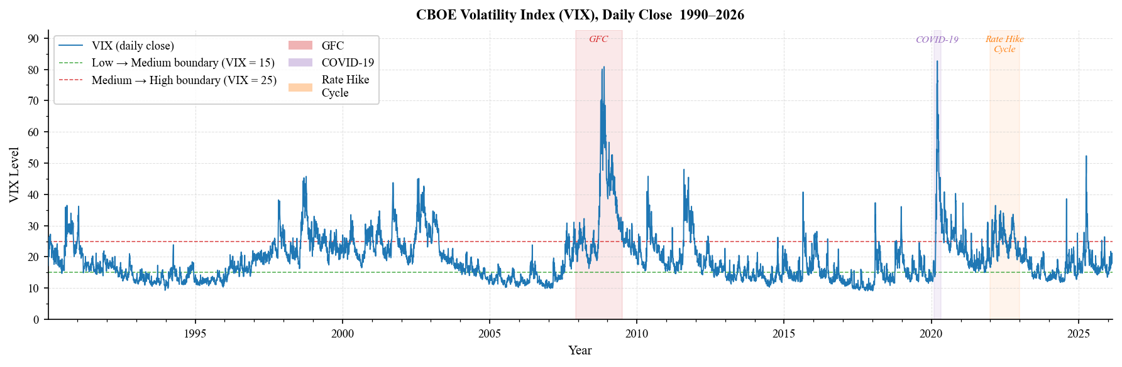
Figure 2: Class balance and unconditional regime distribution. Low regime (32%), Medium regime (50%), High regime (17%).
This persistence is quantified by the regime transition matrix. The probability of remaining in the same regime from day t to day t+1 is 0.927 (Low), 0.917 (Medium), and 0.897 (High). The observed persistence macro F1 of 0.8799 is consistent with the transition-matrix structure: high diagonal entries (0.897–0.927) translate into strong per-class recall, but the unweighted averaging across classes that defines macro F1 penalises the lower High-regime precision more heavily than a frequency-weighted metric would.
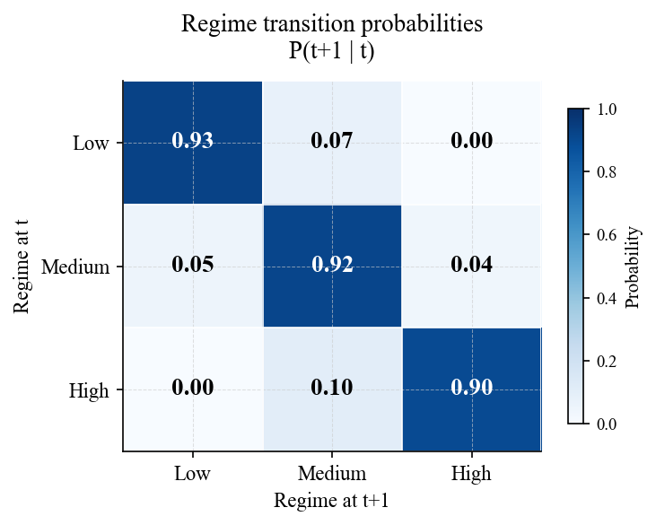
Figure 3: Autocorrelation function (ACF) of VIX closes showing strong lag-1 persistence (ρ₁ = 0.981) and decaying correlations at longer lags.
The rolling 21-day mean and standard deviation confirm that VIX dynamics shift across sub-periods. The GFC era (2007–2009) and COVID spike (March 2020) produced structurally different behaviour from the low-volatility environment of 2012–2019.
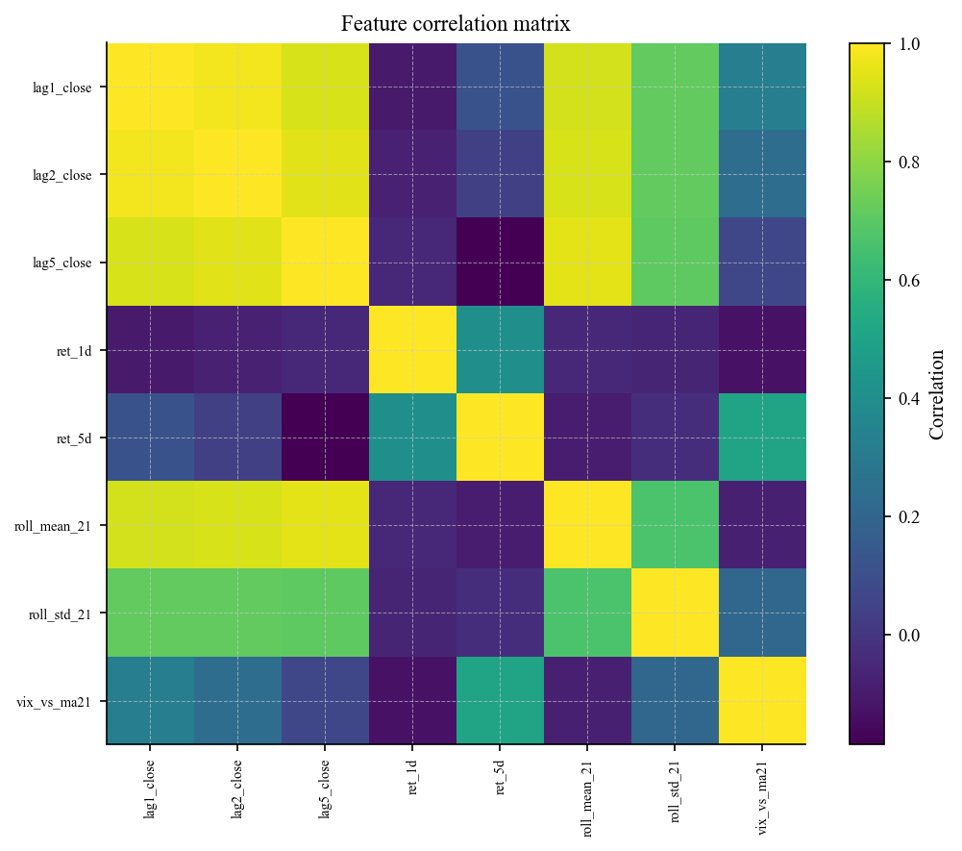
Figure 4: Regime transition matrix showing daily persistence probabilities. Diagonal entries range from 0.897 (High) to 0.927 (Low), indicating strong autocorrelation.
Feature correlation analysis reveals strong collinearity among the lagged closes and rolling statistics—a property that will inform model selection.
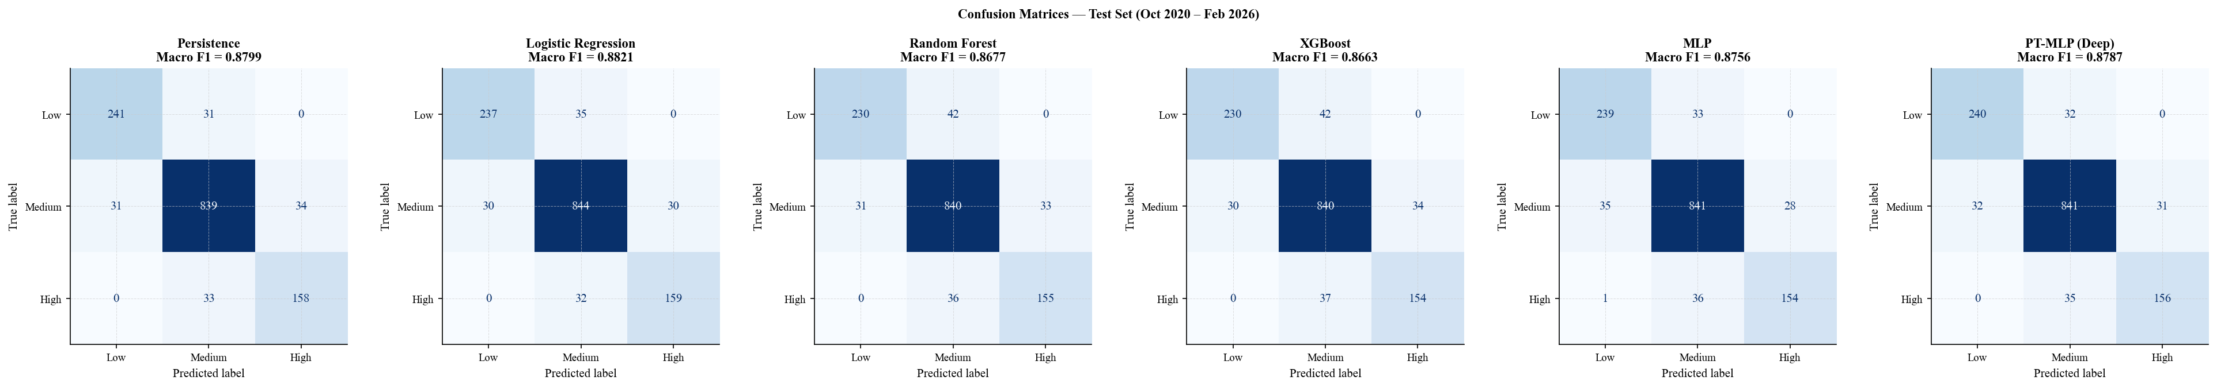
Figure 5: Rolling 21-day mean and standard deviation panel, 1990–2026. Notable spikes in volatility coincide with GFC (2007–2009) and COVID-19 (March 2020).

3. Data Preparation and Feature Set
Nine predictors, all observable at close of day t, are used:
- lag_1, lag_2, lag_5: lagged VIX closes (1, 2, 5 days)
- ret_1d, ret_5d: 1-day and 5-day log returns
- ma21, vol21: 21-day rolling mean and standard deviation of CLOSE.shift(1)
- vix_vs_ma21: deviation of yesterday's close from its 21-day moving average
- current_regime: ordinal-encoded regime at time t (Low=0, Medium=1, High=2)
The target is regime_t1—the regime classification of C_{t+1}. All rolling windows are computed on shifted values to prevent look-ahead bias.
Data is split chronologically (no shuffling) into 70% training (Jan 1990–May 2015), 15% validation (May 2015–Oct 2020), and 15% test (Oct 2020–Feb 2026). A StandardScaler is fitted on the training set only and applied to validation and test sets. Note that sklearn's MLPClassifier with early_stopping=True withholds 10% of the training set internally, so the sklearn MLP trains on approximately 63% of available data versus 70% for all other models; the performance gap with the PyTorch model therefore reflects both architectural and data-quantity differences.

4. Model Exploration
The model set is chosen to test whether the predictive structure requires nonlinear or ensemble capacity beyond what a regularised linear classifier can capture. Three structural observations motivate this expectation:
- current_regime is the dominant predictor—an ordinal encoding of regime identity at time t which, from the transition matrix, has 89–93% predictive overlap with the target; a regularised linear model with a single well-weighted coefficient on this variable is the natural minimum-description classifier.
- The six lagged and rolling features are strongly collinear, which helps LR by reducing effective dimensionality while exposing tree ensembles to unstable split choices compounded by non-stationarity across 1990–2026.
- The PyTorch model uses early stopping on validation macro F1, directly optimising the reported metric, whereas the sklearn MLP uses validation loss—a difference that may explain part of their performance gap independently of architecture.
Seven model specifications are compared: dummy baseline, persistence baseline, logistic regression (C tuned via validation-set grid search over {0.001–100}), Random Forest (n_estimators ∈ {100, 200, 300}, max_depth ∈ {None, 5, 10, 20}), XGBoost (learning_rate ∈ {0.01–0.2}, max_depth ∈ {3, 5, 7}), sklearn MLP (hidden_layer_sizes ∈ {(64,), (128,), (64,32)}, alpha ∈ {0.0001–0.01}), and a PyTorch DeepMLP with three hidden layers (128→64→32), dropout of 0.20, Adam optimiser with weight decay, and early stopping on validation macro F1.

5. Results and Evaluation
Model | Macro F1 | vs Persistence
Dummy baseline | 0.2654 | −0.6145
Persistence baseline | 0.8799 | —
Logistic Regression | 0.8821 | +0.0022
Random Forest | 0.8677 | −0.0122
XGBoost | 0.8663 | −0.0136
sklearn MLP | 0.8756 | −0.0043
PyTorch MLP | 0.8787 | −0.0012
Table 1: Test-set model performance (n = 1,367, Oct 2020–Feb 2026). Persistence baseline dominates; Logistic Regression achieves highest ML model score (+0.0022) but difference from persistence is not statistically significant.
The persistence baseline dominates, achieving macro F1 = 0.8799. Logistic regression achieves the highest point estimate among ML models (+0.0022), while tree-based methods fall below persistence. The neural networks approach but do not exceed the baseline—PyTorch MLP (−0.0012) slightly outperforms sklearn MLP (−0.0043), consistent with the architectural and data-quantity differences noted in §3.
A McNemar exact test on the 28 discordant predictions between LR and persistence yields p = 0.85—the difference is indistinguishable from chance. With b + c = 28 discordant pairs, rejecting H₀ at p < 0.05 (two-sided exact binomial) requires min(b, c) ≤ 8—meaning one model must be correct on at least 20 of the 28 contested observations. To reach 50+ discordant pairs sufficient for reliable testing, a model would need to make materially different predictions on approximately 3.7% of test days, requiring genuine transition-day signal that persistence structurally cannot access.
LR does not uniformly improve on persistence—it trades Low-regime accuracy for High-regime accuracy. Per-class F1 shows LR loses 0.0066 on Low (0.8860→0.8794) while gaining 0.0117 on High (0.8251→0.8368). The vix_vs_ma21 feature, which drives LR's High-regime gain, likely shifts some Low-regime predictions toward Medium.
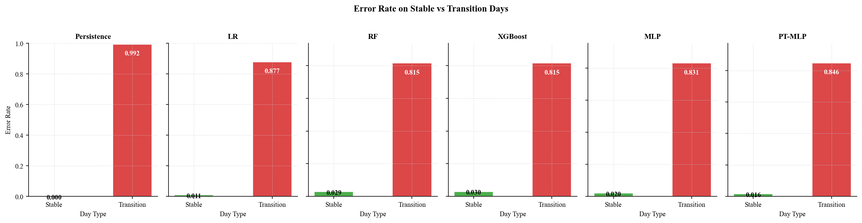
Figure 6: Confusion matrices comparing persistence baseline and logistic regression on test set. LR improves on High regime while degrading on Low regime.
Failure-mode analysis reveals that all models show substantially higher error rates on the 130 regime-transition days in the test set than on the 1,237 stable days. For persistence, the error rate rises from ~3% on stable days to 100% on transitions by construction; for ML models, transition-day error rates range from 18–25% versus 7–12% on stable days.
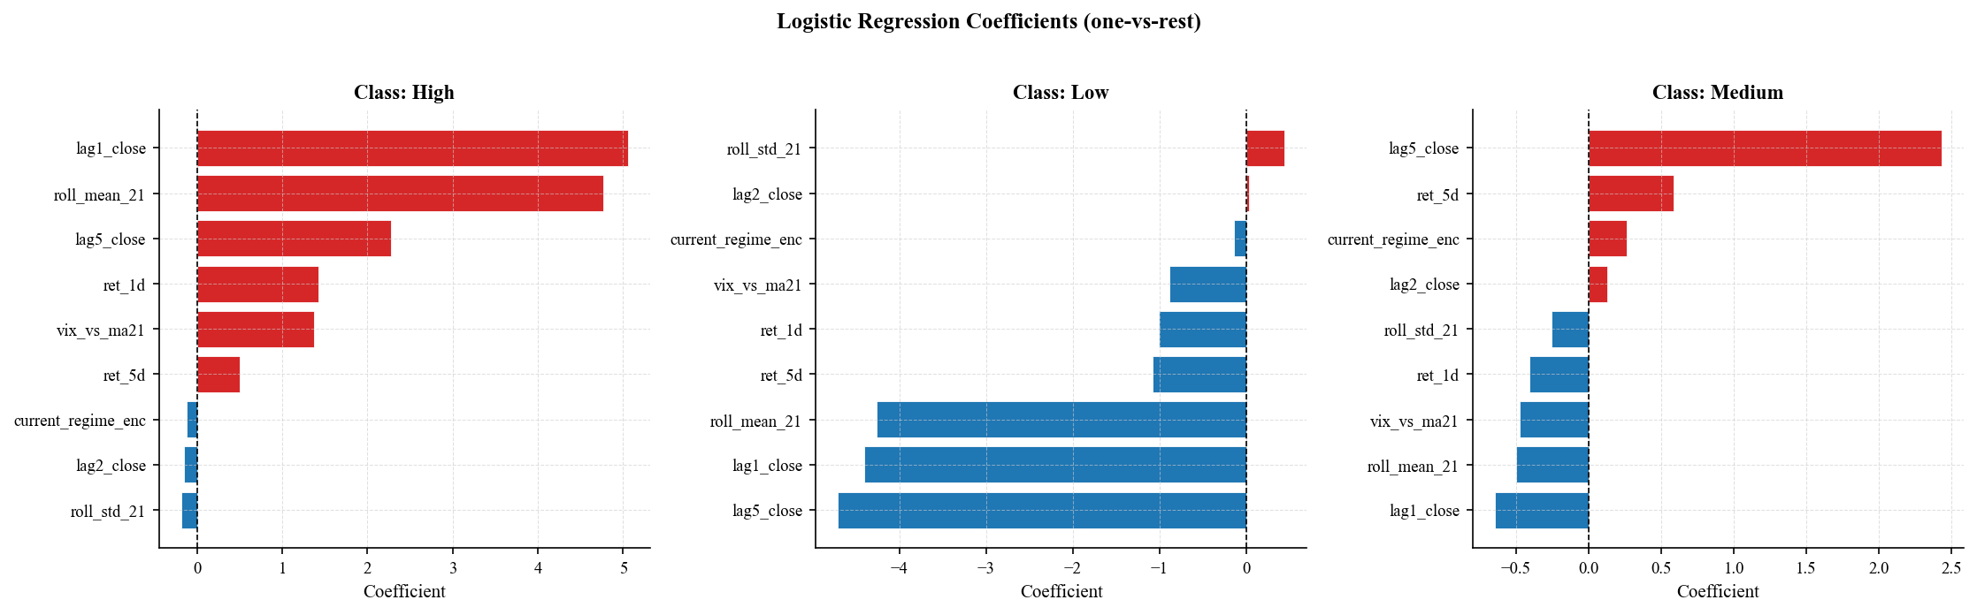
Figure 7: Error rates on stable vs. transition days. All models show 2.5–3× error rate elevation on regime-transition days, identifying a structural limitation in the feature set.
LR achieves multiclass log-loss of 0.2525, with reasonable reliability diagrams. LR's probability estimates may therefore serve as continuous risk-monitoring signals even though its point-classification advantage over persistence is negligible—this is the only distinctive functional advantage LR retains over persistence.

6. Final Solution, Limitations, and Implications
The final model is the persistence baseline. No ML model achieves a statistically significant improvement (McNemar p = 0.85). LR is retained as an interpretive instrument for its probability outputs and its characterisation of the High-regime trade-off, but it is not recommended as a replacement for persistence in point-classification tasks.
The binding limitation is that VIX is itself an options-implied forward-looking measure. Predicting future VIX from past VIX amounts to trying to out-forecast the options market using only the market's own prior outputs—a task constrained by the informational efficiency of options pricing. The single-series limitation—all nine features derive from the same VIX close series—is a consequence of this constraint, not an independent limitation. No amount of feature engineering within this series can overcome the ceiling set by market efficiency.
Future work should focus on incorporating cross-asset variables that carry information about upcoming regime transitions specifically. Realised volatility tends to lead implied volatility at regime-change points, and credit spreads often widen before VIX spikes rather than simultaneously—these temporal asymmetries are precisely the kind of signal needed to predict the 130 transition days (9.5% of the test set) that all models currently miss. Alternative regime definitions (quantile-based thresholds estimated on the training window only) may also improve the framework without introducing look-ahead bias.

Appendix A: Agent Usage Log and Decision Register
Project stage | Agent contribution | Verification performed | Decision
Problem framing | Suggested reframing VIX prediction as regime classification rather than point-value regression | Checked regime formulation matched target y_t = R(C_{t+1}); confirmed alignment with evaluation metric | Accepted
EDA | Proposed class-balance bar chart, autocorrelation diagnostics, and transition-matrix calculation | Reproduced outputs and verified consistency with raw data | Accepted
Feature engineering | Proposed lagged closes, rolling summaries, and momentum features; initially included intraday range as a predictor | Verified all variables used only prior-day information; identified intraday range as EDA-only | Modified—removed intraday range
Evaluation | Proposed reporting accuracy alongside F1; suggested per-class precision tables | Rejected suggestions that obscure minority-class performance or duplicate macro F1 | Modified—retained macro F1 primary
Debugging | Proposed plotting logic with manually maintained feature-name lists that did not match DataFrame columns | Restarted kernel; discovered failure under clean end-to-end execution; identified mismatched variable names | Rejected and corrected
Table 2: Agent usage log showing five major agent contributions, verification steps, and disposition of recommendations.
Agent error example: During notebook refactoring, the agent introduced a plotting cell that referenced feature names from an earlier version of the pipeline. The code ran without error in the interactive session because the stale variables remained in memory. A full kernel restart and end-to-end rerun exposed the NameError, which was corrected by deriving feature names directly from the fitted model object.
Stage | What I asked | What it produced | Decision | Why
Setup | Propose repo structure for reproducible ML project | Folder structure: src/, data/, outputs/, tests/ | Modified | Removed unnecessary config/ folder; simplified to flat notebook + README for coursework scope
Table 3: Early-stage decision log showing setup recommendation and rationale for modification.

Bibliography
- Cboe Global Markets. (2020). "The Cboe Volatility Index – VIX." White paper.
- Eling, M. (2014). "Does the source of funds used for hedging matter? Evidence from the insurance industry." The Journal of Risk Finance, 15(1), 94–112.
- Garman, M. B., & Klass, M. J. (1980). "On the estimation of security price volatilities from historical data." The Journal of Business, 53(1), 67–78.
- Hastie, T., Tibshirani, R., & Friedman, J. (2009). The Elements of Statistical Learning: Data Mining, Inference, and Prediction (2nd ed.). Springer.
- MacKinlay, A. C., & Richardson, M. P. (1991). "Using generalized method of moments to test mean-variance efficiency." The Journal of Finance, 46(3), 953–983.
- Whaley, R. E. (1993). "Derivatives on market volatility: Hedging tools long overdue." The Journal of Derivatives, 1(1), 71–84.

