Lifting the veil: Altered visual perception in derealisation

Authors: Anikó Kusztor¹, Nirmitee Mulay², Makiko Yamada^{3,4}, Jakob Hohwy⁵, Naotsugu Tsuchiya^{1,6-8,}

Affiliations:
¹ School of Psychological Sciences, Monash University, Clayton, VIC, 3800, Australia
² Indian Institute of Science Education And Research Kolkata (IISER Kolkata), Mohanpur, 741246, West Bengal, India
³ Department of Functional Brain Imaging, Institute for Quantum Medical Science, National Institutes for Quantum Science and Technology, Chiba 263-8555, Japan
⁴ Institute for Quantum Life Science, National Institutes for Quantum Science and Technology, Chiba 263-8555, Japan
⁵ Monash Centre for Consciousness & Contemplative Studies, Monash University, Clayton, VIC 3800, Australia
⁶ Turner Institute for Brain and Mental Health & School of Psychological Sciences, Faculty of Medicine, Nursing, and Health Sciences, Monash University, Melbourne, Victoria, Australia
⁷ Center for Information and Neural Networks (CiNet), National Institute of Information and Communications Technology (NICT), Suita, Osaka 565-0871, Japan
⁸ Advanced Telecommunications Research Computational Neuroscience Laboratories, 2-2-2 Hikaridai, Seika-cho, Soraku-gun, Kyoto 619-0288, Japan

Abstract
During an acute episode of depersonalisation/derealisation (DP/DR), people report a complex and idiosyncratic change in their perceptual experience. Specifically, derealisation describes the experience of detachment from the external world and altered visual perception in which the surroundings look faded, foggy or dream-like.
Whilst some have argued that there may not be genuine perceptual changes in derealisation, this proposal is yet to be tested empirically. Thus, we set out to investigate the potential perceptual changes in derealisation. In this Registered Report, we propose to conduct a series of online experiments to reveal the impact of DP/DR on how people interact with visual stimuli and to shed light on the relationship between faded perceptual experiences and an altered sense of reality.

Introduction

Most of us move through our day-to-day life with a sense that our experiences reflect reality without any doubt. Some may even find it hard to answer when asked if their surroundings look real to them because they have never questioned it before. Under some circumstances, however, this ongoing sense of reality becomes compromised. Conditions such as acute stress (Baker et al., 2003; Hunter et al., 2017), being under the influence of psychedelic substances (Mathew et al., 1999; Medford et al., 2003; Niciu et al., 2018), sleep deprivation (Waters et al., 2018) or meditation (Castillo, 1990) can all profoundly change whether we experience ourselves and the external world as part of reality.

Depersonalisation and derealisation experiences are prevalent in both clinical and general populations (Hunter et al., 2004), but many of their experiential characteristics have so far remained unclear. From a diagnostic point of view, depersonalisation describes the experience of the unreality of one’s self, and derealisation is defined as experiencing detachment or unreality of the surrounding environment (American Psychiatric Association, 2013). Although these experiences frequently occur together, they can be distinguished in terms of subjective experiences as well as physiological and neural underpinnings (Dewe et al., 2018; Dutt & Grover, 2009; Ratnam et al., 2016; Sierra et al., 2002). Even so, most psychological inventories measure depersonalisation (DP) and derealisation (DR) together. In this article, therefore, we will use the term DP/DR when we cannot discuss derealisation separately. Nonetheless, the primary target of this research is derealisation.

According to subjective reports and diagnostic guides, derealisation involves visual experiences with altered colour intensity, fogginess, flatness and other perceptual distortions such as changes in distances and size (Ciaunica et al., 2022; Hunter et al., 2003; Sar et al., 2017; Sierra & Berrios, 2000). These perceptual alterations can be divided the following way: metamorphopsia (changes of shapes and colours), micropsia/macropsia (changes in size), and teleopsia (objects look more distant) (Lipsanen et al., 1999). Besides these specific distortions, phenomenological descriptions often emphasise decreased vividness or dullness of the external world (Pienkos & Sass, 2022). When discussing vividness, it is important to note that in some instances, vividness refers to colour intensity only (e.g. Medford, 2012; Yokokawa et al., 2018). However, vividness is perhaps better conceptualised as a subjective quality that is the combination of intensity (i.e., apparent saturation, contrast and brightness), specificity (i.e., blurriness and detailedness), and stability (i.e. length of presence in time) (Fazekas et al., 2020). In addition, terms like dream-likeness, artificialness or the phrase “the world looks as if…” are often used to explain how the world looks unreal. (Dutt & Grover, 2009; Hunter et al., 2017). Thus, it is unclear to what extent specific visual distortions can contribute to the overall experiences of unrealness.

Approaching this question from a theoretical angle, several recent papers put forward arguments in favour of conceptualising derealisation independently from perceptual distortions (Dokic & Martin, 2017; Gładziejewski, 2022; Deroy & Rappe, 2022; Suzuki et al., 2023). According to Dokic and Martin (2017), derealisation arises from a disruption in the sense of reality, which they described as a metacognitive feeling that accompanies experiences regardless of the sensory input. Others posited that it is a specific perceptual component that is diminished in derealisation (Deroy & Rappe, 2022; Gładziejewski, 2022; Minden Ribeiro, 2022; Suzuki et al., 2023). For example, Gładziejewski (2022) argues that the visual experience feels different in derealisation because of diminished connectedness with the external world due to altered interoceptive processes. Suzuki et al. (2023) take a similar position, but they acknowledge that the vividness level of visual content can possibly contribute to derealisation. Thus, theoretical proposals range from those that emphasise more cognitive processes to those emphasising more perceptual processes that underlie derealisation.

Currently, it is unclear whether realness is related to visual perceptual properties such as vividness. To address this issue, Yokokawa et al. (Yokokawa et al., 2018) investigated the experience of unreality and its association with perceived fadedness. They have found that healthy participants rated images with mid-level saturation as less real when the preceding image was highly saturated as opposed to weakly saturated. This apparent fadedness was associated with activity in the dorsolateral prefrontal and parietal cortex as well as striatal D2 receptor availability. These findings suggest that the subjective experience of colour saturation contributes to the perceptual judgments of what constitutes as real. Yet the reason for this association remains unknown.

A clue to the link between realness and vividness might be that most people report experiencing internally generated percepts, such as mental imagery or dreams, as less vivid (Dance et al., 2022; Dawes et al., 2020). Under these “normatively unreal” situations, people know that lower levels of vividness are associated with unreality. This logic may be invoked, either implicitly or explicitly, when people report unrealness in the instances when their perception becomes less vivid for some reason. Alternatively, this association might be invoked in post-perceptual reports. In line with this notion, people tend to report decreased colour saturation and loss of background details when asked to identify the visual characteristics of their dream upon awakening (e.g. Rechtschaffen & Buchignani, 1992; for critique see: Schwitzgebel et al., 2006). Possibly, experiencing low vividness may also give rise to the sense of unrealness.

Here, we gauge the impact of different levels of vividness on what people perceive as real. We operationally define perceived realness as the degree of match between what people see and their internal model of “real” experiences, that is, what they consider normal in their everyday life. To invoke the comparison between the visual stimuli and the participants’ internal model of reality, we instruct the participants to use their day-to-day experiences as reference. Since people experiencing derealisation tend to report altered visual experiences, we assume that referencing everyday experiences will prompt participants to make a comparison between the presented stimuli and their beliefs about reality. Critically, we will manipulate our experimental stimuli to encompass a wide range of vividness from unnaturally low to unnaturally high levels (see Figure 1). Thus, we can systematically assess if the measured realness at particular vividness levels is associated with the experience of derealisation.
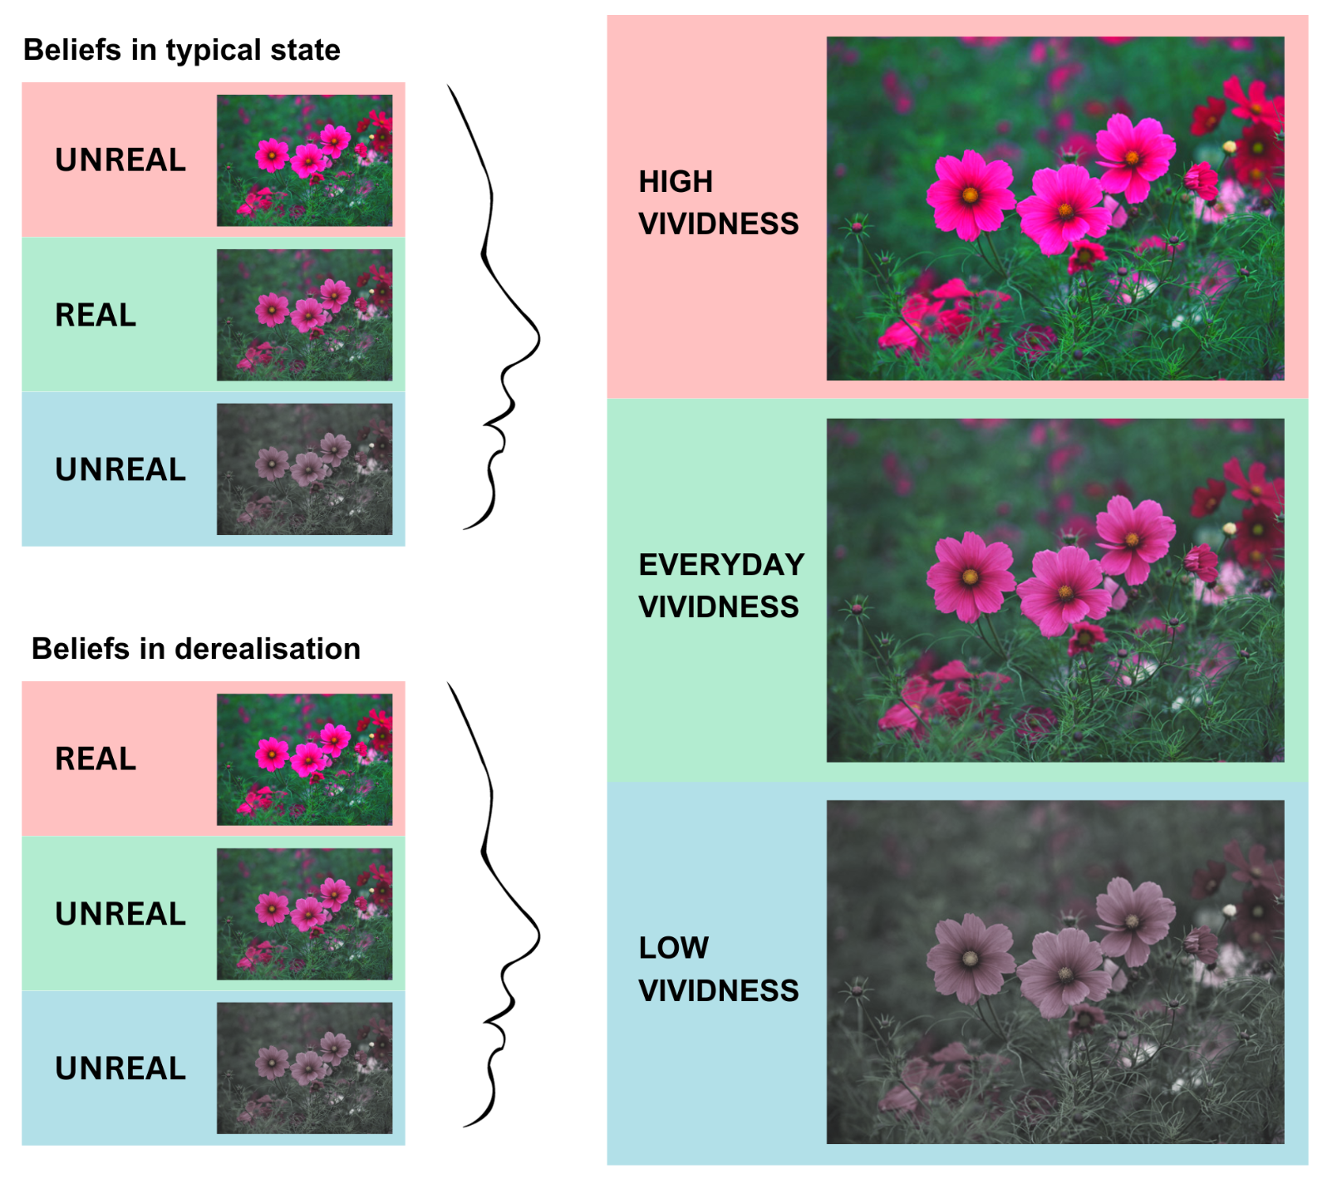

Figure 1. In derealisation, individuals report that their visual experience is distinct from what they believe their environment usually looks in terms of perceptual features like vividness. We propose that by showing images with vividness levels that exceed vividness seen in the day-to-day experiences of most people, we can test how people differ in their beliefs about realness on natural images that are manipulated over a range of luminance contrast or colour saturation. A possible scenario is that a person without derealisation would accept images with everyday vividness levels as close to reality, while a person experiencing derealisation would consider images with everyday vividness levels as falling short of reality.

In this registered report, we propose to conduct two sets of online psychophysics experiments in conjunction with self-reported assessments of DP/DR symptoms. In the first set of experiments, we will examine the impact of different image features contributing to vividness (i.e. saturation levels, contrast levels) on subjective judgments about how real an image looks compared to participants' day-to-day experiences. To do this, we have selectively modified the saturation and contrast levels of naturalistic images in both directions. Following the findings by Yokokawa et al. (2018), we expect that less vivid images (i.e. lower saturation/contrast) will be rated as less real compared to more vivid images.

Our main hypothesis (H1) is that ongoing DP/DR experiences will have an association with the realness ratings. If confirmed, we propose the following interpretations and show their visual illustrations using simulated data in Figure 2.

We may find that people with more severe ongoing DP/DR experiences will judge low and normal levels of saturation as less real compared to people with less DP/DR experiences while judging high levels of saturation as more real (Figure 2a). This finding would support the view that a perceptual shift occurs in experienced vividness in derealisation.

Alternatively, it is possible that more severe DP/DR will result in lower realness ratings for the modified images selectively but not for the original images (Figure 2b). This finding would support the notion of a possible hypersensitivity in the perceptual processing of individuals with derealisation in line with some recent proposals (Ciaunica, Seth, et al., 2022).

Finally, it is also possible severe DP/DR will lead to lower realness ratings across all manipulation levels (Figure 2c). This finding would support the view that realness judgements in derealisation are independent of apparent vividness, and they are informed by meta-cognitive processes rather than perceptual cues (e.g. Dokic & Martin, 2017).

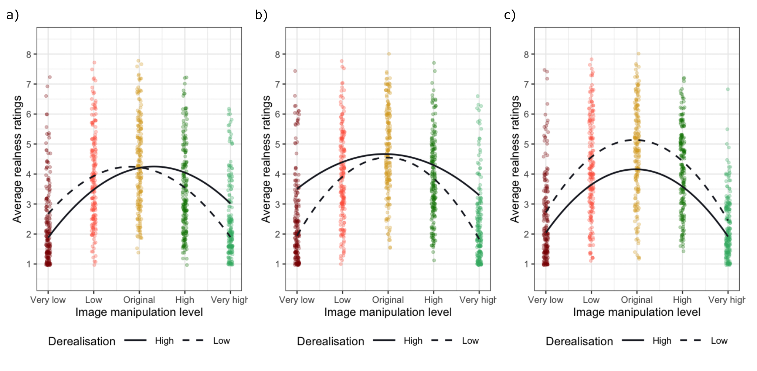
Figure 2. These figures show simulated data demonstrating examples for our proposed interpretations if H1 is supported. In order to simplify this visualisation, we opted to use a quadratic polynomial term for modelling the image manipulation level based on the pilot data we have collected and modified only a single coefficient in the regression model for each example. We have simulated data from 200 participants. The dots represent average responses across participants.

In the second set of experiments, we aim to measure how consistently people can reproduce images that fit their day-to-day experiences with regards to saturation and contrast levels. Rivera-Aparicio and colleagues recently demonstrated that people consistently overestimate the clarity and colourfulness of previously seen images of natural scenes (Rivera-Aparicio et al., 2021). They have coined the term “vividness extension” to describe this phenomenon.
Adapting their experiment, we hypothesise that DP/DR experiences will influence the levels of vividness (i.e. saturation and contrast) people use in the reproduced images (H2). We again describe our proposed interpretations below and present the corresponding visual illustrations in Figure 3.
If DP/DR experiences show an association with the vividness of the reproduced images, we may find people with more severe DP/DR produce more vivid images when asked to match their day-to-day experiences (Figure 3a). This could happen because individuals experiencing derealisation may overestimate how vivid their experiences usually are.
Alternatively, severe DP/DR experiences may lead to producing less vivid images (Figure 3b). This could indicate individuals experiencing derealisation may be inclined to recreate their day-to-day experience with images matching the subjective reports of decreased vividness.

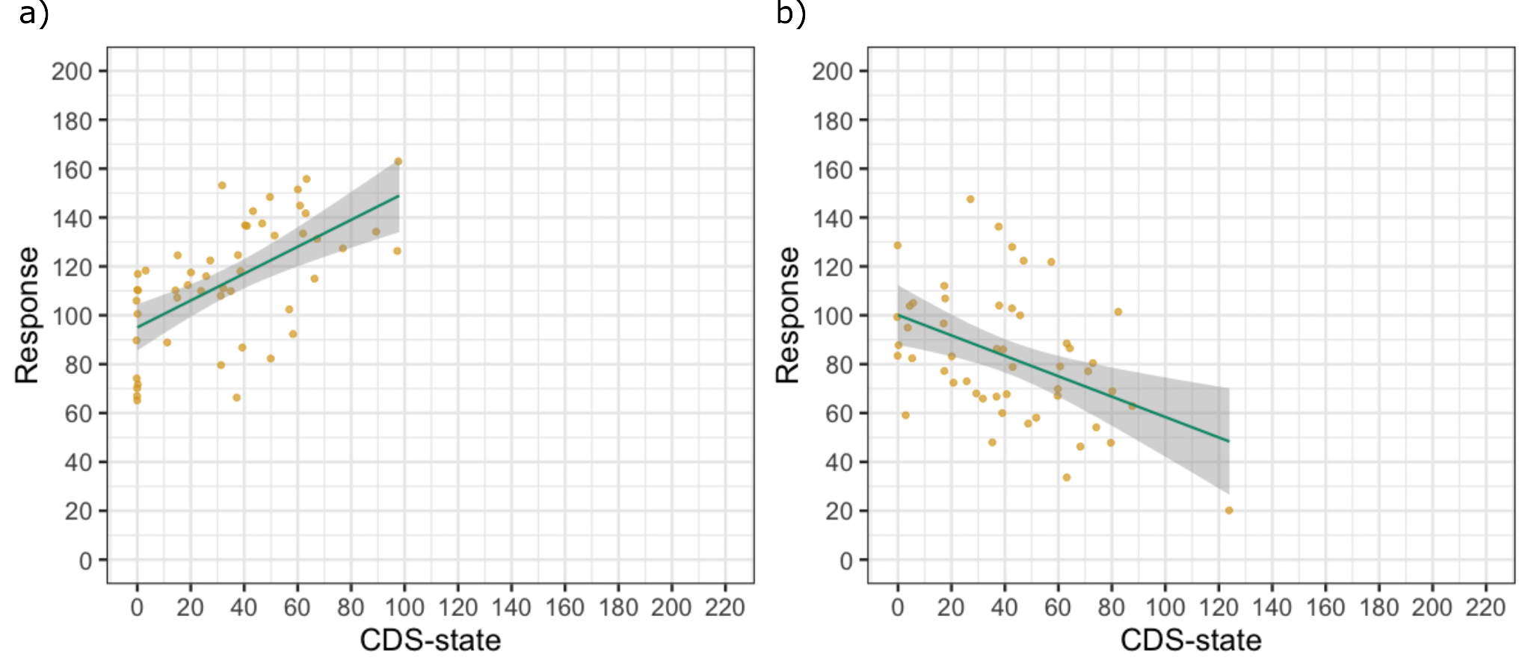
Figure 3. We have again simulated two example datasets demonstrating the proposed interpretations if H2 is supported. The dots represent average responses of 50 simulated participants.

With these experiments, we aim to shed light on the relationship between the vividness of perceptual experiences and an altered sense of realness in derealisation. To this end, we ask participants from a non-clinical population with varying severity of DPDR experiences to evaluate for each presented image, with its particular level of vividness, if it corresponds to “what the world usually looks like”, that is, their beliefs about realness. This means we aim to gauge participants’ mapping between vividness and realness. Notably, this is not meant to reveal changes in vividness perception per se; doing so would in effect be succumbing to the El Greco fallacy, which arises when asking participants to report perceptual attributes of a target stimulus using a reporting tool that invokes the same perceptual attribute (Firestone & Scholl, 2014; see detailed discussion of this question in the supplementary materials). Instead, our goal is to test if certain image features contributing to vividness relate differently to beliefs about realness in people with unreal visual experiences. This approach allows us to provide empirical data on this much debated connection between vividness and realness.
One theoretical possibility is that all experiences in derealisation are less vivid, including one’s internal model and beliefs of what the world usually looks like. In this case, the relationship between different levels of vividness could be maintained regardless of derealisation severity. While we cannot refute this possibility, it seems unlikely. The reason for this is that people experiencing derealisation spontaneously report deviations in their visual experience from what they consider as their usual “real-like” experience, which they would not be able to do if the relationship between beliefs and visual experience was adapted in the way in question.
Thus, we find it reasonable to assume that these reports occur due to a mismatch between the current experience and the template of what the world usually looks like. Moreover, since our study targets a non-clinical population with most likely transient derealisation, we think referring to the participants’ day-to-day experience is appropriate in this instance. Yet we acknowledge that these assumptions may not generalise to all manifestations of derealisation disorder.

Methods

Materials
Realness-rating task (Experiment 1)
We plan to conduct separate experiments with two types of image manipulation: saturation levels (Experiment 1a) and contrast levels (Experiment 1b). We have created and piloted this task using PsychoPy/Js (version 2021.1.4, RRID:SCR_006571) (Peirce et al., 2019). The stimuli consists of the same 100 naturalistic images with four distinct categories of image content: images depicting flowers (25) randomly selected from the stimulus set of Yokokawa et al. (2018), images showing inside (25) and outside (25) environments without visible people present selected form the Scene UNderstanding (SUN) database (Xiao et al., 2010), and images showing people in both outdoor and indoor settings (25) selected from the stimulus set used by Chuyin et al. (2022). All stimuli are available on the project’s online repository page.

We have modified specific properties of these images using the Image Enhance module from the Pillow library (version 8.2.0, RRID:SCR_023337) via Python Programming Language (RRID:SCR_008394). For each image, we have used the unmodified version of the images as well as two versions with high levels (high and very high) and two versions with low levels (low and very low) for a certain property (i.e., saturation, contrast) as shown on Figure 4. Thus, for each experiment, we had five different versions of the 100 images (i.e., very low, low, original, high, very high).

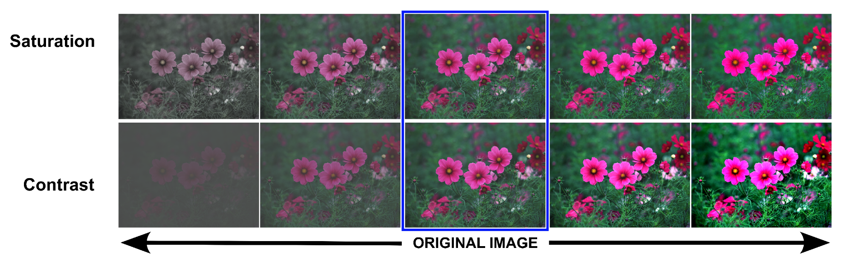
Figure 4. Examples of image manipulations for saturation and contrast levels showing the unmodified image as the original image and two progressively increasing and decreasing versions of the manipulated property.

We counterbalance the presentation of the different image manipulation versions within the experiments so that participants view 100 unique images with all manipulation levels equally represented but without seeing the same image more than once at different levels. Thus, each participant sees 20 images at each of the five manipulation levels adding up to 100 stimuli per participant.

The images are in the middle of the screen for 1 second in randomised order across participants. After each image, the participants see the response screen with an 8-point circular response scale (-4, -3, -2, -1, 1, 2, 3, 4); -4 being the most ‘Unreal’ and +4 being the most ‘Real’. The participant’s task is to evaluate how real the displayed image looks compared to what they usually tend to see in their day-to-day life. In addition, we include 10 randomised catch trials to identify inattentive responders, during which the participants see the text “Special trial” in the middle of the screen for 1 second and then are asked to choose a specific number on the response scale (see Figure 5). The experiment is hosted online on Pavlovia.org (RRID:SCR_023320).

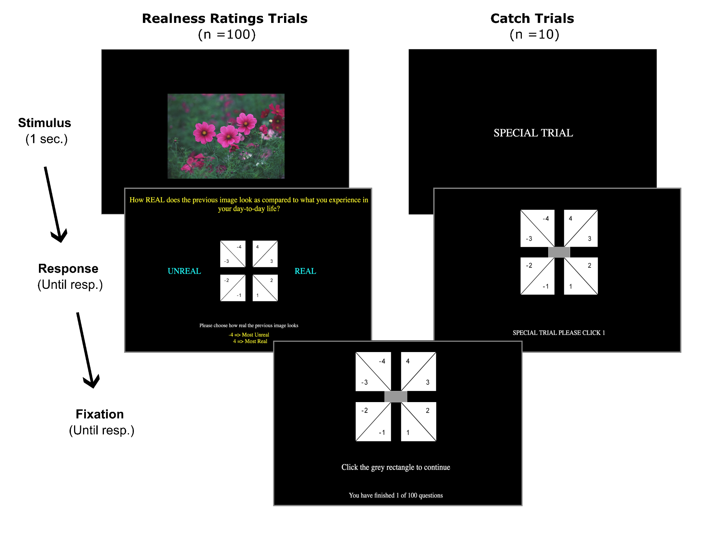
Figure 5. Illustration of Realness rating task. The realness rating trials and catch trials were presented in a pseudo-randomised order.

Image reproduction task (Experiment 2)
For the image reproduction task, we will again focus on saturation (Experiment 2a) and contrast manipulation (Experiment 2b). The experiments have also been already piloted. We have created the task using jsPsych (version 7.2) (de Leeuw, 2015). The task includes 40 different images presented twice. We have selected a subset of the images from Experiment 1 with ten items from all four image content categories (i.e. 10 flowers, 10 inside environments, 10 outside environments, 10 images with people).

The images appear in the middle of the screen with a slider below them. We ask the participant to adjust the images using the slider until it looks like their day-to-day experience (Figure 6). The images are manipulated based on the slider position converted into a percentage. This means when the slider is placed at the position corresponding to 100, then the image appears at 100% saturation/contrast level (i.e., the original image). Accordingly, when the slider is in the position corresponding to 25, then the image appears with 25% of the original saturation/contrast level. We have systematically varied the minimal and maximal positions of the slider. The widest possible range covered is between 10% and 190% of the original saturation/contrast level.

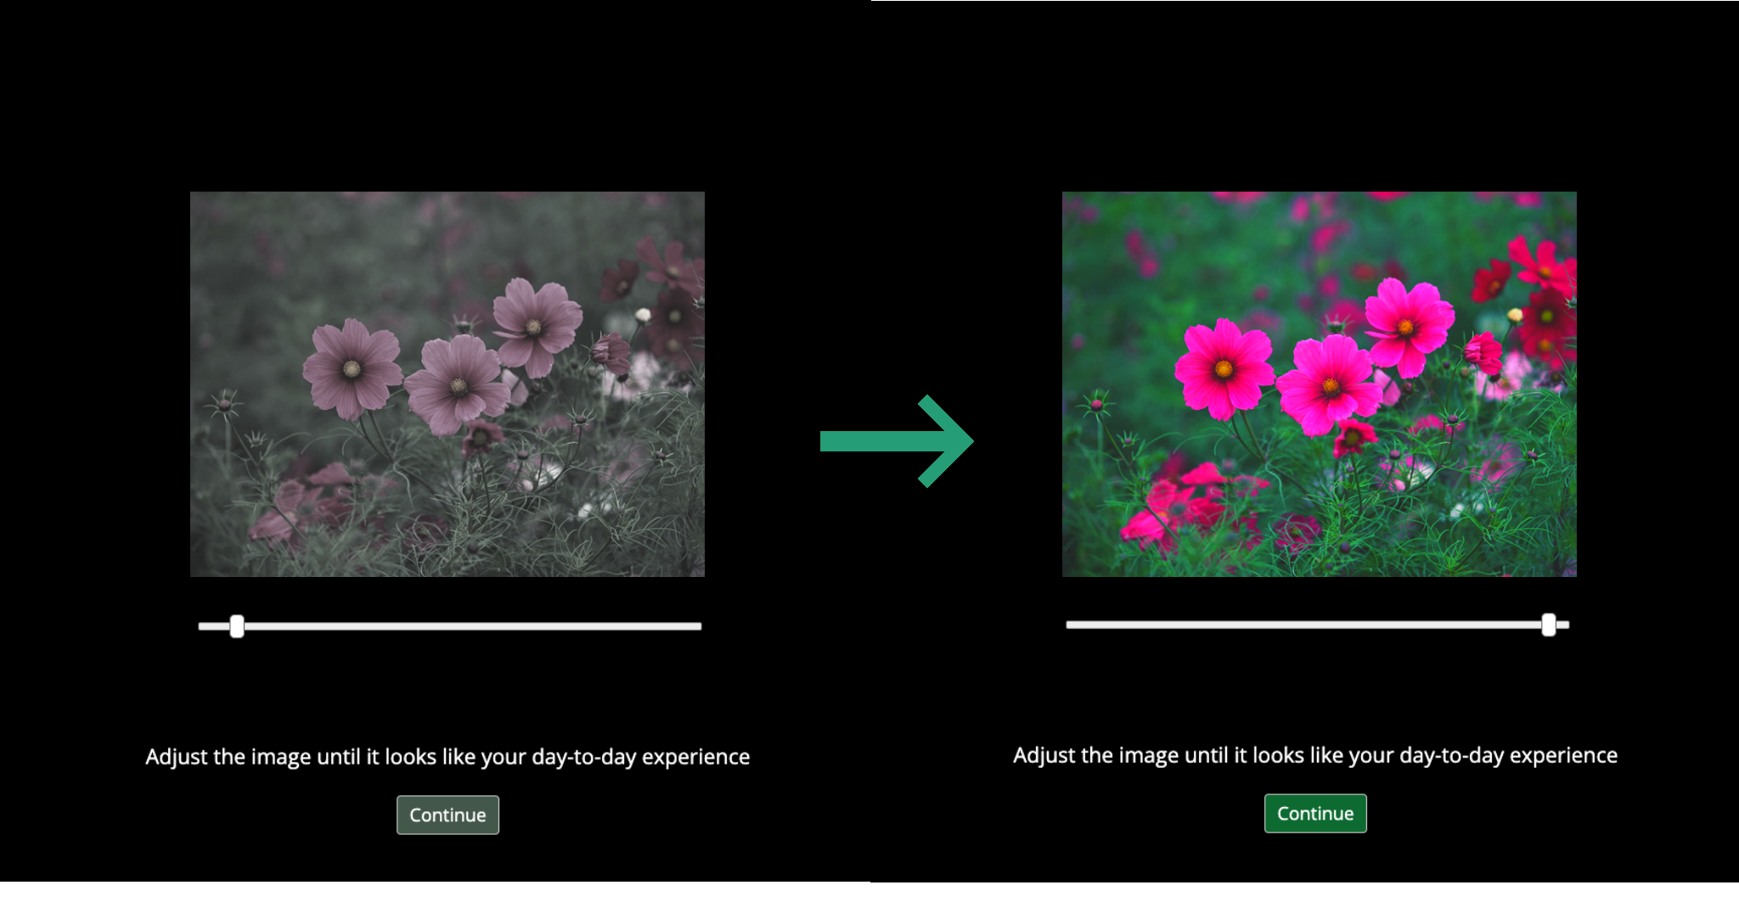
Figure 6. Illustration of the image reproduction task in the saturation condition. Participants adjust the slider below the image and thus set the saturation level of the image. This example shows the same image with extremely low (~20%) on the left side and high (~180%) saturation settings on the right side.

Once the participants are satisfied with the contrast or saturation level of the image, they are asked to click on the “Continue” button at the bottom of the screen.
For each trial, we record the number of adjustments, response times and the final slider positions. To minimise response biases, we pseudo-randomised the slider starting position between 50%, 100% and 150% as well as the direction of increasing slider values. The stimuli are presented in a randomised order first and then a second time in the same order to assess the consistency across responses within participants (e.g., Figure S1). The experiment is hosted on MindProbe.eu using JATOS (version 3.7.x) (Lange et al., 2015).

Cambridge Depersonalisation Scale (CDS)
After the experimental task, we ask the participants to complete questionnaires on DP/DR experiences. We will use the Cambridge Depersonalisation Scale, which is a self-rated questionnaire measuring the frequency and duration of various depersonalisation and derealisation symptoms during the preceding six months (Sierra & Berrios, 2000). Later studies used this scale to assess trait DP/DR, thus we are referring to the Cambridge Depersonalisation Scale as CDS-trait (Hunter et al., 2005). The scale includes 29 items. Each item lists seven options for the duration (0: Not Applicable, 1: Few seconds, 2: Few minutes, 3: Few hours, 4: About a day, 5: More than a day, 6: More than a week) and five options for frequency (0: Never, 1: Rarely, 2: Often, 3: Very Often, 4: All the Time) of the DP/DR episode. Based on the option selected, the scores are summed out of 10 for each item. The total CDS-trait scores range from 0 to 290. In addition, we have included one catch question with special instructions to check if the respondent was reading the items carefully.

The participants will also complete the state version of CDS. The CDS-state aims to assess the severity of DP/DR symptoms the participants are experiencing at the moment while filling out the questionnaire (Medford et al., 2003). It consists of 22 items, which are evaluated on a visual analogue scale based on the intensity of the experience. For our study, we opted to implement a circular response scale ranging from 0% to 100% in steps of ten. The total CDS-state scores range from 0 to 220. After the CDS scales, we also collect the demographic data and details of any psychiatric diagnosis. We will use Qualtrics (Provo, UT, https://www.qualtrics.com) to distribute the questionnaires to the participants.

It is possible that the CDS-state measure might be affected by the preceding task administration, and thus it might misrepresent the population distribution of the CDS-state. However, performing the CDS prior to the task is likely to influence the task outcomes. To better understand this order effect, we will take the following approach. First, we will run the experiments starting with the task and then completing CDS-state until we reach our decision criteria. If we find supporting evidence for H1 in any condition, then we complete a second round of experiment in that condition using the same sample size as in the first round. But this time recording CDS-state before the task. This would allow us to check if there is an increase in DP/DR symptoms during the completion of the task.

Procedure

We will recruit participants with Prolific (www.prolific.co). Eligibility criteria includes being fluent in English and using desktop devices to do the experiment. Before beginning the experimental task, participants are given an explanatory statement and the consent form. The experiment only proceeded when the participants gave their informed consent by pressing a key. Then, we instruct them to 1) make their environment as dark as possible by switching off the lights and/or closing their curtains, 2) adjust the screen brightness to maximum, and 3) turn off any colour adjustment on the screen, such as NightMode, NightShift or F.lux. After that, the participants will complete one practice trial and then proceed to the experiment. For Experiment 1 (the realness-rating task), the participant will receive compensation of £5.63 for their time (45 minutes). For Experiment 2 (the image reproduction task), the compensation will be £4.50 for 30 minutes. The project was approved by the Monash University Human Resource Ethics Committee under ID 17674.

Statistical Analysis

For all data processing and statistical analysis, we use R version 4.2.0 or higher (R Project for Statistical Computing, RRID:SCR_001905).

Pilot data
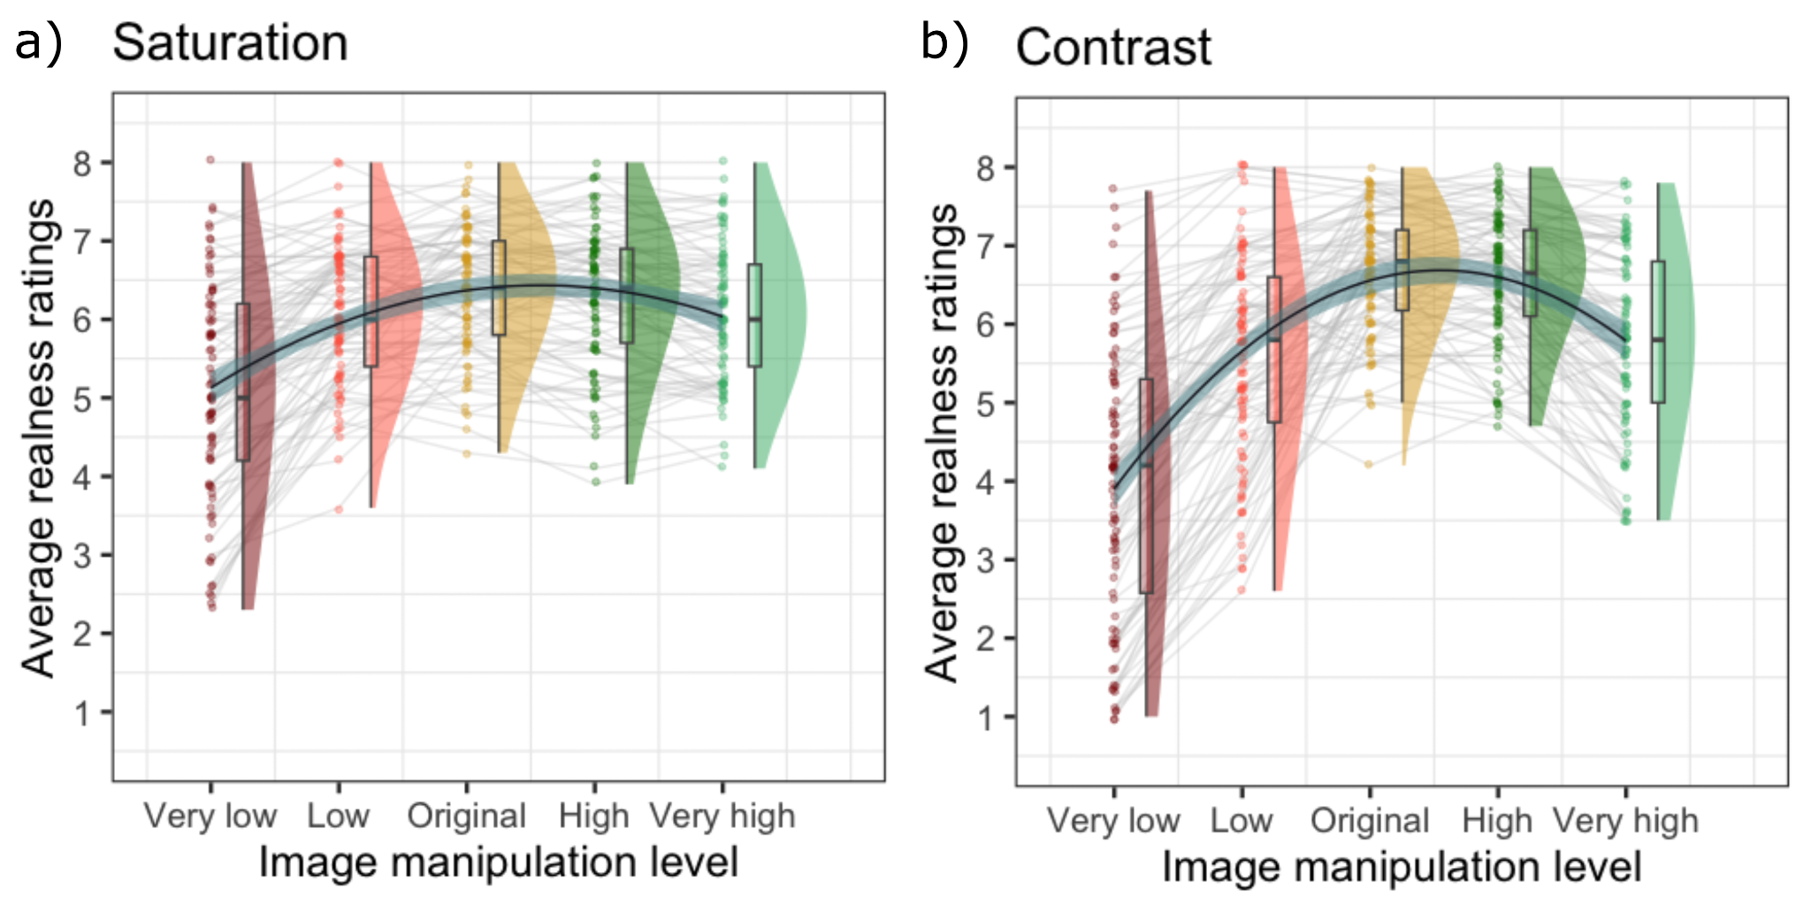
To demonstrate the feasibility of this research project, we have completed separate pilot experiments that included both the saturation and contrast conditions for the realness-rating task and the image reproduction task. The pilot experiments for the realness-rating task only included the CDS questionnaire for the trait, while the pilots of the image reproduction task included CDS questionnaire for both state and trait. For the realness-rating task, we recruited 100 participants for each pilot experiment and excluded any participants who failed to answer correctly to the catch question in the CDS-trait scale (4 exclusions in the saturation condition and 7 exclusions in the contrast condition). In addition, we excluded participants who responded incorrectly to more than 1 out of 10 catch trials in the task (i.e. 90% catch trial accuracy; additional 15 exclusions in the saturation condition and 5 exclusions in the contrast condition). Thus, the final participant number in the realness-rating pilots was N=81 in the saturation condition (Figure 7a) and N=88 in the contrast condition (Figure 7b). We plan to use the same exclusion criteria in the stage 2 analyses. We will report the results of the analyses using data with 100% catch-trial accuracy in the supplementary materials as a check of robustness.
Figure 7. Pilot data from the realness-rating task. The dots represent the average realness rating per participant in each image manipulation level.

In the pilot experiments of the image reproduction task, we recruited 20 participants for each experiment. Here we excluded any participants who failed the catch question in the CDS-trait scale or did not fully finish the inventories. After this, the participant number was N=17 for the saturation condition and N=19 for the contrast condition (Figure 8). We have also assessed the correlation between the responses to the first and second presentation of the same image (i.e. double pass correlation). We calculated the participant’s double pass correlation coefficient using Pearson correlation and applied Fisher transformation on them. We opted to exclude any participant, whose transformed coefficient was 2 standard deviations below the median of the sample (see Figure S1 in the supplementary materials). This criteria led to two additional exclusions in the pilot sample of contrast condition and no further exclusions in the saturation sample.

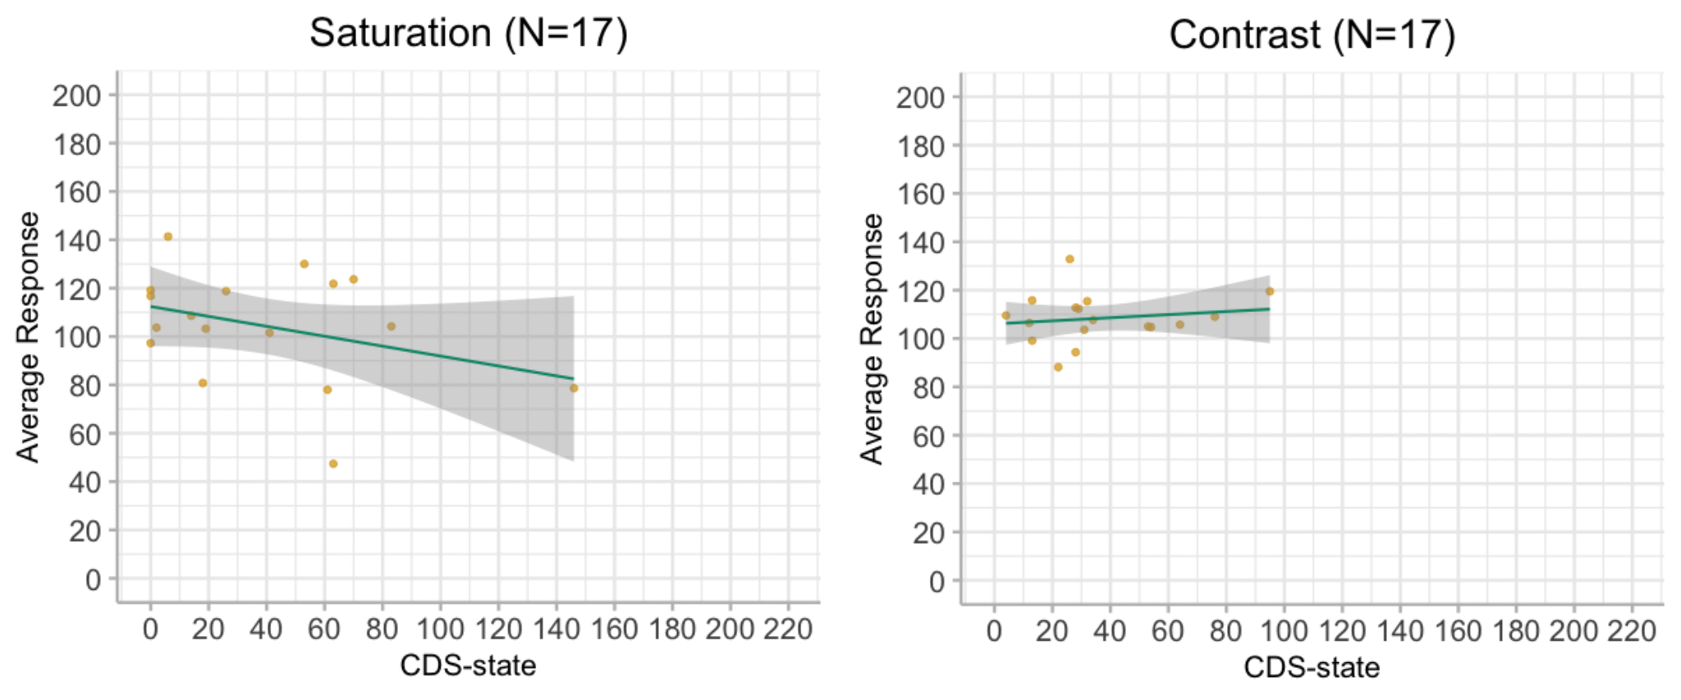
Figure 8. Pilot data from the image reproduction task. The dots represent the average response per participant.

Analysis plan
We will analyse the data using Bayesian mixed-effects modelling with the brms package (Bürkner, 2017). We will set up two models for each experiment, a full model, which includes our derealisation measure and a reduced model, which does not. We will compare the reduced and full models using Bayes Factors (BF) to assess which model is better supported by the data. In line with the recommendation of Schad et al., (2022), first, we describe our models below. Then we will describe the priors which we have selected using our pilot data and prior predictive checks. We opt to do sequential data collection (see details in the sample size estimation section) with an upper limit of 500 participants per experiment and the decision criteria of BF10 or BF1/10. Once we reach either our upper limit of participants or the decision criteria are met, we will stop the data collection. At this stage, we will complete simulation-based calibration for each experiment to test the consistency of the calculated BF for the specific dataset and report the results of the simulations together with our findings (Schad et al., 2022).

Model description
In the case of the realness-rating task, the outcome variable is the realness-ratings transformed to be in the range between 1 to 8, and we will model it as an ordered categorical variable using the cumulative link function. The random effects include random intercepts for stimuli and participants as well as random slopes for the manipulation level for both stimuli and participants. When it comes to the fixed effects, we will model the manipulation levels with a polynomial term. This is because the pilot data shows that the lowest and highest levels of image manipulation tend to result in lower realness ratings compared to the original image. We have used the pilot data to implement a forward selection approach in order to identify what degree of polynomial term provides the largest improvement on the model (see details in Figure S2 in the supplementary materials). Based on this, we will use a quadratic polynomial term for the manipulation level in both saturation and contrast models, and we will also include the quadratic term in the random effect structure. These model parameters will be used in the reduced model. For the full model, we will extend the reduced models with the inclusion of CDS-state scores as the fixed effect and adding an interaction term with the manipulation level. In the case of the image reproduction experiment, the outcome variable is the response of the participant, which was obtained from the final slider position and thus, we treat it as a continuous variable. Here, the reduced model includes the random intercepts (stimuli and participants) only, and the full model includes CDS-state scores. In addition, we plan to complete exploratory analyses by including additional fixed effects, specifically CDS-trait scores and image content categories. However, we will not elaborate on these analyses here as they are not preregistered.

Priors
We opted to use regularising priors, which down-weight unlikely values (Vasishth et al., 2022). We have also completed prior predictive checks on the outcome variables informed by the pilot data. For the realness-rating task, we will use the default student-t prior (3, 0, 2.5) for the intercept. For the fixed effect, we use Normal(0,1) prior. For all random effects variance components and the residual standard deviation, we will use exponential (1) priors. For the correlation matrices in the random effects, we use LKJ(2) priors. In the image reproduction paradigm models, we use Normal(100,30) for the intercept, Normal(0,1) prior for the fixed effects and exponential (0.01) priors for random effects variance components and the residual standard deviation.

Sample size estimation

For all four experiments, we will follow a sequential design with an upper bound of 500 participants based on financial limitations. (Schönbrodt & Wagenmakers, 2018).

For the realness-rating task, we will start with 100 participants due to the complexity of the random effect structure of our proposed models. We will increase the sample size by 100 participants sequentially until we reach the Bayes Factor of 10 in favour of either the null model or the full model, or we reach our upper bound of 500 participants. In the case of the image reproduction experiment, we will start with 50 participants as the initial sample and then increase the sample size by 50 participants sequentially until we reach the Bayes Factor of 10 in favour of either the null model or the full model, or we reach our upper bound. We decided on the starting sample size and the steps-size of the increase based on practical considerations for online experiments, including time and cost efficiency.

To test if the range of the proposed sample size would be appropriate to measure the impact of CDS, we have simulated the sequential data collection process. In the case of the realness rating task, we have used slope coefficients of image manipulation level and random effect structure of the pilot data from the saturation condition in the simulations. For the image reproduction task, we have sampled the previously described priors to simulate the random effect structure (following the principles described by Vasishth et al., 2022). For the CDS-state scores, we have used the mean and standard variation parameters of an unpublished dataset, which we have collected for a different research project, including 93 participants.

In the realness rating task, we chose 0.3 as the smallest regression coefficient of interest with the upper limit of 300 participants in order to reduce the required computation time. In case of the image reproduction task, we chose 0.1 as the smallest regression coefficient of interest. We have also limited the upper limit of the participant number to 250.

So we simulated 100 artificial datasets with the maximum number of participants and simulated the outcome variable using the regression coefficient of the CDS-state, which was set at the value of 0.3 for the realness rating task and 0.1 for the image reproduction task. Then we fitted the reduced and full model with the above-described priors on each dataset sequentially starting with a subset of the simulated participants’ data, and compared the models using Bayes Factor. If the decision criteria of 10 or 1/10 BF were met, then we moved to the next dataset. If the criteria were not met with the first subset of participants, then we added the next subset participants’ data according to the predetermined step-size and completed the model fitting and comparison again and so on until reaching the upper limit of the simulations. Thus, we have effectively simulated 100 rounds of data collection. We have also completed the same steps for simulating null effects via setting the coefficient of CDS-state to zero. The results of the simulated data collections for the realness rating task are shown on Figure 9 and for the image reproduction paradigm in Figure 10.
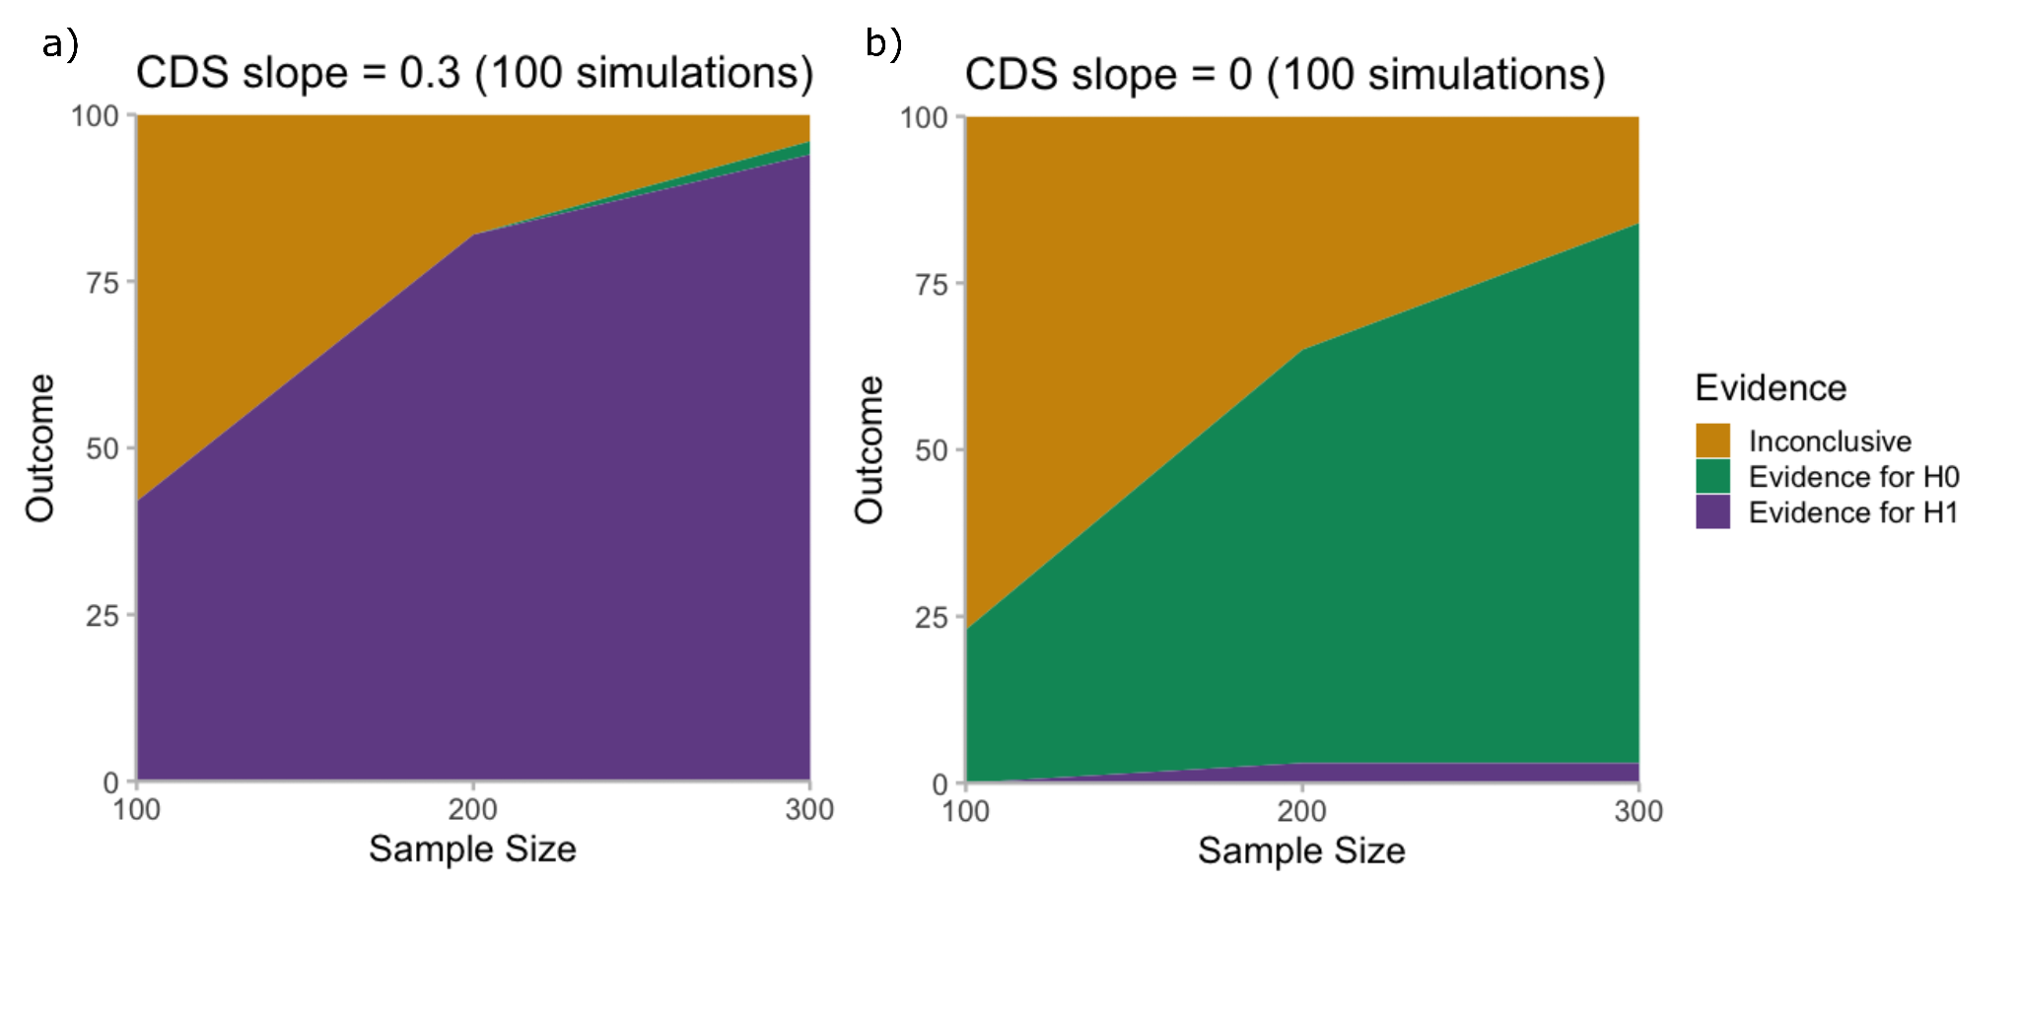
Figure 9. The outcome of 100 simulated runs of data collection for Experiment 1 ( realness rating task) using the decision criteria of 10 or 1/10 BF and stopping at 300 participants. The full model in the simulations did not include an interaction term.

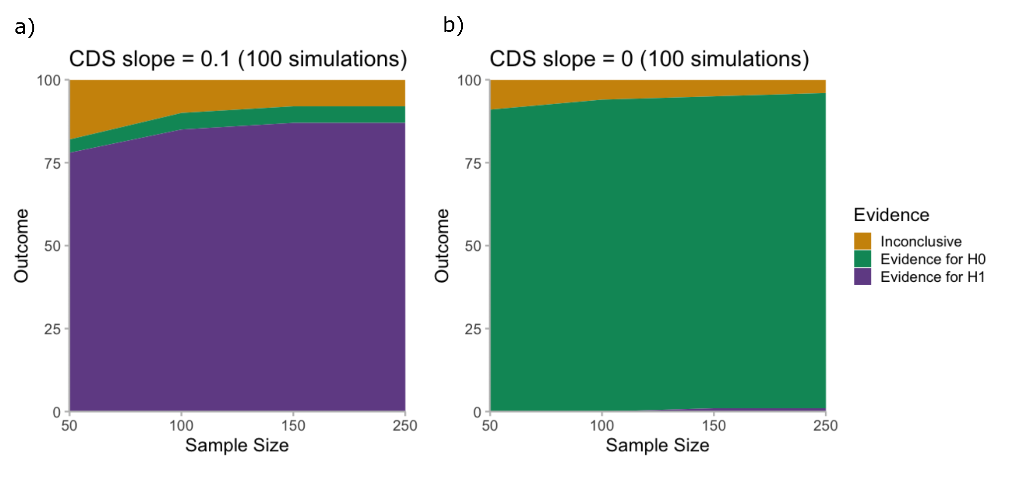
Figure 10. The outcome of 100 simulated runs of data collection for Experiment 2 ( Image reproduction task) using the decision criteria of 10 or 1/10 BF and stopping at 250 participants.

Table 1. Study Design Template
Question | Hypothesis | Sampling plan | Analysis Plan | Rationale for deciding the sensitivity of the test for confirming or disconfirming the hypothesis | Interpretation given different outcomes | Theory that could be shown wrong by the outcomes
Experiment 1  Does the relationship between realness judgements and vividness change when people experience DPDR?  Image manipulation conditions:  - saturation  - contrast | (H1) Current DP/DR experiences influence realness  ratings. | Sequential sampling (with an upper limit of 500 ppts.) until decision criterion is reached (Bayes Factor of 10 supporting H1 or 1/10 supporting H0) | Mixed model comparison via Bayes Factor estimation (based on bridge sampling).  The full models (i.e. H1) include CDS-state while the null models (i.e. H0) do not. | We chose Bayes Factor of 10 as our decision criterion because we have sufficient financial resources to collect up to 500 participants for each experiment.  In the data collection simulations we used a standardised beta coefficient of 0.3 for the fixed effect of CDS-state (without interaction term) in Experiment 1 and 0.1 for the fixed effect of CDS-state in Experiment 2 as the smallest effect size of interest. We chose these effect sizes based on our subjective judgement on what we consider as an interesting effect in these experiments. | H1: Experiencing derealisation changes the association between apparent vividness and realness  H0:  Experiencing derealisation does not affect the association between apparent vividness and realness. | Unreal visual experiences in derealisation are independent of visual cues such as changes in apparent vividness.
Experiment 2  Do people experiencing DPDR differ in the vividness of their day-to-day (‘real’) experience?  Image manipulation conditions:  - saturation  - contrast | (H1) Current DP/DR experiences influence what level of vividness people select to reproduce their day-to-day visual experience. |  |  |  | H1: Experiencing derealisation changes what level of vividness people consider as matching to their usual experiences.  H0: Experiencing derealisation does not affect what level of vividness people consider as matching to their usual experiences.

Data and code availability:
All materials and codes are accessible from https://osf.io/fzsa9/?view_only=51b9a4fac53e46f2ada61b5cd78a0a94.
Competing interests: No competing interests were disclosed.

Supplementary Materials
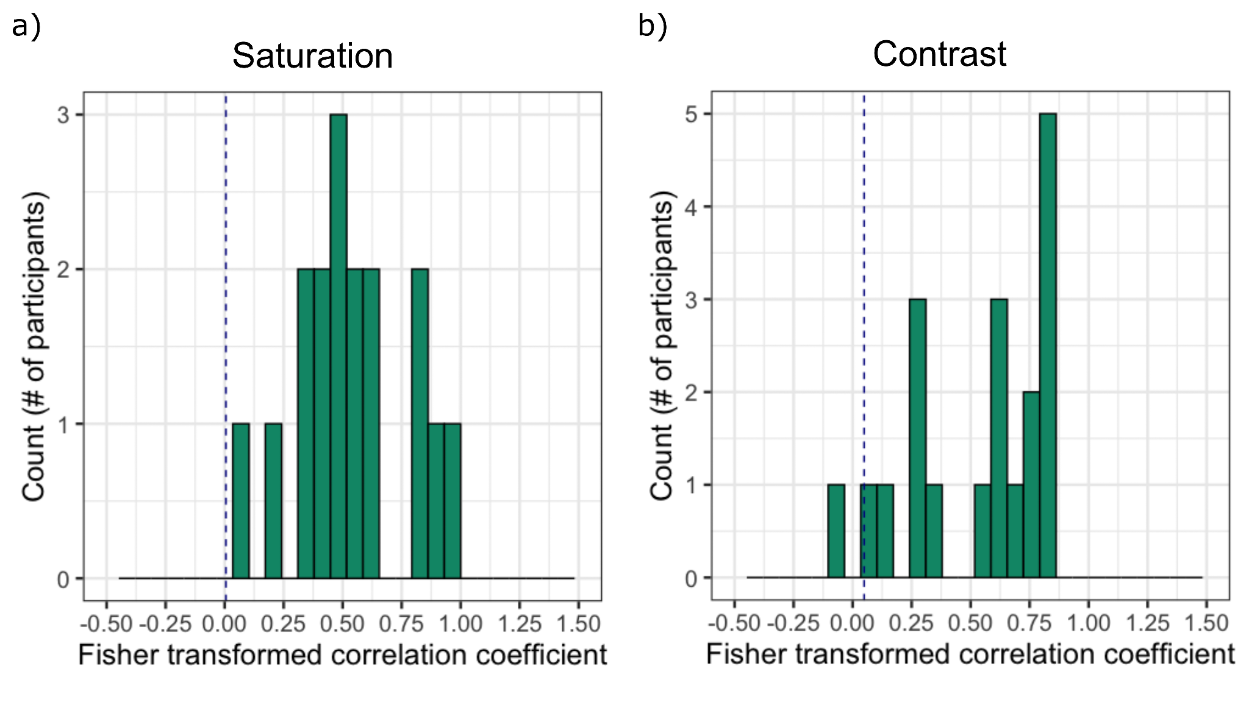

Figure S1. Fisher transformed double-pass Pearson correlation coefficients between the first and second presentation of the stimuli in the image reproduction task in the saturation (a) and contrast (b) pilot experiments before exclusion. The blue dashed line indicates 2 standard deviations below the median Fisher transformed coefficient in the pilot samples. These criteria resulted in two exclusions in the contrast conditions and no exclusions in the saturation condition.

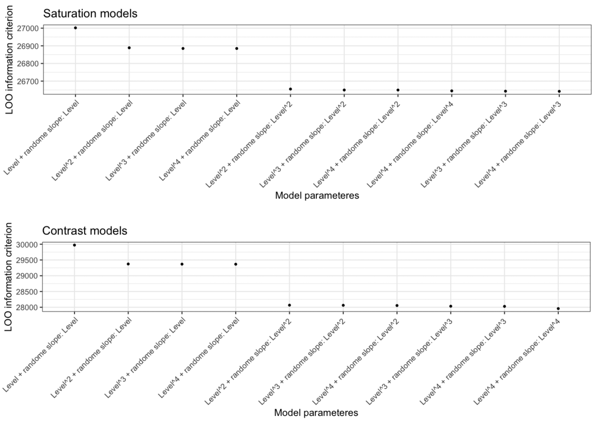

Figure S2. Model comparison using Leave-one-out cross-validation (LOO-CV) information criterion. We compared the reduced model with increasing degrees of the polynomial term on the fixed effect of the manipulation level variable as well as on the random slope of the manipulation level for both stimuli and participants.

S3.
Considerations on the El Greco Fallacy

Here we present an extended discussion of the El Greco Fallacy and argue for its limited relevance in the context of this research project.

Since our study aims to make inferences about difference between two populations (i.e., people experiencing derealisation versus people who do not) by manipulating a perceptual feature (i.e., vividness), the reasoning error known as the El Greco Fallacy (Firestone and Scholl, 2014) may raise some questions to address. In short, the core idea of the El Greco Fallacy is the following: If two groups are asked to report perceptual features of a target stimulus using a reporting tool displaying the same perceptual feature, then any difference found between these groups cannot be due to perceptual mechanisms. This is because the impact of a perceptual distortion must be cancelled out by the reporting tool, which is also affected by the same perceptual distortion. The fallacy occurs when a difference under these circumstances is attributed to perceptual mechanisms given the assumptions a) the perceptual mechanisms between the two groups are the same and b) the perceptual distortion is a constant-error distortion.

For example, if we were to ask people to report how vivid their current environment is via selecting the corresponding image from a set of images with different levels of vividness, then a perceptual shift in vividness would affect both the current environment as well as the images. Therefore, we could not detect the perceptual distortion even if it was present given assumptions a) and b) hold true. At the same time, if we saw a difference between two populations in selected vividness levels, it would be fallacious to conclude that there was a perceptual difference. Instead, the difference would be explained by non-perceptual mechanisms e.g., metacognitive differences, response bias and/or demand characteristics.

As described above, the direct application of the El Greco Fallacy strictly has limited relevance to our experiments because we do not ask participants to reproduce the vividness of their current environment.

In Experiment 1 we ask each participant to rate 100 different images, which we have manipulated to reach unnaturally high or low levels of vividness based on what they believe about their day-to-day experience and assess how real the stimuli look compared to this internal model of their day-to-day experience. So we intend to invoke an evaluation of matchings between manipulated images and a template of what the world usually looks like.

In Experiment 2, we ask participants themselves to manipulate the images with the possibility for selecting unnaturally high or low levels of vividness. We use the following instruction: “Adjust the image until it looks like your day-to-day experience”. Here again we intend to invoke a comparison between the image and the template of what the world usually looks like, but this comparison is done over and over again until the image is as close to matching the template as possible.

In both of our experiments, we use a selection of naturalistic images that are novel to the participants and that were produced under diverse lighting conditions, with different perspectives and composition.

Thus, our study does not aim to test vividness perception per se but the altered relationship between vividness and realness in derealisation. In other words, we consider vividness perception to be the characterization of F in Z = F(X), where X is the image features (such as saturation or contrast) and Z is vividness experience. We aim to describe G in Y = G(Z), where Y is realness experience and Z is vividness experience. Crucially, we do not claim to characterise Z so we will not make inferences about the vividness experience in derealisation based on our experiments. Instead, we presume that realness experience (i.e., Y) is different in derealisation since that is how individuals describe this state. Then, we hypothesise that the relationship between realness and vividness (i.e., G) differs between people with and without derealisation experiences. To test this hypothesis, we seek to manipulate vividness experience (Z) using our stimuli with varying image features.

References

American Psychiatric Association. (2013). Diagnostic and Statistical Manual of Mental Disorders (Fifth Edition). American Psychiatric Association. https://doi.org/10.1176/appi.books.9780890425596
Baker, D., Hunter, E., Lawrence, E., Medford, N., Patel, M., Senior, C., Sierra, M., Lambert, M. V., Phillips, M. L., & David, A. S. (2003). Depersonalisation disorder: Clinical features of 204 cases. The British Journal of Psychiatry, 182(5), 428–433. https://doi.org/10.1192/bjp.182.5.428
Bürkner, P.-C. (2017). brms: An R Package for Bayesian Multilevel Models Using Stan. Journal of Statistical Software, 80, 1–28. https://doi.org/10.18637/jss.v080.i01
Castillo, R. J. (1990). Depersonalization and Meditation. Psychiatry, 53(2), 158–168. https://doi.org/10.1080/00332747.1990.11024497
Chuyin, Z., Koh, Z. H., Gallagher, R., Nishimoto, S., & Tsuchiya, N. (2022). What can we experience and report on a rapidly presented image? Intersubjective measures of specificity of freely reported contents of consciousness. F1000Research, 11, 69. https://doi.org/10.12688/f1000research.75364.2
Ciaunica, A., Pienkos, E., Nakul, E., Madeira, L., & Farmer, H. (2022). Exploration of self- and world-experiences in depersonalization traits. Philosophical Psychology, 0(0), 1–33. https://doi.org/10.1080/09515089.2022.2056009
Ciaunica, A., Seth, A., Limanowski, J., Hesp, C., & Friston, K. J. (2022). I overthink—Therefore I am not: An active inference account of altered sense of self and agency in depersonalisation disorder. Consciousness and Cognition, 101, 103320. https://doi.org/10.1016/j.concog.2022.103320
Dance, C. J., Ipser, A., & Simner, J. (2022). The prevalence of aphantasia (imagery weakness) in the general population. Consciousness and Cognition, 97, 103243. https://doi.org/10.1016/j.concog.2021.103243
Dawes, A. J., Keogh, R., Andrillon, T., & Pearson, J. (2020). A cognitive profile of multi-sensory imagery, memory and dreaming in aphantasia. Scientific Reports, 10(1), Article 1. https://doi.org/10.1038/s41598-020-65705-7
de Leeuw, J. R. (2015). jsPsych: A JavaScript library for creating behavioral experiments in a Web browser. Behavior Research Methods, 47(1), 1–12. https://doi.org/10.3758/s13428-014-0458-y
Deroy, O., & Rappe, S. (2022). The clear and not so clear signatures of perceptual reality in the Bayesian brain. Consciousness and Cognition, 103, 103379. https://doi.org/10.1016/j.concog.2022.103379
Dewe, H., Watson, D. G., Kessler, K., & Braithwaite, J. J. (2018). The depersonalized brain: New evidence supporting a distinction between depersonalization and derealization from discrete patterns of autonomic suppression observed in a non-clinical sample. Consciousness and Cognition, 63, 29–46. https://doi.org/10.1016/j.concog.2018.06.008
Dokic, J., & Martin, J.-R. (2017). Felt Reality and the Opacity of Perception. Topoi, 36(2), 299–309. https://doi.org/10.1007/s11245-015-9327-2
Dutt, A., & Grover, S. (2009). Primary Derealization Syndrome. Journal of Mental Health & Human Behavior, 14(2), 100–104.
Fazekas, P., Nemeth, G., & Overgaard, M. (2020). Perceptual Representations and the Vividness of Stimulus-Triggered and Stimulus-Independent Experiences. Perspectives on Psychological Science, 15(5), 1200–1213. https://doi.org/10.1177/1745691620924039
Firestone, C., & Scholl, B. J. (2014). “Top-Down” Effects Where None Should Be Found: The El Greco Fallacy in Perception Research. Psychological Science, 25(1), 38–46. https://doi.org/10.1177/0956797613485092
Gładziejewski, P. (2022). The rational role of the perceptual sense of reality. Mind & Language, 1–20. https://doi.org/10.1111/mila.12445
Hunter, E. C. M., Baker, D., Phillips, M. L., Sierra, M., & David, A. S. (2005). Cognitive-behaviour therapy for depersonalisation disorder: An open study. Behaviour Research and Therapy, 43(9), 1121–1130. https://doi.org/10.1016/j.brat.2004.08.003
Hunter, E. C. M., Charlton, J., & David, A. S. (2017). Depersonalisation and derealisation: Assessment and management. BMJ, 356, j745. https://doi.org/10.1136/bmj.j745
Hunter, E. C. M., Phillips, M. L., Chalder, T., Sierra, M., & David, A. S. (2003). Depersonalisation disorder: A cognitive–behavioural conceptualisation. Behaviour Research and Therapy, 41(12), 1451–1467. https://doi.org/10.1016/S0005-7967(03)00066-4
Hunter, E. C. M., Sierra, M., & David, A. S. (2004). The epidemiology of depersonalisation and derealisation. A systematic review. Social Psychiatry and Psychiatric Epidemiology, 39(1), 9–18. https://doi.org/10.1007/s00127-004-0701-4
Lange, K., Kühn, S., & Filevich, E. (2015). "Just Another Tool for Online Studies” (JATOS): An Easy Solution for Setup and Management of Web Servers Supporting Online Studies. PLOS ONE, 10(6), e0130834. https://doi.org/10.1371/journal.pone.0130834
Lipsanen, T., Lauerma, H., Peltola, P., & Kallio, S. (1999). Visual distortions and dissociation. The Journal of Nervous and Mental Disease, 187(2), 109–112. https://doi.org/10.1097/00005053-199902000-00007
Mathew, R. J., Wilson, W. H., Chiu, N. Y., Turkington, T. G., Degrado, T. R., & Coleman, R. E. (1999). Regional cerebral blood flow and depersonalization after tetrahydrocannabinol administration. Acta Psychiatrica Scandinavica, 100(1), 67–75. https://doi.org/10.1111/j.1600-0447.1999.tb10916.x
Medford, N. (2012). Emotion and the Unreal Self: Depersonalization Disorder and De-Affectualization. Emotion Review, 4(2), 139–144. https://doi.org/10.1177/1754073911430135
Medford, N., Baker, D., Hunter, E., Sierra, M., Lawrence, E., Phillips, M. L., & David, A. S. (2003). Chronic depersonalization following illicit drug use: A controlled analysis of 40 cases. Addiction, 98(12), 1731–1736. https://doi.org/10.1111/j.1360-0443.2003.00548.x
Minden Ribeiro, M. (2022). Is Presence Perceptual? Phenomenology and Mind, 22, 160. https://doi.org/ 10.17454/pam-2213
Niciu, M. J., Shovestul, B. J., Jaso, B. A., Farmer, C., Luckenbaugh, D. A., Brutsche, N. E., Park, L. T., Ballard, E. D., & Zarate, C. A. (2018). Features of dissociation differentially predict antidepressant response to ketamine in treatment-resistant depression. Journal of Affective Disorders, 232, 310–315. https://doi.org/10.1016/j.jad.2018.02.049
Peirce, J., Gray, J. R., Simpson, S., MacAskill, M., Höchenberger, R., Sogo, H., Kastman, E., & Lindeløv, J. K. (2019). PsychoPy2: Experiments in behavior made easy. Behavior Research Methods, 51(1), 195–203. https://doi.org/10.3758/s13428-018-01193-y
Pienkos, E., & Sass, L. (2022). “Robbed of my life”: The Felt Loss of Familiar and Engaged Presence in Depersonalization/Derealization Disorder. Journal of Phenomenological Psychology, 53(1), 51–81. https://doi.org/10.1163/15691624-20221398
Ratnam, D. (Maj) A., Gupta, L. C. A., Das, B. R. C., & Panda, M. S. P. (2016). A case of episodic derealisation in focal cortical dysplasia: First looks at the whole elephant? Neurology, Psychiatry and Brain Research, 22(3), 135–140. https://doi.org/10.1016/j.npbr.2016.08.001
Rechtschaffen, A., & Buchignani, C. (1992). The Visual Appearance of. The Neuropsychology of Sleep and Dreaming, 143.
Rivera-Aparicio, J., Yu, Q., & Firestone, C. (2021). Hi-def memories of lo-def scenes. Psychonomic Bulletin & Review, 28(3), 928–936. https://doi.org/10.3758/s13423-020-01829-1
Sar, V., Alioğlu, F., & Akyuz, G. (2017). Depersonalization and derealization in self-report and clinical interview: The spectrum of borderline personality disorder, dissociative disorders, and healthy controls. Journal of Trauma & Dissociation, 18(4), 490–506. https://doi.org/10.1080/15299732.2016.1240737
Schad, D. J., Nicenboim, B., Bürkner, P.-C., Betancourt, M., & Vasishth, S. (2022). Workflow techniques for the robust use of bayes factors. Psychological Methods, No Pagination Specified-No Pagination Specified. https://doi.org/10.1037/met0000472
Schönbrodt, F. D., & Wagenmakers, E.-J. (2018). Bayes factor design analysis: Planning for compelling evidence. Psychonomic Bulletin & Review, 25(1), 128–142. https://doi.org/10.3758/s13423-017-1230-y
Schwitzgebel, E., Huang, C., & Zhou, Y. (2006). Do we dream in color? Cultural variations and skepticism. Dreaming, 16, 36–42. https://doi.org/10.1037/1053-0797.16.1.36
Sierra, M., & Berrios, G. E. (2000). The Cambridge Depersonalisation Scale: A new instrument for the measurement of depersonalisation. Psychiatry Research, 93(2), 153–164. https://doi.org/10.1016/s0165-1781(00)00100-1
Sierra, M., Lopera, F., Lambert, M. V., Phillips, M. L., & David, A. S. (2002). Separating depersonalisation and derealisation: The relevance of the ‘lesion method’. Journal of Neurology, Neurosurgery, and Psychiatry, 72(4), 530–532. https://doi.org/10.1136/jnnp.72.4.530
Suzuki, K., Mariola, A., Schwartzman, D. J., & Seth, A. K. (2023). Using Extended Reality to Study the Experience of Presence (pp. 1–31). Springer. https://doi.org/10.1007/7854_2022_401
Vasishth, S., Yadav, H., Schad, D. J., & Nicenboim, B. (2022). Sample Size Determination for Bayesian Hierarchical Models Commonly Used in Psycholinguistics. Computational Brain & Behavior. https://doi.org/10.1007/s42113-021-00125-y
Waters, F., Chiu, V., Atkinson, A., & Blom, J. D. (2018). Severe Sleep Deprivation Causes Hallucinations and a Gradual Progression Toward Psychosis With Increasing Time Awake. Frontiers in Psychiatry, 9. https://doi.org/10.3389/fpsyt.2018.00303
Xiao, J., Hays, J., Ehinger, K. A., Oliva, A., & Torralba, A. (2010). SUN database: Large-scale scene recognition from abbey to zoo. 2010 IEEE Computer Society Conference on Computer Vision and Pattern Recognition, 3485–3492. https://doi.org/10.1109/CVPR.2010.5539970
Yokokawa, K., Ito, T., Takahata, K., Takano, H., Kimura, Y., Ichise, M., Ikoma, Y., Isato, A., Zhang, M.-R., & Kawamura, K. (2018). Neuromolecular basis of faded perception associated with unreality experience. Scientific Reports, 8(1), 1–9. https://doi.org/10.1038/s41598-018-26382-9

