Selection of Participants for the Derealization Interview Study
Short version. Data file: CDS29_item_scores_2026.xlsx, sheet CDS29_scores (N = 197)

1. Columns used from the data file
Table 1 documents the columns of the data file CDS29_item_scores_2026.xlsx, sheet CDS29_scores, which holds one row per participant for the 197 valid respondents. All variables referred to elsewhere in this document are named as they appear in that sheet.
In the CDS-29 (Sierra & Berrios, 2000) each of 29 statements is rated for frequency over the past six months (0–4) and for typical duration (1–6, recorded as 0 when frequency is 0). An item score is frequency plus duration.
Column name | What it contains | Range
ID | Participant identifier from the source survey file. For IDs 1–171 this column is closely rank-ordered by CDS29_Total (Spearman ρ = 0.79 across the file); IDs 172–197 are unordered. It is therefore not a neutral label and should not be used as a participant identifier in publication. | 1–197
ResponseId | Qualtrics response identifier. This is the key linking a participant to their response in the new online questionnaire. | n/a
Q01_freq, Q01_dur, Q01_score … Q29_freq, Q29_dur, Q29_score | Frequency, duration, and item score (freq + dur) for each CDS item, where the two digits are the item number from 01 to 29. For example, Q13_freq is the frequency rating for CDS item 13. | 0–4 / 0–6 / 0–10
CDS29_Total | Sum of the 29 item scores. Sierra and Berrios (2000) proposed a cut-off of 70 to discriminate depersonalization-disorder patients from clinical controls. | 0–290
VisualDR_4item_2_13_19_29 | Sum of item scores for items 2, 13, 19 and 29. These four items are the Alienation from Surroundings factor identified by Sierra et al. (2005), which describes derealization and the experience of being cut off from the world. Throughout this document this column is called AfS. | 0–40
VisualDR_3item_2_13_19 | Sum of items 2, 13 and 19, the narrower perceptual-alteration subset used by Kusztor et al. (2025). Retained for comparability with that work; not used for selection. | 0–30
Qualtrics_Score_raw | CDS total computed by Qualtrics. Identical to CDS29_Total for all 197 participants, so the rebuilt scoring is verified. | 0–290
Table 1. Column dictionary. Note the naming: the column VisualDR_4item_2_13_19_29 is treated here as the Alienation from Surroundings (AfS) subscale, because items 2, 13, 19 and 29 are exactly the derealization factor of Sierra et al. (2005). Using the published factor name gives the selection criterion a citable basis.

2. Composition of the sample
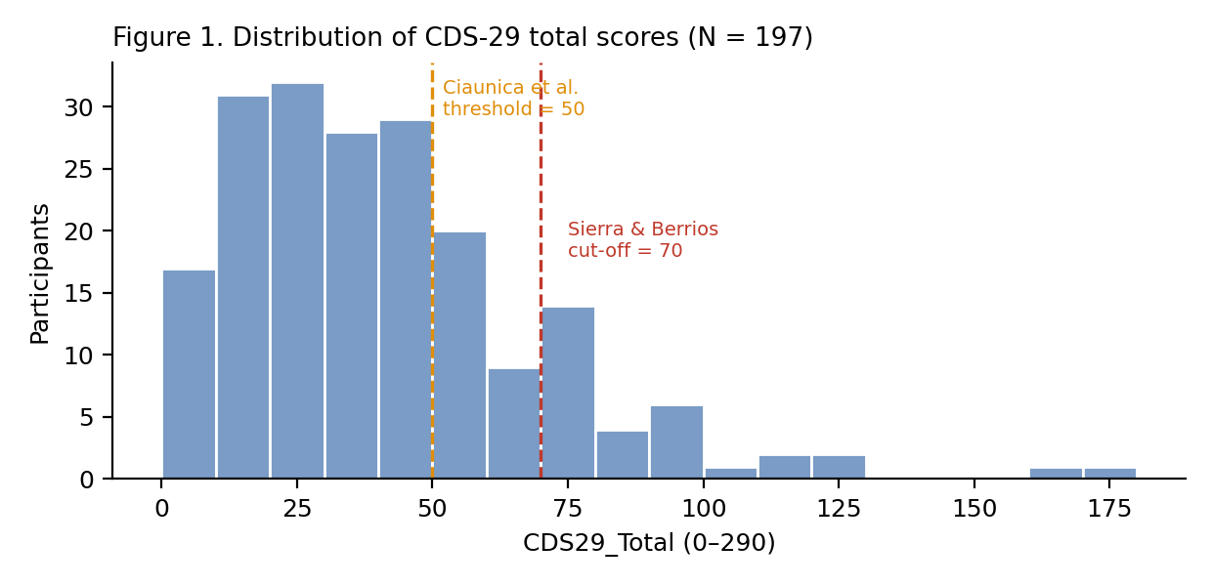
Figure 1. CDS29_Total is right-skewed (mean 41.4, SD 29.0, median 35, maximum 178). Thirty-one participants reach the Sierra and Berrios cut-off of 70; sixty reach 50, the entry threshold used in the comparable interview study by Ciaunica et al. (2023).
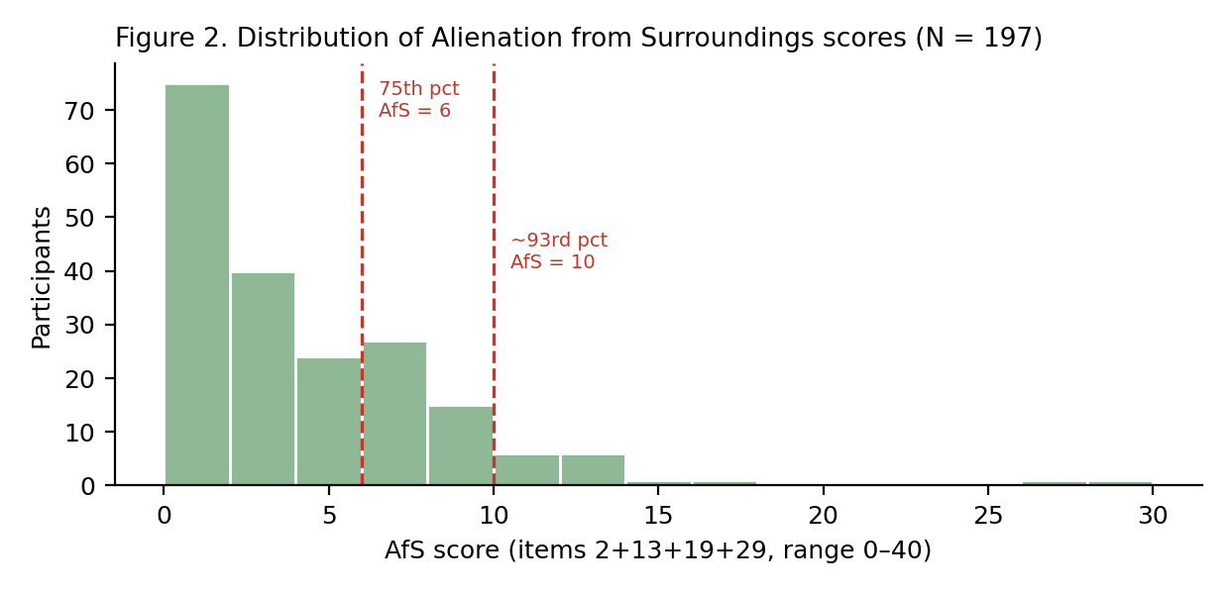
Figure 2. AfS (VisualDR_4item_2_13_19_29, the derealization subscale) is far more compressed: mean 3.70, SD 4.43, median 3, maximum 29. Fifty-eight participants score 6 or above (75th percentile), thirty-one score 8 or above, sixteen score 10 or above, and only four score 15 or above. A strict AfS cut-off would therefore leave too few participants to survive questionnaire non-response and interview refusal.
CDS item | Domain | Endorsed at all (freq > 0) | Sometimes or more (ときどき, freq ≥ 2) | Very often or more (とてもよく, freq ≥ 3)
2 | Alienation from Surroundings | 45 | 11 | 1
13 | Alienation from Surroundings | 74 | 35 | 6
19 | Alienation from Surroundings | 32 | 17 | 5
29 | Alienation from Surroundings | 56 | 24 | 2
Table 2. Endorsement of the four AfS items (N = 197). “Endorsed” means a frequency rating above 0, that is, the participant reported the experience occurring at least rarely rather than never (まったくない). Across the whole sample, 75 participants endorse none of the four items, 60 endorse one, 43 endorse two, 15 endorse three, and only 4 endorse all four, so a criterion requiring several AfS items together is not feasible.
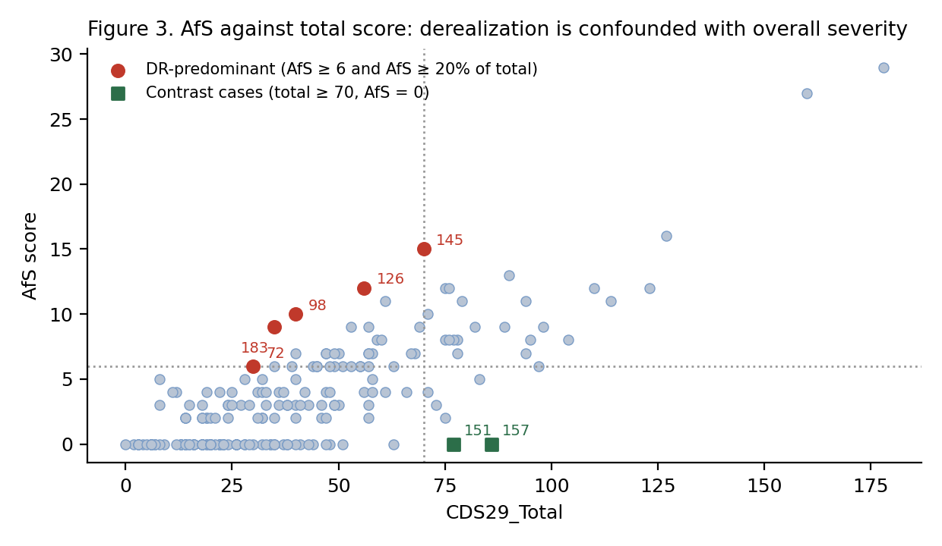
Figure 3. AfS plotted against CDS29_Total. The two are strongly confounded at the upper end, since the three highest AfS scores (IDs 171, 170, 169) also have the three highest totals. Selecting on AfS alone would in effect select on overall symptom severity rather than on derealization. Red points are derealization-predominant participants, defined as AfS ≥ 6 and AfS accounting for at least 20% of that participant's CDS29_Total; in these cases derealization dominates the profile rather than accompanying uniformly elevated symptoms, so they are what allows derealization to be separated from severity (listed in Table 5). Green squares are participants with a high total but no AfS endorsement, used as contrast cases (Table 6).

3. Selection procedure
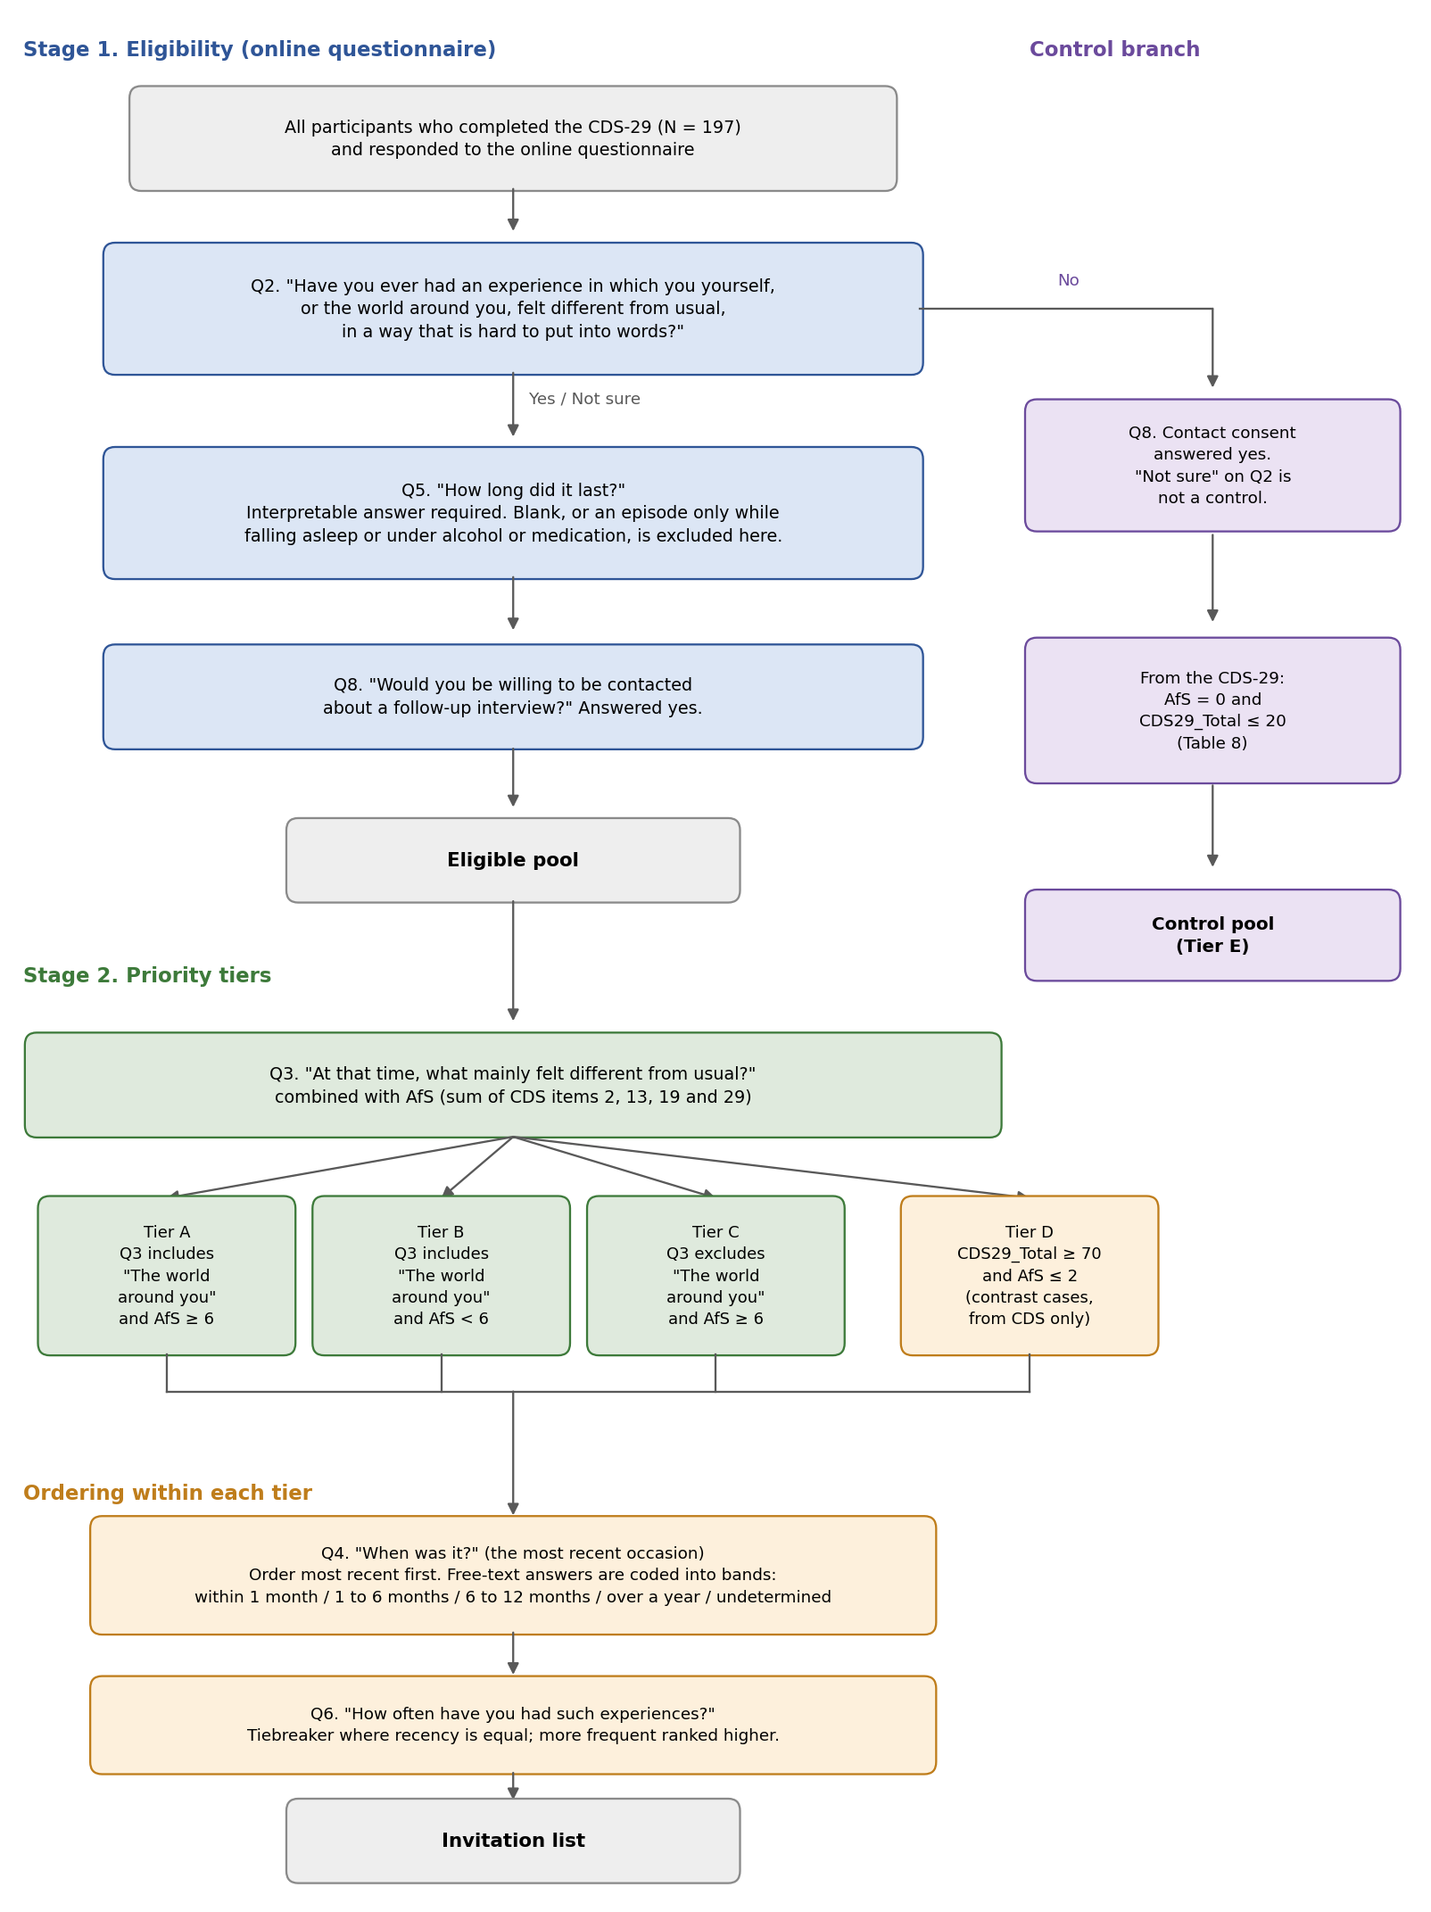
Figure 4. The selection procedure. Stage 1 uses only the online questionnaire and decides eligibility; Stage 2 uses Q3 together with the AfS subscale to assign eligible participants to priority tiers; ordering within each tier uses Q4, with Q6 as a tiebreaker. Tier D is defined from the CDS data alone and does not depend on Q3. The control branch on the right is applied to respondents who answer No at Q2; see Section 3.3.
Selection has two stages. Stage 1 uses only the new online questionnaire and determines who may be invited. Stage 2 uses the CDS-29 data, linked by ResponseId, to prioritise among those who are eligible. The CDS score is used for stratification, not as an inclusion cut-off: it records how often statements were endorsed over six months and does not establish that a participant recognises having had a distinct experience they could describe in an interview.

3.1 Stage 1. Eligibility (from the online questionnaire)
A participant is eligible for an interview invitation if all three conditions below hold. Section 3.3 gives the separate conditions for the control group. These are necessary; no CDS score can substitute for any of them.
- Q2. “Have you ever had an experience in which you yourself, or the world around you, felt different from usual, in a way that is hard to put into words?” Answered Yes or Not sure. Not sure is retained deliberately: difficulty recognising the experience as a discrete event is itself characteristic, and Q5 provides the check.
- Q5. “How long did it last?” Contains an interpretable answer. A blank response, or one describing an episode occurring only while falling asleep or under the influence of alcohol or medication, is grounds for exclusion at this point.
- Q8. “Would you be willing to be contacted about a follow-up interview?” Answered yes.
Q9 (consent to audio recording) is recorded but is not an eligibility criterion; a participant who declines recording may be interviewed with written notes. Q7 (psychiatric or psychosomatic diagnosis history) is collected as interview context, not as an exclusion criterion, since depersonalization and derealization are transdiagnostic and commonly comorbid with anxiety and depressive disorders.

3.2 Stage 2. Priority tiers
Eligible participants are assigned to one of four tiers by combining their AfS score with their answer to Q3, “At that time, what mainly felt different from usual? Please select all that apply”, whose options include “The world around you”. The two sources are independent: Q3 is a current self-categorisation, AfS is a retrospective symptom measure.
Tier | Definition | Why it is included
A | Q3 includes “The world around you” and AfS ≥ 6 | Both sources agree. The clearest derealization cases available.
B | Q3 includes “The world around you” and AfS < 6 | The participant recognises a change in the world but the CDS did not flag it. These cases test whether the questionnaire reaches people a score misses, and are informative rather than noise.
C | Q3 does not include “The world around you” and AfS ≥ 6 | The reverse discrepancy: the CDS flags derealization but the participant does not categorise their experience that way.
D | Contrast cases: CDS29_Total ≥ 70 with AfS ≤ 2, regardless of Q3 | High depersonalization with no derealization endorsement. Including these participants allows statements about what is specific to derealization rather than common to depersonalization generally.
Table 3. Priority tiers.
The tiers order the invitation list; they are not quotas. If the tiers are to be compared with one another, which is the point of including Tiers B, C and D at all, then participants from all four tiers are required, and the number drawn from each should be settled once the questionnaire responses show how many eligible participants each tier contains. Total sample size can be justified on the information power criteria of Malterud et al. (2016): a narrow aim, a highly specific sample, and an analysis strategy that yields dense material from each participant all argue for a comparatively small number of interviews.
Within each tier, participants are ordered by recency, taken from Q4, “When was it?”, which is asked of the most recent occasion. The most recent are placed first. Recency is prioritised because the interview method depends on the participant being able to re-live a specific occasion in detail, and a recent episode is markedly better material than one from several years ago. Because Q4 is free text, responses must be coded into recency bands (within the past month / 1–6 months / 6–12 months / over a year / undetermined) before invitations are issued; period answers are coded by their most recent end, and undetermined answers go to the bottom of their tier rather than being excluded.
Where two participants are equally recent, Q6, “How often have you had such experiences?”, is used as a tiebreaker, with more frequent experiences ranked higher, since a participant with several episodes has more to choose from when anchoring the interview. Frequency is not itself an exclusion criterion: a single vivid episode can be excellent material.
Tiers B and C cannot be listed in advance, because both are defined partly by the answer to Q3, which is not yet available. They will be generated once the questionnaire responses have been collected. Participants may also move between tiers at that point, and the pilot list in Section 4.4 will be revised in the light of those answers.

3.3 Control group
The interview and the image-selection task both require a comparison group of respondents who have not had the experience under study. Controls are drawn from the same 197 CDS-29 respondents and screened with the same online questionnaire, linked by ResponseId. Both groups therefore come from one population, answered in the same language, and read identical CDS wording, including the items about a veil over the senses and about surroundings appearing flat or lifeless. Equal exposure to that vocabulary matters: a control recruited elsewhere would differ from a participant in what they have been invited to consider, and not only in what they have experienced.
A respondent is a control candidate if all four conditions below hold.
- Q2. “Have you ever had an experience in which you yourself, or the world around you, felt different from usual, in a way that is hard to put into words?” Answered No. Unlike the interview group, Not sure is excluded here: a participant may be included on an uncertain recognition of the experience, but a control must clearly not have had it.
- Q8. “Would you be willing to be contacted about a follow-up interview?” Answered yes.
- AfS = 0. None of CDS items 2, 13, 19 or 29 endorsed at all, that is, a frequency rating of 0 on every one of the four.
- CDS29_Total ≤ 20. Low overall depersonalization, so that a control is not someone who scores highly on the rest of the scale while happening to leave the four derealization items blank.
The cut-off of 20 was fixed after counting the pool rather than in advance. Seventy-five of the 197 respondents have AfS = 0, and the median total within that group is 20, so the cut-off is the midpoint of the no-derealization group rather than an arbitrary threshold. It leaves 39 candidates, listed in Table 8. A stricter cut-off is not available in practice: only one respondent scored 0 on the whole scale, and only 15 scored 10 or below. A reserve band of totals from 21 to 35 holds a further 23 respondents with AfS = 0, and can be released if the first wave of invitations does not produce the 20 completed controls required; 35 is the median total of the full sample.
No control candidate appears in Tables 4 to 7, and the exclusion of Tier D is automatic rather than a separate rule: its three members have totals of 75, 77 and 86, far above any cut-off considered here. The high-total, no-derealization contrast cases are therefore interview participants, not controls, which is the intended separation. Q7, psychiatric or psychosomatic diagnosis history, is recorded for controls exactly as it is for the interview group, and is not used to exclude.
Because two of the four conditions come from the questionnaire, the control group itself cannot be fixed until responses are collected. Table 8 is the invitation pool and the screening rules above are applied to the answers afterwards, in the same way that Tiers B and C are generated after the fact.

4. Candidates in the current data
The lists below are the CDS-side inputs to Stage 2. They are provisional: a participant enters the final sample only if they also satisfy the Stage 1 eligibility conditions once questionnaire responses are collected. ResponseId is given for linkage and should be removed before this document is circulated outside the project.

4.1 Participants with AfS ≥ 8, excluding derealization-predominant cases (n = 27)
ID | ResponseId | AfS | CDS29_Total | AfS / Total
171 | R_4pLScl8fGjm4FFo | 29 | 178 | 0.16
170 | R_4vZF452FOAJpx8i | 27 | 160 | 0.17
169 | R_9aZhmsJBtXwFvgt | 16 | 127 | 0.13
159 | R_9ErSR2Q9LAEVHAG | 13 | 90 | 0.14
148 | R_4CCsauTxoiedAls | 12 | 75 | 0.16
166 | R_4FdJAU7Cq9Vpe93 | 12 | 110 | 0.11
191 | R_9iL5lKMUmATdG7L | 12 | 76 | 0.16
168 | R_9vesXPgPfI9DkTa | 12 | 123 | 0.10
161 | R_4fVlkTa6ViaMENC | 11 | 94 | 0.12
195 | R_4ygs9k7LI0gGdxL | 11 | 79 | 0.14
167 | R_4Db6QbYRLjt0Apr | 11 | 114 | 0.10
138 | R_4N3K22iipGpKhSH | 11 | 61 | 0.18
146 | R_9wnCVJ6q4Vfavrb | 10 | 71 | 0.14
131 | R_4wqpd9Cho4DYCL7 | 9 | 57 | 0.16
158 | R_49suDloaX8luLc8 | 9 | 89 | 0.10
144 | R_90HQVbpjcH3WWah | 9 | 69 | 0.13
123 | R_9ZPub1dMnLMgNIO | 9 | 53 | 0.17
164 | R_9ojKT5uPvSeaHse | 9 | 98 | 0.09
155 | R_9CTMDeE1EfOR4DO | 9 | 82 | 0.11
152 | R_4YxZOZP4WAS7fln | 8 | 77 | 0.10
136 | R_9oRgi9l1qqjuIXs | 8 | 59 | 0.14
162 | R_9hH005GZl0aAWX8 | 8 | 95 | 0.08
165 | R_9D6p237JSSzh23X | 8 | 104 | 0.08
153 | R_9OplgeCnV8BO81U | 8 | 78 | 0.10
149 | R_97qHTn3r2z2a6gF | 8 | 75 | 0.11
188 | R_4OqazzeLOlelCiU | 8 | 76 | 0.11
187 | R_4sjq6fW0Ykf0eiY | 8 | 60 | 0.13
Table 4. Participants scoring 8 or above on AfS, ordered by AfS, excluding the four derealization-predominant participants, who are listed in Table 5 instead. The final column gives AfS as a proportion of the total score, showing how far derealization dominates the participant's profile rather than simply reflecting a high overall score.

4.2 Derealization-predominant participants
These are the red points in Figure 3: participants whose AfS is at least 6 and accounts for at least 20% of their CDS29_Total. Because AfS and total are otherwise confounded, deliberately including several of these participants is what allows derealization to be studied as something other than a marker of overall severity.
ID | ResponseId | AfS | CDS29_Total | AfS / Total
183 | R_41dBI6R9FoUY1EY | 9 | 35 | 0.26
98 | R_4xLncfmpn7YPLX3 | 10 | 40 | 0.25
145 | R_9Ib3Yf2yPo5XvCd | 15 | 70 | 0.21
126 | R_4e5KTEvSRNkzFf3 | 12 | 56 | 0.21
72 | R_4KHC8LBhGyULyqE | 6 | 30 | 0.20
Table 5. Derealization-predominant participants. Note that IDs 183, 98 and 72 fall well below every published CDS cut-off on their total score and would be excluded entirely by a total-score criterion, despite derealization dominating their profile. These participants are listed here only, and are not repeated in Table 4.

4.3 Contrast candidates (Tier D)
ID | ResponseId | AfS | CDS29_Total
157 | R_4s7uoZdUSFFzV7z | 0 | 86
151 | R_4QDGnRryVNAoG0W | 0 | 77
150 | R_4RHpnig82Z4AUb7 | 2 | 75
Table 6. High total score with little or no Alienation from Surroundings endorsement, shown as the green squares in Figure 3.

4.4 Pilot candidates
A pilot is run before the main study to confirm that the interview can be completed within the stated time limit and that the online image-selection task works as intended. Pilot participants complete both sessions, exactly as in the main study, so a pilot interview that runs without changes to the guide may count toward the final sample.
The pilot pool is drawn from participants with moderate AfS scores, between 4 and 7, who appear in none of the tables above. This band is high enough that a participant is likely to have an experience to describe in the interview and to judge against in the image-selection task, and low enough that the strongest derealization cases remain available for the main study. Fifty participants meet these conditions.
This list is provisional in the same way as the tiers. Once the questionnaire responses are in, some of these participants will qualify for Tier B or Tier C. Tier B in particular is defined as AfS below 6 together with an endorsement of “The world around you” at Q3, which a participant in this band may well give. The pilot list will be revised accordingly, and participants who move into a tier are no longer drawn on for the pilot.
ID | ResponseId | AfS | CDS29_Total
160 | R_9JrQvHhuCTl5C1K | 7 | 94
154 | R_9v7isvfvrxHrbjD | 7 | 78
143 | R_4kSMT9WW9cArqNR | 7 | 68
142 | R_4wW5moJRhGZ82it | 7 | 67
135 | R_43mXeLiFCbdf7TH | 7 | 58
129 | R_4shpFQdcM50PKkO | 7 | 57
130 | R_4Tw3Ee8lCaqSs4M | 7 | 57
120 | R_9rxe048TvwJ5MWg | 7 | 50
118 | R_9OMZT57iiC7YIVn | 7 | 49
112 | R_4iQ3SnFs8Asjkzo | 7 | 47
113 | R_4n7rrGGygpH5U5c | 7 | 47
99 | R_46ljWAcZJy0QFYr | 7 | 40
163 | R_4sjq5iQRcGtZisx | 6 | 97
139 | R_9T5L8BO1ikZkr61 | 6 | 63
132 | R_9rIUjfKxigPUjbH | 6 | 57
124 | R_9lxM008LdaC5WDd | 6 | 55
125 | R_4rHL5Ply1BjGPKi | 6 | 55
172 | R_9k1FCNbztaKx9W9 | 6 | 53
122 | R_4l5FN425a5I7u49 | 6 | 51
177 | R_9QhC73wLHxKlHpt | 6 | 49
189 | R_4g2e8BYXZ9ENysm | 6 | 48
107 | R_9mcocVeQ6lV6Uil | 6 | 45
108 | R_4ERm2DNYVskX2CJ | 6 | 45
105 | R_4TSjrObOMkB2LjW | 6 | 44
93 | R_4Y4FxkS7UlAGFqk | 6 | 39
85 | R_9bNRSwzjz3bmfVb | 6 | 35
156 | R_4zOzX8CoHj9JzH4 | 5 | 83
134 | R_4oNGN8wQOAiFiil | 5 | 58
96 | R_4QQrmiKk2kF1yAc | 5 | 40
79 | R_4rNeP2rDdgSlzfT | 5 | 32
69 | R_4EnY1ZCz3Wk3ZAx | 5 | 28
15 | R_95LWkD11pjzRDSI | 5 | 8
193 | R_90o7nzRvdNy4kQj | 4 | 71
141 | R_4g7p2vmr6BjxDs9 | 4 | 66
137 | R_4Q4wQrorTUozVDN | 4 | 61
173 | R_4GB0FY2PKkcIfC9 | 4 | 58
127 | R_4XP9Uh2OZveAyZz | 4 | 56
116 | R_4MukZUbBEakXJWF | 4 | 48
111 | R_9qCHNqXAtNtvXxI | 4 | 47
102 | R_9wGrkg7Wv1ObuaB | 4 | 42
90 | R_9E5PFZKcK8V5efz | 4 | 37
87 | R_4lE3wOHVBguOYZn | 4 | 36
196 | R_40PyURBC7Nx2h8O | 4 | 33
77 | R_4Q7T54Y4UdZBelX | 4 | 32
74 | R_9okhvti3Q2zzTKp | 4 | 31
61 | R_9pRAnMFkA6uGUfv | 4 | 25
52 | R_4q81CfgGFrB3mdK | 4 | 22
42 | R_4k6yMiYLLNRx7ml | 4 | 19
18 | R_4OwY8DUm7d3CVDR | 4 | 12
17 | R_9iDpx35Q2bzGUi4 | 4 | 11
Table 7. Pilot candidates: participants with AfS between 4 and 7 who are listed in none of Tables 4, 5 or 6 (n = 50), ordered by AfS and then by CDS29_Total. ID 72 falls within this band but is excluded, since it is already listed in Table 5 as a derealization-predominant candidate.

4.5 Control candidates (n = 39)
The respondents below satisfy the two CDS-side conditions in Section 3.3: AfS = 0 and CDS29_Total ≤ 20. They are the pool from which controls are invited; which of them become controls depends on their answers to Q2 and Q8. Twenty completed controls are required, so the pool is invited in full rather than sampled from.
ID | ResponseId | AfS | CDS29_Total
1 | R_4FXbFRxClyrDden | 0 | 0
2 | R_42hGk2u3VXCRdxD | 0 | 2
3 | R_9tww4EahOFm2YqB | 0 | 3
4 | R_4Fi66Jv9BMa8ZuV | 0 | 3
5 | R_91YBEaSJB0Gttfl | 0 | 3
6 | R_9iF0TnEHz60OPs6 | 0 | 4
7 | R_4fkIKhueiQdSdck | 0 | 5
8 | R_4dHAplexZZBlwzz | 0 | 6
9 | R_4F3ZrfVWI0NOqGj | 0 | 6
10 | R_4fcBakzNBvTZIrq | 0 | 6
182 | R_91nm0yCNKXLKq7L | 0 | 6
11 | R_40TySaNowIrwWja | 0 | 7
12 | R_9PCCfeAHgenIhLr | 0 | 7
14 | R_9ujzmXI4r1GcMF3 | 0 | 8
16 | R_9m959RdIs7fm1P6 | 0 | 9
19 | R_4d9ddp513SInV0B | 0 | 12
20 | R_4M4Oyxn8NcgBeCH | 0 | 13
21 | R_4j9Znm9N4XglxD3 | 0 | 13
22 | R_9MQbKSKZNuhGDP6 | 0 | 13
24 | R_4jU1p776ejft8U5 | 0 | 14
25 | R_9ajLrOwoPv1lh4d | 0 | 14
176 | R_9EmgkP5pCcMGxfj | 0 | 14
28 | R_4ahlCjG6lAxgRyN | 0 | 15
185 | R_4plal5z0mSqZd7P | 0 | 15
30 | R_4Vvfmg3jHNFJhVT | 0 | 16
31 | R_9paPSHaYVSCED7w | 0 | 16
32 | R_4qKBfmAb6nAKQjf | 0 | 16
33 | R_9M3PxtbFKyyNQuB | 0 | 18
35 | R_41u9h6phVIWBe8l | 0 | 18
37 | R_9mgehdBqMghBhQN | 0 | 18
39 | R_4o6XG5wOJHFhZG6 | 0 | 18
40 | R_4bxWBTUSl7qD0s1 | 0 | 18
41 | R_43dX4QYZroZAsQe | 0 | 19
45 | R_42sZ05U2ImOvIIt | 0 | 19
46 | R_9rJJWk01c767jE8 | 0 | 20
47 | R_9ilFPiQPCSO6Jv3 | 0 | 20
48 | R_4OiqFGkV7ALOsiX | 0 | 20
178 | R_9h5rvjDjzyqrpXr | 0 | 20
186 | R_4oEYVE7E3iCeynx | 0 | 20
Table 8. Control candidates: respondents with AfS = 0 and CDS29_Total ≤ 20 (n = 39), ordered by total score and then by ID. The AfS column is retained for comparison with Tables 4 to 7; it is 0 by construction, meaning that CDS items 2, 13, 19 and 29 were all rated at a frequency of 0. No participant listed here appears in any earlier table.

References
Ciaunica, A., Pienkos, E., Nakul, E., Madeira, L., & Farmer, H. (2023). Exploration of self- and world-experiences in depersonalization traits. Philosophical Psychology, 36(2), 380–412.
Kusztor, A., Mulay, N., Yamada, M., Hohwy, J., & Tsuchiya, N. (2025). Lifting the veil: Probing altered visual perception in derealization. Neuroscience of Consciousness, 2025(1), niaf045.
Malterud, K., Siersma, V. D., & Guassora, A. D. (2016). Sample size in qualitative interview studies: Guided by information power. Qualitative Health Research, 26(13), 1753–1760.
Sierra, M., Baker, D., Medford, N., & David, A. S. (2005). Unpacking the depersonalization syndrome: An exploratory factor analysis on the Cambridge Depersonalization Scale. Psychological Medicine, 35(10), 1523–1532.
Sierra, M., & Berrios, G. E. (2000). The Cambridge Depersonalisation Scale: A new instrument for the measurement of depersonalisation. Psychiatry Research, 93(2), 153–164.

