Project: Deploy Java Application on Kubernetes

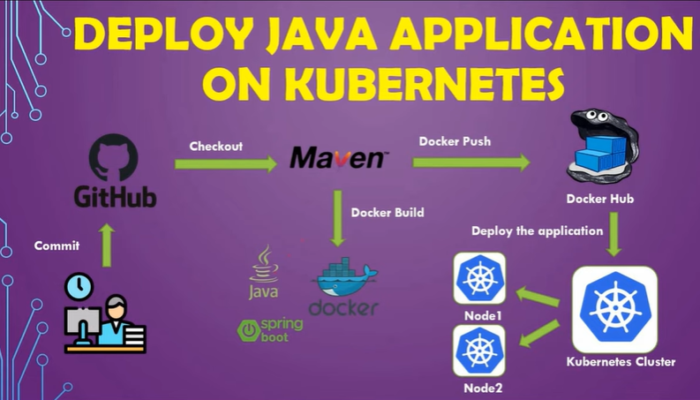

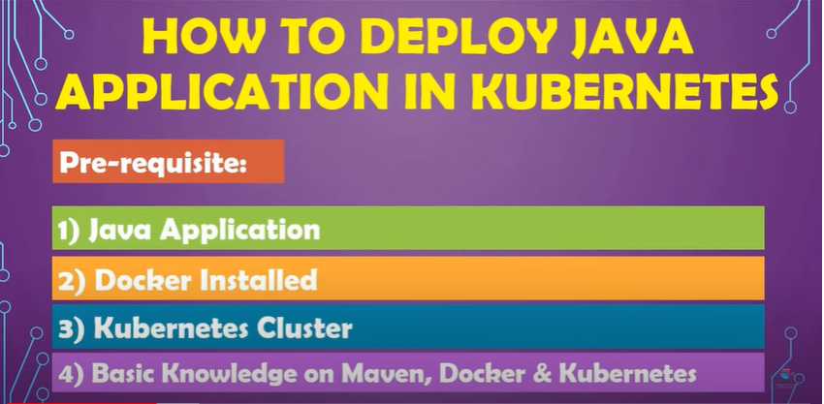

Install Docker

Install Kubectl

Install JAVA and mvn

Step 1 : Download Pakage

$ wget https://download.java.net/java/GA/jdk13.0.1/cec27d702aa74d5a8630c65ae61e4305/9/GPL/openjdk-13.0.1_linux-x64_bin.tar.gz

$ tar -xvf openjdk-13.0.1_linux-x64_bin.tar.gz

$ mv jdk-13.0.1 /opt/

[Step 2: Setting JAVA_HOME and Path Environment Variables](https://www.digitalocean.com/community/tutorials/install-maven-linux-ubuntu#step-2-setting-java-_home-and-path-environment-variables)

JAVA_HOME='/opt/jdk-13.0.1'

PATH="$JAVA_HOME/bin:$PATH"

export PATH

**MAVEN**

[Step 1: Download the Maven Binaries](https://www.digitalocean.com/community/tutorials/install-maven-linux-ubuntu#step-1-download-the-maven-binaries)

$ wget https://mirrors.estointernet.in/apache/maven/maven-3/3.6.3/binaries/apache-maven-3.6.3-bin.tar.gz

$ tar -xvf apache-maven-3.6.3-bin.tar.gz

$ mv apache-maven-3.6.3 /opt/

[Step 2: Setting M2_HOME and Path Variables](https://www.digitalocean.com/community/tutorials/install-maven-linux-ubuntu#step-2-setting-m2-_home-and-path-variables)

M2_HOME='/opt/apache-maven-3.6.3'

PATH="$M2_HOME/bin:$PATH"

export PATH