Western Australian Curriculum
Mathematics
Scope and sequence | Pre-primary–Year 6
For implementation in 2026

Acknowledgement of Country
Kaya. The School Curriculum and Standards Authority (the Authority) acknowledges that our offices are on Whadjuk Noongar boodjar and that we deliver our services on the country of many traditional custodians and language groups throughout Western Australia. The Authority acknowledges the traditional custodians throughout Western Australia and their continuing connection to land, waters and community. We offer our respect to Elders past and present.
Copyright
© School Curriculum and Standards Authority, 2025
This document – apart from any third-party copyright material contained in it – may be freely copied, or communicated on an intranet, for non-commercial purposes in educational institutions, provided that the School Curriculum and Standards Authority (the Authority) is acknowledged as the copyright owner, and that the Authority’s moral rights are not infringed.
Copying or communication for any other purpose can be done only within the terms of the Copyright Act 1968 or with prior written permission of the Authority. Copying or communication of any third-party copyright material can be done only within the terms of the Copyright Act 1968 or with permission of the copyright owners.
Any content in this document that has been derived from the Australian Curriculum may be used under the terms of the Creative Commons Attribution 4.0 International licence.
This document incorporates material from Mathematics K–10 Syllabus (2022) © 2022 NSW Education Standards Authority (NESA) for and on behalf of the Crown in right of the State of New South Wales.
Disclaimer
Any resources such as texts, websites and so on that may be referred to in this document are provided as examples of resources that teachers can use to support their learning programs. Their inclusion does not imply that they are mandatory or that they are the only resources relevant to the course. Teachers must exercise their professional judgement as to the appropriateness of any they may wish to use.
Contents
Overview 1
Guide to reading this document 1
Pre-primary–Year 2 3
Strand: Number and algebra 3
Sub-strand: Understanding number 3
Sub-strand: Understanding equalities and inequalities 10
Sub-strand: Patterns and relationships 11
Sub-strand: Calculating with number 12
Sub-strand: Financial mathematics 14
Sub-strand: Modelling with number 15
Strand: Measurement and geometry 16
Sub-strand: Two-dimensional space and structures 16
Sub-strand: Three-dimensional space and structures 19
Sub-strand: Non-spatial measurement 20
Strand: Probability and statistics 23
Sub-strand: Probability 23
Sub-strand: Statistics 23
Years 3–6 27
Strand: Number and algebra 27
Sub-strand: Understanding number 27
Sub-strand: Understanding equalities and inequalities 38
Sub-strand: Patterns and relationships 39
Sub-strand: Calculating with number 41
Sub-strand: Financial mathematics 51
Sub-strand: Modelling with number 52
Strand: Measurement and geometry 54
Sub-strand: Two-dimensional space and structures 54
Sub-strand: Three-dimensional space and structures 62
Sub-strand: Non-spatial measurement 65
Sub-strand: Modelling with measurement and geometry 68
Strand: Probability and statistics 71
Sub-strand: Probability 71
Sub-strand: Statistics 73
Acknowledgements 79

Overview
The Western Australian Curriculum: Mathematics has been adapted from the previous Western Australian Curriculum (adopted from the Australian Curriculum version 8.1), the New South Wales Curriculum (following the New South Wales Curriculum Reform) and the Australian Curriculum version 9. It has been contextualised for the Western Australian Curriculum and Assessment Outline.

Guide to reading this document
The Scope and sequence shows the mandated curriculum for teaching, written as content descriptions across year levels so that a sequence can be viewed across the years of schooling from Pre-primary to Year 10. The examples illustrate the content and are not mandated. Teachers should use examples relevant to the context of the school and needs of their students.
This Scope and sequence shows the Pre-primary to Year 6 Mathematics curriculum organised by phases of learning: Pre-primary–Year 2 and Years 3–6.
The Mathematics curriculum is organised by three Mathematics strands: Number and algebra; Measurement and geometry; and Probability and statistics.
The Number and algebra strand for Pre-primary to Year 6 includes: Understanding number; Understanding equalities and inequalities; Patterns and relationships; Calculating with number; Financial mathematics; and Modelling with number.
The Measurement and geometry strand for Pre-primary to Year 2 includes: Two-dimensional space and structures; Three-dimensional space and structures; and Non-spatial measurement.
The Measurement and geometry strand for Years 3–6 includes: Two-dimensional space and structures; Three-dimensional space and structures; Non-spatial measurement; and Modelling with measurement and geometry (Years 4–6 only).
The Probability and statistics strand for Pre-primary to Year 6 includes: Probability and Statistics.

The tables below outline the subject organisation for the Pre-primary to Year 6 Mathematics curriculum.
Pre-primary–Year 2
Number and algebra
Understanding  number | Understanding equalities and inequalities | Patterns and relationships | Calculating with number | Financial  mathematics | Modelling with number

Measurement and geometry
Two-dimensional space and structures | Three-dimensional space and structures | Non-spatial measurement

Probability and statistics
Probability | Statistics

Years 3–6
Number and algebra
Understanding  number | Understanding equalities and inequalities | Patterns and relationships | Calculating with number | Financial  mathematics | Modelling with number

Measurement and geometry
Two-dimensional space and structures | Three-dimensional space and structures | Non-spatial measurement | Modelling with measurement and geometry

Probability and statistics
Probability | Statistics

Pre-primary–Year 2

Strand: Number and algebra

Sub-strand: Understanding number
Pre-primary | Year 1 | Year 2
Say, read, write and order numbers to 20, from any starting point. Count collections to 20  For example:  - counting for a purpose, such as counting how many children are in a group so the correct number of items can be collected  - counting forwards and backwards by ones from a given number  - internalising the principles of counting, including each object must be touched or included exactly once as the numbers are said once in order, the objects can be touched in any order from any starting point and the arrangement does not affect the count, and the last number tells ‘how many’ in the whole collection and does not describe the last object touched  - recognising that numbers represent quantities and ‘zero’ is the same as ‘no items’, and that adding one to the count is one more and removing one from the count is one less  - identifying the number before and after a given number  - understanding and using ordinal numbers, such as ‘Abby will have her turn first, Ben will go second, and Jack will be third’ | Say, read, write and order numbers to 120 and recognise the repetition of the 0–9 sequence of digits. Skip count collections by twos, fives and tens from zero  For example:  - counting forwards and backwards by ones from a given number, noticing that counting forward by ones is adding one each count and counting backwards by ones is subtracting one each count  - identifying the number before and after a two-digit number  - exploring hundreds charts to recognise the repetition of digits  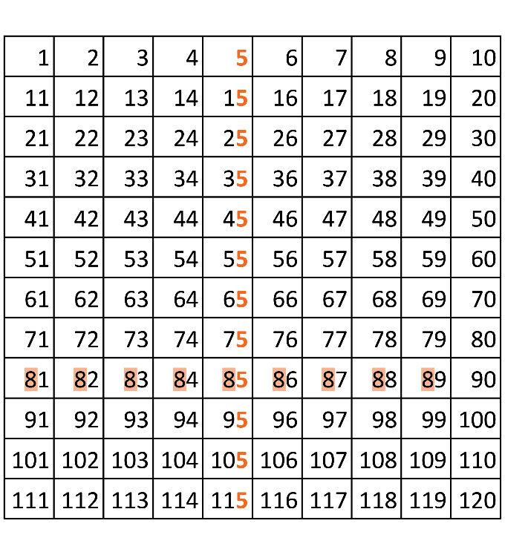  - ordering numbers using numbered cards or number tracks  - counting the same collection by ones, twos, fives or tens | Read, write and order numbers to at least 1020, including on a number line. Recognise the repetition of the 0–99 sequence of digits and the role of zero. Skip count forwards and backwards by twos, threes, fives and tens from any starting point  For example:  - comparing different hundreds charts, such as 101−200 and 701−800, to identify patterns  - identifying the number before and after a given three-digit number  - reading and ordering numbers up to four digits using patterns in the number system, including numbers with zeros in different places and numbers that look and sound similar, such as 808, 880, 818 and 881  - recognising features of number lines, such as the even spaces between the markings and the starting point at 0  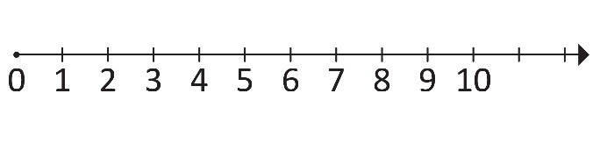  - identifying the missing numbers on the markings for a given number line, such as  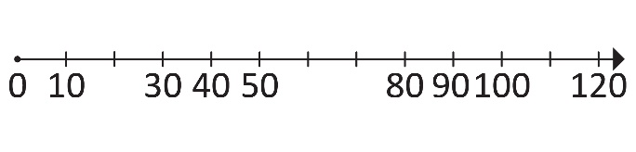
Subitise, partition and compare small collections  For example:  - recognising with a quick look the number of objects in a collection and saying the number without counting  - partitioning collections of up to 10 objects in different ways, such as partitioning a collection of six counters into four counters and two counters, or into three counters and three counters  - comparing and describing small collections using the language more, less and same | Explore different ways to represent and partition collections up to 100, including in groups of 10, using concrete materials  For example:  - recognising that 10 ones is the same as  one 10  - bundling sticks in groups of 10 and combining these with loose sticks to make two-digit numbers. Trusting that a previously prepared bundle contains 10 sticks  - using concrete materials to represent two-digit numbers, then partitioning the number in different ways, such as representing 24 as 10, 10 and 4, or 10 and 14 | Explore different ways to represent and partition two- and three-digit numbers, including in groups of 10 and 10 groups of 10 to make 100, using concrete materials, numbers and symbols  For example:  - counting and representing large sets of concrete materials by systematically grouping in tens and hundreds  - using models, such as base-ten materials and interlocking cubes, to represent and explain grouping  - using concrete materials to partition, rearrange, regroup and rename three-digit numbers in different ways, such as 574 being shown as 5 hundreds, 7 tens and 4 ones or 57 tens and 4 ones
 | Explore partitions of numbers with small collections using part-part-whole relationships  For example:  - creating, recording and recognising combinations of two numbers that add up to numbers up to 10, such as partitioning five into four and one or into three and two, including making all possible whole-number combinations  - exploring part-part-whole 10 facts by arranging collections of 10 objects in different ways  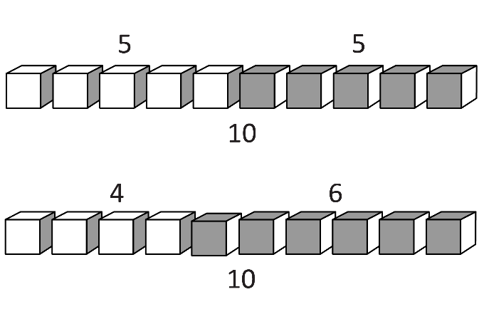  - describing combinations for numbers using more than, less than and double, such as ‘five is one more than four’ or ‘double two and one more’ | Explore the relationship between addition and subtraction with small collections using part-part-whole knowledge, numbers and symbols  For example:  - exploring combinations of two numbers that add to numbers from 11 up to and  including 20  - representing the difference between two numbers using concrete materials and diagrams, such as the difference between 7 and 4 being 3  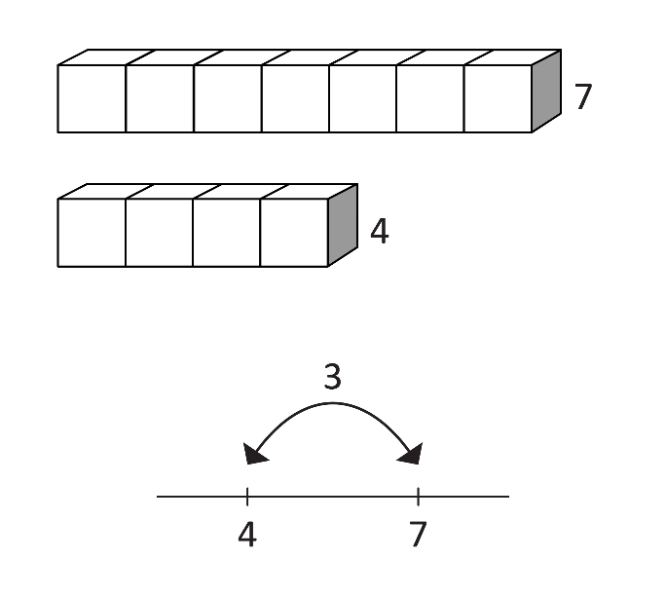  - representing addition and subtraction as inverse operations using concrete materials, drawings and diagrams  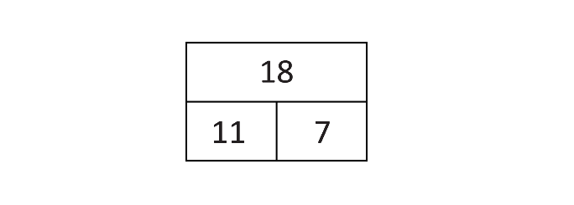  $18=11+7$ and $11=18 7$
Recall addition and subtraction facts to 10
For example:
- recalling combinations of two numbers that add up to 10 and related subtraction facts
- using related number facts, such as
$8+2=10$, so $10-2=8$ and $10-8=2$
Explore grouping and sharing of small collections  For example:  - role-playing equal sharing by distributing objects one by one or in groups of two and counting the number in each group to ensure they have the same amount  - sorting collections of items, such as blocks or shells, into two groups, identifying those that can be shared into equal groups and those that cannot | Explore different ways to equally group or share collections  For example:  - grouping and sharing small collections in different ways using concrete materials, drawings or diagrams, such as splitting a collection of 24 items into equal groups  - using grouping to help count large collections, such as grouping items into fives or tens and skip counting to find the total  - recognising that the more groups to be made from a quantity, the smaller the size of each group | Explore multiplication and division using repeated addition, equal grouping and arrays  For example:  - representing multiplication as repeated addition and division as sharing or equal grouping, using concrete materials, drawings or diagrams  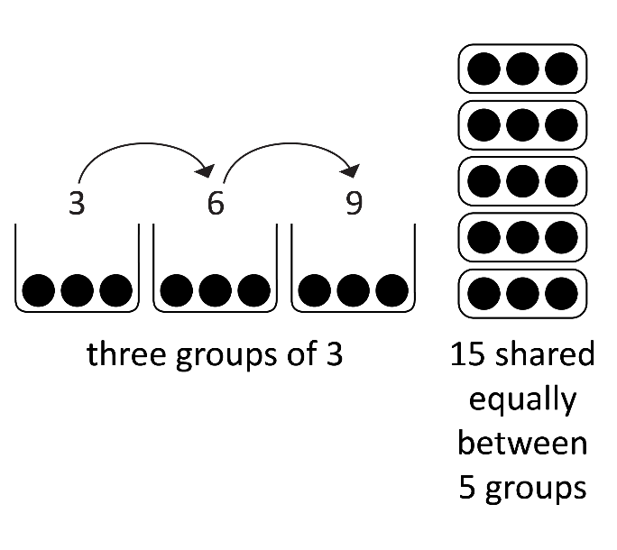  - connecting grouping to arrays, determining and distinguishing between the number of rows/columns and the number in each row/column  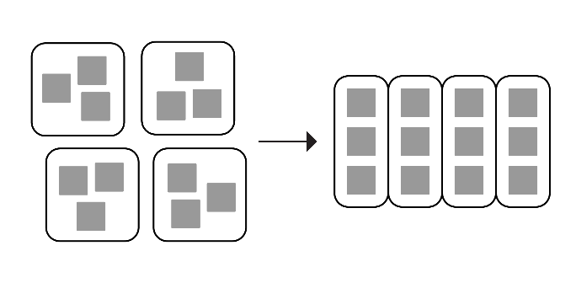  - recognising the commutative property of multiplication using an array  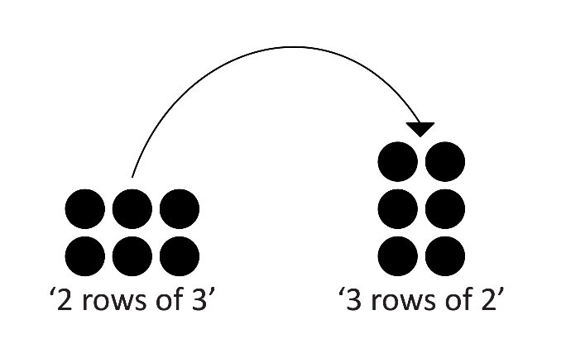
 | Explore and create a half by dividing a physical whole into two equal parts or a collection into two equal quantities, using the language of sharing and grouping  For example:  - sharing a collection of objects into two equal groups, recognising that one group is half of the whole collection  - exploring halves in context, such as a half of a sandwich and the halves of an orange  - exploring different ways to share rectangles or squares of paper into two equal parts, describing them as a half or halves  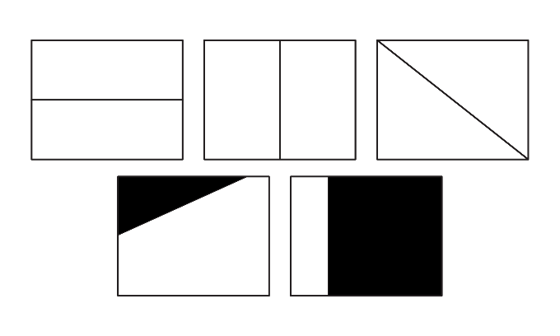 | Recognise, describe and create halves, quarters and eighths by repeatedly halving a physical whole or a collection  For example:  - describing physical representations of fractions using words and numerical representations, such as one-quarter as $\frac{1}{4}$ which means one part out of four equal parts  - using repeated halving of a range of shapes, objects or collections to make halves, quarters and eighths, such as partitioning a strip of paper into two equal lengths, then halving the halves, naming the four equal parts as quarters, then repeating for eighths  - exploring different ways to cut paper squares into halves and quarters, considering questions such as ‘Are two quarters always the same amount as one half?’  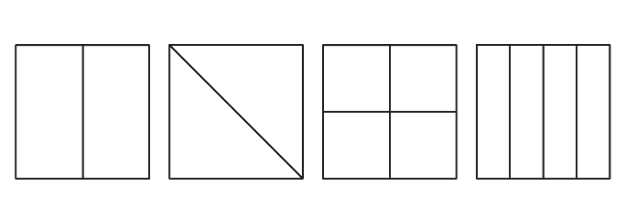

Sub-strand: Understanding equalities and inequalities
Pre-primary | Year 1 | Year 2
Use the equality symbol to indicate the same value in number sentences involving addition and subtraction
For example:
- using the equality symbol to mean ‘is the same as’, such as recognising the quantities on both sides of the equals sign are the same
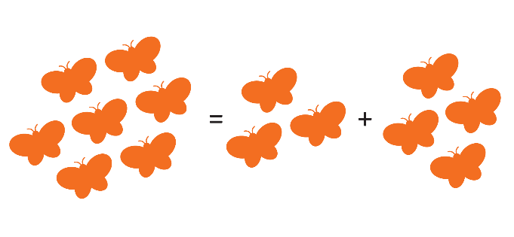
- using the equality symbol to produce true number sentences, such as
$5+2=3+4$ or $9-4=7-2$
- discussing if a given number sentence is true, such as $3=9-5$

Sub-strand: Patterns and relationships
Pre-primary | Year 1 | Year 2
Copy and continue repeating patterns in everyday environments using a range of materials, sounds and movement  For example:  - recognising familiar patterns and repetitions in the natural world and everyday life, such as noticing repeated patterns in a frieze or bunting on a class display board  - using objects, drawings, movements or sounds to recognise that the same pattern can be represented in different ways and used to predict what comes next  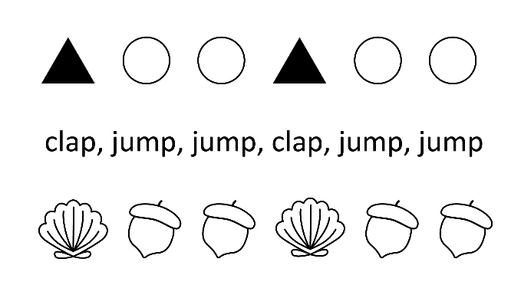 | Continue and create repeating patterns. Explore and label repeating patterns to show how many of each element is in a repeat unit (core)  For example:  - identifying the repeating unit, labelling with symbols such as b, b, b, w, w  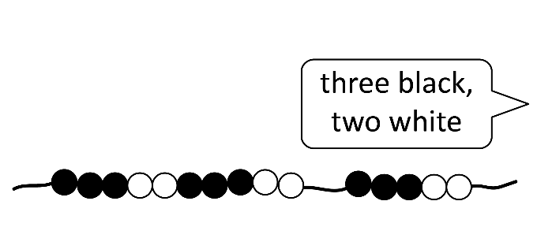  - continuing patterns in everyday situations, such as days of the week, labelling as M, Tu, W, Th, F, Sa, Su and recognising that there are seven days in a repeat unit  - choosing materials to create a pattern that shows a provided number sequence, such as 1, 2, 1, 2, 1, 2 | Recognise and continue increasing or decreasing additive patterns with collections and numbers, and identify missing elements in a pattern  For example:  - identifying the changes in growing patterns as repeated addition and making connections to skip counting. Using a calculator to enter 3 and repeatedly add 3, to model the pattern  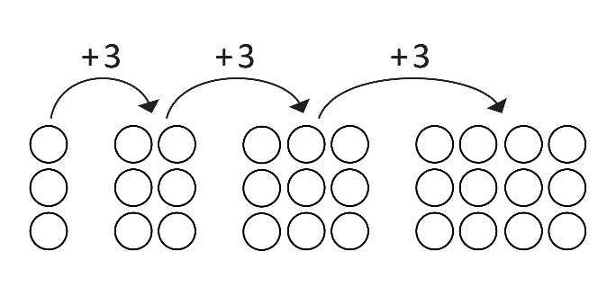  - identifying missing elements in a given pattern  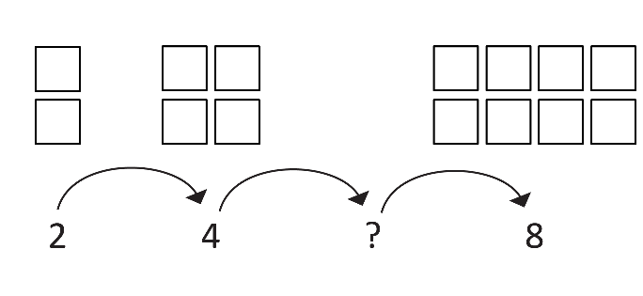

Sub-strand: Calculating with number
Pre-primary | Year 1 | Year 2
 | Manipulate collections to add and subtract quantities to 20 and beyond, exploring a range of strategies  For example:  - exploring strategies, such as counting on, counting back, partitioning and part-part-whole knowledge, to solve addition and subtraction problems  - using concrete materials to partition quantities to assist in addition and subtraction, such as using ten-frames to calculate $9+7$  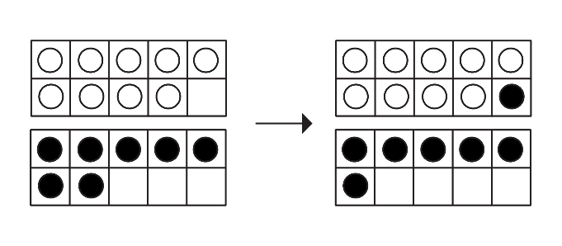  - using non-count-by-one strategies, such as using doubles for near doubles and combining numbers that add to $10$, such as $4+5$ as double $4$, add $1$  - counting back using the jump strategy, such as $16-7$ becoming $16-6-1$ | Add and subtract one- and two-digit numbers, using a range of strategies  For example:  - selecting and applying strategies, such as counting on, partitioning, part-part-whole knowledge, rearranging, regrouping, doubles, near doubles and bridging to 10  - partitioning and rearranging numbers using concrete and written representations  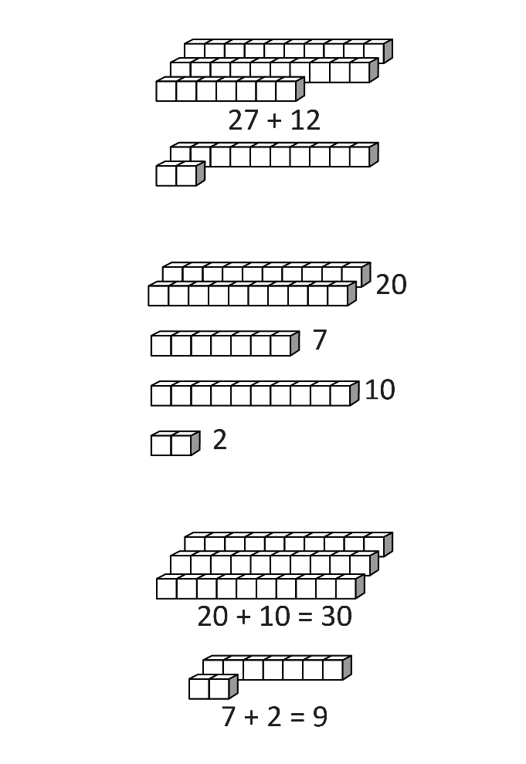  - using number lines or hundreds charts by moving along or up and down in tens and ones to solve addition and subtraction problems, such as the jump strategy for  $$79-33$$  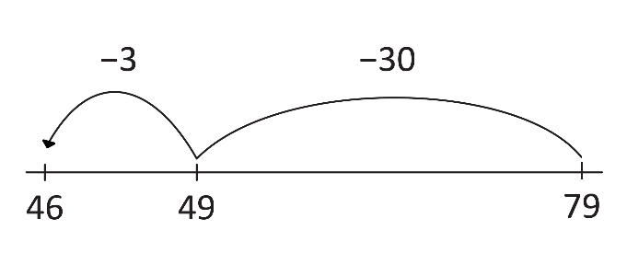

Sub-strand: Financial mathematics
Pre-primary | Year 1 | Year 2
Explore making purchases using coins, notes and debit cards  For example:  - describing that money is used to buy things  - sorting coins, notes and debit cards  - using coins, notes or debit cards to role-play making purchases using appropriate language | Explore different payment formats and identify Australian coins and notes, according to their value  For example:  - arranging Australian coins and notes by value and counting small collections of each with the same denomination  - demonstrating different payment formats using coins and notes, such as a $\$5$ note being equal to five $\$1$ coins in play-based situations | Explore and describe the relationship between dollars ($\$$) and cents (c) and their value in the contexts of spending, saving and donating  For example:  - identifying that $\$3$ is the same as $300$ cents  - counting small collections of coins and using the $\$$ and c symbols to record amounts  - discussing the benefits of saving and donating, including goals and reasons why people save and donate money  - identifying and comparing the cost of familiar items at the school canteen or stalls at a market, noticing the different ways money is represented, such as $\$5$, $35c$, $\$2.40$

Sub-strand: Modelling with number
Pre-primary | Year 1 | Year 2
Explore and represent familiar real-world situations involving adding, removing, grouping or sharing small collections using role-play or concrete materials  For example:  - using role-play and materials to represent mathematical relationships in stories, such as a group bringing three sandwiches and another group adding four more, or children starting with 10 apples but eating three during the picnic; drawing a picture and using materials to represent the situation, discussing and recording the result of the action with a numeral  - using objects to role-play sharing out a collection one by one or handing out equal-sized collections for a purpose, such as sharing art materials like crayons, markers and paper | Represent quantities and actions in real-world situations involving adding, taking away, sharing or equal groupings using role-play, concrete materials, drawings or numbers. Describe the meaning of the representations and answers in context  For example:  - modelling situations, such as keeping track of the number of people on a bus as it stops to pick up and drop off people. Using role-play to represent the situation, explaining connections, such as when people are picked up the number is added to the people already on the bus and recognising the answer as the number of people on the bus when it arrives at the final destination | Identify and represent real-world situations involving addition, subtraction, simple multiplication or division using objects or diagrams labelled with numbers and symbols that match the actions in the situation. Interpret the meaning of answers in context  For example:  - modelling situations, such as determining how many juice boxes priced at $\$2$ can be purchased with 10 $\$1$ coins. Representing the situation using concrete materials, such as grouping 10 $\$1$ coins into pairs, explaining that each group represents the cost of one juice box, then counting the groups and recognising that five groups means that five juice boxes can be purchased  - using familiar situations, such as  - a fundraising activity where children collect bottles for recycling, earning 10c for each bottle  - sharing a raffle prize of biscuits between children  - keeping score when playing sport

Strand: Measurement and geometry

Sub-strand: Two-dimensional space and structures
Pre-primary | Year 1 | Year 2
Sort, name and represent familiar two-dimensional shapes and recognise them within the environment  For example:  - sorting and naming 2D shapes, such as rectangles, squares, triangles, ovals and circles, based on chosen criteria  - locating shapes in the school environment, such as circles and rectangles on the netball court | Name and classify familiar two-dimensional shapes based on sides and vertices using informal language  For example:  - classifying familiar 2D shapes, such as triangles, quadrilaterals, circles and ovals, according to the number of sides and vertices  - exploring the characteristics of rectangles and squares, and saying that both have straight sides and square corners  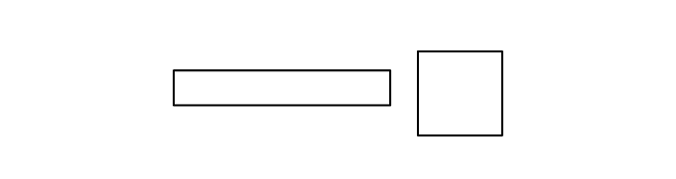  - describing a shape, so that others can name the shape and give reasons for their choice | Identify and draw two-dimensional shapes and describe their similarities and differences using formal spatial language  For example:  - describing 2D shapes using spatial terms, including opposite, parallel, curved, straight and vertices  - drawing 2D shapes, such as triangles, quadrilaterals, circles and ovals, with increasing attention to accuracy  - stating that a square is a rectangle, as both are quadrilaterals with two pairs of parallel sides, but all four sides in a square are equal length  - identifying which shape ‘doesn’t belong’ to a given group, explaining the reasoning
Explore and directly compare the length of everyday items to say which is longer and explain reasoning  For example:  - recognising length as the measure of an object ‘end to end’, such as comparing two leaves side by side to determine which is longer  - using everyday language and phrases, such as longer than, taller than and shorter than, to explain the comparisons | Directly and indirectly compare lengths, including by counting uniform informal units  For example:  - using uniform informal units as a ‘go-between’ to indirectly compare the length of objects, such as using paperclips or connecting blocks to compare the length of a pencil and scissors  - recognising that the same informal unit must be used repeatedly and explaining the relationship between the size of a unit and the number of units needed | Estimate, measure and compare lengths by choosing appropriate uniform informal units and placing end to end without gaps or overlaps  For example:  - choosing suitable uniform informal units and explaining choices, such as using longer units to measure the width of a room  - investigating how gaps and overlaps impact accuracy  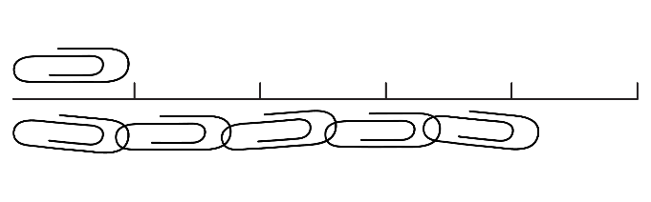  - creating an informal unit measuring tape using matchsticks or paperclips as the unit
Explore and directly compare the areas of two shapes by superimposing one over the other
For example:
- using everyday practical situations to identify area as the total space taken up by a 2D surface, such as the area covered by a rug
- comparing the areas of two similar shapes directly by drawing, tracing or cutting and pasting
- superimposing similar shapes to compare their areas and using everyday language to explain the comparisons, such as placing a foot against the sole of a shoe or lids on jars
Explore quarter-, half- and full turns in everyday situations
For example:
- identifying turns that happen in familiar environments, such as a spinner in a board game (full turn), a half-turn on a hand of a toy clock or a door opening and closing (quarter-turn)
- connecting quarter- and half-turns of the minute hand on a clock to the passing of quarter- and half-hours, and the language of clockwise and anticlockwise
Show and describe position and movement in familiar locations  For example:  - showing positions of people and objects in both practical and play-based situations, and describing using words such as in, out, under, next to, in between etc.  - describing movement in familiar settings using everyday language  - describing the path to a particular location in the classroom or playground | Give and follow directions within familiar locations  For example:  - narrating a pathway as a sequence of steps, using everyday directional language, such as left, right, forward, backward, turn and using familiar landmarks  - providing verbal directions to a particular point or object within the classroom or school play areas  - carrying out own and peer instructions to move around the school, noticing and addressing any inaccuracies | Locate positions and pathways on simple maps of familiar locations  For example:  - interpreting simple maps by identifying objects in different locations  - recognising maps as representations seen from above (bird’s-eye view)  - following a simple route on a map using landmarks and directional language, such as ‘to get to the park, walk towards the pond and then take the path to the left’

Sub-strand: Three-dimensional space and structures
Pre-primary | Year 1 | Year 2
Explore familiar three-dimensional objects in the environment  For example:  - locating 3D objects and differentiating from 2D shapes  - building with 3D objects, such as construction materials, blocks or loose parts, to investigate stacking and rolling | Recognise, sort and name familiar three-dimensional objects and identify the two-dimensional shapes that comprise them  For example:  - naming familiar 3D objects, including cubes, cylinders, cones, spheres and rectangular prisms  - recognising 2D shapes on surfaces of 3D objects, such as a circle visible on the bottom of a glass  - selecting a set of 2D shapes from a collection to match the faces of a provided 3D object | Manipulate, visualise and name familiar three-dimensional objects, informally describe features and connect to common uses  For example:  - selecting a 3D object from a small collection inside a bag, including cubes, cylinders, cones, spheres and rectangular prisms, and describing it by feel, so that others can name the 3D object and give reasons for their choice  - considering how key features of 3D objects, such as flat or curved surfaces, are related to common uses (stacking or rolling)
Explore capacity and directly compare containers to say which holds more and explain reasoning  For example:  - in a play-based context, exploring capacity through intentional questioning focused on how much containers can hold  - directly comparing two containers by filling one with liquid and then pouring it into the other, observing if it fills the second container a little bit, half full, full or overflowing | Directly and indirectly compare the capacities of a pair of containers  For example:  - filling two different containers with liquid, then pouring their contents into two identical transparent containers to compare how much they hold  - exploring containers with the same capacity but different shapes to recognise that a tall, narrow container may hold the same amount as a short, wide container | Estimate, measure and compare the capacities of different containers using uniform informal units  For example:  - using a uniform informal unit such as a yoghurt cup, estimate how many yoghurt cups of water it will take to fill larger containers, pouring water into the containers and counting how many cups they can hold  - identifying that the larger the unit, the fewer number of units the container will hold (less yoghurt cups will be needed to fill a container than tablespoons)  - recognising and explaining why containers of different shapes may have the same capacity

Sub-strand: Non-spatial measurement
Pre-primary | Year 1 | Year 2
Explore mass and directly compare everyday items by hefting  For example:  - directly comparing everyday items to say which is heavier or lighter  - manipulating objects of varying sizes and weights, such as pillows and rocks, to challenge the misconception that larger objects are heavier  - comparing objects of similar size but different weights, such as golf balls and ping-pong balls | Directly compare the masses of two objects by hefting and using balance scales  For example:  - exploring the use of tools, such as pulleys, balance scales and seesaws, to compare the mass of two objects  - predicting the action of balance scales before placing objects on each side of the scale  - using comparative language, such as heavier and lighter, and recognising that the larger object is not necessarily the heavier object  - comparing a range of objects to witness relative mass (an object may be lighter than something, but heavier than something else) | Estimate and compare masses of objects using balance scales and uniform informal units  For example:  - placing an object on one side of the balance scale and estimating the number of counters or blocks needed on the other side of the scale to balance the object  - determining the weight of a lump of playdough using uniform informal units, then reshaping it to witness that the shape of the object does not alter the mass  - ordering the mass of three or more objects and using comparative language to explain the order; lightest, light, heavier, heaviest
Sequence days of the week and times of the day, making connections to routines, and compare duration of familiar events using everyday language  For example:  - exploring the cyclical nature of days of the week, identifying routine days, such as ‘library day’  - describing sequences of events using words, such as morning, lunchtime, afternoon, night-time, yesterday, today and tomorrow  - sequencing familiar events, including the representation of time, with pictorial timelines  - identifying time as a measurement for practical comparisons, such as noticing that eating a meal takes longer (more time) than brushing your teeth | Read the time on digital clocks and make connections to routines. Explore and describe duration informally in years, months, weeks, days, hours, minutes and seconds  For example:  - exploring how time on a digital clock is read in hours and minutes, recognising that if the hour numbers are followed by 00, it is read as o’clock, and if the hour is followed by other numbers (minutes), it is read as nine-fifteen or ten twenty-five  - discussing events and activities and deciding duration, such as having a drink of water taking seconds, recess lasting minutes and the school day lasting hours | Tell time to the hour, half- and quarter-hour on analogue and digital clocks. Identify the date and determine the duration between two events in days using a calendar  For example:  - identifying which hour has passed when the hour hand is not pointing to a numeral  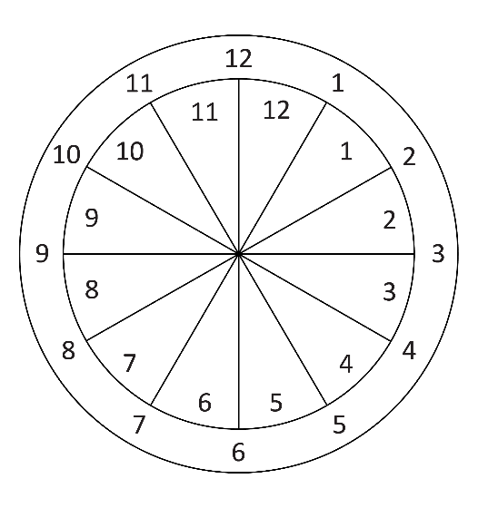  - describing the position of the minute hand on the clock for half past, quarter past and quarter to, recognising that the same time can be read in different ways, such as half past four, four-thirty and thirty minutes past four  - finding specific dates on a calendar, such as birthdays and school events, and determining how many days are left between today and the event, including when the two dates are in different months

Strand: Probability and statistics

Sub-strand: Probability
Pre-primary | Year 1 | Year 2
Identify and describe familiar events using the everyday language of chance  For example:  - reading a story and asking what might happen next and what cannot possibly happen next  - describing real and imagined situations, using terms like will happen, can happen, might happen and cannot happen | Describe and reason about the likelihood of familiar events occurring, using the everyday language of chance  For example:  - expressing the likelihood for events, such as ‘The sun rising in the morning’, ‘Flying home today’ or ‘Rain on sports day’, using terms like cannot happen, unlikely to happen, might happen or certain to happen  - recognising times and reasoning when things don’t go as expected, such as the school bell not ringing at the end of the day | Classify familiar events involving chance as being ‘possible’ or ‘impossible’ and using the everyday language of chance to compare the likelihood of them happening  For example:  - distinguishing impossible from unlikely events with statements such as ‘We never go to the park after school, but it isn’t impossible, as it could happen’  - comparing the likelihood of events, such as ‘Are we more likely to see a bird or a kangaroo in the playground?’ or ‘Is it more likely we will eat lunch at school or have a picnic in the park?’

Sub-strand: Statistics
Pre-primary | Year 1 | Year 2
Describe and interpret real-life data represented in lists, tables and one-to-one block and picture graphs
For example:
- interpreting a picture graph and discussing questions such as ‘Are there more pears or more bananas?’; ‘Which fruit is there most of?’; selecting a fruit not in the display (grapes) and asking ‘How many people brought grapes? How can you tell?’
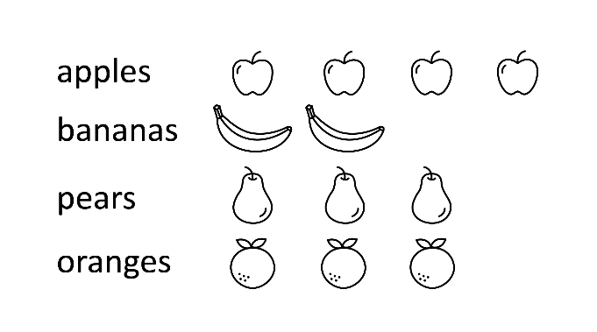
- interpreting a table, reading the headings and categories to determine what data is being shown and answering questions, such as ‘How many children were asked about their favourite sport?’
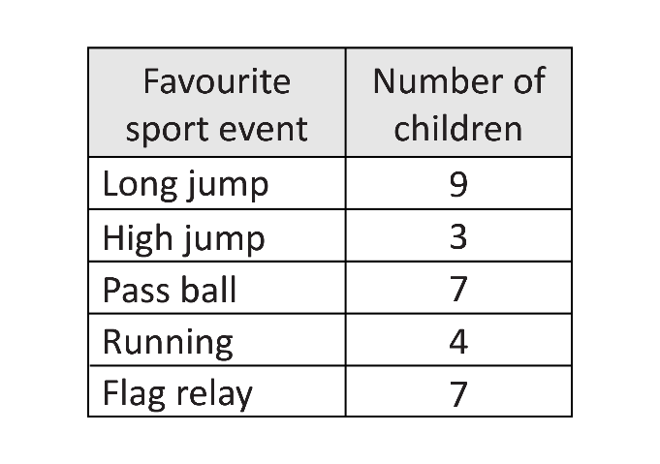
Collect, group and compare data using objects and images to answer questions  For example:  - sorting a collection of leaves from the school grounds to co-create a visual display. Making comparative statements based on the data, such as ‘There are more yellow than brown leaves’  - using objects to organise data when exploring questions, such as ‘Do you prefer running, cycling or dancing?’ and comparing the data by subitising, counting and reasoning  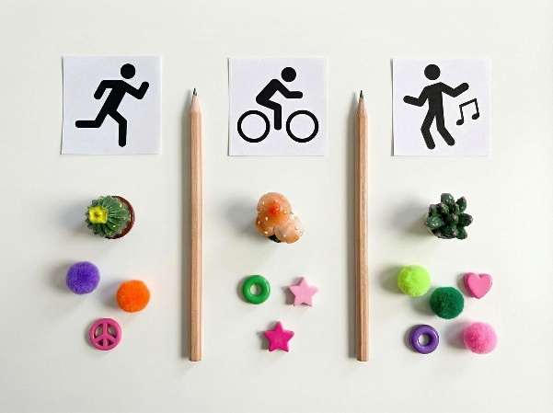 | Answer simple questions of interest by collecting and comparing categorical data to record frequencies  For example:  - collecting and comparing data using objects, pictures, tallies and numbers using one-to-one representation  - exploring strategies to collect and record data to answer a question, such as ‘What is the most common material used in playground equipment?’ and recording the frequency of observations  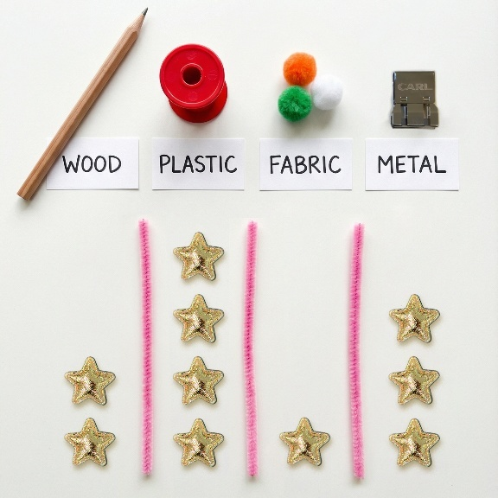 | Choose and answer questions of interest by collecting and comparing categorical data. Display data using lists, tables and one-to-one block and picture graphs  For example:  - answering questions, such as ‘Which month has the most birthdays?’, recording responses and displaying this data on a graph, recognising the need to use similar sized symbols and spacing them uniformly  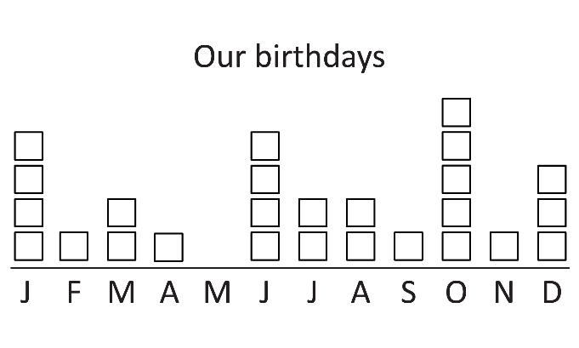  - displaying data from observations in a table or list  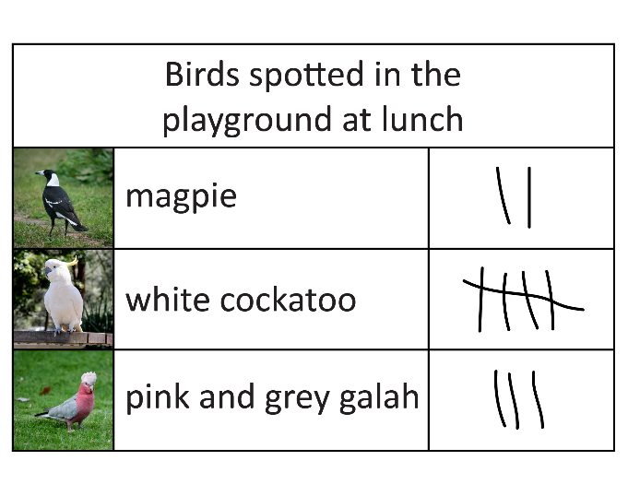

Years 3–6

Strand: Number and algebra

Sub-strand: Understanding number
Year 3 | Year 4 | Year 5 | Year 6
Read, write and order numbers to at least four digits, including on a number line. Recognise the repetition of the 0–999 sequence of digits  For example:  - using diagrams to support reading large numbers based on understanding of place value  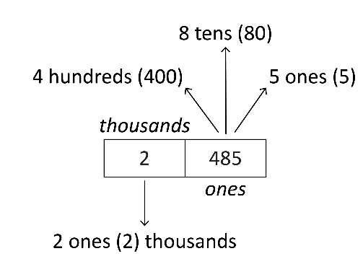  - arranging numbers in the hundreds in ascending and descending order  - comparing different hundreds charts, such as 1301–1400 and 1901–2000, to identify patterns  - identifying missing numbers on the markings for a given number line  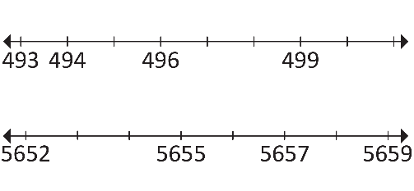 | Read, write and order numbers to at least six digits. Recognise the significance of the final digit to determine odd and even numbers  For example:  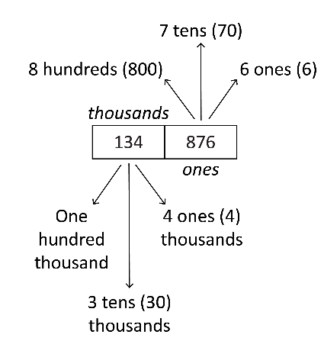  - using diagrams to support reading of numbers to at least six digits, recognising that the sequence of ones, tens and hundreds is repeated in the thousands  - arranging numbers in the thousands in ascending and descending order  - identifying that all whole numbers that end in the digits 0, 2, 4, 6 and 8 are even and that whole numbers ending in 1, 3, 5, 7 and 9 are odd | Read, write and order seven-digit numbers and beyond  For example:  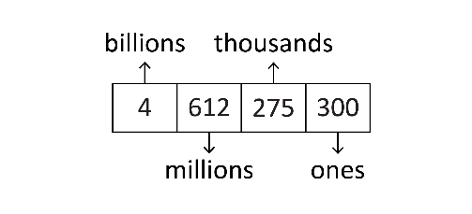  - using diagrams to partition numbers in groups of  three digits, associate them to the place value (i.e. billions, millions etc.) and support reading  - arranging numbers in the millions in ascending and descending order | Investigate the use of positive and negative integers to represent everyday situations. Read, write and order integers on a number line  For example:  - identifying negative integers in familiar contexts, such as temperatures, sea levels, bank balances and buildings with underground parking  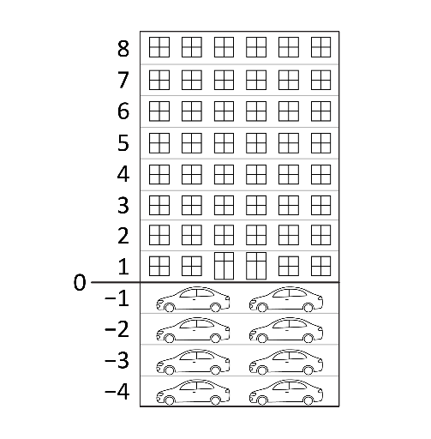  - interpreting the marking of increments on the number line on both sides of the zero mark  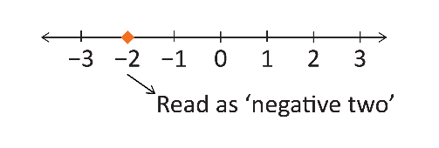
 | Read and write decimal numbers up to two decimal places  For example:  - reading decimal numbers correctly, such as $0.25$ as ‘zero point two five’  - express decimals as both tenths and hundredths, such as $0.25$ is $2$ tenths and $5$ hundredths or $25$ hundredths | Read, write, compare and order decimal numbers, including on a number line  For example:  - reading decimal numbers correctly, such as $1.436$ as ‘one point four three six’  - comparing decimal numbers, such as $0.25<2.5,$ $2.46>2$ and $1.45<1.54$  - comparing and ordering decimal numbers, such as $0.5, 0.75, 0.25, 0.001$, and positioning them on a number line  - interpreting zero digit/s at the end of a decimal, such as recognising that $0.170$ and $0.17$ have the same value
Represent and partition numbers  up to four digits, including groups of 10 (tens), 10 groups of 10 (hundreds) and beyond, using concrete materials and number sentences. Recognise that the value of a digit is determined by its place in a number  For example:  - bundling materials (e.g. pipe-cleaners or popsticks) into groups of 10, 10 groups of 10 to form $100$ and 10 groups of $100$ to form $1000$, connecting bundles to numerals  - using expanded notation to see partitions of a number, including using a calculator, such as  $$328=300+20+8$$  - exploring non-standard partitions, such as  $328=200+125+3$ or $328$ as 3 hundreds and $28$ ones  - recognising the different place values of a digit, such as 8 in 2848  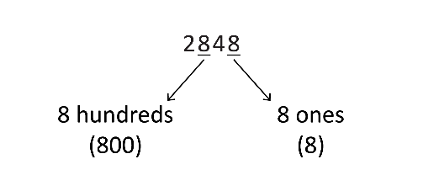 | Represent numbers up to five digits using place value and non-standard partitions with equations. Recognise the multiplicative (10 times as many) place value relationship between adjacent places from right to left  For example:  - partitioning numbers using place value, such as  $1276=1000+200+70+6$,  and non-standard partitions, such as  $3733=3500+200+28+5$ or $3733$ as $37$ hundreds and $33$ ones  - recognising the place value relationships  1(ones) × 10 = 10 (tens)  10 (tens) × 10 = 100 (hundreds)  100 (hundreds) × 10 = 1000 (thousands)  1000 (thousands) × 10 = 10 000 (ten thousands)  - identifying how rearranging digits changes the size of a number, such as forming the second largest number by rearranging the digits within $4321$ | Represent and partition numbers up to seven digits. Use the multiplicative place value relationship between adjacent places to explain the value of a digit  For example:  - partitioning numbers using place value, such as  3 487 621 = 3 000 000 + 400 000 + 80 000 + 7000 + 600 + 20 + 1,  and non-standard partitions, such as  $$645 522=500 000+100 000$$  $$+ 45 000+522$$  - using the multiplicative place value relationship, explaining the different values of the fours in 5446 i.e. the 4 in the hundreds place is 10 times as many as the 4 in the tens place  - identifying the place value relationships  10 000 (ten thousands) ÷ 10 = 1000 (thousands)  1000 (thousands) ÷ 10 = 100 (hundreds)  100 (hundreds) ÷ 10 = 10 (tens)  10 (tens) ÷ 10 = 1 (ones) | Represent and explain the multiplicative place value relationship between places in any number, including decimals  For example:  - using calculators to explore multiplying and dividing whole numbers and decimals by powers of 10, recording results and noticing patterns  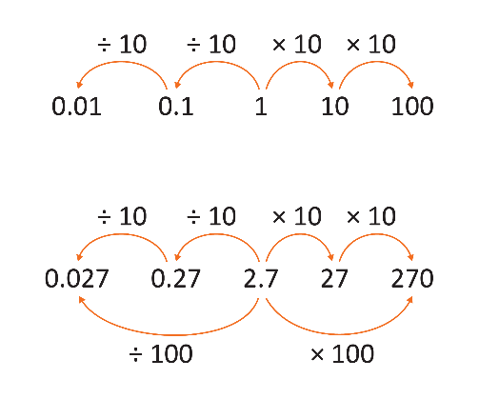  - explaining the multiplicative place value relationship, such as  - $62$ is $10$ times as many as $6.2$ because $60$ is $10$ times as many as $6$ and $2$ is $10$ times as many as $0.2$  - $20.8$ is $100$ times as many as $0.208$ because $20$ is $100$times as many as $0.2$ and $0.8$ is $100$ times as many as $0.08$
 | Represent and explain the relationship between one whole being shared equally among $10$ as $0.1$ or $\frac{1}{10}$ and being shared equally among $100$ as $0.01$ or $\frac{1}{100}$ using concrete materials  For example:  - dividing a long strip of paper into 10 equal parts labelled as $0.1$ and then dividing the last tenth into ten equal parts to demonstrate $0.01$ (hundredths of the whole)  - using a calculator to perform the same process, such as  $1÷10=0.1$ (recognising that $1$ is $10$ times as many as $0.1$) and$0.1÷10=0.01$ (recognising that $0.1$ is $10$ times as many as $0.01$) | Represent and partition decimal numbers. Use the multiplicative place value relationship between adjacent places to explain the value of a digit  For example:  - using place value to partition decimals, such as  $5.37=5+0.3+0.07$and $5.429$ is $5$ ones and $429$ thousandths  - comparing the value of digits by determining numbers that are $10$ times the original decimal number, such as $5.0$ is $10$ times $0.5$  - exploring multiplying and dividing by $10$ using digital tools and explaining place value relationships, such as  $$492 731÷10=49 273.1$$  $$49 273.1÷10=4927.31$$  $$4927.31÷10=492.731$$
Represent and explain the relationship between addition and subtraction using part-part-whole models and number sentences
For example:
- using part-part-whole models to demonstrate how addition and subtraction are inverse operations
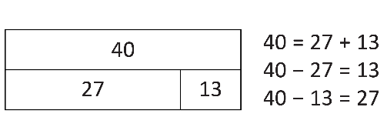
Recall addition and subtraction facts to 20
For example:
- recalling combinations of two numbers that add up to $20$ and related subtraction facts
- using related number facts,
such as $14+6=20$, so $20-6=14$ and $20-14=6$
Explore and represent the relationship between multiplication and division using diagrams, arrays and number sentences  For example:  - understanding that an array is a rectangular arrangement of objects used to model multiplicative situations, where rows represent the first factor and columns represent the second factor  - arranging and rearranging a collection of 12 into arrays, exploring the connection between multiplication and division, such as  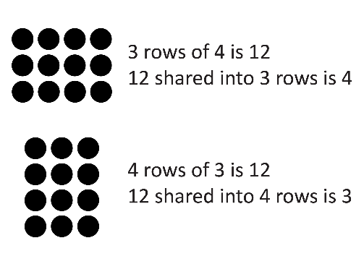  - investigating the result of multiplying and dividing by one and multiplying by zero  - relating doubling to multiplication facts for two and four, recognising that doubling is multiplying by two and halving is dividing by two | Represent and explain the relationship between multiplication and division using arrays and equations  For example:  - using knowledge of arrays to explain how many rows of seven are needed to make 42  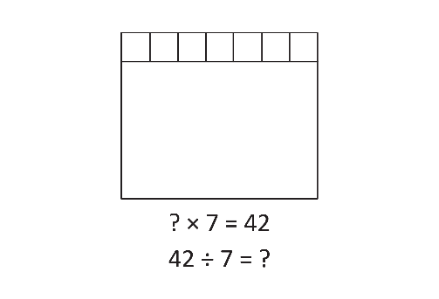 | Explore, identify and represent factors and multiples of whole numbers in arrays and explain reasoning  For example:  - using blocks or grids to form different rectangles to list all possible factors for that number, such as $12$ can form the following rectangles: $1×12, 2×6$and $3×4$  - demonstrating that all multiples can be formed by combining or regrouping, such as multiples of seven can be formed by combining a multiple of two with the corresponding multiple of five  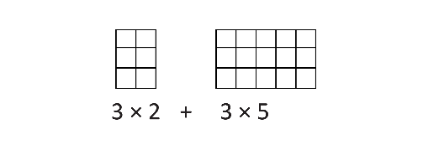  - identifying lowest common multiples and highest common factors of pairs or triples of whole numbers, such as the lowest common multiple of six and nine is 18 and the highest common factor is three and the lowest common multiple of three, four and five is 60 and the highest common factor is one  - creating a sequence of steps based on multiplication and division facts to determine if a number is a multiple or a factor of another number, and representing this in diagrams or flow charts, such as a yes/no flow chart | Explore, identify and represent square, prime and composite numbers in arrays and explain reasoning  For example:  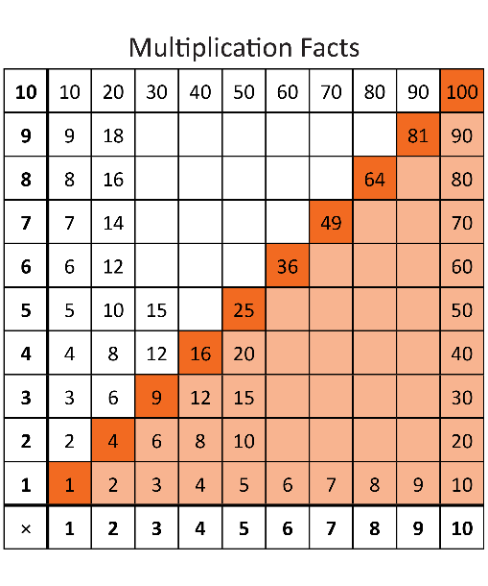  - using visual representations to explore and reason about square numbers  - using tiles, blocks or visual representations to form arrays to explore and explain what makes a number prime or composite  - recognising that a prime number, which has exactly two distinct factors, itself and one, has only one row when represented as an array
Recall multiplication facts of 2, 3, 4, 5 and 10, and related division facts  For example:  - recognising and using the symbols for multiplied by ($×$) and divided by ($÷$)  - using the commutative property of multiplication to extend multiplication facts, such as recognising that if $10×3=30$ then $3×10=30$ | Recall multiplication facts up to 10$×$10, and related division facts  For example:  - using arrays and grid paper to represent and explain patterns in the multiplication and division facts related to $10×10$  - using knowledge of doubles and near doubles to establish the multiplication facts, such as using doubles for $8×6$ where  $2×6=12$ doubles to  $4×6=24$ doubles to  $8×6 =48$  - recognising the distributive property of multiplication, such as when finding $6×7$, knowing that $7$ is made up of $2$ and $5$, so  $6×2=12$ and $6×5=30$, and therefore$12+30 = 42$
Recognise, represent and describe unit fractions $\frac{1}{2},\frac{1}{3},\frac{1}{4}, \frac{1}{5}$and $\frac{1}{10}$.  Combine unit fractions with the same denominator to create a complete whole  For example:  - describing fractions using words and numerical representations, such as one-third as one part out of three, $\frac{1}{3}$ or $1÷3$  - exploring fraction walls  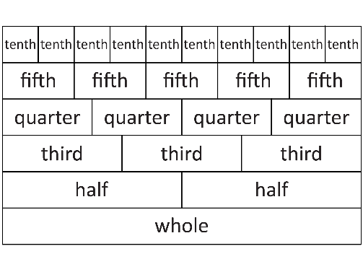  - representing fractions using shapes, objects, paper folding, fraction strips or number lines  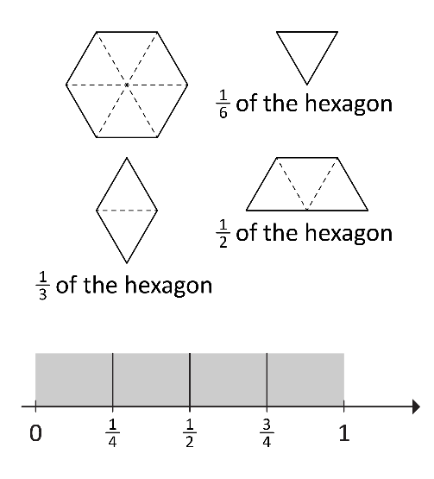  - finding the quantity of a whole collection, given the number of objects in one-third  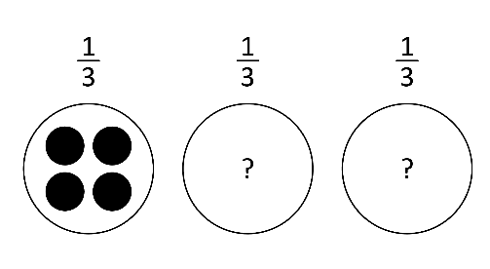  - sharing collections, such as popsticks or counters, between three, four and five people and connecting division with fractions, such as sharing between three people gives $\frac{1}{3}$ of the collection to each and sharing between five people gives $\frac{1}{5}$ of the collection to each | Explore and represent common equivalent fractions and make connections to their decimal representation  For example:  - representing a line, shape, object or collection using equivalent fractions  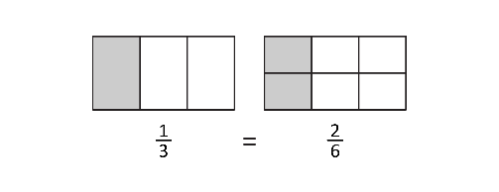  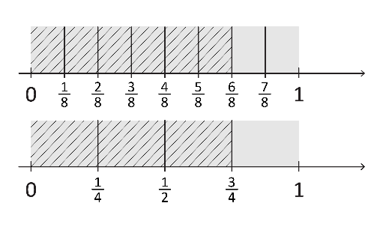  - demonstrating equivalent fractions as lengths and using paper folding  - building familiarity with common equivalent fractions, such as  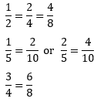  - connecting fractions and decimals by aligning number lines to show equivalence  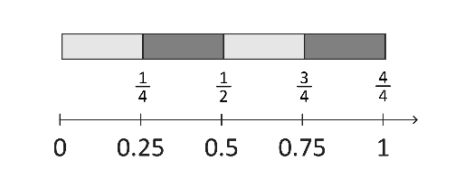 | Count by unit fractions, locate and represent on number lines and extend to mixed numerals  For example:  - cutting objects, such as oranges, into sixths and counting by sixths to find the total  - counting forwards and backwards by unit fractions  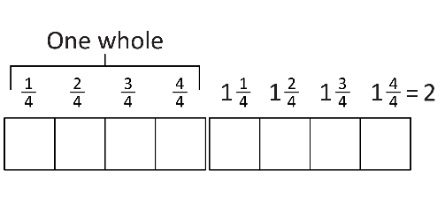  - describing and representing quantities that are more than one whole  - moving flexibly between mixed numerals and improper fractions, such as seeing that $1\frac{1}{4}$ is equivalent to $\frac{5}{4}$ | Order common fractions with the same and related denominators, including mixed numerals, using diagrams and number lines  For example:  - using a range of representations, such as number lines, paper strips, shapes and objects, to assist in ordering common fractions, such as $\frac{1}{2}$ , $\frac{2}{3}$ and $\frac{1}{6}$, and demonstrating that $\frac{1}{3}$ is equivalent to $\frac{2}{6}$ when ordering fractions on a number line  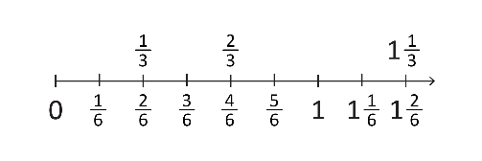
 |  | Identify the use of percentages in everyday situations and recognise that 100% represents a complete whole, which is equal to one  For example:  - using grid paper to represent a whole  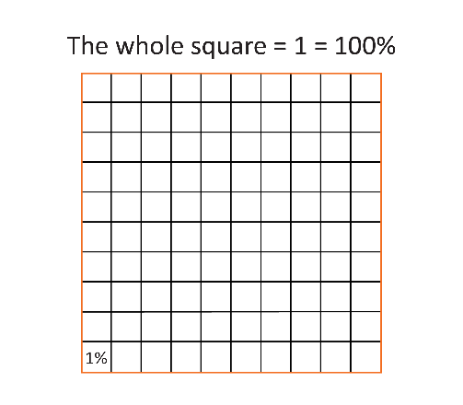  - identifying the use of percentages in familiar contexts, such as battery levels on laptops or tablets, sport statistics or supermarket discounts  - recognising percentages that represent more or less than a whole, such as 120% is more than a whole and 75% is less than a whole | Connect commonly used percentages, including 10%, 25% and 50%, to fractions and decimals, including on a number line  For example:  - recognising the percentage symbol (%) is used to show a ratio out of 100  - contextualising percentages, such as comparing the advantages of being offered a 10%, 25% or 50% discount, in connection to fractions, such as ‘50% off’ is half price  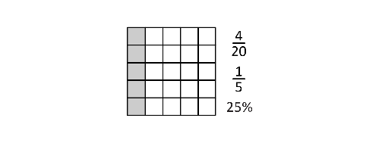  - using representations to identify fractions and the corresponding percentages  - using visual aids to explore percentages as parts of a whole, exploring wholes that are different sizes  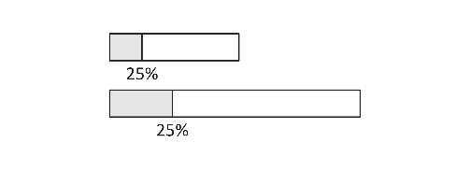

Sub-strand: Understanding equalities and inequalities
Year 3 | Year 4 | Year 5 | Year 6
Explore and use the greater than, less than and equality symbols to compare two whole numbers or statements involving addition and subtraction  For example:  - recognising and using the symbols for greater than ($>$) and less than $\left(<\right)$  - using the correct inequality symbol to compare two given numbers, such as 5 2  - using equality and inequality symbols to compare numbers and statements, such as  7 + 3 11  12 + 8 1 + 19  8 + 4 7 + 6  20 – 12 + 2 10 −3 | Decide if statements of equality and inequality involving the four operations are true, and explain reasoning  For example:  - classifying statements as true (T) or false (F)  $17+0=0$(F)  $52+17<70$(T)  $60-10>60÷10$ (T)  $16$÷$1>16×1$ (F)  - reasoning to identify, without calculating, that  $6×12<6×14$because multiplying 6 by a larger number will result in a larger answer  - reasoning to insert the correct value to make the statement true when there is an unknown quantity, such as 12 + = 20 | Complete and check statements of equality and inequality involving the four operations, and explain reasoning  For example:  - completing statements, such as  28 × 5 ÷ = 28  2 × 3 × 4 × 5 = 4 × 3 ×  - checking statements, such as $2×18=4×9,$to identify if they are true or false, explaining that doubling one number and halving the other will give the same result  - reasoning to insert the correct symbol to make true statements without calculating, such as  15 + 87 16 + 86  - reasoning to make the statement true when there is an unknown quantity, such as  35 × = 70 | Complete, check and construct statements of equality and inequality involving the four operations, including the use of brackets and order of operations, and explain reasoning  For example:  - checking statements to say if they are true (T) or false (F), such as  $\frac{1}{2}×0=\frac{1}{2}$ (F)  $10 × 0.2<10÷2$ (T)  - completing statements, such as  (3 + 5) × 2 23 + 5 × 2  and explaining reasoning using order of operations  - explaining where to put brackets in a number sentence to make the statement true, such as $2+4×7=42$

Sub-strand: Patterns and relationships
Year 3 | Year 4 | Year 5 | Year 6
Create and represent increasing or decreasing additive patterns from any starting point, using concrete materials and numbers, and describe rules to represent the pattern  For example:  - using concrete materials to represent an increasing additive pattern and describing it, recognising the importance of the starting point, such as ‘starting at five and adding three more each time’  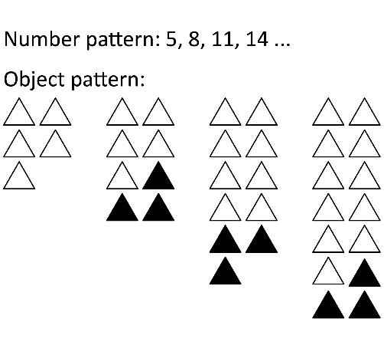  - using concrete materials to represent and describe a decreasing additive pattern, such as  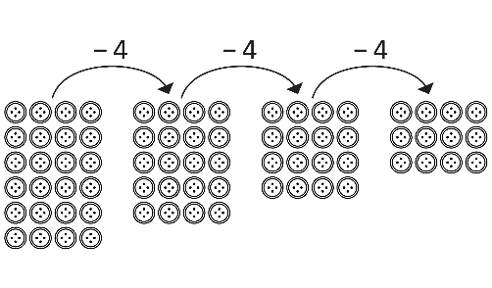  - creating and describing a variety of number patterns that increase or decrease by a constant amount, such as $20, 25, 30$… or $16, 12, 8$… | Create and represent increasing multiplicative patterns, using concrete materials and numbers, and describe rules to represent the pattern  For example:  - using concrete materials to represent an increasing multiplicative pattern and describing it, such as ‘starting at six and multiplying by two each time’  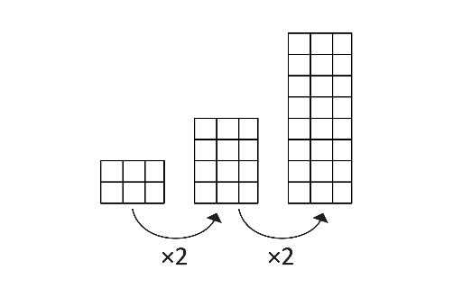  - creating and describing a variety of multiplicative number patterns, such as $2, 10, 50, 250$ … or $4, 12, 36, 108$ … | Follow rules to create increasing or decreasing additive and multiplicative patterns using concrete materials and numbers. Explore ways to predict unknown values  For example:  - following a rule, such as ‘starting at two, double and add one, and repeat’, drawing or creating the pattern and producing the sequence $2, 5, 11, 23$ …  - recognising that the same pattern can be created using different rules and predicting that the number of toothpicks needed for eight boxes will be $1$ plus $8$ lots of $3$ or $4$plus $7$ lots of $3$, such as  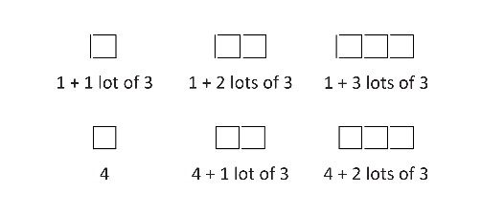  - entering an additive and multiplicative formula, such as  = (A1*3 – 5), into a spreadsheet and following the rule to generate a sequence of numbers, starting from $3$, to determine the $15$th term  - predicting if the next number in a pattern will be odd or even | Create and represent increasing or decreasing patterns using concrete materials and numbers. Use words to generalise rules that relate each element of a pattern to its position  For example:  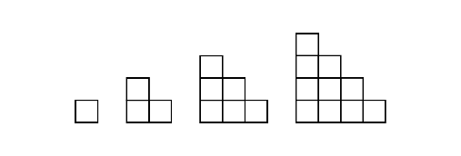  - using toothpicks, counters, blocks or drawings to create patterns, investigating and making predictions, such as the number of squares in the sixth diagram being 21 as  $6+5+4+3+2+1=21$  - recognising that one pattern can generate many rules, such as a square with side lengths of $10$ having $8×8=64$ black squares,  $10+10+8+8$ or  $4×10-4=36$ white squares and  $10×10=100$ squares altogether  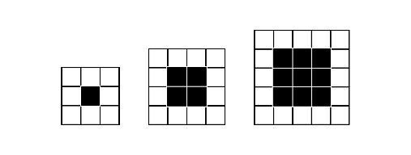  - considering sequences, such as $1, 3, 5…$, and recognising the rule, which in this case is double the position number and subtract one, then using the rule to predict the $200$th odd number

Sub-strand: Calculating with number
Year 3 | Year 4 | Year 5 | Year 6
Add and subtract two- and three-digit numbers using a range of strategies  For example:  - using and applying a range of strategies, such as partitioning, rearranging, number lines, bar models and part-part-whole models  - rearranging and partitioning to facilitate calculations, such as $37+28$ (subtract $3$ from $28$ and add to $37$)  $40+25$ (using place value partitioning)  $$60+5=65$$  - solving subtraction problems efficiently by adding or subtracting a constant amount to both numbers, such as  $534-395$ adding $5$ to both numbers to make  $$539-400=139$$  - using a number line, such as for $159+23$  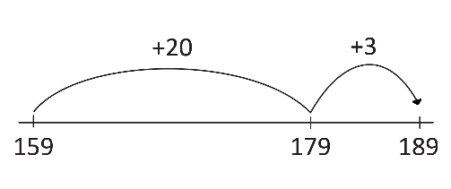  - using a part-part-whole model, such as for  237 – = 189  and using the inverse relationship to solve for change unknown in  189 + = 237  using the inverse of addition (subtraction) to solve 237 – 189 =  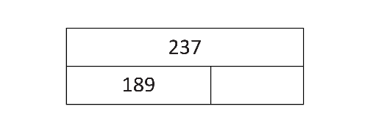 | Add and subtract whole numbers up to four digits using flexible and efficient strategies  For example:  - using and applying a range of strategies, such as  Bridging the decades  (385 + 47 → 385 plus 15 = 400 plus 32 is 432)  Quantity values  (36 + 27 → 36 plus 20 = 56 plus 4 is 60 and 3 is 63)  Compensation  (28 + 35 is the same as 30 + 35 = 65, subtract 2 to obtain 63)  (125 − 78 → 125 – 80 = 45, add 2 to obtain 47)  Levelling  (264 +198 is the same as 262 + 200)  Constant difference  (125 − 78 is the same as 127 − 80)  - setting out standard and  non-standard partitions to facilitate addition and subtraction  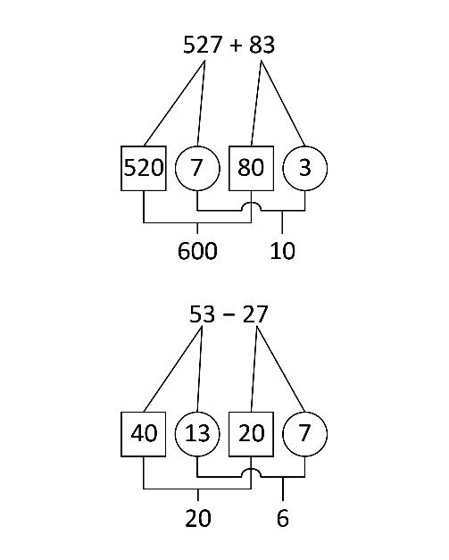  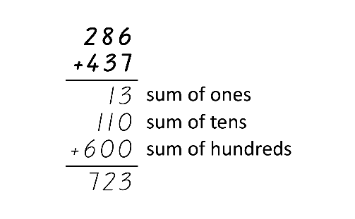  - using algorithms, showing understanding to record addition and subtraction calculations  - recognising how hundreds are exchanged in subtraction algorithms requiring regrouping  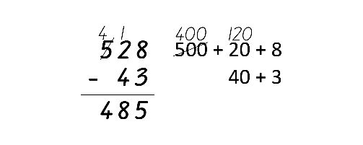  - recognising when mental strategies would be more efficient than a vertical algorithm for subtraction, such as $900-3$ or $500-498$  - using the inverse relationship between addition and subtraction to find missing  numbers in calculations, such as  – 15 = 19  83 = 55 +  18 + 5 = + 16 | Add and subtract any whole numbers using flexible and efficient strategies  For example:  - applying known strategies,  such as  Levelling  (4988 + 955 → 4990 + 953 → 5000 + 943)  Addition for subtraction  (5009 3997 add 3 is 4000 plus 1009)  Constant difference  (5009 − 3997 → 5012 − 4000)  Bridging  (4988 + 955 = 4988 plus 2 plus 10 plus 943)  Place value  (42 000 + 5123 + 246 = 40 000 + 7000 + 300 + 60 + 9)  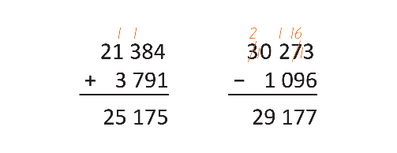  - using algorithms to record addition and subtraction calculations  - identifying efficient and inefficient multidigit subtraction strategies, such as solving $9000-7$ mentally is efficient and solving using an algorithm is inefficient | Choose and use flexible and efficient strategies to calculate with whole numbers, involving any of the four operations, and explore the use of the order of operations  For example:  - selecting and using efficient strategies to multiply whole numbers, such as  $5000×90$mentally but  $4974×87$using a calculator  - applying the order of operations to solve equations, such as  $5+\left(2×3\right)=5+6=11$  - representing remainders appropriately, as whole numbers, fractions or decimals
 |  | Add and subtract fractions with the same denominator using flexible and efficient strategies  For example:  - using concrete materials or diagrams  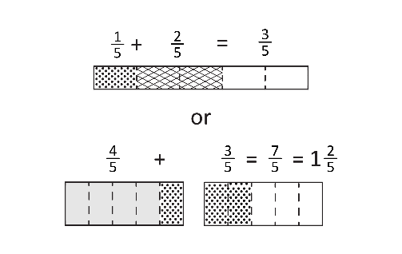  - using diagrams, objects and mental strategies to subtract a unit fraction from any whole number, including one  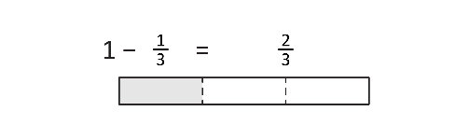 | Add and subtract fractions with related denominators, using flexible and efficient strategies, based on knowledge of equivalence  For example:  - representing fractional quantities with the same or related denominators to add and subtract fractions, such as ‘How much more is$\frac{3}{4}$ than $\frac{3}{8}?$’  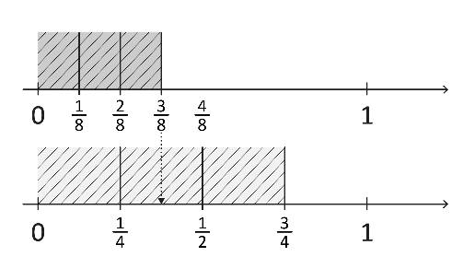  - calculating $\frac{1}{4}$ $+$ $\frac{1}{8} ,$ mentally or with jottings and diagrams, recognising that $\frac{1}{4}= \frac{2}{8}$ , so  $\frac{1}{4}+ \frac{1}{8}=\frac{2}{8}+ \frac{1}{8}=\frac{3}{8}$  - adding fractions by simplifying or grouping, such as  $\frac{7}{8}+\frac{1}{4}=\frac{7}{8}+\frac{2}{8}=1+\frac{1}{8}$  - using a number line, such as for $2 \frac{5}{6}$ – 1 $\frac{1}{6}$  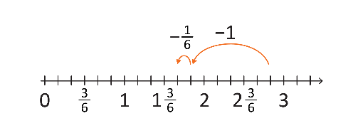
Add and subtract decimals to two decimal places, using flexible and efficient strategies
For example:
- using place value, such as
$8.4+3.6$
$$=8+3+0.4+0.6$$
$$=8+3+1$$
$$=12$$
and
$$5.8+7.4$$
$$5.8+7=12.8$$
$$12.8+0.4=13.2$$
- multiplying decimals by powers of $10$ to solve $2.15+2.35$
$$215+235=450$$
$$450÷100=4.5$$
- applying known strategies,
such as levelling or constant difference levelling
(2.94 + 5.16 → 3 + 5.1)
or constant difference
(2.57 – 1.03 → 2.60 – 1.06)
 | Multiply two-digit numbers by one- and two-digit numbers, and divide whole numbers by one-digit numbers, where there is no remainder, using flexible and efficient strategies  For example:  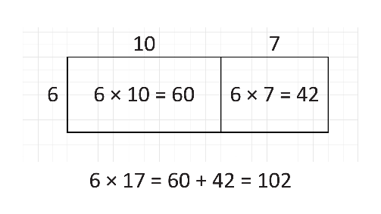  - using a variety of formats to partition numbers into ones and tens and represent operations in arrays to support calculations, such as $6×17$  or $14×16$  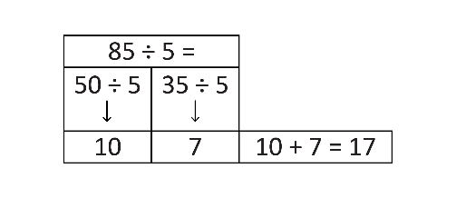  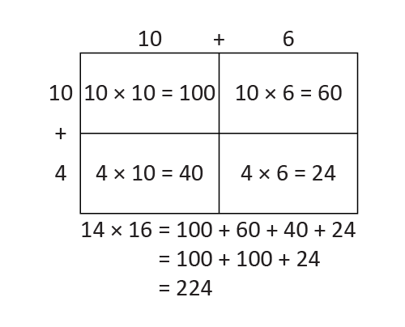  - using knowledge of multiples to partition as appropriate to divide, such as $85÷5=17$  - doubling for multiplying by four and eight, such as  $$8×19$$  $2×19=38$ doubles to  $4×19=76$doubles to  $$8×19=152$$  and halving for dividing by four and eight, such as  $$104÷8$$  $104÷2=52$ halves to  $104÷4=26$ halves to  $104÷8=13$  - doubling and halving to make multiplication easier, such as $45×14$is the same as  $90×7 = 630$ | Multiply larger whole numbers by one- and two-digit numbers and divide whole numbers by one-digit numbers, including those with remainders, using flexible and efficient strategies  For example:  - utilising factors to multiply, such as $36×25$ can be rewritten as $9×4×25$, which is $9×100$  - making division easier by multiplying or dividing by the same amount, such as $28÷4$ is 14$÷2$  - partitioning numbers to simplify multiplication, such as  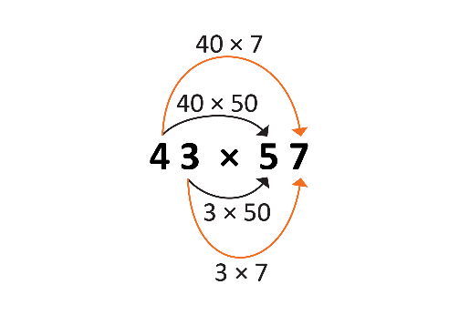  - using multiplication facts to facilitate division, such as  solving $27÷6$ by using $4×6=24$ and $5×6=30$ to predict the result must be between $4$ and $5$, with a remainder ($3=30-27$) | Multiply decimals by whole numbers and multiply and divide decimals by powers of 10, using flexible and efficient strategies  For example:  - exploring multiplying whole numbers by decimals larger and smaller than one to identify misconceptions that multiplying always makes numbers bigger, such as $120×1.5$ and $120×0.5$  - using mental strategies to multiply decimals, such as $3.5×2$  - using place value to mentally multiply and divide decimals by powers of 10, such as  $$5.75×10=57.5$$  $$5.75×100=575$$  $$5.75×1000=5750$$  $$57.5÷10=5.75$$  $$57.5÷100=0.575$$  $$57.5÷1000=0.0575$$
Determine a familiar fraction, decimal or percentage of a whole number
For example:
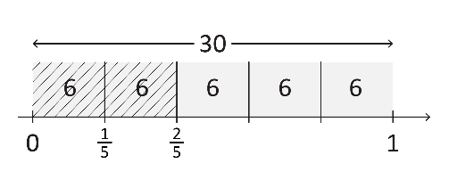
- calculating fractions of whole numbers, such as $\frac{2}{5}×30$
- explaining how $\frac{1}{3}$ of a quantity can be achieved by dividing by three, and how knowledge of $\frac{1}{3}$ of a quantity can be used to find $\frac{2}{3}$ or $\frac{4}{3}$ of the same quantity
- finding $0.2$ of a whole number, recognising that $0.2=$ $\frac{1}{5}$ so finding $0.2$ of a number means dividing by five
- finding 10%, 25% and 50% of a whole number, equating 10% to dividing by 10, 50% to finding half by dividing by two and 25% to finding a quarter by dividing by four or by finding half and half again
10% of $60 = 60 ÷ 10 = $6
50% of 105 = 105 ÷ 2 = 52.5
25% of 1200 = 1200 ÷ 4 = 300
Explore additive estimation strategies to evaluate the reasonableness of a calculation in familiar contexts  For example:  - identifying situations where estimating is useful because a high level of accuracy is not necessary  - estimating by rounding numbers to the nearest ten or hundred, such as rounding $\$219+\$385$ to $\$200+\$400=\$600$  - estimating the results of a calculation to check the reasonableness of calculator results | Explore a range of additive estimation strategies for different situations, including using knowledge of odd and even numbers  For example:  - using front-end estimation where a high level of accuracy is not required, such as estimating  $764+239$ as $700+200$  - rounding to the nearest dollar to estimate cost, such as  $\$16.67+\$4.12+\$0.97+\$0.46$ rounding to  $\$17+\$4+\$1+\$0=\$22$  - overestimating and underestimating for a range, such as for $687+294$, the result will be between  $700+300=1000$ and  $680+290=970$  - checking results of calculations using knowledge of odd and even numbers, such as the sum of two even numbers or two odd numbers must be even | Explore multiplicative estimation strategies and their appropriateness in different situations  For example:  - recognising the effect of rounding both numbers up, both numbers down or one number up and one number down, explaining which estimation is the best approximation and why  - estimating how many pages are in a book series if there are five books in the series and each book (in the series) has about $120$ pages, using doubling and halving to solve i.e.  $10×60=600$ pages  - estimating if $\$30$will be enough to buy six mugs at $\$4.95$ each by rounding to $\$5$ | Use estimation and rounding to make reasonable evaluations and justify results  For example:  - using rounding to simplify divisions, such as approximating $997÷4$to $1000÷4$, which gives a result of approximately $250$  - estimating fractions, such as $\frac{5}{12}$ is a little less than a half  - rounding a decimal to a nearby whole number, such as for $25.14×3.5$, recognising the answer will be between $3×25$ and $4×25$, which is between $75$ and $100$  - rounding up when determining money required for a purchase, and not rounding for digital financial transactions

Sub-strand: Financial mathematics
Year 3 | Year 4 | Year 5 | Year 6
Investigate financial transactions, recognising equivalent values and change  For example:  - identifying different payment methods and situations where they are commonly used, such as cards for public transport and gold coins for donations  - developing an awareness of the value of money relative to everyday items, using catalogues  - representing equivalent values using different denominations, such as 70 cents can be made up of three 20-cent coins and a 10-cent coin, or two 20-cent coins and three 10-cent coins  - representing transactions involving change, such as determining the change from a $\$50$ note used to purchase a $\$24$ shirt and $\$8$ socks for a sport team uniform | Investigate and represent saving and spending, recognising that limited amounts of money are available  For example:  - investigating saving patterns using different weekly amounts and various time periods, such as 4, 8 or 12 weeks  - comparing how total savings can change when weekly savings amounts differ, such as ‘If $\$5$ is saved each week for eight weeks, how much do you save? What if you save $\$7$ a week for the same time?’  - exploring purchasing choices when money is saved rather than spent immediately, recognising that spending decisions can be influenced by external factors, such as friends, media, events and advertising | Identify features of budgets and create a simple budget, comparing prices where possible  For example:  - using a context, such as a school trip or class party, to create a simple budget  - distinguishing between total cost and cost per person  - comparing prices and recognising that a product/service can be overpriced  - developing an awareness that advertising can influence purchasing decisions | Develop plans for savings goals, predict expenses and identify that saving money with a bank attracts interest  For example:  - choosing a savings goal, such as an end-of-year school camp  - using a spreadsheet to keep track of money being raised in a bake sale for the end-of-year school camp. Keeping track of income (money received for the cakes purchased) and expenses (money spent on ingredients), recognising the need to prioritise certain expenses (e.g. ingredients over decorations)  - identifying the importance of checking receipts, including ensuring any % discounts have been accurately applied and using estimation strategies to check the total amount  - discussing the benefits of using a bank for saving

Sub-strand: Modelling with number
Year 3 | Year 4 | Year 5 | Year 6
Identify and represent a range of real-world addition and subtraction situations with part-part-whole models, and multiplication and division situations with arrays. Write number sentences to reach a solution and interpret in context  For example:  - modelling additive situations, such as ‘I had $75$ tomatoes and then picked some more. Now I have $138$. How many did I pick?’ Choosing to use a part-part-whole model and writing number sentences, explaining how each number is related to the situation. Using strategies, such as the relationship between addition and subtraction, to solve, interpreting the answer and the additional tomatoes picked  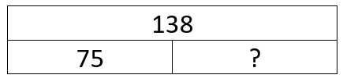  - modelling multiplicative situations, such as sharing $48$ horses into $2, 4, 6$ or $8$ paddocks using arrays, choosing to use multiplication and/or division, writing number sentences  (e.g. $2×=48$) and explaining how each number is connected to the situation (e.g. $2$ is the number of paddocks, $48$ is the total number of horses and the missing number will be the number of horses in each of the two paddocks) | Identify and represent real-world additive and multiplicative situations with diagrams and equations to reach a solution. Interpret and communicate findings in context  For example:  - modelling situations, such as buying five scooters for $\$96$ each, evaluating the situation and identifying that it is multiplicative. Representing the situation using a bar model and equation, explaining that five is the number of scooters and $\$96$ is the cost of each scooter. Using efficient strategies to solve, such as rounding $\$96$ to $\$100$, multiplying $5×100$ and subtracting $5×4$, communicating that the answer is the total cost of buying five scooters  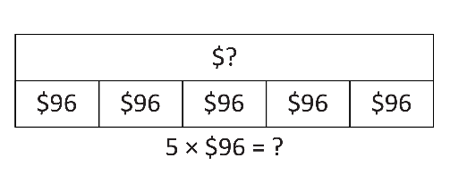 | Identify and represent a range of real-world additive and multiplicative situations with equations, using diagrams where needed. Interpret and communicate findings in context  For example:  - modelling situations, such as determining how many containers Amy collected for ‘Containers for Change’, knowing their total was $12$ times as many as Ling, who collected $25$. Determining the situation to be multiplicative and representing it using a diagram and equation, demonstrating how the representation is connected to the situation,  such as the diagram shows that $12×25$ is $12$ times as many  as $25$. Using efficient strategies to solve, such as halving $12$  and doubling $25$, communicating that the answer is the number of containers Amy collected, which is $12$ times as many as Ling | In real-world situations involving whole numbers, order of operations and fractions with the same denominator, use the following process  - analyse the situation and identify relevant information  - mathematically represent the situation, including using equations to reach a solution  - interpret and communicate findings in the context, exploring and justifying decisions  For example:  - modelling situations, such as determining the total cost of Leith hiring a bike for nine hours, analysing the given information, identifying the relevant information to translate the situation into an equation. Deciding on the operation or combination of operations and applying the order of operations,  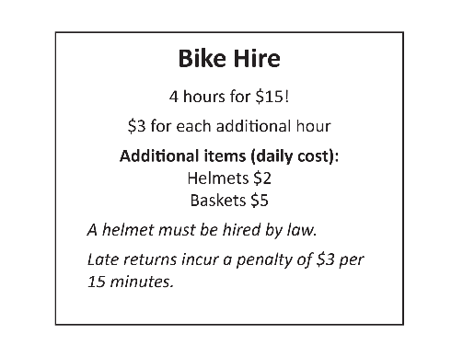  e.g. $15+\left(9-4\right)×3+2=$ Using efficient strategies to solve, interpreting the answer to be the total cost, explaining findings, such as ‘It would have cost $\$17$ to hire the bike for four hours, and it was an extra $\$15$ for five more hours’

Strand: Measurement and geometry

Sub-strand: Two-dimensional space and structures
Year 3 | Year 4 | Year 5 | Year 6
Explore one-step slides (translations) and flips (reflections) of familiar two-dimensional shapes, make connections to line symmetry and describe the movement of the shape  For example:  - sliding or flipping 2D shapes to identify that translations and reflections do not change the size or features  - identifying lines of symmetry on given shapes, such as triangles and squares, using  paper-folding, mirrors or drawings  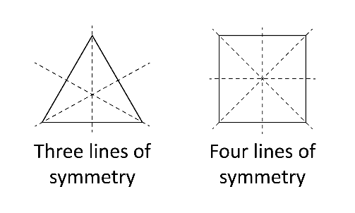 | Explore, visualise, describe and create two-dimensional shapes that result from combining or splitting familiar shapes  For example:    - combining familiar 2D shapes, including quadrilaterals and other polygons to form common shapes  - splitting a given shape, such as a hexagon, into two or more common shapes  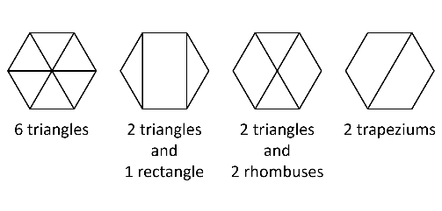 | Explore line and rotational symmetry in two-dimensional shapes  For example:  - identifying line symmetry in the environment, artworks and patterns  - identifying the rotational symmetry of shapes by tracing and rotating them to determine how many times they match their original position in a full rotation, such as a rectangle aligns with itself twice during one complete turn | Explore, visualise and describe translations, reflections or rotations of two-dimensional shapes  For example:  - recognising that translations, reflections or rotations change the position and orientation but not the size of shapes  - transforming shapes to create tessellating patterns, including using digital tools. Describing the transformations used and discussing why these shapes tessellate, including identifying shapes or combinations of shapes that will not tessellate
Estimate, measure and order lengths in uniform units, including millimetres, centimetres and metres  For example:  - creating a metric unit measuring tape by drawing 1 cm markings on a long paper strip using a centimetre cube or tile and using it to estimate, measure and order the length of stationery items  - recognising the need for formal units smaller and larger than the centimetre to measure length and using the abbreviations mm, cm, m and km  - investigating the length of one metre using everyday examples, such as a desk or arm span, and exploring benchmarks for centimetres and millimetres | Estimate, measure and compare  the perimeter of two-dimensional shapes, using scaled instruments and appropriate informal or  formal units  For example:  - recognising that perimeter is  the sum of the lengths that form the boundary of a shape or enclosed space  - selecting and using appropriate scaled instruments, such as a tape measure, ruler or trundle wheel, to measure around the boundary of a shape, e.g. a painting or a garden bed  - using a piece of string to measure the perimeter of irregular shapes, including those that have curved sides | Choose and use appropriate metric units and part units to estimate and measure lengths  For example:  - choosing and using an appropriate unit, such as centimetres when measuring a length of fabric  - recognising that the choice of an appropriate unit may depend upon the need for accuracy rather than simply the size of the object, for instance a bridge may be measured in metres to estimate length, but in millimetres for engineering work  - recording measurements using both whole units and whole and part units, such as 56 millimetres or 5.6 centimetres | Convert between units of length by connecting metric units to the decimal system and extend to units of mass and capacity  For example:  - recognising the significance  of the prefixes in units  of measurement  - converting between units, including millimetres, centimetres, metres, kilometres; milligrams, grams, kilograms, tonnes; millilitres, litres, kilolitres and megalitres  - using place value, such as converting 2600 m to 2.6 km, recognising that 1000 m  equals 1 km  - explaining and using the relationship between the size  of a unit and the number of units needed, such as more grams than kilograms will be needed to measure the same object, and so to convert from kilograms to grams you need to multiply by 1000
Describe and test a sequence of steps to determine the perimeter of rectangles
For example:
- creating a range of rectangles representing paddocks on grid paper and establishing different methods of working out the length of boundary fences
- exploring efficient ways to calculate the perimeters of rectangles, such as adding the length and width together and doubling the result
Compare the areas of two shapes indirectly, using uniform informal units, without gaps and overlaps  For example:  - selecting from a range of uniform informal units, such  as tiles, counters or blocks, to cover shapes  - using uniform informal units to compare areas, recognising why the same unit is used repeatedly  - recognising the relationship between the size of the informal units used and the number of units needed to fill a shape, choosing units that can best cover a shape with no gaps or overlaps | Estimate, measure and compare the areas of rectangles using uniform informal square units in arrays  For example:  - choosing from a range of uniform informal square units, such as tiles, blocks, sticky notes or paper cut-outs, tracing around this unit, creating an array to estimate, measure and compare the area of rectangles  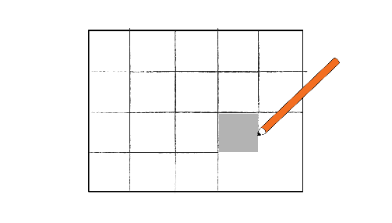 | Identify dimensions of a metric square unit. Estimate, measure and compare areas using metric square units  For example:  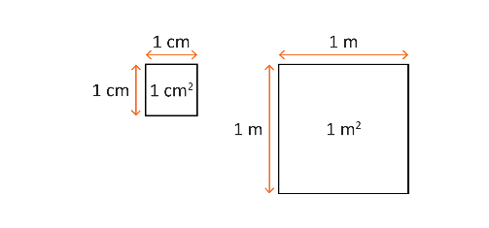  - recognising the dimensions of a metric square unit, recording the area using the abbreviations mm², cm² and m² and using correct terminology, such as 2 cm² being read as ‘two square centimetres’  - recognising that a unit of area can be cut and rearranged and still be the same area, such as a square metre not needing to be ‘square’ – it may be 50 cm by 2 m or 25 cm by 4 m  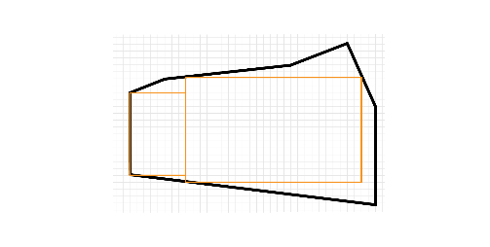  - exploring the use of arrays within irregular shapes to approximate the area, discussing the parts that fall outside of the arrays | Describe and test a sequence of steps to determine the area of rectangles based on dimensions  For example:  - drawing a variety of rectangles on grid paper to investigate patterns in the relationship between the length of the base and the height of rectangles, and their area  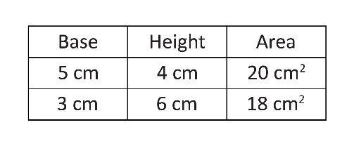  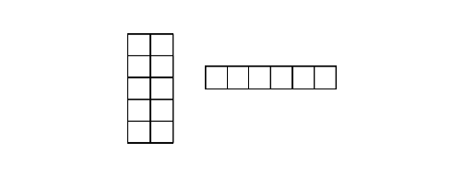  - using grid paper to investigate and compare shapes that have the same perimeter but different areas, such as both rectangles have a perimeter of 14 cm but different areas
Identify angles as measures of turn between two lines that intersect and directly compare angle sizes in everyday situations  For example:  - identifying angles formed by two arms that open and close in everyday situations, such as the arms of a clock, a partially open book, or an open pair of scissors, recognising that a full arm turn forms a circle  - superimposing two angles, aligning one arm and the vertex, and checking the other arm to determine which angle is greater | Indirectly compare angles and identify as being equal to, greater than or less than a right angle  For example:  - identifying angles in the environment and comparing to a right angle, including by using an informal tool where required, such as a pipe-cleaner or bent straw  - recognising that the length of the arms does not affect the size of the angle  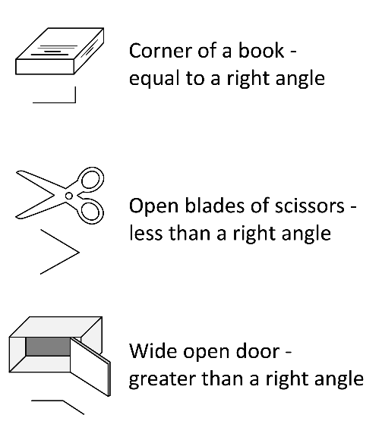 | Estimate, measure and construct angles in degrees using a protractor. Classify acute, right, obtuse, reflex and straight angles  For example:  - estimating and describing the size of angles using known angles as benchmarks  - exploring the scale on a protractor, recognising that protractors usually have two sets of numbers, one for measuring angles in an anticlockwise direction and one for clockwise  - developing and following a sequence of steps to accurately measure angles using a protractor  - recording angle measurements using the symbol for degrees ($°$) | Investigate angles in a right angle, on a straight line, angles at a point and vertically opposite angles, to determine unknown angles and explain reasoning  For example:  - investigating adjacent angles that form a right angle and establish that they add to $90°$ (complementary angles)    - investigating adjacent angles that form a straight angle and establish that they add to $180°$, such as an angle of $120°$ and $60°$ (supplementary angles)      - recognising vertically opposite angles as angles that are directly opposite each other and equal in size, formed when two lines intersect  - recognising and describing angle relationships embedded in diagrams, such as  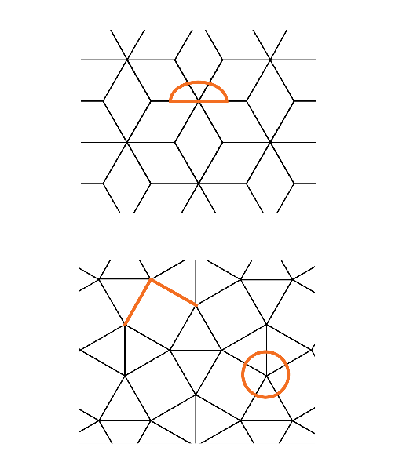
Create and interpret simple maps to show positions and pathways, considering the relative position of key features  For example:  - imagining a ‘bird’s-eye view’ of locations to create maps without scales, such as representing the layout of a classroom or bedroom  - sketching a mud map of the school, identifying the main buildings and orientating to the real world to determine directions to travel | Create or interpret grid maps, describe positions and pathways, and explore scales and legends  For example:  - locating positions on grid maps by coordinating horizontal and vertical references  - exploring scales, such as the length of one square grid equalling $10$ metres  - using maps to move through pathways and describing a journey between two locations on a grid map  - using digital tools to create a grid map of a familiar area, such as the local park | Use directional language, grid references and grid coordinates to describe positions and pathways  For example:  - using a given grid map and compass directions (N, S, E, W), planning, describing and showing a route from one location to another  - recognising the difference between grid references and grid coordinates.  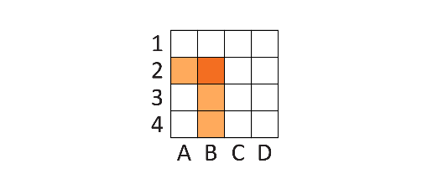  A grid reference identifies a region by labelling the spaces e.g. B2 shows the darker shaded region in that square.  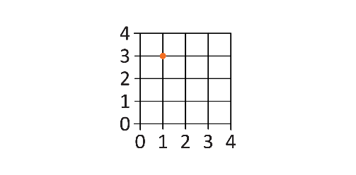  A grid coordinate uses numbers to identify a point where two numbered lines intersect e.g. (1, 3).  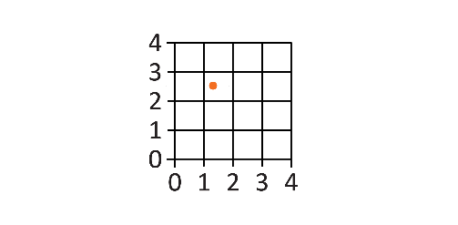  Because a grid coordinate uses numbers, it can identify any point within the spaces by using decimal fractions e.g. (1.25, 2.5).  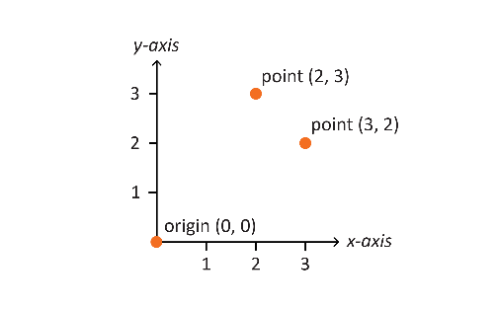  - identifying grid coordinates on the number plane in the first quadrant, describing the horizontal position first, followed by the vertical position. Recognising ($2, 3$) is a different location to ($3, 2$) | Explore the Cartesian plane as the intersection of two number lines at zero, using the coordinate system to locate points in all four quadrants  For example:  - recognising positive and negative integers on the number lines when plotting points in all four quadrants on the Cartesian plane  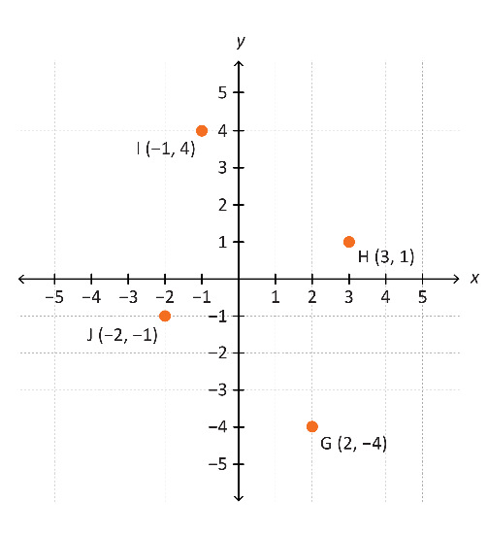

Sub-strand: Three-dimensional space and structures
Year 3 | Year 4 | Year 5 | Year 6
Visualise and make models of three-dimensional objects. Compare and classify objects according to the key features of faces, edges and vertices  For example:  - visualising and constructing models of 3D objects using clay, sticks, card or digital tools  - comparing 3D objects, identifying similarities and differences, such as a pyramid has triangular faces and a cube does not  - classifying a collection of 3D objects, including cubes, cylinders, cones, spheres, rectangular and triangular prisms and pyramids, using geometric language to describe features | Connect three-dimensional objects to their two-dimensional representations and visualise and describe key features that cannot be seen  For example:  - connecting images or drawings to 3D objects, including prisms, pyramids and cylinders  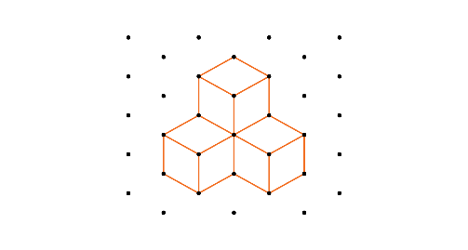  - constructing models of 3D objects, based on 2D sketches, using cubes  - visualising features of 3D objects that cannot be seen, such as recognising the sketch is a square-based pyramid with a square base, four triangular faces, eight edges and five vertices  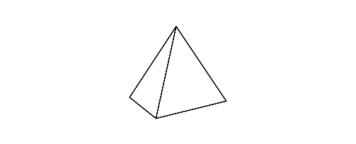 | Visualise and connect three-dimensional objects to their nets and build objects from their nets  For example:  - deconstructing packages to see the nets of different 3D objects, including prisms, pyramids and cylinders  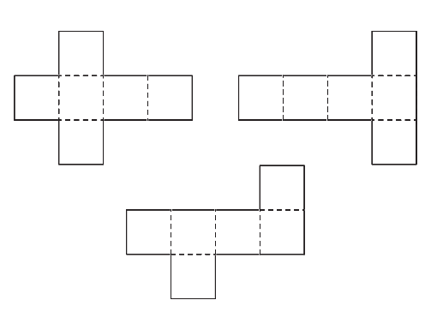  - investigating the variety of nets that can be used to create a particular prism  - examining a diagram to determine whether it is the net of a 3D object or not  - constructing 3D objects from provided nets and from sketching and testing nets, considering the number, shape and placement of faces | Visualise, sketch and construct three-dimensional objects, including prisms and pyramids  For example:  - visualising features to create sketches of 3D objects, showing depth and from different views  - constructing 3D models of prisms and pyramids, given drawings of different views  - creating skeletal 3D models of prisms and pyramids using materials, such as toothpicks, clay, straws and tape
Measure and order capacity in uniform units, including millilitres. Estimate larger capacities using a litre container  For example:  - creating a calibrated measuring instrument by repeatedly pouring a quantity of water, such as 50 mL, into a container, and drawing and labelling a line at each level  - recognising that one-litre containers can be a variety of shapes, such as milk cartons and ice-cream containers | Estimate, measure and compare capacity in litres and millilitres using scaled instruments  For example:  - relating benchmark capacities to everyday containers, such as a 250 mL juice container or a 600 mL water bottle  - recording capacities using the abbreviation for litres (L) and millilitres (mL)  - comparing capacity measurements, such as recognising that a 1500 mL container holds more than a 1 L container | Choose appropriate units to estimate and measure capacity  For example:  - selecting and using appropriate units, such as millilitres for a drinking glass and litres for a bucket  - reading calibrated measuring instruments with evenly spaced markings where not all values are labelled, such as markings for 1.0, 1.2, 1.4, 1.6, 1.8, 2.0, but only 1 and 2 are labelled  - recognising and interpreting decimal notation for capacities, such as 8.7 L is the same as 8 litres and 700 mL
 | Explore and compare volume, and recognise that objects with different shapes can have the same volume  For example:  - identifying volume as the space an object occupies and differentiating it from other measurement attributes  - recognising that objects made with the same number of identical cubes will have the same volume  - creating different objects using the same amount of playdough, observing that they all have the same volume even though they are shaped differently | Identify the dimensions of a metric cubic unit. Construct and compare rectangular prisms using cubes and determine their volume  For example:  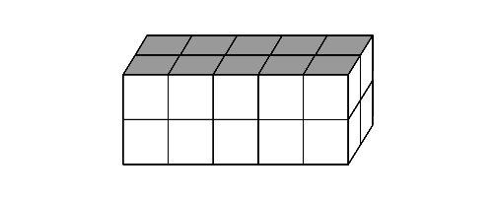  - constructing and comparing rectangular prisms using cubic-centimetre blocks and describing the volumes in terms of layers, such as two layers of 10 cubic-centimetre blocks  - recording volumes using the abbreviation for cubic centimetres (cm³) and cubic metres (m³)  - exploring different rectangular prisms that can be made from the same number of cubes  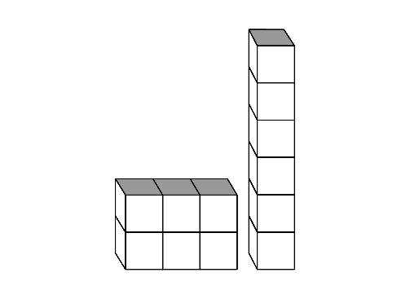 | Describe and test a sequence of steps to determine the volume of rectangular prisms based on dimensions  For example:  - exploring and generalising multiplicative strategies to find volume using diagrams, numbers and words, focusing on the relationship between the number of cubes in a layer and the number of layers in the prism, such as recognising that one layer is 12 cm³ and multiplying by the number of layers to determine volume  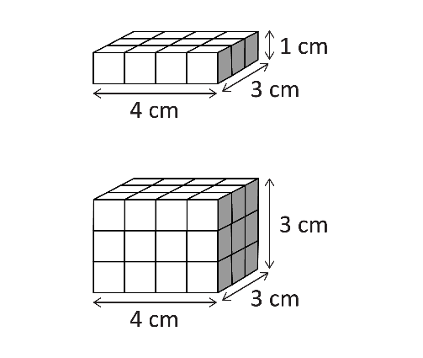

Sub-strand: Non-spatial measurement
Year 3 | Year 4 | Year 5 | Year 6
Measure mass to compare objects to everyday items using kilograms and grams  For example:  - using balance scales to compare the weight of everyday items to common benchmark weights including 100 g, 250 g, $\frac{1}{2}$ kg and 1 kg  - identifying familiar items that weigh about one kilogram,  such as a one-kilogram bag of flour or a litre of milk  - identifying familiar items that are measured in grams, such as chocolate or spices | Estimate and measure mass in kilograms and grams using analogue and digital scales  For example:  - interpreting evenly spaced markings on analogue scales where not all values are labelled  - estimating and weighing the same item using both analogue and digital scales and comparing the readings  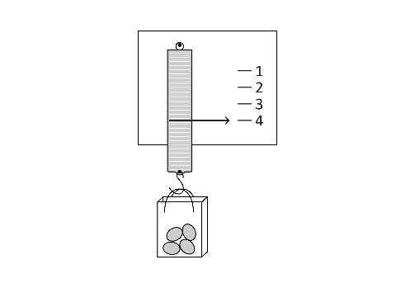  - creating a calibrated scale, and using it to measure the mass of everyday items in grams and kilograms  - recording masses using the abbreviations for grams (g) and kilograms (kg) | Choose appropriate units to estimate, measure and compare mass  For example:  - identifying the appropriate unit and device to measure mass, such as digital scales to measure a school bag (kg) and kitchen scales to measure the weight of ingredients (g)  - comparing readings on digital scales, applying knowledge of decimal numbers, such as recognising that 3.25 kg is heavier than 3.025 kg  - recognising the equivalence of whole number and decimal representations of measurements of mass, such as 3 kg 250 g is the same as 3.25 kg
Tell the time in minutes using analogue and digital clocks. Describe duration in hours, minutes and seconds and identify the relationship between them  For example:  - recognising that the space before the minute hand (in a clockwise direction) indicates the minutes elapsed since the hour past, and that the remaining space on the clock shows how many minutes until the next hour  - developing a sense of how long one second and one minute is, using a timer to determine the duration of simple tasks  - using time to describe the duration of events, such as the three-second rule in netball, 20 minutes for recess and a school day being about 6 hours long | Convert between units of time, tell the time on digital and analogue clocks using ‘am’ and ‘pm’ notation and determine duration  For example:  - using the multiplicative relationship between hours, minutes and seconds to convert between units, such as recognising that an hour is 60 times longer than a minute  - comparing the duration of two familiar events with durations provided in different time units, such as a movie length of 95 minutes and a bus journey of 2 hours and 10 minutes  - relating analogue notation to digital notation for time, such as 20 to 9 in the morning is the same time as 8.40 am | Explore, describe and convert between 12- and 24-hour time systems and use to determine duration  For example:  - using analogue clocks to make connections between 12- and 24-hour time systems  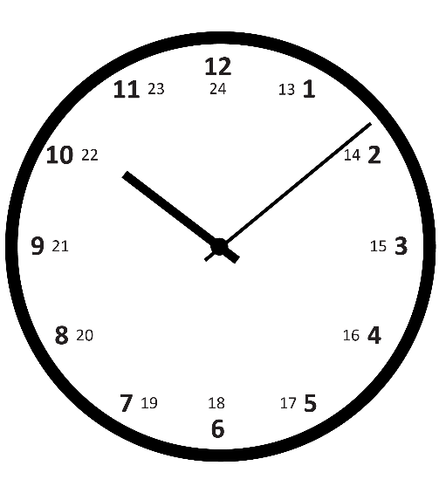  - applying strategies to convert between time systems, understanding that the same time can be described in different ways, such as to convert times from 12.00 pm to 11.59 pm into 24-hour time, 12 is added to the hour  1.00 pm → 1300 in 24-hour time  7.45 pm → 1945 in 24-hour time  - determining duration of events when the starting and finishing times are provided in different systems, such as the duration of a school excursion scheduled to start at 9.30 am and conclude at 1445 | Use timetables and itineraries in  12- and 24-hour time systems to determine the duration of events and journeys  For example:  - applying concrete and mental strategies to determine elapsed time, considering the starting and finishing time  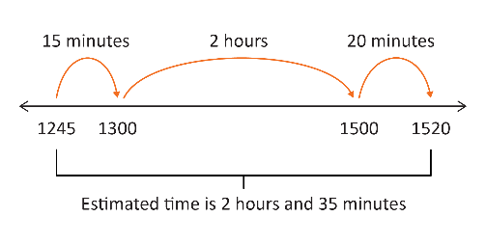  - interpreting a variety of timetables and itineraries from real-life situations, such as a school, movie theatre or public transport authority

Sub-strand: Modelling with measurement and geometry
Year 3 | Year 4 | Year 5 | Year 6
 | In real-world situations involving two-dimensional shapes, three-dimensional objects, grid maps, determining length, capacity or mass in metric units or converting between units of time, mathematically represent the problem to reach a solution. Interpret and communicate findings in the context of the situation  For example:  - modelling situations involving time, such as determining the winner of a summer reading contest where some students have entered their data in minutes and some in hours. Representing the problem using a diagram, such as a table, explaining how information in the table relates to the context. Using efficient strategies to convert between the units of time to determine a winner, interpreting the winner to be the student with the longest duration of reading time  - modelling situations involving units of measurement, such as exploring how much water is needed to fill a bathtub and comparing it to how much water is used during a five-minute shower | In real-world situations involving transformation of two-dimensional shapes, nets, grid reference systems, determining length, area, capacity, volume or mass in metric units or converting between 12- and 24-hour time, mathematically represent the problem to reach a solution. Interpret and communicate findings in the context of the situation  For example:  - modelling situations involving metric units, such as planning items to pack for a school camp, given a list of required items and a weight and size limit for student bags. Representing the problem with diagrams and equations, determining the weights of given items, using estimation strategies where appropriate and determining the total weight. Interpreting the findings, such as the weight could be reduced if a plastic water bottle is chosen rather than a metal one  - modelling situations, such as  - considering if the classroom can fit a new table by creating a grid map of the current configuration of the classroom, to an approximate scale. Using translations and grid references to analyse and solve the problem  - creating a pathway utilising a map of a local community, ensuring all points of interest are explored and identifying the total distance covered | In real-world situations involving transformation of two-dimensional shapes, rectangular prisms, pyramids, Cartesian planes, measuring and converting metric units for length, mass and capacity, determining volume and area in metric units or determining the duration of events and journeys, use the following process  - analyse the situation and identify relevant information  - mathematically represent the situation to reach a solution  - interpret and communicate findings in the context, exploring and justifying decisions  For example:  - planning a class trip to the WA Museum Boola Bardip utilising Transperth timetables and a map of the museum to identify a route and schedule  - designing a monument incorporating both prisms and pyramids to honour an important person. Investigating how the symbolic meaning of prisms and pyramids could reflect the qualities of the important person

Strand: Probability and statistics

Sub-strand: Probability
Year 3 | Year 4 | Year 5 | Year 6
Describe familiar events using the language of chance. Identify and list possible outcomes of everyday chance events  For example:  - describing events as being likely, unlikely, 50-50, possible, certain or impossible, such as  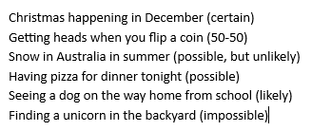  - identifying all possible outcomes for events, such as choosing two pegs from a bag containing three red and three blue pegs | Order the likelihood of everyday chance events. Identify when events are not affected by previous events  For example:  - using lists of familiar events and ordering them from ‘least likely’ to ‘most likely’ to occur, such as seeing a rainbow during recess, finding a pencil in your school bag, having lunch at school on a regular day or winning a national raffle, and discussing why the order of some events might be different for different students  - identifying that obtaining heads when tossing a coin does not affect the chance of obtaining heads on the next toss  - clarifying misconceptions about events that are not affected by previous events, such as if it rains today, it is more likely to rain tomorrow | Compare a range of everyday chance events, grouping into those with outcomes that are equally likely or not equally likely  For example:  - comparing differently divided spinners and identifying if they will produce equally or unequally likely outcomes for each section  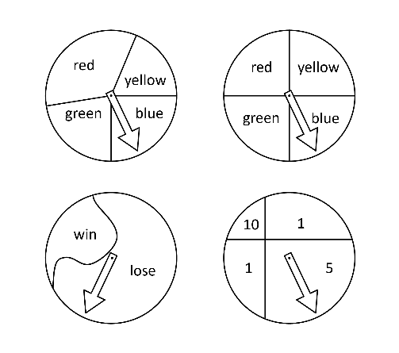  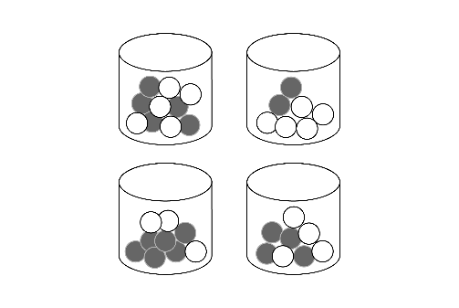  - comparing jars filled with two colours of balls and identifying those with equally likely outcomes and with unequally likely outcomes for each colour | Order everyday chance events and phrases on a scale from 0 to 1, where 0 represents an event that is certain not to happen (impossible) and 1 represents an event that is certain to happen  For example:  - recognising that all measures of probability fall between 0 and 1 or 0% and 100%  - positioning events and phrases on a scale and justifying placements  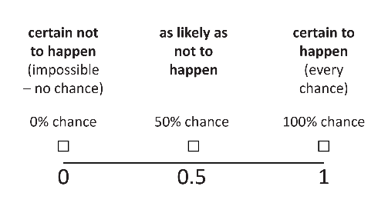
Identify the likelihood of outcomes for planned, equally likely, repeated chance experiments. Conduct the experiments and recognise variation in the results  For example:  - rolling a dice, tossing a coin or choosing a card for a set number of trials and discussing the likelihood of outcomes using the language of chance  - conducting experiments and recording results using tallies, pictures or objects  - comparing results with others and with expected outcomes, discussing how results vary | Predict the likelihood of outcomes of unequally likely, repeated chance experiments. Conduct the experiments, describe variation and compare to the prediction  For example:  - naming blue as the colour  most likely and red as the least likely to be drawn when choosing a block from a bag containing 7 red, 13 blue and 10 yellow blocks  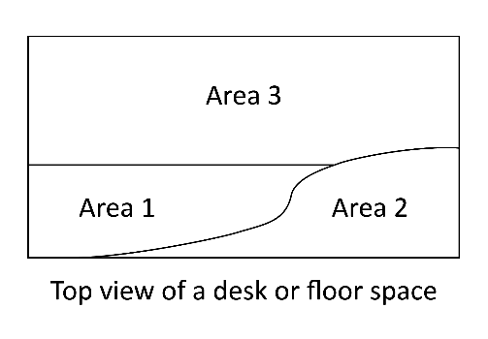  - predicting that a button being tossed will land on Area 3 most often, conducting the experiment 25 times, recording the results and describing differences between predicted and observed results | Conduct repeated chance experiments with equally likely outcomes, including with the use of digital tools. Represent results as fractions, compare with others and discuss variation  For example:  - recording results for 20 trials as fractions, comparing and discussing differences between the results for each group  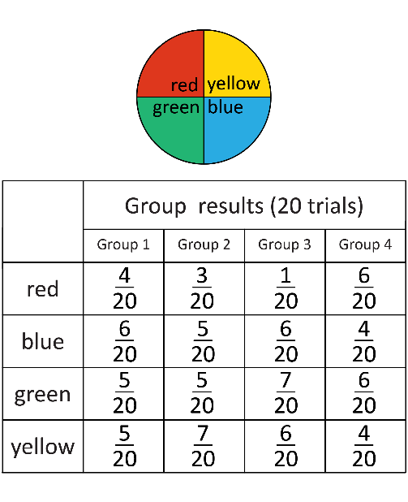 | Conduct repeated chance experiments and simulations with equally likely or unequally likely outcomes, including with the use of digital tools, for an increasing number of trials. Compare expected and observed frequencies in terms of variation as the number of trials increase  For example:  - recording the frequency of each outcome for 20, 30 and 40 trials, and comparing the observed frequency with the expected frequency  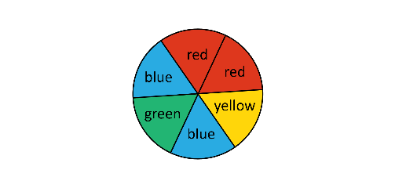  - combining results for groups of students and the whole class, identifying that the results trend closer to the prediction as the number of trials increases

Sub-strand: Statistics
Year 3 | Year 4 | Year 5 | Year 6
Describe and interpret real-life data represented in dot plots and column graphs with scale intervals of one  For example:  - using the dot plot to answer questions, such as ‘How many students have two pets?’, ‘What was the least common number of pets?’  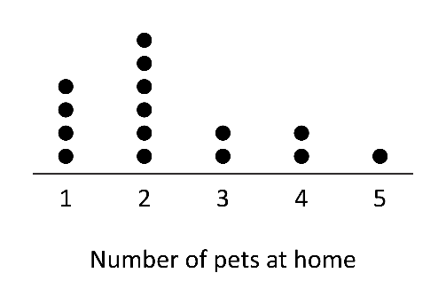  - identifying features of column graphs, such as labels, gaps, categories and titles, and answering questions relating to the information in the graph  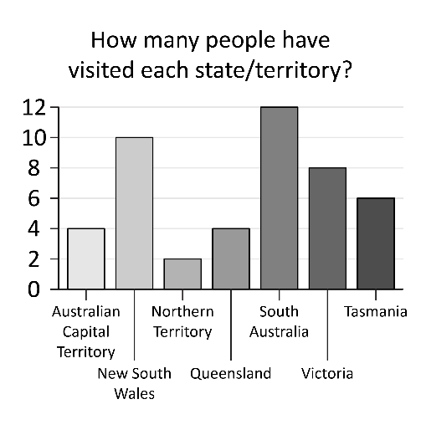 | Describe and interpret real-life data represented in many-to-one pictographs and column graphs  For example:  - discussing advantages of  many-to-one representation, such as it is easier to display larger numbers visually, and challenges, such as identifying ‘how many’ are represented by each symbol or reading values for the columns associated with many-to-one representations  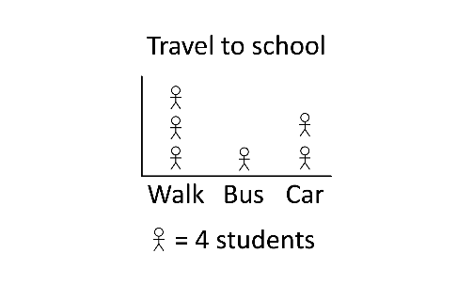  - answering questions relating to the information in many-to-one graphs, such as ‘How many students liked Health and Physical Education (HPE)?’ ‘How many more students liked Mathematics more than English?’ ‘How many times as many students liked Humanities and Social Sciences (HASS) more than the Arts?’  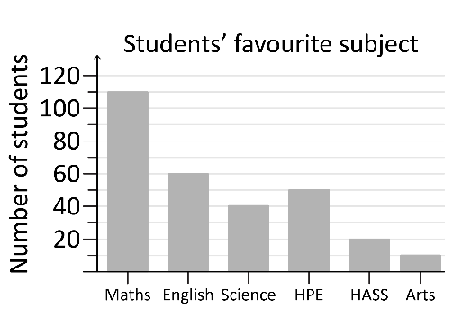 | Describe and interpret line graphs that show how real-life continuous data changes over time  For example:  - identifying features of line graphs, such as labels, scale and title, and answering questions relating to the information in the graph  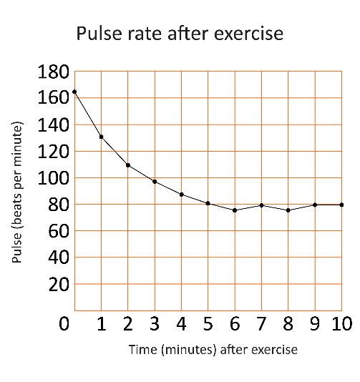 | Describe and interpret a range of displays for real-life numerical data, including side-by-side column graphs, using mode, range and shape  For example:  - recognising that shape describes how data is spread on a graph, for instance whether the responses are grouped, spread out, have more high or low values, or show gaps  - identifying the mode as the most frequently occurring response and the range as the difference between the highest and lowest data values recorded  - interpreting data using mode, range and shape, such as Class 5A has a range of 4, a mode of 0 and the number of students decreases as the number of siblings increases. Comparing this to Class 5B  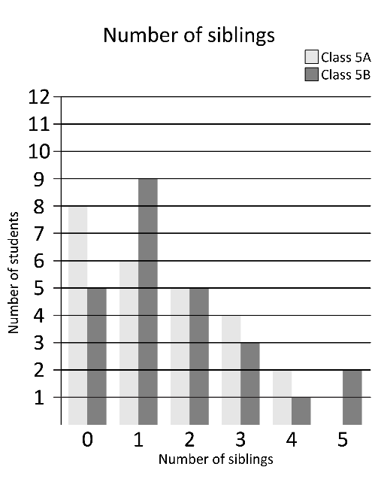
Describe how the features of
real-life data displays may influence an audience
For example:
- considering how the broken axis may affect the interpretation of a display, such as choosing the second graph to convey that bread prices have fluctuated dramatically in the last 12 months
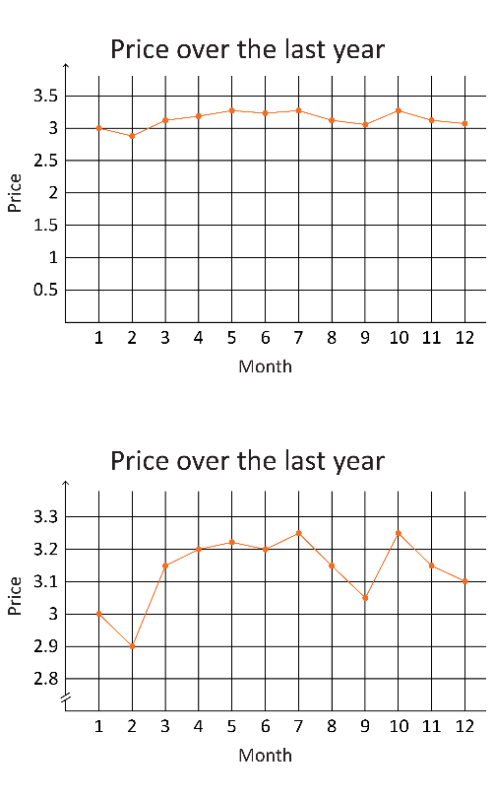
- investigating how sizing, colour, labels or scale may have been used in the construction of a display to influence a particular audience or ‘tell a particular story’
In a real-world context, explore questions of interest by collecting categorical or discrete numerical data through observation or surveys. Organise and represent data in dot plots, tables and column graphs and interpret to answer a question  For example:  - using a suitable method to collect data (observation or survey) to explore a question, such as ‘How do most Year 3 students at our school travel to school?’ Creating a list or table to organise the data and constructing an appropriate display, including with the use of digital tools, to answer the initial question and interpret the data, such as ‘Most students travel by car, as there are limited bus services to our school’  - using conventions, such as equal spaces on axes, naming and labelling axes and choosing appropriate titles for dot plots and column graphs | In a real-world context, pose questions and collect categorical or discrete numerical data, checking for accuracy and consistency. Organise and represent data in pictographs and column graphs, and interpret the data to communicate findings in terms of the context  For example:  - drafting suitable questions, response categories and recording methods to collect data on topics, such as ‘What is the most popular playground game?’  - recording responses accurately, including unexpected responses  - creating data displays, including with the use of digital tools, considering appropriate titles, labels, scales and categories for the axes  - interpreting the data displays created, summarising the information, responding to the initial question and discussing any unexpected results | In a real-world context, pose and refine questions, and collect categorical or discrete numerical data. Organise and make choices to represent data. Interpret and communicate findings in terms of the context, and reflect on variation and accuracy  For example:  - formulating and refining questions, such as refining ‘How many plastic bottles do people in the classroom have in their home bins at the end of a week?’ to ‘How many plastic bottles do people in the classroom have in their recycling bins at home?’  - collecting data using numbers to indicate rating, such as 1 = doesn’t like and 5 = likes a lot, to collect data to answer, ‘How did students at my school enjoy the food choices at the end-of-year event?’  - choosing and creating data displays, such as dot plots, many-to-one column graphs and pictographs, including with the use of digital tools  - discussing if the data provides the information necessary to answer the question and identifying if the type of questions, place, time or people asked could vary the results | In a real-world context involving continuous and discrete numerical data, use the following process  - analyse the situation to pose a question  - choose the most appropriate way to collect data to ensure accuracy and consistency, and make choices to represent data, including line graphs and  side-by-side column graphs  - interpret and communicate findings in terms of the context and describe reasons for variation  For example:  - considering a situation, such as growing plants in different areas of the classroom to formulate a question, such as ‘How does the amount of sunlight affect plant growth?’ Recording and analysing data, including using a spreadsheet. Choosing a line graph to show plant growth over time, using digital tools as appropriate. Interpreting the data to answer the question, considering any reasons for variation in the data, such as distance from light source

Acknowledgements
Stock images from Microsoft 365 used with permission from Microsoft.
Number and algebra
Understanding number
Pre-primary Third content description, second example adapted from: Department of Education WA. (2013). First Steps in Mathematics, Number Book 1 (p. 4). Retrieved March, 2025, from https://myresources.education.wa.edu.au/programs/first-steps-mathematics/number
Used under a Creative Commons Attribution-NonCommercial-NoDerivs 3.0 Unported licence.
Year 1 Fourth content description, third example adapted from: Department of Education WA. (2013). First Steps in Mathematics, Number Book 1 (p. 107). Retrieved March, 2025, from https://myresources.education.wa.edu.au/programs/first-steps-mathematics/number
Used under a Creative Commons Attribution-NonCommercial-NoDerivs 3.0 Unported licence.
Fifth content description, first example adapted from: Department of Education WA. (2013). First Steps in Mathematics, Number Book 1 (p. 94). Retrieved March, 2025, from https://myresources.education.wa.edu.au/programs/first-steps-mathematics/number
Used under a Creative Commons Attribution-NonCommercial-NoDerivs 3.0 Unported licence.
Fifth content description, third example diagram adapted from: Department of Education WA. (2013). [Diagram of boxes cut in different ways]. First Steps in Mathematics, Number Book 1 (p. 101–102). Retrieved March, 2025, from https://myresources.education.wa.edu.au/programs/first-steps-mathematics/number
Used under a Creative Commons Attribution-NonCommercial-NoDerivs 3.0 Unported licence.
Year 2 Sixth content description, third example adapted from: Department of Education WA. (2013). First Steps in Mathematics, Number Book 1 (p. 128). Retrieved March, 2025, from https://myresources.education.wa.edu.au/programs/first-steps-mathematics/number
Used under a Creative Commons Attribution-NonCommercial-NoDerivs 3.0 Unported licence.
Sixth content description, third example diagram adapted from: Department of Education WA. (2013). [Diagram of boxes cut in halves and quarters]. First Steps in Mathematics, Number Book 1 (p. 101). Retrieved March, 2025, from https://myresources.education.wa.edu.au/programs/first-steps-mathematics/number
Used under a Creative Commons Attribution-NonCommercial-NoDerivs 3.0 Unported licence.
Year 3 Seventh diagram adapted from: Department of Education WA. (2013). [Diagram of hexagons]. First Steps in Mathematics, Number Book 1 (p. 121). Retrieved March, 2025, from https://myresources.education.wa.edu.au/programs/first-steps-mathematics/number
Used under a Creative Commons Attribution-NonCommercial-NoDerivs 3.0 Unported licence.
Year 4 Seventh diagram adapted from: Department of Education WA. (2013). [Diagram of equivalent fractions]. First Steps in Mathematics, Number Book 1 (p. 126). Retrieved March, 2025, from https://myresources.education.wa.edu.au/programs/first-steps-mathematics/number
Used under a Creative Commons Attribution-NonCommercial-NoDerivs 3.0 Unported licence.
Number and algebra
Patterns and relationships
Year 5 First diagram from: Department of Education WA. (2013). First Steps in Mathematics, Number Book 2 (p. 260, 261). Retrieved March, 2025, from https://myresources.education.wa.edu.au/programs/first-steps-mathematics/number
Used under a Creative Commons Attribution-NonCommercial-NoDerivs 3.0 Unported licence.
Year 6 First diagram from: Department of Education WA. (2013). First Steps in Mathematics, Number Book 2 (p. 257). Retrieved March, 2025, from https://myresources.education.wa.edu.au/programs/first-steps-mathematics/number
Used under a Creative Commons Attribution-NonCommercial-NoDerivs 3.0 Unported licence.
Second diagram from: Department of Education WA. (2013). First Steps in Mathematics, Number Book 2 (p. 218). Retrieved March, 2025, from https://myresources.education.wa.edu.au/programs/first-steps-mathematics/number
Used under a Creative Commons Attribution-NonCommercial-NoDerivs 3.0 Unported licence.
Number and algebra
Calculating with number
Year 5 Fourth content description, third example adapted from: Department of Education WA. (2013). First Steps in Mathematics, Number Book 2 (p. 96). Retrieved March, 2025, from https://myresources.education.wa.edu.au/programs/first-steps-mathematics/number
Used under a Creative Commons Attribution-NonCommercial-NoDerivs 3.0 Unported licence.
Number and algebra
Financial mathematics
Pre-primary First content description, first example adapted from: Department of Education WA. (2013). First Steps in Mathematics, Number Book 1 (p. 163). Retrieved March, 2025, from https://myresources.education.wa.edu.au/programs/first-steps-mathematics/number
Used under a Creative Commons Attribution-NonCommercial-NoDerivs 3.0 Unported licence.
First content description, second example adapted from: Department of Education WA. (2013). First Steps in Mathematics, Number Book 1 (p. 10). Retrieved March, 2025, from https://myresources.education.wa.edu.au/programs/first-steps-mathematics/number
Used under a Creative Commons Attribution-NonCommercial-NoDerivs 3.0 Unported licence.
Year 1 First content description, second example adapted from: Department of Education WA. (2013). First Steps in Mathematics, Number Book 1 (p. 163). Retrieved March, 2025, from https://myresources.education.wa.edu.au/programs/first-steps-mathematics/number
Used under a Creative Commons Attribution-NonCommercial-NoDerivs 3.0 Unported licence.
Measurement and geometry
Two-dimensional space and structures
Year 2 First diagram from: Department of Education WA. (2013). [Diagram of paper clips used as an informal unit measuring tape]. First Steps in Mathematics, Measurement, Book 1 (p. 118) https://myresources.education.wa.edu.au/programs/first-steps-mathematics/measurement
Used under a Creative Commons Attribution-NonCommercial-NoDerivs 3.0 Unported licence.
Third content description, third example adapted from: Department of Education WA. (2013). First Steps in Mathematics, Measurement, Book 1 (p. 98). Retrieved March, 2025, from https://myresources.education.wa.edu.au/programs/first-steps-mathematics/measurement
Used under a Creative Commons Attribution-NonCommercial-NoDerivs 3.0 Unported licence.
Year 5 Second content description, second example adapted from: Department of Education WA. (2013). First Steps in Mathematics, Measurement, Book 1 (p. 10). Retrieved March, 2025, from https://myresources.education.wa.edu.au/programs/first-steps-mathematics/measurement
Used under a Creative Commons Attribution-NonCommercial-NoDerivs 3.0 Unported licence.
Fourth content description, third example adapted from: Department of Education WA. (2013). First Steps in Mathematics, Measurement, Book 1 (p. 145). Retrieved March, 2025, from https://myresources.education.wa.edu.au/programs/first-steps-mathematics/measurement
Used under a Creative Commons Attribution-NonCommercial-NoDerivs 3.0 Unported licence.
Third diagram adapted from: Department of Education WA. (2013). [Diagram of irregular areas]. First Steps in Mathematics, Measurement, Book 1 (p. 145). Retrieved March, 2025, from https://myresources.education.wa.edu.au/programs/first-steps-mathematics/measurement
Used under a Creative Commons Attribution-NonCommercial-NoDerivs 3.0 Unported licence.
Fourth diagram from: Department of Education WA. (2013). [Three grid diagrams]. First Steps in Mathematics, Space, Developing Geometric Understandings (p. 22). Retrieved August, 2024, from https://myresources.education.wa.edu.au/programs/first-steps-mathematics/space
Used under a Creative Commons Attribution-NonCommercial-NoDerivs 3.0 Unported licence.
Measurement and geometry
Three-dimensional space and structures
Year 1 First content description, third example adapted from: Department of Education WA. (2013). First Steps in Mathematics, Space (p. 56). Retrieved March, 2025, from https://myresources.education.wa.edu.au/programs/first-steps-mathematics/space
Used under a Creative Commons Attribution-NonCommercial-NoDerivs 3.0 Unported licence.
Year 5 Second content description, second example adapted from: Department of Education WA. (2013). First Steps in Mathematics, Measurement, Book 1 (p. 92). Retrieved March, 2025, from https://myresources.education.wa.edu.au/programs/first-steps-mathematics/measurement
Used under a Creative Commons Attribution-NonCommercial-NoDerivs 3.0 Unported licence.
Probability and statistics
Probability
Pre-primary First content description, first example adapted from: Department of Education WA. (2013). First Steps in Mathematics, Chance and Data, Developing Probability and Statistics (p. 15). Retrieved August, 2024, from https://myresources.education.wa.edu.au/programs/first-steps-mathematics/chance-and-data
Used under a Creative Commons Attribution-NonCommercial-NoDerivs 3.0 Unported licence.
Year 2 First content description, first example adapted from: Department of Education WA. (2013). First Steps in Mathematics, Chance and Data, Developing Probability and Statistics (p. 10). Retrieved August, 2024, from https://myresources.education.wa.edu.au/programs/first-steps-mathematics/chance-and-data
Used under a Creative Commons Attribution-NonCommercial-NoDerivs 3.0 Unported licence.
Year 5 First diagram from: Department of Education WA. (2013). [Diagram of four spinners]. First Steps in Mathematics, Chance and Data, Developing Probability and Statistics (p. 49). Retrieved August, 2024, from https://myresources.education.wa.edu.au/programs/first-steps-mathematics/chance-and-data
Used under a Creative Commons Attribution-NonCommercial-NoDerivs 3.0 Unported licence.
Year 6 First diagram from: Department of Education WA. (2013). [Diagram of numerical chance scale]. First Steps in Mathematics, Chance and Data, Developing Probability and Statistics (p. 52). Retrieved August, 2024, from https://myresources.education.wa.edu.au/programs/first-steps-mathematics/chance-and-data
Used under a Creative Commons Attribution-NonCommercial-NoDerivs 3.0 Unported licence.
Probability and statistics
Statistics
Year 2 Third diagram adapted from: Department of Education WA. (2013). [Diagram of block graph]. First Steps in Mathematics, Chance and Data, Developing Probability and Statistics (p. 208). Retrieved August, 2024, from https://myresources.education.wa.edu.au/programs/first-steps-mathematics/chance-and-data
Used under a Creative Commons Attribution-NonCommercial-NoDerivs 3.0 Unported licence.

