Western Australian Curriculum
Mathematics
Scope and sequence | Years 7–10
For implementation in 2026

Acknowledgement of Country
Kaya. The School Curriculum and Standards Authority (the Authority) acknowledges that our offices are on Whadjuk Noongar boodjar and that we deliver our services on the country of many traditional custodians and language groups throughout Western Australia. The Authority acknowledges the traditional custodians throughout Western Australia and their continuing connection to land, waters and community. We offer our respect to Elders past and present.
Copyright
© School Curriculum and Standards Authority, 2025
This document – apart from any third-party copyright material contained in it – may be freely copied, or communicated on an intranet, for non-commercial purposes in educational institutions, provided that the School Curriculum and Standards Authority (the Authority) is acknowledged as the copyright owner, and that the Authority’s moral rights are not infringed.
Copying or communication for any other purpose can be done only within the terms of the Copyright Act 1968 or with prior written permission of the Authority. Copying or communication of any third-party copyright material can be done only within the terms of the Copyright Act 1968 or with permission of the copyright owners.
Any content in this document that has been derived from the Australian Curriculum may be used under the terms of the Creative Commons Attribution 4.0 International licence.
This document incorporates material from Mathematics K–10 Syllabus (2022) © 2022 NSW Education Standards Authority (NESA) for and on behalf of the Crown in right of the State of New South Wales.
Disclaimer
Any resources such as texts, websites and so on that may be referred to in this document are provided as examples of resources that teachers can use to support their learning programs. Their inclusion does not imply that they are mandatory or that they are the only resources relevant to the course. Teachers must exercise their professional judgement as to the appropriateness of any they may wish to use.
Contents
Overview 1
Guide to reading this document 1
Strand: Number and algebra 3
Sub-strand: Understanding number 3
Sub-strand: Calculating with number 14
Sub-strand: Algebraic techniques 21
Sub-strand: Linear and non-linear equations and inequalities 27
Sub-strand: Linear and non-linear patterns and relationships 30
Sub-strand: Financial mathematics 36
Sub-strand: Modelling with number and algebra 39
Strand: Measurement and geometry 43
Sub-strand: Two-dimensional space and structures 43
Sub-strand: Three-dimensional space and structures 64
Sub-strand: Non-spatial measurement 71
Sub-strand: Modelling with measurement and geometry 72
Strand: Probability and statistics 76
Sub-strand: Probability and statistics 76
Sub-strand: Modelling with probability and statistics 94

Overview
The Western Australian Curriculum: Mathematics has been adapted from the previous Western Australian Curriculum (adopted from the Australian Curriculum version 8.1), the New South Wales Curriculum (following the New South Wales Curriculum Reform) and the Australian Curriculum version 9. It has been contextualised for the Western Australian Curriculum and Assessment Outline.

Guide to reading this document
The Scope and sequence shows the mandated curriculum for teaching, written as content descriptions across year levels so that a sequence of content can be viewed across the years of schooling from Pre-primary to Year 10. The examples illustrate the content and are not mandated. Teachers should use examples relevant to the context of their school and needs of their students.
This Scope and sequence shows the Years 7–10 Mathematics curriculum.
The Mathematics curriculum is organised by three Mathematics strands: Number and algebra; Measurement and geometry; and Probability and statistics.
The Number and algebra strand for Years 7–10 includes: Understanding number; Calculating with number; Algebraic techniques; Linear and non-linear equations and inequalities; Linear and non-linear patterns and relationships; Financial mathematics; and Modelling with number and algebra.
The Measurement and geometry strand for Years 7–10 includes: Two-dimensional space and structures; Three-dimensional space and structures; Non-spatial measurement; and Modelling with measurement and geometry.
The Probability and statistics strand for Years 7–10 includes: Probability and statistics; and Modelling with probability and statistics.
The Mathematics curriculum includes optional content in Years 9 and 10, which is intended to build and extend students’ year level knowledge according to areas of interest, understanding of content and preparation for subsequent study. Teachers may choose optional content according to the needs of
the student/s.

The table below outlines the subject organisation for the Years 7–10 Mathematics curriculum.
Years 7–10
Number and algebra
Understanding number | Calculating with number | Algebraic techniques | Linear and non-linear equations and inequalities | Linear and non-linear patterns and relationships | Financial mathematics | Modelling with number and algebra

Measurement and geometry
Two-dimensional space and structures | Three-dimensional space and structures | Non-spatial measurement | Modelling with measurement  and geometry

Probability and statistics
Probability and statistics | Modelling with probability and statistics

Strand: Number and algebra

Sub-strand: Understanding number
Year 7 | Year 8 | Year 9 | Year 10
Explore and represent equivalent fractions with related and unrelated denominators, visually  and numerically  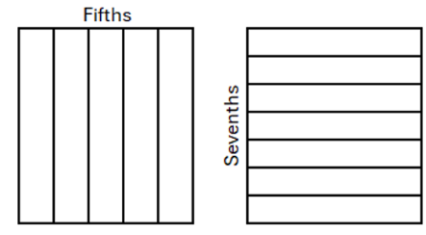  For example:  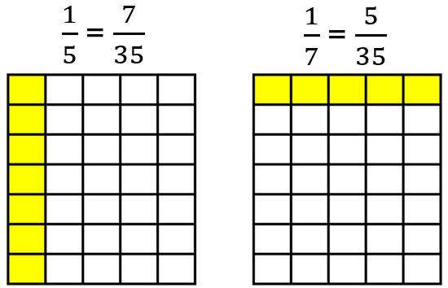  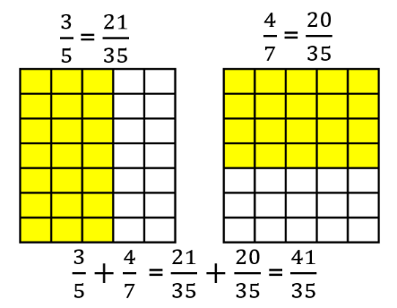  - using the multiplicative relationships between equivalent fractions to justify that $\frac{2}{5}=\frac{6}{15}$ because if the parts are three times smaller, the number of parts needs to be three times greater  - using knowledge of equivalence to explore the truth of statements, such as  $\frac{3}{4} >$ $\frac{2}{3}$ or $\frac{3}{4}$ $+$ $\frac{1}{3}$ $≠$ $\frac{4}{7}$  Explore and explain relationships between fractions, decimals and percentages  For example:  - drawing diagrams to explain $65\%=0.65$ $=\frac{65}{100}= \frac{13}{20}$  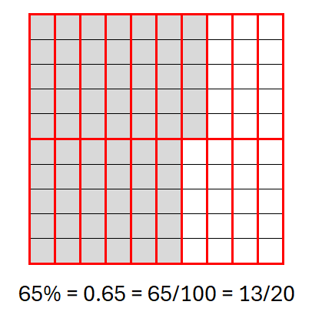  - explaining that as $100\%=1,$ $175\%$ can be represented using a diagram, such as  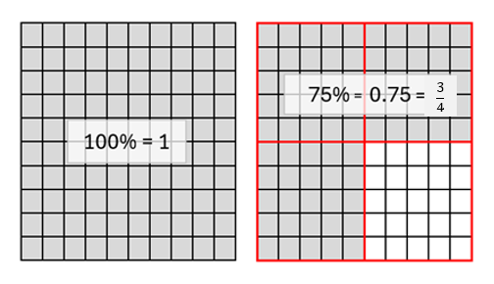  $$175\%=1.75=1\frac{3}{4}$$  - investigating, comparing, generalising and validating calculator strategies to move between percentages, fractions and decimals  Draw and label, or use a given number line, to locate, order and compare with equality and inequality symbols, fractions, terminating decimals, percentages and integers  For example:  - locating $\frac{2}{5}$, $-2$, $-4$, $95\%$, $0.75$ and $2\frac{1}{4}$ on a number line and using this to assist in ordering and comparing numbers using inequalities  $$-4<-2<\frac{2}{5}<0.75<95\%<2\frac{1}{4}$$  - comparing $\frac{3}{5}$ and $\frac{6}{10}$ using equality and inequality symbols  $\frac{3}{5}=\frac{6}{10}$ or $\frac{3}{5}≤\frac{6}{10}$ or $\frac{3}{5}≥\frac{6}{10}$  - comparing $\frac{1}{4}$ and $-\frac{1}{3}$ using inequality symbols  Explore to extend addition and subtraction of positive integers to include negative integers  For example:  - using patterning to explore  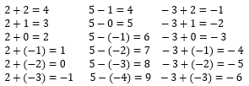  - using number lines to explore  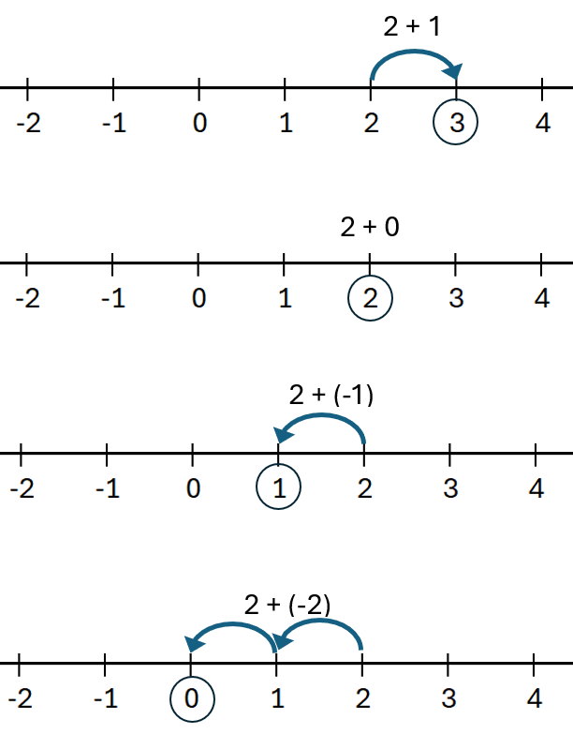  - extending and exploring addition and subtraction as inverse operations of each other by constructing equivalent equations that include  negative integers  If $3+(-5)=-2$, then  $-5+3=-2$  $-2-3=-5$  $-2-(-5)=3$  Explore and interpret multiplication and division of positive fractions, visually and numerically  For example:  - representing $\frac{1}{3}$ $×$ $\frac{4}{5}$  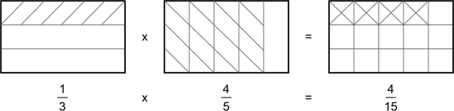  and using to explain $\frac{1}{3}$ $×$ $\frac{4}{5}$ $=$ $\frac{4}{15}$  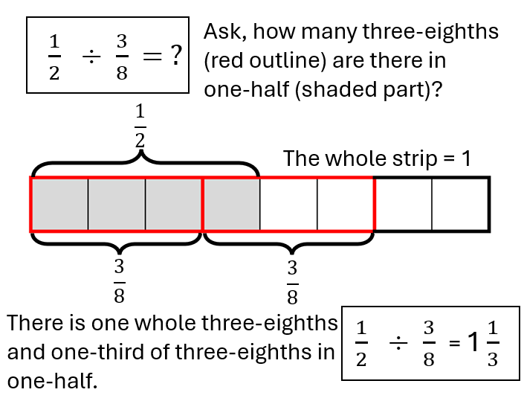  Explore and interpret multiplication and division of positive decimals, visually and numerically  For example:  - representing $0.6×0.5$ in a diagram and using it to explain and make connections to  $\frac{6}{10}$ $×$ $\frac{5}{10}$ $=$ $\frac{30}{100}$  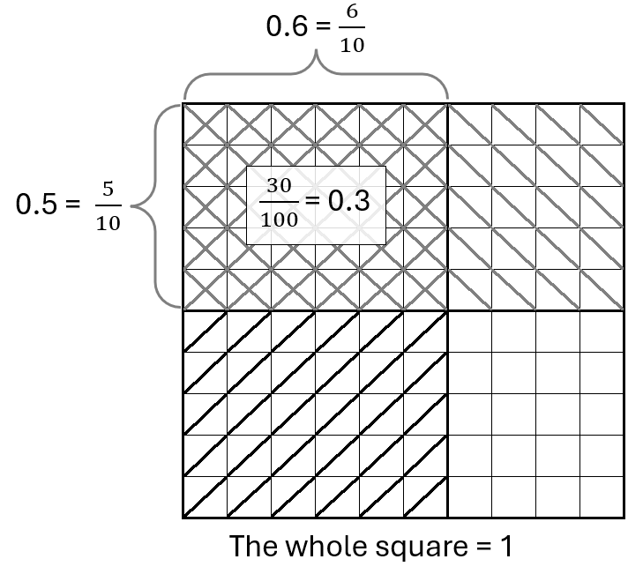  - representing $0.6÷0.2$ in a diagram and using the diagram to explain and make connections to  $\frac{6}{10}$ $÷$ $\frac{2}{10}$ $=$ $3$  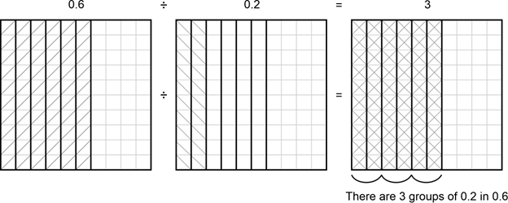  Use place value understanding to explore rounding decimals to a specified number of decimal places  For example:  - using place value to describe $3.64$ as between $3.6$ and $3.7$,$\frac{4}{100}$ greater than $3.6$ and $\frac{6}{100}$ smaller than $3.7$  - when rounding to three decimal places  $1.6248$ rounds to $1.625$  $1.6273$ rounds to $1.627$  $1.6235$ rounds to $1.624$  Extend the use of associative, commutative and distributive laws, additive and multiplicative partitioning, inverse operations, order of operations, equality and inequality to validate a range of mental and written strategies involving the four operations on whole numbers, positive fractions and decimals, and addition and subtraction of integers  For example:  - exploring efficiency of strategic use of partitioning, commutativity and order  of operations to assist  calculation of  $$16×75=4×4×3×25$$  $$=4×25×3×4$$  $$4×2\frac{3}{4}=(4×2)+(4×\frac{3}{4} )$$$-27+35=-27+(27+8)$  $$15.3-4.8=15.3+(-5)+0.2$$  - extending the use of inverse operations to assist calculation of an unknown fraction or decimal in an equation with one operation, such as  $$\frac{5}{8}- ? =\frac{1}{4}$$  $$\frac{5}{8} - \frac{1}{4} = ?$$  $$? ×3.5=16.1$$  $$? =16.1÷3.5$$  - without calculating, justifying statements as true (T) or false (F), such as  $48×2.5=12×10$  $8÷1.8÷2<8÷2÷1.8$  $15×6<15×12÷2$  $-12+3≥-9+(-3)+3$  $\frac{3}{8}×\frac{5}{8}>\frac{5}{8}×\left(\frac{1}{5}+\frac{3}{5}\right)$ | Investigate, define, identify and use correct notation for rational and irrational numbers, including terminating, recurring and  rounded decimals  For example:  - investigating to explain that $3$, $37\%$ and $0.6666$… ($0.\dot{6}$ or $0.67$ rounded to 2dp) are rational numbers as they can be written as the fractions $\frac{3}{1}$, $\frac{37}{100}$ and $\frac{2}{3}$  - investigating to explain that $\sqrt{2}$ and $π$ are irrational numbers as they cannot be written as fractions with an integer numerator and denominator and that $\frac{22}{7}$ and $3.14$ are approximations ($≈)$ for $π$  - investigating terminating, recurring and rounded decimals resulting from dividing $1$ by $1$, $2$, $3$, … to $15,$ comparing to dividing $10$ by $1, 2, 3,$ … to $15$, using correct notation  Draw and label, or use a given number line, to locate, order and compare with equality and inequality symbols, rational and irrational numbers, including numbers written in index form and percentages  For example:  - locating $-1$ $\frac{3}{4}, 3$, $-0.5$, $\sqrt{2}$, $25\%,$ $2^{1}$, $140\%$ and $\frac{1}{3}$ on a number line. Writing the numbers in ascending order. Comparing numbers using $<$ , $>$, $≤,$ $≥$ or $=$ e.g. $\frac{1}{3}$ $<\sqrt{2}$  - justifying why the following statement is true  $$-4\frac{1}{20}>-4.1$$  Explore to extend multiplicative thinking with positive integers to include multiplication and division of negative integers  For example:  - exploring using patterning  $3×2=6$ $-3×2=-6$  $3×1=3$ $-3×1=-3$  $3×0=0$ $-3×0=0$  $3×\left(-1\right)=-3$ $-3×\left(-1\right)=3$  $3×\left(-2\right)=-6$ $-3×\left(-2\right)=6$  - representing $4×-2$ as repeated addition on a number line  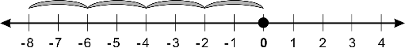  - considering $4×-3$ as  $\left(-3\right)+\left(-3\right)+\left(-3\right)+(-3)$ and $-4×-3$ as $-\left[\left(-3\right)+\left(-3\right)+\left(-3\right)+(-3)\right]$  - extending and exploring multiplication and division as inverse operations of each other, by constructing equivalent equations that include negative integers  $$-7×4=-28 \\ 4×(-7)=-28 \\ -28÷4=-7 \\ -28÷-7= 4$$  - investigating  ${(-5)}^{2}$ and ${-5}^{2}$  ${(-5)}^{3}$ and ${-5}^{3}$  and justifying that there are two numbers that can be squared to give a result of $25$ and that $\sqrt[3]{-125 }=- 5$  Extend the use of associative, commutative and distributive laws, additive and multiplicative partitioning, inverse operations, order of operations, equality and inequality to validate a range of mental and written strategies involving the four operations on any rational number  For example:  - selecting, using and communicating partitioning, commutativity, and order of operations to evaluate  $-74×4$  $$=4×(-70)+ 4×(-4)$$  $$-63 ÷150$$  $$= \frac{-63}{150}$$  $$= \frac{3×(-21)}{3 ×50}$$  $$=\frac{-21}{50}$$  $$-\frac{1}{2}+\frac{3}{5}×\frac{1}{2}$$  $$=-\frac{1}{2}+\frac{3}{10}$$  $$=\frac{3}{10}-\frac{1}{2}$$  - flexibly using associativity and inverse operations to create equivalent equations and using this to solve for unknown fractions or decimals in equations with one operation, such as  $$4\frac{1}{8} - ? =-2\frac{1}{4}$$  $$4\frac{1}{8}-(-2\frac{1}{4} )= ?$$  $$4\frac{1}{8}+2\frac{1}{4}= ?$$  $$4+2+ \frac{1}{8}+ \frac{1}{4}= ?$$  $$? ×3.5=- 16.1$$  $$? =-16.1÷3.5$$  - without calculating, justifying statements as true (T) or  false (F)  $9.6+8÷4>9.6÷8+4$  $9÷(0.4+3)=(9÷0.4)+(9÷3)$ | Investigate very large and very small numbers and move flexibly between their exact and approximated scientific notation  For example:  - exploring contexts for very large numbers (population count, national debt, mass of celestial bodies, data storage) and very small numbers (nanoparticles, sizes of cells, microseconds, microtransactions, tolerances in engineering, winning times in Olympic events) and comparing these quantities or measurements to those in more familiar contexts  - exploring instruments used to measure very large and very small measures, such as the capacity of liquid in a scientific pipette being  $5.72×{10}^{-4}$mL, which is $0.000572$ mL  - choosing to write the size of an atom given as $2.45×{10}^{-7}$ mm exactly as $0.000000245$ mm, and the speed of light given as $299 792 458$ ms as approximately $2.998×{10}^{8}$ ms for accuracy, efficiency  or context  Investigate, define, compare and order real numbers, with  equality and inequality symbols, including those expressed in scientific notation  For example:  - explaining that the real number system includes both rational and irrational numbers  - using efficient strategies to write the real numbers below in descending order and comparing the numbers using  $<, >, ≤, ≥$ or $=$  $\sqrt{π}, -1\frac{1}{2}$, $3.25×{10}^{-1}$, $2^{0}$ , $\sqrt[3]{-8.1 }$, $0.15$, ${1.4}^{0}$, $5.5×{10}^{-2}$, $\sqrt{3}$  - without calculating, justifying why the following are true:  $$3.25×{10}^{-1}>5.5×{10}^{-2}$$  $\sqrt{π} < π$  $$\sqrt{2}>\frac{1}{2}$$  $\sqrt[3]{-64 }>\sqrt[3]{-125}$  Year 9 optional  Explore to develop a sequence of steps to flexibly move between recurring decimals and fractions | Move flexibly between real number inequalities expressed as a worded statement, algebraically or on a number line  For example:  - representing all measurements greater than or equal to two metres as an inequality and on a number line  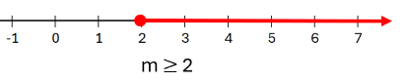  - representing a range of temperatures greater than or equal to $-1.5°$ and less than $3°$ as inequalities and on a number line  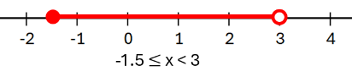  - writing an inequality to match the following number line solution  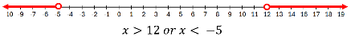
Explore and explain the use of ratios and fractions to compare numbers and quantities. Make connections between equivalent fractions and between equivalent ratios  For example:  - the bar, or the whole, can be considered as $10$ equal parts or $2$ unequal parts made up of the ‘blue part’ and the ‘green part’  exploring ways to compare the sizes of  - the ‘blue part’ and the ‘green part’, such as $4:6$ or $2:3, 6:4$ or $3:2$, $\frac{4}{6}$ or $\frac{2}{3}$ $,$  $\frac{6}{4}$ or 1 $\frac{1}{2}$  - the ‘blue part’ and the ‘whole’, such as  $4:10$ or $2:5$, $10:4$ or 5$:2,$  $\frac{4}{10}$ or $\frac{2}{5} ,$ $\frac{10}{4}$ or $\frac{5}{2}$  - the ‘green part’ to the ‘whole’, such as $6:10$ or $\frac{6}{10}$ or $\frac{3}{5}$  - using diagrams to explain equivalent ratios and simplification of ratios,  such as  $4:6=2:3$ (blue part to green part) or  $4:10=2:5$ (blue part to whole)  - comparing measurements, such as $2$ g to $0.8$ kg  $2: 800$, $1: 400$ or $\frac{1}{400}$ | Explore and apply proportional reasoning to determine unknown numbers in equivalent ratios and fractions  For example:  - giving reasons why $n$must be $2$ if $\frac{n}{5}$ $=$ $\frac{6}{15}$  - moving flexibly between ratios and fractions in order to calculate an unknown, such as $7:4=a:6$  $\frac{7}{4}$ $=$ $\frac{a}{6}$  $$4a=42$$  - dividing a quantity in a given ratio, such as sharing $\$570$ in the ratio $2:1$  Identify, interpret, compare and use familiar rates, including those represented as graphs that show a quantity varying over time  For example:  - identifying $30$ km/h as a rate, interpreting $30$ km as the distance travelled in every one hour, reasoning that this is equivalent to $60$ km travelled in two hours, $15$ km in $30$ minutes or $0.5$ km in one minute  - determining that purchasing cheese at $\$3.75/100$ grams is a better buy than purchasing the same product at $\$42$/kilogram  - given the following  distance-time graph of a car travelling to visit a friend,  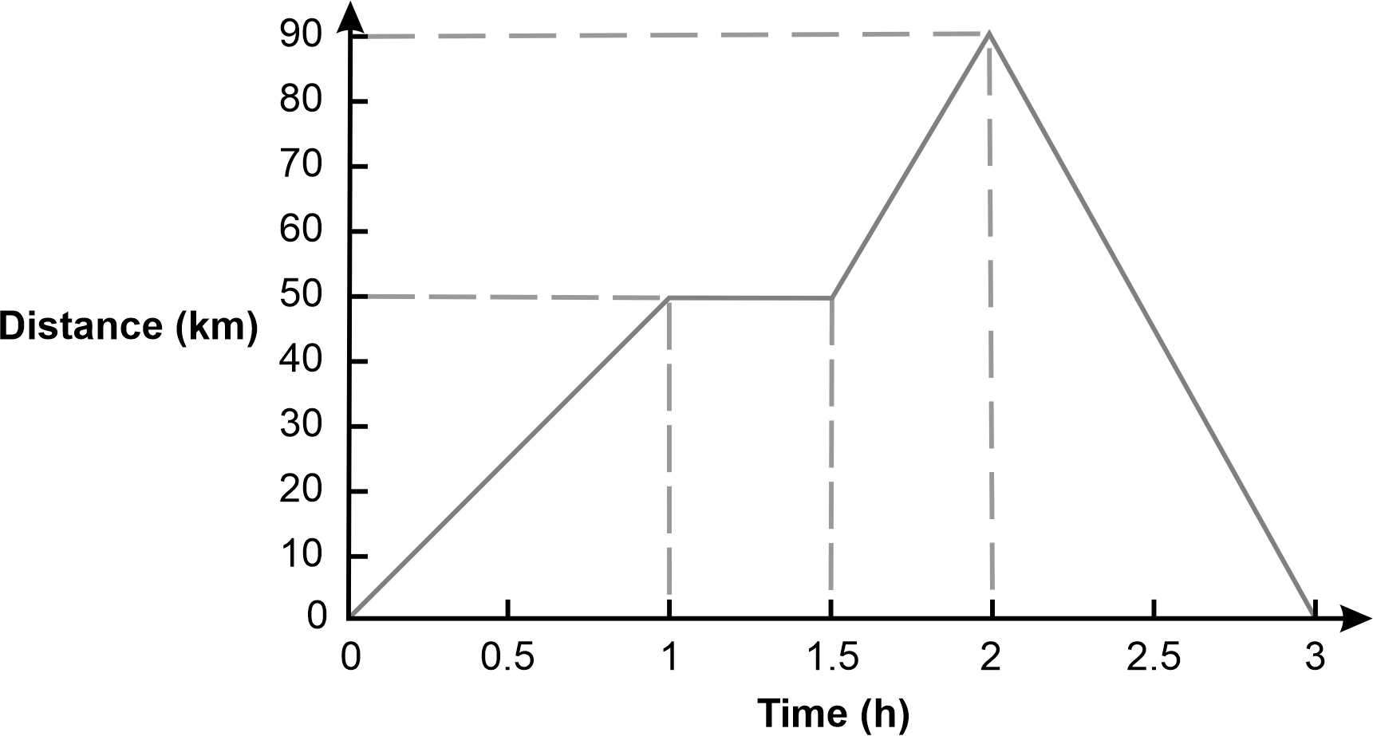  explaining the significance of the horizontal line segments and calculating the average speed of the trip in the first  two hours

Sub-strand: Calculating with number
Year 7 | Year 8 | Year 9 | Year 10
Convert between fractions, decimals and percentages using flexible and efficient strategies  For example:  - mentally converting, with jottings if needed, $12.5\%$ to a fraction using thinking, such as $12.5\%$ is half of $25\%$ $\left(\frac{1}{4}\right)$ and half of $\frac{1}{4}$ is $\frac{1}{8}$ and converting $\frac{3}{20}$ to a percentage using thinking, such as $\frac{3}{20}$ is equivalent to $\frac{15}{100}$ and is therefore $15\%$  - converting $37.5\%$ to a fraction, communicating thinking using a sequence of equations, such as  $\frac{37.5}{100}$ $=$ $\frac{375}{1000}$ $= \frac{3}{8}$  - converting $\frac{97}{22}$ to a decimal (2dp), using a calculator  Determine percentages of quantities and express one quantity as a percentage of another using flexible and efficient strategies  For example:  - mentally calculating, with jottings if needed, $10\%$ of $570,$ using the result to calculate $5\%$ and $30\%$ of $570$ and finding $25\%$ of $60$ using thinking, such as  $\frac{1}{4}$ $×60$ is $15$  - determining the percentage that $0.48$ is of $2$, communicating thinking using a sequence of equations, such as  $$\frac{0.48}{2}$$  $$=\frac{48}{200}$$  $$=\frac{24}{100}$$  $$=24\%$$  - using a calculator to find $17\%$ of $\$9.20$ | Calculate percentage increases  and decreases, using knowledge of fractions and decimals to  improve efficiency  For example:  - mentally, with jottings if needed, increasing $360$ by $10\%$ using thinking, such as  $360+10\%$ of $360$  $=$ $360$ $+$ $\frac{1}{10}$ $×$ $360$  or by using strategies, such as  $110\%$ of $360$  $=$ $1.1$ of $360$  - mentally, with jottings if needed, decreasing $360$ by $25\%$ using  $360-25\%$ of $360$  $=$ $360$ $-$ $\frac{1}{4}$ $×$ $360$  or by using strategies, such as  $75\%$ of $360$  $=$ $\frac{3}{4}$of $360$  - using a calculator to increase a population of $5560$ by $107\%$ using  $5560+1.07$ of $5560$  or  $2.07$ of $5560$
Add and subtract integers using flexible and efficient strategies  For example:  - mentally calculating, with jottings if needed,  $-8+20$ using $20-8$  $7-13$ using $7-7-6$  $3-(-12)$ using $3+12$  $-6+(-4)$ using $-6-4$  - communicating thinking to the solution of  $$-35+48-(-15)+(-11)$$  using a sequence of equations, such as  $$=-35+(35+13)+15-11$$  $$=(-35+35)+13+4$$  $$=17$$  - using a calculator to evaluate  $$-54+\left(-723\right)-94-(-6873)$$  Add and subtract positive fractions with related and unrelated denominators using flexible and efficient strategies  For example:  - mentally calculating, with jottings if needed,  $1\frac{7}{8}$+ $2\frac{1}{4}$ using thinking, such as $3\frac{7}{8}$+ $\frac{1}{4}$ which is $4\frac{1}{8}$  - communicating thinking using a sequence of equations for  $\frac{2}{7}$ $+\frac{2}{3}$ and $2\frac{1}{3}$ $-$ $1\frac{1}{2}$ , simplifying answers where possible  - using a calculator to evaluate$6\frac{3}{7}$ $+$ $18\frac{5}{9}$  Multiply and divide positive fractions using flexible and  efficient strategies  For example:  - mentally calculating, with jottings if needed, $5\frac{1}{2}$ $÷$ $\frac{1}{4}$ using thinking, such as there are $20$ quarters in $5$ and $2$ quarters in $\frac{1}{2}$, so the answer is $22$ and calculating $\frac{2}{3}$ $×$ $6\frac{1}{2}$ using thinking, such as $\frac{2}{3}×6$ is $4$ and $\frac{2}{3}$ $×$ $\frac{1}{2}$ is the same as $\frac{1}{2}$ $×$ $\frac{2}{3}$ or $\frac{1}{3}$ so the answer is $4\frac{1}{3}$  - communicating thinking using a sequence of equations, for calculations, such as  $\frac{2}{5}$ $×2\frac{2}{3}$  $\frac{2}{7}$ $÷\frac{2}{3}$  $\frac{1}{2}×\left(\frac{2}{5}+\frac{3}{10}\right)$  simplifying answers where possible  - using a calculator to evaluate  $11\frac{2}{7}÷\left(2\frac{2}{3}×\frac{1}{2}\right)$  Multiply and divide positive decimals using flexible and  efficient strategies  For example:  - mentally calculating, with jottings if needed, $0.25×1.2$ by using thinking, such as  $\frac{1}{4}$ of $1.2$which is $0.3$  - communicating thinking using a sequence of equations, for calculations, such as  $$6.4÷0.8$$  $$=64÷8$$  $$=8$$  $$7.8×9$$  $$=7.8×10-7.8$$  $$=78-7.8$$  $$=70.2$$  $$0.36÷8$$  $$0.36÷2$$  $$0.18÷2$$  $$0.09÷2$$  $$=0.045$$  - using a calculator to evaluate $27.4÷1.05$  Use appropriate rounding, estimation strategies and context to check reasonableness of solutions  For example:  - recognising that $6\frac{3}{7}$ $+$ $18\frac{5}{9}$ could be rounded to  $6\frac{1}{2}$ $+$ $18\frac{1}{2}$ and applying appropriate strategies to approximate ($≈)$ the solution, using this estimation as a tool  to check if the solution  derived from the actual values  is reasonable  - recognising that  $695÷0.527$could be rounded to$700÷0.5$ and that dividing a number by a number less  than one, makes it bigger. Applying appropriate strategies to approximate the solution, using this estimation as a tool  to check that the solution derived from the actual values  is reasonable  - recognising that an interest of $4.95\%$ of $\$500$ as being approximately $5\%$ of $\$500$ and that multiplying by a number less than one makes the  number smaller. Applying appropriate strategies to approximate the solution, using this estimation and the context as a tool to check that the solution derived from the actual values is reasonable | Multiply and divide integers using flexible and efficient strategies  For example:  - mentally calculating, with jottings if needed, $\frac{-35}{ 5}$ by using thinking, such as $5×$ ? $=$ $-35$ or calculating $(2)(-6)(-45)$ using thinking, such as  $2×(-45)×(-6)$ which is the same as $-90×(-6)$ or $540$  - communicating thinking to the solution of $24×(-13)$ using a sequence of equations, such as  $$=20×\left(-13\right)+4×\left(-13\right)$$  $$=-260+(-52)$$  $=-260$–$52$  $=-260$–$50$–$2$  $= -312$  - using a calculator to evaluate $-817÷(-35)$ to two decimal places (2dp)  Use flexible and efficient strategies for calculations involving the four operations with rational numbers, including those written in index form, using rounding, estimation or the context to check reasonableness of results  For example:  - mentally, with jottings if needed, calculating  $$5-6^{2}÷(-4)$$  $${\left(2^{4}×{10}^{2}÷4^{2}\right)}^{2}$$  $\left({-8}^{2}\right)$ ÷ $\left(2^{3}\right)$  - communicating thinking using a sequence of equations for calculations, such as  $$-5.1+8.3-0.6$$  $1$ $\frac{1}{2}+$5 $\frac{3}{5}$  and using rounding and properties of numbers to check reasonableness of results  - using a calculator to efficiently determine a solution to the hypotenuse of a right-angled triangle (e.g. $\sqrt{{3.2}^{2}+ {7.85}^{2}}$cm), checking that the solution is reasonable, using an estimation of $\sqrt{3^{2}+8^{2}}$ and knowing  that the hypotenuse is the longest side | Use flexible and efficient strategies for calculations involving the four operations with real numbers and express solutions in exact form or as an approximation  For example:  - determining the unknown side of a right-angled triangle, with a side length of $1$ cm and a hypotenuse of $2$ cm, as being exactly $\sqrt{3}$ cm and approximately as $1.73$ cm  - recognising that solutions can be written exactly or as approximations, such as in a semicircle with a radius of  $6$ units, the area can be written exactly as $18π$ square units and approximately as $56.55$ square units (2dp)  - determining the average speed of light if the distance between the Earth and the Sun is  $1.496×{10}^{11}$ metres and the time taken for light to travel from the Earth to the Sun is $4.987×{10}^{2}$ seconds, discussing differences between rounding decimal numbers before calculating and rounding the solution | Use absolute and percentage error to compare the result of using approximate rather than exact real numbers on final calculations  For example:  - investigating the use of  absolute error to determine percentage error  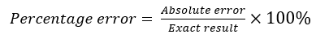  where absolute error is the positive difference between the approximate and exact results  in situations, such as  - calculating the surface area of cylinders using $3.14$ instead of the exact value of $π$ or by using $π$ and then rounding the area of the base circles  - applying Pythagoras’ theorem or trigonometry to find a missing side in a  right-angled triangle and using $1.41$ instead of the exact value of $\sqrt{2}$  - applying the compound interest formula and using $2.67\%$ interest per annum instead of $2\frac{2}{3}$%

Sub-strand: Algebraic techniques
Year 7 | Year 8 | Year 9 | Year 10
Represent in expanded form, evaluate, and compare numbers expressed in index notation, including powers of $10$  For example:  - identifying that $7^{3}$ has a base of $7$ and an index or power of $3$ and can be written as $7×7×7$ which can be evaluated as $343$  - recognising that  $$5^{4}=5×5×5×5$$  $=625$  and that $625$ is $25$ times as great as $25$ and $125$ times as great as $5$  - identifying and recognising patterns within powers of $10$, such as $1000$ is the same as $10×10×10$which can be written as ${10}^{3}$ which has a base of $10$ and an index or power of $3$  - making connections between powers of $10$ and place value, such as $4000$ ($4×{10}^{3}$) is $100$ times as great as $40$ ($4×{10}^{1}$) and $1000$ times as small as four million ($4×{10}^{6}$)  Extend knowledge of factors to represent natural numbers as products of prime factors using index notation as appropriate  For example:  - making connections between a series of equations and a tree diagram to express $24$ as a product of primes  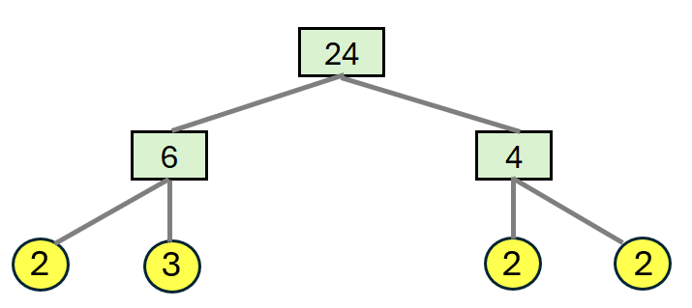  $$24 =6×4 \\ =2×3×2×2 \\ =3×2×2×2$$  We can write this in index form  as $3×2^{3}$  - investigating the use of different pairs of initial factors, such as $8×3$ or $2×12$ when determining the prime factors  of $24$  Explore and explain connections between square numbers and square roots, cube numbers and cube roots, as products of repeated factors  For example:  - deducing that if $9×9$ is $9²$, or $81$, then$\sqrt{81}=9$ and if $6×6×6$ is $6^{3}$ or $216$, then $\sqrt[3]{216}$ $=6$  - estimating the square root or cube root of a whole number, such as $\sqrt{34 }$ by reasoning that it lies between $\sqrt{25}$ and $\sqrt{36 }$ and is closer to $\sqrt{36}$ so could be estimated to be $5.8$. Using a calculator to confirm a solution of $5.83$ (2dp) | Develop and apply the index laws for numbers in index form with positive-integer and zero indices  For example:  - exploring expressions, such as  $$3^{2}×3^{4}$$  $$=\left(3×3\right)×\left(3×3×3×3\right)$$  $$=3^{6}$$  or $3^{2 + 4}$  and  $3^{5}÷3^{2}$  $$=\frac{3×3×3×3×3}{3×3}$$  $$=3^{3}$$  or $3^{5 - 2}$  and  $${\left(3^{3}\right)}^{2}$$  $$=3^{3}×3^{3}$$  $$=3×3×3×3×3×3$$  $$=3^{6}$$  or $3^{3×2}$  and  $${ \left(2×3\right)}^{2}$$  $$=\left(2×3\right)×\left(2×3\right)$$  $$= 2^{2}×3^{2}$$  and  $${ \left(\frac{2}{3}\right)}^{2}$$  $$=\left(\frac{2}{3}\right)×\left(\frac{2}{3}\right)$$  $$=\frac{2^{2}}{3^{2}}$$  and using words to generalise each of these rules  - exploring the meaning of the zero-index using examples, such as  $$\frac{5^{2}}{5^{2}}=\frac{25}{25}=1$$  and  $$\frac{5^{2}}{5^{2}}=5^{2 - 2}$$  $$=5^{0}$$  $∴5^{0}=1$  and by patterning in  $2^{4}$, $2^{3}$, $2^{2}$, $2^{1}$, $2^{0}$  - applying the index laws to simplify and evaluate, mentally or with a calculator, depending on the complexity of the numbers, communicating thinking using a sequence of equations for expressions,  such as  $${(2^{2})}^{3}×2×2^{3}$$  $${((3}^{8}÷3^{6})×3^{2})÷3^{0}$$  $${ \left(\frac{4}{3}\right)}^{2}$$ | Extend and apply index laws with positive-integer indices and the zero index to variable bases, and simplify where appropriate  For example:  - generalising numerical expressions, such as  $$2^{2}×2^{3}=2^{2 + 3}=2^{5}$$to $a^{m}×a^{n}=a^{m + n}$  and hence simplifying  $b^{3}×b^{7}×b$ or $3e^{2}×5e^{4}$  $2^{5}÷2^{3}=2^{5 - 3}=2^{2}$  to $a^{m}÷a^{n}=a^{m - n}$  and hence simplifying  $\frac{h^{8}}{h^{3}}$ or ${3ay}^{5}÷{6ay}^{3}$  $${\left(2^{2}\right)}^{3}=2^{2 × 3}=2^{6}$$to ${\left(a^{m}\right)}^{n}=a^{mn}$and hence simplifying  ${\left({7e}^{2}\right)}^{3}$ or ${\left({2cd}^{2}\right)}^{4}$  ${ \left(\frac{2}{3}\right)}^{2}=\left(\frac{2^{1×2}}{3^{1×2}}\right)$ $=\frac{2^{2}}{3^{2}}$  to ${ \left(\frac{a}{b}\right)}^{n}=\frac{a^{n}}{b^{n}}$  and hence simplifying  ${\left(\frac{2b}{3e}\right)}^{3}$or ${ \left(\frac{5}{{4x}^{2}}\right)}^{2}$  $$2^{3}÷2^{3}=2^{3-3}=2^{0}=1$$  to $a^{0}=1$and hence simplifying  ${-5k}^{0}$ $-$ 7  Extend and apply index laws with numerical expressions of base-10 to include negative-integer indices. Develop the relationship between these negative indices and equivalent fractions and decimals  For example:  - applying patterns, index notation and laws to negative integer numerical indices  Patterns  $${10}^{1}$$ $${10}^{0}$$ $${10}^{-1}$$ $${10}^{-2}$$ $${10}^{-3}$$  $$10$$ $$1$$ $\frac{1}{{10}^{1}}$ or $\frac{1}{10}$ $\frac{1}{{10}^{2}}$ or $\frac{1}{100}$ $\frac{1}{{10}^{3}}$ or $\frac{1}{1000}$  $$10$$ $$1$$ $$0.1$$ $$0.01$$ $$0.001$$  - using index laws  ${ 10}^{2}÷{10}^{6}$  $$=\frac{{10}^{2}}{{10}^{6}}$$  $$=\frac{10×10}{10×10×10×10×10×10}$$  $$=\frac{1}{{10}^{4}}$$  and making connections to  ${10}^{2}÷{10}^{6}$  $$={10}^{2-6}$$  $$={10}^{-4}$$  $∴{10}^{-4}=\frac{1}{{10}^{4}}$ or $1÷10 000$  - explaining when using scientific notation that  $3.2×{10}^{-4}=3.2×\frac{1}{10 000}=\frac{3.2}{10 000}$ or $0.00032$ | Extend and apply index laws  with positive-integer indices and variable bases, to include negative-integer indices  For example:  - applying patterns, index notation and laws to establish  $a^{-1}=\frac{1}{a}$, $a^{-2}=\frac{1}{a^{2}}$, $a^{-3}=\frac{1}{a^{3}}$ and $a^{-n}=\frac{1}{a^{n}}$  - representing expressions involving negative-integer indices as expressions involving positive-integer indices and vice versa  $x^{-3}=\frac{1}{x^{3}}$, ${2x}^{-1}=\frac{2}{x^{1}}=\frac{2}{x}$ ,  $\frac{4}{x}=\frac{4}{x^{1}}={4x}^{-1}$ , $\frac{1}{x^{2}}=x^{-2}$  - justifying why these statements are true  $\frac{9x^{5}}{{3x}^{-5}}={3x}^{10}$$$9x^{-7}÷ 3x^{5}≠3x^{2}$$  $${\left({3a}^{2}\right)}^{2}×a^{3}≠6a^{7}$$  $${ a}^{5}×a^{-7}=\frac{1}{a^{2}}$$  Substitute values into real-life linear, quadratic or simple exponential formulas to determine unknowns using digital tools  For example:  - using software and a real-life situation; such as the height of a toy rocket launched from the ground being modelled by a quadratic given as  $h={-16t}^{2}+128,$to find unknown values  of $h$ and $t$  - using spreadsheets to investigate  $A=P{(1+i)}^{n}$for different values of unknowns  Year 10 optional  Simplify algebraic products and quotients involving indices with integer and fractional indices  Year 10 optional  Establish the connection between fractional indices and surds. Perform the four operations with surds and rationalise the denominator  if required  Year 10 optional  Interpret and use base-10 logarithmic scales on graphs of  real-life contexts
Use real-world contexts or concrete materials to introduce the concept of a variable to represent a number using a letter. Create simple algebraic expressions and evaluate by substituting a given value for  the variable/s  For example:  - introducing a variable using unknown numbers of chocolates in two different sized bags where $m=$ number of chocolates in one small bag, $g=$ number of chocolates in one large bag, creating expressions, such as  - the number of chocolates in three large bags and one small bag as being  $$3×g+m=3g+m$$  - the difference between the number of chocolates in the bags as being $g-m$  - combining the number of chocolates in five large bags and two small bags and sharing them between four people as being $\frac{5g+2m}{4}$  and evaluating each expression if the numbers of chocolates in each bag is known  - using concrete materials, such as algebra tiles, to visually represent numbers as variables  - using expressions of everyday formulas, such as carry-on bag size for an aeroplane flight being determined by the length $+$ width $+$ depth ($l+w+d$) and using substitution to determine if a bag is of an appropriate size  Extend and apply the associative and commutative laws and properties of numbers to include variables  For example:  - considering the accuracy of the following equations and explaining thinking  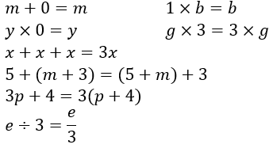 | Extend and apply knowledge of additive and multiplicative partitioning, order of operations and the associative and commutative laws of numbers, to create or simplify algebraic expressions involving the four operations  For example:  - simplifying the following algebraic expressions  $$-m+2-5m-8+2m$$  $$3p×2e×(-5)$$  $$15x÷3x$$  $$\frac{3p}{6}$$  - considering the accuracy of the following equations and explaining thinking  $$a÷6b =a÷2÷3b$$  $$-12h×10a=3h×(-8×5a)$$  $$3a×\left(-5b\right)×2g=5a×(-2b)×3g$$  $$m÷(-3)=5m÷(-15)$$  $$20÷\left(a+b\right)=(20÷a)+(20÷b)$$  - creating and comparing algebraic expressions to represent the total number of chocolates for a group of four people, each holding a bag that has the same unknown number of chocolates, if each person is given an extra three chocolates  Extend and apply knowledge of the distributive law with numbers to algebraically expand and factorise expressions with a common numerical factor  For example:  - connecting the visual representation of $2×37$using an area model  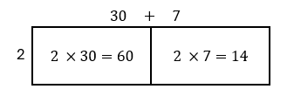  $$=60+14$$  to $2(a+7)$  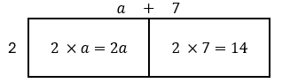  = $2a+14$,  factorising using reverse thinking  $$2a+14$$  $$=2×a+2×7$$  $=$ $2(a+7)$  and verifying the factorisation using the distributive law  - expanding and simplifying expressions, such as  $5 (2g-h+6)$  $$-4 (-3p+\left(-2\right))$$  $$-7b+5\left(b-3\right)$$communicating thinking using a sequence of equations  - factorising expressions, such as  $-4-12k$  $2m-6m^{3}+18-4de$ | Explore and apply the distributive law to expand and factorise algebraic expressions with a common algebraic factor,  including collecting like terms  where appropriate  For example:  - extending expansion and factorisation using the distributive law with  numerical factors, to expansion and factorisation with  algebraic factors  $$2b(m+3c)$$  $$=2b×m+2b×3c$$  $$=2bm+6bc$$  and factorising using reverse thinking  $$2bm+6bc$$  $$=2b×m+2b×3c \\ = 2b\left(m+3c\right)$$  verifying factorisation using the distributive law  - expanding and simplifying expressions, such as  $3b(2b-c+1)$  $$-2k(-3k+\left(-2\right))$$  $$-2b\left(b-3\right)-7b+5$$  $$x\left(x+2\right)-6\left(x-3\right)$$communicating thinking using a sequence of equations  - factorising expressions, such as  $9mp-3m+6me$  $-2d^{2}-3d^{3}$  Explore and apply the  distributive law to expand binomial products, collecting like terms where appropriate  For example:  - connecting the visual representation of expansion with numbers, such as  $$24×37=(20+4)(30+7)$$  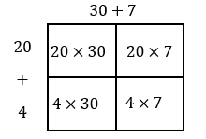  to  $$\left(a+b\right)\left(c+d\right)$$  $$=ac+ad+bc+bd$$  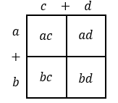  and using to expand and simplify $\left(x+3\right)\left(x+8\right)$ 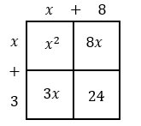  $=x^{2}+8x+3x+24$  $=x^{2}+11x+24$  - communicating thinking of expansion and simplification of equations, such as  $${(y-4)}^{2}$$  $$(c+8)(c-8)$$  $$(2y-3p)(-y-7p)$$  $${\left(b+2\right)}^{2}-5$$  Year 9 optional  Explore efficient strategies to simplify expressions that involve addition, subtraction,  multiplication or division of algebraic fractions with an algebraic term in the numerator and a whole number denominator | Extend and apply knowledge of  the expansion of binomial  products to explore the factorisation of monic quadratics  For example:  - extending knowledge of expansion of  $\left(x+4\right)\left(x+3\right)$  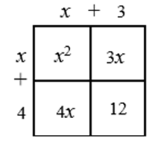  to make connections to factorising quadratics using knowledge of multiples and partitioning  $$x^{2}+7x+12$$  $$= x^{2}+4x+3x+12$$  $$= x\left(x+4\right)+3(x+4)$$  $=\left(x+4\right)\left(x+3\right)$  - factorising $x^{2}+12x+20$ by making connections between the expansion of binomial products and the area model and generalising to a factorising strategy involving factors of $20$  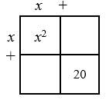  - factorising quadratics, such as  $x^{2}-14x+24$ , $x^{2}-3x-28$ and $x^{2}+9x-22$  Year 10 optional  Factorise monic and non-monic quadratic expressions  using techniques, such as completing the square, perfect squares, difference of squares and grouping in pairs for four-term expressions  Year 10 optional  Explore efficient strategies to simplify expressions that involve addition, subtraction, multiplication or division of algebraic fractions with an algebraic expression in the numerator and/or denominator, including the use of factorisation

Sub-strand: Linear and non-linear equations and inequalities
Year 7 | Year 8 | Year 9 | Year 10
Solve simple linear equations involving up to two operations and verify the solution by substitution  For example:  - using a context, such as ‘Three bags with equal numbers of chocolates were tipped into a container that already held five chocolates. There were $62$ chocolates altogether. How many were in each bag?’  - exploring and comparing a variety of strategies, such as the balance model, backtracking or inspection, to solve an equation, showing a sequence of steps to communicate thinking. Checking the solution by substitution using jottings or calculator for equations, such as  $$5m-3 = 12$$  $$-3+m=11$$  $$e-3=-2$$  $$48=14+2p$$  $$\frac{e}{2}-1=5$$  $$0.1v=12$$  $$\frac{1}{4}+2k=\frac{3}{8}$$  Note: equations involving multiplication and division of negative integers are introduced in Year 8; however, equations, such as $6-w=5$, that can be solved by inspection are in the  Year 7 curriculum | Solve linear equations involving  up to three operations, including those with negative coefficients  or requiring collection of like  terms, and verify the solution  by substitution  For example:  - using a strategy, such as the balance model, backtracking or inspection, to solve an equation, showing a sequence of steps to communicate thinking. Checking the solution by substitution using jottings or calculator for equations, such as  $1-2p=-10$  $$3-4h+6h=7$$  $$4.3 = \frac{5y -1.2}{2}$$  $\frac{8p}{3}$ $=$ $\frac{3}{5}$  - communicating thinking to solve  $3p-5q=5$ when $p=- 4$  Determine and explain why there are two solutions to a quadratic equation of the form  $x^{2}=k$ if $k>0$  For example:  - reasoning that for $x^{2}=9$ there are two values of $x$ that satisfy this quadratic equation given that $3^{2}$ and ${\left(-3\right)}^{2}$both equal $9$  - solving $b^{2}+7=71$ and verifying solutions  - using knowledge of quadratic equations in situations involving Pythagoras’ theorem, recognising that the solution must be positive because of the context | Solve linear equations involving brackets and/or a variable on each side of the equation, and verify the solution by substitution  For example:  - using a strategy, such as the balance model, backtracking or inspection, to solve an equation, showing a sequence of steps to communicate thinking. Checking the solution by substitution, using jottings or calculator for equations, such as  $3(y - 5) =-6y$  $$9=7(-4r-1)$$  $$3d-7=5d+8$$  $\frac{2 - e}{5}=-4$  $$4\left(\frac{3}{4}c-3\right)=2c+2$$  - communicating thinking to solve  $5e+2f=7.5-3f$ when $e=0$ or when $f=0$  Determine and explain why there are up to two solutions to a quadratic equation of the form ${ax}^{2}=k$and verify the possible solution/s by substitution  For example:  - reasoning and appropriately communicating that for $x^{2}=k$ there could be  - two solutions $(k>0)$  - one solution $(k=0)$  - no real solutions $(k<0)$  - considering ${2x}^{2}=10$, explaining that $x$ can be expressed in exact form as  $x=±\sqrt{5}$ or as a decimal approximation of  $x≈±2.24$ (2dp)  and checking by substitution  ${2(\sqrt{5})}^{2}$ and ${2(-\sqrt{5})}^{2}$  both equal $10$  Year 9 optional  Solve linear equations that involve simple algebraic fractions with numerical denominators and verify the solution by substitution  Year 9 optional  Solve quadratic equations in factorised form using the null factor theorem and verify the solution/s  by substitution | Solve one-variable linear inequalities involving brackets and/or a variable on each side. Represent the solution on a  number line and verify the solution by substitution  For example:  - using a strategy, such as the balance model, backtracking or inspection, to solve an inequality, showing a sequence of steps to communicate thinking for inequations, such as  $-2m-1≥-3m+2$,  representing solutions as  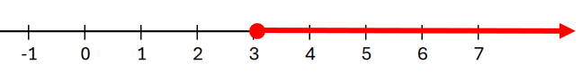  and checking by substituting a value greater than $3,$ such as $m=4,$ to show that the inequality holds true  $$-2(4)-1≥-3(4)+2$$  $$-9≥-10$$  Determine the solution to linear simultaneous equations in the forms $y=mx+c$ or$ax+by=c$ graphically and verify the solution by substitution  For example:  - graphing linear equations,  such as  $y=2x+1$ and $x+y=4$, manually or digitally  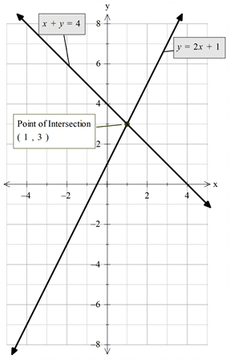  verifying that $(1, 3)$ is the point of intersection of the lines  Note: consider graphs of parallel lines that will have no solution  Year 10 optional  Determine the solution to linear simultaneous equations in the forms $y=mx+c$ or$ax+by=c$ algebraically and verify the solution by substitution or using digital tools  Year 10 optional  Identify the region on the Cartesian plane defined by linear inequalities  Year 10 optional  Solve monic and non-monic quadratic equations graphically and algebraically, including the use of the quadratic formula, factorising techniques and digital tools, and verify the solution/s by substitution  Year 10 optional  Use algebraic techniques to solve exponential equations that involve terms with related bases  Year 10 optional  Solve cubic equations in the form ${ax}^{3}=k$ or in factored form, algebraically or using digital tools

Sub-strand: Linear and non-linear patterns and relationships
Year 7 | Year 8 | Year 9 | Year 10
Explore, describe and represent concrete and real-world, linear and non-linear growing patterns using a table of values and a graph. Determine unknown values in  the pattern  For example:  - using diagrams or concrete materials, such as matchsticks and counters, to continue growing patterns and represent as number sequences in situations, such as chairs around connecting square tables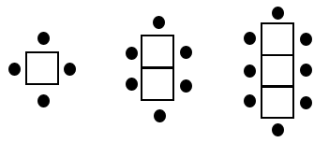  or growing dots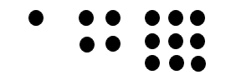  - using words to  generalise rules  - using variables  meaningfully to express rules as algebraic equations  - producing a table of values  - plotting points in the first quadrant on the Cartesian plane and describing the shape of the relationship  and using the sequence rule, table of values or graph to determine unknown values | Use a table of values to move flexibly between the equation of a line represented by $y=mx+c$and its graph and make connections between the algebraic and graphical solution of the equation. Explore and explain similarities and differences between multiple lines on the same axes  For example:  - using an equation, such as  $y=5x-1$, generate a table of values, plot the coordinates on the Cartesian plane and create a line, recognising that there is an infinite number of ordered pairs in any given linear relationship. Connecting the graph of  $y=5x-1$ to solving equations, such as  $9=5x-1$ and $1.5=5x-1,$ graphically and algebraically  - extracting a table of values from a linear graph and using the table to determine the equation of the line  For the following graph  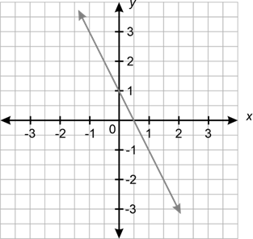  a corresponding table of values can be produced  $$x$$ $-$1 0 1 2  $$y$$ $$3$$ 1 $-$1 $-$3  The equation of the linear relationship can be determined as $y=-2x+1$ by recognising the values of $m$ and $c$ as the constant difference between values of 𝑦 (i.e. $-2$) and  the value of 𝑦 when $x=0$ respectively  - investigating and describing similarities and differences between multiple lines, using terms such as steepness, direction, parallel, non-parallel, pass through the same point, increasing and decreasing | Use the Cartesian plane to explore finding the distance, gradient and midpoint between two points  For example:  - plotting and joining two points on a Cartesian plane to form a line segment. Investigating, explaining and validating strategies, such as  - using vertical and horizontal units between points to form sides of a right-angled triangle and applying Pythagoras’ theorem to determine the distance between the two points  - counting the vertical difference and horizontal difference between the points and dividing the vertical rise by the horizontal run to determine gradient ($m)$. Connecting gradient to ratio, such as $3$ units to the right and $6$ units up, is the same as $5$ units to the right and $10$ units up. Distinguishing between line segments with positive and negative gradients and those with the same gradient. Exploring gradients of horizontal and vertical line segments  - using the halfway points  of the vertical and horizontal units to determine the midpoint  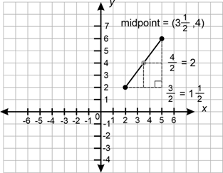  Move flexibly between the equation of a line, represented by  $y=mx+c$, and its graph using the gradient and $y$-intercept. Graph the equation of a line represented in $ax+by=c$form  For example:  - interpreting the coefficient of $x$($m$) in $y=mx+c$ form as the gradient/slope/rate of change and the constant ($c$) as the vertical intercept  - finding the equation of a line given the gradient ($m$) and the vertical intercept or by extracting the gradient and vertical intercept from a graph and using the equation to determine whether a given point lies on the line  - graphing an equation of a  line using the gradient and vertical intercept  in $y=mx+c$form, verifying the accuracy of the drawn graph using another point  - graphing an equation of a line written in $ax+by=c$form using the vertical and horizontal intercepts (i.e. when $x=0$ and when $y=0)$, verifying the accuracy of the drawn graph using another point  - investigating to compare and contrast graphs and equations of horizontal, vertical and parallel lines  Year 9 optional  Develop and use the algebraic formulas for finding the distance, midpoint and gradient between  two points  Year 9 optional  Rearrange formulas, including  $ax+by=c$, to change the subject of the formula | Use a table of values to plot points and graph quadratic functions of the form $y={ax}^{2}+c$. Identify and relate key graphical and algebraic features and make connections to the graphical and algebraic solution/s of ${ax}^{2}+c=k.$Use digital tools to explore the shapes, features and related solutions to more complex quadratic functions  For example:  - making connections between graphical and algebraic representations of quadratics, such as  - the shape and concavity of the parabola and the value of the coefficient of $x^{2}$  - the vertical intercept and the value of $c$  - the horizontal intercepts when they exist  - approximate solutions to examples, such as  ${-x}^{2}+4$ $=3.2$using the graph of $y={-x}^{2}+4$ and checking solutions using digital tools  - using digital tools to graph easily factorised monic quadratics, such as  $y= x^{2}+4x$ and  $y= x^{2}-7x+10$, exploring connections between the graphical and algebraic representations, and approximating and checking solutions to related equations  Use a table of values to plot points and graph exponential functions of the form $y=a^{x}$where$a>0.$ Identify and relate key graphical and algebraic features and use these to determine graphical solutions of related equations. Use digital tools to explore the shapes, features and related solutions to more complex exponential functions  For example:  - making connections between graphical and algebraic representations of exponentials, such as  - the vertical intercept  - the direction of the graph given the nature of $x$  - the shape of the graph given the value of $a$  - the asymptote  - approximate solutions to examples, such as $2^{x}=3$ and $y=2^{2.5}$ using the graph of $y=2^{x}$ and checking solutions using digital tools  - using digital tools to explore real-life exponential growth and decay situations, making connections between the algebraic and graphical forms
 |  | Identify rates as direct proportion, represent algebraically and graphically, and use both forms  to predict unknown values and interpret in the context of  the situation  For example:  - identifying that the relationship between the rate at which water drips from a tap into a bucket in each minute ($d$) and the amount of water in the bucket ($w$) in millilitres are directly proportional. Recognising that if there are $600$ mL in the bucket after $40$ minutes, then this can be represented as $w=15d$. Representing the equation graphically, recognising that $m=15$and that the  $y$-intercept is ($0, 0$), predicting unknown values and interpreting in context  Use a table of values to plot points and graph quadratic functions of the form $y={ax}^{2}$, describe key features and make connections to the algebraic solution/s of ${ax}^{2}=k$  For example:  - graphing $y= {3x}^{2}$ manually or digitally, recognising that it is a parabola with an axis of symmetry at $x=0$ and a turning point at ($0, 0$) and using it to solve${ 3x}^{2}=12$, verifying the solution algebraically  ${3x}^{2}= 12$  $${ x}^{2}= 4$$  $$x= ±2$$  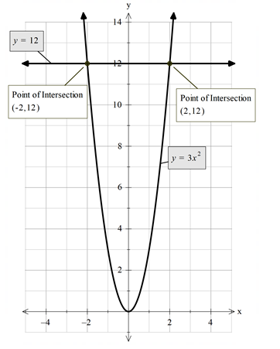  and connecting to the graphical solutions of ($-2, 12$) and ($2 , 12)$  Year 9 optional  Investigate indirect proportion, represent algebraically and graphically, use both forms  to predict unknown values  and interpret in the context of  the situation | Identify and distinguish between linear, quadratic and exponential functions represented by equations, tables of values and graphs  For example:  - recognising that in a table of values, if there is a constant difference between consecutive values of the dependent variable, then the function is linear. If there is a constant second difference between consecutive values of the dependent variable, then the function is quadratic, and if the ratio between the consecutive values of the dependent variable is constant, then the function is exponential  - investigating the links between algebraic and graphical representations of each function type using digital tools  Year 10 optional  Use gradient and/or point/s to graphically and algebraically determine equations of parallel and perpendicular lines  Year 10 optional  Graph monic and non-monic quadratics of the form  $y={ax}^{2}+bx+c$or  $y=a({x-p)}^{2}+q$ and their transformations, manually and using digital tools. Identify and connect key graphical and algebraic features and make connections to the algebraic solution/s  Year 10 optional  Explore and use strategies, including digital tools, to model the equation of a quadratic function from a table of values or graph  Year 10 optional  Explore, describe and interpret circles and rectangular hyperbolas where the asymptotes are parallel to the axes, and their transformations, using digital  tools, and make connections between the algebraic and  graphical representations

Sub-strand: Financial mathematics
Year 7 | Year 8 | Year 9 | Year 10
Identify the features of transactional statements and verify transactions. Explain reasons for checking and keeping financial records  For example:  - identifying features of transactional statements (e.g. bank, subscription, canteen, transport, prepaid debit card), including account information, statement period, transaction details (credits and debits), opening and closing balances, fees and interest earned  (if appropriate)  - explaining the importance of checking and keeping receipts and invoices, and tracking and verifying transactions for the purpose of budgeting and identifying suspicious transactions, such as  ‘Alice paid for a meal at a cafe electronically. She had bought a coffee for $\$5.50$ and a wrap for $\$12.75$. When she checked her bank statement on her bank app, she realised she had been charged $\$31$. Explain using calculations, how the error could have occurred and  what Alice could do to address the mistake.’ | Identify the advantages and disadvantages of various forms of payment for goods and services, and determine penalties, such as interest charged and fees, inherent in these payments  For example:  - considering payment forms, such as cash, EFTPOS, debit and credit payments, online payments, gift cards and transfers, including potential savings, costs and risks  - identifying and calculating surcharges and total amounts paid when using a debit card for purchases ($0.75\%$ transaction fee on top of the $\$25$ purchase)  - determining penalties for not adhering to the terms of credit, such as ‘buy now, pay later’ schemes, in situations such as ‘Bill made an $\$80$ purchase, paying four $\$20$ instalments. He was late to pay each monthly instalment which incurred  a $\$10$ late fee each month.  What percentage of the purchase price did Bill spend on late fees?’ | Explore, explain and perform calculations that relate to earning income. Identify the elements of an income statement/pay slip, including employer superannuation contributions and income tax as a deduction from gross income  For example:  - explaining that individuals earn an income in various ways, including salaries, wages (penalty rates),  self-employment, commission or piecework  - determining the total wage earned for a casual employee on $\$23.50$ per hour who works fixed hours on the weekend and earns time and a half for all hours worked on a Saturday  - determining the exact commission on the sale of a $\$755$ painting given the commission rate of $4$ $\frac{2}{3}\%$  - explaining the features and calculations within pay slips relating to pay period, payment details, deductions, tax paid, superannuation, gross and  net pay, overtime and  bonuses, year-to-date totals, employer information and payment method  Develop and use the simple interest formula to solve problems relating to saving and borrowing  For example:  - a car loan of $\$14 500$ is charged with $9.25\%$ p.a. simple interest over a three-year period. How much interest will be charged for each month of the loan?  Year 9 optional  Use authenticated websites to explore and compare different savings account options based on their characteristics (interest rates, fees, withdrawal policy)  or  Compare price, quality, terms  and conditions of goods and services, such as phone plans and digital subscriptions | Explore, explain and calculate income tax, including the use of  tax tables  For example:  - investigating differences in tax paid for incomes $\$10$ either  side of one of the intervals in  a current financial year  tax bracket  Apply repeated simple interest to develop the compound interest formula and solve problems that relate to saving and borrowing  For example:  - using a loan of $\$5000$ over three years at $4\%$ p.a., show repeated yearly simple interest calculations and demonstrate connections to the compounded interest formula  - using the compound interest formula to calculate the exact interest earned for an investment of  $\$12 000$ at $3\frac{1}{3}\%$ over four years, compounded yearly  - comparing different finance options, such as ‘Is it better to borrow $\$2000$ from a store finance program that offers $8.55\%$ p.a. simple interest over $18$ months or from a bank that offers $7.2\%$ p.a., compounded yearly, over two years?’  Year 10 optional  Use authenticated websites to investigate how changes to the principal, rate of return, voluntary contributions and time can affect superannuation balances  or  Compare characteristics of insurance, such as young driver car insurance or holiday insurance, and recognise that the cost is higher when the risk is higher

Sub-strand: Modelling with number and algebra
Year 7 | Year 8 | Year 9 | Year 10
In real-world situations involving whole numbers, positive fractions, decimals and percentages, addition and subtraction of integers, numbers in index form, linear equations with up to two operations, simple number  patterns and/or transactional money statements  - analyse the situation, decide if an exact or approximate solution is required and determine assumptions  and constraints  - represent the situation mathematically in order to reach a solution  - interpret and communicate findings in terms of the context and any assumptions or constraints  For example:  - discussing assumptions, if any, choosing a representation, such as a number line or numerical equation, and communicating a solution using correct mathematical notation and use of context, given a problem, such as ‘In Nepal, the temperature overnight was reported to be between $-11°$ and $-13°$. It rose by around $20°$ to $25°$ to reach its daytime peak before falling slightly less than its rise. What was the final temperature?’  - discussing assumptions, their impact on solutions and communication of solutions in problem situations, such as  ‘A restaurant serves between $60$ and $80$ customers for lunch each day. Many customers order the scallop dish which requires around $0.15$ kg of scallops per person. What weight of  scallops should the chef order each week?’  While an exact number of kilograms is required to place a weekly order, this is an estimate based on assumptions, such as number of days per week the restaurant is open, number of people choosing the dish, importance of minimising wastage and customer expectation the dish will be available. Considering the range of possible solutions based on different assumptions and, therefore, when communicating a solution, the consequent need to describe and qualify the assumptions and constraints on which it is based  - people often exercise at  60–80% of their maximum heart rate. A formula determining the maximum heart rate in beats per minute a person should reach when exercising can be calculated using:  $220-$ age (in years). What would be the target heart rate range for exercise for you at different stages in your life?  Discussing assumptions, such as the formula not being suitable to use for very young or very old people. Choosing to represent the situation graphically or by using a linear equation. Interpreting and communicating the solution in terms of age and the initial assumptions | In real-world situations involving rational and irrational numbers, ratios, rates, percentage increases and decreases, numbers in index form, the distributive law, factorisation, linear equations with up to three operations, linear or simple quadratic relationships and/or penalties involved in different forms of goods and services payment  - analyse the situation, decide if an exact or approximate solution is required and determine assumptions  and constraints  - represent the situation mathematically in order to reach a solution  - interpret and communicate findings in terms of the context and any assumptions or constraints  For example:  - using a supermarket catalogue to create problems, such as  ‘Which is the better deal, and by how much, when buying two orange juices costing $\$4.15$ each – a discount of $30\%$, buying one and getting one for half price or three for $\$10$?’  While it is clear an exact solution is required, it is necessary to discuss assumptions, such as only wanting to buy two juices, even if buying three could be cheaper per juice, and rounding all calculations to the nearest $5$c. Such assumptions would impact the representation, solution and communication of the solution  - ‘A childcare centre has $26$ children, but some children need extra supervision. Using a ratio of one adult per three children for most children and one adult per two for the rest, determine how  many adults should be caring for the children?’  Discussing that an exact solution is required and that it needs to be assumed that the number of adults would need to be rounded up to ensure compliance. Representing the situation with equivalent ratios and communicating the solution using whole numbers and the context of the child care  - using measurement knowledge to solve problems, such as ‘The equal sides of a tile in the shape of an isosceles triangle are $2$ cm longer than the shorter side. If the perimeter of the tile is  $22.5$ cm, estimate the number of tiles that will fit along a 1 m line.’ Discussing assumptions, if any, choosing to represent the situation as an algebraic equation, communicating the solution in terms of the triangle and assumptions and constraints made | In real-world situations involving scientific notation, real numbers, linear equations with variables and/or brackets on either side of the equation, quadratic graphs and equations, direct proportion and/or simple interest, earning income or income statements  - analyse the situation, decide if an exact or approximate solution is required and determine assumptions  and constraints  - represent the situation mathematically in order to reach a solution  - interpret and communicate findings in terms of the context and any assumptions or constraints  For example:  - suppose ‘Moogle Millions’ made a profit of approximately  $4.15×{10}^{7}$dollars in 2025. The company hopes profits will increase significantly over the next few years. Explore what would happen if profits doubled, tripled or increased by a fixed amount each year. Which pattern best explains how profits would become $100$ times higher by 2029? Discussing that as the original profit would have been rounded in its representation in scientific notation, it follows that the solution will also be rounded. Exploring assumptions, such as no market changes over the stated years, representing the solution using scientific notation and applying index laws ($4.15×{10}^{7}×{10}^{2}$), communicating the answer using scientific notation and  the context  - using a newspaper bank advertisement on rates paid for investments over different time periods to investigate and compare the simple interest Suzie would earn if she invested $\$2500$ at the given rates for the time periods advertised  - ‘A fruit grower packs small and medium bags of oranges. The medium bags have two more oranges than the small bags. If the grower packs $500$ oranges into $40$ bags, how many oranges should be put in each medium bag?’  Discussing assumptions, such as all $500$ oranges are packed, choosing to represent the situation as an algebraic equation and communicating the solution in terms of the fruit growing context and assumptions and constraints made | In real-world situations involving real numbers, absolute and percentage error, linear inequalities, simultaneous equations, real-world formulas, quadratic or exponential functions, taxation and/or compound interest  - analyse the situation, decide if an exact or approximate solution is required and determine assumptions  and constraints  - represent the situation mathematically in order to reach a solution  - interpret and communicate findings in terms of the context and any assumptions or constraints  For example:  - using situations such as ‘Jackson invests $\$12 500$ in an account, paying $3\frac{1 }{3}\%$ compounded fortnightly for  $2\frac{1}{2}$ years. Compare the amount earned if the interest is calculated using $3.33\%$ rather than its exact $3\frac{1}{3}\%.$’ Discussing that an exact solution is required, with assumptions, such as there are $26$ fortnights in a year. Choosing to represent the situation using the compound interest formula  and communicating the comparison between rates  using the exact difference, percentage difference and language of the problem  - the cross-sectional shape of a tunnel can be represented by the quadratic equation  $y=-0.75x^{2}+12.$ Determine, using digital tools, (i) the maximum height of the tunnel and (ii) the maximum height a truck entering a tunnel could be, if its width is $4.8$ m. Discussing assumptions, such as the $x$-axis is level ground and the tunnel is one way, choosing to represent graphically using digital tools, interpreting the turning point of the graph as its maximum height and communicating the solution in terms of the tunnel and assumptions and constraints made  - ‘The growth of a bacteria changes according to the function $y=800×{1.26}^{t}$, where $t$ is the time in hours after bacteria has been placed in a petri dish for experimental analysis. Using digital tools, determine when the number of bacteria will double?’  Discussing assumptions, such as the petri dish is closed so no further bacteria can enter, and the function remains consistent over time. Choosing to represent the function as an equation or graph to find an approximate answer, acknowledging the limitations of accuracy in the graph, and using digital tools to refine the solution. Communicating the appropriately rounded solution in the context of the problem, with assumptions and constraints made

Strand: Measurement and geometry

Sub-strand: Two-dimensional space and structures
Year 7 | Year 8 | Year 9 | Year 10
Establish and apply relationships between lengths of sides, perimeter and area for squares, rectangles and triangles. Generalise and apply formulas, using appropriate units  For example:  - establishing the perimeter of an equilateral triangle is three times as long as the length of one of its sides and the length of one side is $\frac{1}{3}$ of the length of the perimeter, generalising as  $P=3l$where $l$is the number of length units in a side and $P$ is the number of length units in the perimeter of an equilateral triangle  - using grid paper or dynamic geometry software to demonstrate that for squares and rectangles, the number of length units in the length multiplied by the number of length units in the width provides the number of square units of area, generalising this to $A=l^{2}$and $A=l×w$ respectively. Extending understanding to part-units by comparing areas determined using formula with diagrams showing whole and part-units of length and area  - using grid paper or dynamic geometry software to draw a rectangle, length $5$ units and width $1$ unit, determining its area and repeating for subsequent rectangles with a constant length of $5$ units and widths increasing by $1$ unit of length. Graphing the width compared to the area of the rectangles, connecting the graph to the constant  increasing area in the sequence of drawn rectangles  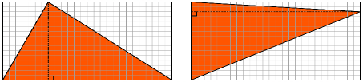  - using grid paper to draw a rectangle around any right-angled or acute triangle, comparing the area inside the triangle to that outside the triangle,  explaining how the area of the rectangle can be used to determine the area of a triangle. Generalising to a formula in symbols, such as  $Area triangle=\frac{1}{2 }×b×h$  and demonstrating how an obtuse triangle can be cut and rearranged to confirm the formula works for any triangle  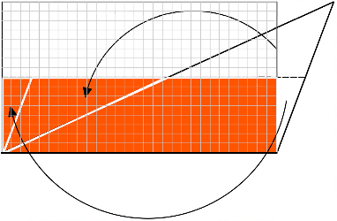  - using diagrams and reasoning to determine whether it is possible or not to calculate the following and if so, determining  - the length of a rectangle, given that it has an area of $20$ square centimetres  - the perimeter of a square, given that it has an area of $8100$ square metres  - the area of an isosceles triangle, given that the length of its base is $8$cm, which is the same as the length of its  perpendicular height  - the area of a rectangle  of length $5$cm and  width $3.4$ mm  Explore and explain efficient strategies to determine the perimeter and area of irregular or composite shapes composed of squares and rectangles  For example:  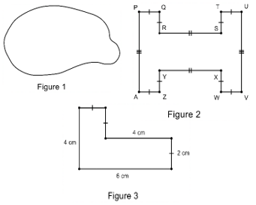  - using rulers, grid paper, scissors, string, geometric reasoning or dynamic geometry software to investigate different ways of determining the perimeter and area of irregular and composite rectangular shapes as in Figures 1, 2 and 3 including exploring  - the minimum number of lengths requiring measurement in order to reason other lengths and hence calculate perimeter  in Figure 2  - different reasoning to find the length of unlabelled sides and hence calculate perimeter and area of Figure 3  - ways of decomposing the shape by cutting or dividing all shapes into squares or rectangles to find area of the parts and hence total area or superimposing a rectangle around each shape determining the area of the rectangle and using subtraction of the area of space within the rectangle but outside the shape, in order to estimate or determine exact area  comparing strategies with others to determine and  explain the most efficient and accurate method  - drawing different composite square and rectangular shapes that have equal areas but different perimeters and those that have equal perimeters but different areas, justifying using application of formula  Explore and establish connections and conversions between units  of area  For example:  - using diagrams to represent and explain connections between numbers of different units of equal areas, such as  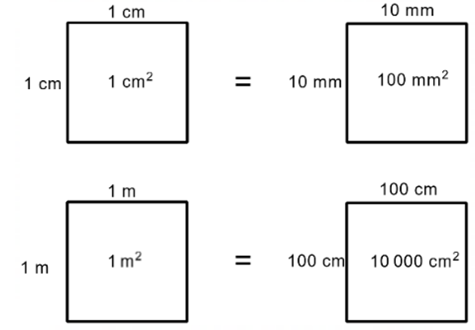  recognising that $1$ m is $100$ times as large as $1$ cm but $1$ square metre is $10 000$ times as large as $1$ square centimetre  - applying knowledge of place value and relative sizes of units to explain conversions  between units of area, such as $0.72$ cm² to mm²  - extending thinking to include  $1$ ha $= 10 000$ m² and  $1$ km² $= 1 000 000$ m² $= 100$ ha | Establish and apply relationships between lengths of sides, perpendicular lengths, lengths of diagonals, perimeter and area for parallelograms, trapeziums, rhombuses and kites. Generalise and apply formulas, using appropriate units  For example:  - using properties of quadrilaterals to establish relationships between lengths of sides and perimeters, generalising as formulas in symbols, such as the perimeter of a rhombus is $P=4l$ where $l$ is the number of length units in a side and$P$ is the number of length units in the perimeter  - using scissors or dynamic geometry software to strategically cut parallelograms, trapeziums, rhombuses and kites, translating, reflecting or rotating the cut piece/s to form a rectangle and derive formulas for area, including  - generalising that the area of a parallelogram is equal to the length of one of the parallel sides multiplied by perpendicular distance between the parallel sides, leading to a formula, such as  $$Area parallelogram=b×h$$  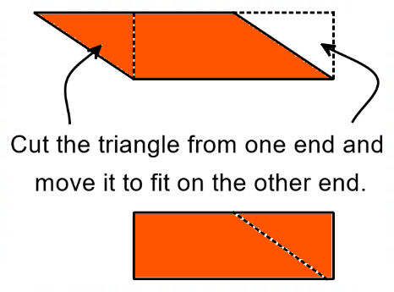  cutting the triangle from one end and moving it to fit on the other end    - generalising that the area in a trapezium is the same as half the length of the perpendicular height multiplied by the total length of the parallel sides, leading to a formula, such as  $$Area trapezium=\frac{1}{2}h ×\left(a+b\right)$$  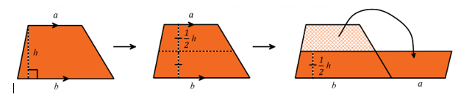  - generalising that the area of a kite is the same as half the product of the diagonals, leading to a formula, such as  $$Area kite=\frac{1}{2}×x×y$$  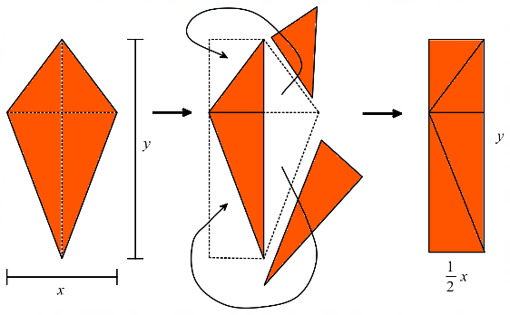  and discussing what is the same before and after each quadrilateral is cut and transformed  - drawing different parallelograms, trapeziums, rhombuses or kites, each with an area of $15$ cm²  - investigating different ways of finding the area of a hexagon using the formulas of a rectangle, parallelogram, trapezium or triangle  Identify, describe and explore the relationship between the radius, diameter and circumference of a circle and use this to establish and apply formulas to determine perimeter and area, using appropriate units  For example:  - using concrete examples of circles to establish relationships between the lengths of the diameter and the circumference by measuring using string; creating and interpreting a graph of diameter and circumference and entering results into a spreadsheet  to show that circumference  $÷$ diameter is approximately  $3.1$ ($π$). Generalising and applying relationships, such as the number of length units in the perimeter or circumference of a circle is approximately $3.1$ ($π$) times greater than the  number of length units in the diameter and the length of the radius is approximately $\frac{1}{6}$ of  the circumference  - establishing the relationship between the number of length units in the radius and number of square units in the area of a circle by dissecting a cut out circle into many congruent sectors, arranging them to form an approximate parallelogram with a height of $r$ and a base of $πr$ and generalising the area of a parallelogram determined to $Area circle=πr^{2}$  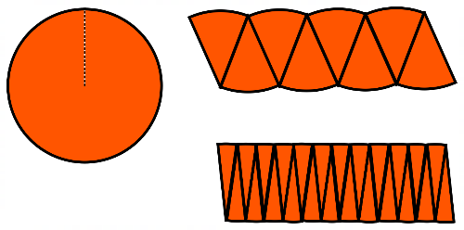  - determining the circumference of a circle given that its area is $37$ cm² and the area of a circle given that its circumference is $171$ mm  Investigate in order to establish, define and use Pythagoras’ theorem to determine the length of an unknown side in a right-angled triangle  For example:  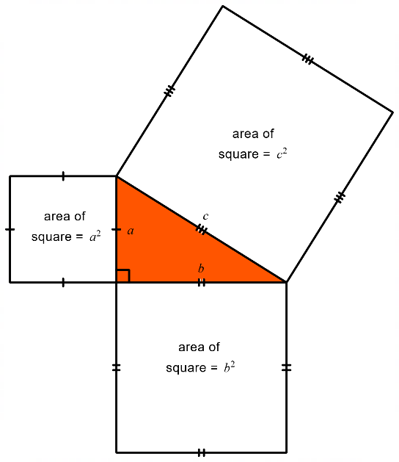  - using grid paper or dynamic geometry software to draw a right-angled triangle, identifying the shorter sides and the hypotenuse, and exploring the relationship between the area of the squares on the two shorter sides to the area of the square on the hypotenuse. Testing, predicting and generalising the relationship to the formula  $$a^{2}+b^{2}=c^{2}$$  - applying Pythagoras’ theorem to determine the length of the diagonal of a rectangle with width $7$ cm and length $9$ cm, in centimetre units, communicating the solution through a sequence of equations and demonstrating that the solution would be positive due to the context | Explore, explain and use efficient strategies to determine the perimeter and area of composite shapes involving triangles, quadrilaterals and/or circles, (including sectors), using appropriate units  For example:  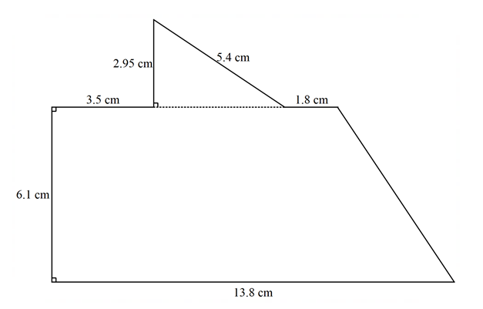  Figure 1  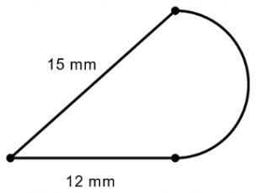  Figure 2  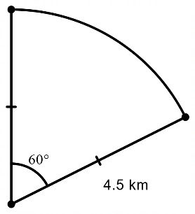  Figure 3  - exploring ways to determine perimeter using strategies appropriate to the shape, such as direct measurement, calculations of circumference and Pythagoras’ theorem, knowledge of transformations or symmetrical parts. Applying addition of the length parts to determine an estimation, approximation or exact value  of perimeter in appropriate length units  - exploring ways to determine area using strategies appropriate to the shape, such as decomposition into familiar polygons and circles or parts thereof and applying formulas, superimposing a rectangle around a shape and subtracting the area of space within the rectangle but outside the shape, from the area of the rectangle, knowledge of transformations or symmetrical parts. Applying strategies to determine an estimation, approximation or exact value of area in appropriate square units and comparing strategies with others to determine and  explain the most efficient and accurate method  Use Pythagoras’ theorem to determine the perimeter and area of shapes involving right-angled triangles, in both exact and decimal approximation form. Investigate and apply the converse of Pythagoras’ theorem to establish whether a triangle is right-angled  For example:  - determining the height, area and perimeter of a right-angled triangle, with base length of  $12$ cm and hypotenuse $16$ cm, in exact (height $=\sqrt{112}$ cm,  $P=28+\sqrt{112}$ cm,$A=6\sqrt{112}$ cm²) or approximate units  (height $=10.583$ cm,  $P=38.583$ cm,$A=63.498$ cm²)  - exploring and using Pythagoras’ theorem and geometric reasoning to determine the area of a rhombus with a side length of $8$ cm and one diagonal of $15$cm or a regular hexagon with side length $5$ cm  - using vertical and horizontal units between points plotted on a Cartesian plane and applying Pythagoras’ theorem to determine the distance between the two points  - justifying whether $5$ cm, $12$ cm and $13$ cm is a Pythagorean triad (lengths that form the sides of a right-angled triangle)  Year 9 optional  Explore and apply Pythagoras’ theorem and trigonometry to simple situations involving right-angled triangles in three-dimensional contexts projected to two dimensions | Use Pythagoras’ theorem and/or trigonometry to determine unknown sides and angles in  right-angled triangles involving angles of elevation and depression  For example:  - identifying, describing and defining angles of elevation  and depression  - determining unknown sides and/or angles of elevation or depression from given right-angled triangle diagrams by choosing an appropriate trigonometric ratio, applying and communicating solutions in appropriate units through a sequence of equations  - sketching and labelling  right-angled triangle diagrams and choosing and using appropriate techniques to solve problems in situations, such as  - determining the angle of depression from the top of an $820$ m hill to a bushfire $5.8$ km away  - calculating the height of a flagpole erected on top  of a Perth building given that at a distance of $300$ m from the base of the building, the angles of elevation to the bottom and top of the flagpole are $37°$ and $39°$ respectively  Year 10 optional  Apply right-angled trigonometry to two-dimensional situations involving navigational bearings  Year 10 optional  Explore to establish and use the sine, cosine and area rule to determine unknown sides and angles for any triangle  Year 10 optional  Use the unit circle and dynamic geometry software to explore  and represent trigonometric functions graphically  Year 10 optional  Solve simple trigonometric equations graphically, algebraically or using the unit circle and verify solution/s by substitution
Explore, identify, define, name, label and apply the language, notation and conventions of geometry for points, lines, angles and polygons  For example:  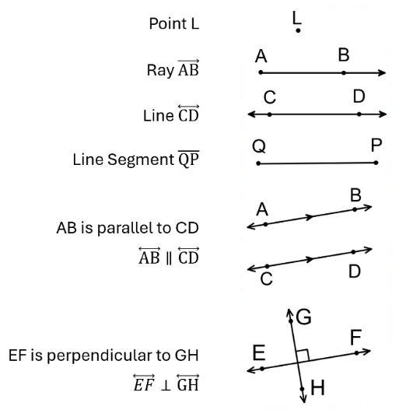  - using conventions, such as the use of capitals and appropriate symbols, to label, name and define points, rays, line segments, lines, parallel lines and perpendicular lines  - using conventions, such as capitals, Greek letters and appropriate symbols, to label, name and define acute or obtuse angles 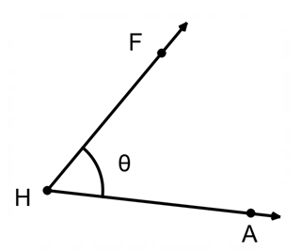  as $∠H$or $∠FHA$ or $∠AHF$ or $θ$,  right or perpendicular angles,  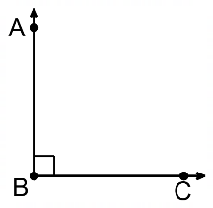  as $∠ABC$ or $∠CBA$ or $∠B$, and angles at a point as complementary, supplementary and adjacent angles  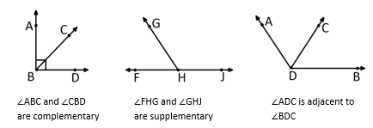  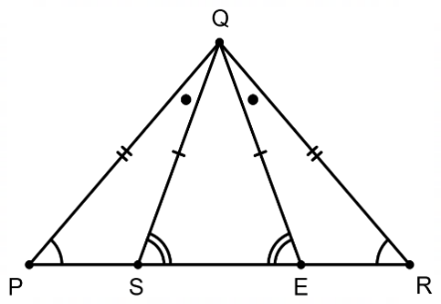  - applying correct notation and labelling conventions to triangles and polygons to indicate equal angles, equal sides and parallel sides, such as in $∆PQR$ and $∆SQE$  and in the irregular, concave  hexagon EFGHIJ  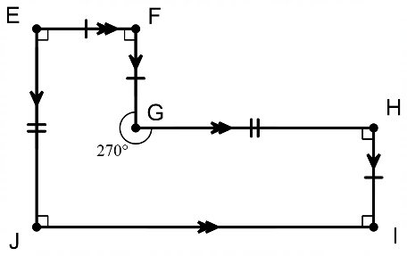  justifying that EFGHIJ is the same as HIJEFG but is not the same as EIJHGF  - exploring geometric terminology and naming conventions used in dynamic geometry software  Investigate, identify and describe corresponding, alternate and  co-interior angles formed when two parallel lines are crossed by a transversal. Use relationships to determine unknown angles and explain reasoning  For example:  - using paper folding or dynamic geometry software to create a pair of parallel lines crossed by a transversal, identifying congruent and supplementary angles and labelling pairs of angles as corresponding, alternate and co-interior  - finding unknown angles within pairs of parallel lines. Explaining reasoning in situations, such as  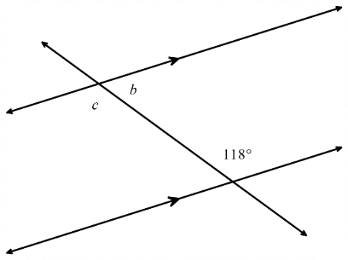  $c=118°$ (alternate to given angle)  $b=62°$ (co-interior with given angle)  - finding the value of $x$ in the diagram below and giving reasons  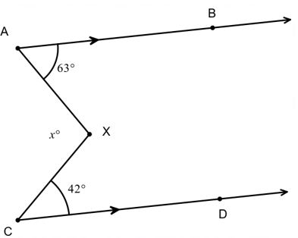  constructing a line XY through X parallel to AB and CD  $63°+∠AXY=180°$ (co-interior angles, $AB∥XY$)  $∴∠AXY=117°$  $42°+∠CXY=180°$ (co-interior angles $CD∥XY$)  $∴∠CXY=138°$  $x+∠AXY+∠CXY=360°$ (angles at a point)  $x=105$  comparing geometric reasoning with others, noting that there are alternative ways of determining and explaining the size of angles  Demonstrate that the interior angle sum of a triangle is $180°$  For example:  - using a variety of paper triangles to mark corners, ripping and placing the corners (angles) in a straight line to generalise that the sum of the angles in $∆ABC$can be determined by $∠A+∠B+∠C=180°$  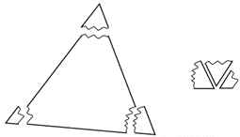  - using knowledge of alternate angles in parallel lines and supplementary angles to explain why the sum of the angles in a triangle is $180°$ using a  sequence of logically  connected statements  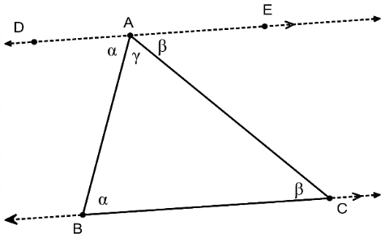  Explore to classify and name triangles according to their side and angle properties. Use the properties to determine unknown angles in triangles and explain reasoning  For example:  - creating a classification  scheme for triangles based on sides and angles, representing it as a sequence of decisions in a flow chart  - using reasoning and/or construction to decide and explain whether the following triangles are possible or impossible, naming and labelling possible triangles and comparing the construction and naming with others  - a triangle with sides of $4$ cm, $10$ cm and $5$ cm  - a triangle with all angles $60°$  - a triangle with one side of $8$ cm and a $90 QUOTE °$angle  - a triangle with two equal sides of $7$ cm and the included angle $45°$  - a triangle with two equal angles of 95$QUOTE °$  - determining unknown sides  and angles in triangles, explaining and comparing reasons with others  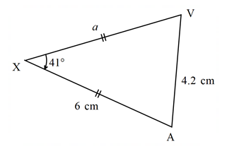  $a=6$ cm (equal sides in an isosceles triangle)  $∠ XAV$ and $∠XVA=69.5°$ (equal base angles of an isosceles triangle) | Explore, identify, classify and establish properties of quadrilaterals, including the interior angle sum. Use this to determine unknown sides and angles in quadrilaterals and explain reasoning  For example:  - creating a classification scheme for quadrilaterals based on sides, angles and diagonals, representing it as a sequence of decisions in a flow chart  - exploring strategies, such as cutting a quadrilateral into two triangles or marking the corners of a quadrilateral, ripping and placing the corners (angles) in a revolution, to generalise to the sum of the interior angles in any quadrilateral being $360°$  - determining unknown angles in a quadrilateral, explaining reasons, such as finding the value of $x$ given PQRS is a parallelogram  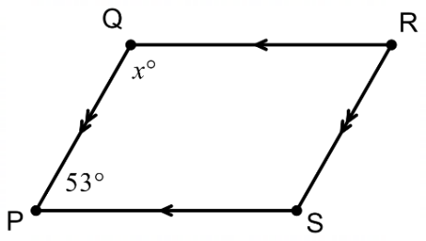  $QR || PS$ (opposite sides of a parallelogram are parallel)  $x+53°=180°$ (co-interior angles are supplementary),  $∴x=127$  - extending interior angle sum of triangles and quadrilaterals to include other polygons | Explore to identify and describe conditions for triangles to be congruent. Use this to determine unknown sides or angles in pairs  of congruent triangles and  explain reasoning  For example:  - constructing manually or by using dynamic geometry software, the following triangles with the given conditions  - three sides of $5$ cm, $6$ cm and $4$ cm  - two sides of $7$ cm, $5$ cm and an included angle of $27°$  - one side of $5$ cm and two angles, $32°$ and $54°$  - one right angle, a hypotenuse of$11$ cm and one side of $4.5$ cm  - two sides of $5.5$ cm and  $4$ cm and a non-included angle of $63°$  - three angles of $51°, 24°$ and $105°$  comparing with others, reasoning and generalising which conditions confirm congruent triangles (SSS, SAS, RHS, AAS) and which do not  - identifying and justifying two triangles being congruent in words and symbols, communicating that $∆PQR$ $≅$ $∆WDE$ because all three pairs of corresponding sides are equal to each other (SSS)  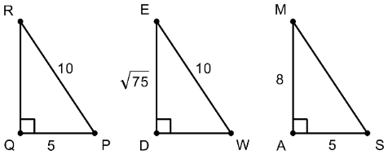  - determining the test that confirms that two triangles are congruent, the congruency statement and unknown sides or angles, giving reasons in situations such as  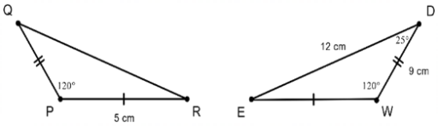  the two sides and included angle of $∆PQR$ is equal to the two sides and included angle of $∆WDE,$ therefore $∆PQR≅∆WDE$ (SAS)  $\overline{QR} =$ $12$ cm as it corresponds to $\overline{DE}$ and $∠Q$ $=$ $25°$ as it corresponds to $∠D$ | Explore to identify and describe conditions for triangles to be similar. Use this to determine unknown sides and angles in pairs of similar triangles and explain reasoning  For example:  - constructing manually or by using dynamic geometry software, the following pairs  of triangles with the  given conditions  - triangle 1 with sides of  $3$ cm, $5$ cm and $4.5$ cm and triangle 2 with sides of  $6$ cm, $10$ cm and $9$ cm  - triangle 1 with an angle of $35°$ and a side of $8$ cm and triangle 2 with an angle of $35°$ and a side of $4$ cm  - triangle 1 with sides of $4$ cm and $6$ cm, with an included angle of $25°$ and triangle 2 with sides of $6$ cm and 9 cm, with an included angle  of $25°$  - triangle 1 with angles of $127°$ and $21°$ and triangle 2 with angles of $32°$ and $21°$  - triangle 1 with sides of $4$cm, $7.5$ cm and $4.5$ cm, and triangle 2 with sides of  $3$ cm, $15$ cm and $9$ cm  - triangle 1 with hypotenuse of $13$ cm, a $90°$ angle and the shortest side being  $10$ cm, and triangle 2 with hypotenuse of $6.5$ cm, a  $90°$ angle and the shortest side being $5$ cm  comparing with others to see if similar triangles have been produced, reasoning and generalising conditions to confirm similar triangles (SSS, SAS, RHS, AA)  - identifying and justifying  two triangles being similar in words and symbols  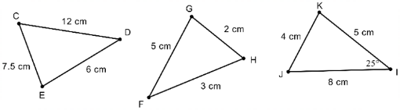  recognising $∆CDE\sim ∆IJK$ because all three corresponding sides are in proportion (SSS)  (scale $=$ $\frac{2}{3}$ )  - determining the test that confirms two triangles are similar, the similarity statement and finding unknown sides or angles, giving reasons in situations such as  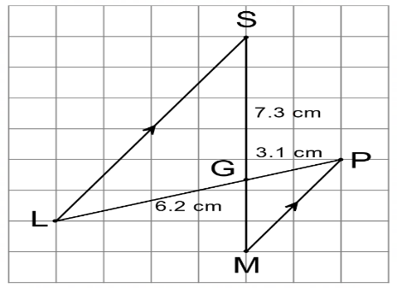  communicating in both words and symbols that $∠SGL$ $=∠MGP$ because they are vertically opposite and $∠GSL$ $=∠GMP$ as they are alternate angles, in parallel lines  $∴$ $∆SGL$ $\sim$ $∆MGP$ because two angles of $∆SGL$ are equal to two angles of $∆MGP$ (AA)  $\overline{GM}$ $=$ $3.65$ cm as corresponding sides in similar triangles are in proportion  Year 10 optional  Explore geometric relationships and apply deductive reasoning and a sequence of logically connected statements, to produce proofs of similar triangles and angle/chord/radius/tangent properties in circles
Plot coordinates on the Cartesian plane and explore, visualise, predict and determine image coordinates after translation or reflection  across the axes, or rotation about the origin  For example:  - plotting the following points $D\left(-1, 6\right), E\left(3, -2\right),$ $F(2, 4)$ onto paper or dynamic geometry software. Using counters for coordinates, paper folding and tracing, digitally moving points and/or reasoning and visualisation to determine the image coordinates ($D^{'}$, $E^{'}$, $F^{'}$) after a transformation, such as  - $2$ units left and $3$ units down  - a reflection across the $x$-axis  - a rotation of $180°$ anticlockwise about  the origin  - a rotation of $90°$ clockwise about the origin  - generalising the effect of the transformation on the coordinate (e.g. in a reflection in the $x$-axis, the $y$ part of the coordinate changes sign from a positive to a negative and vice versa) and investigating whether there are different ways of translating, reflecting or rotating the points that produce the same transformation | Recognise and identify equal corresponding sides and equal corresponding angles of congruent figures. Explore, visualise, predict and determine the translation, reflection, rotation, or combination of these transformations, to match one congruent figure to another  For example:  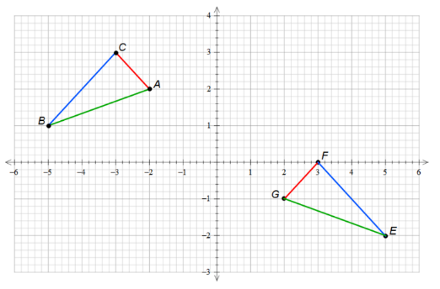  - identifying and expressing in both words and symbols that between the figure and its image, corresponding sides are the same length, corresponding angles are the same size, the triangles are the same shape and size and are therefore congruent ( $∆ABC ≅ ∆GEF)$  - using cardboard triangles, paper folding and tracing, dynamic geometry software and/or reasoning to predict, visualise and investigate different combinations and patterns of transformations that exactly match the figure of $∆ABC$to its image $∆GEF$. Investigating to determine whether a sequence of transformations is commutative or not  - investigating, exploring and creating designs in textile patterns involving the translation, reflection and rotation of congruent figures using dynamic geometry software or A3 paper and  shape templates | Construct similar figures by enlargement and reduction, and use this to establish, explain and apply properties of similar figures  For example:  - constructing similar figures using techniques such as dynamic geometry software, grids, compasses and centres of enlargement or reduction. Design, test and refine a sequence of steps for producing similar figures  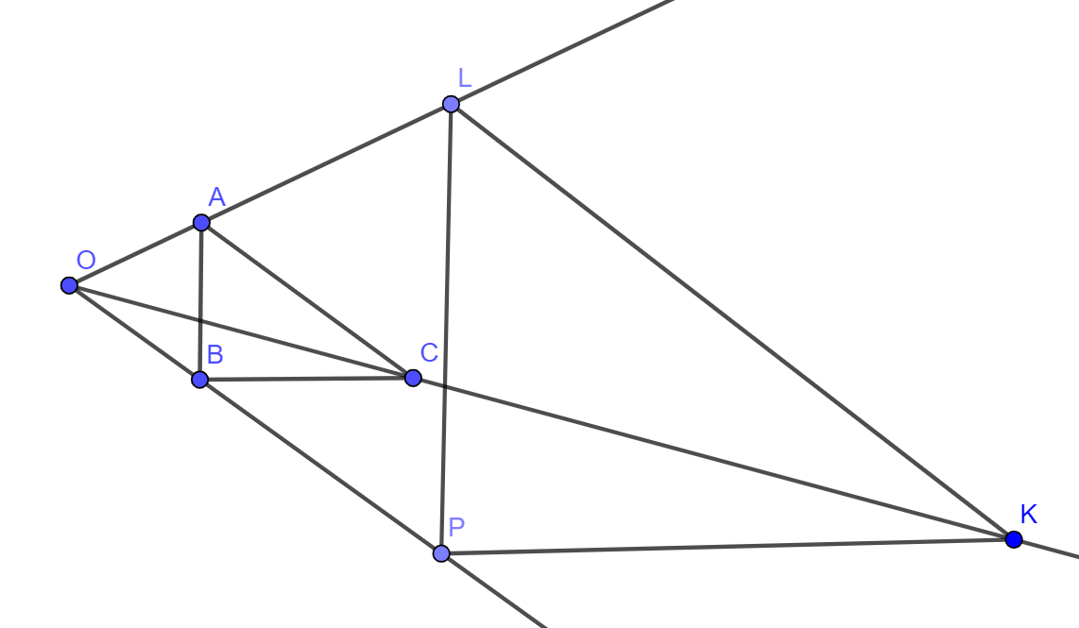  - comparing what is the same and what is different between the original figure and its image, noting that they are the same shape but not necessarily the same size. Measuring to generalise the properties of similar figures  - corresponding angles are the same size  - corresponding sides are in proportion  ( $\frac{\overline{AB}}{\overline{LP}}$ = $\frac{\overline{AC}}{\overline{LK}}$ = $\frac{\overline{BC}}{\overline{PK}})$  and recognising that this proportion is the scale or scale factor. Writing a similarity statement between pairs of similar figures, such as $∆ABC \sim ∆LPK$  - determining the scale factor between similar figures using corresponding lengths in situations, such as  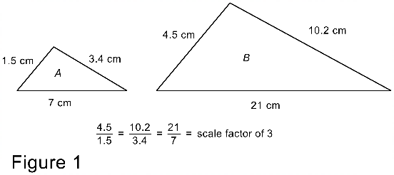  $\frac{4.5}{1.5} = \frac{10.2}{3.4} = \frac{21}{7} =$ scale factor of $3$  and  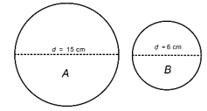  $\frac{6}{15} =$scale factor of $\frac{2}{5}$ ,  recognising that an original figure will be enlarged if the scale factor is greater than one but will be reduced if the scale factor is greater than zero but less than one  Use similarity to investigate and explain the constancy of the sine, cosine and tangent ratios for a given angle in right-angled triangles. Choose and use a trigonometric ratio to determine the length of an unknown side or the size of an unknown angle  For example:  - identifying and labelling the hypotenuse, adjacent and opposite sides with respect to a given angle in a right-angled triangle in any orientation  - verifying the constancy of each trigonometric ratio for a given angle by creating a series of similar triangles, measuring corresponding side lengths and identifying and determining the constancy of the different ratios between sides using the trigonometric notation of$\sin{θ},\cos{θ},\tan{θ}$  - choosing and using a trigonometric ratio to determine the length of a wheelchair ramp in the following situation  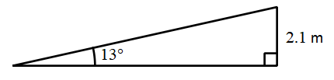  - choosing and using a trigonometric ratio to determine the size of the missing angle $θ$ in the  following situation  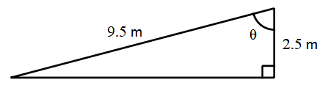  Apply the properties of similarity  to determine scales, lengths and angles of real-life figures from  scale drawings, maps, plans  and photographs  For example:  - exploring and interpreting maps, plans and scale drawings, recognising that between the scale drawing and actual figure, angles are equal, and sides are in proportion  - determining the scale used between a floor plan and actual house, the width of a bookcase using the scale or ratio on its construction plan and the actual radius of a cell, given a scale and its biological drawing  - exploring scale by mapping a $30 000$ hectare bushfire onto  a map  - exploring scale in photographs, such as taking a picture of a person standing next to a tree, using their height and the tree’s height in the image and the actual height of the person to determine a scale factor and hence estimating the actual height of the tree, discussing and finding ways to improve  the estimate  Year 9 optional  Explore the relationship between sine and cosine ratios and the unit circle, determine their approximate values for angles from 0° to 360°, and identify pairs of angles that share the same ratio value  Year 9 optional  Apply deductive reasoning and use a sequence of logically connected statements to produce proofs of congruent triangles | Investigate, explore and determine the effect on the perimeter and area of shapes when they are enlarged or reduced by a scale factor  For example:  - determining the perimeter and area of figures, such as triangles, quadrilaterals, circles and composite figures, that have been drawn using grid paper, a compass or dynamic geometry software. Making a prediction as to what the perimeter and area of their similar figures would be when side lengths or diameters have been doubled, tripled or halved. Testing this prediction by constructing the scaled figures manually or by using dynamic geometry software to determine the new perimeter and area. Using results to explain and make generalisations as to the effect on perimeter $(×k)$ and area (${×k}^{2}$) when a figure has been scaled with a given scale factor ($k$)  - determining the scale factor when a semicircle with an area of $42.47$ cm² is enlarged to have an area of$679.59$ cm²

Sub-strand: Three-dimensional space and structures
Year 7 | Year 8 | Year 9 | Year 10
Move flexibly between building  and drawing rectangular and composite rectangular prisms from different views  For example:  - building rectangular prisms or composite rectangular prisms using at most $12$ cubes, visualising and drawing manually, the front, top, side and isometric views. Using dynamic geometry software  and the three-dimensional coordinate system to draw representations of  rectangular and composite rectangular prisms  - using provided isometric or perspective drawings of rectangular and composite rectangular prisms to build the prism from blocks  - exploring the views of rectangular and composite rectangular buildings depicted in map software, highlighting what is the same and what is different between each view | Explore in order to visualise and draw cross-sections of different solids and use this to identify prisms  For example:  - using concrete materials, such as a block of cheese, round cake, chocolate moulded into a triangular prism, ice-cream cone, chocolate ball or playdough square-based pyramid, to visualise, predict, draw then cut different  cross-sections, identifying that any cross-section taken parallel to the base in a right prism is always congruent  - exploring how many different polygons can be formed from the cut faces of a cube
Establish and apply relationships between the number of identical layers of cubic units, the number of cubic units in each identical layer and volume for rectangular prisms and composite rectangular prisms. Generalise and apply the formula, using appropriate units  For example:  - using layers of interlocking blocks or dynamic geometry software to reinforce that volume is measured in cubic units and that the volume of a rectangular prism is determined by the number of cubic units in any outer layer, multiplied by the number of identical layers in the prism, generalising to $V=l^{3}$ or $V=l×w×h$for cubes and rectangular prisms respectively. Extending understanding to part-units by comparing volumes determined using the formula with diagrams showing whole and part-units of length and volume  - using blocks, grid paper or dynamic geometry software to construct a rectangular prism with a length of $5$ units, a width of $1$ unit and a depth of $1$ unit, determining its volume and repeating for subsequent rectangular prisms, with a constant length of $5$ units, a constant width of $1$ unit and increasing units of depth. Graphing the depth compared to the volume of the prism, connecting the graph to the constant increasing volume in the sequence of prisms and using the graph to determine relationships between the quantities, including finding the depth of the prism if the volume is $18.5$ cm³  - determining the unknown depth of a rectangular prism given it has a length of $23.4$ cm, a width of $13.75$ cm and a volume of $4872.81$ cm³ using a formula  - using composite rectangular prisms made of blocks or depicted as isometric or oblique drawings to visualise, determine and compare methods for finding volume  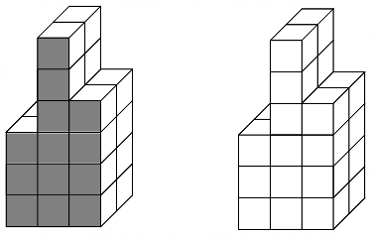  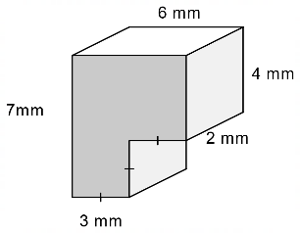 | Establish and apply relationships between the area of a uniform cross-section, the length perpendicular to that uniform  cross-section and the volume of right prisms. Generalise, apply formulas and use this to connect to capacity if required, using appropriate units  For example:  - recognising that right prisms have uniform cross-sections that match the base of the prism and that the volume is determined by calculating the area of the cross-sectional base, multiplying it by the number of units of height, in relation to that base, generalising to  $V=base area×height$and using the formula to determine the volume in cubic units, converting to capacity units if required  - using knowledge of volume of prism formulas and capacity conversions to find  - the capacity of a $16$ cm tall trapezoidal prism that has trapezoidal sides with parallel lengths of $17.2$ cm and $12.3$ cm, and a perpendicular height of $11.5$ cm  - the side length of a cube with capacity $32$ L  (using $\sqrt[3]{32}$)  - possible dimensions of a triangular prism that holds $40$ cm³  Explore and establish connections and conversions between units of volume and between units of volume and capacity  For example:  - using models and diagrams of cubes or rectangular prisms to represent and explain connections between numbers of different units of equal volume, such as  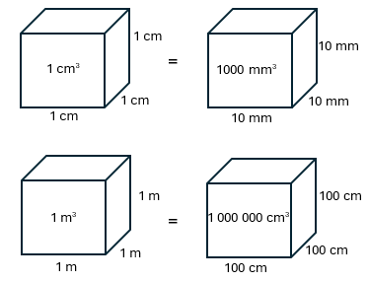  recognising that$1$ cm is $10$ times as large as $1$ mm but  $1$ cubic cm is $1000$ times as large as $1$ cubic mm  - applying knowledge of place value and relative sizes of units to explain conversions between units of volume, such as  $0.25$ m³ to cm³  - using materials, such as a milk carton, a medicine syringe or graduated beakers, to show that $1$ cm³ $= 1$ mL, $1000$ cm³ $= 1$ L, and extending thinking to  $1$ m³ $= 1000$ L or $1$ kL,  $1000$ m³ $= 1$ megalitre (ML) and $1 000 000$ m³ $= 1$ gigalitre (GL)  - choosing an object with a known volume in cubic centimetres, immersing it in water to show the millilitres it displaces, and connecting to conversion between units, such as $95$ cm³ is the same as $95$ mL  - using knowledge of conversions, place value and relative sizes of units to assist in explaining the capacity in millilitres of a $0.73$ m³ storage container | Establish, explain and apply formulas to determine the volume, capacity and surface area of cylinders, using appropriate units  For example:  - recognising that a cylinder has uniform cross-sections of a circle and multiplying the area of this circle by the height, generalising to $Volume cylinder= πr^{2}×h$ to determine the volume in cubic units, converting to capacity units if required  - decomposing a cylinder into a sketched net or visualising its net, as comprising two equal circles and a rectangle, showing the addition of the area of the faces to generalise to a formula $SA cylinder=2πr^{2}+2πrh$and applying to determine the surface area in square units  - investigating and designing the net of the largest possible cylindrical closed container on an A3 sheet of cardboard by considering which attribute best determines ‘largest’, applying formulas, calculations and conversions before constructing, comparing and ordering cylinders with others  Explore and explain efficient strategies to determine the surface area of right prisms using appropriate units  For example:  - using strategies, such as unfolding a cardboard prism, visualising or drawing the net or different two-dimensional views of the prism, recognising congruent faces and showing related area calculations of the different faces, in a sequence of steps, adding to determine the surface area in square units  - determining the depth of a rectangular prism, given that it has a surface area of $726$cm², length of $15$ cm and width of $5$ cm  - determining the surface area of a cube given that its volume is $15.625$ m³  Use dynamic geometry software  to explore and construct familiar objects in three dimensions  using transformations of  two-dimensional figures  For example:  - using dynamic geometry software to show transformations of  two-dimensional figures in the plane through a third dimension to create prisms and cylinders, such as constructing a right cylinder by rotating a rectangle around a line in the plane of the rectangle or rotating a triangle around an axis to create a cone. Describing different views of the object, altering the dimensions and highlighting what is the same and what is different about the original object and  its alteration  - drawing a two-dimensional shape and describing how to transform images of the shape to represent a  three-dimensional object, using at least two different transformations, such as translating, rotating or reflecting a square to form a cube | Use efficient strategies and apply formulas to determine the volume, capacity and surface area of composite solids, using  appropriate units  For example:  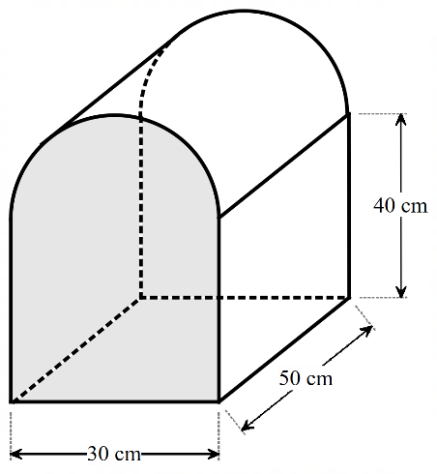  - exploring the orientation of the object to identify the base end and the height. Use strategies to calculate the volume, such as dividing the base end into familiar shapes to determine the area of the cross-sectional base and multiplying by the height or dividing the composite solid into familiar prisms, applying appropriate formulas and adding to find total volume. Using the volume to determine capacity and comparing strategies with others,  deciding which approach is the most efficient  - visualising or drawing the net or different two-dimensional views of a composite object, recognising congruent faces and showing area calculations of the different faces in a sequence of steps, adding to determine the surface area in square units  Investigate, calculate and identify the impact of errors on the accuracy and outcome of results in measurement situations  For example:  - determining the length of a wooden beam leaning against a wall, using a clinometer or large protractor to measure an angle of elevation and applying trigonometry and/or Pythagoras’ theorem. Comparing calculated and actual measurements of the wooden beam and discussing accuracy of results in terms of absolute and percentage error, the measuring instruments, the size of the measurement unit used and human error  - determining the planned height of an access ramp being built from a carpark to the entrance of a leisure centre, given that the plan is for it to be $3.5$ m long, on an inclination of $12°.$ Discussing any implications of the miscalculation or error of $1°$ on the access ramp build  - investigating the effect on capacity of the following fibreglass swimming pool if the $2.4$ m height was accidentally read as $2.6$ m, determining percentage error and discussing the impact of the misreading  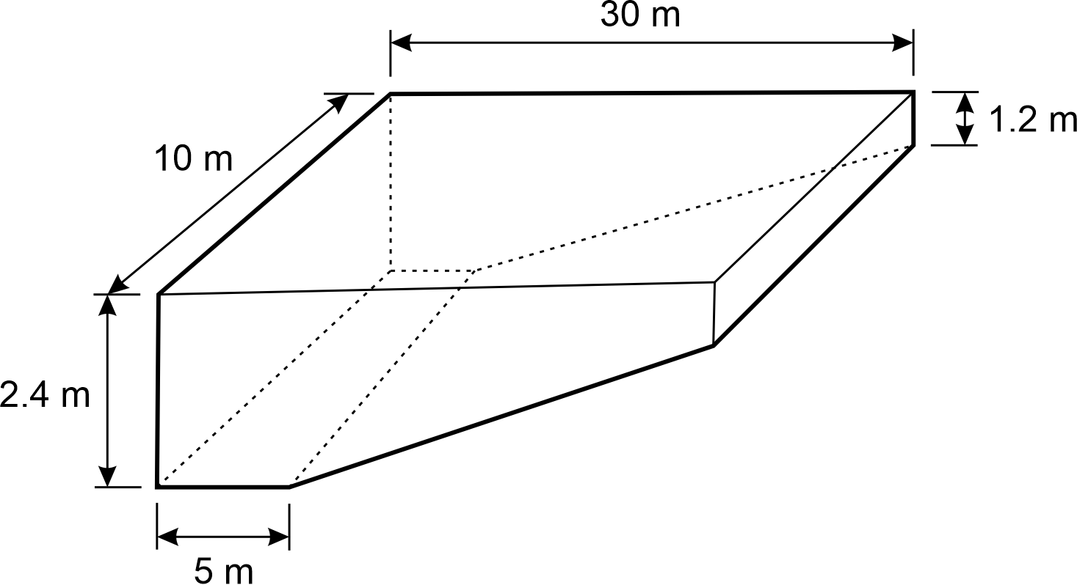  Investigate in order to determine the effect on surface area and volume when objects are enlarged or reduced by a scale factor  For example:  - constructing similar objects with a given scale using dynamic geometry software, cardboard, grid or isometric paper and discussing what is the same and what is different about the object and its enlarged/reduced image. Calculating and comparing the surface area and volume of the object and its image. Determining that the surface area of the object is enlarged or reduced by the square of the scale factor ($×k^{2}$) and that the volume of the object is enlarged or reduced by the cube of the scale factor (${×k}^{3}$)  - determining the scale factor when a rectangular prism with a volume of $44.8$ cm³ is enlarged to have a volume of $1209.6$ cm³  - exploring the impact of changes in scale on the surface area and volume in situations involving 3D printing or production prototypes  Year 10 optional  Explore, explain and apply efficient strategies and formulas to determine the surface area and volume of right pyramids, right cones, spheres and related composite solids

Sub-strand: Non-spatial measurement
Year 7 | Year 8 | Year 9 | Year 10
Explore and interpret representations of time zones within Australia using  12- and 24-hour time and  determine the local time at different locations considering different times of the year  For example:  - using maps, number lines or digital tools to interpret and explore the language and thinking used in determining and communicating current times across Australia (AEST, ACST, AWST and DST)  - determining current times in Sydney during Daylight Saving Time (DST) if it is 2245 hours in Perth or a quarter past 3 in the afternoon in the Northern Territory or 7.35 pm in Tasmania | Explore and interpret representations of national and international time zones using  12- and 24-hour time, and determine the duration of events across multiple time zones  For example:  - using maps, number lines or digital tools to interpret and explore the language and thinking used in determining international time zones and comparing times in Beijing, China to Suva, Fiji and Toronto, Canada  - recognising the challenges of planning regular three-hour virtual meeting times for a company that has staff in both Vancouver, Canada and Perth, Western Australia, and determining suitable starting and ending times for these meetings, including consideration of Coordinated Universal Time (UTC)

Sub-strand: Modelling with measurement and geometry
Year 7 | Year 8 | Year 9 | Year 10
In real-world situations involving perimeter and area of squares, rectangles, triangles and rectangular composite shapes, parallel lines, properties of triangles, transformations of points, views of rectangular prisms and rectangular composite objects, volume and/or Australian time zones  - analyse the situation, decide if an exact or approximate solution is required and determine assumptions  and constraints  - represent the situation mathematically in order to reach a solution  - interpret and communicate findings in terms of the context and any assumptions or constraints  For example:  - ‘Maya is a Year 7 student who lives in Albany, WA and wants to phone her grandmother who lives in Adelaide, SA. Maya would like to call her grandmother after school and also knows her grandmother goes to bed at 7.30 pm. Determine a suitable time  range in which Maya could ring her grandmother.’  Realising that an approximate range of times is required, that Maya would need to ring her grandmother after school finishes at approximately 4 pm in Albany and before 7 pm in Adelaide, to allow time for the conversation. Maya would also need to consider if it is daylight saving time or not. Choosing to represent the situation using a number line, communicating  the solution as an appropriate local time range for Maya  and checking against the  initial assumptions  - ‘Charlie is planning to knit a floor rug. She already has $5$ m of braiding that she will use to go around the outside edge of the rug. She wants to know if she should knit a square or a rectangular rug to maximise the floor space that the rug will cover. What shape and dimensions should Charlie choose?’  Deciding that an accurate answer is required, that the perimeter length needs to be less than $5$ m to allow the braid ends to be connected, so a small reduction in the length of braid should be determined, and that the room dimensions and visual appeal of the rug will be constraining factors. Representing the situation using square and rectangle diagrams, choosing the attribute of area to determine the largest floor space and reasoning using patterning, to find possible dimensions that satisfy the braid length (perimeter) of $4.92$ m (assuming $8$ cm to connect the braid). Determining the area of each possibility in square units. Identifying and communicating that the square of side length $1.23$m provides the maximum possible area of $1.51$ m², that it satisfies the constraint of $4.92$ m and would be a suitable, visually appealing shape | In real-world situations involving perimeter and area of quadrilaterals and circles, properties of quadrilaterals, transformations of figures, Pythagoras’ theorem, congruency, cross-sections, volume or capacity of prisms and/or international time zones  - analyse the situation, decide if an exact or approximate solution is required and determine assumptions  and constraints  - represent the situation mathematically in order to reach a solution  - interpret and communicate findings in terms of the context and any assumptions or constraints  For example:  - ‘Barri has designed a disposable sugar sachet, the shape of a triangular prism. The length of the prism is $52$ mm, and the end face has a base length of $0.9$ cm and perpendicular height of  $8$ mm. Barri is asked to redesign the sachet to have a volume of $2$ cm³ by altering just one dimension. Determine the new dimensions of the sugar sachet.’  Assuming that an exact solution would be required given the degree of accuracy of the measurements and the size of the object. Choosing to represent the situation as an oblique sketch and with the formula for volume of a triangular prism. Showing calculations using the same units and solving equations to determine new dimensions. Communicating the solution with the chosen units and explaining that the solution could differ, depending on the dimension chosen to alter | In real-world situations involving the perimeter and area of composite shapes and right-angled triangles, enlargement and reduction of similar figures, finding unknown side lengths and angles using trigonometric ratios, scale in similar figures and/or volume, capacity and surface area of right prisms and cylinders  - analyse the situation, decide if an exact or approximate solution is required and determine assumptions  and constraints  - represent the situation mathematically in order to reach a solution  - interpret and communicate findings in terms of the context and any assumptions or constraints  For example:  - ‘A building firm is constructing a roof beam with an $11.4$ m base beam parallel to a $7.6$ m roof beam and $1.5$ m apart. The firm wants to insert a truss to connect from one top corner to the diagonal bottom corner to ensure that the beam is rigid. What is the total length of roof beam needed to build the whole roof beam?’  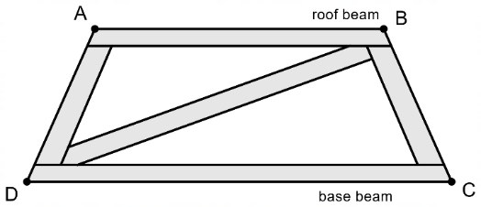  Deciding that an exact answer to the nearest millimetre is required for building purposes and that the truss is straight. Choosing to use properties of an isosceles trapezium and Pythagoras’ theorem to determine the length of the truss and the length of the equal, non-parallel sides and the perimeter of a trapezium to determine the total length of beam. Communicating the solution in the context of the roof beam and to the nearest millimetre | In real-world situations involving Pythagoras’ theorem, trigonometry and angles of elevation and depression in right-angled triangles, volume, capacity and surface area of composite objects, the impact of errors in measurement and/or the effect of enlargement and reduction on perimeter, area and volume of similar figures and objects  - analyse the situation, decide if an exact or approximate solution is required and determine assumptions  and constraints  - represent the situation mathematically in order to reach a solution  - interpret and communicate findings in terms of the context and any assumptions or constraints  For example:  - ‘A drone is hovering at a height of $455$ m. The angles of depression from the drone to a boat in trouble are at first $9°$ and then $14°.$ How far has the troubled boat travelled between the two observations?’ Making assumptions, such as the sea is relatively flat, the drone’s height is constant and that it does not change position. Using representations, such as a diagram, choosing a trigonometric function, such as tangent and determining the difference between the horizontal distance from the drone at $9°$ to $14°$. Communicating the solution in terms of the drone and the  boat and with reference to  the assumptions  - ‘A construction firm needs to build a bespoke hollow cylindrical $1.25$ m cement pipe with an outer diameter of  $32.5$ cm and a pipe thickness of $6.5$ cm. Determine the volume of cement required to make the pipe and the maximum capacity of the pipe at any given time.’  Making assumptions, such as an exact volume and capacity is required and that the thickness of the pipe is uniform with the pipe cross-section congruent throughout the length of the pipe. Choosing to use consistent, appropriate units, such as metres. Selecting efficient strategies and appropriate formulas to determine the volume of the pipe in cubic metres, rounding up appropriately to ensure enough cement. Determining the volume of the hollow pipe and converting to capacity in litres. Communicating the solution to the total volume of the pipe in cubic metres and the capacity of the pipe in litres, making reference to the assumptions made

Strand: Probability and statistics

Sub-strand: Probability and statistics
Year 7 | Year 8 | Year 9 | Year 10
Construct sample spaces for  single-stage chance experiments, assign probabilities to the outcomes and predict frequencies for different numbers of trials  For example:  - discussing probability terminology, such as probability, favourable outcome, event, trial, sample space, experiment.  Producing a sample space for a standard six-sided dice  S $=$ {1, 2, 3, 4, 5, 6} and determining the probability of rolling a 4 using  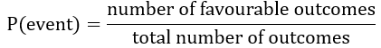  so P($4$) $=\frac{1}{6}$, $0.17, 16.67\%$ or a one-in-six chance.  In 100 trials, it would be expected that the number of times 4 would occur would be approximately  $\frac{1 }{6}×100=16.67$which would be rounded to 17  - assigning probabilities to events involving coins, dice, spinners, cards, lucky dips etc. | Construct sample spaces, such as lists, simple tree diagrams, tables or arrays, to show all possible outcomes for two events. Assign probabilities to outcomes and events including those involving ‘and’, ‘not’, ‘at least’, exclusive ‘or’ and inclusive ‘or’  For example:  - constructing sample spaces to show all outcomes for two free throws at a basketball game, where a score or miss is equally likely, such as  S $=$ {SS, SM, MS, MM}  or  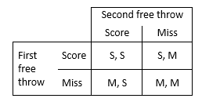  or  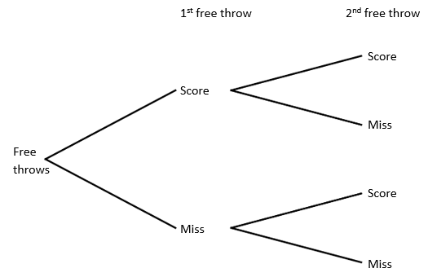  and using to assign probabilities to events, such as  P(a miss first and a score second)  P(a miss first or a score second)  P(at least one score)  P(not having any misses)  - creating a sample space to show all outcomes for rolling two standard dice  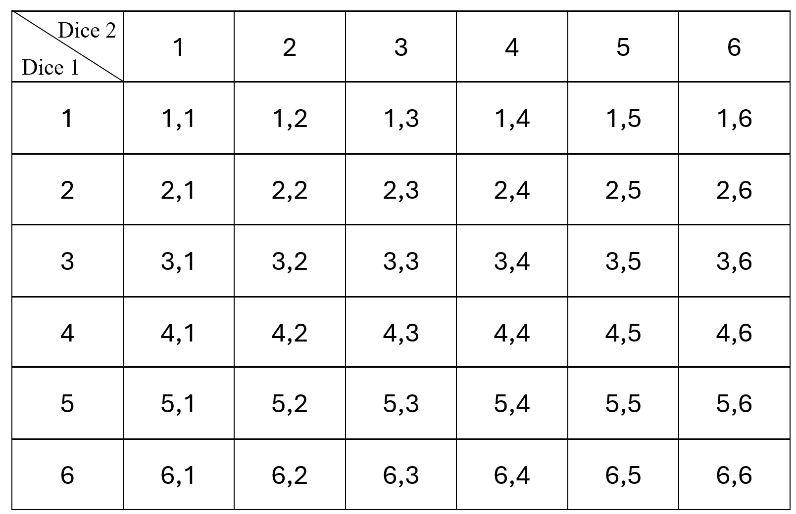  and using to assign probabilities to events, such as  P(rolling a 1 first)  P(rolling at least one 5)  P(not rolling a double)  P(rolling a 4 first and a 4 second)  P(sum of 6)  Recognise that complementary events have a combined probability of one and use this relationship to calculate probabilities  For example:  - exploring the language of complementary events, such as rolling a 3 on a dice and not rolling a 3 on a dice. Verifying that as the probability of rolling a 3 on a dice is $\frac{1}{6}$and the probability of not rolling a 3 on a dice is $\frac{5}{6}$, then the sum of the event and its complement is 1  - using complementary events to assign the probability of not choosing a red 3 from a standard pack of cards by  P(not choosing a red 3)  $=$ $1-$ P(choosing a red 3)  $=$ $1-\frac{2}{52}$  $=$ $\frac{50}{52}$ or $\frac{25}{26}$  or $96.2\%$ or $0.962$  or a 25 in 26 chance  - using complementary events to assign a probability to rolling at most a 9 from a 10-sided dice roll by identifying that P(at most a 9) and P(10) are complementary events. Using $1$ $-$ $\frac{1}{10}$ to determine the  expected probability | Construct sample spaces to show outcomes for two-stage chance experiments both with and without replacement. Assign probabilities to outcomes and make informal connections to independent and dependent events  For example:  - the digits 1, 2, 3, 4 and 5 are written on ping-pong balls and placed in a bag. Two balls are drawn consecutively without replacement to make a two-digit number. Choosing from a list, an array or a tree diagram to show all possible outcomes and use this to find the probability that the number formed is even. Repeating with replacement. Noting that the events of drawing one ball after another with replacement are independent as the outcome of the first event does not impact the outcome of the second event  - choosing to construct a tree diagram sample space to represent a box of three chocolates, containing one strawberry and two caramel chocolates, with two chocolates being randomly selected, one after the other. Determining the probability of selecting two caramels in each of the  following scenarios  - with replacement:  the three chocolates have coloured wrappers to indicate the flavour. A chocolate is randomly chosen, the flavour noted and the chocolate replaced (independent events)  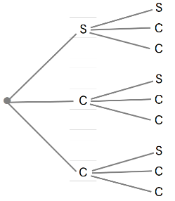  P(caramel, caramel) $=$ $\frac{4}{9}$  - without replacement:  three unwrapped  chocolates, needing to be eaten to identify flavours (dependent events)  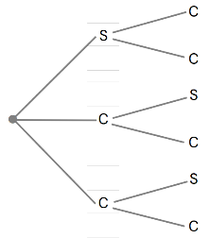  P(caramel, caramel) $=\frac{2}{6}=\frac{1}{3}$  Year 9 optional  Identify independent and dependent two-stage chance events using $P(A and B)=P(A)×P(B)$ and sample spaces, such as tree diagrams, to determine the probability of independent events | Choose and construct  appropriate sample spaces to show outcomes for two- and three-stage chance experiments both with and without replacement. Assign probabilities to events involving conditional statements, such as ‘if ... then’, ‘given’, ‘of’, ‘knowing that’  For example:  - recognising and interpreting the notation and language of conditional probability, such as from a dice roll and a coin toss, determining  P(3 and a tail|dice shows a prime number)  i.e. the probability of flipping a 3 and a tail, given that the dice roll was a prime number. Choosing from a list, array or tree diagram to show all outcomes and assign a probability  - choosing and representing a suitable sample space, such as an array, for rolling two  eight-sided dice to assist in determining the probability of a sum of 14, given that both dice show an even number. Use knowledge and reasoning of conditional events to restrict the sample space and assign conditional probabilities  - choosing to represent the sample space of drawing three marbles from a bag containing two red, one green and two blue marbles, one after the other without replacement, in a tree diagram. Determining the probability of events, such as ‘drawing a blue marble third, given the first was red’ and ‘drawing a green marble first, knowing that the second  was blue’  Year 10 optional  Use weighted tree diagrams and/or formulas to assign probabilities to two- and  three-stage chance events including situations involving conditional probability
Conduct repeated single-stage chance experiments and simulations to produce datasets, including through the use of digital tools, for an increasingly large number of trials. Discuss and describe variation and  estimated probabilities for outcomes, and compare to predictions and theoretical probability, where appropriate  For example:  - conducting an experiment to find the estimated probability of a drawing pin falling point up or point down when tossed. Completing 20 trials, determining relative frequencies (fraction of those that landed point up or point down), comparing with others, describing variation in results and estimating probabilities of each outcome. Repeating over a large number of trials, comparing to others again and using the data to estimate the probability that a pin will land point down when tossed. Comparing this to former estimates of probabilities  and discussing the law of  large numbers  - conducting a simulation to determine the chance of randomly choosing a person who supports the Dockers from a family comprising three Eagles supporters, two Dockers supporters and one Geelong supporter. Predicting the expected probability before using a random number generator from 1–6, with 1, 2, 3 representing the Eagles supporters, 4 and 5 representing the Dockers supporters and 6 representing the Geelong supporter, over 20 trials. Determining the relative frequency that a Dockers supporter is chosen, comparing results with others, describing variation and estimating the probability. Repeating over an increasingly large number of trials. Comparing results of estimated probability to theoretical probability and discussing variation  - conducting an experiment to predict the unknown distribution of red, green and blue counters in a bag of 12. Randomly choosing a counter, noting its colour, replacing and recording the frequencies of red, green and blue over 50 trials. Determining the relative frequencies for each colour, noting that they add to one. Comparing results with others, describing variation and predicting colour distribution. Repeating over many trials, and again comparing to others, calculating appropriate averages, predicting colour distribution, then confirming the actual number of each colour in the bag. Describing comparisons of predicted and actual colour distribution. Relating to the theoretical probability and discussing variation in the experimental probability as the number  of trials increases (law of  large numbers) | Conduct repeated chance experiments and simulations for two events to produce datasets, including through the use of digital tools, for a large number of trials. Discuss, explain and compare variation and estimated probabilities for simple and compound events  For example:  - conducting a simulation to determine the estimated probability of not getting two tails when tossing two coins. Predicting the probability before using a virtual coin toss or random number generator with 1 representing ‘heads’ and 2 representing ‘tails’, to flip two coins for a large number of trials. Comparing results with others, and with predicted and theoretical probability results, discussing and explaining any variation and making connections to complementary events.  - Conducting an experiment to find the estimated probability of a difference of 6 between the sum of the numbers shown on two white dice and the number shown on a green dice. Completing an actual or virtual dice experiment to produce a large set of data, representing results in a column graph and using to estimate the probability of the difference being 6. Comparing the shape of the graph in terms of clusters, gaps, outliers and symmetry with others and noting variation. Explaining and justifying conclusions made regarding the probability of a difference of 6 between the sum of the numbers shown on two white dice and the number shown on a green dice | Conduct repeated two-stage chance experiments and simulations, both with and without replacement, to produce datasets, including through the use of digital tools. Discuss, compare and interpret variation and estimated probabilities for compound events  For example:  - conducting an experiment to find the estimated probability of choosing two hazelnut  chocolates, one after the other, from a box containing seven strawberry, 11 hazelnut and two caramel chocolates for the following scenarios  - with replacement:  the chocolates have coloured wrappers to indicate the flavour. A chocolate is randomly chosen, the flavour noted, the chocolate replaced, and a second chocolate is chosen, and the flavour is noted  - without replacement:  the chocolates are unwrapped, needing to be eaten to identify flavours (not replaced), choosing and using an appropriate tool, such as a 1–20 random number generator (1–7 strawberry,  8–18 hazelnut and 19–20 caramel) to simulate and generate large datasets for both scenarios.  Using the datasets to estimate the probability of drawing a hazelnut followed by another hazelnut in each case, comparing and explaining differences in the estimated probabilities of drawing two hazelnuts between scenarios. Discussing and interpreting the effects of with/without replacement and the chance variation on the datasets and the conclusions drawn.  For students engaging in Year 9 optional, extending and connecting to the probability formula for independent events | Conduct repeated chance experiments and simulations to model conditional probability and produce datasets using digital tools. Discuss, compare and analyse variation and estimated probabilities for conditional events  For example:  - conducting an experiment to find the estimated probability of drawing a red marble third, given the first was green, when drawing three marbles consecutively, without replacement, from a bag containing 19 red, eight blue and 13 green marbles. Choosing and using an appropriate tool, such as a  1–40 random number generator, to simulate the situation. Producing a large number of trials to estimate the probability of drawing a red marble third, given the first was green. Comparing results with others, recognising the effect of ‘without replacement’, conditional events and chance variation on the datasets produced and the estimated probability. Comparing and analysing differences between the  initial prediction and the estimated probability.  For students engaging in Year 10 optional, extending and connecting to the probability formula for conditional events  - conducting a simulation of an amusement arcade game where the prizes are three toys, with the chances of winning a toy dinosaur being $20\%$, a fluffy dice $50\%$ and a stuffed toy $30\%.$ Making predictions of the average number of played games required to win at least one of each of all three prizes. Choosing and using an appropriate tool, such as a virtual spinner or a random 1–10 number generator, to simulate the situation and to produce a large dataset. Using data to estimate the average number of games played to collect at least one of each of all three prizes. Comparing results with others, describing and explaining variation of results. Discussing, comparing and analysing differences in the average number of games needed to win at least one of each of all three prizes, in situations where it was given that the first prize drawn was  - a stuffed toy  - a toy dinosaur  - a fluffy dice  - conducting simulations to produce datasets for situations involving chance, such as the ‘birthday problem’ or ‘three door problem'
Explore and determine the mean, mode, median and range for sets  of data and justify, using the context, which measure best reflects the dataset  For example:  - using concrete materials, such as a small collection of  - beakers of different amounts of water  - ‘fake’ $100 notes allocated to students ($500, $200, $500, $1400, $600, $0)  to physically show the mode and the range, reordering to demonstrate the median and redistributing evenly between each data point to show the mean (generalising to a numerical calculation of the mean). Discussing which measure of average best reflects each physical context  - given the mean number of pets in seven households is 4.25, working backwards to produce and explain seven reasonable data points  - using data sources, such as primary, discrete data collected from chance experiments, or secondary, continuous data, such as the maximum temperature/rainfall in the class town or city for each month of the year, to determine mean, mode, median and range using written jottings or digital tools depending on the complexity of the data. Explaining and justifying which is the most reflective of the dataset | Analyse data represented in stem-and-leaf plots, column graphs and frequency tables to determine the mean, mode/s, median and range. Describe the effect of any outliers on the statistical measures  For example:  - using information recorded in a table, on the number of cups of coffee consumed by people in an office on a given day  Number of cups 0 1 2 3 9  Frequency 12 27 16 5 1  determining the mean, mode, median and range of the data with and without the outlier, manually or with digital tools.  Comparing and describing differences in the two sets of statistical measures (with and without outlier), recognising the impact of the outlier on mean and range and understanding why it is often more appropriate to use the mode or median to describe data when an outlier is included in the calculations | Analyse data with multiple variables represented in tables. Describe using statistical measures and relative frequencies to make inferences  For example:  - describing data in tables involving variables, such as the states of Australia, their population, land size and median house price. Determining proportions, such as the percentage of Australians who live in NSW or the fraction of land size that WA is of Australia, and statistical measures, such as the average median house price. Discussing possible inferences that could be made from the data | Analyse bivariate data represented in a two-way table using proportions and comment on possible association between categorical variables  For example:  - forty people in the suburb of Gosnells were randomly surveyed about dog adoption from the local dog shelter to produce data to guide an adoption advertising campaign. Using the data given in a two-way table  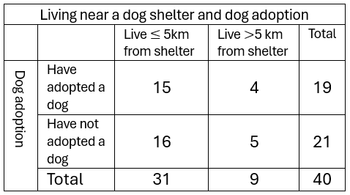  determining proportions, such as $\frac{15}{31}$ of the population that live within 5 km of the dog shelter have adopted a dog, which is similar to $\frac{4}{9}$ of the population that live further than 5 km from the dog shelter and have adopted a dog. Commenting that proximity to a dog shelter does not appear to have an association with dog adoption. Discussing how the information could be used to guide the dog adoption advertising campaign
Represent primary categorical and numerical data in a Venn diagram, calculate related relative frequencies and interpret results  For example:  - collecting data from a Year 7 maths class on different options for an end of term activity, such as those who would prefer to go to a movie, those who would prefer tenpin bowling, those who are happy with either option and those who like none of the options. Representing the results in a Venn diagram and determining the proportion (relative frequency) of students who chose the movies and not tenpin bowling (e.g. $\frac{4}{5}$). Analysing results, such as most of our class would like to go to a movie because the film playing at that time is very popular. Acknowledging that the data would vary if recorded on a different day or from a different Year 7 class, impacting conclusions. Discussing whether it would be valid to use the data from this maths class to make decisions for the whole population of Year 7 students  Represent collected data in a stem-and-leaf plot, describe the shape and spread including outliers, and compare to dot plots or column graphs. Use the data to estimate probabilities of specific outcomes  For example:  - collecting data, such as the number of items of stationery in pencil cases, with one-half of the class representing results on a stem-and-leaf plot and the other on a dot plot, manually or by using digital tools.  Stem-and-leaf plot displaying number of items of stationery in pencil cases  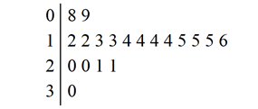  Dot plot displaying number  of items of stationery in  pencil cases  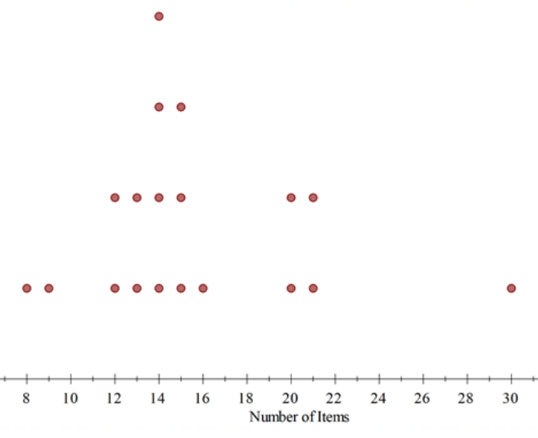  Each half of the class to comment on the shape of the data from their distribution. Identifying clustering of most items between 12–16,  non-symmetrical, a spread in items of 22 (30–8), gaps between 9–12 and 16–20 and an outlier of 30, recognising that 30 items could be the result of an error or that one person has a lot of stationery items. Comparing displays and recognising that a stem-and-leaf plot provides detailed information about individual data points and the dot plot (or column/bar graph) provides a clear picture of the mode, shape, spread and outliers of the distribution. Determining the probability that a person chosen at random from the class would be someone from the ‘cluster’, that is, has 12–16 items of stationery in their pencil case | Use secondary data represented in two-way tables and Venn diagrams to describe events, including those that are mutually exclusive. Estimate related probabilities and make predictions as appropriate  For example:  - using data represented in completed or partially completed two-way tables, such as information concerning jackets ordered by members of a netball club and whether the jacket had a hood or a name printed on the back  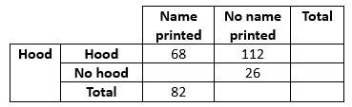  Determining and describing the jackets of 14 students as having a name printed but not having a hood, 68 students as having a hood and a name printed and 194 students having a hood, or a name printed. Determining related probabilities, such as a student being chosen at random who does not have a name printed on their jacket.  Identifying and describing that the outcomes of having a hood and having a name printed are not mutually exclusive, as they can occur at the same time.  Using the data to predict that in a future group of 300 netball club members  $\frac{112}{220}$ $×300=152.72,$ or approximately half the members, would order a jacket with a hood but no name, acknowledging that future outcomes will be affected by chance variation, such as fashion trends  - using data represented in a completed or partially completed Venn diagram concerning a sample of 180 people at the Perth Royal Show being asked by the organisers to complete a questionnaire as to whether they had visited the cat pavilion only, the dog pavilion only, both  or neither.  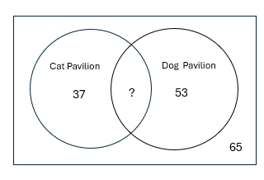  Reasoning that the number of people who had visited both pavilions was 25. Determining related probabilities of a person being chosen at random for a follow-up survey, who had visited at least one of the pavilions.  Recognising that visiting the cat pavilion and the dog pavilion are not mutually exclusive events, as both events could occur. Understanding that for mutually exclusive events, such as buying a Royal Show entrance ticket online or buying it at the gate, a Venn diagram depicting how visitors purchased tickets  would appear as two  non-interconnecting circles.  Determining that approximately $36\%$ of visitors to the Royal Show do not go to either pavilion and using this to inform possible action for future Royal Shows, acknowledging that future predictions will be affected by chance variation, such as weather  Investigate and explain techniques for data collection, including census, survey, experiment and observation, and explain the practicalities and implications of obtaining data through these techniques  For example:  - defining and identifying data collection techniques and explaining the practicalities and implications of each in situations, such as  - Australian Bureau of Statistics, five-yearly surveys  - polling voters  - testing a new medicine  - studying animal behaviour  Explore, analyse and compare variation between results from same size random samples drawn from the same population. Identify and explain how chance variation impacts on data validity, reliability and conclusions drawn  For example:  - defining sample, random sample and population in the context of producing a dataset of the heights of a sample of five students, randomly chosen from the Year 8 school population using a random number generator. Determining mean, mode, median, range and proportions (e.g. fraction or percentage of students between 150 and 155 cm tall) manually or with digital tools from this sample. Repeating for different samples of five students, comparing and analysing variation between the samples, including the effect of outliers. Repeating the process with samples of 15 students, recognising the effect of the increased sample size on variation. Commenting on the impact of the sample size and the validity and reliability of the datasets as indicators of the height of the total population of Year 8 students | Explore, choose and create  graphical or visual representations and justify choice with regards to context, purpose, data type and intended audience  For example:  - using digital tools and a variety of data types and data sizes, explore and create standard and  non-standard representations, such as histograms, line graphs, Venn diagrams, two-way tables, stem-and-leaf plots, stacked bar charts, pie charts, infographics or 3D graphs  - discussing determining factors involved in choosing an appropriate representation, such as where the representation will be displayed, whether the data is categorical, numerical, continuous or discrete, the message the representation will be intending to convey, who will be viewing the representation and what level of detail or complexity in the representation is appropriate for the audience  - using topics of interest involving sports statistics, environmental data over time, social media ‘likes’ etc., selecting and creating an appropriate display based on the dataset and the  determining factors  Interpret and compare multiple datasets represented in back-to-back stem-and-leaf plots and histograms with consideration of shape, spread and centre  For example:  - given a back-to-back stem-and-leaf plot of pulse rates before and after exercise to show heart beats per minute, describing the shape of ‘before’ and ‘after’ as both being non-symmetrical and positively skewed.  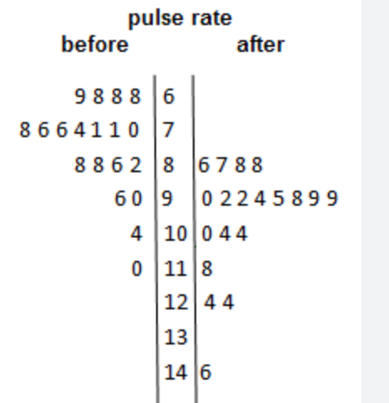  Comparing the gaps (a significant gap between 124 and the outlier of 146 in the ‘after’ pulses), clusters (tighter clustering around the middle values in the ‘after’ pulses) and range (significantly higher in the ‘after’ pulses due to the outlier). Determining the mean, mode and median of ‘before’ and ‘after’, recognising that the ‘after’ pulses have more than one mode and calculating the differences between the mean and the median between each of the datasets. Generalising to ‘after’ pulse rates have higher central tendencies, a wider spread and tighter clustering compared to the ‘before’ pulse rates  - describing comparative histograms displaying the growth of seedlings after different fertilisers are applied, in terms of shape and spread  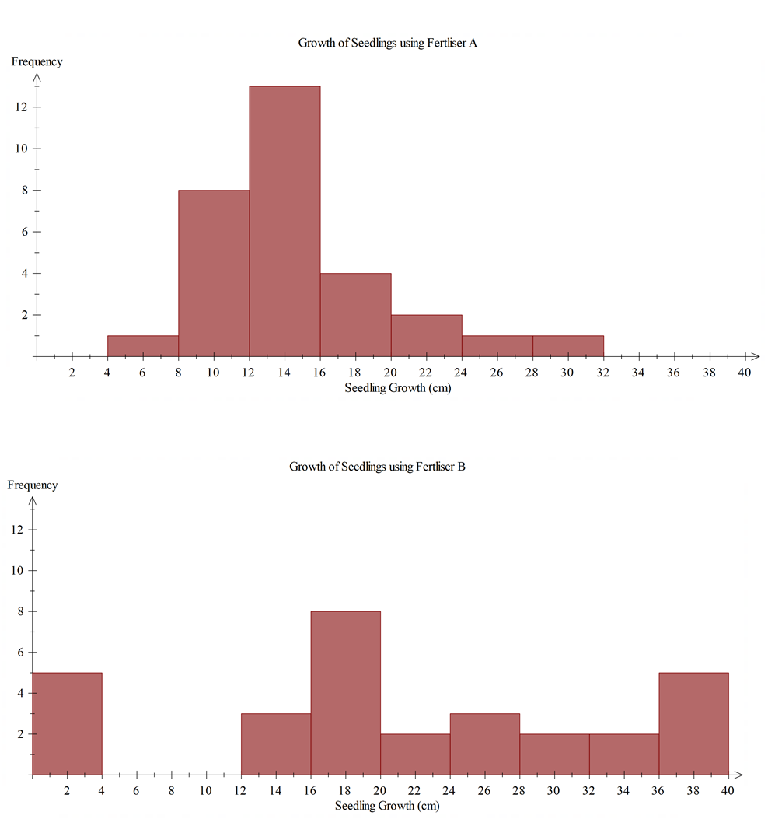  - describing the shape, spread and centre of the Australian Bureau of Statistics population pyramid, in terms of the age structure of people in Australia over time  Describe different sampling methods and analyse how the different methods can affect the results of surveys. Identify and explain how chance variation impacts on the data validity, reliability and conclusions drawn from surveys  For example:  - exploring and explaining systematic, stratified, clustered, convenience or capture-recapture sampling methods, and deciding which method would be most representative of a total population (e.g. stratified sampling would be most  suitable when surveying employee satisfaction across different departments)  - conducting a survey of fellow students to decide a suitable frozen yoghurt to be included in the school canteen menu. Assigning different sampling methods to groups of students to each produce two different samples. Each group analysing their samples separately to determine and compare findings, discussing chance variation. Comparing results between groups and discussing factors that could explain differences. Suggesting and explaining which of the sampling methods produces a valid and reliable dataset on which a prediction of the total population for this scenario can be made  - explaining how the number of people with Type A blood could be estimated, justifying choices of sampling size and method with consideration to ensuring the collection of valid and  reliable data  Year 9 optional  Produce and organise accurate and valid, ungrouped continuous data to construct histograms and frequency polygons. Determine summary statistics and analyse the distribution in terms of centre, shape and spread | Represent secondary data in  two-way tables or Venn  diagrams and assign probabilities to outcomes involving  conditional statements  For example:  - choosing from a Venn diagram or two-way table to represent information, such as a 200-people survey about which social media platform they use. 115 use ‘Quickgram’ only, 13 use ‘Z’ only and 45 use neither. Determine the probability that a person chosen at random uses ‘Z’ given that they also use ‘Quickgram’.  Note: situations involving mutually exclusive events should also be included  Represent the relationship between bivariate data in a scatter plot and draw a trend line by eye if appropriate. Use the graph and context to describe any association in terms of strength, direction, linearity and outliers. Make predictions and recognise  and explain any limitations of  the model  For example:  - representing data of the arm span and height, in centimetres, of a group of students, manually or with digital tools, depending on the amount or complexity of the data, in a scatter plot.  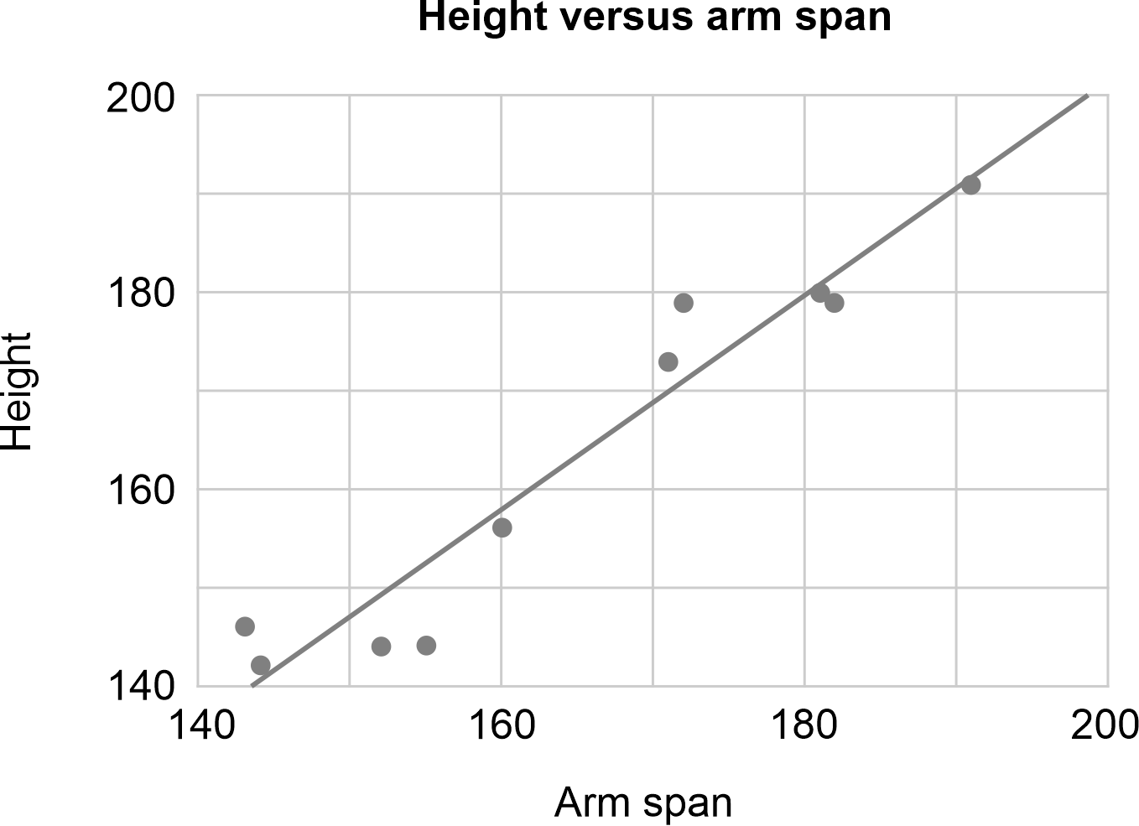  Describing the data as having a strong, positive, linear relationship between arm span and height, with arm span increasing as height increases and with no outliers. Using the trend line to make predictions between known data values, such as predicting the height of a student with an arm span of 165 cm (interpolation), and beyond known data values, such as predicting the arm span of a student who is 210 cm tall (extrapolation), discussing the validity of each prediction and explaining the predictions limitations in terms of chance variation  Represent and analyse boxplots. Explain differences between multiple boxplot datasets in terms of shape, spread and centre. Compare or match the shapes of boxplots to distributions depicting the same data  For example:  - using a five-number summary calculated from a dataset to assist in producing a boxplot manually or with digital tools, depending on the size and complexity of the data, and conversely, using a given boxplot to extract a  five-number summary. Analysing the distribution in terms of shape (symmetry, skewness and clustering), spread (range and IQR) and centre (median)  - representing multiple datasets, such as test results for Class A and Class B, manually or with digital tools, on the same scale and comparing differences between the shape, spread and centre of the distributions  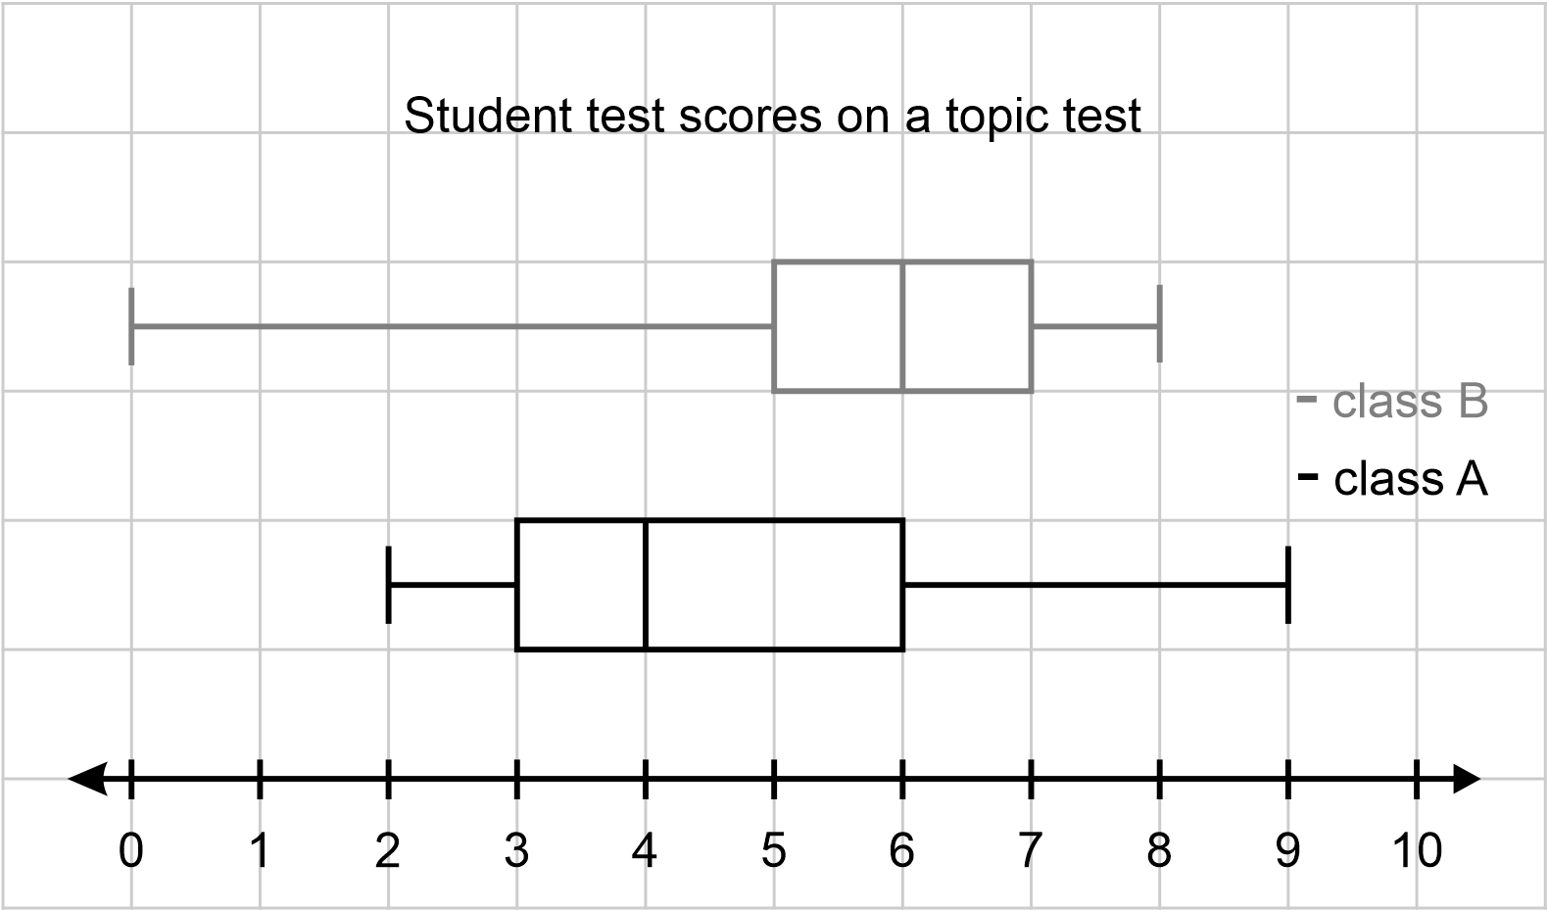  - analysing a negatively skewed distribution, where the mean is smaller than the median, and comparing it with a positively skewed distribution, where the mean is larger than the median  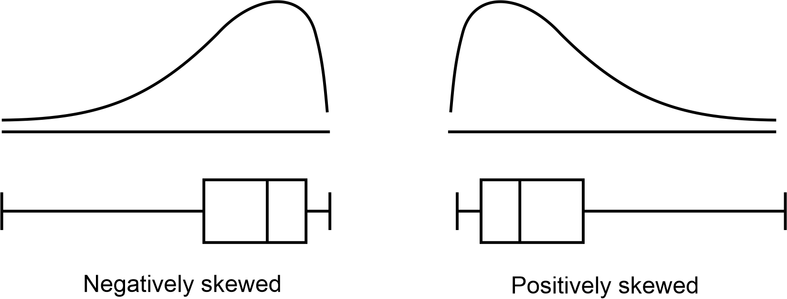  - describing the shape of boxplots and matching the distributions to histograms  and dot plots  Year 10 optional  Produce, organise and represent accurate and valid data in a cumulative frequency graph, and use this to analyse quartiles  and percentiles  Year 10 optional  Determine the mean and standard deviation of a dataset. Investigate, analyse and interpret the effect of individual data values, including outliers, on the standard deviation
Critically analyse statistical statements made in the media and other real-life situations, that relate to the averages of mean, mode and median. Investigate the impact of chance variation on the dataset from which the averages were determined  For example:  - critically commenting on the terminology and meaning of the averages quoted and the impact of chance variation in data, on statements made in the media, such as  - the average Australian family has 2.1 children  - the Fever netball team scored 42 goals in a game on three occasions in the season. This number of goals occurred more than any other score that season  - half of Australia’s population earn less than $\$75 000$ per year and the average wage is $\$98 000$ per year  - a popular confectionery company stating that the typical price of a $180$ g chocolate bar is $\$4.25$ | Critically analyse visual representations and tables in the media and other real-life situations to identify misleading or inaccurate features and interpretations. Recognise the impact of the validity and reliability of the data used  For example:  - using the following graphical display showing the cost of services for a day care business, to describe misleading features  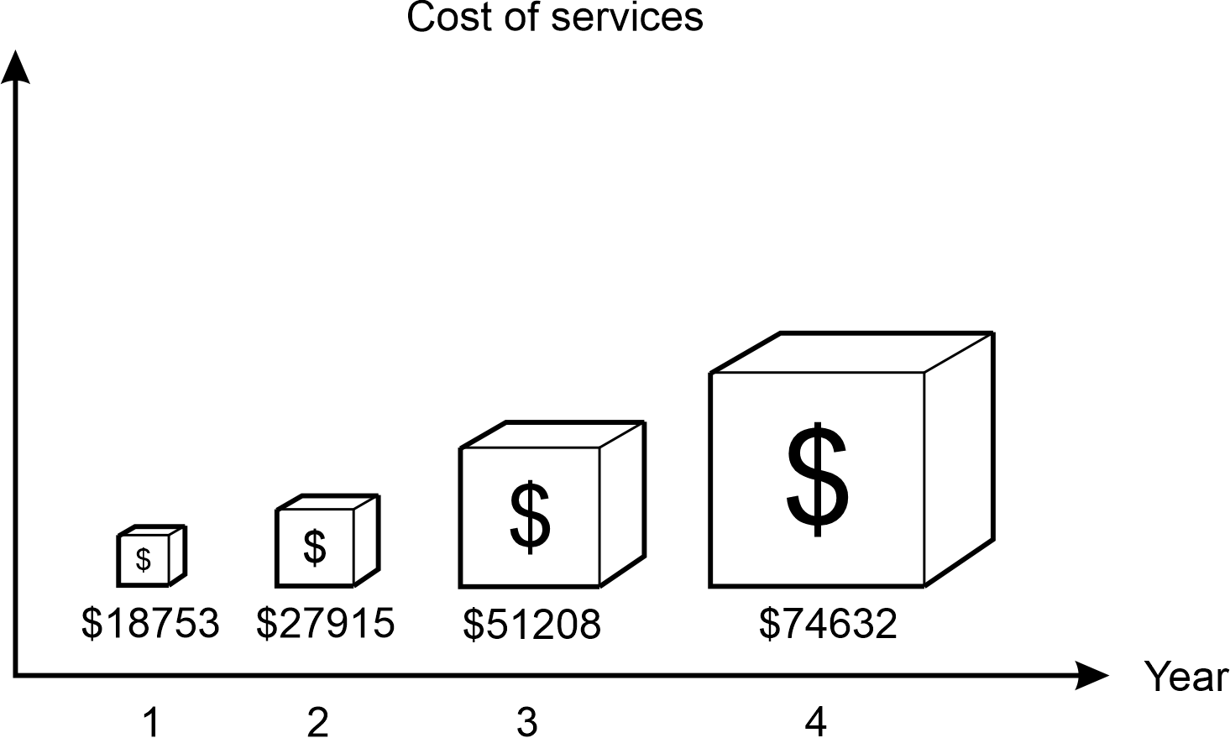  Recognising the title and axes labels do not provide clarity as to the purpose of the graph, the scale is distorted or non-existent, the use of selective data from only four years and no acknowledgement of the source presenting the display, thus meaning the data that the graph is depicting may not be valid and reliable. There is an inappropriate use of size for each of the ‘blocks’, creating the impression that the fourth year had at least four times the cost of services than the second. The graph is a biased representation and influences the audience into thinking that the cost of services has increased more than it actually has  - the results of people completing the written learner driver’s licence test in a town in WA for one month were represented in a column graph for the State Licensing report. The report stated: ‘There was great  variation in results; however, the average score was 25.3 and most people scored above the pass mark of 26’  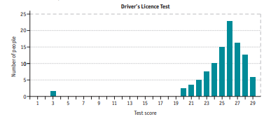  Critically looking at the validity  of including the outlier in the comments and calculations, the mean being the chosen  ‘average’ and the accuracy of  the calculations | Critically analyse statistics in the media and other real-life situations relating to data samples, including the effect of chance variation on sample analyses  For example:  - critically commenting on whether a statistical sample is produced from valid and reliable data by considering factors, such as sample size, random variation, measurement or recording error, inconsistencies or biases in where, when and how the data sample was collected. Recognising that uncertainty in sampling produces uncertainty of conclusions. Commenting on situations such as  - a newsagent in a small country town advertises that they have had two  million-dollar winners in the past week, encouraging customers to buy the winning ticket from them  - a major national supermarket conducted a survey about brand preferences using an online form. They received  65 responses  - researchers want to estimate the population of fish in a dam using the capture-recapture method. They capture and tag 100 fish, release them back into the dam and after a month, capture another 100 fish, finding that 10 of them are tagged. They estimate the population of fish in the dam to be 1000  - a pharmaceutical company conducts a paid clinical trial with 30 volunteers to test  the efficacy of a new drug  for headaches | Critically analyse the claims, inferences and conclusions of statistical reports in the media and other real-life situations, and identify potential sources of bias  For example:  - critically analysing the source, sampling method, validity and reliability of the dataset, accuracy and appropriateness of statistical measures and representations, interpretation and extrapolation of results, including conclusions regarding association, and overall implications and recommendations outlined, to identify possible bias in reports involving  - the effectiveness of a  new exercise regimen in  a magazine  - climate change trends and the impact on a local ecosystem reported in the community newspaper  - a post on social media concerning crime rates in your local area  - satisfaction ratings and reports on social media concerning restaurants or other places to visit

Sub-strand: Modelling with probability and statistics
Year 7 | Year 8 | Year 9 | Year 10
In real-world situations involving assigning a probability to  single-stage chance experiments  or simulations, statistical  measures, stem-and-leaf plots, dot plots, column graphs and/or  Venn diagrams  - analyse the situation, pose questions as required and determine assumptions  and constraints  - determine appropriate production of a valid and reliable dataset, statistical measures, data representations and analyses, including examination of distributions, to effectively investigate the situation  - interpret, draw inferences and communicate findings in terms of the context, assumptions, constraints, chance variation and knowledge or insights gained  For example:  - ‘What are the chances that the next song on a shuffled playlist is 3.5 minutes long?’  Analysing the situation by considering the number of songs on a playlist, where to find the length of a song on the playlist and the time units used to show the length of a song. Posing questions, such as ‘How long is a song?’ Determining experimental constraints, such as choosing a sample of class members’ playlists to represent the group and only using the first 20 songs played. Discussing how data from the sample could be collated and recorded to ensure validity and reliability, including rounding. Representing the data as a stem-and-leaf plot, determining the relative frequencies for lengths (e.g. fraction of songs that were  3.2 minutes long) and the mean, mode, median and range. Analysing the shape and distribution of the data, commenting on variation. Interpreting the results and drawing inferences to predict the probability of the next song being 3.5 minutes long. Communicating findings in terms of the playlist, qualifying that variation would exist due to reasons, such as the order songs were shuffled, the chosen class members and the type of music they prefer, and commenting on whether and why the dataset would be reflective of a broader population of songs | In real-world situations involving two-stage chance experiments or simulations, complementary events, data collection methods, same-sized random sampling and/or analysis of graphs, tables and data  - analyse the situation, pose questions as required and determine assumptions  and constraints  - determine appropriate production of a valid and reliable dataset, statistical measures, data representations and analyses, including examination of distributions, to effectively investigate the situation  - interpret, draw inferences and communicate findings in terms of the context, assumptions, constraints, chance variation and knowledge or insights gained  For example:  - ‘Who has the best chance of winning in a game of throwing two 10-sided dice where Player One wins if the sum of the dice is 9, 10, 11 or 12, Player Two wins if the sum is 13, 14, 15 or 16 and Player Three wins for all other sums of dice?’  Analysing the situation by considering the sums of dice Player Three could win with. Posing questions, such as ‘What are all the possible sums when two 10-sided dice are rolled?’ and ‘What is the probability of each sum occurring?’. Making assumptions, such as the dice are fair and that the game is based on a single roll of the dice. Deciding to represent the problem by producing an array or by conducting a simulation over a large number of trials. Using representation, data or complementary events to determine the chance of each player winning and hence, the winner. Communicating the results in the context of the game and with a consideration to variation  - ‘The health department has noticed an increase in back problems in 13–15-year-old adolescents. The recommended weight of backpacks for this  age group is 8 kg or less. Investigate if this backpack weight is typical for adolescents in this age group.’  Analysing the situation by considering an appropriate sample size of backpacks to be weighed, the units of weight to be used and what is meant  by ‘typical’. Posing questions, such as ‘How much does a backpack weigh?’ From the analysis, determining constraints, such as a sample of backpacks from Year 8 students should be weighed rather than the population of Year 8 students and the backpacks should be weighed to the nearest half kilogram. Making assumptions, such as the measuring scale is accurate and that the weight reflects what students carry on a daily basis. Randomly choosing a student sample using a random number generator, weighing their backpacks and recording the results in a frequency table. Determining the mean, mode, median and range, representing in an appropriate graph and commenting on variation and the effect of outliers. Repeating the task with a different same-sized sample to consider variation. Communicating the findings in terms of the average weights of the sample backpacks compared to the recommended weight, and commenting if and why this result would be reflective of the broader population | In real-world situations involving two-stage chance experiments or simulations both with or without replacement, different sampling methods, choosing and creating graphical representations  and/or analysis of tables and comparative graphs  - analyse the situation, pose questions as required and determine assumptions  and constraints  - determine appropriate production of a valid and reliable dataset, statistical measures, data representations and analyses, including examination of distributions, to effectively investigate the situation  - interpret, draw inferences and communicate findings in terms of the context, assumptions, constraints, chance variation and knowledge or insights gained  For example:  - ‘What are the chances of Kevin randomly choosing two consecutive days in April next year to holiday?’  Analysing the situation by recognising that days cannot be repeated and that the last day of April cannot be included as the first of the consecutive days. Posing questions, such as ‘How many days in April?’ and ‘What are the possible consecutive dates?’ Producing a large set of data using a random calendar date or sequence generator, representing the results in a table and using to estimate the probability of randomly choosing two consecutive April dates. Interpreting and communicating the result, recognising and acknowledging the impact of chance variation  - ‘Oliver is planning his holidays for next year. He wants to spend a week in Esperance for one holiday and a week in Geraldton for another holiday. Oliver wants to determine the best months to holiday according to the weather.’  Analysing the situation by determining the important aspects of weather. Posing questions, such as ‘What is the maximum temperature in each month for each of the places in the last 10 years?’ Making assumptions, such as his employer allowing him to take holidays in two separate weeks. Producing valid and reliable data from a source, such as the Bureau of Meteorology. Choosing and using appropriate comparative representations depending on the data collected. Analysing and interpreting the representations, communicating when Oliver should travel to these destinations in reference to the initial qualifications | In real-world situations involving two- and three-stage chance experiments both with and without replacement, conditional probability or statements, boxplots, bivariate data and/or two-way tables  - analyse the situation, pose questions as required and determine assumptions  and constraints  - determine appropriate production of a valid and reliable dataset, statistical measures, data representations and analyses, including examination of distributions, to effectively investigate the situation  - interpret, draw inferences and communicate findings, in terms of the context, assumptions, constraints, chance variation and knowledge or insights gained  For example:  Using the modelling process to investigate topics, such as  - analysing the number of kicks made by two Western Australian football teams in the previous football season, comparing to the number of games won and providing advice to coaching staff for the upcoming season  - investigating the validity of a statement in a health magazine that read, ‘The average adolescent has a resting heart rate of approximately 80 beats per minute which is reduced depending on the number of hours of exercise they do per week’  Year 10 optional  Using the modelling process to design and conduct a chance experiment, simulation or statistics experiment on a topic of interest

