CAMPUS ENERGY
CONSUMPTION ANALYTICS
Exploratory Analysis, Forecasting,
Energy-Saving Scenarios and Business Recommendations

Final Project Report
Prepared using the public I-BLEND dataset from IIIT-Delhi
Analysis period: 10 August 2013 – 31 December 2017
Project completed: 5 November 2026
IMPORTANT DATASET CONTEXT
This is a historical public-data case study of IIIT-Delhi. It is not a measurement of Heritage Institute of Technology or any other campus.

Table of Contents
- 1. Executive Summary
- 2. Project Objectives
- 3. Dataset and Scope
- 4. Data Preparation and Quality
- 5. Exploratory and Energy Analysis
- 6. Forecasting Methodology
- 7. Forecasting Results
- 8. Energy-Saving Scenario Analysis
- 9. Business Insights and Recommendations
- 10. Limitations
- 11. Conclusion and Future Scope
- 12. Reproducibility and Project Outputs
- 13. References
- Appendix A. Selected Visualizations

1. Executive Summary
This project analyzes historical electricity-use data from the public I-BLEND dataset associated with IIIT-Delhi. The workflow covers data inventory and validation, cleaning, hourly aggregation, exploratory analysis, energy-consumption assessment, forecasting, hypothetical energy-saving scenarios, and business recommendations.
The processed hourly dataset contains 38,520 records from 10 August 2013 through 31 December 2017. Of these, 33,671 records contain valid campus-total energy values, corresponding to 87.41% observed coverage. The remaining 4,849 records are missing or invalid for this campus-total measure.
Five forecasting approaches were evaluated on a continuous 9,370-hour segment using a chronological 80/20 split. Lag-Based Regression achieved the lowest test MAE (8.822 kWh) and RMSE (12.099 kWh), modestly outperforming the previous-hour naive baseline. The MAE improvement was approximately 3.98%; however, moving-block bootstrap intervals included zero, so superiority is not statistically conclusive.
Hypothetical reductions of 5%, 10%, 15% and 20% applied to observed baseline energy correspond to approximately 171,723, 343,447, 515,170 and 686,894 kWh respectively. These are scenario calculations, not measured savings or demonstrated feasible targets.

2. Project Objectives
- Examine historical campus electricity-consumption patterns.
- Assess meter-data availability, missingness and quality.
- Compare energy consumption across monitored buildings where coverage permits.
- Investigate hourly, daily, monthly and weekday patterns.
- Develop baseline and regression-based forecasting models.
- Evaluate forecast performance using MAE, RMSE and bias.
- Estimate hypothetical energy savings under specified reduction scenarios.
- Translate evidence into practical, appropriately qualified recommendations.

3. Dataset and Scope
I-BLEND is the Indian Buildings Energy Consumption Dataset. Its published data descriptor describes 52 months of one-minute electrical measurements from seven commercial and residential buildings at an academic campus in India, alongside supplementary occupancy and other contextual data. The project uses the IIIT-Delhi dataset; therefore, its findings must not be represented as measured consumption at Heritage Institute of Technology.
The processed hourly energy dataset used here spans 10 August 2013 to 31 December 2017. The original dataset includes meter readings and supplementary occupancy data. Wi-Fi-based occupancy is an estimate of presence, not an exact headcount. Supplementary weather observations from 2018 were not treated as contemporaneous predictors for 2013–2017 energy readings.
Dataset item | Project treatment
Energy measurements | Cleaned and aggregated to hourly observations.
Time zone | Asia/Kolkata used for timestamp interpretation.
Occupancy | Used as an estimate; not treated as exact people counts.
Weather | 2018 supplementary observations not joined as contemporaneous 2013–2017 weather.
Missing readings | Preserved as missing; not automatically replaced with zero.

4. Data Preparation and Quality
- Inspected source files, schemas, timestamps and measurement coverage.
- Cleaned minute-level energy readings and standardized timestamps to Asia/Kolkata.
- Converted power readings to energy units during hourly aggregation (power in watts divided by 60 for minute intervals, then aggregated as appropriate in the processing pipeline).
- Constructed hourly energy records and calendar/time features.
- Applied explicit meter-coverage criteria for building and campus-level summaries.
- Preserved missing observations rather than interpreting absent readings as zero consumption.
The hourly processed dataset contains 38,520 records. For the campus-total measure used in Step 10G, 33,671 records were valid (87.41% coverage) and 4,849 were missing or invalid. Coverage is not uniform across the years, which affects the comparability of annual sums.

5. Exploratory and Energy Analysis
Exploratory analysis examined campus and building-level energy distributions, coverage, temporal patterns, and unusual observations. Building-level and campus-level summaries were interpreted with explicit coverage requirements because not all meters were complete at all times. Daily averages were calculated only for days meeting the project's minimum hourly-observation rule; gaps were not bridged as if continuous.
Annual valid-observation totals and coverage are shown below. These are sums of observed records, not necessarily complete calendar-year consumption totals.
Year | Observed energy (kWh) | Valid hours | Total hours | Coverage
2013 | 263,723 | 3,090 | 3,456 | 89.41%
2014 | 747,741 | 8,180 | 8,760 | 93.38%
2015 | 585,168 | 6,366 | 8,760 | 72.67%
2016 | 788,596 | 7,387 | 8,784 | 84.10%
2017 | 1,049,241 | 8,648 | 8,760 | 98.72%

2013 is a partial year in this processed dataset, beginning in August. 2015 has the lowest annual coverage (72.67%), while 2017 has the highest (98.72%). It would be misleading to infer a simple year-over-year consumption trend from these annual sums without accounting for different observation windows and missingness.

6. Forecasting Methodology
Evaluation component | Value
Selected continuous observed segment | 9,370 hourly observations
Training set | 7,496 observations (80%)
Testing set | 1,874 observations (20%)
Training end | 18 April 2017, 16:00
Testing start | 18 April 2017, 17:00
Evaluation design | Chronological split; rolling one-step-ahead predictions

All models were evaluated using rolling one-step-ahead predictions. Actual previous observations from within the test period were available when generating subsequent predictions. This is not the same as a fixed-origin, multi-step forecast where no test-period actuals are revealed after the forecast origin.

7. Forecasting Results
Five models were compared. MAE and RMSE are reported in kWh. Bias is predicted minus actual; positive bias indicates average overprediction and negative bias indicates average underprediction.
Model | Test n | MAE (kWh) | RMSE (kWh) | Bias (kWh)
Lag-Based Regression | 1,874 | 8.822 | 12.099 | +0.528
Naive Previous Hour | 1,874 | 9.188 | 13.438 | +0.052
Seasonal Naive (24h) | 1,874 | 16.467 | 24.480 | +0.965
Calendar Regression | 1,874 | 28.905 | 34.279 | +5.798
Linear Trend Regression | 1,874 | 30.227 | 36.573 | −5.980

Lag-Based Regression achieved the best MAE and RMSE. Its MAE was 8.822 kWh versus 9.188 kWh for the previous-hour baseline, a 3.98% reduction. RMSE improved by approximately 9.97%. The naive baseline had a slightly lower median absolute error, so the lag model did not win on every error measure.
Robustness analysis found that the lag model had lower average absolute error and a lower 95th-percentile absolute error, but some individual hours and weekdays favored the naive baseline. Moving-block bootstrap intervals for daily MAE improvement using 3-, 7- and 14-day blocks all included zero. Treat the model improvement as modest and exploratory, not conclusive proof of general superiority.

8. Energy-Saving Scenario Analysis
Scenario analysis applies fixed percentage reductions to the total observed baseline energy of 3,434,469.04 kWh. It is a sensitivity/planning exercise: no intervention was implemented and no actual savings were measured.
Scenario | Assumed reduction | Estimated savings (kWh) | Remaining observed-baseline energy (kWh)
Baseline | 0% | 0 | 3,434,469
Scenario 1 | 5% | 171,723 | 3,262,746
Scenario 2 | 10% | 343,447 | 3,091,022
Scenario 3 | 15% | 515,170 | 2,919,299
Scenario 4 | 20% | 686,894 | 2,747,575

The 10% scenario corresponds to approximately 343,447 kWh and the 20% scenario to approximately 686,894 kWh. These estimates inherit the limitations of the observed baseline: 87.41% coverage, missing observations, and variable meter completeness. No currency savings are calculated because no verified electricity tariff was supplied. The scenario percentages do not establish technical feasibility.

9. Business Insights and Recommendations
The recommendations below translate the available evidence into proposed management actions. They are not claims that an institution has already implemented the actions or achieved savings.
Priority | Recommendation | Suggested KPI
High | Improve hourly meter-data completeness and automate missing-data alerts. | Valid hourly meter observations (%)
High | Investigate periods with missing readings, especially lower-coverage periods such as 2015. | Missing hourly readings per month
High | Establish a regular energy-monitoring dashboard with monthly reviews. | Monthly energy review completion rate
Medium | Pilot practical efficiency measures and measure their effects against a documented baseline. | Measured kWh reduction against baseline
Medium | Use lag-based forecasting as an experimental planning aid, monitored against a simple baseline. | Future chronological-test MAE and RMSE
Medium | Investigate high-consumption periods alongside operating schedules before changing equipment use. | Energy consumption by hour and day

The strongest directly supported operational priority is improving data completeness and investigating missing readings. The historical dataset also supports regular monitoring and further investigation of high-consumption periods. Efficiency measures should be piloted and evaluated against a documented baseline before claiming savings. The forecasting model may be used experimentally as a planning aid, with continued comparison against a simple baseline.

10. Limitations
- The source is a historical public IIIT-Delhi case study, not the user's own campus measurements.
- Campus-total energy observations are incomplete; annual coverage varies and totals may not be directly comparable.
- Missing readings were not imputed as zero; the observed baseline may omit consumption during missing periods.
- Occupancy data derived from Wi-Fi activity are estimates, not exact headcounts.
- The forecasting experiment uses one selected continuous historical segment and rolling one-step-ahead evaluation.
- The improvement over the naive baseline is modest; bootstrap confidence intervals include zero.
- Energy-saving scenarios are hypothetical and do not demonstrate achievable savings.
- No monetary savings can be estimated without a verified tariff.
- Building-specific interventions require verified building-level evidence.

11. Conclusion and Future Scope
The project demonstrates a reproducible analytical workflow for historical campus energy data, from cleaning and exploration through forecasting, scenario analysis and business recommendations. Lag-Based Regression performed best by MAE among the five evaluated models, but the gain over a simple previous-hour baseline was small and statistically inconclusive under the block-bootstrap analysis.
The most defensible practical recommendations are to improve meter-data completeness, investigate missing readings, establish regular energy reviews, and test efficiency measures through measured pilots. Future work could use verified current-campus data, evaluate multiple continuous periods, add temporally aligned weather and operational variables, develop longer-horizon forecasts, and assess interventions using before/after measurements.

12. Reproducibility and Project Outputs
The analysis is implemented in sequential R scripts. Processed datasets, CSV summaries, figures and Markdown reports are stored in the project directories. Key outputs include the hourly processed dataset, forecasting test results, model-comparison tables, refined exploratory and forecasting plots, Step 10G scenario tables and plots, and Step 11 business-insight and recommendation files.
Before submission, retain the R scripts and output folders together, verify that the dataset files are accessible, and ensure the final figures correspond to the same script versions and results presented in this report.

13. References
Rashid, H., Singh, P., & Singh, A. (2019). I-BLEND, a campus-scale commercial and residential buildings electrical energy dataset. Scientific Data, 6, Article 190015. https://doi.org/10.1038/sdata.2019.15
Rashid, H., Singh, P., & Singh, A. (2017). I-BLEND dataset collection. figshare. https://doi.org/10.6084/m9.figshare.c.3893581
R Core Team. R: A Language and Environment for Statistical Computing. https://www.r-project.org/
Wickham, H. et al. Tidyverse: Easily Install and Load the Tidyverse. https://www.tidyverse.org/
Dataset citation and publication details were verified against the Scientific Data article and its data citation. The original dataset landing page is available through the figshare DOI.

Appendix A. Selected Visualizations
The final report includes 12 selected figure files organized into three categories: energy-saving analysis, forecasting and model evaluation, and recommendations. These visualizations support the key findings, illustrate the analytical results, and provide a clear overview of the project's outcomes. All figures included in the report are based on available project outputs.

Figure 1. Daily average hourly campus energy
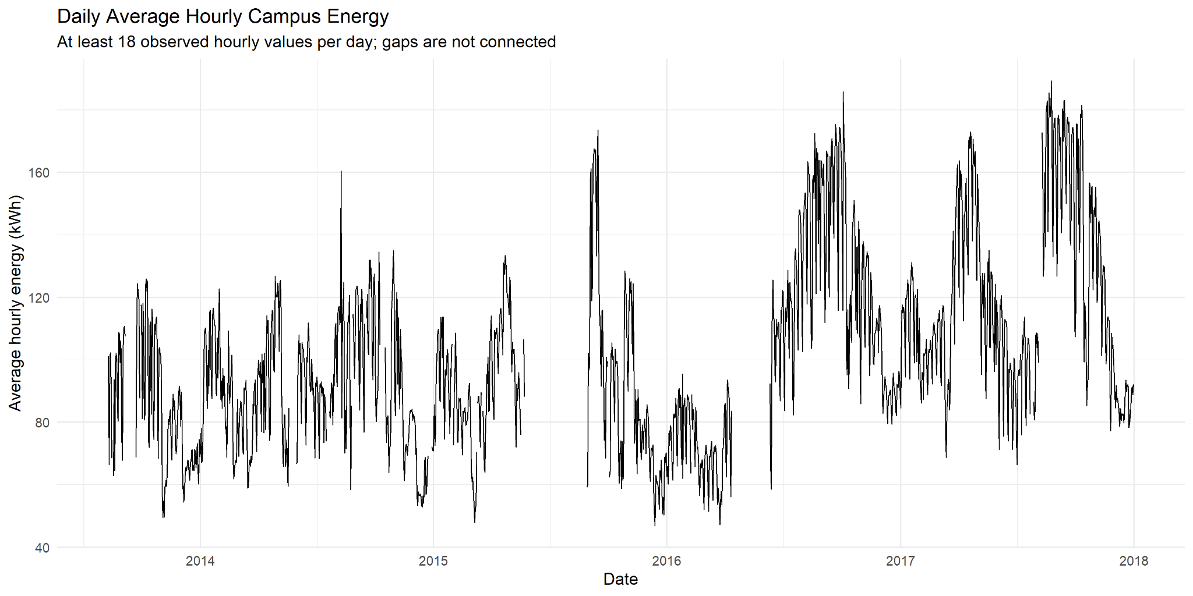
Daily average hourly energy; days with at least 18 qualifying hourly observations are included. Missing periods are not treated as zero.

Figure 2. Monthly average hourly energy
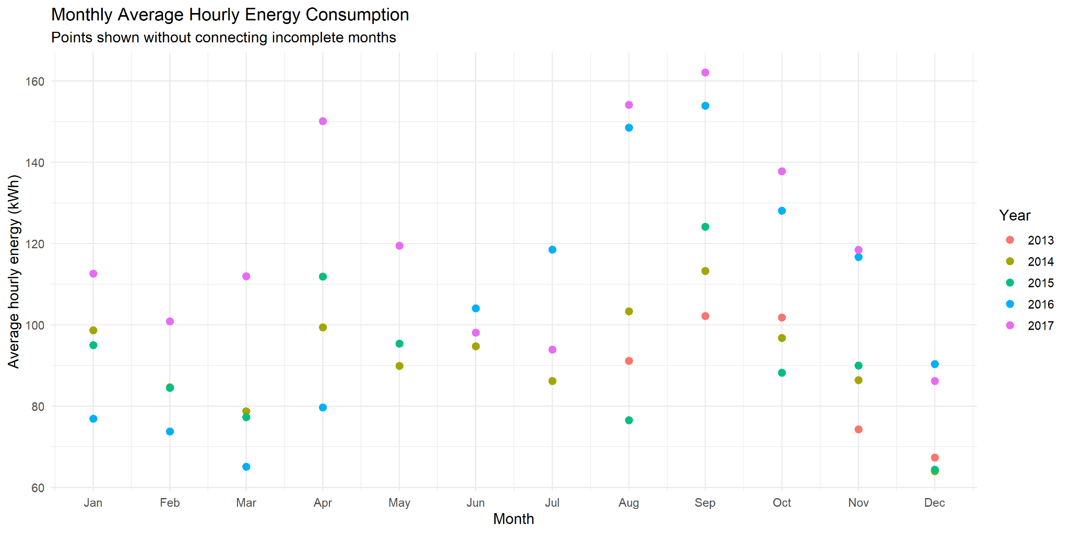
Monthly comparison; incomplete months should be interpreted cautiously.

Figure 3. Actual versus predicted energy
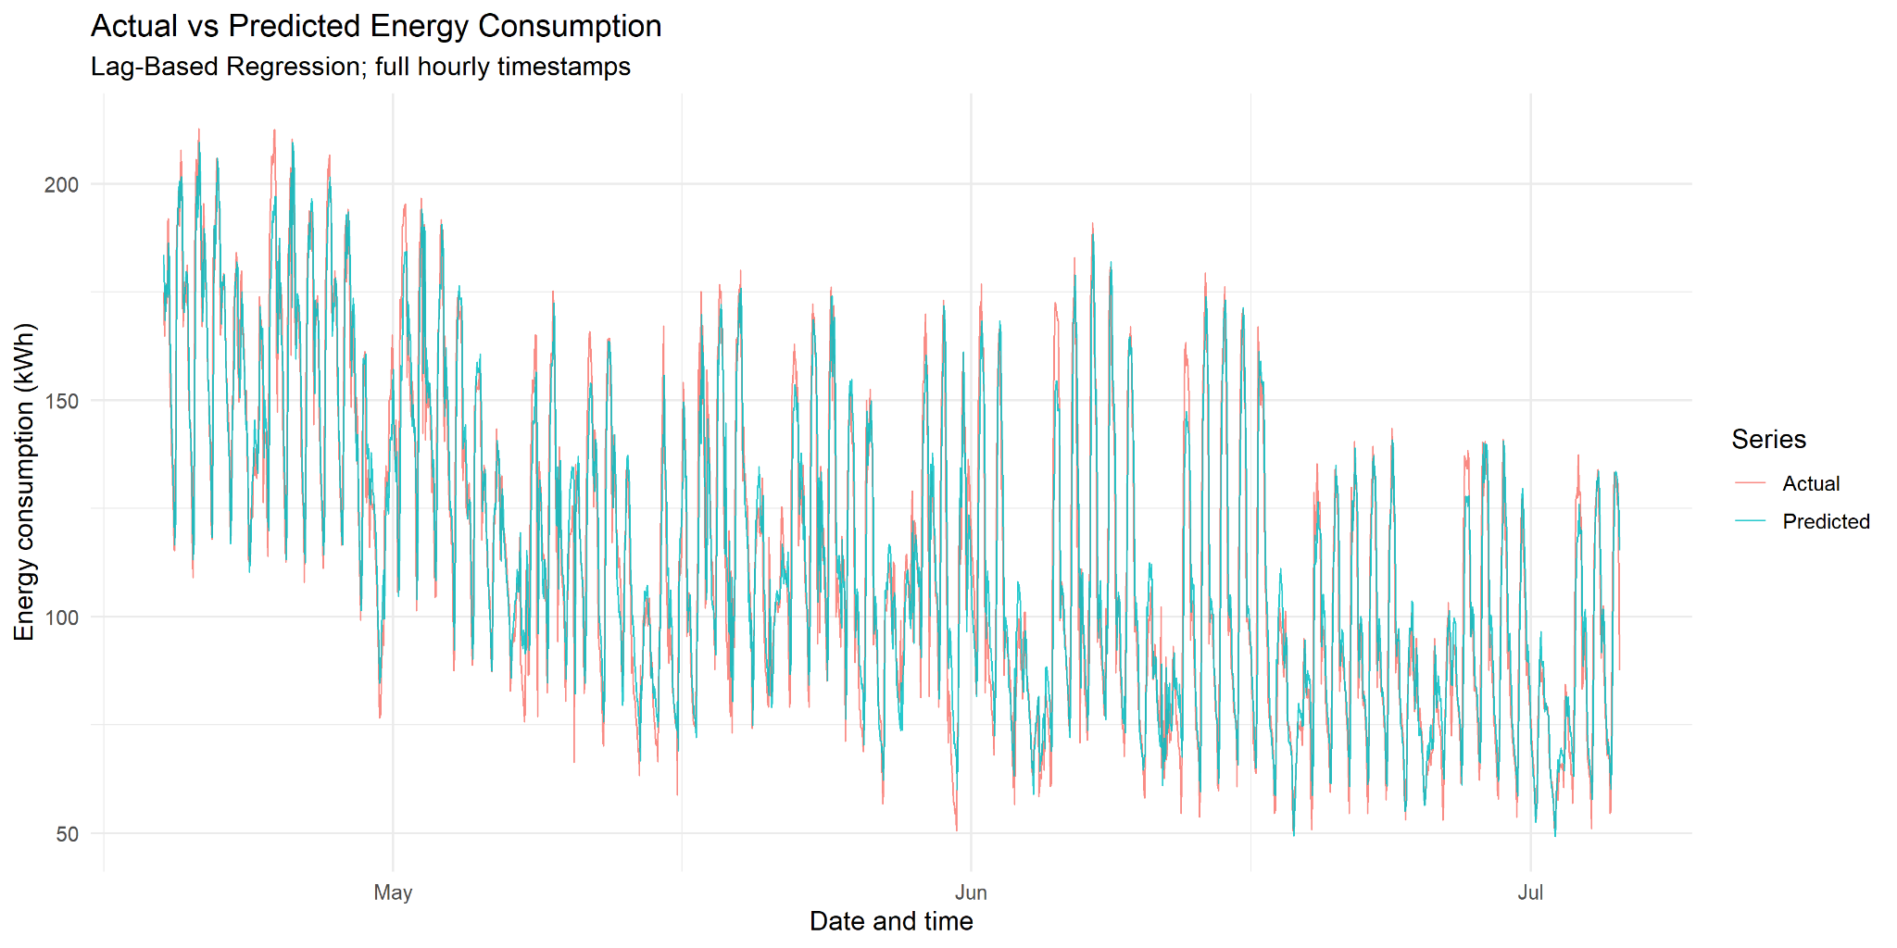
Rolling one-step-ahead test predictions from the selected lag-based model.

Figure 4. Forecast residuals over time
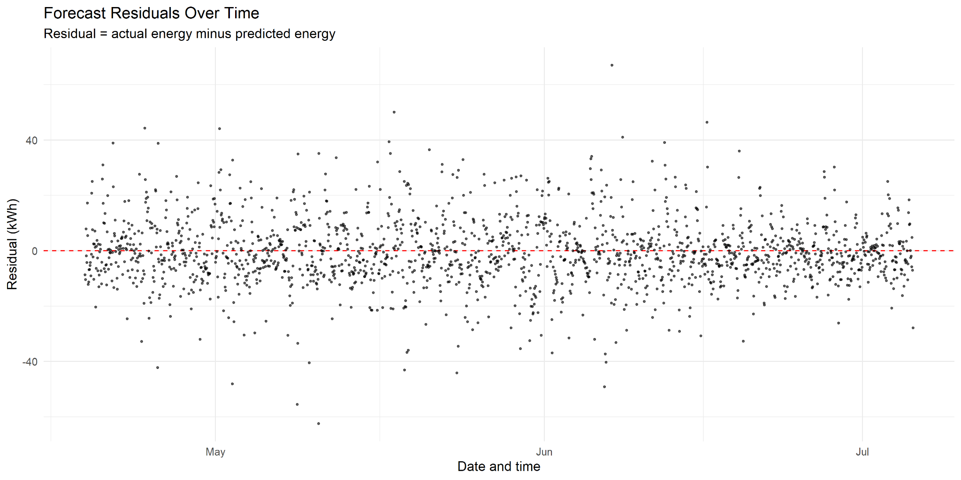
Residual equals actual minus predicted; positive values indicate underprediction.

Figure 5. Forecast error by hour
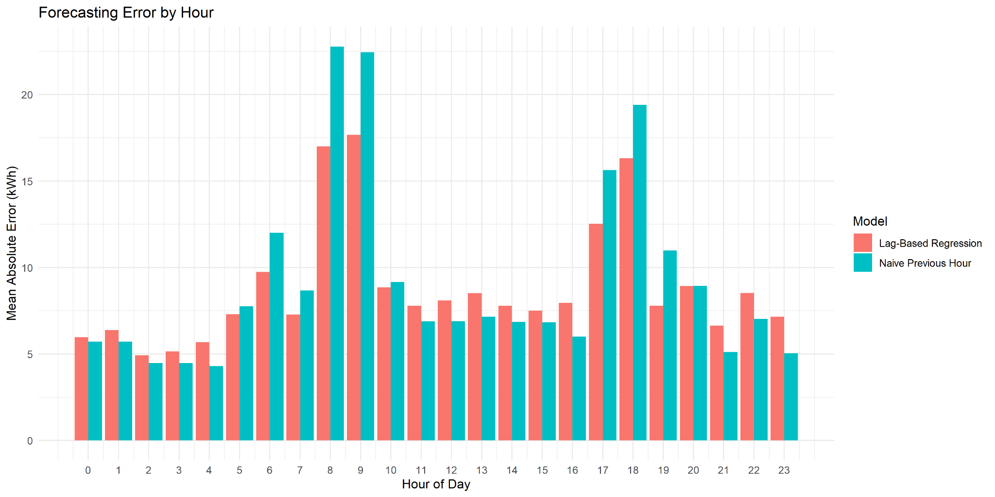
Hourly variation in forecast error, useful for identifying time windows for further investigation.

Figure 6. Moving-block bootstrap
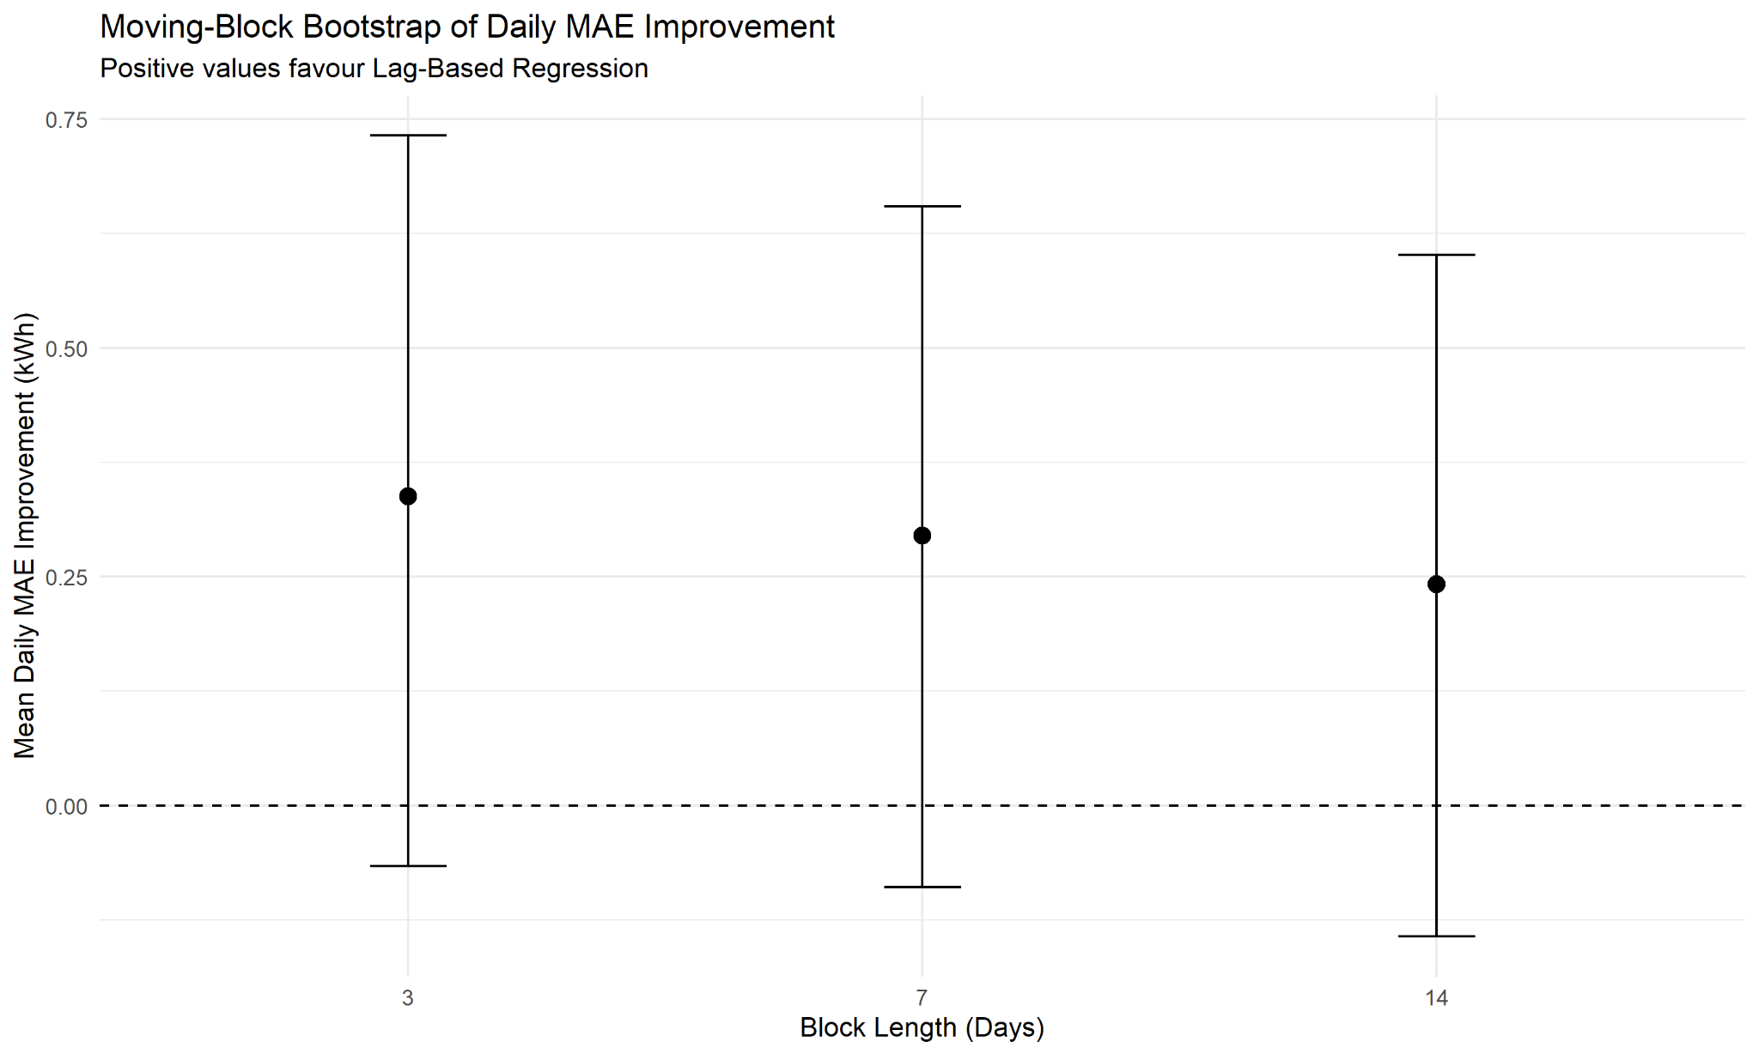
Bootstrap intervals for daily MAE improvement; the previously calculated intervals include zero.

Figure 7. Overall potential energy savings
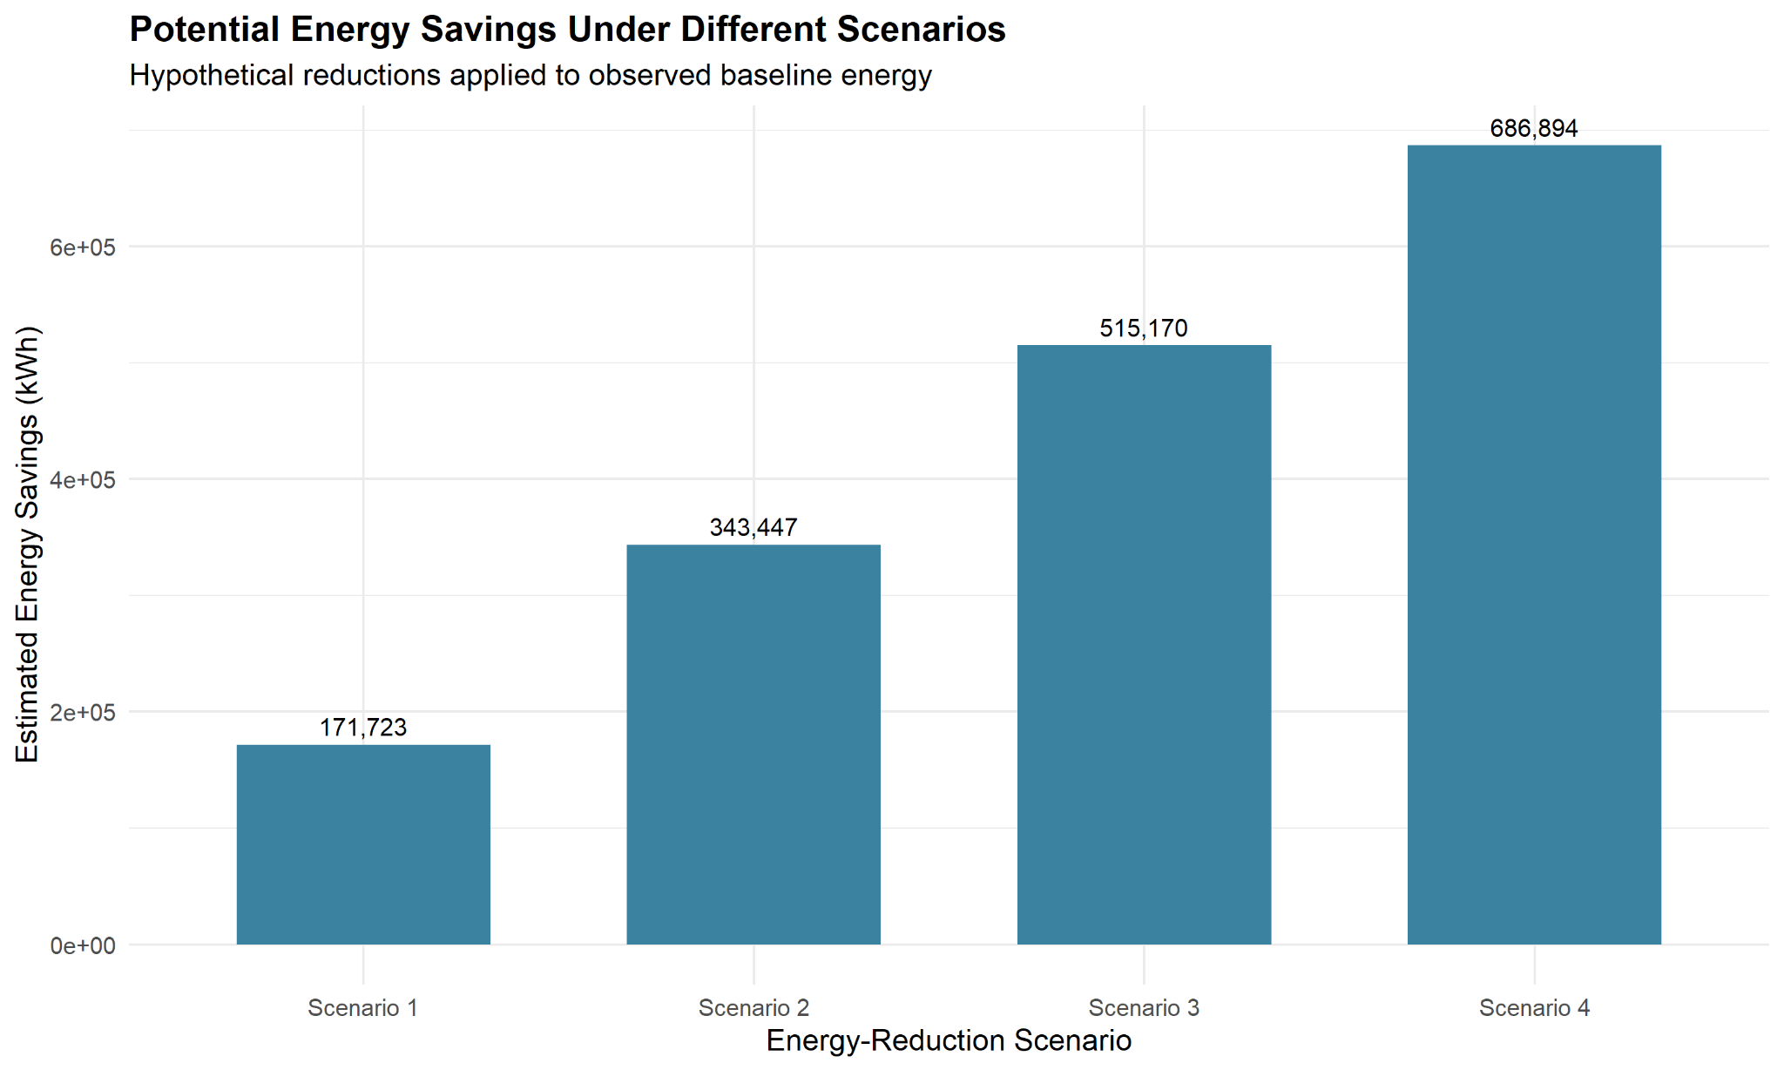
Hypothetical savings calculated as a percentage of observed baseline energy.

Figure 8. Remaining energy under scenarios
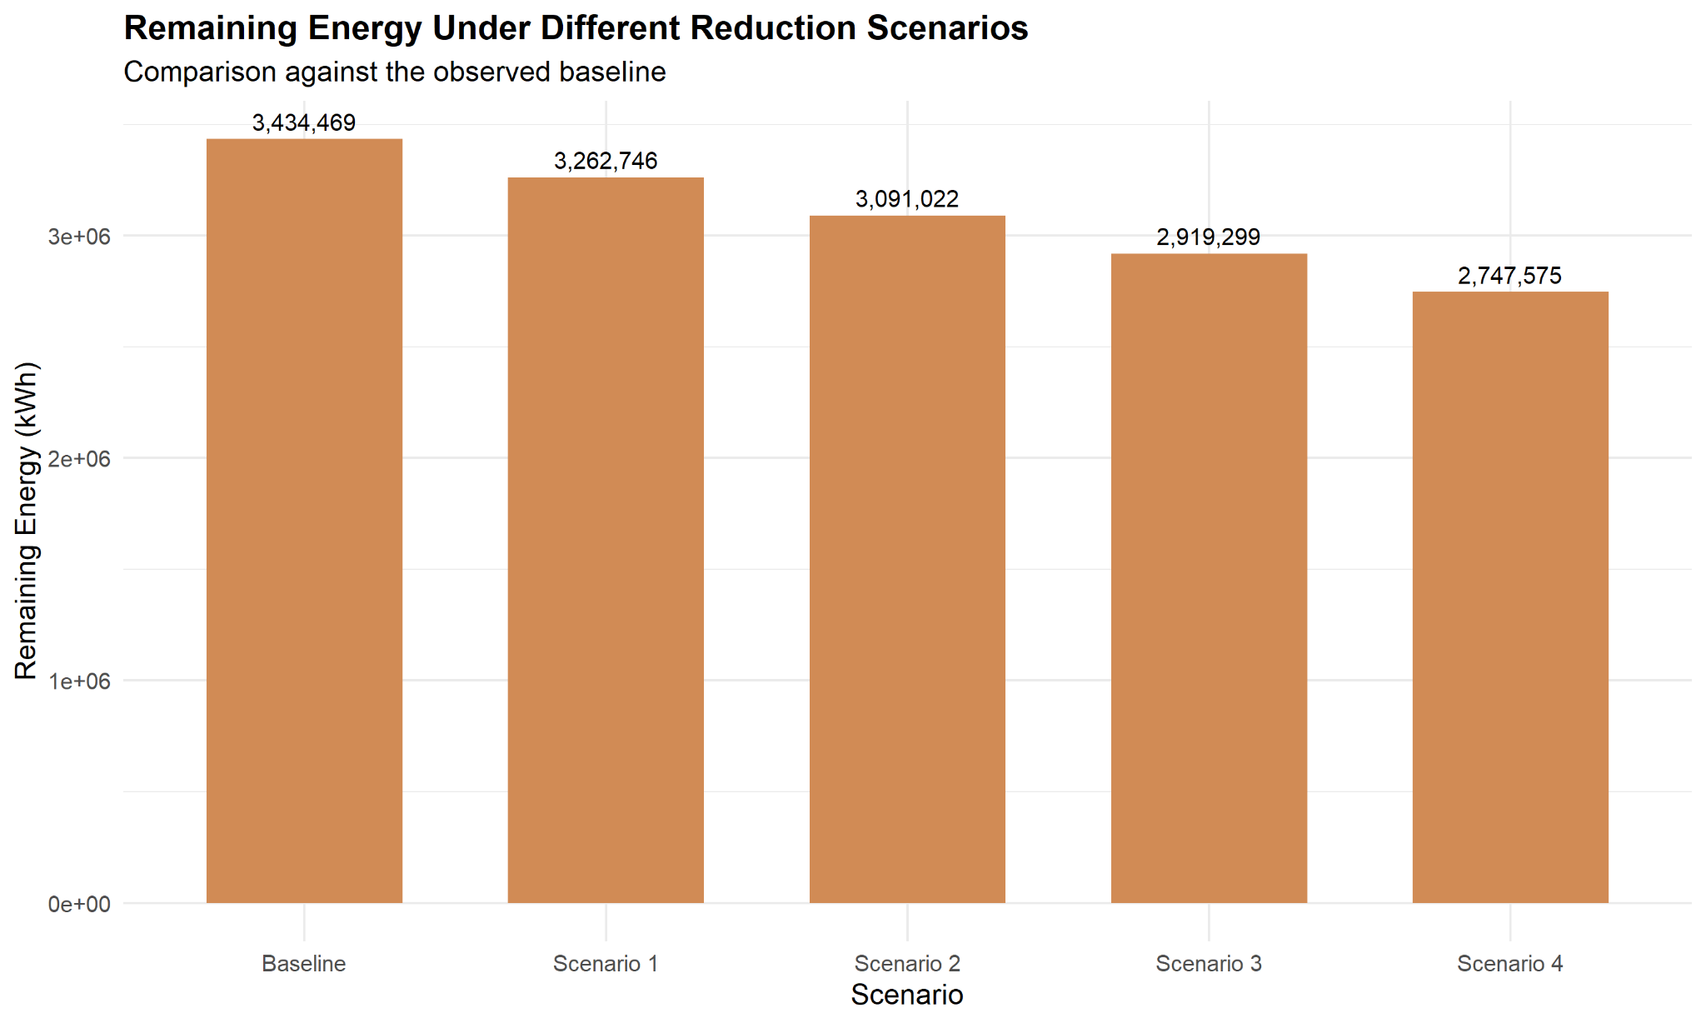
Remaining observed-baseline energy under each hypothetical reduction scenario.

Figure 9. Annual potential energy savings
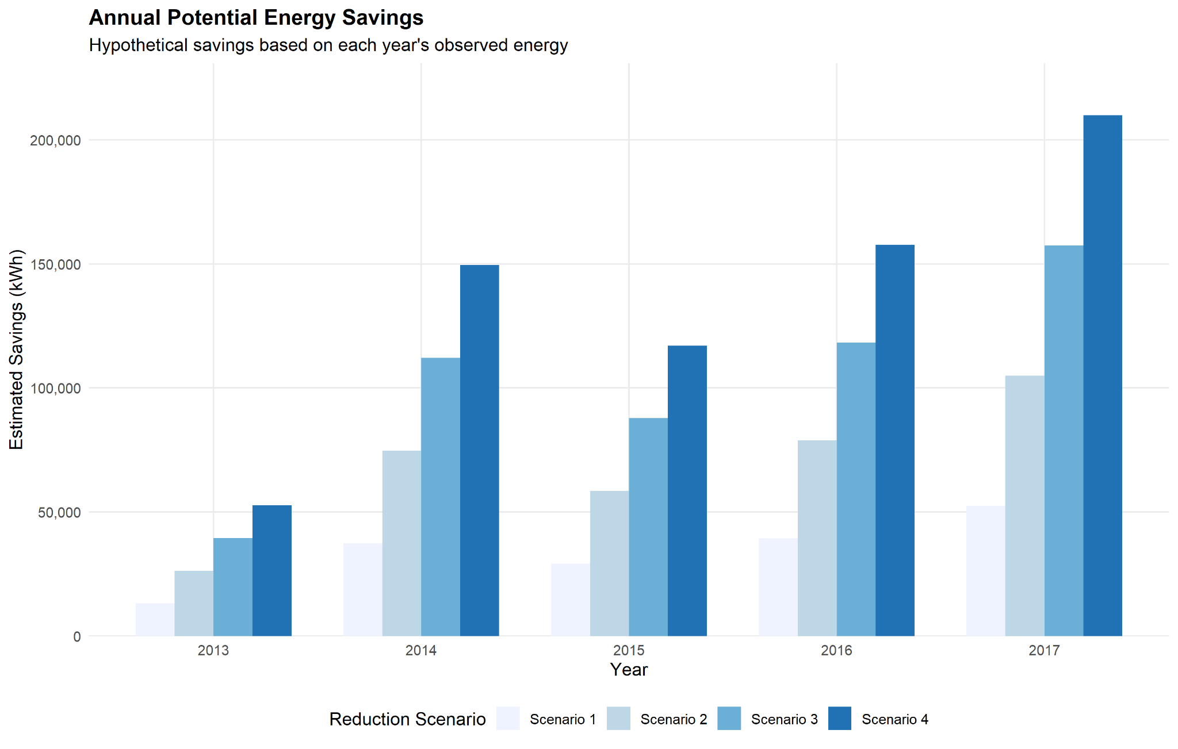
Annual scenario values are based on each year's observed energy and should not be compared as complete annual totals.

Figure 10. Observed annual energy
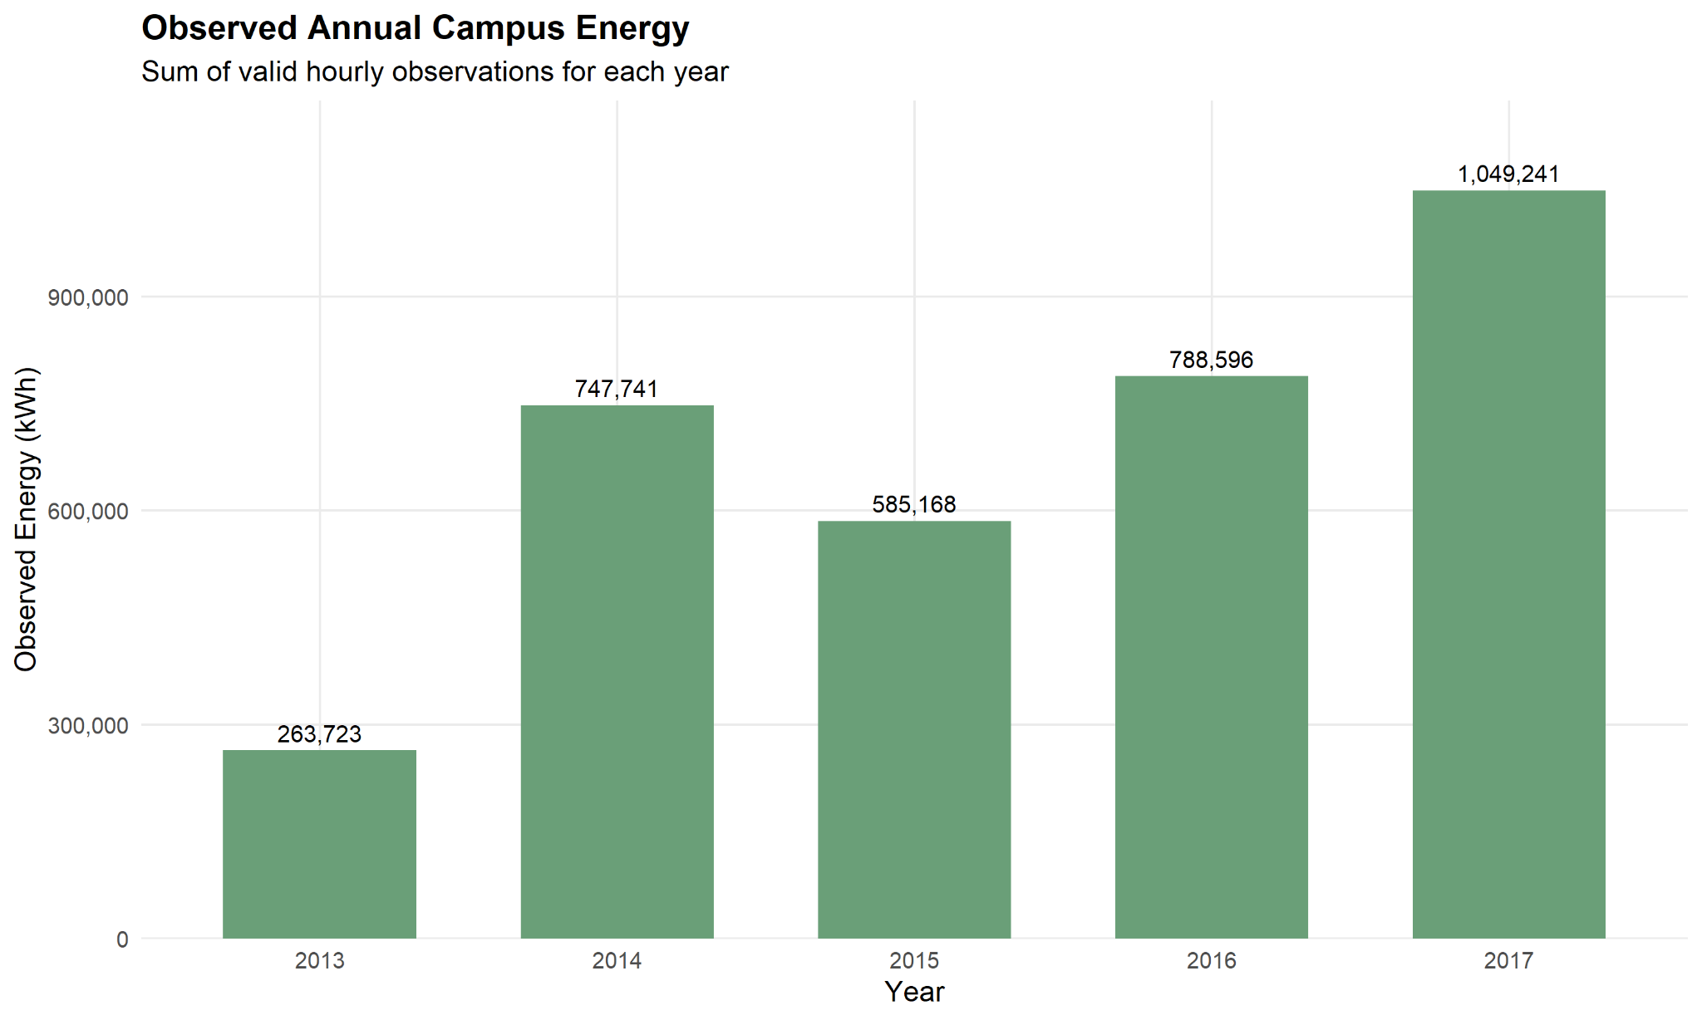
Sum of valid hourly observations by year; coverage and observation-window differences affect comparability.

Figure 11. Annual data coverage
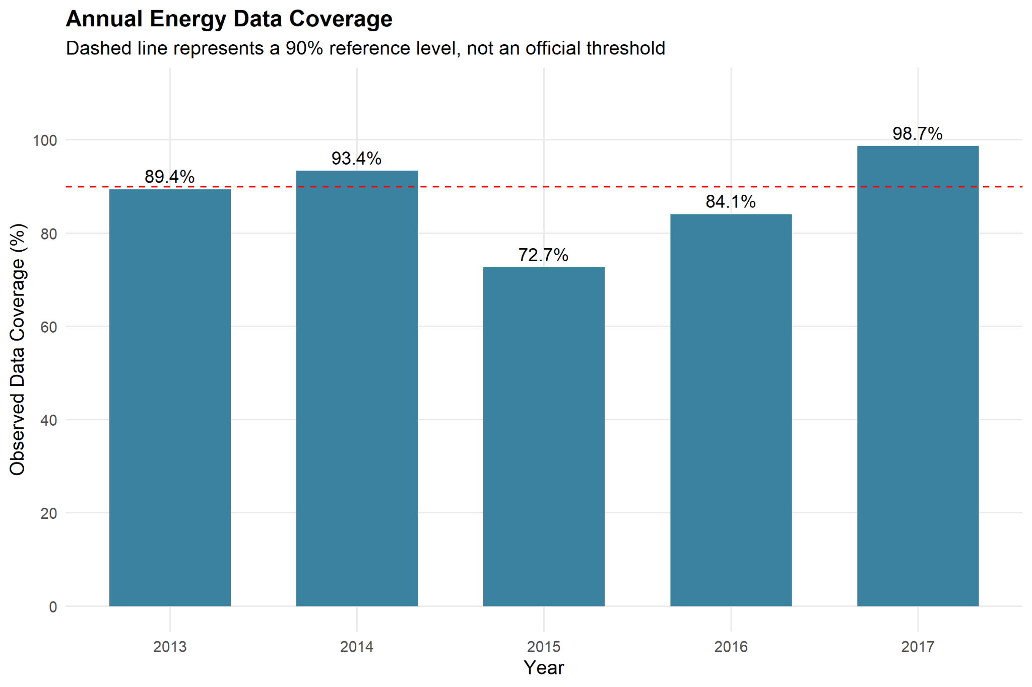
Coverage varies by year; the 90% dashed line is an illustrative reference, not an official threshold.

Figure 12. Recommendation priorities
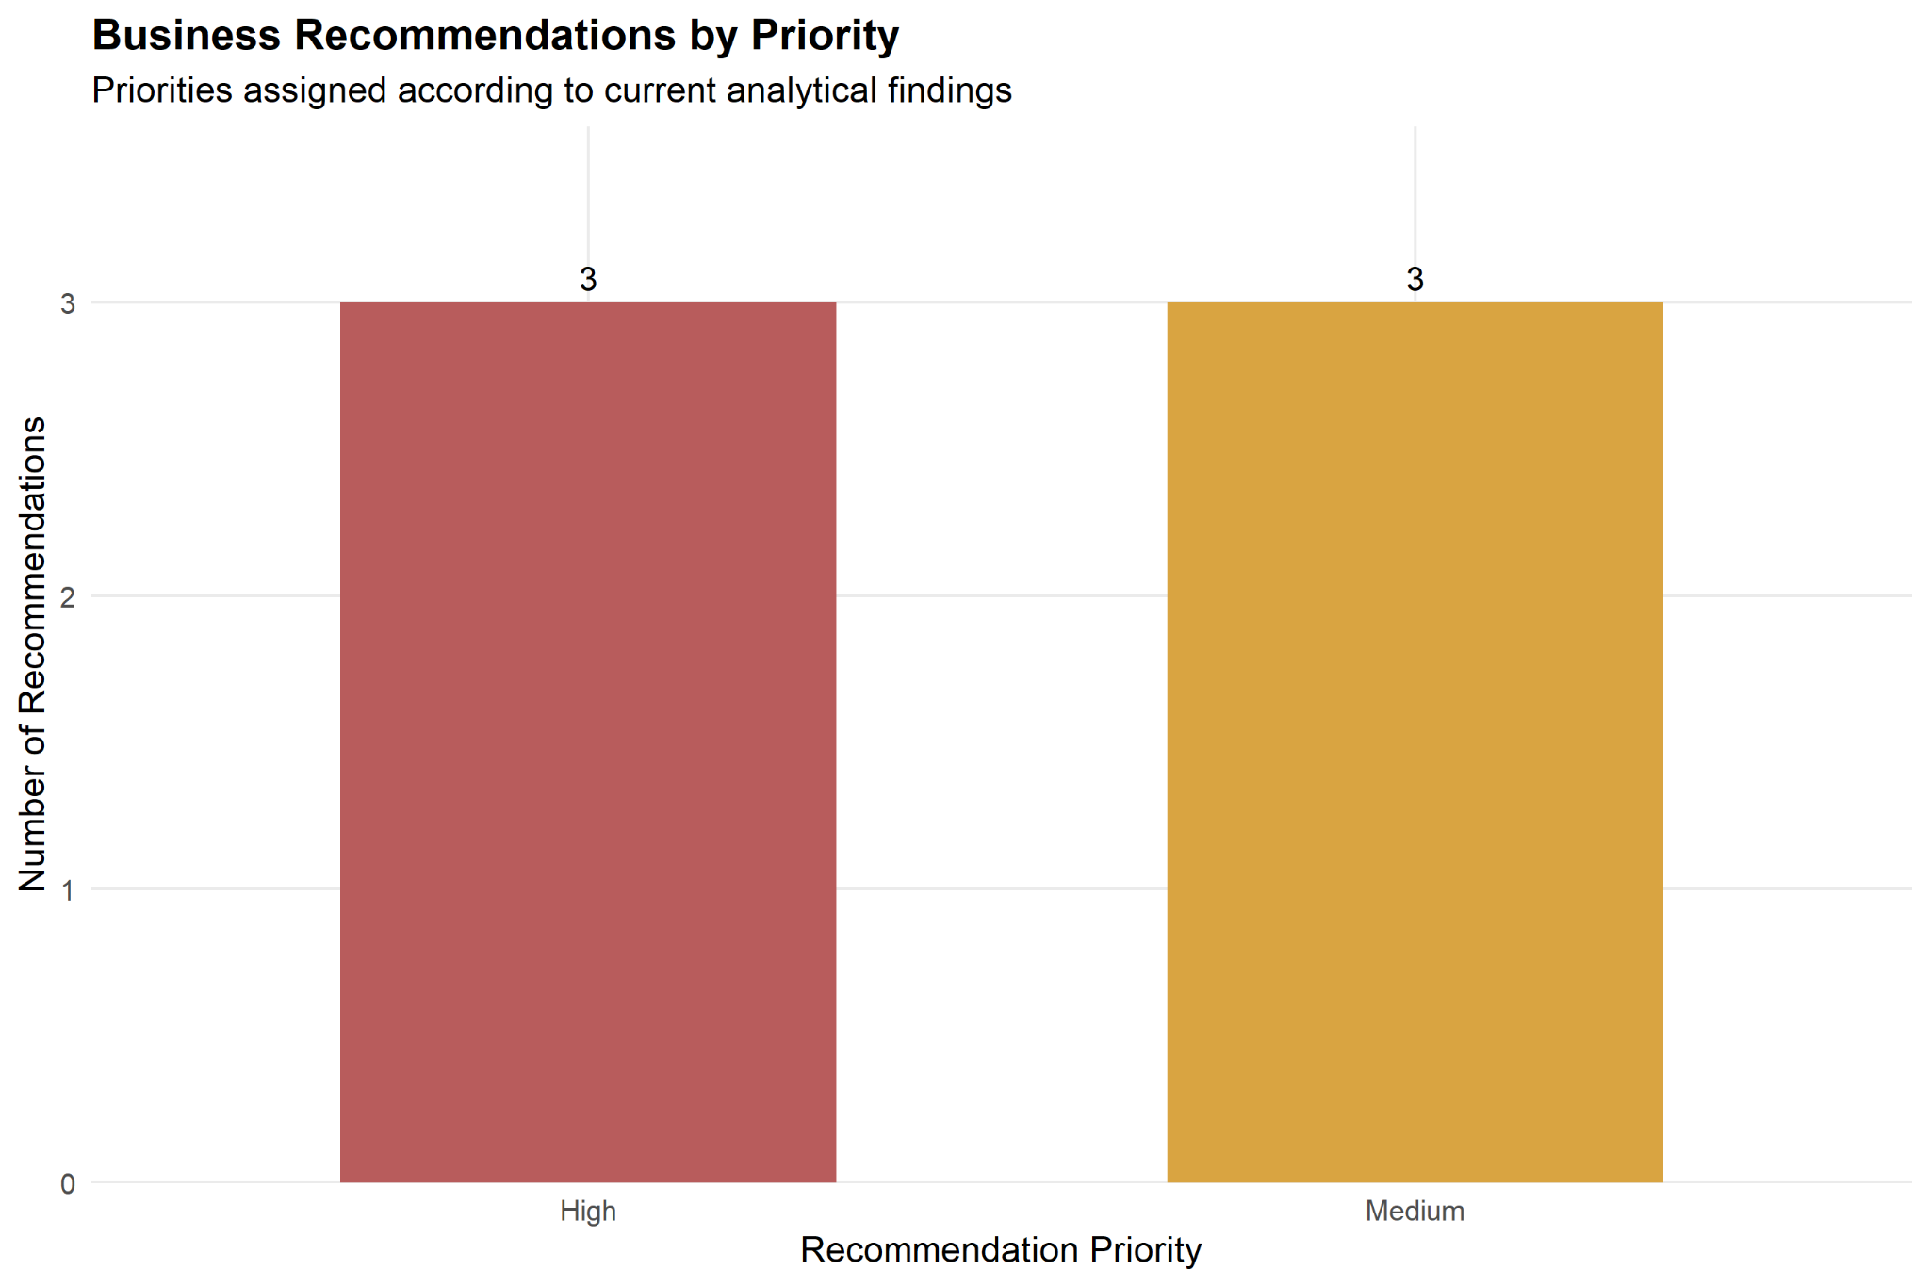
Three high-priority and three medium-priority recommendations were proposed.

