***“ACCP prime semester 2 END***

***DISM DUMS”***

***“SQL server”***

1. *AlwaysOn future was first introduced in SQL server version___________?*

* *2000*
* *2005*
* *2008*
* *2012*

1. *The __________ statement is not supported by SQL server Azure due to which the user connect switch between database in SQL azure?*

* *Update*
* *Use*
* *Insert*
* *Alter*

1. *Version of SQL server 2016 is free and offers basic futures?*

* *Enterprise*
* *Web*
* *Express*
* *Developer*

1. *___________ future makes it attractive for the end user to use SQL server 2016 for business intelligence on a wide variety of mobile devices?*

* *Enhanced in-memory*
* *Always encrypted*
* *Rich visualization*
* *Advanced analytics*

1. *Security upgrades is apart from always encrypted are?*

* *Row level security and information masking*
* *Indexes and views*
* *Database caching*
* *Automatic failover*

1. *Which of the following transacts-SQL statement are used to set and declare local variables( choose 3 correct answer)?*

* *Use*
* *Declare*
* *Set*
* *Select*

1. *Which error option sets the ERROR_NUMBER and @@ERROR values to msg_id or 5000 irrespective of the severity level?*

* *Log*
* *Seterror*
* *Nowait*
* *Error_number*

1. *Match this columns?*

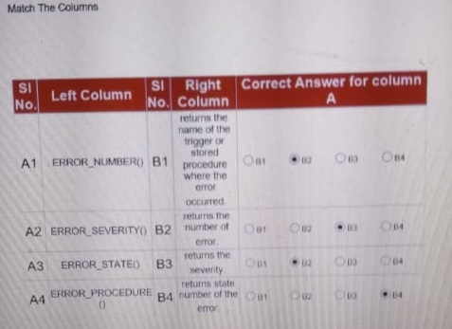

***“XML”***

1. *The __________ process invoice converting data into textual form and passing it to a browser or so?*

* *Creation*
* *Access*
* *Modification*
* *Serialisation*

1. *Which of the following connect BA part of the document prolog?*
2. *<?xml version =”1.0” encoding =”isc-8859-1”?>*
3. *<Name>the Alchemist</Name>*
4. *<!ELEMENT Book {Name}>*
5. *<!DOCTYPE Book [?]>*

* *1*
* *2*
* *3*
* *4*

1. *An _________ in XML is a placeholder that consist of a name and a value?*

* *DTD*
* *Element*
* *Entity*
* *Food element*

1. *The Following are steps to create internal DTDs can you arrange them in order?*
2. *Declare all the possible elements*
3. *Declare all the possible element attributes*
4. *Set the attribute data types and values*
5. *Declare all the possible Entities*
6. *Set the order in which element must appear*
7. *Specify the permissible element children if any*

* *1,2,3,4,5,6*
* *2,3,5,4,1,6*
* *1,6,5,2,3,4*
* *5,3,6,1,2,4*

1. *<xs:complex Type name=”Books”>*

*<xs:simple Content>*

*<xs:extension base=”xs:string”>*

*<xs:attribute name=”BookCode” Type=”xs:positiveinteger”/>*

*</xs:extension>*

*</xs:simple Content>*

*</xs:complex Type>*

*The following does the above piece of the code represent?*

* *Empty elements*
* *Mixed*
* *Only elements*
* *Only text*

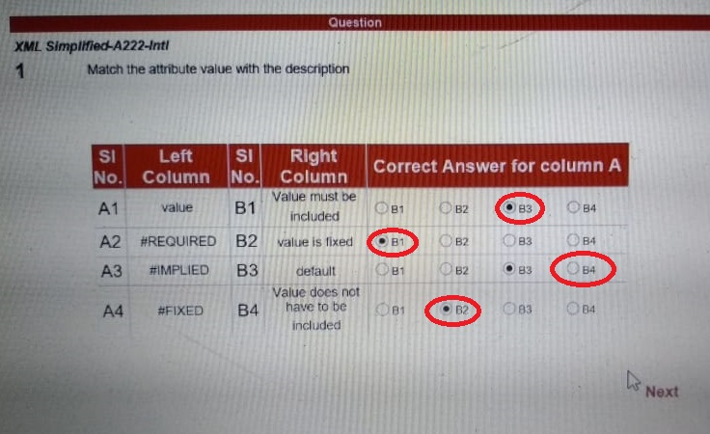

***“modern Marker for data interchange”***

*1)..Which of the following are the uses of JSON?*

* *Defining rules for sending web data*
* *Serializing data*
* *Describing process for sending web data*
* *Facilitate between incompatible platform*

*2) Which of the following JSON future ensures communication between two application designed in different programming language?*

* *Extensibility*
* *Scalability*
* *Interoperability*
* *Reusability*

*3) identify the language from which JSON is derived?*

* *JavaScript*
* *PHP*
* *C*
* *ECMScript*

*4) which of the following protocol service uses JSON?*

* *GData web protocol*
* *HTTP*
* *IP*
* *SOAP*
* *JSON-WSP*

*5.) Which of the following aspect describes JSON?*

* *Converts Java objects into JSON text*
* *Offers parse() function*
* *Is a java library*
* *Does not serialize object*

*6.) Identify the error in the following code?*

*{*

*“”peripherais””[{*

*“”Mouse””:[{*

*“”Brand””:””Logitech””,*

*“”Type””:””Optical””,*

*“”Price””:300,*

*}]*

*}]}*

* *P of peripherais in small case*
* *Price in Double Quates*
* *Comma after the last member of nested mouse object*
* *Colon missing after peripherais*

*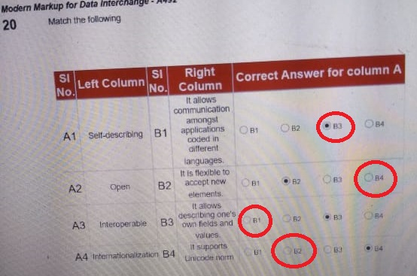7).Match The Following?*

***“Essentials of c# programming (application programming in c sharp)”***

*1). Which of the following components of the .NET framework enable interoperability of dynamic language with the .NET FRAMEWORK?*

* *Common language runtime (CLR)*
* *Best framework classes*
* *Dynamic language runtime (DLR)*
* *Common type system (CTS)*

*2). When a C# God is written and saved in the visual studio IDE, the .NET p solution is safe in a ___________ file?*

* *.sin*
* *.csproj*
* *.cs*
* *.exe*

*3). Which of the following statement about delegates is in c sharp are correct?*

* *A delegate can accept a block of code as a parameter*
* *A delegate can invoke one method at a time*
* *A delegate can encapsulate static method*
* *A delegate is declared using the delegate keyword*

*4).CLR stands for ____________?*

* *C Sharp language runtime*
* *Common language runtime*
* *Common language repository*
* *Common layer runtime*

*5). Which of the following information of a service endpoint specifies the communication infrastructure that enable communication of messages?*

* *Address*
* *Binding*
* *Contract*
* *URL*

*6). How can you enable communication between threads while synchronizing the threads?*

* *By implementing looking using the look keyword*
* *By using synchronization events*
* *By using the thread pool class*
* *By using the task class*

*7). Which one of the following statements about generics is incorrect?*

* *Generics improve system performance since their development requires very less memory*
* *Generous ensure implementation of the strongly typed programming model*
* *Generic lead to lesser runtime errors caused by casting or boxing*
* *Generics can be implemented using explicit or implicit casting*

*8).which of the following standard query operators determine if a given value is present in the expression?*

* *Order by*
* *Contains*
* *Count*
* *Sum*

***“Programming with Microsoft Azure”***

*1).Can you rearrange the step given below to edit or delete exiting subscriptions?*

1. *In the general section, click subscription*
2. *Click all services option*
3. *Select manage, cancel subscription, or upgrade subscription on the display menu bar*
4. *From the subscription page, select the required solution*

* *B,A,D,C*
* *A,B,C,D*
* *A,C,D,B*
* *A,B,D,C*

*2).MSDTC uses the classes present in __________ for managing distributed transaction on cloud?*

* *System. Uploads*
* *System. Transactions*
* *System. Cache*
* *Translation scope*

*3).__________________ is a framework that helps build HTTP-based top services on top of the .NET framework*

* *.NET framework 3.0*
* *Windows communication framework*
* *ASP.NET web API*
* *.NET web API*

*4).________________ was the first framework to be included with WCF?*

* *.NET framework 3.0*
* *.NET framework 2.0*
* *ASP.NET web API*
* *XML web framework*

*5). An SOA defines ________ number of key roles?*

* *2*
* *4*
* *5*
* *3*