BAKERZ BITE
Bakery e-Project Website
DEVELOPER GUIDE
Project Team
# | Member | Student ID
1 | Zarish (Team Leader) | Student1731320
2 | Ayesha Faizan | Student1731614
3 | Fariha | Student1730174
4 | Hadia Khan | Student1732712
5 | Maha Zareen | Student1731318
6 | Shamaim Fatima | Student1730746

Acknowledgement
We would like to express our sincere gratitude to our faculty, Mr. Muhammad Umar Ali, and our coordinator, Miss Malaika, for their guidance, patience and encouragement throughout the development of the Bakerz Bite e-project.
Their feedback on our design, code structure and documentation helped us improve the website at every stage. Their support turned a classroom assignment into a project we are proud of.
We also thank our batch 2606F1 classmates and everyone who tested the website and shared suggestions.
Team Bakerz Bite

Table of Contents
1. About Bakerz Bite 3
1.1 Problem Definition 3
1.2 Requirements 3
1.3 Scope and Limitations 3
1.4 Design Specifications 4
1.5 Technologies Used 4
2. Site Structure 5
2.1 Sitemap 5
2.2 Wireframes 5
3. File Maps 7
3.1 Project File Map 7
3.2 Internal Structure of Files 7
4. Flow Diagrams 10
4.1 Basic Flow 10
4.2 Detailed Flows 10
4.3 Data Flow Diagrams 16
5. Source Code Excerpts 18
5.1 index.html 18
5.2 style.css 22
5.3 script.js 24
6. Installation Instructions 25
7. Test Data 26
8. Task Sheet 27
9. Future Improvements 28
10. Conclusion 29
11. Glossary 30
Thank You 31

1. About Bakerz Bite
Bakerz Bite is a bakery website that lets customers explore the full bakery range, choose a delivery or pickup area, build a cart and read about the bakery. It is a Single-Page-Application style, responsive website that works in the leading browsers on desktop, tablet and mobile.
The site presents six product categories: cakes, savory items, cupcakes and pastries, shakes, coffee and customised cakes. It also has bakery merchandise, special offers, customer feedback, an About page with a photo gallery and a Contact page with an FAQ.

1.1 Problem Definition
Small bakeries often depend on word of mouth and social media. Customers cannot easily see the full menu, compare prices, pick a quantity or find out where the bakery delivers. The Bakerz Bite website solves this by giving customers one place to:
- browse the complete menu with images and prices,
- select delivery or pickup and choose their area,
- pick quantities and add items to a cart,
- read offers and customer reviews, and
- contact the bakery and find answers in the FAQ.

1.2 Requirements
Functional
- Home page with hero carousel, categories, search and filter.
- Six product sections with detail modals and quantity controls.
- Merchandise and offers sections.
- Location popup with delivery/pickup toggle and area list.
- Cart badge, cart sidebar and checkout confirmation.
- Feedback form with star rating and a testimonial carousel.
- Back-to-top button that appears after scrolling down.
- About page with video and a lightbox gallery; Contact page with form, map and FAQ.
Non-functional
- Responsive layout for desktop, tablet and mobile.
- Works in current Chrome, Edge, Firefox and Safari.
- Consistent colour theme and fonts across all pages.
- Easy to maintain: one stylesheet, one script file and plain HTML pages.

1.3 Scope and Limitations
Scope
- A front-end website built with HTML, CSS, JavaScript and Bootstrap.
- Menu display, cart handling and customer interaction on the client side.
- Static content pages (About, Contact, FAQ).
Limitations
- The website is front-end only; no server or database is connected.
- Orders are not sent to the bakery or stored on a server.
- Online payment is not included.
- Customer reviews are stored in the visitor's own browser.
- An internet connection is needed for libraries, fonts and the map.

1.4 Design Specifications
Item | Specification
Pages | index.html (home), About.html, contact.html
Layout | Bootstrap 5 grid; header, sections, footer on every page; top bar and navbar stay fixed at the top while scrolling
Colours | Background #fff8ed, gold #DEA347, light purple #d8a7ff, dark purple #3b123c, hover #511d53
Fonts | Poppins, Playfair Display, Dancing Script, Great Vibes, body font Cinzel with sans-serif fallback
Icons | Font Awesome 7.3.0
Animation | AOS scroll animations, Counter-Up visitor counter, Bootstrap carousels
Alerts | SweetAlert2 pop-ups
Navigation aid | Floating back-to-top button (appears after 300px scroll)
Breakpoints | Tablet 888px, mobile 480px, small mobile 360px; modal-specific queries at 500px and others

1.5 Technologies Used
Technology | Version | Purpose
HTML5 | - | Page structure
CSS3 | - | Styling, layout, media queries
JavaScript (ES6) | - | Interaction, cart, validation
Bootstrap | 5.3.8 | Grid, navbar, modals, carousel, accordion
jQuery | 3.7.1 | Required by Counter-Up and Waypoints
Counter-Up and Waypoints | 1.0.0 / 4.0.1 | Animated visitor counter
AOS | 2.3.1 | Animate on scroll
Lightbox2 | 2.12.0 | Gallery image viewer
Font Awesome | 7.3.0 | Icons
SweetAlert2 | 11 | Alert dialogs
Google Fonts | - | Typography
localStorage | - | Saves customer reviews in the browser

2. Site Structure

2.1 Sitemap
The sitemap shows the three pages, the sections inside each page and how the product modals lead to the cart.
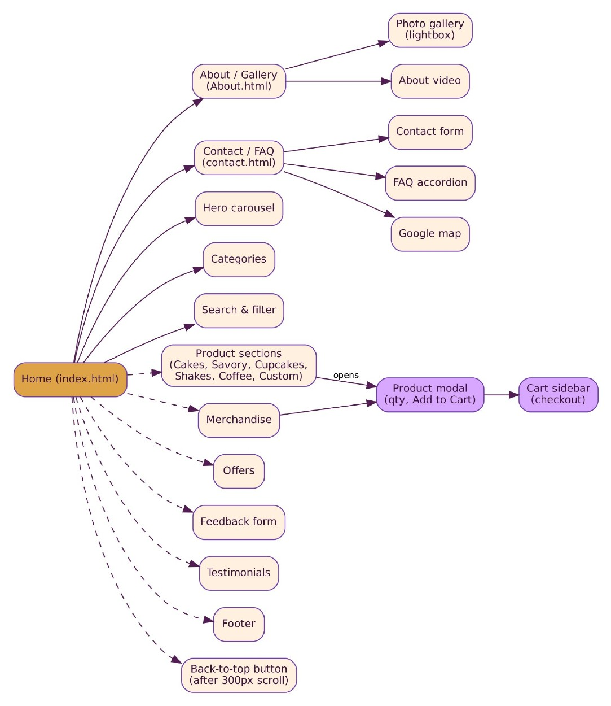
Figure 1: Sitemap

2.2 Wireframes
The wireframes show the block layout of each main screen.
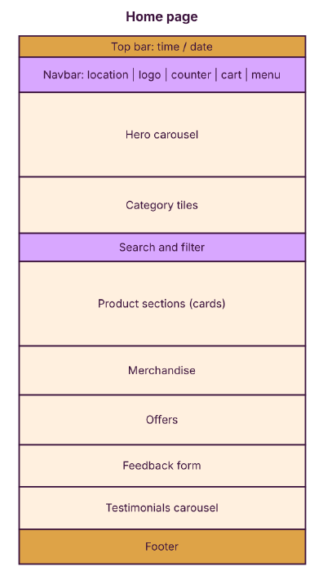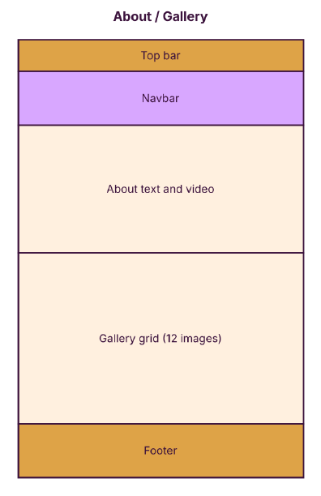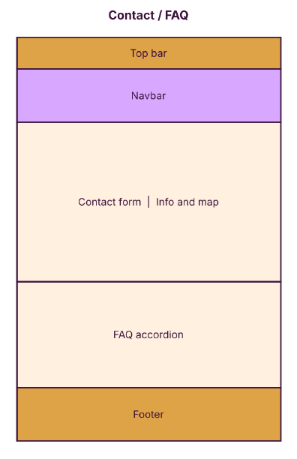
Figure 2: Home, About and Contact page wireframes
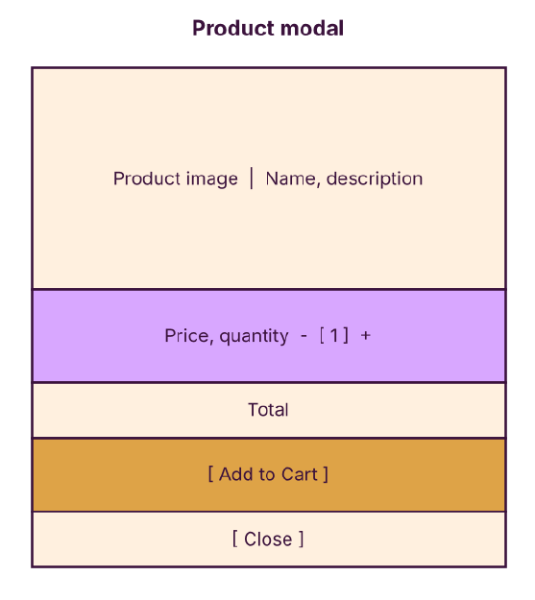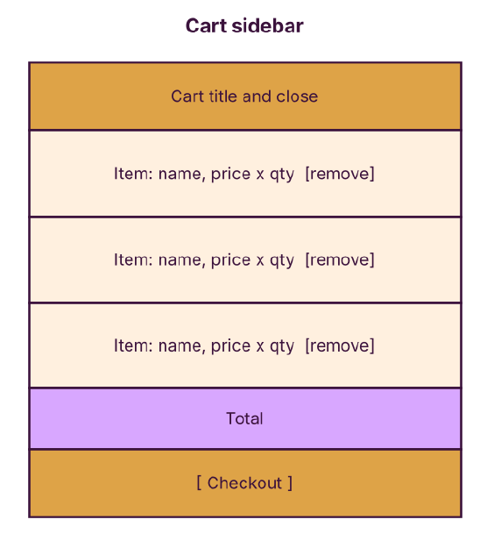
Figure 3: Product modal and cart sidebar wireframes

3. File Maps

3.1 Project File Map
This map shows every file in the project and how the pages connect to the stylesheet, script and media folder. A new developer can start here to find what to change.
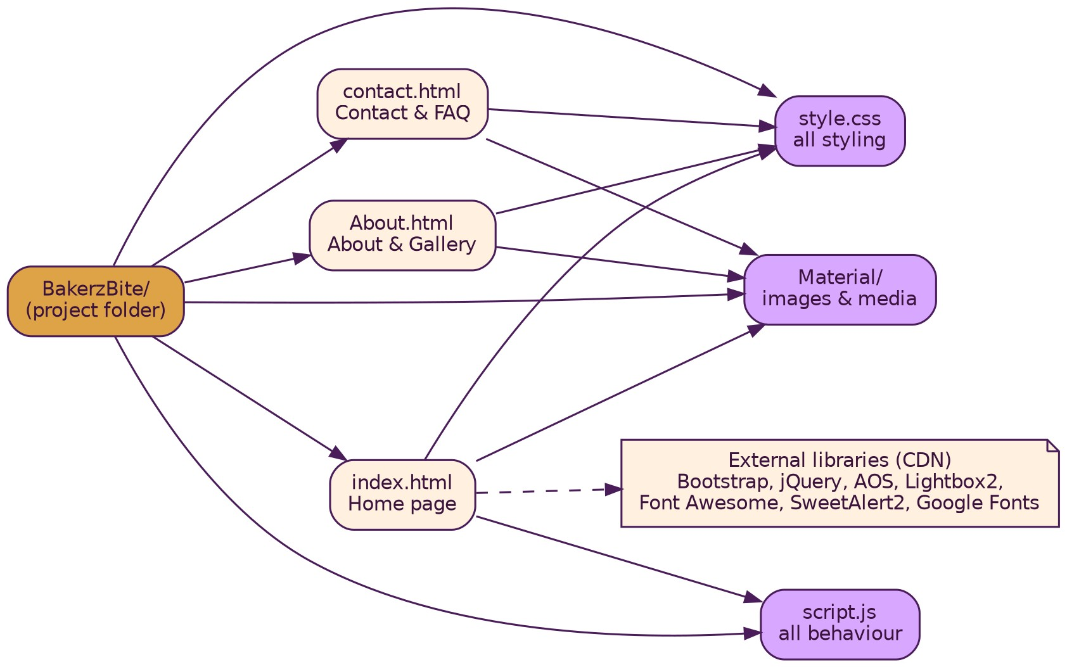
Figure 4: Project file map
File | Purpose
index.html | Home page: header, product sections, modals, merchandise, offers, cart sidebar, feedback, testimonials, footer
About.html | About text, video and photo gallery
contact.html | Contact form, map and FAQ
style.css | All styles and media queries
script.js | All behaviour: location, quantities, feedback, search, cart
Material/ | Images, logo and video used by the pages

3.2 Internal Structure of Files
Each large file is organised in a fixed order. The maps below give the order and line range of each part, so a developer can jump to the right place.
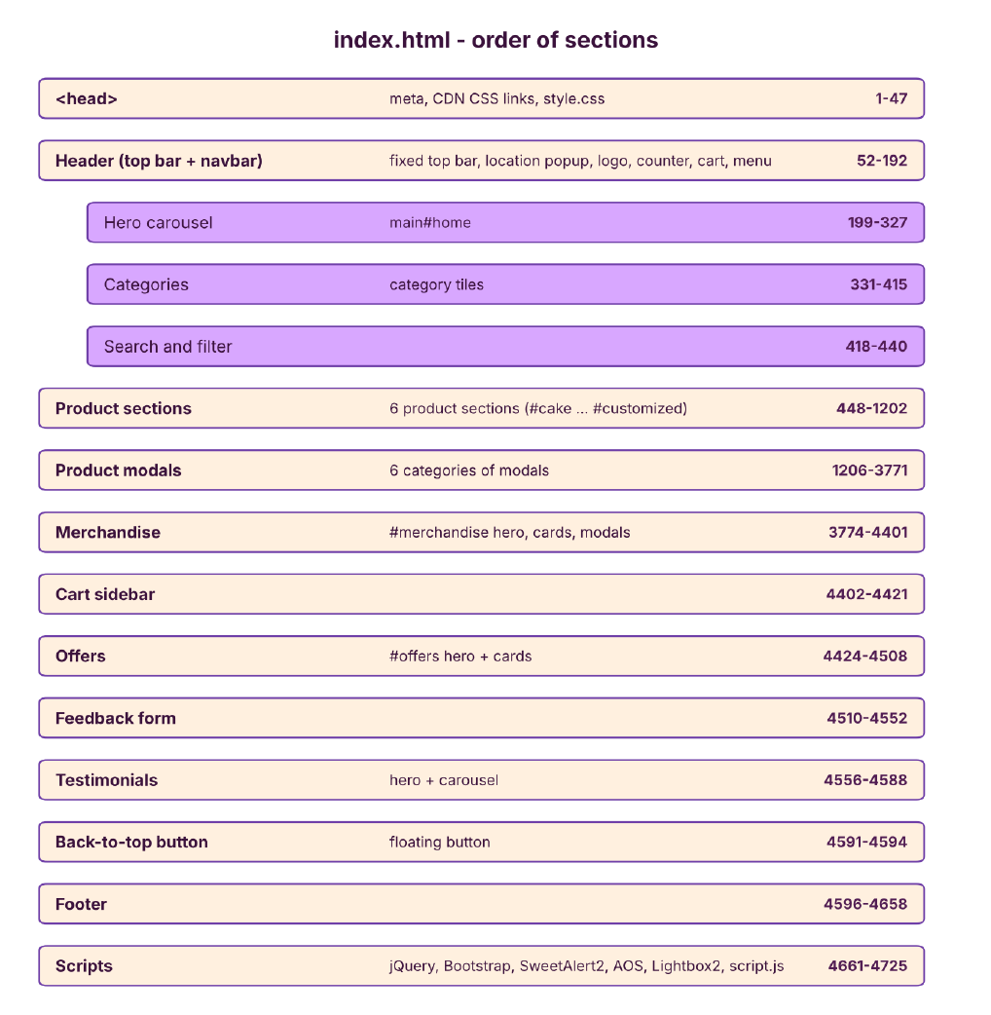
Figure 5: index.html section order
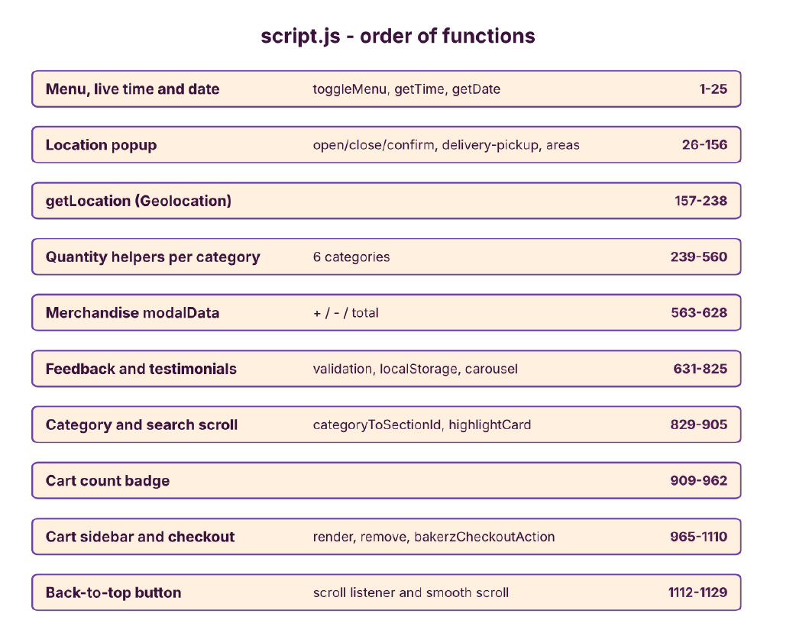
Figure 6: script.js function order
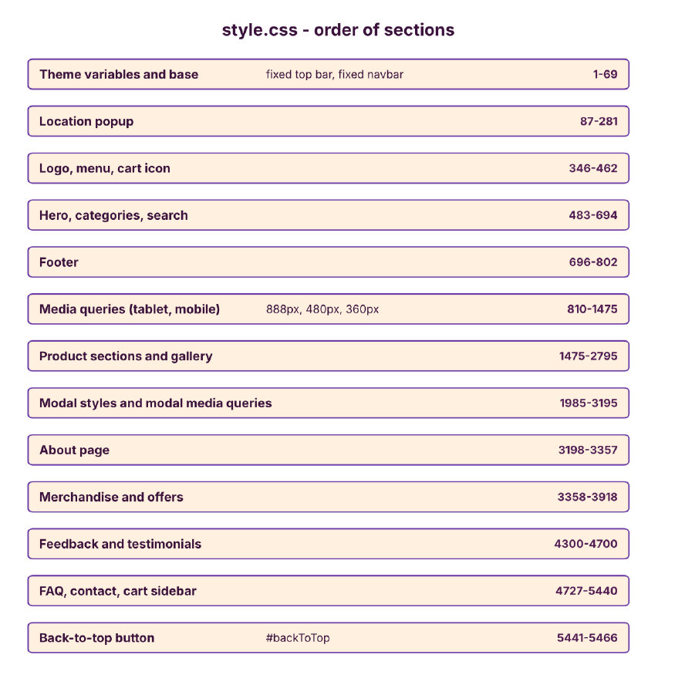
Figure 7: style.css section order
Line numbers are for the delivered version of each file and will shift as code is added.

4. Flow Diagrams

4.1 Basic Flow
The basic flow shows a typical visit from opening the site to checkout.
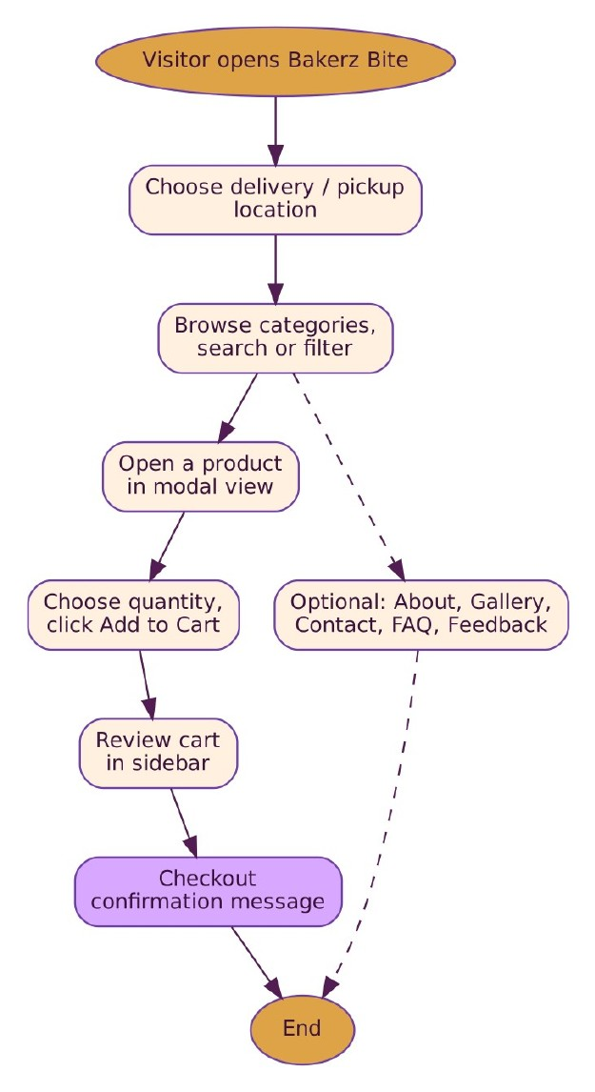
Figure 8: Basic visitor flow

4.2 Detailed Flows
The following diagrams show how each feature works internally.

Page load
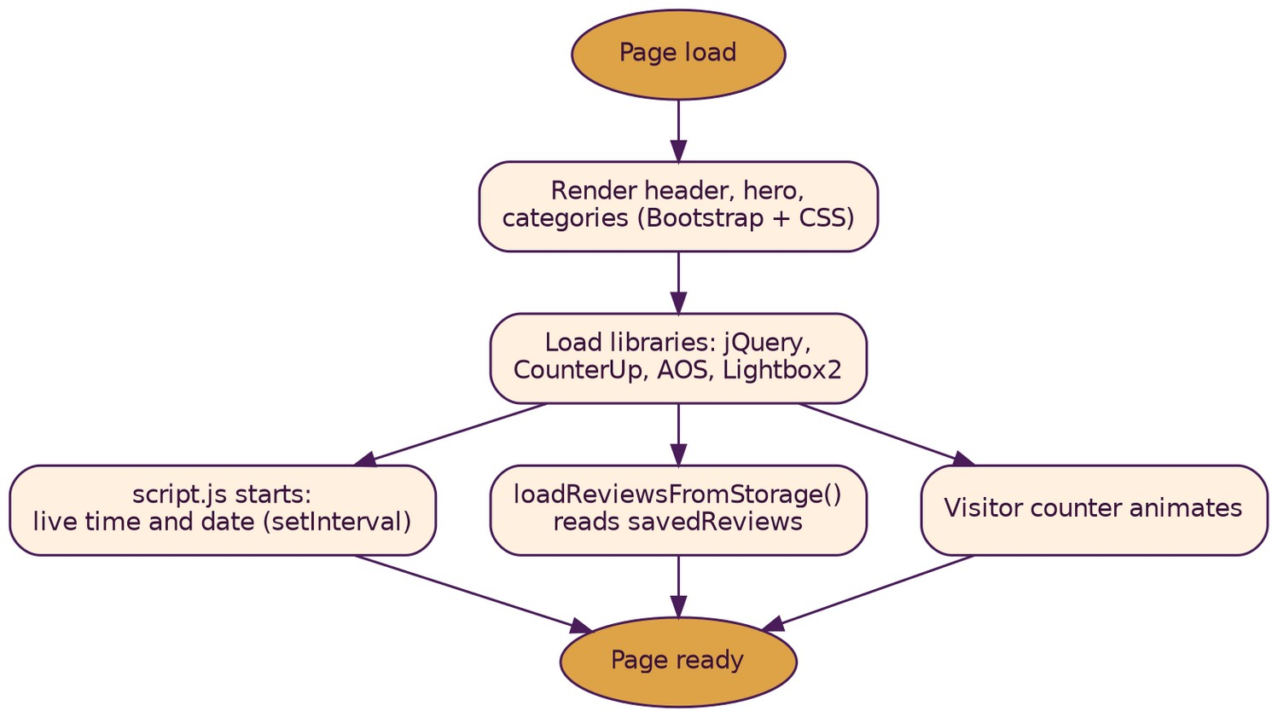
Figure 9: Page load and initialisation

Location selection
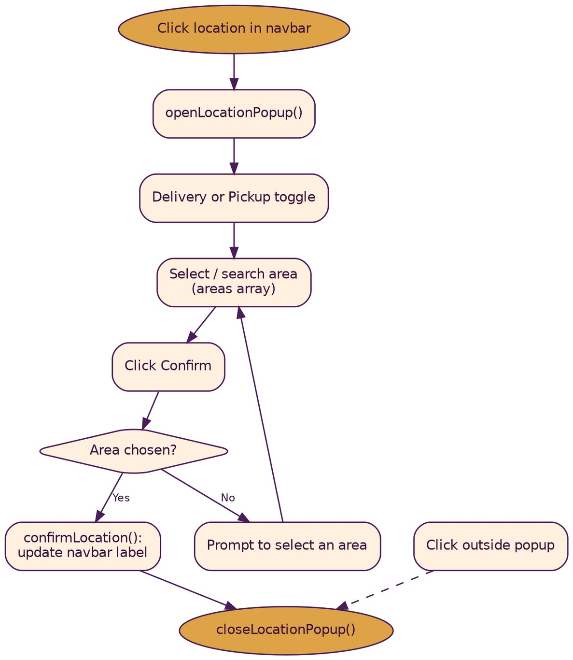
Figure 10: Location selection

Browse, modal and cart
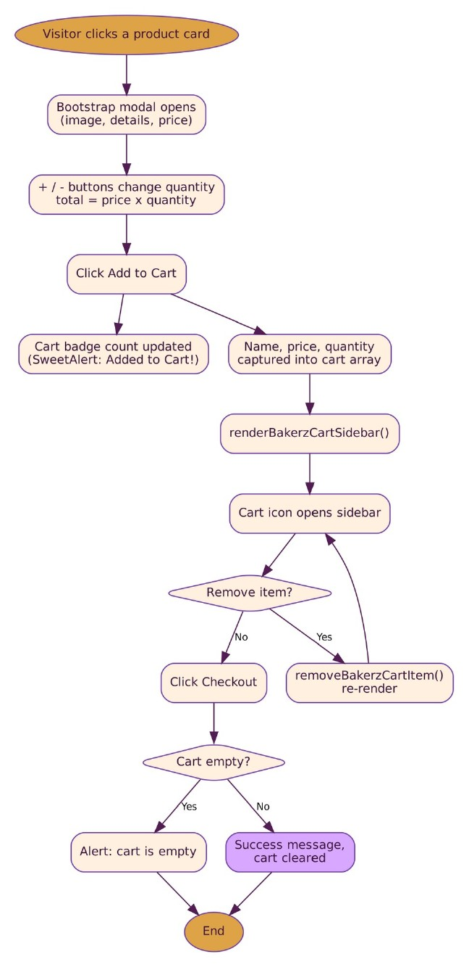
Figure 11: Product modal, cart and checkout

Category filter and search
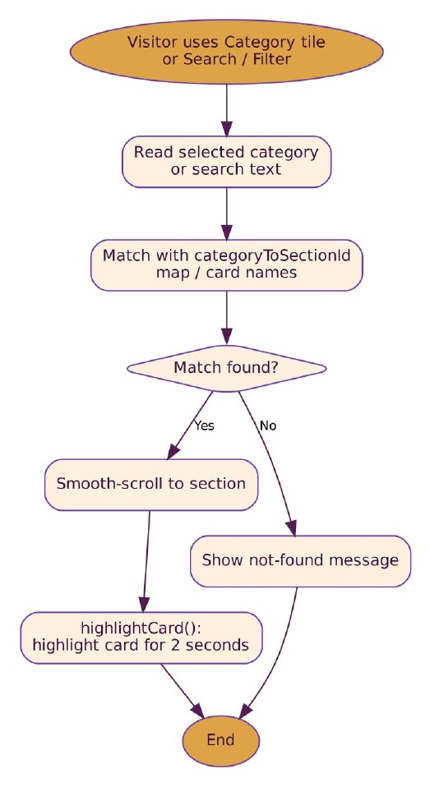
Figure 12: Category filter and search

Feedback and testimonials
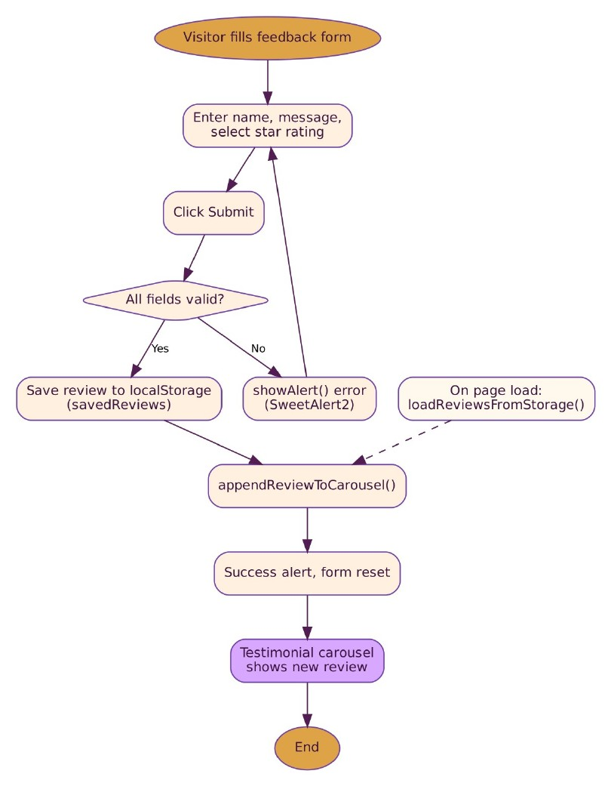
Figure 13: Feedback and testimonials

Contact form
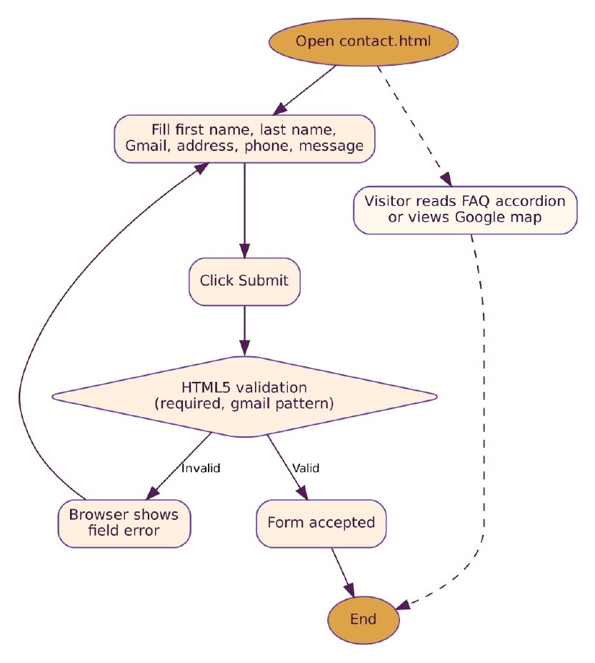
Figure 14: Contact form and FAQ

Gallery
Figure 15: About page gallery

Menu navigation and back-to-top
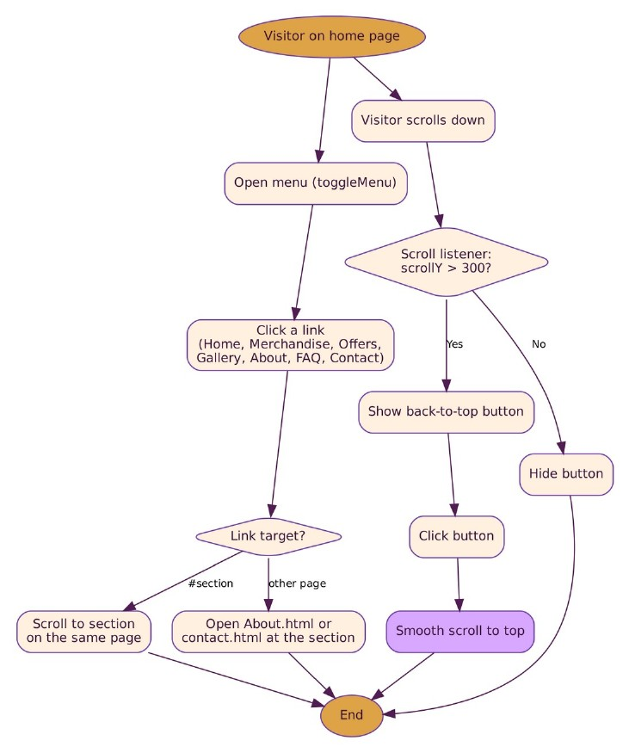
Figure 16: Menu links and back-to-top button

4.3 Data Flow Diagrams
Level 0 shows the website as one process with the visitor and its data store. Level 1 breaks it into six processes.
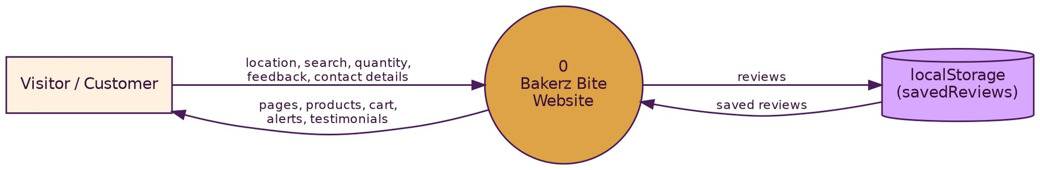
Figure 17: DFD Level 0
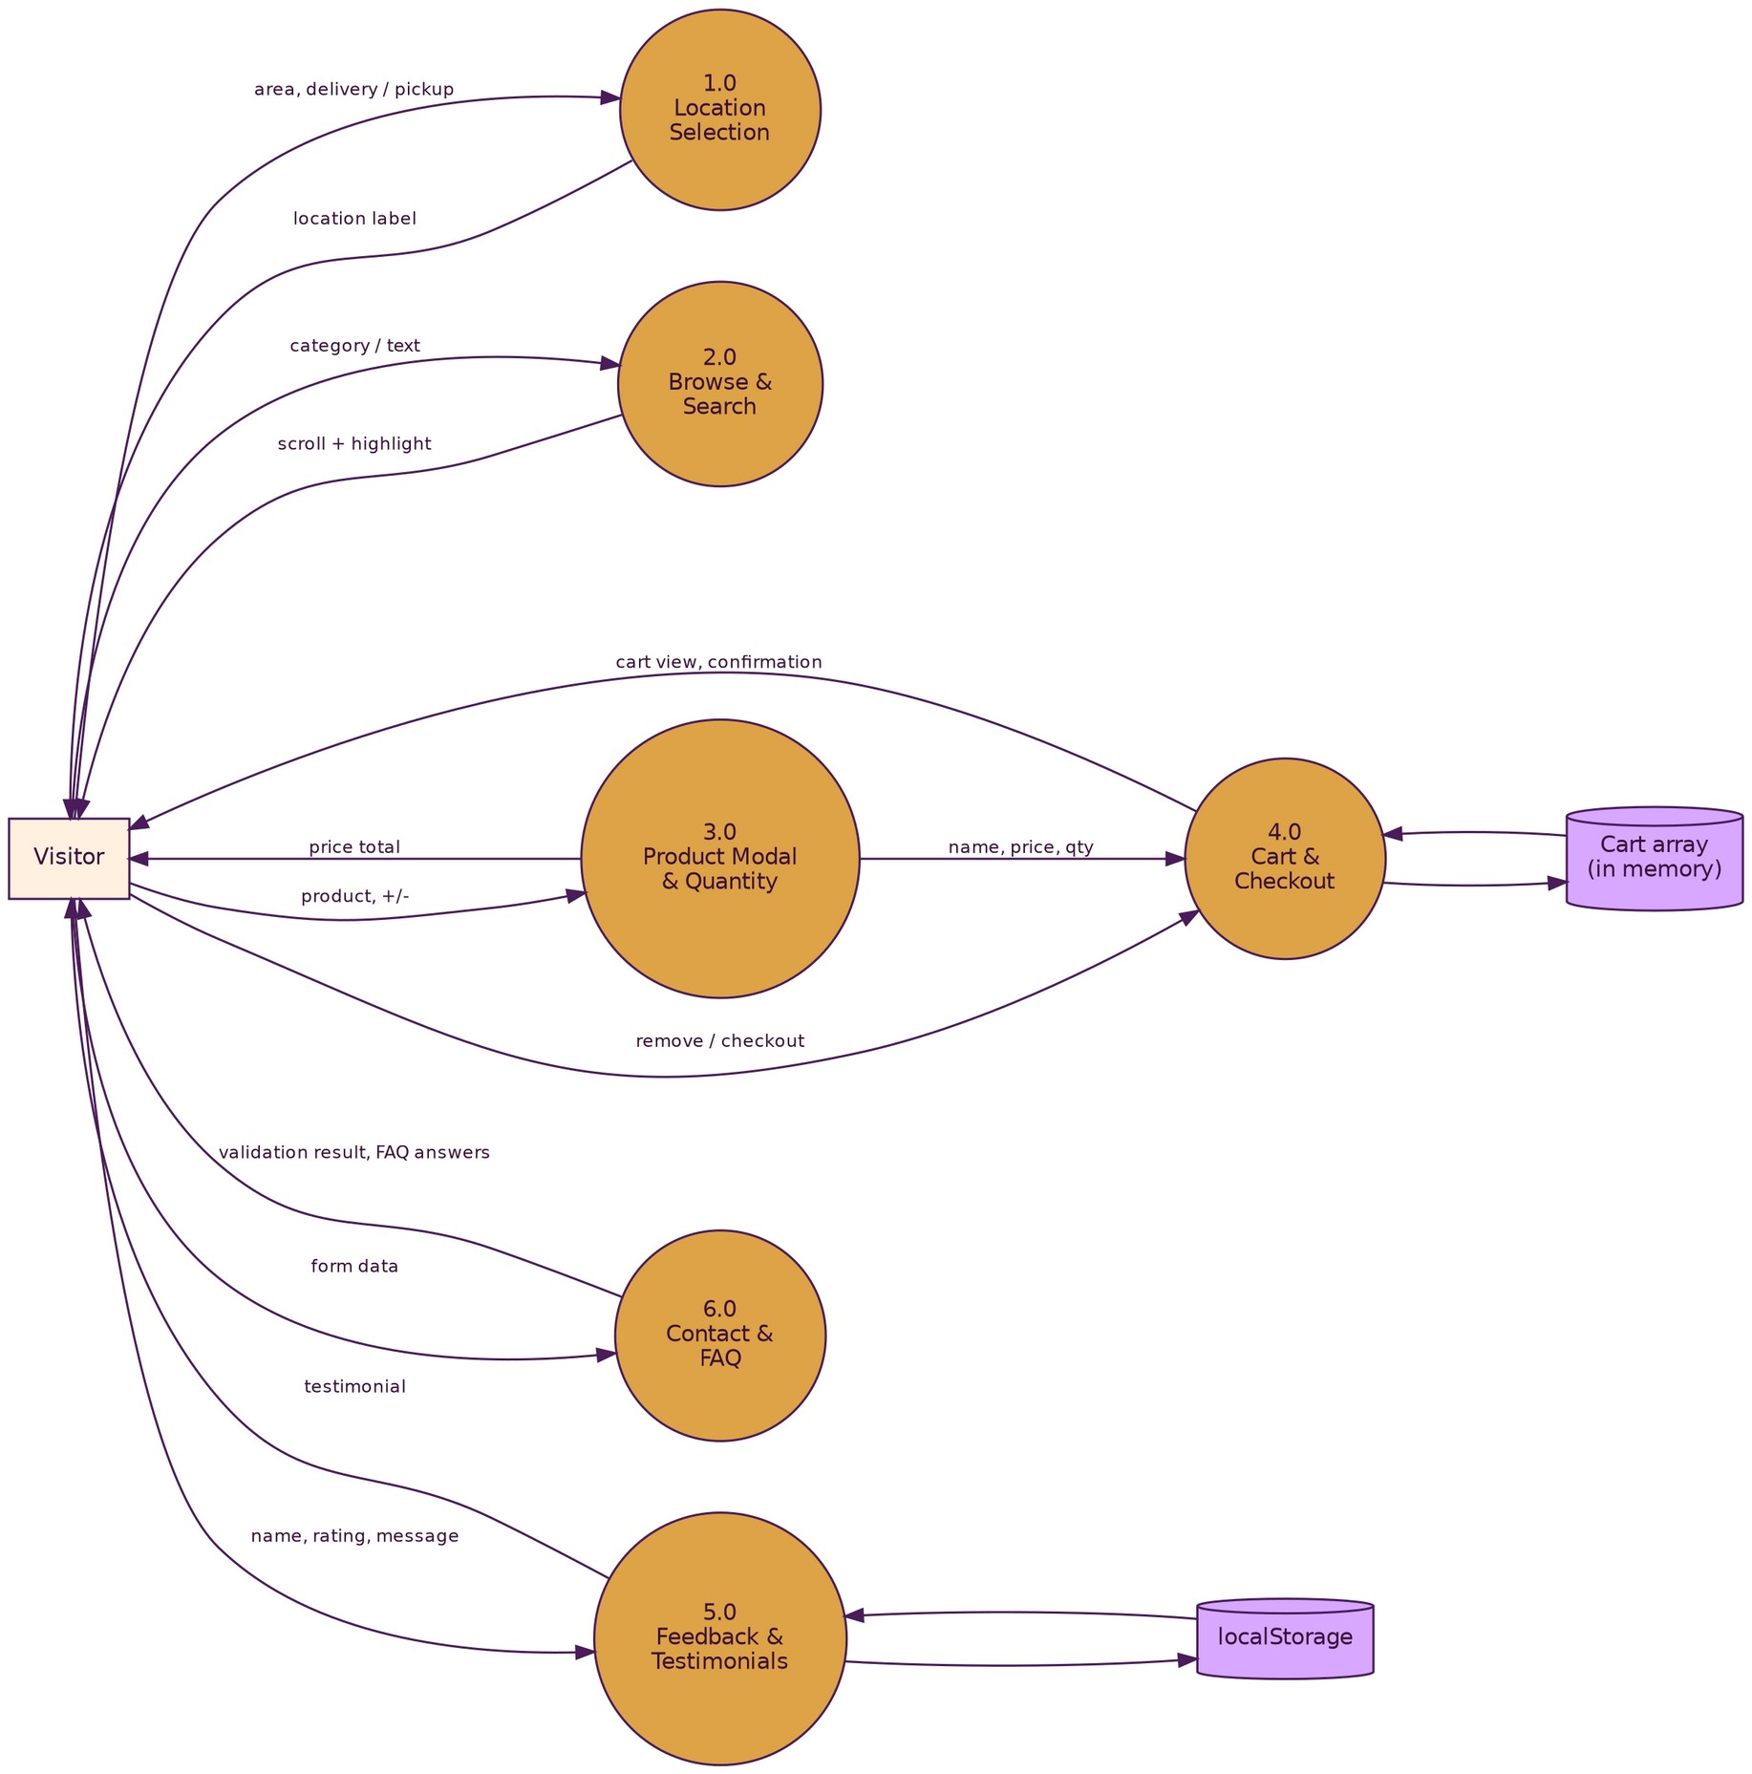
Figure 18: DFD Level 1

5. Source Code Excerpts
The excerpts below show the main parts of the code. Line numbers are relative to each excerpt.

5.1 index.html
Header: top bar and navigation with location, logo, visitor counter, cart and menu.
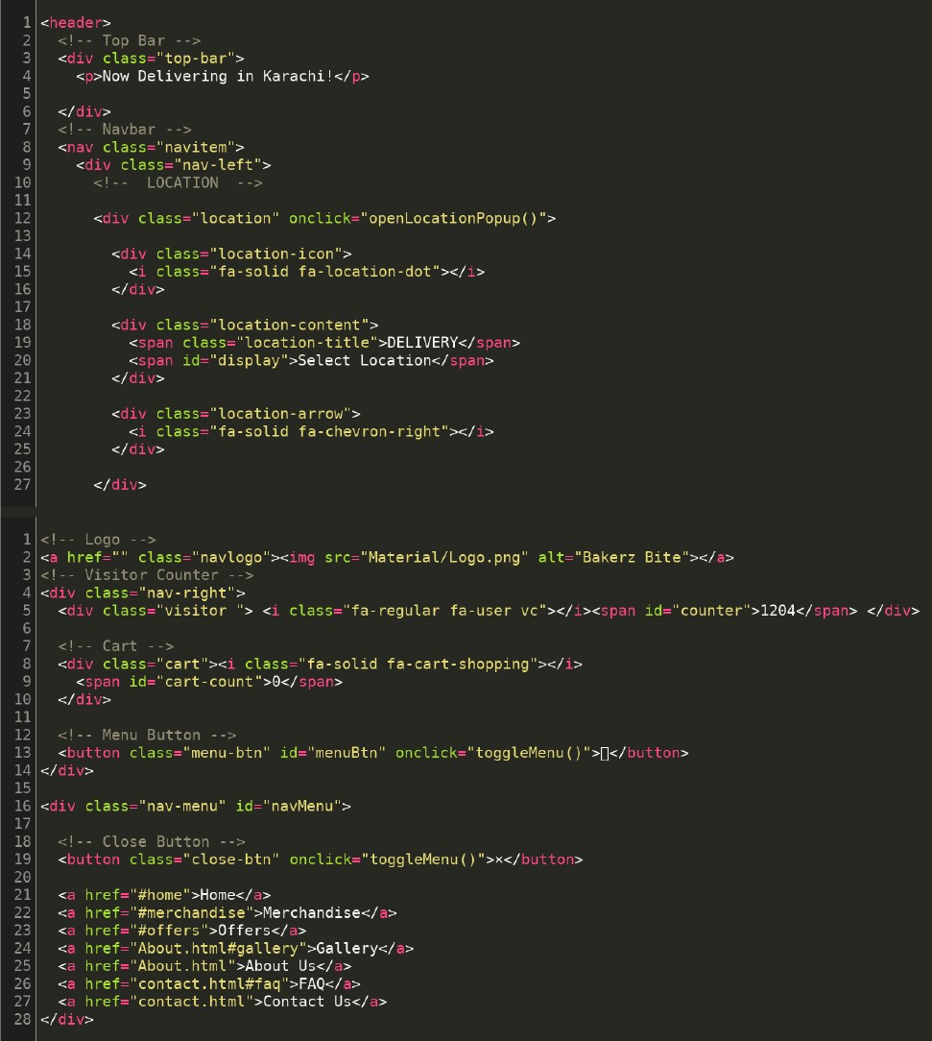
Figure 19: Header (index.html)
Products: section heading and product cards that open the modal.
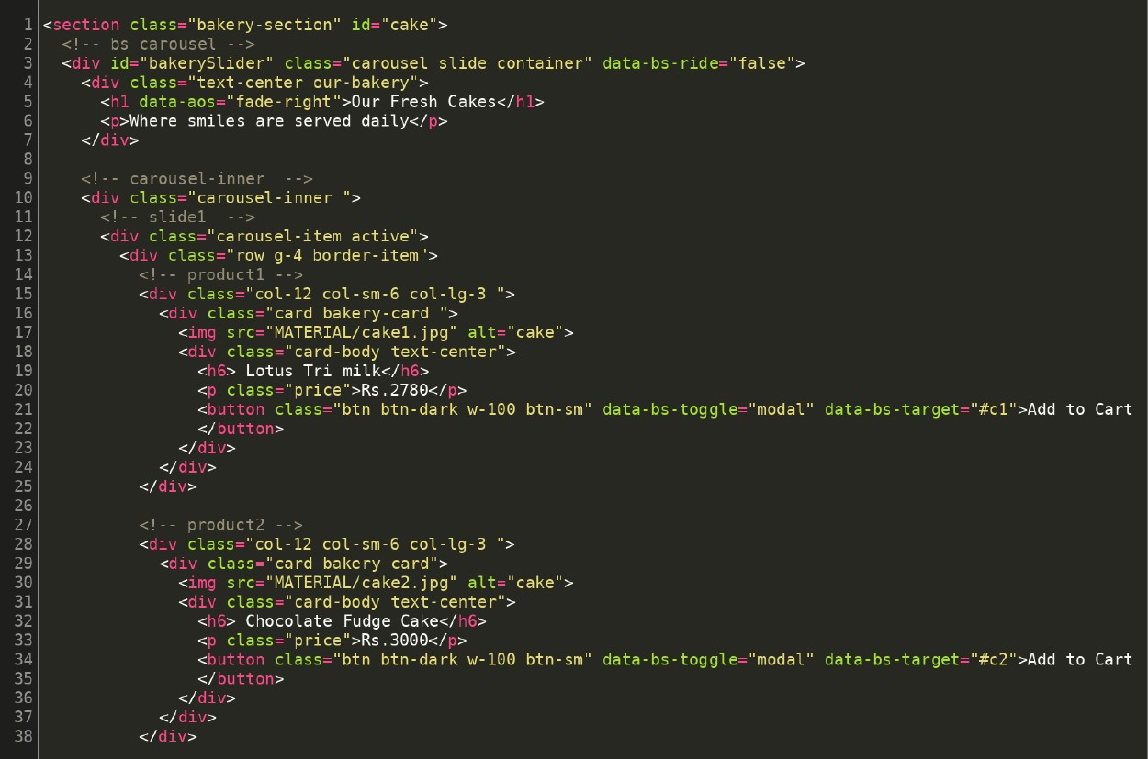
Figure 20: Product section (index.html)
Modals: product modal with image, details, quantity buttons and Add to Cart.
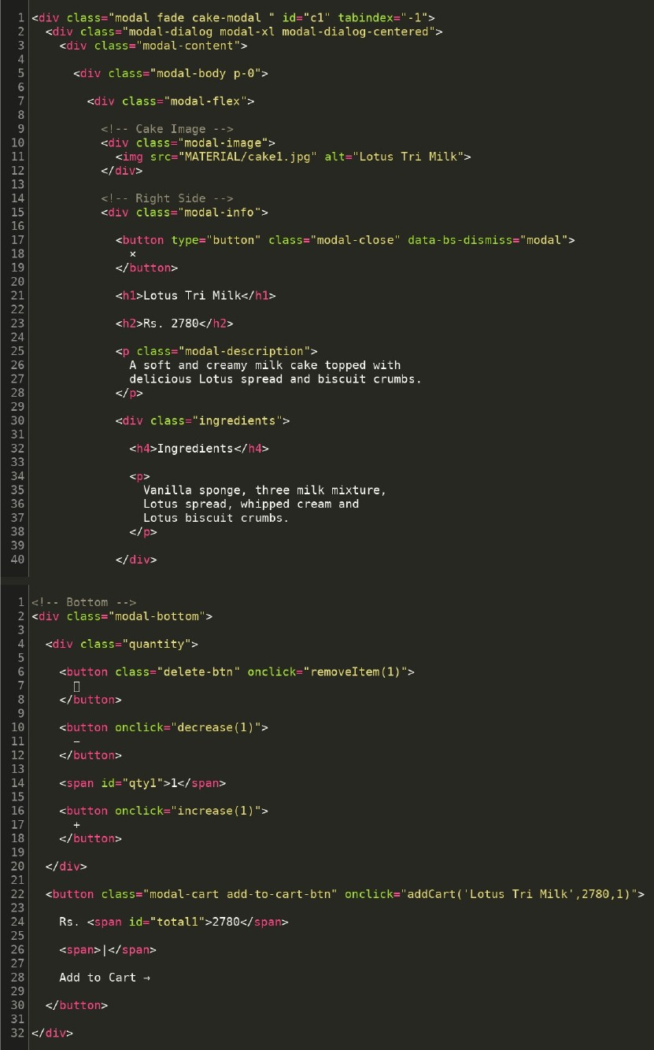
Figure 21: Product modal (index.html)
Merchandise and offers: merchandise card and the offers heading and card.
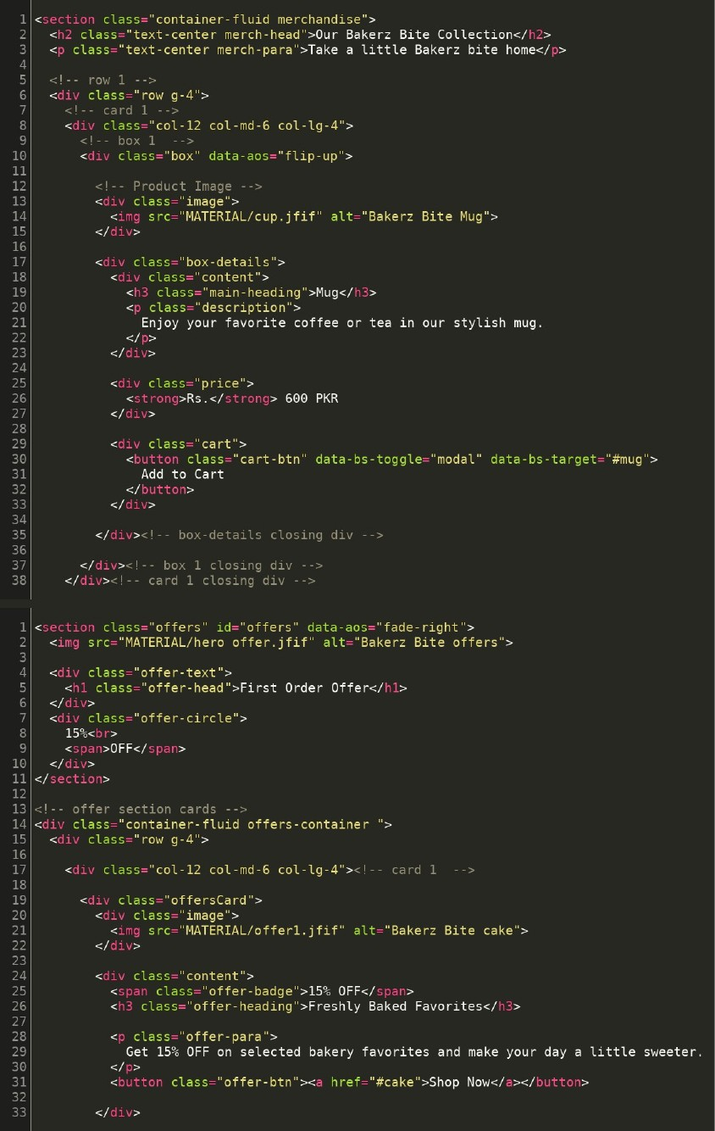
Figure 22: Merchandise and offers (index.html)

5.2 style.css
Theme and navbar: colour variables, base styles, and the fixed top bar and navbar.
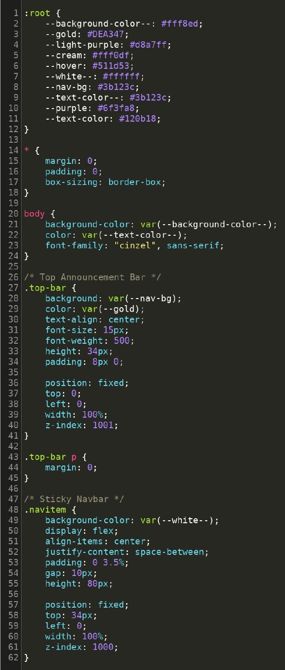
Figure 23: Theme variables and navbar (style.css)
Media query: modal layout for screens up to 500px.
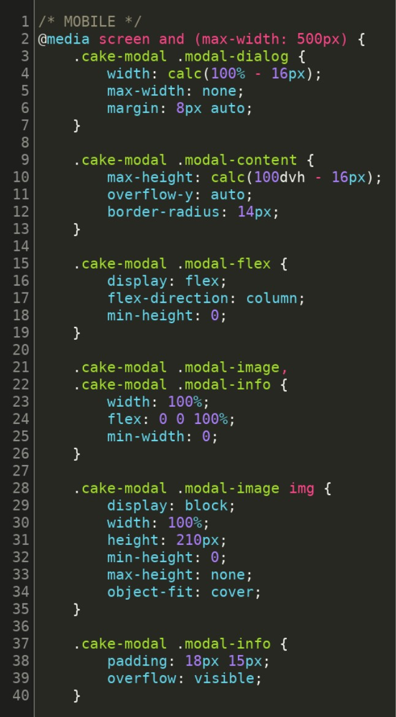
Figure 24: Mobile media query (style.css)

5.3 script.js
Cart sidebar: captures item details on Add to Cart and updates the sidebar.
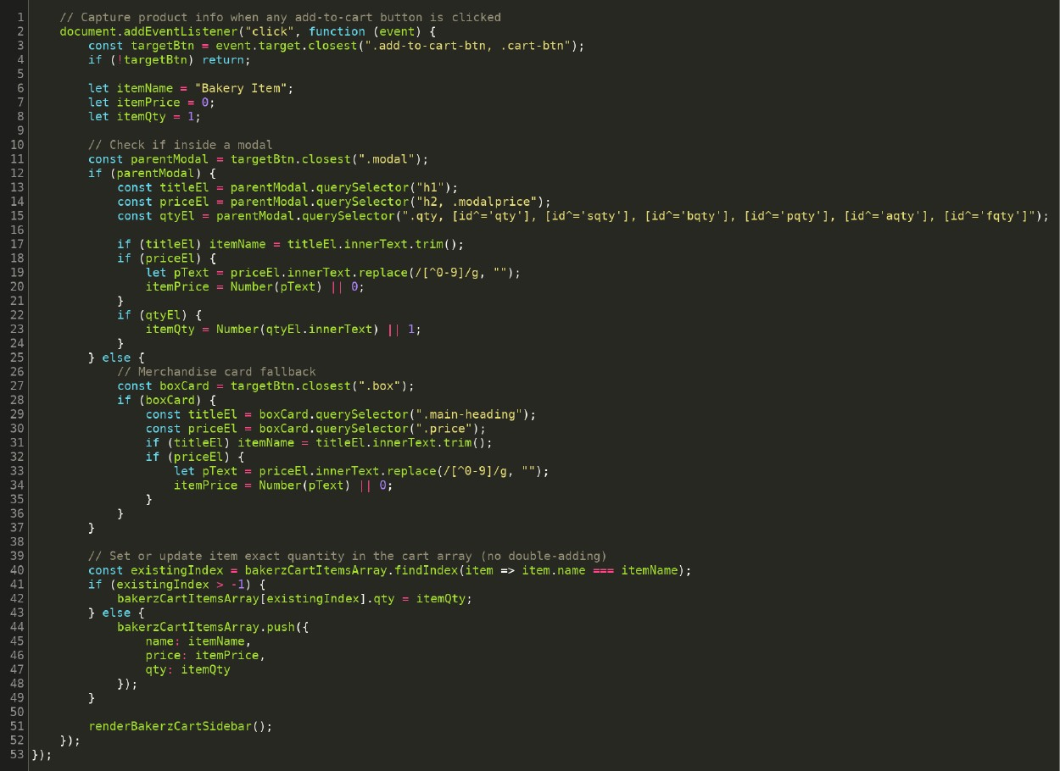
Figure 25: Cart sidebar handler (script.js)

6. Installation Instructions
Bakerz Bite is a static website, so no server installation is needed.
Step | Action
1 | Copy the whole project folder to your computer. Keep index.html, About.html, contact.html, style.css, script.js and the Material folder together.
2 | Install a current browser such as Chrome, Edge or Firefox.
3 | Connect to the internet, because Bootstrap, jQuery, fonts, icons and the map load from CDNs.
4 | Open index.html in the browser by double-clicking it.
5 | Use the navigation menu to open the About and Contact pages.
Folder rules for developers: keep file names and relative paths unchanged, add new images to the Material folder, and add new styles and functions to the matching section of style.css and script.js (see section 3.2).

7. Test Data
Each test case lists the action and the expected result. All test cases were run on the completed website and passed.
ID | Test Action | Expected Result | Result
T01 | Open index.html | Home page loads with hero, categories and footer | Pass
T02 | Click location, choose Delivery, select an area, Confirm | Navbar shows selected area; popup closes | Pass
T03 | Confirm without selecting an area | User is asked to select an area | Pass
T04 | Click outside the location popup | Popup closes | Pass
T05 | Click a category tile | Page scrolls to that section | Pass
T06 | Search "coffee" in search box | Page scrolls to the matching section and highlights the card | Pass
T07 | Click a product card | Modal opens with image, price and quantity | Pass
T08 | Press + and - in the modal | Quantity and total update; quantity does not go below 1 | Pass
T09 | Click Add to Cart | Success alert appears and cart badge updates | Pass
T10 | Open cart sidebar | Added item with name, price and quantity is listed | Pass
T11 | Remove an item in the cart | Item is removed and the list updates | Pass
T12 | Click Checkout with an empty cart | Empty-cart alert is shown | Pass
T13 | Click Checkout with items | Success message appears and cart is cleared | Pass
T14 | Submit feedback with an empty field | Error alert appears | Pass
T15 | Submit valid feedback with rating | Success alert; review appears in testimonials | Pass
T16 | Reload page after feedback | Saved review is still shown | Pass
T17 | Submit contact form with non-gmail email | Browser blocks submission with error | Pass
T18 | Open FAQ items | Answer expands and collapses | Pass
T19 | Open About page and click a gallery image | Lightbox opens; can go next, previous and close | Pass
T20 | Resize to mobile width | Menu button appears; layout stacks correctly | Pass
T21 | Scroll down more than 300px on the home page, then click the back-to-top button | Button appears and the page scrolls smoothly to the top | Pass
T22 | Open the menu and click Gallery, then FAQ | Gallery opens at the gallery section of the About page; FAQ opens at the FAQ section of the Contact page | Pass

8. Task Sheet
The table lists the work done by each team member.
Member | Student ID | Role | Tasks | Status
Zarish (Team Leader) | Student1731320 | Group Leader | Merge and integrate all team members' code, screen recording, remaining functions, User Guide, Developer Guide, final testing, coordination and completion | Lead
Shamaim Fatima | Student1730746 | Frontend Developer | Navbar, carousel banner, categories bar, search bar, footer | Active
Maha Zareen | Student1731318 | Frontend Developer | Product cards for all categories, product modals, gallery section, About us, ticker | Active
Fariha | Student1730174 | Frontend Developer | Merchandise section, feedback and review form, offers section, local storage, FAQ | Active
Ayesha Faizan | Student1731614 | Frontend Developer | Site map, Contact Us page | Active
Hadia Khan | Student1732712 | Group Member | Product modals, image collection | Active

9. Future Improvements
- Add a backend and database to store orders, products and customers.
- Add user accounts and order history.
- Add online payment (card and mobile wallet).
- Send order confirmation by email or SMS.
- Add an admin panel to manage menu, prices and offers.
- Store reviews on a server so all visitors see them.
- Show live order tracking and delivery charges by area.
- Add multi-language support and accessibility improvements.

10. Conclusion
Bakerz Bite delivers a complete front-end bakery website with a clear structure, responsive design and a working cart experience. This guide documents its pages, files, flows and code so that future developers can maintain and extend it with confidence.

11. Glossary
Term | Meaning
HTML | HyperText Markup Language; defines page structure
CSS | Cascading Style Sheets; defines appearance
JavaScript | Programming language that adds behaviour to pages
Bootstrap | CSS/JS framework for responsive layouts and components
CDN | Content Delivery Network; hosts libraries loaded by the page
Modal | Pop-up window over the page, used for product details
Media query | CSS rule that applies at certain screen sizes
localStorage | Browser storage used to keep reviews
Carousel | Slideshow of images or reviews
DFD | Data Flow Diagram
SPA | Single-Page Application

Thank You
We sincerely thank our faculty, Mr. Muhammad Umar Ali, for his teaching, patience and support. His guidance helped us understand how to plan, build and document a real website. We are grateful for the time he gave us and for the standards he encouraged us to reach.
Thank you.

