BAKERZ BITE
Bakery e-Project Website
USER GUIDE
Project Team
# | Member | Student ID
1 | Zarish (Team Leader) | Student1731320
2 | Ayesha Faizan | Student1731614
3 | Fariha | Student1730174
4 | Hadia Khan | Student1732712
5 | Maha Zareen | Student1731318
6 | Shamaim Fatima | Student1730746

Appreciation
We would like to express our sincere gratitude to our faculty, Mr. Muhammad Umar Ali, and our coordinator, Miss Malaika, for their guidance, patience and encouragement throughout the development of the Bakerz Bite e-project.
Their feedback helped us improve both the website and this guide at every stage. Their support turned a classroom assignment into a project we are proud of.
We also thank our batch 2606F1 classmates and everyone who tested the website and shared suggestions.
Team Bakerz Bite

Table of Contents
1. About Bakerz Bite 4
1.1 Overview 4
1.2 Why Bakerz Bite 4
1.3 What You Need 4
1.4 Finding Your Way 5
2. How to Order: Step by Step 6
2.1 The Steps 7
2.2 Good to Know 11
3. Layout Top 11
3.1 Top Banner 11
3.2 Delivery Location 12
3.3 Phone Number, Logo and Visitor Counter 12
3.4 Cart Icon (Home page only) 12
3.5 Menu Button and Side Menu 13
4. Layout Bottom 14
5. Home Page (index.html) 15
5.1 Hero Slider 15
5.2 Category Icons 15
5.3 Search and Category List 15
5.4 Product Sections 16
5.5 Product Details Window 16
5.6 Merchandise 16
5.7 Your Cart 17
5.8 Offers 17
5.9 Share Your Feedback 18
5.10 What Our Customers Say 20
5.11 Back-to-Top Button 21
6. About and Gallery Page (About.html) 22
6.1 About Us 22
6.2 Bakery Gallery 22
7. Contact Page (contact.html) 24
7.1 Contact Us Form 24
7.2 Visit Bakerz Bite 26
7.3 Frequently Asked Questions 27
8. Messages You May See 28

1. About Bakerz Bite

1.1 Overview
Bakerz Bite is a bakery website that lets customers explore the full bakery range, choose a delivery or pickup area, build a cart and read about the bakery. It is a responsive website with three pages that works in the leading browsers on desktop, tablet and mobile.
The site presents six product categories: cakes, savory items, cupcakes and pastries, shakes, coffee and customised cakes. It also has bakery merchandise, special offers, customer feedback, an About page with a photo gallery and a Contact page with an FAQ.
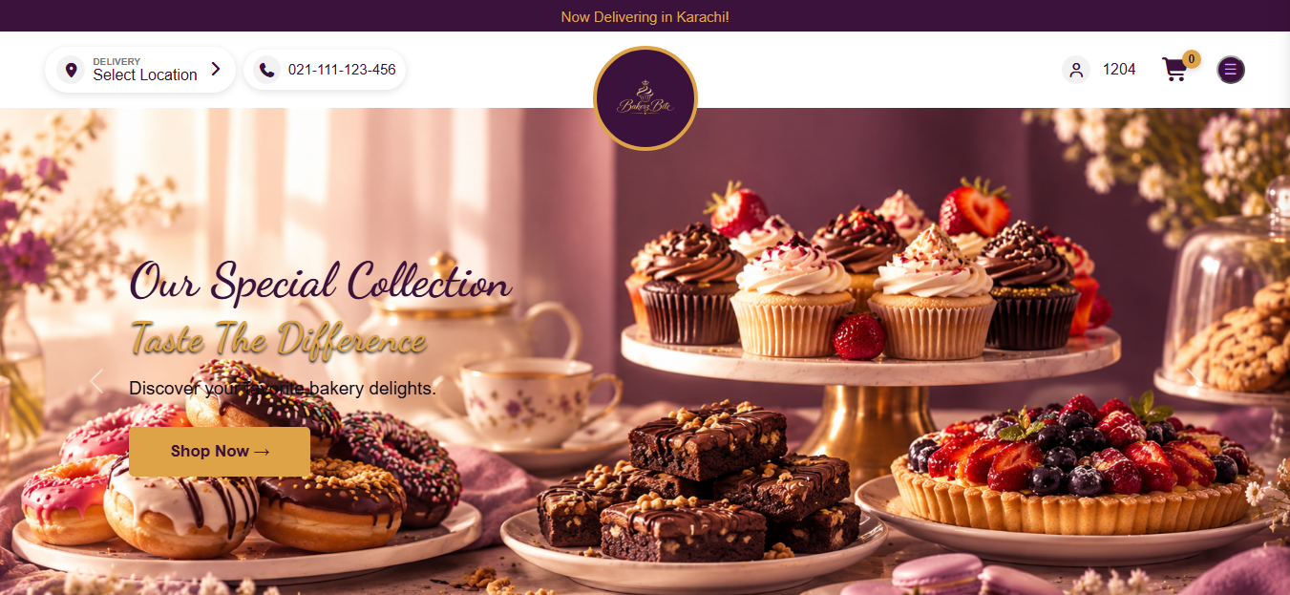
Figure 1: Home page of Bakerz Bite

1.2 Why Bakerz Bite
Bakerz Bite was built to give a Karachi bakery a place online where customers can find everything in one visit. The main reasons are:
- Customers search online. People look for bakeries on their phones. A website lets Bakerz Bite be found and shown at any hour.
- The whole range in one place. Cakes, savories, cupcakes and pastries, shakes, coffee, custom cakes and merchandise are all on one page, with price, description and ingredients before anyone orders.
- Ordering is simple. Choose Delivery or Pick-Up and your area, pick a quantity, see the total, and check out from the cart.
- It builds trust. The About page, photo gallery, customer reviews and FAQ show the bakery and what customers say about it.
- It works on every device. The layout adjusts to phones, tablets and computers.
- Customers can reach the bakery. The Contact page has a form, phone number, email and address.

1.3 What You Need
- A computer, tablet or phone with a current browser such as Chrome, Edge, Firefox or Safari.
- An internet connection. Fonts, icons and animations load online.
- Optional: allow location access if you want your coordinates shown in the footer.

1.4 Finding Your Way
The website has three pages. Flowchart 1 shows what you can do on each one. The menu button on every page takes you to the others.
Page | File | What it is for
Home | index.html | Browse products, order, offers, feedback, reviews
About and Gallery | About.html | The bakery story, video and photo gallery
Contact | contact.html | Contact form, store details, map and FAQ

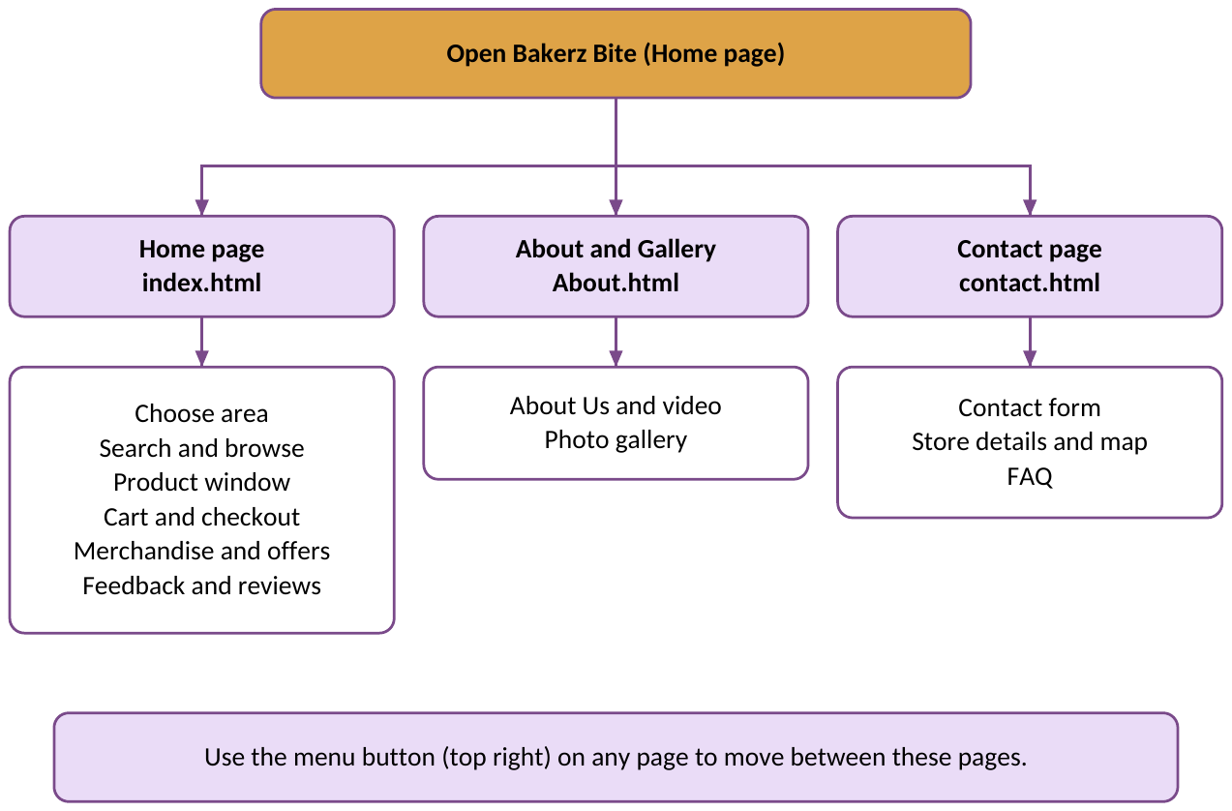
Flowchart 1: What you can do on each page

2. How to Order: Step by Step
Follow these seven steps to order from the Home page. Flowchart 2 shows the whole route, including what happens if you skip a step.
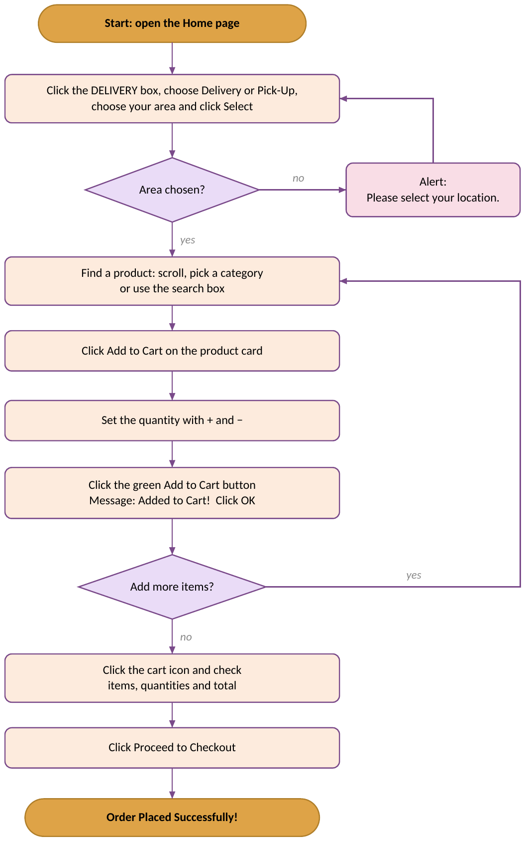
Flowchart 2: How to place an order

2.1 The Steps
Step 1: Choose your order type and area
- Click the DELIVERY / Select Location box at the top left.
- Click Delivery or Pick-Up.
- Open Please select your area and choose your area.
- Click Select. Your area now shows in the navigation bar.
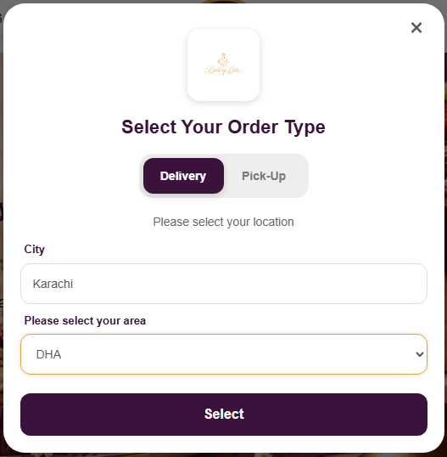
Figure 2: Select Your Order Type window
Step 2: Find a product
Scroll down the Home page, click a category icon, choose a category from the list, or type a product name in the search box and press Enter.
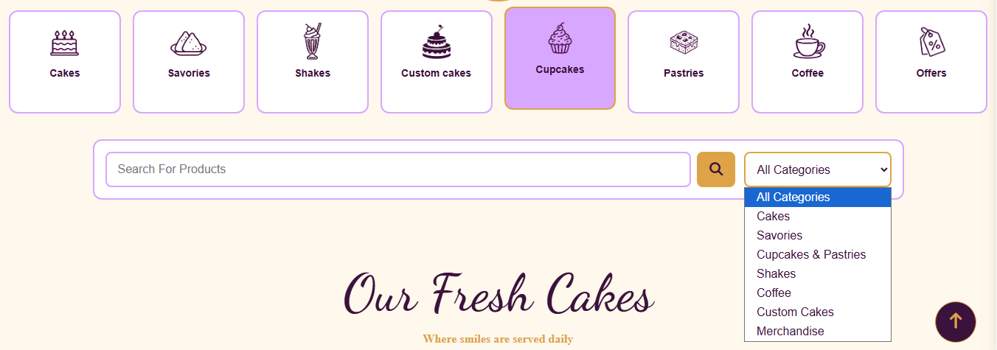
Figure 3: Search box and All Categories list
Step 3: Open the product
Click Add to Cart on the product card. The product details window opens.
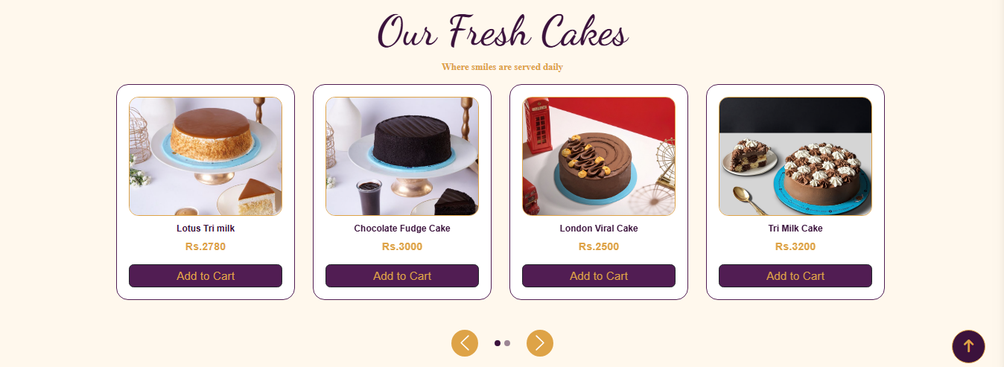
Figure 4: Product cards
Step 4: Choose the quantity and add it
- Click + to add one more, or − to remove one. The quantity never goes below 1.
- The green button shows the total for your quantity.
- Click the green Rs. … | Add to Cart → button.
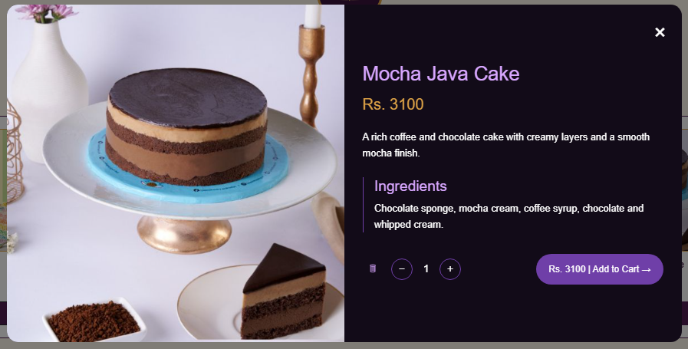
Figure 5: Product details window
Step 5: Confirm
The message Added to Cart! appears. Click OK. To add more items, repeat Steps 2 to 4.
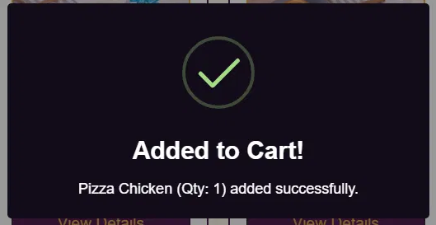
Figure 6: Added to Cart! message
Step 6: Check your cart
- Click the cart icon at the top. The Your Cart Items panel opens.
- Check each item, its quantity and the Total Amount.
- Click the trash button next to an item to remove it.
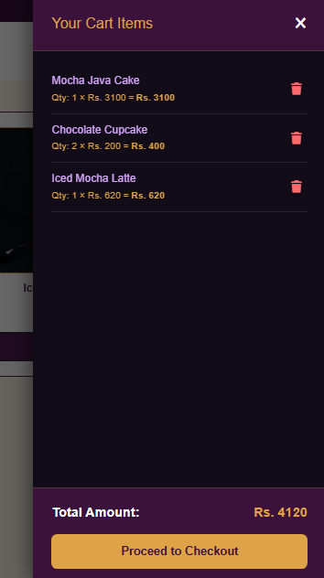
Figure 7: Your Cart Items panel
Step 7: Check out
Click Proceed to Checkout. The message Order Placed Successfully! appears and the cart is emptied.
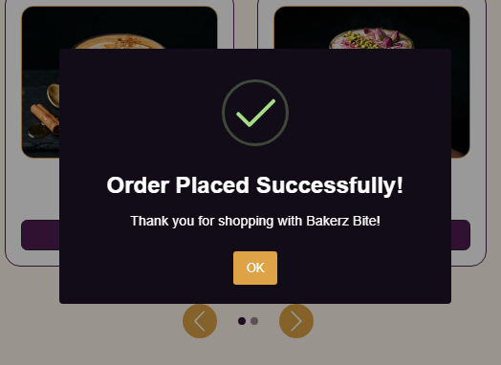
Figure 8: Order Placed Successfully! message

2.2 Good to Know
- The cart is kept on the page only. If you reload or leave the page, it is emptied. Finish your order before you leave.
- The cart icon is on the Home page only.
- If you click Proceed to Checkout with an empty cart, you see Your cart is empty!

3. Layout Top
The top of every page is the same. It has a banner, a location box, the phone number, the logo, a visitor counter and the menu button. On the Home page it also has the cart icon.
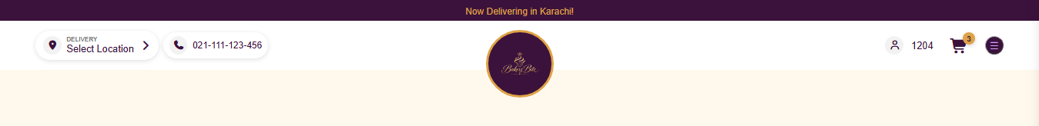
Figure 9: Top bar and navigation bar

3.1 Top Banner
The banner reads Now Delivering in Karachi!

3.2 Delivery Location
Click the DELIVERY / Select Location box to open the Select Your Order Type window (see Figure 2).
- Delivery / Pick-Up: click one of the two buttons. The chosen button is highlighted. Delivery is selected at first.
- City: shows Karachi and cannot be changed.
- Please select your area: choose from the 20 areas in the list: Gulshan-e-Iqbal, Gulistan-e-Johar, North Nazimabad, Nazimabad, PECHS, Clifton, DHA, Bahadurabad, Federal B Area, North Karachi, Malir, Korangi, Landhi, Saddar, Tariq Road, Defence View, Johar Town, Scheme 33, Buffer Zone and Surjani Town.
- Select: saves your area, closes the window and shows the area in the navigation bar.
- To close the window without choosing, click the × button or click outside the window.
If you click Select without choosing an area, a message asks you to select your location. Choose an area and click Select again.
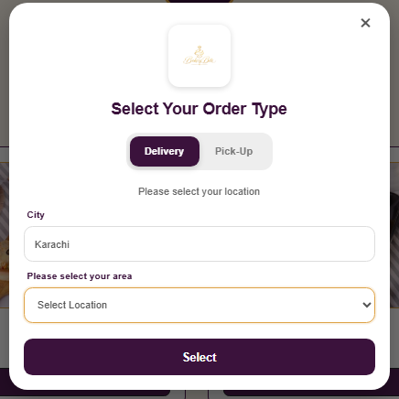
Figure 11: Select Location popup with no area chosen

3.3 Phone Number, Logo and Visitor Counter
- Phone number: the bakery helpline, 021-111-123-456.
- Logo: the Bakerz Bite logo, in the centre.
- Visitor counter: the person icon with a number. It counts up when the page loads.

3.4 Cart Icon (Home page only)
The cart icon shows a number for the items you have added. Click it to open your cart (see Step 6).

3.5 Menu Button and Side Menu
Click the menu button (three lines) at the top right to open the side menu. Click × to close it.
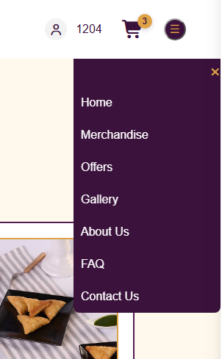
Figure 10: Side menu
Menu link | Takes you to
Home | The Home page
Merchandise | The merchandise section
Offers | The offers section
Gallery | The photo gallery on the About page
About Us | The About page
FAQ | The Contact page, where the FAQ is
Contact Us | The Contact page

4. Layout Bottom
The footer is the same on every page.
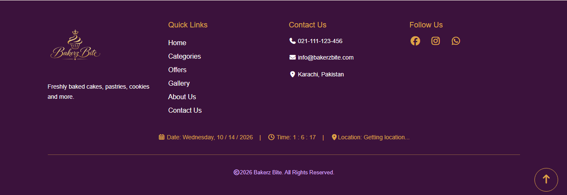
Figure 12: Footer
- Bakerz Bite: the logo and a short description.
- Quick Links: Home, Categories, Offers, Gallery, About Us and Contact Us.
- Contact Us: phone 021-111-123-456, email info@bakerzbite.com and location Karachi, Pakistan.
- Follow Us: Facebook, Instagram and WhatsApp icons.
- Status bar: today’s date, the live time and your location. Your browser asks permission to share your location. If you allow it, your coordinates are shown. If you refuse, the text “Getting location...” stays.
- Copyright line: © 2026 Bakerz Bite. All Rights Reserved.

5. Home Page (index.html)

5.1 Hero Slider
A large banner slides on its own every 4 seconds. It has four slides: Freshly Baked – Made With Love, Sweet Moments – Made Fresh Daily, Delicious Treats – For Every Occasion and Our Special Collection – Taste The Difference. Use the left and right arrows to move by hand. Click Shop Now → to jump to the cakes.

Figure 13: Hero slider

5.2 Category Icons
Click an icon to jump to that section of the page.
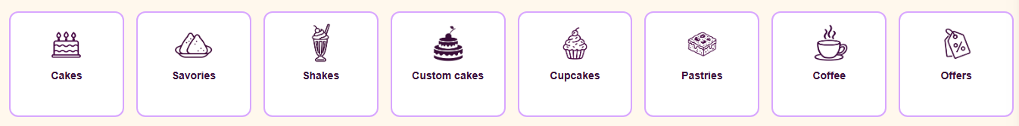
Figure 14: Category icons
Icon | Goes to
Cakes | Our Fresh Cakes
Savories | Royal Savories
Shakes | The Shake Corner
Custom cakes | Custom Cake
Cupcakes | Cupcakes & Pastry
Pastries | Cupcakes & Pastry
Coffee | The Coffee Corner
Offers | First Order Offer

5.3 Search and Category List
See Figure 3.
- Search For Products: type a product name, such as “mango”, and press Enter or click the magnifying glass. The page scrolls to the first match, which grows briefly and glows gold. If nothing matches, nothing happens.
- All Categories list: choose Cakes, Savories, Cupcakes & Pastries, Shakes, Coffee, Custom Cakes or Merchandise and the page scrolls to that section.

5.4 Product Sections
The shop has six sections. Each product card shows a photo, the name and the price in Rs.
Section | Products
Our Fresh Cakes | 8 (two slides of 4)
Royal Savories | 8 (two slides of 4)
Cupcakes & Pastry | 8 (two slides of 4)
The Shake Corner | 4
The Coffee Corner | 8 (two slides of 4)
Custom Cake | 4

Sections with more than 4 products have arrows and dots under the cards. Click them to see the other 4 products.
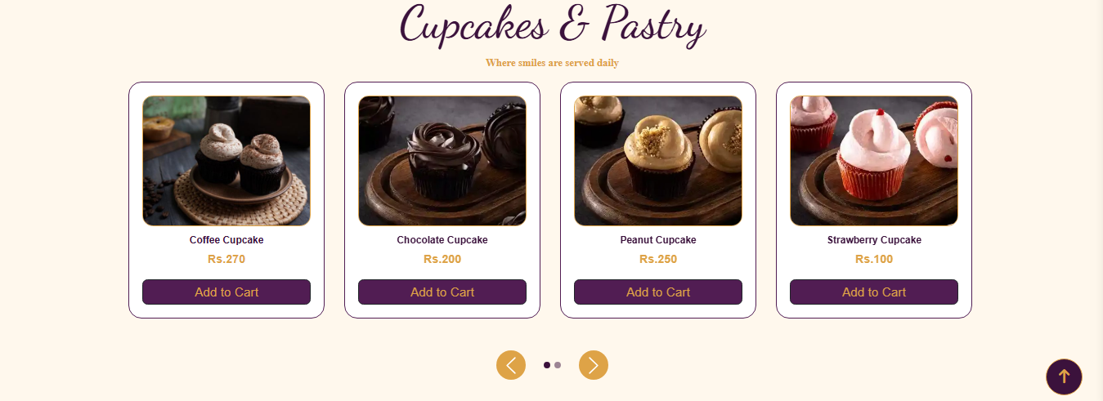
Figure 15: A product section with slider arrows

5.5 Product Details Window
Click Add to Cart on a card to open the window (see Figure 5). It shows a large photo, the name, the price, a short description and the ingredients. For custom cakes it shows the cake details.
Quantity buttons
- Click + to increase the quantity.
- Click − to decrease it. The minimum is 1.
- Click the trash button to reset the quantity to 1.
- The green button shows the total, for example Rs. 5560. Click it to add the item to your cart.
- Click × to close the window without adding anything.

5.6 Merchandise
The Bakerz Bite Merchandise banner leads into Our Bakerz Bite Collection: Mug, Tumbler, Spoons, Cake Box, Cap and Bag. Each card has a photo, a short description, the price in PKR and an Add to Cart button that opens the same kind of details window.
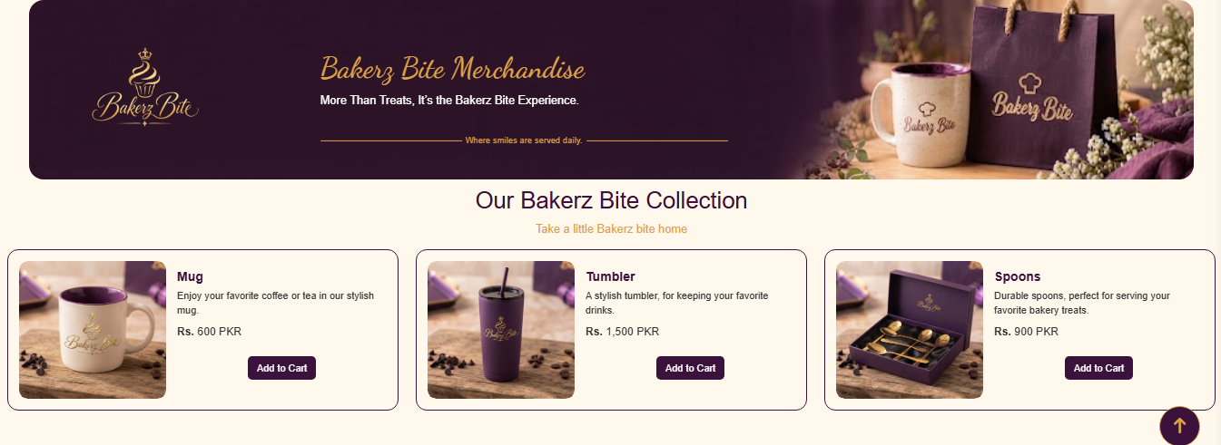
Figure 16: Merchandise collection

5.7 Your Cart
Click the cart icon to open Your Cart Items (see Figure 7).
- Each item shows its name, quantity, price and line total.
- Adding an item that is already in the cart updates its quantity. It does not create a second line.
- Click the trash button next to an item to remove it. Total Amount updates.
- Click Proceed to Checkout to place the order. The cart is emptied. With an empty cart you see “Your cart is empty!”
- Click × or click outside the panel to close it.
Note: the number on the cart icon counts the items you added. The panel is the accurate list of what you will order, so check it before checkout.

5.8 Offers
The First Order Offer banner promotes 15% OFF for new customers. Three offer cards are shown, each marked 15% OFF:
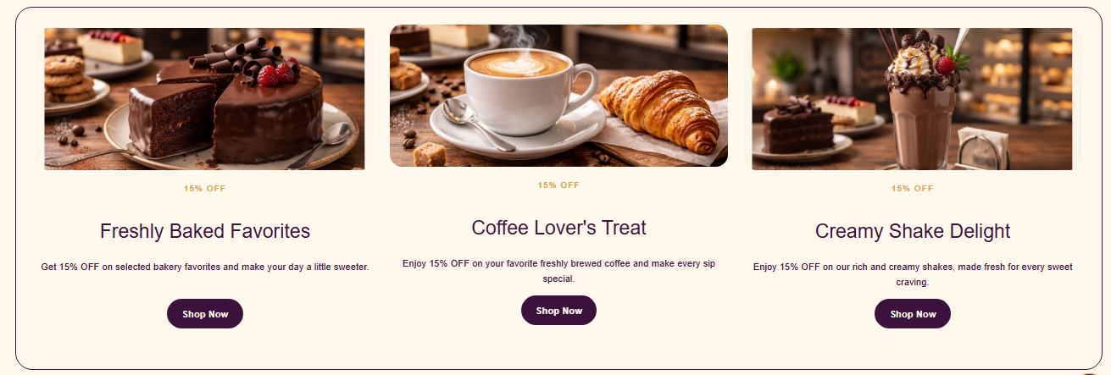
Figure 17: Offers section
- Freshly Baked Favorites: Shop Now goes to the cakes.
- Coffee Lover’s Treat: Shop Now goes to the coffee.
- Creamy Shake Delight: Shop Now goes to the shakes.

5.9 Share Your Feedback
Use this form to tell Bakerz Bite about your experience.
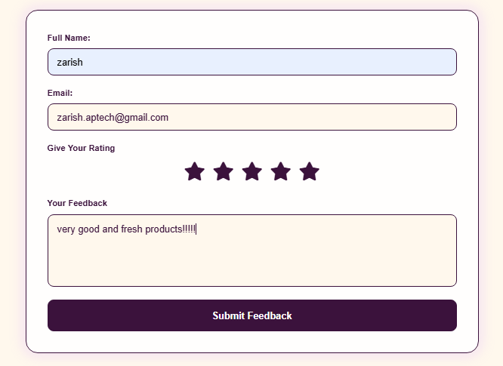
Figure 18: Share Your Feedback form
Form fields
- Full Name: type your name. Do not leave it blank.
- Email: type your email address. Do not leave it blank.
- Give Your Rating: click a star from 1 to 5. The stars fill in as you move over them. A rating is required.
- Your Feedback: type your comment. Do not leave it blank.
Click Submit Feedback. The form checks your entries in turn and shows a message if something is wrong (Flowchart 3).
Problem | Message
Name, email or feedback is empty | Missing Information – Please fill in all fields before submitting.
No star chosen | Rating Required – Please select a star rating using the stars.
Everything is filled in | Thank You! Your feedback has been submitted successfully.
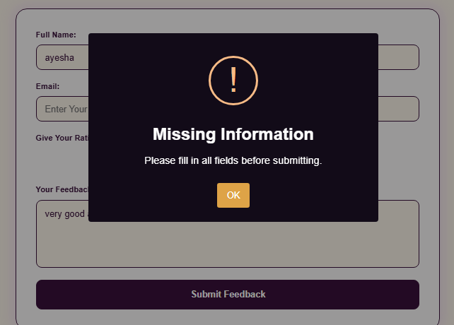
Figure 19: Missing Information message
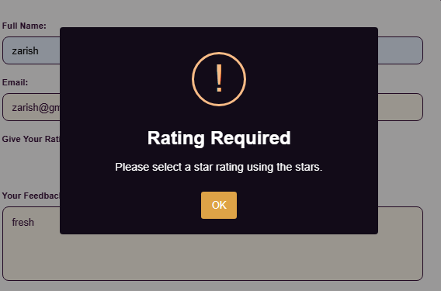
Figure 20: Rating Required message
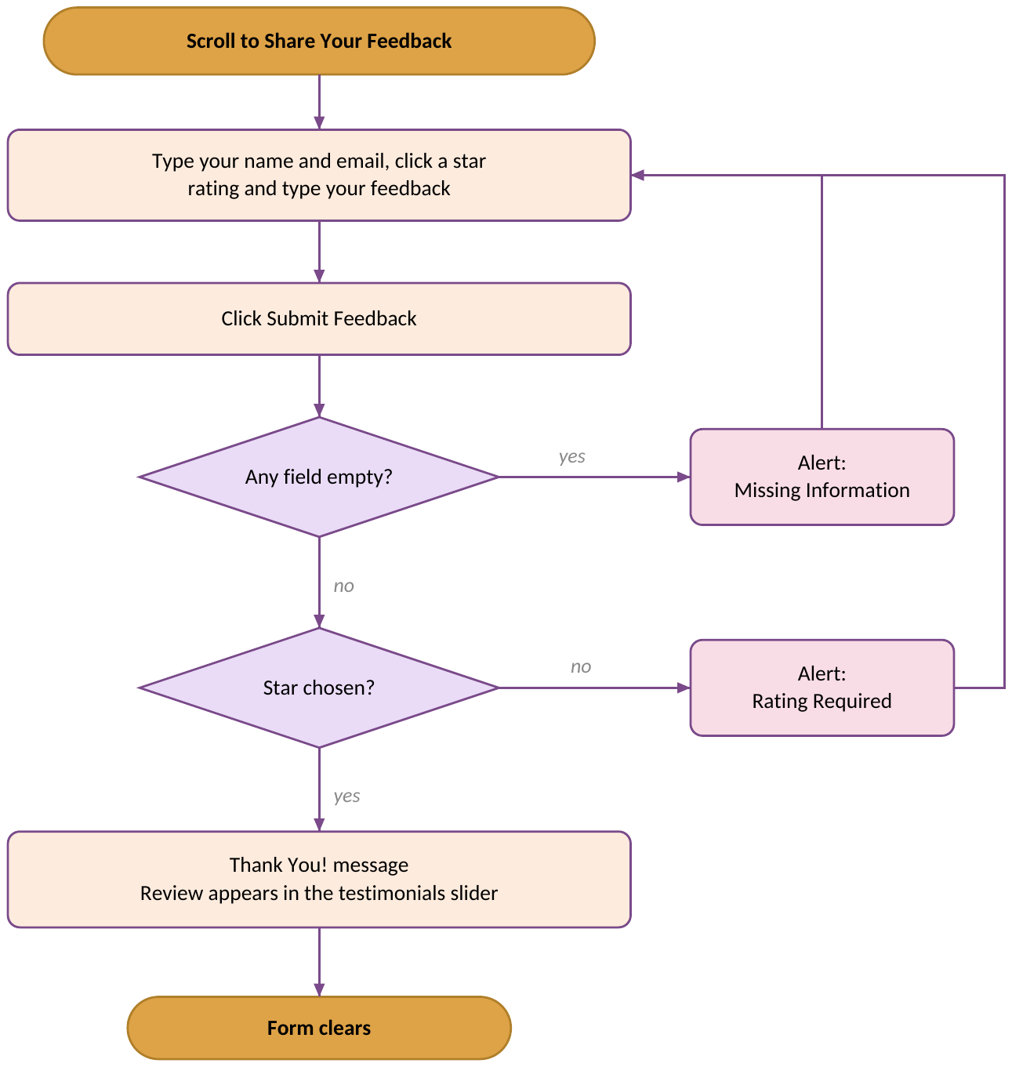
Flowchart 3: Submitting feedback
Note: your review is saved in your own browser only. It appears on your device and is not shared with other visitors.

5.10 What Our Customers Say
A slider shows customer reviews with star ratings. Three sample reviews (Sarah Khan, Ayesha Ahmed and Hassan Ali) are shown first, and your own reviews follow them. Use the arrows or dots to move between reviews. The slider also moves on its own.
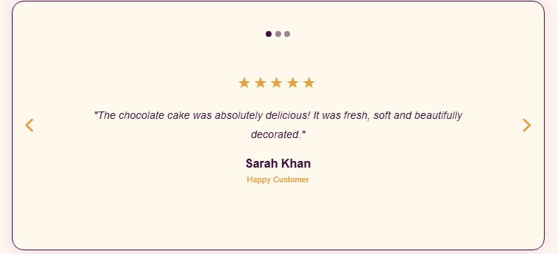
Figure 21: Customer testimonials

5.11 Back-to-Top Button
When you scroll down the Home page, a round button with an up arrow appears at the bottom right. Click it to glide back to the top of the page.

Figure 22: Back-to-top button

6. About and Gallery Page (About.html)
Open it from the side menu (About Us or Gallery) or from the footer. Gallery takes you straight to the photos.

6.1 About Us
The heading A Little Slice of Happiness introduces the bakery. Three highlights follow: Freshly Baked, Made With Love and Premium Quality. A baking video plays on a loop without sound. Click Explore Our Treats to go to the cakes on the Home page.
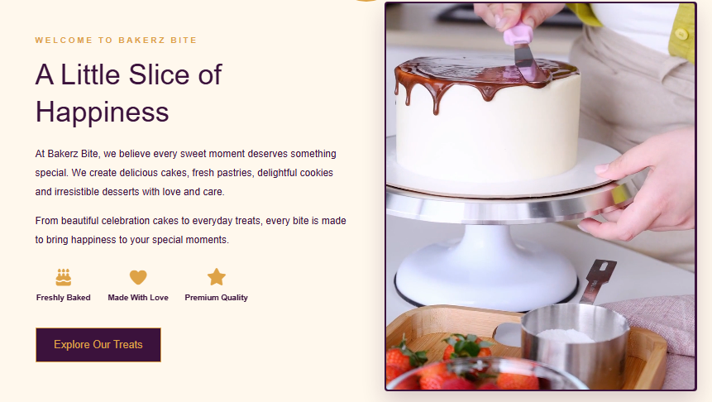
Figure 23: About Us section

6.2 Bakery Gallery
A grid of 12 photos shows cakes, savories, cupcakes, pastry, shakes, coffee and custom cakes.
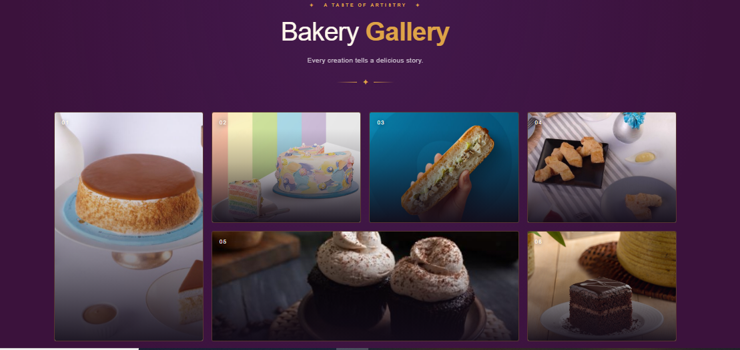
Figure 24: Bakery Gallery
- Move the mouse over a photo to see its caption.
- Click a photo to open it in a large viewer (Figure 25).
- Close the viewer with the × button or by clicking outside the photo.
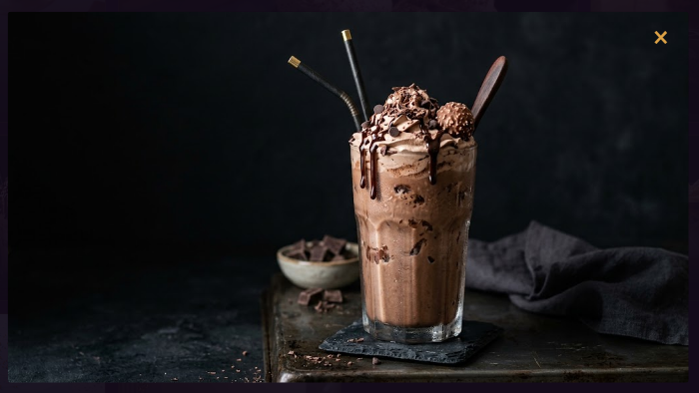
Figure 25: Gallery photo in the viewer

7. Contact Page (contact.html)
Open it from the side menu (Contact Us or FAQ) or from the footer.
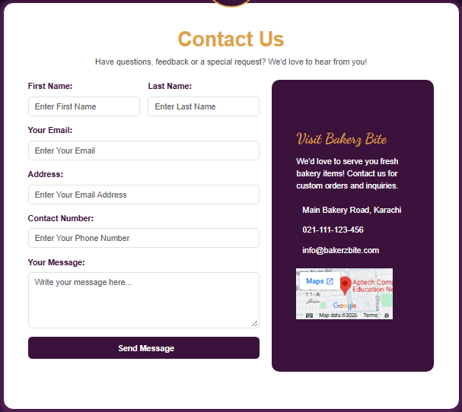
Figure 26: Contact page

7.1 Contact Us Form
All fields are required.
First Name and Last Name
- Do not leave blank.
Your Email
- Do not leave blank.
- Must be a Gmail address ending in @gmail.com, for example name@gmail.com.
Address
- Do not leave blank.
Contact Number
- Do not leave blank.
Your Message
- Do not leave blank.
Click Send Message. If a field is empty or the email is not a valid @gmail.com address, your browser shows a prompt next to the field (Figure 27). Correct it and try again. When every field is valid, the form is submitted and you are taken to the Home page (Flowchart 4).
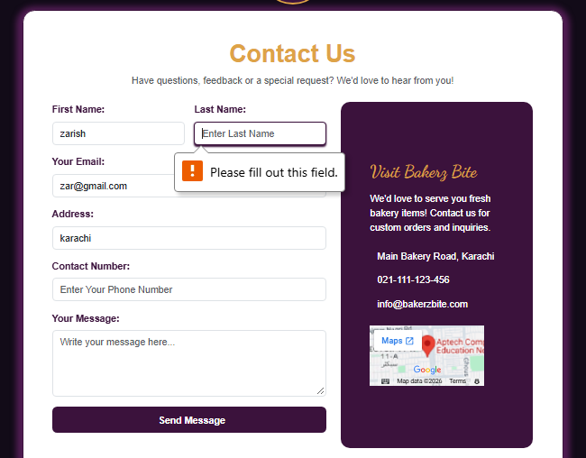
Figure 27: Browser prompt next to an empty field
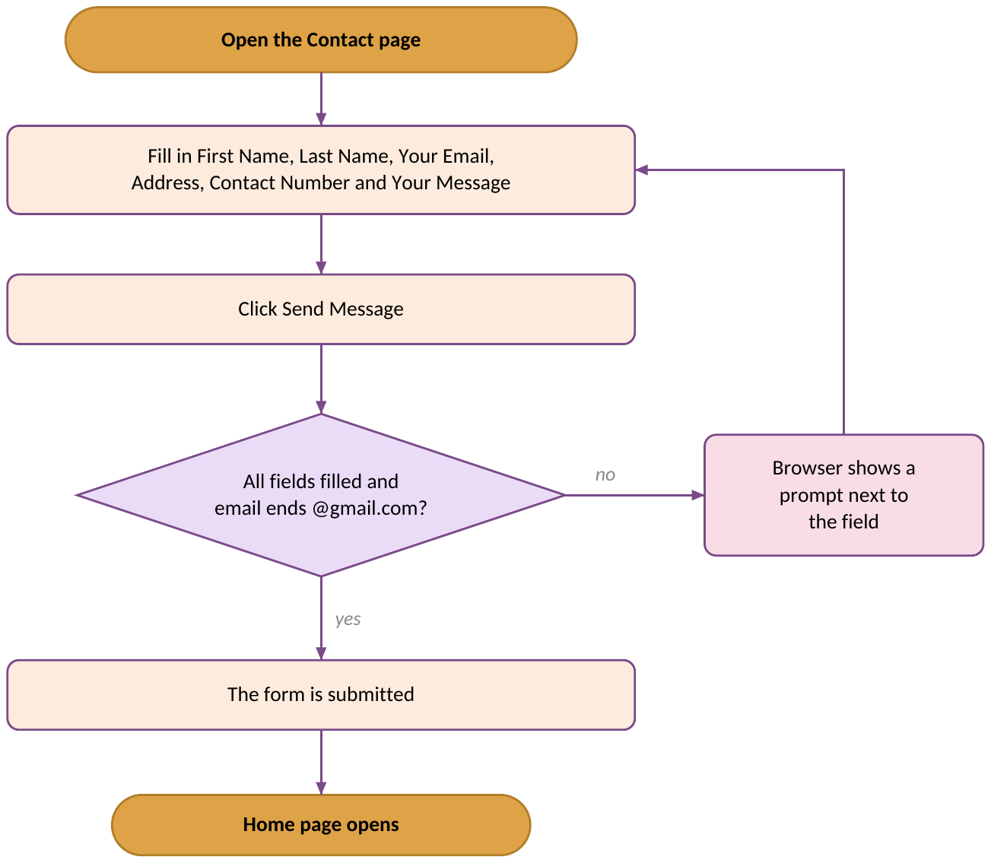
Flowchart 4: Sending a message

7.2 Visit Bakerz Bite
The box next to the form shows the bakery’s address (Main Bakery Road, Karachi), phone number (021-111-123-456), email (info@bakerzbite.com) and a small map.

7.3 Frequently Asked Questions
Click a question to show its answer. Click it again to hide it. Only one answer is open at a time. The questions are:
- What is Bakerz Bite?
- How can I place an order at Bakerz Bite?
- What products does Bakerz Bite offer?
- Do you offer a discount on the first order?
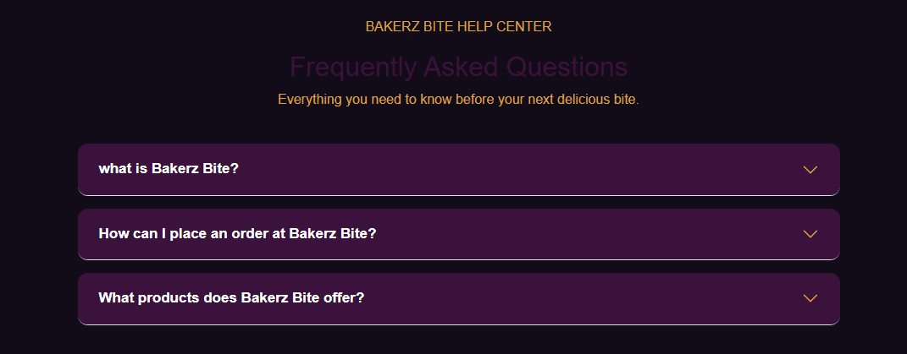
Figure 28: Frequently Asked Questions

8. Messages You May See
Every pop-up message on the website, where it appears and what to do.
Where | Message | What to do
Location popup | Please select your location. | Choose an area, then click Select.
Product window | Added to Cart! | The item is in your cart. Click OK.
Cart panel | Your cart is empty! | Add an item before you check out.
Cart panel | Order Placed Successfully! Thank you for shopping with Bakerz Bite! | Your order is complete. The cart is emptied.
Feedback form | Missing Information – Please fill in all fields before submitting. | Fill in your name, email and feedback.
Feedback form | Rating Required – Please select a star rating using the stars. | Click a star from 1 to 5.
Feedback form | Thank You! Your feedback has been submitted successfully. | Your review appears in the testimonials slider.
Contact form | A prompt from your browser next to a field | Fill in the field, or use an address ending in @gmail.com.
Footer | Getting location... | Allow location access in your browser if you want your coordinates shown.
Thank You For Reading The Documentation.
Please Follow The Instructions Above !!

