Galaxy Explorer
Create a Web page (HTML5 + CSS3 + images) that looks like the screenshot below:
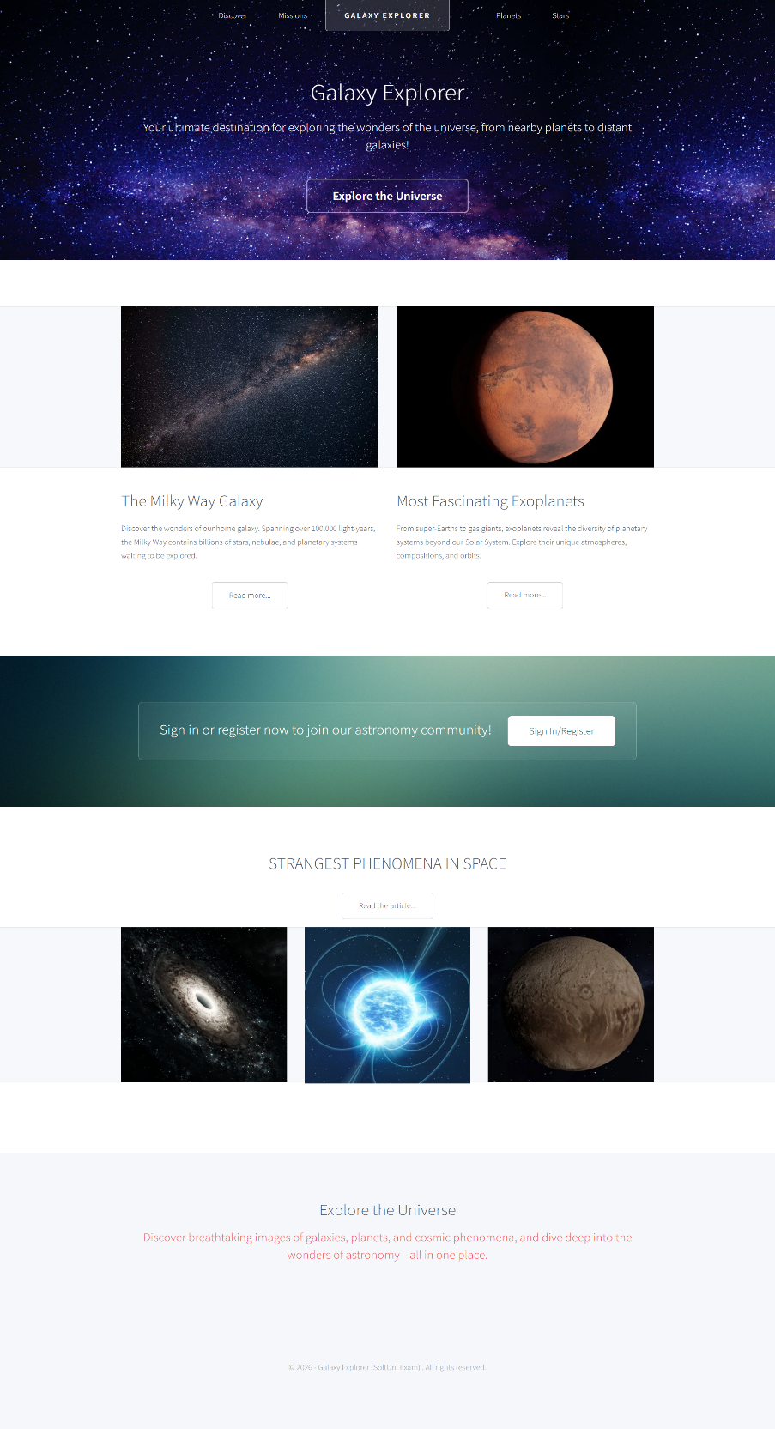

You are given the above screenshots + all required images.

Output
The output should be valid HTML5 + CSS3 + images that implement the above web page.

Constraints
- Use fonts 'Source Sans Pro', sans-serif ("https://fonts.googleapis.com/css?family=Source+Sans+Pro:300,300italic,400,400italic,600")
- The site should open correctly in the latest version of Chrome

