The Hand of Noxus
Create a Web page (HTML5 + CSS3) that looks and behaves like the screenshot below:
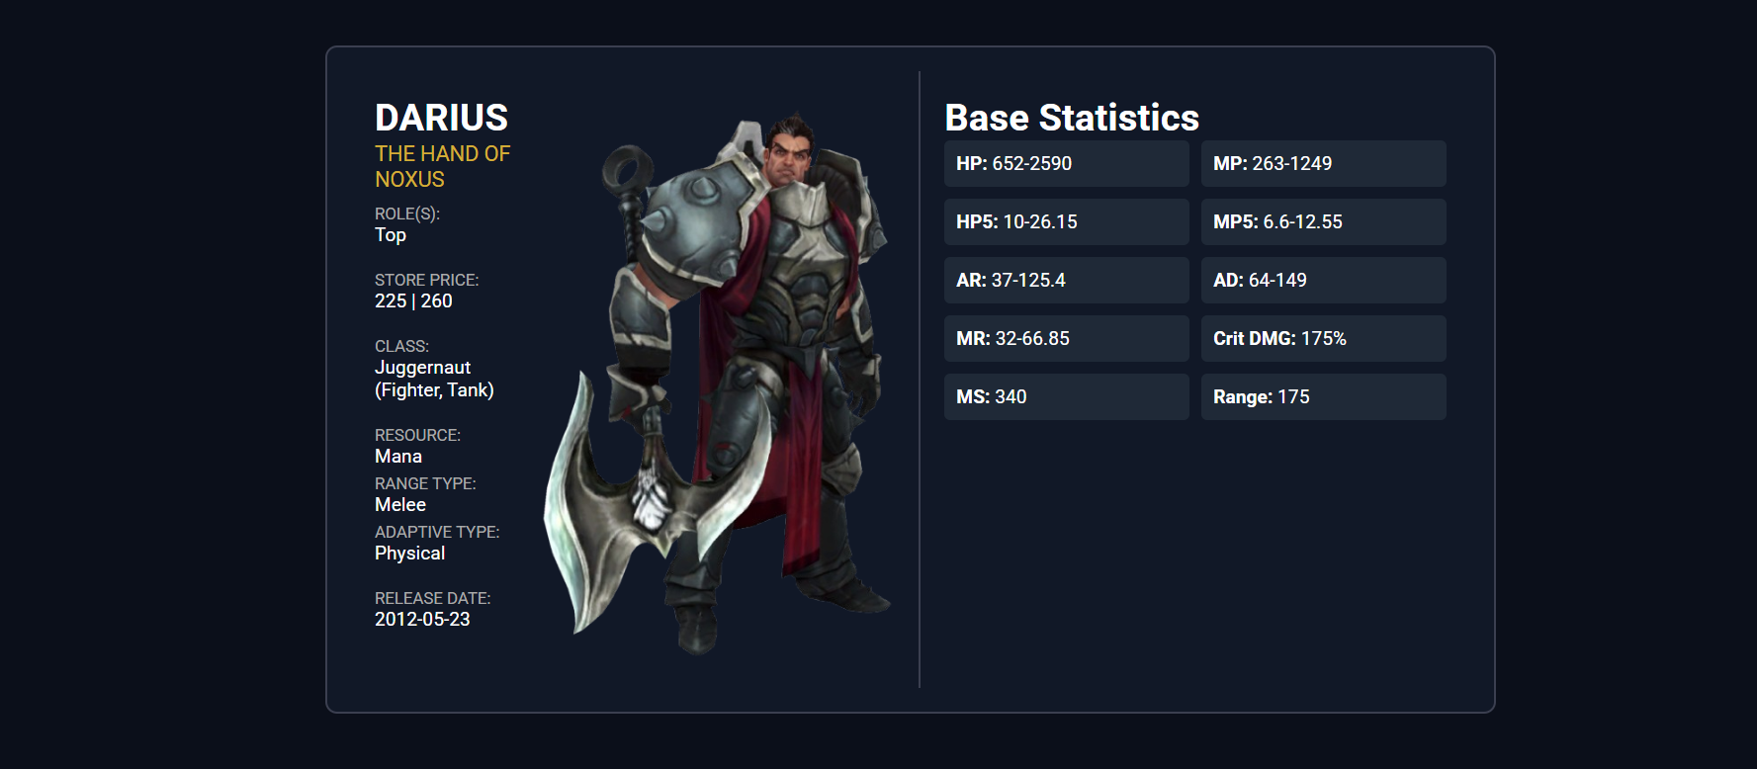

Output
The output should be valid HTML5 + CSS3 + images that implement the above web page.
- Use the Google fonts Roboto- (https://fonts.googleapis.com/css2?family=Roboto&display=swap)
- The site should open correctly in the latest version of Chrome

