WanderSphere
Create a Web page (HTML5 + CSS3 + images) that looks and behaves like the screenshot below:
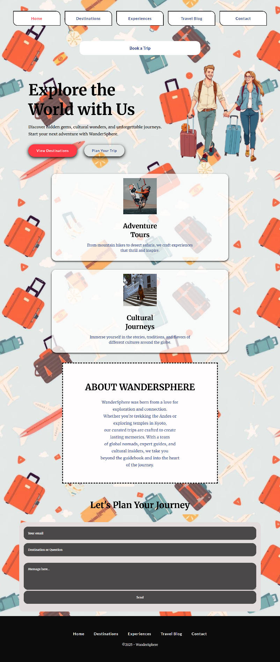
You are given the above screenshots + all required images.

Output
The output should be valid HTML5 + CSS3 + images that implement the above web page.

Constraints
- Use font 'Merriweather' for the text and font 'Lato' for the buttons – (https://fonts.googleapis.com/css2?family=Merriweather:wght@300;400;700&display=swap)
(https://fonts.googleapis.com/css2?family=Lato:wght@400;700&display=swap)
- The site should open correctly in the latest version of Chrome

