**Current work**

1. Attentional discounted utility

I developed a theory that I term “*attentional discounted utility*”. The purpose of this theory is to incorporate attentional mechanism into the discounted utility framework. One benefit of doing this is that you may only need to introduce one additional parameter to a conventional discounted utility model, in order to account for a broad set of anomalies. The model also makes some new predictions (such as what I hope to test in the experiment).

Let me explain it from the very beginning. The role of attention in decision making can be understood using the metaphor of information-processing system. When the system receives signals from multiple sources and is unable to process all of this information at the same time, attention acts as a random sampler, actively sampling these signals and thus limiting the amount of information that enters the higher-order processing. This view of attention can trace back to Broadbent (1958) and is re-emphasized by Gottlieb (2012). You can see some other decision theories also adopting a similar view, e.g. decision field theory (Busemeyer and Townsend, 1993).

In psychological experiments and the real world, it is often found that people tend to pay more attention to the information with higher reward values, either implicitly or explicitly. For example, in visual search tasks, search for a salient target can be slowed when a distractor is associated with a large reward in previous trials (Anderson et al., 2011). In finance, investors tend to check their accounts more frequently when they anticipate gains rather than losses (Golman et al., 2017; Olafsson and Pagel, 2017). I apply this insight to intertemporal choices.

The *attentional discounted utility* model works as follows. Imagine that there is a sequence of rewards $X=\left[x_{0},x_{1},…,x_{T}\right]$, which yields reward $x_{t}$ in period $t$. Each reward $x_{t}$ acts as an information source that continuously sends value signals. The value signal is represented by a utility function $u\left(x_{t}\right)$. Attention randomly samples the signals across these sources and the sampling weight for $u\left(x_{t}\right)$ is denoted by $w_{t}$ (hereafter termed as “attention weight”). Finally, the value of the sequence is calculated by the mean sample value.

There are two mechanisms involved in the determination of $w_{t}$. First, when a reward $x_{t}$ is detected having a higher value, it can capture more attention, and thus the signals from it are sampled more frequently. Second, adjusting the attention weights may trigger a cognitive cost. The objective in the sampling process is assumed to be maximizing the total value of sampled signals at some cognitive cost $C$, that is,

$$\max_{w_{0},…,w_{T}}{\sum_{t=0}^{T}{w_{t}u\left(x_{t}\right)}-C}$$

$s.t. \sum_{t=0}^{T}{w_{t}}=1,$ $w_{t}≥0 for all t=0,…,T$

I use the Shannon cost function, which is a commonly used information cost function in the literature (Caplin et al., 2022; Matějka and McKay, 2015), for the cognitive cost. In the simplest case, $C=λ\sum_{t=0}^{T}{w_{t}\log\left(w_{t}/d_{t}\right)}$, where $d_{t}$ denote the original discounting factor for period $t$.

Solving the problem by the Lagrangian method, we have

$$w_{t}=\frac{d_{t}e^{u\left(x_{t}\right)/λ}}{\sum_{τ=0}^{T}{d_{τ}e^{u\left(x_{τ}\right)/λ}}}$$

*How to understand the Shannon cost function?*

This may involve some basic knowledge in data compression. Though we do not know how the values are encoded in the brain, one principle (as is implied by the predictive coding theory) might be to minimize the expected code length. Suppose the reward sequence is [£0, £10, £30]. Given that the sequence has three periods, we can decompose it into three events: “receive £0 in Day 0”(Event 1), “receive £10 in Day 1”(Event 2), “receive £30 in Day 2”(Event 3). If we use the *binary system* to encode each event, we may encode Event 1 with number 1, encode Event 2 with number 10, and Event 3 with number 11. Assume the sampling weights for each event are 0.5, 0.3, and 0.2, then the expected code length (digits) will be 1 × 0.5 + 2 × 0.3 + 2 × 0.2 = 1.5

Now, given that Event 3 has the largest reward among the three events, the signals from it may be sampled more frequently. Assume the sampling weights are now 0.2, 0.3, and 0.5, then the best way to encode each event should be, to encode Event 3 with number 1 and Event 0 with number 11. Under this encoding rule, the expected code length is still 1.5; but if we keep the original encoding rule unchanged, the expected code length will become 1.8. The extra expected code length 1.8 – 1.5 = 0.3, is called the redundancy of coding.

Suppose our brain uses the activation of neurons to represent events. In the original encoding rule, to encode Event 0, we need one neuron to be activated. For Event 2, we need two neurons to be activated. When there are more events in the sequence, we may need more activated neurons to encode them, which may consume more cognitive resources. Therefore, we want to reduce the redundancy of coding.

Obviously, the optimal encoding rule is dependent on the sampling weights. At the first stage of information processing, the value of each reward is encoded (and time discounting may be a part of this encoding process), and the encoding rule is optimal for some sampling weight $d_{t}$, i.e. discounting factor. Then the attentional mechanism transmits $d_{t}$ to $w_{t}$, thus creating some redundancy.

Suppose the code length for an event $t$ is $l_{t}$. It can be proved, under the binary system, the optimal encoding rule implies $2^{l_{t}}∝1/w_{t}$ (by intuition, the events that are sampled more frequently need to be coded with a smaller number). So, the minimum expected code length should be $\sum_{t=0}^{T}{w_{t}l_{t}}=-\sum_{t=0}^{T}{w_{t}log_{2}\left(w_{t}\right)}$.

However, when determining $l_{t}$, our brain refers to $d_{t}$, thus the expected code is $-\sum_{t=0}^{T}{w_{t}log_{2}\left(d_{t}\right)}$. Replacing 2 by $e$, the redundancy in this case is $\sum_{t=0}^{T}{w_{t}\log\left(w_{t}/d_{t}\right)}$.

Therefore, the Shannon cost function characterizes the relative cost of coding redundancy, compared to the cumulative value of sampled signals.

1. Model comparison

I fitted multiple models to two datasets, from Ericson et al. (2015) and Chávez et al. (2017) respectively. The *Ericson* dataset contains 23,131 choices of 939 participants, collected via MTurk. The *Chávez* dataset contains 34,515 choices of 1,284 participants, collected from Mexico high school and first-year university students. Each choice in the datasets is between a small sooner reward, namely SS, and a large later reward, namely LL.

The models for comparison include the attentional discounted utility model, with the exponential and uniform discounting factors (attention, attention_uni), and 8 other discounting models: exponential (expo), double exponential (expo2), hyperbolic (hb), dual-parameter hyperbolic (hb2), magnitude-dependent hyperbolic (hbmd), quasi-hyperbolic (quasihb), quasi-hyperbolic with fixed delay cost (quasihb_fc), homogeneous costly empathy (hce). In each model, I use the power utility function and a logit-link function to connect the value difference between options and choice probability. I also fitted the intertemporal tradeoff model (trade) and a popular decision-tree-based machine learning algorithm called “xgboost”. The mode parameters are estimated using maximum likelihood method.

I randomly select the responses from 20% of the participants as the test sample and set the rest as the train sample. I assume the preferences are homogeneous and use the models trained on the train sample to predict the choices in the test sample. The results can be illustrated by the figure below.

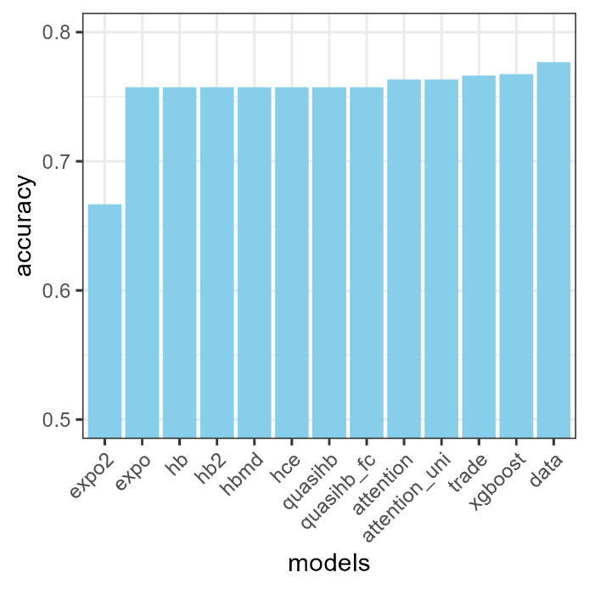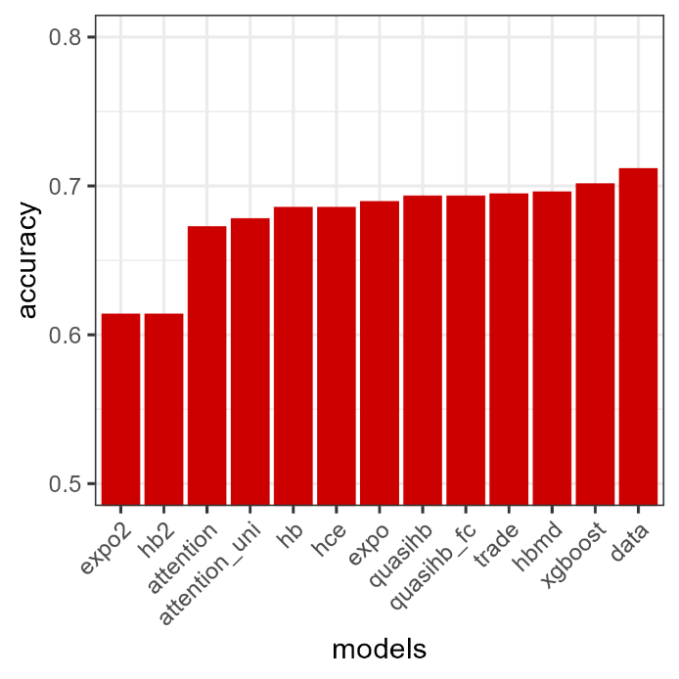

1. The *Chávez* data
2. The *Ericson* data

There are three notable points about the results. First, if we take the choices of the majority of people as the prediction, our accuracy will be 70.2% for the *Ericson* data and 76.7% for the *Chávez* data (we make a single prediction for each question, which means there is always a minority of people choosing the other option rather than the predicted one). This is reflected by the bar “data” in each sub-figure. Such numbers are the upper limits of predictive accuracy, and when the performance of a model approaches the limits, a further increase in model performance could be difficult. Thus, the predictive accuracy for many of the models is close to each other. Testing more conditions on a larger sample may mitigate this issue.

Second, the performance of “xgboost” dominates the other models. The intertemporal tradeoff model also has a good performance – one reason might be that such models use some features to capture the interaction effect between two options while the other models (time discounting models) do not. Thus, if we purely focus on goodness of fit, carefully constructing features may be more important than the structure of a model itself.

Third, the attentional discounted utility model may not perform very well on the *Ericson* data. This is partly because this datasets contains some very small amounts in money. In this dataset, 33% of the small sooner rewards are smaller than $5, while 15% of them are between $1,000 and $10,000. The attentional discounted utility model uses an exponential structure, thus may not be good at distinguishing those small amounts. If we omits these small amounts (<$5) or use a log utility function, the model can actually perform a lot better (ranking just behind the xgboost model).

1. Experimental tests

The experiment is to test whether attention allocation over sequential outcomes may affect intertemporal choices. Suppose a decision maker needs to choose between: (A) receive £100 today. (B) receive £50 today and £70 in 1 month. Option A is a single-period reward, so measuring the value of option A is straightforward. Option B consists of two periods, thus it may involve some attention allocation process while integrating the rewards in each period together.

According to the model prediction, when we increase “1 month” to some longer delay, the decision maker has to split attention over a wider time interval; thus, she has less attention that could be allocated to the immediate reward (£50). Meanwhile, when we increase “£70” by some amount, it can capture more attention; in this case, she will also pay less attention to the immediate reward £50. Under such circumstances, the decision maker is less sensitive to the changes in the immediate reward in option B; thus, increasing that by the same amount may lead fewer people to shift their choices from A to B.

**Other work**

1. Information and the willingness to exert effort

This is the first work that I did after upgrade. At that point, I wish to test the relationship between the timing of information and the willingness to exert effort. I designed an experiment. There are multiple trials in the experiment. In each trial, there are some tedious tasks (such as typing the CAPTCHA code), and the participants can get a fixed amount of reward after completing the tasks. They can choose to complete the tasks or skip (at any time) to the next trial. The number of tasks in each trial can be either 3 or 6, each occurring with equal probability. There are two conditions: (1) the number of tasks is revealed when each trial begins; (2) the number of tasks is revealed when you have completed 3 tasks.

In the first condition, when the number of tasks in a trial is revealed to be 6, you may prefer to skip. In the second condition, you do not know how many tasks need to be done when a trial begins, but if you skip, you cannot get the reward. Thus, you might try to do some tasks and wait for the outcome to be revealed. Even if it turns out that the number of tasks is 6, given that you’ve already did 3 tasks, you may not want to quit. Therefore, I expect people to be more likely to complete the tasks in second condition than in the first condition.

The interesting point is, previously we often assume that people avoid facing uncertainty in their work; however, in some cases such as the second condition in the experiment, uncertainty may push people to work more.

I wrote the experimental program, got the ethic approval, but there are three issues: (1) this experiment has multiple trials, so finishing that may need quite a long time (need a high participation fee and might be not proper for online study); (2) I went to Royalflush; (3) there is not much literature, or a widely recognized theory on the cost function of effort, though my argument relies on it.

1. Valuation of effort

I come up a new method to characterize the cost function of effort, based on the insights from rational inattention theory. The experimental design is as follows. Suppose there are 5 red balls and 5 blue balls in a black box. You can change the color of a ball by completing a task. You can freely decide how many tasks you want to complete; after that, you randomly draw a ball from the box. If a red ball is drawn, you can get reward $R$; if a blue ball is drawn, you can get reward $B$, where $R>B$.

Suppose you change $x$ blue balls to red balls. The cost of effort can be denoted by $C(x)$. I assume that you select $x$ to maximize the expected utility, i.e. $\frac{5+x}{10}R+\frac{5-x}{10}B-C\left(x\right)$. Thus, $C^{'}\left(x\right)=0.1\left(R-B\right)$. We can manipulate the reward for red ball and blue ball to elicit the marginal value of effort.

I wrote the experimental program. But before doing this research, maybe it would be better to run an experiment without effort, because the following question is more fundamental.

1. Value integration in risky choices

Suppose you place 10 balls (red and blue) in a box. Then a ball is drawn randomly from it. Your payoff depends on the color of the ball drawn, and there are two possible scenarios:

Scenario 1: If a red ball is drawn, you win £2; if a blue ball is drawn, you win £0.

Scenario 2: If a red ball is drawn, you win £0; if a blue ball is drawn, you win £1.

You will be assigned to each scenario with equal probability. Ahead of a draw, you can choose how many red and blue balls to place in the box. How would you choose?

Now, the two scenarios change to:

Scenario 1: If a red ball is drawn, you win £2; if a blue ball is drawn, you win £1.

Scenario 2: If a red ball is drawn, you win £0; if a blue ball is drawn, you win £0.

In this case, how many red and blue balls would you choose to place in the box?

These two question use the same paradigm as what I describe above, but the participants can change the color of balls without exerting effort. I expect people would put more red balls in the second condition than in the first condition. If so, it means that people may compare the options in each state separately, then integrate them; rather than compute the expect value of each option, then compare them (because the expected value matrix is the same for each condition).

1. Something I did in Royalflush

That’s a long story. The goal of people in Royalflush is to build a robot financial advisor, that can provide all kinds of information and advice to their users. At first, they counted on behavioral finance, that’s why I went there. Then things have changed…I did quite a lot of work there, and one of them is building a very complex model of lifecycle consumption and portfolio choice. A small team in CS department of Zhejiang University is seeking to solve the technical problems in this model based on some reinforcement learning algorithms. If they succeed, I may apply the attentional discounted utility model to a lifecycle problem.

Anderson, B. A., Laurent, P. A., and Yantis, S. (2011). Value-driven attentional capture. *Proceedings of the National Academy of Sciences*, *108*(25), 10367–10371. https://doi.org/10.1073/pnas.1104047108

Broadbent, D. E. (1958). *Perception and communication.* Pergamon Press. http://content.apa.org/books/10037-000

Busemeyer, J. R., and Townsend, J. T. (1993). Decision field theory: A dynamic-cognitive approach to decision making in an uncertain environment. *Psychological Review*, *100*(3), 432–459. https://doi.org/10.1037/0033-295X.100.3.432

Caplin, A., Dean, M., and Leahy, J. (2022). Rationally Inattentive Behavior: Characterizing and Generalizing Shannon Entropy. *Journal of Political Economy*, *130*(6), 1676–1715. https://doi.org/10.1086/719276

Chávez, M. E., Villalobos, E., Baroja, J. L., and Bouzas, A. (2017). Hierarchical Bayesian modeling of intertemporal choice. *Judgment and Decision Making*, *12*(1), 19–28. https://doi.org/10.1017/S1930297500005210

Ericson, K. M., White, J. M., Laibson, D., and Cohen, J. D. (2015). Money Earlier or Later? Simple Heuristics Explain Intertemporal Choices Better Than Delay Discounting Does. *Psychological Science*, *26*(6), 826–833. https://doi.org/10.1177/0956797615572232

Golman, R., Hagmann, D., and Loewenstein, G. (2017). Information Avoidance. *Journal of Economic Literature*, *55*(1), 96–135. https://doi.org/10.1257/jel.20151245

Gottlieb, J. (2012). Attention, Learning, and the Value of Information. *Neuron*, *76*(2), 281–295. https://doi.org/10.1016/j.neuron.2012.09.034

Matějka, F., and McKay, A. (2015). Rational Inattention to Discrete Choices: A New Foundation for the Multinomial Logit Model. *American Economic Review*, *105*(1), 272–298. https://doi.org/10.1257/aer.20130047

Olafsson, A., and Pagel, M. (2017). *The Ostrich in Us: Selective Attention to Financial Accounts, Income, Spending, and Liquidity* (w23945). National Bureau of Economic Research. https://doi.org/10.3386/w23945