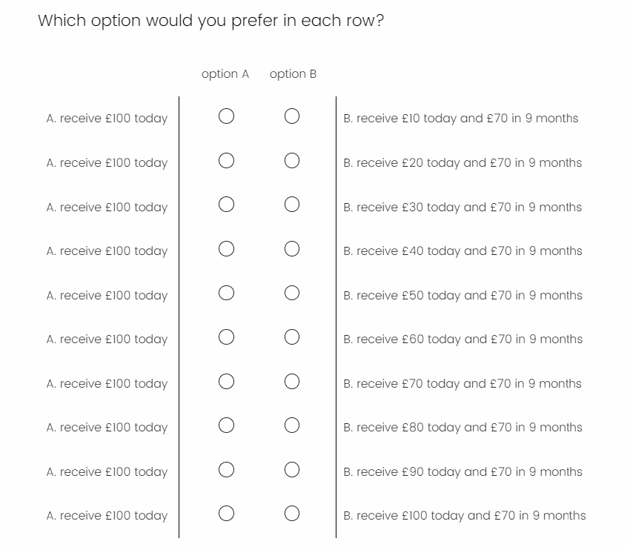

option A

(immediate reward)

immediate reward of option B

delayed reward of option B

time length of option B

the amount **varying** across rows

the amount **constant** across rows