BFCM 2026 · COMPETITOR RESEARCH
BFCM 2026 Competitor Research Report
Every product we sell for Black Friday – Cyber Monday 2026, every competitor we track against it, what worked in BFCM 2025, the deal prices we plan and the stock we need to Nov 30.
Owner: Shayan Rana · Prepared for Erik Fisher & Joseph Fisher
Data as of Oct 15, 2026 · United States and Canada
COMPETITORS TRACKED  744  US 661 · CA 83 | DIRECT COMPETITORS  403  same product type and material | OUR BFCM 2025 SALES LIFT  2.74x · 3.14x  US · CA, BFCM week vs 30 days before | CHECKS PASSED  16 of 16  re-computed from the raw data

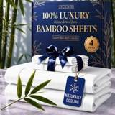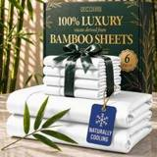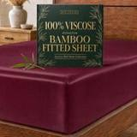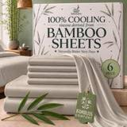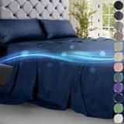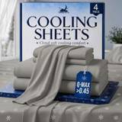
DC B4 · DC B6 · DC Bamboo Fitted · SL B6 · DC Cooling 4pc · SL Cooling 4pc

Contents
1. Executive summary
2. How the tracker works
3. Competitor classification
4. BFCM 2025: what worked
5. BFCM 2026 deal prices
6. Stock to Nov 30
7. Product chapters: United States
DC B4 · DC B6 · DC Bamboo Fitted · SL B6 · DC Cooling 4pc · SL Cooling 4pc · SL Cooling Comforter · SL Cooling Fitted · SL Cooling Pillowcase · DC S4 · DC S6 · DC Satin Fitted · SSS4 · CL Cooling Sheets · CL Pillowcases · DC Beach Towel · DC Chair Cover · DC Linen Curtains · DC Welcome Sign · SL Quilt Set · DC Silk Pillowcase · SL Mask Contoured · SL Mask Velcro · SL B4 · SL Bamboo Pillowcase · SL Cooling 6pc · SL Satin 6pc
8. Product chapters: Canada
DC B4 · DC B6 · DC S4 · DC S6 · DC Satin Fitted · SSS4
9. Verification
10. Open items and next steps
Appendix: glossary

Click any entry to jump to it. Every product chapter starts on its own page with the product photo, its key numbers, its BFCM 2026 deal and stock position, a price map and the full list of competitors with photos.

1. Executive summary
This report is the written, shareable version of the BFCM 2026 competitor tracker. It covers the same data as the tracker workbook and dashboard: every product, every mapped competitor, the BFCM 2025 results, the BFCM 2026 deal prices and the stock outlook to Nov 30.
PRODUCTS COVERED  33  27 US · 6 Canada listings | COMPETITORS  744  403 direct · 150 alternative material | BFCM 2025 DEAL HISTORY  706  competitors with a known BFCM 2025 deal type | STRIKETHROUGH SHOWN TODAY  231 of 723  competitor pages checked

BFCM 2026 DEALS  22  product listings with a deal price (deal sheet, Oct 27) | DEAL DISCOUNT (HERO)  5%–41%  off today's price; Bamboo 4 and 6 Piece deepest | VARIATIONS SHORT TO NOV 30  377  186 out of stock now · 191 short even with inbound | VARIATIONS COVERED  1,006  89 of them only if inbound arrives in time

Key findings
- A plain price cut moved rank the most in BFCM 2025. In the US, competitors that only cut the price improved their Best Seller Rank by a median 1.56x (114 competitors), against 1.03x for a Prime Exclusive Discount (265) and 1.00x for no deal (139).
- BFCM is a big week for us. Our sales per day in BFCM week 2025 were 2.74x the 30 days before in the US and 3.14x in Canada. Each product's own lift (Section 4) drives its stock need.
- Most of our rivals are direct. 403 of 744 competitors sell the same product type in the same material family as ours. They lead every competitor list in this report; alternative-material rivals are kept separately so they don't distort the price comparison.
- Deal prices now come from the team's deal sheet. For 22 product listings the report shows today's price and the actual BFCM 2026 deal price from the Oct 27 deal page export (one price per deal, 5%–41% off on the hero variation), next to our own 2025 cut and the median cut rivals ran in 2025 (Section 5). Amazon's maximum moves daily until the Nov 13 deadline.
- Stock is the main risk. 28 of 30 products with stock data have at least one variation that runs short before Nov 30: 186 variations are out of stock now and 191 are short even if all inbound arrives (Section 6 and each product chapter).

Decisions this report supports
- Which deal type to run per product, using the BFCM 2025 rank lift by deal type.
- Whether our BFCM 2026 deal price undercuts the direct competitors (the price map in each product chapter).
- Which variations need stock sent now, and which cannot be covered in time.

2. How the tracker works
The tracker follows seven steps. Every competitor row carries the same fields, so any product can be compared with any other.
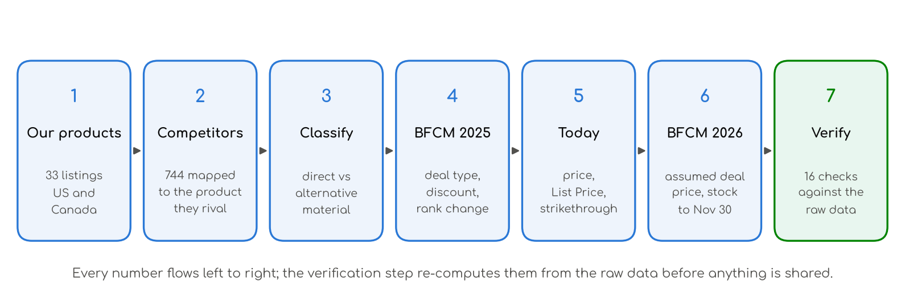

What each step means
Step | What it covers
1. Our products | 33 product listings: 27 in the United States and 6 in Canada. Each has a role for BFCM (hero, core, clearance, gifting, off-season, launch, liquidation) and a scope (Core, Other, Not launched).
2. Competitors | 744 competitor listings, each mapped to the product it competes with. Price, List Price, Best Seller Rank, rating, reviews and weekly units are for the competitor's tracked size, so the comparison is like for like.
3. Classify | Each competitor is Direct (same product type, same material family), Alternative material, Material not verified or Different product type. Section 3 shows the rule.
4. BFCM 2025 | For each competitor: the deal type it ran, the price before BFCM (median Nov 1–19) and during BFCM week, the discount, and how its Best Seller Rank changed. Rank lift = rank before ÷ rank during, so 1.50x means 50% better.
5. Today | Today's price, List Price, whether Amazon shows a strikethrough and at what price, and any deal running now.
6. BFCM 2026 | The deal and deal price for every variation (team deal sheet, Oct 27) and stock: units at Amazon and inbound vs the units needed to Nov 30.
7. Verify | 16 checks re-compute the numbers from the raw data and compare the workbook with the dashboard. All pass (Section 9).

How to read the competitor tables
Column | Meaning
Photo, competitor | Product photo, brand, listing title, material and rating with review count. A Coming Soon image means no photo is available yet.
Size · colour | The variation tracked. Prices compare like for like with our same size where we sell it.
Price / List | Today's price and the List Price the listing shows.
vs ours | How far the competitor's price is from ours for the same size: −20% means 20% cheaper than us.
Strikethrough | Whether Amazon shows a crossed-out reference price today, and its value.
BFCM 2025 deal | Deal type run in BFCM 2025: Price cut only, Prime Exclusive Discount, Coupon only, Lightning Deal, Best Deal, or None.
2025 before → during | Median price Nov 1–19, 2025 → lowest price in BFCM week, and the discount between them.
Rank lift | Best Seller Rank before ÷ during BFCM week. Above 1.00x = rank improved.
Units / wk | Estimated units sold per week today.

3. Competitor classification
Our products are compared first with competitors that sell the same thing in the same material. A bamboo sheet set is compared with other bamboo-viscose sheet sets; a cooling sheet set made of nylon-spandex cooling knit is compared with other cooling knits, not with bamboo or microfiber. Rivals in other materials are kept, but in their own group, so they don't distort the price comparison.
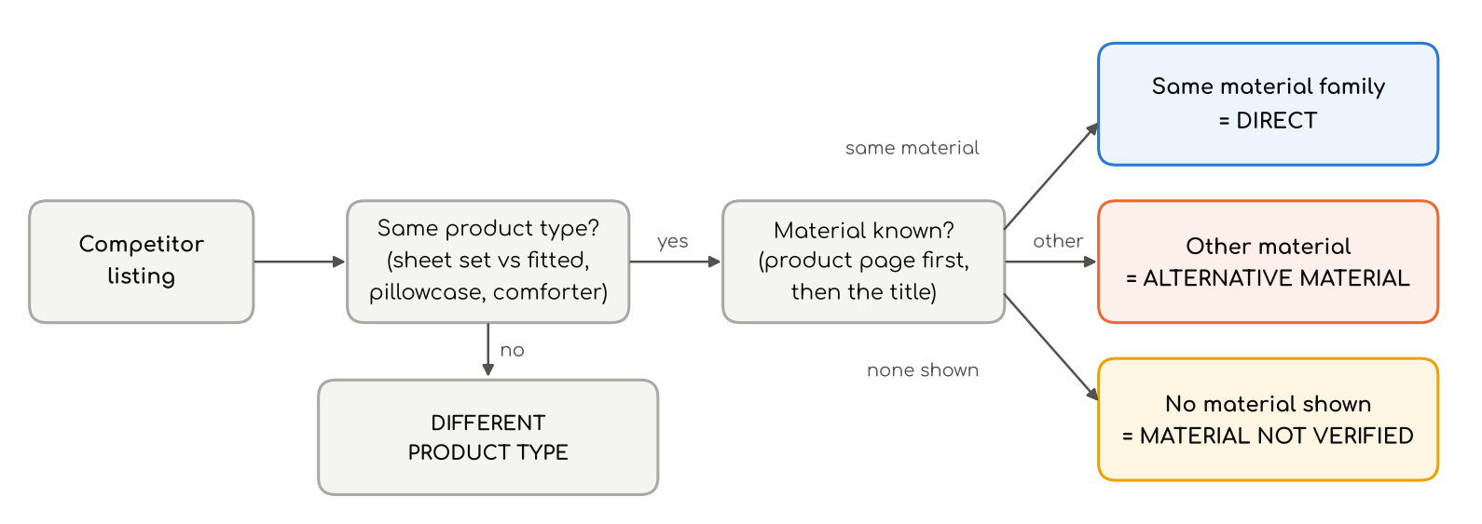
Group | Competitors | Rule
Direct | 403 | Same product type and the same material family as ours (material from the competitor's product page where checked, otherwise its title).
Material not verified | 30 | Same product type, but neither the page nor the title names the material. Treated as a possible direct rival.
Alternative material | 150 | Same product type, different material (e.g. microfiber or cotton against our bamboo).
Different product type | 26 | A different product (e.g. a fitted sheet only against our full sheet set).
Not classified | 135 | Products outside the sheet, pillowcase and comforter families (curtains, towels, chair covers, signs, quilts, masks), where a material rule doesn't apply.

Our materials
Our product family | Material it is compared on
Bamboo sheets and pillowcases (Decolure, Sleep Sanctuary, Sleephoria) | Viscose from bamboo
CooLinens and Sleephoria cooling sheets, pillowcases, comforter | Synthetic nylon-spandex cooling knit (CooLinens 90% nylon / 10% spandex; Sleephoria BreezeWeave is the same fabric family)
Decolure cooling sheets | Microfiber blend (a different material from Sleephoria cooling)
Satin sheets | Polyester satin
Silk pillowcase and sleep masks | Mulberry silk
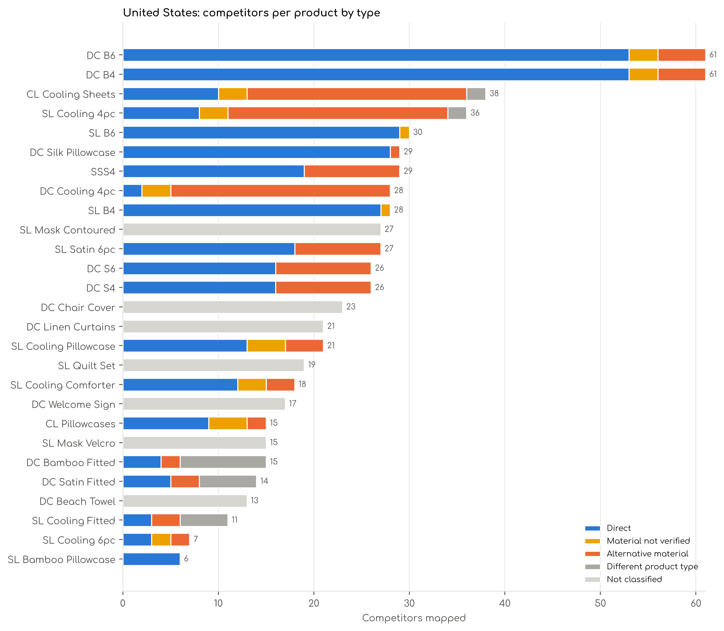
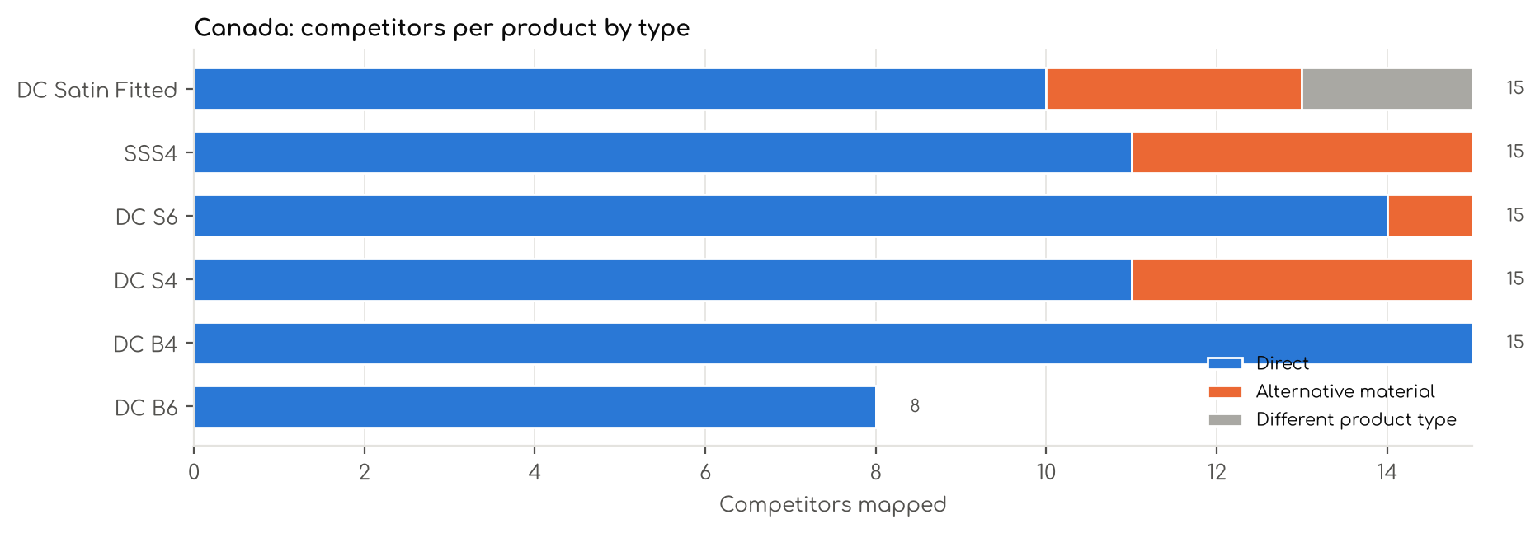

4. BFCM 2025: what worked
Rank lift compares each competitor's Best Seller Rank in BFCM week 2025 with its median rank Nov 1–19. 1.00x means no change; 1.50x means the rank number fell by a third (better). Only competitors with a measured rank in both periods are counted, and deal types with fewer than 3 competitors are left out.
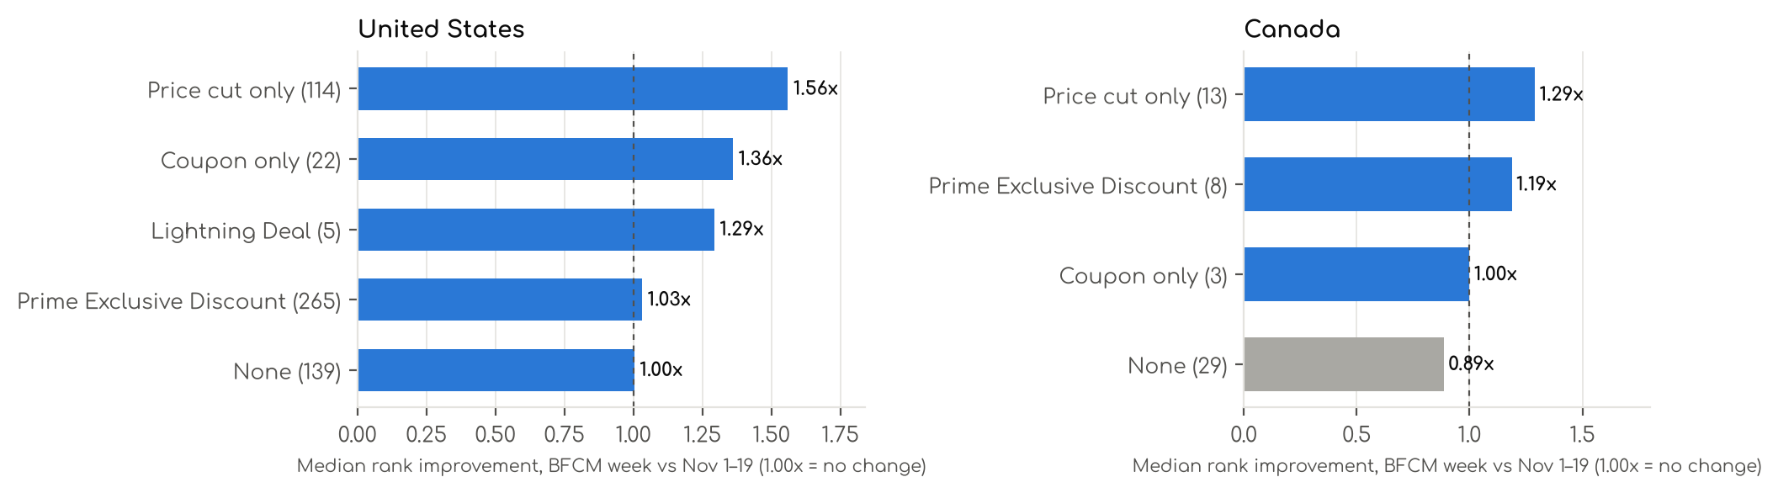

United States
Deal type in BFCM 2025 | Competitors | Median rank lift | Median discount | Share that improved
Price cut only | 114 | 1.56x | 20% | 83%
Coupon only | 22 | 1.36x | 19% | 64%
Lightning Deal | 5 | 1.29x | 26% | 60%
Prime Exclusive Discount | 265 | 1.03x | 17% | 57%
None | 139 | 1.00x | 0% | 50%

Canada
Deal type in BFCM 2025 | Competitors | Median rank lift | Median discount | Share that improved
Price cut only | 13 | 1.29x | 15% | 69%
Prime Exclusive Discount | 8 | 1.19x | 22% | 63%
Coupon only | 3 | 1.00x | 20% | 33%
None | 29 | 0.89x | 0% | 31%

Deeper discount vs rank change
Each dot is one US competitor in BFCM 2025. A deeper discount does not guarantee a better rank: many Prime Exclusive Discounts at 15–25% left rank flat, while plain price cuts more often moved it.
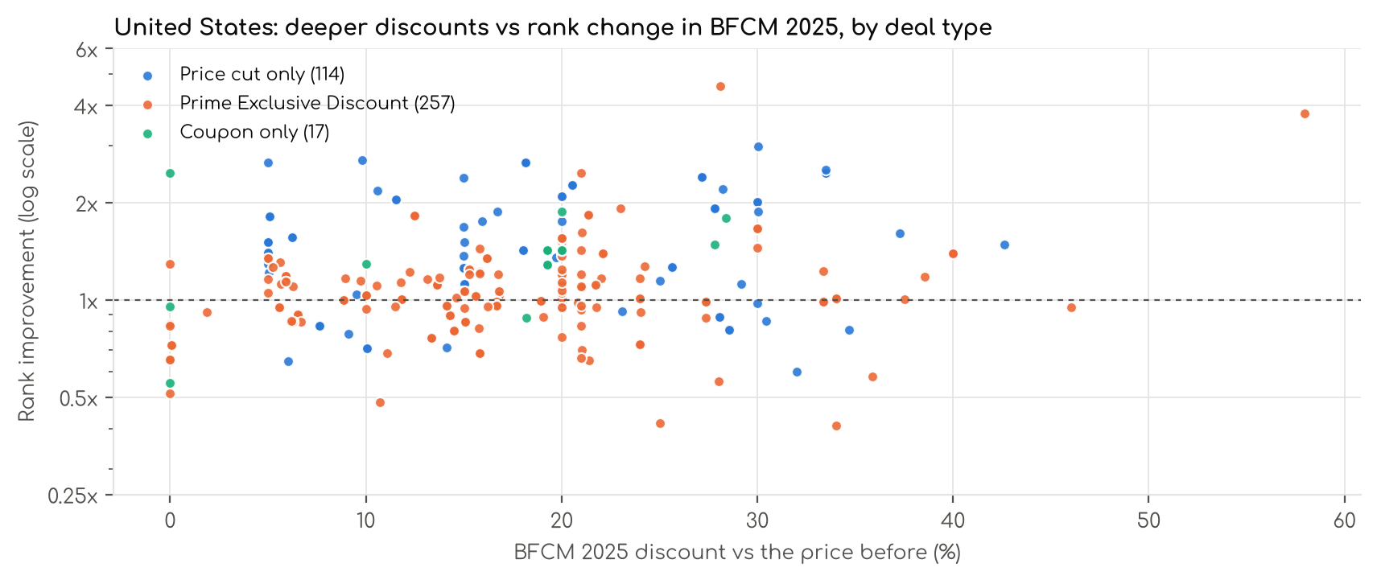

Our own BFCM 2025 sales lift
Sales lift = our sales per day in BFCM week 2025 (Nov 20 – Dec 1, 12 days) ÷ sales per day in the 30 days before (Oct 21 – Nov 19). Account level: 2.74x in the US, 3.14x in Canada. TACoS = ad cost ÷ total sales.
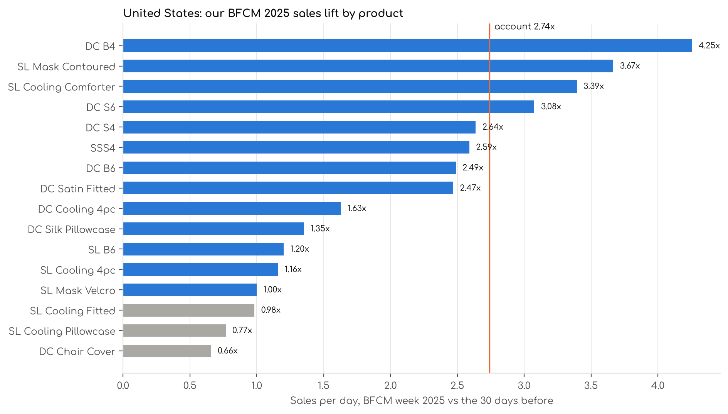
Product | Sales lift | Sales / day, 30 days before | Sales / day, BFCM week | Units, 30 days before | Units, BFCM week | TACoS before | TACoS BFCM
DC B4 | 4.25x | $6,608 | $28,119 | 2,758 | 5,141 | 13.0% | 6.8%
SL Mask Contoured | 3.67x | $2 | $7 | 3 | 5 | 0.0% | 0.0%
SL Cooling Comforter | 3.39x | $549 | $1,862 | 274 | 459 | 27.0% | 12.3%
DC S6 | 3.08x | $878 | $2,699 | 797 | 1,072 | 19.8% | 14.9%
DC S4 | 2.64x | $4,609 | $12,155 | 4,334 | 4,995 | 15.0% | 8.0%
SSS4 | 2.59x | $1,170 | $3,029 | 1,022 | 1,207 | 18.3% | 15.8%
DC B6 | 2.49x | $8,788 | $21,868 | 3,442 | 3,572 | 7.4% | 6.4%
DC Satin Fitted | 2.47x | $1,000 | $2,470 | 1,630 | 1,910 | 11.2% | 7.8%
DC Cooling 4pc | 1.63x | $161 | $262 | 123 | 83 | 9.7% | 10.0%
DC Silk Pillowcase | 1.35x | $317 | $429 | 189 | 104 | 31.7% | 33.6%
SL B6 | 1.20x | $929 | $1,116 | 423 | 231 | 35.5% | 18.7%
SL Cooling 4pc | 1.16x | $2,540 | $2,942 | 1,179 | 547 | 18.2% | 7.1%
SL Mask Velcro | 1.00x | $1 | $1 | 2 | 1 | 2.3% | 8.5%
SL Cooling Fitted | 0.98x | $207 | $203 | 269 | 102 | 0.0% | 0.0%
SL Cooling Pillowcase | 0.77x | $330 | $254 | 606 | 191 | 45.5% | 42.9%
DC Chair Cover | 0.66x | $23 | $15 | 17 | 5 | 12.1% | 4.3%
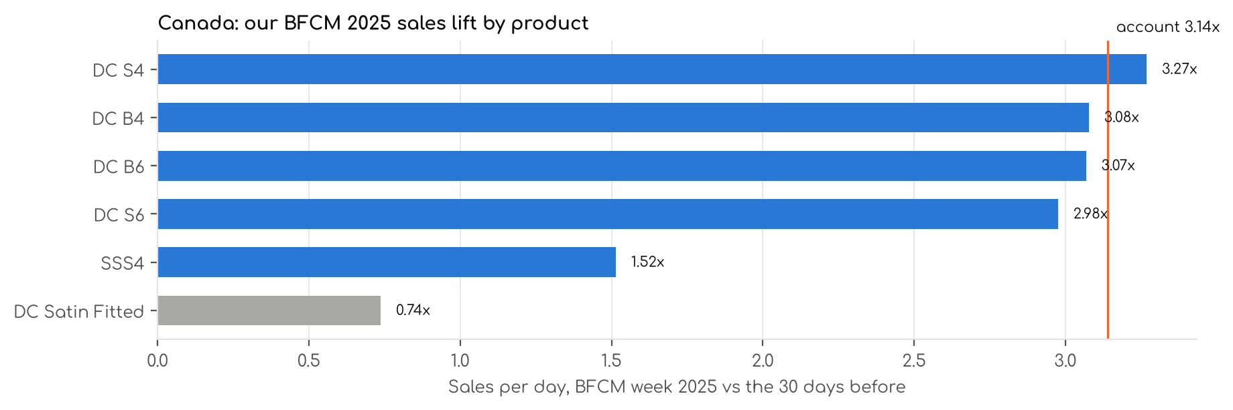
Product | Sales lift | Sales / day, 30 days before | Sales / day, BFCM week | Units, 30 days before | Units, BFCM week | TACoS before | TACoS BFCM
DC S4 | 3.27x | C$1,576 | C$5,153 | 1,704 | 2,667 | 15.1% | 10.7%
DC B4 | 3.08x | C$1,280 | C$3,941 | 636 | 908 | 13.1% | 12.2%
DC B6 | 3.07x | C$2,604 | C$7,990 | 1,315 | 1,982 | 12.3% | 6.0%
DC S6 | 2.98x | C$838 | C$2,493 | 918 | 1,201 | 16.6% | 13.1%
SSS4 | 1.52x | C$6 | C$8 | 5 | 3 | 0.0% | 0.0%
DC Satin Fitted | 0.74x | C$315 | C$233 | 618 | 168 | 0.0% | 1.3%

5. BFCM 2026 deal prices
Deal prices come from the team's BFCM deal sheet (Amazon deal page export, Oct 27, 2026). For every variation it shows the deal, its dates, today's price and Amazon's maximum deal price, or a manual price where one is set. A Best Deal runs at one price for all its days. The deal price is shown next to the evidence: the cut we ran on the same product in BFCM 2025 and the median cut our competitors ran.
Amazon's maximum moves daily until the Nov 13 deadline. On Oct 27 most deals needed only about 5% off today's price, while Bamboo 4 and 6 Piece needed 20–28%. Prices here are refreshed with each new export. Each product chapter lists every variation's deal status (eligible, out of stock, no reference price, flagged).
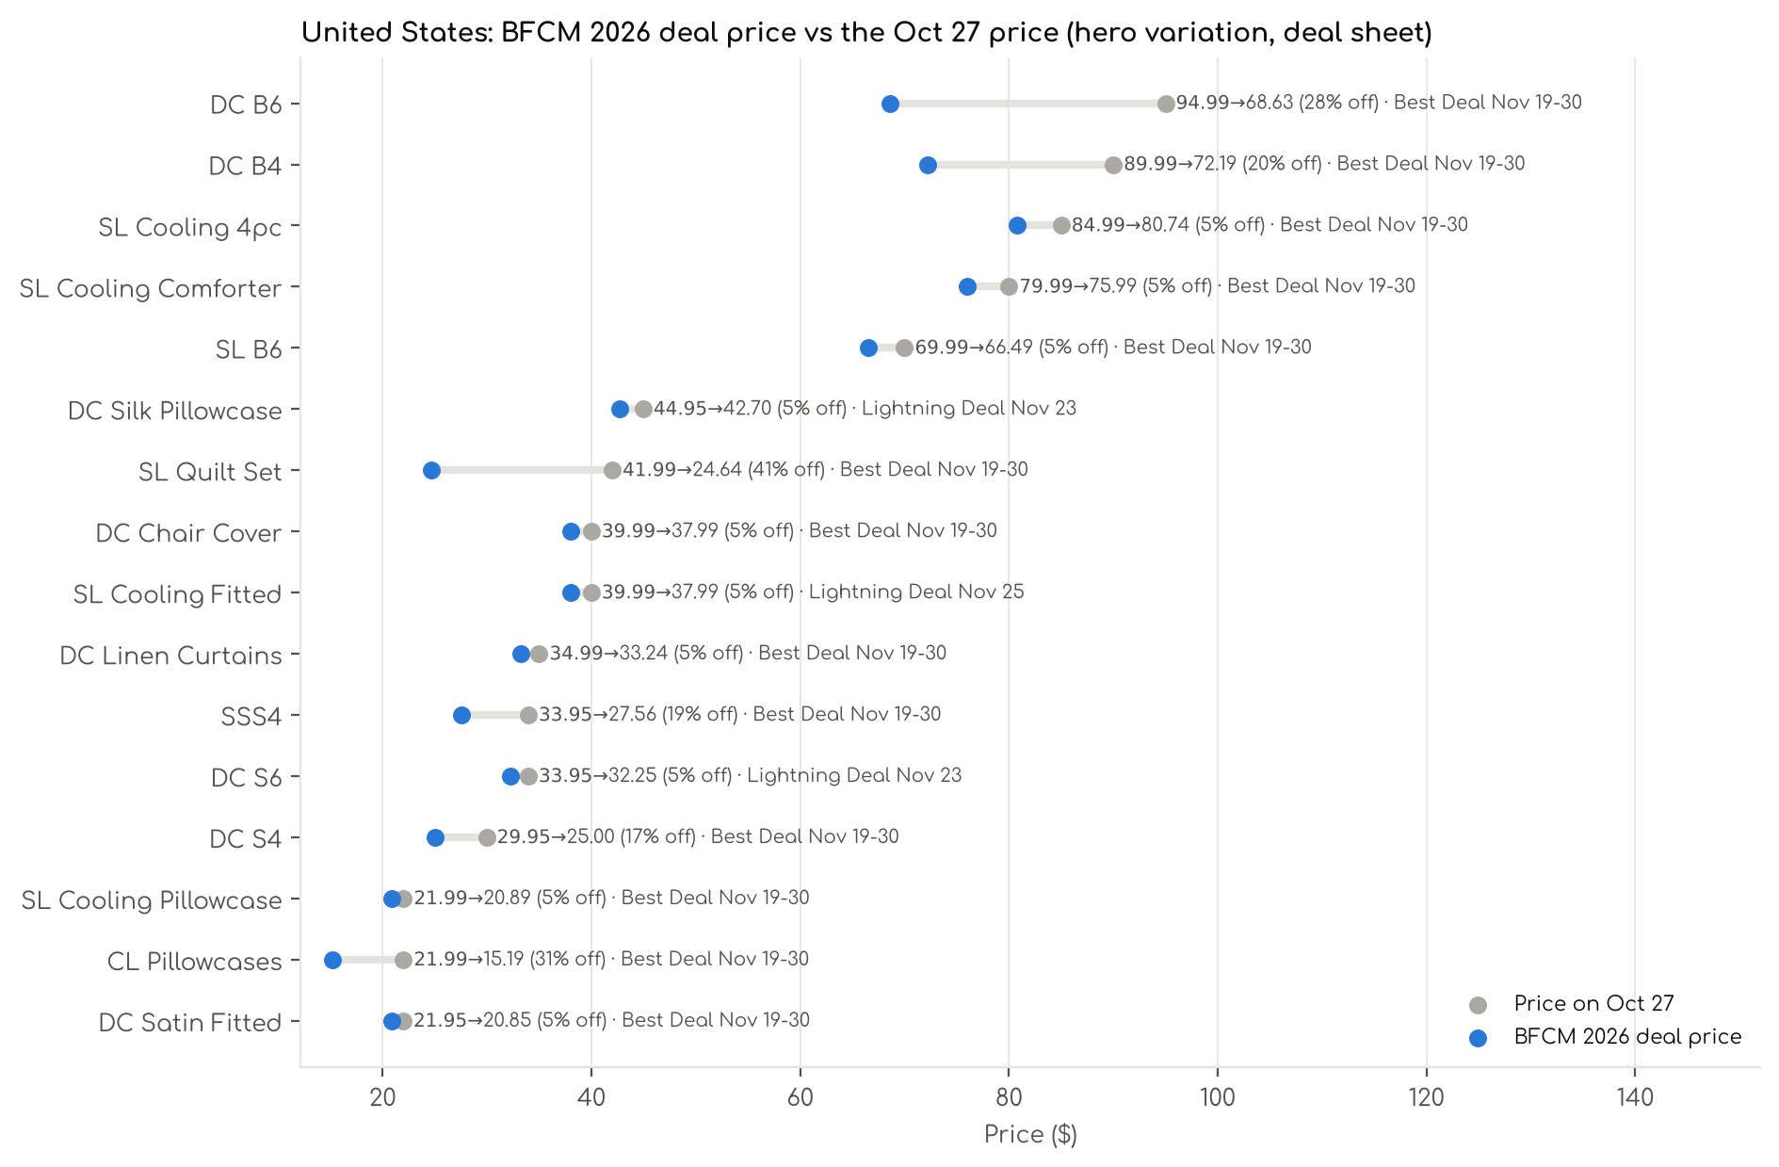
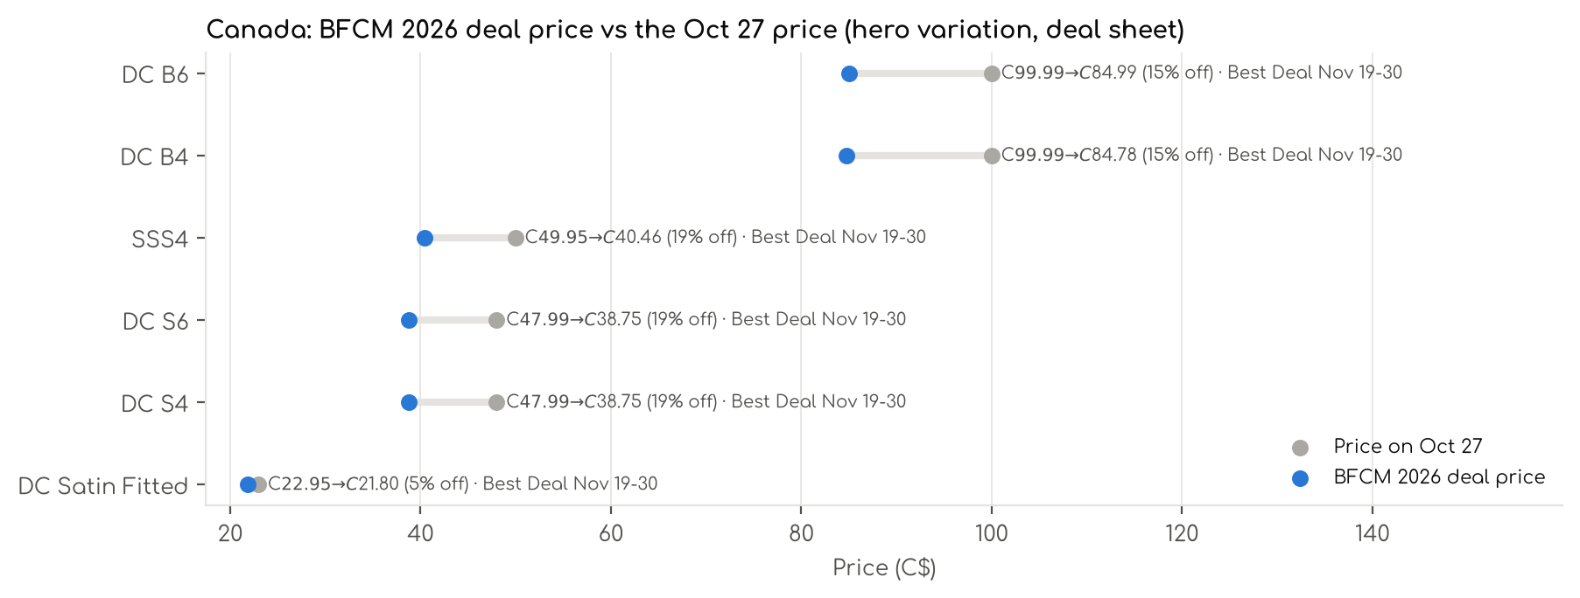

Deal prices by product
Product | Mkt | Deal | Hero variation | Price Oct 27 | Deal price | Off | Range across variations | Our 2025 cut | Rivals' 2025 cut | Direct median today
DC B4 | US | Best Deal Nov 19-30 | King White | $89.99 | $72.19 | 20% | 7%–30% | 5% | 26% (7) | $79.99
DC B6 | US | Best Deal Nov 19-30 | King White | $94.99 | $68.63 | 28% | 5%–39% | 5% | 26% (7) | $79.99
SL B6 | US | Best Deal Nov 19-30 | King Taupe | $69.99 | $66.49 | 5% | 0%–5% | 0% | 24% (4) | $79.99
SL Cooling 4pc | US | Best Deal Nov 19-30 | King Light Grey | $84.99 | $80.74 | 5% | 0%–5% | 0% | 21% (7) | $144.99
SL Cooling Comforter | US | Best Deal Nov 19-30 | King Light Grey & Dark Grey | $79.99 | $75.99 | 5% | 5%–5% | 20% | 15% (4) | $46.95
SL Cooling Fitted | US | Lightning Deal Nov 25 | King White | $39.99 | $37.99 | 5% | 0%–20% | 0% | 17% (2) | $74.99
SL Cooling Pillowcase | US | Best Deal Nov 19-30 | Queen Blue | $21.99 | $20.89 | 5% | 0%–5% | 0% | 29% (2) | $17.52
DC S4 | US | Best Deal Nov 19-30 | Queen Black | $29.95 | $25.00 | 17% | 0%–25% | 15% | 8% (3) | $23.49
DC S6 | US | Lightning Deal Nov 23 | King Black | $33.95 | $32.25 | 5% | 0%–23% | 5% | 8% (3) | $23.49
DC Satin Fitted | US | Best Deal Nov 19-30 | Queen Black | $21.95 | $20.85 | 5% | 5%–5% | 11% | 5% (2) | $13.99
SSS4 | US | Best Deal Nov 19-30 | Queen Navy Blue | $33.95 | $27.56 | 19% | 3%–23% | 7% | 6% (4) | $21.99
CL Pillowcases | US | Best Deal Nov 19-30 | Queen White | $21.99 | $15.19 | 31% | 29%–31% | — | 29% (2) | $16.99
DC Chair Cover | US | Best Deal Nov 19-30 | Pack of 6 Chocolate | $39.99 | $37.99 | 5% | 0%–5% | 5% | 30% (3) | $22.94
DC Linen Curtains | US | Best Deal Nov 19-30 | 52x108 Ivory | $34.99 | $33.24 | 5% | 0%–5% | — | 31% (6) | $23.99
SL Quilt Set | US | Best Deal Nov 19-30 | Queen Ivory | $41.99 | $24.64 | 41% | 0%–41% | — | 13% (4) | $32.28
DC Silk Pillowcase | US | Lightning Deal Nov 23 | Standard White | $44.95 | $42.70 | 5% | 5%–5% | 0% | 15% (6) | $22.49
DC B4 | CA | Best Deal Nov 19-30 | Queen White | C$99.99 | C$84.78 | 15% | 0%–31% | 5% | 26% (7) | C$74.99
DC B6 | CA | Best Deal Nov 19-30 | King Taupe | C$99.99 | C$84.99 | 15% | 0%–79% | 5% | 26% (7) | C$159.97
DC S4 | CA | Best Deal Nov 19-30 | Queen Black | C$47.99 | C$38.75 | 19% | 0%–39% | 15% | 8% (3) | C$44.96
DC S6 | CA | Best Deal Nov 19-30 | Queen Black | C$47.99 | C$38.75 | 19% | -14%–35% | 5% | 8% (3) | C$59.45
DC Satin Fitted | CA | Best Deal Nov 19-30 | Queen Black | C$22.95 | C$21.80 | 5% | -38%–5% | 11% | 5% (2) | C$23.90
SSS4 | CA | Best Deal Nov 19-30 | King Stone Grey | C$49.95 | C$40.46 | 19% | 0%–23% | 7% | 6% (4) | C$44.96
Hero variation = our best seller in the deal. Range = discount off today's price across all variations with a deal price. Direct median today = the median price of this product's direct competitors.

6. Stock to Nov 30
For every variation: units needed = today's sales per day × 34 days (Oct 16 – Nov 18) + today's sales per day × the BFCM lift × 12 days (Nov 19–30). The lift is the product's own BFCM 2025 sales lift where it is reliable (0.8x to 8x); otherwise the account lift (US 2.74x, Canada 3.14x) is used and marked *.
Status | Variations | Meaning
Covered to Nov 30 | 917 | Units at Amazon now cover the need to Nov 30.
Needs inbound in time | 89 | Covered only if the inbound units arrive before the variation runs out. Inbound has no confirmed arrival date yet.
Short even with inbound | 191 | At Amazon + inbound is less than the need; more stock has to be sent.
Out of stock now | 186 | Zero units at Amazon today.
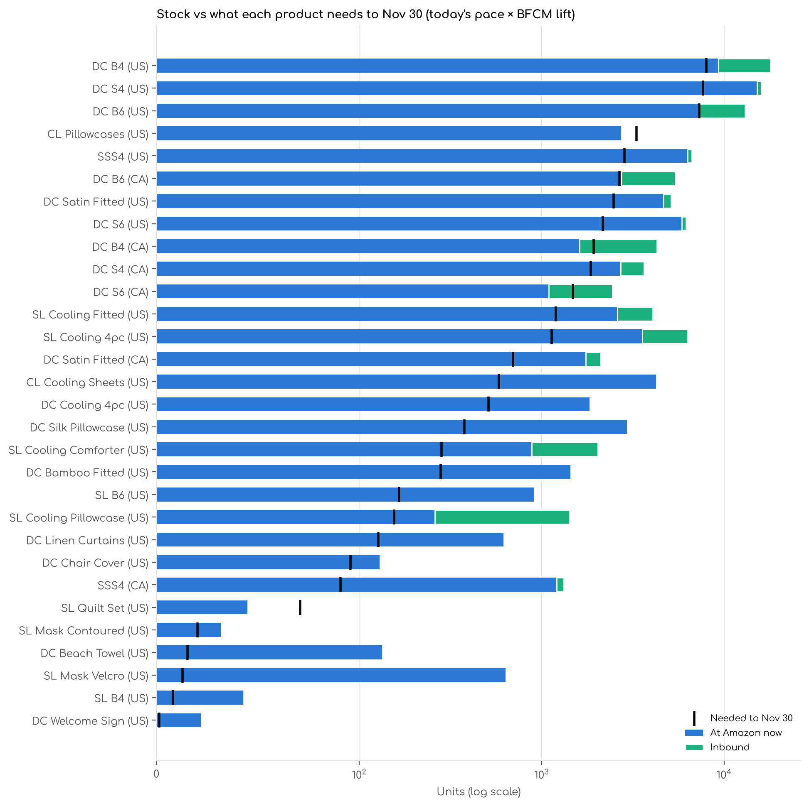

Stock by product
Product | Mkt | Sales / day | Lift used | At Amazon | Inbound | Needed to Nov 30 | Covered | Needs inbound | Short | Out now
DC B4 | US | 93.7 | 4.25x | 9,323 | 8,578 | 7,973 | 37 | 30 | 7 | 6
DC S4 | US | 117.0 | 2.64x | 15,135 | 832 | 7,679 | 72 | 4 | 25 | 8
DC B6 | US | 114.3 | 2.49x | 7,216 | 5,817 | 7,299 | 50 | 16 | 10 | 3
CL Pillowcases | US | 49.5 | 2.74x * | 2,737 | 0 | 3,308 | 5 | 0 | 7 | 0
SSS4 | US | 43.7 | 2.59x | 6,303 | 336 | 2,842 | 64 | 1 | 16 | 11
DC B6 | CA | 37.6 | 3.07x | 2,744 | 2,642 | 2,666 | 33 | 7 | 8 | 16
DC Satin Fitted | US | 39.1 | 2.47x | 4,656 | 459 | 2,485 | 40 | 0 | 13 | 9
DC S6 | US | 30.5 | 3.08x | 5,874 | 322 | 2,164 | 90 | 2 | 11 | 5
DC B4 | CA | 27.2 | 3.08x | 1,615 | 2,658 | 1,928 | 32 | 13 | 5 | 21
DC S4 | CA | 25.4 | 3.27x | 2,705 | 940 | 1,862 | 56 | 1 | 16 | 26
DC S6 | CA | 21.3 | 2.98x | 1,094 | 1,348 | 1,485 | 43 | 6 | 21 | 27
SL Cooling Fitted | US | 26.2 | 0.98x | 2,604 | 1,461 | 1,198 | 42 | 0 | 6 | 3
SL Cooling 4pc | US | 23.7 | 1.16x | 3,570 | 2,742 | 1,134 | 41 | 8 | 3 | 7
DC Satin Fitted | CA | 9.7 | 3.14x * | 1,748 | 360 | 696 | 38 | 0 | 4 | 18
CL Cooling Sheets | US | 8.7 | 2.74x * | 4,261 | 20 | 582 | 59 | 0 | 1 | 0
DC Cooling 4pc | US | 9.6 | 1.63x | 1,835 | 15 | 511 | 37 | 0 | 4 | 2
DC Silk Pillowcase | US | 7.5 | 1.35x | 2,945 | 0 | 377 | 16 | 0 | 1 | 0
SL Cooling Comforter | US | 3.8 | 3.39x | 883 | 1,151 | 283 | 12 | 1 | 4 | 2
DC Bamboo Fitted | US | 4.2 | 2.74x * | 1,443 | 0 | 280 | 18 | 0 | 2 | 2
SL B6 | US | 3.4 | 1.20x | 912 | 0 | 165 | 33 | 0 | 7 | 4
SL Cooling Pillowcase | US | 2.3 | 2.74x * | 260 | 1,160 | 156 | 7 | 0 | 0 | 4
DC Linen Curtains | US | 1.9 | 2.74x * | 621 | 0 | 127 | 33 | 0 | 4 | 1
DC Chair Cover | US | 1.4 | 2.74x * | 130 | 0 | 96 | 2 | 0 | 4 | 2
SSS4 | CA | 1.7 | 1.52x | 1,209 | 114 | 91 | 35 | 0 | 3 | 2
SL Quilt Set | US | 1.1 | 2.74x * | 45 | 0 | 71 | 6 | 0 | 6 | 6
SL Mask Contoured | US | 0.3 | 3.67x | 32 | 0 | 20 | 2 | 0 | 2 | 0
DC Beach Towel | US | 0.2 | 2.74x * | 134 | 0 | 15 | 4 | 0 | 0 | 0
SL Mask Velcro | US | 0.3 | 1.00x | 638 | 0 | 13 | 4 | 0 | 0 | 0
SL B4 | US | 0.1 | 2.74x * | 43 | 0 | 8 | 3 | 0 | 1 | 0
DC Welcome Sign | US | 0.0 | 2.74x * | 22 | 0 | 1 | 3 | 0 | 0 | 1
* account lift used because the product's own BFCM 2025 lift was not available or not reliable. Each product chapter lists the variations that are not covered.

7. Product chapters: United States
One chapter per US product listing: core BFCM products first, then other products, then products not launched yet.

US · DC B4: Decolure Bamboo Sheets 4 Piece
 | Listing title | DECOLURE 100% Viscose from Bamboo Sheets King Size | 4 Pc Cooling Bed Set
 | Marketplace | United States
 | Family · role | Bamboo · Hero: rank and profit
 | Scope · stage | Core · Re-Launch
 | Amazon parent | B0HJCSXJQ6
 | Best seller | B08KQHRDDG (King White)
 | Variations | 81 (75 with a live price)
 | Sizes | King, Queen, California King, Full, Twin
 | Colours | 16

OUR PRICE TODAY  $94.99  King White | BFCM 2026 DEAL PRICE  $89.99 → $72.19  Best Deal Nov 19-30 · 20% off the Oct 27 price | STOCK TO NOV 30  7 short · 6 out  9,323 at Amazon · 8,578 inbound · need 7,973 | BFCM 2025 SALES LIFT  4.25x  1,813 units in the last 28 days | DIRECT COMPETITORS  53  median $79.99 · 31 cheaper than us

BFCM 2025: how this product did
Period | Sales | Units | Organic units | Ad units | Ad cost | TACoS | Sessions | Unit session % | Avg price
Oct 21 – Nov 19, 2025 (30 days before) | $198,255 | 2,758 | 2,569 | 189 | $25,869 | 13.0% | 52,332 | 5.3% | $71.88
Nov 20 – Dec 1, 2025 (BFCM week) | $337,429 | 5,141 | 4,878 | 263 | $23,068 | 6.8% | 84,261 | 6.1% | $65.63
Dec 2 – 31, 2025 | $369,105 | 4,855 | 4,550 | 305 | $36,215 | 9.8% | 69,986 | 6.9% | $76.03
Best seller in BFCM 2025: B08KQHRDDG: $74.99 before (median Nov 1 – 19) → $71.24 in BFCM week, 5% lower; Best Seller Rank 10,318 → 5,240.
Our BFCM 2025 deals: Lightning Deal 11-02 to 11-03 (cancelled, 78 variations); Lightning Deal 11-06 to 11-07 (cancelled, 78 variations); Lightning Deal 11-13 to 11-14 (cancelled, 78 variations); Best Deal 11-20 to 12-02 (ran, 78 variations, 4,890 units)
Stock in BFCM 2025: 5 of 80 variations hit zero FBA stock on at least one observed day in BFCM week; weighted by sales mix, about 0.9% of variation-days were lost.

BFCM 2026 deal
Deal | Hero variation | Price Oct 27 | Deal price | Off | Variations (deal page) | Our 2025 cut | Rivals' 2025 cut
Best Deal Nov 19-30 | King White | $89.99 | $72.19 | 20% | 78 eligible, 1 not on the deal page, 1 no reference price, 1 out of stock; 7%–30% off | 5% ($74.99 → $71.24) | 26% (7 rivals)
Deal notes
- Amazon deal price now. King White B08KQHRDDG: live $94.99, Amazon reference still $79.99 (not reset after the Oct 2 and Oct 9 price rises), Sep 15-28 Best Deal $75.99 inside the BFCM lookback, Oct 16 Lightning Deal max $67.99 (28% below live). On 13 SKUs with a higher reference Amazon still caps the deal at the Sep Best Deal price.
- Pre-BFCM deal decision. Oct 16 Lightning Deal: cancel approved to keep the BFCM price clean; running it would have pushed the BFCM deal to about $64.59 or lower on King White. 9-day STR test on Cal King Taupe and Full Creme runs to Oct 19. B4 BFCM Best Deal confirmed Nov 19-30.

Stock to Nov 30
Sales per day today 93.7 · lift used 4.25x (this product's own BFCM 2025 lift) · need to Nov 30 7,973 units · at Amazon 9,323 · inbound 8,578. Covered 37, needs inbound in time 30, short 7, out of stock now 6.
Size | Colour | At Amazon | Inbound | Sales / day | Need to Nov 30 | Short by | Runs out | Status
Queen | White | 353 | 372 | 5.7 | 485 | — | Nov 24 | Needs inbound in time
Queen | Taupe | 332 | 528 | 4.6 | 393 | — | Nov 26 | Needs inbound in time
King | Olive | 230 | 54 | 3.9 | 335 | 51 | Nov 23 | Short even with inbound
King | Navy Blue | 245 | 156 | 3.6 | 308 | — | Nov 25 | Needs inbound in time
King | Burgundy | 219 | 270 | 3.3 | 278 | — | Nov 25 | Needs inbound in time
Queen | Olive | 262 | 216 | 3.2 | 276 | — | Nov 29 | Needs inbound in time
King | Black | 171 | 174 | 2.9 | 244 | — | Nov 24 | Needs inbound in time
Queen | Navy Blue | 204 | 186 | 2.8 | 236 | — | Nov 27 | Needs inbound in time
Queen | Creme | 153 | 288 | 2.4 | 206 | — | Nov 24 | Needs inbound in time
Queen | Burgundy | 139 | 96 | 2.3 | 198 | — | Nov 24 | Needs inbound in time
Queen | Midgrey | 145 | 96 | 1.7 | 147 | — | Nov 29 | Needs inbound in time
California King | Taupe | 22 | 60 | 1.5 | 129 | 47 | Oct 29 | Short even with inbound
King | Charcoal | 4 | 138 | 1.3 | 113 | — | Oct 18 | Needs inbound in time
King | Light Pink | 34 | 90 | 1.2 | 102 | — | Nov 12 | Needs inbound in time
Queen | Charcoal | 92 | 30 | 1.2 | 100 | — | Nov 28 | Needs inbound in time
Queen | Grey | 69 | 240 | 1.1 | 96 | — | Nov 24 | Needs inbound in time
Queen | Purple | 15 | 156 | 1.0 | 87 | — | Oct 29 | Needs inbound in time
California King | White | 26 | 198 | 1.0 | 83 | — | Nov 10 | Needs inbound in time
Full | Olive | 69 | 0 | 0.9 | 80 | 11 | Nov 27 | Short even with inbound
Twin | Navy Blue | 46 | 0 | 0.9 | 77 | 31 | Nov 21 | Short even with inbound
California King | Olive | 60 | 90 | 0.9 | 74 | — | Nov 26 | Needs inbound in time
King | Light Olive | 68 | 48 | 0.9 | 73 | — | Nov 28 | Needs inbound in time
Full | Midgrey | 39 | 102 | 0.8 | 66 | — | Nov 21 | Needs inbound in time
Twin | Taupe | 34 | 0 | 0.8 | 65 | 31 | Nov 20 | Short even with inbound
California King | Black | 47 | 12 | 0.8 | 65 | 6 | Nov 24 | Short even with inbound
Full | Black | 21 | 30 | 0.7 | 55 | 4 | Nov 16 | Short even with inbound
California King | Charcoal | 8 | 162 | 0.6 | 54 | — | Oct 27 | Needs inbound in time
Full | Grey | 11 | 60 | 0.6 | 51 | — | Nov 2 | Needs inbound in time
California King | Creme | 33 | 108 | 0.6 | 48 | — | Nov 23 | Needs inbound in time
Full | Creme | 17 | 90 | 0.6 | 48 | — | Nov 14 | Needs inbound in time
Twin | Light Blue | 32 | 78 | 0.5 | 39 | — | Nov 26 | Needs inbound in time
California King | Light Blue | 0 | 48 | 0.4 | 37 | — | now | Out of stock now
Full | Light Grey | 24 | 48 | 0.4 | 37 | — | Nov 23 | Needs inbound in time
Twin | Light Pink | 25 | 48 | 0.3 | 30 | — | Nov 26 | Needs inbound in time
Twin | Purple | 28 | 126 | 0.3 | 29 | — | Nov 29 | Needs inbound in time
California King | Purple | 11 | 60 | 0.3 | 27 | — | Nov 18 | Needs inbound in time
Twin | Black | 11 | 30 | 0.3 | 26 | — | Nov 18 | Needs inbound in time
California King | Sage Green | 11 | 48 | 0.2 | 20 | — | Nov 20 | Needs inbound in time
Full | Burgundy | 0 | 90 | 0.2 | 14 | — | now | Out of stock now
Queen | Black | 0 | 186 | 0.1 | 10 | — | now | Out of stock now
Full | Light Pink | 0 | 126 | 0.1 | 8 | — | now | Out of stock now
King | Taupe | 0 | 360 | 0.1 | 4 | — | now | Out of stock now
Full | Taupe | 0 | 90 | 0.0 | 3 | — | now | Out of stock now

Sales mix, last 28 days
By size: King 777 · Queen 614 · California King 145 · Full 140 · Twin 137
By colour (top 8): White 351 · Olive 185 · Navy Blue 174 · Creme 167 · Light Blue 152 · Burgundy 142 · Light Grey 117 · Taupe 87

Competitors (61)
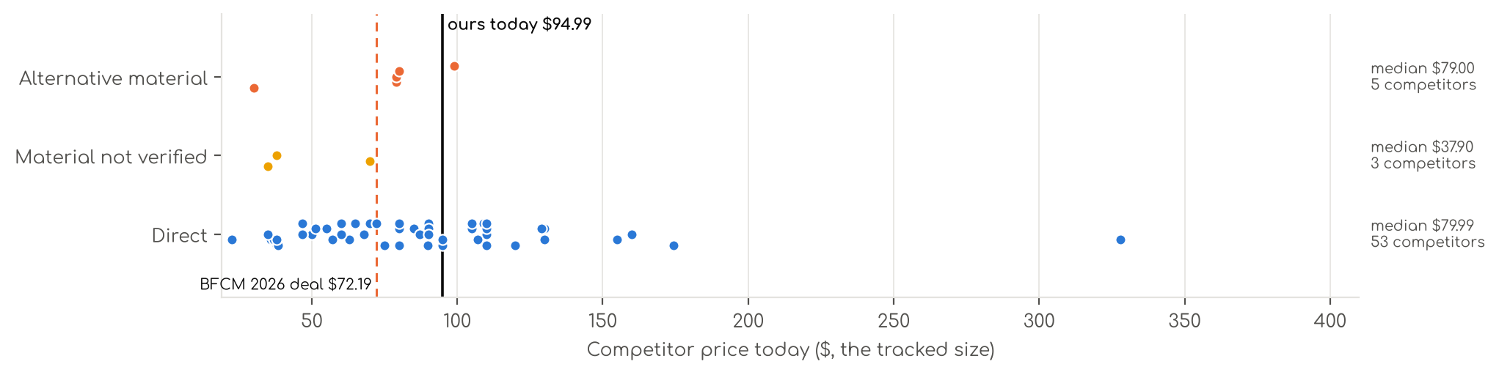
Photo | Competitor | Size · colour | Price | List | vs ours | Strike- through | BFCM 2025 deal | 2025 before → during | Disc. | Rank lift | Units / wk
Direct · 53
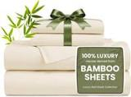 | Love's cabin  Love's cabin 4 Piece Queen Sheet Set, 100% Rayon Derived from Bamboo, Cooling & Breathable, Soft Silky Deep Pocket up to…  Bamboo viscose · 4.4★ 1,900 · Beatable  Prime Exclusive already running before BFCM week; List Price $49.99 | Queen · Beige | $37.99 | $44.99 | -58% | List Price $44.99 | Prime Exclusive Discount | $36.99 → $29.99 | 19% | 0.99x | 924
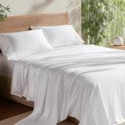 | Bedsure  Bedsure PureWoven 100% Rayon Derived from Bamboo, Queen Sheets, 4 Pieces  Bamboo viscose · 4.4★ 65,061 · Aspirational  Buy Box RAISED in BFCM week (median $69.99 vs $66.49 before); List Price $78.99 | Queen · 02 - White | $62.99 | $69.99 | -30% | List Price $69.99 | Prime Exclusive Discount | $66.49 → $55.99 | 16% | 0.68x | 809
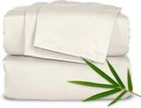 | Pure Bamboo  Pure Bamboo King Sheets, Genuine 100% Organic Viscose Derived from Bamboo Bed Sheet Set, Luxuriously Soft & Cooling, Dou…  Bamboo viscose · 4.5★ 21,927 · Aspirational  List Price $139.99/$149.99 | King · Ivory | $109.99 | — | +16% | Not shown | None | $109.99 → $109.99 | 0% | 0.48x | 809
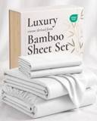 | Hotel Sheets Direct  Hotel Sheets Direct 4 Piece Bed Sheet Set Queen Size, 100% Viscose Derived from Bamboo Sheets Set with 2 Pillowcases, Co…  Bamboo viscose · 4.4★ 37,179 · Aspirational  Lightning Deal 11-07 to 11-11; Coupon 20% (11-12 to 12-02); List Price $72.99 | Queen · White | $79.99 | — | -11% | Not shown | Price cut only | $72.99 → $57.99 | 21% | 2.27x | 347
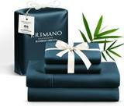 | KRIMANO  KRIMANO Bamboo Viscose Sheet Set King Size, Cooling Sheets Bed Set  Bamboo viscose · 4.5★ 263 · Beatable  List Price $94.89 | King · 1.navy Blue | $79.99 | — | -16% | Not shown | None | $72.99 → $72.99 | 0% | 1.89x | 185
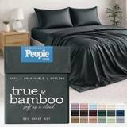 | TRUE BAMBOO  TRUE BAMBOO Sheets Set King Size - Silky Soft & Cooling - Dark Gray  Bamboo viscose · 4.6★ 167 · Beatable | Queen · Dark Gray | $79.99 | $129.99 | -11% | List Price $129.99 | Not live in 2025 | — | — | — | 185
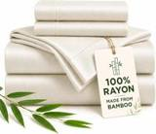 | CozyLux  CozyLux King Size Sheets Set, 100% Rayon Derived from Bamboo, Sateen Weave  Bamboo viscose · 4.6★ 93 | King · Ivory | $35.99 | — | -62% | List Price $44.99 | Not live in 2025 | — | — | — | 185
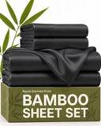 | CGK Unlimited  100% Rayon Derived from Bamboo - Bamboo Sheets Queen Size - Black  Bamboo viscose · 4.4★ 1,169  List Price $64.99 | Queen · Black | $49.99 | — | -44% | Not shown | Price cut only | $39.99 → $29.74 | 26% | 1.27x | 173
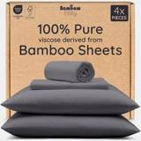 | Bambaw  Bambaw 100% Viscose Derived from Bamboo Sheets Queen Size Set – 4pcs Cooling Sheet Set, Super Soft Sheets Queen Size, Lu…  Bamboo viscose · 4.3★ 2,766 · Beatable  List Price $103.45 | Queen · Charcoal | $89.99 | — | 0% | Not shown | None | $89.99 → $89.99 | 0% | 1.17x | 104
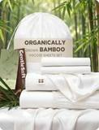 | Bedsure  Bedsure PureWoven Organically Grown Bamboo Viscose Queen Sheet Set, 4PCS  Bamboo viscose · 4.5★ 588 · Beatable  Prime Exclusive already running before BFCM week; List Price $114.99 | Queen · 01 - White | $89.99 | $119.99 | 0% | List Price $119.99 | Prime Exclusive Discount | $99.99 → $72.64 | 27% | 0.99x | 104
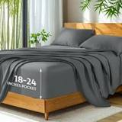 | SONORO KATE  Bamboo Sheets  Bamboo viscose · 4.5★ 3,776 · Beatable  Coupon 15% (11-06 to 11-19); List Price $79.99 | King · Dark Grey | $79.99 | — | -16% | Not shown | Prime Exclusive Discount | $79.99 → $63.99 | 20% | 1.55x | 104
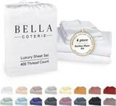 | BC BELLA COTERIE  Bella Coterie Luxury Bamboo Viscose King Size Sheet Set  Bamboo viscose · 4.4★ 5,871 · Beatable  Coupon 20.00 USD (12-03 to 12-05); List Price $169.99 | King - 2 Pillowcases · 01 - White | $154.99 | — | +63% | Not shown | Price cut only | $134.99 → $110.50 | 18% | 2.66x | 92
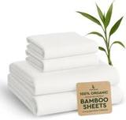 | BAMPURE  BAMPURE 100% Rayon from Bamboo Sheets King Size - 4pc Cooling King Sheets  Bamboo viscose · 4.4★ 4,095 · Beatable  Coupon 5.00 USD (11-01 to 11-04); Buy Box RAISED in BFCM week (median $99.99 vs $84.99 before); List Price $99.99 | King · White | $67.98 | $99.99 | -28% | List Price $99.99 | Prime Exclusive Discount | $84.99 → $79.99 | 6% | 1.14x | 81
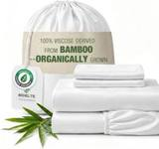 | BEDELITE  BEDELITE Bamboo Viscose Sheet Set, Queen Size, 4 Pieces, White  Bamboo viscose · 4.5★ 113 · Beatable | Queen · White | $84.98 | $99.89 | -6% | List Price $99.89 | Not live in 2025 | — | — | — | 81
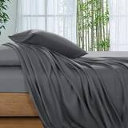 | SONORO KATE  SONORO KATE 100% Viscose Derived from Bamboo_Sheets Queen Size,4PC  Bamboo viscose · 4.5★ 3,911 · Beatable  Coupon 10% (11-04 to 12-05); List Price $59.99 | Queen · Dark Grey | $59.99 | — | -33% | Not shown | Prime Exclusive Discount | $59.99 → $47.99 | 20% | 1.20x | 81
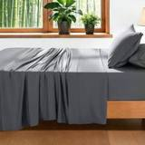 | AiAngu  Bamboo Sheets  Bamboo viscose · 4.6★ 121 · Poor | Queen · Dark Grey | $74.99 | $79.99 | -17% | List Price $79.99 | Not live in 2025 | — | — | — | 81
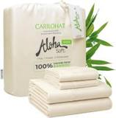 | Cariloha  Cariloha Aloha Soft Bamboo Viscose Sheet Set - Natural - Queen  Bamboo viscose · 4.4★ 426 · Poor  Coupon 20%, 30% (11-01 to 12-05); List Price $119.00 | Queen · Natural | $107.10 | — | +19% | List Price $119.00 | Prime Exclusive Discount | $119.00 → $71.40 | 40% | 1.39x | 81
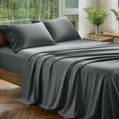 | Davmabcjy  100% Organically Grown Bamboo Viscose King Sheet Set with Pockets on Side  Bamboo viscose · 4.2★ 81 · Beatable | King (Deep Fits 16" ) · Dark Grey-side Pockets | $59.99 | — | -37% | Not shown | Not live in 2025 | — | — | — | 35
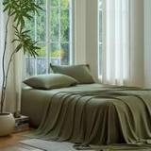 | DOZ by SIJO  Bamboo Sheets  Bamboo viscose · 4.4★ 1,909 · Beatable  List Price $55.00 | Queen · Olive | $55.00 | — | -39% | Not shown | None | $55.00 → $55.00 | 0% | 1.18x | 35
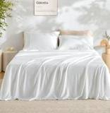 | GOKOTTA  GOKOTTA King Bamboo Rayon Sheets Set, Silky Soft Cooling Sheets Stay Put  Bamboo viscose · 4.4★ 3,371 · Beatable  Lightning Deal 11-09 to 11-09; Coupon 10.00 USD, 20.00 USD (11-02 to 11-18); List Price $105.00 | King - 4 PCS · 00 Bright White | $109.00 | — | +15% | Not shown | Price cut only | $105.00 → $84.00 | 20% | 1.47x | 35
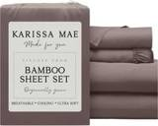 | KARISSA MAE  Cooling Sheets  Bamboo viscose · 4.3★ 474 · Beatable  No Buy Box history in price history for BFCM 2025 | King - 2 Pillowcases · 10 - Mocha | $119.99 | — | +26% | Not shown | — | — | — | — | 35
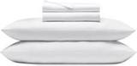 | Cozy Earth  Cozy Earth Luxury Bed Sheet Set, 100% Viscose from Bamboo Fabric  Bamboo viscose · 3.9★ 425 · Poor  List Price $328.00 | King · White | $328.00 | — | +245% | Not shown | Prime Exclusive Discount | $262.40 → $229.60 | 13% | 1.82x | 35
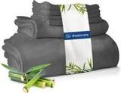 | DREAMCARE  DREAMCARE 100% Rayon Bamboo Sheets King Size - 4pc Cooling Sheets King Size  Bamboo viscose · 4.5★ 2,261 · Poor  Buy Box RAISED in BFCM week (median $62.88 vs $58.99 before); List Price $58.99 | King · 5 - Gray | $46.74 | $59.99 | -51% | List Price $59.99 | Prime Exclusive Discount | $58.99 → $49.99 | 15% | 1.24x | 35
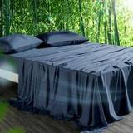 | HOT SLEEPER SHEETS  Cooling Sheets Set Queen Size, Viscose Derived from Bamboo for Hot Sleepers | Deep Pocket Up to 16 Inch | Silky Soft & B…  Bamboo viscose · 4.4★ 674 · Poor  List Price $107.98 | Queen · Navy | $51.29 | $62.99 | -43% | Typical price $62.99 | Price cut only | $62.99 → $45.89 | 27% | 2.40x | 35
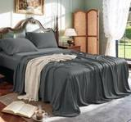 | Shilucheng  Shilucheng 100% Viscose Derived from Bamboo_ Sheets Queen Size 4pcs  Bamboo viscose · 4.4★ 6,629 · Poor  Buy Box RAISED in BFCM week (median $58.30 vs $54.90 before); List Price $59.90 | Queen · 01 - Dark Grey | $46.66 | $54.90 | -48% | List Price $54.90 | Prime Exclusive Discount | $54.90 → $46.64 | 15% | 0.86x | 35
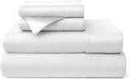 | Cosy House Collection  Cosy House Collection 100% Rayon Derived from Bamboo Bed Sheet Set  Bamboo viscose · 4.3★ 7,941  List Price $199.99 | King · White | $89.95 | — | -5% | Not shown | None | $89.95 → $89.95 | 0% | 0.65x | 35
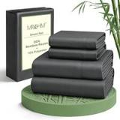 | MR&HM  MR&HM Queen Sheets 4 Pieces, Rayon Derived from Bamboo Blend, Dark Grey  Bamboo viscose · 4.4★ 616  Prime Exclusive already running before BFCM week; Buy Box RAISED in BFCM week (median $37.99 vs $32.99 before); List Price $45.99 | Queen · Grey | $36.99 | — | -59% | List Price $38.99 | Prime Exclusive Discount | $29.99 → $28.04 | 7% | 0.90x | 35
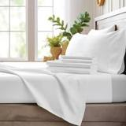 | Bamboo Bay  Bamboo Bay 4 Piece Queen Size Sheet Set, 100% Viscose Made from Bamboo, Breathab  Bamboo viscose · 4.4★ 739 · Beatable  Buy Box RAISED in BFCM week (median $99.98 vs $64.99 before); List Price $129.98 | Queen · 01 - White | $89.98 | — | -0% | Not shown | None | $64.99 → $99.98 | -54% | 0.54x | 18
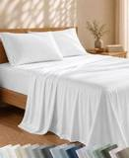 | California Design Den  California Design Den 100% Viscose from Bamboo Sheets Queen, Dark Olive  Bamboo viscose · 4.6★ 76 · Beatable | Queen · Bright White | $89.99 | — | 0% | Not shown | Not live in 2025 | — | — | — | 18
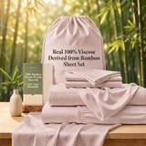 | TWK  TWK Real 100% Viscose Derived from Bamboo Sheets Set Queen Size, Cooling & Silky  Bamboo viscose · 4.9★ 121 · Beatable | Queen · Sand | $65.00 | $79.00 | -28% | Typical price $79.00 | Not live in 2025 | — | — | — | 18
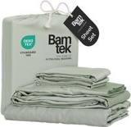 | Bamtek  Viscose Bamboo Sheets Queen Size 4PC Set - Cooling Bedding for Hot Sleepers with  Bamboo viscose · 4.4★ 641 · Poor  Coupon 40.00 USD (11-01 to 11-10); List Price $129.99 | Queen · Sage | $94.99 | — | +6% | Not shown | Prime Exclusive Discount | $104.99 → $83.99 | 20% | 1.41x | 18
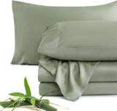 | JSD  JSD Sage Green 100% Viscose Derived from Bamboo Cooling Sheet Set Queen  Bamboo viscose · 4.3★ 281 · Poor  Coupon 5% (11-01 to 11-17); List Price $74.99 | Queen · Green | $56.99 | — | -37% | Not shown | None | $56.99 → $56.99 | 0% | 0.90x | 18
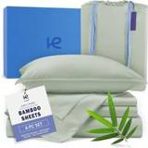 | Kickoff Home  Bamboo Sheets  Bamboo viscose · 4.6★ 688 · Poor  Coupon 25% (11-01 to 11-05); List Price $124.99 | King · Sage Green | $86.99 | $84.99 | -8% | Not shown | Price cut only | $118.99 → $79.13 | 33% | 2.47x | 18
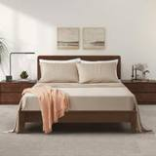 | LB Luxury Bamboo Market  Bamboo Sheets  Bamboo viscose · 4.5★ 517 · Poor  List Price $159.94 | Queen · Dune | $129.94 | — | +44% | Not shown | Prime Exclusive Discount | $119.94 → $103.95 | 13% | 0.76x | 18
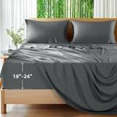 | Shilucheng  Shilucheng 100% Viscose Derived from Bamboo_Sheets, Extra Deep Pocket  Bamboo viscose · 4.5★ 1,639 · Poor  Coupon 20% (11-02 to 11-12); List Price $84.99 | King · Dark Grey | $69.99 | $84.99 | -26% | List Price $84.99 | Prime Exclusive Discount | $84.99 → $64.59 | 24% | 0.73x | 18
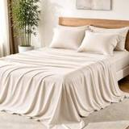 | KAKIJUMN  KAKIJUMN 6 Piece King Sheets Set, Rayon Derived from Bamboo Blend  Bamboo viscose · 4.0★ 71 | Queen · Warm Beige | $38.39 | $47.99 | -57% | List Price $47.99 | Not live in 2025 | — | — | — | 18
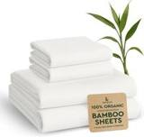 | BAMPURE  Bamboo Sheets  Bamboo viscose · 4.4★ 30 · Beatable  List Price $69.99 | Twin - 3 Pieces Set · White | $37.99 | — | -42% | Not shown | None | $69.99 → $69.99 | 0% | 1.14x | 5
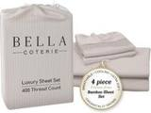 | BC BELLA COTERIE  4 Piece Bamboo Sheet Set  Bamboo viscose · 4.4★ 5,652 · Beatable | Queen - 2 Pillowcases · 22 - Striped Dune | $159.99 | — | +78% | Not shown | Not live in 2025 | — | — | — | 5
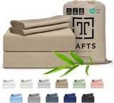 | Tafts  Bamboo Sheets Queen Size, 100% Pure Viscose derived from Bamboo Bed Sheet Set, L  Bamboo viscose · 4.5★ 3,184 · Beatable  Coupon 20%; List Price $119.99 | Queen · Nude Beige | $104.99 | — | +17% | Not shown | Coupon only | $99.99 → $80.74 | 19% | 1.29x | 5
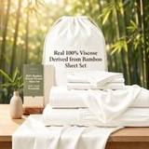 | TWK  TWK Real 100% Viscose Derived from Bamboo Sheets Set Queen Size, Cooling & Silky  Bamboo viscose · 4.5★ — · Beatable | Queen · White | $105.00 | — | +17% | Not shown | Not live in 2025 | — | — | — | 5
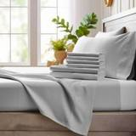 | Bamboo Bay  Bamboo Sheets  Bamboo viscose · 4.5★ 2,691 · Poor  Buy Box RAISED in BFCM week (median $109.98 vs $86.99 before); List Price $129.98 | Queen · 04 - Light Grey | $79.98 | — | -11% | Not shown | None | $86.99 → $93.48 | -7% | 0.82x | 5
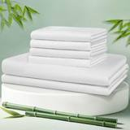 | LBRO2M  LBRO2M Cooling Bed Sheet 100% Viscose Derived from Bamboo Sheet Set Queen Size 6  Bamboo viscose · 4.4★ 18 · Poor  Lightning Deal 11-01 to 11-01; List Price $179.97 | King 6 Pcs · White | $94.99 | — | 0% | Not shown | Prime Exclusive Discount | $95.99 → $67.19 | 30% | 1.66x | 5
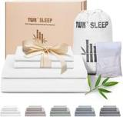 | TWK  TWK Luxury Sheet Set, Genuine 100% Viscose Derived from Bamboo, Cooling & Breathable, Silky Soft, Bedding Sheets & Pillo…  Bamboo viscose · 4.5★ 11 · Poor | King · White | $46.74 | — | -51% | Not shown | Not live in 2025 | — | — | — | 5
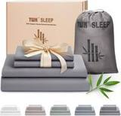 | TWK  TWK Luxury Sheet Set, Genuine 100% Organic Viscose Derived from Bamboo, Cooling & Breathable, Silky Soft, Bedding Sheets…  Bamboo viscose · 4.5★ 39 · Poor  Coupon 30%; Buy Box RAISED in BFCM week (median $79.00 vs $69.00 before); List Price $69.00 | King · Mist Gray | $109.99 | — | +16% | Not shown | Coupon only | $69.00 → $74.00 | -7% | 0.68x | 5
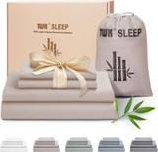 | TWK  4 Piece Bamboo Sheet Set  Bamboo viscose · 4.5★ 2 · Poor | King · Sand | $109.99 | — | +16% | Not shown | Not live in 2025 | — | — | — | 5
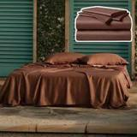 | Vesta  Vesta Sheet Set – Soft, Breathable & Cooling, 100% Viscose Derived from Bamboo,  Bamboo viscose · 4.3★ 35 · Poor  List Price $174.30 | King/Cali King · Terra Cotta | $174.30 | — | +83% | Not shown | None | $174.30 → $174.30 | 0% | 1.15x | 5
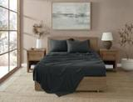 | Brooklyn Loom  Brooklyn Loom 300 Thread Count Sateen 100% Rayon from Bamboo Deep Pocket 4 Piece  Bamboo viscose · 4.5★ 13  List Price $260.00 | King (U.S. Standard) · Charcoal | $129.99 | — | +37% | Not shown | None | $129.99 → $129.99 | 0% | — | 5
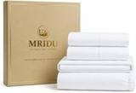 | MRIDU  MRIDU Bamboo Viscose Sheet Set, 4-Piece, Pure White, King  Bamboo viscose · 3.9★ 24 | Full · Pure White | $89.99 | — | +20% | Not shown | Not live in 2025 | — | — | — | 5
 | TOSMO  TOSMO Luxury Cooling Sheet Set - 100% Viscose from Bamboo, 4-Piece Bedding Set (King Size) - 18” Extra Deep Pockets, Oek…  Bamboo viscose · 4.4★ 53 · Beatable  List Price $169.99 | King · White | $129.00 | — | +36% | — | Prime Exclusive Discount | $134.00 → $105.39 | 21% | 1.83x | —
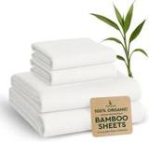 | BAMPURE  BAMPURE 100% Rayon from Bamboo Sheets Queen Size - 4pc Cooling Sheets Queen  Bamboo viscose · 4.4★ 4,320 · Beatable  Buy Box RAISED in BFCM week (median $99.99 vs $84.99 before); List Price $99.99 | Queen | $72.23 | — | -20% | — | Prime Exclusive Discount | $84.99 → $79.99 | 6% | 1.19x | —
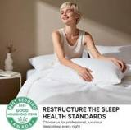 | TWK  TWK Genuine 100% Viscose Derived from Natural Bamboo Bed Sheets Set,Cooling & Silky Soft Bed Sheets,Deep Pocket Up to 18…  Bamboo viscose · 4.5★ 6 · Poor  Coupon 50%; List Price $109.00 | King · White | $109.99 | — | +16% | — | Coupon only | — | — | — | —
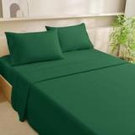 | MCO  MCO 4 Piece Cooling & Breathable Queen Sheet Set, Rayon Derived from Bamboo, 16" Deep Pocket, Hotel Luxury Soft Silky Qu…  Bamboo viscose · 4.0★ 482 | Queen · Green | $22.50 | — | -75% | — | Not live in 2025 | — | — | — | —
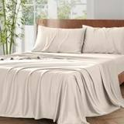 | Vipfree  Vipfree California King Sheet Set, Cooling Rayon 4-Piece Bedding with Deep Pockets, Sand, 300 Thread Count  Bamboo viscose · 4.4★ 436  List Price $97.99 | California King · Sand | $34.99 | — | -63% | — | Price cut only | $97.99 → $69.99 | 29% | 0.81x | —
Material not verified · 3
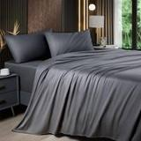 | Shilucheng  Shilucheng 4 Piece Queen Sheet Sets, Cooling Sheets, Dark Grey  4.3★ 24,352  Coupon 15%; List Price $34.90 | Queen · Grey | $34.99 | — | -61% | Not shown | Coupon only | $34.90 → $28.18 | 19% | 1.42x | 173
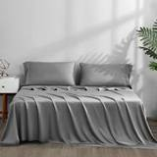 | ACCURATEX  ACCURATEX Cooling Sheets for Hot Sleepers, King Size, Grey  4.4★ 1,040 · Poor  Lightning Deal 11-13 to 11-13; Buy Box RAISED in BFCM week (median $74.99 vs $69.99 before); List Price $74.99 | King · Grey | $69.99 | — | -26% | Not shown | Prime Exclusive Discount | $59.49 → $59.49 | 0% | 0.65x | 35
 | Shilucheng  Shilucheng 4 Piece King Sheet Sets, Cooling Sheets, Dark Grey  4.3★ 24,333  Coupon 15%; List Price $37.90 | King · Grey | $37.90 | — | -60% | Not shown | Coupon only | $37.90 → $30.32 | 20% | 1.42x | 18
Alternative material · 5
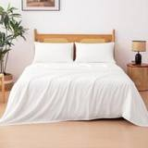 | Amazon Basics  Amazon Basics Bamboo Viscose Sheet Set, 4-Piece, Queen, White  Microfiber / polyester · 4.0★ 36 | Queen · White | $29.99 | — | -67% | Not shown | Not live in 2025 | — | — | — | 173
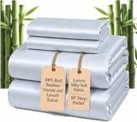 | Pillcase  100% Real Bamboo Viscose & Lyocell Tencel Sheets Set Queen Size | Breathable & C  Microfiber / polyester · 4.8★ 279 · Beatable | Queen · French Blue | $79.00 | $109.00 | -12% | List Price $109.00 | Not live in 2025 | — | — | — | 35
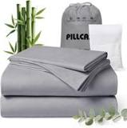 | Pillcase  100% Real Bamboo Viscose & Lyocell Tencel Sheets Set Queen Size | Breathable & C  Microfiber / polyester · 4.9★ 201 · Beatable | Queen · Charcoal | $79.00 | — | -12% | List Price $99.00 | Not live in 2025 | — | — | — | 18
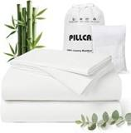 | Pillcase  Cooling Hotel Bedding Sheet Set - 4pcs Bamboo Viscose & Tencel Blend, Moisture-W  Microfiber / polyester · 4.0★ — · Beatable | King · Pearl White | $79.99 | — | -16% | Not shown | Not live in 2025 | — | — | — | 5
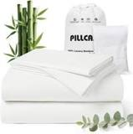 | Pillcase  Pillcase Luxury Organic Tencel & Viscose from Bamboo Cooling Sheet Set,Silky Soft Lyocell Sheets with Deep Pocket, Hypoa…  Lyocell / eucalyptus · 4.9★ 201 · Beatable | King · White | $99.00 | — | +4% | — | Not live in 2025 | — | — | — | —

US · DC B6: Decolure Bamboo Sheets 6 Piece
 | Listing title | DECOLURE 100% Viscose from Bamboo Sheets King Size | 6 Pc Cooling Bed Set
 | Marketplace | United States
 | Family · role | Bamboo · Hero: rank and profit
 | Scope · stage | Core · Re-Launch
 | Amazon parent | B0H6335KNV
 | Best seller | B0CQ2XQF9N (King White)
 | Variations | 86 (65 with a live price)
 | Sizes | King, Queen, Full, California King, Twin, Cal King
 | Colours | 17

OUR PRICE TODAY  $99.99  King White | BFCM 2026 DEAL PRICE  $94.99 → $68.63  Best Deal Nov 19-30 · 28% off the Oct 27 price | STOCK TO NOV 30  10 short · 3 out  7,216 at Amazon · 5,817 inbound · need 7,299 | BFCM 2025 SALES LIFT  2.49x  1,905 units in the last 28 days | DIRECT COMPETITORS  53  median $79.99 · 35 cheaper than us

BFCM 2025: how this product did
Period | Sales | Units | Organic units | Ad units | Ad cost | TACoS | Sessions | Unit session % | Avg price
Oct 21 – Nov 19, 2025 (30 days before) | $263,646 | 3,442 | 3,297 | 145 | $19,611 | 7.4% | 49,108 | 7.0% | $76.60
Nov 20 – Dec 1, 2025 (BFCM week) | $262,412 | 3,572 | 3,402 | 170 | $16,813 | 6.4% | 51,029 | 7.0% | $73.46
Dec 2 – 31, 2025 | $357,241 | 4,230 | 3,971 | 259 | $28,943 | 8.1% | 58,825 | 7.2% | $84.45
Best seller in BFCM 2025: B0CQ2XQF9N: $79.99 before (median Nov 1 – 19) → $75.99 in BFCM week, 5% lower; Best Seller Rank 7,795 → 6,218.
Our BFCM 2025 deals: Lightning Deal 11-03 to 11-04 (cancelled, 77 variations); Lightning Deal 11-13 to 11-14 (cancelled, 77 variations); Best Deal 11-20 to 12-02 (ran, 78 variations, 2,927 units)
Stock in BFCM 2025: 4 of 79 variations hit zero FBA stock on at least one observed day in BFCM week; weighted by sales mix, about 0.9% of variation-days were lost.

BFCM 2026 deal
Deal | Hero variation | Price Oct 27 | Deal price | Off | Variations (deal page) | Our 2025 cut | Rivals' 2025 cut
Best Deal Nov 19-30 | King White | $94.99 | $68.63 | 28% | 67 eligible, 8 out of stock, 6 no reference price, 1 manual price; 5%–39% off | 5% ($79.99 → $75.99) | 26% (7 rivals)
Deal notes
- Amazon deal price now. Amazon reference still the pre-relaunch price: King live $99.99, reference $84.99, max deal $72.24 (28% below live); Queen $94.99 / $79.99 / $67.99; Cal King $99.99 / $84.99 / $72.24; Full $79.99 / $69.99 / $59.49; Twin $69.99 / $59.99 / $50.99. The Sep 26-30 Best Deal caps 8 SKUs. With the STR live, the $104.99 list price would allow a King deal up to $89.24.
- Pre-BFCM deal decision. Oct 15 Lightning Deal: the team recommended cancelling; the Oct 22-28 Best Deal is decided as it comes up. Without the deals the Sep 26-30 ceiling expires Oct 30 (30-day lookback) or Nov 29 (60-day). STR cycle on hero sizes planned after Oct 15, finishing before Nov 12. Stock then: 6,768 at FBA and 4,746 inbound, next arrival Oct 16.

Stock to Nov 30
Sales per day today 114.3 · lift used 2.49x (this product's own BFCM 2025 lift) · need to Nov 30 7,299 units · at Amazon 7,216 · inbound 5,817. Covered 50, needs inbound in time 16, short 10, out of stock now 3.
Size | Colour | At Amazon | Inbound | Sales / day | Need to Nov 30 | Short by | Runs out | Status
King | Taupe | 67 | 60 | 17.8 | 1,134 | 1,007 | Oct 18 | Short even with inbound
Queen | White | 377 | 288 | 6.0 | 386 | — | Nov 29 | Needs inbound in time
Queen | Taupe | 144 | 30 | 5.9 | 376 | 202 | Nov 8 | Short even with inbound
King | Black | 65 | 4 | 3.5 | 223 | 154 | Nov 2 | Short even with inbound
King | Charcoal | 51 | 216 | 3.1 | 198 | — | Oct 31 | Needs inbound in time
King | Navy Blue | 33 | 140 | 3.0 | 191 | 18 | Oct 26 | Short even with inbound
King | Creme | 0 | 324 | 2.8 | 179 | — | now | Out of stock now
King | Burgundy | 122 | 4 | 2.6 | 169 | 43 | Nov 22 | Short even with inbound
Queen | Navy Blue | 3 | 0 | 2.4 | 152 | 149 | Oct 16 | Short even with inbound
King | Sage Green | 71 | 120 | 2.4 | 150 | — | Nov 14 | Needs inbound in time
Queen | Charcoal | 30 | 60 | 2.3 | 148 | 58 | Oct 27 | Short even with inbound
California King | Taupe | 42 | 41 | 2.3 | 145 | 62 | Nov 2 | Short even with inbound
King | Purple | 29 | 0 | 2.1 | 133 | 104 | Oct 28 | Short even with inbound
Full | White | 68 | 54 | 1.7 | 109 | — | Nov 20 | Needs inbound in time
King | Midgrey | 102 | 160 | 1.7 | 108 | — | Nov 28 | Needs inbound in time
California King | White | 32 | 72 | 1.4 | 87 | — | Nov 7 | Needs inbound in time
California King | Creme | 49 | 124 | 1.0 | 66 | — | Nov 23 | Needs inbound in time
King | Olive | 17 | 112 | 0.9 | 61 | — | Nov 1 | Needs inbound in time
California King | Light Blue | 19 | 140 | 0.8 | 48 | — | Nov 9 | Needs inbound in time
California King | Olive | 34 | 20 | 0.7 | 46 | — | Nov 23 | Needs inbound in time
California King | Grey | 10 | 64 | 0.6 | 40 | — | Oct 30 | Needs inbound in time
Full | Taupe | 25 | 30 | 0.5 | 34 | — | Nov 23 | Needs inbound in time
Twin | Navy Blue | 14 | 108 | 0.5 | 33 | — | Nov 11 | Needs inbound in time
Queen | Black | 29 | 192 | 0.5 | 32 | — | Nov 27 | Needs inbound in time
California King | Navy Blue | 12 | 156 | 0.5 | 29 | — | Nov 10 | Needs inbound in time
Full | Charcoal | 0 | 30 | 0.5 | 29 | — | now | Out of stock now
Full | Midgrey | 7 | 6 | 0.4 | 28 | 15 | Oct 30 | Short even with inbound
Full | Grey | 11 | 30 | 0.2 | 13 | — | Nov 26 | Needs inbound in time
California King | Light Olive | 0 | 40 | 0.2 | 11 | — | now | Out of stock now

Sales mix, last 28 days
By size: King 975 · Queen 665 · Full 122 · California King 97 · Twin 46
By colour (top 8): White 418 · Taupe 292 · Creme 146 · Navy Blue 146 · Light Grey 117 · Light Blue 116 · Burgundy 91 · Olive 88

Competitors (61)
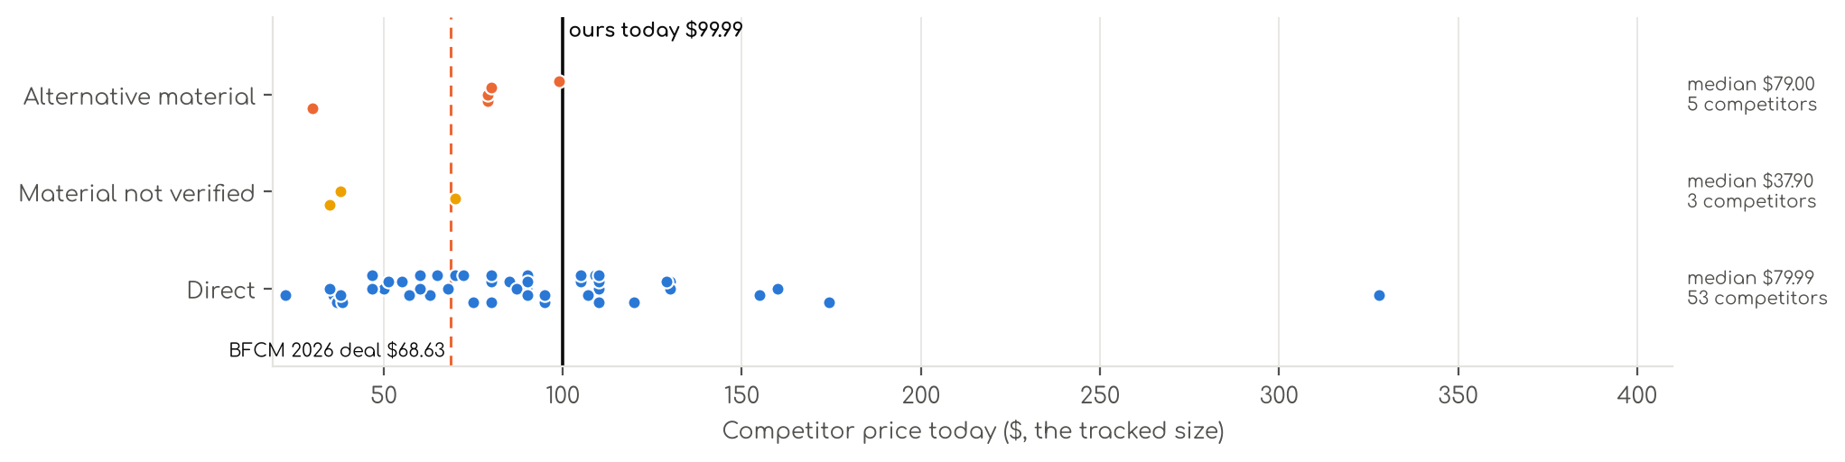
Photo | Competitor | Size · colour | Price | List | vs ours | Strike- through | BFCM 2025 deal | 2025 before → during | Disc. | Rank lift | Units / wk
Direct · 53
 | Love's cabin  Love's cabin 4 Piece Queen Sheet Set, 100% Rayon Derived from Bamboo, Cooling & Breathable, Soft Silky Deep Pocket up to…  Bamboo viscose · 4.4★ 1,900 · Beatable  Prime Exclusive already running before BFCM week; List Price $49.99 | Queen · Beige | $37.99 | $44.99 | -60% | List Price $44.99 | Prime Exclusive Discount | $36.99 → $29.99 | 19% | 0.99x | 924
 | Bedsure  Bedsure PureWoven 100% Rayon Derived from Bamboo, Queen Sheets, 4 Pieces  Bamboo viscose · 4.4★ 65,061 · Aspirational  Buy Box RAISED in BFCM week (median $69.99 vs $66.49 before); List Price $78.99 | Queen · 02 - White | $62.99 | $69.99 | -34% | List Price $69.99 | Prime Exclusive Discount | $66.49 → $55.99 | 16% | 0.68x | 809
 | Pure Bamboo  Pure Bamboo King Sheets, Genuine 100% Organic Viscose Derived from Bamboo Bed Sheet Set, Luxuriously Soft & Cooling, Dou…  Bamboo viscose · 4.5★ 21,927 · Aspirational  List Price $139.99/$149.99 | King · Ivory | $109.99 | — | +10% | Not shown | None | $109.99 → $109.99 | 0% | 0.48x | 809
 | Hotel Sheets Direct  Hotel Sheets Direct 4 Piece Bed Sheet Set Queen Size, 100% Viscose Derived from Bamboo Sheets Set with 2 Pillowcases, Co…  Bamboo viscose · 4.4★ 37,179 · Aspirational  Lightning Deal 11-07 to 11-11; Coupon 20% (11-12 to 12-02); List Price $72.99 | Queen · White | $79.99 | — | -16% | Not shown | Price cut only | $72.99 → $57.99 | 21% | 2.27x | 347
 | KRIMANO  KRIMANO Bamboo Viscose Sheet Set King Size, Cooling Sheets Bed Set  Bamboo viscose · 4.5★ 263 · Beatable  List Price $94.89 | King · 1.navy Blue | $79.99 | — | -20% | Not shown | None | $72.99 → $72.99 | 0% | 1.89x | 185
 | TRUE BAMBOO  TRUE BAMBOO Sheets Set King Size - Silky Soft & Cooling - Dark Gray  Bamboo viscose · 4.6★ 167 · Beatable | Queen · Dark Gray | $79.99 | $129.99 | -16% | List Price $129.99 | Not live in 2025 | — | — | — | 185
 | CozyLux  CozyLux King Size Sheets Set, 100% Rayon Derived from Bamboo, Sateen Weave  Bamboo viscose · 4.6★ 93 | King · Ivory | $35.99 | — | -64% | List Price $44.99 | Not live in 2025 | — | — | — | 185
 | CGK Unlimited  100% Rayon Derived from Bamboo - Bamboo Sheets Queen Size - Black  Bamboo viscose · 4.4★ 1,169  List Price $64.99 | Queen · Black | $49.99 | — | -47% | Not shown | Price cut only | $39.99 → $29.74 | 26% | 1.27x | 173
 | Bambaw  Bambaw 100% Viscose Derived from Bamboo Sheets Queen Size Set – 4pcs Cooling Sheet Set, Super Soft Sheets Queen Size, Lu…  Bamboo viscose · 4.3★ 2,766 · Beatable  List Price $103.45 | Queen · Charcoal | $89.99 | — | -5% | Not shown | None | $89.99 → $89.99 | 0% | 1.17x | 104
 | Bedsure  Bedsure PureWoven Organically Grown Bamboo Viscose Queen Sheet Set, 4PCS  Bamboo viscose · 4.5★ 588 · Beatable  Prime Exclusive already running before BFCM week; List Price $114.99 | Queen · 01 - White | $89.99 | $119.99 | -5% | List Price $119.99 | Prime Exclusive Discount | $99.99 → $72.64 | 27% | 0.99x | 104
 | SONORO KATE  Bamboo Sheets  Bamboo viscose · 4.5★ 3,776 · Beatable  Coupon 15% (11-06 to 11-19); List Price $79.99 | King · Dark Grey | $79.99 | — | -20% | Not shown | Prime Exclusive Discount | $79.99 → $63.99 | 20% | 1.55x | 104
 | BC BELLA COTERIE  Bella Coterie Luxury Bamboo Viscose King Size Sheet Set  Bamboo viscose · 4.4★ 5,871 · Beatable  Coupon 20.00 USD (12-03 to 12-05); List Price $169.99 | King - 2 Pillowcases · 01 - White | $154.99 | — | +55% | Not shown | Price cut only | $134.99 → $110.50 | 18% | 2.66x | 92
 | BAMPURE  BAMPURE 100% Rayon from Bamboo Sheets King Size - 4pc Cooling King Sheets  Bamboo viscose · 4.4★ 4,095 · Beatable  Coupon 5.00 USD (11-01 to 11-04); Buy Box RAISED in BFCM week (median $99.99 vs $84.99 before); List Price $99.99 | King · White | $67.98 | $99.99 | -32% | List Price $99.99 | Prime Exclusive Discount | $84.99 → $79.99 | 6% | 1.14x | 81
 | BEDELITE  BEDELITE Bamboo Viscose Sheet Set, Queen Size, 4 Pieces, White  Bamboo viscose · 4.5★ 113 · Beatable | Queen · White | $84.98 | $99.89 | -11% | List Price $99.89 | Not live in 2025 | — | — | — | 81
 | SONORO KATE  SONORO KATE 100% Viscose Derived from Bamboo_Sheets Queen Size,4PC  Bamboo viscose · 4.5★ 3,911 · Beatable  Coupon 10% (11-04 to 12-05); List Price $59.99 | Queen · Dark Grey | $59.99 | — | -37% | Not shown | Prime Exclusive Discount | $59.99 → $47.99 | 20% | 1.20x | 81
 | AiAngu  Bamboo Sheets  Bamboo viscose · 4.6★ 121 · Poor | Queen · Dark Grey | $74.99 | $79.99 | -21% | List Price $79.99 | Not live in 2025 | — | — | — | 81
 | Cariloha  Cariloha Aloha Soft Bamboo Viscose Sheet Set - Natural - Queen  Bamboo viscose · 4.4★ 426 · Poor  Coupon 20%, 30% (11-01 to 12-05); List Price $119.00 | Queen · Natural | $107.10 | — | +13% | List Price $119.00 | Prime Exclusive Discount | $119.00 → $71.40 | 40% | 1.39x | 81
 | Davmabcjy  100% Organically Grown Bamboo Viscose King Sheet Set with Pockets on Side  Bamboo viscose · 4.2★ 81 · Beatable | King (Deep Fits 16" ) · Dark Grey-side Pockets | $59.99 | — | -40% | Not shown | Not live in 2025 | — | — | — | 35
 | DOZ by SIJO  Bamboo Sheets  Bamboo viscose · 4.4★ 1,909 · Beatable  List Price $55.00 | Queen · Olive | $55.00 | — | -42% | Not shown | None | $55.00 → $55.00 | 0% | 1.18x | 35
 | GOKOTTA  GOKOTTA King Bamboo Rayon Sheets Set, Silky Soft Cooling Sheets Stay Put  Bamboo viscose · 4.4★ 3,371 · Beatable  Lightning Deal 11-09 to 11-09; Coupon 10.00 USD, 20.00 USD (11-02 to 11-18); List Price $105.00 | King - 4 PCS · 00 Bright White | $109.00 | — | +9% | Not shown | Price cut only | $105.00 → $84.00 | 20% | 1.47x | 35
 | KARISSA MAE  Cooling Sheets  Bamboo viscose · 4.3★ 474 · Beatable  No Buy Box history in price history for BFCM 2025 | King - 2 Pillowcases · 10 - Mocha | $119.99 | — | +20% | Not shown | — | — | — | — | 35
 | Cozy Earth  Cozy Earth Luxury Bed Sheet Set, 100% Viscose from Bamboo Fabric  Bamboo viscose · 3.9★ 425 · Poor  List Price $328.00 | King · White | $328.00 | — | +228% | Not shown | Prime Exclusive Discount | $262.40 → $229.60 | 13% | 1.82x | 35
 | DREAMCARE  DREAMCARE 100% Rayon Bamboo Sheets King Size - 4pc Cooling Sheets King Size  Bamboo viscose · 4.5★ 2,261 · Poor  Buy Box RAISED in BFCM week (median $62.88 vs $58.99 before); List Price $58.99 | King · 5 - Gray | $46.74 | $59.99 | -53% | List Price $59.99 | Prime Exclusive Discount | $58.99 → $49.99 | 15% | 1.24x | 35
 | HOT SLEEPER SHEETS  Cooling Sheets Set Queen Size, Viscose Derived from Bamboo for Hot Sleepers | Deep Pocket Up to 16 Inch | Silky Soft & B…  Bamboo viscose · 4.4★ 674 · Poor  List Price $107.98 | Queen · Navy | $51.29 | $62.99 | -46% | Typical price $62.99 | Price cut only | $62.99 → $45.89 | 27% | 2.40x | 35
 | Shilucheng  Shilucheng 100% Viscose Derived from Bamboo_ Sheets Queen Size 4pcs  Bamboo viscose · 4.4★ 6,629 · Poor  Buy Box RAISED in BFCM week (median $58.30 vs $54.90 before); List Price $59.90 | Queen · 01 - Dark Grey | $46.66 | $54.90 | -51% | List Price $54.90 | Prime Exclusive Discount | $54.90 → $46.64 | 15% | 0.86x | 35
 | MR&HM  MR&HM Queen Sheets 4 Pieces, Rayon Derived from Bamboo Blend, Dark Grey  Bamboo viscose · 4.4★ 616  Prime Exclusive already running before BFCM week; Buy Box RAISED in BFCM week (median $37.99 vs $32.99 before); List Price $45.99 | Queen · Grey | $36.99 | — | -61% | List Price $38.99 | Prime Exclusive Discount | $29.99 → $28.04 | 7% | 0.90x | 35
 | Cosy House Collection  Cosy House Collection 100% Rayon Derived from Bamboo Bed Sheet Set  Bamboo viscose · 4.3★ 7,941  List Price $199.99 | King · White | $89.95 | — | -10% | Not shown | None | $89.95 → $89.95 | 0% | 0.65x | 35
 | Bamboo Bay  Bamboo Bay 4 Piece Queen Size Sheet Set, 100% Viscose Made from Bamboo, Breathab  Bamboo viscose · 4.4★ 739 · Beatable  Buy Box RAISED in BFCM week (median $99.98 vs $64.99 before); List Price $129.98 | Queen · 01 - White | $89.98 | — | -5% | Not shown | None | $64.99 → $99.98 | -54% | 0.54x | 18
 | California Design Den  California Design Den 100% Viscose from Bamboo Sheets Queen, Dark Olive  Bamboo viscose · 4.6★ 76 · Beatable | Queen · Bright White | $89.99 | — | -5% | Not shown | Not live in 2025 | — | — | — | 18
 | TWK  TWK Real 100% Viscose Derived from Bamboo Sheets Set Queen Size, Cooling & Silky  Bamboo viscose · 4.9★ 121 · Beatable | Queen · Sand | $65.00 | $79.00 | -32% | Typical price $79.00 | Not live in 2025 | — | — | — | 18
 | Bamtek  Viscose Bamboo Sheets Queen Size 4PC Set - Cooling Bedding for Hot Sleepers with  Bamboo viscose · 4.4★ 641 · Poor  Coupon 40.00 USD (11-01 to 11-10); List Price $129.99 | Queen · Sage | $94.99 | — | 0% | Not shown | Prime Exclusive Discount | $104.99 → $83.99 | 20% | 1.41x | 18
 | JSD  JSD Sage Green 100% Viscose Derived from Bamboo Cooling Sheet Set Queen  Bamboo viscose · 4.3★ 281 · Poor  Coupon 5% (11-01 to 11-17); List Price $74.99 | Queen · Green | $56.99 | — | -40% | Not shown | None | $56.99 → $56.99 | 0% | 0.90x | 18
 | Kickoff Home  Bamboo Sheets  Bamboo viscose · 4.6★ 688 · Poor  Coupon 25% (11-01 to 11-05); List Price $124.99 | King · Sage Green | $86.99 | $84.99 | -13% | Not shown | Price cut only | $118.99 → $79.13 | 33% | 2.47x | 18
 | LB Luxury Bamboo Market  Bamboo Sheets  Bamboo viscose · 4.5★ 517 · Poor  List Price $159.94 | Queen · Dune | $129.94 | — | +37% | Not shown | Prime Exclusive Discount | $119.94 → $103.95 | 13% | 0.76x | 18
 | Shilucheng  Shilucheng 100% Viscose Derived from Bamboo_Sheets, Extra Deep Pocket  Bamboo viscose · 4.5★ 1,639 · Poor  Coupon 20% (11-02 to 11-12); List Price $84.99 | King · Dark Grey | $69.99 | $84.99 | -30% | List Price $84.99 | Prime Exclusive Discount | $84.99 → $64.59 | 24% | 0.73x | 18
 | KAKIJUMN  KAKIJUMN 6 Piece King Sheets Set, Rayon Derived from Bamboo Blend  Bamboo viscose · 4.0★ 71 | Queen · Warm Beige | $38.39 | $47.99 | -60% | List Price $47.99 | Not live in 2025 | — | — | — | 18
 | BAMPURE  Bamboo Sheets  Bamboo viscose · 4.4★ 30 · Beatable  List Price $69.99 | Twin - 3 Pieces Set · White | $37.99 | — | -46% | Not shown | None | $69.99 → $69.99 | 0% | 1.14x | 5
 | BC BELLA COTERIE  4 Piece Bamboo Sheet Set  Bamboo viscose · 4.4★ 5,652 · Beatable | Queen - 2 Pillowcases · 22 - Striped Dune | $159.99 | — | +68% | Not shown | Not live in 2025 | — | — | — | 5
 | Tafts  Bamboo Sheets Queen Size, 100% Pure Viscose derived from Bamboo Bed Sheet Set, L  Bamboo viscose · 4.5★ 3,184 · Beatable  Coupon 20%; List Price $119.99 | Queen · Nude Beige | $104.99 | — | +11% | Not shown | Coupon only | $99.99 → $80.74 | 19% | 1.29x | 5
 | TWK  TWK Real 100% Viscose Derived from Bamboo Sheets Set Queen Size, Cooling & Silky  Bamboo viscose · 4.5★ — · Beatable | Queen · White | $105.00 | — | +11% | Not shown | Not live in 2025 | — | — | — | 5
 | Bamboo Bay  Bamboo Sheets  Bamboo viscose · 4.5★ 2,691 · Poor  Buy Box RAISED in BFCM week (median $109.98 vs $86.99 before); List Price $129.98 | Queen · 04 - Light Grey | $79.98 | — | -16% | Not shown | None | $86.99 → $93.48 | -7% | 0.82x | 5
 | LBRO2M  LBRO2M Cooling Bed Sheet 100% Viscose Derived from Bamboo Sheet Set Queen Size 6  Bamboo viscose · 4.4★ 18 · Poor  Lightning Deal 11-01 to 11-01; List Price $179.97 | King 6 Pcs · White | $94.99 | — | -5% | Not shown | Prime Exclusive Discount | $95.99 → $67.19 | 30% | 1.66x | 5
 | TWK  TWK Luxury Sheet Set, Genuine 100% Viscose Derived from Bamboo, Cooling & Breathable, Silky Soft, Bedding Sheets & Pillo…  Bamboo viscose · 4.5★ 11 · Poor | King · White | $46.74 | — | -53% | Not shown | Not live in 2025 | — | — | — | 5
 | TWK  4 Piece Bamboo Sheet Set  Bamboo viscose · 4.5★ 2 · Poor | King · Sand | $109.99 | — | +10% | Not shown | Not live in 2025 | — | — | — | 5
 | TWK  TWK Luxury Sheet Set, Genuine 100% Organic Viscose Derived from Bamboo, Cooling & Breathable, Silky Soft, Bedding Sheets…  Bamboo viscose · 4.5★ 39 · Poor  Coupon 30%; Buy Box RAISED in BFCM week (median $79.00 vs $69.00 before); List Price $69.00 | King · Mist Gray | $109.99 | — | +10% | Not shown | Coupon only | $69.00 → $74.00 | -7% | 0.68x | 5
 | Vesta  Vesta Sheet Set – Soft, Breathable & Cooling, 100% Viscose Derived from Bamboo,  Bamboo viscose · 4.3★ 35 · Poor  List Price $174.30 | King/Cali King · Terra Cotta | $174.30 | — | +74% | Not shown | None | $174.30 → $174.30 | 0% | 1.15x | 5
 | MRIDU  MRIDU Bamboo Viscose Sheet Set, 4-Piece, Pure White, King  Bamboo viscose · 3.9★ 24 | Full · Pure White | $89.99 | — | +13% | Not shown | Not live in 2025 | — | — | — | 5
 | Brooklyn Loom  Brooklyn Loom 300 Thread Count Sateen 100% Rayon from Bamboo Deep Pocket 4 Piece  Bamboo viscose · 4.5★ 13  List Price $260.00 | King (U.S. Standard) · Charcoal | $129.99 | — | +30% | Not shown | None | $129.99 → $129.99 | 0% | — | 5
 | TOSMO  TOSMO Luxury Cooling Sheet Set - 100% Viscose from Bamboo, 4-Piece Bedding Set (King Size) - 18” Extra Deep Pockets, Oek…  Bamboo viscose · 4.4★ 53 · Beatable  List Price $169.99 | King · White | $129.00 | — | +29% | — | Prime Exclusive Discount | $134.00 → $105.39 | 21% | 1.83x | —
 | BAMPURE  BAMPURE 100% Rayon from Bamboo Sheets Queen Size - 4pc Cooling Sheets Queen  Bamboo viscose · 4.4★ 4,320 · Beatable  Buy Box RAISED in BFCM week (median $99.99 vs $84.99 before); List Price $99.99 | Queen | $72.23 | — | -24% | — | Prime Exclusive Discount | $84.99 → $79.99 | 6% | 1.19x | —
 | TWK  TWK Genuine 100% Viscose Derived from Natural Bamboo Bed Sheets Set,Cooling & Silky Soft Bed Sheets,Deep Pocket Up to 18…  Bamboo viscose · 4.5★ 6 · Poor  Coupon 50%; List Price $109.00 | King · White | $109.99 | — | +10% | — | Coupon only | — | — | — | —
 | MCO  MCO 4 Piece Cooling & Breathable Queen Sheet Set, Rayon Derived from Bamboo, 16" Deep Pocket, Hotel Luxury Soft Silky Qu…  Bamboo viscose · 4.0★ 482 | Queen · Green | $22.50 | — | -76% | — | Not live in 2025 | — | — | — | —
 | Vipfree  Vipfree California King Sheet Set, Cooling Rayon 4-Piece Bedding with Deep Pockets, Sand, 300 Thread Count  Bamboo viscose · 4.4★ 436  List Price $97.99 | California King · Sand | $34.99 | — | -65% | — | Price cut only | $97.99 → $69.99 | 29% | 0.81x | —
Material not verified · 3
 | Shilucheng  Shilucheng 4 Piece Queen Sheet Sets, Cooling Sheets, Dark Grey  4.3★ 24,352  Coupon 15%; List Price $34.90 | Queen · Grey | $34.99 | — | -63% | Not shown | Coupon only | $34.90 → $28.18 | 19% | 1.42x | 173
 | ACCURATEX  ACCURATEX Cooling Sheets for Hot Sleepers, King Size, Grey  4.4★ 1,040 · Poor  Lightning Deal 11-13 to 11-13; Buy Box RAISED in BFCM week (median $74.99 vs $69.99 before); List Price $74.99 | King · Grey | $69.99 | — | -30% | Not shown | Prime Exclusive Discount | $59.49 → $59.49 | 0% | 0.65x | 35
 | Shilucheng  Shilucheng 4 Piece King Sheet Sets, Cooling Sheets, Dark Grey  4.3★ 24,333  Coupon 15%; List Price $37.90 | King · Grey | $37.90 | — | -62% | Not shown | Coupon only | $37.90 → $30.32 | 20% | 1.42x | 18
Alternative material · 5
 | Amazon Basics  Amazon Basics Bamboo Viscose Sheet Set, 4-Piece, Queen, White  Microfiber / polyester · 4.0★ 36 | Queen · White | $29.99 | — | -68% | Not shown | Not live in 2025 | — | — | — | 173
 | Pillcase  100% Real Bamboo Viscose & Lyocell Tencel Sheets Set Queen Size | Breathable & C  Microfiber / polyester · 4.8★ 279 · Beatable | Queen · French Blue | $79.00 | $109.00 | -17% | List Price $109.00 | Not live in 2025 | — | — | — | 35
 | Pillcase  100% Real Bamboo Viscose & Lyocell Tencel Sheets Set Queen Size | Breathable & C  Microfiber / polyester · 4.9★ 201 · Beatable | Queen · Charcoal | $79.00 | — | -17% | List Price $99.00 | Not live in 2025 | — | — | — | 18
 | Pillcase  Cooling Hotel Bedding Sheet Set - 4pcs Bamboo Viscose & Tencel Blend, Moisture-W  Microfiber / polyester · 4.0★ — · Beatable | King · Pearl White | $79.99 | — | -20% | Not shown | Not live in 2025 | — | — | — | 5
 | Pillcase  Pillcase Luxury Organic Tencel & Viscose from Bamboo Cooling Sheet Set,Silky Soft Lyocell Sheets with Deep Pocket, Hypoa…  Lyocell / eucalyptus · 4.9★ 201 · Beatable | King · White | $99.00 | — | -1% | — | Not live in 2025 | — | — | — | —

US · DC Bamboo Fitted: Decolure Bamboo Fitted Sheet
 | Listing title | DECOLURE 100% Viscose Derived from Bamboo Fitted Sheet | King Size Fitted Sheet Only | Ultra Soft Cooling Sheets for Hot Sleepers, 17" Deep Pocket w/Corner Straps, Breathable, Oeko-Tex (Burgundy)
 | Marketplace | United States
 | Family · role | Bamboo · Excluded (ranking variations OOS to Dec 3)
 | Scope · stage | Core · Launch
 | Amazon parent | B0H8596KK1
 | Best seller | B0FX2RGLBW (King Burgundy)
 | Variations | 22 (19 with a live price)
 | Sizes | King, Queen
 | Colours | 11

OUR PRICE TODAY  $39.95  King Burgundy | BFCM 2026 DEAL  Not in a deal  regular price through BFCM | STOCK TO NOV 30  2 short · 2 out  1,443 at Amazon · 0 inbound · need 280 | DIRECT COMPETITORS  4  median $49.99 · 1 cheaper than us

BFCM 2026 deal
Not in a BFCM 2026 deal: sells at its regular price through BFCM.

Stock to Nov 30
Sales per day today 4.2 · lift used 2.74x (account lift, assumed) · need to Nov 30 280 units · at Amazon 1,443 · inbound 0. Covered 18, needs inbound in time 0, short 2, out of stock now 2.
Size | Colour | At Amazon | Inbound | Sales / day | Need to Nov 30 | Short by | Runs out | Status
Queen | Mid Grey | 23 | 0 | 0.5 | 31 | 8 | Nov 23 | Short even with inbound
King | White | 0 | 0 | 0.1 | 8 | 8 | now | Out of stock now
King | Mid Grey | 1 | 0 | 0.0 | 3 | 2 | Nov 9 | Short even with inbound
Queen | Black | 0 | 0 | 0.0 | 2 | 2 | now | Out of stock now

Sales mix, last 28 days
By size: King 64 · Queen 38
By colour (top 8): Grey 16 · Burgundy 14 · Taupe 14 · Olive 10 · Light Grey 10 · Creme 9 · Mid Grey 7 · White 7

Competitors (15)
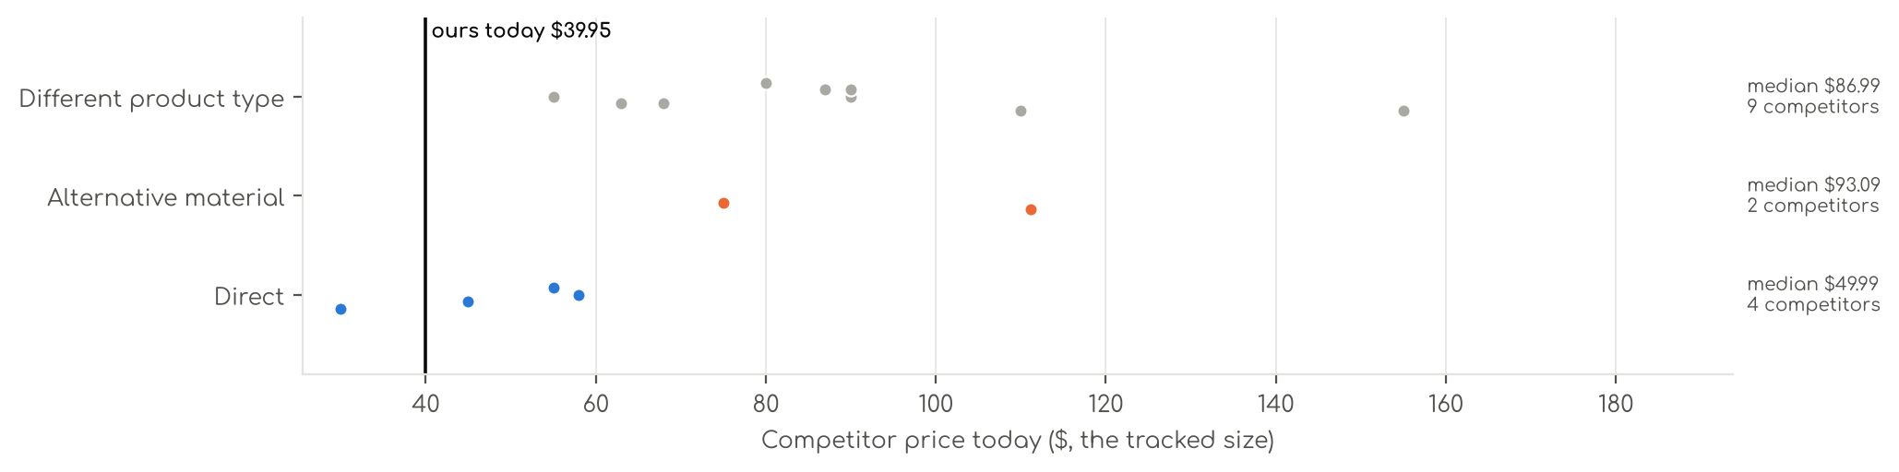
Photo | Competitor | Size · colour | Price | List | vs ours | Strike- through | BFCM 2025 deal | 2025 before → during | Disc. | Rank lift | Units / wk
Direct · 4
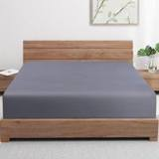 | Zaizaihome  Bamboo Viscose Cooling Fitted Sheet King Size Only  Bamboo viscose · 4.3★ 1,029 · Beatable  Buy Box RAISED in BFCM week (median $29.99 vs $27.59 before); List Price $29.99 | King · Dark Grey | $29.99 | — | -25% | Not shown | Prime Exclusive Discount | $27.59 → $23.69 | 14% | 0.96x | 81
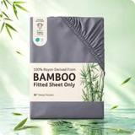 | Bedsure  Bedsure PureWoven Queen Fitted Sheet Qnly, 100% Rayon Derived from Bamboo  Bamboo viscose · 4.4★ 168 · Beatable | Queen (1 PC) · 01 - Grey | $44.99 | — | +19% | List Price $49.99 | Not live in 2025 | — | — | — | 81
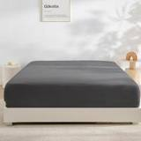 | GOKOTTA  GOKOTTA Fitted Sheet Queen Only,100% Rayon Derived from Bamboo Fitted Sheet,Ultr  Bamboo viscose · 4.6★ 976 · Aspirational  Coupon 10% (11-01 to 11-01); List Price $100.00 | King · Darkgrey | $58.00 | — | +45% | Not shown | Price cut only | $54.00 → $43.20 | 20% | 1.22x | 35
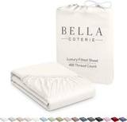 | BC BELLA COTERIE  Bella Coterie | Luxury Bamboo Viscose King Size Fitted Sheet Only  Bamboo viscose · 4.5★ 331 · Beatable  List Price $54.99 | King · Ivory | $54.99 | — | +38% | Not shown | None | $54.99 → $54.99 | 0% | 0.86x | 35
Alternative material · 2
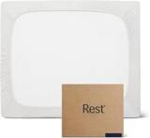 | REST  REST® Evercool®+ Fitted Sheet, Full Size, Light Blue, 15" Deep (up to 18’’), Bre  Synthetic cooling knit · 4.4★ 663 · Aspirational  Lightning Deal 11-09 to 11-10; List Price $139.00 | King · Arctic White | $111.20 | $139.00 | +178% | List Price $139.00 | Price cut only | $111.20 → $104.25 | 6% | 1.56x | 35
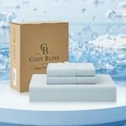 | Cozy Bliss  Cooling Fitted Sheet  Synthetic cooling knit · 4.5★ 456 · Beatable  No Buy Box history in price history for BFCM 2025; List Price $89.99 | Queen(no Flat Sheet) · Cool Blue | $74.99 | — | +98% | Not shown | — | — | — | 1.12x | 5
Different product type · 9
 | Pure Bamboo  Pure Bamboo King Sheets, Genuine 100% Organic Viscose Derived from Bamboo Bed Sheet Set, Luxuriously Soft & Cooling, Dou…  Bamboo viscose · 4.5★ 21,927 · Aspirational  List Price $139.99/$149.99 | King · Ivory | $109.99 | — | +175% | Not shown | None | $109.99 → $109.99 | 0% | 0.48x | 809
 | Bedsure  Bedsure PureWoven 100% Rayon Derived from Bamboo, Queen Sheets, 4 Pieces  Bamboo viscose · 4.4★ 65,061  Buy Box RAISED in BFCM week (median $69.99 vs $66.49 before); List Price $78.99 | Queen · 02 - White | $62.99 | $69.99 | +66% | List Price $69.99 | Prime Exclusive Discount | $66.49 → $55.99 | 16% | 0.68x | 809
 | Bambaw  Bambaw 100% Viscose Derived from Bamboo Sheets Queen Size Set – 4pcs Cooling Sheet Set, Super Soft Sheets Queen Size, Lu…  Bamboo viscose · 4.3★ 2,766 · Beatable  List Price $103.45 | Queen · Charcoal | $89.99 | — | +137% | Not shown | None | $89.99 → $89.99 | 0% | 1.17x | 104
 | Bedsure  Bedsure PureWoven Organically Grown Bamboo Viscose Queen Sheet Set, 4PCS  Bamboo viscose · 4.5★ 588 · Beatable  Prime Exclusive already running before BFCM week; List Price $114.99 | Queen · 01 - White | $89.99 | $119.99 | +137% | List Price $119.99 | Prime Exclusive Discount | $99.99 → $72.64 | 27% | 0.99x | 104
 | SONORO KATE  Bamboo Sheets  Bamboo viscose · 4.5★ 3,776 · Beatable  Coupon 15% (11-06 to 11-19); List Price $79.99 | King · Dark Grey | $79.99 | — | +100% | Not shown | Prime Exclusive Discount | $79.99 → $63.99 | 20% | 1.55x | 104
 | BC BELLA COTERIE  Bella Coterie Luxury Bamboo Viscose King Size Sheet Set  Bamboo viscose · 4.4★ 5,871 · Beatable  Coupon 20.00 USD (12-03 to 12-05); List Price $169.99 | King - 2 Pillowcases · 01 - White | $154.99 | — | +288% | Not shown | Price cut only | $134.99 → $110.50 | 18% | 2.66x | 92
 | BAMPURE  BAMPURE 100% Rayon from Bamboo Sheets King Size - 4pc Cooling King Sheets  Bamboo viscose · 4.4★ 4,095  Coupon 5.00 USD (11-01 to 11-04); Buy Box RAISED in BFCM week (median $99.99 vs $84.99 before); List Price $99.99 | King · White | $67.98 | $99.99 | +70% | List Price $99.99 | Prime Exclusive Discount | $84.99 → $79.99 | 6% | 1.14x | 81
 | DOZ by SIJO  Bamboo Sheets  Bamboo viscose · 4.4★ 1,909 · Beatable  List Price $55.00 | Queen · Olive | $55.00 | — | +45% | Not shown | None | $55.00 → $55.00 | 0% | 1.18x | 35
 | Kickoff Home  Bamboo Sheets  Bamboo viscose · 4.6★ 688 · Poor  Coupon 25% (11-01 to 11-05); List Price $124.99 | King · Sage Green | $86.99 | $84.99 | +118% | Not shown | Price cut only | $118.99 → $79.13 | 33% | 2.47x | 18

US · SL B6: Sleep Sanctuary Bamboo Sheets 6 Piece
 | Listing title | SLEEP SANCTUARY 100% Viscose Derived from Bamboo Sheets King Size, 6 Pc Set | Cooling BamBliss Comfort for Hot Sleepers | Cloud Soft | Deep 17" Pocket w Corner Straps | Luxury Bed Set | Taupe
 | Marketplace | United States
 | Family · role | Bamboo · Core
 | Scope · stage | Core · Re-Launch
 | Amazon parent | B0HBWXDWJ5
 | Best seller | B0DDTYDHVB (King Taupe)
 | Variations | 82 (38 with a live price)
 | Sizes | King, Queen, Full, Twin, California King
 | Colours | 16

OUR PRICE TODAY  $69.99  King Taupe | BFCM 2026 DEAL PRICE  $69.99 → $66.49  Best Deal Nov 19-30 · 5% off the Oct 27 price | STOCK TO NOV 30  7 short · 4 out  912 at Amazon · 0 inbound · need 165 | BFCM 2025 SALES LIFT  1.20x  91 units in the last 28 days | DIRECT COMPETITORS  29  median $79.99 · 9 cheaper than us

BFCM 2025: how this product did
Period | Sales | Units | Organic units | Ad units | Ad cost | TACoS | Sessions | Unit session % | Avg price
Oct 21 – Nov 19, 2025 (30 days before) | $27,880 | 423 | 376 | 47 | $9,894 | 35.5% | 6,527 | 6.5% | $65.91
Nov 20 – Dec 1, 2025 (BFCM week) | $13,397 | 231 | 213 | 18 | $2,505 | 18.7% | 2,834 | 8.2% | $57.99
Dec 2 – 31, 2025 | $63,405 | 963 | 869 | 94 | $15,156 | 23.9% | 11,372 | 8.5% | $65.84
Best seller in BFCM 2025: B0DDTYDHVB: $69.99 before (median Nov 1 – 19) → $69.99 in BFCM week, no cut; Best Seller Rank 104,479 → 165,550; Prime Exclusive price seen 11-28 to 12-01 (4 days).
Stock in BFCM 2025: 0 of 80 variations hit zero FBA stock on at least one observed day in BFCM week; weighted by sales mix, about 0.0% of variation-days were lost.

BFCM 2026 deal
Deal | Hero variation | Price Oct 27 | Deal price | Off | Variations (deal page) | Our 2025 cut | Rivals' 2025 cut
Best Deal Nov 19-30 | King Taupe | $69.99 | $66.49 | 5% | 42 out of stock, 31 eligible, 7 no reference price; 0%–5% off | 0% ($69.99 → $69.99) | 24% (4 rivals)
Deal notes
- Pre-BFCM deal decision. Oct 14-27 Best Deal: cancel recommended (4.3 units a day Oct 1-10, no lift from Prime Big Deal Days).

Stock to Nov 30
Sales per day today 3.4 · lift used 1.20x (this product's own BFCM 2025 lift) · need to Nov 30 165 units · at Amazon 912 · inbound 0. Covered 33, needs inbound in time 0, short 7, out of stock now 4.
Size | Colour | At Amazon | Inbound | Sales / day | Need to Nov 30 | Short by | Runs out | Status
California King | Purple | 11 | 0 | 0.3 | 13 | 2 | Nov 23 | Short even with inbound
California King | Light Pink | 6 | 0 | 0.2 | 11 | 5 | Nov 11 | Short even with inbound
Full | Sage Green | 7 | 0 | 0.2 | 11 | 4 | Nov 15 | Short even with inbound
Queen | Creme | 1 | 0 | 0.1 | 6 | 5 | Oct 23 | Short even with inbound
King | White | 0 | 0 | 0.1 | 5 | 5 | now | Out of stock now
Twin | — | 4 | 0 | 0.1 | 5 | 1 | Nov 22 | Short even with inbound
California King | Black | 1 | 0 | 0.1 | 3 | 2 | Oct 31 | Short even with inbound
King | Midgrey | 2 | 0 | 0.1 | 2 | 0 | Nov 22 | Short even with inbound
Twin | Light Pink | 0 | 0 | 0.0 | 1 | 1 | now | Out of stock now
King | Creme | 0 | 0 | 0.0 | 1 | 1 | now | Out of stock now
King | Light Blue | 0 | 0 | 0.0 | 0 | 0 | now | Out of stock now

Sales mix, last 28 days
By size: King 55 · Queen 16 · Full 11 · Twin 5 · California King 4
By colour (top 8): Taupe 28 · Creme 14 · Olive 12 · Light Olive 6 · Light Grey 5 · White 5 · Midgrey 5 · Navy Blue 5

Competitors (30)
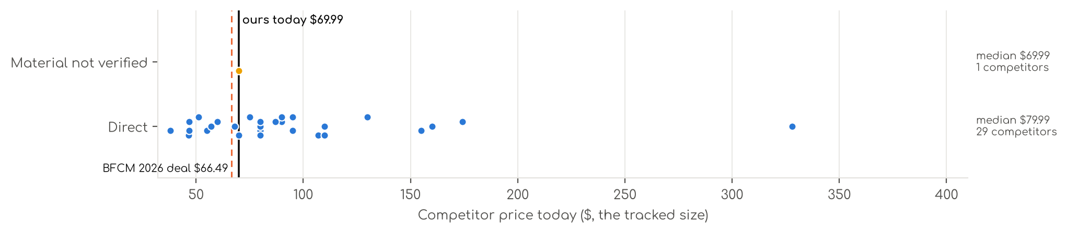
Photo | Competitor | Size · colour | Price | List | vs ours | Strike- through | BFCM 2025 deal | 2025 before → during | Disc. | Rank lift | Units / wk
Direct · 29
 | Pure Bamboo  Pure Bamboo King Sheets, Genuine 100% Organic Viscose Derived from Bamboo Bed Sheet Set, Luxuriously Soft & Cooling, Dou…  Bamboo viscose · 4.5★ 21,927 · Aspirational  List Price $139.99/$149.99 | King · Ivory | $109.99 | — | +57% | Not shown | None | $109.99 → $109.99 | 0% | 0.48x | 809
 | Hotel Sheets Direct  Hotel Sheets Direct 4 Piece Bed Sheet Set Queen Size, 100% Viscose Derived from Bamboo Sheets Set with 2 Pillowcases, Co…  Bamboo viscose · 4.4★ 37,179 · Aspirational  Lightning Deal 11-07 to 11-11; Coupon 20% (11-12 to 12-02); List Price $72.99 | Queen · White | $79.99 | — | +17% | Not shown | Price cut only | $72.99 → $57.99 | 21% | 2.27x | 347
 | KRIMANO  KRIMANO Bamboo Viscose Sheet Set King Size, Cooling Sheets Bed Set  Bamboo viscose · 4.5★ 263 · Beatable  List Price $94.89 | King · 1.navy Blue | $79.99 | — | +14% | Not shown | None | $72.99 → $72.99 | 0% | 1.89x | 185
 | Bambaw  Bambaw 100% Viscose Derived from Bamboo Sheets Queen Size Set – 4pcs Cooling Sheet Set, Super Soft Sheets Queen Size, Lu…  Bamboo viscose · 4.3★ 2,766 · Beatable  List Price $103.45 | Queen · Charcoal | $89.99 | — | +31% | Not shown | None | $89.99 → $89.99 | 0% | 1.17x | 104
 | Bedsure  Bedsure PureWoven Organically Grown Bamboo Viscose Queen Sheet Set, 4PCS  Bamboo viscose · 4.5★ 588 · Beatable  Prime Exclusive already running before BFCM week; List Price $114.99 | Queen · 01 - White | $89.99 | $119.99 | +31% | List Price $119.99 | Prime Exclusive Discount | $99.99 → $72.64 | 27% | 0.99x | 104
 | SONORO KATE  Bamboo Sheets  Bamboo viscose · 4.5★ 3,776 · Beatable  Coupon 15% (11-06 to 11-19); List Price $79.99 | King · Dark Grey | $79.99 | — | +14% | Not shown | Prime Exclusive Discount | $79.99 → $63.99 | 20% | 1.55x | 104
 | BC BELLA COTERIE  Bella Coterie Luxury Bamboo Viscose King Size Sheet Set  Bamboo viscose · 4.4★ 5,871 · Beatable  Coupon 20.00 USD (12-03 to 12-05); List Price $169.99 | King - 2 Pillowcases · 01 - White | $154.99 | — | +121% | Not shown | Price cut only | $134.99 → $110.50 | 18% | 2.66x | 92
 | BAMPURE  BAMPURE 100% Rayon from Bamboo Sheets King Size - 4pc Cooling King Sheets  Bamboo viscose · 4.4★ 4,095 · Beatable  Coupon 5.00 USD (11-01 to 11-04); Buy Box RAISED in BFCM week (median $99.99 vs $84.99 before); List Price $99.99 | King · White | $67.98 | $99.99 | -3% | List Price $99.99 | Prime Exclusive Discount | $84.99 → $79.99 | 6% | 1.14x | 81
 | SONORO KATE  SONORO KATE 100% Viscose Derived from Bamboo_Sheets Queen Size,4PC  Bamboo viscose · 4.5★ 3,911 · Beatable  Coupon 10% (11-04 to 12-05); List Price $59.99 | Queen · Dark Grey | $59.99 | — | -12% | Not shown | Prime Exclusive Discount | $59.99 → $47.99 | 20% | 1.20x | 81
 | AiAngu  Bamboo Sheets  Bamboo viscose · 4.6★ 121 · Poor | Queen · Dark Grey | $74.99 | $79.99 | +9% | List Price $79.99 | Not live in 2025 | — | — | — | 81
 | Cariloha  Cariloha Aloha Soft Bamboo Viscose Sheet Set - Natural - Queen  Bamboo viscose · 4.4★ 426 · Poor  Coupon 20%, 30% (11-01 to 12-05); List Price $119.00 | Queen · Natural | $107.10 | — | +56% | List Price $119.00 | Prime Exclusive Discount | $119.00 → $71.40 | 40% | 1.39x | 81
 | DOZ by SIJO  Bamboo Sheets  Bamboo viscose · 4.4★ 1,909 · Beatable  List Price $55.00 | Queen · Olive | $55.00 | — | -20% | Not shown | None | $55.00 → $55.00 | 0% | 1.18x | 35
 | Cozy Earth  Cozy Earth Luxury Bed Sheet Set, 100% Viscose from Bamboo Fabric  Bamboo viscose · 3.9★ 425 · Poor  List Price $328.00 | King · White | $328.00 | — | +369% | Not shown | Prime Exclusive Discount | $262.40 → $229.60 | 13% | 1.82x | 35
 | DREAMCARE  DREAMCARE 100% Rayon Bamboo Sheets King Size - 4pc Cooling Sheets King Size  Bamboo viscose · 4.5★ 2,261 · Poor  Buy Box RAISED in BFCM week (median $62.88 vs $58.99 before); List Price $58.99 | King · 5 - Gray | $46.74 | $59.99 | -33% | List Price $59.99 | Prime Exclusive Discount | $58.99 → $49.99 | 15% | 1.24x | 35
 | HOT SLEEPER SHEETS  Cooling Sheets Set Queen Size, Viscose Derived from Bamboo for Hot Sleepers | Deep Pocket Up to 16 Inch | Silky Soft & B…  Bamboo viscose · 4.4★ 674 · Poor  List Price $107.98 | Queen · Navy | $51.29 | $62.99 | -25% | Typical price $62.99 | Price cut only | $62.99 → $45.89 | 27% | 2.40x | 35
 | Shilucheng  Shilucheng 100% Viscose Derived from Bamboo_ Sheets Queen Size 4pcs  Bamboo viscose · 4.4★ 6,629 · Poor  Buy Box RAISED in BFCM week (median $58.30 vs $54.90 before); List Price $59.90 | Queen · 01 - Dark Grey | $46.66 | $54.90 | -32% | List Price $54.90 | Prime Exclusive Discount | $54.90 → $46.64 | 15% | 0.86x | 35
 | Bamtek  Viscose Bamboo Sheets Queen Size 4PC Set - Cooling Bedding for Hot Sleepers with  Bamboo viscose · 4.4★ 641 · Poor  Coupon 40.00 USD (11-01 to 11-10); List Price $129.99 | Queen · Sage | $94.99 | — | +39% | Not shown | Prime Exclusive Discount | $104.99 → $83.99 | 20% | 1.41x | 18
 | JSD  JSD Sage Green 100% Viscose Derived from Bamboo Cooling Sheet Set Queen  Bamboo viscose · 4.3★ 281 · Poor  Coupon 5% (11-01 to 11-17); List Price $74.99 | Queen · Green | $56.99 | — | -17% | Not shown | None | $56.99 → $56.99 | 0% | 0.90x | 18
 | Kickoff Home  Bamboo Sheets  Bamboo viscose · 4.6★ 688 · Poor  Coupon 25% (11-01 to 11-05); List Price $124.99 | King · Sage Green | $86.99 | $84.99 | +24% | Not shown | Price cut only | $118.99 → $79.13 | 33% | 2.47x | 18
 | LB Luxury Bamboo Market  Bamboo Sheets  Bamboo viscose · 4.5★ 517 · Poor  List Price $159.94 | Queen · Dune | $129.94 | — | +90% | Not shown | Prime Exclusive Discount | $119.94 → $103.95 | 13% | 0.76x | 18
 | Shilucheng  Shilucheng 100% Viscose Derived from Bamboo_Sheets, Extra Deep Pocket  Bamboo viscose · 4.5★ 1,639 · Poor  Coupon 20% (11-02 to 11-12); List Price $84.99 | King · Dark Grey | $69.99 | $84.99 | 0% | List Price $84.99 | Prime Exclusive Discount | $84.99 → $64.59 | 24% | 0.73x | 18
 | BAMPURE  Bamboo Sheets  Bamboo viscose · 4.4★ 30 · Aspirational  List Price $69.99 | Twin - 3 Pieces Set · White | $37.99 | — | -31% | Not shown | None | $69.99 → $69.99 | 0% | 1.14x | 5
 | BC BELLA COTERIE  4 Piece Bamboo Sheet Set  Bamboo viscose · 4.4★ 5,652 · Aspirational | Queen - 2 Pillowcases · 22 - Striped Dune | $159.99 | — | +134% | Not shown | Not live in 2025 | — | — | — | 5
 | Bamboo Bay  Bamboo Sheets  Bamboo viscose · 4.5★ 2,691 · Poor  Buy Box RAISED in BFCM week (median $109.98 vs $86.99 before); List Price $129.98 | Queen · 04 - Light Grey | $79.98 | — | +17% | Not shown | None | $86.99 → $93.48 | -7% | 0.82x | 5
 | LBRO2M  LBRO2M Cooling Bed Sheet 100% Viscose Derived from Bamboo Sheet Set Queen Size 6  Bamboo viscose · 4.4★ 18 · Poor  Lightning Deal 11-01 to 11-01; List Price $179.97 | King 6 Pcs · White | $94.99 | — | +36% | Not shown | Prime Exclusive Discount | $95.99 → $67.19 | 30% | 1.66x | 5
 | TWK  TWK Luxury Sheet Set, Genuine 100% Organic Viscose Derived from Bamboo, Cooling & Breathable, Silky Soft, Bedding Sheets…  Bamboo viscose · 4.5★ 39 · Poor  Coupon 30%; Buy Box RAISED in BFCM week (median $79.00 vs $69.00 before); List Price $69.00 | King · Mist Gray | $109.99 | — | +57% | Not shown | Coupon only | $69.00 → $74.00 | -7% | 0.68x | 5
 | TWK  TWK Luxury Sheet Set, Genuine 100% Viscose Derived from Bamboo, Cooling & Breathable, Silky Soft, Bedding Sheets & Pillo…  Bamboo viscose · 4.5★ 11 · Poor | King · White | $46.74 | — | -33% | Not shown | Not live in 2025 | — | — | — | 5
 | TWK  4 Piece Bamboo Sheet Set  Bamboo viscose · 4.5★ 2 · Poor | King · Sand | $109.99 | — | +57% | Not shown | Not live in 2025 | — | — | — | 5
 | Vesta  Vesta Sheet Set – Soft, Breathable & Cooling, 100% Viscose Derived from Bamboo,  Bamboo viscose · 4.3★ 35 · Poor  List Price $174.30 | King/Cali King · Terra Cotta | $174.30 | — | +149% | Not shown | None | $174.30 → $174.30 | 0% | 1.15x | 5
Material not verified · 1
 | ACCURATEX  ACCURATEX Cooling Sheets for Hot Sleepers, King Size, Grey  4.4★ 1,040 · Poor  Lightning Deal 11-13 to 11-13; Buy Box RAISED in BFCM week (median $74.99 vs $69.99 before); List Price $74.99 | King · Grey | $69.99 | — | 0% | Not shown | Prime Exclusive Discount | $59.49 → $59.49 | 0% | 0.65x | 35

US · DC Cooling 4pc: Decolure Cooling Sheets 4 Piece
 | Listing title | DECOLURE Cooling Sheets Queen Set 4pcs - Luxurious & Ultra-Soft Cooling Bed Sheets Queen Size for Hot Sleepers - Comfortable Bamboo Viscose Microfiber Queen Bed Sheets Set Cooling (Navy)
 | Marketplace | United States
 | Family · role | Cooling · Off-season (aged variations only)
 | Scope · stage | Core · Re-Launch
 | Amazon parent | B0HLLHYGLQ
 | Best seller | B0C9LS5H2T (Queen Navy Blue)
 | Variations | 66 (38 with a live price)
 | Sizes | Queen, King, Full, Twin, California King, Cal King
 | Colours | 17

OUR PRICE TODAY  $37.95  Queen Navy Blue | BFCM 2026 DEAL  Not in a deal  regular price through BFCM | STOCK TO NOV 30  4 short · 2 out  1,835 at Amazon · 15 inbound · need 511 | BFCM 2025 SALES LIFT  1.63x  89 units in the last 28 days | DIRECT COMPETITORS  2  median $32.74 · 1 cheaper than us

BFCM 2025: how this product did
Period | Sales | Units | Organic units | Ad units | Ad cost | TACoS | Sessions | Unit session % | Avg price
Oct 21 – Nov 19, 2025 (30 days before) | $4,833 | 123 | 111 | 12 | $467 | 9.7% | 4,250 | 2.9% | $39.29
Nov 20 – Dec 1, 2025 (BFCM week) | $3,148 | 83 | 79 | 4 | $315 | 10.0% | 1,884 | 4.4% | $37.93
Dec 2 – 31, 2025 | $8,734 | 229 | 216 | 13 | $804 | 9.2% | 5,044 | 4.5% | $38.14
Best seller in BFCM 2025: Best Seller Rank 156,082 → 176,144.
Our BFCM 2025 deals: Lightning Deal 11-09 to 11-10 (cancelled, 32 variations); Lightning Deal 11-12 to 11-13 (cancelled, 32 variations); Best Deal 11-20 to 12-02 (cancelled, 38 variations)
Stock in BFCM 2025: 2 of 31 variations hit zero FBA stock on at least one observed day in BFCM week; weighted by sales mix, about 0.0% of variation-days were lost.

BFCM 2026 deal
Not in a BFCM 2026 deal: sells at its regular price through BFCM.

Stock to Nov 30
Sales per day today 9.6 · lift used 1.63x (this product's own BFCM 2025 lift) · need to Nov 30 511 units · at Amazon 1,835 · inbound 15. Covered 37, needs inbound in time 0, short 4, out of stock now 2.
Size | Colour | At Amazon | Inbound | Sales / day | Need to Nov 30 | Short by | Runs out | Status
Queen | Beige | 29 | 0 | 1.0 | 55 | 26 | Nov 12 | Short even with inbound
Full | Light Pink | 22 | 0 | 0.6 | 33 | 11 | Nov 19 | Short even with inbound
Cal King | Graphite | 9 | 0 | 0.3 | 13 | 4 | Nov 19 | Short even with inbound
Full | Cool Grey | 0 | 0 | 0.2 | 12 | 12 | now | Out of stock now
Twin | White | 4 | 0 | 0.1 | 4 | 0 | Nov 27 | Short even with inbound
Queen | Graphite | 0 | 0 | 0.1 | 3 | 3 | now | Out of stock now

Sales mix, last 28 days
By size: Queen 41 · King 32 · Full 9 · Twin 4 · California King 3
By colour (top 8): Light Blue 18 · Navy Blue 17 · Regal Purple 16 · Midnight Black 13 · Cool Grey 10 · Light Grey 5 · Cream 2 · Light Pink 2

Competitors (28)
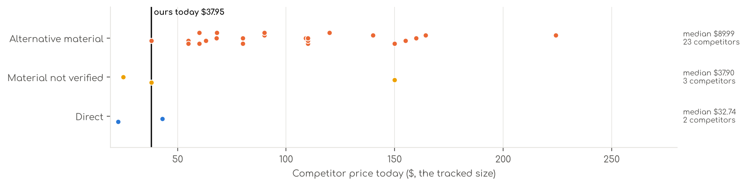
Photo | Competitor | Size · colour | Price | List | vs ours | Strike- through | BFCM 2025 deal | 2025 before → during | Disc. | Rank lift | Units / wk
Direct · 2
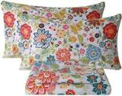 | Bedlifes  Cooling Sheets  Microfiber / polyester · 4.6★ 13,223 · Aspirational  Coupon 10% (11-01 to 11-19); List Price $35.99 | Queen · Spring Flower | $22.49 | — | -41% | Not shown | Prime Exclusive Discount | $25.99 → $14.03 | 46% | 0.95x | 92
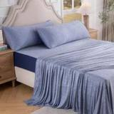 | OMERAI  Cooling Sheets  Microfiber / polyester · 4.7★ 4 · Beatable | King 4 PC · Blue | $42.99 | $59.99 | +8% | List Price $59.99 | Not live in 2025 | — | — | — | 5
Material not verified · 3
 | Shilucheng  Shilucheng 4 Piece King Sheet Sets, Cooling Sheets, Dark Grey  4.3★ 24,333 · Beatable  Coupon 15%; List Price $37.90 | King · Grey | $37.90 | — | -5% | Not shown | Coupon only | $37.90 → $30.32 | 20% | 1.42x | 18
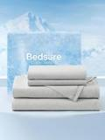 | Bedsure  Cooling Sheets  4.2★ 512 · Beatable  No Buy Box history in price history for BFCM 2025; List Price $82.99 | Queen · 01 - Grey | $149.99 | — | +295% | Not shown | — | — | — | — | 5
 | David's Home  Cooling Sheets  4.3★ 169 · Beatable  Coupon 20%, 40% (11-01 to 11-20); List Price $67.99 | — | $24.99 | — | -34% | — | Prime Exclusive Discount | $39.99 → $10.00 | 75% | 0.98x | —
Alternative material · 23
 | Pure Bamboo  Pure Bamboo King Sheets, Genuine 100% Organic Viscose Derived from Bamboo Bed Sheet Set, Luxuriously Soft & Cooling, Dou…  Bamboo viscose · 4.5★ 21,927 · Aspirational  List Price $139.99/$149.99 | King · Ivory | $109.99 | — | +175% | Not shown | None | $109.99 → $109.99 | 0% | 0.48x | 809
 | Bedsure  Bedsure PureWoven 100% Rayon Derived from Bamboo, Queen Sheets, 4 Pieces  Bamboo viscose · 4.4★ 65,061  Buy Box RAISED in BFCM week (median $69.99 vs $66.49 before); List Price $78.99 | Queen · 02 - White | $62.99 | $69.99 | +66% | List Price $69.99 | Prime Exclusive Discount | $66.49 → $55.99 | 16% | 0.68x | 809
 | Hotel Sheets Direct  Hotel Sheets Direct 4 Piece Bed Sheet Set Queen Size, 100% Viscose Derived from Bamboo Sheets Set with 2 Pillowcases, Co…  Bamboo viscose · 4.4★ 37,179 · Aspirational  Lightning Deal 11-07 to 11-11; Coupon 20% (11-12 to 12-02); List Price $72.99 | Queen · White | $79.99 | — | +111% | Not shown | Price cut only | $72.99 → $57.99 | 21% | 2.27x | 347
 | Bambaw  Bambaw 100% Viscose Derived from Bamboo Sheets Queen Size Set – 4pcs Cooling Sheet Set, Super Soft Sheets Queen Size, Lu…  Bamboo viscose · 4.3★ 2,766 · Beatable  List Price $103.45 | Queen · Charcoal | $89.99 | — | +137% | Not shown | None | $89.99 → $89.99 | 0% | 1.17x | 104
 | Bedsure  Bedsure PureWoven Organically Grown Bamboo Viscose Queen Sheet Set, 4PCS  Bamboo viscose · 4.5★ 588 · Beatable  Prime Exclusive already running before BFCM week; List Price $114.99 | Queen · 01 - White | $89.99 | $119.99 | +137% | List Price $119.99 | Prime Exclusive Discount | $99.99 → $72.64 | 27% | 0.99x | 104
 | SONORO KATE  Bamboo Sheets  Bamboo viscose · 4.5★ 3,776 · Beatable  Coupon 15% (11-06 to 11-19); List Price $79.99 | King · Dark Grey | $79.99 | — | +100% | Not shown | Prime Exclusive Discount | $79.99 → $63.99 | 20% | 1.55x | 104
 | BC BELLA COTERIE  Bella Coterie Luxury Bamboo Viscose King Size Sheet Set  Bamboo viscose · 4.4★ 5,871 · Beatable  Coupon 20.00 USD (12-03 to 12-05); List Price $169.99 | King - 2 Pillowcases · 01 - White | $154.99 | — | +288% | Not shown | Price cut only | $134.99 → $110.50 | 18% | 2.66x | 92
 | BAMPURE  BAMPURE 100% Rayon from Bamboo Sheets King Size - 4pc Cooling King Sheets  Bamboo viscose · 4.4★ 4,095 · Aspirational  Coupon 5.00 USD (11-01 to 11-04); Buy Box RAISED in BFCM week (median $99.99 vs $84.99 before); List Price $99.99 | King · White | $67.98 | $99.99 | +70% | List Price $99.99 | Prime Exclusive Discount | $84.99 → $79.99 | 6% | 1.14x | 81
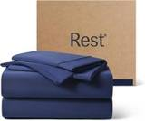 | REST  Cooling Sheets  Synthetic cooling knit · 4.3★ 1,149 · Beatable  Lightning Deal 11-14 to 11-14; List Price $299.00 | Queen · Midnight Blue | $224.25 | $299.00 | +491% | List Price $299.00 | Price cut only | $299.00 → $215.88 | 28% | 1.93x | 81
 | SONORO KATE  SONORO KATE 100% Viscose Derived from Bamboo_Sheets Queen Size,4PC  Bamboo viscose · 4.5★ 3,911 · Beatable  Coupon 10% (11-04 to 12-05); List Price $59.99 | Queen · Dark Grey | $59.99 | — | +58% | Not shown | Prime Exclusive Discount | $59.99 → $47.99 | 20% | 1.20x | 81
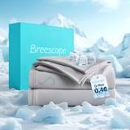 | Breescape  Cooling Sheets  Synthetic cooling knit · 4.2★ 595 · Beatable  Coupon 30% (11-01 to 11-02); List Price $179.99 | King · Gray | $149.99 | $179.99 | +275% | List Price $179.99 | Price cut only | $125.99 → $119.69 | 5% | 1.40x | 35
 | DOZ by SIJO  Bamboo Sheets  Bamboo viscose · 4.4★ 1,909 · Beatable  List Price $55.00 | Queen · Olive | $55.00 | — | +45% | Not shown | None | $55.00 → $55.00 | 0% | 1.18x | 35
 | GOKOTTA  GOKOTTA King Bamboo Rayon Sheets Set, Silky Soft Cooling Sheets Stay Put  Bamboo viscose · 4.4★ 3,371 · Beatable  Lightning Deal 11-09 to 11-09; Coupon 10.00 USD, 20.00 USD (11-02 to 11-18); List Price $105.00 | King - 4 PCS · 00 Bright White | $109.00 | — | +173% | Not shown | Price cut only | $105.00 → $84.00 | 20% | 1.47x | 35
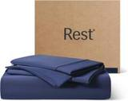 | REST  Cooling Sheets 4/6 Pcs  Synthetic cooling knit · 4.3★ 1,149 · Beatable  Lightning Deal 11-14 to 11-14; List Price $219.00 | King · Midnight Blue | $164.25 | $219.00 | +311% | List Price $219.00 | Price cut only | $219.00 → $158.12 | 28% | 1.93x | 35
 | KARISSA MAE  Cooling Sheets  Bamboo viscose · 4.3★ 474  No Buy Box history in price history for BFCM 2025 | King - 2 Pillowcases · 10 - Mocha | $119.99 | — | +200% | Not shown | — | — | — | — | 35
 | Shilucheng  Shilucheng 100% Viscose Derived from Bamboo_Sheets, Extra Deep Pocket  Bamboo viscose · 4.5★ 1,639 · Beatable  Coupon 18.00 USD, 20% (11-01 to 11-12); List Price $74.99 | Queen · Dark Grey | $59.99 | $74.99 | +58% | List Price $74.99 | Prime Exclusive Discount | $74.99 → $56.99 | 24% | 0.73x | 18
 | BAMPURE  Bamboo Sheets  Bamboo viscose · 4.4★ 30 · Aspirational  List Price $69.99 | Twin - 3 Pieces Set · White | $37.99 | — | +12% | Not shown | None | $69.99 → $69.99 | 0% | 1.14x | 5
 | BC BELLA COTERIE  4 Piece Bamboo Sheet Set  Bamboo viscose · 4.4★ 5,652 · Beatable | Queen - 2 Pillowcases · 22 - Striped Dune | $159.99 | — | +322% | Not shown | Not live in 2025 | — | — | — | 5
 | DOWNCOOL  Cooling Sheets  Synthetic cooling knit · 4.2★ 6 · Beatable  Buy Box RAISED in BFCM week (median $69.99 vs $35.99 before); List Price $69.99 | Full · White | $139.99 | — | +289% | Not shown | Prime Exclusive Discount | $35.99 → $29.99 | 17% | 0.99x | 5
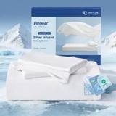 | Elegear  Elegear Silver Infused Cooling Bed Sheets Queen, Arc-Chill® 3.0 Cool Tech, Silve  Synthetic cooling knit · 4.4★ 131 · Beatable | Queen (Flat Sheet: 90" x 102") · White | $67.99 | $79.99 | +79% | Typical price $79.99 | Not live in 2025 | — | — | — | 5
 | Shilucheng  Shilucheng 100% Viscose Derived from Bamboo_ Sheets King Size 4pcs  Bamboo viscose · 4.4★ 6,629 · Beatable  Buy Box RAISED in BFCM week (median $68.90 vs $64.90 before); List Price $69.90 | King · 01 - Dark Grey | $54.90 | $64.90 | +37% | List Price $64.90 | Prime Exclusive Discount | $64.90 → $55.12 | 15% | 0.86x | 5
 | Pillcase  Pillcase Luxury Organic Tencel & Viscose from Bamboo Cooling Sheet Set,Silky Soft Lyocell Sheets with Deep Pocket, Hypoa…  Lyocell / eucalyptus · 4.5★ 35 · Poor  Coupon 40%; List Price $199.00 | King · White | $109.99 | — | +175% | Not shown | Coupon only | $94.52 → $94.52 | 0% | 2.47x | 5
 | TWK  TWK Luxury Sheet Set, Genuine 100% Organic Viscose Derived from Bamboo, Cooling & Breathable, Silky Soft, Bedding Sheets…  Bamboo viscose · 4.5★ 39 · Poor  Coupon 30%; Buy Box RAISED in BFCM week (median $79.00 vs $69.00 before); List Price $69.00 | King · Mist Gray | $109.99 | — | +175% | Not shown | Coupon only | $69.00 → $74.00 | -7% | 0.68x | 5

US · SL Cooling 4pc: Sleephoria Cooling Sheets 4 Piece
 | Listing title | SLEEPHORIA Cooling Sheets - BreezeWeave 4 PC King Size Cooling Bed Sheets for Hot Sleepers & Deep, Cool Rest - Cloud Soft, Silky Smooth, 16 in Deep Pocket, Ultra Durable (Light Grey)
 | Marketplace | United States
 | Family · role | Cooling · Off-season (aged variations only)
 | Scope · stage | Core · Re-Launch
 | Amazon parent | B0H8PNVWP1
 | Best seller | B0F7LZQNHM (King Light Grey)
 | Variations | 61 (40 with a live price)
 | Sizes | King, Queen, Full, Cal King, Twin
 | Colours | 13

OUR PRICE TODAY  $84.99  King Light Grey | BFCM 2026 DEAL PRICE  $84.99 → $80.74  Best Deal Nov 19-30 · 5% off the Oct 27 price | STOCK TO NOV 30  3 short · 7 out  3,570 at Amazon · 2,742 inbound · need 1,134 | BFCM 2025 SALES LIFT  1.16x  332 units in the last 28 days | DIRECT COMPETITORS  8  median $144.99 · 3 cheaper than us

BFCM 2025: how this product did
Period | Sales | Units | Organic units | Ad units | Ad cost | TACoS | Sessions | Unit session % | Avg price
Oct 21 – Nov 19, 2025 (30 days before) | $76,193 | 1,179 | 1,101 | 78 | $13,838 | 18.2% | 20,660 | 5.7% | $64.63
Nov 20 – Dec 1, 2025 (BFCM week) | $35,310 | 547 | 529 | 18 | $2,503 | 7.1% | 7,571 | 7.2% | $64.55
Dec 2 – 31, 2025 | $57,985 | 912 | 847 | 65 | $6,154 | 10.6% | 14,467 | 6.3% | $63.58
Best seller in BFCM 2025: B0F7LZQNHM: $69.99 before (median Nov 1 – 19) → $69.99 in BFCM week, no cut; Best Seller Rank 33,935 → 46,117.
Stock in BFCM 2025: 10 of 54 variations hit zero FBA stock on at least one observed day in BFCM week; weighted by sales mix, about 14.4% of variation-days were lost.

BFCM 2026 deal
Deal | Hero variation | Price Oct 27 | Deal price | Off | Variations (deal page) | Our 2025 cut | Rivals' 2025 cut
Best Deal Nov 19-30 | King Light Grey | $84.99 | $80.74 | 5% | 38 eligible, 23 out of stock; 0%–5% off | 0% ($69.99 → $69.99) | 21% (7 rivals)

Stock to Nov 30
Sales per day today 23.7 · lift used 1.16x (this product's own BFCM 2025 lift) · need to Nov 30 1,134 units · at Amazon 3,570 · inbound 2,742. Covered 41, needs inbound in time 8, short 3, out of stock now 7.
Size | Colour | At Amazon | Inbound | Sales / day | Need to Nov 30 | Short by | Runs out | Status
King | Light Grey | 65 | 126 | 1.5 | 74 | — | Nov 25 | Needs inbound in time
Queen | White | 61 | 150 | 1.3 | 64 | — | Nov 27 | Needs inbound in time
King | Cream | 45 | 126 | 1.0 | 46 | — | Nov 28 | Needs inbound in time
Full | White | 1 | 36 | 1.0 | 46 | 9 | Oct 16 | Short even with inbound
Twin | Cool Grey | 10 | 42 | 0.6 | 28 | — | Nov 1 | Needs inbound in time
King | Graphite | 0 | 0 | 0.5 | 25 | 25 | now | Out of stock now
Cal King | Midnight Black | 22 | 0 | 0.5 | 24 | 2 | Nov 25 | Short even with inbound
Queen | Midnight Black | 13 | 90 | 0.4 | 20 | — | Nov 15 | Needs inbound in time
Twin | Light Blue | 6 | 42 | 0.3 | 13 | — | Nov 5 | Needs inbound in time
King | Light Pink | 2 | 96 | 0.3 | 12 | — | Oct 23 | Needs inbound in time
Full | Light Grey | 0 | 0 | 0.2 | 11 | 11 | now | Out of stock now
Twin | Beige | 6 | 0 | 0.2 | 11 | 5 | Nov 11 | Short even with inbound
King | Navy Blue | 0 | 0 | 0.2 | 8 | 8 | now | Out of stock now
King | Sage Green | 0 | 102 | 0.1 | 6 | — | now | Out of stock now
Twin | Light Pink | 0 | 72 | 0.1 | 3 | — | now | Out of stock now
Full | Midnight Black | 0 | 36 | 0.1 | 2 | — | now | Out of stock now
Cal King | Beige | 1 | 48 | 0.0 | 2 | — | Nov 9 | Needs inbound in time
Twin | Light Grey | 0 | 0 | 0.0 | 2 | 2 | now | Out of stock now

Sales mix, last 28 days
By size: King 114 · Queen 113 · Full 43 · Cal King 32 · Twin 30
By colour (top 8): Graphite 85 · Light Grey 34 · Light Blue 34 · White 31 · Regal Purple 30 · Navy Blue 25 · Cream 24 · Midnight Black 18

Competitors (36)
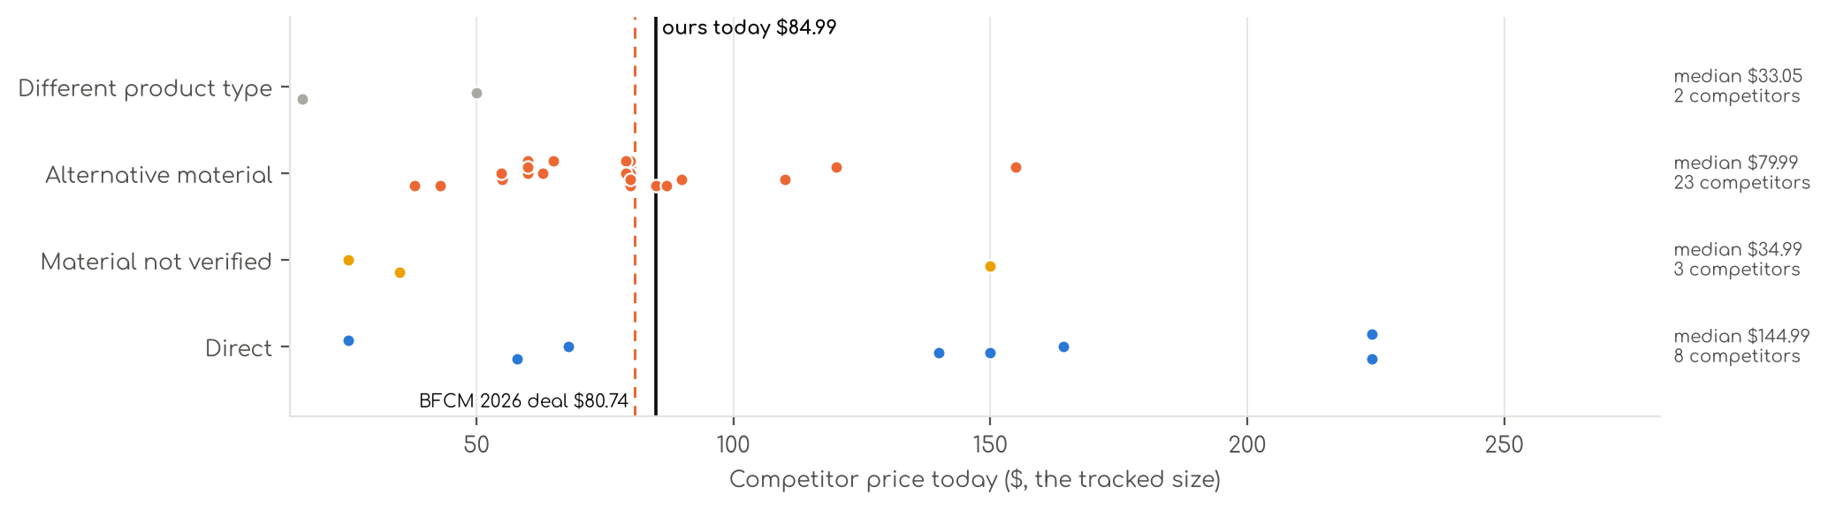
Photo | Competitor | Size · colour | Price | List | vs ours | Strike- through | BFCM 2025 deal | 2025 before → during | Disc. | Rank lift | Units / wk
Direct · 8
 | REST  Cooling Sheets  Synthetic cooling knit · 4.3★ 1,149 · Beatable  Lightning Deal 11-14 to 11-14; List Price $299.00 | Queen · Midnight Blue | $224.25 | $299.00 | +180% | List Price $299.00 | Price cut only | $299.00 → $215.88 | 28% | 1.93x | 81
 | Breescape  Cooling Sheets  Synthetic cooling knit · 4.2★ 595 · Beatable  Coupon 30% (11-01 to 11-02); List Price $179.99 | King · Gray | $149.99 | $179.99 | +76% | List Price $179.99 | Price cut only | $125.99 → $119.69 | 5% | 1.40x | 35
 | REST  Cooling Sheets 4/6 Pcs  Synthetic cooling knit · 4.3★ 1,149 · Beatable  Lightning Deal 11-14 to 11-14; List Price $219.00 | King · Midnight Blue | $164.25 | $219.00 | +93% | List Price $219.00 | Price cut only | $219.00 → $158.12 | 28% | 1.93x | 35
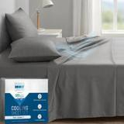 | Degrees of Comfort  Coolmax® Cooling Sheets for Hot Sleepers, Queen Size, Grey  Synthetic cooling knit · 4.1★ 7,328  Prime Exclusive already running before BFCM week; Buy Box RAISED in BFCM week (median $37.99 vs $34.99 before); List Price $39.99 | Queen · Grey | $24.99 | $29.99 | -69% | Typical price $29.99 | Prime Exclusive Discount | $33.24 → $28.49 | 14% | 0.90x | 35
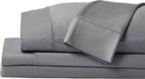 | SHEEX  SHEEX - Original Performance Sheets Set (Queen) Graphite - Cooling Sheets - Mois  Synthetic cooling knit · 4.4★ 3,256 · Beatable  Coupon 25%, 30% (11-14 to 11-18); List Price $299.00 | Queen · Graphite | $224.25 | — | +180% | Not shown | None | $299.00 → $299.00 | 0% | 2.41x | 5
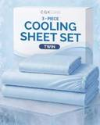 | CGK Unlimited  Cooling Sheets Set Twin XL Size - 3 Piece Summer Bed Sheets for Hot Sleepers & N  Synthetic cooling knit · 4.1★ 118 · Poor | Twin · 06 - Sky Blue | $57.99 | — | -3% | Not shown | Not live in 2025 | — | — | — | 5
 | DOWNCOOL  Cooling Sheets  Synthetic cooling knit · 4.2★ 6 · Poor  Buy Box RAISED in BFCM week (median $69.99 vs $35.99 before); List Price $69.99 | Full · White | $139.99 | — | +115% | Not shown | Prime Exclusive Discount | $35.99 → $29.99 | 17% | 0.99x | 5
 | Elegear  Elegear Silver Infused Cooling Bed Sheets Queen, Arc-Chill® 3.0 Cool Tech, Silve  Synthetic cooling knit · 4.4★ 131 · Poor | Queen (Flat Sheet: 90" x 102") · White | $67.99 | $79.99 | -15% | Typical price $79.99 | Not live in 2025 | — | — | — | 5
Material not verified · 3
 | Shilucheng  Shilucheng 4 Piece Queen Sheet Sets, Cooling Sheets, Dark Grey  4.3★ 24,352  Coupon 15%; List Price $34.90 | Queen · Grey | $34.99 | — | -56% | Not shown | Coupon only | $34.90 → $28.18 | 19% | 1.42x | 173
 | Bedsure  Cooling Sheets  4.2★ 512 · Poor  No Buy Box history in price history for BFCM 2025; List Price $82.99 | Queen · 01 - Grey | $149.99 | — | +88% | Not shown | — | — | — | — | 5
 | David's Home  Cooling Sheets  4.3★ 169  Coupon 20%, 40% (11-01 to 11-20); List Price $67.99 | — | $24.99 | — | -69% | — | Prime Exclusive Discount | $39.99 → $10.00 | 75% | 0.98x | —
Alternative material · 23
 | Love's cabin  Love's cabin 4 Piece Queen Sheet Set, 100% Rayon Derived from Bamboo, Cooling & Breathable, Soft Silky Deep Pocket up to…  Bamboo viscose · 4.4★ 1,900  Prime Exclusive already running before BFCM week; List Price $49.99 | Queen · Beige | $37.99 | $44.99 | -53% | List Price $44.99 | Prime Exclusive Discount | $36.99 → $29.99 | 19% | 0.99x | 924
 | Pure Bamboo  Pure Bamboo King Sheets, Genuine 100% Organic Viscose Derived from Bamboo Bed Sheet Set, Luxuriously Soft & Cooling, Dou…  Bamboo viscose · 4.5★ 21,927 · Aspirational  List Price $139.99/$149.99 | King · Ivory | $109.99 | — | +29% | Not shown | None | $109.99 → $109.99 | 0% | 0.48x | 809
 | Bedsure  Bedsure PureWoven 100% Rayon Derived from Bamboo, Queen Sheets, 4 Pieces  Bamboo viscose · 4.4★ 65,061 · Beatable  Buy Box RAISED in BFCM week (median $69.99 vs $66.49 before); List Price $78.99 | Queen · 02 - White | $62.99 | $69.99 | -21% | List Price $69.99 | Prime Exclusive Discount | $66.49 → $55.99 | 16% | 0.68x | 809
 | Hotel Sheets Direct  Hotel Sheets Direct 4 Piece Bed Sheet Set Queen Size, 100% Viscose Derived from Bamboo Sheets Set with 2 Pillowcases, Co…  Bamboo viscose · 4.4★ 37,179 · Aspirational  Lightning Deal 11-07 to 11-11; Coupon 20% (11-12 to 12-02); List Price $72.99 | Queen · White | $79.99 | — | 0% | Not shown | Price cut only | $72.99 → $57.99 | 21% | 2.27x | 347
 | KRIMANO  KRIMANO Bamboo Viscose Sheet Set King Size, Cooling Sheets Bed Set  Bamboo viscose · 4.5★ 263 · Beatable  List Price $94.89 | King · 1.navy Blue | $79.99 | — | -6% | Not shown | None | $72.99 → $72.99 | 0% | 1.89x | 185
 | TRUE BAMBOO  TRUE BAMBOO Sheets Set King Size - Silky Soft & Cooling - Dark Gray  Bamboo viscose · 4.6★ 167 | Queen · Dark Gray | $79.99 | $129.99 | 0% | List Price $129.99 | Not live in 2025 | — | — | — | 185
 | Bambaw  Bambaw 100% Viscose Derived from Bamboo Sheets Queen Size Set – 4pcs Cooling Sheet Set, Super Soft Sheets Queen Size, Lu…  Bamboo viscose · 4.3★ 2,766 · Beatable  List Price $103.45 | Queen · Charcoal | $89.99 | — | +13% | Not shown | None | $89.99 → $89.99 | 0% | 1.17x | 104
 | SONORO KATE  Bamboo Sheets  Bamboo viscose · 4.5★ 3,776 · Beatable  Coupon 15% (11-06 to 11-19); List Price $79.99 | King · Dark Grey | $79.99 | — | -6% | Not shown | Prime Exclusive Discount | $79.99 → $63.99 | 20% | 1.55x | 104
 | BC BELLA COTERIE  Bella Coterie Luxury Bamboo Viscose King Size Sheet Set  Bamboo viscose · 4.4★ 5,871 · Beatable  Coupon 20.00 USD (12-03 to 12-05); List Price $169.99 | King - 2 Pillowcases · 01 - White | $154.99 | — | +82% | Not shown | Price cut only | $134.99 → $110.50 | 18% | 2.66x | 92
 | SONORO KATE  SONORO KATE 100% Viscose Derived from Bamboo_Sheets Queen Size,4PC  Bamboo viscose · 4.5★ 3,911 · Beatable  Coupon 10% (11-04 to 12-05); List Price $59.99 | Queen · Dark Grey | $59.99 | — | -25% | Not shown | Prime Exclusive Discount | $59.99 → $47.99 | 20% | 1.20x | 81
 | BEDELITE  BEDELITE Bamboo Viscose Sheet Set, Queen Size, 4 Pieces, White  Bamboo viscose · 4.5★ 113 | Queen · White | $84.98 | $99.89 | +6% | List Price $99.89 | Not live in 2025 | — | — | — | 81
 | DOZ by SIJO  Bamboo Sheets  Bamboo viscose · 4.4★ 1,909 · Beatable  List Price $55.00 | Queen · Olive | $55.00 | — | -31% | Not shown | None | $55.00 → $55.00 | 0% | 1.18x | 35
 | Davmabcjy  100% Organically Grown Bamboo Viscose King Sheet Set with Pockets on Side  Bamboo viscose · 4.2★ 81 | King (Deep Fits 16" ) · Dark Grey-side Pockets | $59.99 | — | -29% | Not shown | Not live in 2025 | — | — | — | 35
 | KARISSA MAE  Cooling Sheets  Bamboo viscose · 4.3★ 474  No Buy Box history in price history for BFCM 2025 | King - 2 Pillowcases · 10 - Mocha | $119.99 | — | +41% | Not shown | — | — | — | — | 35
 | Pillcase  100% Real Bamboo Viscose & Lyocell Tencel Sheets Set Queen Size | Breathable & C  Microfiber / polyester · 4.8★ 279 | Queen · French Blue | $79.00 | $109.00 | -1% | List Price $109.00 | Not live in 2025 | — | — | — | 35
 | Kickoff Home  Bamboo Sheets  Bamboo viscose · 4.6★ 688 · Poor  Coupon 25% (11-01 to 11-05); List Price $124.99 | King · Sage Green | $86.99 | $84.99 | +2% | Not shown | Price cut only | $118.99 → $79.13 | 33% | 2.47x | 18
 | California Design Den  California Design Den 100% Viscose from Bamboo Sheets Queen, Dark Olive  Bamboo viscose · 4.6★ 76 | Queen · Bright White | $89.99 | — | +13% | Not shown | Not live in 2025 | — | — | — | 18
 | Pillcase  100% Real Bamboo Viscose & Lyocell Tencel Sheets Set Queen Size | Breathable & C  Microfiber / polyester · 4.9★ 201 | Queen · Charcoal | $79.00 | — | -1% | List Price $99.00 | Not live in 2025 | — | — | — | 18
 | Shilucheng  Shilucheng 100% Viscose Derived from Bamboo_Sheets, Extra Deep Pocket  Bamboo viscose · 4.5★ 1,639  Coupon 18.00 USD, 20% (11-01 to 11-12); List Price $74.99 | Queen · Dark Grey | $59.99 | $74.99 | -25% | List Price $74.99 | Prime Exclusive Discount | $74.99 → $56.99 | 24% | 0.73x | 18
 | TWK  TWK Real 100% Viscose Derived from Bamboo Sheets Set Queen Size, Cooling & Silky  Bamboo viscose · 4.9★ 121 | Queen · Sand | $65.00 | $79.00 | -19% | Typical price $79.00 | Not live in 2025 | — | — | — | 18
 | OMERAI  Cooling Sheets  Microfiber / polyester · 4.7★ 4 | King 4 PC · Blue | $42.99 | $59.99 | -49% | List Price $59.99 | Not live in 2025 | — | — | — | 5
 | Pillcase  Cooling Hotel Bedding Sheet Set - 4pcs Bamboo Viscose & Tencel Blend, Moisture-W  Microfiber / polyester · 4.0★ — | King · Pearl White | $79.99 | — | -6% | Not shown | Not live in 2025 | — | — | — | 5
 | Shilucheng  Shilucheng 100% Viscose Derived from Bamboo_ Sheets King Size 4pcs  Bamboo viscose · 4.4★ 6,629  Buy Box RAISED in BFCM week (median $68.90 vs $64.90 before); List Price $69.90 | King · 01 - Dark Grey | $54.90 | $64.90 | -35% | List Price $64.90 | Prime Exclusive Discount | $64.90 → $55.12 | 15% | 0.86x | 5
Different product type · 2
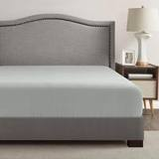 | Comfort Spaces  Comfort Spaces Coolmax Moisture Wicking Fitted Sheet ONLY Super Soft, Fade Resis  Synthetic cooling knit · 4.2★ 1,336  Buy Box RAISED in BFCM week (median $24.33 vs $19.57 before); List Price $16.99 | Queen Deep Pocket · Grey | $16.10 | — | -80% | Not shown | Price cut only | $19.57 → $17.60 | 10% | 0.71x | 185
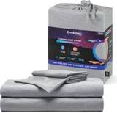 | Brookstone  Cooling Fitted Sheet  Synthetic cooling knit · 4.1★ 184 · Poor  Coupon 10% (11-11 to 11-27); List Price $49.99 | Twin · Gray | $49.99 | — | -17% | Not shown | Prime Exclusive Discount | $49.99 → $39.99 | 20% | 1.05x | 5

US · SL Cooling Comforter: Sleephoria Cooling Comforter
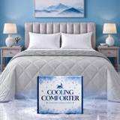 | Listing title | SLEEPHORIA Cooling Comforter - BreezeWeave Cooling Blanket King Size for Hot Sleepers & Deep Rest - Cloud Soft, Breathable, Ultra Durable, Easy Care, Reversible - 108 x 90 in (Light Grey & Dark Grey)
 | Marketplace | United States
 | Family · role | Cooling · Off-season (lost $2.4K at BFCM 2025)
 | Scope · stage | Core · Re-Launch
 | Amazon parent | B0FTG1NNKG
 | Best seller | B0F7M4Q2HQ (King Light Grey & Dark Grey)
 | Variations | 20 (14 with a live price)
 | Sizes | King, Queen, Full, Twin
 | Colours | 5

OUR PRICE TODAY  —  King Light Grey & Dark Grey | BFCM 2026 DEAL PRICE  $79.99 → $75.99  Best Deal Nov 19-30 · 5% off the Oct 27 price | STOCK TO NOV 30  4 short · 2 out  883 at Amazon · 1,151 inbound · need 283 | BFCM 2025 SALES LIFT  3.39x  78 units in the last 28 days | DIRECT COMPETITORS  12  median $46.95 · 11 cheaper than us

BFCM 2025: how this product did
Period | Sales | Units | Organic units | Ad units | Ad cost | TACoS | Sessions | Unit session % | Avg price
Oct 21 – Nov 19, 2025 (30 days before) | $16,458 | 274 | 222 | 52 | $4,437 | 27.0% | 6,705 | 4.1% | $60.07
Nov 20 – Dec 1, 2025 (BFCM week) | $22,342 | 459 | 411 | 48 | $2,744 | 12.3% | 7,753 | 5.9% | $48.68
Dec 2 – 31, 2025 | $69,319 | 1,125 | 984 | 141 | $8,916 | 12.9% | 23,974 | 4.7% | $61.62
Best seller in BFCM 2025: B0F7M4Q2HQ: $64.99 before (median Nov 1 – 19) → $51.99 in BFCM week, 20% lower; Best Seller Rank 130,761 → 86,410; Prime Exclusive price seen 11-24 to 12-01 (8 days).
Stock in BFCM 2025: 0 of 15 variations hit zero FBA stock on at least one observed day in BFCM week; weighted by sales mix, about 0.0% of variation-days were lost.

BFCM 2026 deal
Deal | Hero variation | Price Oct 27 | Deal price | Off | Variations (deal page) | Our 2025 cut | Rivals' 2025 cut
Best Deal Nov 19-30 | King Light Grey & Dark Grey | $79.99 | $75.99 | 5% | 14 eligible, 5 out of stock, 1 no reference price; 5%–5% off | 20% ($64.99 → $51.99) | 15% (4 rivals)

Stock to Nov 30
Sales per day today 3.8 · lift used 3.39x (this product's own BFCM 2025 lift) · need to Nov 30 283 units · at Amazon 883 · inbound 1,151. Covered 12, needs inbound in time 1, short 4, out of stock now 2.
Size | Colour | At Amazon | Inbound | Sales / day | Need to Nov 30 | Short by | Runs out | Status
Full | Light Grey & Dark Grey | 13 | 0 | 1.1 | 84 | 71 | Oct 26 | Short even with inbound
King | Light Grey & Dark Grey | 0 | 0 | 0.9 | 64 | 64 | now | Out of stock now
Twin | Light Grey & Dark Grey | 16 | 0 | 0.3 | 19 | 3 | Nov 26 | Short even with inbound
Twin | Blue & Dark Grey | 7 | 0 | 0.2 | 16 | 9 | Nov 15 | Short even with inbound
Queen | Mint Green & Dark Grey | 0 | 84 | 0.1 | 4 | — | now | Out of stock now
Queen | Blue & Light Grey | 1 | 116 | 0.1 | 4 | — | Nov 4 | Needs inbound in time
Full | Blue & Light Grey | 2 | 0 | 0.0 | 3 | 1 | Nov 22 | Short even with inbound

Sales mix, last 28 days
By size: King 35 · Queen 24 · Full 13 · Twin 6
By colour (top 8): Light Grey & Dark Grey 53 · Pink & Beige 10 · Blue & Dark Grey 6 · Mint Green & Dark Grey 5 · Blue & Light Grey 4

Competitors (18)
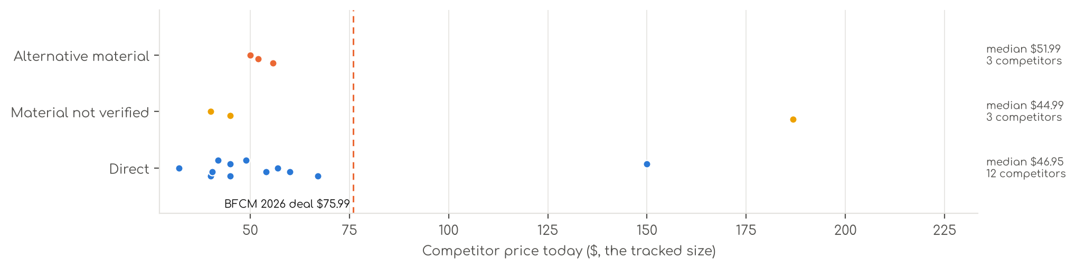
Photo | Competitor | Size · colour | Price | List | vs ours | Strike- through | BFCM 2025 deal | 2025 before → during | Disc. | Rank lift | Units / wk
Direct · 12
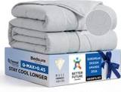 | Bedsure  Cooling Comforter  Synthetic cooling knit · 4.5★ 142 · Beatable | King(102"x90") · Grey | $44.99 | $59.99 | -44% | List Price $59.99 | Not live in 2025 | — | — | — | 185
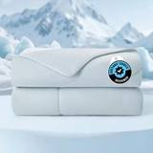 | Cozy Bliss  SL Cooling Comforter  Synthetic cooling knit · 4.5★ 2,707 · Aspirational  Prime Exclusive already running before BFCM week; Buy Box RAISED in BFCM week (median $68.99 vs $49.09 before); List Price $84.99 | Queen(90"*90") · Blue | $59.99 | $79.99 | -14% | List Price $79.99 | Prime Exclusive Discount | $49.09 → $46.63 | 5% | 1.05x | 104
 | DOWNCOOL  SL Cooling Comforter  Synthetic cooling knit · 4.4★ 904 | Full/Queen(90"x90") · 01dark Grey | $31.99 | $39.99 | -51% | List Price $39.99 | Not live in 2025 | — | — | — | 104
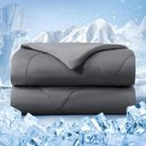 | bedsmile  SL Cooling Comforter  Synthetic cooling knit · 4.3★ 741 · Beatable  Prime Exclusive 11-03 to 12-05; Prime Exclusive already running before BFCM week; List Price $59.99 | Queen(90"x90") · Dark Gray | $44.99 | — | -36% | List Price $59.99 | Lightning Deal | $39.99 → $37.04 | 7% | 0.99x | 92
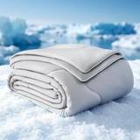 | EASELAND  SL Cooling Comforter  Synthetic cooling knit · 4.4★ 1,093 · Beatable  Lightning Deal 11-08 to 11-08; Buy Box RAISED in BFCM week (median $65.90 vs $37.56 before); List Price $69.90 | 90"x90" · Grey | $48.90 | — | -28% | Not shown | Prime Exclusive Discount | $37.56 → $35.59 | 5% | 1.27x | 81
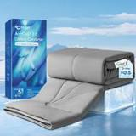 | Elegear  SL Cooling Comforter  Synthetic cooling knit · 4.2★ 1,487 · Beatable  Prime Exclusive already running before BFCM week; List Price $58.99 | Queen 79'' x 86'' · Dark Gray | $39.98 | $44.89 | -43% | Typical price $44.89 | Prime Exclusive Discount | $39.59 → $29.99 | 24% | 1.27x | 35
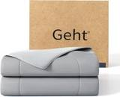 | Gehtmnl  SL Cooling Comforter  Synthetic cooling knit · 4.4★ 655 · Beatable | Queen(90"x90") · Frosty Light Grey | $53.99 | — | -23% | Not shown | Not live in 2025 | — | — | — | 35
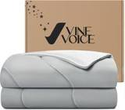 | Vine Voice  SL Cooling Comforter  Synthetic cooling knit · 4.4★ 888 · Beatable | Full / Queen (90"x90") · Silver Gray | $56.99 | — | -12% | Typical price $62.29 | Not live in 2025 | — | — | — | 35
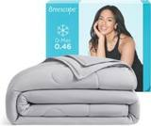 | Breescape  SL Cooling Comforter  Synthetic cooling knit · 4.4★ 343 · Beatable  List Price $199.99 | King / Cali King (96"x106") · Misty Gray | $149.99 | — | +88% | Not shown | Price cut only | $139.99 → $132.99 | 5% | 1.30x | 18
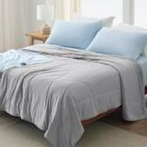 | Bedsure  SL Cooling Comforter  Synthetic cooling knit · 4.4★ 282 · Beatable  No Buy Box history in price history for BFCM 2025; List Price $82.99 | Full/Queen(88"x88") · Gray | $41.85 | — | -36% | Not shown | — | — | — | 0.84x | 5
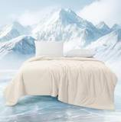 | MASVIS  SL Cooling Comforter  Synthetic cooling knit · 4.5★ 204 | Queen (90"x90") · Beige | $66.99 | — | -4% | Not shown | Not live in 2025 | — | — | — | 5
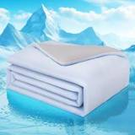 | Wolliwa  SL Cooling Comforter  Synthetic cooling knit · 4.5★ 384  List Price $69.99 | 108"x90“ · Light Blue | $40.37 | — | -40% | Not shown | None | $69.99 → $69.99 | 0% | 0.75x | 5
Material not verified · 3
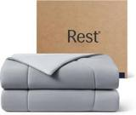 | REST  SL Cooling Comforter  4.3★ 4,110 · Beatable  Lightning Deal 11-06 to 11-11; List Price $249.00 | King / Cali King (106"x90") · Cool Gray | $186.75 | $249.00 | +133% | List Price $249.00 | Price cut only | $249.00 → $165.58 | 34% | 2.53x | 220
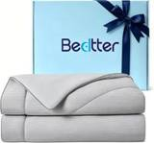 | Bedtter  Cooling Comforter  4.5★ 12 · Beatable  Coupon 80.00 USD (11-01 to 11-17); List Price $140.00 | Twin · Grey Stripes | $44.99 | — | -31% | Not shown | Prime Exclusive Discount | $209.00 → $87.90 | 58% | 3.78x | 5
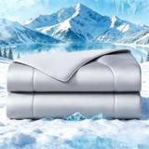 | jiaao  Cooling Comforter  4.0★ 83 | Queen Size(90" X90“) · Light Grey | $40.00 | — | -43% | Not shown | Not live in 2025 | — | — | — | 5
Alternative material · 3
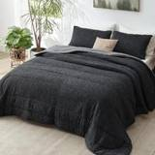 | Bedsure  SL Cooling Comforter  Microfiber / polyester · 4.4★ 3,538  Lightning Deal 11-05 to 11-12; List Price $58.99 | Queen · Charcoal Black | $55.79 | — | -20% | List Price $89.99 | Price cut only | $59.99 → $44.99 | 25% | 1.15x | 347
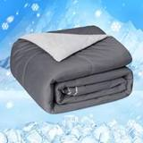 | HOMFINE  Cooling Comforter  Microfiber / polyester · 4.5★ 1,560 · Beatable  Coupon 20% (11-01 to 11-02); Prime Exclusive already running before BFCM week; List Price $67.99 | Queen (90"x90") · Gray | $51.99 | — | -26% | Not shown | Prime Exclusive Discount | $53.59 → $53.59 | 0% | 1.29x | 185
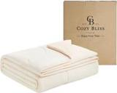 | Cozy Bliss  SL Cooling Comforter  Microfiber / polyester · 4.5★ 442 · Beatable  Prime Exclusive 11-01 to 11-19; Lightning Deal 11-09 to 11-15; Prime Exclusive already running before BFCM week; List Price $99.99 | Queen(90"*90") · Creamy Ivory/Soft Apricot | $49.99 | — | -29% | Typical price $69.99 | Price cut only | $49.99 → $47.49 | 5% | 2.67x | 81

US · SL Cooling Fitted: Sleephoria Cooling Fitted Sheet
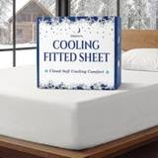 | Listing title | SLEEPHORIA Cooling Fitted Sheet King Size - 1 PC BreezeWeave Cooling Sheets for Hot Sleepers & Cool Rest w/ 16 in Deep Pocket - Corner Straps, Cloud Soft, Ultra Durable - 73 x 77 in (White)
 | Marketplace | United States
 | Family · role | Cooling · Off-season
 | Scope · stage | Core · Re-Launch
 | Amazon parent | B0GR6GBJYC
 | Best seller | B0F7M3YQ5R (King White)
 | Variations | 65 (39 with a live price)
 | Sizes | King, Queen, Full, Cal King, Twin
 | Colours | 13

OUR PRICE TODAY  $39.99  King White | BFCM 2026 DEAL PRICE  $39.99 → $37.99  Lightning Deal Nov 25 · 5% off the Oct 27 price | STOCK TO NOV 30  6 short · 3 out  2,604 at Amazon · 1,461 inbound · need 1,198 | BFCM 2025 SALES LIFT  0.98x  513 units in the last 28 days | DIRECT COMPETITORS  3  median $74.99 · 1 cheaper than us

BFCM 2025: how this product did
Period | Sales | Units | Organic units | Ad units | Ad cost | TACoS | Sessions | Unit session % | Avg price
Oct 21 – Nov 19, 2025 (30 days before) | $6,199 | 269 | 269 | 0 | $0 | 0.0% | 3,758 | 7.2% | $23.05
Nov 20 – Dec 1, 2025 (BFCM week) | $2,437 | 102 | 102 | 0 | $0 | 0.0% | 753 | 13.5% | $23.89
Dec 2 – 31, 2025 | $8,842 | 373 | 373 | 0 | $0 | 0.0% | 2,737 | 13.6% | $23.71
Best seller in BFCM 2025: B0F7M3YQ5R: $24.99 before (median Nov 1 – 19) → $24.99 in BFCM week, no cut.
Stock in BFCM 2025: 0 of 65 variations hit zero FBA stock on at least one observed day in BFCM week; weighted by sales mix, about 0.0% of variation-days were lost.

BFCM 2026 deal
Deal | Hero variation | Price Oct 27 | Deal price | Off | Variations (deal page) | Our 2025 cut | Rivals' 2025 cut
Lightning Deal Nov 25 | King White | $39.99 | $37.99 | 5% | 40 eligible, 21 out of stock, 3 no reference price, 1 manual price; 0%–20% off | 0% ($24.99 → $24.99) | 17% (2 rivals)
Deal notes
- BFCM deal status. Nov 25 Lightning Deal cancelled in Seller Central while a Best Deal is pursued; if not granted it is rescheduled as a Lightning Deal.

Stock to Nov 30
Sales per day today 26.2 · lift used 0.98x (this product's own BFCM 2025 lift) · need to Nov 30 1,198 units · at Amazon 2,604 · inbound 1,461. Covered 42, needs inbound in time 0, short 6, out of stock now 3.
Size | Colour | At Amazon | Inbound | Sales / day | Need to Nov 30 | Short by | Runs out | Status
Queen | Navy Blue | 41 | 0 | 2.2 | 101 | 60 | Nov 2 | Short even with inbound
King | Cool Blue | 12 | 0 | 0.3 | 15 | 3 | Nov 20 | Short even with inbound
Cal King | Sage Green | 4 | 0 | 0.2 | 11 | 7 | Nov 1 | Short even with inbound
Full | Cream | 4 | 0 | 0.1 | 6 | 2 | Nov 12 | Short even with inbound
Cal King | Light Grey | 3 | 0 | 0.1 | 4 | 1 | Nov 21 | Short even with inbound
Cal King | Regal Purple | 1 | 0 | 0.1 | 4 | 3 | Oct 27 | Short even with inbound
Twin | Cool Grey | 0 | 144 | 0.0 | 1 | — | now | Out of stock now
Full | Light Pink | 0 | 0 | 0.0 | 1 | 1 | now | Out of stock now
Full | Regal Purple | 0 | 0 | 0.0 | 1 | 1 | now | Out of stock now

Sales mix, last 28 days
By size: King 243 · Queen 196 · Full 37 · Cal King 28 · Twin 9
By colour (top 8): White 121 · Cool Grey 64 · Light Grey 58 · Midnight Black 57 · Beige 44 · Sage Green 40 · Cream 34 · Regal Purple 27

Competitors (11)
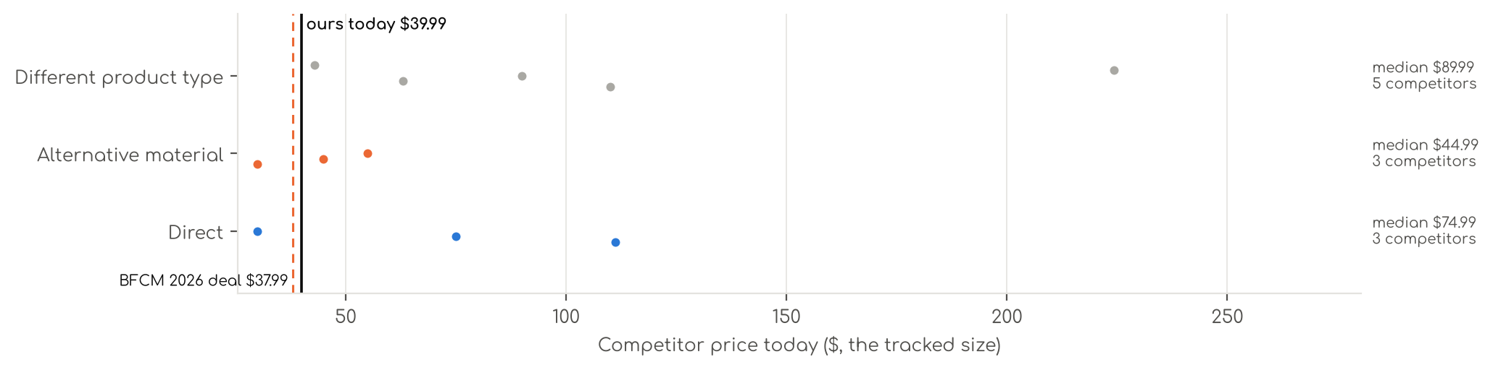
Photo | Competitor | Size · colour | Price | List | vs ours | Strike- through | BFCM 2025 deal | 2025 before → during | Disc. | Rank lift | Units / wk
Direct · 3
 | REST  REST® Evercool®+ Fitted Sheet, Full Size, Light Blue, 15" Deep (up to 18’’), Bre  Synthetic cooling knit · 4.4★ 663 · Beatable  Lightning Deal 11-09 to 11-10; List Price $139.00 | King · Arctic White | $111.20 | $139.00 | +178% | List Price $139.00 | Price cut only | $111.20 → $104.25 | 6% | 1.56x | 35
 | Cozy Bliss  Cooling Fitted Sheet  Synthetic cooling knit · 4.5★ 456 · Beatable  No Buy Box history in price history for BFCM 2025; List Price $89.99 | Queen(no Flat Sheet) · Cool Blue | $74.99 | — | +97% | Not shown | — | — | — | 1.12x | 5
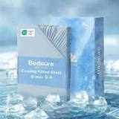 | Bedsure  Cooling Fitted Sheet  Synthetic cooling knit · 4.3★ 111 · Poor | King (78x80+16) · 04 - Blue | $29.99 | — | -25% | Not shown | Not live in 2025 | — | — | — | 5
Alternative material · 3
 | Zaizaihome  Bamboo Viscose Cooling Fitted Sheet King Size Only  Bamboo viscose · 4.3★ 1,029 · Beatable  Buy Box RAISED in BFCM week (median $29.99 vs $27.59 before); List Price $29.99 | King · Dark Grey | $29.99 | — | -25% | Not shown | Prime Exclusive Discount | $27.59 → $23.69 | 14% | 0.96x | 81
 | Bedsure  Bedsure PureWoven Queen Fitted Sheet Qnly, 100% Rayon Derived from Bamboo  Bamboo viscose · 4.4★ 168 · Beatable | Queen (1 PC) · 01 - Grey | $44.99 | — | +18% | List Price $49.99 | Not live in 2025 | — | — | — | 81
 | BC BELLA COTERIE  Bella Coterie | Luxury Bamboo Viscose King Size Fitted Sheet Only  Bamboo viscose · 4.5★ 331  List Price $54.99 | King · Ivory | $54.99 | — | +38% | Not shown | None | $54.99 → $54.99 | 0% | 0.86x | 35
Different product type · 5
 | Pure Bamboo  Pure Bamboo King Sheets, Genuine 100% Organic Viscose Derived from Bamboo Bed Sheet Set, Luxuriously Soft & Cooling, Dou…  Bamboo viscose · 4.5★ 21,927 · Aspirational  List Price $139.99/$149.99 | King · Ivory | $109.99 | — | +175% | Not shown | None | $109.99 → $109.99 | 0% | 0.48x | 809
 | Bedsure  Bedsure PureWoven 100% Rayon Derived from Bamboo, Queen Sheets, 4 Pieces  Bamboo viscose · 4.4★ 65,061  Buy Box RAISED in BFCM week (median $69.99 vs $66.49 before); List Price $78.99 | Queen · 02 - White | $62.99 | $69.99 | +66% | List Price $69.99 | Prime Exclusive Discount | $66.49 → $55.99 | 16% | 0.68x | 809
 | Bedsure  Bedsure PureWoven Organically Grown Bamboo Viscose Queen Sheet Set, 4PCS  Bamboo viscose · 4.5★ 588 · Beatable  Prime Exclusive already running before BFCM week; List Price $114.99 | Queen · 01 - White | $89.99 | $119.99 | +137% | List Price $119.99 | Prime Exclusive Discount | $99.99 → $72.64 | 27% | 0.99x | 104
 | REST  Cooling Sheets  Synthetic cooling knit · 4.3★ 1,149  Lightning Deal 11-14 to 11-14; List Price $299.00 | Queen · Midnight Blue | $224.25 | $299.00 | +490% | List Price $299.00 | Price cut only | $299.00 → $215.88 | 28% | 1.93x | 81
 | OMERAI  Cooling Sheets  Microfiber / polyester · 4.7★ 4 · Beatable | King 4 PC · Blue | $42.99 | $59.99 | +8% | List Price $59.99 | Not live in 2025 | — | — | — | 5

US · SL Cooling Pillowcase: Sleephoria Cooling Pillowcases
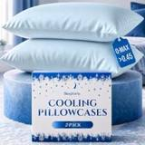 | Listing title | SLEEPHORIA Cooling Pillow Cases - BreezeWeave Queen Size Set of 2 Pillowcases for Hot Sleepers & Cool, Deep Rest - Cloud Soft, Silky Smooth, Ultra Durable, Easy Care, Hidden Zipper (Blue)
 | Marketplace | United States
 | Family · role | Cooling · Off-season
 | Scope · stage | Core · Re-Launch
 | Amazon parent | B0FTSVDG77
 | Best seller | B0F7LJS3N2 (Queen Blue)
 | Variations | 12 (3 with a live price)
 | Sizes | Queen, King, Standard
 | Colours | 4

OUR PRICE TODAY  —  Queen Blue | BFCM 2026 DEAL PRICE  $21.99 → $20.89  Best Deal Nov 19-30 · 5% off the Oct 27 price | STOCK TO NOV 30  0 short · 4 out  260 at Amazon · 1,160 inbound · need 156 | BFCM 2025 SALES LIFT  0.77x  54 units in the last 28 days | DIRECT COMPETITORS  13  median $17.52 · 11 cheaper than us

BFCM 2025: how this product did
Period | Sales | Units | Organic units | Ad units | Ad cost | TACoS | Sessions | Unit session % | Avg price
Oct 21 – Nov 19, 2025 (30 days before) | $9,911 | 606 | 474 | 132 | $4,509 | 45.5% | 4,670 | 13.0% | $16.35
Nov 20 – Dec 1, 2025 (BFCM week) | $3,042 | 191 | 148 | 43 | $1,305 | 42.9% | 1,534 | 12.5% | $15.93
Dec 2 – 31, 2025 | $6,362 | 402 | 315 | 87 | $2,147 | 33.8% | 3,313 | 12.1% | $15.83
Best seller in BFCM 2025: B0F7LJS3N2: $15.99 before (median Nov 1 – 19) → $15.99 in BFCM week, no cut; Best Seller Rank 74,485 → 102,469.

BFCM 2026 deal
Deal | Hero variation | Price Oct 27 | Deal price | Off | Variations (deal page) | Our 2025 cut | Rivals' 2025 cut
Best Deal Nov 19-30 | Queen Blue | $21.99 | $20.89 | 5% | 7 eligible, 3 out of stock, 2 no reference price; 0%–5% off | 0% ($15.99 → $15.99) | 29% (2 rivals)

Stock to Nov 30
Sales per day today 2.3 · lift used 2.74x (account lift, assumed) · need to Nov 30 156 units · at Amazon 260 · inbound 1,160. Covered 7, needs inbound in time 0, short 0, out of stock now 4.
Size | Colour | At Amazon | Inbound | Sales / day | Need to Nov 30 | Short by | Runs out | Status
Queen | Blue | 0 | 64 | 0.4 | 29 | — | now | Out of stock now
Standard | Blue | 0 | 96 | 0.1 | 4 | — | now | Out of stock now
Queen | Dark Grey | 0 | 192 | 0.0 | 2 | — | now | Out of stock now
King | Dark Grey | 0 | 308 | 0.0 | 2 | — | now | Out of stock now

Sales mix, last 28 days
By size: Queen 29 · King 23 · Standard 2
By colour (top 8): Light Grey 18 · Blue 18 · White 16 · Dark Grey 2

Competitors (21)
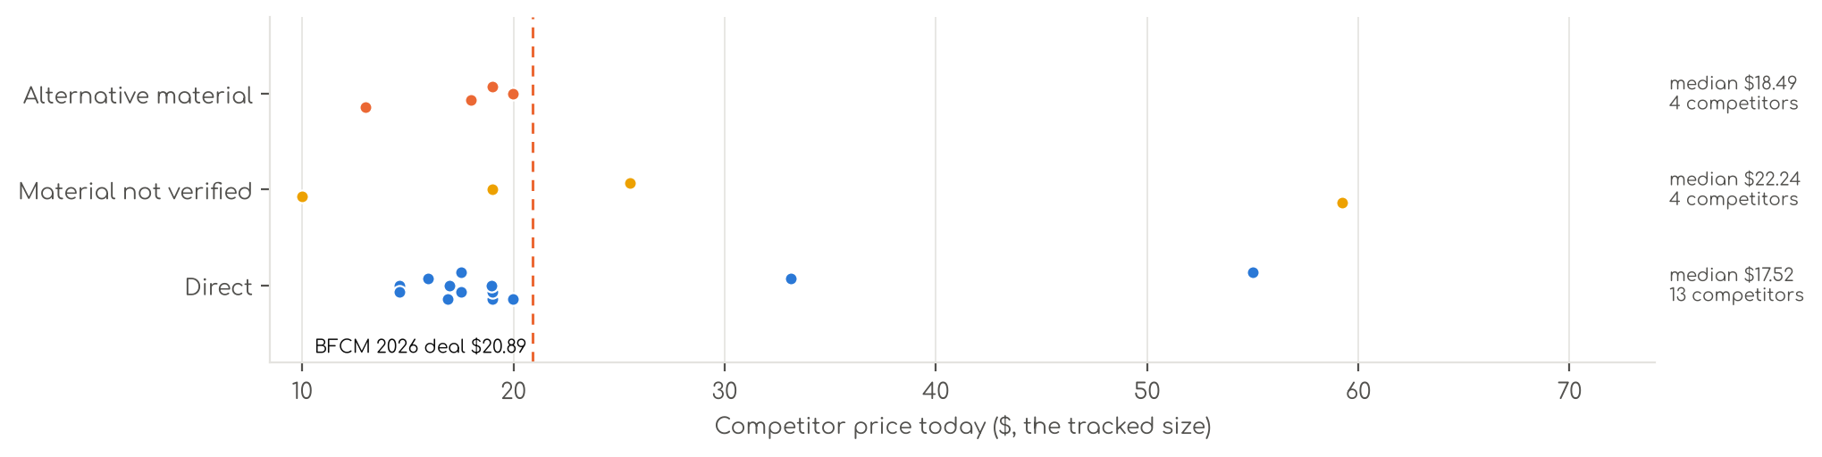
Photo | Competitor | Size · colour | Price | List | vs ours | Strike- through | BFCM 2025 deal | 2025 before → during | Disc. | Rank lift | Units / wk
Direct · 13
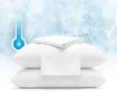 | Serta  Serta Power Chill Cooling Pillow Protectors, Standard/Queen (2 Pack)  Synthetic cooling knit · 4.3★ 3,545 · Aspirational  List Price $19.99 | Standard/Queen · White | $19.02 | — | -9% | Not shown | None | $14.46 → $14.19 | 2% | 1.38x | 1,040
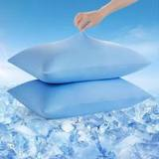 | Avolare  Avolare Cooling Pillow Cases Queen Size Set of 2,Arc-Chill 3.0 Cool Pillowcases  Synthetic cooling knit · 4.4★ 3,832 · Beatable  Coupon 10%, 15% (11-01 to 12-05); List Price $19.99 | Queen (U.S. Standard) · Blue | $17.52 | $19.99 | -20% | Not shown | Prime Exclusive Discount | $15.99 → $13.67 | 15% | 0.80x | 173
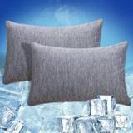 | CHOSHOME  CHOSHOME Cooling Pillow Cases Zipper Pillow Covers Q-Max > 0.45 Zippered Pillowcases for Hot Sleepers, Soft, Breathable,…  Synthetic cooling knit · 4.4★ 1,768 · Beatable  List Price $19.99 | Standard · Grey | $14.60 | — | -14% | Not shown | Prime Exclusive Discount | $15.56 → $13.13 | 16% | 1.03x | 104
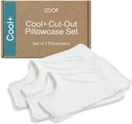 | Coop Home Goods  Coop Home Goods Cool+ Cooling Pillow Case Set of 2, Dove Grey Queen Size Pillow  Synthetic cooling knit · 4.5★ 507 · Beatable | Queen · White | $33.15 | $39.00 | +51% | Typical price $39.00 | Not live in 2025 | — | — | — | 104
 | Avolare  Avolare Cooling Pillow Cases for Hot Sleepers Queen Size 2 Pack, Grey  Synthetic cooling knit · 4.4★ 3,872 · Aspirational  Coupon 10%, 15% (11-01 to 12-05); List Price $19.99 | Queen (U.S. Standard) · Blue | $17.52 | $19.99 | -20% | Not shown | Prime Exclusive Discount | $15.99 → $13.67 | 15% | 0.80x | 92
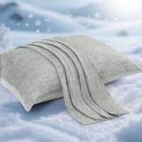 | Elegear  Elegear Cooling Pillow Cases for Hot Sleepers, Set of 2, Queen 20'' x 30''  Synthetic cooling knit · 4.3★ 8,391 · Aspirational  List Price $18.75 | Standard (20" x 26") · Grey | $16.88 | — | -19% | List Price $18.75 | Prime Exclusive Discount | $18.75 → $15.00 | 20% | 1.10x | 35
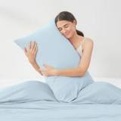 | Cozy Bliss  Cozy Bliss 2 Pack Cooling Pillow Cases, Queen 20" x 30", Dark Gray  Synthetic cooling knit · 4.5★ 707 · Beatable  Lightning Deal 11-16 to 11-16; List Price $36.99 | Queen(20"x30") · Blue | $18.99 | — | -14% | Not shown | Prime Exclusive Discount | $23.99 → $18.99 | 21% | 0.98x | 35
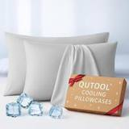 | QUTOOL  Luxury Cooling Pillowcases Queen Size 2 Pack, Q-Max>0.4 Cool Touch for Hot Sleepers&Night Sweats Beauty Sleep Anti-Frizz…  Synthetic cooling knit · 4.4★ 769 · Beatable  Prime Exclusive 11-23 to 12-01; Buy Box RAISED in BFCM week (median $19.99 vs $18.99 before); List Price $29.99 | Queen · Gray | $16.99 | — | -23% | Not shown | Lightning Deal | $18.99 → $13.99 | 26% | 1.29x | 35
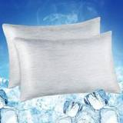 | LUXEAR  LUXEAR 2 Pack Cooling Pillow Cases for Hot Sleepers, Arc-Chill Q-Max > 0.5 Cool  Synthetic cooling knit · 4.2★ 6,718  List Price $24.99 | Standard (20" X 26") · Gray | $15.95 | — | -24% | Not shown | None | $15.95 → $15.95 | 0% | 0.91x | 35
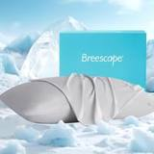 | Breescape  Breescape Cooling Pillow Cases Queen Size Set of 2, BlendTek™ Cooling Technology  Synthetic cooling knit · 4.4★ 305 · Beatable  Buy Box RAISED in BFCM week (median $54.99 vs $38.49 before); List Price $54.99 | King · Misty Gray | $54.99 | — | +129% | Not shown | Prime Exclusive Discount | $38.49 → $36.56 | 5% | 1.35x | 18
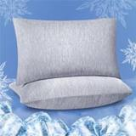 | Fittia  FITTIA Cooling Pillow Cases with Zipper, 2 Pack, Standard Size 20"x26"  Synthetic cooling knit · 4.3★ 1,335 · Beatable  List Price $21.99 | Standard 20"x 26" · Grey | $19.99 | — | -4% | Not shown | None | $19.99 → $19.99 | 0% | 0.81x | 18
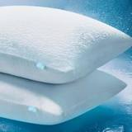 | Niagara Sleep Solution  Niagara Set of 2 Cooling Pillow Cases Standard Size, CoolSpan™ Technology Q-Max 0.4 Cooling Pillowcases for Hot Sleepers…  Synthetic cooling knit · 4.4★ 109 · Beatable  List Price $14.99 | Standard · Grey | $14.60 | — | -14% | Not shown | None | $8.99 → $8.99 | 0% | 0.84x | 5
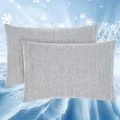 | Topcee  Topcee Cooling Pillowcases, 2 Packs Queen Size Arc-Chill Q-Max>0.5 Ultra Soft Co  Synthetic cooling knit · 4.2★ 227 · Beatable  List Price $29.99 | Queen(20"x30") · Gray | $18.95 | — | -14% | Not shown | None | $13.99 → $13.99 | 0% | 0.83x | 5
Material not verified · 4
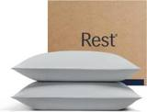 | REST  REST® Evercool®+ Cooling Pillowcases for Hot Sleepers, Standard, 2PCS  4.4★ 1,226 · Beatable  Lightning Deal 11-15 to 11-15; List Price $79.00 | Standard (2 pcs) · Light Gray | $59.25 | $79.00 | +184% | List Price $79.00 | Price cut only | $79.00 → $55.30 | 30% | 2.02x | 208
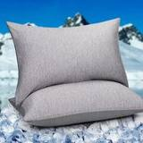 | HOMFINE  HOMFINE Cooling Pillowcases for Hot Sleepers King Size Set of 2, Grey  4.3★ 1,309 · Beatable  Coupon 20%, 24% (11-01 to 11-19); List Price $24.99 | King · Grey | $9.99 | — | -58% | Typical price $12.99 | Prime Exclusive Discount | $23.99 → $18.23 | 24% | 1.01x | 81
 | Bedsure  Bedsure Cooling Pillow Cases Queen Size Set of 2 for Hot Sleepers, Grey  4.5★ 676 · Beatable  List Price $32.99 | Queen · Grey | $18.99 | $24.99 | -14% | — | None | — | — | 0.84x | 5
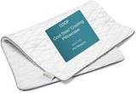 | Coop Home Goods  Coop Home Goods Cool Side Pillowcase, Queen Size Cooling Pillow Case for Hot Sle  4.3★ 1,158 · Beatable  Lightning Deal 11-01 to 11-07; List Price $30.00 | Queen · Standard | $25.50 | — | +16% | List Price $30.00 | Prime Exclusive Discount | $30.00 → $24.00 | 20% | 1.11x | 5
Alternative material · 4
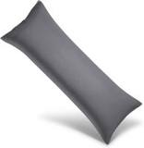 | WISHSMILE  WishSmile Cooling Queen Pillowcases Set of 2 Breathable Cool Silky Soft Rayon De  Bamboo viscose · 4.4★ 7,225 · Aspirational  Buy Box RAISED in BFCM week (median $13.99 vs $11.99 before); List Price $17.99 | 1 Pack Body(20x54)-Regular · Dark Grey | $12.99 | — | -38% | Not shown | Prime Exclusive Discount | $11.99 → $10.19 | 15% | 1.07x | 809
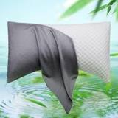 | ELIBABA  Cooling Side Sleeper Pillow Cases - Curved Rayon Derived from Bamboo Pillowcase  Bamboo viscose · 4.2★ 1,630 · Beatable  List Price $22.99 | 1 Pack Queen (20 x 30) · Dark Grey | $17.99 | — | -14% | Not shown | Prime Exclusive Discount | $18.99 → $15.19 | 20% | 1.07x | 92
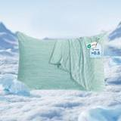 | Marchpower  Marchpower Cooling Pillow Cases for Hot Sleepers, Japanese Arc Chill Cooling Pil  Cotton · 4.3★ 1,247 · Beatable  No Buy Box history in price history for BFCM 2025; List Price $29.99 | Standard 20"x 26" · Green | $19.99 | — | -4% | Not shown | — | — | — | 1.44x | 5
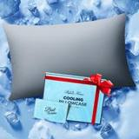 | Rifens  Ice Cooling Pillowcase for Hot Sleepers, Instantly Cool, Stay Cold All Night, Softer Than Silk Pillow Cases, Pillow Cove…  Silk · 4.6★ 219 · Beatable  List Price $25.99 | Standard · Gray | $18.99 | — | +12% | Not shown | Price cut only | $14.99 → $10.78 | 28% | 0.88x | 5

US · DC S4: Decolure Satin Sheets 4 Piece
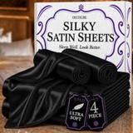 | Listing title | DECOLURE Satin Sheets Queen Size | Softer Than Silk | Luxury 4 Pc Bed Set
 | Marketplace | United States
 | Family · role | Satin · Clearance with margin
 | Scope · stage | Core · Maintenance
 | Amazon parent | B0H631FLT8
 | Best seller | B0839MKJMV (Queen Black)
 | Variations | 118 (98 with a live price)
 | Sizes | Queen, King, Full, Twin
 | Colours | 29

OUR PRICE TODAY  $29.95  Queen Black | BFCM 2026 DEAL PRICE  $29.95 → $25.00  Best Deal Nov 19-30 · 17% off the Oct 27 price | STOCK TO NOV 30  25 short · 8 out  15,135 at Amazon · 832 inbound · need 7,679 | BFCM 2025 SALES LIFT  2.64x  2,620 units in the last 28 days | DIRECT COMPETITORS  16  median $23.49 · 16 cheaper than us

BFCM 2025: how this product did
Period | Sales | Units | Organic units | Ad units | Ad cost | TACoS | Sessions | Unit session % | Avg price
Oct 21 – Nov 19, 2025 (30 days before) | $138,273 | 4,334 | 3,992 | 342 | $20,799 | 15.0% | 69,580 | 6.2% | $31.90
Nov 20 – Dec 1, 2025 (BFCM week) | $145,859 | 4,995 | 4,737 | 258 | $11,715 | 8.0% | 82,662 | 6.0% | $29.20
Dec 2 – 31, 2025 | $267,243 | 8,497 | 7,799 | 698 | $29,328 | 11.0% | 112,119 | 7.6% | $31.45
Best seller in BFCM 2025: B0839MKJMV: $29.95 before (median Nov 1 – 19) → $25.46 in BFCM week, 15% lower; Best Seller Rank 5,988 → 4,292.
Our BFCM 2025 deals: Lightning Deal 11-06 to 11-07 (cancelled, 114 variations); Lightning Deal 11-14 to 11-15 (cancelled, 114 variations); Best Deal 11-20 to 12-02 (ran, 111 variations, 4,311 units)
Stock in BFCM 2025: 1 of 122 variations hit zero FBA stock on at least one observed day in BFCM week; weighted by sales mix, about 0.0% of variation-days were lost.

BFCM 2026 deal
Deal | Hero variation | Price Oct 27 | Deal price | Off | Variations (deal page) | Our 2025 cut | Rivals' 2025 cut
Best Deal Nov 19-30 | Queen Black | $29.95 | $25.00 | 17% | 93 eligible, 18 out of stock, 6 manual price; 0%–25% off | 15% ($29.95 → $25.46) | 8% (3 rivals)
Deal notes
- Amazon deal price now. Max deal prices have reset: 10% off the current price. Queen Black $29.95 live: about $26.96 at BFCM if the lookback stays clean, about $25.61 if the Oct 16 Best Deal runs.
- Pre-BFCM deal decision. Oct 16-28 Best Deal: the team recommends cancelling (fee needs ~1.6x sales; the Aug deal lifted 1.37x). S4 BFCM Best Deal confirmed Nov 19-30 in US and CA.

Stock to Nov 30
Sales per day today 117.0 · lift used 2.64x (this product's own BFCM 2025 lift) · need to Nov 30 7,679 units · at Amazon 15,135 · inbound 832. Covered 72, needs inbound in time 4, short 25, out of stock now 8.
Size | Colour | At Amazon | Inbound | Sales / day | Need to Nov 30 | Short by | Runs out | Status
Full | Black | 589 | 0 | 9.7 | 636 | 47 | Nov 28 | Short even with inbound
Queen | Navy Blue | 140 | 0 | 2.4 | 159 | 19 | Nov 27 | Short even with inbound
King | White | 128 | 1 | 2.1 | 136 | 7 | Nov 28 | Short even with inbound
King | Purple | 106 | 0 | 1.7 | 112 | 6 | Nov 28 | Short even with inbound
Queen | Red | 0 | 0 | 1.7 | 112 | 112 | now | Out of stock now
Queen | Ivory | 76 | 0 | 1.7 | 110 | 34 | Nov 22 | Short even with inbound
King | Navy Blue | 80 | 0 | 1.6 | 108 | 28 | Nov 23 | Short even with inbound
King | Stone Grey | 39 | 42 | 1.5 | 99 | 18 | Nov 9 | Short even with inbound
Queen | Sea Teal | 72 | 0 | 1.5 | 96 | 24 | Nov 23 | Short even with inbound
Twin | Black | 57 | 0 | 1.3 | 83 | 26 | Nov 22 | Short even with inbound
Queen | Lavender | 5 | 0 | 1.1 | 72 | 67 | Oct 19 | Short even with inbound
King | Striped White | 19 | 78 | 1.1 | 69 | — | Nov 2 | Needs inbound in time
King | Rosewood | 32 | 0 | 1.0 | 65 | 33 | Nov 16 | Short even with inbound
Queen | Burnt Orange | 23 | 0 | 0.9 | 62 | 39 | Nov 8 | Short even with inbound
Full | Navy Blue | 25 | 6 | 0.9 | 62 | 31 | Nov 10 | Short even with inbound
King | Burnt Orange | 46 | 0 | 0.9 | 56 | 10 | Nov 25 | Short even with inbound
King | Striped Red | 0 | 90 | 0.8 | 54 | — | now | Out of stock now
Full | Stone Grey | 52 | 0 | 0.8 | 54 | 2 | Nov 29 | Short even with inbound
Queen | Gold | 18 | 0 | 0.8 | 52 | 34 | Nov 6 | Short even with inbound
Queen | Striped White | 34 | 18 | 0.8 | 49 | — | Nov 22 | Needs inbound in time
Queen | Dark Green | 0 | 0 | 0.7 | 49 | 49 | now | Out of stock now
Queen | Striped Red | 26 | 0 | 0.7 | 48 | 22 | Nov 18 | Short even with inbound
Full | Red | 16 | 0 | 0.7 | 43 | 27 | Nov 8 | Short even with inbound
Full | Sea Teal | 25 | 0 | 0.6 | 41 | 16 | Nov 20 | Short even with inbound
Full | Gold | 30 | 18 | 0.6 | 36 | — | Nov 25 | Needs inbound in time
Twin | White | 26 | 0 | 0.5 | 31 | 5 | Nov 26 | Short even with inbound
Twin | Taupe | 11 | 0 | 0.5 | 30 | 19 | Nov 7 | Short even with inbound
King | Pink | 16 | 78 | 0.4 | 26 | — | Nov 20 | Needs inbound in time
Twin | Navy Blue | 21 | 0 | 0.4 | 24 | 3 | Nov 26 | Short even with inbound
Full | Striped White | 17 | 0 | 0.3 | 21 | 4 | Nov 25 | Short even with inbound
Queen | Striped Blue | 0 | 0 | 0.3 | 18 | 18 | now | Out of stock now
Twin | Striped Grey | 0 | 0 | 0.2 | 15 | 15 | now | Out of stock now
Full | Burnt Orange | 2 | 0 | 0.2 | 11 | 9 | Oct 27 | Short even with inbound
King | Striped Black | 0 | 0 | 0.0 | 3 | 3 | now | Out of stock now
King | Taupe | 1 | 0 | 0.0 | 3 | 2 | Nov 9 | Short even with inbound
Full | Striped Black | 0 | 0 | 0.0 | 1 | 1 | now | Out of stock now
King | Striped Gold | 0 | 0 | 0.0 | 1 | 1 | now | Out of stock now

Sales mix, last 28 days
By size: Queen 1,226 · King 705 · Full 538 · Twin 151
By colour (top 8): Black 854 · Grey 217 · White 139 · Red 132 · Purple 115 · Blue 105 · Stone Grey 104 · Ivory 101

Competitors (26)
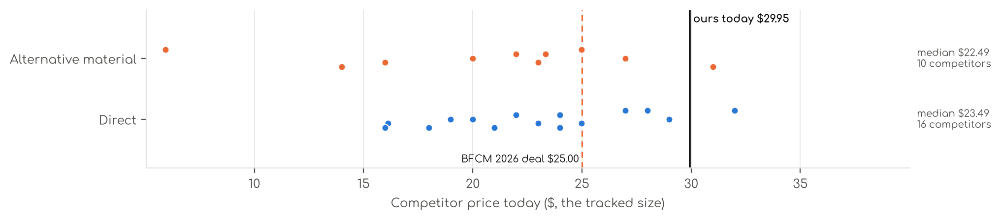
Photo | Competitor | Size · colour | Price | List | vs ours | Strike- through | BFCM 2025 deal | 2025 before → during | Disc. | Rank lift | Units / wk
Direct · 16
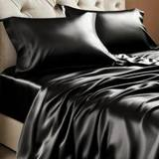 | BEDELITE  BEDELITE Satin Sheets Queen Size Bed Set, Black, 4 Pieces  Satin (polyester) · 4.3★ 6,297 · Aspirational  Prime Exclusive 11-01 to 12-05; Prime Exclusive already running before BFCM week; List Price $23.99 | Queen · Black | $17.99 | — | -44% | List Price $19.99 | Price cut only | $17.99 → $17.09 | 5% | 1.51x | 1,963
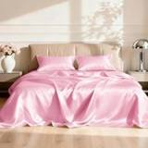 | Love's cabin  Love's cabin Satin Queen Sheets Set, 4 Pieces, Pink, 15" Deep Pocket  Satin (polyester) · 4.5★ 5,747 · Aspirational  Prime Exclusive already running before BFCM week; List Price $25.99 | Queen · Pink | $16.13 | $19.99 | -50% | List Price $19.99 | Prime Exclusive Discount | $17.99 → $17.99 | 0% | 0.84x | 809
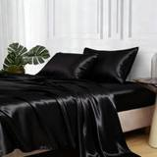 | MR&HM  MR&HM Satin Sheets Queen Size with Elastic Corner Straps, Black  Satin (polyester) · 4.4★ 17,886 · Aspirational  Prime Exclusive 11-01 to 12-05; Lightning Deal 11-08 to 11-14; Prime Exclusive already running before BFCM week; List Price $28.99 | Queen · Black | $19.99 | — | -37% | List Price $28.99 | None | $17.99 → $17.99 | 0% | 1.34x | 809
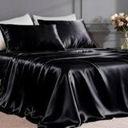 | FreshCulture  Satin Sheets  Satin (polyester) · 4.4★ 780 · Beatable  List Price $34.99 | Full · Black | $23.99 | — | -20% | Not shown | Prime Exclusive Discount | $23.99 → $18.69 | 22% | 1.39x | 104
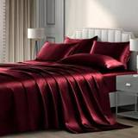 | P Pothuiny  P Pothuiny 6-Piece Queen Satin Sheet Set Burgundy Silky Sheets  Satin (polyester) · 4.4★ 4,031 · Poor  Prime Exclusive already running before BFCM week; Buy Box RAISED in BFCM week (median $31.99 vs $29.99 before); List Price $48.99 | Queen · Burgundy | $26.99 | — | -16% | Not shown | Prime Exclusive Discount | $29.99 → $24.95 | 17% | 1.03x | 104
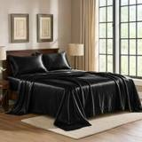 | Pure Bedding  Pure Bedding Satin Sheets Queen [4-Piece, Black] Hotel Luxury Silky Bed Sheets - Extra Soft 1800 Microfiber Sheet Set, W…  Satin (polyester) · 4.4★ 9,828 · Beatable  Buy Box RAISED in BFCM week (median $20.02 vs $18.99 before); List Price $32.99 | Queen · Black | $20.99 | — | -34% | Not shown | Price cut only | $18.99 → $17.54 | 8% | 0.83x | 92
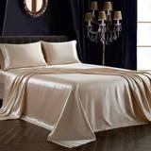 | SiinvdaBZX  SiinvdaBZX 4Pcs Satin Sheet Set Queen Size 15-Inch Deep Pocket, Beige  Satin (polyester) · 4.4★ 6,981 · Beatable  Prime Exclusive already running before BFCM week; Buy Box RAISED in BFCM week (median $26.99 vs $24.49 before); List Price $52.59 | Queen · Beige | $22.99 | — | -28% | Not shown | Prime Exclusive Discount | $24.49 → $21.59 | 12% | 1.00x | 92
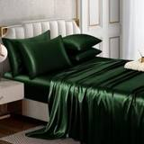 | Horbaunal  Horbaunal 6 Piece Satin Sheet Set Queen, Emerald Green Queen Bed Sheets  Satin (polyester) · 4.4★ 772 · Beatable  Prime Exclusive already running before BFCM week; Buy Box RAISED in BFCM week (median $37.99 vs $33.43 before); List Price $45.49 | Queen · Green | $28.99 | — | -9% | Not shown | Prime Exclusive Discount | $33.43 → $28.87 | 14% | 1.12x | 35
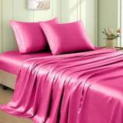 | VACVELT  Satin Sheets  Satin (polyester) · 4.5★ 1,017 · Beatable  Prime Exclusive already running before BFCM week; Buy Box RAISED in BFCM week (median $25.99 vs $20.99 before); List Price $46.38 | Full · Hot Pink | $21.99 | — | -27% | Not shown | Prime Exclusive Discount | $20.99 → $17.67 | 16% | 1.20x | 35
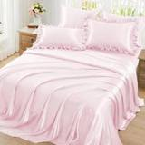 | Homiest  Satin Sheets  Satin (polyester) · 4.5★ 205 · Beatable  List Price $34.99 | Queen · Blush Pink | $27.99 | — | -12% | Not shown | None | $28.99 → $28.99 | 0% | 1.03x | 18
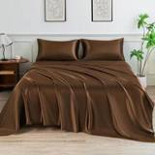 | LIFCOM  LIFCOM Satin Sheets Queen,4Pcs Bed Set with 15" Deep Pocket,Brown  Satin (polyester) · 4.2★ 361 · Beatable  Buy Box RAISED in BFCM week (median $24.39 vs $22.99 before); List Price $31.99 | Queen · Brown | $23.99 | — | -25% | Not shown | Prime Exclusive Discount | $22.99 → $19.27 | 16% | 1.35x | 18
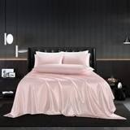 | HommxJF  Satin Sheets  Satin (polyester) · 4.3★ 1,032 · Poor  List Price $26.99 | Full · Blush Pink | $24.99 | — | -17% | Not shown | None | $24.99 → $24.99 | 0% | 1.20x | 18
 | MK Home  Satin Sheets  Satin (polyester) · 4.3★ 10,761 · Poor  List Price $59.99 | Queen · Red | $18.99 | — | -41% | Not shown | None | $28.99 → $28.99 | 0% | 0.70x | 18
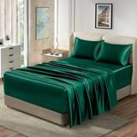 | Homiest  Satin Sheets  Satin (polyester) · 4.4★ 12,125 · Beatable  Prime Exclusive already running before BFCM week; List Price $52.78 | EXTRA DEEP pocket - Full size · Blackish Green | $23.99 | $25.99 | -25% | Typical price $25.99 | Prime Exclusive Discount | $23.39 → $21.32 | 9% | 1.00x | 5
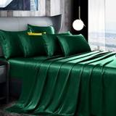 | Manyshofu  Satin Sheets  Satin (polyester) · 4.3★ 907 · Beatable  Buy Box RAISED in BFCM week (median $43.99 vs $35.99 before); List Price $46.99 | California King · Dark Green | $31.99 | — | -0% | Not shown | None | $35.99 → $43.99 | -22% | 0.83x | 5
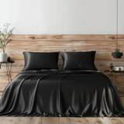 | Candoury  Satin Sheets  Satin (polyester) · 4.3★ 5,277  No Buy Box history in price history for BFCM 2025; List Price $35.99 | Queen · Black | $15.99 | — | -50% | Not shown | — | — | — | 0.76x | 5
Alternative material · 10
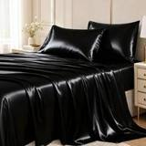 | CozyLux  CozyLux Satin Sheets Queen, 4-Piece 14-Inch Deep Pocket Sheet Set  Microfiber / polyester · 4.3★ 7,075 · Beatable  Lightning Deal 11-09 to 11-16; Prime Exclusive already running before BFCM week; List Price $22.99 | Queen · Black | $13.99 | $18.99 | -56% | List Price $18.99 | Prime Exclusive Discount | $17.99 → $16.99 | 6% | 0.95x | 347
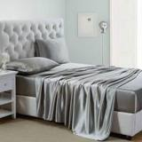 | Lanest Housing  Lanest Housing Silk Satin Sheets, Queen Size Satin Bed Sheet Set with Deep Pockets, Cooling Soft and Hypoallergenic Sati…  Silk · 4.3★ 5,837 · Beatable  Buy Box RAISED in BFCM week (median $27.79 vs $19.99 before); List Price $37.99 | Queen · Gray | $22.99 | — | -28% | Not shown | Prime Exclusive Discount | $19.99 → $17.99 | 10% | 1.04x | 208
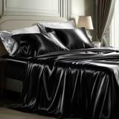 | Bedsure  Satin Sheets  Microfiber / polyester · 4.3★ 2,745 · Poor  Prime Exclusive already running before BFCM week; Buy Box RAISED in BFCM week (median $28.99 vs $24.99 before); List Price $44.99 | Queen · 02 - Black | $19.99 | — | -37% | Not shown | Prime Exclusive Discount | $22.39 → $20.99 | 6% | 0.85x | 92
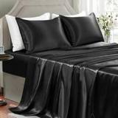 | GOLAL  GOLAL Satin Sheets Full Size - 4 Pieces Luxury Silky Soft Bed Sheets, Wrinkle-Free Black Satin Silk Sheet Set with 1 Dee…  Silk · 4.4★ 3,943 · Poor  Coupon 10%, 5% (11-01 to 12-05); Buy Box RAISED in BFCM week (median $21.99 vs $16.05 before); List Price $24.99 | Full · Black | $21.99 | — | -27% | Not shown | Prime Exclusive Discount | $16.05 → $17.59 | -10% | 0.44x | 81
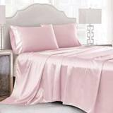 | Cobedzy  Satin Sheets  Microfiber / polyester · 4.4★ 2,838 · Beatable  List Price $38.99 | Queen · Blush Pink | $24.99 | — | -22% | Typical price $26.99 | Price cut only | $27.99 → $22.39 | 20% | 1.41x | 35
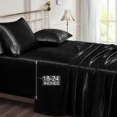 | Vonty  Satin Sheets  Microfiber / polyester · 4.2★ 909 · Poor  Buy Box RAISED in BFCM week (median $42.99 vs $30.99 before); List Price $49.99 | King - Extra Deep Pocket · Black | $30.99 | — | -9% | Not shown | Prime Exclusive Discount | $30.99 → $25.79 | 17% | 1.07x | 35
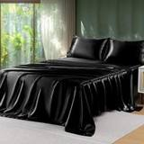 | Sasttie  Sasttie Satin Sheets Queen Size - 4 Pieces Luxury Soft Black Silky Bed Sheets Set with Pillowcases - Smooth Silk-Like Sa…  Silk · 4.5★ 968  Prime Exclusive already running before BFCM week; Buy Box RAISED in BFCM week (median $19.99 vs $16.99 before); List Price $19.98 | Queen · Black | $15.99 | — | -50% | Not shown | Prime Exclusive Discount | $15.99 → $15.98 | 0% | 0.72x | 35
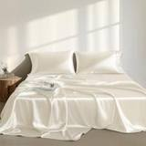 | Madison Park  Satin Sheets  Microfiber / polyester · 4.5★ 127 · Poor  List Price $35.99 | Queen · Ivory | $26.99 | — | -16% | Not shown | None | $30.99 → $30.99 | 0% | 0.97x | 18
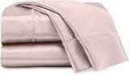 | Martex  Satin Sheets  Microfiber / polyester · 4.3★ 2,260 · Beatable  Buy Box RAISED in BFCM week (median $26.99 vs $23.21 before); List Price $34.99 | Queen · Pink | $23.34 | — | -27% | Typical price $26.99 | None | $23.21 → $26.99 | -16% | 1.03x | 5
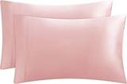 | Juicy Couture  Juicy Couture Queen Size Satin Bed Sheet Set, Deep Pocket Silky Satin Queen Shee  Microfiber / polyester · 4.6★ 46 · Poor  No Buy Box history in price history for BFCM 2025; List Price $19.99 | Standard Pillowcases - 2 Piece Set · Pink | $5.93 | — | -81% | Not shown | — | — | — | 1.08x | 5

US · DC S6: Decolure Satin Sheets 6 Piece
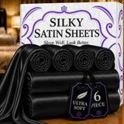 | Listing title | DECOLURE Satin Sheets King Size | Softer Than Silk | Luxury 6 Pc Bed Set
 | Marketplace | United States
 | Family · role | Satin · Clearance with margin
 | Scope · stage | Core · Maintenance
 | Amazon parent | B0HDTF4MN2
 | Best seller | B0C7FXXS6R (King Black)
 | Variations | 119 (101 with a live price)
 | Sizes | Queen, King, Full, Twin
 | Colours | 29

OUR PRICE TODAY  $33.95  King Black | BFCM 2026 DEAL PRICE  $33.95 → $32.25  Lightning Deal Nov 23 · 5% off the Oct 27 price | STOCK TO NOV 30  11 short · 5 out  5,874 at Amazon · 322 inbound · need 2,164 | BFCM 2025 SALES LIFT  3.08x  486 units in the last 28 days | DIRECT COMPETITORS  16  median $23.49 · 16 cheaper than us

BFCM 2025: how this product did
Period | Sales | Units | Organic units | Ad units | Ad cost | TACoS | Sessions | Unit session % | Avg price
Oct 21 – Nov 19, 2025 (30 days before) | $26,325 | 797 | 658 | 139 | $5,223 | 19.8% | 12,231 | 6.5% | $33.03
Nov 20 – Dec 1, 2025 (BFCM week) | $32,391 | 1,072 | 927 | 145 | $4,831 | 14.9% | 13,542 | 7.9% | $30.22
Dec 2 – 31, 2025 | $66,735 | 2,149 | 1,781 | 368 | $11,103 | 16.6% | 27,084 | 7.9% | $31.05
Best seller in BFCM 2025: B0C7FXXS6R: $33.95 before (median Nov 1 – 19) → $32.25 in BFCM week, 5% lower; Best Seller Rank 41,421 → 28,292.
Our BFCM 2025 deals: Lightning Deal 11-09 to 11-10 (cancelled, 111 variations); Lightning Deal 11-10 to 11-11 (cancelled, 111 variations); Best Deal 11-20 to 12-02 (ran, 89 variations, 1,008 units)
Stock in BFCM 2025: 1 of 115 variations hit zero FBA stock on at least one observed day in BFCM week; weighted by sales mix, about 0.9% of variation-days were lost.

BFCM 2026 deal
Deal | Hero variation | Price Oct 27 | Deal price | Off | Variations (deal page) | Our 2025 cut | Rivals' 2025 cut
Lightning Deal Nov 23 | King Black | $33.95 | $32.25 | 5% | 98 eligible, 17 out of stock, 1 manual price; 0%–23% off | 5% ($33.95 → $32.25) | 8% (3 rivals)
Deal notes
- BFCM deal status. Nov 23 Lightning Deal cancelled in Seller Central while a Best Deal is pursued; rescheduled if not granted.

Stock to Nov 30
Sales per day today 30.5 · lift used 3.08x (this product's own BFCM 2025 lift) · need to Nov 30 2,164 units · at Amazon 5,874 · inbound 322. Covered 90, needs inbound in time 2, short 11, out of stock now 5.
Size | Colour | At Amazon | Inbound | Sales / day | Need to Nov 30 | Short by | Runs out | Status
King | Red | 0 | 0 | 0.7 | 50 | 50 | now | Out of stock now
Full | Rosewood | 13 | 0 | 0.6 | 40 | 27 | Nov 6 | Short even with inbound
King | Dark Green | 5 | 0 | 0.4 | 31 | 26 | Oct 26 | Short even with inbound
Queen | Striped Black | 28 | 0 | 0.4 | 28 | 0 | Nov 29 | Short even with inbound
King | Striped White | 0 | 0 | 0.3 | 24 | 24 | now | Out of stock now
King | White | 20 | 0 | 0.3 | 23 | 3 | Nov 26 | Short even with inbound
Queen | Burnt Orange | 14 | 0 | 0.2 | 16 | 2 | Nov 27 | Short even with inbound
Full | Sage Green | 13 | 0 | 0.2 | 14 | 1 | Nov 28 | Short even with inbound
Full | Sea Teal | 8 | 0 | 0.2 | 14 | 6 | Nov 19 | Short even with inbound
Twin | Navy Blue | 6 | 30 | 0.2 | 13 | — | Nov 17 | Needs inbound in time
Queen | Champagne | 0 | 0 | 0.2 | 12 | 12 | now | Out of stock now
Full | Striped Gold | 9 | 0 | 0.2 | 11 | 2 | Nov 25 | Short even with inbound
Twin | Sage Green | 4 | 30 | 0.2 | 11 | — | Nov 9 | Needs inbound in time
Twin | Ivory | 7 | 0 | 0.1 | 9 | 2 | Nov 24 | Short even with inbound
Full | Baby Blue | 5 | 0 | 0.1 | 9 | 4 | Nov 20 | Short even with inbound
Twin | White | 2 | 0 | 0.1 | 7 | 5 | Nov 4 | Short even with inbound
Full | Dark Green | 0 | 0 | 0.1 | 6 | 6 | now | Out of stock now
King | Taupe | 0 | 0 | 0.0 | 2 | 2 | now | Out of stock now

Sales mix, last 28 days
By size: Queen 202 · King 187 · Full 62 · Twin 35
By colour (top 8): Black 123 · Rosewood 41 · Gold 33 · Red 23 · Grey 22 · Lavender 21 · Purple 20 · Sea Teal 19

Competitors (26)
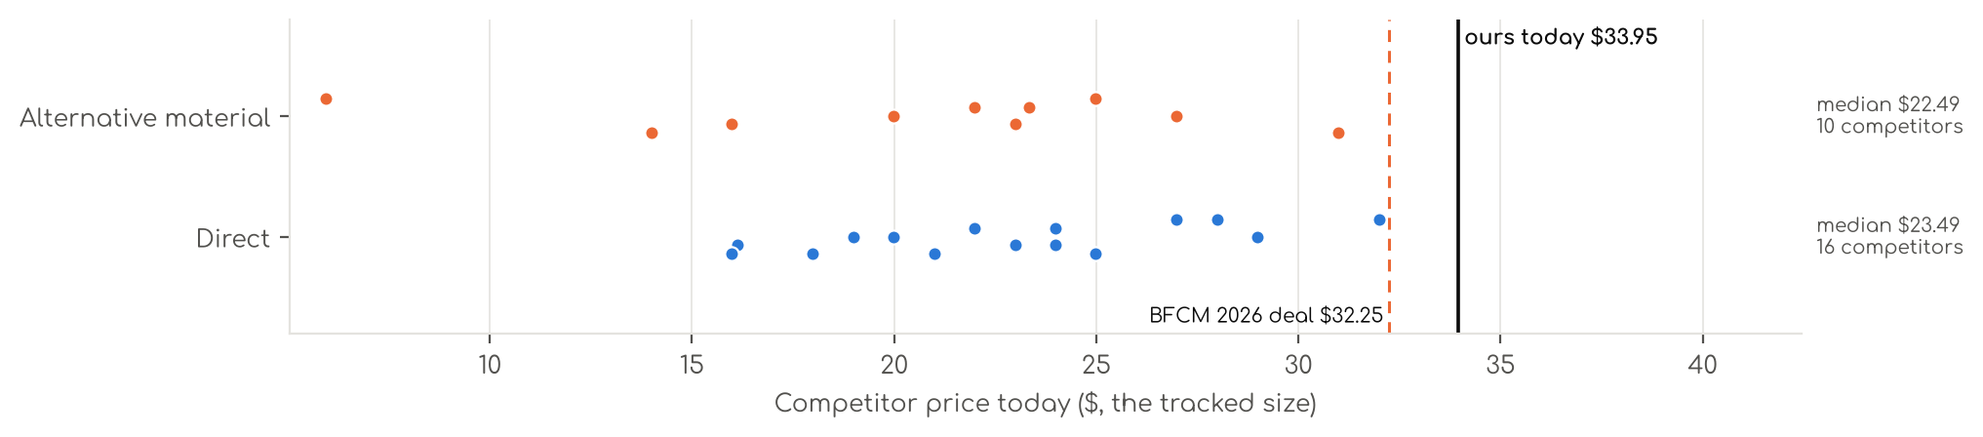
Photo | Competitor | Size · colour | Price | List | vs ours | Strike- through | BFCM 2025 deal | 2025 before → during | Disc. | Rank lift | Units / wk
Direct · 16
 | BEDELITE  BEDELITE Satin Sheets Queen Size Bed Set, Black, 4 Pieces  Satin (polyester) · 4.3★ 6,297 · Aspirational  Prime Exclusive 11-01 to 12-05; Prime Exclusive already running before BFCM week; List Price $23.99 | Queen · Black | $17.99 | — | -44% | List Price $19.99 | Price cut only | $17.99 → $17.09 | 5% | 1.51x | 1,963
 | Love's cabin  Love's cabin Satin Queen Sheets Set, 4 Pieces, Pink, 15" Deep Pocket  Satin (polyester) · 4.5★ 5,747 · Aspirational  Prime Exclusive already running before BFCM week; List Price $25.99 | Queen · Pink | $16.13 | $19.99 | -50% | List Price $19.99 | Prime Exclusive Discount | $17.99 → $17.99 | 0% | 0.84x | 809
 | MR&HM  MR&HM Satin Sheets Queen Size with Elastic Corner Straps, Black  Satin (polyester) · 4.4★ 17,886 · Aspirational  Prime Exclusive 11-01 to 12-05; Lightning Deal 11-08 to 11-14; Prime Exclusive already running before BFCM week; List Price $28.99 | Queen · Black | $19.99 | — | -37% | List Price $28.99 | None | $17.99 → $17.99 | 0% | 1.34x | 809
 | FreshCulture  Satin Sheets  Satin (polyester) · 4.4★ 780 · Beatable  List Price $34.99 | Full · Black | $23.99 | — | -20% | Not shown | Prime Exclusive Discount | $23.99 → $18.69 | 22% | 1.39x | 104
 | P Pothuiny  P Pothuiny 6-Piece Queen Satin Sheet Set Burgundy Silky Sheets  Satin (polyester) · 4.4★ 4,031 · Beatable  Prime Exclusive already running before BFCM week; Buy Box RAISED in BFCM week (median $31.99 vs $29.99 before); List Price $48.99 | Queen · Burgundy | $26.99 | — | -16% | Not shown | Prime Exclusive Discount | $29.99 → $24.95 | 17% | 1.03x | 104
 | Pure Bedding  Pure Bedding Satin Sheets Queen [4-Piece, Black] Hotel Luxury Silky Bed Sheets - Extra Soft 1800 Microfiber Sheet Set, W…  Satin (polyester) · 4.4★ 9,828 · Aspirational  Buy Box RAISED in BFCM week (median $20.02 vs $18.99 before); List Price $32.99 | Queen · Black | $20.99 | — | -34% | Not shown | Price cut only | $18.99 → $17.54 | 8% | 0.83x | 92
 | SiinvdaBZX  SiinvdaBZX 4Pcs Satin Sheet Set Queen Size 15-Inch Deep Pocket, Beige  Satin (polyester) · 4.4★ 6,981 · Beatable  Prime Exclusive already running before BFCM week; Buy Box RAISED in BFCM week (median $26.99 vs $24.49 before); List Price $52.59 | Queen · Beige | $22.99 | — | -28% | Not shown | Prime Exclusive Discount | $24.49 → $21.59 | 12% | 1.00x | 92
 | Horbaunal  Horbaunal 6 Piece Satin Sheet Set Queen, Emerald Green Queen Bed Sheets  Satin (polyester) · 4.4★ 772 · Beatable  Prime Exclusive already running before BFCM week; Buy Box RAISED in BFCM week (median $37.99 vs $33.43 before); List Price $45.49 | Queen · Green | $28.99 | — | -9% | Not shown | Prime Exclusive Discount | $33.43 → $28.87 | 14% | 1.12x | 35
 | VACVELT  Satin Sheets  Satin (polyester) · 4.5★ 1,017 · Beatable  Prime Exclusive already running before BFCM week; Buy Box RAISED in BFCM week (median $25.99 vs $20.99 before); List Price $46.38 | Full · Hot Pink | $21.99 | — | -27% | Not shown | Prime Exclusive Discount | $20.99 → $17.67 | 16% | 1.20x | 35
 | Homiest  Satin Sheets  Satin (polyester) · 4.5★ 205 · Beatable  List Price $34.99 | Queen · Blush Pink | $27.99 | — | -12% | Not shown | None | $28.99 → $28.99 | 0% | 1.03x | 18
 | HommxJF  Satin Sheets  Satin (polyester) · 4.3★ 1,032 · Beatable  List Price $26.99 | Full · Blush Pink | $24.99 | — | -17% | Not shown | None | $24.99 → $24.99 | 0% | 1.20x | 18
 | LIFCOM  LIFCOM Satin Sheets Queen,4Pcs Bed Set with 15" Deep Pocket,Brown  Satin (polyester) · 4.2★ 361 · Beatable  Buy Box RAISED in BFCM week (median $24.39 vs $22.99 before); List Price $31.99 | Queen · Brown | $23.99 | — | -25% | Not shown | Prime Exclusive Discount | $22.99 → $19.27 | 16% | 1.35x | 18
 | MK Home  Satin Sheets  Satin (polyester) · 4.3★ 10,761 · Beatable  List Price $59.99 | Queen · Red | $18.99 | — | -41% | Not shown | None | $28.99 → $28.99 | 0% | 0.70x | 18
 | Homiest  Satin Sheets  Satin (polyester) · 4.4★ 12,125 · Beatable  Prime Exclusive already running before BFCM week; List Price $52.78 | EXTRA DEEP pocket - Full size · Blackish Green | $23.99 | $25.99 | -27% | Typical price $25.99 | Prime Exclusive Discount | $23.39 → $21.32 | 9% | 1.00x | 5
 | Manyshofu  Satin Sheets  Satin (polyester) · 4.3★ 907 · Beatable  Buy Box RAISED in BFCM week (median $43.99 vs $35.99 before); List Price $46.99 | California King · Dark Green | $31.99 | — | -3% | Not shown | None | $35.99 → $43.99 | -22% | 0.83x | 5
 | Candoury  Satin Sheets  Satin (polyester) · 4.3★ 5,277  No Buy Box history in price history for BFCM 2025; List Price $35.99 | Queen · Black | $15.99 | — | -50% | Not shown | — | — | — | 0.76x | 5
Alternative material · 10
 | CozyLux  CozyLux Satin Sheets Queen, 4-Piece 14-Inch Deep Pocket Sheet Set  Microfiber / polyester · 4.3★ 7,075 · Aspirational  Lightning Deal 11-09 to 11-16; Prime Exclusive already running before BFCM week; List Price $22.99 | Queen · Black | $13.99 | $18.99 | -56% | List Price $18.99 | Prime Exclusive Discount | $17.99 → $16.99 | 6% | 0.95x | 347
 | Lanest Housing  Lanest Housing Silk Satin Sheets, Queen Size Satin Bed Sheet Set with Deep Pockets, Cooling Soft and Hypoallergenic Sati…  Silk · 4.3★ 5,837 · Aspirational  Buy Box RAISED in BFCM week (median $27.79 vs $19.99 before); List Price $37.99 | Queen · Gray | $22.99 | — | -28% | Not shown | Prime Exclusive Discount | $19.99 → $17.99 | 10% | 1.04x | 208
 | Bedsure  Satin Sheets  Microfiber / polyester · 4.3★ 2,745 · Beatable  Prime Exclusive already running before BFCM week; Buy Box RAISED in BFCM week (median $28.99 vs $24.99 before); List Price $44.99 | Queen · 02 - Black | $19.99 | — | -37% | Not shown | Prime Exclusive Discount | $22.39 → $20.99 | 6% | 0.85x | 92
 | GOLAL  GOLAL Satin Sheets Full Size - 4 Pieces Luxury Silky Soft Bed Sheets, Wrinkle-Free Black Satin Silk Sheet Set with 1 Dee…  Silk · 4.4★ 3,943 · Beatable  Coupon 10%, 5% (11-01 to 12-05); Buy Box RAISED in BFCM week (median $21.99 vs $16.05 before); List Price $24.99 | Full · Black | $21.99 | — | -27% | Not shown | Prime Exclusive Discount | $16.05 → $17.59 | -10% | 0.44x | 81
 | Cobedzy  Satin Sheets  Microfiber / polyester · 4.4★ 2,838 · Beatable  List Price $38.99 | Queen · Blush Pink | $24.99 | — | -22% | Typical price $26.99 | Price cut only | $27.99 → $22.39 | 20% | 1.41x | 35
 | Vonty  Satin Sheets  Microfiber / polyester · 4.2★ 909 · Poor  Buy Box RAISED in BFCM week (median $42.99 vs $30.99 before); List Price $49.99 | King - Extra Deep Pocket · Black | $30.99 | — | -9% | Not shown | Prime Exclusive Discount | $30.99 → $25.79 | 17% | 1.07x | 35
 | Sasttie  Sasttie Satin Sheets Queen Size - 4 Pieces Luxury Soft Black Silky Bed Sheets Set with Pillowcases - Smooth Silk-Like Sa…  Silk · 4.5★ 968  Prime Exclusive already running before BFCM week; Buy Box RAISED in BFCM week (median $19.99 vs $16.99 before); List Price $19.98 | Queen · Black | $15.99 | — | -50% | Not shown | Prime Exclusive Discount | $15.99 → $15.98 | 0% | 0.72x | 35
 | Madison Park  Satin Sheets  Microfiber / polyester · 4.5★ 127 · Beatable  List Price $35.99 | Queen · Ivory | $26.99 | — | -16% | Not shown | None | $30.99 → $30.99 | 0% | 0.97x | 18
 | Martex  Satin Sheets  Microfiber / polyester · 4.3★ 2,260 · Beatable  Buy Box RAISED in BFCM week (median $26.99 vs $23.21 before); List Price $34.99 | Queen · Pink | $23.34 | — | -27% | Typical price $26.99 | None | $23.21 → $26.99 | -16% | 1.03x | 5
 | Juicy Couture  Juicy Couture Queen Size Satin Bed Sheet Set, Deep Pocket Silky Satin Queen Shee  Microfiber / polyester · 4.6★ 46 · Poor  No Buy Box history in price history for BFCM 2025; List Price $19.99 | Standard Pillowcases - 2 Piece Set · Pink | $5.93 | — | -82% | Not shown | — | — | — | 1.08x | 5

US · DC Satin Fitted: Decolure Satin Fitted Sheet
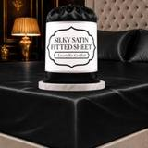 | Listing title | DECOLURE Satin Fitted Sheet Queen Size | Softer Than Silk | Luxury 1 Pc Set
 | Marketplace | United States
 | Family · role | Satin · Opportunistic
 | Scope · stage | Core · Maintenance
 | Amazon parent | B0DZ17NCJ4
 | Best seller | B0DBW1PNJ8 (Queen Black)
 | Variations | 68 (53 with a live price)
 | Sizes | Queen, King, Full, Twin
 | Colours | 17

OUR PRICE TODAY  $21.95  Queen Black | BFCM 2026 DEAL PRICE  $21.95 → $20.85  Best Deal Nov 19-30 · 5% off the Oct 27 price | STOCK TO NOV 30  13 short · 9 out  4,656 at Amazon · 459 inbound · need 2,485 | BFCM 2025 SALES LIFT  2.47x  759 units in the last 28 days | DIRECT COMPETITORS  5  median $13.99 · 4 cheaper than us

BFCM 2025: how this product did
Period | Sales | Units | Organic units | Ad units | Ad cost | TACoS | Sessions | Unit session % | Avg price
Oct 21 – Nov 19, 2025 (30 days before) | $30,007 | 1,630 | 1,538 | 92 | $3,372 | 11.2% | 17,028 | 9.6% | $18.41
Nov 20 – Dec 1, 2025 (BFCM week) | $29,639 | 1,910 | 1,831 | 79 | $2,318 | 7.8% | 18,981 | 10.1% | $15.52
Dec 2 – 31, 2025 | $45,438 | 2,466 | 2,306 | 160 | $5,539 | 12.2% | 24,008 | 10.3% | $18.43
Best seller in BFCM 2025: B0DBW1PNJ8: $16.95 before (median Nov 1 – 19) → $15.15 in BFCM week, 11% lower; Best Seller Rank 21,529 → 13,184.
Our BFCM 2025 deals: Lightning Deal 11-01 to 11-01 (cancelled, 60 variations); Lightning Deal 11-04 to 11-05 (cancelled, 60 variations); Lightning Deal 11-13 to 11-14 (cancelled, 60 variations); Best Deal 11-20 to 12-02 (ran, 66 variations, 1,865 units)
Stock in BFCM 2025: 0 of 68 variations hit zero FBA stock on at least one observed day in BFCM week; weighted by sales mix, about 0.0% of variation-days were lost.

BFCM 2026 deal
Deal | Hero variation | Price Oct 27 | Deal price | Off | Variations (deal page) | Our 2025 cut | Rivals' 2025 cut
Best Deal Nov 19-30 | Queen Black | $21.95 | $20.85 | 5% | 52 eligible, 16 out of stock; 5%–5% off | 11% ($16.95 → $15.15) | 5% (2 rivals)
Deal notes
- Amazon deal price now. Queen reference moved to the current $21.95; Oct 16 Best Deal max $19.76 (10% below today). 17 SKUs still carry the old lower reference (mostly Twin and Full, plus Queen Navy and Blush), cut 14-23%.
- Pre-BFCM deal decision and stock. Oct 16 Best Deal: cancel proposed. Stock: 8 ranking variations out of stock with no inbound (King Black, King Grey, King Stone Grey, Queen White, Queen Baby Blue, Full Black, Full White, Twin Black); the 699 inbound units are on colours already in stock. If these are not back by Nov 19 the SF BFCM Best Deal may be cancelled.

Stock to Nov 30
Sales per day today 39.1 · lift used 2.47x (this product's own BFCM 2025 lift) · need to Nov 30 2,485 units · at Amazon 4,656 · inbound 459. Covered 40, needs inbound in time 0, short 13, out of stock now 9.
Size | Colour | At Amazon | Inbound | Sales / day | Need to Nov 30 | Short by | Runs out | Status
Queen | Purple | 113 | 0 | 2.2 | 142 | 29 | Nov 24 | Short even with inbound
King | White | 71 | 0 | 1.2 | 74 | 3 | Nov 28 | Short even with inbound
Queen | Blush Pink | 26 | 0 | 1.1 | 71 | 45 | Nov 7 | Short even with inbound
Queen | Sage Green | 26 | 0 | 1.0 | 62 | 36 | Nov 10 | Short even with inbound
King | Navy Blue | 34 | 0 | 1.0 | 61 | 27 | Nov 18 | Short even with inbound
King | Rosewood | 22 | 0 | 0.8 | 54 | 32 | Nov 9 | Short even with inbound
Queen | Navy Blue | 28 | 0 | 0.7 | 46 | 18 | Nov 19 | Short even with inbound
King | Ivory | 7 | 0 | 0.6 | 39 | 32 | Oct 26 | Short even with inbound
King | Sage Green | 16 | 0 | 0.6 | 39 | 23 | Nov 9 | Short even with inbound
Full | Purple | 19 | 0 | 0.6 | 38 | 19 | Nov 15 | Short even with inbound
King | Dark Green | 22 | 0 | 0.6 | 38 | 16 | Nov 19 | Short even with inbound
King | Black | 0 | 0 | 0.6 | 38 | 38 | now | Out of stock now
Twin | Sage Green | 31 | 0 | 0.6 | 38 | 7 | Nov 25 | Short even with inbound
King | Grey | 0 | 0 | 0.3 | 18 | 18 | now | Out of stock now
Queen | Baby Blue | 1 | 0 | 0.3 | 18 | 17 | Oct 18 | Short even with inbound
King | Stone Grey | 0 | 0 | 0.2 | 12 | 12 | now | Out of stock now
Full | White | 0 | 0 | 0.2 | 10 | 10 | now | Out of stock now
Queen | White | 0 | 19 | 0.1 | 8 | — | now | Out of stock now
Queen | Sea Teal | 0 | 0 | 0.1 | 7 | 7 | now | Out of stock now
Queen | Ivory | 0 | 0 | 0.1 | 6 | 6 | now | Out of stock now
Twin | Black | 0 | 0 | 0.1 | 3 | 3 | now | Out of stock now
King | Sea Teal | 0 | 0 | 0.0 | 1 | 1 | now | Out of stock now

Sales mix, last 28 days
By size: Queen 362 · King 210 · Full 122 · Twin 65
By colour (top 8): Black 90 · Purple 85 · Grey 72 · Red 62 · White 61 · Sage Green 55 · Navy Blue 47 · Dark Green 46

Competitors (14)
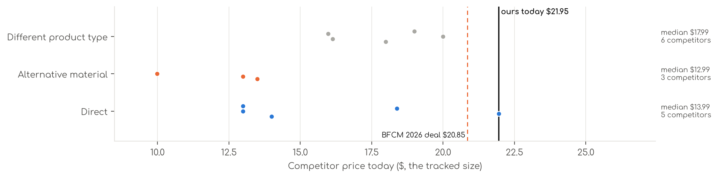
Photo | Competitor | Size · colour | Price | List | vs ours | Strike- through | BFCM 2025 deal | 2025 before → during | Disc. | Rank lift | Units / wk
Direct · 5
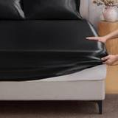 | BEDELITE  Satin Fitted Sheet  Satin (polyester) · 4.4★ 528 · Beatable  Prime Exclusive already running before BFCM week; Buy Box RAISED in BFCM week (median $16.99 vs $13.59 before); List Price $16.99 | Queen · Black | $13.99 | — | -36% | List Price $16.99 | Prime Exclusive Discount | $13.59 → $12.74 | 6% | 1.10x | 208
 | Bedsure  Satin Fitted Sheet  Satin (polyester) · 4.5★ 223 · Poor  Prime Exclusive already running before BFCM week; List Price $24.99 | — | $21.95 | — | 0% | — | Prime Exclusive Discount | $15.99 → $9.99 | 38% | 1.00x | 5
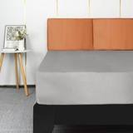 | Lirex  Satin Fitted Sheet  Satin (polyester) · 4.5★ 733 · Poor  Buy Box RAISED in BFCM week (median $12.99 vs $11.69 before); List Price $12.99 | Twin · Light Grey | $12.99 | — | -35% | Not shown | Prime Exclusive Discount | $11.69 → $9.98 | 15% | 1.02x | 5
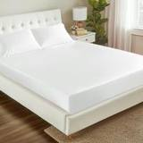 | Love's cabin  Satin Fitted Sheet  Satin (polyester) · 4.3★ 81 · Poor  Prime Exclusive already running before BFCM week; List Price $16.99 | Queen · White | $18.38 | — | -16% | Not shown | Prime Exclusive Discount | $16.99 → $13.29 | 22% | 0.95x | 5
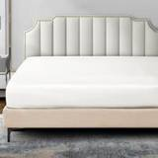 | P Pothuiny  Satin Fitted Sheet  Satin (polyester) · 4.4★ 8 · Poor  No Buy Box history in price history for BFCM 2025; List Price $19.99 | Ivory White | $12.99 | — | -41% | Not shown | — | — | — | 1.38x | 5
Alternative material · 3
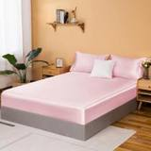 | NSGZ  Satin Fitted Sheet  Microfiber / polyester · 4.4★ 601 · Poor  List Price $15.99 | Full · Pink | $13.49 | — | -36% | Not shown | None | $12.99 → $12.49 | 4% | 0.91x | 81
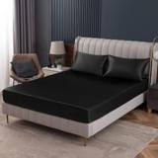 | Homiest  Satin Fitted Sheet  Microfiber / polyester · 4.7★ 357 · Beatable  Prime Exclusive already running before BFCM week; Buy Box RAISED in BFCM week (median $14.99 vs $12.99 before); List Price $23.02 | Twin - Fitted · Black | $12.99 | — | -35% | Not shown | Prime Exclusive Discount | $12.99 → $10.94 | 16% | 0.82x | 35
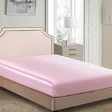 | JUWENIN  Satin Fitted Sheet  Microfiber / polyester · 4.4★ 256  No Buy Box history in price history for BFCM 2025 | Twin/TwinXL · Pink | $9.99 | — | -50% | Not shown | — | — | — | 0.84x | 5
Different product type · 6
 | BEDELITE  BEDELITE Satin Sheets Queen Size Bed Set, Black, 4 Pieces  Satin (polyester) · 4.3★ 6,297  Prime Exclusive 11-01 to 12-05; Prime Exclusive already running before BFCM week; List Price $23.99 | Queen · Black | $17.99 | — | -18% | List Price $19.99 | Price cut only | $17.99 → $17.09 | 5% | 1.51x | 1,963
 | Love's cabin  Love's cabin Satin Queen Sheets Set, 4 Pieces, Pink, 15" Deep Pocket  Satin (polyester) · 4.5★ 5,747  Prime Exclusive already running before BFCM week; List Price $25.99 | Queen · Pink | $16.13 | $19.99 | -27% | List Price $19.99 | Prime Exclusive Discount | $17.99 → $17.99 | 0% | 0.84x | 809
 | MR&HM  MR&HM Satin Sheets Queen Size with Elastic Corner Straps, Black  Satin (polyester) · 4.4★ 17,886  Prime Exclusive 11-01 to 12-05; Lightning Deal 11-08 to 11-14; Prime Exclusive already running before BFCM week; List Price $28.99 | Queen · Black | $19.99 | — | -9% | List Price $28.99 | None | $17.99 → $17.99 | 0% | 1.34x | 809
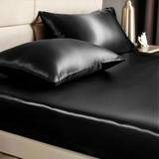 | BEDELITE  BEDELITE Satin Queen Fitted Sheet & Pillowcases Set, Black, 3 Pieces  Satin (polyester) · 4.4★ 1,858 · Beatable  Prime Exclusive 11-01 to 12-05; Lightning Deal 11-09 to 11-09; Prime Exclusive already running before BFCM week; List Price $19.99 | Queen · Black | $15.98 | $19.99 | -27% | List Price $19.99 | Price cut only | $15.99 → $15.18 | 5% | 1.81x | 208
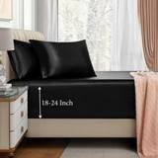 | VACVELT  VACVELT 3pcs Queen Black Extra Deep Pocket Satin Fitted Sheet Set  Satin (polyester) · 4.2★ 747 · Beatable  Prime Exclusive already running before BFCM week; List Price $47.98 | Queen · Black | $18.99 | — | -13% | Not shown | Prime Exclusive Discount | $25.99 → $17.15 | 34% | 1.01x | 92
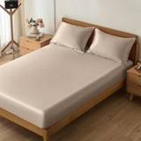 | VACVELT  Satin Sheets  Satin (polyester) · 4.4★ 209 · Beatable  List Price $19.99 | Queen · Beige | $17.99 | — | -18% | Not shown | None | $20.99 → $19.99 | 5% | 1.15x | 18

US · SSS4: Sleep Sanctuary Satin Sheets 4 Piece
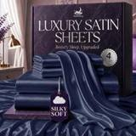 | Listing title | SLEEP SANCTUARY Satin Sheets Queen Size – 4 Piece Luxury Silky Bed Set, Softer Than Silk, 15" Deep Pocket, Cooling & Wrinkle-Free, Moisture-Wicking & Breathable for Hair & Skin (Navy Blue)
 | Marketplace | United States
 | Family · role | Satin · Clearance with margin
 | Scope · stage | Core · Maintenance
 | Amazon parent | B0HFWXSCFP
 | Best seller | B0DDRH9RD7 (Queen Navy Blue)
 | Variations | 117 (81 with a live price)
 | Sizes | King, Queen, Full, Twin
 | Colours | 29

OUR PRICE TODAY  $33.95  Queen Navy Blue | BFCM 2026 DEAL PRICE  $33.95 → $27.56  Best Deal Nov 19-30 · 19% off the Oct 27 price | STOCK TO NOV 30  16 short · 11 out  6,303 at Amazon · 336 inbound · need 2,842 | BFCM 2025 SALES LIFT  2.59x  700 units in the last 28 days | DIRECT COMPETITORS  19  median $21.99 · 19 cheaper than us

BFCM 2025: how this product did
Period | Sales | Units | Organic units | Ad units | Ad cost | TACoS | Sessions | Unit session % | Avg price
Oct 21 – Nov 19, 2025 (30 days before) | $35,087 | 1,022 | 893 | 129 | $6,436 | 18.3% | 13,752 | 7.4% | $34.33
Nov 20 – Dec 1, 2025 (BFCM week) | $36,346 | 1,207 | 1,082 | 125 | $5,731 | 15.8% | 14,508 | 8.3% | $30.11
Dec 2 – 31, 2025 | $175,723 | 6,045 | 5,625 | 420 | $26,765 | 15.2% | 225,125 | 2.7% | $29.07
Best seller in BFCM 2025: B0DDRH9RD7: $33.95 before (median Nov 1 – 19) → $31.41 in BFCM week, 7% lower; Best Seller Rank 30,755 → 27,176.
Our BFCM 2025 deals: Lightning Deal 11-09 to 11-10 (cancelled, 112 variations); Lightning Deal 11-14 to 11-15 (cancelled, 112 variations); Best Deal 11-20 to 12-02 (ran, 114 variations, 1,152 units)
Stock in BFCM 2025: 1 of 114 variations hit zero FBA stock on at least one observed day in BFCM week; weighted by sales mix, about 0.0% of variation-days were lost.

BFCM 2026 deal
Deal | Hero variation | Price Oct 27 | Deal price | Off | Variations (deal page) | Our 2025 cut | Rivals' 2025 cut
Best Deal Nov 19-30 | Queen Navy Blue | $33.95 | $27.56 | 19% | 52 eligible, 39 out of stock, 20 flagged by amazon, 5 no reference price; 3%–23% off | 7% ($33.95 → $31.41) | 6% (4 rivals)

Stock to Nov 30
Sales per day today 43.7 · lift used 2.59x (this product's own BFCM 2025 lift) · need to Nov 30 2,842 units · at Amazon 6,303 · inbound 336. Covered 64, needs inbound in time 1, short 16, out of stock now 11.
Size | Colour | At Amazon | Inbound | Sales / day | Need to Nov 30 | Short by | Runs out | Status
King | Navy Blue | 73 | 18 | 1.6 | 106 | 15 | Nov 22 | Short even with inbound
Queen | Purple | 49 | 0 | 1.6 | 103 | 54 | Nov 15 | Short even with inbound
King | Stone Grey | 65 | 0 | 1.5 | 100 | 35 | Nov 21 | Short even with inbound
Full | Purple | 39 | 0 | 1.1 | 73 | 34 | Nov 18 | Short even with inbound
Full | Blush Pink | 3 | 0 | 1.1 | 68 | 65 | Oct 17 | Short even with inbound
Queen | Ivory | 6 | 0 | 0.8 | 51 | 45 | Oct 22 | Short even with inbound
Full | Ivory | 39 | 0 | 0.8 | 51 | 12 | Nov 24 | Short even with inbound
Queen | Striped Red | 37 | 0 | 0.8 | 49 | 12 | Nov 23 | Short even with inbound
King | Rosewood | 16 | 0 | 0.7 | 48 | 32 | Nov 5 | Short even with inbound
Twin | Gold | 9 | 0 | 0.7 | 46 | 37 | Oct 27 | Short even with inbound
Queen | Striped Pink | 0 | 0 | 0.6 | 36 | 36 | now | Out of stock now
Full | Gold | 32 | 0 | 0.5 | 35 | 3 | Nov 27 | Short even with inbound
Twin | Pink | 31 | 0 | 0.5 | 33 | 2 | Nov 28 | Short even with inbound
Queen | Champagne | 14 | 0 | 0.5 | 33 | 19 | Nov 12 | Short even with inbound
Queen | Striped Blue | 8 | 0 | 0.5 | 31 | 23 | Nov 1 | Short even with inbound
Twin | Striped Black | 0 | 0 | 0.4 | 26 | 26 | now | Out of stock now
Full | Sage Green | 11 | 48 | 0.3 | 21 | — | Nov 17 | Needs inbound in time
Full | Striped Pink | 9 | 0 | 0.3 | 19 | 10 | Nov 15 | Short even with inbound
Twin | Stone Grey | 15 | 0 | 0.3 | 16 | 1 | Nov 28 | Short even with inbound
Full | Striped Grey | 0 | 0 | 0.2 | 15 | 15 | now | Out of stock now
Queen | Black | 0 | 0 | 0.1 | 7 | 7 | now | Out of stock now
Twin | Baby Blue | 0 | 0 | 0.1 | 7 | 7 | now | Out of stock now
Full | White | 0 | 0 | 0.1 | 6 | 6 | now | Out of stock now
Queen | Blue | 0 | 0 | 0.1 | 3 | 3 | now | Out of stock now
King | Striped Pink | 0 | 0 | 0.1 | 3 | 3 | now | Out of stock now
King | Striped White | 0 | 0 | 0.0 | 3 | 3 | now | Out of stock now
Full | Rosewood | 0 | 0 | 0.0 | 2 | 2 | now | Out of stock now
King | Black | 0 | 0 | 0.0 | 1 | 1 | now | Out of stock now

Sales mix, last 28 days
By size: King 336 · Queen 195 · Full 110 · Twin 59
By colour (top 8): Gold 86 · Navy Blue 63 · Grey 45 · Blush Pink 45 · Purple 42 · White 37 · Rosewood 36 · Ivory 36

Competitors (29)
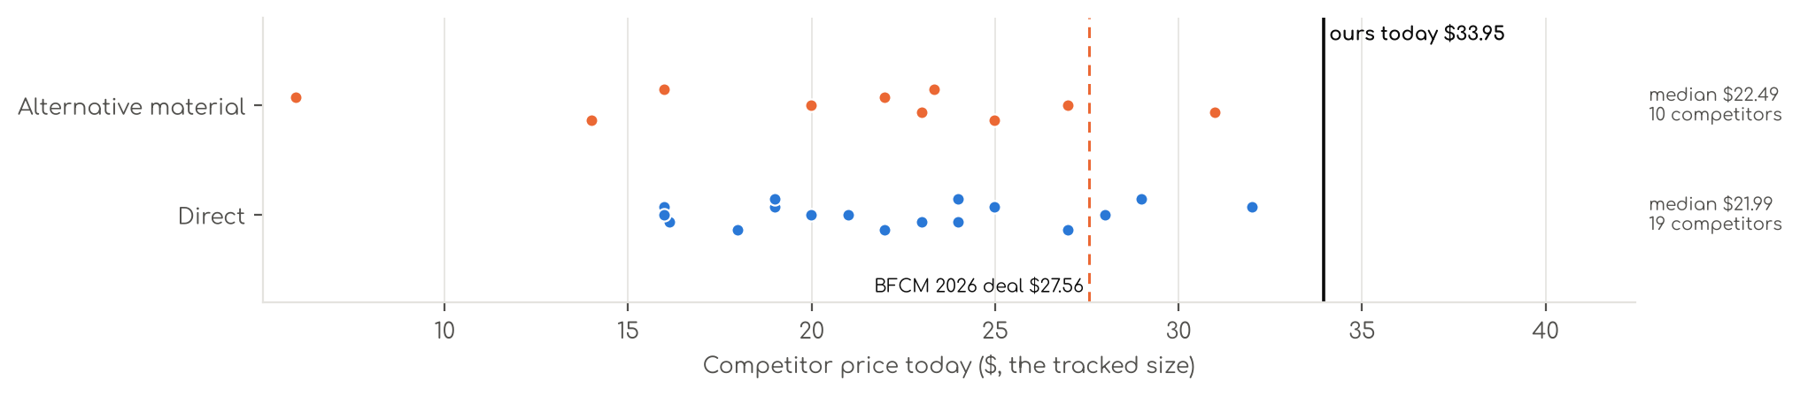
Photo | Competitor | Size · colour | Price | List | vs ours | Strike- through | BFCM 2025 deal | 2025 before → during | Disc. | Rank lift | Units / wk
Direct · 19
 | BEDELITE  BEDELITE Satin Sheets Queen Size Bed Set, Black, 4 Pieces  Satin (polyester) · 4.3★ 6,297 · Aspirational  Prime Exclusive 11-01 to 12-05; Prime Exclusive already running before BFCM week; List Price $23.99 | Queen · Black | $17.99 | — | -47% | List Price $19.99 | Price cut only | $17.99 → $17.09 | 5% | 1.51x | 1,963
 | Love's cabin  Love's cabin Satin Queen Sheets Set, 4 Pieces, Pink, 15" Deep Pocket  Satin (polyester) · 4.5★ 5,747 · Aspirational  Prime Exclusive already running before BFCM week; List Price $25.99 | Queen · Pink | $16.13 | $19.99 | -52% | List Price $19.99 | Prime Exclusive Discount | $17.99 → $17.99 | 0% | 0.84x | 809
 | MR&HM  MR&HM Satin Sheets Queen Size with Elastic Corner Straps, Black  Satin (polyester) · 4.4★ 17,886 · Aspirational  Prime Exclusive 11-01 to 12-05; Lightning Deal 11-08 to 11-14; Prime Exclusive already running before BFCM week; List Price $28.99 | Queen · Black | $19.99 | — | -41% | List Price $28.99 | None | $17.99 → $17.99 | 0% | 1.34x | 809
 | BEDELITE  BEDELITE Satin Queen Fitted Sheet & Pillowcases Set, Black, 3 Pieces  Satin (polyester) · 4.4★ 1,858 · Aspirational  Prime Exclusive 11-01 to 12-05; Lightning Deal 11-09 to 11-09; Prime Exclusive already running before BFCM week; List Price $19.99 | Queen · Black | $15.98 | $19.99 | -53% | List Price $19.99 | Price cut only | $15.99 → $15.18 | 5% | 1.81x | 208
 | FreshCulture  Satin Sheets  Satin (polyester) · 4.4★ 780 · Poor  List Price $34.99 | Full · Black | $23.99 | — | -25% | Not shown | Prime Exclusive Discount | $23.99 → $18.69 | 22% | 1.39x | 104
 | P Pothuiny  P Pothuiny 6-Piece Queen Satin Sheet Set Burgundy Silky Sheets  Satin (polyester) · 4.4★ 4,031 · Poor  Prime Exclusive already running before BFCM week; Buy Box RAISED in BFCM week (median $31.99 vs $29.99 before); List Price $48.99 | Queen · Burgundy | $26.99 | — | -21% | Not shown | Prime Exclusive Discount | $29.99 → $24.95 | 17% | 1.03x | 104
 | SiinvdaBZX  SiinvdaBZX 4Pcs Satin Sheet Set Queen Size 15-Inch Deep Pocket, Beige  Satin (polyester) · 4.4★ 6,981 · Beatable  Prime Exclusive already running before BFCM week; Buy Box RAISED in BFCM week (median $26.99 vs $24.49 before); List Price $52.59 | Queen · Beige | $22.99 | — | -32% | Not shown | Prime Exclusive Discount | $24.49 → $21.59 | 12% | 1.00x | 92
 | Pure Bedding  Pure Bedding Satin Sheets Queen [4-Piece, Black] Hotel Luxury Silky Bed Sheets - Extra Soft 1800 Microfiber Sheet Set, W…  Satin (polyester) · 4.4★ 9,828 · Poor  Buy Box RAISED in BFCM week (median $20.02 vs $18.99 before); List Price $32.99 | Queen · Black | $20.99 | — | -38% | Not shown | Price cut only | $18.99 → $17.54 | 8% | 0.83x | 92
 | VACVELT  VACVELT 3pcs Queen Black Extra Deep Pocket Satin Fitted Sheet Set  Satin (polyester) · 4.2★ 747 · Poor  Prime Exclusive already running before BFCM week; List Price $47.98 | Queen · Black | $18.99 | — | -44% | Not shown | Prime Exclusive Discount | $25.99 → $17.15 | 34% | 1.01x | 92
 | Horbaunal  Horbaunal 6 Piece Satin Sheet Set Queen, Emerald Green Queen Bed Sheets  Satin (polyester) · 4.4★ 772 · Poor  Prime Exclusive already running before BFCM week; Buy Box RAISED in BFCM week (median $37.99 vs $33.43 before); List Price $45.49 | Queen · Green | $28.99 | — | -15% | Not shown | Prime Exclusive Discount | $33.43 → $28.87 | 14% | 1.12x | 35
 | VACVELT  Satin Sheets  Satin (polyester) · 4.5★ 1,017 · Poor  Prime Exclusive already running before BFCM week; Buy Box RAISED in BFCM week (median $25.99 vs $20.99 before); List Price $46.38 | Full · Hot Pink | $21.99 | — | -31% | Not shown | Prime Exclusive Discount | $20.99 → $17.67 | 16% | 1.20x | 35
 | LIFCOM  LIFCOM Satin Sheets Queen,4Pcs Bed Set with 15" Deep Pocket,Brown  Satin (polyester) · 4.2★ 361 · Beatable  Buy Box RAISED in BFCM week (median $24.39 vs $22.99 before); List Price $31.99 | Queen · Brown | $23.99 | — | -29% | Not shown | Prime Exclusive Discount | $22.99 → $19.27 | 16% | 1.35x | 18
 | Homiest  Satin Sheets  Satin (polyester) · 4.5★ 205 · Poor  List Price $34.99 | Queen · Blush Pink | $27.99 | — | -18% | Not shown | None | $28.99 → $28.99 | 0% | 1.03x | 18
 | HommxJF  Satin Sheets  Satin (polyester) · 4.3★ 1,032 · Poor  List Price $26.99 | Full · Blush Pink | $24.99 | — | -22% | Not shown | None | $24.99 → $24.99 | 0% | 1.20x | 18
 | MK Home  Satin Sheets  Satin (polyester) · 4.3★ 10,761 · Poor  List Price $59.99 | Queen · Red | $18.99 | — | -44% | Not shown | None | $28.99 → $28.99 | 0% | 0.70x | 18
 | VACVELT  Satin Sheets  Satin (polyester) · 4.4★ 209 · Poor  List Price $19.99 | Queen · Beige | $17.99 | — | -47% | Not shown | None | $20.99 → $19.99 | 5% | 1.15x | 18
 | Homiest  Satin Sheets  Satin (polyester) · 4.4★ 12,125 · Beatable  Prime Exclusive already running before BFCM week; List Price $52.78 | EXTRA DEEP pocket - Full size · Blackish Green | $23.99 | $25.99 | -35% | Typical price $25.99 | Prime Exclusive Discount | $23.39 → $21.32 | 9% | 1.00x | 5
 | Candoury  Satin Sheets  Satin (polyester) · 4.3★ 5,277 · Poor  No Buy Box history in price history for BFCM 2025; List Price $35.99 | Queen · Black | $15.99 | — | -53% | Not shown | — | — | — | 0.76x | 5
 | Manyshofu  Satin Sheets  Satin (polyester) · 4.3★ 907 · Poor  Buy Box RAISED in BFCM week (median $43.99 vs $35.99 before); List Price $46.99 | California King · Dark Green | $31.99 | — | -14% | Not shown | None | $35.99 → $43.99 | -22% | 0.83x | 5
Alternative material · 10
 | CozyLux  CozyLux Satin Sheets Queen, 4-Piece 14-Inch Deep Pocket Sheet Set  Microfiber / polyester · 4.3★ 7,075 · Aspirational  Lightning Deal 11-09 to 11-16; Prime Exclusive already running before BFCM week; List Price $22.99 | Queen · Black | $13.99 | $18.99 | -59% | List Price $18.99 | Prime Exclusive Discount | $17.99 → $16.99 | 6% | 0.95x | 347
 | Lanest Housing  Lanest Housing Silk Satin Sheets, Queen Size Satin Bed Sheet Set with Deep Pockets, Cooling Soft and Hypoallergenic Sati…  Silk · 4.3★ 5,837 · Beatable  Buy Box RAISED in BFCM week (median $27.79 vs $19.99 before); List Price $37.99 | Queen · Gray | $22.99 | — | -32% | Not shown | Prime Exclusive Discount | $19.99 → $17.99 | 10% | 1.04x | 208
 | Bedsure  Satin Sheets  Microfiber / polyester · 4.3★ 2,745 · Beatable  Prime Exclusive already running before BFCM week; Buy Box RAISED in BFCM week (median $28.99 vs $24.99 before); List Price $44.99 | Queen · 02 - Black | $19.99 | — | -41% | Not shown | Prime Exclusive Discount | $22.39 → $20.99 | 6% | 0.85x | 92
 | GOLAL  GOLAL Satin Sheets Full Size - 4 Pieces Luxury Silky Soft Bed Sheets, Wrinkle-Free Black Satin Silk Sheet Set with 1 Dee…  Silk · 4.4★ 3,943 · Poor  Coupon 10%, 5% (11-01 to 12-05); Buy Box RAISED in BFCM week (median $21.99 vs $16.05 before); List Price $24.99 | Full · Black | $21.99 | — | -31% | Not shown | Prime Exclusive Discount | $16.05 → $17.59 | -10% | 0.44x | 81
 | Sasttie  Sasttie Satin Sheets Queen Size - 4 Pieces Luxury Soft Black Silky Bed Sheets Set with Pillowcases - Smooth Silk-Like Sa…  Silk · 4.5★ 968 · Beatable  Prime Exclusive already running before BFCM week; Buy Box RAISED in BFCM week (median $19.99 vs $16.99 before); List Price $19.98 | Queen · Black | $15.99 | — | -53% | Not shown | Prime Exclusive Discount | $15.99 → $15.98 | 0% | 0.72x | 35
 | Cobedzy  Satin Sheets  Microfiber / polyester · 4.4★ 2,838 · Poor  List Price $38.99 | Queen · Blush Pink | $24.99 | — | -26% | Typical price $26.99 | Price cut only | $27.99 → $22.39 | 20% | 1.41x | 35
 | Vonty  Satin Sheets  Microfiber / polyester · 4.2★ 909 · Poor  Buy Box RAISED in BFCM week (median $42.99 vs $30.99 before); List Price $49.99 | King - Extra Deep Pocket · Black | $30.99 | — | -14% | Not shown | Prime Exclusive Discount | $30.99 → $25.79 | 17% | 1.07x | 35
 | Madison Park  Satin Sheets  Microfiber / polyester · 4.5★ 127 · Beatable  List Price $35.99 | Queen · Ivory | $26.99 | — | -21% | Not shown | None | $30.99 → $30.99 | 0% | 0.97x | 18
 | Juicy Couture  Juicy Couture Queen Size Satin Bed Sheet Set, Deep Pocket Silky Satin Queen Shee  Microfiber / polyester · 4.6★ 46 · Beatable  No Buy Box history in price history for BFCM 2025; List Price $19.99 | Standard Pillowcases - 2 Piece Set · Pink | $5.93 | — | -84% | Not shown | — | — | — | 1.08x | 5
 | Martex  Satin Sheets  Microfiber / polyester · 4.3★ 2,260 · Poor  Buy Box RAISED in BFCM week (median $26.99 vs $23.21 before); List Price $34.99 | Queen · Pink | $23.34 | — | -31% | Typical price $26.99 | None | $23.21 → $26.99 | -16% | 1.03x | 5

US · CL Cooling Sheets: CooLinens Cooling Sheets 4 Piece
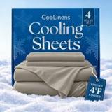 | Listing title | COOLINENS Cooling Sheets Queen Size | 4 Piece Set for Hot Sleepers
 | Marketplace | United States
 | Family · role | Cooling · Launch
 | Scope · stage | Other · Launched Oct 15, 2026
 | Amazon parent | B0H6K5RPX6
 | Best seller | —
 | Variations | 60 (60 with a live price)
 | Sizes | Queen, Full, California King, King, Twin
 | Colours | 12

OUR PRICE TODAY  $87.99 | BFCM 2026 DEAL  Not in a deal  regular price through BFCM | STOCK TO NOV 30  1 short · 0 out  4,261 at Amazon · 20 inbound · need 582 | DIRECT COMPETITORS  10  median $144.99 · 3 cheaper than us

BFCM 2026 deal
Not in a BFCM 2026 deal: sells at its regular price through BFCM.

Stock to Nov 30
Sales per day today 8.7 · lift used 2.74x (account lift, assumed) · need to Nov 30 582 units · at Amazon 4,261 · inbound 20. Covered 59, needs inbound in time 0, short 1, out of stock now 0.
Size | Colour | At Amazon | Inbound | Sales / day | Need to Nov 30 | Short by | Runs out | Status
King | Beige | 27 | 0 | 0.5 | 32 | 5 | Nov 26 | Short even with inbound

Sales mix, last 28 days
By size: Queen 41 · Full 1
By colour (top 8): Graphite 30 · Cool Grey 11 · Light Pink 1

Competitors (38)
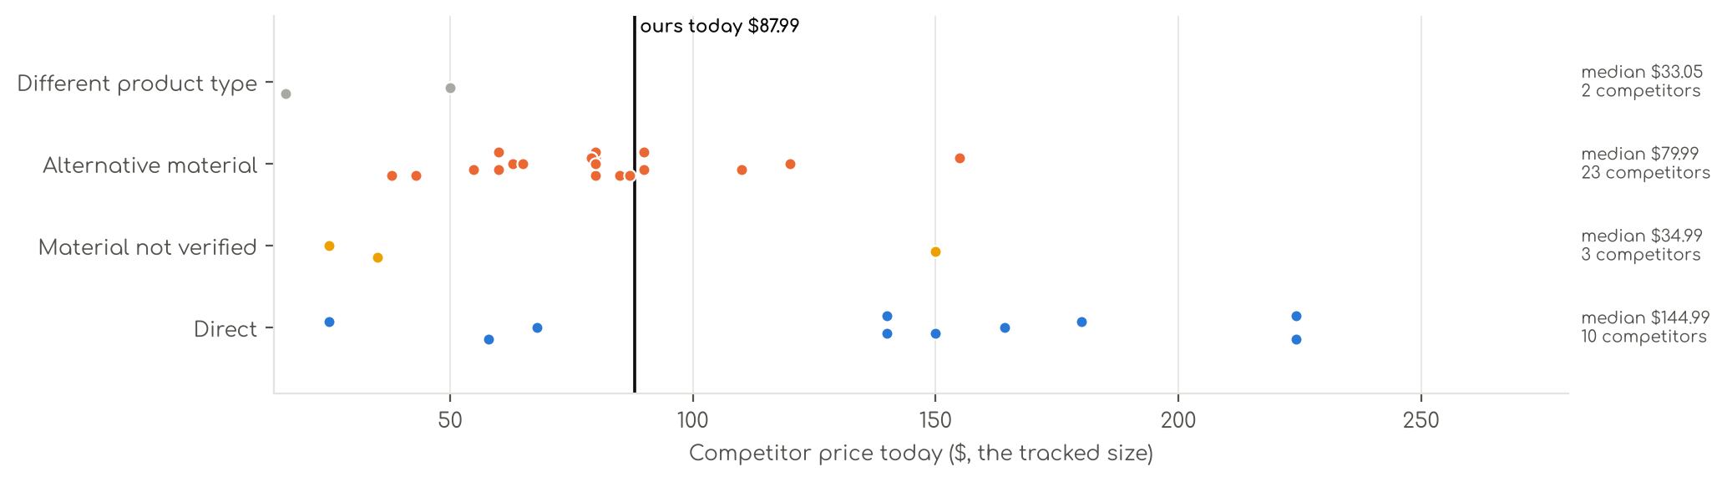
Photo | Competitor | Size · colour | Price | List | vs ours | Strike- through | BFCM 2025 deal | 2025 before → during | Disc. | Rank lift | Units / wk
Direct · 10
 | REST  Cooling Sheets  Synthetic cooling knit · 4.3★ 1,149 · Beatable  Lightning Deal 11-14 to 11-14; List Price $299.00 | Queen · Midnight Blue | $224.25 | $299.00 | +155% | List Price $299.00 | Price cut only | $299.00 → $215.88 | 28% | 1.93x | 81
 | Breescape  Cooling Sheets  Synthetic cooling knit · 4.2★ 595 · Beatable  Coupon 30% (11-01 to 11-02); List Price $179.99 | King · Gray | $149.99 | $179.99 | +60% | List Price $179.99 | Price cut only | $125.99 → $119.69 | 5% | 1.40x | 35
 | REST  Cooling Sheets 4/6 Pcs  Synthetic cooling knit · 4.3★ 1,149 · Beatable  Lightning Deal 11-14 to 11-14; List Price $219.00 | King · Midnight Blue | $164.25 | $219.00 | +75% | List Price $219.00 | Price cut only | $219.00 → $158.12 | 28% | 1.93x | 35
 | Degrees of Comfort  Coolmax® Cooling Sheets for Hot Sleepers, Queen Size, Grey  Synthetic cooling knit · 4.1★ 7,328  Prime Exclusive already running before BFCM week; Buy Box RAISED in BFCM week (median $37.99 vs $34.99 before); List Price $39.99 | Queen · Grey | $24.99 | $29.99 | -72% | Typical price $29.99 | Prime Exclusive Discount | $33.24 → $28.49 | 14% | 0.90x | 35
 | SHEEX  SHEEX - Original Performance Sheets Set (Queen) Graphite - Cooling Sheets - Mois  Synthetic cooling knit · 4.4★ 3,256 · Beatable  Coupon 25%, 30% (11-14 to 11-18); List Price $299.00 | Queen · Graphite | $224.25 | — | +155% | Not shown | None | $299.00 → $299.00 | 0% | 2.41x | 5
 | CGK Unlimited  Cooling Sheets Set Twin XL Size - 3 Piece Summer Bed Sheets for Hot Sleepers & N  Synthetic cooling knit · 4.1★ 118 · Poor | Twin · 06 - Sky Blue | $57.99 | — | -17% | Not shown | Not live in 2025 | — | — | — | 5
 | DOWNCOOL  Cooling Sheets  Synthetic cooling knit · 4.2★ 6 · Poor  Buy Box RAISED in BFCM week (median $69.99 vs $35.99 before); List Price $69.99 | Full · White | $139.99 | — | +87% | Not shown | Prime Exclusive Discount | $35.99 → $29.99 | 17% | 0.99x | 5
 | Elegear  Elegear Silver Infused Cooling Bed Sheets Queen, Arc-Chill® 3.0 Cool Tech, Silve  Synthetic cooling knit · 4.4★ 131 · Poor | Queen (Flat Sheet: 90" x 102") · White | $67.99 | $79.99 | -23% | Typical price $79.99 | Not live in 2025 | — | — | — | 5
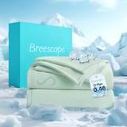 | Breescape  Breescape Cooling Sheets King Size - BlendTek Dry & Cool Technology Cooling Bed  Synthetic cooling knit · 3.8★ 73  List Price $179.99 | King · Green | $179.99 | — | +91% | Not shown | Price cut only | $125.99 → $119.69 | 5% | 1.40x | 5
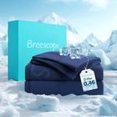 | Breescape  Breescape Cooling Sheets King Size - BlendTek Dry & Cool Technology Cooling Bed  Synthetic cooling knit · 3.8★ 73  List Price $139.99 | Full · Twilight Blue | $139.99 | — | +87% | Not shown | Price cut only | $139.99 → $118.99 | 15% | 1.37x | 5
Material not verified · 3
 | Shilucheng  Shilucheng 4 Piece Queen Sheet Sets, Cooling Sheets, Dark Grey  4.3★ 24,352  Coupon 15%; List Price $34.90 | Queen · Grey | $34.99 | — | -60% | Not shown | Coupon only | $34.90 → $28.18 | 19% | 1.42x | 173
 | Bedsure  Cooling Sheets  4.2★ 512 · Poor  No Buy Box history in price history for BFCM 2025; List Price $82.99 | Queen · 01 - Grey | $149.99 | — | +70% | Not shown | — | — | — | — | 5
 | David's Home  Cooling Sheets  4.3★ 169  Coupon 20%, 40% (11-01 to 11-20); List Price $67.99 | — | $24.99 | — | -72% | — | Prime Exclusive Discount | $39.99 → $10.00 | 75% | 0.98x | —
Alternative material · 23
 | Love's cabin  Love's cabin 4 Piece Queen Sheet Set, 100% Rayon Derived from Bamboo, Cooling & Breathable, Soft Silky Deep Pocket up to…  Bamboo viscose · 4.4★ 1,900  Prime Exclusive already running before BFCM week; List Price $49.99 | Queen · Beige | $37.99 | $44.99 | -57% | List Price $44.99 | Prime Exclusive Discount | $36.99 → $29.99 | 19% | 0.99x | 924
 | Pure Bamboo  Pure Bamboo King Sheets, Genuine 100% Organic Viscose Derived from Bamboo Bed Sheet Set, Luxuriously Soft & Cooling, Dou…  Bamboo viscose · 4.5★ 21,927 · Aspirational  List Price $139.99/$149.99 | King · Ivory | $109.99 | — | +17% | Not shown | None | $109.99 → $109.99 | 0% | 0.48x | 809
 | Bedsure  Bedsure PureWoven 100% Rayon Derived from Bamboo, Queen Sheets, 4 Pieces  Bamboo viscose · 4.4★ 65,061 · Beatable  Buy Box RAISED in BFCM week (median $69.99 vs $66.49 before); List Price $78.99 | Queen · 02 - White | $62.99 | $69.99 | -28% | List Price $69.99 | Prime Exclusive Discount | $66.49 → $55.99 | 16% | 0.68x | 809
 | Hotel Sheets Direct  Hotel Sheets Direct 4 Piece Bed Sheet Set Queen Size, 100% Viscose Derived from Bamboo Sheets Set with 2 Pillowcases, Co…  Bamboo viscose · 4.4★ 37,179 · Aspirational  Lightning Deal 11-07 to 11-11; Coupon 20% (11-12 to 12-02); List Price $72.99 | Queen · White | $79.99 | — | -9% | Not shown | Price cut only | $72.99 → $57.99 | 21% | 2.27x | 347
 | KRIMANO  KRIMANO Bamboo Viscose Sheet Set King Size, Cooling Sheets Bed Set  Bamboo viscose · 4.5★ 263 · Beatable  List Price $94.89 | King · 1.navy Blue | $79.99 | — | -15% | Not shown | None | $72.99 → $72.99 | 0% | 1.89x | 185
 | TRUE BAMBOO  TRUE BAMBOO Sheets Set King Size - Silky Soft & Cooling - Dark Gray  Bamboo viscose · 4.6★ 167 | Queen · Dark Gray | $79.99 | $129.99 | -9% | List Price $129.99 | Not live in 2025 | — | — | — | 185
 | Bambaw  Bambaw 100% Viscose Derived from Bamboo Sheets Queen Size Set – 4pcs Cooling Sheet Set, Super Soft Sheets Queen Size, Lu…  Bamboo viscose · 4.3★ 2,766 · Beatable  List Price $103.45 | Queen · Charcoal | $89.99 | — | +2% | Not shown | None | $89.99 → $89.99 | 0% | 1.17x | 104
 | SONORO KATE  Bamboo Sheets  Bamboo viscose · 4.5★ 3,776 · Beatable  Coupon 15% (11-06 to 11-19); List Price $79.99 | King · Dark Grey | $79.99 | — | -15% | Not shown | Prime Exclusive Discount | $79.99 → $63.99 | 20% | 1.55x | 104
 | BC BELLA COTERIE  Bella Coterie Luxury Bamboo Viscose King Size Sheet Set  Bamboo viscose · 4.4★ 5,871 · Beatable  Coupon 20.00 USD (12-03 to 12-05); List Price $169.99 | King - 2 Pillowcases · 01 - White | $154.99 | — | +65% | Not shown | Price cut only | $134.99 → $110.50 | 18% | 2.66x | 92
 | SONORO KATE  SONORO KATE 100% Viscose Derived from Bamboo_Sheets Queen Size,4PC  Bamboo viscose · 4.5★ 3,911 · Beatable  Coupon 10% (11-04 to 12-05); List Price $59.99 | Queen · Dark Grey | $59.99 | — | -32% | Not shown | Prime Exclusive Discount | $59.99 → $47.99 | 20% | 1.20x | 81
 | BEDELITE  BEDELITE Bamboo Viscose Sheet Set, Queen Size, 4 Pieces, White  Bamboo viscose · 4.5★ 113 | Queen · White | $84.98 | $99.89 | -3% | List Price $99.89 | Not live in 2025 | — | — | — | 81
 | DOZ by SIJO  Bamboo Sheets  Bamboo viscose · 4.4★ 1,909 · Beatable  List Price $55.00 | Queen · Olive | $55.00 | — | -37% | Not shown | None | $55.00 → $55.00 | 0% | 1.18x | 35
 | KARISSA MAE  Cooling Sheets  Bamboo viscose · 4.3★ 474  No Buy Box history in price history for BFCM 2025 | King - 2 Pillowcases · 10 - Mocha | $119.99 | — | +28% | Not shown | — | — | — | — | 35
 | Pillcase  100% Real Bamboo Viscose & Lyocell Tencel Sheets Set Queen Size | Breathable & C  Microfiber / polyester · 4.8★ 279 | Queen · French Blue | $79.00 | $109.00 | -10% | List Price $109.00 | Not live in 2025 | — | — | — | 35
 | Davmabcjy  100% Organically Grown Bamboo Viscose King Sheet Set with Pockets on Side  Bamboo viscose · 4.2★ 81 | King (Deep Fits 16" ) · Dark Grey-side Pockets | $59.99 | — | -36% | Not shown | Not live in 2025 | — | — | — | 35
 | Kickoff Home  Bamboo Sheets  Bamboo viscose · 4.6★ 688 · Poor  Coupon 25% (11-01 to 11-05); List Price $124.99 | King · Sage Green | $86.99 | $84.99 | -7% | Not shown | Price cut only | $118.99 → $79.13 | 33% | 2.47x | 18
 | Shilucheng  Shilucheng 100% Viscose Derived from Bamboo_Sheets, Extra Deep Pocket  Bamboo viscose · 4.5★ 1,639  Coupon 18.00 USD, 20% (11-01 to 11-12); List Price $74.99 | Queen · Dark Grey | $59.99 | $74.99 | -32% | List Price $74.99 | Prime Exclusive Discount | $74.99 → $56.99 | 24% | 0.73x | 18
 | TWK  TWK Real 100% Viscose Derived from Bamboo Sheets Set Queen Size, Cooling & Silky  Bamboo viscose · 4.9★ 121 | Queen · Sand | $65.00 | $79.00 | -26% | Typical price $79.00 | Not live in 2025 | — | — | — | 18
 | Pillcase  100% Real Bamboo Viscose & Lyocell Tencel Sheets Set Queen Size | Breathable & C  Microfiber / polyester · 4.9★ 201 | Queen · Charcoal | $79.00 | — | -10% | List Price $99.00 | Not live in 2025 | — | — | — | 18
 | California Design Den  California Design Den 100% Viscose from Bamboo Sheets Queen, Dark Olive  Bamboo viscose · 4.6★ 76 | Queen · Bright White | $89.99 | — | +2% | Not shown | Not live in 2025 | — | — | — | 18
 | OMERAI  Cooling Sheets  Microfiber / polyester · 4.7★ 4 | King 4 PC · Blue | $42.99 | $59.99 | -54% | List Price $59.99 | Not live in 2025 | — | — | — | 5
 | Shilucheng  Shilucheng 100% Viscose Derived from Bamboo_ Sheets King Size 4pcs  Bamboo viscose · 4.4★ 6,629  Buy Box RAISED in BFCM week (median $68.90 vs $64.90 before); List Price $69.90 | King · 01 - Dark Grey | $54.90 | $64.90 | -42% | List Price $64.90 | Prime Exclusive Discount | $64.90 → $55.12 | 15% | 0.86x | 5
 | Pillcase  Cooling Hotel Bedding Sheet Set - 4pcs Bamboo Viscose & Tencel Blend, Moisture-W  Microfiber / polyester · 4.0★ — | King · Pearl White | $79.99 | — | -15% | Not shown | Not live in 2025 | — | — | — | 5
Different product type · 2
 | Comfort Spaces  Comfort Spaces Coolmax Moisture Wicking Fitted Sheet ONLY Super Soft, Fade Resis  Synthetic cooling knit · 4.2★ 1,336  Buy Box RAISED in BFCM week (median $24.33 vs $19.57 before); List Price $16.99 | Queen Deep Pocket · Grey | $16.10 | — | -82% | Not shown | Price cut only | $19.57 → $17.60 | 10% | 0.71x | 185
 | Brookstone  Cooling Fitted Sheet  Synthetic cooling knit · 4.1★ 184 · Poor  Coupon 10% (11-11 to 11-27); List Price $49.99 | Twin · Gray | $49.99 | — | -29% | Not shown | Prime Exclusive Discount | $49.99 → $39.99 | 20% | 1.05x | 5

US · CL Pillowcases: CooLinens Cooling Pillowcases 2 Piece
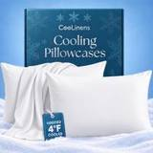 | Listing title | COOLINENS Cooling Pillow Cases Queen Size | Set of 2 for Hot Sleepers
 | Marketplace | United States
 | Family · role | Cooling · Launch
 | Scope · stage | Other · Launch
 | Amazon parent | B0HLSNQNCK
 | Best seller | B0H5WWMPNN (Queen White)
 | Variations | 12 (12 with a live price)
 | Sizes | Queen, Standard, King
 | Colours | 4

OUR PRICE TODAY  $19.99  Queen White | BFCM 2026 DEAL PRICE  $21.99 → $15.19  Best Deal Nov 19-30 · 31% off the Oct 27 price | STOCK TO NOV 30  7 short · 0 out  2,737 at Amazon · 0 inbound · need 3,308 | DIRECT COMPETITORS  9  median $16.99 · 5 cheaper than us

BFCM 2026 deal
Deal | Hero variation | Price Oct 27 | Deal price | Off | Variations (deal page) | Our 2025 cut | Rivals' 2025 cut
Best Deal Nov 19-30 | Queen White | $21.99 | $15.19 | 31% | 12 eligible; 29%–31% off | — | 29% (2 rivals)

Stock to Nov 30
Sales per day today 49.5 · lift used 2.74x (account lift, assumed) · need to Nov 30 3,308 units · at Amazon 2,737 · inbound 0. Covered 5, needs inbound in time 0, short 7, out of stock now 0.
Size | Colour | At Amazon | Inbound | Sales / day | Need to Nov 30 | Short by | Runs out | Status
Queen | Light Grey | 205 | 0 | 7.8 | 518 | 313 | Nov 10 | Short even with inbound
Queen | White | 204 | 0 | 7.7 | 512 | 308 | Nov 10 | Short even with inbound
Standard | White | 218 | 0 | 6.4 | 428 | 210 | Nov 18 | Short even with inbound
King | White | 223 | 0 | 4.5 | 304 | 81 | Nov 23 | Short even with inbound
King | Dark Grey | 136 | 0 | 4.0 | 268 | 132 | Nov 17 | Short even with inbound
King | Light Grey | 229 | 0 | 3.5 | 235 | 6 | Nov 29 | Short even with inbound
Standard | Dark Grey | 127 | 0 | 1.9 | 128 | 1 | Nov 29 | Short even with inbound

Sales mix, last 28 days
By size: Queen 126 · Standard 107 · King 77
By colour (top 8): Dark Grey 92 · White 84 · Light Grey 71 · Blue 63

Competitors (15)
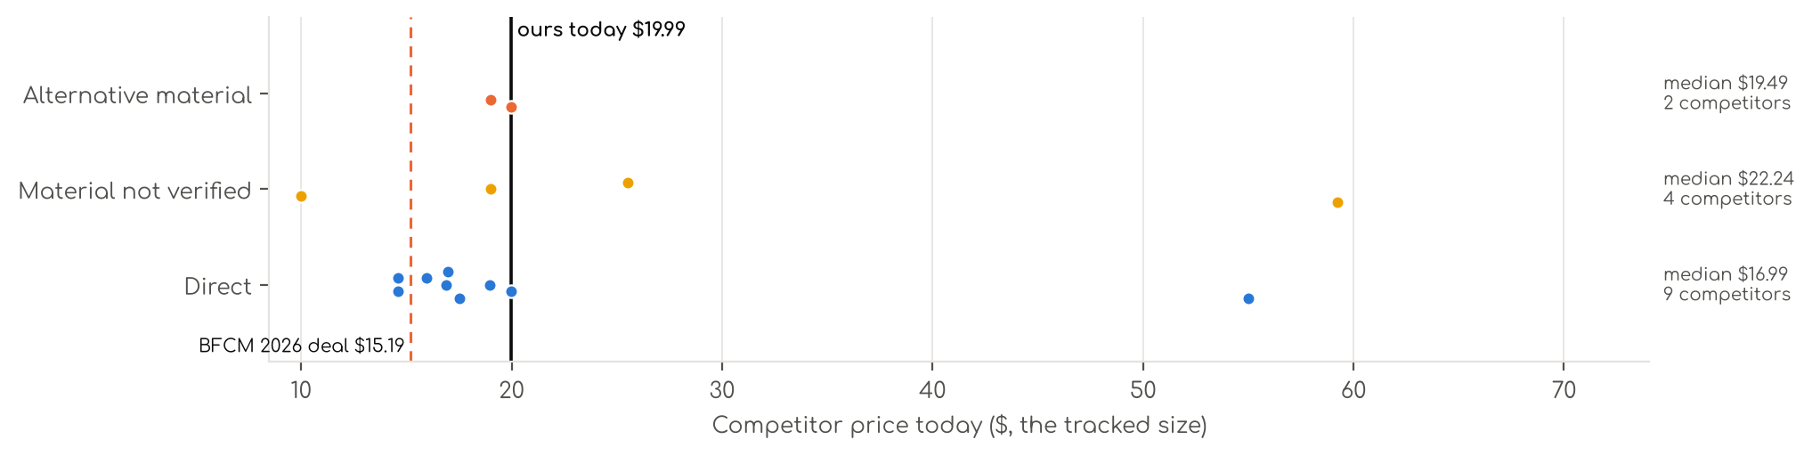
Photo | Competitor | Size · colour | Price | List | vs ours | Strike- through | BFCM 2025 deal | 2025 before → during | Disc. | Rank lift | Units / wk
Direct · 9
 | Avolare  Avolare Cooling Pillow Cases Queen Size Set of 2,Arc-Chill 3.0 Cool Pillowcases  Synthetic cooling knit · 4.4★ 3,832 · Aspirational  Coupon 10%, 15% (11-01 to 12-05); List Price $19.99 | Queen (U.S. Standard) · Blue | $17.52 | $19.99 | -12% | Not shown | Prime Exclusive Discount | $15.99 → $13.67 | 15% | 0.80x | 173
 | CHOSHOME  CHOSHOME Cooling Pillow Cases Zipper Pillow Covers Q-Max > 0.45 Zippered Pillowcases for Hot Sleepers, Soft, Breathable,…  Synthetic cooling knit · 4.4★ 1,768 · Beatable  List Price $19.99 | Standard · Grey | $14.60 | — | -19% | Not shown | Prime Exclusive Discount | $15.56 → $13.13 | 16% | 1.03x | 104
 | Elegear  Elegear Cooling Pillow Cases for Hot Sleepers, Set of 2, Queen 20'' x 30''  Synthetic cooling knit · 4.3★ 8,391 · Aspirational  List Price $18.75 | Standard (20" x 26") · Grey | $16.88 | — | — | List Price $18.75 | Prime Exclusive Discount | $18.75 → $15.00 | 20% | 1.10x | 35
 | LUXEAR  LUXEAR 2 Pack Cooling Pillow Cases for Hot Sleepers, Arc-Chill Q-Max > 0.5 Cool  Synthetic cooling knit · 4.2★ 6,718 · Aspirational  List Price $24.99 | Standard (20" X 26") · Gray | $15.95 | — | — | Not shown | None | $15.95 → $15.95 | 0% | 0.91x | 35
 | QUTOOL  Luxury Cooling Pillowcases Queen Size 2 Pack, Q-Max>0.4 Cool Touch for Hot Sleepers&Night Sweats Beauty Sleep Anti-Frizz…  Synthetic cooling knit · 4.4★ 769 · Beatable  Prime Exclusive 11-23 to 12-01; Buy Box RAISED in BFCM week (median $19.99 vs $18.99 before); List Price $29.99 | Queen · Gray | $16.99 | — | -15% | Not shown | Lightning Deal | $18.99 → $13.99 | 26% | 1.29x | 35
 | Breescape  Breescape Cooling Pillow Cases Queen Size Set of 2, BlendTek™ Cooling Technology  Synthetic cooling knit · 4.4★ 305 · Beatable  Buy Box RAISED in BFCM week (median $54.99 vs $38.49 before); List Price $54.99 | King · Misty Gray | $54.99 | — | +162% | Not shown | Prime Exclusive Discount | $38.49 → $36.56 | 5% | 1.35x | 18
 | Fittia  FITTIA Cooling Pillow Cases with Zipper, 2 Pack, Standard Size 20"x26"  Synthetic cooling knit · 4.3★ 1,335 · Beatable  List Price $21.99 | Standard 20"x 26" · Grey | $19.99 | — | — | Not shown | None | $19.99 → $19.99 | 0% | 0.81x | 18
 | Topcee  Topcee Cooling Pillowcases, 2 Packs Queen Size Arc-Chill Q-Max>0.5 Ultra Soft Co  Synthetic cooling knit · 4.2★ 227 · Beatable  List Price $29.99 | Queen(20"x30") · Gray | $18.95 | — | -5% | Not shown | None | $13.99 → $13.99 | 0% | 0.83x | 5
 | Niagara Sleep Solution  Niagara Set of 2 Cooling Pillow Cases Standard Size, CoolSpan™ Technology Q-Max 0.4 Cooling Pillowcases for Hot Sleepers…  Synthetic cooling knit · 4.4★ 109 · Poor  List Price $14.99 | Standard · Grey | $14.60 | — | -19% | Not shown | None | $8.99 → $8.99 | 0% | 0.84x | 5
Material not verified · 4
 | REST  REST® Evercool®+ Cooling Pillowcases for Hot Sleepers, Standard, 2PCS  4.4★ 1,226 · Beatable  Lightning Deal 11-15 to 11-15; List Price $79.00 | Standard (2 pcs) · Light Gray | $59.25 | $79.00 | — | List Price $79.00 | Price cut only | $79.00 → $55.30 | 30% | 2.02x | 208
 | HOMFINE  HOMFINE Cooling Pillowcases for Hot Sleepers King Size Set of 2, Grey  4.3★ 1,309 · Beatable  Coupon 20%, 24% (11-01 to 11-19); List Price $24.99 | King · Grey | $9.99 | — | -52% | Typical price $12.99 | Prime Exclusive Discount | $23.99 → $18.23 | 24% | 1.01x | 81
 | Bedsure  Bedsure Cooling Pillow Cases Queen Size Set of 2 for Hot Sleepers, Grey  4.5★ 676 · Beatable  List Price $32.99 | Queen · Grey | $18.99 | $24.99 | -5% | — | None | — | — | 0.84x | 5
 | Coop Home Goods  Coop Home Goods Cool Side Pillowcase, Queen Size Cooling Pillow Case for Hot Sle  4.3★ 1,158 · Beatable  Lightning Deal 11-01 to 11-07; List Price $30.00 | Queen · Standard | $25.50 | — | +28% | List Price $30.00 | Prime Exclusive Discount | $30.00 → $24.00 | 20% | 1.11x | 5
Alternative material · 2
 | Marchpower  Marchpower Cooling Pillow Cases for Hot Sleepers, Japanese Arc Chill Cooling Pil  Cotton · 4.3★ 1,247 · Beatable  No Buy Box history in price history for BFCM 2025; List Price $29.99 | Standard 20"x 26" · Green | $19.99 | — | — | Not shown | — | — | — | 1.44x | 5
 | Rifens  Ice Cooling Pillowcase for Hot Sleepers, Instantly Cool, Stay Cold All Night, Softer Than Silk Pillow Cases, Pillow Cove…  Silk · 4.6★ 219 · Beatable  List Price $25.99 | Standard · Gray | $18.99 | — | +6% | Not shown | Price cut only | $14.99 → $10.78 | 28% | 0.88x | 5

US · DC Beach Towel: Decolure Beach Towel
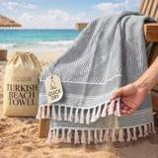 | Listing title | DECOLURE Turkish Beach Towel Oversized 39x73 Inch - 100% Turkish Cotton, Quick Dry and Sand Free Beach Towels for Travel - Lightweight, Absorbent & Soft Peshtemal Towel - (Gray Wave)
 | Marketplace | United States
 | Family · role | Other · Other
 | Scope · stage | Other · Liquidation
 | Amazon parent | B0GZVXL6DZ
 | Best seller | B0DQ92K585 (39" x 73" Gray)
 | Variations | 14 (0 with a live price)
 | Sizes | 39" x 73"
 | Colours | 7

OUR PRICE TODAY  —  39" x 73" Gray | BFCM 2026 DEAL  Not in a deal  regular price through BFCM | STOCK TO NOV 30  Covered  134 at Amazon · 0 inbound · need 15 | COMPETITORS  13  median $14.99 · 10 cheaper than us

BFCM 2025: how this product did
Period | Sales | Units | Organic units | Ad units | Ad cost | TACoS | Sessions | Unit session % | Avg price
Oct 21 – Nov 19, 2025 (30 days before) | $60 | 3 | 3 | 0 | $0 | 0.0% | 33 | 9.1% | $19.95
Nov 20 – Dec 1, 2025 (BFCM week) | $0 | 0 | 0 | 0 | $0 | — | 25 | 0.0% | —
Dec 2 – 31, 2025 | $0 | 0 | 0 | 0 | $0 | — | 21 | 0.0% | —
Best seller in BFCM 2025: B0DQ92K585: $19.95 before (median Nov 1 – 19) → $19.95 in BFCM week, no cut; Best Seller Rank 3,997,312 → 4,003,695.

BFCM 2026 deal
Not in a BFCM 2026 deal: sells at its regular price through BFCM.

Stock to Nov 30
Sales per day today 0.2 · lift used 2.74x (account lift, assumed) · need to Nov 30 15 units · at Amazon 134 · inbound 0. Covered 4, needs inbound in time 0, short 0, out of stock now 0.

Sales mix, last 28 days
By size: 39" x 73" 2
By colour (top 8): Cyan 1 · Gray 1

Competitors (13)
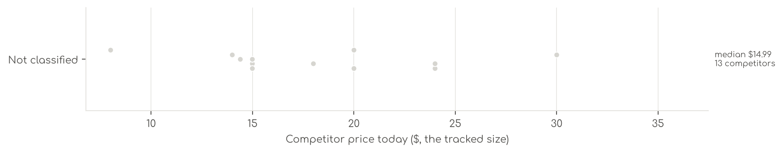
Photo | Competitor | Size · colour | Price | List | vs ours | Strike- through | BFCM 2025 deal | 2025 before → during | Disc. | Rank lift | Units / wk
Not classified · 13
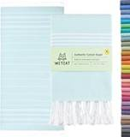 | WETCAT  WETCAT Turkish Beach Towel Oversized (38"x71") 100% Turkish Cotton, Made in Turkey - Sand Free, Extra Large, Ultra Soft,…  4.6★ 13,408 · Aspirational  List Price $40.00 | Beach Towel (38" x 71") · Aqua | $23.99 | — | +12% | Not shown | Price cut only | $23.99 → $20.39 | 15% | 1.68x | 81
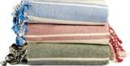 | Salt Earth  36"x72" Cotton Turkish Quick Dry Sand Free Beach Towel 4 Pack (Alloy) | Salt Ear  4.4★ 488  Buy Box RAISED in BFCM week (median $25.99 vs $18.54 before); List Price $40.99 | Pack of 3 · Olive Green, Brick, Sky Blue | $23.99 | — | +12% | Not shown | Prime Exclusive Discount | $18.54 → $18.19 | 2% | 0.92x | 18
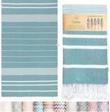 | Mebien touche de la nature  Turkish Beach Towel  4.5★ 2,252 · Aspirational  List Price $23.99 | Large · Teal | $14.40 | $19.99 | -33% | Not shown | Prime Exclusive Discount | $19.99 → $14.52 | 27% | 0.88x | 5
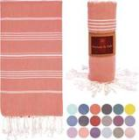 | Nature Is Gift  Turkish Beach Towel  4.6★ 1,901 · Aspirational  List Price $17.99 | X-Large · Coral | $13.99 | $17.99 | -35% | List Price $17.99 | Prime Exclusive Discount | $17.99 → $14.39 | 20% | 1.24x | 5
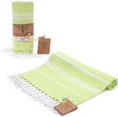 | SMYRNA TURKISH COTTON  SMYRNA TURKISH COTTON Classical Series Original Turkish Beach Towel | Prewashed, 37 x 71 Inches | Peshtemal and Turkish …  4.5★ 4,592 · Aspirational  List Price $19.99 | One Pack · Pistachio Green | $7.99 | — | -63% | Not shown | None | $8.99 → $8.99 | 0% | 0.68x | 5
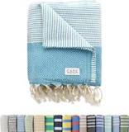 | Cape Comforts  Turkish Beach Towel  4.5★ 444 · Beatable  List Price $19.99 | 1 Pack · Diamond - Aqua | $19.99 | — | -7% | Not shown | Prime Exclusive Discount | $19.99 → $15.79 | 21% | 2.47x | 5
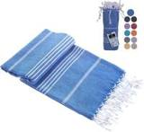 | Casamollis  Casamollis Turkish Beach Towel, Prewashed, 100% Cotton, Soft, Absorbent, Quick Dry, Sand Free Large Oversize Beach Towel…  4.4★ 120 · Beatable  List Price $22.50 | Large · Blue | $14.99 | — | -30% | Not shown | None | $14.99 → $14.99 | 0% | 1.03x | 5
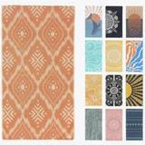 | FESHKA  FESHKA Sand Proof Turkish Beach Towel – Oversized, Quick Dry & Lightweight Travel Towel - 100% Organic Cotton Beach Blan…  4.4★ 500 · Beatable  List Price $47.00 | Large · 14 - Rust/Beige | $14.99 | — | -30% | Not shown | Lightning Deal | $49.00 → $27.90 | 43% | 1.80x | 5
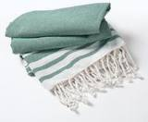 | Goroly Home  Goroly Home Cotton Turkish Peshtemal Beach Towel, Extra Large, Thin Quick Dry Sand Free Pool & Swim Towel, Bathing Blank…  4.4★ 206 · Beatable  List Price $18.99 | 36x71 · Pista Green | $29.99 | — | +40% | Not shown | Price cut only | $9.49 → $6.64 | 30% | 1.87x | 5
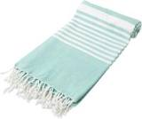 | Organic Cotton Mart  Turkish Beach Towel  4.4★ 72 · Beatable  List Price $22.99 | 71"x37" · Teal | $19.99 | — | -7% | Not shown | Prime Exclusive Discount | $14.99 → $11.84 | 21% | 1.62x | 5
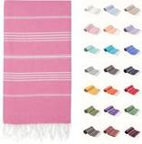 | PARK&OZ  Turkish Beach Towel  4.4★ 290 · Beatable  Buy Box RAISED in BFCM week (median $11.99 vs $9.99 before); List Price $19.99 | X Large · Pink | $14.99 | — | -30% | Not shown | None | $9.99 → $9.99 | 0% | 0.63x | 5
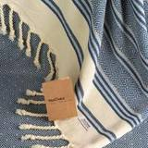 | Your Choice  Your Choice Turkish Beach Towel (71x41) - 100% Cotton Turkish Towel, Sand Free Quick Dry Oversized, Lightweight Compact …  4.5★ 315 · Beatable  List Price $40.99 | Large · 1pc-navy | $17.99 | — | -16% | Not shown | None | $17.99 → $17.99 | 0% | 1.01x | 5
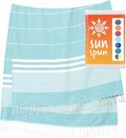 | SUNSPUN LINENS  SUNSPUN LINENS Turkish Beach Towel, 39x63in Extra Large Quick Dry Cotton Oversized Turkish Bath Towel & Blanket for Adul…  4.4★ 745  List Price $10.61 | 39x63 inches · Aqua | $14.99 | — | -30% | Not shown | Price cut only | $12.99 → $9.99 | 23% | 0.92x | 5

US · DC Chair Cover: Decolure Waterproof Chair Cover
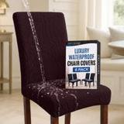 | Listing title | Waterproof Dining Chair Covers Set of 6 - 3 Layers Thick Fabric Parsons Chair Slip Covers - Jacquard Kitchen Chair Covers & Stretch Protectors Dining Room, Restaurant - Removable Washable (Chocolate)
 | Marketplace | United States
 | Family · role | Other · Other
 | Scope · stage | Other · Liquidation
 | Amazon parent | B0FB6DM5X9
 | Best seller | B0CY63VCW1 (Pack of 6 Chocolate)
 | Variations | 12 (5 with a live price)
 | Sizes | Pack of 6, Pack of 4
 | Colours | 6

OUR PRICE TODAY  $39.99  Pack of 6 Chocolate | BFCM 2026 DEAL PRICE  $39.99 → $37.99  Best Deal Nov 19-30 · 5% off the Oct 27 price | STOCK TO NOV 30  4 short · 2 out  130 at Amazon · 0 inbound · need 96 | BFCM 2025 SALES LIFT  0.66x  30 units in the last 28 days | COMPETITORS  23  median $22.94 · 14 cheaper than us

BFCM 2025: how this product did
Period | Sales | Units | Organic units | Ad units | Ad cost | TACoS | Sessions | Unit session % | Avg price
Oct 21 – Nov 19, 2025 (30 days before) | $684 | 17 | 17 | 0 | $83 | 12.1% | 656 | 2.6% | $40.23
Nov 20 – Dec 1, 2025 (BFCM week) | $180 | 5 | 5 | 0 | $8 | 4.3% | 193 | 2.6% | $35.99
Dec 2 – 31, 2025 | $922 | 25 | 16 | 9 | $63 | 6.9% | 520 | 4.8% | $36.87
Best seller in BFCM 2025: B0CY63VCW1: $41.99 before (median Nov 1 – 19) → $39.99 in BFCM week, 5% lower; Best Seller Rank 721,803 → 785,429.
Our BFCM 2025 deals: Best Deal 11-20 to 12-02 (cancelled, 12 variations)

BFCM 2026 deal
Deal | Hero variation | Price Oct 27 | Deal price | Off | Variations (deal page) | Our 2025 cut | Rivals' 2025 cut
Best Deal Nov 19-30 | Pack of 6 Chocolate | $39.99 | $37.99 | 5% | 6 eligible, 6 out of stock; 0%–5% off | 5% ($41.99 → $39.99) | 30% (3 rivals)

Stock to Nov 30
Sales per day today 1.4 · lift used 2.74x (account lift, assumed) · need to Nov 30 96 units · at Amazon 130 · inbound 0. Covered 2, needs inbound in time 0, short 4, out of stock now 2.
Size | Colour | At Amazon | Inbound | Sales / day | Need to Nov 30 | Short by | Runs out | Status
Pack of 6 | Beige | 27 | 0 | 0.4 | 28 | 1 | Nov 29 | Short even with inbound
Pack of 6 | Chocolate | 24 | 0 | 0.4 | 25 | 1 | Nov 29 | Short even with inbound
Pack of 6 | Wine Red | 1 | 0 | 0.2 | 11 | 10 | Oct 21 | Short even with inbound
Pack of 4 | Wine Red | 0 | 0 | 0.1 | 8 | 8 | now | Out of stock now
Pack of 4 | Chocolate | 4 | 0 | 0.1 | 7 | 3 | Nov 20 | Short even with inbound
Pack of 4 | Beige | 0 | 0 | 0.0 | 3 | 3 | now | Out of stock now

Sales mix, last 28 days
By size: Pack of 6 23 · Pack of 4 7
By colour (top 8): Chocolate 12 · Beige 10 · Wine Red 5 · Black 3

Competitors (23)
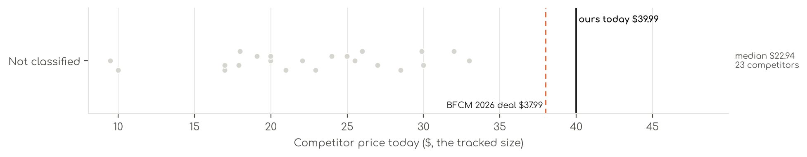
Photo | Competitor | Size · colour | Price | List | vs ours | Strike- through | BFCM 2025 deal | 2025 before → during | Disc. | Rank lift | Units / wk
Not classified · 23
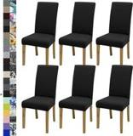 | BIETYONE  Waterproof Chair Cover  4.6★ 1,765 · Aspirational  List Price $32.99 | .Black | $20.99 | — | -17% | Not shown | Price cut only | $26.99 → $16.93 | 37% | 1.61x | 347
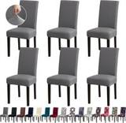 | Fafua  Fafua Chair Covers, Stretch Dining Room Chair Covers Set of 6, Removable Washable Dining Chair Slipcovers for Home, Hote…  4.6★ 2,227 · Aspirational  Buy Box RAISED in BFCM week (median $22.93 vs $19.69 before); List Price $21.88 | .Grey | $17.89 | — | -29% | List Price $18.88 | Prime Exclusive Discount | $19.69 → $17.93 | 9% | 1.17x | 173
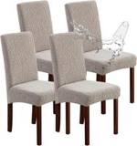 | Genina  Genina Waterproof Dining Chair Covers Set of 4 Parsons Chair Slipcovers  4.7★ 2,930 · Aspirational  Buy Box RAISED in BFCM week (median $29.98 vs $19.99 before); List Price $29.98 | Leaves-warm Gray | $22.07 | — | -13% | Typical price $19.99 | Prime Exclusive Discount | $19.99 → $17.69 | 12% | 0.95x | 173
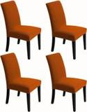 | Artrello  Chair Covers for Dining Room - Stretch Chair Slipcovers for Decorative Seat Protector Armless Removable Washable Elastic…  4.5★ 4,016 · Aspirational  No Buy Box history in price history for BFCM 2025; List Price $34.99 | Autumn Orange | $23.99 | — | -5% | Not shown | — | — | — | 0.71x | 92
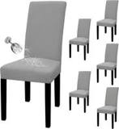 | Easy-Going  Easy-Going 100% Waterproof Dining Room Chair Covers Set of 6, Large  4.6★ 4,711 · Aspirational  Coupon 10%; List Price $34.99 | Light Gray | $25.99 | — | +3% | Not shown | Coupon only | $25.99 → $23.39 | 10% | 1.30x | 92
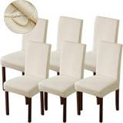 | Genina  Waterproof Chair Cover  4.6★ 2,729 · Aspirational  Buy Box RAISED in BFCM week (median $35.99 vs $31.99 before); List Price $36.99 | Beige | $28.49 | — | +13% | Not shown | Prime Exclusive Discount | $31.99 → $26.63 | 17% | 1.20x | 92
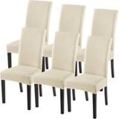 | SearchI  Waterproof Chair Cover  4.6★ 10,643 · Aspirational  Lightning Deal 11-02 to 11-16; List Price $38.99 | Beige Rhombus | $29.99 | $34.99 | +19% | List Price $34.99 | Price cut only | $37.04 → $26.59 | 28% | 2.21x | 92
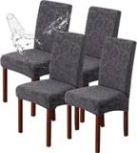 | Genina  Waterproof Dining Room Chair Covers, Stretch Parsons Chair Slipcovers  4.7★ 1,655 · Aspirational  Buy Box RAISED in BFCM week (median $21.69 vs $18.99 before); List Price $21.69 | Flower Pattern-dark Gray | $19.99 | $23.99 | -21% | List Price $23.99 | Prime Exclusive Discount | $18.99 → $17.14 | 10% | 1.15x | 81
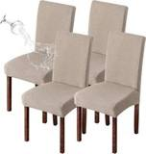 | Genina  Genina Waterproof Chair Covers for Dining Room Chair Slipcovers Set of 4  4.5★ 1,786 · Aspirational  Prime Exclusive already running before BFCM week; List Price $29.98 | Khaki | $19.99 | — | -21% | Not shown | Prime Exclusive Discount | $22.08 → $18.71 | 15% | 1.20x | 81
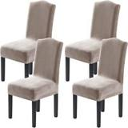 | H.VERSAILTEX  H.VERSAILTEX Dining Chair Covers Stretch for Dining Room Set of 4 Parson Chair Slipcovers Protectors, Soft Thick Solid V…  4.5★ 5,385 · Aspirational | Taupe | $31.99 | — | +27% | Not shown | Prime Exclusive Discount | $31.99 → $25.27 | 21% | 1.10x | 81
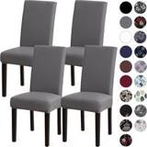 | Sufdari  Sufdari Dining Chair Covers,Kitchen Cover,Parsons Slipcover,Spandex Protectors for Room Stretch Chairs Cover Set of 4 -G…  4.6★ 2,070 · Aspirational  Coupon 10% (11-01 to 11-05); List Price $17.99 | .Gray | $16.99 | — | -33% | Not shown | Prime Exclusive Discount | $18.99 → $15.19 | 20% | 1.37x | 81
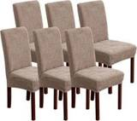 | YUEANG  YUEANG Dining Chair Covers Set of 6, Stretch Parsons Chair Slipcovers  4.6★ 1,526 · Aspirational  List Price $35.99 | Taupe | $29.99 | — | +19% | Not shown | None | $35.99 → $35.99 | 0% | 1.48x | 81
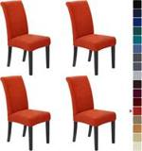 | Howhic  Waterproof Chair Cover  4.6★ 8,870 · Aspirational  Buy Box RAISED in BFCM week (median $24.49 vs $21.99 before); List Price $39.99 | Pumpkin Orange | $32.99 | — | +31% | Not shown | None | $21.99 → $23.99 | -9% | 0.80x | 35
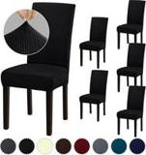 | Fafua  Fafua Stretch Dining Room Chair Covers Set of 6, Removable Washable Chair Covers for Dining Chairs,Dining Room, Hotel, C…  4.6★ 865 · Beatable  Coupon 20% (11-01 to 12-05); List Price $34.88 | .Black | $19.10 | $23.88 | -24% | List Price $23.88 | None | $23.88 → $23.88 | 0% | 1.01x | 35
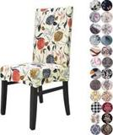 | Lalluxy  Lalluxy Stretchy Washable Parson Dining Chair Covers/Slipcovers Set of 4  4.6★ 3,594 · Aspirational  List Price $26.99 | Orange Flowers | $17.99 | — | -29% | Not shown | Price cut only | $22.99 → $15.99 | 30% | 0.86x | 18
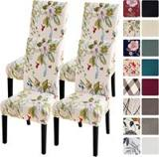 | SearchI  Waterproof Chair Cover  4.6★ 5,341 · Aspirational  Lightning Deal 11-14 to 11-14; Coupon 10% (11-01 to 11-05); Buy Box RAISED in BFCM week (median $26.99 vs $24.29 before); List Price $31.99 | Beige+flowers | $22.94 | $26.99 | -9% | List Price $26.99 | Prime Exclusive Discount | $24.29 → $21.32 | 12% | 1.22x | 18
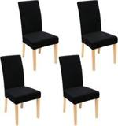 | Smiry  Smiry Velvet Dining Chair Covers, Parsons Chair Slipcovers Set of 4  4.6★ 7,521 · Aspirational  Coupon 30% (11-01 to 11-05); List Price $33.99 | Black | $26.99 | $31.99 | +7% | List Price $31.99 | Prime Exclusive Discount | $26.99 → $18.89 | 30% | 1.45x | 18
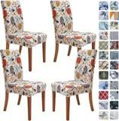 | SPRINGRICO  Waterproof Chair Cover  4.7★ 6,302 · Aspirational  List Price $26.90 | Floral4 | $25.49 | — | +1% | Not shown | Prime Exclusive Discount | $25.49 → $20.14 | 21% | 0.93x | 18
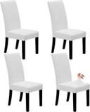 | Easy-Going  Waterproof Chair Cover  4.6★ 1,034 · Beatable  List Price $28.99 | White | $24.99 | — | -1% | Not shown | None | $23.99 → $23.99 | 0% | 1.12x | 18
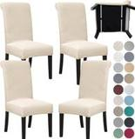 | SPRINGRICO  Waterproof Chair Cover  4.7★ 1,526 · Beatable  List Price $39.99 | S2-beige | $29.89 | — | +18% | Not shown | Prime Exclusive Discount | $29.89 → $23.61 | 21% | 0.96x | 18
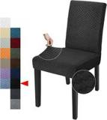 | YEMYHOM  Waterproof Chair Cover  4.6★ 1,638 · Beatable  Buy Box RAISED in BFCM week (median $10.59 vs $9.99 before); List Price $13.99 | Black | $9.99 | — | -60% | Not shown | Prime Exclusive Discount | $9.99 → $8.37 | 16% | 0.95x | 18
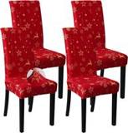 | FORCHEER  Waterproof Chair Cover  4.6★ 1,385 · Beatable  List Price $25.99 | Christmas 5 | $16.99 | — | -33% | Not shown | None | $20.99 → $20.99 | 0% | 0.85x | 5
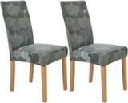 | Secgo  Waterproof Chair Cover  4.6★ 837 · Beatable  Prime Exclusive already running before BFCM week; List Price $24.99 | Garden Glam | $9.48 | — | -62% | Typical price $9.99 | Prime Exclusive Discount | $11.10 → $9.87 | 11% | 0.68x | 5

US · DC Linen Curtains: Decolure Linen Curtains
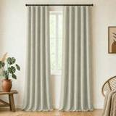 | Listing title | DECOLURE 100% Blackout Linen Curtains 108 Inches Long | Ivory
 | Marketplace | United States
 | Family · role | Other · Liquidation
 | Scope · stage | Other · Liquidation
 | Amazon parent | B0H2Z62MJZ
 | Best seller | B0F63C8HL2 (52x108 Ivory)
 | Variations | 42 (37 with a live price)
 | Sizes | 52x72, 52x108, 52x84, 52x120, 52x96, 52x63, 52x90
 | Colours | 6

OUR PRICE TODAY  $34.99  52x108 Ivory | BFCM 2026 DEAL PRICE  $34.99 → $33.24  Best Deal Nov 19-30 · 5% off the Oct 27 price | STOCK TO NOV 30  4 short · 1 out  621 at Amazon · 0 inbound · need 127 | COMPETITORS  21  median $23.99 · 16 cheaper than us

BFCM 2025: how this product did
Period | Sales | Units | Organic units | Ad units | Ad cost | TACoS | Sessions | Unit session % | Avg price
Oct 21 – Nov 19, 2025 (30 days before) | $0 | 0 | 0 | 0 | $0 | — | 0 | — | —
Nov 20 – Dec 1, 2025 (BFCM week) | $0 | 0 | 0 | 0 | $0 | — | 0 | — | —
Dec 2 – 31, 2025 | $2,310 | 83 | 83 | 0 | $0 | 0.0% | 1,859 | 4.5% | $27.83

BFCM 2026 deal
Deal | Hero variation | Price Oct 27 | Deal price | Off | Variations (deal page) | Our 2025 cut | Rivals' 2025 cut
Best Deal Nov 19-30 | 52x108 Ivory | $34.99 | $33.24 | 5% | 21 no reference price, 16 eligible, 5 out of stock; 0%–5% off | — | 31% (6 rivals)

Stock to Nov 30
Sales per day today 1.9 · lift used 2.74x (account lift, assumed) · need to Nov 30 127 units · at Amazon 621 · inbound 0. Covered 33, needs inbound in time 0, short 4, out of stock now 1.
Size | Colour | At Amazon | Inbound | Sales / day | Need to Nov 30 | Short by | Runs out | Status
52x72 | Light Grey | 25 | 0 | 0.5 | 31 | 6 | Nov 25 | Short even with inbound
52x84 | Light Grey | 15 | 0 | 0.3 | 18 | 3 | Nov 25 | Short even with inbound
52x120 | Ivory | 15 | 0 | 0.2 | 16 | 1 | Nov 28 | Short even with inbound
52x72 | Linen | 8 | 0 | 0.2 | 15 | 7 | Nov 18 | Short even with inbound
52x84 | Light Beige | 0 | 0 | 0.0 | 1 | 1 | now | Out of stock now

Sales mix, last 28 days
By size: 52x72 6 · 52x108 2 · 52x84 2 · 52x120 1 · 52x96 1
By colour (top 8): Light Grey 5 · Ivory 3 · Beige 2 · Linen 1 · Natural 1

Competitors (21)
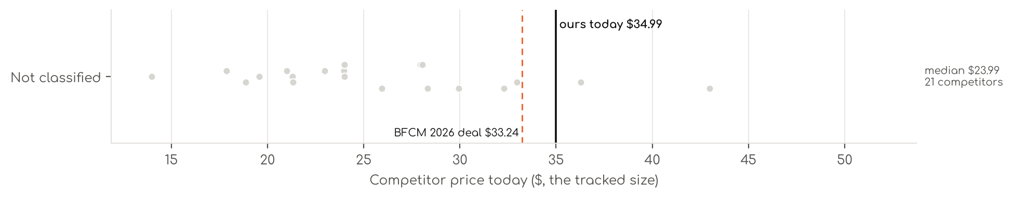
Photo | Competitor | Size · colour | Price | List | vs ours | Strike- through | BFCM 2025 deal | 2025 before → during | Disc. | Rank lift | Units / wk
Not classified · 21
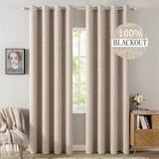 | MIULEE  MIULEE 100% Blackout Linen Curtains for Bedroom 52x84 Inches Natural Beige  4.6★ 10,414 · Aspirational  Coupon 20% (11-01 to 11-02); List Price $29.95 | 52"W x 84"L (Pack of 2) · Beige | $25.95 | — | -13% | List Price $27.73 | Prime Exclusive Discount | $29.95 → $21.56 | 28% | 0.56x | 3,464
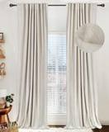 | 100% Blackout Shield  Linen Total Blackout Curtains for Bedroom Living Room 84 Inch, Cream  4.5★ 9,093 · Aspirational  List Price $39.99 | 50"W x 84"L (Pack of 2) · Alba | Cream | $32.97 | $39.99 | +11% | List Price $39.99 | Price cut only | $38.99 → $26.51 | 32% | 0.60x | 2,079
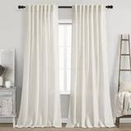 | Nanspring  Cream Linen Back Tab Curtains 84 Inch Length for Living Room 2 Panel Set Neutral  4.7★ 7,261 · Aspirational  Coupon 20% (12-03 to 12-05); Buy Box RAISED in BFCM week (median $17.98 vs $15.98 before); List Price $14.98 | 52"W x 84"L (Pack of 2) · Natural | $13.98 | — | -53% | Not shown | Prime Exclusive Discount | $15.98 → $11.98 | 25% | 0.42x | 2,079
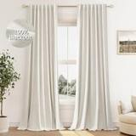 | Guken  Guken Cream Linen Blackout Curtains 84 Inch Length 2 Panels Set for Living Room Bedroom Back Tab Thermal Insulated 100% …  4.5★ 2,791 · Beatable  Lightning Deal 11-03 to 11-03; Buy Box RAISED in BFCM week (median $26.98 vs $23.98 before); List Price $19.79 | 52"W x 84"L (Pack of 2) · Cream | $17.86 | $18.80 | -40% | Typical price $18.80 | Prime Exclusive Discount | $23.98 → $15.38 | 36% | 0.58x | 2,079
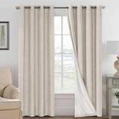 | H.VERSAILTEX  H.VERSAILTEX 100% Blackout Linen Curtains 84" L 2 Panels Natural  4.6★ 25,977 · Aspirational  Lightning Deal 11-06 to 11-06; Coupon 20% (11-01 to 11-02); List Price $45.98 | 52"W x 84"L (Pack of 2) · Natural | $27.95 | — | -6% | Not shown | Price cut only | $38.95 → $22.35 | 43% | 1.49x | 809
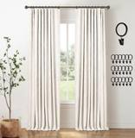 | INOVADAY  INOVADAY 100% Blackout Curtains for Bedroom Black Out Curtains 84 Inch Long  4.5★ 5,371 · Aspirational  Coupon 20% (11-01 to 11-03); List Price $38.99 | 50"W x 84"L (Pack of 2) · Beige | $28.33 | $34.95 | -5% | Typical price $34.95 | Price cut only | $38.99 → $25.46 | 35% | 0.81x | 347
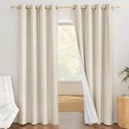 | NICETOWN  NICETOWN Natural 100% Blackout Linen Curtains 84 inch Long Burg for Living Room, 1 Pair, 52" Width Each Panel, Farmhouse…  4.5★ 4,378 · Aspirational  Coupon 21% (11-01 to 11-01); List Price $39.95 | 52"W x 84"L (Pack of 2) · Natural | $18.88 | $27.29 | -37% | List Price $27.29 | None | $23.95 → $23.95 | 0% | 0.30x | 347
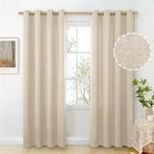 | BGment  BGment Oatmeal Linen Curtains 84 Inch Length 2 Panels Set for Living Room  4.6★ 718 · Beatable  Buy Box RAISED in BFCM week (median $35.99 vs $21.29 before); List Price $43.99 | 52"W x 84"L (Pack of 2) · Oatmeal | $21.29 | — | -29% | Not shown | Prime Exclusive Discount | $21.29 → $18.09 | 15% | 0.94x | 347
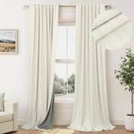 | Pitalk  100% Blackout Curtains 84 Inch Length 2 Panels Set Neutral Boho Linen Farmhouse for Bedroom Windows Living Room Darkenin…  4.4★ 1,608 · Beatable  List Price $39.99 | 52"W x 84"L (Pack of 2) · Natural | $23.98 | $26.98 | -20% | Typical price $26.98 | Prime Exclusive Discount | $29.98 → $23.68 | 21% | 0.70x | 347
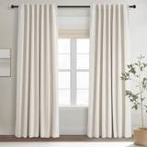 | Topfinel  Topfinel Cream Linen Blackout Curtains 84 Inch Long for Bedroom Living Room, Ivo  4.3★ 1,639 · Beatable  Coupon 5.00 USD (11-01 to 12-05); List Price $34.99 | 52"W x 84"L (Pack of 2) · Birch | $28.04 | $32.99 | -6% | Typical price $32.99 | Prime Exclusive Discount | $32.99 → $26.06 | 21% | 0.66x | 347
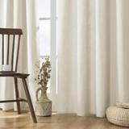 | Joydeco  Joydeco Linen Curtains 96 inch Length 2 Panel Set, Light Filtering Curtain for Living Room Bedroom, 52 inch Wide Drapes …  4.7★ 1,430 · Poor  Coupon 2.00 USD (12-04 to 12-05); List Price $45.99 | 52"W x 96"L (Pack of 2) · Ivory on Linen | $32.28 | $42.99 | +8% | List Price $42.99 | None | $33.99 → $33.99 | 0% | 0.78x | 347
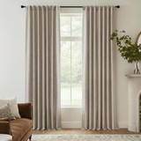 | RYB HOME  RYB HOME Natural Beige 100% Blackout Curtains for Bedroom 84 Inch Long  4.5★ 1,072 · Poor  Coupon 24% (11-18 to 11-19); Buy Box RAISED in BFCM week (median $29.85 vs $21.00 before); List Price $29.85 | 52"W x 84"L (Pack of 2) · Natural Beige | $21.33 | $29.85 | -28% | List Price $29.85 | Prime Exclusive Discount | $21.00 → $19.70 | 6% | 0.86x | 347
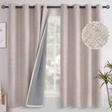 | YoungsTex  Linen Curtains  4.7★ 2,019 · Beatable  Coupon 10% (11-17 to 12-05); Buy Box RAISED in BFCM week (median $28.89 vs $21.76 before); List Price $38.86 | 52"W x 63"L (Pack of 2) · Beige | $19.58 | — | -34% | List Price $21.76 | Prime Exclusive Discount | $21.76 → $17.61 | 19% | 0.89x | 208
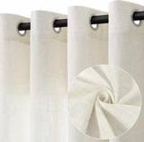 | Jowels  Jowels Natural Linen Grommet Curtains 84 Inch Long 2 Panels for Living Room  4.6★ 1,089 · Poor  Coupon 20% (11-07 to 11-19); List Price $21.98 | 52"W x 84"L (Pack of 2) · Natural | $20.99 | — | -30% | Not shown | Prime Exclusive Discount | $21.98 → $17.58 | 20% | 0.77x | 197
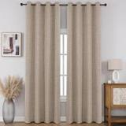 | CUCRAF  CUCRAF 100% Blackout Window Curtains 84 inches Long 2 Panels Set, Faux Linen Look Thermal Insulated Grommet Drapes, Room…  4.7★ 2,808 · Beatable  Coupon 10.00 USD; List Price $27.99 | 52"W x 84"L (Pack of 2) · Light Khaki | $23.99 | $27.99 | -20% | List Price $27.99 | Coupon only | $27.99 → $22.90 | 18% | 0.88x | 173
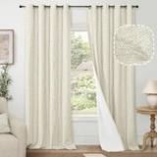 | Lajode  Lajode Natural Linen Blackout Curtains for Bedroom - 52x84 Inch 2 Panels  4.6★ 1,408 · Beatable  List Price $46.99 | 52"W x 84"L (Pack of 2) · Natural | $29.94 | — | +0% | Not shown | Price cut only | $29.94 → $21.20 | 29% | 1.12x | 92
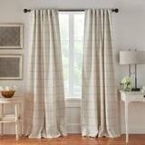 | Threadmade  Threadmade Brighton Windowpane Plaid Blackout Window Curtain Panel, Linen - 52" W x 84" L  4.5★ 2,281 · Beatable  List Price $49.99 | 52"W x 84"L (Pack of 1) · Linen | $36.29 | $44.99 | +22% | List Price $44.99 | Price cut only | $49.48 → $42.49 | 14% | 0.71x | 92
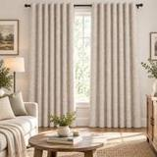 | Zyvola Store  Zyvola 100% Blackout Curtains 84 inch Length Faux Linen (W52 x L84, Beige)  4.8★ 767 · Poor  Prime Exclusive 11-01 to 12-05; Prime Exclusive already running before BFCM week; List Price $23.99 | 52"W x 84"L (Pack of 2) · Beige | $23.99 | — | -20% | Not shown | Price cut only | $20.99 → $18.99 | 10% | 1.04x | 92
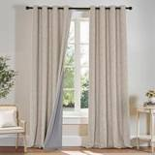 | PONY DANCE  PONY DANCE Linen Blackout Curtains for Bedroom 84 Inches Long, 2 Panels Set  4.8★ 267 · Poor  List Price $29.97 | 52"W x 84"L (Pack of 2) · Linen | $22.97 | — | -23% | Not shown | None | $21.97 → $22.97 | -5% | 0.71x | 81
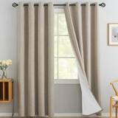 | Yakamok  Yakamok Natural Linen Textured Curtains 84 Inches Long for Living Room  4.7★ 22,765 · Aspirational  Prime Exclusive already running before BFCM week; List Price $29.99 | 52"W x 84"L (Pack of 2) · Natural Linen | $23.99 | — | -20% | Not shown | Prime Exclusive Discount | $18.04 → $18.04 | 0% | 0.83x | 35
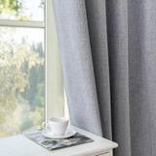 | Zyvola  Linen Curtains  4.7★ 4 · Poor  Buy Box RAISED in BFCM week (median $43.99 vs $35.39 before); List Price $44.99 | 52"W x 96"L (Pack of 2) · *Grommet | Light Grey | $42.99 | — | +44% | Not shown | None | $35.39 → $36.39 | -3% | 1.06x | 5

US · DC Welcome Sign: Decolure Front Door Welcome Sign
 | Listing title | DECOLURE Welcome Sign for Front Porch - Tall Solid Wood Porch Door Sign with 10 Magnetic Seasonal & Holiday Pieces, Rustic Farmhouse Outdoor Decor for Year Round Welcoming Entryway (Porch Brown)
 | Marketplace | United States
 | Family · role | Other · Other
 | Scope · stage | Other · Liquidation
 | Amazon parent | B0H1N61MK6
 | Best seller | B0DQ84FD76 (One Size Brown)
 | Variations | 7 (0 with a live price)
 | Sizes | One Size
 | Colours | 7

OUR PRICE TODAY  —  One Size Brown | BFCM 2026 DEAL  Not in a deal  regular price through BFCM | STOCK TO NOV 30  0 short · 1 out  22 at Amazon · 0 inbound · need 1 | COMPETITORS  17  median $33.99 · 12 cheaper than us

BFCM 2025: how this product did
Period | Sales | Units | Organic units | Ad units | Ad cost | TACoS | Sessions | Unit session % | Avg price
Oct 21 – Nov 19, 2025 (30 days before) | $0 | 0 | 0 | 0 | $0 | — | 33 | 0.0% | —
Nov 20 – Dec 1, 2025 (BFCM week) | $0 | 0 | 0 | 0 | $0 | — | 16 | 0.0% | —
Dec 2 – 31, 2025 | $0 | 0 | 0 | 0 | $1 | — | 18 | 0.0% | —
Best seller in BFCM 2025: B0DQ84FD76: $32.95 before (median Nov 1 – 19) → $32.95 in BFCM week, no cut; Best Seller Rank 4,437,982 → 4,553,497.

BFCM 2026 deal
Not in a BFCM 2026 deal: sells at its regular price through BFCM.

Stock to Nov 30
Sales per day today 0.0 · lift used 2.74x (account lift, assumed) · need to Nov 30 1 units · at Amazon 22 · inbound 0. Covered 3, needs inbound in time 0, short 0, out of stock now 1.
Size | Colour | At Amazon | Inbound | Sales / day | Need to Nov 30 | Short by | Runs out | Status
One Size | Brown | 0 | 0 | 0.0 | 1 | 1 | now | Out of stock now

Sales mix, last 28 days
By size: One Size 2
By colour (top 8): Black 1 · Brown 1

Competitors (17)
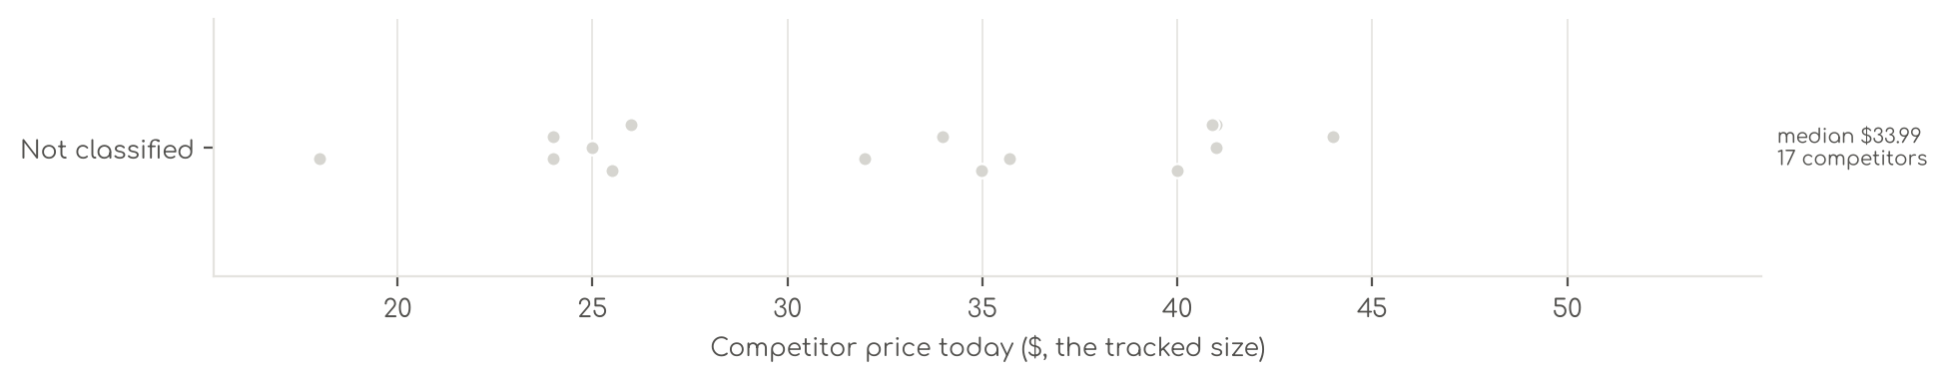
Photo | Competitor | Size · colour | Price | List | vs ours | Strike- through | BFCM 2025 deal | 2025 before → during | Disc. | Rank lift | Units / wk
Not classified · 17
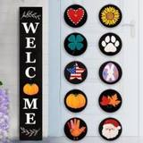 | PERFNIQUE  Perfnique Welcome sign for front porch standing, 47 x 7.9 Inch Wooden Leaner Sign with 10 Interchangeable Designed Icons…  4.5★ 1,039 · Aspirational  Buy Box RAISED in BFCM week (median $42.48 vs $37.99 before); List Price $39.99 | Black · Black | $34.99 | — | -8% | Not shown | Prime Exclusive Discount | $37.99 → $31.99 | 16% | 1.21x | 104
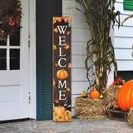 | Seimip  Front Door Welcome Sign  3.9★ 299 · Beatable  Buy Box RAISED in BFCM week (median $26.99 vs $22.99 before); List Price $49.99 | large · Fall Pumpkin | $23.99 | — | -37% | Not shown | Prime Exclusive Discount | $22.99 → $19.97 | 13% | 1.16x | 104
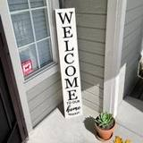 | DOUSUI  Vertical Wood Welcome Sign for Front Porch Vertical Decorative Sign Front Door Outdoor Indoor Welcome Sign 47.2x7.8 Inch…  3.6★ 139 · Beatable  List Price $25.99 | 47.2x7.8 Inch · white | $24.99 | — | -34% | Not shown | None | $25.99 → $24.99 | 4% | 0.97x | 81
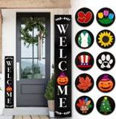 | MONJITA  Monjita Welcome Sign for Front Porch Standing, Interchangeable Wooden Sign with 5 Designed Double-Sided Icons for Front …  4.5★ 498 · Aspirational  Buy Box RAISED in BFCM week (median $40.35 vs $35.99 before); List Price $37.99 | XL · Black | $33.99 | — | -10% | Not shown | Prime Exclusive Discount | $35.99 → $29.99 | 17% | 0.96x | 35
 | Surfapans  Surfapans Welcome Sign for Front porch Standing 45"X9" Black  4.4★ 574 · Aspirational  Buy Box RAISED in BFCM week (median $42.99 vs $40.89 before); List Price $60.99 | 45"L x 9"W · Welcome（Black) | $40.99 | — | +8% | Not shown | None | $40.89 → $40.89 | 0% | 1.00x | 35
 | TQianJiang  Interchangeable Welcome Sign for Front Porch Standing 47"X8" Wood  3.8★ 221 · Beatable  List Price $39.99 | 47 ×8Inches · Wood | $34.99 | — | -8% | Not shown | None | $37.99 → $37.99 | 0% | 0.80x | 35
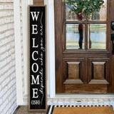 | comurdyo  comurdyo Welcome-ish Sign for Front porch Standing 45"X9" Wood Black  4.2★ 263 · Beatable  List Price $64.99 | 45x9 Inches · Wood Black-Wood Sign | $35.69 | $39.89 | -6% | Typical price $39.89 | None | $36.99 → $36.99 | 0% | 0.80x | 18
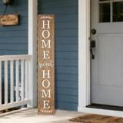 | LianheCy  Front Door Welcome Sign  4.0★ 115 · Beatable  List Price $22.99 | 47x7.8x0.9 inches · home-Brown | $24.99 | — | -34% | Not shown | None | $24.99 → $24.99 | 0% | 1.21x | 18
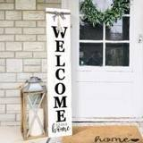 | MODE HOME  MODE HOME Large Vertical Welcome Sign for Front Door Porch, 47x10 Inch Solid Wood Farmhouse Porch Decor, 3D Raised Lette…  4.4★ 312 · Beatable  List Price $49.99 | 47.21 inches x 9.84 inches · Whitewashed | $43.99 | — | +16% | Not shown | Prime Exclusive Discount | $38.99 → $31.19 | 20% | 1.14x | 18
 | SRSZHIYUE  Front Door Welcome Sign  3.9★ 23 · Beatable  List Price $43.99 | 45"X9" · Interchangeable Welcome Black | $40.89 | — | +8% | Not shown | None | $38.49 → $38.49 | 0% | 1.45x | 18
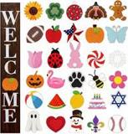 | Yalikop  Yalikop Interchangeable Welcome Sign for Front Porch 47 x 7.9'', Wood Color  3.8★ 51 · Beatable  List Price $41.99 | 47.2 x 7.9 x 0.8 inches · Wood Color | $39.99 | — | +5% | Not shown | None | $41.99 → $41.99 | 0% | 1.17x | 18
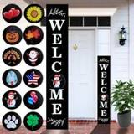 | Consevisen  Consevisen Welcome Sign for Front Door Porch Standing, Interchangeable 47 x 7.9 Inch Outdoor Vertical Wooden Welcome Sig…  3.5★ 198 · Beatable  No Buy Box history in price history for BFCM 2025; List Price $59.99 | Large · Black | $31.99 | — | -16% | Not shown | — | — | — | 0.91x | 5
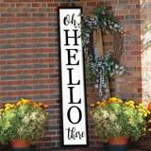 | flowtorely  Front Door Welcome Sign  4.5★ 557 · Beatable  List Price $40.99 | 45"L x 9"W · Oh Hello There Outdoor （Welcome Black) | $40.99 | — | +8% | Not shown | None | $38.99 → $38.99 | 0% | 1.02x | 5
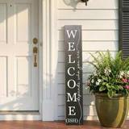 | Hentonwell  Welcome Porch Sign Decor,Hanging Wooden Door Sign,Rustic Porch Standing Decorative Signs,Vertical Plaques for Front Door…  4.0★ 54 · Beatable  List Price $27.99 | 47.2 inches (Height) · Black | $23.99 | $26.99 | -37% | Typical price $26.99 | None | $23.85 → $23.83 | 0% | 0.77x | 5
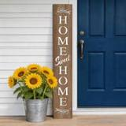 | homuvdok  Front Door Welcome Sign  4.0★ 129 · Beatable  List Price $39.99 | 7.8" x 47.2" · Natural Board | $25.99 | — | -32% | Not shown | Price cut only | $39.99 → $25.99 | 35% | — | 5
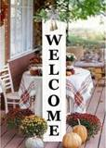 | RLWangChao  Front Door Welcome Sign  3.8★ 233 · Beatable  List Price $39.99 | 47"L x 8"W · White | $25.49 | $29.99 | -33% | Typical price $29.99 | Price cut only | $29.99 → $20.99 | 30% | 0.98x | 5
 | Dlerom  Spring Summer Welcome for Front Porch Standing, Daisy Wooden Porch Sign for Front Door Decorations, Rustic Farmhouse Han…  3.9★ 17 | 47x7.8 inches · Yellow & White | $17.99 | — | -53% | Not shown | Not live in 2025 | — | — | — | 5

US · SL Quilt Set: Sleephoria Quilt Set
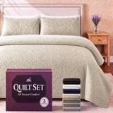 | Listing title | SLEEPHORIA Queen Quilt Bedding Set | Lightweight Summer Bedspread 3 Pc
 | Marketplace | United States
 | Family · role | Other · Liquidation
 | Scope · stage | Other · Liquidation
 | Amazon parent | B0GZW9QWJM
 | Best seller | B0FGZDR11L (Queen Ivory)
 | Variations | 21 (11 with a live price)
 | Sizes | Queen, King, Twin
 | Colours | 7

OUR PRICE TODAY  $41.99  Queen Ivory | BFCM 2026 DEAL PRICE  $41.99 → $24.64  Best Deal Nov 19-30 · 41% off the Oct 27 price | STOCK TO NOV 30  6 short · 6 out  45 at Amazon · 0 inbound · need 71 | COMPETITORS  19  median $32.28 · 14 cheaper than us

BFCM 2025: how this product did
Period | Sales | Units | Organic units | Ad units | Ad cost | TACoS | Sessions | Unit session % | Avg price
Oct 21 – Nov 19, 2025 (30 days before) | $0 | 0 | 0 | 0 | $0 | — | 0 | — | —
Nov 20 – Dec 1, 2025 (BFCM week) | $1,187 | 41 | 41 | 0 | $0 | 0.0% | 147 | 27.9% | $28.94
Dec 2 – 31, 2025 | $3,216 | 119 | 119 | 0 | $0 | 0.0% | 4,324 | 2.8% | $27.02

BFCM 2026 deal
Deal | Hero variation | Price Oct 27 | Deal price | Off | Variations (deal page) | Our 2025 cut | Rivals' 2025 cut
Best Deal Nov 19-30 | Queen Ivory | $41.99 | $24.64 | 41% | 11 out of stock, 10 eligible; 0%–41% off | — | 13% (4 rivals)
Deal notes
- Pre-BFCM deal decision. Oct 16-28 Best Deal: cancel proposed; only 42 units left across the parent after the liquidation.

Stock to Nov 30
Sales per day today 1.1 · lift used 2.74x (account lift, assumed) · need to Nov 30 71 units · at Amazon 45 · inbound 0. Covered 6, needs inbound in time 0, short 6, out of stock now 6.
Size | Colour | At Amazon | Inbound | Sales / day | Need to Nov 30 | Short by | Runs out | Status
Twin | Light Grey | 1 | 0 | 0.2 | 16 | 15 | Oct 19 | Short even with inbound
Queen | Navy Blue | 3 | 0 | 0.1 | 8 | 5 | Nov 9 | Short even with inbound
King | Light Grey | 0 | 0 | 0.1 | 7 | 7 | now | Out of stock now
Queen | Taupe | 0 | 0 | 0.1 | 7 | 7 | now | Out of stock now
Queen | Ivory | 1 | 0 | 0.1 | 6 | 5 | Oct 26 | Short even with inbound
Queen | Light Grey | 1 | 0 | 0.1 | 5 | 4 | Oct 29 | Short even with inbound
Queen | White | 2 | 0 | 0.0 | 3 | 1 | Nov 23 | Short even with inbound
Queen | Black | 1 | 0 | 0.0 | 2 | 1 | Nov 17 | Short even with inbound
King | Navy Blue | 0 | 0 | 0.0 | 2 | 2 | now | Out of stock now
King | Black | 0 | 0 | 0.0 | 1 | 1 | now | Out of stock now
Twin | Taupe | 0 | 0 | 0.0 | 1 | 1 | now | Out of stock now
King | White | 0 | 0 | 0.0 | 1 | 1 | now | Out of stock now

Sales mix, last 28 days
By size: Queen 19 · King 8 · Twin 5
By colour (top 8): Ivory 10 · Light Grey 8 · Navy Blue 5 · White 3 · Sage Green 3 · Taupe 2 · Black 1

Competitors (19)
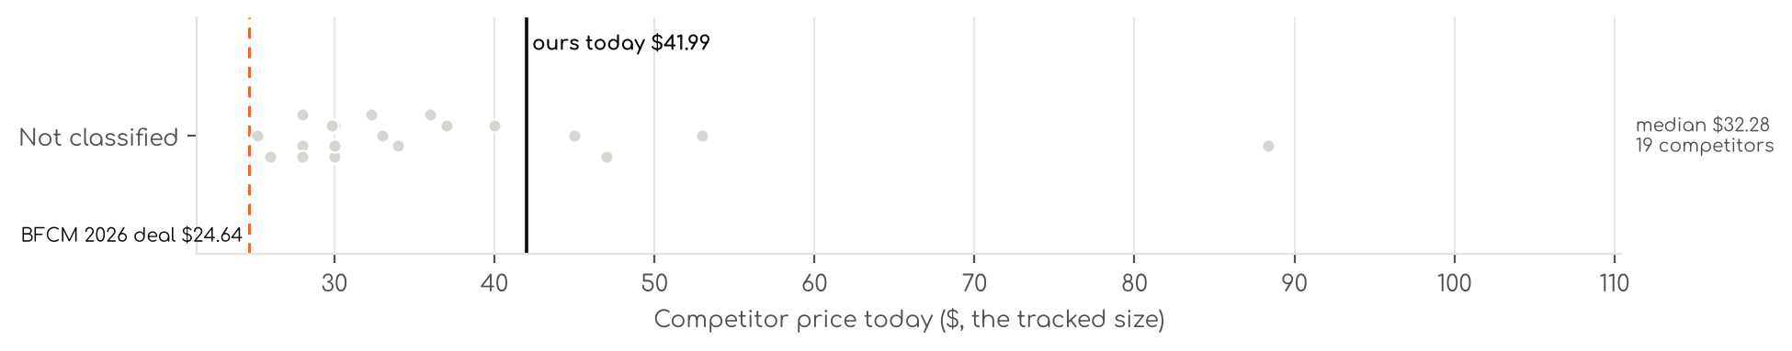
Photo | Competitor | Size · colour | Price | List | vs ours | Strike- through | BFCM 2025 deal | 2025 before → during | Disc. | Rank lift | Units / wk
Not classified · 19
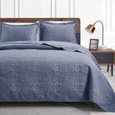 | Love's cabin  Love's cabin Quilts for Queen Bed Blue Bedspreads - Soft Bed Summer Lightweight Bedspread Comforter - Modern Style Coin …  4.6★ 9,469 · Aspirational  Prime Exclusive already running before BFCM week; Buy Box RAISED in BFCM week (median $35.99 vs $27.54 before); List Price $35.99 | Queen · Blue | $25.99 | $31.99 | -38% | List Price $31.99 | Prime Exclusive Discount | $27.54 → $27.54 | 0% | 0.51x | 809
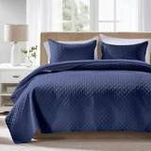 | FLYMME  FLYMME Quilts Queen Size - Ultra Soft Navy Blue Quilt Lightweight Microfiber Bedspreads, Classic Basket Weave Pattern Be…  4.3★ 1,454 · Aspirational  Prime Exclusive 11-01 to 11-11; Prime Exclusive already running before BFCM week; List Price $27.99 | Queen · Navy | $27.99 | — | -33% | Not shown | None | $25.19 → $27.99 | -11% | 0.52x | 347
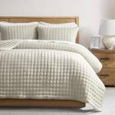 | WDCOZY  WDCOZY Beige Queen Size Quilts Bedding Sets with 2 Pillow Shams, Neutral Lightweight Soft Bedspread Coverlet, Quilted Bl…  4.4★ 5,513 · Beatable  List Price $41.99 | Queen · Beige | $44.99 | — | +7% | Not shown | None | $44.99 → $44.99 | 0% | 0.83x | 347
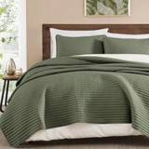 | WRENSONGE  Queen Quilt-Lightweight Bedspreads Olive Green Queen Size Quilt Bedding Set  4.5★ 942 · Beatable  Prime Exclusive 11-01 to 12-05; Lightning Deal 11-03 to 11-15; Prime Exclusive already running before BFCM week; List Price $49.99 | Queen · Green | $39.99 | — | -5% | List Price $49.99 | Price cut only | $39.99 → $37.98 | 5% | 1.22x | 220
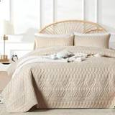 | akkialla  akkialla Full/Queen Size Quilt Bedding Set,Beige Lightweight Microfiber Soft Bedspread,Modern Style Geoetric Pattern Cov…  4.4★ 1,378 · Beatable  List Price $27.99 | Full · Beige | $27.99 | — | -4% | Not shown | None | $27.99 → $27.99 | 0% | 0.75x | 197
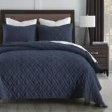 | HORIMOTE HOME  HORIMOTE HOME Quilt Set Queen Size Navy Blue, Classic Geometric Diamond Stitched Pattern, Ultra Soft Microfiber Lightwei…  4.6★ 9,080 · Aspirational  List Price $36.99 | Queen · Navy | $29.99 | — | -29% | Not shown | Prime Exclusive Discount | $31.99 → $25.27 | 21% | 0.83x | 185
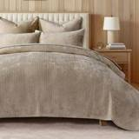 | EverGrace  EverGrace Striped Channel Velvet Quilt Set, King Size, Urban Taupe  4.5★ 1,097 · Beatable  Prime Exclusive 12-04 to 12-05; List Price $129.99 | King · Taupe | $88.34 | $92.99 | +96% | Typical price $92.99 | Price cut only | $93.99 → $79.03 | 16% | 1.75x | 173
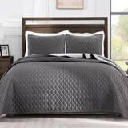 | Exclusivo Mezcla  Exclusivo Mezcla Reversible Full Queen Quilt Bedding Set, Grey  4.5★ 17,360 · Aspirational  List Price $37.99 | Full · Grey | $25.19 | $27.99 | -13% | Typical price $27.99 | Price cut only | $29.99 → $24.98 | 17% | 1.88x | 104
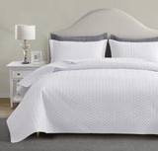 | Maple&Stone  Maple&Stone White Quilt Set Queen Size, Lightweight Bedspread  4.4★ 2,762 · Aspirational  Coupon 10%; List Price $32.99 | Queen · White | $29.99 | — | -29% | Not shown | Coupon only | $29.99 → $29.99 | 0% | 0.55x | 104
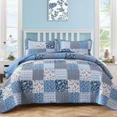 | Mybedsoul  Mybedsoul Boho Quilts Queen Size, Patchwork Floral Bedding Set, Blue  4.6★ 4,352 · Aspirational  Buy Box RAISED in BFCM week (median $44.99 vs $35.99 before); List Price $39.99 | Queen · Blue | $35.99 | — | -14% | List Price $44.99 | Prime Exclusive Discount | $35.99 → $32.39 | 10% | 0.94x | 92
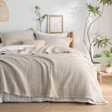 | Bedsure  Bamboo Sheets  4.6★ 1,294 · Beatable  Buy Box RAISED in BFCM week (median $56.99 vs $50.99 before); List Price $56.99 | Queen / Full · 01 - Light Beige (Solid Border) | $46.99 | — | +12% | List Price $58.99 | Prime Exclusive Discount | $50.99 → $42.49 | 17% | 0.96x | 81
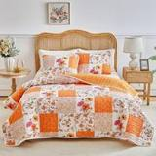 | Joyreap  Bamboo Sheets  4.6★ 1,595 · Beatable | Queen-90"x90" · Orange | $29.99 | — | -29% | Not shown | Price cut only | $32.99 → $29.99 | 9% | 0.79x | 81
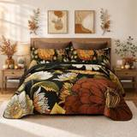 | Tyrot  Tyrot 3 Piece Black Boho Floral King Quilt Bedding Sets  4.7★ 1,849 · Beatable  Lightning Deal 11-03 to 11-03; Coupon 10% (11-07 to 11-13); List Price $52.99 | King · Black | $52.99 | — | +18% | Not shown | Prime Exclusive Discount | $52.99 → $41.64 | 21% | 0.65x | 81
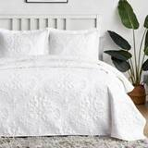 | Hansleep  Bamboo Sheets  4.6★ 5,920 · Aspirational  Coupon 44% (11-07 to 11-15); List Price $34.99 | Oversized King-106"x96" · White | $36.99 | — | +27% | Not shown | Prime Exclusive Discount | $44.99 → $27.64 | 39% | 1.18x | 35
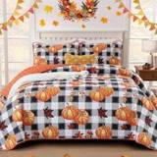 | Anibedding  Bamboo Sheets  4.6★ 361 · Poor  No Buy Box history in price history for BFCM 2025 | Queen · Pumpkin (Black and White) | $32.28 | — | -23% | List Price $37.98 | — | — | — | 1.08x | 35
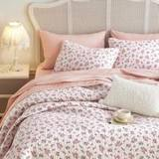 | Wake In Cloud  Bamboo Sheets  4.6★ 512 · Aspirational  List Price $55.99 | King · Pink | $27.99 | — | -38% | Not shown | None | $41.99 → $41.99 | 0% | 1.06x | 18
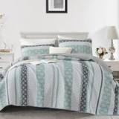 | Luxudecor  Luxudecor Quilts Queen Size Boho Sage Green Quilt Bedspreads Bedding Set, 3 Pieces Summer Queen Coverlet Sets with 2 Sha…  4.6★ 40 · Beatable | Queen · Green | $33.99 | — | -19% | Not shown | Not live in 2025 | — | — | — | 5
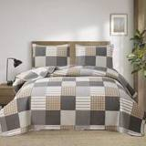 | Ycosy  Bamboo Sheets  4.5★ 1,264 · Beatable  Buy Box RAISED in BFCM week (median $39.99 vs $32.29 before) | King · Grey Brown Plaid | $32.99 | — | -27% | Not shown | Prime Exclusive Discount | $32.29 → $28.89 | 11% | 1.11x | 5
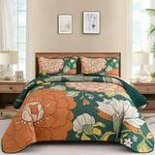 | DJY  Bamboo Sheets  4.6★ 424 · Poor  Coupon 20% (11-06 to 11-19); List Price $42.99 | Queen · Green | $29.85 | — | -29% | Not shown | Prime Exclusive Discount | $36.98 → $28.47 | 23% | 1.92x | 5

US · DC Silk Pillowcase: Decolure Silk Pillowcase
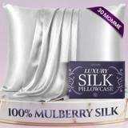 | Listing title | DECOLURE 100% Pure Mulberry Silk Pillow Case Standard Size – Highest Grade 30 Momme 6A+, Luxuriously Soft & Cooling Silk Pillowcase for Hair & Skin, Hypoallergenic, Breathable, Hidden Zipper (White)
 | Marketplace | United States
 | Family · role | Silk · Gifting
 | Scope · stage | Other · Re-Launch
 | Amazon parent | B0DQQQWYPT
 | Best seller | B0DBR5SY67 (Standard White)
 | Variations | 18 (17 with a live price)
 | Sizes | Standard, Queen, King
 | Colours | 6

OUR PRICE TODAY  $44.95  Standard White | BFCM 2026 DEAL PRICE  $44.95 → $42.70  Lightning Deal Nov 23 · 5% off the Oct 27 price | STOCK TO NOV 30  1 short · 0 out  2,945 at Amazon · 0 inbound · need 377 | BFCM 2025 SALES LIFT  1.35x  125 units in the last 28 days | DIRECT COMPETITORS  28  median $22.49 · 24 cheaper than us

BFCM 2025: how this product did
Period | Sales | Units | Organic units | Ad units | Ad cost | TACoS | Sessions | Unit session % | Avg price
Oct 21 – Nov 19, 2025 (30 days before) | $9,503 | 189 | 175 | 14 | $3,013 | 31.7% | 3,572 | 5.3% | $50.28
Nov 20 – Dec 1, 2025 (BFCM week) | $5,142 | 104 | 86 | 18 | $1,726 | 33.6% | 2,158 | 4.8% | $49.45
Dec 2 – 31, 2025 | $28,402 | 583 | 519 | 64 | $4,118 | 14.5% | 6,855 | 8.5% | $48.72
Best seller in BFCM 2025: B0DBR5SY67: $44.95 before (median Nov 1 – 19) → $44.95 in BFCM week, no cut; Best Seller Rank 206,269 → 220,150.
Our BFCM 2025 deals: Lightning Deal 11-09 to 11-10 (cancelled, 14 variations); Best Deal 11-20 to 12-02 (cancelled, 18 variations)
Stock in BFCM 2025: 4 of 15 variations hit zero FBA stock on at least one observed day in BFCM week; weighted by sales mix, about 7.2% of variation-days were lost.

BFCM 2026 deal
Deal | Hero variation | Price Oct 27 | Deal price | Off | Variations (deal page) | Our 2025 cut | Rivals' 2025 cut
Lightning Deal Nov 23 | Standard White | $44.95 | $42.70 | 5% | 17 eligible, 1 out of stock; 5%–5% off | 0% ($44.95 → $44.95) | 15% (6 rivals)
Deal notes
- BFCM deal status. Nov 23 Lightning Deal cancelled in Seller Central while a Best Deal is pursued; if not granted it is rescheduled as a Lightning Deal.

Stock to Nov 30
Sales per day today 7.5 · lift used 1.35x (this product's own BFCM 2025 lift) · need to Nov 30 377 units · at Amazon 2,945 · inbound 0. Covered 16, needs inbound in time 0, short 1, out of stock now 0.
Size | Colour | At Amazon | Inbound | Sales / day | Need to Nov 30 | Short by | Runs out | Status
Standard | Grey | 14 | 0 | 0.5 | 25 | 11 | Nov 12 | Short even with inbound

Sales mix, last 28 days
By size: Standard 70 · Queen 28 · King 27
By colour (top 8): White 38 · Champagne 24 · Ivory 21 · Silver Grey 19 · Grey 13 · Coral 10

Competitors (29)
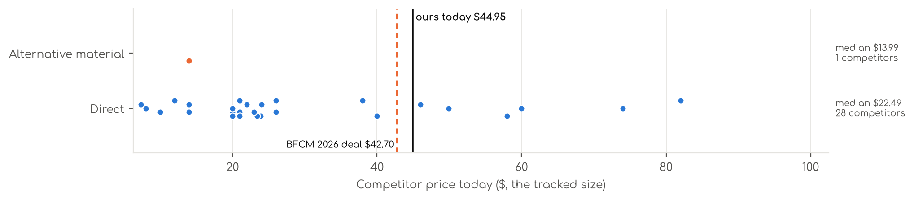
Photo | Competitor | Size · colour | Price | List | vs ours | Strike- through | BFCM 2025 deal | 2025 before → during | Disc. | Rank lift | Units / wk
Direct · 28
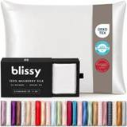 | INFIIXSO  Blissy Silk Pillowcase - 100% Pure Mulberry Silk - 22 Momme 6A High-Grade Fibers - Silk Pillow Cover for Hair & Skin - R…  Silk · 4.5★ 10,441 · Aspirational  List Price $109.85 | Queen · Blissy White | $57.98 | — | +16% | Not shown | Prime Exclusive Discount | $54.89 → $39.47 | 28% | 4.59x | 1,732
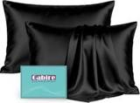 | Gabire  Silk Pillow Cases  Silk · 4.6★ 3,189  Buy Box RAISED in BFCM week (median $19.99 vs $18.99 before); List Price $29.99 | Standard (20"×26") · 4. Black (2 Pack) | $19.99 | — | -60% | Not shown | Prime Exclusive Discount | $18.99 → $15.99 | 16% | 1.44x | 1,732
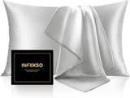 | INFIIXSO  INFIIXSO Mulberry Silk Pillowcase for Hair and Skin, Silk Pillow Cases Standard Size with Hidden Zipper 20x26 Inches, Ul…  Silk · 4.5★ 6,271  Prime Exclusive 11-01 to 12-05; Lightning Deal 11-03 to 11-10; Prime Exclusive already running before BFCM week; List Price $9.79 | Standard · Light Grey | $7.99 | — | -82% | List Price $9.79 | Price cut only | $7.99 → $5.59 | 30% | 2.98x | 1,732
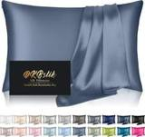 | DKBslik  Silk Pillowcase  Silk · 4.5★ 21,803  Buy Box RAISED in BFCM week (median $11.95 vs $8.36 before); List Price $18.99 | Standard - 20×26 Inch · Ash Blue-1pc | $7.34 | — | -85% | Not shown | Prime Exclusive Discount | $8.36 → $7.89 | 6% | 1.31x | 1,040
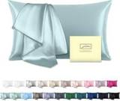 | Suatien  Mulberry Silk Pillowcase for Hair and Skin Standard Size 20"X 26" Pillow Case with Hidden Zipper Soft Breathable Smooth …  Silk · 4.5★ 41,661  Lightning Deal 11-14 to 11-14; List Price $11.99 | Standard · Haze Blue | $11.99 | — | -73% | Not shown | Prime Exclusive Discount | $11.99 → $7.91 | 34% | 0.41x | 924
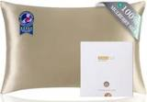 | ZIMASILK  ZIMASILK 100% Pure Mulberry Silk Pillow Cases for Hair and Skin, Soft, Hypoallergenic & Smooth, Both Sides Grade 6A Silk…  Silk · 4.6★ 52,198 · Aspirational  Prime Exclusive 11-26 to 12-01; Coupon 10%, 15% (11-01 to 12-05); List Price $24.99 | Queen · Taupe | $23.91 | $25.99 | -52% | List Price $25.99 | Lightning Deal | $24.99 → $19.49 | 22% | 0.79x | 809
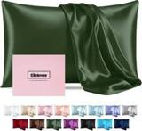 | Casbrove  Silk Pillowcase  Silk · 4.5★ 3,879  Lightning Deal 11-05 to 11-15; Coupon 15%; List Price $9.99 | Standard · Green | $9.99 | — | -78% | Not shown | Coupon only | $9.99 → $7.21 | 28% | 1.49x | 197
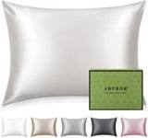 | Adubor  Adubor 100% Silk Pillowcase - Mulberry Silk Pillow Cases, 22 Momme 6A Grade Fibers, Silk Pillow Case for Hair and Skin H…  Silk · 4.4★ 18,955  List Price $21.99 | Standard · Ivory White | $19.99 | — | -56% | Not shown | Price cut only | $16.99 → $15.19 | 11% | 2.18x | 185
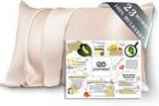 | PROMEED  Silk Pillowcase  Silk · 4.5★ 1,973 · Aspirational  Coupon 10% (11-01 to 12-05); List Price $29.99 | Standard 20"x26" · Champagne | $24.00 | — | -52% | Not shown | Prime Exclusive Discount | $23.00 → $18.40 | 20% | 1.19x | 173
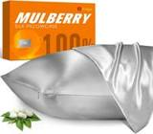 | J JIMOO  100% Mulberry Silk Pillowcase for Hair and Skin, 22 Momme Pure Natural Silk Pillow Case Both Sided with Zipper, Pillow C…  Silk · 4.5★ 31,715  Coupon 10%, 5% (11-01 to 12-05); List Price $39.99 | Standard · Silver Grey | $25.99 | — | -42% | Not shown | Price cut only | $25.99 → $23.44 | 10% | 2.71x | 173
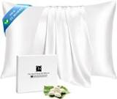 | Ravmix  Ravmix 100% Silk Pillow Cases with Zipper, 21 Momme Mulberry Silk Pillowcase for Hair Skin Health, Soft Smooth Breathabl…  Silk · 4.5★ 33,594  List Price $22.99 | Standard · White | $19.99 | — | -56% | Not shown | Price cut only | $17.99 → $14.44 | 20% | 1.35x | 104
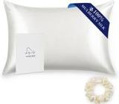 | ALASKA BEAR  Silk Pillowcase  Silk · 4.5★ 25,340 · Aspirational  List Price $35.99 | Queen 20''x30'' · White Ivory | $25.99 | — | -48% | Not shown | None | $25.99 → $25.99 | 0% | 0.71x | 92
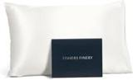 | Fishers Finery  Silk Pillowcase  Silk · 4.6★ 9,036 · Aspirational  Coupon 15% (11-13 to 11-17); List Price $75.00 | Queen (U.S. Standard) · Natural White (Undyed) | $59.99 | — | +20% | Not shown | None | $57.99 → $57.99 | 0% | 0.96x | 92
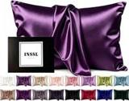 | INSSL  Silk Pillowcase  Silk · 4.5★ 11,647  Lightning Deal 11-14 to 11-14; List Price $22.99 | Standard · Dark Purple | $13.99 | — | -69% | Not shown | Price cut only | $14.99 → $12.74 | 15% | 1.51x | 92
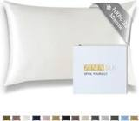 | ZIMASILK  Silk Pillowcase  Silk · 4.5★ 672 · Beatable  Coupon 10% (12-05 to 12-05); List Price $69.99 | Standard 20"x26" · Ivory | $37.99 | — | -24% | Not shown | Prime Exclusive Discount | $36.99 → $29.22 | 21% | 1.42x | 81
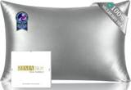 | ZIMASILK  Silk Pillowcase  Silk · 4.5★ 1,208 · Beatable  Coupon 10% (12-03 to 12-05); List Price $25.29 | Standard 20"x26" · Grey | $23.39 | $24.69 | -53% | Typical price $24.69 | Prime Exclusive Discount | $25.29 → $19.22 | 24% | 1.17x | 81
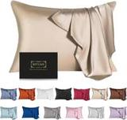 | SIYUAN  Silk Pillowcase  Silk · 4.5★ 9,825  Buy Box RAISED in BFCM week (median $12.31 vs $11.69 before); List Price $13.99 | Toddler · Champagne | $13.99 | — | -72% | Not shown | None | $11.69 → $11.89 | -2% | 0.89x | 81
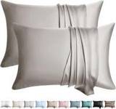 | WLOSJ  Silk Pillow  Silk · 4.2★ 1,464  Coupon 20%; List Price $45.99 | Queen · Gray | $19.99 | — | -60% | Not shown | Coupon only | $20.88 → $14.95 | 28% | 1.79x | 81
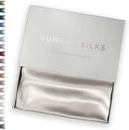 | Colorado Home Co  Silk Pillowcase  Silk · 4.6★ 1,971 · Beatable  Buy Box RAISED in BFCM week (median $56.99 vs $45.59 before); List Price $101.99 | 1 Pack Queen Pillowcase (20" x 30") · Off White | $45.99 | — | -8% | Not shown | Prime Exclusive Discount | $45.59 → $39.32 | 14% | 1.17x | 18
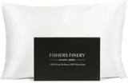 | Fishers Finery  Silk Pillowcase  Silk · 4.6★ 2,700 · Beatable  Coupon 15% (11-13 to 11-17); List Price $101.00 | King - Set of 1 · Natural White (Undyed) | $81.99 | — | +49% | Not shown | None | $77.99 → $77.99 | 0% | 1.03x | 18
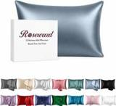 | ROSEWARD  Silk Pillowcase  Silk · 4.4★ 1,035 · Beatable  List Price $45.99 | Queen · Blue Grey | $39.99 | — | -20% | Not shown | Prime Exclusive Discount | $39.99 → $31.99 | 20% | 1.21x | 18
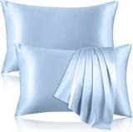 | Kinself  Silk Pillowcase  Silk · 4.5★ 1,457  List Price $34.99 | Standard · Little Blue | $20.99 | — | -53% | Not shown | None | $18.99 → $18.99 | 0% | 0.86x | 18
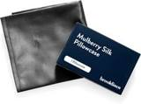 | Brooklinen  Silk Pillowcase  Silk · 4.4★ 147 · Poor  List Price $69.00 | — | $74.00 | — | +48% | Not shown | None | $69.00 → $69.00 | 0% | 1.44x | 5
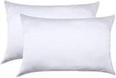 | Jocoku  Silk Pillowcase  Silk · 4.4★ 14,841  Coupon 15% (11-01 to 11-06); List Price $32.99 | Standard · White | $21.99 | — | -51% | Not shown | None | $21.99 → $21.99 | 0% | 0.79x | 5
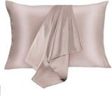 | JOGJUE  Silk Pillowcase  Silk · 4.4★ 8,036  Coupon 15% (11-01 to 11-05); List Price $41.98 | Standard · Apricotgray | $20.99 | — | -53% | Not shown | None | $20.99 → $20.99 | 0% | 0.79x | 5
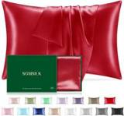 | SGMSILK  Silk Pillowcase  Silk · 4.5★ 673  Lightning Deal 11-07 to 11-07; Coupon 20%; List Price $25.99 | King 20"x36" · Red | $20.99 | — | -62% | Not shown | Coupon only | $22.98 → $18.38 | 20% | 1.88x | 5
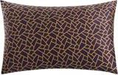 | Slpbaby  Silk Pillowcase  Silk · 4.7★ 21,427  List Price $37.99 | Standard · Pattern26 | $22.99 | — | -49% | Not shown | None | $22.99 → $22.99 | 0% | 0.86x | 5
 | RENESSY  Silk Pillowcase  Silk · 4.6★ 2,510 · Beatable  Lightning Deal 11-03 to 11-03; List Price $49.99 | — | $49.90 | — | -0% | — | Price cut only | $49.99 → $42.49 | 15% | 2.39x | —
Alternative material · 1
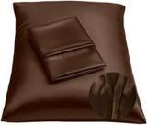 | BLISSFORD  Silk Pillowcase  Microfiber / polyester · 4.6★ 55,029  List Price $11.99 | Standard (2-pack) · Brown | $13.99 | — | -72% | Not shown | None | $11.99 → $11.99 | 0% | 0.82x | 220

US · SL Mask Contoured: Sleep Sanctuary Silk Sleep Mask - Contoured
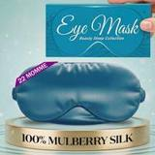 | Listing title | SLEEP SANCTUARY 100% Pure Mulberry Silk Sleep Mask - 22 Momme Light Blocking 3D Contour Silk Eye Mask for Sleeping - Secure Fit for Side Sleepers, Women & Men - Cloud Soft (Peacock Blue)
 | Marketplace | United States
 | Family · role | Silk · Gifting
 | Scope · stage | Other · Liquidation
 | Amazon parent | B0GDML4FK7
 | Best seller | B0F4XRFWGR (One Size Peacock Blue)
 | Variations | 4 (0 with a live price)
 | Sizes | One Size
 | Colours | 4

OUR PRICE TODAY  —  One Size Peacock Blue | BFCM 2026 DEAL  Not in a deal  regular price through BFCM | STOCK TO NOV 30  2 short · 0 out  32 at Amazon · 0 inbound · need 20 | BFCM 2025 SALES LIFT  3.67x  4 units in the last 28 days | COMPETITORS  27  median $22.49 · 18 cheaper than us

BFCM 2025: how this product did
Period | Sales | Units | Organic units | Ad units | Ad cost | TACoS | Sessions | Unit session % | Avg price
Oct 21 – Nov 19, 2025 (30 days before) | $60 | 3 | 3 | 0 | $0 | 0.0% | 153 | 2.0% | $19.95
Nov 20 – Dec 1, 2025 (BFCM week) | $88 | 5 | 5 | 0 | $0 | 0.0% | 99 | 5.1% | $17.56
Dec 2 – 31, 2025 | $394 | 19 | 19 | 0 | $0 | 0.0% | 169 | 11.2% | $20.74
Best seller in BFCM 2025: B0F4XRFWGR: $19.95 before (median Nov 1 – 19) → $19.95 in BFCM week, no cut; Best Seller Rank 776,788 → 788,668.

BFCM 2026 deal
Not in a BFCM 2026 deal: sells at its regular price through BFCM.

Stock to Nov 30
Sales per day today 0.3 · lift used 3.67x (this product's own BFCM 2025 lift) · need to Nov 30 20 units · at Amazon 32 · inbound 0. Covered 2, needs inbound in time 0, short 2, out of stock now 0.
Size | Colour | At Amazon | Inbound | Sales / day | Need to Nov 30 | Short by | Runs out | Status
One Size | Misty Blue | 1 | 0 | 0.2 | 18 | 17 | Oct 19 | Short even with inbound
One Size | Peacock Blue | 1 | 0 | 0.0 | 2 | 1 | Nov 17 | Short even with inbound

Sales mix, last 28 days
By size: One Size 4
By colour (top 8): Peacock Blue 4

Competitors (27)
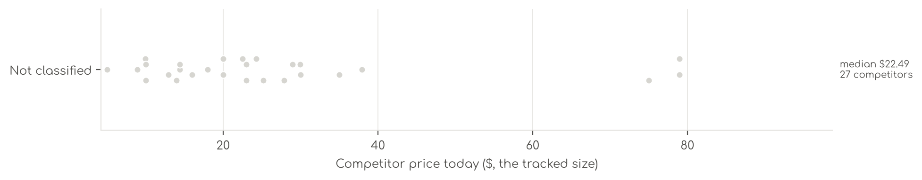
Photo | Competitor | Size · colour | Price | List | vs ours | Strike- through | BFCM 2025 deal | 2025 before → during | Disc. | Rank lift | Units / wk
Not classified · 27
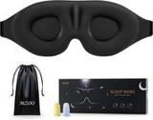 | MZOO  SS Silk Sleep Mask - Contoured  4.6★ 101,412 · Aspirational  Coupon 2.00 USD, 5.00 USD (11-01 to 12-02); List Price $22.99 | — | $13.99 | $17.99 | -46% | List Price $17.99 | Prime Exclusive Discount | $14.99 → $9.99 | 33% | 1.23x | 13,857
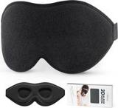 | LitBear  SS Silk Sleep Mask  4.7★ 17,354 · Aspirational  Prime Exclusive 12-05 to 12-05; List Price $15.99 | — | $12.95 | $14.39 | -50% | Typical price $14.39 | Price cut only | $15.99 → $13.59 | 15% | 1.25x | 3,464
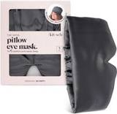 | Kitsch  SS Silk Sleep Mask  4.3★ 1,648 · Aspirational  List Price $25.99 | — | $14.39 | $17.99 | -45% | Not shown | Price cut only | $14.38 → $12.72 | 12% | 2.04x | 1,848
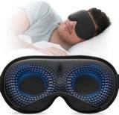 | YFONG  SS Silk Sleep Mask - Contoured  4.6★ 8,046 · Aspirational  Prime Exclusive already running before BFCM week; Buy Box RAISED in BFCM week (median $16.99 vs $13.59 before); List Price $16.99 | — | $14.39 | — | -45% | Not shown | Prime Exclusive Discount | $13.59 → $12.91 | 5% | 1.16x | 1,848
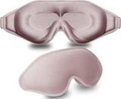 | FengXinZi Store  SS Silk Sleep Mask - Contoured  4.6★ 3,765 · Aspirational  List Price $13.98 | — | $9.98 | — | -62% | Not shown | Prime Exclusive Discount | $9.93 → $9.37 | 6% | 1.12x | 1,732
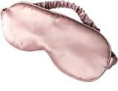 | LULUSILK  SS Silk Sleep Mask  4.4★ 12,325 · Aspirational | — | $9.99 | — | -62% | Not shown | Price cut only | $9.99 → $8.49 | 15% | 1.12x | 809
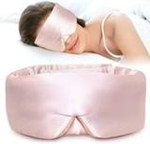 | LitBear  SS Silk Sleep Mask  4.4★ 2,143 · Beatable  Prime Exclusive already running before BFCM week; List Price $29.99 | — | $29.99 | — | +16% | Not shown | Prime Exclusive Discount | $28.49 → $23.99 | 16% | 1.22x | 809
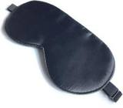 | spacepower  SS Silk Sleep Mask  4.6★ 5,889  List Price $10.99 | — | $4.99 | — | -81% | Not shown | Prime Exclusive Discount | $4.99 → $3.94 | 21% | 1.10x | 809
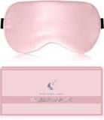 | BLSSNZ  SS Silk Sleep Mask - Contoured  4.5★ 1,593 · Aspirational  List Price $19.99 | — | $9.99 | — | -62% | Not shown | Prime Exclusive Discount | $9.99 → $7.99 | 20% | 1.03x | 347
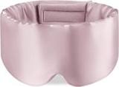 | Zenssia  Zenssia 100% Mulberry Silk Sleep Mask Eye Mask for Man and Woman with Adjustable Headband, Full Size Large Sleep Mask & …  4.5★ 1,571 · Aspirational  List Price $24.99 | Full | $19.99 | — | -23% | Not shown | Price cut only | $19.99 → $15.99 | 20% | 2.09x | 347
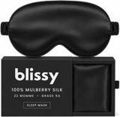 | BLISSY  SS Silk Sleep Mask  4.4★ 1,225 · Beatable  List Price $49.95 | — | $27.87 | $49.95 | +7% | List Price $49.95 | Price cut only | $27.87 → $22.84 | 18% | 1.43x | 347
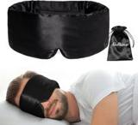 | iCooBreeze  SS Silk Sleep Mask  4.5★ 2,063 · Beatable  Coupon 2.00 USD (11-01 to 11-19); List Price $22.99 | — | $19.99 | — | -23% | Not shown | Prime Exclusive Discount | $19.99 → $15.99 | 20% | 1.09x | 347
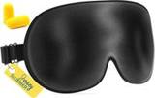 | Jersey Slumber  SS Silk Sleep Mask  4.5★ 28,100 · Aspirational  List Price $20.99 | — | $8.89 | — | -66% | Not shown | Price cut only | $8.89 → $7.56 | 15% | 1.06x | 220
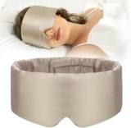 | SECZIPE  SECZIPE 100% Mulberry Silk Sleep Mask Eye Mask for Women Man with Adjustable Band, for Side Sleeper Blackout Sleep Mask …  4.5★ 867 · Beatable  Coupon 3.00 USD (11-07 to 12-05); List Price $29.99 | Taupe | $22.99 | — | -11% | Not shown | Prime Exclusive Discount | $22.99 → $17.99 | 22% | 1.11x | 220
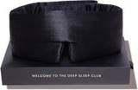 | DROWSY  SS Silk Sleep Mask  4.3★ 1,740 · Beatable  List Price $79.00 | — | $79.00 | — | +204% | Not shown | None | $79.00 → $79.00 | 0% | 1.98x | 208
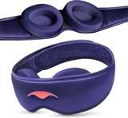 | Manta Sleep  SS Silk Sleep Mask - Contoured  4.0★ 587 · Beatable  List Price $75.00 | — | $75.00 | — | +189% | Not shown | Price cut only | $75.00 → $60.00 | 20% | 1.75x | 197
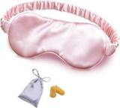 | OLESILK  SS Silk Sleep Mask  4.4★ 2,501 · Beatable  List Price $19.99 | — | $15.99 | — | -38% | Not shown | Prime Exclusive Discount | $13.99 → $11.19 | 20% | 0.95x | 185
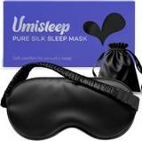 | Umisleep Store  SS Silk Sleep Mask  4.5★ 402 · Aspirational  Coupon 10% (12-03 to 12-05); Buy Box RAISED in BFCM week (median $19.99 vs $14.99 before); List Price $19.99 | — | $17.99 | $18.99 | -31% | List Price $18.99 | Prime Exclusive Discount | $14.99 → $9.99 | 33% | 0.99x | 173
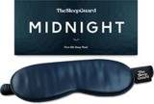 | TheSleepGuard  SS Silk Sleep Mask - Contoured  4.3★ 717 · Beatable  Coupon 5%; List Price $39.95 | — | $29.95 | — | +15% | Not shown | Coupon only | $29.95 → $29.95 | 0% | 0.96x | 104
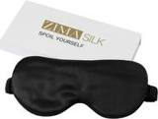 | ZIMASILK  SS Silk Sleep Mask - Contoured  4.5★ 2,507 · Beatable  List Price $29.99 | — | $22.49 | $24.99 | -13% | List Price $24.99 | Prime Exclusive Discount | $24.99 → $19.74 | 21% | 1.20x | 104
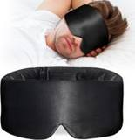 | ATreebay  SS Silk Sleep Mask  4.5★ 345 · Beatable  Coupon 2.00 USD (11-02 to 11-16); List Price $22.99 | — | $22.99 | — | -11% | Not shown | Prime Exclusive Discount | $19.99 → $15.99 | 20% | 1.52x | 92
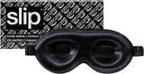 | SLIP  SS Silk Sleep Mask - Contoured  4.3★ 401 · Beatable  List Price $75.00 | — | $79.00 | — | +204% | Not shown | Price cut only | $75.00 → $60.00 | 20% | 0.94x | 92
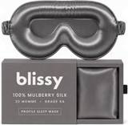 | BLISSY  SS Silk Sleep Mask - Contoured  4.0★ 188 · Beatable | — | $37.96 | — | +46% | Not shown | Not live in 2025 | — | — | — | 35
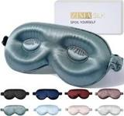 | ZIMASILK  SS Silk Sleep Mask - Contoured  4.3★ 1,106 · Beatable  List Price $50.00 | — | $28.99 | — | +12% | Not shown | None | $28.99 → $28.99 | 0% | 1.17x | 35
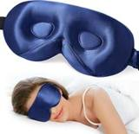 | LitBear  SS Silk Sleep Mask - Contoured  4.3★ 441 · Beatable  List Price $33.99 | — | $24.29 | $26.99 | -6% | Typical price $26.99 | Prime Exclusive Discount | $26.99 → $21.59 | 20% | 0.98x | 18
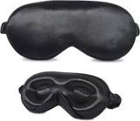 | ZIMASILK  SS Silk Sleep Mask - Contoured  4.3★ 219 · Beatable  List Price $27.99 | — | $25.19 | $27.99 | -3% | List Price $27.99 | Prime Exclusive Discount | $27.99 → $21.83 | 22% | 1.17x | 18
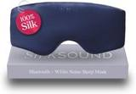 | Back Bay Audio  SS Silk Sleep Mask - Contoured  3.8★ 347 · Poor  Coupon 10%, 5% (11-01 to 11-19); Buy Box RAISED in BFCM week (median $49.99 vs $34.99 before); List Price $49.99 | — | $34.99 | — | +35% | Not shown | Prime Exclusive Discount | $34.99 → $27.99 | 20% | 1.02x | 5

US · SL Mask Velcro: Sleep Sanctuary Silk Sleep Mask - Velcro
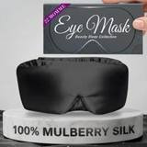 | Listing title | SLEEP SANCTUARY 100% Pure Mulberry Silk Sleep Mask - 22 Momme Light Blocking Hook & Loop Silk Eye Mask for Sleeping - Secure Fit for Side Sleepers, Women & Men - Cloud Soft (Black)
 | Marketplace | United States
 | Family · role | Silk · Gifting
 | Scope · stage | Other · Launch
 | Amazon parent | B0GDMSK15Z
 | Best seller | B0F4XQ7L8Q (One Size Black)
 | Variations | 4 (4 with a live price)
 | Sizes | One Size
 | Colours | 4

OUR PRICE TODAY  $17.99  One Size Black | BFCM 2026 DEAL  Not in a deal  regular price through BFCM | STOCK TO NOV 30  Covered  638 at Amazon · 0 inbound · need 13 | BFCM 2025 SALES LIFT  1.00x  13 units in the last 28 days | COMPETITORS  15  median $17.99 · 10 cheaper than us

BFCM 2025: how this product did
Period | Sales | Units | Organic units | Ad units | Ad cost | TACoS | Sessions | Unit session % | Avg price
Oct 21 – Nov 19, 2025 (30 days before) | $40 | 2 | 2 | 0 | $1 | 2.3% | 46 | 4.3% | $19.95
Nov 20 – Dec 1, 2025 (BFCM week) | $16 | 1 | 1 | 0 | $1 | 8.5% | 33 | 3.0% | $15.96
Dec 2 – 31, 2025 | $70 | 3 | 3 | 0 | $2 | 2.6% | 52 | 5.8% | $23.28
Best seller in BFCM 2025: B0F4XQ7L8Q: $19.95 before (median Nov 1 – 19) → $15.96 in BFCM week, 20% lower; Best Seller Rank 679,269 → 721,536; Prime Exclusive price seen 11-20 to 12-01 (7 days).

BFCM 2026 deal
Not in a BFCM 2026 deal: sells at its regular price through BFCM.

Stock to Nov 30
Sales per day today 0.3 · lift used 1.00x (this product's own BFCM 2025 lift) · need to Nov 30 13 units · at Amazon 638 · inbound 0. Covered 4, needs inbound in time 0, short 0, out of stock now 0.

Sales mix, last 28 days
By size: One Size 13
By colour (top 8): Black 5 · Misty Blue 4 · Pink 3 · Peacock Blue 1

Competitors (15)
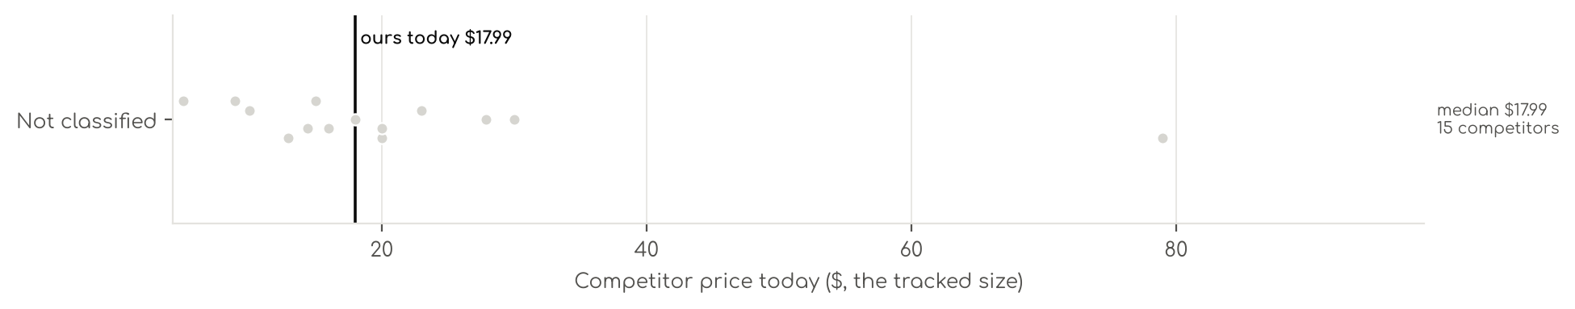
Photo | Competitor | Size · colour | Price | List | vs ours | Strike- through | BFCM 2025 deal | 2025 before → during | Disc. | Rank lift | Units / wk
Not classified · 15
 | LitBear  SS Silk Sleep Mask  4.7★ 17,354  Prime Exclusive 12-05 to 12-05; List Price $15.99 | — | $12.95 | $14.39 | -37% | Typical price $14.39 | Price cut only | $15.99 → $13.59 | 15% | 1.25x | 3,464
 | Kitsch  SS Silk Sleep Mask  4.3★ 1,648  List Price $25.99 | — | $14.39 | $17.99 | -30% | Not shown | Price cut only | $14.38 → $12.72 | 12% | 2.04x | 1,848
 | LitBear  SS Silk Sleep Mask  4.4★ 2,143 · Aspirational  Prime Exclusive already running before BFCM week; List Price $29.99 | — | $29.99 | — | +47% | Not shown | Prime Exclusive Discount | $28.49 → $23.99 | 16% | 1.22x | 809
 | LULUSILK  SS Silk Sleep Mask  4.4★ 12,325 · Aspirational | — | $9.99 | — | -51% | Not shown | Price cut only | $9.99 → $8.49 | 15% | 1.12x | 809
 | spacepower  SS Silk Sleep Mask  4.6★ 5,889  List Price $10.99 | — | $4.99 | — | -76% | Not shown | Prime Exclusive Discount | $4.99 → $3.94 | 21% | 1.10x | 809
 | iCooBreeze  SS Silk Sleep Mask  4.5★ 2,063 · Aspirational  Coupon 2.00 USD (11-01 to 11-19); List Price $22.99 | — | $19.99 | — | -2% | Not shown | Prime Exclusive Discount | $19.99 → $15.99 | 20% | 1.09x | 347
 | Zenssia  Zenssia 100% Mulberry Silk Sleep Mask Eye Mask for Man and Woman with Adjustable Headband, Full Size Large Sleep Mask & …  4.5★ 1,571 · Aspirational  List Price $24.99 | Full | $19.99 | — | -2% | Not shown | Price cut only | $19.99 → $15.99 | 20% | 2.09x | 347
 | BLISSY  SS Silk Sleep Mask  4.4★ 1,225 · Beatable  List Price $49.95 | — | $27.87 | $49.95 | +37% | List Price $49.95 | Price cut only | $27.87 → $22.84 | 18% | 1.43x | 347
 | SECZIPE  SECZIPE 100% Mulberry Silk Sleep Mask Eye Mask for Women Man with Adjustable Band, for Side Sleeper Blackout Sleep Mask …  4.5★ 867 · Beatable  Coupon 3.00 USD (11-07 to 12-05); List Price $29.99 | Taupe | $22.99 | — | +13% | Not shown | Prime Exclusive Discount | $22.99 → $17.99 | 22% | 1.11x | 220
 | Jersey Slumber  SS Silk Sleep Mask  4.5★ 28,100  List Price $20.99 | — | $8.89 | — | -56% | Not shown | Price cut only | $8.89 → $7.56 | 15% | 1.06x | 220
 | DROWSY  SS Silk Sleep Mask  4.3★ 1,740 · Aspirational  List Price $79.00 | — | $79.00 | — | +287% | Not shown | None | $79.00 → $79.00 | 0% | 1.98x | 208
 | OLESILK  SS Silk Sleep Mask  4.4★ 2,501 · Aspirational  List Price $19.99 | — | $15.99 | — | -22% | Not shown | Prime Exclusive Discount | $13.99 → $11.19 | 20% | 0.95x | 185
 | Umisleep Store  SS Silk Sleep Mask  4.5★ 402 · Beatable  Coupon 10% (12-03 to 12-05); Buy Box RAISED in BFCM week (median $19.99 vs $14.99 before); List Price $19.99 | — | $17.99 | $18.99 | -12% | List Price $18.99 | Prime Exclusive Discount | $14.99 → $9.99 | 33% | 0.99x | 173
 | ATreebay  SS Silk Sleep Mask  4.5★ 345 · Beatable  Coupon 2.00 USD (11-02 to 11-16); List Price $22.99 | — | $22.99 | — | +13% | Not shown | Prime Exclusive Discount | $19.99 → $15.99 | 20% | 1.52x | 92
 | YFONG  SS Silk Sleep Mask  4.3★ 272 · Beatable  Buy Box RAISED in BFCM week (median $19.99 vs $16.99 before); List Price $19.99 | — | $14.99 | — | -27% | — | Prime Exclusive Discount | $16.99 → $14.99 | 12% | 1.14x | —

US · SL B4: Sleep Sanctuary Bamboo Sheets 4 Piece
NOT LAUNCHED YET. No live price, rating or sales are expected. Competitors are mapped so the launch can be priced against them.
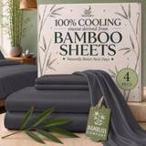 | Listing title | SLEEP SANCTUARY 100% Viscose Derived from Bamboo Sheets Twin Size, 4 Pc Set
 | Marketplace | United States
 | Family · role | Bamboo · Not launched yet
 | Scope · stage | Not launched · Production
 | Amazon parent | B0F54RNQPT
 | Best seller | B0DDTY5RQX (Twin Charcoal)
 | Variations | 84 (4 with a live price)
 | Sizes | Twin, California King, Full, King, Queen
 | Colours | 16

OUR PRICE TODAY  $61.99  Twin Charcoal | BFCM 2026 DEAL  Not in a deal  regular price through BFCM | STOCK TO NOV 30  1 short · 0 out  43 at Amazon · 0 inbound · need 8 | DIRECT COMPETITORS  27  median $79.99 · 4 cheaper than us

BFCM 2025: how this product did
Period | Sales | Units | Organic units | Ad units | Ad cost | TACoS | Sessions | Unit session % | Avg price
Nov 20 – Dec 1, 2025 (BFCM week) | $0 | 0 | 0 | 0 | $0 | — | 0 | — | —
Best seller in BFCM 2025: B0DDTY5RQX: $54.99 before (median Nov 1 – 19) → $54.99 in BFCM week, no cut; Best Seller Rank 103,857 → 166,212.

BFCM 2026 deal
Not in a BFCM 2026 deal: sells at its regular price through BFCM.

Stock to Nov 30
Sales per day today 0.1 · lift used 2.74x (account lift, assumed) · need to Nov 30 8 units · at Amazon 43 · inbound 0. Covered 3, needs inbound in time 0, short 1, out of stock now 0.
Size | Colour | At Amazon | Inbound | Sales / day | Need to Nov 30 | Short by | Runs out | Status
Twin | Charcoal | 4 | 0 | 0.1 | 7 | 3 | Nov 20 | Short even with inbound

Sales mix, last 28 days
By size: Twin 2
By colour (top 8): Charcoal 2

Competitors (28)
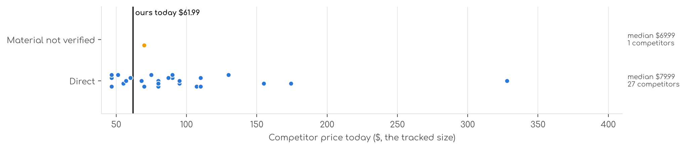
Photo | Competitor | Size · colour | Price | List | vs ours | Strike- through | BFCM 2025 deal | 2025 before → during | Disc. | Rank lift | Units / wk
Direct · 27
 | Pure Bamboo  Pure Bamboo King Sheets, Genuine 100% Organic Viscose Derived from Bamboo Bed Sheet Set, Luxuriously Soft & Cooling, Dou…  Bamboo viscose · 4.5★ 21,927 · Aspirational  List Price $139.99/$149.99 | King · Ivory | $109.99 | — | +100% | Not shown | None | $109.99 → $109.99 | 0% | 0.48x | 809
 | Hotel Sheets Direct  Hotel Sheets Direct 4 Piece Bed Sheet Set Queen Size, 100% Viscose Derived from Bamboo Sheets Set with 2 Pillowcases, Co…  Bamboo viscose · 4.4★ 37,179 · Aspirational  Lightning Deal 11-07 to 11-11; Coupon 20% (11-12 to 12-02); List Price $72.99 | Queen · White | $79.99 | — | +45% | Not shown | Price cut only | $72.99 → $57.99 | 21% | 2.27x | 347
 | KRIMANO  KRIMANO Bamboo Viscose Sheet Set King Size, Cooling Sheets Bed Set  Bamboo viscose · 4.5★ 263 · Beatable  List Price $94.89 | King · 1.navy Blue | $79.99 | — | +45% | Not shown | None | $72.99 → $72.99 | 0% | 1.89x | 185
 | Bambaw  Bambaw 100% Viscose Derived from Bamboo Sheets Queen Size Set – 4pcs Cooling Sheet Set, Super Soft Sheets Queen Size, Lu…  Bamboo viscose · 4.3★ 2,766 · Beatable  List Price $103.45 | Queen · Charcoal | $89.99 | — | +64% | Not shown | None | $89.99 → $89.99 | 0% | 1.17x | 104
 | Bedsure  Bedsure PureWoven Organically Grown Bamboo Viscose Queen Sheet Set, 4PCS  Bamboo viscose · 4.5★ 588 · Beatable  Prime Exclusive already running before BFCM week; List Price $114.99 | Queen · 01 - White | $89.99 | $119.99 | +64% | List Price $119.99 | Prime Exclusive Discount | $99.99 → $72.64 | 27% | 0.99x | 104
 | SONORO KATE  Bamboo Sheets  Bamboo viscose · 4.5★ 3,776 · Beatable  Coupon 15% (11-06 to 11-19); List Price $79.99 | King · Dark Grey | $79.99 | — | +45% | Not shown | Prime Exclusive Discount | $79.99 → $63.99 | 20% | 1.55x | 104
 | BC BELLA COTERIE  Bella Coterie Luxury Bamboo Viscose King Size Sheet Set  Bamboo viscose · 4.4★ 5,871 · Beatable  Coupon 20.00 USD (12-03 to 12-05); List Price $169.99 | King - 2 Pillowcases · 01 - White | $154.99 | — | +182% | Not shown | Price cut only | $134.99 → $110.50 | 18% | 2.66x | 92
 | BAMPURE  BAMPURE 100% Rayon from Bamboo Sheets King Size - 4pc Cooling King Sheets  Bamboo viscose · 4.4★ 4,095 · Beatable  Coupon 5.00 USD (11-01 to 11-04); Buy Box RAISED in BFCM week (median $99.99 vs $84.99 before); List Price $99.99 | King · White | $67.98 | $99.99 | +24% | List Price $99.99 | Prime Exclusive Discount | $84.99 → $79.99 | 6% | 1.14x | 81
 | SONORO KATE  SONORO KATE 100% Viscose Derived from Bamboo_Sheets Queen Size,4PC  Bamboo viscose · 4.5★ 3,911 · Beatable  Coupon 10% (11-04 to 12-05); List Price $59.99 | Queen · Dark Grey | $59.99 | — | +9% | Not shown | Prime Exclusive Discount | $59.99 → $47.99 | 20% | 1.20x | 81
 | AiAngu  Bamboo Sheets  Bamboo viscose · 4.6★ 121 · Poor | Queen · Dark Grey | $74.99 | $79.99 | +36% | List Price $79.99 | Not live in 2025 | — | — | — | 81
 | Cariloha  Cariloha Aloha Soft Bamboo Viscose Sheet Set - Natural - Queen  Bamboo viscose · 4.4★ 426 · Poor  Coupon 20%, 30% (11-01 to 12-05); List Price $119.00 | Queen · Natural | $107.10 | — | +95% | List Price $119.00 | Prime Exclusive Discount | $119.00 → $71.40 | 40% | 1.39x | 81
 | DOZ by SIJO  Bamboo Sheets  Bamboo viscose · 4.4★ 1,909 · Beatable  List Price $55.00 | Queen · Olive | $55.00 | — | +0% | Not shown | None | $55.00 → $55.00 | 0% | 1.18x | 35
 | Cozy Earth  Cozy Earth Luxury Bed Sheet Set, 100% Viscose from Bamboo Fabric  Bamboo viscose · 3.9★ 425 · Poor  List Price $328.00 | King · White | $328.00 | — | +496% | Not shown | Prime Exclusive Discount | $262.40 → $229.60 | 13% | 1.82x | 35
 | DREAMCARE  DREAMCARE 100% Rayon Bamboo Sheets King Size - 4pc Cooling Sheets King Size  Bamboo viscose · 4.5★ 2,261 · Poor  Buy Box RAISED in BFCM week (median $62.88 vs $58.99 before); List Price $58.99 | King · 5 - Gray | $46.74 | $59.99 | -15% | List Price $59.99 | Prime Exclusive Discount | $58.99 → $49.99 | 15% | 1.24x | 35
 | HOT SLEEPER SHEETS  Cooling Sheets Set Queen Size, Viscose Derived from Bamboo for Hot Sleepers | Deep Pocket Up to 16 Inch | Silky Soft & B…  Bamboo viscose · 4.4★ 674 · Poor  List Price $107.98 | Queen · Navy | $51.29 | $62.99 | -7% | Typical price $62.99 | Price cut only | $62.99 → $45.89 | 27% | 2.40x | 35
 | Shilucheng  Shilucheng 100% Viscose Derived from Bamboo_ Sheets Queen Size 4pcs  Bamboo viscose · 4.4★ 6,629 · Poor  Buy Box RAISED in BFCM week (median $58.30 vs $54.90 before); List Price $59.90 | Queen · 01 - Dark Grey | $46.66 | $54.90 | -15% | List Price $54.90 | Prime Exclusive Discount | $54.90 → $46.64 | 15% | 0.86x | 35
 | Bamtek  Viscose Bamboo Sheets Queen Size 4PC Set - Cooling Bedding for Hot Sleepers with  Bamboo viscose · 4.4★ 641 · Poor  Coupon 40.00 USD (11-01 to 11-10); List Price $129.99 | Queen · Sage | $94.99 | — | +73% | Not shown | Prime Exclusive Discount | $104.99 → $83.99 | 20% | 1.41x | 18
 | JSD  JSD Sage Green 100% Viscose Derived from Bamboo Cooling Sheet Set Queen  Bamboo viscose · 4.3★ 281 · Poor  Coupon 5% (11-01 to 11-17); List Price $74.99 | Queen · Green | $56.99 | — | +4% | Not shown | None | $56.99 → $56.99 | 0% | 0.90x | 18
 | Kickoff Home  Bamboo Sheets  Bamboo viscose · 4.6★ 688 · Poor  Coupon 25% (11-01 to 11-05); List Price $124.99 | King · Sage Green | $86.99 | $84.99 | +58% | Not shown | Price cut only | $118.99 → $79.13 | 33% | 2.47x | 18
 | LB Luxury Bamboo Market  Bamboo Sheets  Bamboo viscose · 4.5★ 517 · Poor  List Price $159.94 | Queen · Dune | $129.94 | — | +136% | Not shown | Prime Exclusive Discount | $119.94 → $103.95 | 13% | 0.76x | 18
 | Shilucheng  Shilucheng 100% Viscose Derived from Bamboo_Sheets, Extra Deep Pocket  Bamboo viscose · 4.5★ 1,639 · Poor  Coupon 20% (11-02 to 11-12); List Price $84.99 | King · Dark Grey | $69.99 | $84.99 | +27% | List Price $84.99 | Prime Exclusive Discount | $84.99 → $64.59 | 24% | 0.73x | 18
 | Bamboo Bay  Bamboo Sheets  Bamboo viscose · 4.5★ 2,691 · Poor  Buy Box RAISED in BFCM week (median $109.98 vs $86.99 before); List Price $129.98 | Queen · 04 - Light Grey | $79.98 | — | +45% | Not shown | None | $86.99 → $93.48 | -7% | 0.82x | 5
 | LBRO2M  LBRO2M Cooling Bed Sheet 100% Viscose Derived from Bamboo Sheet Set Queen Size 6  Bamboo viscose · 4.4★ 18 · Poor  Lightning Deal 11-01 to 11-01; List Price $179.97 | King 6 Pcs · White | $94.99 | — | +73% | Not shown | Prime Exclusive Discount | $95.99 → $67.19 | 30% | 1.66x | 5
 | TWK  TWK Luxury Sheet Set, Genuine 100% Organic Viscose Derived from Bamboo, Cooling & Breathable, Silky Soft, Bedding Sheets…  Bamboo viscose · 4.5★ 39 · Poor  Coupon 30%; Buy Box RAISED in BFCM week (median $79.00 vs $69.00 before); List Price $69.00 | King · Mist Gray | $109.99 | — | +100% | Not shown | Coupon only | $69.00 → $74.00 | -7% | 0.68x | 5
 | TWK  TWK Luxury Sheet Set, Genuine 100% Viscose Derived from Bamboo, Cooling & Breathable, Silky Soft, Bedding Sheets & Pillo…  Bamboo viscose · 4.5★ 11 · Poor | King · White | $46.74 | — | -15% | Not shown | Not live in 2025 | — | — | — | 5
 | TWK  4 Piece Bamboo Sheet Set  Bamboo viscose · 4.5★ 2 · Poor | King · Sand | $109.99 | — | +100% | Not shown | Not live in 2025 | — | — | — | 5
 | Vesta  Vesta Sheet Set – Soft, Breathable & Cooling, 100% Viscose Derived from Bamboo,  Bamboo viscose · 4.3★ 35 · Poor  List Price $174.30 | King/Cali King · Terra Cotta | $174.30 | — | +217% | Not shown | None | $174.30 → $174.30 | 0% | 1.15x | 5
Material not verified · 1
 | ACCURATEX  ACCURATEX Cooling Sheets for Hot Sleepers, King Size, Grey  4.4★ 1,040 · Poor  Lightning Deal 11-13 to 11-13; Buy Box RAISED in BFCM week (median $74.99 vs $69.99 before); List Price $74.99 | King · Grey | $69.99 | — | +27% | Not shown | Prime Exclusive Discount | $59.49 → $59.49 | 0% | 0.65x | 35

US · SL Bamboo Pillowcase: Sleephoria Bamboo Pillowcases
NOT LAUNCHED YET. No live price, rating or sales are expected. Competitors are mapped so the launch can be priced against them.
 | Listing title | SLEEPHORIA 100% Viscose Dervied from Bamboo Pillowcase King Size 2-Pieces (Black)
 | Marketplace | United States
 | Family · role | Bamboo · Other
 | Scope · stage | Not launched · Production
 | Amazon parent | B0FX2RDXXR
 | Best seller | —
 | Variations | 54 (0 with a live price)
 | Sizes | King, Queen, Standard
 | Colours | 18

OUR PRICE TODAY  — | BFCM 2026 DEAL  Not in a deal  regular price through BFCM | DIRECT COMPETITORS  6  median $13.49 · 0 cheaper than us

BFCM 2026 deal
Not in a BFCM 2026 deal: sells at its regular price through BFCM.

Competitors (6)
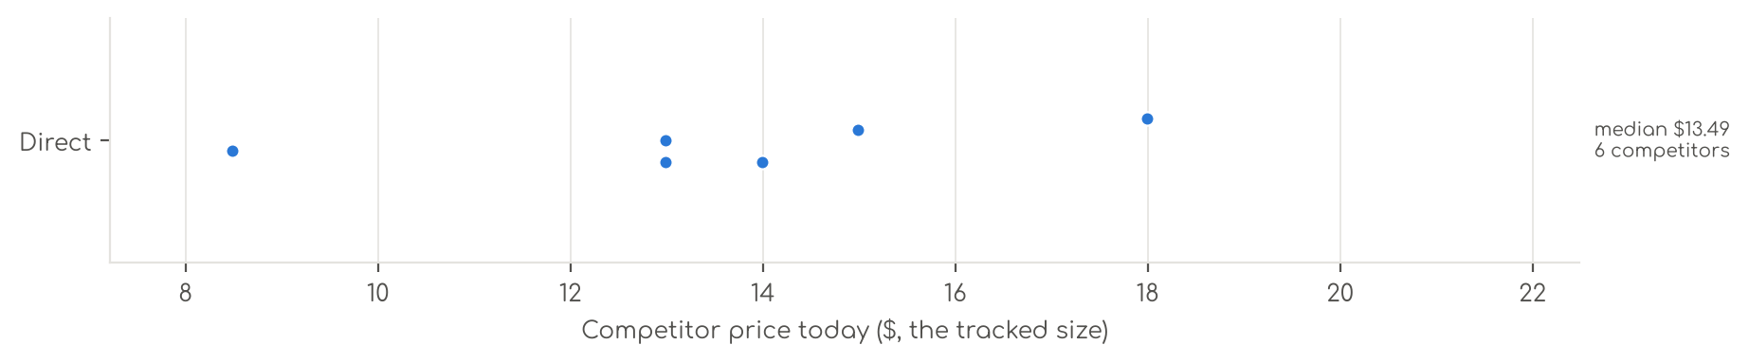
Photo | Competitor | Size · colour | Price | List | vs ours | Strike- through | BFCM 2025 deal | 2025 before → during | Disc. | Rank lift | Units / wk
Direct · 6
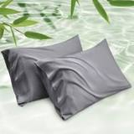 | Bedsure  Bedsure PureWoven Pillow Cases Queen Set of 2, Rayon Derived from Bamboo  Bamboo viscose · 4.4★ 37,593  Buy Box RAISED in BFCM week (median $14.99 vs $11.19 before); List Price $14.99 | Queen (20" X 30") · 01 - Dark Grey | $12.99 | $17.49 | — | List Price $17.49 | Prime Exclusive Discount | $11.19 → $9.99 | 11% | 0.48x | 1,040
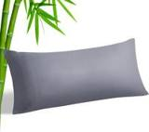 | BEDELITE  BEDELITE Cooling Pillow Cases for Hot Sleepers & Night Sweats, Rayon Derived fro  Bamboo viscose · 4.4★ 12,316  Prime Exclusive 11-03 to 12-05; Lightning Deal 11-09 to 11-12; Prime Exclusive already running before BFCM week; List Price $9.99 | Body（20"X 54"） · Grey | $8.49 | — | — | List Price $9.99 | Price cut only | $8.49 → $7.98 | 6% | 0.64x | 924
 | WISHSMILE  WishSmile Cooling Queen Pillowcases Set of 2 Breathable Cool Silky Soft Rayon De  Bamboo viscose · 4.4★ 7,225  Buy Box RAISED in BFCM week (median $13.99 vs $11.99 before); List Price $17.99 | 1 Pack Body(20x54)-Regular · Dark Grey | $12.99 | — | — | Not shown | Prime Exclusive Discount | $11.99 → $10.19 | 15% | 1.07x | 809
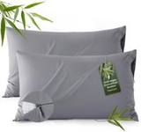 | Bedsure  Bedsure Zipper Pillow Cases Queen, Cooling Pillow Cases Queen Size Set of 2, Ray  Bamboo viscose · 4.6★ 1,289  Buy Box RAISED in BFCM week (median $16.99 vs $14.24 before); List Price $16.99 | Queen (20" x 30") · 01 - Grey | $14.99 | $23.15 | — | List Price $23.15 | Prime Exclusive Discount | $14.24 → $13.29 | 7% | 0.85x | 347
 | ELIBABA  Cooling Side Sleeper Pillow Cases - Curved Rayon Derived from Bamboo Pillowcase  Bamboo viscose · 4.2★ 1,630  List Price $22.99 | 1 Pack Queen (20 x 30) · Dark Grey | $17.99 | — | — | Not shown | Prime Exclusive Discount | $18.99 → $15.19 | 20% | 1.07x | 92
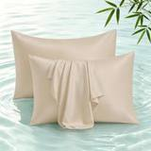 | Shunjie.Home  2 Pack Cooling Pillowcases for Hot Sleepers & Night Sweats, 400 TC Bamboo Viscos  Bamboo viscose · 4.5★ 622  List Price $13.99 | 2Pack - Queen · Beige | $13.99 | — | — | Not shown | Prime Exclusive Discount | $13.99 → $10.63 | 24% | 0.92x | 5

US · SL Cooling 6pc: Sleephoria Cooling Sheets 6 Piece
NOT LAUNCHED YET. No live price, rating or sales are expected. Competitors are mapped so the launch can be priced against them.
 | Listing title | SLEEPHORIA Cooling Sheets - BreezeWeave 6 PC California King Size Cooling Bed Sheets for Hot Sleepers & Deep, Cool Rest - Cloud Soft, Silky Smooth, 16 in Deep Pocket, Ultra Durable (Beige)
 | Marketplace | United States
 | Family · role | Cooling · Off-season (aged variations only)
 | Scope · stage | Not launched · Production
 | Amazon parent | B0H7JVGTZW
 | Best seller | —
 | Variations | 60 (0 with a live price)
 | Sizes | California King, Full, King, Queen, Twin
 | Colours | 12

OUR PRICE TODAY  — | BFCM 2026 DEAL  Not in a deal  regular price through BFCM | DIRECT COMPETITORS  3  median $149.99 · 0 cheaper than us

BFCM 2026 deal
Not in a BFCM 2026 deal: sells at its regular price through BFCM.

Competitors (7)
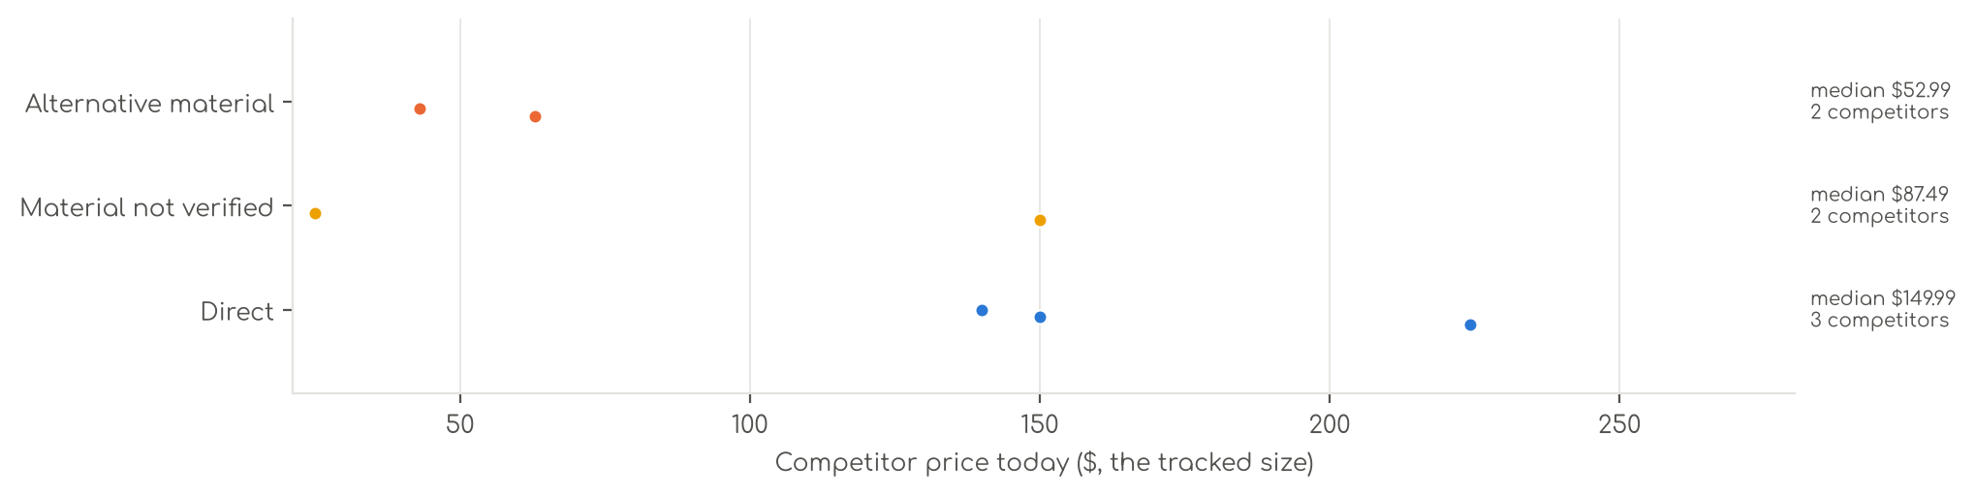
Photo | Competitor | Size · colour | Price | List | vs ours | Strike- through | BFCM 2025 deal | 2025 before → during | Disc. | Rank lift | Units / wk
Direct · 3
 | REST  Cooling Sheets  Synthetic cooling knit · 4.3★ 1,149  Lightning Deal 11-14 to 11-14; List Price $299.00 | Queen · Midnight Blue | $224.25 | $299.00 | — | List Price $299.00 | Price cut only | $299.00 → $215.88 | 28% | 1.93x | 81
 | Breescape  Cooling Sheets  Synthetic cooling knit · 4.2★ 595  Coupon 30% (11-01 to 11-02); List Price $179.99 | King · Gray | $149.99 | $179.99 | — | List Price $179.99 | Price cut only | $125.99 → $119.69 | 5% | 1.40x | 35
 | DOWNCOOL  Cooling Sheets  Synthetic cooling knit · 4.2★ 6  Buy Box RAISED in BFCM week (median $69.99 vs $35.99 before); List Price $69.99 | Full · White | $139.99 | — | — | Not shown | Prime Exclusive Discount | $35.99 → $29.99 | 17% | 0.99x | 5
Material not verified · 2
 | Bedsure  Cooling Sheets  4.2★ 512  No Buy Box history in price history for BFCM 2025; List Price $82.99 | Queen · 01 - Grey | $149.99 | — | — | Not shown | — | — | — | — | 5
 | David's Home  Cooling Sheets  4.3★ 169  Coupon 20%, 40% (11-01 to 11-20); List Price $67.99 | — | $24.99 | — | — | — | Prime Exclusive Discount | $39.99 → $10.00 | 75% | 0.98x | —
Alternative material · 2
 | Bedsure  Bedsure PureWoven 100% Rayon Derived from Bamboo, Queen Sheets, 4 Pieces  Bamboo viscose · 4.4★ 65,061  Buy Box RAISED in BFCM week (median $69.99 vs $66.49 before); List Price $78.99 | Queen · 02 - White | $62.99 | $69.99 | — | List Price $69.99 | Prime Exclusive Discount | $66.49 → $55.99 | 16% | 0.68x | 809
 | OMERAI  Cooling Sheets  Microfiber / polyester · 4.7★ 4 | King 4 PC · Blue | $42.99 | $59.99 | — | List Price $59.99 | Not live in 2025 | — | — | — | 5

US · SL Satin 6pc: Sleephoria Satin Sheets 6pcs
NOT LAUNCHED YET. No live price, rating or sales are expected. Competitors are mapped so the launch can be priced against them.
 | Listing title | SLEEPHORIA Satin Bed Sheets - 6 Piece Luxury Silky Full Size Bedding Set - Softer Than Silk, Wrinkle-Free with 15” Deep Pocket Fitted Sheet, Perfect for Hair & Skin, Gifts for Women (Baby Blue)
 | Marketplace | United States
 | Family · role | Satin · Clearance with margin
 | Scope · stage | Not launched · Production
 | Amazon parent | B0H41WN38B
 | Best seller | —
 | Variations | 116 (0 with a live price)
 | Sizes | Full, King, Queen, Twin
 | Colours | 29

OUR PRICE TODAY  — | BFCM 2026 DEAL  Not in a deal  regular price through BFCM | DIRECT COMPETITORS  18  median $21.49 · 0 cheaper than us

BFCM 2026 deal
Not in a BFCM 2026 deal: sells at its regular price through BFCM.

Competitors (27)
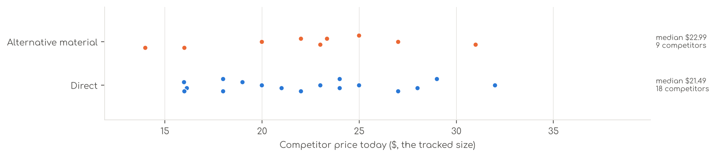
Photo | Competitor | Size · colour | Price | List | vs ours | Strike- through | BFCM 2025 deal | 2025 before → during | Disc. | Rank lift | Units / wk
Direct · 18
 | BEDELITE  BEDELITE Satin Sheets Queen Size Bed Set, Black, 4 Pieces  Satin (polyester) · 4.3★ 6,297  Prime Exclusive 11-01 to 12-05; Prime Exclusive already running before BFCM week; List Price $23.99 | Queen · Black | $17.99 | — | — | List Price $19.99 | Price cut only | $17.99 → $17.09 | 5% | 1.51x | 1,963
 | Love's cabin  Love's cabin Satin Queen Sheets Set, 4 Pieces, Pink, 15" Deep Pocket  Satin (polyester) · 4.5★ 5,747  Prime Exclusive already running before BFCM week; List Price $25.99 | Queen · Pink | $16.13 | $19.99 | — | List Price $19.99 | Prime Exclusive Discount | $17.99 → $17.99 | 0% | 0.84x | 809
 | MR&HM  MR&HM Satin Sheets Queen Size with Elastic Corner Straps, Black  Satin (polyester) · 4.4★ 17,886  Prime Exclusive 11-01 to 12-05; Lightning Deal 11-08 to 11-14; Prime Exclusive already running before BFCM week; List Price $28.99 | Queen · Black | $19.99 | — | — | List Price $28.99 | None | $17.99 → $17.99 | 0% | 1.34x | 809
 | BEDELITE  BEDELITE Satin Queen Fitted Sheet & Pillowcases Set, Black, 3 Pieces  Satin (polyester) · 4.4★ 1,858  Prime Exclusive 11-01 to 12-05; Lightning Deal 11-09 to 11-09; Prime Exclusive already running before BFCM week; List Price $19.99 | Queen · Black | $15.98 | $19.99 | — | List Price $19.99 | Price cut only | $15.99 → $15.18 | 5% | 1.81x | 208
 | FreshCulture  Satin Sheets  Satin (polyester) · 4.4★ 780  List Price $34.99 | Full · Black | $23.99 | — | — | Not shown | Prime Exclusive Discount | $23.99 → $18.69 | 22% | 1.39x | 104
 | P Pothuiny  P Pothuiny 6-Piece Queen Satin Sheet Set Burgundy Silky Sheets  Satin (polyester) · 4.4★ 4,031  Prime Exclusive already running before BFCM week; Buy Box RAISED in BFCM week (median $31.99 vs $29.99 before); List Price $48.99 | Queen · Burgundy | $26.99 | — | — | Not shown | Prime Exclusive Discount | $29.99 → $24.95 | 17% | 1.03x | 104
 | Pure Bedding  Pure Bedding Satin Sheets Queen [4-Piece, Black] Hotel Luxury Silky Bed Sheets - Extra Soft 1800 Microfiber Sheet Set, W…  Satin (polyester) · 4.4★ 9,828  Buy Box RAISED in BFCM week (median $20.02 vs $18.99 before); List Price $32.99 | Queen · Black | $20.99 | — | — | Not shown | Price cut only | $18.99 → $17.54 | 8% | 0.83x | 92
 | SiinvdaBZX  SiinvdaBZX 4Pcs Satin Sheet Set Queen Size 15-Inch Deep Pocket, Beige  Satin (polyester) · 4.4★ 6,981  Prime Exclusive already running before BFCM week; Buy Box RAISED in BFCM week (median $26.99 vs $24.49 before); List Price $52.59 | Queen · Beige | $22.99 | — | — | Not shown | Prime Exclusive Discount | $24.49 → $21.59 | 12% | 1.00x | 92
 | VACVELT  VACVELT 3pcs Queen Black Extra Deep Pocket Satin Fitted Sheet Set  Satin (polyester) · 4.2★ 747  Prime Exclusive already running before BFCM week; List Price $47.98 | Queen · Black | $18.99 | — | — | Not shown | Prime Exclusive Discount | $25.99 → $17.15 | 34% | 1.01x | 92
 | Horbaunal  Horbaunal 6 Piece Satin Sheet Set Queen, Emerald Green Queen Bed Sheets  Satin (polyester) · 4.4★ 772  Prime Exclusive already running before BFCM week; Buy Box RAISED in BFCM week (median $37.99 vs $33.43 before); List Price $45.49 | Queen · Green | $28.99 | — | — | Not shown | Prime Exclusive Discount | $33.43 → $28.87 | 14% | 1.12x | 35
 | VACVELT  Satin Sheets  Satin (polyester) · 4.5★ 1,017  Prime Exclusive already running before BFCM week; Buy Box RAISED in BFCM week (median $25.99 vs $20.99 before); List Price $46.38 | Full · Hot Pink | $21.99 | — | — | Not shown | Prime Exclusive Discount | $20.99 → $17.67 | 16% | 1.20x | 35
 | Homiest  Satin Sheets  Satin (polyester) · 4.5★ 205  List Price $34.99 | Queen · Blush Pink | $27.99 | — | — | Not shown | None | $28.99 → $28.99 | 0% | 1.03x | 18
 | HommxJF  Satin Sheets  Satin (polyester) · 4.3★ 1,032  List Price $26.99 | Full · Blush Pink | $24.99 | — | — | Not shown | None | $24.99 → $24.99 | 0% | 1.20x | 18
 | MK Home  Satin Sheets  Satin (polyester) · 4.3★ 10,761  List Price $59.99 | Queen · Red | $18.99 | — | — | Not shown | None | $28.99 → $28.99 | 0% | 0.70x | 18
 | VACVELT  Satin Sheets  Satin (polyester) · 4.4★ 209  List Price $19.99 | Queen · Beige | $17.99 | — | — | Not shown | None | $20.99 → $19.99 | 5% | 1.15x | 18
 | Candoury  Satin Sheets  Satin (polyester) · 4.3★ 5,277  No Buy Box history in price history for BFCM 2025; List Price $35.99 | Queen · Black | $15.99 | — | — | Not shown | — | — | — | 0.76x | 5
 | Homiest  Satin Sheets  Satin (polyester) · 4.4★ 12,125  Prime Exclusive already running before BFCM week; List Price $52.78 | EXTRA DEEP pocket - Full size · Blackish Green | $23.99 | $25.99 | — | Typical price $25.99 | Prime Exclusive Discount | $23.39 → $21.32 | 9% | 1.00x | 5
 | Manyshofu  Satin Sheets  Satin (polyester) · 4.3★ 907  Buy Box RAISED in BFCM week (median $43.99 vs $35.99 before); List Price $46.99 | California King · Dark Green | $31.99 | — | — | Not shown | None | $35.99 → $43.99 | -22% | 0.83x | 5
Alternative material · 9
 | CozyLux  CozyLux Satin Sheets Queen, 4-Piece 14-Inch Deep Pocket Sheet Set  Microfiber / polyester · 4.3★ 7,075  Lightning Deal 11-09 to 11-16; Prime Exclusive already running before BFCM week; List Price $22.99 | Queen · Black | $13.99 | $18.99 | — | List Price $18.99 | Prime Exclusive Discount | $17.99 → $16.99 | 6% | 0.95x | 347
 | Lanest Housing  Lanest Housing Silk Satin Sheets, Queen Size Satin Bed Sheet Set with Deep Pockets, Cooling Soft and Hypoallergenic Sati…  Silk · 4.3★ 5,837  Buy Box RAISED in BFCM week (median $27.79 vs $19.99 before); List Price $37.99 | Queen · Gray | $22.99 | — | — | Not shown | Prime Exclusive Discount | $19.99 → $17.99 | 10% | 1.04x | 208
 | Bedsure  Satin Sheets  Microfiber / polyester · 4.3★ 2,745  Prime Exclusive already running before BFCM week; Buy Box RAISED in BFCM week (median $28.99 vs $24.99 before); List Price $44.99 | Queen · 02 - Black | $19.99 | — | — | Not shown | Prime Exclusive Discount | $22.39 → $20.99 | 6% | 0.85x | 92
 | GOLAL  GOLAL Satin Sheets Full Size - 4 Pieces Luxury Silky Soft Bed Sheets, Wrinkle-Free Black Satin Silk Sheet Set with 1 Dee…  Silk · 4.4★ 3,943  Coupon 10%, 5% (11-01 to 12-05); Buy Box RAISED in BFCM week (median $21.99 vs $16.05 before); List Price $24.99 | Full · Black | $21.99 | — | — | Not shown | Prime Exclusive Discount | $16.05 → $17.59 | -10% | 0.44x | 81
 | Cobedzy  Satin Sheets  Microfiber / polyester · 4.4★ 2,838  List Price $38.99 | Queen · Blush Pink | $24.99 | — | — | Typical price $26.99 | Price cut only | $27.99 → $22.39 | 20% | 1.41x | 35
 | Sasttie  Sasttie Satin Sheets Queen Size - 4 Pieces Luxury Soft Black Silky Bed Sheets Set with Pillowcases - Smooth Silk-Like Sa…  Silk · 4.5★ 968  Prime Exclusive already running before BFCM week; Buy Box RAISED in BFCM week (median $19.99 vs $16.99 before); List Price $19.98 | Queen · Black | $15.99 | — | — | Not shown | Prime Exclusive Discount | $15.99 → $15.98 | 0% | 0.72x | 35
 | Vonty  Satin Sheets  Microfiber / polyester · 4.2★ 909  Buy Box RAISED in BFCM week (median $42.99 vs $30.99 before); List Price $49.99 | King - Extra Deep Pocket · Black | $30.99 | — | — | Not shown | Prime Exclusive Discount | $30.99 → $25.79 | 17% | 1.07x | 35
 | Madison Park  Satin Sheets  Microfiber / polyester · 4.5★ 127  List Price $35.99 | Queen · Ivory | $26.99 | — | — | Not shown | None | $30.99 → $30.99 | 0% | 0.97x | 18
 | Martex  Satin Sheets  Microfiber / polyester · 4.3★ 2,260  Buy Box RAISED in BFCM week (median $26.99 vs $23.21 before); List Price $34.99 | Queen · Pink | $23.34 | — | — | Typical price $26.99 | None | $23.21 → $26.99 | -16% | 1.03x | 5

8. Product chapters: Canada
One chapter per Canadian product listing. Prices are in Canadian dollars (C$).

CA · DC B4: Decolure Bamboo Sheets 4 Piece
 | Listing title | DECOLURE 100% Organic Bamboo Viscose Sheets Queen Size 4 pcs - Ultra Soft & Luxuriously Cooling, 16" Deep Pocket, Double Stitching, Perfect for Hot Sleepers - Luxury Queen Bed Sheets Set (White)
 | Marketplace | Canada
 | Family · role | Bamboo · Hero: rank and profit
 | Scope · stage | Core · Re-Launch
 | Amazon parent | B08LW37SB9
 | Best seller | B08KQJGM74 (Queen White)
 | Variations | 80 (75 with a live price)
 | Sizes | Queen, King, Full, Twin, California King
 | Colours | 16

OUR PRICE TODAY  C$99.99  Queen White | BFCM 2026 DEAL PRICE  C$99.99 → C$84.78  Best Deal Nov 19-30 · 15% off the Oct 27 price | STOCK TO NOV 30  5 short · 21 out  1,615 at Amazon · 2,658 inbound · need 1,928 | BFCM 2025 SALES LIFT  3.08x  479 units in the last 28 days | DIRECT COMPETITORS  15  median C$74.99 · 13 cheaper than us

BFCM 2025: how this product did
Period | Sales | Units | Organic units | Ad units | Ad cost | TACoS | Sessions | Unit session % | Avg price
Oct 21 – Nov 19, 2025 (30 days before) | C$38,404 | 636 | 604 | 32 | C$5,035 | 13.1% | 15,737 | 4.0% | C$60.38
Nov 20 – Dec 1, 2025 (BFCM week) | C$47,287 | 908 | 834 | 74 | C$5,783 | 12.2% | 20,224 | 4.5% | C$52.08
Dec 2 – 31, 2025 | C$84,123 | 1,439 | 1,317 | 122 | C$11,213 | 13.3% | 32,665 | 4.4% | C$58.46
Our BFCM 2025 deals: Lightning Deal 11-08 to 11-09 (ran, 80 variations, 38 units); Lightning Deal 11-15 to 11-15 (ran, 80 variations, 13 units); Best Deal 11-20 to 12-02 (ran, 77 variations, 891 units)
Stock in BFCM 2025: 1 of 79 variations hit zero FBA stock on at least one observed day in BFCM week; weighted by sales mix, about 2.1% of variation-days were lost.

BFCM 2026 deal
Deal | Hero variation | Price Oct 27 | Deal price | Off | Variations (deal page) | Our 2025 cut | Rivals' 2025 cut
Best Deal Nov 19-30 | Queen White | C$99.99 | C$84.78 | 15% | 70 eligible, 4 out of stock, 4 no reference price, 2 manual price; 0%–31% off | 5% (C$74.99 → C$71.24) | 26% (7 rivals)
Deal notes
- Amazon deal price now. Amazon uses the current CA$99.99 as reference. BFCM max showing now: 12% off (CA$87.99 on most King/Queen/Cal King); the figure keeps changing. The Sep 30 LD drops out of the lookback by Oct 30.
- Pre-BFCM deal decision. Oct 16-24 Canada Best Deal: cancel approved to keep the BFCM price clean.

Stock to Nov 30
Sales per day today 27.2 · lift used 3.08x (this product's own BFCM 2025 lift) · need to Nov 30 1,928 units · at Amazon 1,615 · inbound 2,658. Covered 32, needs inbound in time 13, short 5, out of stock now 21.
Size | Colour | At Amazon | Inbound | Sales / day | Need to Nov 30 | Short by | Runs out | Status
King | Charcoal | 0 | 0 | 2.4 | 170 | 170 | now | Out of stock now
Full | Light Pink | 0 | 18 | 1.8 | 128 | 110 | now | Out of stock now
Queen | Navy Blue | 10 | 66 | 1.4 | 100 | 24 | Oct 22 | Short even with inbound
King | Navy Blue | 42 | 48 | 1.2 | 85 | — | Nov 18 | Needs inbound in time
Queen | Olive | 38 | 48 | 1.1 | 80 | — | Nov 17 | Needs inbound in time
King | White | 51 | 0 | 1.1 | 78 | 27 | Nov 22 | Short even with inbound
Full | Olive | 0 | 0 | 0.8 | 57 | 57 | now | Out of stock now
King | Grey | 17 | 36 | 0.7 | 50 | — | Nov 7 | Needs inbound in time
Full | Charcoal | 0 | 0 | 0.6 | 43 | 43 | now | Out of stock now
King | Sage Green | 0 | 0 | 0.6 | 43 | 43 | now | Out of stock now
Queen | Sage Green | 16 | 126 | 0.6 | 40 | — | Nov 12 | Needs inbound in time
Queen | Charcoal | 0 | 0 | 0.5 | 33 | 33 | now | Out of stock now
Queen | Light Blue | 22 | 102 | 0.5 | 32 | — | Nov 22 | Needs inbound in time
King | Creme | 20 | 102 | 0.5 | 32 | — | Nov 21 | Needs inbound in time
Full | Black | 1 | 84 | 0.4 | 31 | — | Oct 17 | Needs inbound in time
King | Light Pink | 13 | 66 | 0.4 | 28 | — | Nov 16 | Needs inbound in time
Queen | Black | 0 | 48 | 0.4 | 26 | — | now | Out of stock now
Full | Sage Green | 3 | 12 | 0.4 | 26 | 11 | Oct 23 | Short even with inbound
Queen | Light Pink | 5 | 54 | 0.3 | 21 | — | Oct 31 | Needs inbound in time
Queen | Grey | 9 | 144 | 0.3 | 20 | — | Nov 16 | Needs inbound in time
King | Light Olive | 0 | 30 | 0.3 | 18 | — | now | Out of stock now
Twin | Burgundy | 7 | 132 | 0.2 | 17 | — | Nov 13 | Needs inbound in time
Full | Light Grey | 0 | 0 | 0.2 | 17 | 17 | now | Out of stock now
Full | Purple | 14 | 0 | 0.2 | 16 | 2 | Nov 27 | Short even with inbound
King | Burgundy | 4 | 48 | 0.2 | 16 | — | Nov 2 | Needs inbound in time
Full | Burgundy | 0 | 12 | 0.2 | 14 | 2 | now | Out of stock now
Twin | Purple | 7 | 6 | 0.2 | 13 | 0 | Nov 18 | Short even with inbound
Twin | Light Olive | 0 | 42 | 0.2 | 13 | — | now | Out of stock now
Queen | Burgundy | 0 | 0 | 0.1 | 8 | 8 | now | Out of stock now
Twin | Sage Green | 0 | 0 | 0.1 | 7 | 7 | now | Out of stock now
Full | Grey | 0 | 0 | 0.1 | 5 | 5 | now | Out of stock now
Full | Light Blue | 0 | 0 | 0.1 | 5 | 5 | now | Out of stock now
Twin | Light Pink | 0 | 0 | 0.1 | 5 | 5 | now | Out of stock now
California King | Light Pink | 1 | 6 | 0.1 | 5 | — | Oct 29 | Needs inbound in time
California King | Sage Green | 0 | 0 | 0.1 | 4 | 4 | now | Out of stock now
Twin | Charcoal | 0 | 0 | 0.1 | 4 | 4 | now | Out of stock now
Full | Creme | 0 | 0 | 0.0 | 3 | 3 | now | Out of stock now
Full | Midgrey | 0 | 0 | 0.0 | 3 | 3 | now | Out of stock now
Twin | Light Grey | 0 | 0 | 0.0 | 3 | 3 | now | Out of stock now

Sales mix, last 28 days
By size: Queen 200 · King 179 · Full 59 · Twin 23 · California King 18
By colour (top 8): White 67 · Taupe 60 · Black 44 · Navy Blue 37 · Light Blue 36 · Light Grey 34 · Grey 28 · Olive 25

Competitors (15)
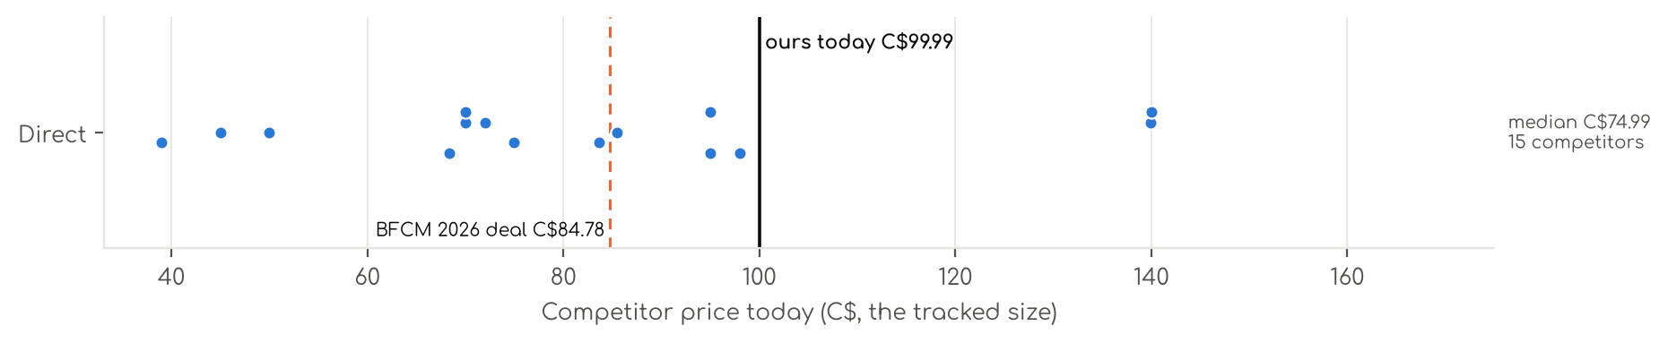
Photo | Competitor | Size · colour | Price | List | vs ours | Strike- through | BFCM 2025 deal | 2025 before → during | Disc. | Rank lift | Units / wk
Direct · 15
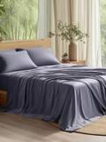 | Bedsure  Bedsure Sheet Queen Size - 4 Piece 100% Bamboo Rayon Sheet Set Dark Grey  Bamboo viscose · 4.3★ 60,808  Amazon.ca organic #1 for 'bamboo sheets queen'; 100% Bamboo; 600+ bought in past month bought past month; variation_count = distinct childre | Queen · 01 - Dark Grey | C$94.99 | — | -5% | List Price C$109.99 | Prime Exclusive Discount | C$72.19 → C$55.27 | 23% | 1.83x | —
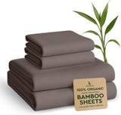 | BAMPURE  BAMPURE 100% Organic Bamboo Sheets Queen 4PC - Cooling Sheets Set  Bamboo viscose · 4.3★ 7,346  Amazon.ca organic #1 for 'bamboo sheets king'; 100% Viscose Derived from Bamboo; Search child B07XF1K1R3; selected Queen child B07X8FPWJH. v | Queen · Stone Gray | C$83.69 | — | -16% | Was price C$92.99 | Price cut only | C$92.99 → C$78.99 | 15% | 1.41x | —
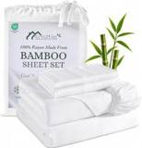 | Sasttie  Sasttie White Silky-Soft Bamboo Sheets Queen Size 4-Piece, 100% Rayon Made from Bamboo 300TC, Cooling Sheet for Hot Slee…  Bamboo viscose · 4.5★ 19  Amazon.ca organic #2 for 'cooling bamboo sheets'; Rayon Derived from Bamboo; variation_count = distinct children exposed in page variation m | Queen · White | C$49.99 | — | -50% | List Price C$64.99 | Not live in 2025 | — | — | — | —
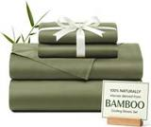 | Andency  Andency Bamboo Cooling Olive Sheets Set, 4pcs Queen Sheets for Hot Sleepers  Bamboo viscose · 4.4★ 736  Amazon.ca organic #5 for 'bamboo sheets king'; Bamboo Viscose – Temperature Regulation for Deeper, Restful Sleep; Search child B0CWKJ5SJ9; s | Queen · Olive Green | C$69.99 | — | -30% | Not shown | — | — | — | — | —
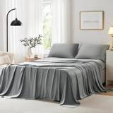 | ACCURATEX  ACCURATEX Bamboo Cooling Sheets for Hot Sleepers, Queen Size, Grey  Bamboo viscose · 4.3★ 1,019  Amazon.ca organic #7 for 'cooling bamboo sheets'; 100% bamboo; Search child B09PYB9C45; selected Queen child B0BKLHTWGS. Orderable; availabi | Queen · Grey | C$94.99 | — | -5% | Not shown | Prime Exclusive Discount | C$94.99 → C$75.99 | 20% | 1.28x | —
 | KRIMANO  Bamboo Viscose Sheet Set Queen Size, Cooling Sheets Bed Set 4pcs  Bamboo viscose · 4.4★ 765  Amazon.ca organic #10 for 'bamboo sheets king'; Viscose Derived from Bamboo; Search child B0FT7LZ2CD; selected Queen child B0FT7LV7PP. varia | Queen · 1.navy Blue | C$97.99 | — | -2% | Not shown | Not live in 2025 | — | — | — | —
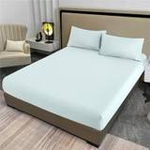 | MCO  100% Bamboo King Size Sheets Set, Cooling&Breathable-Light Blue  Bamboo viscose · 3.9★ 255  Amazon.ca organic #11 for 'bamboo sheets king'; 100% Bamboo; No Queen option exposed; King used. variation_count = distinct children exposed | King · Light Blue | C$38.99 | — | -61% | Not shown | None | C$39.99 → C$39.99 | 0% | 0.54x | —
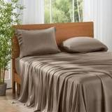 | KRIMANO  Queen Size Sheet Set, Viscose Bamboo Sheets 4-Piece, 100% Viscose Derived from Bamboo, Hotel Luxury Silky & Cooling for …  Bamboo viscose · 4.5★ 23  Amazon.ca organic #12 for 'bamboo sheets queen'; 100% Viscose Derived from Bamboo; variation_count = distinct children exposed in page varia | Queen · 3. Premium Taupe | C$85.49 | — | -15% | Was price C$89.99 | Not live in 2025 | — | — | — | —
 | Bambaw  Bambaw 100% Viscose Derived from Bamboo Sheets Queen Size Set – 4pcs Cooling Sheet Set, Super Soft Sheets Queen Size, Lu…  Bamboo viscose · 4.3★ 3,030  Amazon.ca organic #12 for 'bamboo sheets king'; 100% Viscose Derived from Bamboo; Search child B0DR98RPTK; selected Queen - 4 PCS child B0DR | Queen · Charcoal | C$139.95 | — | +40% | Not shown | Price cut only | C$139.95 → C$118.96 | 15% | 1.60x | —
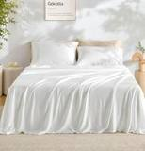 | GOKOTTA  Gökotta Queen Bed Sheets 4 Piece, 100% FSC® Certified Bamboo, Cooling  Bamboo viscose · 4.4★ 2,698  Amazon.ca organic #12 for 'cooling bamboo sheets'; 100% Rayon Made from Bamboo; Search child B0B6VQC7LD; selected Queen - 4 PCS child B08F3H | Queen · 01 Cream White | C$139.99 | — | +40% | List Price C$154.99 | Price cut only | C$139.99 → C$114.99 | 18% | 1.56x | —
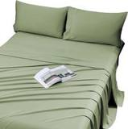 | Viviland  Viviland Cooling Queen Sheets, 100% Viscose Derived Bamboo, Sage Green  Bamboo viscose · 4.4★ 146  Amazon.ca organic #13 for 'bamboo sheets king'; 100% Viscose; Search child B0F1KLQJZ7; selected Queen (U.S. Standard) child B0H8S57BK7. vari | Queen · Sage Green | C$68.39 | — | -32% | Was price C$71.99 | Not live in 2025 | — | — | — | —
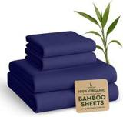 | BAMPURE  BAMPURE 100% Organic Bamboo Sheets Queen 4PC - Cooling Sheets Set  Bamboo viscose · 3.3★ 18  Amazon.ca organic #14 for 'bamboo sheets queen'; 100% Viscose Derived from Bamboo; Page parent field repeats the selected child; no distinct | Queen · Navy | C$74.99 | — | -25% | List Price C$89.99 | Price cut only | C$89.99 → C$78.99 | 12% | 1.41x | —
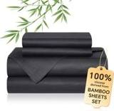 | YASMENG  100% Bamboo Rayon Cooling Sheets Queen Set Black Silky Soft Bedding  Bamboo viscose · 1.0★ 1  Amazon.ca organic #17 for 'bamboo sheets queen'; 100% Rayon Derived from Bamboo; Page parent field repeats the selected child; no distinct p | Queen · Black | C$44.99 | — | -55% | List Price C$94.99 | Not live in 2025 | — | — | — | —
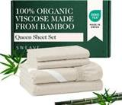 | Sweave  100% Organically Rayon Derived from Bamboo Sheets Queen, 4Pcs Set, Ivory  Bamboo viscose · 4.0★ 25  Amazon.ca organic #17 for 'bamboo sheets king'; 100% Organic Viscose Derived from Bamboo; Search child B0CNRPZJBK; selected Queen child B0CN | Queen · Ivory (100% Organic Viscose Made from Bamboo) | C$71.99 | — | -28% | Not shown | None | C$146.53 → C$146.53 | 0% | 0.89x | —
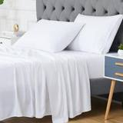 | CAROMIO  CAROMIO Sheets Set Queen Size Rayon Derived from Bamboo, Cooling Bed Sheets  Bamboo viscose · 4.2★ 1,050  Amazon.ca organic #18 for 'bamboo sheets king'; 100% Viscose from Bamboo; Search child B08XK9TQDZ; selected Queen child B08XK2ZFTL. variatio | Queen · White | C$69.99 | — | -30% | Not shown | Prime Exclusive Discount | C$79.99 → C$62.99 | 21% | 1.10x | —

CA · DC B6: Decolure Bamboo Sheets 6 Piece
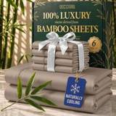 | Listing title | DECOLURE 100% Organic Viscose Derived from Bamboo Sheets King Size 6pcs - Ultra Soft & Luxuriously Cooling, 17" Deep Pocket, Double Stitching, Perfect for Hot Sleepers - King Bed Sheets (Taupe)
 | Marketplace | Canada
 | Family · role | Bamboo · Hero: rank and profit
 | Scope · stage | Core · Re-Launch
 | Amazon parent | B0D71YJYNL
 | Best seller | B0CQ3178D7 (King Taupe)
 | Variations | 81 (74 with a live price)
 | Sizes | King, Queen, Full, California King, Twin
 | Colours | 16

OUR PRICE TODAY  C$99.99  King Taupe | BFCM 2026 DEAL PRICE  C$99.99 → C$84.99  Best Deal Nov 19-30 · 15% off the Oct 27 price | STOCK TO NOV 30  8 short · 16 out  2,744 at Amazon · 2,642 inbound · need 2,666 | BFCM 2025 SALES LIFT  3.07x  714 units in the last 28 days | DIRECT COMPETITORS  8  median C$159.97 · 1 cheaper than us

BFCM 2025: how this product did
Period | Sales | Units | Organic units | Ad units | Ad cost | TACoS | Sessions | Unit session % | Avg price
Oct 21 – Nov 19, 2025 (30 days before) | C$78,110 | 1,315 | 1,231 | 84 | C$9,628 | 12.3% | 30,898 | 4.3% | C$59.40
Nov 20 – Dec 1, 2025 (BFCM week) | C$95,882 | 1,982 | 1,877 | 105 | C$5,793 | 6.0% | 28,069 | 7.1% | C$48.38
Dec 2 – 31, 2025 | C$98,854 | 1,631 | 1,525 | 106 | C$8,816 | 8.9% | 31,381 | 5.2% | C$60.61
Our BFCM 2025 deals: Lightning Deal 11-05 to 11-05 (ran, 80 variations, 31 units); Lightning Deal 11-13 to 11-14 (ran, 80 variations, 67 units); Best Deal 11-20 to 12-02 (ran, 80 variations, 1,979 units)
Stock in BFCM 2025: 3 of 77 variations hit zero FBA stock on at least one observed day in BFCM week; weighted by sales mix, about 1.0% of variation-days were lost.

BFCM 2026 deal
Deal | Hero variation | Price Oct 27 | Deal price | Off | Variations (deal page) | Our 2025 cut | Rivals' 2025 cut
Best Deal Nov 19-30 | King Taupe | C$99.99 | C$84.99 | 15% | 72 eligible, 3 no reference price, 3 out of stock, 2 manual price; 0%–79% off | 5% (C$79.99 → C$75.99) | 26% (7 rivals)

Stock to Nov 30
Sales per day today 37.6 · lift used 3.07x (this product's own BFCM 2025 lift) · need to Nov 30 2,666 units · at Amazon 2,744 · inbound 2,642. Covered 33, needs inbound in time 7, short 8, out of stock now 16.
Size | Colour | At Amazon | Inbound | Sales / day | Need to Nov 30 | Short by | Runs out | Status
Queen | White | 0 | 0 | 2.6 | 188 | 188 | now | Out of stock now
King | Taupe | 144 | 9 | 2.4 | 170 | 17 | Nov 26 | Short even with inbound
Full | Burgundy | 0 | 0 | 2.4 | 170 | 170 | now | Out of stock now
Full | Light Pink | 0 | 0 | 2.4 | 170 | 170 | now | Out of stock now
Queen | Taupe | 40 | 6 | 1.5 | 108 | 62 | Nov 10 | Short even with inbound
Full | White | 100 | 18 | 1.5 | 104 | — | Nov 29 | Needs inbound in time
Full | Navy Blue | 0 | 0 | 1.2 | 85 | 85 | now | Out of stock now
Full | Creme | 19 | 0 | 1.1 | 81 | 62 | Oct 31 | Short even with inbound
King | Charcoal | 36 | 124 | 1.1 | 79 | — | Nov 16 | Needs inbound in time
King | Burgundy | 71 | 4 | 1.1 | 78 | 3 | Nov 27 | Short even with inbound
King | Black | 7 | 8 | 0.8 | 57 | 42 | Oct 23 | Short even with inbound
King | Sage Green | 0 | 0 | 0.8 | 54 | 54 | now | Out of stock now
Queen | Navy Blue | 19 | 0 | 0.7 | 48 | 29 | Nov 11 | Short even with inbound
King | Grey | 0 | 0 | 0.6 | 42 | 42 | now | Out of stock now
Full | Midgrey | 5 | 0 | 0.6 | 40 | 35 | Oct 23 | Short even with inbound
King | Light Blue | 16 | 128 | 0.4 | 28 | — | Nov 19 | Needs inbound in time
King | Olive | 0 | 0 | 0.3 | 18 | 18 | now | Out of stock now
Twin | White | 0 | 0 | 0.2 | 14 | 14 | now | Out of stock now
Twin | Sage Green | 0 | 0 | 0.2 | 14 | 14 | now | Out of stock now
California King | Navy Blue | 8 | 20 | 0.2 | 13 | — | Nov 21 | Needs inbound in time
Full | Taupe | 0 | 0 | 0.1 | 11 | 11 | now | Out of stock now
Twin | Navy Blue | 2 | 0 | 0.1 | 11 | 9 | Oct 28 | Short even with inbound
California King | Taupe | 0 | 0 | 0.1 | 7 | 7 | now | Out of stock now
California King | Charcoal | 2 | 8 | 0.1 | 6 | — | Nov 6 | Needs inbound in time
California King | Burgundy | 6 | 4 | 0.1 | 6 | — | Nov 28 | Needs inbound in time
Full | Grey | 0 | 0 | 0.1 | 5 | 5 | now | Out of stock now
Full | Light Blue | 0 | 0 | 0.1 | 5 | 5 | now | Out of stock now
Twin | Light Olive | 2 | 12 | 0.1 | 5 | — | Nov 12 | Needs inbound in time
Twin | Grey | 0 | 0 | 0.1 | 4 | 4 | now | Out of stock now
California King | Purple | 0 | 12 | 0.0 | 3 | — | now | Out of stock now
Queen | Midgrey | 0 | 0 | 0.0 | 3 | 3 | now | Out of stock now

Sales mix, last 28 days
By size: King 340 · Queen 271 · Full 73 · California King 24 · Twin 6
By colour (top 8): White 142 · Taupe 96 · Creme 70 · Navy Blue 62 · Charcoal 56 · Burgundy 42 · Light Blue 41 · Light Grey 36

Competitors (8)
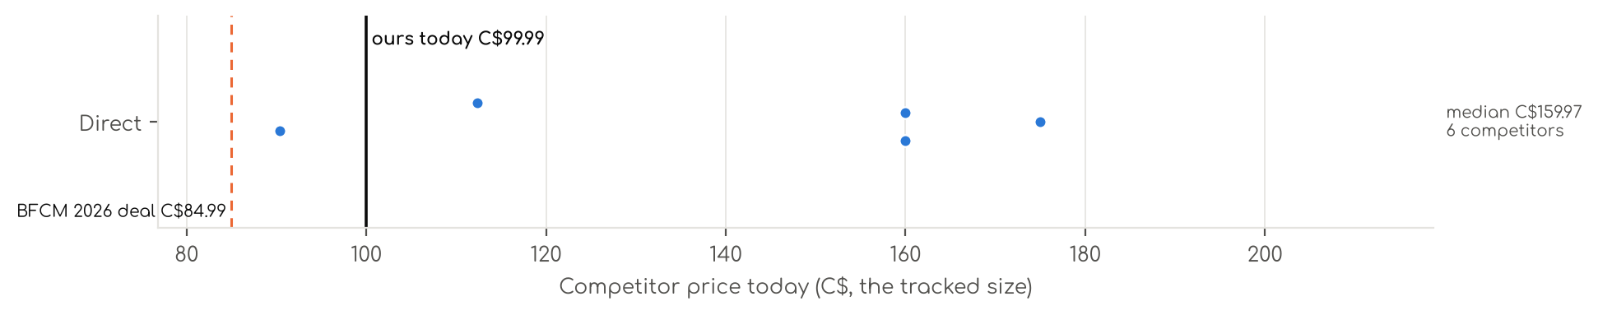
Photo | Competitor | Size · colour | Price | List | vs ours | Strike- through | BFCM 2025 deal | 2025 before → during | Disc. | Rank lift | Units / wk
Direct · 8
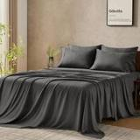 | GOKOTTA  Gökotta Queen Bed Sheets 6 Piece, 100% FSC® Certified Bamboo, Cooling  Bamboo viscose · 4.4★ 2,698  Amazon.ca organic #2 for 'bamboo sheets queen 6 piece'; 100% Rayon Made from Bamboo; variation_count = distinct children exposed in page var | Queen · 05 Dark Grey | C$159.99 | — | +60% | Not shown | Coupon only | C$159.99 → C$127.99 | 20% | 1.49x | —
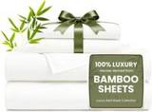 | Love's cabin  Love's cabin 100% Rayon Derived from Bamboo, Queen Sheets, 6 Pieces, White  Bamboo viscose · 4.4★ 1,854  Amazon.ca organic #12 for '6 piece bamboo sheets'; 100% Rayon Derived from Bamboo; variation_count = distinct children exposed in page varia | Queen · 01-white | C$90.36 | — | -10% | Not shown | Not live in 2025 | — | — | — | —
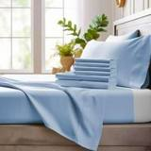 | Bamboo Bay  Bamboo Bay Luxury Bamboo Sheets Queen Size - 6 Piece Ultra Soft Cooling Sheets for Hot Sleepers - 100% Organic Bamboo Qu…  Bamboo viscose · 4.4★ 2,826  Amazon.ca organic #13 for '6 piece bamboo sheets'; 100% Organic Bamboo; Exact standard Queen sheet/set option selected; pillowcase-only, sho | Queen · Light Blue | — | — | — | Not shown | None | C$94.99 → C$94.99 | 0% | 0.82x | —
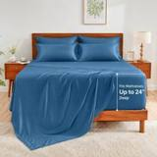 | GOKOTTA  Queen Bed Sheets 6 Piece Set by Gökotta, 24" Extra Deep Pocket Fitted Sheets with Elastic Corner Straps, 150 GSM Thicker…  Bamboo viscose · 4.5★ 323  Amazon.ca organic #13 for 'bamboo sheets queen 6 piece'; 100% Rayon Derived from Bamboo; variation_count = distinct children exposed in page | Queen · 03 Blue | C$174.99 | — | +75% | Not shown | Price cut only | C$174.99 → C$131.24 | 25% | 1.29x | —
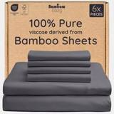 | Bambaw  Bambaw 100% Viscose Derived from Bamboo Sheets Queen Size Set – 6pcs Cooling Queen Sheet Set, Deep Pocket Fits Up to 16'…  Bamboo viscose · 4.3★ 3,030  Amazon.ca organic #17 for 'bamboo sheets queen 6 piece'; 100% Viscose Derived from Bamboo; variation_count = distinct children exposed in pa | Queen · Charcoal | C$159.95 | — | +60% | Not shown | Price cut only | C$159.95 → C$135.96 | 15% | 1.61x | —
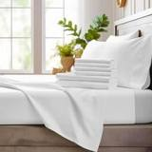 | Bamboo Bay  Bamboo Bay Luxury Bamboo Sheets Queen Size - 6 Piece Ultra Soft Cooling Sheets for Hot Sleepers - 100% Organic Bamboo Qu…  Bamboo viscose · 4.6★ 222  Amazon.ca organic #22 for 'bamboo sheets queen 6 piece'; 100% Organic Bamboo; Page parent field repeats the selected child; no distinct pare | Queen · White | C$112.35 | — | +12% | Not shown | — | — | — | 0.97x | —
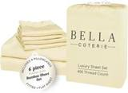 | BC BELLA COTERIE  Bella Coterie 6 Piece Luxury Bamboo Viscose Queen Sheet Set  Bamboo viscose · 4.4★ 6,192  Amazon.ca organic #38 for 'bamboo sheets queen 6 piece'; 100% Viscose Made from Bamboo; Selected new-variation stock/orderability not establ | Queen · 19 - Lemonade | — | — | — | Not shown | Not live in 2025 | — | — | — | —
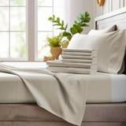 | Bamboo Bay  Bamboo Bay Luxury Bamboo Sheets Queen Size - 6 Piece Ultra Soft Cooling Sheets for Hot Sleepers - 100% Organic Bamboo Qu…  Bamboo viscose · 4.4★ 107  Amazon.ca organic #39 for 'bamboo sheets queen 6 piece'; 100% Organic Bamboo; Page parent field repeats the selected child; no distinct pare | Queen · Ivory | C$159.99 | — | +60% | Not shown | — | — | — | — | —

CA · DC S4: Decolure Satin Sheets 4 Piece
 | Listing title | DECOLURE Satin Bed Sheets - 4 Piece Luxury Silky Queen Size Bedding Set - Softer Than Silk, Wrinkle-Free with 15” Deep Pocket Fitted Sheet, Perfect for Hair & Skin, Gifts for Women (Black)
 | Marketplace | Canada
 | Family · role | Satin · Clearance with margin
 | Scope · stage | Core · Maintenance
 | Amazon parent | B0CT3HF44M
 | Best seller | B0839MKJMV (Queen Black)
 | Variations | 127 (98 with a live price)
 | Sizes | Queen, King, Full, Twin
 | Colours | 36

OUR PRICE TODAY  C$47.99  Queen Black | BFCM 2026 DEAL PRICE  C$47.99 → C$38.75  Best Deal Nov 19-30 · 19% off the Oct 27 price | STOCK TO NOV 30  16 short · 26 out  2,705 at Amazon · 940 inbound · need 1,862 | BFCM 2025 SALES LIFT  3.27x  455 units in the last 28 days | DIRECT COMPETITORS  11  median C$44.96 · 7 cheaper than us

BFCM 2025: how this product did
Period | Sales | Units | Organic units | Ad units | Ad cost | TACoS | Sessions | Unit session % | Avg price
Oct 21 – Nov 19, 2025 (30 days before) | C$47,285 | 1,704 | 1,467 | 237 | C$7,150 | 15.1% | 35,756 | 4.8% | C$27.75
Nov 20 – Dec 1, 2025 (BFCM week) | C$61,831 | 2,667 | 2,445 | 222 | C$6,603 | 10.7% | 38,883 | 6.9% | C$23.18
Dec 2 – 31, 2025 | C$97,479 | 3,494 | 3,124 | 370 | C$12,895 | 13.2% | 59,789 | 5.8% | C$27.90
Our BFCM 2025 deals: Coupon 10-22 to 11-16 (ran, 2 variations); Lightning Deal 11-03 to 11-04 (ran, 112 variations, 56 units); Lightning Deal 11-11 to 11-12 (ran, 112 variations, 79 units); Best Deal 11-20 to 12-02 (ran, 111 variations, 2,614 units)
Stock in BFCM 2025: 1 of 117 variations hit zero FBA stock on at least one observed day in BFCM week; weighted by sales mix, about 0.4% of variation-days were lost.

BFCM 2026 deal
Deal | Hero variation | Price Oct 27 | Deal price | Off | Variations (deal page) | Our 2025 cut | Rivals' 2025 cut
Best Deal Nov 19-30 | Queen Black | C$47.99 | C$38.75 | 19% | 88 eligible, 23 out of stock, 5 no reference price, 1 not on the deal page; 0%–39% off | 15% (C$29.95 → C$25.46) | 8% (3 rivals)

Stock to Nov 30
Sales per day today 25.4 · lift used 3.27x (this product's own BFCM 2025 lift) · need to Nov 30 1,862 units · at Amazon 2,705 · inbound 940. Covered 56, needs inbound in time 1, short 16, out of stock now 26.
Size | Colour | At Amazon | Inbound | Sales / day | Need to Nov 30 | Short by | Runs out | Status
Queen | Lavender | 0 | 0 | 2.7 | 198 | 198 | now | Out of stock now
Queen | Black | 29 | 0 | 1.2 | 89 | 60 | Nov 7 | Short even with inbound
Queen | Gold | 0 | 0 | 0.9 | 66 | 66 | now | Out of stock now
Queen | Rosewood | 21 | 0 | 0.7 | 53 | 32 | Nov 12 | Short even with inbound
Full | Lavender | 3 | 0 | 0.6 | 45 | 42 | Oct 19 | Short even with inbound
Queen | Striped Purple | 0 | 0 | 0.5 | 37 | 37 | now | Out of stock now
Twin | Pink | 0 | 0 | 0.5 | 33 | 33 | now | Out of stock now
Queen | Striped Black | 12 | 0 | 0.4 | 31 | 19 | Nov 11 | Short even with inbound
King | Dark Green | 30 | 0 | 0.4 | 31 | 1 | Nov 29 | Short even with inbound
Queen | Burnt Orange | 0 | 0 | 0.4 | 26 | 26 | now | Out of stock now
Queen | Ivory | 6 | 10 | 0.3 | 25 | 9 | Nov 1 | Short even with inbound
Full | Red | 7 | 0 | 0.3 | 23 | 16 | Nov 6 | Short even with inbound
Queen | Striped White | 0 | 0 | 0.3 | 22 | 22 | now | Out of stock now
Twin | Grey | 0 | 0 | 0.3 | 22 | 22 | now | Out of stock now
Twin | Rosewood | 0 | 0 | 0.3 | 21 | 21 | now | Out of stock now
Twin | Navy Blue | 0 | 0 | 0.3 | 19 | 19 | now | Out of stock now
Twin | Blue | 0 | 0 | 0.3 | 18 | 18 | now | Out of stock now
Twin | Black | 3 | 0 | 0.2 | 18 | 15 | Oct 27 | Short even with inbound
King | Ivory | 12 | 0 | 0.2 | 16 | 4 | Nov 24 | Short even with inbound
Queen | Baby Blue | 0 | 0 | 0.2 | 16 | 16 | now | Out of stock now
King | Taupe | 0 | 100 | 0.2 | 15 | — | now | Out of stock now
King | Striped Grey | 0 | 0 | 0.2 | 15 | 15 | now | Out of stock now
Queen | Taupe-01 | 0 | 0 | 0.2 | 15 | 15 | now | Out of stock now
Queen | Navy Blue | 0 | 0 | 0.2 | 13 | 13 | now | Out of stock now
Full | Striped Red | 4 | 0 | 0.2 | 12 | 8 | Nov 7 | Short even with inbound
Twin | Baby Blue | 8 | 0 | 0.1 | 11 | 3 | Nov 23 | Short even with inbound
Full | Purple | 8 | 0 | 0.1 | 8 | 0 | Nov 29 | Short even with inbound
King | Striped White | 3 | 36 | 0.1 | 7 | — | Nov 17 | Needs inbound in time
Twin | Striped White | 0 | 0 | 0.1 | 6 | 6 | now | Out of stock now
Queen | Dark Green | 0 | 0 | 0.1 | 5 | 5 | now | Out of stock now
Twin | Gold | 0 | 0 | 0.1 | 5 | 5 | now | Out of stock now
Full | Ivory | 4 | 0 | 0.1 | 5 | 1 | Nov 25 | Short even with inbound
Full | Striped Gold | 4 | 0 | 0.1 | 5 | 1 | Nov 25 | Short even with inbound
Full | Sea Teal | 5 | 0 | 0.1 | 5 | 0 | Nov 29 | Short even with inbound
King | Striped Blue | 4 | 0 | 0.1 | 5 | 1 | Nov 25 | Short even with inbound
Full | Gold | 0 | 0 | 0.1 | 4 | 4 | now | Out of stock now
Twin | Ivory | 0 | 0 | 0.0 | 3 | 3 | now | Out of stock now
Full | Burnt Orange | 0 | 0 | 0.0 | 3 | 3 | now | Out of stock now
Queen | Stripe Grey-01 | 0 | 0 | 0.0 | 3 | 3 | now | Out of stock now
Queen | Striped Pink | 0 | 0 | 0.0 | 3 | 3 | now | Out of stock now
Twin | Lavender | 0 | 0 | 0.0 | 3 | 3 | now | Out of stock now
Twin | Purple | 0 | 0 | 0.0 | 3 | 3 | now | Out of stock now
Full | Rosewood | 0 | 0 | 0.0 | 1 | 1 | now | Out of stock now

Sales mix, last 28 days
By size: Queen 225 · King 98 · Full 92 · Twin 40
By colour (top 8): Black 76 · Grey 38 · Pink 34 · Blush Pink 27 · White 26 · Navy Blue 24 · Blue 22 · Purple 22

Competitors (15)
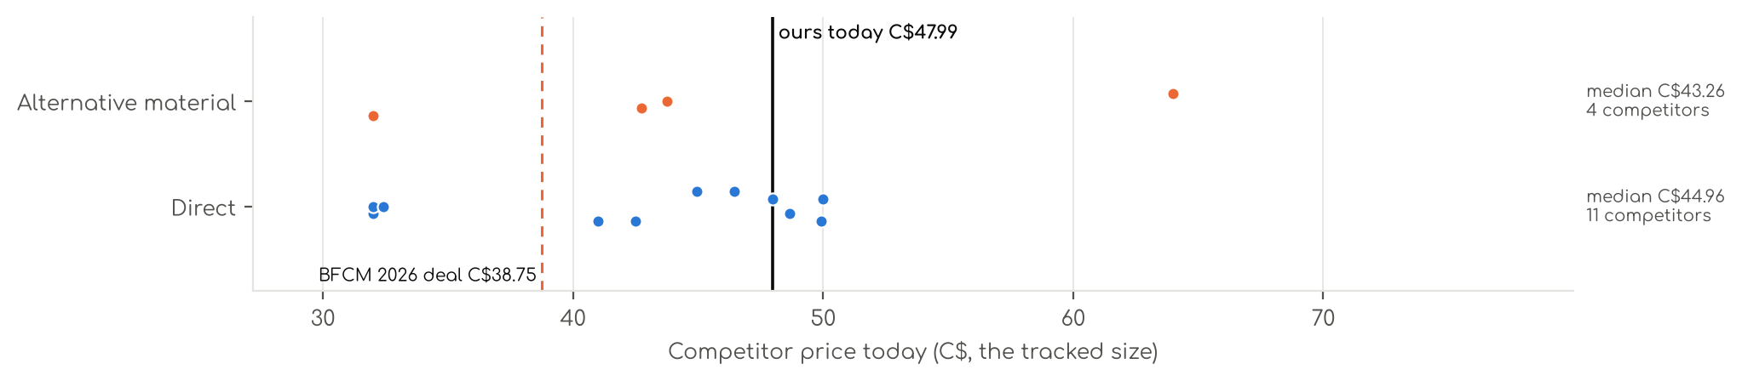
Photo | Competitor | Size · colour | Price | List | vs ours | Strike- through | BFCM 2025 deal | 2025 before → during | Disc. | Rank lift | Units / wk
Direct · 11
 | MR&HM  MR&HM Satin Sheets Queen Size with Elastic Corner Straps, Black  Satin (polyester) · 4.2★ 17,432  Amazon.ca organic #2 for 'satin sheets queen'; 100% Polyester Satin; 100+ bought in past month bought past month; variation_count = distinct | Queen · 01- Black | C$40.99 | — | -15% | Was price C$46.99 | None | C$39.99 → C$38.39 | 4% | 1.71x | —
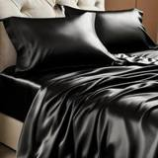 | BEDELITE  BEDELITE Satin Sheets Queen Size Bed Set, Black, 4 Pieces  Satin (polyester) · 4.1★ 346  Amazon.ca organic #3 for 'satin sheets queen'; 100% Polyester Satin; 100+ bought in past month bought past month; variation_count = distinct | Queen · Black | C$31.99 | — | -33% | Was price C$37.99 | Not live in 2025 | — | — | — | —
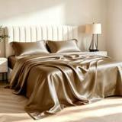 | HENGWEITEXT  HENGWEI Satin Sheet Set Queen Size, 4 Pieces Silky Bed Sheets with Deep Pocket, Luxury Soft Bedding Set Breathable and C…  Satin (polyester) · 4.2★ 2,515  Amazon.ca organic #5 for 'silk satin sheets'; Satin; Search child B0BYCB7QDF; selected Queen child B0BYC3HK7X. variation_count = distinct ch | Queen · Sd-brown | C$31.99 | — | -33% | Not shown | Coupon only | — | — | 1.00x | —
 | GOLAL  Black Satin Sheets Queen Size - 4 Pieces Luxury Silky Soft Bed Sheets  Satin (polyester) · 4.2★ 1,280  Amazon.ca organic #7 for 'silk satin sheets'; 100% polyester; Exact standard Queen sheet/set option selected; pillowcase-only, short-Queen, | Queen · Black | C$47.99 | — | 0% | Not shown | Prime Exclusive Discount | C$47.99 → C$34.55 | 28% | 0.88x | —
 | BEDELITE  BEDELITE Satin Sheets Queen Size Bed Set, Black, 4 Pieces  Satin (polyester) · 4.4★ 5,584  Amazon.ca organic #13 for 'satin sheets queen'; 100% Polyester Satin; variation_count = distinct children exposed in page variation map, not | Queen · Black | C$44.96 | — | -6% | Not shown | Price cut only | C$73.48 → C$60.16 | 18% | 0.78x | —
 | Pure Bedding  Pure Bedding Satin Sheets Queen [4-Piece, Black] Hotel Luxury Silky Bed Sheets - Extra Soft 1800 Microfiber Sheet Set, W…  Satin (polyester) · 4.2★ 12,410  Amazon.ca organic #14 for 'silk satin sheets'; 100% Microfiber; variation_count = distinct children exposed in page variation map, not a gua | Queen · Black | C$49.91 | — | +4% | Not shown | Price cut only | C$83.61 → C$45.19 | 46% | 0.91x | —
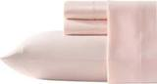 | Laura Ashley  Laura Ashley - Queen Sheet Set, 100% Soft & Silky Smooth Satin Bed Sheets, Deep Pockets, Bedding with Matching Fitted Sh…  Satin (polyester) · 4.3★ 13  Amazon.ca organic #16 for 'satin sheets queen'; 100% Polyester; variation_count = distinct children exposed in page variation map, not a gua | Queen · Bliss Pink | C$48.67 | — | +1% | Not shown | Not live in 2025 | — | — | — | —
 | Pure Bedding  Satin Sheets Queen [4-Piece, Black] Hotel Luxury Silky Bed Sheets - Extra Soft 1800 Microfiber Sheet Set, Wrinkle, Fade,…  Satin (polyester) · 4.2★ 41  Amazon.ca organic #22 for 'satin sheets queen'; 100% Microfiber; variation_count = distinct children exposed in page variation map, not a gu | Queen · Black-01 | C$32.40 | — | -32% | Not shown | — | — | — | — | —
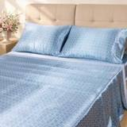 | Lirex  Lirex Satin Sheets Queen Size Bed Set, 4 Piece Sheet Set with 14" Deep Pocket, Luxury Smooth & Soft Microfiber, Includes…  Satin (polyester) · 4.6★ 4  Amazon.ca organic #22 for 'satin sheets king'; Polyester; Search child B0GWPTWBQL; selected Queen child B0GWPMHSL9. variation_count = distin | Queen · Blue Daisy | C$49.99 | — | +4% | Not shown | Not live in 2025 | — | — | — | —
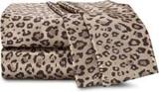 | Martex  4-Piece Martex Elegance Satin Sheets | Queen Size Bed Sheets | Luxury Hotel Quality Bed Sheets Set | Satin Sheets | Silk…  Satin (polyester) · 4.2★ 1,078  Amazon.ca organic #24 for 'satin sheets queen'; 100% Polyester; variation_count = distinct children exposed in page variation map, not a gua | Queen · Brown | C$46.45 | — | -3% | Not shown | None | C$44.76 → C$44.65 | 0% | 1.27x | —
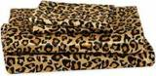 | Beatrice Home Fashions  Elite Home Products 100% Luxury Satin Polyester Solid Sheet Set, Queen, Leopard  Satin (polyester) · 4.0★ 996  Amazon.ca organic #24 for 'satin sheets king'; 100% Polyester; Search child B072K5TZVP; selected Queen child B0721C4SD3. variation_count = d | Queen · Leopard | C$42.49 | — | -11% | Was price C$47.95 | — | — | — | 1.00x | —
Alternative material · 4
 | Sasttie  Sasttie Satin Sheets Queen - 4 Pieces Luxury Soft Black Silky Bed Sheets Set with Pillowcases - Smooth Silk-Like Drap Sa…  Silk · 4.2★ 962  Amazon.ca organic #1 for 'satin sheets queen'; satin; 300+ bought in past month bought past month; Search child B0F2H9HRJJ; selected Queen c | Queen · Black | C$31.99 | — | -33% | Not shown | None | C$24.99 → C$24.99 | 0% | 0.64x | —
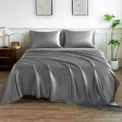 | LIFCOM  Satin Sheets Queen Size Bed Set,Similar to Silk Sheets,4Pcs Luxury Satin Sheet Set with 15 Inches Deep Pocket (Queen, Da…  Silk · 4.3★ 351  Amazon.ca organic #15 for 'silk satin sheets'; Satin; Search child B0DCC5T8MG; selected Queen child B0DCC37WB3. variation_count = distinct c | Queen · Dark Grey | C$42.74 | — | -11% | Was price C$44.99 | Price cut only | C$39.99 → C$37.99 | 5% | 1.00x | —
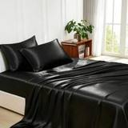 | Lanest Housing  Lanest Housing Silk Satin Sheets, 4-Piece Queen Size Satin Bed Sheet Set with Deep Pockets, Cooling Soft and Hypoallerge…  Silk · 4.2★ 5,574  Amazon.ca organic #21 for 'silk satin sheets'; 100% Polyester; variation_count = distinct children exposed in page variation map, not a guar | Queen · Black | C$43.77 | — | -9% | Was price C$52.02 | None | C$54.66 → C$52.84 | 3% | 0.74x | —
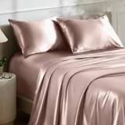 | Bare Home  Bare Home Poly Satin Sheet Set Similar to Silk (Queen, Blush)  Silk · 3.6★ 114  Amazon.ca organic #23 for 'satin sheets king'; Poly Satin; variation_count = distinct children exposed in page variation map, not a guarante | Queen · 05 - Blush | C$63.99 | — | +33% | Was price C$67.99 | Not live in 2025 | — | — | — | —

CA · DC S6: Decolure Satin Sheets 6 Piece
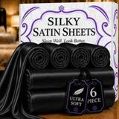 | Listing title | DECOLURE Satin Bed Sheets - 6 Piece Luxury Silky Queen Size Bedding Set - Softer Than Silk, Wrinkle-Free with 15” Deep Pocket Fitted Sheet, Perfect for Hair & Skin, Gifts for Women (Black)
 | Marketplace | Canada
 | Family · role | Satin · Clearance with margin
 | Scope · stage | Core · Maintenance
 | Amazon parent | B0CJSDXDJW
 | Best seller | B0C7FX1GFS (Queen Black)
 | Variations | 118 (105 with a live price)
 | Sizes | Queen, King, Full, Twin
 | Colours | 31

OUR PRICE TODAY  C$47.99  Queen Black | BFCM 2026 DEAL PRICE  C$47.99 → C$38.75  Best Deal Nov 19-30 · 19% off the Oct 27 price | STOCK TO NOV 30  21 short · 27 out  1,094 at Amazon · 1,348 inbound · need 1,485 | BFCM 2025 SALES LIFT  2.98x  326 units in the last 28 days | DIRECT COMPETITORS  14  median C$59.45 · 2 cheaper than us

BFCM 2025: how this product did
Period | Sales | Units | Organic units | Ad units | Ad cost | TACoS | Sessions | Unit session % | Avg price
Oct 21 – Nov 19, 2025 (30 days before) | C$25,132 | 918 | 823 | 95 | C$4,168 | 16.6% | 19,229 | 4.8% | C$27.38
Nov 20 – Dec 1, 2025 (BFCM week) | C$29,919 | 1,201 | 1,081 | 120 | C$3,933 | 13.1% | 16,679 | 7.2% | C$24.91
Dec 2 – 31, 2025 | C$50,577 | 1,800 | 1,627 | 173 | C$7,673 | 15.2% | 29,238 | 6.2% | C$28.10
Our BFCM 2025 deals: Lightning Deal 11-04 to 11-05 (ran, 99 variations, 18 units); Lightning Deal 11-14 to 11-15 (ran, 99 variations, 1 units); Best Deal 11-20 to 12-02 (ran, 83 variations, 1,081 units)
Stock in BFCM 2025: 0 of 110 variations hit zero FBA stock on at least one observed day in BFCM week; weighted by sales mix, about 0.0% of variation-days were lost.

BFCM 2026 deal
Deal | Hero variation | Price Oct 27 | Deal price | Off | Variations (deal page) | Our 2025 cut | Rivals' 2025 cut
Best Deal Nov 19-30 | Queen Black | C$47.99 | C$38.75 | 19% | 97 eligible, 11 out of stock, 8 no reference price, 1 manual price; -14%–35% off | 5% (C$33.95 → C$32.25) | 8% (3 rivals)

Stock to Nov 30
Sales per day today 21.3 · lift used 2.98x (this product's own BFCM 2025 lift) · need to Nov 30 1,485 units · at Amazon 1,094 · inbound 1,348. Covered 43, needs inbound in time 6, short 21, out of stock now 27.
Size | Colour | At Amazon | Inbound | Sales / day | Need to Nov 30 | Short by | Runs out | Status
King | Stone Grey | 0 | 0 | 2.4 | 167 | 167 | now | Out of stock now
King | Dark Green | 0 | 0 | 0.9 | 64 | 64 | now | Out of stock now
King | Striped White | 5 | 0 | 0.9 | 61 | 56 | Oct 20 | Short even with inbound
Queen | Striped Purple | 0 | 0 | 0.8 | 59 | 59 | now | Out of stock now
Queen | Rosewood | 15 | 330 | 0.8 | 54 | — | Nov 3 | Needs inbound in time
Full | Black | 43 | 0 | 0.7 | 51 | 8 | Nov 26 | Short even with inbound
King | Red | 0 | 0 | 0.6 | 43 | 43 | now | Out of stock now
King | Black | 18 | 0 | 0.6 | 42 | 24 | Nov 14 | Short even with inbound
Queen | Stone Grey | 31 | 700 | 0.6 | 40 | — | Nov 24 | Needs inbound in time
Queen | Purple | 22 | 0 | 0.5 | 38 | 16 | Nov 20 | Short even with inbound
Twin | Black | 5 | 0 | 0.5 | 35 | 30 | Oct 25 | Short even with inbound
King | Rosewood | 0 | 0 | 0.4 | 28 | 28 | now | Out of stock now
Queen | Red | 16 | 0 | 0.4 | 27 | 11 | Nov 20 | Short even with inbound
King | Purple | 0 | 0 | 0.3 | 24 | 24 | now | Out of stock now
Queen | Sea Teal | 0 | 0 | 0.3 | 24 | 24 | now | Out of stock now
Queen | Striped Grey | 7 | 0 | 0.3 | 22 | 15 | Nov 5 | Short even with inbound
King | Striped Gold | 0 | 0 | 0.3 | 21 | 21 | now | Out of stock now
King | White | 3 | 0 | 0.3 | 19 | 16 | Oct 26 | Short even with inbound
King | Sea Teal | 18 | 78 | 0.3 | 19 | — | Nov 28 | Needs inbound in time
Queen | Grey | 0 | 0 | 0.2 | 17 | 17 | now | Out of stock now
King | Blue | 14 | 0 | 0.2 | 16 | 2 | Nov 27 | Short even with inbound
Full | Burnt Orange | 1 | 0 | 0.2 | 15 | 14 | Oct 19 | Short even with inbound
Full | Striped Grey | 5 | 18 | 0.2 | 15 | — | Nov 6 | Needs inbound in time
Queen | Taupe | 5 | 24 | 0.2 | 15 | — | Nov 6 | Needs inbound in time
King | Grey | 2 | 0 | 0.2 | 13 | 11 | Oct 25 | Short even with inbound
Twin | Rosewood | 3 | 0 | 0.2 | 12 | 9 | Nov 1 | Short even with inbound
Queen | Champagne | 0 | 0 | 0.2 | 11 | 11 | now | Out of stock now
King | Striped Purple | 0 | 0 | 0.1 | 10 | 10 | now | Out of stock now
King | Striped Black | 0 | 0 | 0.1 | 10 | 10 | now | Out of stock now
Queen | Lavender | 6 | 0 | 0.1 | 10 | 4 | Nov 20 | Short even with inbound
Twin | Grey | 5 | 24 | 0.1 | 10 | — | Nov 18 | Needs inbound in time
Queen | Ivory | 8 | 0 | 0.1 | 9 | 1 | Nov 27 | Short even with inbound
Queen | Red | 3 | 0 | 0.1 | 8 | 5 | Nov 11 | Short even with inbound
Full | Red | 7 | 0 | 0.1 | 8 | 1 | Nov 27 | Short even with inbound
Twin | Purple | 0 | 0 | 0.1 | 7 | 7 | now | Out of stock now
Twin | Red | 0 | 0 | 0.1 | 7 | 7 | now | Out of stock now
Queen | Baby Blue | 0 | 0 | 0.1 | 6 | 6 | now | Out of stock now
Full | Grey | 3 | 0 | 0.1 | 6 | 3 | Nov 17 | Short even with inbound
Twin | Pink | 0 | 0 | 0.1 | 6 | 6 | now | Out of stock now
Full | Rosewood | 0 | 0 | 0.1 | 5 | 5 | now | Out of stock now
King | Baby Blue | 0 | 0 | 0.1 | 5 | 5 | now | Out of stock now
Queen | Pink | 0 | 0 | 0.1 | 5 | 5 | now | Out of stock now
Twin | White | 2 | 0 | 0.1 | 5 | 3 | Nov 12 | Short even with inbound
Full | Champagne | 1 | 0 | 0.0 | 3 | 2 | Nov 9 | Short even with inbound
Full | Sage Green | 0 | 0 | 0.0 | 3 | 3 | now | Out of stock now
Full | Ivory | 0 | 0 | 0.0 | 2 | 2 | now | Out of stock now
Full | Purple | 0 | 0 | 0.0 | 2 | 2 | now | Out of stock now
King | Ivory | 0 | 0 | 0.0 | 2 | 2 | now | Out of stock now
Queen | Dark Green | 0 | 0 | 0.0 | 2 | 2 | now | Out of stock now
Queen | Striped Black | 0 | 0 | 0.0 | 2 | 2 | now | Out of stock now
Full | Striped Purple | 0 | 0 | 0.0 | 2 | 2 | now | Out of stock now
Twin | Blush Pink | 1 | 0 | 0.0 | 2 | 1 | Nov 17 | Short even with inbound
King | Taupe | 0 | 0 | 0.0 | 1 | 1 | now | Out of stock now
Twin | Gold | 1 | 0 | 0.0 | 1 | 0 | Nov 23 | Short even with inbound

Sales mix, last 28 days
By size: Queen 130 · King 103 · Full 59 · Twin 34
By colour (top 8): Black 65 · Rosewood 22 · Red 22 · Purple 21 · Striped Grey 20 · White 20 · Stone Grey 16 · Baby Blue 13

Competitors (15)
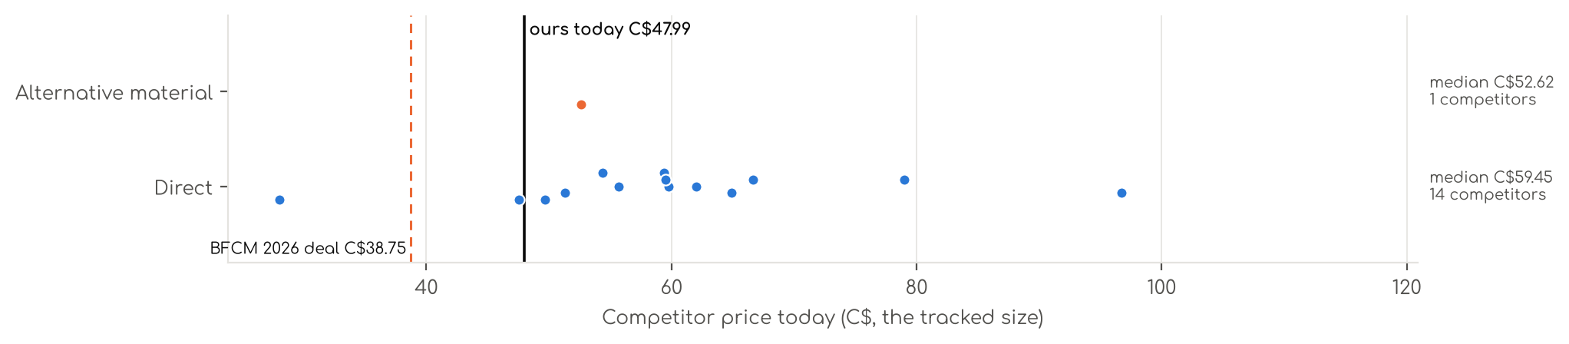
Photo | Competitor | Size · colour | Price | List | vs ours | Strike- through | BFCM 2025 deal | 2025 before → during | Disc. | Rank lift | Units / wk
Direct · 14
 | JUWENIN  Satin Sheet Set, 6 Piece Soft Silky Bed Sheets Deep Pocket, Good for Skin and Hair 1 Satin Fitted Sheet + 1 Flat Sheet +…  Satin (polyester) · 4.1★ 29  Amazon.ca organic #1 for 'satin sheets 6 piece'; 100%POLYESTER; Search child B0FNR1PKQB; selected Queen-6PCS child B0FNR1QR4J. Orderable; av | Queen · Gray | C$27.99 | — | -42% | Not shown | — | — | — | 1.71x | —
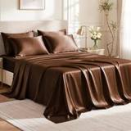 | Love's cabin  Love's cabin Satin Queen Sheets Set, 6 Pieces, Brown, 15" Deep Pocket  Satin (polyester) · 4.4★ 5,953  Amazon.ca organic #5 for 'satin sheets queen 6 piece'; 100% Polyester; variation_count = distinct children exposed in page variation map, no | Queen · Brown. | C$51.29 | — | +7% | Not shown | Not live in 2025 | — | — | — | —
 | P Pothuiny  P Pothuiny 6-Piece Queen Satin Sheet Set Burgundy Silky Sheets  Satin (polyester) · 4.4★ 3,487  Amazon.ca organic #6 for 'satin sheets queen 6 piece'; 100% Polyester Satin; variation_count = distinct children exposed in page variation m | Queen · Burgundy | C$55.67 | — | +16% | Not shown | None | C$50.65 → C$53.14 | -5% | 0.76x | —
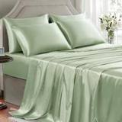 | GOLAL  Sage Green Satin Sheets Queen Size - 6 Pieces Silky Soft Bed Sheets  Satin (polyester) · 4.0★ 31  Amazon.ca organic #10 for 'satin sheets queen 6 piece'; 100% Polyester; variation_count = distinct children exposed in page variation map, n | Queen · Sage Green | C$66.66 | — | +39% | Was price C$88.10 | Prime Exclusive Discount | C$49.99 → C$39.99 | 20% | 0.87x | —
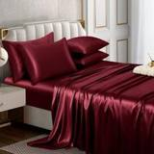 | Horbaunal  Horbaunal 6 Piece Satin Sheet Set Queen Size Luxury Silky & Soft Burgundy Satin Queen Bed Sheet Set with 16" Deep Pocket…  Satin (polyester) · 4.4★ 842  Amazon.ca organic #12 for 'satin sheets queen 6 piece'; 100% Polyester; variation_count = distinct children exposed in page variation map, n | Queen · Burgundy | C$54.37 | — | +13% | Was price C$62.09 | None | C$50.06 → C$58.33 | -17% | 0.89x | —
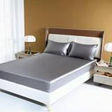 | JUWENIN  JUWENIN Satin Sheet Set, 6 Piece Soft Silky Bed Sheets Deep Pocket, Good for Skin and Hair 1 Satin Fitted Sheet + 1 Flat…  Satin (polyester)  Amazon.ca organic #15 for 'satin sheets queen 6 piece'; 100%polyester Satin; variation_count = distinct children exposed in page variation m | Queen · Gray | C$49.70 | — | +4% | Not shown | None | C$35.93 → C$35.81 | 0% | — | —
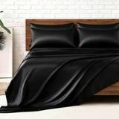 | MR&HM  MR&HM Satin Sheets Queen Size with Elastic Corner Straps, Black  Satin (polyester) · 4.2★ 17,432  Amazon.ca organic #16 for 'satin sheets 6 piece'; 100% Polyester Satin; variation_count = distinct children exposed in page variation map, n | Queen · 01- Black | C$64.89 | — | +35% | Was price C$74.35 | None | C$90.26 → C$90.26 | 0% | 1.71x | —
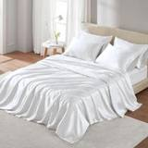 | Madison Park  Madison Park Essentials Satin Sheet Set Luxury and Silky with Natural Sheen, Elastic 14" Pocket fits up to 16" Mattress,…  Satin (polyester) · 4.3★ 40  Amazon.ca organic #19 for 'satin sheets queen 6 piece'; 100% Polyester Solid Satin; Page parent field repeats the selected child; no distinc | Queen · White | C$59.75 | — | +25% | Not shown | None | C$48.84 → C$49.08 | -0% | 1.42x | —
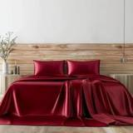 | Candoury  Candoury - Satin Sheet Set 6 Piece Luxury Queen Bed Sheets Set - Soft Durable Flat Sheet Set - Top Sheet, Fitted Sheet &…  Satin (polyester) · 4.2★ 5,080  Amazon.ca organic #24 for 'satin sheets queen 6 piece'; 100% Satin Polyester; Orderable; availability wording: Usually ships within 3 to 4 d | Queen · Burgundy | C$78.99 | — | +65% | Not shown | None | C$78.34 → C$78.34 | 0% | 0.49x | —
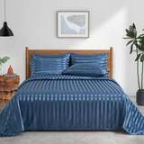 | P Pothuiny  P Pothuiny 6-Piece Queen Satin Sheet Set Flint Blue Striped Printed  Satin (polyester) · 4.4★ 23  Amazon.ca organic #31 for 'satin sheets queen 6 piece'; Satin; Page parent field repeats the selected child; no distinct parent ASIN exposed | Queen · Flint Blue | C$59.40 | — | +24% | Not shown | — | — | — | — | —
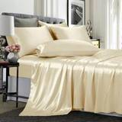 | TREELY  TREELY 6 Piece Satin Sheets King Size Silky Smooth Beige Satin Sheet Set with Deep Pocket, Satin Fitted Sheet, Flat Shee…  Satin (polyester) · 5.0★ 3  Amazon.ca organic #37 for 'satin sheets 6 piece'; Satin; No Queen option exposed; King used. Page parent field repeats the selected child; n | King · Beige | C$47.57 | — | -5% | Not shown | None | C$47.61 → C$80.37 | -69% | 0.98x | —
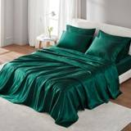 | Madison Park  Madison Park Satin Sheets Queen Size, Luxurious Silky Bed Sheets, Elastic 14" Pocket fits up to 16" Mattress, Wrinkle-Fr…  Satin (polyester) · 4.2★ 110  Amazon.ca organic #37 for 'satin sheets queen 6 piece'; Satin; variation_count = distinct children exposed in page variation map, not a guar | Queen · Emerald Green | C$96.70 | — | +102% | Not shown | — | — | — | 1.00x | —
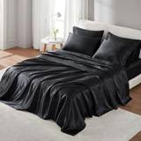 | Madison Park  Madison Park Essentials Premier Comfort SHET20-173 Satin 6 Piece Sheet Set, Queen, Black  Satin (polyester) · 4.0★ 2,955  Amazon.ca organic #39 for 'satin sheets queen 6 piece'; Polyester; Page Fabric Type field is non-material text (3.27); Material field used i | Queen · Black | C$61.99 | — | +29% | Not shown | None | C$50.69 → C$48.16 | 5% | 1.20x | —
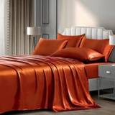 | P Pothuiny  P Pothuiny 6-Piece Queen Satin Sheet Set Burnt Orange Silky Sheets  Satin (polyester) · 4.0★ 64  Amazon.ca organic #40 for 'satin sheets queen 6 piece'; 100% Polyester Satin; Page parent field repeats the selected child; no distinct pare | Queen · Burnt Orange | C$59.50 | — | +24% | Not shown | None | C$74.34 → C$74.34 | 0% | — | —
Alternative material · 1
 | Madison Park  Madison Park Essentials Polyester Satin 6 Piece Sheet Set with Ivory MPE20-904, Queen  Microfiber / polyester · 4.4★ 123  Amazon.ca organic #9 for 'satin sheets queen 6 piece'; 100% Polyester Solid Satin; variation_count = distinct children exposed in page varia | Queen · Ivory | C$52.62 | — | +10% | Not shown | None | C$55.24 → C$57.27 | -4% | 1.11x | —

CA · DC Satin Fitted: Decolure Satin Fitted Sheet
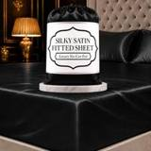 | Listing title | DECOLURE Satin Fitted Sheet Queen Size (1 PC) – Luxuriously Smooth & Softer Than Silk Bed Sheets w/ 15 Inch Deep Pocket Hypoallergenic Wrinkle Free, Secure Snug Fit, Elastic Corner Straps (Black)
 | Marketplace | Canada
 | Family · role | Satin · Opportunistic
 | Scope · stage | Core · Maintenance
 | Amazon parent | B0FQC9C5QT
 | Best seller | B0DBW1PNJ8 (Queen Black)
 | Variations | 68 (55 with a live price)
 | Sizes | Queen, Twin, Full, King
 | Colours | 17

OUR PRICE TODAY  C$22.95  Queen Black | BFCM 2026 DEAL PRICE  C$22.95 → C$21.80  Best Deal Nov 19-30 · 5% off the Oct 27 price | STOCK TO NOV 30  4 short · 18 out  1,748 at Amazon · 360 inbound · need 696 | BFCM 2025 SALES LIFT  0.74x  204 units in the last 28 days | DIRECT COMPETITORS  10  median C$23.90 · 5 cheaper than us

BFCM 2025: how this product did
Period | Sales | Units | Organic units | Ad units | Ad cost | TACoS | Sessions | Unit session % | Avg price
Oct 21 – Nov 19, 2025 (30 days before) | C$9,458 | 618 | 618 | 0 | C$0 | 0.0% | 9,672 | 6.4% | C$15.30
Nov 20 – Dec 1, 2025 (BFCM week) | C$2,791 | 168 | 166 | 2 | C$36 | 1.3% | 2,381 | 7.1% | C$16.62
Dec 2 – 31, 2025 | C$7,219 | 433 | 433 | 0 | C$3 | 0.0% | 5,821 | 7.4% | C$16.67
Our BFCM 2025 deals: Best Deal 10-22 to 11-05 (ran, 49 variations, 346 units)
Stock in BFCM 2025: 1 of 34 variations hit zero FBA stock on at least one observed day in BFCM week; weighted by sales mix, about 0.0% of variation-days were lost.

BFCM 2026 deal
Deal | Hero variation | Price Oct 27 | Deal price | Off | Variations (deal page) | Our 2025 cut | Rivals' 2025 cut
Best Deal Nov 19-30 | Queen Black | C$22.95 | C$21.80 | 5% | 50 eligible, 14 out of stock, 3 manual price, 1 no reference price; -38%–5% off | 11% (C$16.95 → C$15.15) | 5% (2 rivals)

Stock to Nov 30
Sales per day today 9.7 · lift used 3.14x (account lift, assumed) · need to Nov 30 696 units · at Amazon 1,748 · inbound 360. Covered 38, needs inbound in time 0, short 4, out of stock now 18.
Size | Colour | At Amazon | Inbound | Sales / day | Need to Nov 30 | Short by | Runs out | Status
King | Black | 0 | 0 | 1.4 | 100 | 100 | now | Out of stock now
Full | White | 48 | 0 | 0.8 | 59 | 11 | Nov 25 | Short even with inbound
Queen | Red | 0 | 0 | 0.5 | 36 | 36 | now | Out of stock now
King | White | 4 | 0 | 0.5 | 34 | 30 | Oct 23 | Short even with inbound
Queen | White | 0 | 0 | 0.4 | 31 | 31 | now | Out of stock now
Queen | Dark Green | 16 | 0 | 0.4 | 30 | 14 | Nov 19 | Short even with inbound
Queen | Pink | 0 | 0 | 0.4 | 29 | 29 | now | Out of stock now
Queen | Black | 0 | 0 | 0.4 | 28 | 28 | now | Out of stock now
King | Grey | 0 | 0 | 0.3 | 19 | 19 | now | Out of stock now
Queen | Grey | 0 | 0 | 0.2 | 16 | 16 | now | Out of stock now
King | Navy Blue | 0 | 0 | 0.2 | 14 | 14 | now | Out of stock now
Twin | Black | 0 | 0 | 0.1 | 11 | 11 | now | Out of stock now
King | Stone Grey | 0 | 0 | 0.1 | 8 | 8 | now | Out of stock now
Queen | Sea Teal | 0 | 0 | 0.1 | 7 | 7 | now | Out of stock now
King | Dark Green | 0 | 0 | 0.1 | 5 | 5 | now | Out of stock now
Queen | Blush Pink | 0 | 0 | 0.1 | 5 | 5 | now | Out of stock now
King | Red | 2 | 0 | 0.1 | 4 | 2 | Nov 17 | Short even with inbound
Queen | Navy Blue | 0 | 0 | 0.1 | 4 | 4 | now | Out of stock now
King | Ivory | 0 | 0 | 0.1 | 4 | 4 | now | Out of stock now
Full | Black | 0 | 0 | 0.1 | 4 | 4 | now | Out of stock now
King | Rosewood | 0 | 0 | 0.0 | 3 | 3 | now | Out of stock now
Queen | Sage Green | 0 | 0 | 0.0 | 3 | 3 | now | Out of stock now

Sales mix, last 28 days
By size: Queen 84 · Twin 44 · Full 41 · King 35
By colour (top 8): Black 24 · Pink 24 · White 24 · Grey 19 · Dark Green 16 · Red 16 · Lavender 12 · Rosewood 11

Competitors (15)
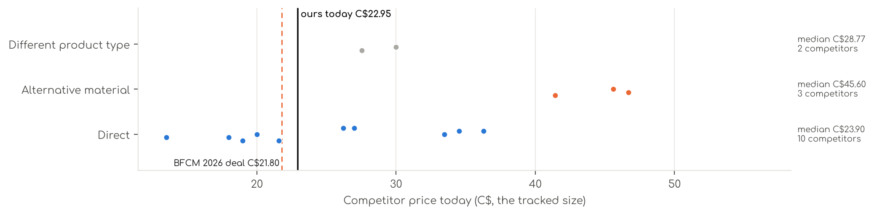
Photo | Competitor | Size · colour | Price | List | vs ours | Strike- through | BFCM 2025 deal | 2025 before → during | Disc. | Rank lift | Units / wk
Direct · 10
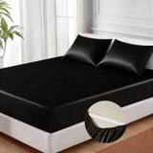 | MR&HM  MR&HM Satin Fitted Sheet Queen Size with Elastic Corner Straps, Black  Satin (polyester) · 3.9★ 648  Amazon.ca organic #1 for 'satin fitted sheet queen'; 100% Polyester Satin; 100+ bought in past month bought past month; variation_count = di | Queen · 01 - Black | C$21.59 | — | -10% | Was price C$23.99 | Price cut only | C$27.99 → C$23.79 | 15% | 1.71x | —
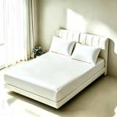 | FLCA  Solid Fitted Sheet - Deep Pocket Satin Bed Sheet, Breathable Soft and Comfortable - Wrinkle, Fade, Stain and Abrasion Re…  Satin (polyester) · 3.8★ 242  Amazon.ca organic #3 for 'satin fitted sheet'; SATIN; Search child B07Q6RTH8J; selected Queen child B07Q7PR1MD. variation_count = distinct c | Queen · White | C$17.99 | — | -25% | Not shown | None | C$17.99 → C$17.99 | 0% | 1.43x | —
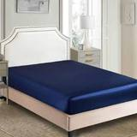 | JUWENIN  Fitted Sheet - Luxury Silky Soft Satin Bottom Sheet - Deep Pockets, Shrinkage and Fade Resistant - Easy Care - 1 Fitted …  Satin (polyester) · 4.2★ 125  Amazon.ca organic #4 for 'satin fitted sheet queen'; 100%POLYESTER; variation_count = distinct children exposed in page variation map, not a | Queen · Navy | C$19.99 | — | -17% | Not shown | None | — | — | 0.80x | —
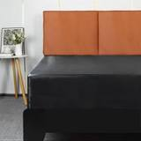 | Lirex  Lirex Satin Fitted Sheet, Luxurious Silky Smooth Polyester Bedding Soft Deep Pocket Bed Sheets Mattress Cover, Queen, Bl…  Satin (polyester) · 4.4★ 430  Amazon.ca organic #4 for 'satin fitted sheet'; Polyester; Search child B0D62V4P12; selected Queen child B0D62VPSSW. variation_count = distin | Queen · Black | C$36.29 | — | +52% | Not shown | Prime Exclusive Discount | C$23.89 → C$20.30 | 15% | 1.41x | —
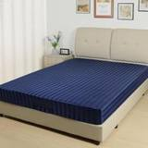 | Lirex  Lirex Satin Fitted Sheet, Silky & Soft Polyester Satin Weave Bed Sheets, 14"/36 cm Deep Pocket with Elastic Corner Strap…  Satin (polyester) · 4.1★ 39  Amazon.ca organic #11 for 'satin fitted sheet'; Satin; Search child B0FDZV4JVL; selected Queen child B0F7R36H12. variation_count = distinct | Queen · Navy Blue Stripes | C$26.21 | — | +9% | Not shown | None | C$22.55 → C$23.99 | -6% | 0.82x | —
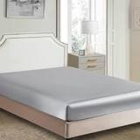 | JUWENIN  Fitted Sheet - Luxury Silky Soft Satin Bottom Sheet - Deep Pockets, Shrinkage and Fade Resistant - Easy Care - 1 Fitted …  Satin (polyester) · 3.7★ 26  Amazon.ca organic #12 for 'satin fitted sheet queen'; 100%POLYESTER; variation_count = distinct children exposed in page variation map, not | Queen · Grey | C$18.99 | — | -21% | Not shown | None | C$18.99 → C$18.99 | 0% | 0.92x | —
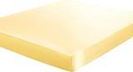 | uxcell  uxcell Satin Fitted Sheet Queen Size, Solid Silky 12" Deep Pocket for Bed Sheet, Soft Breathable Bed Fitted Sheet 79"x60…  Satin (polyester) · 3.6★ 7  Amazon.ca organic #23 for 'satin fitted sheet queen'; 100% Polyester; Page parent field repeats the selected child; no distinct parent ASIN | Queen · White | C$13.49 | — | -44% | Not shown | None | C$25.19 → C$25.19 | 0% | 0.99x | —
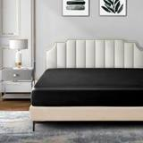 | P Pothuiny  P Pothuiny Satin Fitted Sheet Queen Black Single Mattress Cover Only  Satin (polyester) · 4.4★ 534  Amazon.ca organic #24 for 'satin fitted sheet queen'; 100% Polyester Satin; variation_count = distinct children exposed in page variation ma | Queen · Black | C$33.48 | — | +40% | Not shown | None | C$29.57 → C$29.57 | 0% | 0.91x | —
 | Homiest  Homiest Black Satin Fitted Sheet Queen Size Deep Pocket Luxury Ultra Soft Bedding  Satin (polyester) · 4.5★ 484  Amazon.ca organic #26 for 'satin fitted sheet queen'; Polyester,silky,satin; variation_count = distinct children exposed in page variation m | Queen · Brown | C$34.53 | — | +44% | Not shown | None | C$25.73 → C$29.95 | -16% | 0.76x | —
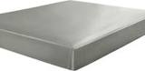 | uxcell  uxcell Satin Fitted Sheet Queen Size, Solid Silky 12" Deep Pocket for Bed Sheet, Soft Breathable Bed Fitted Sheet 79"x60…  Satin (polyester) · 3.8★ 22  Amazon.ca organic #36 for 'satin fitted sheet queen'; 100% Polyester; Page parent field repeats the selected child; no distinct parent ASIN | Queen · White | C$26.99 | — | +13% | Not shown | — | — | — | 1.00x | —
Alternative material · 3
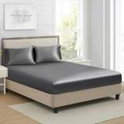 | Lanest Housing  Queen Silk Satin Fitted Sheet, Soft Deep Pocket Single Bottom Bed Sheets Sold Separately, Wrinkle Free, Non- Fading, Bre…  Silk · 4.0★ 4,038  Amazon.ca organic #19 for 'satin fitted sheet'; Satin,Silky; Search child B09CL5Z5HS; selected Queen child B09CL6BLJC. variation_count = dis | Queen · Grey | C$41.44 | — | +73% | Not shown | None | C$48.96 → C$48.05 | 2% | 0.55x | —
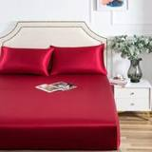 | Luxbedding  LuxBedding Satin Fitted Bed Sheet Only, Soft as Silk, Queue, Burgundy  Silk · 4.3★ 1,600  Amazon.ca organic #30 for 'satin fitted sheet'; 100% Polyester; Search child B08QF3YY8G; selected Queen - Fitted Sheet Only child B08QF4WDWL | Queen · Red | C$46.69 | — | +95% | Not shown | None | C$58.57 → C$57.07 | 3% | 0.79x | —
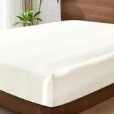 | BEDELITE  BEDELITE Satin Fitted Sheet Queen Size for Hair & Skin, Luxury Soft Silk-Like Bed Sheet with Elastic Corner Straps, 1 De…  Silk · 4.5★ 490  Amazon.ca organic #32 for 'satin fitted sheet'; 100% Polyester Satin; Search child B0FL2DCWX7; selected Queen child B0FL2BKPPN. variation_co | Queen · Ivory | C$45.60 | — | +90% | Not shown | — | — | — | — | —
Different product type · 2
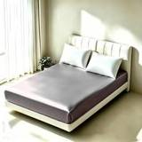 | FLCA  1 Piece Satin Fitted Sheet Only Classic Luxury Silky Soft Bed Sheets Solid Color (Grey, Fitted Sheet(Queen))  Satin (polyester) · 4.3★ 312  Amazon.ca organic #5 for 'satin fitted sheet'; Polyester,Silky,Satin; Search child B08FCBB96H; selected Fitted sheet(Queen) child B08FCC1QFF | Queen · Grey | C$27.55 | — | +15% | Not shown | None | C$20.66 → C$20.66 | 0% | 0.55x | —
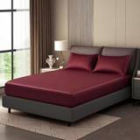 | YASMENG  Wine Red Queen Satin Fitted Sheets Only with 14" Elastic Deep Pocket  Satin (polyester) · 4.1★ 153  Amazon.ca organic #8 for 'satin fitted sheet'; 100% Microfiber; Search child B0CPS7PQBH; selected Queen child B0CPSG8X6G. variation_count = | Queen · Burgundy | C$29.99 | — | +25% | Not shown | Prime Exclusive Discount | C$29.99 → C$22.49 | 25% | 1.74x | —

CA · SSS4: Sleep Sanctuary Satin Sheets 4 Piece
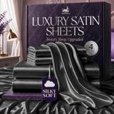 | Listing title | Sleep Sanctuary Satin Sheets King Size – 4 Piece Luxury Silky Bed Set, Softer Than Silk, 15" Deep Pocket, Cooling & Wrinkle-Free, Moisture-Wicking & Breathable for Hair & Skin (Stone Grey)
 | Marketplace | Canada
 | Family · role | Satin · Clearance with margin
 | Scope · stage | Core · Maintenance
 | Amazon parent | B0F2Z7C4ST
 | Best seller | B0DDR1ZPRZ (King Stone Grey)
 | Variations | 116 (86 with a live price)
 | Sizes | King, Queen, Twin, Full
 | Colours | 29

OUR PRICE TODAY  C$49.95  King Stone Grey | BFCM 2026 DEAL PRICE  C$49.95 → C$40.46  Best Deal Nov 19-30 · 19% off the Oct 27 price | STOCK TO NOV 30  3 short · 2 out  1,209 at Amazon · 114 inbound · need 91 | BFCM 2025 SALES LIFT  1.52x  31 units in the last 28 days | DIRECT COMPETITORS  11  median C$44.96 · 7 cheaper than us

BFCM 2025: how this product did
Period | Sales | Units | Organic units | Ad units | Ad cost | TACoS | Sessions | Unit session % | Avg price
Oct 21 – Nov 19, 2025 (30 days before) | C$166 | 5 | 5 | 0 | C$0 | 0.0% | 127 | 3.9% | C$33.20
Nov 20 – Dec 1, 2025 (BFCM week) | C$101 | 3 | 3 | 0 | C$0 | 0.0% | 83 | 3.6% | C$33.53
Dec 2 – 31, 2025 | C$618 | 18 | 18 | 0 | C$0 | 0.0% | 250 | 7.2% | C$34.33
Stock in BFCM 2025: 0 of 41 variations hit zero FBA stock on at least one observed day in BFCM week; weighted by sales mix, about 0.0% of variation-days were lost.

BFCM 2026 deal
Deal | Hero variation | Price Oct 27 | Deal price | Off | Variations (deal page) | Our 2025 cut | Rivals' 2025 cut
Best Deal Nov 19-30 | King Stone Grey | C$49.95 | C$40.46 | 19% | 50 no reference price, 33 eligible, 33 out of stock; 0%–23% off | 7% (C$33.95 → C$31.41) | 6% (4 rivals)

Stock to Nov 30
Sales per day today 1.7 · lift used 1.52x (this product's own BFCM 2025 lift) · need to Nov 30 91 units · at Amazon 1,209 · inbound 114. Covered 35, needs inbound in time 0, short 3, out of stock now 2.
Size | Colour | At Amazon | Inbound | Sales / day | Need to Nov 30 | Short by | Runs out | Status
King | Baby Blue | 0 | 0 | 0.3 | 17 | 17 | now | Out of stock now
King | Navy Blue | 4 | 0 | 0.2 | 11 | 7 | Nov 2 | Short even with inbound
King | Ivory | 1 | 0 | 0.2 | 11 | 10 | Oct 19 | Short even with inbound
King | Striped Grey | 5 | 0 | 0.2 | 11 | 6 | Nov 6 | Short even with inbound
Queen | Purple | 0 | 0 | 0.1 | 5 | 5 | now | Out of stock now

Sales mix, last 28 days
By size: King 23 · Queen 5 · Twin 2 · Full 1
By colour (top 8): Navy Blue 4 · Stone Grey 4 · Black 3 · White 3 · Purple 3 · Baby Blue 2 · Champagne 2 · Grey 2

Competitors (15)
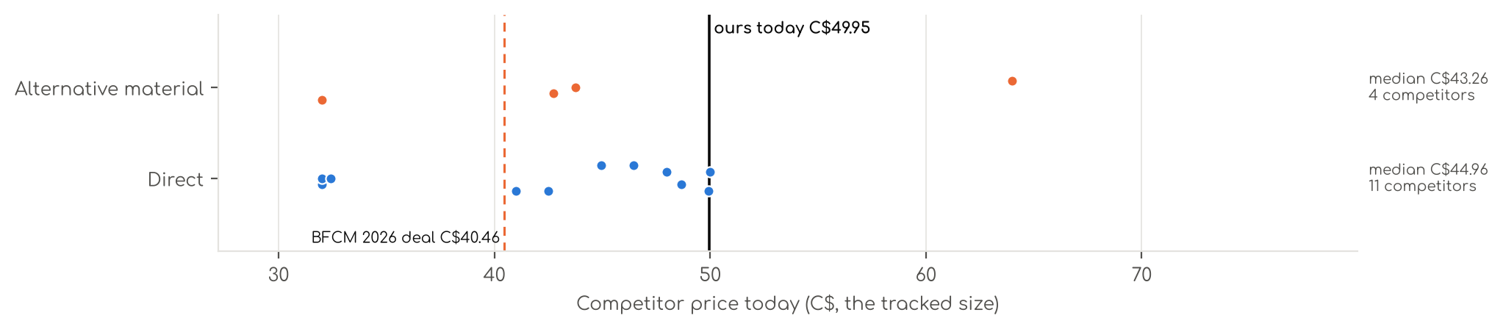
Photo | Competitor | Size · colour | Price | List | vs ours | Strike- through | BFCM 2025 deal | 2025 before → during | Disc. | Rank lift | Units / wk
Direct · 11
 | MR&HM  MR&HM Satin Sheets Queen Size with Elastic Corner Straps, Black  Satin (polyester) · 4.2★ 17,432  Amazon.ca organic #2 for 'satin sheets queen'; 100% Polyester Satin; 100+ bought in past month bought past month; Reused DC S4 competitor ob | Queen · 01- Black | C$40.99 | — | -13% | Was price C$46.99 | None | C$39.99 → C$38.39 | 4% | 1.71x | —
 | BEDELITE  BEDELITE Satin Sheets Queen Size Bed Set, Black, 4 Pieces  Satin (polyester) · 4.1★ 346  Amazon.ca organic #3 for 'satin sheets queen'; 100% Polyester Satin; 100+ bought in past month bought past month; Reused DC S4 competitor ob | Queen · Black | C$31.99 | — | -32% | Was price C$37.99 | Not live in 2025 | — | — | — | —
 | HENGWEITEXT  HENGWEI Satin Sheet Set Queen Size, 4 Pieces Silky Bed Sheets with Deep Pocket, Luxury Soft Bedding Set Breathable and C…  Satin (polyester) · 4.2★ 2,515  Amazon.ca organic #5 for 'silk satin sheets'; Satin; Reused DC S4 competitor observation, no separate search. Search child B0BYCB7QDF; selec | Queen · Sd-brown | C$31.99 | — | -32% | Not shown | Coupon only | — | — | 1.00x | —
 | GOLAL  Black Satin Sheets Queen Size - 4 Pieces Luxury Silky Soft Bed Sheets  Satin (polyester) · 4.2★ 1,280  Amazon.ca organic #7 for 'silk satin sheets'; 100% polyester; Reused DC S4 competitor observation, no separate search. Exact standard Queen | Queen · Black | C$47.99 | — | +2% | Not shown | Prime Exclusive Discount | C$47.99 → C$34.55 | 28% | 0.88x | —
 | BEDELITE  BEDELITE Satin Sheets Queen Size Bed Set, Black, 4 Pieces  Satin (polyester) · 4.4★ 5,584  Amazon.ca organic #13 for 'satin sheets queen'; 100% Polyester Satin; Reused DC S4 competitor observation, no separate search. variation_cou | Queen · Black | C$44.96 | — | -4% | Not shown | Price cut only | C$73.48 → C$60.16 | 18% | 0.78x | —
 | Pure Bedding  Pure Bedding Satin Sheets Queen [4-Piece, Black] Hotel Luxury Silky Bed Sheets - Extra Soft 1800 Microfiber Sheet Set, W…  Satin (polyester) · 4.2★ 12,410  Amazon.ca organic #14 for 'silk satin sheets'; 100% Microfiber; Reused DC S4 competitor observation, no separate search. variation_count = d | Queen · Black | C$49.91 | — | +6% | Not shown | Price cut only | C$83.61 → C$45.19 | 46% | 0.91x | —
 | Laura Ashley  Laura Ashley - Queen Sheet Set, 100% Soft & Silky Smooth Satin Bed Sheets, Deep Pockets, Bedding with Matching Fitted Sh…  Satin (polyester) · 4.3★ 13  Amazon.ca organic #16 for 'satin sheets queen'; 100% Polyester; Reused DC S4 competitor observation, no separate search. variation_count = d | Queen · Bliss Pink | C$48.67 | — | +4% | Not shown | Not live in 2025 | — | — | — | —
 | Pure Bedding  Satin Sheets Queen [4-Piece, Black] Hotel Luxury Silky Bed Sheets - Extra Soft 1800 Microfiber Sheet Set, Wrinkle, Fade,…  Satin (polyester) · 4.2★ 41  Amazon.ca organic #22 for 'satin sheets queen'; 100% Microfiber; Reused DC S4 competitor observation, no separate search. variation_count = | Queen · Black-01 | C$32.40 | — | -31% | Not shown | — | — | — | — | —
 | Lirex  Lirex Satin Sheets Queen Size Bed Set, 4 Piece Sheet Set with 14" Deep Pocket, Luxury Smooth & Soft Microfiber, Includes…  Satin (polyester) · 4.6★ 4  Amazon.ca organic #22 for 'satin sheets king'; Polyester; Reused DC S4 competitor observation, no separate search. Search child B0GWPTWBQL; | Queen · Blue Daisy | C$49.99 | — | +6% | Not shown | Not live in 2025 | — | — | — | —
 | Martex  4-Piece Martex Elegance Satin Sheets | Queen Size Bed Sheets | Luxury Hotel Quality Bed Sheets Set | Satin Sheets | Silk…  Satin (polyester) · 4.2★ 1,078  Amazon.ca organic #24 for 'satin sheets queen'; 100% Polyester; Reused DC S4 competitor observation, no separate search. variation_count = d | Queen · Brown | C$46.45 | — | -1% | Not shown | None | C$44.76 → C$44.65 | 0% | 1.27x | —
 | Beatrice Home Fashions  Elite Home Products 100% Luxury Satin Polyester Solid Sheet Set, Queen, Leopard  Satin (polyester) · 4.0★ 996  Amazon.ca organic #24 for 'satin sheets king'; 100% Polyester; Reused DC S4 competitor observation, no separate search. Search child B072K5T | Queen · Leopard | C$42.49 | — | -9% | Was price C$47.95 | — | — | — | 1.00x | —
Alternative material · 4
 | Sasttie  Sasttie Satin Sheets Queen - 4 Pieces Luxury Soft Black Silky Bed Sheets Set with Pillowcases - Smooth Silk-Like Drap Sa…  Silk · 4.2★ 962  Amazon.ca organic #1 for 'satin sheets queen'; satin; 300+ bought in past month bought past month; Reused DC S4 competitor observation, no s | Queen · Black | C$31.99 | — | -32% | Not shown | None | C$24.99 → C$24.99 | 0% | 0.64x | —
 | LIFCOM  Satin Sheets Queen Size Bed Set,Similar to Silk Sheets,4Pcs Luxury Satin Sheet Set with 15 Inches Deep Pocket (Queen, Da…  Silk · 4.3★ 351  Amazon.ca organic #15 for 'silk satin sheets'; Satin; Reused DC S4 competitor observation, no separate search. Search child B0DCC5T8MG; sele | Queen · Dark Grey | C$42.74 | — | -9% | Was price C$44.99 | Price cut only | C$39.99 → C$37.99 | 5% | 1.00x | —
 | Lanest Housing  Lanest Housing Silk Satin Sheets, 4-Piece Queen Size Satin Bed Sheet Set with Deep Pockets, Cooling Soft and Hypoallerge…  Silk · 4.2★ 5,574  Amazon.ca organic #21 for 'silk satin sheets'; 100% Polyester; Reused DC S4 competitor observation, no separate search. variation_count = di | Queen · Black | C$43.77 | — | -7% | Was price C$52.02 | None | C$54.66 → C$52.84 | 3% | 0.74x | —
 | Bare Home  Bare Home Poly Satin Sheet Set Similar to Silk (Queen, Blush)  Silk · 3.6★ 114  Amazon.ca organic #23 for 'satin sheets king'; Poly Satin; Reused DC S4 competitor observation, no separate search. variation_count = distin | Queen · 05 - Blush | C$63.99 | — | +36% | Was price C$67.99 | Not live in 2025 | — | — | — | —

9. Verification
Before this report was built, every number was re-computed from the raw data and the workbook was compared with the dashboard, row by row. A check passes only with zero mismatches.
Check | Rows checked | Mismatches | Result
Competitor BFCM 2025 price and rank (US) | 635 | 0 | Pass
Competitor BFCM 2025 price and rank (CA) | 71 | 0 | Pass
Workbook vs dashboard, competitor rows | 744 | 0 | Pass
Price vs ours | 697 | 0 | Pass
Our live variation prices | 1,307 | 0 | Pass
Account BFCM 2025 sales lift (US) | 1 | 0 | Pass
Account BFCM 2025 sales lift (CA) | 1 | 0 | Pass
Our BFCM 2025 deal units | 19 | 0 | Pass
No zero or negative values | 744 | 0 | Pass
Photos | 1,890 | 0 | Pass
Photos from the other marketplace | 93 | 0 | Pass
BFCM 2026 plan mapped | 21 | 0 | Pass
BFCM 2026 deal prices vs the deal sheet | 2,037 | 0 | Pass
BFCM 2026 stock per variation | 1,383 | 0 | Pass
BFCM 2026 stock, workbook vs dashboard | 30 | 0 | Pass
Stock run-out dates vs the stock plan | 43 | 0 | Pass
The tracker workbook also has 0 formula errors across 21,808 formulas.

10. Open items and next steps
Item | What happens next | When
Final BFCM 2026 deal prices | Deal prices move daily until submission; re-export the deal sheet, refresh the tracker and submit on the price actually read. Fix SKUs at a loss, below the seller minimum, with no reference price or flagged by Amazon. | By Nov 13, 2026
Inbound arrival dates | Add the arrival date for each inbound shipment so 'Needs inbound in time' can be confirmed or moved to 'Short'. | As shipments are booked
Variations short or out of stock | Decide replenishment for the variations listed in each product chapter; anything that can't arrive by Nov 18 should be left out of the deal or paused in ads. | This week
Competitor prices | Re-check competitor prices and strikethroughs in the week before Nov 19, when rivals set their deal prices. | Nov 12 – 18, 2026
Products not launched yet | SL B4, SL Satin 6pc, SL Cooling 6pc and SL Bamboo Pillowcase: competitors are mapped; prices to be set at launch. | At launch

Appendix: glossary
Term | Meaning
BFCM week | Black Friday to Cyber Monday deal period. 2025: Nov 20 – Dec 1. 2026 deals: Nov 19–30.
Best Seller Rank | Amazon's sales rank in the category; a lower number is better.
Rank lift | Rank before BFCM ÷ rank during BFCM week. 1.50x = rank improved by a third; below 1.00x = rank got worse.
Sales lift | Our sales per day in BFCM week ÷ sales per day in the 30 days before.
TACoS | Total advertising cost of sales: ad cost ÷ total sales.
List Price / Strikethrough | The reference price on the listing, and whether Amazon shows it crossed out next to today's price (List Price, Typical price or Was price).
Price cut only | The price was lowered without a deal badge or coupon.
Prime Exclusive Discount | A discount shown only to Prime members.
Lightning Deal / Best Deal | Time-limited Amazon deals with a deal badge; Best Deals run for several days.
Direct competitor | Same product type and same material family as ours.
Alternative material | Same product type, different material.
BFCM 2026 deal price | The deal price on Amazon's deal page for each variation (Amazon's maximum, or a manual price), from the team's deal sheet. One price per deal.
Covered / Needs inbound / Short / Out now | Stock status per variation against the units needed to Nov 30 (Section 6).

