Bedding Market Intelligence
Amazon United States, Canada and United Kingdom — market size, demand, competition, pricing and opportunity
October 2026 · research date 26 October 2026
Contents
- Executive summary
- Scope, sources and method
- Market size and growth
- Channels and Amazon’s role
- Category structure and demand
- Materials and category trends
- Country profiles: US, Canada, UK
- Competitor landscape
- Pricing ranges
- Customer behaviour and unmet needs
- Advertising and customer-acquisition environment
- Trade, fees and compliance environment
- Market opportunities and barriers
- Sources

Executive summary
The US is the largest bedding opportunity by a wide margin, Canada is a smaller but less crowded extension, and the UK is a distinct, price-sensitive, duvet-led market. Across all three, the categories easiest to enter are mid-priced, specification-led cotton products with a provable quality benefit; commodity microfiber, waterproof protectors and bulky toppers carry the highest entry barriers.
- Market size. Bed linen is worth roughly $8.6–11.2bn in the US, about $1.37bn in Canada and about $3.5bn in the UK (publisher estimates, 2024–25). Broad home bedding, including mattresses and pillows, is $32.75bn, $6.06bn and $8.02bn. Online accounts for about a quarter to a third of sales, and is growing faster than stores.
- Demand. Size-led generic searches dominate on Amazon US (“king size sheets set” ~327k and “queen sheets” ~205–291k monthly searches; “duvet cover” ~504k). Material searches are smaller but meaningful: “bamboo sheets” ~205–342k, “silk sheets” ~133k, “cotton sheets” ~97k, “100% cotton sheets” ~71k, “linen sheets” ~58k. In January–September 2026, search volume for “queen sheets” rose 52%, “linen sheets” 63% and “cotton sheets” 26% year on year, while “satin sheets” fell 17% and “cooling sheets” 12%.
- Seasonality. Cooling and bamboo searches peak in May–August at two to three times their winter level; silk pillowcases peak in November–December; Prime Day, the October event and Black Friday–Cyber Monday drive the largest spikes in generic sheet searches.
- Competition. Every major US segment is concentrated: the top ten brands hold most of the tracked volume, and leaders carry thousands to hundreds of thousands of reviews and add several hundred new reviews a month. Review barriers range from a median of about 130 reviews (waffle duvet covers) to more than 26,000 (generic sheet sets).
- Pricing. US sheet sets cluster at $20–30 (microfiber, satin), $40–70 (cotton, cooling) and $80–150 (bamboo viscose, linen). Canada sits higher in local currency; UK price points are low, with microfibre fitted sheets from about £6 and cotton mostly £11–34.
- Customers. Fit after washing (pocket depth, shrinkage), softness, breathability, pilling and colour accuracy dominate reviews in all three countries; fit or sizing appears in 40–55% of sampled reviews.
- Trade. Pakistan is the leading supplier of bed linen to the UK and enters it duty-free under the UK’s Developing Countries Trading Scheme; Pakistani cotton bed linen pays about 16.7% in the US (including a 10% tariff in force since July 2026) and 17% in Canada.
- Opportunity themes. Mid-price cotton sheet sets with verified post-wash fit (US, Canada); textured and pre-washed cotton niches with low review barriers (US); UK-native-size cotton duvet cover sets; replacement fitted sheets and pillowcase bundles; and hospitality-grade white linen supply in the UK.

Scope, sources and method
This report covers textile bedding — sheet sets, fitted sheets, pillowcases, duvet covers, quilts and coverlets, comforters, mattress protectors and toppers — on Amazon in the US, Canada and the UK, with reference to other channels. All external sources were accessed on 26 October 2026; figures are labelled as follows.
Label | Meaning
FACT | Observed on an official source or a live public page
CLAIM | What a seller states about its own product, not independently verified
ESTIMATE | Third-party market model or analytics-tool estimate
CALC | Arithmetic on cited inputs
Evidence used: publisher market estimates (Grand View Research, Mordor Intelligence, Future Market Insights, ECDB and others); 33 live Amazon search pages across the three marketplaces (1,627 listing observations) with 15 product-page captures and 122 customer review cards; commercial Amazon keyword and listing analytics for 27 US bedding segments; Amazon search-query market totals (all sellers, monthly); public price and review histories for leading listings; official customs, labelling and fee pages; and trade press.
Limitations: market-size reports use different definitions and years and should not be averaged; analytics-tool sales figures are estimates and tend to overstate (sibling listings can repeat parent sales); search-page captures for the US and UK retained an overseas delivery location, so they show discovery prices rather than domestic rankings; review samples show what customers talk about, not defect rates; and tariff rates were read from search extracts of official pages and must be confirmed by a licensed customs broker.

Market size and growth
The bed-linen market is about three times larger in the US than in the UK and about eight times larger than in Canada; all three are growing faster online than in stores.
Country | Broad home bedding 2024 (incl. mattresses) | Forecast CAGR 2025–33 | Online share 2024 | Home textiles 2025 | Derived bed linen 2025
United States | $32.75bn | 8.8% | 24.8% | $26.48bn | $11.16bn
Canada | $6.06bn | 10.9% | 21.9% | $3.12bn | $1.37bn
United Kingdom | $8.02bn | 7.2% | 32.5% | $7.62bn | $3.50bn
Sources: Grand View Research (broad bedding, M01–M03); Mordor Intelligence home textiles × published bed-linen share (M07–M09). ESTIMATES / CALC.
Other estimates put US bed linen at $8.6bn (2025, Future Market Insights) to $10.9bn (bed and bath linen, 2024), US online bedding at 28–34% of sales, Canadian online home textiles at about 24%, and UK bedding e-commerce at about $1.26bn (2024, ECDB).
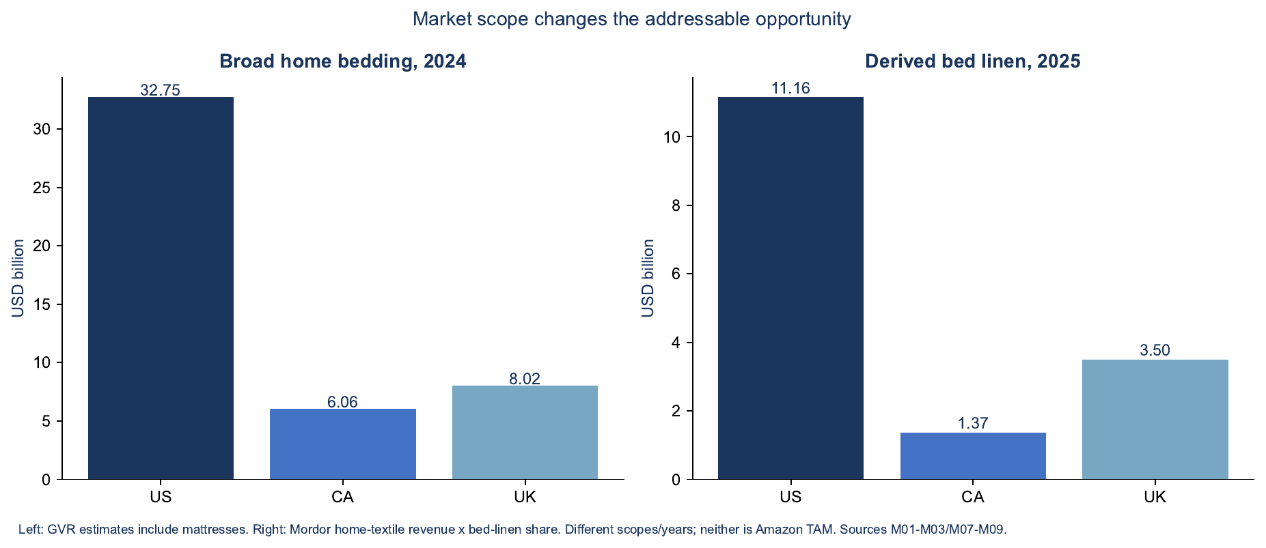
Figure 1. Market scope changes the addressable opportunity: broad home bedding (2024) vs derived bed linen (2025)
Source: Grand View Research and Mordor Intelligence estimates; neither series measures Amazon demand.

Channels and Amazon’s role
Amazon is now one of the largest bedding retailers in North America, but no public source measures its share of textile bedding alone.
- US: Furniture Today estimates Amazon’s US bedding sales at about $3.1bn in 2024, second only to Mattress Firm among the top 25 bedding retailers, though that figure includes mattresses.
- UK: Dunelm reported £1,825m revenue in FY2026 (up 3.1%) and a 7.9% share of UK homewares and furniture, with 42% digital participation; Amazon, Dunelm, ASDA, Tesco and B&M are commonly cited as the leading bedding retailers.
- Canada: no public estimate of Amazon.ca’s bedding share was found; IKEA and domestic retailers anchor prices (IKEA Queen fitted sheets observed at CAD 17.99–34.99).
Channel | What it offers | What it costs | Fit
Amazon marketplaces | Large discoverable demand, fast fulfilment | Referral and fulfilment fees, advertising, returns; strong review barriers | Best for testing a clearly differentiated product
Brand website (DTC) | Control of education, bundles and retention | Paid social/search acquisition, payment fees, 3PL and parcel costs | Useful for premium or story-led products
Other marketplaces (Walmart, Wayfair, Etsy, eBay) | Additional reach | Platform-specific rules, fees and service levels | Assess after the product is proven
Retail and wholesale | Shelf discovery and buyer trust | Wholesale margins, allowances, chargebacks | Requires buyer interest and quote-backed pricing
Hospitality and institutional (UK first) | Repeat replacement demand; no review moat | Long sampling cycles, laundering validation, credit terms | Strong fit for standard white cotton-rich linen
Private-label / contract manufacture | Buyer supplies brand and channel | Tight quotes and MOQs, audits, customer concentration | Natural route for manufacturers

Category structure and demand
Generic sheet sets are by far the largest Amazon US segment; specialist segments are an order of magnitude smaller, but several have far lower review barriers.
US segment | Head-term monthly searches | Median price | Median reviews of tracked listings | Listings under 500 reviews | Est. monthly revenue of tracked listings | Typical suggested CPC | Seasonality
Generic sheet & pillowcase sets (mostly microfiber) | “queen sheets” 205–291k | $35.98 | 26,544 | 0% | $79.6M | $2.64 | Q4, January
100% / organic cotton sheet sets | “cotton sheets” 97k | $63.99 | 2,453 | 15% | $11.9M | $2.63 | Stable
Pre-washed cotton sheet sets | ~25k | $39.99 | 492 | 73% | $4.5M | $2.21 | Stable
Bamboo-viscose sheet sets | “bamboo sheets” 205–342k | $88.99 | 2,782 | 14% | $9.0M | $6.43 | Summer, November
Cooling sheet sets | “cooling sheets” 112k | $69.99 | 1,934 | 10% | $8.4M | $1.41 | May–August
Polyester satin sheet sets | “silk sheets” 133k; “satin sheets” 78k | $25–27 | 1,074–5,500 | 0–27% | $3.5–6.1M | $1.25–1.97 | Flat
Fitted sheets (satin / bamboo viscose) | segment total 108k / 695k | $18.49 / $49.99 | 662 / 224 | 35% / 60% | $0.5M / $6.9M | $1.11 | Follows sheet sets
Linen sheet sets | “linen sheets” 58k | $129.89 | 1,004 | 30% | $1.3M | $2.61 | Summer
Solid duvet covers | “duvet cover” 504k | $44.99 | 3,194 | 19% | $13.0M | $1.29 | Autumn–winter
Waffle-weave duvet covers | “queen duvet cover” 132k | $56.99 | 131 | 85% | $2.8M | $1.44 | Autumn–winter
Quilt sets | “quilt” 182k | $29.99 | 1,609 | 20% | $3.8M | $0.56 | Spring–summer
Waterproof mattress protectors | “twin xl mattress protector” 122k | $27.49 | 6,073 | 5% | $6.4M | $1.86 | Back-to-school
Latex mattress toppers | “latex mattress topper” 25k | $207 | 257 | 60% | $1.0M | $1.33 | —
Silk pillowcases | “silk pillowcase” 120k | — | — | — | — | $3.05 | Nov–Dec
Source: commercial Amazon keyword and listing analytics, research dates June 2025 – October 2026 (ESTIMATES; revenue totals are upper bounds).
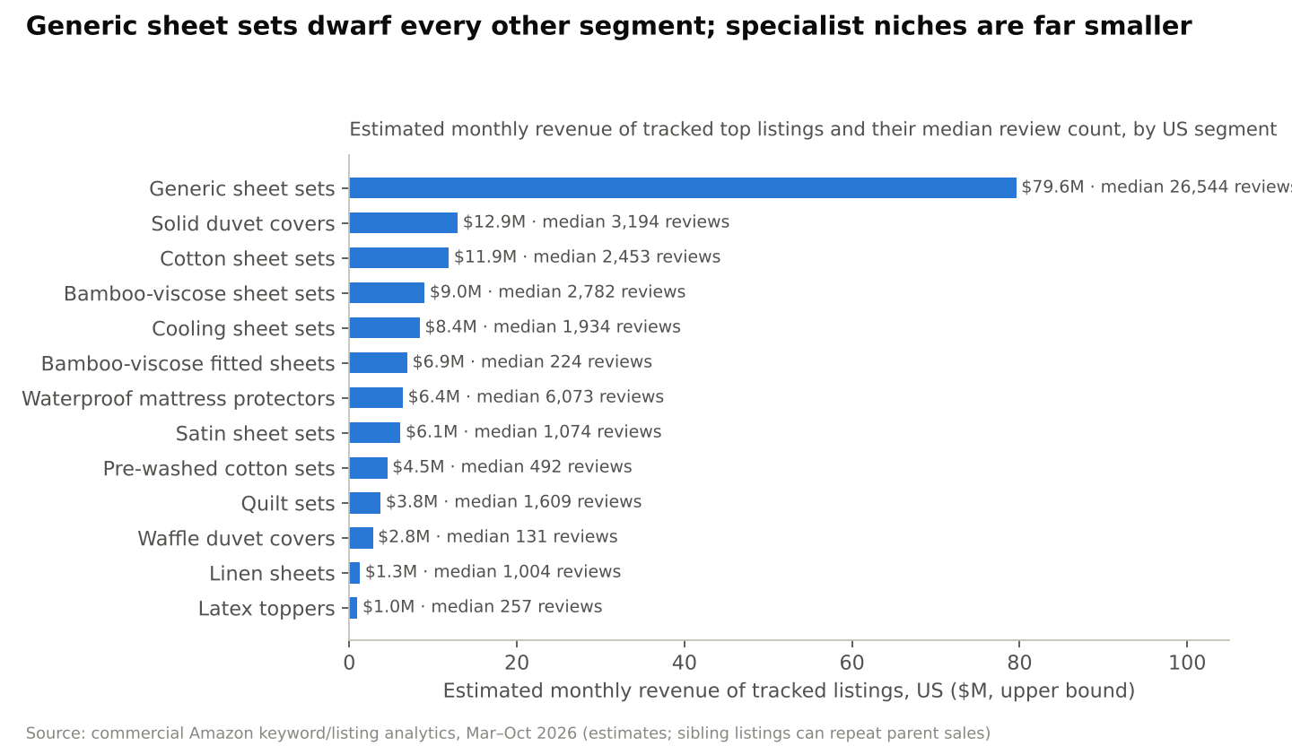
Figure 2. Generic sheet sets dwarf every other segment; specialist niches are far smaller
Source: commercial Amazon keyword and listing analytics, estimates.
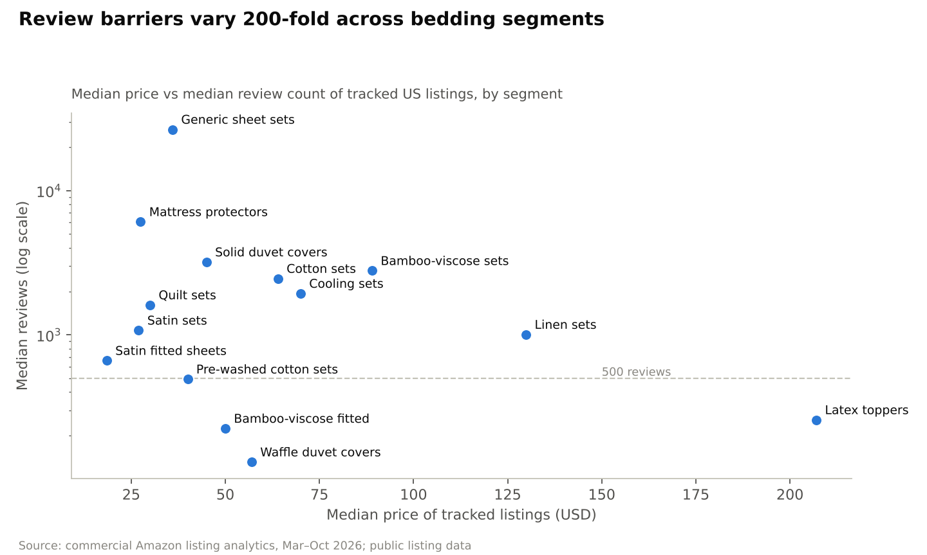
Figure 3. Review barriers vary 200-fold across bedding segments
Source: commercial Amazon listing analytics; public listing data.
Demand trend, January–September 2026 vs the same months of 2025 (US Amazon search volume per week, all sellers):
Query | Change
“linen sheets” | +63%
“queen sheets” | +52%
“cotton sheets” | +26%
“king sheets” | +16%
“silk pillowcase” | +12%
“bamboo sheets” | +10%
“fitted sheet” | +7%
“sheet set” | −1%
“cooling sheets” | −12%
“satin sheets” | −17%
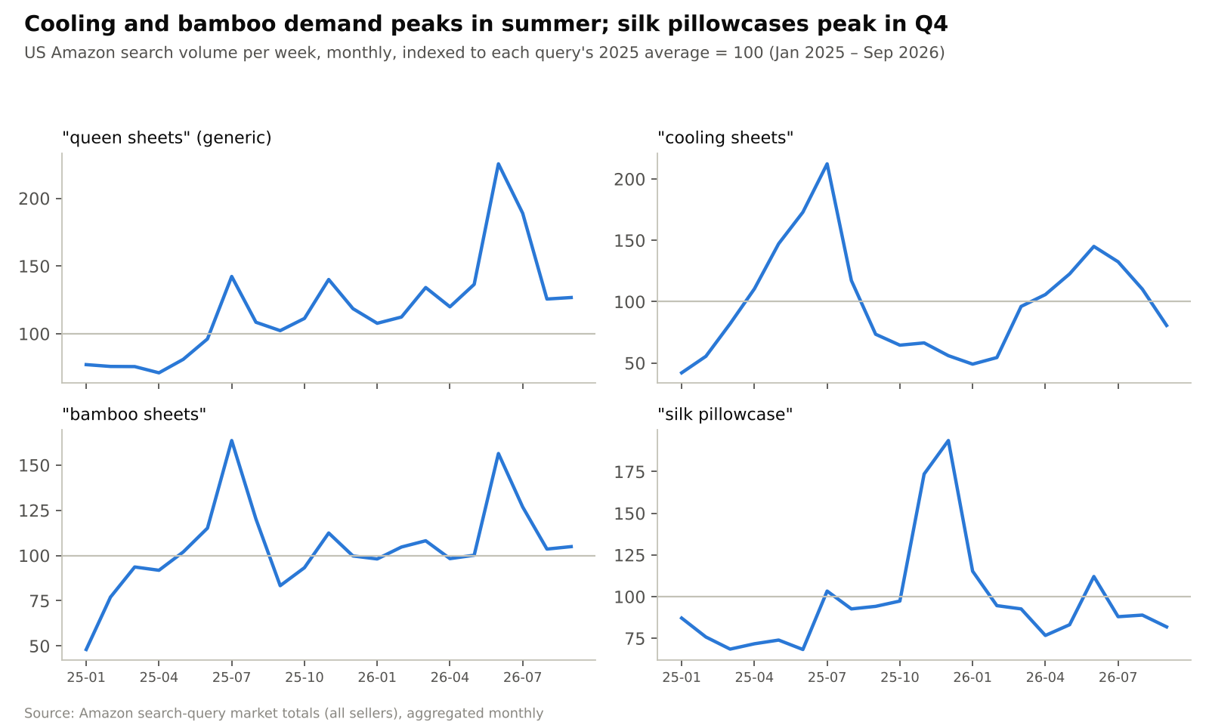
Figure 4. Cooling and bamboo demand peaks in summer; silk pillowcases peak in Q4
Source: Amazon search-query market totals (all sellers), indexed. Canada’s search volume for the same queries is roughly 8% of US volume.

Materials and category trends
Shoppers are moving toward natural and “honest-spec” materials — cotton and linen searches are growing fastest — while synthetic satin and generic “cooling” claims are losing momentum.
Material | What it is | Consumer proposition | What to check | Watch-outs
Cotton percale | Cotton in a plain weave | Crisp, matte, breathable | 200–300 single-ply TC; post-wash shrink and tear | Wrinkles; inflated thread-count and “Egyptian” claims
Cotton sateen | Cotton in a sateen weave | Smooth, lustrous, warmer | 300–500 single-ply TC; pilling and snagging | Not the same as polyester satin
Microfiber / polyester satin | Synthetic fibre; satin is a weave | Affordable, soft, easy care | GSM, finish; pilling, static, colour-fastness | Heat retention; lowest price points
Bamboo-derived viscose | Regenerated cellulose | Soft and drapey | Correct generic name, weight, wash tests | US FTC: must say “rayon/viscose made from bamboo”; no antibacterial or eco claims without proof
Lyocell / TENCEL | Regenerated cellulose; TENCEL is a trademark | Smooth, moisture-managing | Licensed branding, composition, pilling | Low search coverage is not proof of an open market
Linen | Flax fibre | Textured, premium, breathable | 150–180 GSM test range; seam slippage, shrinkage | Wrinkles, lint in early washes; “linen-look” cotton is not linen
Cotton blends | Fibre percentages decide behaviour | Easy care, laundry durability (hospitality) | Declared percentages; repeated-wash serviceability | Cannot be marketed as 100% cotton
Size conventions differ. US and Canadian Queen mattresses are 60 × 80 in and King 76 × 80 in; UK Double is 135 × 190 cm, King 150 × 200 cm and Super King 180 × 200 cm, and duvet sizes vary by retailer. US-style four-piece sheet sets are much less central in the UK, where the core purchase is a fitted sheet plus a duvet cover set. Thread count alone does not predict quality (Consumer Reports); measured fit and wash durability are more defensible claims.

Country profiles

United States
- Size and demand: largest market ($11.2bn derived bed linen); the deepest search demand for every segment; summer peaks for cooling and bamboo; Prime Day (June 2026), the October event and Black Friday–Cyber Monday are the key sales windows.
- Price tiers: $13–30 microfiber and satin; $40–70 cotton and cooling; $80–150 bamboo viscose and linen; $159+ for direct-to-consumer cotton brands such as Brooklinen.
- Competition: the most concentrated and best-reviewed market; leading listings add several hundred reviews a month.
- Customer expectations: deep pockets that still fit after washing, breathable cotton, honest material claims.
- Difficulty for a new brand: high on generic terms; medium in specialist cotton and textured duvet niches.

Canada
- Size and demand: about $1.37bn bed linen; search volume about 8% of the US for the same queries; bilingual (English/French) shoppers and labels.
- Price tiers: higher in local currency than the US — sheet sets mostly CAD 46–76 (median ~CAD 57), duvet covers ~CAD 70, bamboo viscose ~CAD 92.
- Competition: a thinner field than the US: median review counts of tracked listings are roughly 500–1,400 in sheet segments, versus 2,000–5,000 in the US.
- Difficulty for a new brand: medium–low; the trade-off is a smaller absolute market and a 17% duty on most bed linen.

United Kingdom
- Size and demand: about $3.5bn bed linen; duvet-led purchasing; demand rises in autumn and winter.
- Price tiers: microfibre fitted sheets from about £6–11; duvet cover sets typically £11–38 (median ~£21); cotton sheet and duvet sets mostly £11–34; premium Egyptian cotton and linen £40+.
- Competition: Utopia Bedding leads most best-seller lists (fitted sheets with about 135k ratings), followed by Bedsure, Amazon Basics, GC Gaveno and Sonia Moonlight in microfibre and Catherine Lansfield, Dreamscene and Sleepdown in printed duvet sets.
- Economics: 20% VAT is included in shelf prices, which compresses margins at UK price points even where import duty is zero.
- Difficulty for a new brand: high on Amazon; hospitality and private-label supply are viable alternative routes.

Competitor landscape
Leading brands win on review mass, wide size-and-colour ranges and strike-through list pricing rather than on coupons; most segments have one to three dominant brands and a long, thinly reviewed tail.
US segment | Leading brands observed (price; approximate public review count) | Top-3 share of tracked volume (EST)
Generic sheet sets | CGK Unlimited ($25–35; ~440k), California Design Den ($37–70; ~88k), LANE LINEN ($45–90; ~33k), Bedsure, Utopia, Amazon Basics | ~36%
Cotton sheet sets | LANE LINEN ($35–85; ~31k), California Design Den ($28–90; ~87k), MooMee (~$80), Laura Ashley, Eddie Bauer | ~54%
Pre-washed cotton sets | LANE LINEN ($40–75), MooMee ($35–80), smaller brands with under 500 reviews | ~85%
Bamboo-viscose sets | Bedsure (~$56; ~65k), Pure Bamboo (~$100; ~24k), Love’s Cabin (~$36), Bella Coterie (~$135), Hotel Sheets Direct | ~52%
Satin sheet sets | BEDELITE (~$36), Love’s Cabin (~$20), MR&HM (~$32; ~18k), CozyLux, Lanest | ~52%
Cooling sheet sets | Bedsure, Pure Bamboo, Bella Coterie, REST (~$349) | ~63%
Quilt sets | Love’s Cabin (~$27), WDCOZY (~$45), Exclusivo Mezcla (~$25; ~17k), WRENSONGE, HORIMOTE | ~59%
Duvet covers, solid | Bedsure ($18–175; ~38k), MooMee (~$90; ~15k), CGK Unlimited (~$38), Simple&Opulence, California Design Den | ~46%
Duvet covers, waffle weave | Bedsure ($84–90; ~4k), PHF ($38–40), David’s Home, smaller brands under 300 reviews | ~90%
Waterproof protectors | Utopia Bedding ($25–29; ~123k), SafeRest (~281k), Nordic Elk, Four Seasons Essentials | ~56%
Pillowcases | ZIMASILK (~$37; ~52k), INFIIXSO (~$65), WISHSMILE (~$20) | ~63%
Sources: public listing data and commercial analytics estimates, June 2025 – October 2026; review counts rounded and may pool variants.
Country | Comparators observed on live search pages
Canada | California Design Den, LANE LINEN, THREAD SPREAD, LIFETOWN, JELLYMONI, Bedsure (sheets and duvets); Utopia, Sasttie, BEDLORE, Niagara Sleep Solution (protectors and toppers); IKEA in-store anchors
United Kingdom | Utopia, Sapphire Collection, Yard, GC GAVENO CAVAILIA (sheets and duvets); Silentnight, GMTEXTILES (protectors and toppers); Dunelm and IKEA as retail anchors
How the leaders win (public price and review histories, January–October 2026):
- Review velocity: the largest bamboo-viscose brands added roughly 340–450 reviews a month; leading satin brands 180–200.
- Strike-through pricing, not coupons: leaders sold 20–30% below their stated list prices and ran coupons on almost no days.
- Deep variation grids: one parent listing covering every size and many colours, with A+ content and 7–9 images.
- Two coexisting models: volume brands at $20–60 with very large review bases, and premium brands at $100–350 built on one strong claim.
Who supplies the category (trade press; not verified at source): Utopia Bedding is a Karachi-based mill brand and a leading seller in the UK and US; California Design Den and Mayfair Linen are made in India; Bedsure belongs to a Chinese manufacturer. Gul Ahmed and Nishat Mills (Pakistan) and Welspun (India) are major integrated home-textile manufacturers.
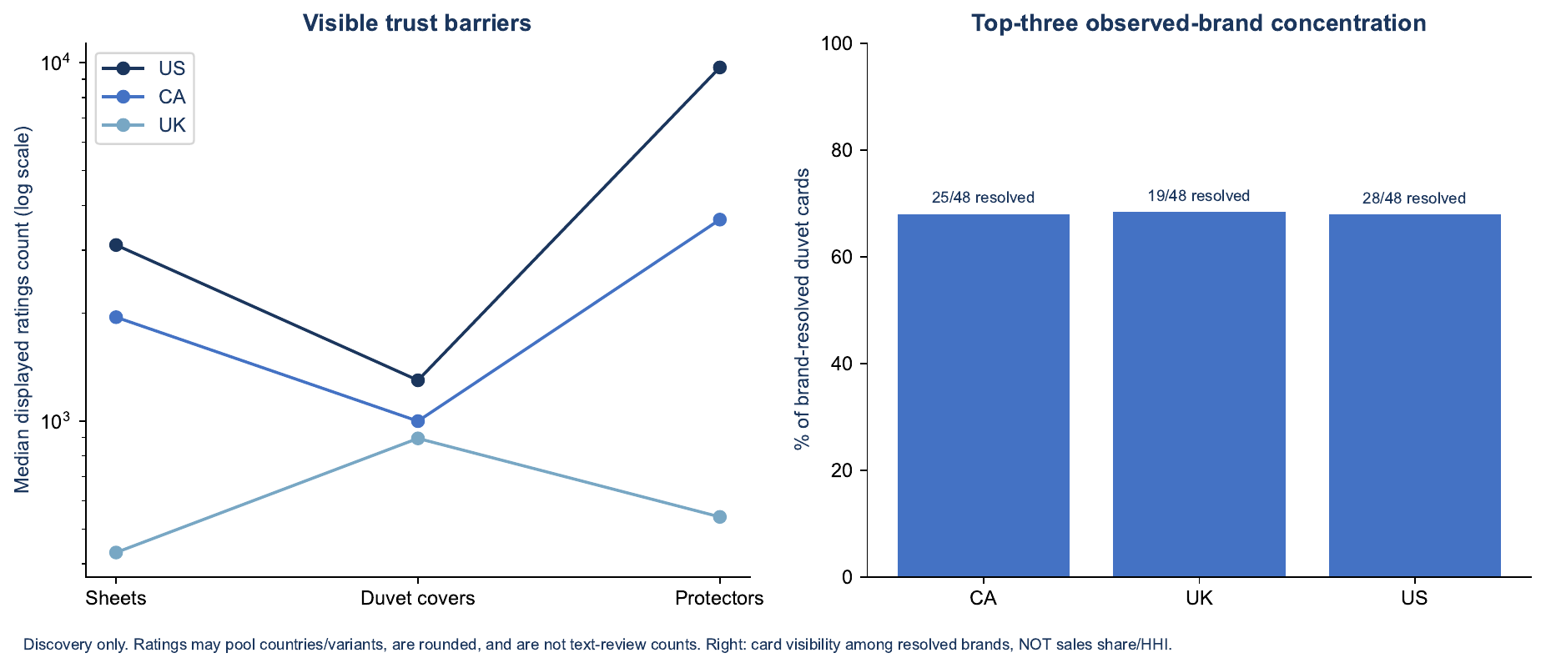
Figure 5. Visible trust barriers (median displayed ratings) and top-three observed-brand concentration in duvet queries
Source: live search-page captures, 26 October 2026; card visibility, not sales share.

Pricing ranges
Observed prices vary widely within every category; they are discovery ranges from live search pages, not recommended prices.
Market | Sheets (n · median · range) | Duvet covers | Fitted sheets | Pillowcases | Protectors | Toppers | Comforters | Quilts
US (USD) | 38 · 41.99 · 15.00–149.99 | 41 · 55.99 · 14.99–89.99 | 46 · 19.99 · 8.99–79.99 | 58 · 19.99 · 8.99–65.99 | 46 · 32.49 · 11.99–119.00 | 44 · 69.99 · 13.99–349.00 | 48 · 36.99 · 21.98–309.00 | 57 · 69.99 · 15.29–169.99
Canada (CAD) | 47 · 56.99 · 32.77–119.99 | 43 · 69.99 · 38.99–179.99 | 48 · 26.74 · 10.96–64.99 | 48 · 18.49 · 10.99–56.96 | 48 · 30.95 · 13.00–79.99 | 48 · 74.94 · 25.99–554.00 | 48 · 56.49 · 23.80–149.05 | 44 · 98.44 · 34.19–176.76
UK (GBP) | 17 · 47.22 · 12.05–77.10 | 29 · 21.04 · 10.55–38.00 | 25 · 11.37 · 7.16–31.18 | 19 · 9.89 · 3.99–22.92 | 24 · 11.38 · 6.99–26.00 | 29 · 31.99 · 9.94–130.24 | not comparable | not comparable
Source: 33 live search-page captures, 26 October 2026; mixed sizes and set configurations; conditional coupons excluded.
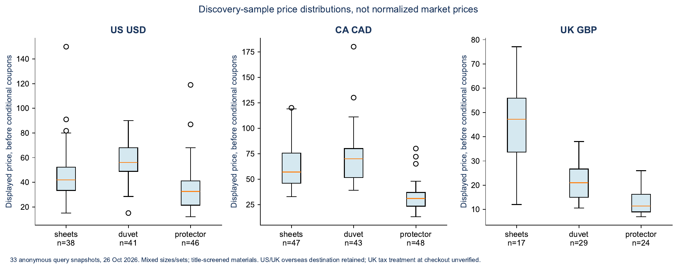
Figure 6. Discovery-sample price distributions by marketplace (sheets, duvet covers, protectors)
Source: live search-page captures, 26 October 2026.

Customer behaviour and unmet needs
Fit after washing is the most consistent customer concern in every country, followed by softness, breathability, pilling and colour accuracy; most of these can be solved through specification and quality control.
Topics mentioned in 122 sampled reviews (one review can mention several):
Reviewer country | Reviews | Comfort / softness | Fit / sizing | Durability / pilling | Shrinkage
US (imported on Canadian/UK pages) | 25 | 17 | 10 | 2 | 1
Canada | 40 | 25 | 22 | 4 | 1
United Kingdom | 33 | 18 | 13 | 2 | 0
Mention counts, not complaint rates. Examples: “Pockets were not deep enough. Ask for 18” pocket got 15”” (Canada, Aug 2026); first-wash dye transfer on a duvet set (UK, Dec 2025); confusion between “bamboo” wording and an 80% polyester protector (Canada, Aug 2025).
Recurring complaint themes by construction (independent lab tests and retailer review summaries):
Construction | Main complaints | What addresses them
Cotton percale | Shrinkage leaves pockets too shallow; pilling after 1–2 years; crisp feel; wrinkles | Pre-shrunk long-staple single-ply yarn; 15–16” pocket with all-round elastic, sized for post-wash fit
Cotton sateen | Wrinkles; sleeps warm; pillowcases slide off | Honest 300–400 TC single-ply; envelope pillowcases
Bamboo viscose | Pilling in the first year; heat despite “cooling” claims; doubts about fibre content | Heavier fabric, double-stitched seams, accurate labelling
Microfiber | Traps heat; pills; static; thin and bunches | Heavier brushed fabric; anti-pill finish
Polyester satin | Sheets and pillows slide off; loose elastic; snags | Corner straps plus all-round elastic; heavier charmeuse
Linen | Lint in early washes; scratchy at first; fit changes after washing | Stonewashed, pre-shrunk flax; shrink allowance
Duvet covers | Zip snags; colour bleed on first wash; cotton wrinkles | Eight corner ties; hidden quality zip; colour-fast dyeing
Quilt sets | Thinner than expected; colour differs from photos | Stated weight; true-colour photography
Waterproof protectors | Crinkle noise; sleeps hot; waterproofing fades | TPU membrane; soft knit top; deep skirt
Toppers | Odour; flattening; heat; shifting | Certified foam; non-slip base; accurate dimensions
Broader behaviour patterns: lighter and pastel shades generate more colour-mismatch returns than dark and mid tones across bedding; Queen and King account for the large majority of US sheet demand; demand concentrates in a handful of neutral colours (white, cream, greys, navy); and deal-driven purchases tend to come back more often than full-price ones. Underserved needs worth testing: dependable post-wash fit, truthful fibre and layer communication, wash-durable colour, easy duvet fitting and reliable replacement availability. None is yet a proven gap — incumbents address parts of each.

Advertising and customer-acquisition environment
Advertising is the largest variable cost of entering Amazon bedding, and acquisition costs differ sharply by segment.
- Industry benchmarks (third-party, US Home & Kitchen, 2025–26): cost per click $0.80–1.35, click-through 0.35–0.50%, conversion 6.6–13% and ACoS 15–27%; platform-wide ACoS around 28–32% (Pacvue and other agency reports).
- Segment bid levels (analytics-tool suggested bids, median of top keywords): bamboo viscose about $6.43; cotton and generic sheet sets $2.21–2.64; linen $2.61; silk pillowcases $2.17; satin $1.25–1.97; mattress protectors $1.86; duvet covers $1.10–1.44; cooling $1.41; quilts $0.56.
- New entrants: brands without reviews or ranking history typically pay materially more per order than incumbents for several months, and paid sales velocity tends to fade quickly once spend is reduced unless reviews and organic ranking have been built.
- What works across the category: broad and phrase discovery with long-tail exact targeting tends to be cheaper per order than concentrated head-term bidding; large top-of-search premiums raise cost per order sharply.
- Seasonal windows: Prime Day, the October event, Black Friday–Cyber Monday and January promotions; summer for cooling products.

Trade, fees and compliance environment
The UK offers the lowest import duty for Pakistani-origin bed linen; the US carries the highest duty and the most regulatory change.
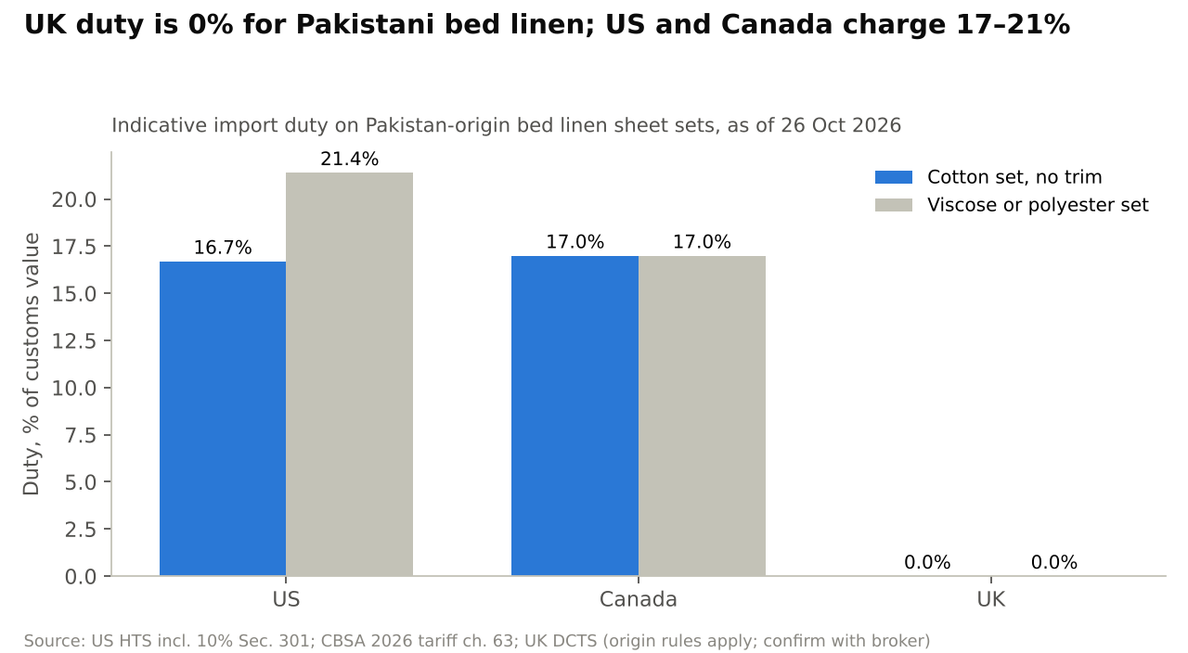
Figure 7. UK duty is 0% for Pakistani bed linen; US and Canada charge 17–21%
Source: US HTS and Section 301 notices; CBSA 2026 Customs Tariff; UK Trade Tariff and DCTS guidance (search extracts of official pages; broker confirmation required).
Topic | United States | Canada | United Kingdom
Cotton bed linen duty (Pakistan origin) | 6.7% MFN + 10% Section 301 = 16.7% (plus 0.3464% MPF, 0.125% HMF) | 17% (GPT does not cover chapter 63) | 0% under DCTS Enhanced Preferences (12% standard rate)
Viscose or polyester bed linen | 11.4% + 10% = 21.4% | 17% | 0%
Embroidered or piped cotton | 20.9% + 10% = 30.9% | 17% | 0%
Recent changes | IEEPA tariffs struck down (Feb 2026); 10% Section 301 on Pakistan since 24 Jul 2026, under court challenge; de minimis suspended; stricter rules for foreign importers proposed | CARM requires importers to post their own security | DCTS origin rules updated 1 Jan 2026; India–UK trade agreement gives Indian textiles 0% from Jul 2026
Import tax | Sales tax collected by Amazon | GST/HST, recoverable | 20% import VAT, postponed accounting available
Labelling | FTC Textile Act fibre content, “Made in Pakistan”, identity; “rayon made from bamboo” | Bilingual fibre content, CA identification number | Textile labelling regulations; “viscose”, not “bamboo”
Safety | Mattress pads and filled toppers under 16 CFR 1632; Prop 65; state PFAS restrictions | Textile flammability regulations | Fire regulations cover mattresses, pillows and fillings
Amazon referral fee | 15% Home & Kitchen | ~15% | 15%; 8% “Home Products” band up to £20 (category confirmation needed)
FBA fulfilment (boxed sheet set) | about $6.50–7.40; bulky quilts and toppers far higher | CAD 12–13 range | Large parcel tiers ~£4–5
Origin rule: for US and UK purposes, bed linen generally takes the origin of the country where the fabric is woven, so fabric sourced from a third country can change the duty outcome. Sourcing landscape: Pakistan exported about $3.1bn of bed wear in FY2024-25 (flat in FY2025-26) and is the leading supplier of bed linen to the UK (roughly half of UK imports by value), while India leads US cotton bed-linen imports (about 59% vs Pakistan’s 19%). Pakistani mills face higher energy costs than regional peers and a weak 2025-26 cotton crop.

Market opportunities and barriers
The most attractive openings are specification-led cotton products where a verified quality benefit can be shown; the least attractive are commodity segments defended by very large review bases and low prices.
Opportunity theme | Markets | Why it is attractive | What it requires
Mid-price cotton sheet sets with verified post-wash fit | US, Canada | Cotton search demand growing; fit is the top customer concern; leaders rarely state measured post-wash fit | Lab-tested shrinkage and pocket depth; honest specifications
Pre-washed and textured (waffle) cotton niches | US | Median review barriers under 500; mid prices ($40–60) | Ability to compete with one or two dominant brands in each niche
UK-native-size cotton duvet cover sets | UK | Duvet-led market; 0% duty for Pakistani origin; colour-fastness complaints | Native sizes and terminology; price headroom after VAT
Replacement fitted sheets and pillowcase bundles | US, UK | Low review barrier in fitted sheets; replacement purchases | Bundling to lift order value
Hospitality and private-label white cotton-rich linen | UK first | Repeat laundering demand; no review barrier; duty preference | B2B sampling, quotes and buyer approvals
Canada as a follow-on market | Canada | Thinner competition and lower review barriers | Bilingual labels; 17% duty; smaller volume
Segments with the highest entry barriers: commodity microfiber sheet sets (review bases of hundreds of thousands, very low prices); waterproof mattress protectors (median ~6,000 reviews, membrane technology); bulky comforters, quilts and toppers (high fulfilment and storage fees, return risk); bamboo viscose (high advertising costs and labelling risk); and silk pillowcases (specialist fibre).
Market-wide risks: advertising costs rising faster than conversion; tariff changes (US Section 301 outcome); VAT and fee-threshold effects in the UK; returns driven by fit and colour; and freight and working-capital pressure from long lead times.

Sources
Market estimates: Grand View Research home bedding (US, Canada, UK) · Mordor Intelligence home textiles (US, UK, Canada) · Future Market Insights · ECDB · Furniture Today Top 25 Bedding Retailers · Dunelm Group annual report 2026 · Pakistan Bureau of Statistics trade data.
Official and regulatory: US FTC textile and bamboo guidance · US CPSC mattress guidance · USITC Harmonized Tariff Schedule · CBP fees and forced-labour pages · USTR Section 301 notices · CBSA import guide and 2026 Customs Tariff chapter 63 · Canada Textile Labelling and Advertising Regulations · GOV.UK textile labelling, VAT, importing and DCTS guidance · Pakistan Single Window export guidance · Amazon seller pricing pages (sell.amazon.com, .ca, .co.uk).
Market observation: live Amazon search and product pages (US, Canada, UK), 26 October 2026 · commercial Amazon keyword and listing analytics (June 2025 – October 2026) · public price and review histories · Amazon search-query market totals (all sellers) · Consumer Reports, Good Housekeeping, Which? and retailer testing summaries · manufacturer websites (Gul Ahmed, Nishat Mills, Welspun) · retailer pages (Brooklinen, IKEA).
All figures are estimates or observations as of the dates shown and may change; tariff and fee details require confirmation with a licensed customs broker and Amazon Seller Central before any commercial decision.

