**Revised Component Interface and Initial Prototype**

for

Order It: Place, Track, Eat

Group Members:   
Ahmed Moatasim 16L-4332  
Farwa Khawar 16L-4171  
Minahil Imtiaz 16L-4126  
Shafin Salim 16L-4298  
Sikander Hassan Khan 16L-4375

Group Name:  
FAMSS

4th November, 2019

**Rights and Responsibilities**

Below are mentioned the improved rights and responsibilities for the specialized order module.

|  |  |
| --- | --- |
| **Rights** | Status |
| 1. An Order Object with correctly populated Dish objects and proper priority code assigned will be sent to the Kitchen Management module who will then update the queue | Agreed after discussion with Kitchen Management group |
| 1. On placing specialized order by passing the Order object as argument the Kitchen Module will provide the time required for completion of the order | Agreed after discussion with Kitchen Management group |
| 1. An Order Object with correctly populated Dish objects and proper priority code assigned will be sent to the Hall Management module so he can track the progress of order | Agreed after discussion with Hall Management group |
| 1. Complete access to Ingredient repository will be provided for subtracting the ingredients to be used in preparation of dishes of specialized order | Pending despite discussion with Inventory Management Group |
| 1. Complete access to Order repository will be provided for adding the records of specialized orders and displaying menu for specialized order | Agreed after discussion with Order Management |
| 1. Complete access to Order repository will be provided for changing the previous status of order when specialized order is placed by Hall Manager | Agreed after discussion with Order Management group |
| 1. For information of the ingredients to be used in a dish read access to Dish Details repository will be provided | Agreed after discussion with Inventory Management Group |
| 1. For displaying menu for specialized order read access to Dish repository will be provided | Agreed after discussion with Inventory Management Group |
|  |  |
| **Responsibilities:** |  |
| 1. Hall Manager can place specialized order after the order has been served 2. The order status will be changed to “In Progress” when Hall Manager places specialized order 3. Kitchen Manager can place specialized order after the order has been completed or dish has been marked “Cooked” 4. The menu for specialized order displaying complimentary dishes and previously ordered dishes will be shown to Hall Manager 5. The menu for specialized order displaying only the previously ordered dishes will be shown to Kitchen Manager 6. Assign the priority code for the specialized order placed by Hall Manager 7. Assign the priority code for the specialized order placed by Kitchen Manger 8. Subtract the ingredients used in the dishes of specialized order from inventory 9. Display time to Hall Manager for completion of specialized order |  |

**Prototype Design:**

The specialized order module has specialized screens for hall manager and kitchen manager, according to their roles and responsibilities. Each screen has been designed in tablet layout. Below are screenshots of the prototype design.

**Kitchen Manager Special Order Screen**

The following screen is designed for the Kitchen Manager comprising a toolbar at the top and the recycler view containing the details of the orders. Scrollview is implemented in this screen.

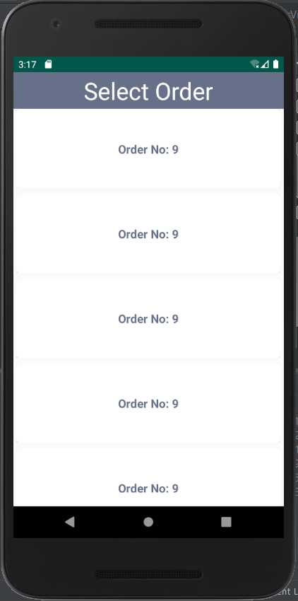

**Hall Manager Special Order Screen**

The following screen is designed for Hall Manager comprising a toolbar ar the top and the recycler view containing the details of the orders and their respective tables. Scrollview is implemented in this screen.

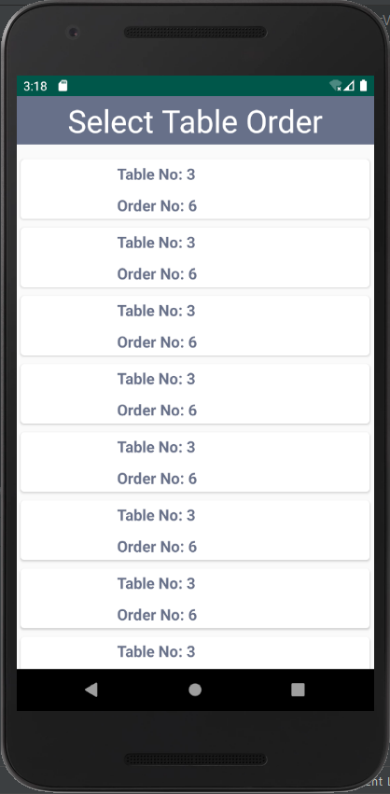

**Kitchen Manager Special Order Summary Screen**

In the action bar, role of the user is displayed here it is “Kitchen Manager”. Then, the title of the screen “Special Order Summary” is displayed. The text views have been used for displaying the table number and the order number. A recycler view has been used to display the summary of order i.e. food items ordered as specialized order. Each row of recycler view contains:

* Image view for displaying the image of dish
* Text view for displaying name of dish
* Text view for displaying the quantity ordered

Then two buttons are shown on the screen one in green color with “Confirm” text to proceed and place order and other one in red color with “Discard” text to discard the changes.

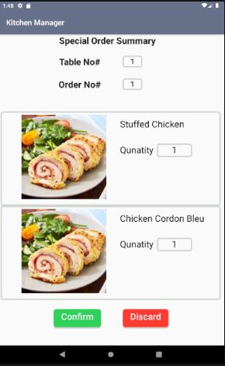

**Hall Manager Special Order Summary Screen**

In the action bar, role of the user is displayed here it is “Hall Manager”. Then, the title of the screen “Special Order Summary” is displayed. The text views have been used for displaying the table number and the order number. A recycler view has been used to display the summary of order i.e. food items ordered as specialized order. Each row of recycler view contains:

* Image view for displaying the image of dish
* Text view for displaying name of dish
* Text view for displaying the quantity ordered

Then two buttons are shown on the screen one in green color with “Confirm” text to proceed and place order and other one in red color with “Discard” text to discard the changes.

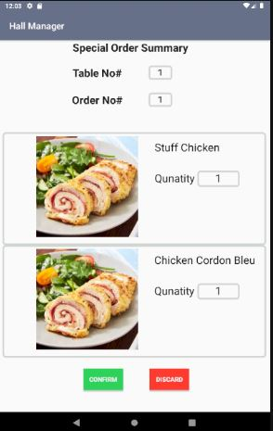

**Kitchen Manager Special Order Dish Selection Screen**

At the top of the screen in the action, it displays the name of the manager that is “Kitchen Manager”. For the Kitchen manager, it displays a list of previously ordered dishes from which he may select a dish and then choose the quantity of the dish. Each list item in recycler view shows a checkbox, its image, its name and the quantity adjusting buttons and quantity number.

* Checkbox for selecting the list item
* Image view for displaying the image of dish
* Text view for displaying name of dish
* Edit text field for displaying the quantity being ordered
* “+” and “-” buttons for adjusting the quantity number

Then a button is shown on the screen which says “Proceed”. It is supposed to take the selected list items and their quantity to order summary.

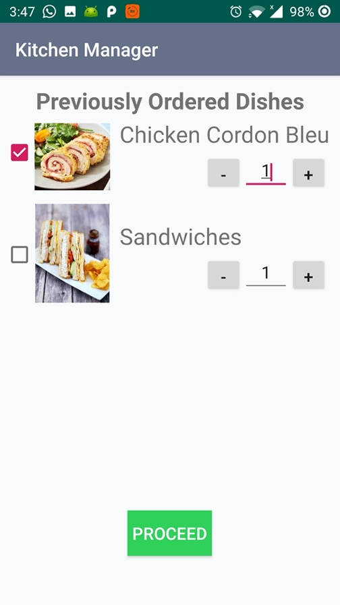

**Hall Manager Special Order Dish Selection Screen**

At the top of the screen in the action, it displays the name of the manager that is “Hall Manager”. For the Hall Manager, it displays a list of previously ordered dishes and a list of complimentary dishes from which he may select a dish and then choose the quantity of the dish too. Each list item in recycler view shows a checkbox, its image, its name and the quantity adjusting buttons and quantity number.

* Checkbox for selecting the list item
* Image view for displaying the image of dish
* Text view for displaying name of dish
* Edit text field for displaying the quantity being ordered
* “+” and “-” buttons for adjusting the quantity number

Then a button is shown on the screen which says “Proceed”. It is supposed to take the selected list items and their quantity to order summary.

