**Prototype 2.0**

for

Order It: Place, Track, Eat

Group Members:   
Ahmed Moatasim 16L-4332  
Farwa Khawar 16L-4171  
Minahil Imtiaz 16L-4126  
Shafin Salim 16L-4298  
Sikander Hassan Khan 16L-4375

Group Name:  
FAMSS

13th November, 2019

**Prototype Design**

The specialized order module has specialized screens for hall manager and kitchen manager, according to their roles and responsibilities. Each screen has been designed in tablet layout. Below are screenshots of the prototype design

**Kitchen Manager Special Order Screen**

The following screen is designed for the Kitchen Manager comprising a toolbar at the top and the recycler view containing the details of the orders. Scrollview is implemented in this screen.

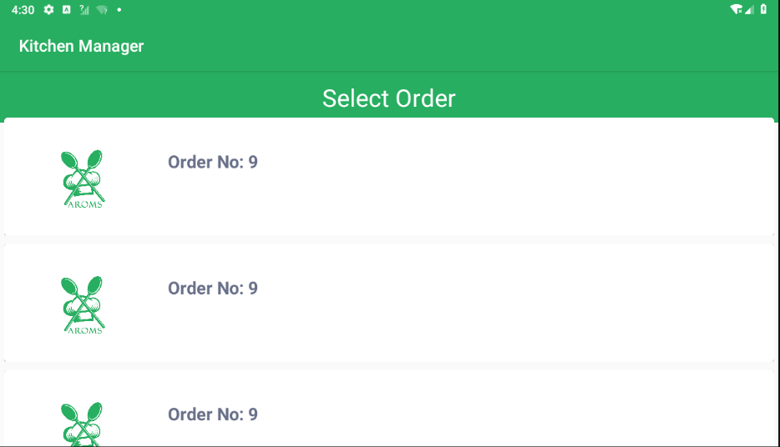

**Hall Manager Special Order Screen**

The following screen is designed for Hall Manager comprising a toolbar ar the top and the recycler view containing the details of the orders and their respective tables. Scrollview is implemented in this screen.

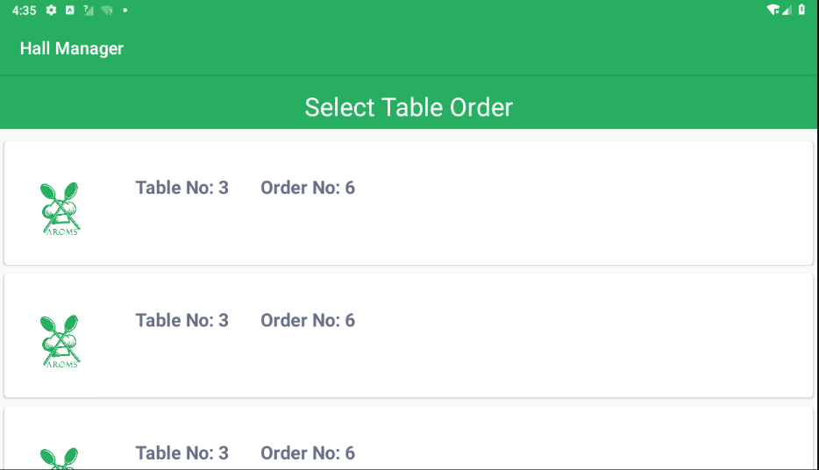

**Kitchen Manager Special Order Dish Selection Screen**

At the top of the screen in the action, it displays the name of the manager that is “Kitchen Manager”. For the Kitchen manager, it displays a list of previously ordered dishes from which he may select a dish and then choose the quantity of the dish. Each list item in recycler view shows a checkbox, its image, its name and the quantity adjusting buttons and quantity number.

* Checkbox for selecting the list item
* Image view for displaying the image of dish
* Text view for displaying name of dish
* Edit text field for displaying the quantity being ordered
* “+” and “-” buttons for adjusting the quantity number

Then a button is shown on the screen which says “Proceed”. It is supposed to take the selected list items and their quantity to order summary.

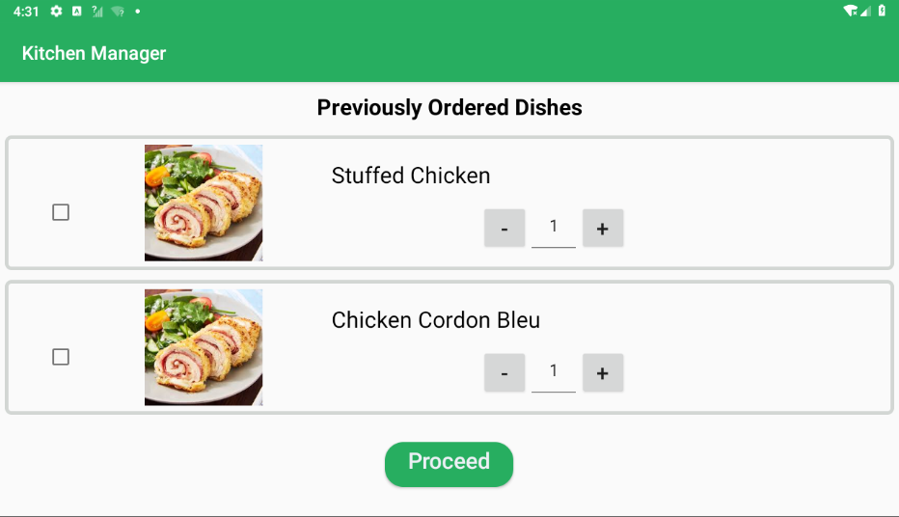

**Hall Manager Special Order Dish Selection Screen**

At the top of the screen in the action, it displays the name of the manager that is “Hall Manager”. For the Hall Manager, it displays a list of previously ordered dishes and a list of complimentary dishes from which he may select a dish and then choose the quantity of the dish too. Each list item in recycler view shows a checkbox, its image, its name and the quantity adjusting buttons and quantity number.

* Checkbox for selecting the list item
* Image view for displaying the image of dish
* Text view for displaying name of dish
* Edit text field for displaying the quantity being ordered
* “+” and “-” buttons for adjusting the quantity number

Then a button is shown on the screen which says “Proceed”. It is supposed to take the selected list items and their quantity to order summary.

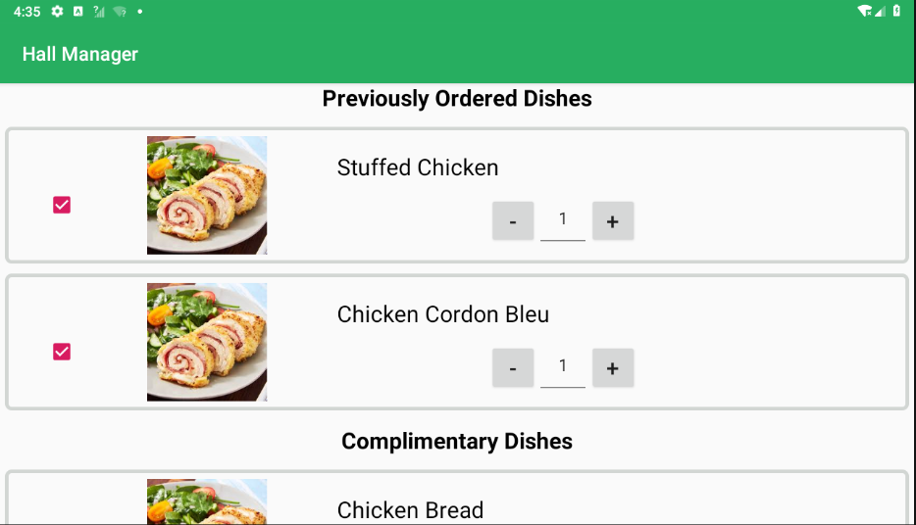

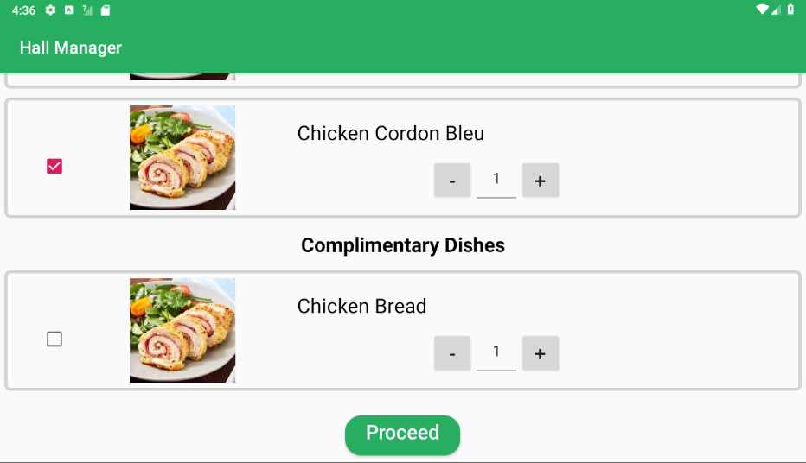

**Kitchen Manager Special Order Summary Screen**

In the action bar, role of the user is displayed here it is “Kitchen Manager”. Then, the title of the screen “Special Order Summary” is displayed. The text views have been used for displaying the table number and the order number. A recycler view has been used to display the summary of order i.e. food items ordered as specialized order. Each row of recycler view contains:

* Image view for displaying the image of dish
* Text view for displaying name of dish
* Text view for displaying the quantity ordered

Then two buttons are shown on the screen one in green color with “Confirm” text to proceed and place order and other one in red color with “Discard” text to discard the changes.

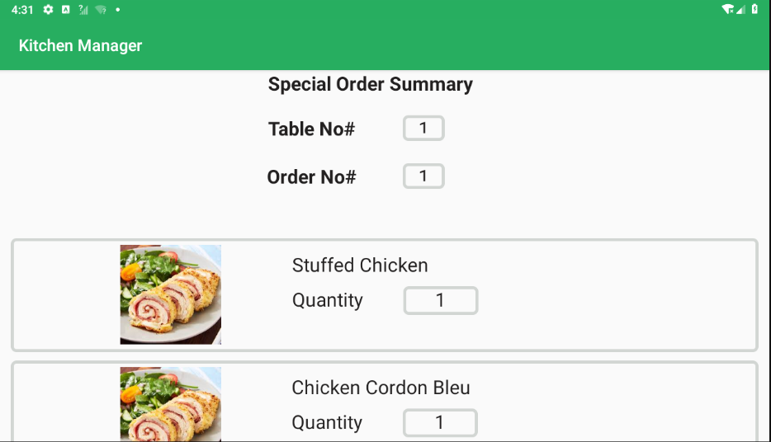

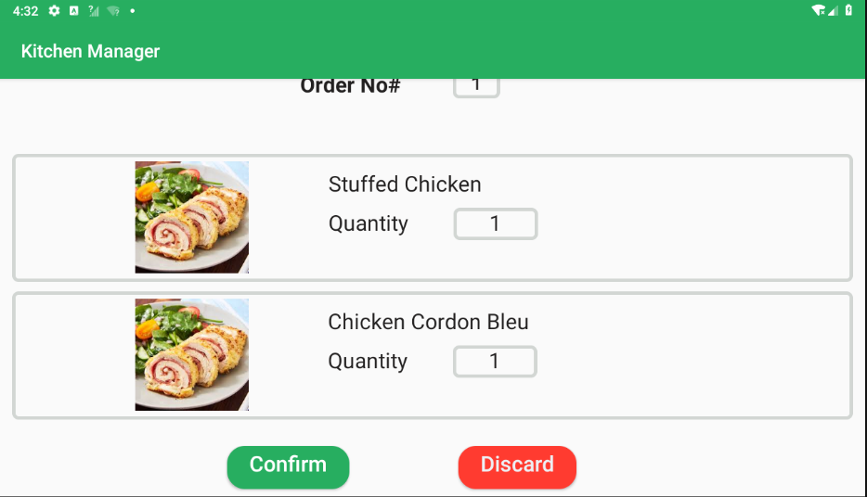

**Hall Manager Special Order Summary Screen**

In the action bar, role of the user is displayed here it is “Hall Manager”. Then, the title of the screen “Special Order Summary” is displayed. The text views have been used for displaying the table number and the order number. A recycler view has been used to display the summary of order i.e. food items ordered as specialized order. Each row of recycler view contains:

* Image view for displaying the image of dish
* Text view for displaying name of dish
* Text view for displaying the quantity ordered

Then two buttons are shown on the screen one in green color with “Confirm” text to proceed and place order and other one in red color with “Discard” text to discard the changes.

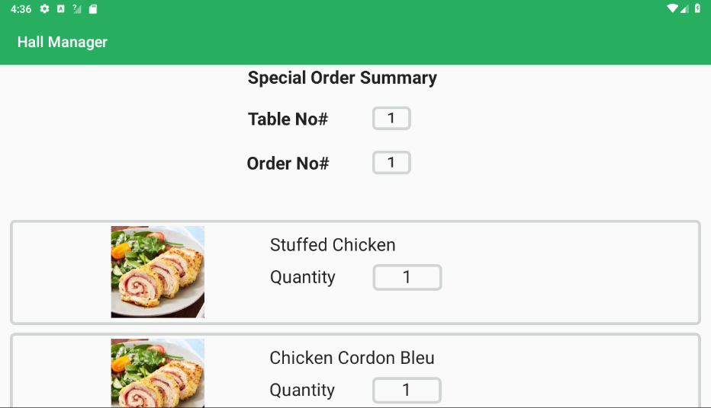

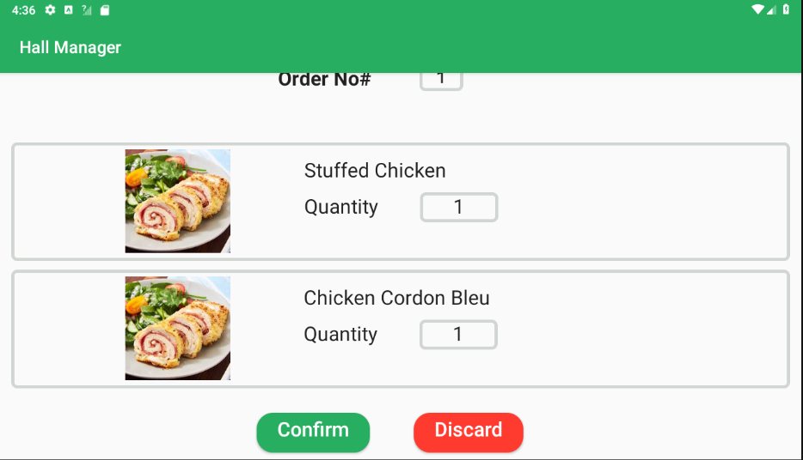

**Changes Made:**

Following changes have been made in the module:

* Code has been added for Firebase database references for connectivity to database as well as writing on the database.
* Data can be written to the Order Table

**Improvements Required:**

The following list of improvements are required in this module:

* The database reference read, update and delete operations still have to be implemented.

**Errors:**

Our program is dependent on the proper data provided by Order module. We haven’t received any data from the Order Module group. We have implemented our own Order class by referring to the Firebase Database Schema.