WATCHLIST MANAGER
Linux Lab Project Report

Student Name | ZARMIN SHAIKH
Roll / Division | F07 / G
Enrollment No. | 24004501210415
University / Subject | LJ University / OS Linux Lab

A menu-driven Bash application for managing movies and web series.

1. Introduction

1.1 Project Purpose
The purpose of the Watchlist Manager project is to develop a menu-driven Linux application using Bash Shell Scripting. It helps users maintain a list of movies and web series, track whether a title is pending or watched, save ratings, search recommendations by genre, calculate average ratings, create backups, and view activity logs.

1.2 Use of Bash Scripting
Bash scripting connects Linux commands and user input to automate tasks. In this project, read is used to accept values, echo displays messages, grep searches records, sed updates a selected record, awk calculates average ratings, sort randomizes recommendations, and tar creates compressed backups. Activity logs record important actions.

1.3 Benefits of a Single Menu
The menu gives users one place to add titles, update watched status and ratings, find unwatched titles by genre, view rating summaries, create backups, and inspect recent activity. The watchlist is stored in a CSV file, which is simple to read and process with Linux tools.

2. Folder Structure
The project is organized into the following files and directories:
watchlist/
├── main.sh Main menu and command-line options
├── README.md Project overview and instructions
├── lib/
│ └── functions.sh Functions for watchlist operations
├── data/
│ └── watchlist.csv Movie/series records
├── backups/ Compressed backup files
├── logs/
│ └── activity.log Record of actions performed
├── reports/ Folder for reports
└── weekend_picks.txt Random recommendations from cron task
Note: The exact files present in the folder may vary as backups and logs are generated while the program runs.

3. Features and Screenshots
Add the screenshots from your own terminal in the marked areas below. The report currently contains screenshot placeholders because terminal screenshots were not included with the reference file.

1) Add a title
This feature asks the user for a title, type (Movie/Series), and genre. It checks that the values are not empty and checks for a duplicate title before adding a new record to data/watchlist.csv. The new record starts with pending status.
Commands / functions: read, grep, cut, echo, log()
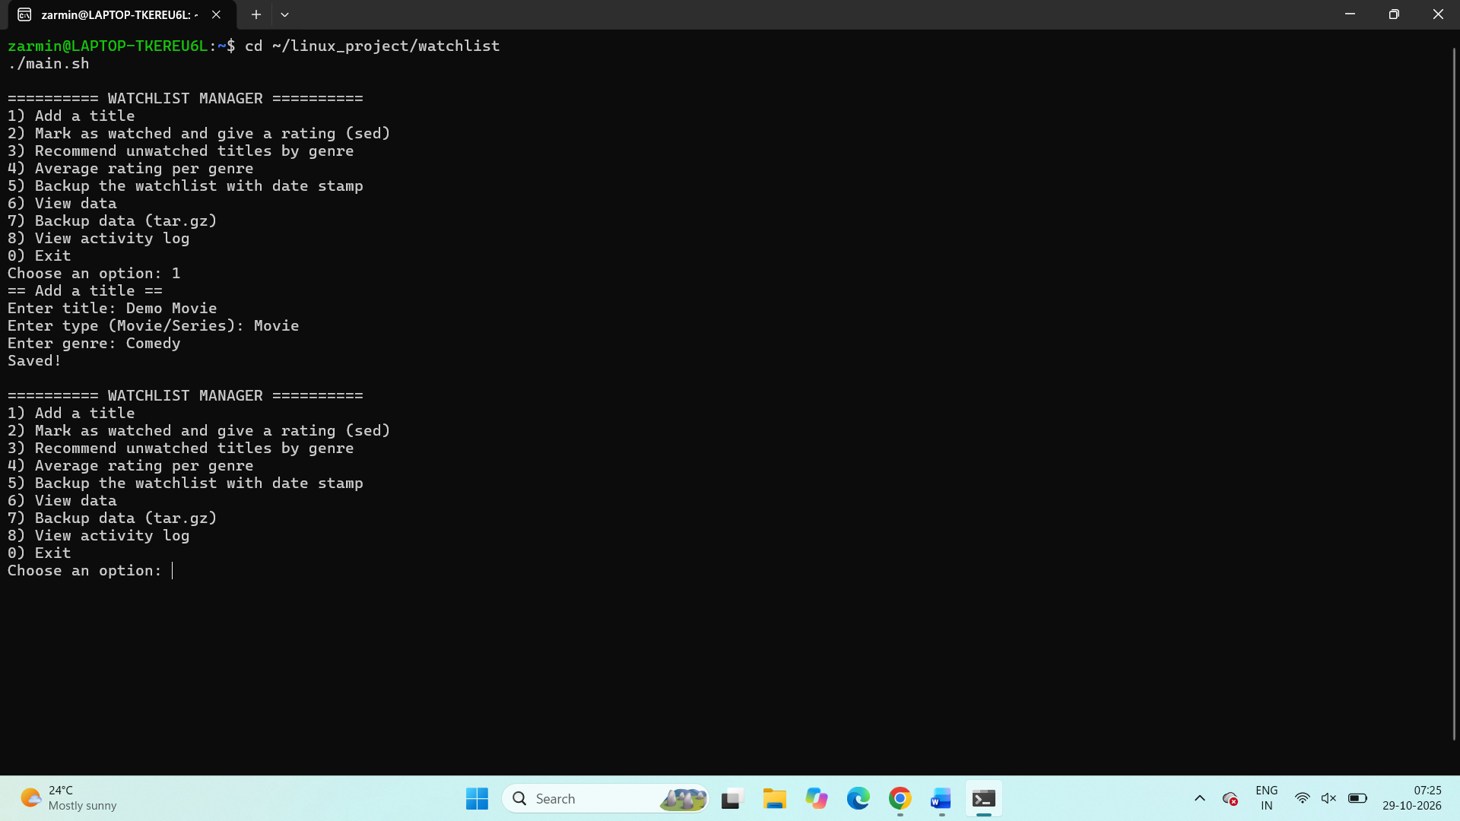

2) Mark as watched and give a rating
This feature asks for a title and a rating from 1 to 10. If the title is found and the rating is valid, sed updates the selected record with watched status and the entered rating.
Commands / functions: grep, sed -i, read, log()
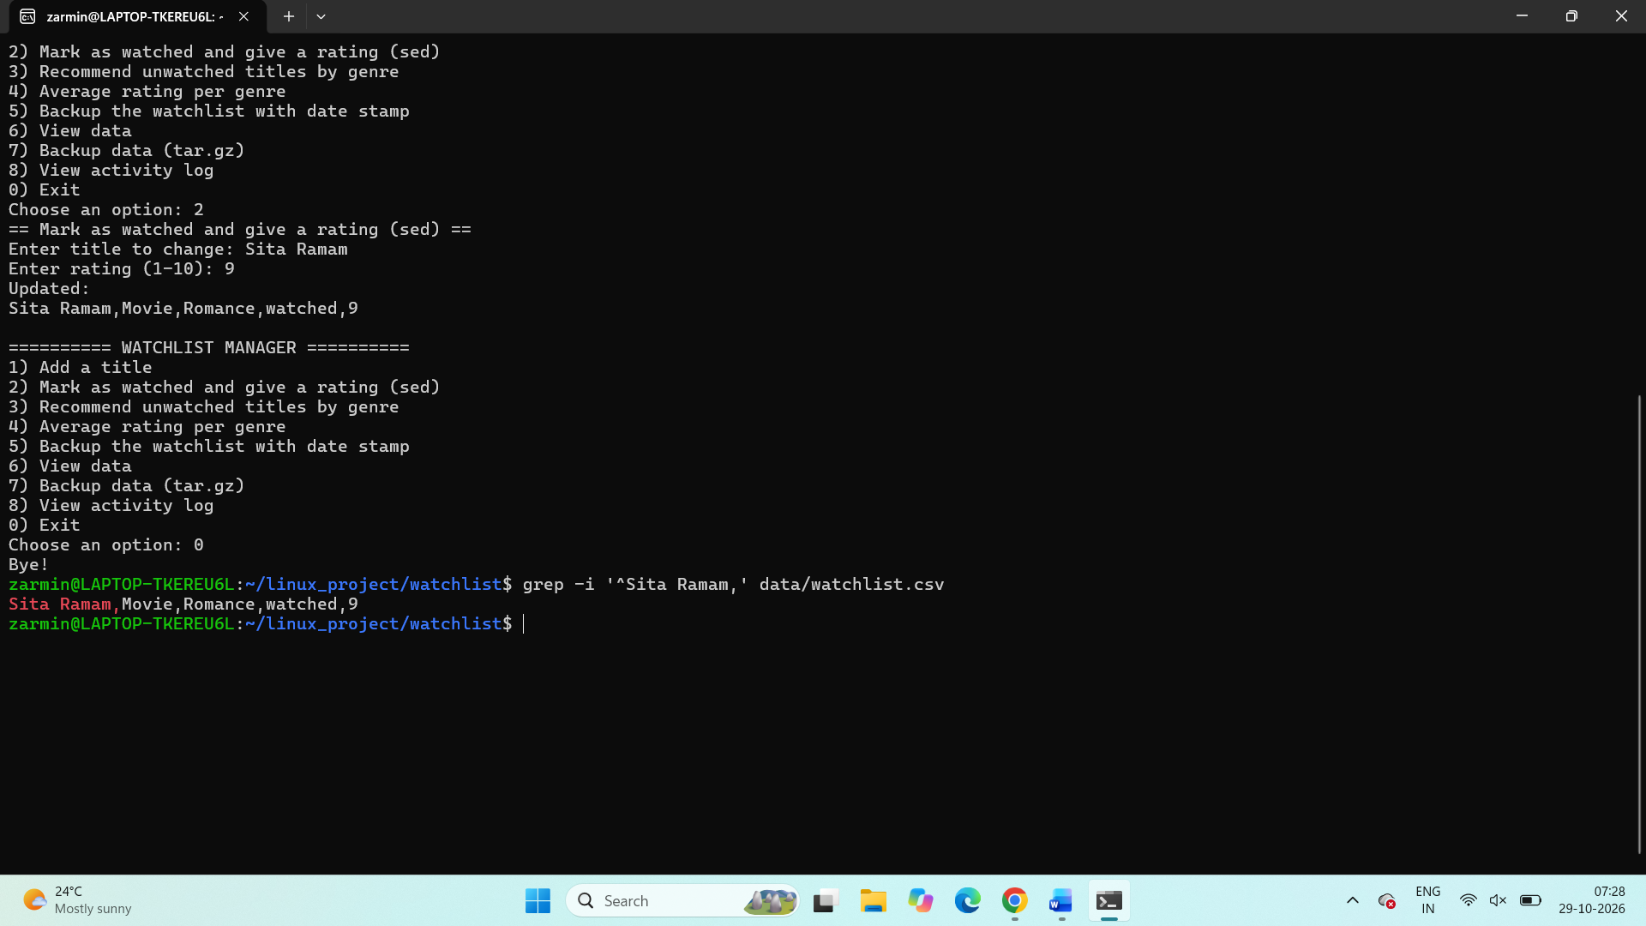

3) Recommend unwatched titles by genre
The user enters a genre. The program searches the CSV file for titles in that genre whose status is pending and displays matching records. If there are no matches, it displays a message.
Commands / functions: grep -i, read, log()
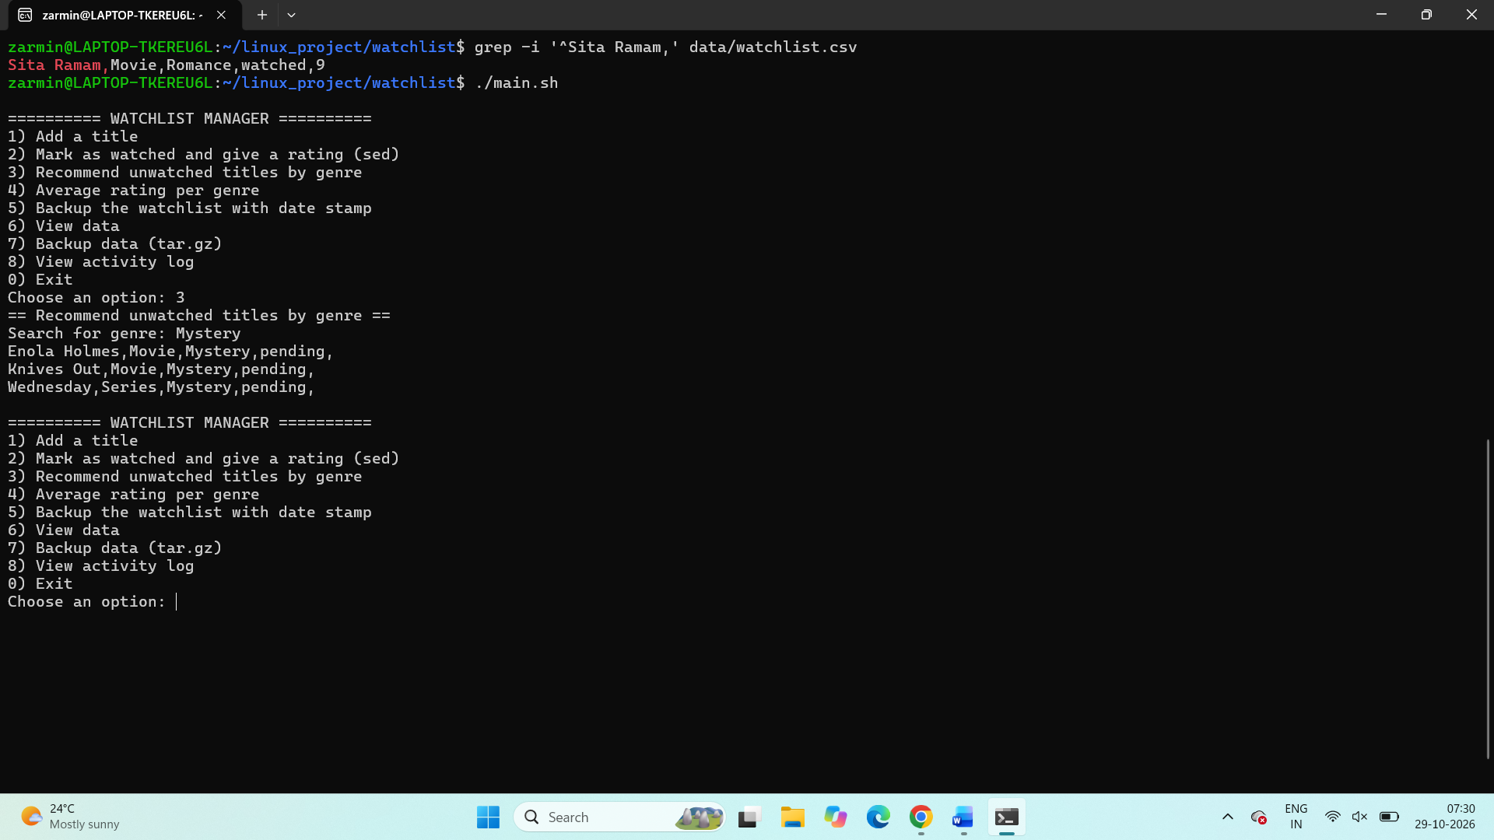

4) Average rating per genre
This feature processes watched records with ratings and calculates the average rating for each genre. The output is displayed with two decimal places.
Commands / functions: awk -F','
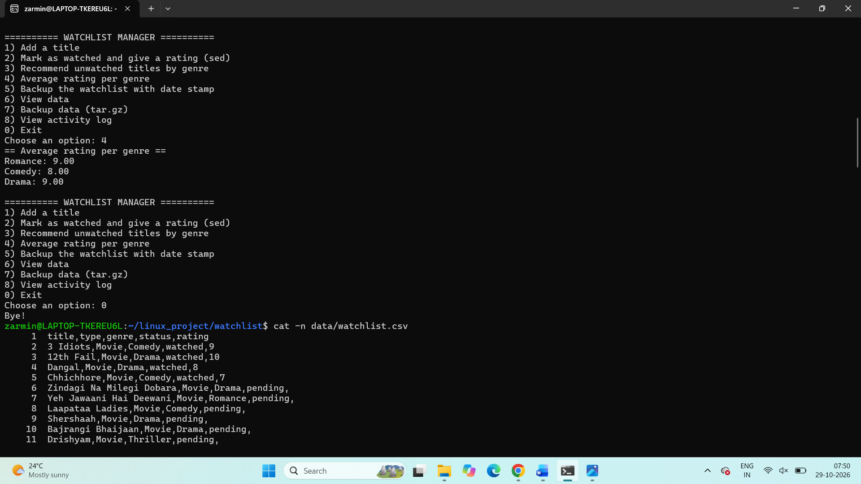

5) Backup the watchlist with date stamp
This feature creates a compressed archive of the data directory. The backup filename contains the current date and time so that different backups can be identified.
Commands / functions: tar, date, log()
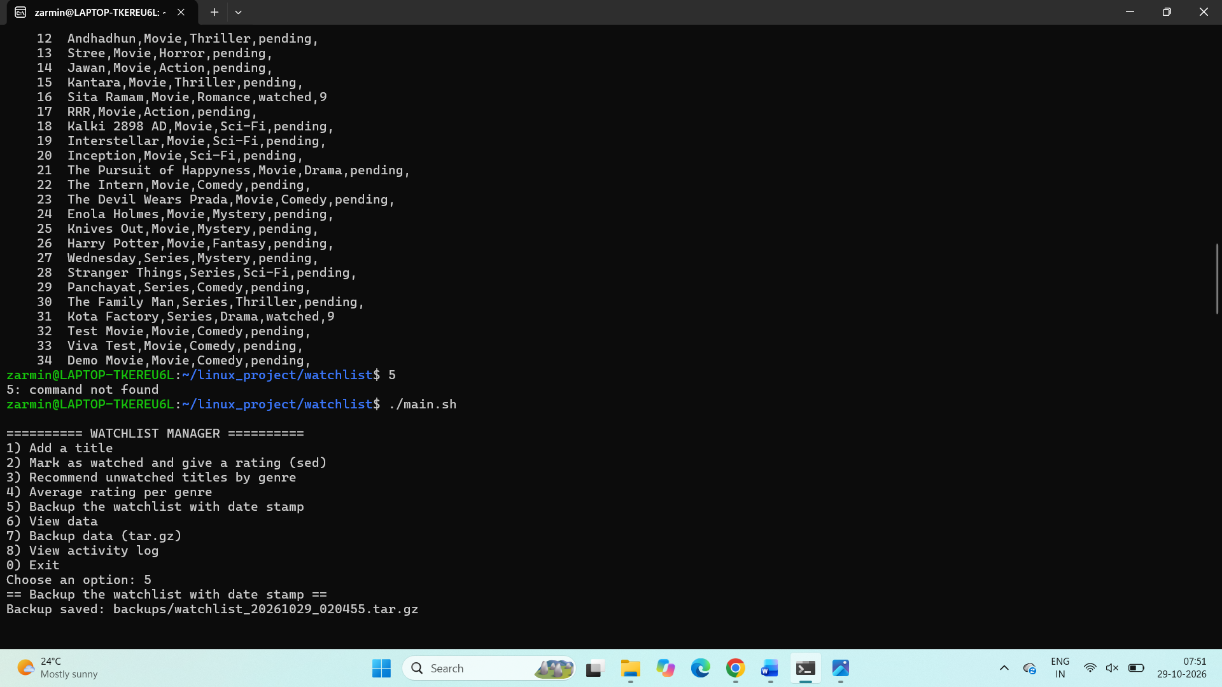

6) View data
This feature checks whether the CSV data file exists and displays the watchlist with line numbers, using a page-by-page view.
Commands / functions: check_data(), cat -n, more
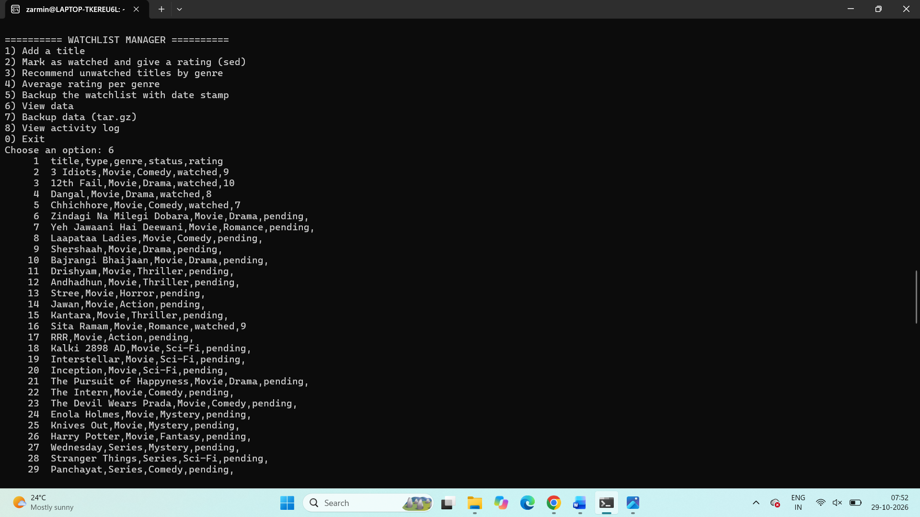

7) Backup data as tar.gz
This feature creates a compressed backup of the data directory in the backups folder. It also displays the saved backup path and file size.
Commands / functions: tar -czf, date, du -h, cut, log()
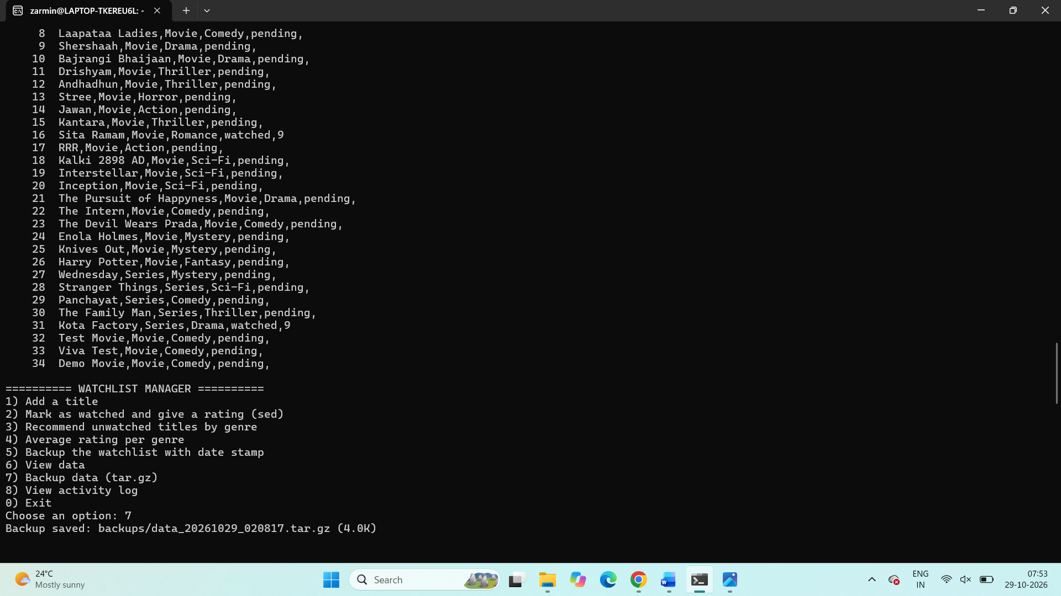

8) View activity log
This feature displays recent records from logs/activity.log. Log entries include timestamps and descriptions of actions such as adding a title, updating a rating, or creating a backup.
Commands / functions: tail -n 15, log()
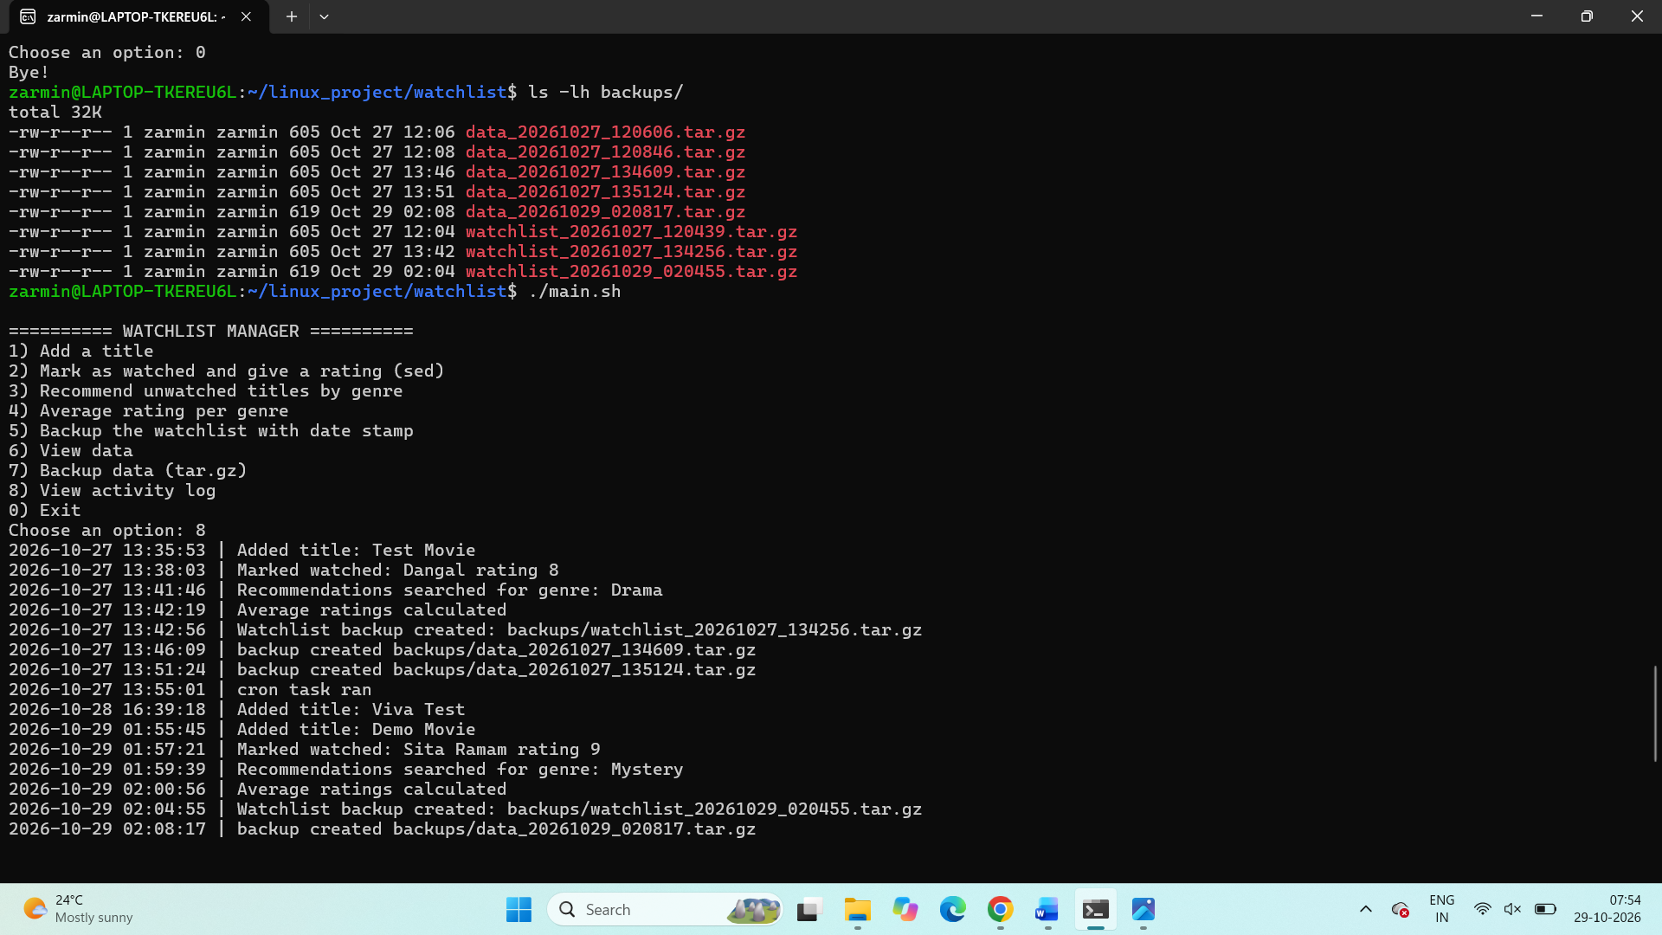

9) Automatic weekend recommendations
The cron task searches for pending titles, randomizes their order, and saves up to three recommendations in weekend_picks.txt. The documented schedule runs every Saturday at 7:00 PM, provided the cron service and environment are running.
Commands / functions: grep, sort -R, head -n 3, >, crontab
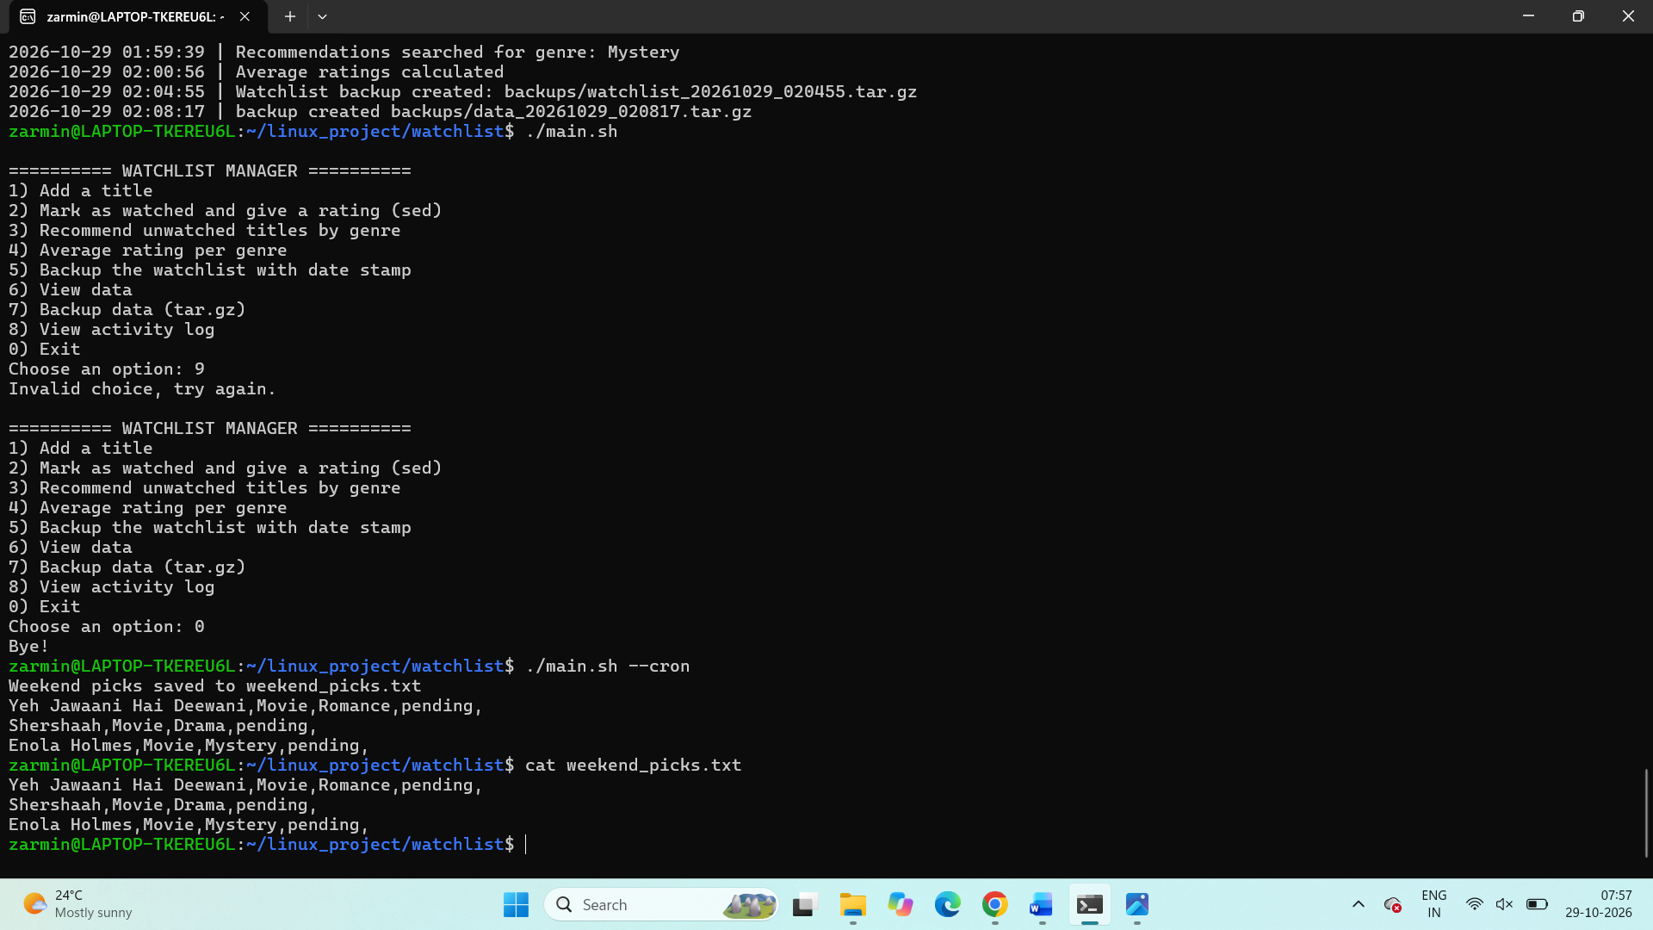

4. Important Commands Used
Command | Purpose
grep | Searches text or records in a file; used for title checks and genre recommendations.
cut -d',' -f1 | Uses comma as delimiter and extracts the first CSV field, the title.
sed -i | Edits a file directly; used to update a title's status and rating.
awk -F',' | Uses comma-separated fields to process CSV records and calculate genre averages.
sort -R | Randomizes the order of matching lines for recommendations.
head -n 3 | Selects the first three lines after randomization.
tar -czf | Creates a gzip-compressed archive.
date | Adds a timestamp to backup filenames.
du -h | Displays file size in a human-readable format.
cat -n / more | Displays data with line numbers and page-by-page navigation.
tail -n 15 | Displays the most recent 15 lines of the activity log.
crontab -l | Displays the current user's scheduled cron jobs.

5. Testing and Validation
Suggested screenshots/evidence to include after running your own project:
- Main menu displayed in the terminal.
- Adding a sample title and confirming it appears in the CSV file.
- Updating a title to watched and entering a valid rating.
- Searching for unwatched titles by genre.
- Displaying average ratings by genre.
- Creating a dated backup and a tar.gz backup.
- Viewing recent activity log entries.
- Running the cron task manually and showing weekend_picks.txt.
- Showing the crontab entry with crontab -l.

6. Conclusion
This project provides practical experience with Bash Shell Scripting and Linux command-line tools. It demonstrates how to accept user input, validate records, search and update CSV data, calculate summary values, create compressed backups, maintain activity logs, and schedule a task with crontab. The project also helps develop confidence in using Linux commands for everyday file and data management.

Appendix: How to Run the Project
cd ~/linux_project/watchlist
./main.sh
./main.sh --help
./main.sh --backup
./main.sh --cron
Before submission, replace each screenshot placeholder with a clear screenshot from your own terminal. Also verify the final folder structure and the required archive filename against your instructor's assignment instructions.

