Software Requirements and Design Document

for

<Student Management System>

Prepared by Samiya,Zarnab,Ayesha

NexaGen

25/11/2024

Table of Contents

Table of Contents ii

1. Introduction 1

1.1 Purpose 1

1.2 Product Scope 1

1.3 Title 1

1.4 Objectives 1

1.5 Problem Statement 1

2. Overall Description 2

2.1 Product Perspective 2

2.2 Product Functions 2

2.3 List of Use Cases 3

2.4 Extended Use Cases 3

2.5 Use Case Diagram 4

3. Other Nonfunctional Requirements 4

3.1 Performance Requirements 4

3.2 Safety Requirements 4

3.3 Security Requirements 5

3.4 Software Quality Attributes 5

3.5 Business Rules 5

3.6 Operating Environment 5

3.7 User Interfaces 5

4. Domain Model 6

5. System Sequence Diagram 7

6. Sequence Diagram 9

7. Class Diagram 10

8. Package Diagram 11

9. Deployment Diagram 12

# Introduction

## Purpose

This document specifies the software requirements for the Nexagen StudentHub system. The purpose of this document is to provide a detailed description of the system's functionality, scope, and objectives, specifically designed for university students to streamline their academic management. This document focuses solely on the core functionalities of the student management subsystem.

## Product Scope

Nexagen StudentHub is a comprehensive student management system aimed at ensuring university students have access to all vital academic information in one platform. The system addresses challenges like missed deadlines, lack of organized course material, and difficulty finding classroom locations or contact details. Key benefits include enhanced organization, efficient communication, and increased academic productivity. By aligning with corporate goals of aiding the next generation through innovative solutions, the Nexagen StudentHub is integral to fulfilling this vision.

## Title

*Nexagen StudentHub:A Comprehensive Student Management System.*

## Objectives

The objectives of *Nexagen StudentHub* are as follows:

* Provide students with an intuitive platform to access essential academic information.
* Ensure students never miss important deadlines or notifications.
* Facilitate communication with teachers and peers through accessible contact details.
* Enhance students' ability to manage their schedules, attendance, and coursework effectively.

## Problem Statement University students often struggle to keep track of critical academic information, resulting in missed deadlines, confusion over class schedules, and difficulty accessing relevant course materials or contact information. The manual or scattered approach to managing these tasks leads to inefficiencies and frustration.

*Nexagen StudentHub* addresses these challenges by offering a centralized platform where students can:

* View class schedules and upcoming deadlines.
* Access teacher contact details and course material links.
* Receive timely notifications and deadline reminders.
* Search for classrooms and view attendance records.
* Check exam timetables and registration details.

By automating these processes and providing a user-friendly interface, *Nexagen StudentHub* reduces dependency on manual tracking, enhances academic performance, and ensures students stay informed and organized. The feasibility of this solution is strengthened by its scalable architecture and alignment with the latest technological tools.

# Overall Description

## Product Perspective

*Nexagen StudentHub* is a **self-contained product** developed to streamline academic management for university students. It is designed as a **new application**, independent of any prior system. The platform acts as an integrated solution connecting students, teachers, and institutional systems.  
The major components and subsystems include:

* **User Interface**: For seamless interaction with students.
* **Database**: Stores all student, course, schedule, and notification-related information.
* **Notification System**: Sends reminders and alerts for upcoming deadlines and exams.
* **Search Functionality**: Assists in finding classrooms, venues, or other information.
* **Access Control**: Ensures role-based access to the system.

## Product Functions

The system must perform the following high-level functions:

* Manage and display **class schedules**.
* Notify users about **upcoming deadlines** and other academic events.
* Provide access to **teacher contact information**.
* Display **registration details** and **exam timetables**.
* Store and retrieve **course materials**.
* Enable **search** for classrooms and venues.
* Track and display **attendance records**.
* Send **deadline reminders** via the notification system

## List of Use Cases

* View class schedule
* View upcoming deadlines
* Access Teacher Contact Information
* View Registeration Details
* Receive Notifications
* Search For Classrooms/Venues
* Receive Deadline Remainders
* Access course material links
* View Attendance Record
* Check Exam Timetable

## Extended Use Cases

* **View Class Schedule**: Notify students of schedule changes in real-time and sync schedules with personal calendars.
* **View Upcoming Deadlines**: Provide a calendar view to track deadlines with urgency-based prioritization.
* **Access Teacher Contact Information**: Enable direct messaging or scheduling appointments with teachers.
* **View Registration Details**: Alert students of incomplete registrations or upcoming deadlines for course changes.
* **Receive Notifications**: Customize notifications by categories, with an option for email or SMS delivery.
* **Search for Classrooms/Venues**: Offer GPS-based navigation for locating classrooms and nearby facilities.
* **Receive Deadline Reminders**: Allow students to set personalized reminder timings for deadlines.
* **Access Course Material Links**: Provide offline access to downloaded course materials for convenience.
* **View Attendance Record**: Notify students if attendance falls below the required threshold for eligibility.
* **Check Exam Timetable**: Display countdowns to exams and resolve conflicts in exam schedules.

## Use Case Diagram

# Other Nonfunctional Requirements

## Performance Requirements

* The system should support **simultaneous access** by up to 500 users without significant delay (<2 seconds for page load).
* Notifications must be sent within **5 seconds** of triggering an event.
* The system should handle up to **10,000 records** in the database without performance degradation.

## Safety Requirements

• Data integrity must be maintained during power failures or crashes through **regular backups**.

• Notifications should not contain sensitive personal information to prevent unintended data exposure.

## Security Requirements

• The system must enforce **user authentication** with secure passwords.

• User roles should restrict access, e.g., students can only view their data, and administrators manage the database.

• All sensitive data, such as attendance and grades, must be encrypted.

• The system should comply with **FERPA** or equivalent student privacy standards.

## Software Quality Attributes

• **Reliability**: The system should have 99.9% uptime.

• **Usability**: The interface should be intuitive for non-technical users, with minimal training required.

• **Maintainability**: The system should allow easy updates for new features or bug fixes.

• **Portability**: Compatible with major browsers and mobile devices (iOS and Android).

• **Adaptability**: The system should be scalable for new features and increased user capacity.

## Business Rules

* Only students with a valid university ID can access the system.
* Teachers can upload course materials but cannot modify schedules Timetable.
* Notifications for deadlines must be sent at least **24 hours** before the due date.

## Operating Environment

• **Hardware**: Requires a server with at least 16 GB RAM and 500 GB storage.

• **Operating System**: Compatible with Windows Server 2019, Ubuntu 20.04, or later.

• **Database**: MySQL 8.0 or PostgreSQL 13.0.

• **Development Tools**: Developed using Java (Spring Suit Tool)

## User Interfaces

## The system will provide:

* **Dashboard**: Displays class schedules, deadlines, and notifications at a glance.
* **Search Bar**: Allows quick access to classrooms or venues.
* **Course Page**: Displays course materials, attendance, and exam timetables.
* **Notification Panel**: Lists recent alerts.  
  GUI Standards:
* Consistent navigation bar across all screens.
* Accessible error messages and feedback for user actions.
* Mobile-friendly layout with responsive design.

# Domain Model

# 

# 5.System Sequence

# 6.Sequence Diagram

# 

# 

# 7.Class Diagram

# 

# 8.Component Diagram

# 9.Package Diagram

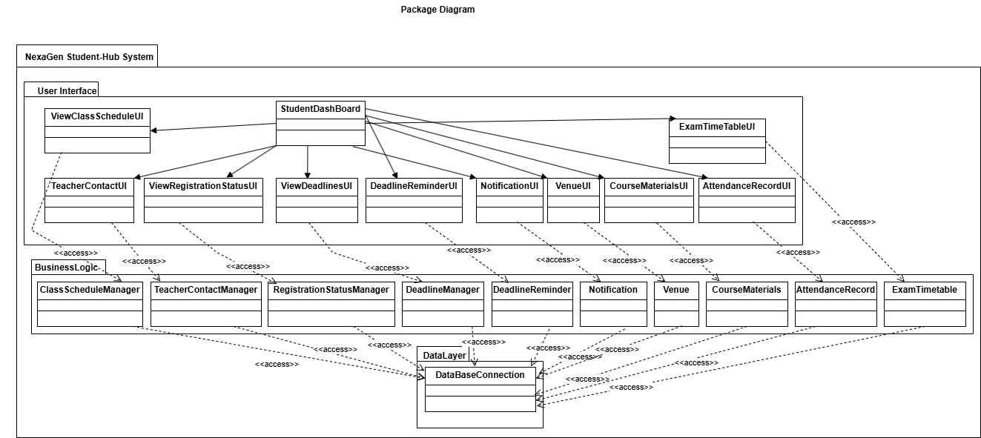

**10**.**DEPLOYMENT DIAGRAM**

# 