**PROBLEM STATEMENT**

**KPI’s REQUIREMENT**

We need to analyze key indicators for our pizza sales data to gain insights into our business performance. Specifically, we want to calculate the following metrics:

1. **Total Revenue**: The sum of the total price of all pizza orders.
2. **Average Order Value**: The average amount spent per order, calculated by dividing the total revenue by the total number of orders.
3. **Total Pizzas Sold**: The sum of the quantities of all pizzas sold.
4. **Total Orders**: The total number of orders placed.
5. **Average Pizzas Per Order**: The average number of pizzas sold per order, calculated by dividing the total number of pizzas sold by the total number of orders.

**CHARTS RQUIREMENT**

We would like to visualize various aspects of our pizza sales data to gain insights and understand key trends. We have identified the following requirements for creating charts:

1. **Daily Trend for Total Orders:**

Create a bar chart that displays the daily trend of total orders over a specific time period. This chart will help us identify any patterns or fluctuations in order volumes on a daily basis.

1. **Monthly Trend of Total Orders:**

Create a line chart that illustrates the hourly trend of total orders throughout the day. This chart will allow us to identify peak hours of periods of high order activity.

1. **Percentage of Sales by Pizza Category:**

Create a pie chart that shows the distribution of sales across different pizza categories. This chart will provide insights into the popularity of various pizza categories and their contribution to overall sales.

1. **Percentage of Sales by Pizza Size:**

Generate a pie chart that represents the percentage of sales attributed to different pizza sizes. This chart will help us understand customer preferences for pizza sizes and their impact on sales.

1. **Total Pizzas Sold by Pizza Category:**

Create a funnel chart that presents the total number of pizzas sold for each pizza category. This chart will allow us to compare the sales performance of different pizza categories.

1. **Top 5 Best Sellers by Revenue, Total Quantity and Total Orders:**

Create a bar chart highlighting the top 5 best-selling pizzas based on the Revenue, Total Quantity, Total Orders, this chart will help us identify the most popular pizza options.

1. **Bottom 5 Best Sellers by Revenue, Total Quantity and Total Orders:**

Create a bar chart showcasing the bottom 5 worst-selling pizzas based on the Revenue, Total Quantity, Total Orders, This chart will enable us to identify underperforming or less popular pizza options.

**################## SQL query and output of KPI’s Requirements ###########**

**!---KPI's Metrics---Total Revenue**

select sum(total_price) as Total_Revenue

from pizza_sales;

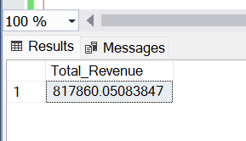

**!---KPI's Metrics--- Average Order Value (total price/total order)**

select (sum(total_price) / count(distinct order_id)) AS Avg_order_value

from pizza_sales;

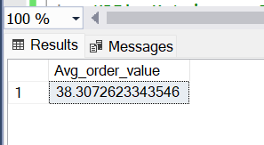

**!---KPI's Metrics--- Total Pizzas Sold**

select sum(quantity) AS Total_pizzas_sold

from pizza_sales;

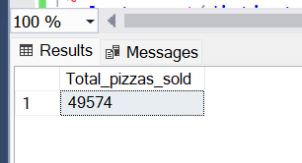

**!---KPI's Metrics--- Total Orders**

select count(distinct order_id) AS Total_orders

from pizza_sales;

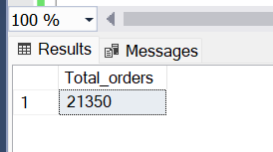

**!---KPI's Metrics--- Average Pizzas Per Order (total number of pizzas sold/ total number of order)**

select CAST(cast(sum(quantity) as decimal (10,2))/ cast(count(distinct order_id) as decimal (10,2)) AS DECIMAL(10,2)) AS Avg_pizzas_per_order

from pizza_sales;

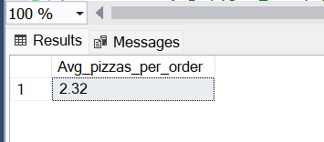

**!----------1-Datily Trend for Total Order**

select DATENAME(DW,order_date) as Order_day, count(distinct order_id) as total_order

from pizza_sales

group by DATENAME(DW,order_date);

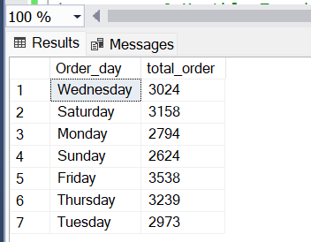

**!----------2-Monthly Trend of Total Order**

select DATENAME(MONTH,order_date) AS Month_name, count(distinct order_id) as Total_orders

from pizza_sales

group by DATENAME(MONTH,order_date);

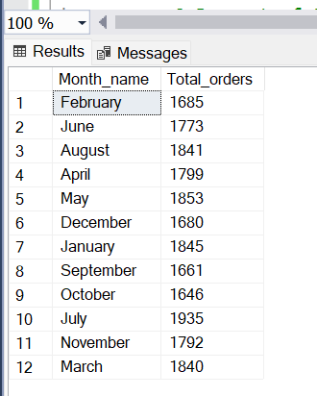

**!----------3-Percent of Sales by Pizzas Catagory (pizzas_catagory, total_revenue, percent_of_total_revenue)**

select pizza_category, cast (sum(total_price) as decimal (10,2)) as total_revenue,

cast (sum(total_price)*100 / (select sum(total_price) from pizza_sales) as decimal(10,2)) as Sales_perct

from pizza_sales

group by pizza_category;

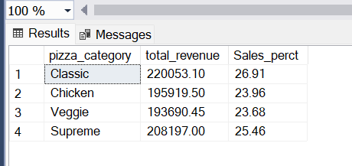

**!----------4-Percentage of Sales by Pizza Size (pizza_size, total_sales, pct_total_sale_on_pizza_size)**

select pizza_size, cast(sum(total_price) as decimal(10,2)) as total_revenue,

cast(sum(total_price)*100 / (select sum(total_price) from pizza_sales) as decimal(10,2)) as pct_on_sales_pizza_size

from pizza_sales

group by pizza_size

order by pizza_size;

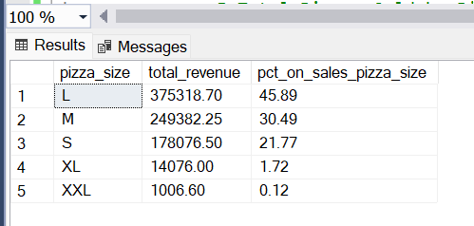

**!--------------5-Total Pizzas Sold by Pizza Category (pizza_category, total_quantity_sold)**

select pizza_category, sum(quantity) as toal_quantity_sold

from pizza_sales

group by pizza_category;

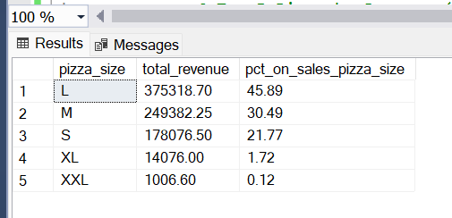

**!-------------6-Top 5 Pizza by Revenue (top 5 pizza_name, total_revenue)**

select top 5 pizza_name, sum(total_price) as total_revenue

from pizza_sales

group by pizza_name

order by total_revenue DESC;

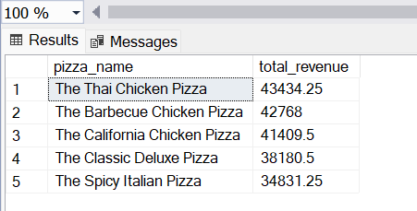

**!--------------Bottom 5 Pizza by Revenue (Botoom 5 pizza_name, total_revenue)**

select top 5 pizza_name, sum(total_price) as total_revenue

from pizza_sales

group by pizza_name

order by total_revenue ASC;

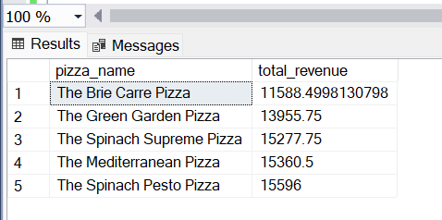

**!----------------7- Top 5 Pizza by Quantity ( Top 5 pizza_name, total_quantity)**

select top 5 pizza_name, sum(quantity) as total_quantity

from pizza_sales

group by pizza_name

order by total_quantity DESC;

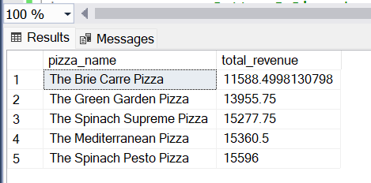

**!----------------- Bottom 5 Pizza by Quantity**

select top 5 pizza_name, sum(quantity) as total_quantity

from pizza_sales

group by pizza_name

order by total_quantity ASC;

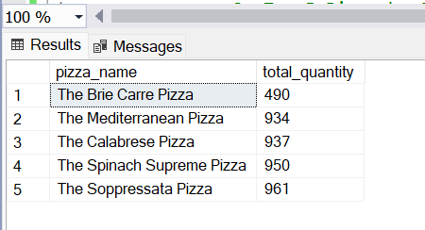

**!----------------8- Top 5 Pizza by Orders ( Top 5 pizza_name, total_orders)**

select top 5 pizza_name, count(distinct order_id) as total_orders

from pizza_sales

group by pizza_name

order by total_orders DESC;

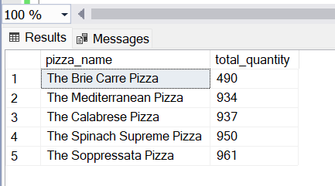

**!-----------------Bottom 5 Pizza by Orders**

select top 5 pizza_name, count(distinct order_id) as total_orders

from pizza_sales

group by pizza_name

order by total_orders ASC;

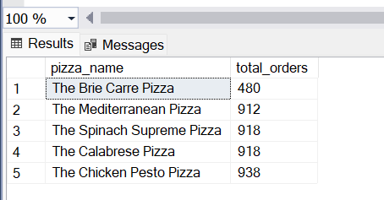

**### NOTE ##**

If want to apply Month, Week, Quarter filter, it can be use WHERE clause

Example: filtering for January

select DATENAME(DW,order_date) as Order_day, count(distinct order_id) as total_order

from pizza_sales

where MONTH(order_date) = 1

group by DATENAME(DW,order_date);

*Example; filtering first quarter*

select pizza_category, cast (sum(total_price) as decimal (10,2)) as total_revenue,

cast (sum(total_price)*100 / (select sum(total_price) from pizza_sales where DATEPART(quarter, order_date) = 1

) as decimal(10,2)) as Sales_perct

from pizza_sales

where DATEPART(quarter, order_date) = 1

group by pizza_category;