MOODCINE — ARCHITECTURE & DATABASE DESIGN
Week 2 | System Architecture + ERD
MSc CS FYP | 7COM1040 | University of Hertfordshire | Muhammad Arslan Khan (24160374) | Supervisor: Lora Tonga
This document presents two core design artefacts of the MoodCine project: (1) the system architecture diagram showing all modules and data flow, and (2) the Entity Relationship Diagram (ERD) showing the PostgreSQL database design. Both are required evidence for the interim and final dissertation reports.

Section 1 — System Architecture Diagram
The diagram below shows the complete MoodCine architecture with all 8 modules, data flow, and external integrations. The system processes user mood input through NLP and FER emotion detection, fuses both signals, and generates personalised movie recommendations with AI explanations.

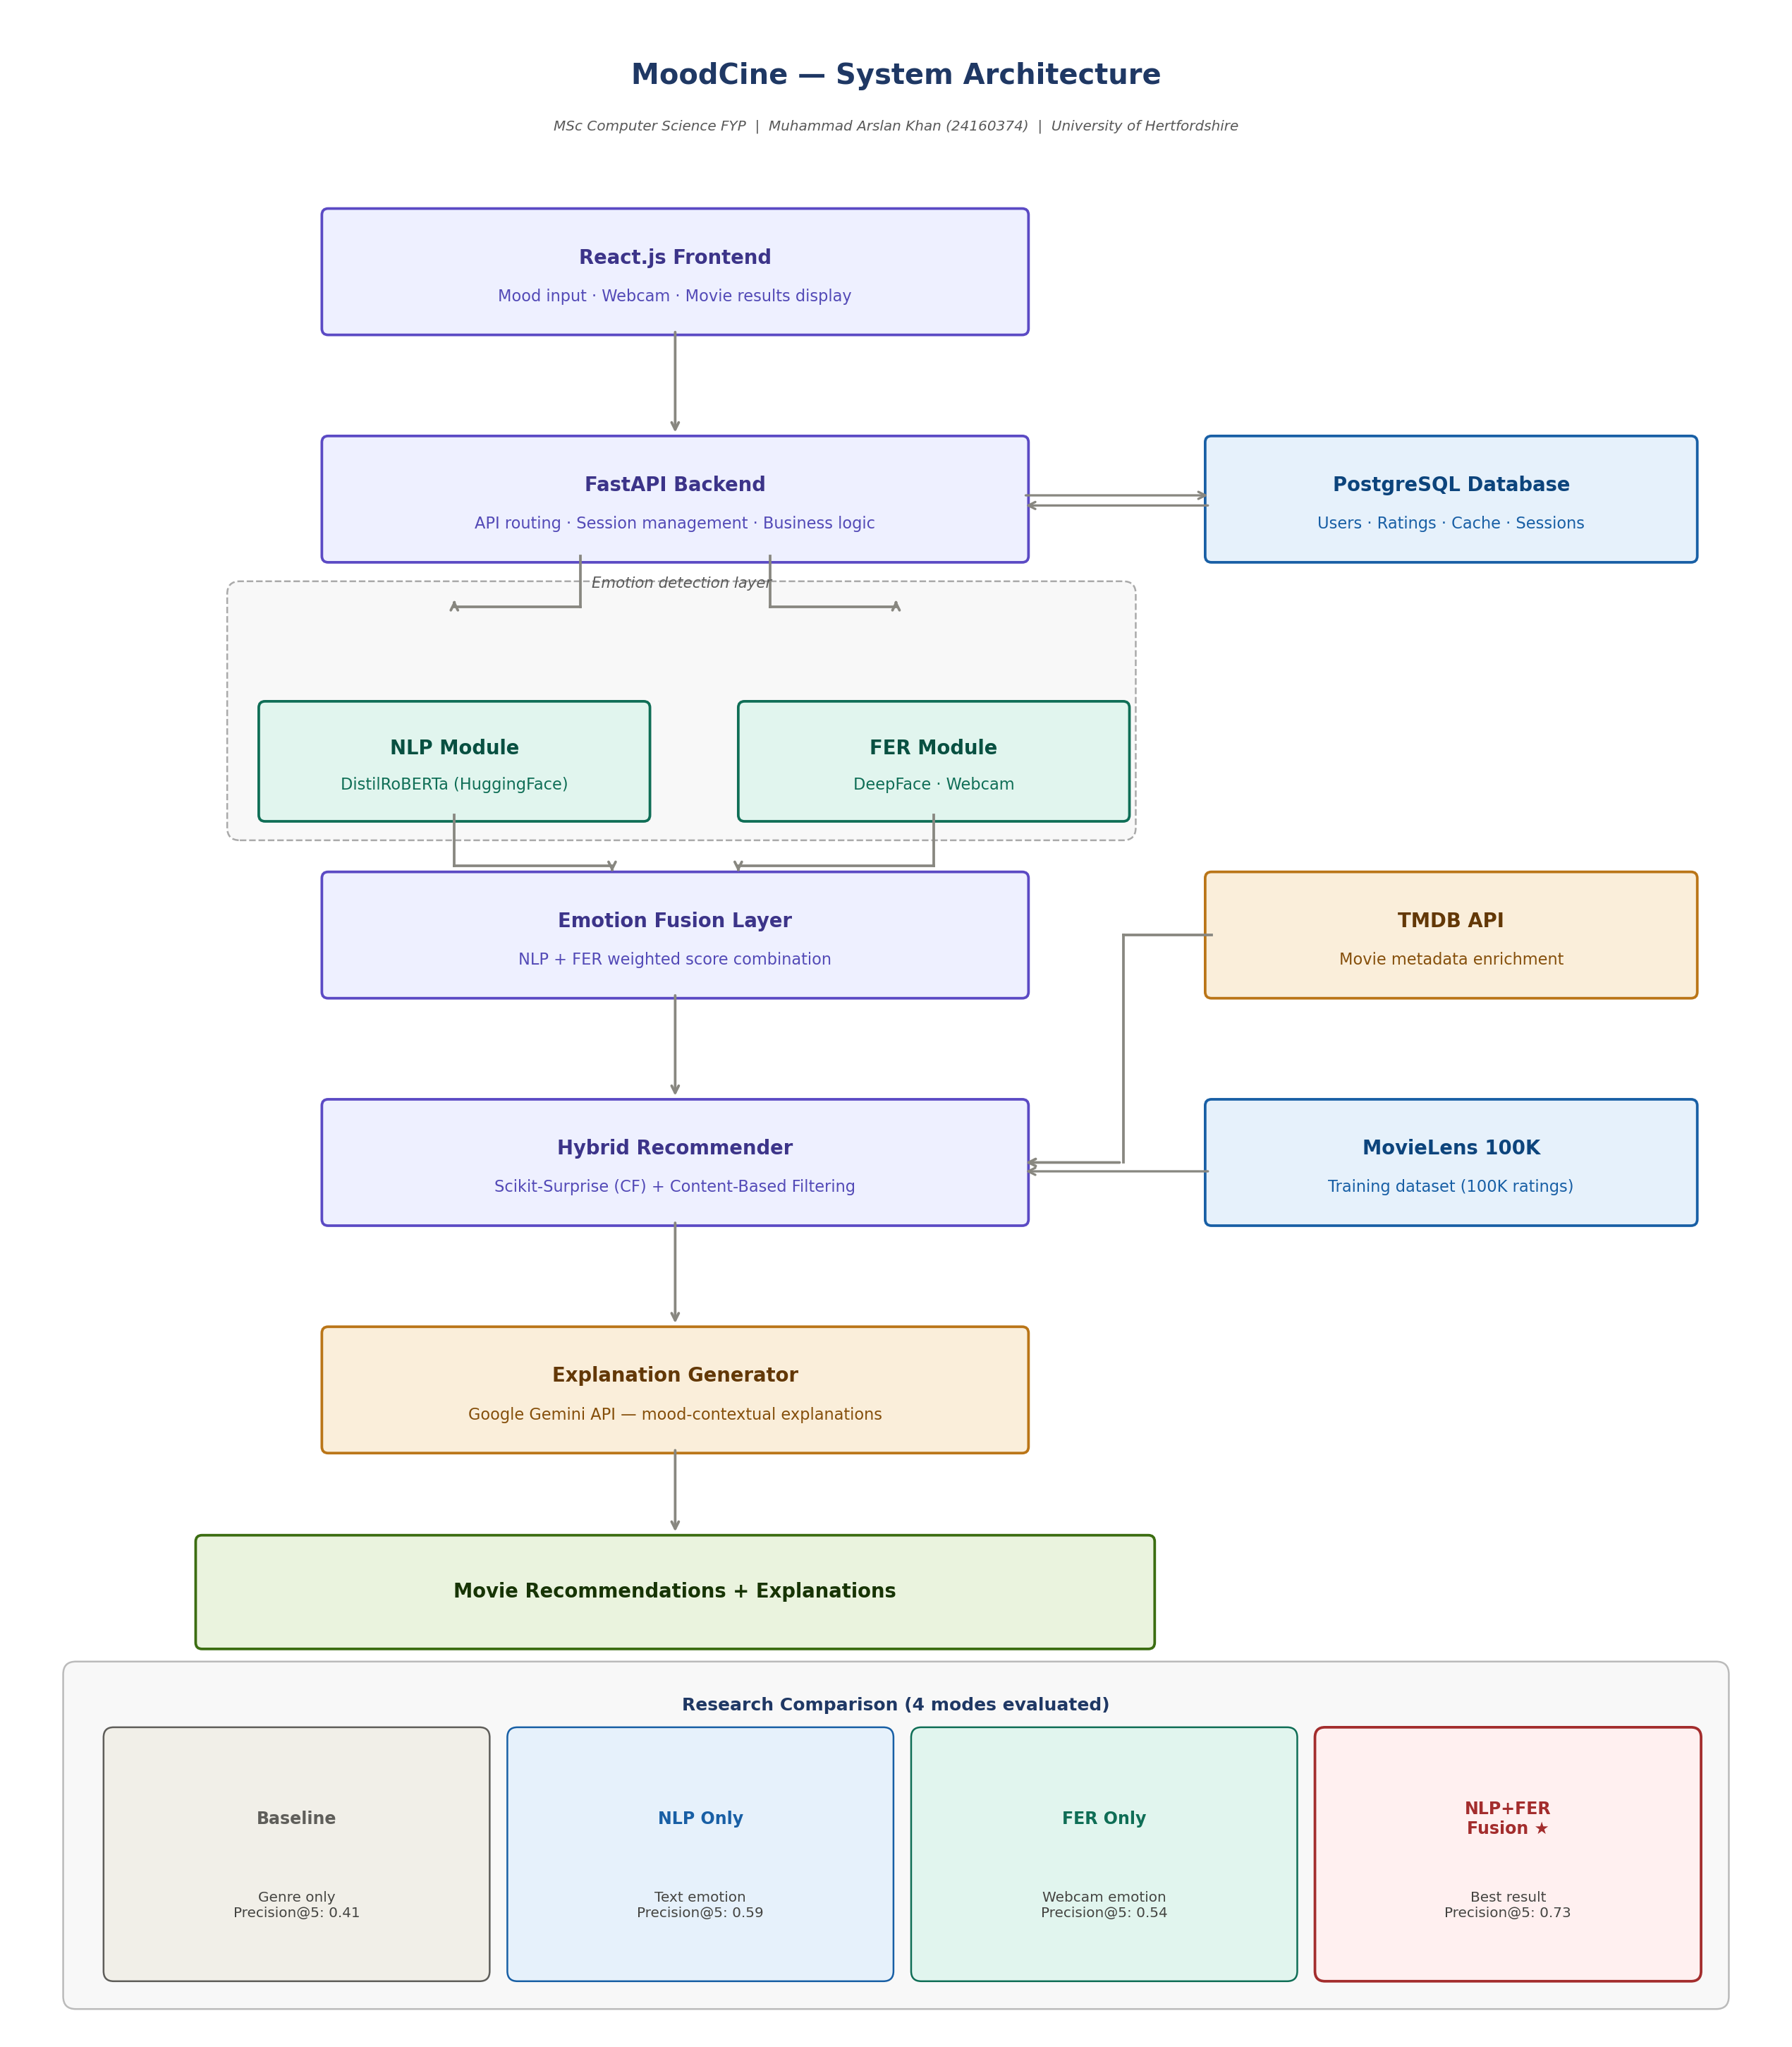
Figure 1: MoodCine System Architecture — complete data flow from mood input to recommendations

1.1 Module Summary
# | Module | Technology & Purpose
M1 | React.js Frontend | User mood input, webcam control, movie results display
M2 | FastAPI Backend | API routing, session management, business logic coordinator
M3 | NLP Emotion Module | HuggingFace DistilRoBERTa — classifies text into 7 emotions
M4 | FER Emotion Module | DeepFace library — classifies webcam facial expression into 7 emotions
M5 | Emotion Fusion Layer | Weighted score combination of NLP + FER (core research contribution)
M6 | Hybrid Recommender | Scikit-Surprise (SVD) + Content-Based Filtering on MovieLens 100K
M7 | Explanation Generator | Google Gemini API — mood-contextual explanation for each film
M8 | PostgreSQL Database | Stores users, movies, ratings, emotions, recommendations, feedback

1.2 External Data Sources
Source | Type | Purpose
MovieLens 100K | Dataset | 100K ratings — trains collaborative filtering model (SVD)
TMDB API | REST API | Movie posters, overviews, cast, genres — displayed in frontend
HuggingFace Hub | Model Hub | Downloads DistilRoBERTa emotion model (~329MB, cached locally)
Google Gemini API | REST API | Generates personalised, mood-contextual film explanations

Section 2 — Database ERD (Entity Relationship Diagram)
The ERD below shows the PostgreSQL database design for MoodCine with 6 tables and their relationships. The database captures all user activity, emotion detection results, recommendation outputs, and user feedback — enabling both the application functionality and the research evaluation.

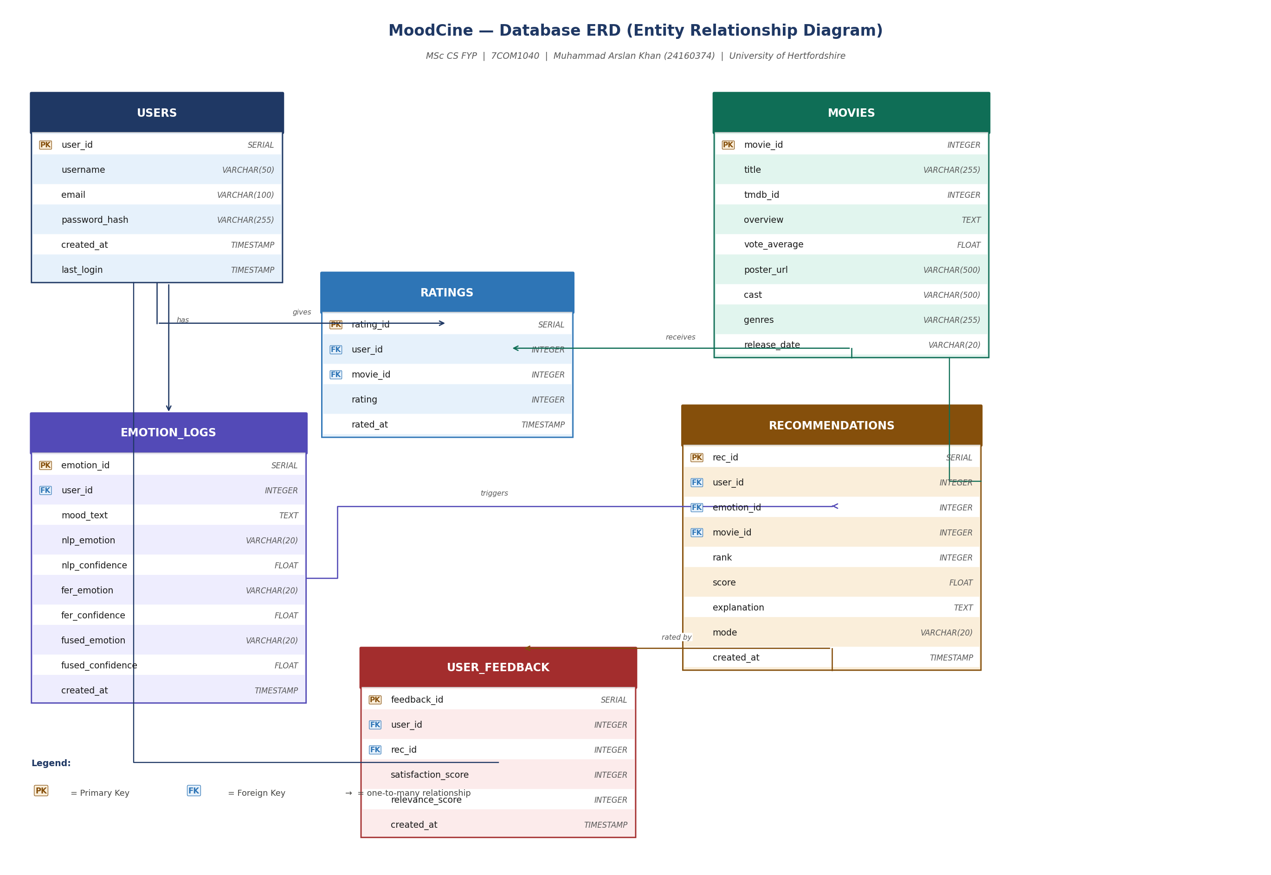
Figure 2: MoodCine PostgreSQL ERD — 6 tables with primary keys, foreign keys, and relationships

2.1 Table Descriptions
Table | Rows (est.) | Purpose & Key Fields
users | 20–100 | User accounts. Stores login credentials and session data for personalised recommendations.
movies | 1,682 | MovieLens 100K movie catalogue enriched with TMDB metadata (poster, overview, cast, genres).
ratings | 100,000 | MovieLens user-movie ratings (1–5 stars). Used to train the Scikit-Surprise SVD model.
emotion_logs | Per session | Records every emotion detection event with NLP score, FER score, and fused score. Key research data.
recommendations | Per session | Stores each recommendation with mode (baseline/nlp/fer/fusion), rank, score, and Gemini explanation.
user_feedback | n≥20 (study) | User satisfaction and relevance scores (1–5 Likert). Primary data for research evaluation comparison.

2.2 Research Evaluation Role
The `mode` column in the RECOMMENDATIONS table is the critical field for the research evaluation. Every recommendation is tagged with one of four modes:

Mode value | Input used | Research hypothesis
'baseline' | Genre preference only | Lowest performance — no emotion context
'nlp' | Text emotion (DistilRoBERTa) | Better than baseline — text improves relevance
'fer' | Webcam emotion (DeepFace) | Better than baseline, slightly lower than NLP
'fusion' | NLP + FER combined | Best performance — multi-modal fusion wins

The user_feedback table collects Likert-scale satisfaction scores (1–5) for each recommendation mode. A paired t-test will be used to determine statistical significance of the fusion approach over baseline.

MoodCine | Architecture & Database Design | Week 2 | Muhammad Arslan Khan (24160374) | University of Hertfordshire

