|  |  |
| --- | --- |
|  | **2011** |
|  | Computer Graphics Project  Mohit Kothar (200801066) Viranch Mehta (200801035) |

|  |
| --- |
| **[l-Systems Generator]** |
| lSystems is a simple L-System Generator written in Python using PyOpenGL. It was made by Mohit Kothari(mohitrajkothari@gmail.com) and Viranch Mehta(viranch.mehta@gmail.com) for a 3rd ComputerGraphics course. |

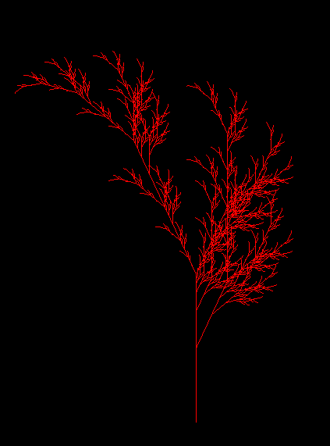

# Introduction

We have developed an L-System generator which when be given rules and other parameters of the L-Systems will draw the same using different primitive figures such as line, cube, circle etc.

The system thus generated can be moved in the window, and can be rotated or zoomed giving user the full capability to maneuver the system. There is also a **RIGHT_CLICK** Menu provided for the user, in here he can choose to draw a standard system, select shapes for current system, change color, orientation, increase or decrease iterations etc.

Shortcuts will be displayed on the console after the program is run.

User can specify the system rules and other parameters in a text file and the file must be saved in **examples_systems** folder. The text file should follow certain conventions as stated below

Va;<list of all variables without separation>

Ax;<Axiom of the System>

Ru;<Rule of system>

####For each rule there one line is there#####

####Rule is defined as <variable>:<replacement>####

An;<Angle>

Si;<size> ###between 0 and 1####

It;<iteration> ###number of iterations to be performed####

Sh;<shape>###choose from the list [square,line,circle,cube,cylinder]###

##MEANS COMMENTS NOT TO BE INCLUDED IN TEXT FILE

**Example File:-**

lsystems.txt

Va;FXY

Ax;XF

Ru;X:X+YF++YF-FX--FXFX-YF+

Ru;Y:-FX+YFYF++YF+FX--FX-Y

Sh;line

Si;0.01

An;60

It;4

To run the file user should issue the following command

python2 main.py <filename without extension>

E.g.

python2 main.py gosper

**For more reference like dependency etc. please refer to README file present in the same folder.**

# Techniques Employed

We have applied following techniques that were either taught us in class or we learned on our own.

* Affine Transformations are used very heavily in drawing the systems string generated by the L-System Generator
* To generate the L-System we have used python’s “**reduce” and “replace”** functions to generate the L-Sytstem given an axiom and rules
* Depth testing to give certain 3D effects for cube, cylinders etc.
* Ortho Projection used in Resizing so that the world coordinates are scaled properly
* glutCreateMenu and glutAddEntry for creating custom menu for the user.
* Python file handling for parsing the user defined file
* gluCylinder for drawing cylinders and GL_QUADS for cubes
* Perspective Projection to give 3D effect
* glutSpecialFunc callback to add arrow moving capabilities.

# Notations for the System

The following notations are implemented in our system , they have been obtained from <http://en.wikipedia.org/wiki/L-system> and <http://www.oocities.org/gplatl/LSystem/LSystem.html>

|  |  |
| --- | --- |
| **'F':** Draw a Line  **'+':** Turn Right by predefined angle i.e. objects angle  **'-':** Turn Left by predefined angle  **'G':** Move forward without drawing  **']':** Restore previously saved states  **'[':** Save current state  **'&'**: Pitch down  **'^':** Pitch up  **'\':** Roll left  **'/':** Roll right |  |

# Future Improvements

If time permits we would also like to implement the following if possible:-

* Right now the 3D effects are not clearly visible make it more obvious
* Adding Lighting and Shading
* Add Shadows of the figure
* Texture Mapping and create customized 3D L-Systems

# References

We assert that all code in lSystems was handwritten by us. Nevertheless certain resources were used for learning or inspiration

* <http://en.wikipedia.org/wiki/L-system>
* <http://www.oocities.org/gplatl/LSystem/LSystem.html>
* <http://www.opengl.org/> For API Reference
* <http://evelands.net/evan/lsystem02.php> For Example Systems
* <http://bioquest.org/products/files/13157_Real-time%203D%20Plant%20Structure%20Modeling%20by%20L-System.pdf> (The Turtle Picture is taken from here)