Contents

General 2

Multi module maven project 2

Fork / Join framework in Java 3

Reflection vs Proxies vs Method handles 4

# General

## Multi module maven project

Parent:

mvn archetype:generate -DgroupId=com.javalab -DartifactId=parent-project

pom.xml --> <packaging>pom</packaging>

<modules>

<module>core</module>

<module>api</module>

</modules>

Children:

cd parent-project

mvn archetype:generate -DgroupId=com.javalab -DartifactId=core

mvn archetype:generate -DgroupId=com.javalab -DartifactId=api

<parent>

<artifactId>parent-project</artifactId>

<groupId>com.javalab</groupId>

<version>1.0-SNAPSHOT</version>

</parent>

Ref: [Multi-Module Project with Maven | Baeldung](https://www.baeldung.com/maven-multi-module)

## Fork / Join framework in Java

<Real work example should be prepared>

Ref: [Guide to the Fork/Join Framework in Java | Baeldung](https://www.baeldung.com/java-fork-join)

[Java Fork-Join pool. The purpose of a Fork-Join Pool in Java… | by Gathila Harischandra | Medium](https://medium.com/@gathilaharism/java-fork-join-pool-with-an-example-320a0d3d5b4c)

## Reflection vs Proxies vs Method handles

Why method handlers are a better choice?

ThreeTypeAccess.Java example

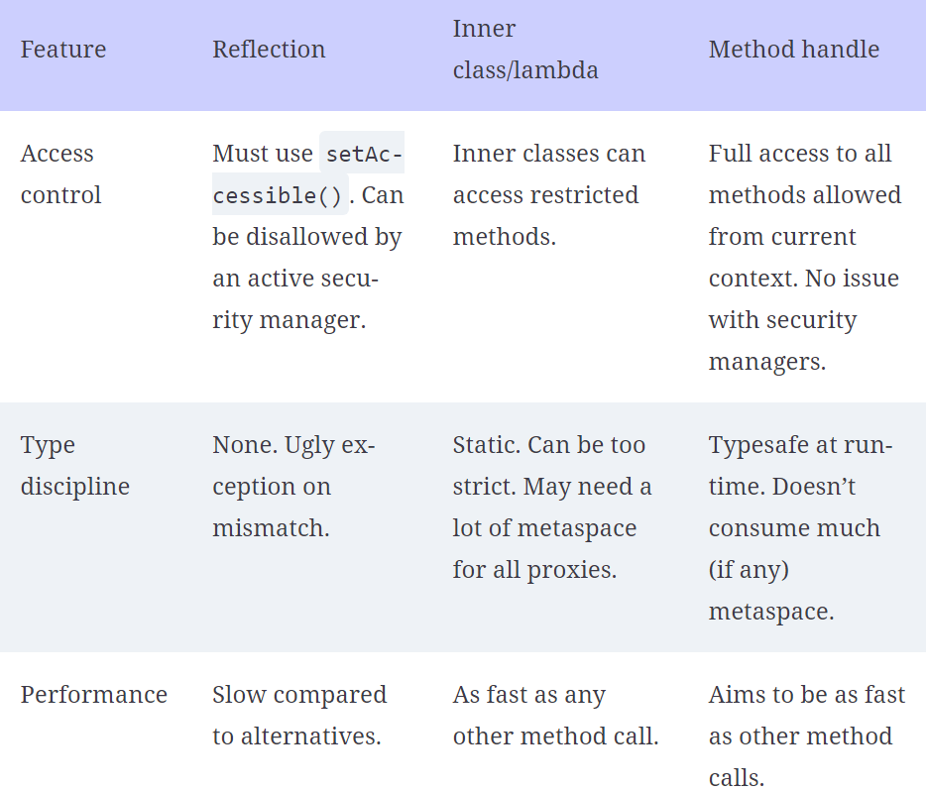

Ref: [17 Modern internals | The Well-Grounded Java Developer, Second Edition](https://learning.oreilly.com/library/view/the-well-grounded-java/9781617298875/OEBPS/Text/17.htm#heading_id_13) (17.3.4)

# Functional

x