Freight Rate Prediction
Technical Report

1. Executive Summary
A gradient boosting regression model was built to predict freight load rates (posted_rate) from load characteristics (distance, weight, equipment type, route, and market signals). The model was validated using a time-based train/holdout split that mirrors the real prediction task (predicting a future period, not interpolating within known dates).
On held-out data (loads the model never trained on), the final model achieves:
- R² = 0.83 (0.84 average across a 5-fold rolling time-based check)
- Mean Absolute Error (MAE) = $119.72 per load
- Mean Absolute Percentage Error (MAPE) = 5.20%
Expressed as an average prediction accuracy (100% − MAPE), the model is approximately 95% accurate per individual load. This is an intuitive framing of the MAPE figure above, not a separate metric — R² and MAE/MAPE remain the primary reported measures of model quality throughout this report.

2. Data Overview
Two datasets were provided:
- train-test.csv — 48,000 labeled loads, 2025-01-01 to 2025-10-31, used for training and internal validation.
- validation.csv — 12,000 unlabeled loads, 2025-11-01 to 2025-12-31, used only for final prediction.
Columns: load_id, pickup, delivery, pickup/delivery latitude & longitude, distance, equipment, weight, date, market_index, quote_signal, and (train-test.csv only) posted_rate, the prediction target.
posted_rate ranges from $57.22 to $25,533.00 (median $2,030.76), and is right-skewed — most loads cluster in a moderate price range with a long tail of expensive loads.

3. Validation Strategy
Because validation.csv covers a period strictly after train-test.csv, a random shuffle-split would not reflect the real task and would overstate accuracy. Instead, a time-based split was used:
- Training slice: January–August 2025 (38,477 rows)
- Holdout slice: September–October 2025 (9,523 rows), never seen during training
All reported accuracy figures come from this holdout, not from training data, unless explicitly labeled otherwise.

4. Data Cleaning
Two columns had missing values: weight (300 rows, 0.62%) and market_index (374 rows, 0.78%). Both were filled rather than dropped:
- weight → filled with the median weight for that load's equipment type (different truck types carry different typical loads).
- market_index → filled with the median for that calendar month (a market signal expected to drift over time).
A binary flag was added for each column indicating whether a value was imputed, allowing the model to learn if imputed rows behave differently.

5. Feature Engineering
Final feature set (17 features):
- distance, weight, market_index, quote_signal (numeric, as provided)
- weight_per_mile (derived: weight ÷ distance)
- pickup/delivery latitude & longitude
- month, day_of_week, is_weekend (derived from date)
- equipment, one-hot encoded (Dry Van / Flatbed / Reefer)
- weight_was_missing, market_index_was_missing (imputation flags)
Raw pickup/delivery city names were dropped: their location is already captured numerically by latitude/longitude, and the city-pair itself was too sparse to use directly (4,014 unique combinations across 48,000 rows). No feature was ever derived from posted_rate, to avoid target leakage.

6. Model Selection
Three baseline models were compared on the holdout split:
Model | MAE | RMSE | MAPE
Linear Regression | $138.72 | $638.30 | 7.85%
Random Forest | $150.35 | $650.85 | 6.73%
Gradient Boosting | $116.87 | $635.13 | 5.50%

Gradient Boosting was selected and further improved with two changes:
- Log-target training: the model was trained on log(1 + posted_rate) instead of the raw dollar value, reducing sensitivity to the right-skewed target and large outlier loads.
- Hyperparameter tuning: RandomizedSearchCV using TimeSeriesSplit cross-validation (not standard K-Fold), so tuning never validates on data chronologically before its own training fold.

7. Final Model Performance
Metric | Value
MAE | $119.72
RMSE | $638.22
MAPE | 5.20%
R² (single holdout) | 0.8251
R² (5-fold rolling average) | 0.8401

The 5-fold rolling time-based cross-validation (five sequential train/holdout windows across the full dataset) was run to confirm the single Sep–Oct holdout result was not a lucky or unlucky split. Results were consistent (mean R² = 0.84, mean MAE = $115.24), supporting the reliability of the reported accuracy.

8. Additional Techniques Evaluated
Four further improvements were tested against the same holdout to see if accuracy could be pushed higher:
Technique | MAE | MAPE | R² | Result
XGBoost (tuned) | $125.52 | 5.55% | 0.8250 | No improvement over Gradient Boosting
Sample weighting by rate | $130.29 | 5.85% | 0.8264 | Marginal R² gain, worse MAE/MAPE
Extra interaction/region features | $131.63 | 5.93% | 0.8264 | No meaningful gain

None of these produced a decisive improvement over the reference Gradient Boosting model, which was retained as final. Feature importance analysis showed distance alone accounts for approximately 97% of the model's predictive signal — consistent with the limited gains from additional features.

9. Error Analysis and Known Limitation
Errors are not evenly distributed. The top quartile of posted_rate (>$3,336) and the longest-distance quartile (>1,636 miles) both show substantially higher average error than the rest of the data. The ten largest individual errors are all long-haul loads (1,600–3,000 miles) where posted_rate is unusually high ($13,000–$20,000) relative to comparable loads, and the model consistently under-predicts them by $10,000–$16,000.
None of the techniques in Section 8 reduced these specific errors — the magnitude and rows affected were nearly unchanged before and after. This indicates these rows behave as outliers or noise in the underlying data rather than a systematic, fixable bias in the model.

10. December Forecast
december-chart-inputs.csv specifies a fixed load profile (Lexington → Fort Wayne, 360 miles, Dry Van, 32,000 lb) across every day of December 2025, isolating the effect of date alone. Two required inputs were not provided in that file (pickup/delivery coordinates and market_index/quote_signal) and were reconstructed from real historical data: coordinates via an exact city lookup from train-test.csv, and market signals via the daily median across all routes in validation.csv for that date (flagged as imputed).
Because the load profile is fixed, the resulting predictions vary only with day-of-week, producing a repeating weekly pattern:
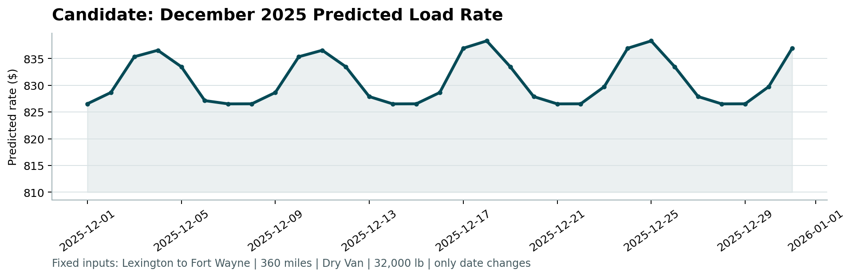

11. Conclusion
The final model (Gradient Boosting, log-target trained, hyperparameter-tuned) achieves R² = 0.83, MAE = $119.72, and MAPE = 5.20% on genuinely unseen holdout data — equivalent to roughly 95% average per-load accuracy. Predictions for all 12,000 loads in validation.csv and the 31-day December forecast were generated, validated by the provided score.py, and are included with this submission.

