INSTRUCTOR ANSWER KEY · INTERNAL · DO NOT DISTRIBUTE TO STUDENTS

LAB 01 ANSWER KEY
HDL FOUNDATIONS AND SELF-CHECKING VERIFICATION
Reference answers for instruction, grading, and hidden-test construction; run the full regression on the course simulator before official release.
01  week | 4  experiments | 4  hidden tests | INTERNAL  release level
Language and sources: All solutions use Verilog-2001 (.v). The Week 02/03/04/06/07 code was adapted from the submitted RISC-V codebases; Week 01 and Week 05 were added under the same contract.

1. Quick answer summary
Topic | Required answer/contract
Combinational | always @(*)/assign must assign the output on every path; use blocking assignments; no latch.
Sequential | Update at posedge; reset_n is active-low; priority is reset → clear → enable → hold; use nonblocking assignments.
Verification | The oracle computes expected values, counts errors, includes a timeout, and prints exactly one final conclusion.
Synthesis | No multiple driver, no inferred latch, and no derived clock created by logic.

2. Answers for each experiment

Experiment 1: Three description styles and synthesis
Required conclusion: Implement a mux/adder using structural, dataflow, and behavioral styles to observe equivalence.

Core answer
- All three mux descriptions must have the same truth table: sel=0 selects a, and sel=1 selects b.
- Adder32 uses modulo-2^32 addition; the carry beyond 32 bits is discarded when the interface contains only sum.
- Structural style is useful for illustrating gates; dataflow is concise and easy to parameterize; behavioral style is convenient for complex conditional logic.

Verilog-2001 reference solution
Reference file: INSTRUCTOR/REFERENCE_RTL/Week_01/mux_adder_reference.v
`timescale 1ns/1ps

module mux2_dataflow #(parameter W=32)(
input wire [W-1:0] a, b, input wire sel,
output wire [W-1:0] y);
assign y = sel ? b : a;
endmodule
module mux2_behavioral #(parameter W=32)(
input wire [W-1:0] a, b, input wire sel,
output reg [W-1:0] y);
always @(*) begin
if (sel) y = b;
else y = a;
end
endmodule
module adder32(input wire [31:0] a, b, output wire [31:0] sum);
assign sum = a + b;
endmodule

//==========================================================
TestBench
//==========================================================

//=================
mux2_dataflow
//=================

`timescale 1ns/1ps

module tb_mux2;
parameter W = 32;

reg [W-1:0] a;
reg [W-1:0] b;
reg sel;
wire [W-1:0] y;

integer errors;
integer vector_count;
integer seed;
integer i;

mux2_dataflow #(.W(W)) dut (
.a (a),
.b (b),
.sel (sel),
.y (y)
);

task check_mux;
input [W-1:0] exp_y;
begin
#1;
vector_count = vector_count + 1;
if (y !== exp_y) begin
errors = errors + 1;
$display("[ERROR] Vector %0d: sel=%b a=%h b=%h | Expected y=%h, Got y=%h",
vector_count, sel, a, b, exp_y, y);
end
end
endtask

initial begin
seed = 32'h2026_0906;
errors = 0;
vector_count = 0;
a = 32'd0;
b = 32'd0;
sel = 1'b0;

$display("--- Starting MUX2 Verification (Seed: %0d) ---", seed);

a = 32'hAAAAAAAA; b = 32'h55555555; sel = 1'b0; check_mux(32'hAAAAAAAA);
sel = 1'b1; check_mux(32'h55555555);

a = 32'hFFFFFFFF; b = 32'h00000000; sel = 1'b0; check_mux(32'hFFFFFFFF);
sel = 1'b1; check_mux(32'h00000000);

a = 32'h12345678; b = 32'h87654321; sel = 1'b0; check_mux(32'h12345678);
sel = 1'b1; check_mux(32'h87654321);

for (i = 0; i < 200; i = i + 1) begin
a = {$random(seed), $random(seed)};
b = {$random(seed), $random(seed)};
sel = $random(seed) & 1'b1;
check_mux(sel ? b : a);
end

$display("--- Verification Summary ---");
$display("Seed : %0d", seed);
$display("Vectors run : %0d", vector_count);
$display("Errors count : %0d", errors);

if (errors == 0)
$display("TEST_PASS");
else
$display("TEST_FAIL errors=%0d", errors);

$finish;
end

initial begin
#10000;
$display("[TIMEOUT] Simulation terminated due to timeout.");
$display("TEST_FAIL errors=%0d", errors + 1);
$finish;
end

endmodule

//=================
tb_adder32
//=================

module tb_adder32;
reg [31:0] a;
reg [31:0] b;
wire [31:0] sum;
integer errors;
integer vector_count;
integer seed;
integer i;

adder32 dut (
.a(a),
.b(b),
.sum(sum)
);

task check_adder;
input [31:0] exp_sum;
begin
#1;
vector_count = vector_count + 1;
if (sum !== exp_sum) begin
errors = errors + 1;
$display("[ERROR] Vector %0d: a=%h b=%h | Expected sum=%h, Got sum=%h",
vector_count, a, b, exp_sum, sum);
end
end
endtask

initial begin
seed = 32'h2026_0906;
errors = 0;
vector_count = 0;
a = 32'd0;
b = 32'd0;

$display("--- Starting Adder32 Verification (Seed: %0d) ---", seed);

a = 32'h00000000;
b = 32'h00000000;
check_adder(32'h00000000);

a = 32'h12345678;
b = 32'h00000000;
check_adder(32'h12345678);

a = 32'hFFFFFFFF;
b = 32'h00000001;
check_adder(32'h00000000);

a = 32'hFFFFFFFF;
b = 32'hFFFFFFFF;
check_adder(32'hFFFFFFFE);

a = 32'h7FFFFFFF;
b = 32'h00000001;
check_adder(32'h80000000);

a = 32'hAAAAAAAA;
b = 32'h55555555;
check_adder(32'hFFFFFFFF);

for (i = 0; i < 200; i = i + 1) begin
a = {$random(seed), $random(seed)};
b = {$random(seed), $random(seed)};
check_adder((a + b) & 32'hFFFFFFFF);
end

$display("--- Verification Summary ---");
$display("Seed : %0d", seed);
$display("Vectors run : %0d", vector_count);
$display("Errors count : %0d", errors);

if (errors == 0)
$display("TEST_PASS");
else
$display("TEST_FAIL errors=%0d", errors);

$finish;
end

initial begin
#10000;
$display("[TIMEOUT] Simulation reached limit.");
$display("TEST_FAIL errors=%0d", errors + 1);
$finish;
end
endmodule

Expected results
Scenario | Correct result
sel=0 | y=a
sel=1 | y=b
0xFFFFFFFF+1 | sum=0x00000000
Mutant with inverted sel | The test must FAIL

Errors requiring a deduction or correction
- Missing an else/default branch, causing a latch.
- Using nonblocking assignments in combinational logic, creating difficult-to-read delta-cycle dependencies.
- Checking only a few favorable vectors without random or exhaustive testing.
Waveform oracle: The submitted image must allow direct comparison of clk, reset_n, en/clear, stimulus, q or the output under test; mark the clock edge at which the oracle makes its decision.

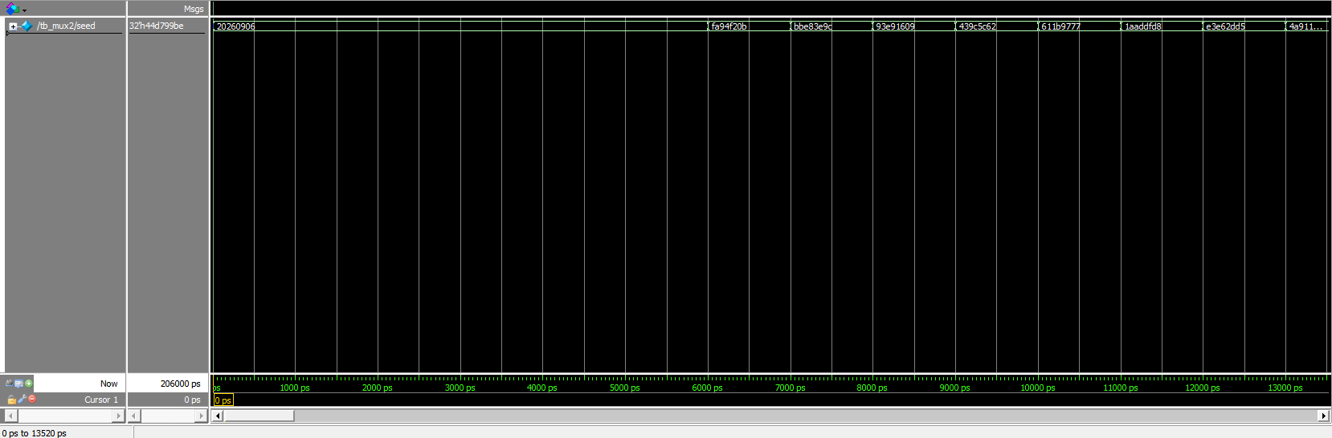
Fig1: tb_mux2.v

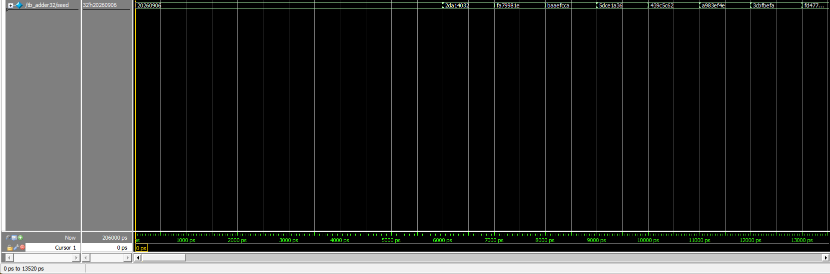
Fig2: tb_adder32.v

Experiment 2: Register with enable/clear
Required conclusion: Practice state, nonblocking assignments, and the priority order reset → clear → enable → hold.

Core answer
- The active-low reset has priority over every other signal.
- When reset_n=1 and clear=1, q becomes 0 even when en=1.
- When clear=0 and en=1, q takes d; when en=0, q holds its value.

Verilog-2001 reference solution
Reference file: INSTRUCTOR/REFERENCE_RTL/Week_01/reg_en_clr.v
`timescale 1ns/1ps
module reg_en_clr #(parameter W=32)(
input wire clk, reset_n, en, clear,
input wire [W-1:0] d,
output reg [W-1:0] q);
always @(posedge clk or negedge reset_n) begin
if (!reset_n) q <= {W{1'b0}};
else if (clear) q <= {W{1'b0}};
else if (en) q <= d;
end
endmodule
//==========================================================
TestBench
//==========================================================

module tb_reg_en_clr;
parameter W = 32;

reg clk;
reg reset_n;
reg en;
reg clear;
reg [W-1:0] d;
wire [W-1:0] q;
integer errors;
integer vector_count;
integer seed;
integer i;

reg_en_clr #(.W(W)) dut (
.clk(clk),
.reset_n(reset_n),
.en(en),
.clear(clear),
.d(d),
.q(q)
);

always #5 clk = ~clk;

task check_q;
input [W-1:0] exp_q;
begin
#1;
vector_count = vector_count + 1;
if (q !== exp_q) begin
errors = errors + 1;
$display("[ERROR] Vector %0d @ %0t ps: clk_edge | Expected q=%h, Got q=%h (en=%b, clear=%b, reset_n=%b)",
vector_count, $time, exp_q, q, en, clear, reset_n);
end
end
endtask

initial begin
seed = 32'h2026_0906;
errors = 0;
vector_count = 0;
clk = 1'b0;
reset_n = 1'b1;
en = 1'b0;
clear = 1'b0;
d = 32'd0;

$display("--- Starting reg_en_clr Verification (Seed: %0d) ---", seed);

#2;
reset_n = 1'b0;
d = 32'hDEADBEEF;
en = 1'b1;
#1;
if (q !== 32'd0) begin
errors = errors + 1;
$display("[ERROR] Asynchronous reset failed to clear output immediately.");
end

#8;
@(negedge clk);
reset_n = 1'b1;

@(negedge clk);
en = 1'b1;
clear = 1'b0;
d = 32'h12345678;
@(posedge clk);
check_q(32'h12345678);

@(negedge clk);
en = 1'b0;
clear = 1'b0;
for (i = 0; i < 20; i = i + 1) begin
d = {$random(seed), $random(seed)};
@(posedge clk);
check_q(32'h12345678);
@(negedge clk);
end

@(negedge clk);
en = 1'b1;
clear = 1'b1;
d = 32'hFFFFFFFF;
@(posedge clk);
check_q(32'd0);

@(negedge clk);
en = 1'b1;
clear = 1'b0;
d = 32'hCAFEBABE;
@(posedge clk);
check_q(32'hCAFEBABE);

@(negedge clk);
en = 1'b0;
clear = 1'b1;
@(posedge clk);
check_q(32'd0);

$display("--- Verification Summary ---");
$display("Seed : %0d", seed);
$display("Vectors run : %0d", vector_count);
$display("Errors count : %0d", errors);

if (errors == 0)
$display("TEST_PASS");
else
$display("TEST_FAIL errors=%0d", errors);

$finish;
end

initial begin
#50000;
$display("[TIMEOUT] Simulation terminated due to timeout.");
$display("TEST_FAIL errors=%0d", errors + 1);
$finish;
end
endmodule

Expected results
Scenario | Correct result
reset_n=0 | q=0
clear=1,en=1 | q=0
clear=0,en=1 | q=d after the clock edge
clear=0,en=0 | q holds its value

Errors requiring a deduction or correction
- Reversing the reset polarity.
- Placing enable before clear.
- Using blocking assignments in always @(posedge clk...) or unnecessarily assigning q<=q.
Waveform oracle: The submitted image must allow direct comparison of clk, reset_n, en/clear, stimulus, q or the output under test; mark the clock edge at which the oracle makes its decision.

Experiment 3: Self-checking testbench
Required conclusion: Move from waveform inspection to oracle-based verification.

Core answer
- The check task compares using ===/!== so that X values are also detected as errors.
- The timeout must be independent of the stimulus flow so a deadlock still terminates.
- The simulation ends with exactly one TEST_PASS when errors=0; otherwise it prints TEST_FAIL.

Verilog-2001 reference solution
Reference file: INSTRUCTOR/REFERENCE_RTL/Week_01/tb_reg_en_clr.v
`timescale 1ns/1ps
module tb_reg_en_clr;
reg clk, reset_n, en, clear;
reg [31:0] d;
wire [31:0] q;
integer errors;
reg_en_clr dut(clk, reset_n, en, clear, d, q);
always #5 clk = ~clk;
task check32;
input [31:0] expected;
begin
#1;
if (q !== expected) begin
errors = errors + 1;
$display("MISMATCH q=%h expected=%h", q, expected);
end
end
endtask
initial begin
clk=0; reset_n=0; en=0; clear=0; d=0; errors=0;
#2; check32(32'd0);
#8; reset_n=1; d=32'h12345678; en=1;
@(posedge clk); check32(32'h12345678);
en=0; d=32'hAAAAAAAA;
@(posedge clk); check32(32'h12345678);
en=1; clear=1;
@(posedge clk); check32(32'd0);
if (errors==0) $display("TEST_PASS");
else $display("TEST_FAIL errors=%0d", errors);
$finish;
end
initial begin #1000; $display("TEST_TIMEOUT"); $finish; end
endmodule

Expected results
Scenario | Correct result
RTL correct | One TEST_PASS line
Mutant | TEST_FAIL or $fatal before the timeout
X at the output | Counted as a mismatch

Errors requiring a deduction or correction
- Using == turns X into an unknown result, so if does not catch the error.
- Displaying PASS without checking errors.
- No timeout.
Waveform oracle: The submitted image must allow direct comparison of clk, reset_n, en/clear, stimulus, q or the output under test; mark the clock edge at which the oracle makes its decision.

Experiment 4: Synthesis checkpoint
Required conclusion: Demonstrate that the code can be synthesized and mapped to the FPGA.

Core answer
- The FPGA top level is only an I/O checkpoint for the small modules.
- CLOCK_50 feeds the sequential logic directly; use a clock-enable counter when slower observation is needed.
- LEDR can display the low bits of q/sum; KEY generates reset_n with the correct polarity.

Verilog-2001 reference solution
Reference file: INSTRUCTOR/REFERENCE_RTL/Week_01/fpga_clock_enable_demo.v
module fpga_clock_enable_demo(
input wire CLOCK_50, input wire reset_n,
output wire [9:0] LEDR);
reg [25:0] counter;
always @(posedge CLOCK_50 or negedge reset_n) begin
if (!reset_n) counter <= 26'd0;
else counter <= counter + 1'b1;
end
assign LEDR = counter[25:16];
endmodule

Expected results
Scenario | Correct result
Compile | No error or unclassified critical warning
RTL Viewer | One clock domain
Reset | Output returns to a defined state

Errors requiring a deduction or correction
- Using div[N] as a new clock.
- Omitting debounce when KEY is used as data.
- Driving the same register from multiple always blocks.
Waveform oracle: The submitted image must allow direct comparison of clk, reset_n, en/clear, stimulus, q or the output under test; mark the clock edge at which the oracle makes its decision.

3. Recommended hidden tests
Test | Stimulus/intent | Oracle
MUX X-awareness | Drive X values on sel/a/b; the testbench must not report a false PASS. | The oracle uses case equality.
Priority collision | clear=1 and en=1 at the same edge. | q=0.
Long hold | en=0 for 20 edges while d changes continuously. | q does not change.
Mutant | Invert the mux branch or give clear lower priority than enable. | The student TB must detect it.

Principle: A hidden test must check functionality and side effects, include a timeout, and not depend on internal hierarchy unless the published interface requires it.

4. Answers to oral examination questions

1. Why does combinational logic use blocking assignments while sequential logic uses nonblocking assignments?
In Verilog-2001, blocking (=) is used in always @(*) to describe combinational functions. Nonblocking (<=) is used in always @(posedge clk...) so registers sample the old state at the same clock edge and update simultaneously, avoiding line-order dependencies and races between always blocks.

2. Is a good-looking waveform sufficient to prove that a module is correct?
No. A waveform is only one observation sample. PASS evidence requires an oracle, a vector/corner-case set, a timeout, and an automated conclusion; the waveform is used to diagnose a failing test.

3. When clear and enable are both 1, what should q be?
Under the lab contract, the order is reset → clear → enable → hold, so q must become 0. A different priority does not meet the interface contract even if an individual waveform appears reasonable.
Student submission package reference: The main report is the completed student manual exported as DSD_Labxx_MSSV_HoVaTen.pdf. It must contain the student information, RTL code, testbench code, and waveform evidence embedded after each experiment. The package must also include clean rtl/ and sim/ directories, the required truth/state table PDF, test log, waveform debug image, RTL Viewer image, and reflection file.

5. Grading gates and minimum evidence
Gate | Instructor verification method
Modules compile without serious functional warnings. | PASS when the log/automated test proves it; the waveform is explanatory evidence only.
The self-checking test detects a mutant supplied by the instructor. | PASS when the log/automated test proves it; the waveform is explanatory evidence only.
The log includes the seed, vector count, error count, and PASS/FAIL result. | PASS when the log/automated test proves it; the waveform is explanatory evidence only.
The FPGA checkpoint does not use a clock divider as a new logic clock. | PASS when the log/automated test proves it; the waveform is explanatory evidence only.

6. Unified grading rules
Item | Weight | Answer-key guidance
Functionally correct RTL | 40% | Pass public and hidden tests; ISA or side-effect errors are severe.
Verification | 25% | The test has an oracle, corner cases, a timeout, and a reproducible log.
Architecture explanation | 20% | Explain the cause, signal lifetime, and trade-offs; do not merely read the waveform.
Interface engineering | 10% | Correct width, names, reset polarity, clock edge, and module contract.
Clean submission package | 5% | Runs from a clean folder; no db/output_files/work/WLF.

Not a golden implementation: If the starter RTL, hex program, or control encoding changes, increment the answer-key version and rerun the full regression before using it for grading.

