REFERENCED CIRCUIT AND VERILOG CODES

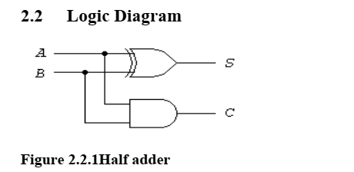
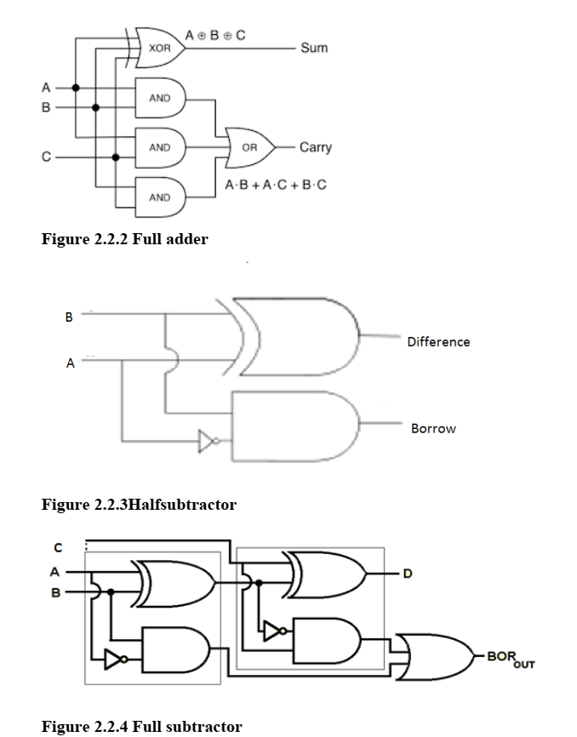
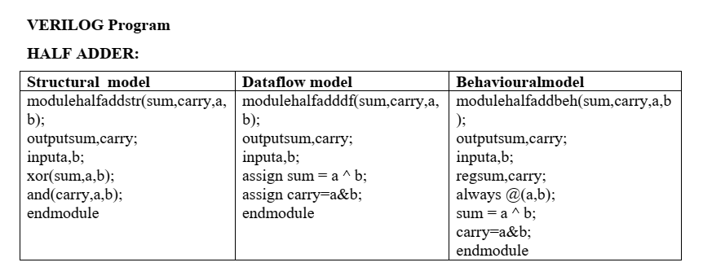
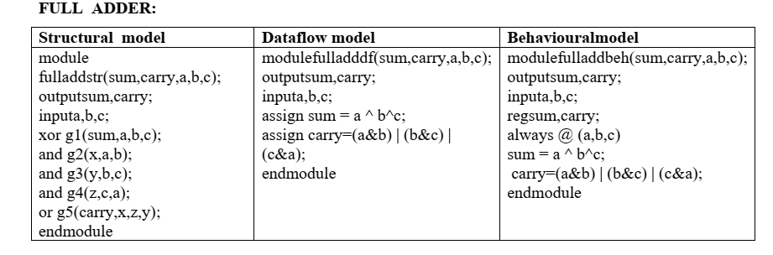
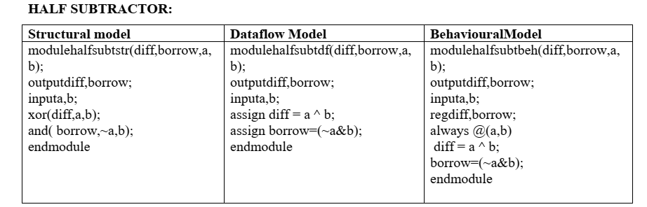
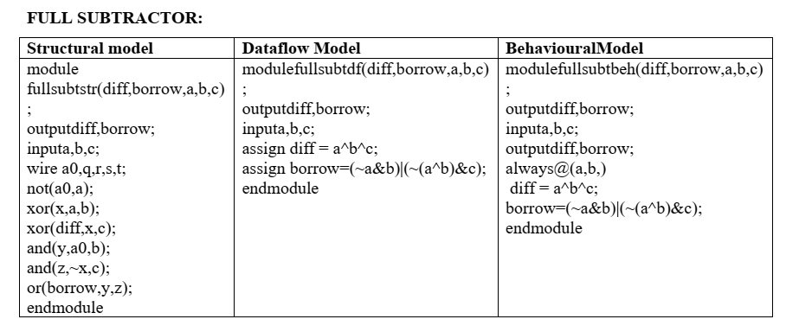
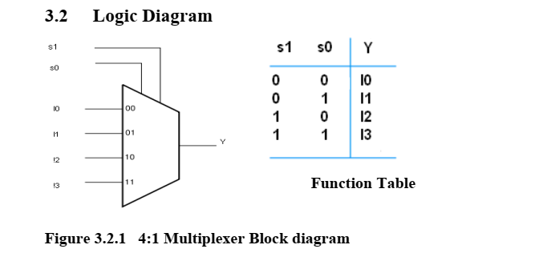
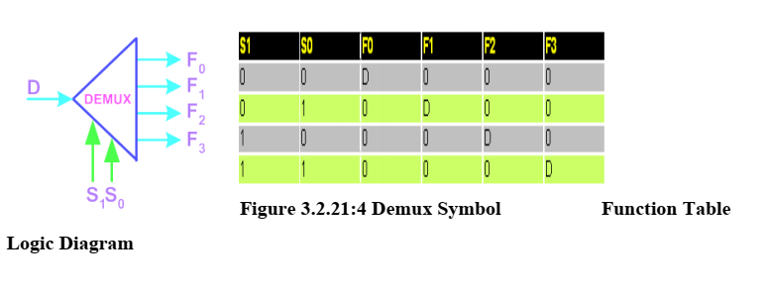
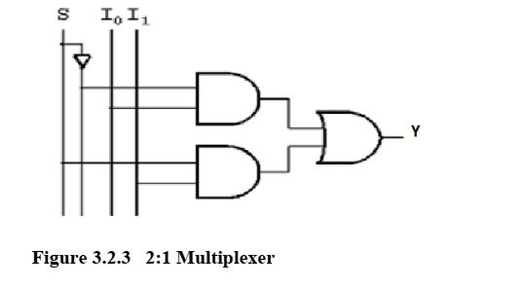
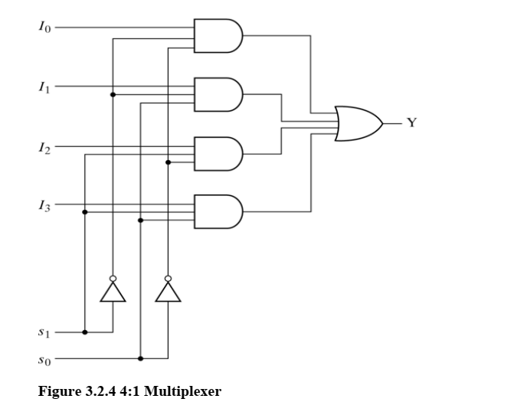
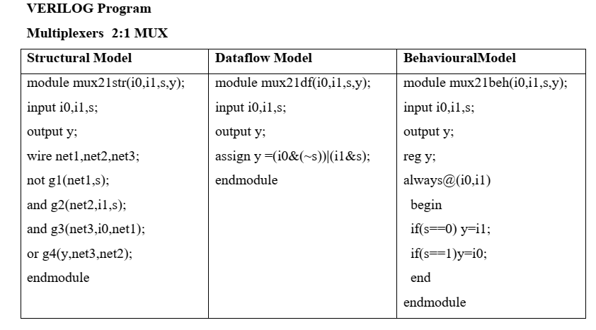
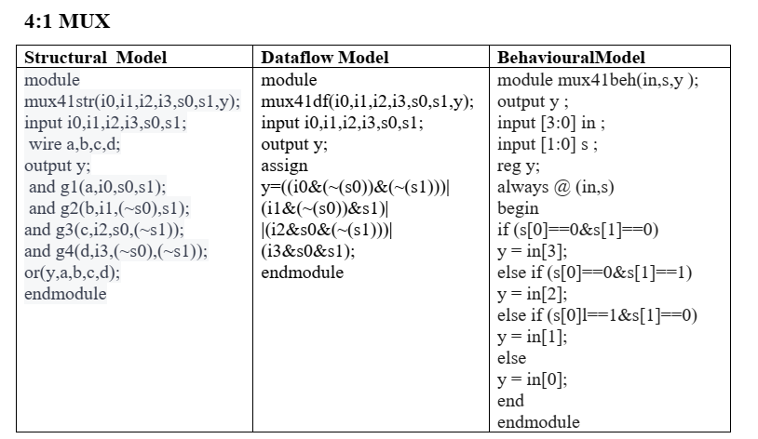
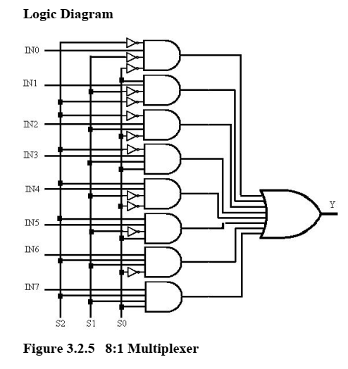
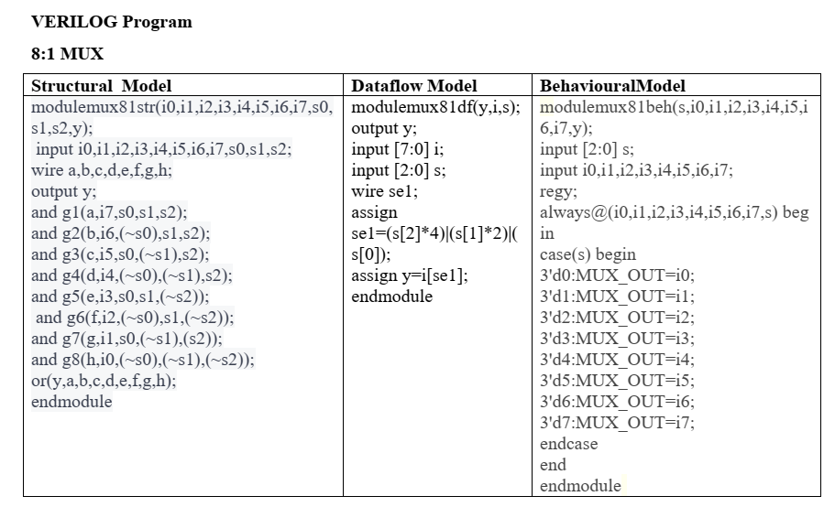
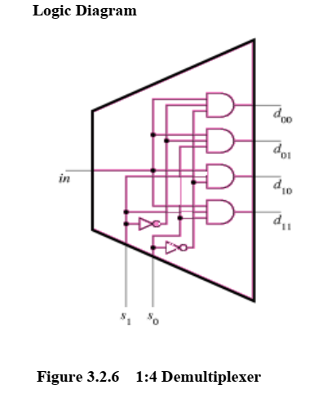
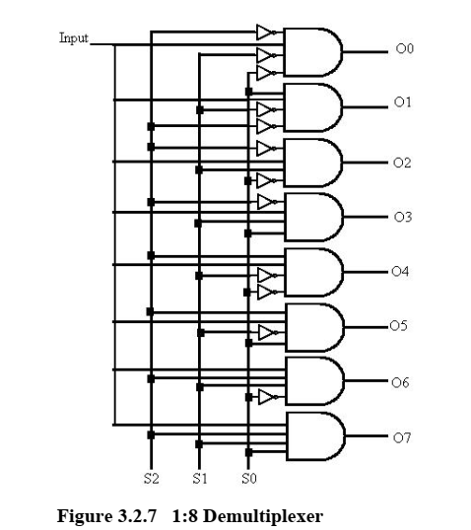
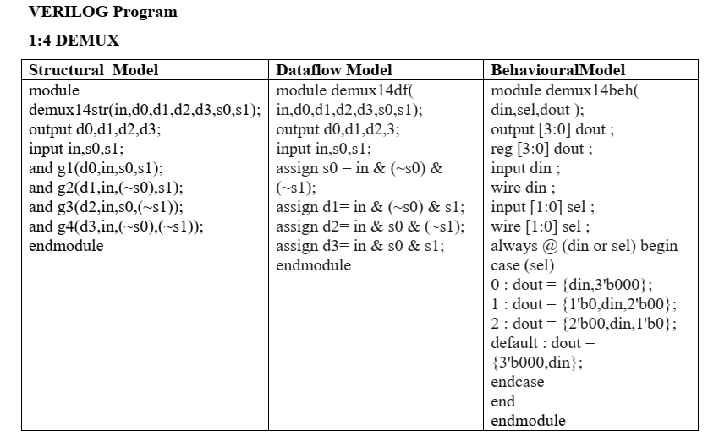
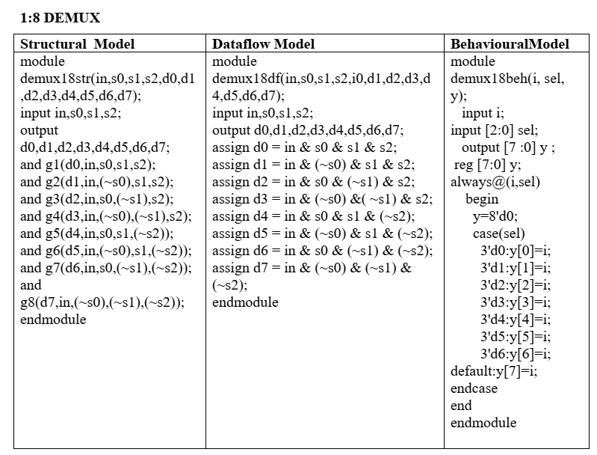
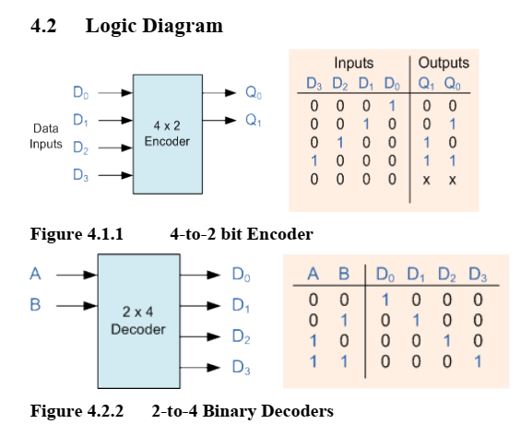
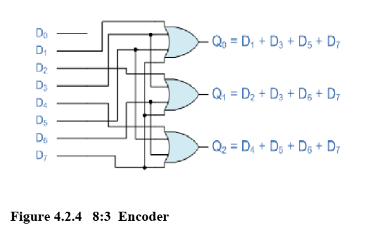
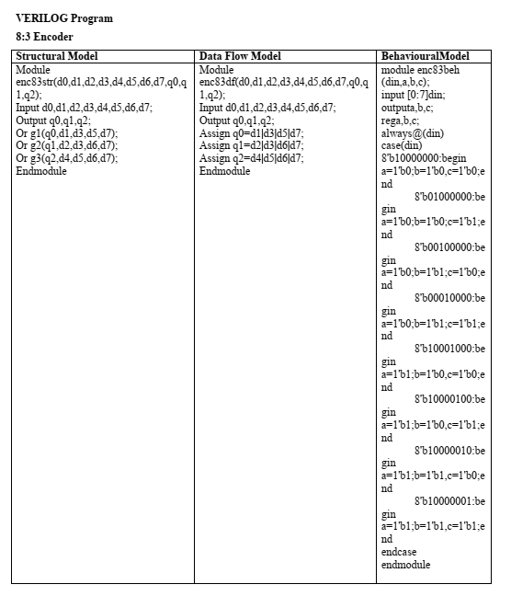
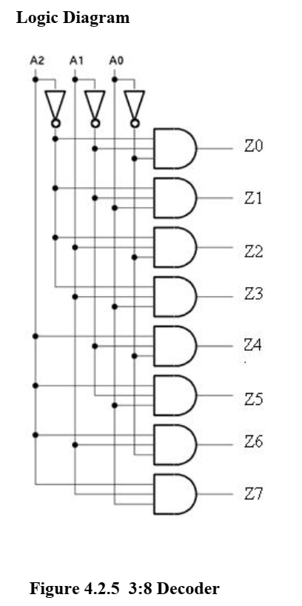
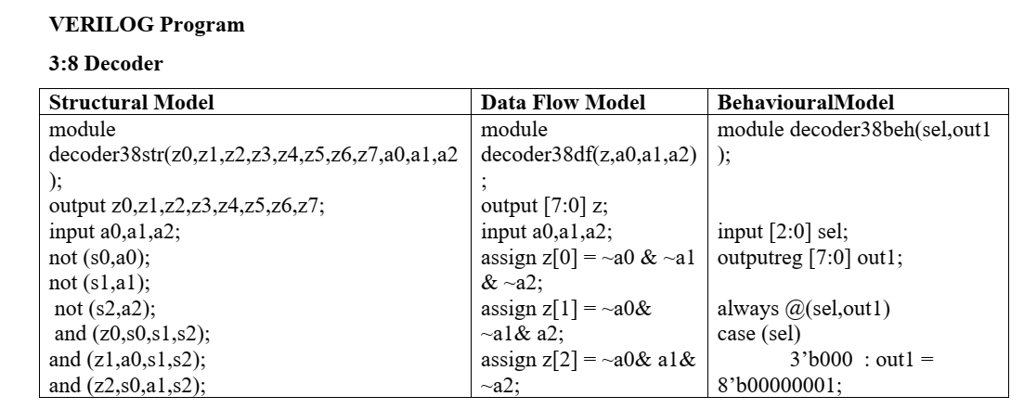
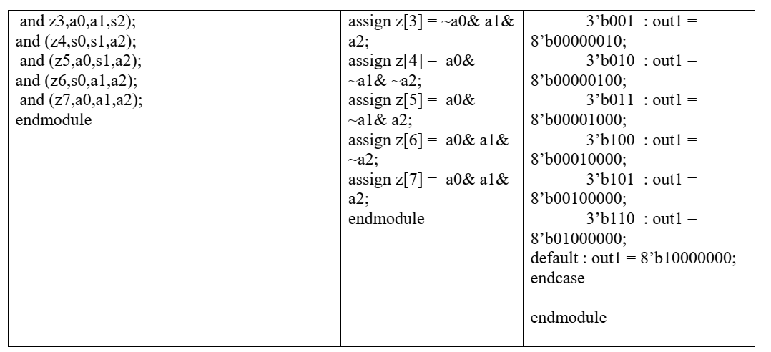
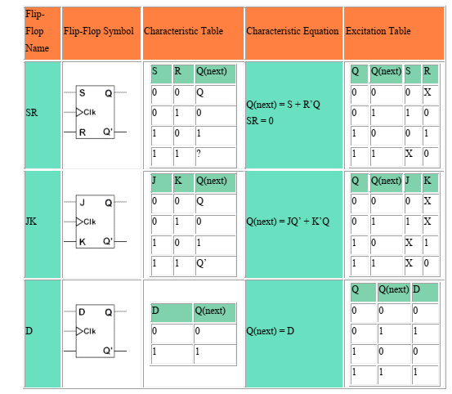
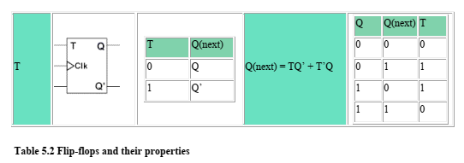
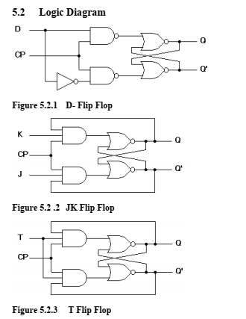
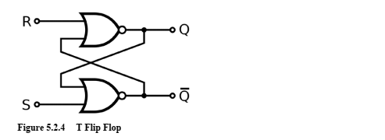
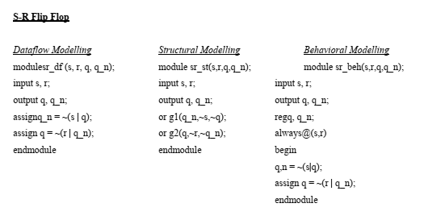
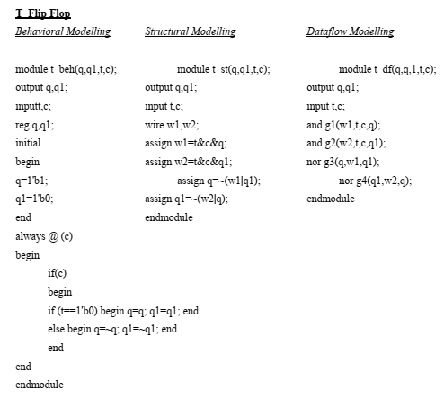
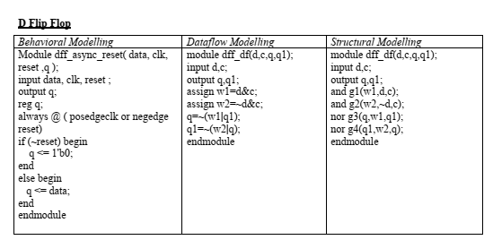
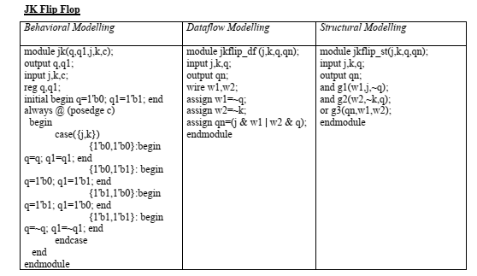
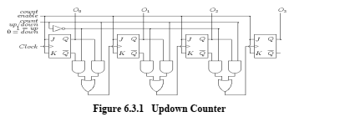
Refer to the tutorial “Quartus II Introduction Using Verilog Design” to create the first project in Quartus II and implement a simple circuit on the DE2-115 kit.

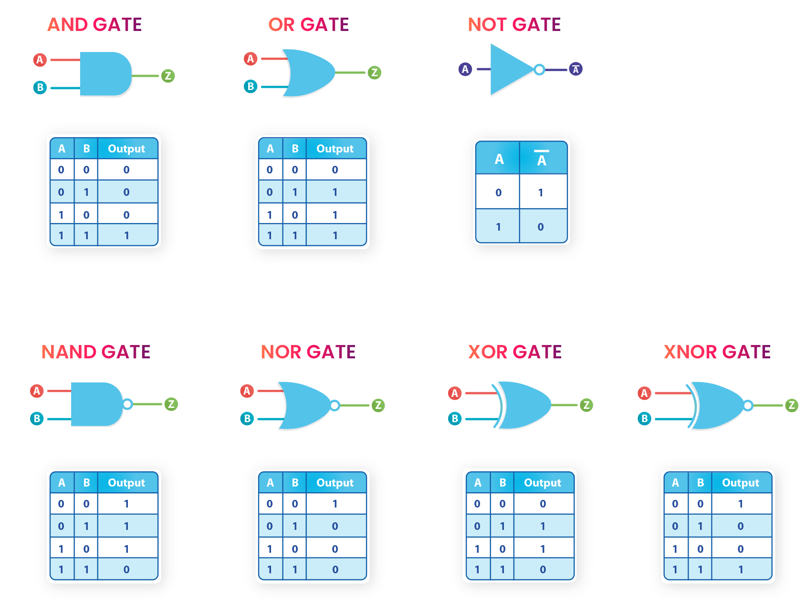

II.1 EXPERIMENT 1: BASIC LOGIC GATES

Referenced Verilog code in three modeling styles: dataflow, behavioral, and gate-level:

Gate-level (Structural Model) :

module allgate_GL ( a, b, yand,yor,ynot,ynand,ynor,yxor,yxnor );
input a,b;
output yand, yor, ynot, ynand, ynor, yxor, yxnor;

and G1(yand,a,b); // AND Operation
or G2(yor,a, b); // OR Operation
not G3(ynot,a) ; // NOT Operation
nand G4 (ynand,a,b); // NAND Operation
nor G5(ynor,a,b); //NOR Operation
xor G6(yxor,a,b); //XOR Operation
xnor G7(yxnor,a,b); //XNOR Operation
endmodule // END of the module

Write the Top-level verilog module to implement the allgate_GL module in DE2-FPGA Kit

II.2 LAB EXPERIMENT 2 : WRITE VERILOG HDL CODES TO SIMULATE AND IMPLEMENT THE HALF ADDER CIRCUIT:

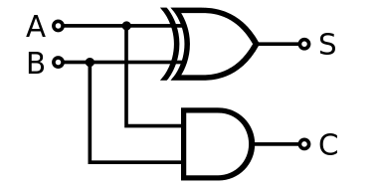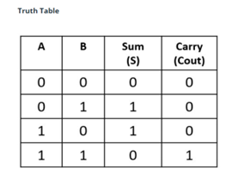

Dataflow model:

module half_adder_dataflow(input a, b, output s, Cout);
assign s = a ^ b;
assign Cout = a & b;
endmodule

Behavior Model :
module half_adder_behavior(sum,carry,a,b );
output sum,carry;
input a,b;
reg sum,carry;
always @(*)
begin
sum <= a ^ b;
carry <= a&b ;
end
endmodule

Gate-level (Structural Model) :

module half_adder_structural(input a, b, output s, Cout);
xor G1(s,a,b);
and G2(Cout,a,b);
endmodule

II.3 EXPERIMENT 3: WRITE VERILOG HDL CODES TO SIMULATE AND IMPLEMENT THE FULL ADDER CIRCUIT:
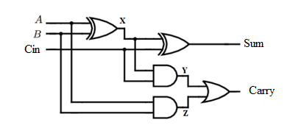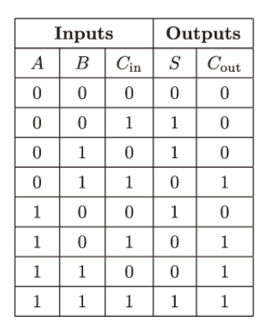

Dataflow model:
module full_adder_DF(input a, b, cin, output S, Cout);
assign S = a ^ b ^ cin;
assign Cout = (a & b) | (b & cin) | (a & cin);
endmodule

Behavior Model using case :

module full_adder_BH1 (input wire A, B, Cin, output reg S, output reg Cout);
always @(*)
begin

case ({A, B, Cin})
3'b000: begin S = 0; Cout = 0; end
3'b001: begin S = 1; Cout = 0; end
3'b010: begin S = 1; Cout = 0; end
3'b011: begin S = 0; Cout = 1; end
3'b100: begin S = 1; Cout = 0; end
3'b101: begin S = 0; Cout = 1; end
3'b110: begin S = 0; Cout = 1; end
3'b111: begin S = 1; Cout = 1; end
endcase
end

Behavior Model using if else :

module full_adder( A, B, Cin, S, Cout);

input wire A, B, Cin;
output reg S, Cout;

always @(*)
begin
if(A==0 && B==0 && Cin==0)
begin
S=0;
Cout=0;
end

else if(A==0 && B==0 && Cin==1)
begin
S=1;
Cout=0;
end

else if(A==0 && B==1 && Cin==0)
begin
S=1;
Cout=0;
end

else if(A==0 && B==1 && Cin==1)
begin
S=0;
Cout=1;
end

else if(A==1 && B==0 && Cin==0)
begin
S=1;
Cout=0;
end

else if(A==1 && B==0 && Cin==1)
begin
S=0;
Cout=1;
end

else if(A==1 && B==1 && Cin==0)
begin
S=0;
Cout=1;
end

else if(A==1 && B==1 && Cin==1)
begin
S=1;
Cout=1;
end

end

endmodule

endmodule
module full_adder_BH(a,b,c,sum,carry);
output sum,carry;
input a,b,c;
reg sum,carry;
always @(*)
begin
sum <= a^ b^c;
carry <=(a&b) | (b&c) | (c&a);
end
endmodule

Gate-level (Structural Model) :
module full_adder_STRU(A, B, Cin, Sum, Carry);
output Sum,Carry;
input A,B,Cin;
wire x,y,z;
xor g1(x,A,B);
xor g2(Sum,x,Cin);
and g3(y,x,Cin);
and g4(z,A,B);
or g5(Carry,x,y);
endmodule

II.4 EXPERIMENT 4 : WRITE VERILOG HDL CODES TO SIMULATE AND IMPLEMENT THE RIPPLE CARRY ADDER CIRCUIT:

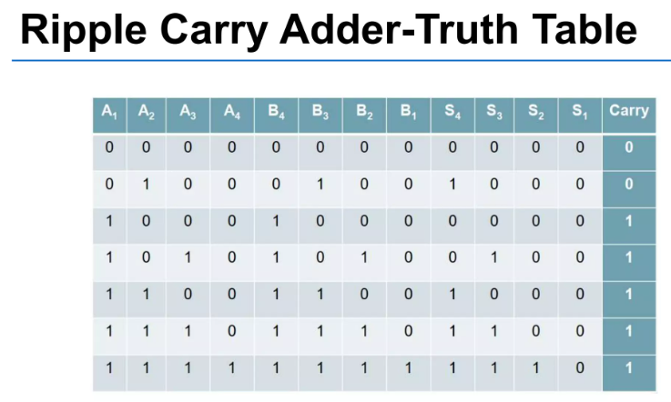
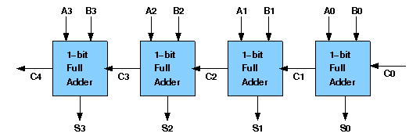

Structural Model:
module full_adder_STRU(A, B, Cin, Sum, Carry);
output Sum,Carry;
input A,B,Cin;
wire x,y,z;
xor g1(x,A,B);
xor g2(Sum,x,Cin);
and g3(y,x,Cin);
and g4(z,A,B);
or g5(Carry,x,y);
endmodule

module four_bit_adder_STRU(cin,a,b,s,cout);
input [3:0] a,b;
input cin;
output [3:0] s;
output cout;
wire [2:0] w_carry;
full_adder_STRU C1(a[0],b[0],cin,s[0], w_carry[0]);
full_adder_STRU C2(a[1],b[1], w_carry[0],s[1], w_carry[1]);
full_adder_STRU C3(a[2],b[2], w_carry[1],s[2], w_carry[2]);
full_adder_STRU C4(a[3],b[3], w_carry[2],s[3], cout);
endmodule

Dataflow model:
module Four_bit_Adder_DF(A,B,Cin,Sum,Cout);
input [3:0] A,B;
input Cin;
output wire [3:0]Sum;
output wire Cout;
wire [4:0]temp;
assign temp=A+B+Cin;
assign Sum=temp[3:0];
assign Cout=temp[4];
endmodule

II.5 EXPERIMENT 5 :WRITE VERILOG HDL CODES TO SIMULATE AND IMPLEMENT 2:1 MULTIPLEXER CIRCUIT:

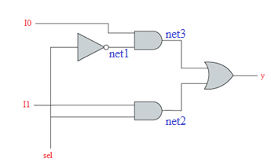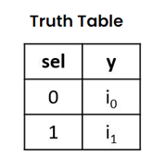

Dataflow model:
module mux21_data_flow(i0,i1,sel,y);
input i0,i1,sel;
output y;
assign y =(i0&(~sel))|(i1&sel);
endmodule

Behavior Model :
module mux21_Behavioural (i0,i1,sel,y);
input i0,i1,sel;
output y;
reg y;
always@(*)
begin
if (sel == 1'b0) y = i0;
else y = i1;
end
endmodule

Structural Model:

module mux21_structural(i0,i1,sel,y);
input i0,i1,sel;
output y;
wire net1,net2,net3;
not g1(net1,sel);
and g2(net2,i1,sel);
and g3(net3,i0,net1);
or g4(y,net3,net2);
endmodule

II.6 EXPERIMENT 6 : WRITE VERILOG HDL CODES TO SIMULATE AND IMPLEMENT 4:1 MULTIPLEXER CIRCUIT:

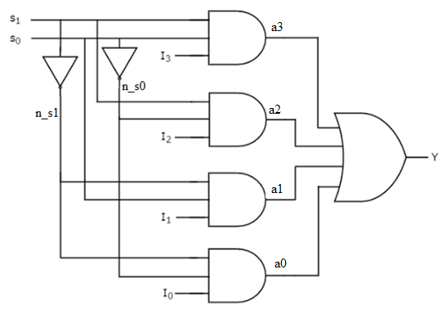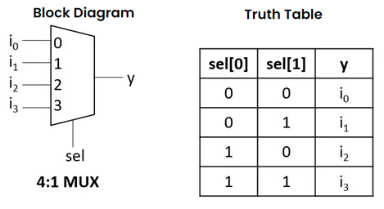

Structural Model:

module mux41_structural (i0,i1,i2,i3,s0,s1,y);
input i0,i1,i2,i3,s0,s1;
output y;
wire n_s0,n_s1, a0,a1,a2,a3;
not g0(n_s0,s0);
not g1(n_s1,s1);
and g2(a0,i0,n_s0,n_s1);
and g3(a1,i1,n_s1,s0);
and g4(a2,i2,s1,n_s0);
and g5(a3,i3,s1,s0);
or g6(y,a0,a1,a2,a3);
endmodule

Dataflow model:
module mux41_df (i0,i1,i2,i3,s0,s1,y);
input i0,i1,i2,i3,s0,s1;
output y;
assign y= i0&(~s1)&(~s0) | i1 &(~s1)&s0 | i2&s1&(~s0) | i3&s1&s0;
endmodule

module mux41beh_v1(in,s,y );
output y ;
input [3:0] in ;
input [1:0] s ;
reg y;
always @(*)
begin
if (s == 2'b00)
y <= in[0];
else if (s == 2'b01)
y <= in[1];
else if (s == 2'b10)
y <= in[2];
else
y <= in[3];
end
endmodule

Behavior Model :
module mux41beh_v2(in,s,y );
output y ;
input [3:0]in ;
input [1:0]s ;
reg y;
always @(*)
begin
case (s)
2'b00: y <= in[0];
2'b01: y <= in[1];
2'b10: y <= in[2];
2'b11: y <= in[3];
endcase
end
endmodule

II.7 EXPERIMENT 7 : WRITE VERILOG HDL CODES TO SIMULATE AND IMPLEMENT 16:1 MULTIPLEXER CIRCUIT USING STRUCTURAL MODEL FROM FIVE 4:1 MULTIPLEXER MODULE

