LAB 01 · WEEK 01

HDL FOUNDATIONS AND SELF-CHECKING VERIFICATION
  - From combinational/sequential logic to oracle-based testbenches — do not use a waveform as the only PASS criterion.
180′  in-lab | 3–5h  pre/post lab | 4  experiments | 10%  course weight

Student information
Full name: __________________________________________ | Student ID: ______________________________
Course: Digital System Design (DSD) | Group/Class: __________________________
Submission date: __________________________________________ | Instructor: __________________________

Weekly outcome: Students can write synthesizable Verilog modules, distinguish combinational and sequential logic, and build self-checking testbenches with timeouts.
HDL language: Use Verilog-2001 during the foundation stage: .v files, wire/reg, always @(*) and always @(posedge clk...). SystemVerilog is introduced only after students have mastered Verilog.

Evidence requirements after each experiment
Required: Immediately after each experiment, students must submit the RTL code, testbench, and one waveform screenshot captured from ModelSim or Questa. The screenshot must show the test name, time scale, clock/reset, stimulus signals, the output under test, and the PASS/FAIL line if printed by the testbench.
vlog -2001 rtl/*.v sim/tb_*.v
vsim work.tb_<experiment_name>
add wave -r /*
run -all
Capture procedure: After the signals are stable, select Zoom Full or the cycle range being graded, then use the ModelSim/Questa Capture/Export Image function. Insert the image in the waveform area immediately after the experiment; do not submit only a WLF file.

1. Pre-lab preparation
- Boolean algebra and signed/unsigned binary numbers.
- Install ModelSim/Questa or an equivalent environment.
- Read the course reset_n convention and coding style.

2. Architecture used
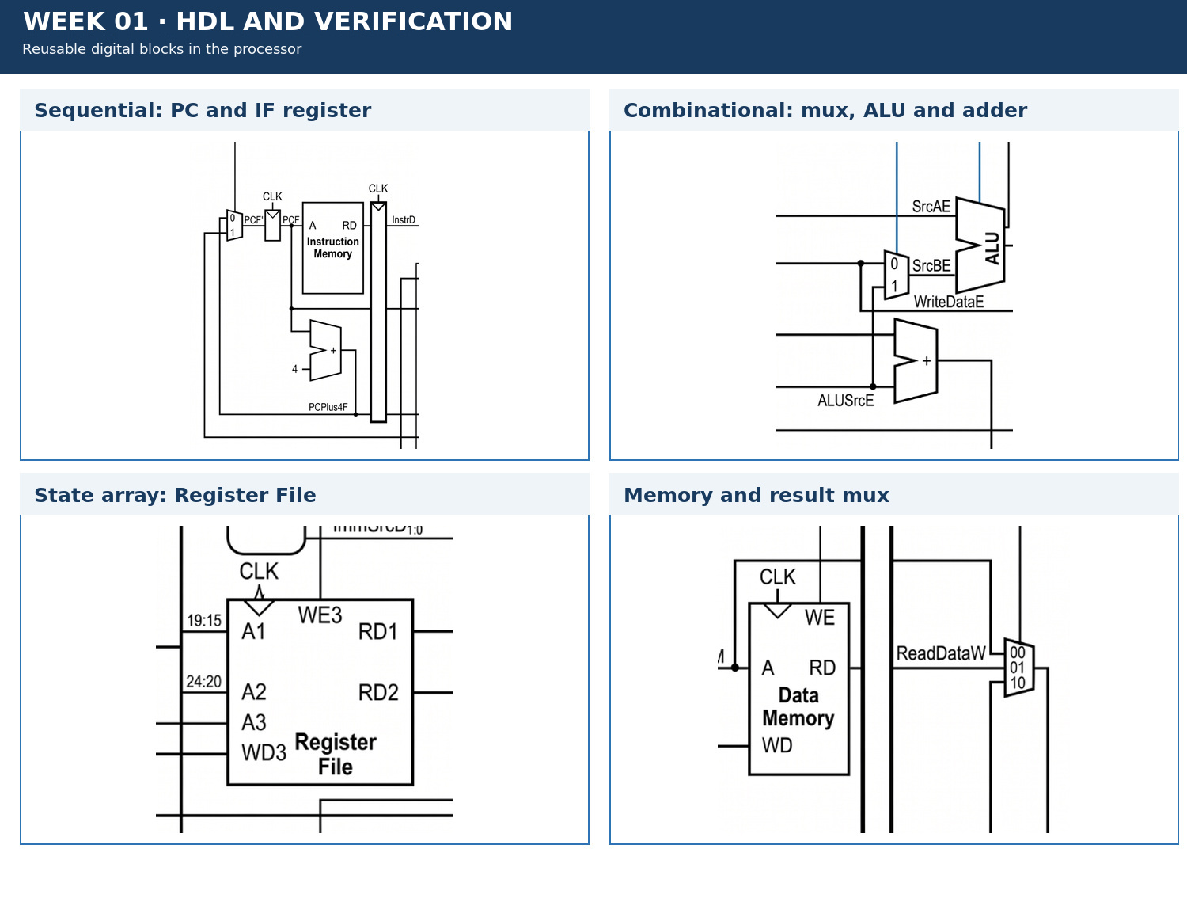
Figure 1.1 · Datapath/module area used in Week 01.

3. Module contract
Module/block | Main inputs | Main outputs
mux2 | a[31:0], b[31:0], sel | y[31:0]
adder32 | a, b | sum
reg_en_clr | clk, reset_n, en, clear, d | q
tb_* | stimulus + expected model | PASS/FAIL + timeout

4. Mandatory common contract
Item | Convention
HDL language | Verilog-2001 (.v): wire/reg, always @(*), always @(posedge clk); do not use SystemVerilog syntax yet
Required ISA | RV32I subset: add, sub, and, or, slt, addi, lw, sw, beq
Extension | jal is enabled only when JumpE, ResultSrc=10, and the corresponding test is complete
Clock/reset | posedge clk; reset_n active-low; no gated clock, and do not use negedge to avoid a hazard
Addressing | PC increments by 4; instruction/data memory uses word addressing through addr[...:2]
Signal naming | Use F/D/E/M/W stage suffixes; state widths explicitly in the interface
Verification | Every test must determine PASS/FAIL automatically and include a timeout; submit a ModelSim/Questa waveform image after each experiment

5. Core code skeleton — Verilog-2001
module reg_en_clr #(parameter W=32) (
input wire clk, reset_n, en, clear,
input wire [W-1:0] d,
output reg [W-1:0] q
);
always @(posedge clk or negedge reset_n) begin
// TODO: reset -> clear -> enable -> hold
end
endmodule

6. Lab procedure

Experiment 1: Three description styles and synthesis
Aim: Implement a mux/adder using structural, dataflow, and behavioral styles to observe equivalence.

Procedure
- Write mux2 in all three styles.
- Write adder32 using assign and always @*.
- Compare the RTL Viewer results and state which style is easiest to parameterize.

Checkpoints
- Cover all small vectors and at least 200 random vectors.
- No latch warning.
- All three implementations produce the same result.

Submission evidence immediately after the experiment
Required item | Content to enter/attach | Suggested filename
RTL code | All modules/blocks for the experiment, using correct Verilog-2001. | exp_01_rtl.v
Testbench | Self-checking testbench with an oracle, error counter, and timeout. | tb_exp_01.v
Waveform | ModelSim/Questa image showing clock/reset, inputs, outputs, and the checking moment. | exp_01_waveform.png
Result log | Compile command, simulator, runtime, and TEST_PASS/TEST_FAIL. | exp_01_run.log

RTL code entry area
// EXPERIMENT 01 — STUDENT RTL CODE (Verilog-2001)
// Paste the student's module code here or record the name of the submitted file.

Testbench entry area
// EXPERIMENT 01 — STUDENT TESTBENCH
// Paste the self-checking testbench code here or record the name of the submitted file.
Evidence insertion area: Paste the RTL code, testbench code, and waveform image in the designated locations when completing the report. If separate files are submitted, record the exact corresponding paths.

Experiment 2: Register with enable/clear
Aim: Practice state, nonblocking assignments, and the priority order reset → clear → enable → hold.

Procedure
- Implement reg_en_clr with a posedge clock.
- Create reset, hold, enable, and conflicting-clear sequences.
- Write a manual assertion after each clock edge.

Checkpoints
- Q=0 when reset_n=0.
- Clear has priority over enable.
- Q holds its value when en=0.

Submission evidence immediately after the experiment
Required item | Content to enter/attach | Suggested filename
RTL code | All modules/blocks for the experiment, using correct Verilog-2001. | exp_02_rtl.v
Testbench | Self-checking testbench with an oracle, error counter, and timeout. | tb_exp_02.v
Waveform | ModelSim/Questa image showing clock/reset, inputs, outputs, and the checking moment. | exp_02_waveform.png
Result log | Compile command, simulator, runtime, and TEST_PASS/TEST_FAIL. | exp_02_run.log

RTL code entry area
// EXPERIMENT 02 — STUDENT RTL CODE (Verilog-2001)
// Paste the student's module code here or record the name of the submitted file.

Testbench entry area
// EXPERIMENT 02 — STUDENT TESTBENCH
// Paste the self-checking testbench code here or record the name of the submitted file.
Evidence insertion area: Paste the RTL code, testbench code, and waveform image in the designated locations when completing the report. If separate files are submitted, record the exact corresponding paths.

Experiment 3: Self-checking testbench
Aim: Move from waveform inspection to oracle-based verification.

Procedure
- Create a check(expected, actual) task.
- Add an error counter and a timeout.
- Print exactly one TEST_PASS or TEST_FAIL line at the end of the simulation.

Checkpoints
- A deliberately faulty test must FAIL.
- A correct test must PASS before the timeout.
- Use the waveform only to explain failures.

Submission evidence immediately after the experiment
Required item | Content to enter/attach | Suggested filename
RTL code | All modules/blocks for the experiment, using correct Verilog-2001. | exp_03_rtl.v
Testbench | Self-checking testbench with an oracle, error counter, and timeout. | tb_exp_03.v
Waveform | ModelSim/Questa image showing clock/reset, inputs, outputs, and the checking moment. | exp_03_waveform.png
Result log | Compile command, simulator, runtime, and TEST_PASS/TEST_FAIL. | exp_03_run.log

RTL code entry area
// EXPERIMENT 03 — STUDENT RTL CODE (Verilog-2001)
// Paste the student's module code here or record the name of the submitted file.

Testbench entry area
// EXPERIMENT 03 — STUDENT TESTBENCH
// Paste the self-checking testbench code here or record the name of the submitted file.
Evidence insertion area: Paste the RTL code, testbench code, and waveform image in the designated locations when completing the report. If separate files are submitted, record the exact corresponding paths.

Experiment 4: Synthesis checkpoint
Aim: Demonstrate that the code can be synthesized and mapped to the FPGA.

Procedure
- Compile a small top-level design.
- Connect inputs from SW/KEY and outputs to LEDs.
- Record the resource summary and clock warnings.

Checkpoints
- No inferred latch.
- No multiple driver.
- The top-level design operates stably after reset.

Submission evidence immediately after the experiment
Required item | Content to enter/attach | Suggested filename
RTL code | All modules/blocks for the experiment, using correct Verilog-2001. | exp_04_rtl.v
Testbench | Self-checking testbench with an oracle, error counter, and timeout. | tb_exp_04.v
Waveform | ModelSim/Questa image showing clock/reset, inputs, outputs, and the checking moment. | exp_04_waveform.png
Result log | Compile command, simulator, runtime, and TEST_PASS/TEST_FAIL. | exp_04_run.log

RTL code entry area
// EXPERIMENT 04 — STUDENT RTL CODE (Verilog-2001)
// Paste the student's module code here or record the name of the submitted file.

Testbench entry area
// EXPERIMENT 04 — STUDENT TESTBENCH
// Paste the self-checking testbench code here or record the name of the submitted file.
Evidence insertion area: Paste the RTL code, testbench code, and waveform image in the designated locations when completing the report. If separate files are submitted, record the exact corresponding paths.

7. Standard simulation procedure
- Compile all sources from a clean directory; classify every warning.
- Run the new module unit test before the integration test.
- Run directed corner cases, followed by a regression with a timeout.
- Open the waveform only for a failing test or a required checkpoint.
- Save a log containing the test name, seed, ending cycle, and PASS/FAIL result.

8. Acceptance gate
- PASS — Modules compile without serious functional warnings.
- PASS — The self-checking test detects a mutant supplied by the instructor.
- PASS — The log includes the seed, vector count, error count, and PASS/FAIL result.
- PASS — The FPGA checkpoint does not use a clock divider as a new logic clock.

9. Submission package
Required main report: DSD_Labxx_MSSV_HoVaTen.pdf
Export the completed student manual as this PDF. It must include the student information, RTL code, testbench code, and waveform evidence inserted in the designated sections after each experiment.
The submission package must contain:
- Clean rtl/ and sim/ directories
- 01_truth_or_state_tables.pdf
- 02_test_log.txt
- 03_waveform_debug.png
- 04_rtl_viewer.png
- 05_reflection.md
Do not submit: db/, incremental_db/, output_files/, work/, temporary transcripts, large WLF files, backups, or solution references.

10. Weekly rubric
Item | Weight | Minimum condition
Functionally correct RTL | 40% | Public and hidden tests PASS; no timeout.
Verification | 25% | Self-checking, corner cases, and a reproducible log.
Architecture explanation | 20% | Correctly trace signal lifetime and control causes.
Interface engineering | 10% | Correct names, widths, polarity, and clock/reset contract.
Clean submission package | 5% | Contains no tool-generated output; the script runs from a clean folder.

11. Oral examination questions
- Why does combinational logic use blocking assignments while sequential logic uses nonblocking assignments?
- Is a good-looking waveform sufficient to prove that a module is correct?
- When clear and enable are both 1, what should q be?

Reference
RISC-V Unprivileged ISA Specification, RV32I Base Integer Instruction Set: https://docs.riscv.org/reference/isa/unpriv/rv32.html

