LAB 02 · WEEK 02

RV32I BUILDING BLOCKS
  - PC, memory, Register File, immediate extension, and ALU use one consistent 32-bit contract.
180′  in-lab | 3–5h  pre/post lab | 4  experiments | 12%  course weight

Student information
Full name: __________________________________________ | Student ID: ______________________________
Course: Digital System Design (DSD) | Group/Class: __________________________
Submission date: __________________________________________ | Instructor: __________________________

Weekly outcome: Students complete and independently verify the blocks that will be reused in single-cycle, multi-cycle, and pipeline processors.
HDL language: Use Verilog-2001 during the foundation stage: .v files, wire/reg, always @(*) and always @(posedge clk...). SystemVerilog is introduced only after students have mastered Verilog.

Evidence requirements after each experiment
Required: Immediately after each experiment, students must submit the RTL code, testbench, and one waveform screenshot captured from ModelSim or Questa. The screenshot must show the test name, time scale, clock/reset, stimulus signals, the output under test, and the PASS/FAIL line if printed by the testbench.
vlog -2001 rtl/*.v sim/tb_*.v
vsim work.tb_<experiment_name>
add wave -r /*
run -all
Capture procedure: After the signals are stable, select Zoom Full or the cycle range being graded, then use the ModelSim/Questa Capture/Export Image function. Insert the image in the waveform area immediately after the experiment; do not submit only a WLF file.

1. Pre-lab preparation
- Complete Lab 01.
- Read the RV32I R/I/S/B formats.
- Prepare a bit-field table for the 9 baseline instructions.

2. Architecture used
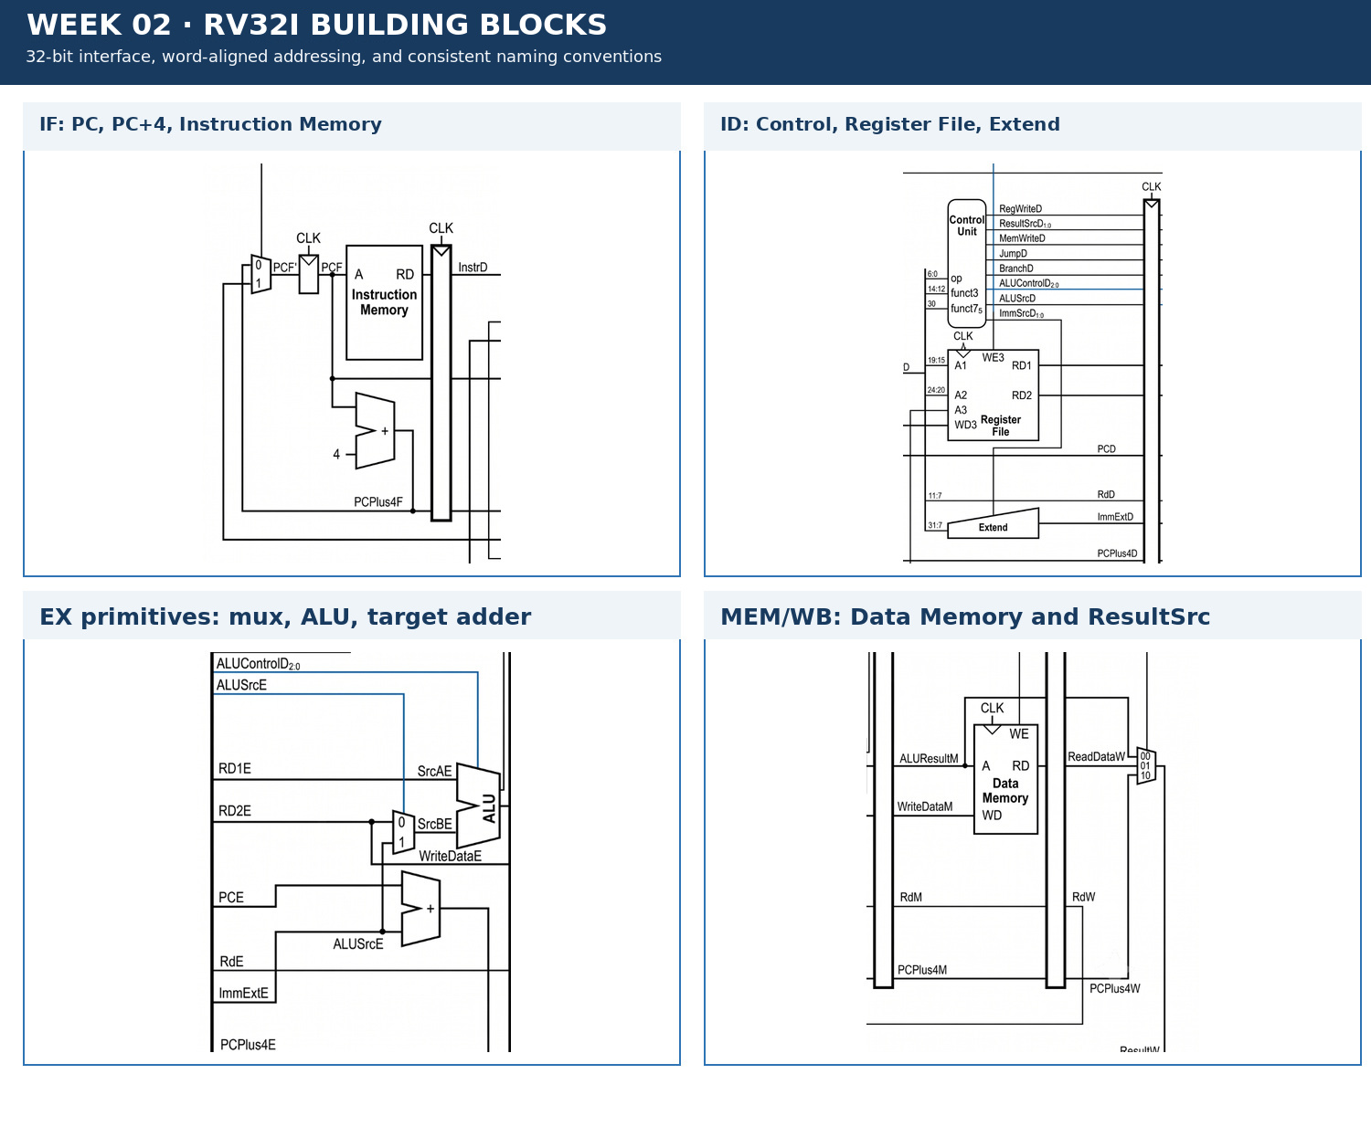
Figure 2.1 · Datapath/module area used in Week 02.

3. Module contract
Module/block | Main inputs | Main outputs
program_counter | clk, reset_n, en, pc_next | pc
instruction_memory | addr | instr
register_file | clk, we3, a1, a2, a3, wd3 | rd1, rd2
extend | instr[31:7], imm_src | imm_ext
alu | src_a, src_b, alu_control | alu_result, zero

4. Mandatory common contract
Item | Convention
HDL language | Verilog-2001 (.v): wire/reg, always @(*), always @(posedge clk); do not use SystemVerilog syntax yet
Required ISA | RV32I subset: add, sub, and, or, slt, addi, lw, sw, beq
Extension | jal is enabled only when JumpE, ResultSrc=10, and the corresponding test is complete
Clock/reset | posedge clk; reset_n active-low; no gated clock, and do not use negedge to avoid a hazard
Addressing | PC increments by 4; instruction/data memory uses word addressing through addr[...:2]
Signal naming | Use F/D/E/M/W stage suffixes; state widths explicitly in the interface
Verification | Every test must determine PASS/FAIL automatically and include a timeout; submit a ModelSim/Questa waveform image after each experiment

5. Core code skeleton — Verilog-2001
module register_file (
input wire clk, we3,
input wire [4:0] a1, a2, a3,
input wire [31:0] wd3,
output wire [31:0] rd1, rd2
);
reg [31:0] rf [0:31];
// TODO: x0 read=0 and write to x0 ignored
endmodule

6. Lab procedure

Experiment 1: PC and Instruction Memory
Aim: Implement word-aligned instruction fetch with PC+4.

Procedure
- Implement a PC with enable.
- Implement the ROM index using addr[31:2] or a slice appropriate for the memory depth.
- Load a small hex program and trace three instructions.

Checkpoints
- PC resets to 0.
- PC holds when en=0.
- Addresses 0, 4, and 8 read three consecutive words.

Submission evidence immediately after the experiment
Required item | Content to enter/attach | Suggested filename
RTL code | All modules/blocks for the experiment, using correct Verilog-2001. | exp_01_rtl.v
Testbench | Self-checking testbench with an oracle, error counter, and timeout. | tb_exp_01.v
Waveform | ModelSim/Questa image showing clock/reset, inputs, outputs, and the checking moment. | exp_01_waveform.png
Result log | Compile command, simulator, runtime, and TEST_PASS/TEST_FAIL. | exp_01_run.log

RTL code entry area
// EXPERIMENT 01 — STUDENT RTL CODE (Verilog-2001)
// Paste the student's module code here or record the name of the submitted file.

Testbench entry area
// EXPERIMENT 01 — STUDENT TESTBENCH
// Paste the self-checking testbench code here or record the name of the submitted file.
Evidence insertion area: Paste the RTL code, testbench code, and waveform image in the designated locations when completing the report. If separate files are submitted, record the exact corresponding paths.

Experiment 2: 32×32 Register File
Aim: Two combinational read ports, one synchronous write port, and an immutable x0.

Procedure
- Implement combinational reads.
- Block writes when a3=0.
- Check read-after-write on the next cycle.

Checkpoints
- x0 always reads as 0.
- we3=0 does not change state.
- The two read ports are independent.

Submission evidence immediately after the experiment
Required item | Content to enter/attach | Suggested filename
RTL code | All modules/blocks for the experiment, using correct Verilog-2001. | exp_02_rtl.v
Testbench | Self-checking testbench with an oracle, error counter, and timeout. | tb_exp_02.v
Waveform | ModelSim/Questa image showing clock/reset, inputs, outputs, and the checking moment. | exp_02_waveform.png
Result log | Compile command, simulator, runtime, and TEST_PASS/TEST_FAIL. | exp_02_run.log

RTL code entry area
// EXPERIMENT 02 — STUDENT RTL CODE (Verilog-2001)
// Paste the student's module code here or record the name of the submitted file.

Testbench entry area
// EXPERIMENT 02 — STUDENT TESTBENCH
// Paste the self-checking testbench code here or record the name of the submitted file.
Evidence insertion area: Paste the RTL code, testbench code, and waveform image in the designated locations when completing the report. If separate files are submitted, record the exact corresponding paths.

Experiment 3: Immediate extension
Aim: Decode I/S/B immediates with the correct sign and bit positions.

Procedure
- Write the bit-concatenation table before coding.
- Create positive and negative vectors for I, S, and B.
- Check that the B immediate has bit 0 equal to 0.

Checkpoints
- -1 sign-extends to 0xFFFFFFFF.
- The S-immediate combines the two fields correctly.
- The B-immediate reaches offsets ±4 and ±8.

Submission evidence immediately after the experiment
Required item | Content to enter/attach | Suggested filename
RTL code | All modules/blocks for the experiment, using correct Verilog-2001. | exp_03_rtl.v
Testbench | Self-checking testbench with an oracle, error counter, and timeout. | tb_exp_03.v
Waveform | ModelSim/Questa image showing clock/reset, inputs, outputs, and the checking moment. | exp_03_waveform.png
Result log | Compile command, simulator, runtime, and TEST_PASS/TEST_FAIL. | exp_03_run.log

RTL code entry area
// EXPERIMENT 03 — STUDENT RTL CODE (Verilog-2001)
// Paste the student's module code here or record the name of the submitted file.

Testbench entry area
// EXPERIMENT 03 — STUDENT TESTBENCH
// Paste the self-checking testbench code here or record the name of the submitted file.
Evidence insertion area: Paste the RTL code, testbench code, and waveform image in the designated locations when completing the report. If separate files are submitted, record the exact corresponding paths.

Experiment 4: ALU and zero
Aim: Implement the baseline arithmetic/logic operations, including signed SLT.

Procedure
- Implement add/sub/and/or/slt.
- Test overflow wrap-around.
- Generate zero from alu_result==0.

Checkpoints
- SLT uses signed comparison.
- Zero is correct when the result is 0.
- The default case does not create a latch.

Submission evidence immediately after the experiment
Required item | Content to enter/attach | Suggested filename
RTL code | All modules/blocks for the experiment, using correct Verilog-2001. | exp_04_rtl.v
Testbench | Self-checking testbench with an oracle, error counter, and timeout. | tb_exp_04.v
Waveform | ModelSim/Questa image showing clock/reset, inputs, outputs, and the checking moment. | exp_04_waveform.png
Result log | Compile command, simulator, runtime, and TEST_PASS/TEST_FAIL. | exp_04_run.log

RTL code entry area
// EXPERIMENT 04 — STUDENT RTL CODE (Verilog-2001)
// Paste the student's module code here or record the name of the submitted file.

Testbench entry area
// EXPERIMENT 04 — STUDENT TESTBENCH
// Paste the self-checking testbench code here or record the name of the submitted file.
Evidence insertion area: Paste the RTL code, testbench code, and waveform image in the designated locations when completing the report. If separate files are submitted, record the exact corresponding paths.

7. Standard simulation procedure
- Compile all sources from a clean directory; classify every warning.
- Run the new module unit test before the integration test.
- Run directed corner cases, followed by a regression with a timeout.
- Open the waveform only for a failing test or a required checkpoint.
- Save a log containing the test name, seed, ending cycle, and PASS/FAIL result.

8. Acceptance gate
- PASS — Every module has its own test and at least one corner case.
- PASS — Do not mix 8/16-bit buses into the 32-bit datapath.
- PASS — PC increments by 4, not by 1.
- PASS — Memory indexing does not use the full byte address as a word index.

9. Submission package
Required main report: DSD_Labxx_MSSV_HoVaTen.pdf
Export the completed student manual as this PDF. It must include the student information, RTL code, testbench code, and waveform evidence inserted in the designated sections after each experiment.
The submission package must contain:
- rtl/components/
- sim/unit/
- rv32i_field_table.pdf
- unit_test_log.txt
- waveforms/
- resource_snapshot.png
Do not submit: db/, incremental_db/, output_files/, work/, temporary transcripts, large WLF files, backups, or solution references.

10. Weekly rubric
Item | Weight | Minimum condition
Functionally correct RTL | 40% | Public and hidden tests PASS; no timeout.
Verification | 25% | Self-checking, corner cases, and a reproducible log.
Architecture explanation | 20% | Correctly trace signal lifetime and control causes.
Interface engineering | 10% | Correct names, widths, polarity, and clock/reset contract.
Clean submission package | 5% | Contains no tool-generated output; the script runs from a clean folder.

11. Oral examination questions
- Why does the PC increment by 4?
- Why must x0 block both writes and reads?
- How is the B immediate concatenated differently from the I-type immediate?

Reference
RISC-V Unprivileged ISA Specification, RV32I Base Integer Instruction Set: https://docs.riscv.org/reference/isa/unpriv/rv32.html

