LAB 03 · WEEK 03

RV32I SINGLE-CYCLE DATAPATH
  - Integrate the datapath and control for the ALU subset first, then freeze the interface before adding memory and branch support.
180′  in-lab | 3–5h  pre/post lab | 3  experiments | 14%  course weight

Student information
Full name: __________________________________________ | Student ID: ______________________________
Course: Digital System Design (DSD) | Group/Class: __________________________
Submission date: __________________________________________ | Instructor: __________________________

Weekly outcome: Students integrate a single-cycle processor for add, sub, and, or, slt, and addi, and trace one instruction from fetch to write-back.
HDL language: Use Verilog-2001 during the foundation stage: .v files, wire/reg, always @(*) and always @(posedge clk...). SystemVerilog is introduced only after students have mastered Verilog.

Evidence requirements after each experiment
Required: Immediately after each experiment, students must submit the RTL code, testbench, and one waveform screenshot captured from ModelSim or Questa. The screenshot must show the test name, time scale, clock/reset, stimulus signals, the output under test, and the PASS/FAIL line if printed by the testbench.
vlog -2001 rtl/*.v sim/tb_*.v
vsim work.tb_<experiment_name>
add wave -r /*
run -all
Capture procedure: After the signals are stable, select Zoom Full or the cycle range being graded, then use the ModelSim/Questa Capture/Export Image function. Insert the image in the waveform area immediately after the experiment; do not submit only a WLF file.

1. Pre-lab preparation
- All Lab 02 unit tests PASS.
- Prepare the main-decoder and ALU-decoder truth tables.
- Understand the single-cycle critical path.

2. Architecture used
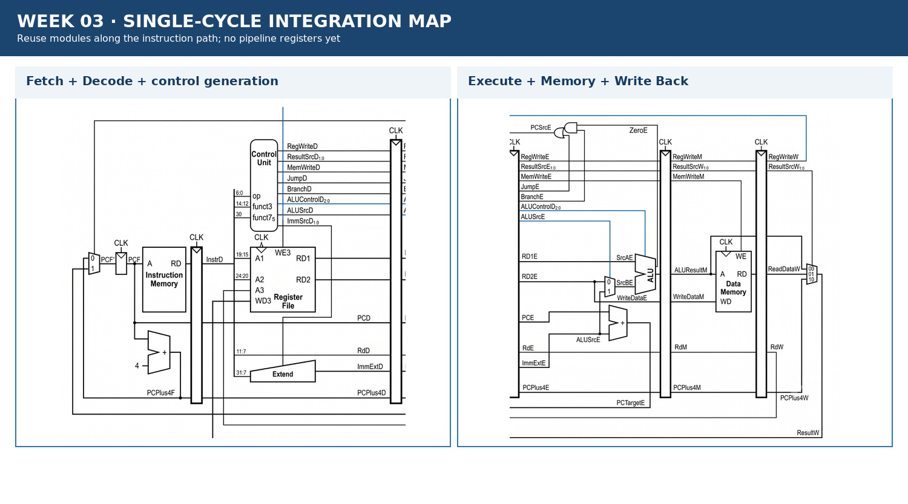
Figure 3.1 · Datapath/module area used in Week 03.

3. Module contract
Module/block | Main inputs | Main outputs
main_decoder | op[6:0] | RegWrite, ImmSrc, ALUSrc, MemWrite, ResultSrc, Branch, Jump, ALUOp
alu_decoder | op[5], funct3, funct7[5], ALUOp | ALUControl
single_cycle_core | clk, reset_n | PC, Instr, debug writeback
result_mux | ALUResult, ReadData, PCPlus4 | Result

4. Mandatory common contract
Item | Convention
HDL language | Verilog-2001 (.v): wire/reg, always @(*), always @(posedge clk); do not use SystemVerilog syntax yet
Required ISA | RV32I subset: add, sub, and, or, slt, addi, lw, sw, beq
Extension | jal is enabled only when JumpE, ResultSrc=10, and the corresponding test is complete
Clock/reset | posedge clk; reset_n active-low; no gated clock, and do not use negedge to avoid a hazard
Addressing | PC increments by 4; instruction/data memory uses word addressing through addr[...:2]
Signal naming | Use F/D/E/M/W stage suffixes; state widths explicitly in the interface
Verification | Every test must determine PASS/FAIL automatically and include a timeout; submit a ModelSim/Questa waveform image after each experiment

5. Core code skeleton — Verilog-2001
always @(*) begin
RegWrite = 1'b0; MemWrite = 1'b0; Branch = 1'b0; Jump = 1'b0;
ResultSrc = 2'b00; ALUSrc = 1'b0; ImmSrc = 2'b00; ALUOp = 2'b00;
case (op)
// TODO: RV32I baseline decode
default: begin end
endcase
end

6. Lab procedure

Experiment 1: Control table
Aim: Convert instruction fields into a safe control word.

Procedure
- Complete the truth table for six instructions.
- Set a default that does not write a register or memory.
- Separate the main decoder and ALU decoder.

Checkpoints
- An unsupported opcode has no side effect.
- add/sub are distinguished by funct7[5].
- addi uses ALUSrc=1.

Submission evidence immediately after the experiment
Required item | Content to enter/attach | Suggested filename
RTL code | All modules/blocks for the experiment, using correct Verilog-2001. | exp_01_rtl.v
Testbench | Self-checking testbench with an oracle, error counter, and timeout. | tb_exp_01.v
Waveform | ModelSim/Questa image showing clock/reset, inputs, outputs, and the checking moment. | exp_01_waveform.png
Result log | Compile command, simulator, runtime, and TEST_PASS/TEST_FAIL. | exp_01_run.log

RTL code entry area
// EXPERIMENT 01 — STUDENT RTL CODE (Verilog-2001)
// Paste the student module code here or record the submitted filename.

Testbench entry area
// EXPERIMENT 01 — STUDENT TESTBENCH
// Paste the self-checking testbench code here or record the submitted filename.
Evidence insertion area: Paste the RTL code, testbench code, and waveform image in the designated locations when completing the report. If separate files are submitted, record the exact corresponding paths.

Experiment 2: ALU-subset datapath
Aim: Integrate IF–ID–EX–WB in one long cycle.

Procedure
- Connect the PC, IMEM, RF, Extend, ALU, and result mux.
- Run a sequential dependency program.
- Trace PC, Instr, rs1/rs2/rd, SrcA/SrcB, ALUResult, and Result.

Checkpoints
- Each instruction updates the correct rd.
- x0 does not change.
- There is no X on a valid write-back path.

Submission evidence immediately after the experiment
Required item | Content to enter/attach | Suggested filename
RTL code | All modules/blocks for the experiment, using correct Verilog-2001. | exp_02_rtl.v
Testbench | Self-checking testbench with an oracle, error counter, and timeout. | tb_exp_02.v
Waveform | ModelSim/Questa image showing clock/reset, inputs, outputs, and the checking moment. | exp_02_waveform.png
Result log | Compile command, simulator, runtime, and TEST_PASS/TEST_FAIL. | exp_02_run.log

RTL code entry area
// EXPERIMENT 02 — STUDENT RTL CODE (Verilog-2001)
// Paste the student module code here or record the submitted filename.

Testbench entry area
// EXPERIMENT 02 — STUDENT TESTBENCH
// Paste the self-checking testbench code here or record the submitted filename.
Evidence insertion area: Paste the RTL code, testbench code, and waveform image in the designated locations when completing the report. If separate files are submitted, record the exact corresponding paths.

Experiment 3: Directed regression
Aim: Build a signature instead of checking every waveform by eye.

Procedure
- Write a program that produces a final value in x31.
- The testbench waits for the signature or a timeout.
- Add signed slt and negative-number cases.

Checkpoints
- The signature matches the golden value.
- An unsupported opcode does not corrupt state.
- The test reruns from a clean directory.

Submission evidence immediately after the experiment
Required item | Content to enter/attach | Suggested filename
RTL code | All modules/blocks for the experiment, using correct Verilog-2001. | exp_03_rtl.v
Testbench | Self-checking testbench with an oracle, error counter, and timeout. | tb_exp_03.v
Waveform | ModelSim/Questa image showing clock/reset, inputs, outputs, and the checking moment. | exp_03_waveform.png
Result log | Compile command, simulator, runtime, and TEST_PASS/TEST_FAIL. | exp_03_run.log

RTL code entry area
// EXPERIMENT 03 — STUDENT RTL CODE (Verilog-2001)
// Paste the student module code here or record the submitted filename.

Testbench entry area
// EXPERIMENT 03 — STUDENT TESTBENCH
// Paste the self-checking testbench code here or record the submitted filename.
Evidence insertion area: Paste the RTL code, testbench code, and waveform image in the designated locations when completing the report. If separate files are submitted, record the exact corresponding paths.

7. Standard simulation procedure
- Compile all sources from a clean directory; classify every warning.
- Run the new module unit test before the integration test.
- Run directed corner cases, followed by a regression with a timeout.
- Open the waveform only for a failing test or a required checkpoint.
- Save a log containing the test name, seed, ending cycle, and PASS/FAIL result.

8. Acceptance gate
- PASS — Six ALU/addi instructions pass the directed tests.
- PASS — Control defaults create no side effect.
- PASS — The signature test passes before timeout.
- PASS — The critical path is explained from the PC to Register File write data.

9. Submission package
Required main report: DSD_Labxx_MSSV_HoVaTen.pdf
Export the completed student manual as this PDF. It must include the student information, RTL code, testbench code, and waveform evidence inserted in the designated sections after each experiment.
The submission package must contain:
- rtl/single_cycle/
- sim/single_cycle/
- control_table.pdf
- trace_one_instruction.pdf
- regression.log
- rtl_schematic.png
Do not submit: db/, incremental_db/, output_files/, work/, temporary transcripts, large WLF files, backups, or solution references.

10. Weekly rubric
Item | Weight | Minimum condition
Functionally correct RTL | 40% | Public and hidden tests PASS; no timeout.
Verification | 25% | Self-checking, corner cases, and a reproducible log.
Architecture explanation | 20% | Correctly trace signal lifetime and control causes.
Interface engineering | 10% | Correct names, widths, polarity, and clock/reset contract.
Clean submission package | 5% | Contains no tool-generated output; the script runs from a clean folder.

11. Oral examination questions
- Which instruction creates the longest critical path?
- Which side effect can an incorrect default control create?
- Why is signed slt different from an unsigned comparison?

Reference
RISC-V Unprivileged ISA Specification, RV32I Base Integer Instruction Set: https://docs.riscv.org/reference/isa/unpriv/rv32.html

