LAB 05 · WEEK 05

RV32I MULTI-CYCLE AND CONTROL FSM
  - Reuse datapath blocks over time to understand state sequencing before moving to the pipeline.
180′  in-lab | 3–5h  pre/post lab | 3  experiments | 15%  course weight

Student information
Full name: __________________________________________ | Student ID: ______________________________
Course: Digital System Design (DSD) | Group/Class: __________________________
Submission date: __________________________________________ | Instructor: __________________________

Weekly outcome: Students design an IF/ID/EX/MEM/WB FSM for the required subset and prove that the control outputs are correct in each state.
HDL language: Use Verilog-2001 during the foundation stage: .v files, wire/reg, always @(*) and always @(posedge clk...). SystemVerilog is introduced only after students have mastered Verilog.

Evidence requirements after each experiment
Required: Immediately after each experiment, students must submit the RTL code, testbench, and one waveform screenshot captured from ModelSim or Questa. The screenshot must show the test name, time scale, clock/reset, stimulus signals, the output under test, and the PASS/FAIL line if printed by the testbench.
vlog -2001 rtl/*.v sim/tb_*.v
vsim work.tb_<experiment_name>
add wave -r /*
run -all
Capture procedure: After the signals are stable, select Zoom Full or the cycle range being graded, then use the ModelSim/Questa Capture/Export Image function. Insert the image in the waveform area immediately after the experiment; do not submit only a WLF file.

1. Pre-lab preparation
- Single-cycle baseline PASS.
- Draw the state transitions for add/addi/lw/sw/beq.
- Distinguish architectural state from temporary state.

2. Architecture used
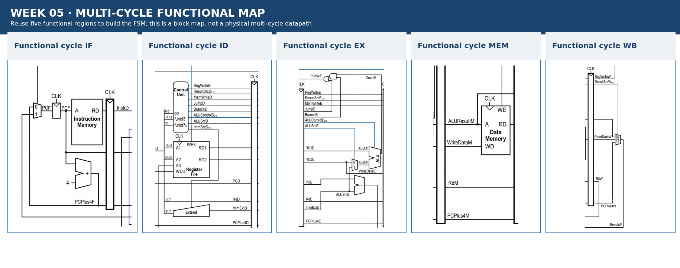
Figure 5.1 · Datapath/module area used in Week 05.
Figure note: The figure only divides functional regions taken from the pipeline datapath. Students must draw the physical multi-cycle datapath themselves; do not treat the pipeline registers in the figure as multi-cycle holding registers.

3. Module contract
Module/block | Main inputs | Main outputs
mc_datapath | control word + memory/RF data | opcode/funct + ALU flags
mc_controller | clk, reset_n, op, funct3, zero | PCWrite, IRWrite, RegWrite, MemWrite, selects
holding_registers | IR, OldPC, A, B, ALUOut, MDR | stored values
multicycle_core | clk, reset_n | debug state + signature

4. Mandatory common contract
Item | Convention
HDL language | Verilog-2001 (.v): wire/reg, always @(*), always @(posedge clk); do not use SystemVerilog syntax yet
Required ISA | RV32I subset: add, sub, and, or, slt, addi, lw, sw, beq
Extension | jal is enabled only when JumpE, ResultSrc=10, and the corresponding test is complete
Clock/reset | posedge clk; reset_n active-low; no gated clock, and do not use negedge to avoid a hazard
Address | PC increments by 4; instruction/data memory uses word addressing through addr[...:2]
Signal naming | Use F/D/E/M/W stage suffixes; state widths explicitly in the interface
Verification | Every test must determine PASS/FAIL automatically and include a timeout; submit a ModelSim/Questa waveform image after each experiment

5. Core code skeleton — Verilog-2001
localparam [3:0] S_IF=4'd0, S_ID=4'd1, S_MEMADR=4'd2,
S_MEMRD=4'd3, S_MEMWB=4'd4, S_MEMWR=4'd5,
S_EXEC_R=4'd6, S_ALUWB=4'd7, S_EXEC_I=4'd8, S_BRANCH=4'd9;
reg [3:0] state, next_state;
// TODO: state register + next-state/Moore outputs with safe defaults

6. Lab procedure

Experiment 1: State chart
Aim: Convert the instruction lifetime into an FSM with a safe default.

Procedure
- Draw the state graph.
- Create the Moore-output table for each state.
- Identify shared states and instruction-specific states.

Checkpoints
- Every path returns to IF.
- MemWrite/RegWrite are asserted only in the correct state.
- An illegal opcode safely returns to IF.

Submission evidence immediately after the experiment
Required item | Content to enter/attach | Suggested filename
RTL code | All modules/blocks for the experiment, using correct Verilog-2001. | exp_01_rtl.v
Testbench | Self-checking testbench with an oracle, error counter, and timeout. | tb_exp_01.v
Waveform | ModelSim/Questa image showing clock/reset, inputs, outputs, and the checking moment. | exp_01_waveform.png
Result log | Compile command, simulator, runtime, and TEST_PASS/TEST_FAIL. | exp_01_run.log

RTL code entry area
// EXPERIMENT 01 — STUDENT RTL CODE (Verilog-2001)
// Paste the student module code here or record the submitted filename.

Testbench entry area
// EXPERIMENT 01 — STUDENT TESTBENCH
// Paste the self-checking testbench code here or record the submitted filename.
Evidence insertion area: Paste the RTL code, testbench code, and waveform image in the designated locations when completing the report. If separate files are submitted, record the exact corresponding paths.

Experiment 2: Datapath reuse
Aim: Use holding registers to reuse the ALU/memory.

Procedure
- Implement IR, A, B, ALUOut, and MDR.
- Determine ALUSrcA/B and ResultSrc for each state.
- Trace one lw through all five steps.

Checkpoints
- A holding register updates only when enabled.
- OldPC is not changed before the target is computed.
- ALUOut retains its value across the required states.

Submission evidence immediately after the experiment
Required item | Content to enter/attach | Suggested filename
RTL code | All modules/blocks for the experiment, using correct Verilog-2001. | exp_02_rtl.v
Testbench | Self-checking testbench with an oracle, error counter, and timeout. | tb_exp_02.v
Waveform | ModelSim/Questa image showing clock/reset, inputs, outputs, and the checking moment. | exp_02_waveform.png
Result log | Compile command, simulator, runtime, and TEST_PASS/TEST_FAIL. | exp_02_run.log

RTL code entry area
// EXPERIMENT 02 — STUDENT RTL CODE (Verilog-2001)
// Paste the student module code here or record the submitted filename.

Testbench entry area
// EXPERIMENT 02 — STUDENT TESTBENCH
// Paste the self-checking testbench code here or record the submitted filename.
Evidence insertion area: Paste the RTL code, testbench code, and waveform image in the designated locations when completing the report. If separate files are submitted, record the exact corresponding paths.

Experiment 3: Controller + integration
Aim: Integrate the FSM with the datapath and run the subset regression.

Procedure
- Implement the state register on posedge.
- Implement combinational next-state/output logic.
- Run add/addi/lw/sw/beq.

Checkpoints
- No latch in the controller.
- The cycle count matches the state graph.
- The signature matches the single-cycle design.

Submission evidence immediately after the experiment
Required item | Content to enter/attach | Suggested filename
RTL code | All modules/blocks for the experiment, using correct Verilog-2001. | exp_03_rtl.v
Testbench | Self-checking testbench with an oracle, error counter, and timeout. | tb_exp_03.v
Waveform | ModelSim/Questa image showing clock/reset, inputs, outputs, and the checking moment. | exp_03_waveform.png
Result log | Compile command, simulator, runtime, and TEST_PASS/TEST_FAIL. | exp_03_run.log

RTL code entry area
// EXPERIMENT 03 — STUDENT RTL CODE (Verilog-2001)
// Paste the student module code here or record the submitted filename.

Testbench entry area
// EXPERIMENT 03 — STUDENT TESTBENCH
// Paste the self-checking testbench code here or record the submitted filename.
Evidence insertion area: Paste the RTL code, testbench code, and waveform image in the designated locations when completing the report. If separate files are submitted, record the exact corresponding paths.

7. Standard simulation procedure
- Compile all sources from a clean directory; classify every warning.
- Run the new module unit test before the integration test.
- Run directed corner cases, followed by a regression with a timeout.
- Open the waveform only for a failing test or a required checkpoint.
- Save a log containing the test name, seed, ending cycle, and PASS/FAIL result.

8. Acceptance gate
- PASS — The FSM does not depend on MIPS opcodes.
- PASS — Every instruction returns to IF.
- PASS — Write enables are asserted in only one defined state.
- PASS — The architectural signature matches single-cycle.

9. Submission package
Required main report: DSD_Labxx_MSSV_HoVaTen.pdf
Export the completed student manual as this PDF. It must include the student information, RTL code, testbench code, and waveform evidence inserted in the designated sections after each experiment.
The submission package must contain:
- rtl/multicycle/
- sim/multicycle/
- fsm_state_graph.pdf
- control_word_table.pdf
- instruction_traces/
- regression.log
Do not submit: db/, incremental_db/, output_files/, work/, temporary transcripts, large WLF files, backups, or solution references.

10. Weekly rubric
Item | Weight | Minimum condition
Functionally correct RTL | 40% | Public and hidden tests PASS; no timeout.
Verification | 25% | Self-checking, corner cases, and a reproducible log.
Architecture explanation | 20% | Correctly trace signal lifetime and control causes.
Interface engineering | 10% | Correct names, widths, polarity, and clock/reset contract.
Clean submission package | 5% | Contains no tool-generated output; the script runs from a clean folder.

11. Oral examination questions
- How does architectural state differ from a holding register?
- How do Moore outputs make the controller safer?
- Why does multi-cycle not use pipeline registers in the Week 06 sense?

Reference
RISC-V Unprivileged ISA Specification, RV32I Base Integer Instruction Set: https://docs.riscv.org/reference/isa/unpriv/rv32.html

