LAB 06 · WEEK 06

FIVE-STAGE PIPELINE WITHOUT HAZARDS
  - Move the datapath to IF–ID–EX–MEM–WB, freeze signal lifetime, and use NOPs to isolate pipeline errors.
180′  in-lab | 3–5h  pre/post lab | 4  experiments | 15%  course weight

Student information
Full name: __________________________________________ | Student ID: ______________________________
Course: Digital System Design (DSD) | Group/Class: __________________________
Submission date: __________________________________________ | Instructor: __________________________

Weekly outcome: Students implement four pipeline registers, align control/data, and run a NOP-scheduled program.
HDL language: Use Verilog-2001 during the foundation stage: .v files, wire/reg, always @(*) and always @(posedge clk...). SystemVerilog is introduced only after students have mastered Verilog.

Evidence requirements after each experiment
Required: Immediately after each experiment, students must submit the RTL code, testbench, and one waveform screenshot captured from ModelSim or Questa. The screenshot must show the test name, time scale, clock/reset, stimulus signals, the output under test, and the PASS/FAIL line if printed by the testbench.
vlog -2001 rtl/*.v sim/tb_*.v
vsim work.tb_<experiment_name>
add wave -r /*
run -all
Capture procedure: After the signals are stable, select Zoom Full or the cycle range being graded, then use the ModelSim/Questa Capture/Export Image function. Insert the image in the waveform area immediately after the experiment; do not submit only a WLF file.

1. Pre-lab preparation
- Understand latency vs throughput.
- Create a table of signals that must survive to E/M/W.
- Prepare a program without close dependencies.

2. Architecture used
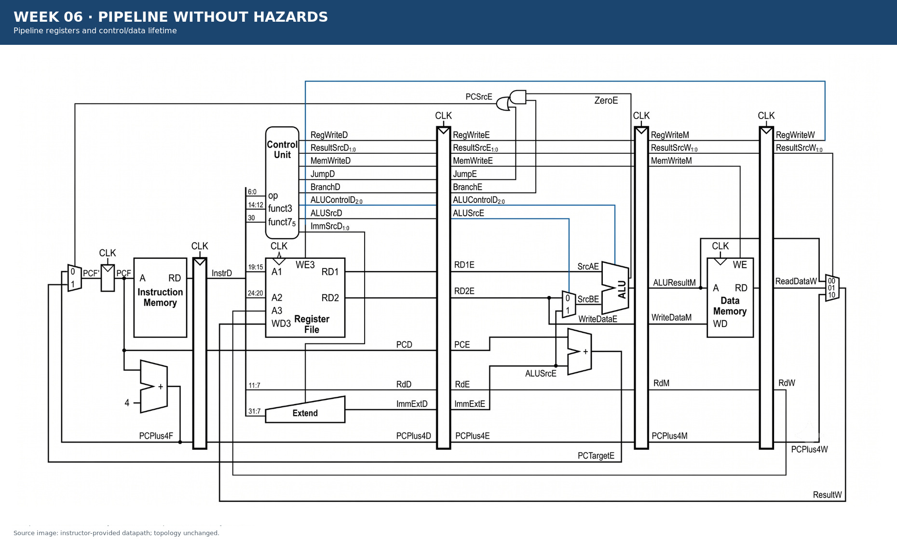
Figure 6.1 · Datapath/module area used in Week 06.

3. Module contract
Module/block | Main inputs | Main outputs
if_id | PCF, InstrF, PCPlus4F, en, clear | PCD, InstrD, PCPlus4D
id_ex | control D + operands/ids/immediate | control E + data E
ex_mem | control E + ALU/store/rd/PC+4 | control M + data M
mem_wb | control M + ALU/read/rd/PC+4 | control W + data W
pipelined_core_nohaz | clk, reset_n | debug F/D/E/M/W

4. Mandatory common contract
Item | Convention
HDL language | Verilog-2001 (.v): wire/reg, always @(*), always @(posedge clk); do not use SystemVerilog syntax yet
Required ISA | RV32I subset: add, sub, and, or, slt, addi, lw, sw, beq
Extension | jal is enabled only when JumpE, ResultSrc=10, and the corresponding test is complete
Clock/reset | posedge clk; reset_n active-low; no gated clock, and do not use negedge to avoid a hazard
Address | PC increments by 4; instruction/data memory uses word addressing through addr[...:2]
Signal naming | Use F/D/E/M/W stage suffixes; state widths explicitly in the interface
Verification | Every test must determine PASS/FAIL automatically and include a timeout; submit a ModelSim/Questa waveform image after each experiment

5. Core code skeleton — Verilog-2001
assign PCTargetE = PCE + ImmExtE;
assign BranchTakenE = BranchE & ZeroE;
assign PCSrcE = BranchTakenE | JumpE;
// JumpE may be tied low for the 9-instruction baseline.

6. Lab procedure

Experiment 1: Pipeline-register contracts
Aim: Carry the correct data/control through the correct number of cycles.

Procedure
- Create the input/output table for each register.
- Implement reset/clear/enable priority.
- Unit-test hold and clear.

Checkpoints
- Do not omit Rd or ResultSrc.
- A control flush produces a no-side-effect state.
- All registers use posedge.

Submission evidence immediately after the experiment
Required item | Content to enter/attach | Suggested filename
RTL code | All modules/blocks for the experiment, using correct Verilog-2001. | exp_01_rtl.v
Testbench | Self-checking testbench with an oracle, error counter, and timeout. | tb_exp_01.v
Waveform | ModelSim/Questa image showing clock/reset, inputs, outputs, and the checking moment. | exp_01_waveform.png
Result log | Compile command, simulator, runtime, and TEST_PASS/TEST_FAIL. | exp_01_run.log

RTL code entry area
// EXPERIMENT 01 — STUDENT RTL CODE (Verilog-2001)
// Paste the student module code here or record the submitted filename.

Testbench entry area
// EXPERIMENT 01 — STUDENT TESTBENCH
// Paste the self-checking testbench code here or record the submitted filename.
Evidence insertion area: Paste the RTL code, testbench code, and waveform image in the designated locations when completing the report. If separate files are submitted, record the exact corresponding paths.

Experiment 2: Five-stage integration
Aim: Integrate the pipeline before adding forwarding/stall.

Procedure
- Connect IF/ID/EX/MEM/WB.
- Set forwarding=00, stall=0, flush=0.
- Trace one instruction through five stages.

Checkpoints
- Write-back is correct after the latency.
- Control and data belong to the same instruction.
- Do not use negedge to hide a race.

Submission evidence immediately after the experiment
Required item | Content to enter/attach | Suggested filename
RTL code | All modules/blocks for the experiment, using correct Verilog-2001. | exp_02_rtl.v
Testbench | Self-checking testbench with an oracle, error counter, and timeout. | tb_exp_02.v
Waveform | ModelSim/Questa image showing clock/reset, inputs, outputs, and the checking moment. | exp_02_waveform.png
Result log | Compile command, simulator, runtime, and TEST_PASS/TEST_FAIL. | exp_02_run.log

RTL code entry area
// EXPERIMENT 02 — STUDENT RTL CODE (Verilog-2001)
// Paste the student module code here or record the submitted filename.

Testbench entry area
// EXPERIMENT 02 — STUDENT TESTBENCH
// Paste the self-checking testbench code here or record the submitted filename.
Evidence insertion area: Paste the RTL code, testbench code, and waveform image in the designated locations when completing the report. If separate files are submitted, record the exact corresponding paths.

Experiment 3: NOP-scheduled regression
Aim: Confirm the basic pipeline core when hazards are eliminated by software.

Procedure
- Insert enough NOP spacing.
- Run ALU, memory, and branch separately.
- Compare the signature with single-cycle.

Checkpoints
- The independent program passes.
- The NOP-scheduled program passes.
- The program without NOPs may fail and the reason must be explained.

Submission evidence immediately after the experiment
Required item | Content to enter/attach | Suggested filename
RTL code | All modules/blocks for the experiment, using correct Verilog-2001. | exp_03_rtl.v
Testbench | Self-checking testbench with an oracle, error counter, and timeout. | tb_exp_03.v
Waveform | ModelSim/Questa image showing clock/reset, inputs, outputs, and the checking moment. | exp_03_waveform.png
Result log | Compile command, simulator, runtime, and TEST_PASS/TEST_FAIL. | exp_03_run.log

RTL code entry area
// EXPERIMENT 03 — STUDENT RTL CODE (Verilog-2001)
// Paste the student module code here or record the submitted filename.

Testbench entry area
// EXPERIMENT 03 — STUDENT TESTBENCH
// Paste the self-checking testbench code here or record the submitted filename.
Evidence insertion area: Paste the RTL code, testbench code, and waveform image in the designated locations when completing the report. If separate files are submitted, record the exact corresponding paths.

Experiment 4: Branch resolve at EX
Aim: Compute the target with a separate adder and redirect when the instruction is in E.

Procedure
- Carry PCE and ImmExtE into EX.
- Generate BranchTakenE and PCSrcE.
- Temporarily insert NOPs after a branch to avoid wrong-path side effects.

Checkpoints
- PCTargetE=PCE+ImmExtE.
- PCSrcE is asserted only for a branch in E.
- Do not use ALUResultE as the target unless the entire contract changes.

Submission evidence immediately after the experiment
Required item | Content to enter/attach | Suggested filename
RTL code | All modules/blocks for the experiment, using correct Verilog-2001. | exp_04_rtl.v
Testbench | Self-checking testbench with an oracle, error counter, and timeout. | tb_exp_04.v
Waveform | ModelSim/Questa image showing clock/reset, inputs, outputs, and the checking moment. | exp_04_waveform.png
Result log | Compile command, simulator, runtime, and TEST_PASS/TEST_FAIL. | exp_04_run.log

RTL code entry area
// EXPERIMENT 04 — STUDENT RTL CODE (Verilog-2001)
// Paste the student module code here or record the submitted filename.

Testbench entry area
// EXPERIMENT 04 — STUDENT TESTBENCH
// Paste the self-checking testbench code here or record the submitted filename.
Evidence insertion area: Paste the RTL code, testbench code, and waveform image in the designated locations when completing the report. If separate files are submitted, record the exact corresponding paths.

7. Standard simulation procedure
- Compile all sources from a clean directory; classify every warning.
- Run the new module unit test before the integration test.
- Run directed corner cases, followed by a regression with a timeout.
- Open the waveform only for a failing test or a required checkpoint.
- Save a log containing the test name, seed, ending cycle, and PASS/FAIL result.

8. Acceptance gate
- PASS — The four pipeline registers pass hold/clear tests.
- PASS — The NOP-scheduled baseline reaches the signature.
- PASS — Branch target/decision is located at EX.
- PASS — The waveform trace shows the same instruction through F/D/E/M/W.

9. Submission package
Required main report: DSD_Labxx_MSSV_HoVaTen.pdf
Export the completed student manual as this PDF. It must include the student information, RTL code, testbench code, and waveform evidence inserted in the designated sections after each experiment.
The submission package must contain:
- rtl/pipeline_nohaz/
- sim/pipeline_nohaz/
- pipeline_contract.xlsx or PDF
- trace_5_stage.pdf
- nop_schedule.S
- regression.log
Do not submit: db/, incremental_db/, output_files/, work/, temporary transcripts, large WLF files, backups, or solution references.

10. Weekly rubric
Item | Weight | Minimum condition
Functionally correct RTL | 40% | Public and hidden tests PASS; no timeout.
Verification | 25% | Self-checking, corner cases, and a reproducible log.
Architecture explanation | 20% | Correctly trace signal lifetime and control causes.
Interface engineering | 10% | Correct names, widths, polarity, and clock/reset contract.
Clean submission package | 5% | Contains no tool-generated output; the script runs from a clean folder.

11. Oral examination questions
- Which control signals must reach M/W?
- Why do NOPs isolate alignment errors?
- How many wrong-path instructions does a branch at EX create?

Reference
RISC-V Unprivileged ISA Specification, RV32I Base Integer Instruction Set: https://docs.riscv.org/reference/isa/unpriv/rv32.html

