LAB 07 · WEEK 07

HAZARD-AWARE PIPELINE AND FPGA CAPSTONE
  - M→E/W→E forwarding, load-use stall, branch flush, regression, and the final hardware demonstration.
180′  in-lab | 3–5h  pre/post lab | 4  experiments | 20%  course weight

Student information
Full name: __________________________________________ | Student ID: ______________________________
Course: Digital System Design (DSD) | Group/Class: __________________________
Submission date: __________________________________________ | Instructor: __________________________

Weekly outcome: Students remove NOPs with the Hazard Unit, apply correct forwarding priority, insert one load-use bubble, and flush wrong-path instructions when the branch resolves at EX.
HDL language: Use Verilog-2001 during the foundation stage: .v files, wire/reg, always @(*) and always @(posedge clk...). SystemVerilog is introduced only after students have mastered Verilog.

Evidence requirements after each experiment
Required: Immediately after each experiment, students must submit the RTL code, testbench, and one waveform screenshot captured from ModelSim or Questa. The screenshot must show the test name, time scale, clock/reset, stimulus signals, the output under test, and the PASS/FAIL line if printed by the testbench.
vlog -2001 rtl/*.v sim/tb_*.v
vsim work.tb_<experiment_name>
add wave -r /*
run -all
Capture procedure: After the signals are stable, select Zoom Full or the cycle range being graded, then use the ModelSim/Questa Capture/Export Image function. Insert the image in the waveform area immediately after the experiment; do not submit only a WLF file.

1. Pre-lab preparation
- The no-hazard pipeline passes Lab 06.
- Draw timelines for ALU RAW, load-use, and taken beq.
- Freeze F/D/E/M/W signal naming.

2. Architecture used
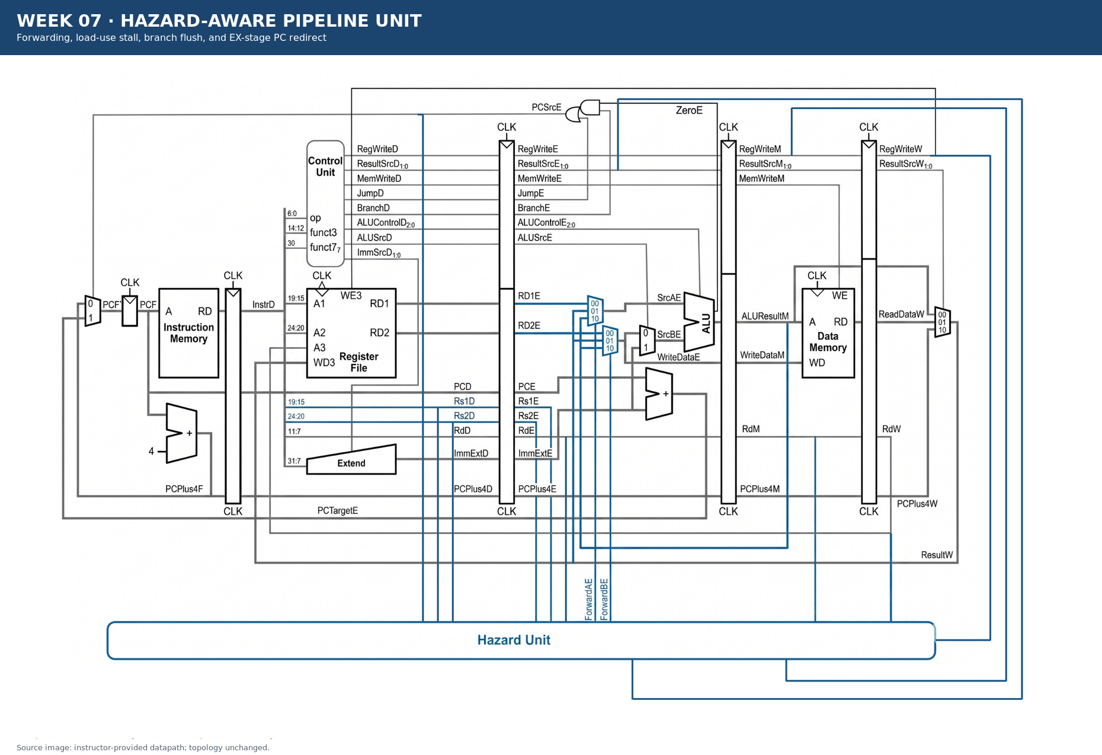
Figure 7.1 · Datapath/module area used in Week 07.

3. Module contract
Module/block | Main inputs | Main outputs
hazard_unit | Rs1D, Rs2D, Rs1E, Rs2E, RdE/M/W, RegWriteM/W, ResultSrcE[0], PCSrcE | ForwardAE/BE, StallF/D, FlushD/E
forward_muxes | RD1E/RD2E, ResultW, ALUResultM | SrcAE, WriteDataE
pipeline_core | clk, reset_n | signature + debug bus
fpga_wrapper | CLOCK_50, KEY, SW | LEDR/HEX/SignalTap

4. Mandatory common contract
Item | Convention
HDL language | Verilog-2001 (.v): wire/reg, always @(*), always @(posedge clk); do not use SystemVerilog syntax yet
Required ISA | RV32I subset: add, sub, and, or, slt, addi, lw, sw, beq
Extension | jal is enabled only when JumpE, ResultSrc=10, and the corresponding test is complete
Clock/reset | posedge clk; reset_n active-low; no gated clock, and do not use negedge to avoid a hazard
Address | PC increments by 4; instruction/data memory uses word addressing through addr[...:2]
Signal naming | Use F/D/E/M/W stage suffixes; state widths explicitly in the interface
Verification | Every test must determine PASS/FAIL automatically and include a timeout; submit a ModelSim/Questa waveform image after each experiment

5. Core code skeleton — Verilog-2001
wire lwStall;
assign lwStall = ResultSrcE[0] && (RdE != 5'd0) &&
((Rs1D == RdE) || (Rs2D == RdE));
assign StallF = lwStall;
assign StallD = lwStall;
assign FlushD = PCSrcE;
assign FlushE = lwStall | PCSrcE;
// M->E forwarding has priority over W->E.

6. Lab procedure

Experiment 1: EX forwarding
Aim: Resolve RAW hazards when the result is in M or W.

Procedure
- Compare Rs1E/Rs2E with RdM/RdW.
- Give M→E priority over W→E.
- Forward operand B before the ALUSrc mux so store data is correct.

Checkpoints
- Do not forward when Rd=0.
- Do not forward when RegWrite=0.
- A chain of three ALU dependencies needs no NOP.

Submission evidence immediately after the experiment
Required item | Content to enter/attach | Suggested filename
RTL code | All modules/blocks for the experiment, using correct Verilog-2001. | exp_01_rtl.v
Testbench | Self-checking testbench with an oracle, error counter, and timeout. | tb_exp_01.v
Waveform | ModelSim/Questa image showing clock/reset, inputs, outputs, and the checking moment. | exp_01_waveform.png
Result log | Compile command, simulator, runtime, and TEST_PASS/TEST_FAIL. | exp_01_run.log

RTL code entry area
// EXPERIMENT 01 — STUDENT RTL CODE (Verilog-2001)
// Paste the student module code here or record the submitted filename.

Testbench entry area
// EXPERIMENT 01 — STUDENT TESTBENCH
// Paste the self-checking testbench code here or record the submitted filename.
Evidence insertion area: Paste the RTL code, testbench code, and waveform image in the designated locations when completing the report. If separate files are submitted, record the exact corresponding paths.

Experiment 2: Load-use stall
Aim: Hold F/D and insert one bubble into E for exactly one cycle.

Procedure
- Create lwStall from ResultSrcE[0], RdE, Rs1D, and Rs2D.
- Connect StallF, StallD, and FlushE.
- Test lw→ALU and lw→store.

Checkpoints
- Exactly one bubble.
- No instruction is lost or duplicated.
- Add UseRs1D/UseRs2D after the baseline passes.

Submission evidence immediately after the experiment
Required item | Content to enter/attach | Suggested filename
RTL code | All modules/blocks for the experiment, using correct Verilog-2001. | exp_02_rtl.v
Testbench | Self-checking testbench with an oracle, error counter, and timeout. | tb_exp_02.v
Waveform | ModelSim/Questa image showing clock/reset, inputs, outputs, and the checking moment. | exp_02_waveform.png
Result log | Compile command, simulator, runtime, and TEST_PASS/TEST_FAIL. | exp_02_run.log

RTL code entry area
// EXPERIMENT 02 — STUDENT RTL CODE (Verilog-2001)
// Paste the student module code here or record the submitted filename.

Testbench entry area
// EXPERIMENT 02 — STUDENT TESTBENCH
// Paste the self-checking testbench code here or record the submitted filename.
Evidence insertion area: Paste the RTL code, testbench code, and waveform image in the designated locations when completing the report. If separate files are submitted, record the exact corresponding paths.

Experiment 3: Control hazard
Aim: Flush wrong-path instructions when the PC redirects at EX.

Procedure
- Connect PCSrcE to FlushD and FlushE.
- Test taken/not-taken/backward.
- Place a side-effecting instruction on the wrong path.

Checkpoints
- Wrong-path instructions do not write registers.
- Wrong-path instructions do not write memory.
- The PC changes to the correct PCTargetE.

Submission evidence immediately after the experiment
Required item | Content to enter/attach | Suggested filename
RTL code | All modules/blocks for the experiment, using correct Verilog-2001. | exp_03_rtl.v
Testbench | Self-checking testbench with an oracle, error counter, and timeout. | tb_exp_03.v
Waveform | ModelSim/Questa image showing clock/reset, inputs, outputs, and the checking moment. | exp_03_waveform.png
Result log | Compile command, simulator, runtime, and TEST_PASS/TEST_FAIL. | exp_03_run.log

RTL code entry area
// EXPERIMENT 03 — STUDENT RTL CODE (Verilog-2001)
// Paste the student module code here or record the submitted filename.

Testbench entry area
// EXPERIMENT 03 — STUDENT TESTBENCH
// Paste the self-checking testbench code here or record the submitted filename.
Evidence insertion area: Paste the RTL code, testbench code, and waveform image in the designated locations when completing the report. If separate files are submitted, record the exact corresponding paths.

Experiment 4: Capstone regression + FPGA
Aim: Freeze the contract and create reproducible evidence.

Procedure
- Run unit → integration → architectural regression.
- Compile for the correct device with the timing constraint.
- Demonstrate signature/PC/hazard state with LED/HEX or SignalTap.

Checkpoints
- No timeout.
- The signature matches the golden value.
- The clean package contains no db/output_files/work/WLF.

Submission evidence immediately after the experiment
Required item | Content to enter/attach | Suggested filename
RTL code | All modules/blocks for the experiment, using correct Verilog-2001. | exp_04_rtl.v
Testbench | Self-checking testbench with an oracle, error counter, and timeout. | tb_exp_04.v
Waveform | ModelSim/Questa image showing clock/reset, inputs, outputs, and the checking moment. | exp_04_waveform.png
Result log | Compile command, simulator, runtime, and TEST_PASS/TEST_FAIL. | exp_04_run.log

RTL code entry area
// EXPERIMENT 04 — STUDENT RTL CODE (Verilog-2001)
// Paste the student module code here or record the submitted filename.

Testbench entry area
// EXPERIMENT 04 — STUDENT TESTBENCH
// Paste the self-checking testbench code here or record the submitted filename.
Evidence insertion area: Paste the RTL code, testbench code, and waveform image in the designated locations when completing the report. If separate files are submitted, record the exact corresponding paths.

7. Standard simulation procedure
- Compile all sources from a clean directory; classify every warning.
- Run the new module unit test before the integration test.
- Run directed corner cases, followed by a regression with a timeout.
- Open the waveform only for a failing test or a required checkpoint.
- Save a log containing the test name, seed, ending cycle, and PASS/FAIL result.

8. Acceptance gate
- PASS — ALU RAW runs without NOPs.
- PASS — Load-use creates exactly one bubble.
- PASS — Taken branch flushes the correct wrong-path instructions.
- PASS — Regression runs from a clean directory and FPGA compile meets timing.

9. Submission package
Required main report: DSD_Labxx_MSSV_HoVaTen.pdf
Export the completed student manual as this PDF. It must include the student information, RTL code, testbench code, and waveform evidence inserted in the designated sections after each experiment.
The submission package must contain:
- rtl/pipeline_hazard/
- sim/unit+integration+regression/
- programs/
- constraints/
- logs/
- waveforms/
- fpga_evidence/
- final_report.pdf
Do not submit: db/, incremental_db/, output_files/, work/, temporary transcripts, large WLF files, backups, or solution references.

10. Weekly rubric
Item | Weight | Minimum condition
Functionally correct RTL | 40% | Public and hidden tests PASS; no timeout.
Verification | 25% | Self-checking, corner cases, and a reproducible log.
Architecture explanation | 20% | Correctly trace signal lifetime and control causes.
Interface engineering | 10% | Correct names, widths, polarity, and clock/reset contract.
Clean submission package | 5% | Contains no tool-generated output; the script runs from a clean folder.

11. Oral examination questions
- When M and W both match, which source is selected?
- Why cannot load-use be resolved with the current forwarding alone?
- How does FlushE differ from StallD in effect?

Reference
RISC-V Unprivileged ISA Specification, RV32I Base Integer Instruction Set: https://docs.riscv.org/reference/isa/unpriv/rv32.html

