**Ebay Microservices Monolithic Project**

**Architecture Design Patterns**

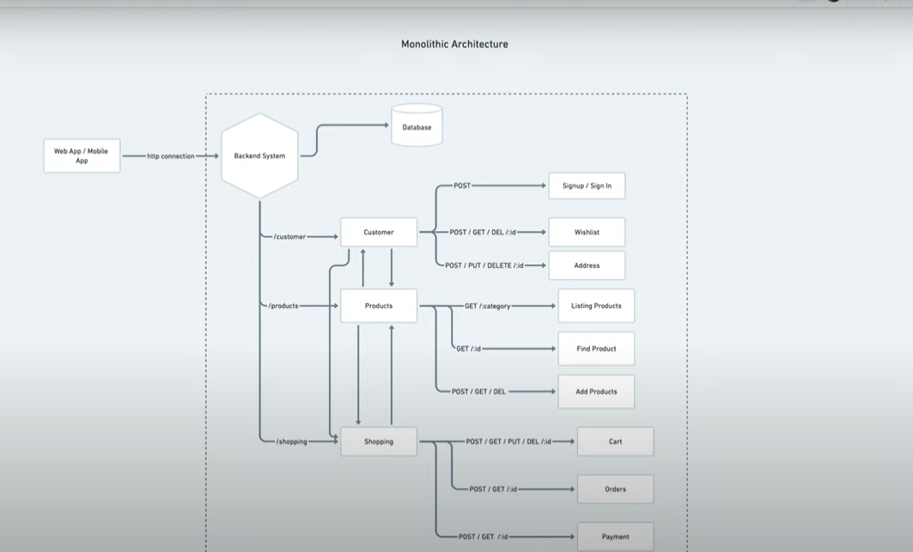

If you see this diagram they are tightly coupled like customer is depending on product and product is depending on customer

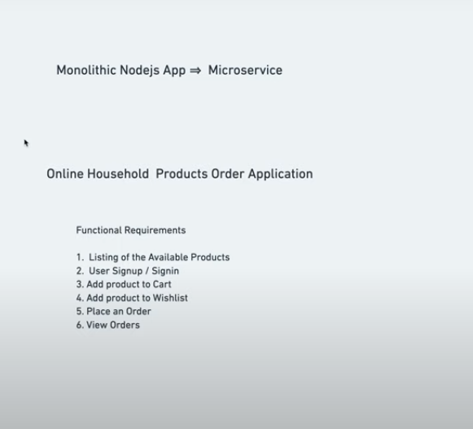

Now you see the microservices design pattern

**Architecture Design Pattern**

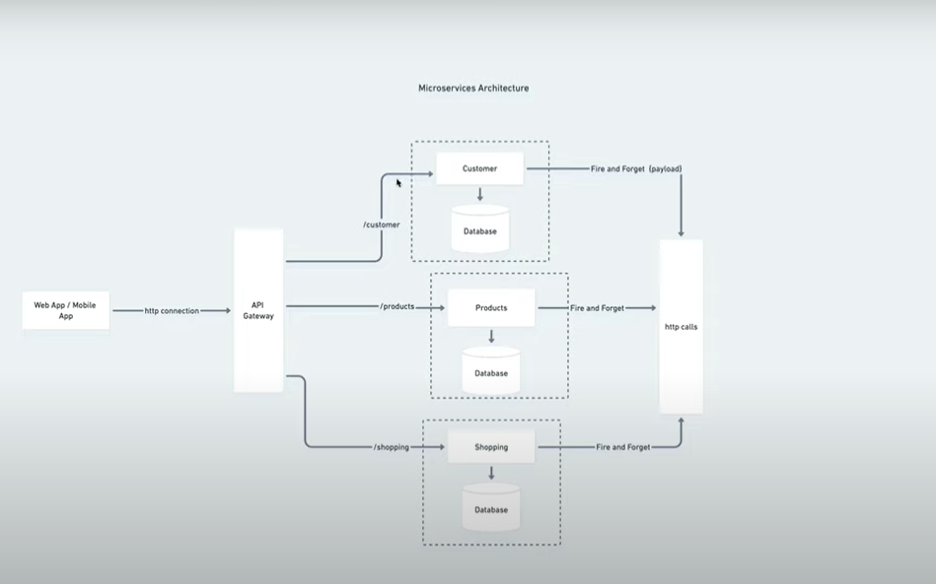

If you see this architecture they have there own database and memory management system also you see they are loosly coupled due to isolation in nature secondly microservice is used cqrs pattern

**Common Design Pattern**

