Abstract

Table of contents
Abstract, abstract and table of contents are not listed in the table of contents, but should be included in the header. To do this, select the respective heading and choose the format template "Title".
List of figures III
List of tables IV
List of abbreviations V
List of symbols VI
1. Introduction 1
2. Basics 3
3. Examples 5
4. Chapter heading 9
4.1 Headline 2 9
4.1.1 Headline 3 9
4.1.2 Headline 3 9
4.2 Headline 2 9
5. Summary and conclusion 11
5.1 Summary 11
5.2 Conclusion and outlook 11
6. References 13
Appendix 15

Notes on the structure:
1. title page with matr. no.
2. abstract (or abstract if the paper is written in English)
3. abstract (or abridged version if the thesis is written in English)
4. table of contents (two pages from here on)
5. indexes (numbered in Roman numerals)
6. introduction (first page numbered with the Arabic numeral "1")
7. ...
8. bibliography
9. appendix (if necessary divided into appendix A and appendix B)

Page break:
Each new whole-numbered chapter on an odd page (Section breaks always start on an odd page (Word 2016: Page layout - Page breaks Section breaks "Odd page")).

List of figures
Figure 3.1: Tick, Trick and Track 6
Figure 3.2: This is the figure caption for Figure 3.2 when the text extends over more than one line 6

Note:
If there are not many figures and tables, the indexes can also be placed on one page.
In the case of figure and table captions, references should be used so that the index can be created automatically. When specifying a source, make sure that it is not included in the directory. The key combination: CTRL + ALT + ENTER can be used to separate the source from the figure or table caption.
The directories are to be designed variably. For example, if there are a large number of indices, a separate directory can be created for them.
The indentation must be adjusted so that the captions of figures or tables that are more than one line long in the index can be indented to a certain height: Styles > Caption: Right-click > Change... > Format > Paragraph > Special indent: Hanging (select appropriate spacing)

List of tables
Table 3.1: Table test 7

List of abbreviations
Abbreviation Explanation
EEG Erneuerbare-Energien-Gesetz

List of symbols
Greek symbols
Symbol Unit Description
ρ_{L} [kg/m³] Air density

Latin symbols
Symbol Unit Description
G [W/m²] Global radiation

Introduction
This is an example text. This is an example text (Klöpffer and Grahl, 2009). This is an example text. This is an example text. This is an example text. This is an example text. This is an example text. This is an example text. This is an example text. This is an example text. This is an example text. This is an example text.

Basics
This is a sample text. This is an example text. This is an example text. This is an example text. This is an example text. This is an example text. This is an example text. This is an example text. This is an example text. This is an example text. This is an example text. This is an example text. (Stadt Essen, 2019)

Examples

References (citations):
. (Stadt Essen, 2019) Source refers to a section.
(Stadt Essen, 2019). Source refers to one sentence only
(Stadt Essen, 2019), (Klöpffer and Grahl, 2009) several sources are separated by a comma.

For sources with one to two authors, all authors are named in the associated citations; for two authors, they are separated by "and". If there are more than two authors, only the first author is mentioned and the remaining authors are summarised with "et al.”

Equations:
According to Einstein:
 | $E=m ∙ c^{2},$ | (3.1)
where $E$ is the energy, $m$ the mass and $c$ the speed of light. According to equation (3.1), the energy is $E$:
 | $$E=1000 J.$$ | (3.2)

Figure with caption with one line:
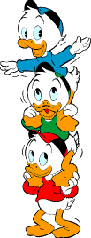
Figure 3.1: Tick, Trick and Track
(Lustiges Taschenbuch, 2019)

Illustration with inscription with two lines:
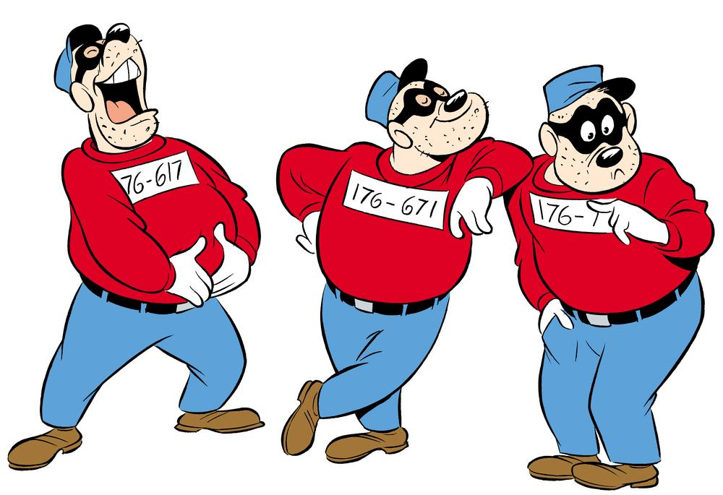
Figure 3.2: This is the figure caption for Figure 3.2 when the text extends over more than one line
(Kalle Anka & Co, 2018)

Remark:
The caption must not be separated from the image. To do this, select the image and choose "Do not separate from next paragraph" under: Paragraph Line and Page Break select "Do not separate from next paragraph".

Tables:

Table 3.1: Table test
Column 1 | Column 2 | Column 3
Entry 1 | Entry 2 | Entry 3
Entry 4 | Entry 5 | Entry 6

The spacing before and after tables, figures and equations as well as their labelling must be chosen consistently and sensibly. In case of ambiguities, consult your supervisor!

Chapter heading
Text

Headline 2
Text

Headline 3
Text

Headline 3
Text

Headline 2

Summary and conclusion

Summary

Conclusion and outlook

References
Kalle Anka & Co (2018): Quiz: Det här visste du inte om Björnligan! Schwedisch. Hrsg. von Bergström, A. url: https://www.kalleanka.se/tag/quiz/page/3/ (Retrieved: 19.06.2019).
Klöpffer, W. & Grahl, B. (2009): Ökobilanz (LCA): Ein Leitfaden für Ausbildung und Beruf. Weinheim: John Wiley & Sons. isbn: 978-3-527-32043-1.
Maier, S. (Hrsg.) (2019): Tick, Trick und Track. S. Egmont Ehapa Media GmbH. url: https://www.lustiges-taschenbuch.de/entenhausen/charaktere/die-ducks/tick-trick-und-track (Retrieved: 19.06.2019).
Stadt Essen (Hrsg.) (2019): Bevölkerungsbewegung. url: https://www.essen.de/
rathaus/statistik/Statistik_Bevoelkerung.de.html (Retrieved: 21.06.2019).

Remark:
Break hyperlinks with a manual line break (Shift + Enter) to preserve the formatting of the references and the format of the hyperlink.

Appendix

This is an example text. This is an example text. This is an example text. This is an example text. This is an example text. This is an example text.

