

**About arc42**

arc42, the Template for documentation of software and system architecture.

By Dr. Gernot Starke, Dr. Peter Hruschka and contributors.

Template Revision: 7.0 EN (based on asciidoc), January 2017

© We acknowledge that this document uses material from the arc 42 architecture template, <http://www.arc42.de>. Created by Dr. Peter Hruschka & Dr. Gernot Starke

# Introduction and Goals

The Image Sharing App is made to revolutionize the way photography enthusiasts and professionals engage with visual content. This document outlines the core goals and scope of the app that focuses on delivering a unique image-sharing experience. With a commitment to advanced editing tools, customizable filters, and community building, the app aims to set new standards in the dynamic landscape of visual content platforms.

## Requirements Overview

The Image Sharing App aims to create a unique platform for editing, sharing, and discovering high-quality images with a global community. Picnify aims to enable both expression and community interaction.  
  
Key requirements:

* iOS / Android mobile app
* Integrated User Management
* Community Features
* Advanced picture editing & customized filters
* Picture sharing
* Subscription model

## Quality Goals

|  |  |  |
| --- | --- | --- |
| Priority | Quality | Motivation |
| 1 | Reliability / Stability | Implement robust backend to handle an increasing number of users, images, and interactions |
| 2 | Performance Efficiency | Fast load times despite high quality uploads |
| 3 | Operability / Usability | Seamless and responsive user experience across different devices and network conditions. |

## Stakeholders

|  |  |  |  |  |  |  |  |  |  |  |  |  |  |  |
| --- | --- | --- | --- | --- | --- | --- | --- | --- | --- | --- | --- | --- | --- | --- |
| |  |  | | --- | --- | | Role / Name | Expectations | | User (photography enthusiasts) | Dynamic storytelling with high quality images and option to interact with family & friends | | Marketing Manager | Market a high quality picture sharing app that appeals to a wide &  diverse target audience | | Project Manager | Perform transparent risk management & quality assurance to  stay within budget constraints | | Lead Developer | Establish & maintain code quality standards &  cross platform integration | | UX / UI Designer | Focus on visually consistent but also user-centered and  accessible design | |  |  |

# Architecture Constraints

|  |  |  |
| --- | --- | --- |
| Type | Constraints | Background and / or motivation n |
| Technical | The app must be implemented in Flutter | Facilitate a consistent development approach |
| Technical | Third party software/filters must be open-source & installable via a package manager | External dependencies should be available via package manager/installer |
| Operating system | Mobile OS independent development | Application should run on both iOs and Android to reach a wide audience |
| Security | Robust security measures (Compliance with Privacy Regulations) | Protect user data, including images and personal information |

## Business Context

## Ein Bild, das Text, Diagramm, Reihe, Plan enthält. Automatisch generierte Beschreibung

# Solution Strategy

|  |  |
| --- | --- |
| Goal/Requirements | Architectural Approach |
| Reliability / Stability | Microservices |
| Performance Efficiency | Content Delivery Network (CDN) |
| Operability / Usability | Single Page Application architecture |
| Cross-platform | Flutter |

# Building Block View

## Level 1

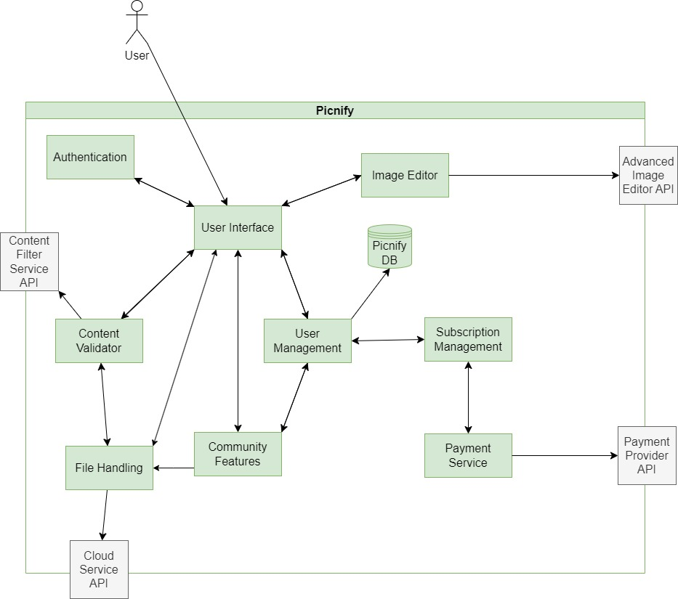

|  |  |
| --- | --- |
| Component | Responsibility |
| User Interface | UI and UX for Picnify. |
| File Handling | Service for handling and packing images and other content files. |
| Content Validator | First-level filter of harmful or undesired images and text. |
| Authentication | Service for user authentication and authorization |
| Community Features | Service for handling community features such as commenting, liking and posting. |
| User Management | Service for features regarding user management, including user-to-user (friend requests, tagging) and admin-to-user interactions (blocking, unblocking, editing user data) |
| Image Editor | Service for first level image editor. |
| Subscription Management | Service for user subscription features. |
| Payment Service | Service and adapter for payment services and providers |
| Content Filter Service API | API(s) of external content filter service. |
| Cloud Service API | API(s) of external cloud storage provider. |
| Payment Provider API | API(s) of external payment providers. |
| Advanced Image Editor API | API(s) of external image editor. |

# Runtime View

## Create Post

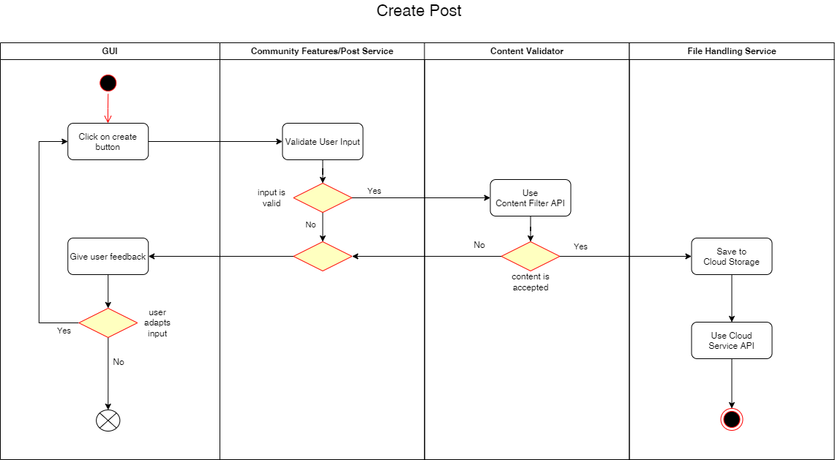

## Edit Image

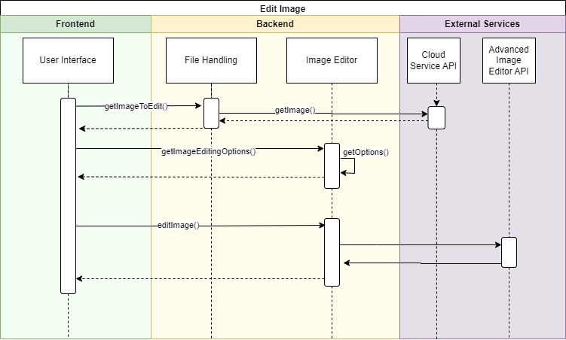

## Deployment View

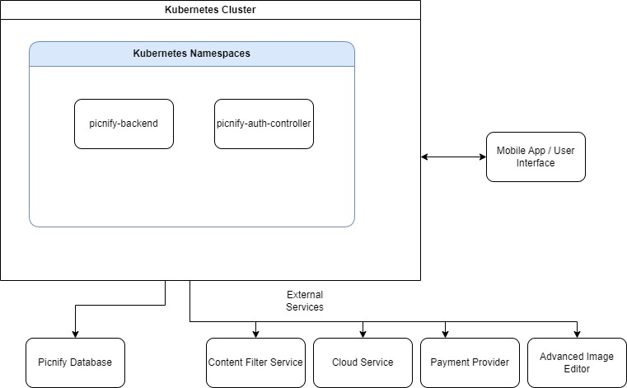

# Crosscutting Concepts

Development concepts

* Continuous integration and continuous deployment (CI/CD) for rapid delivery of features.
* Automated tests succeeding deployment to improve quality assurance.

Architecture and design patterns

* Usage of Microservices offers a modular design approach while being easy to scale based on demand. Moreover, if one microservice fails, it doesn’t affect the entire system since the services are widely decoupled.
* Usage of the “Saga” pattern for implementation of service-spanning business transactions.
* CAP-Theorem: Focus on availability and partition tolerance while accepting only eventual consistency will allow the system to be highly available to the customers.
* Separation of concerns: Do not implement business logic within the presentation layer or the data source (--> MVC pattern)! This enables exchangeability and therefore increases future flexibility by avoiding getting stuck to a certain technology or vendor.

Safety and security concepts

* Biometric Authentication via fingerprint recognition for identity verification.
* Data Encryption to protect sensitive data such as user credentials and images.

# Design Decisions

|  |  |  |  |
| --- | --- | --- | --- |
| Problem | Considered Alternatives | Decision | Date |
| Cross-platform development | Flutter, React + Swift | Flutter; avoid need of additional resources for development | Nov 2023 |
| Security issues | validation of uploads, encryption, access controls, rate limiting | validation of uploads using AI and upload limitations | Nov 2023 |
| Insufficient data storage | NoSQL databases, SQL databases | NoSQL databases to handle large-scale data | Nov 2023 |

# Quality Requirements

## Quality Tree

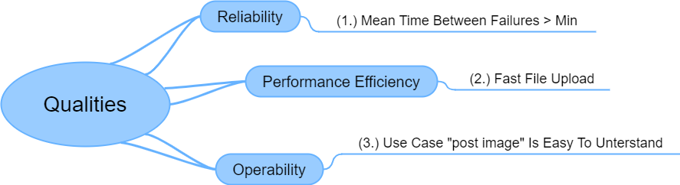

## Quality Scenarios

|  |  |  |
| --- | --- | --- |
| Quality Scenario | Description | Date |
| 1. The Mean time between failures is higher than acceptable minimum | The average error rate for a hundred million transactions processed per year is acceptable if lower than 0.00032 per second.  This leads to a minimum mean time elapsed between two reported failures of 52 minutes. For a detailed description of the calculation and assumptions see below. | Jan 2024 |
| 1. Usecase “post image” is easy to understand | A user can publish a self-made photograph in a post to share it with the community in less than 5 minutes. | Nov 2023 |
| 1. Fast file upload | The upload of an image with size of 20 MB at least with 10 Mbit/s upload speed (tested with speedtest.net by Ookla) does not take longer than 30 sec. | Nov 2023 |

Calculation of the mean time between failures (MTBF):

Assumptions:   
It seems to be acceptable to have 0.01% of the transactions failing within a year due to an error. For 100 million transactions per year this would result in 0.01 million errors within a time period of 31.536 million seconds (3600 s/h ⋅ 24 h/d ⋅ 365 d/y = 31 536 000 seconds per year).

  
**Note:** Errors are automatically reported to a monitoring server. Based on this data the error rate for an observed time period can be obtained.

The MTBF is given by the expectancy value of the time till an error occurs.   
For the probability density function f(t) at the time t of an error event the MTBF can be calculated with the following formula:  


Assuming an exponential distribution the density function is given by the following expression:

  
Therefore, the MTBF of the whole bulk of transactions can be easily determined as the inverse value of the error rate:

MTBF = 1/ (3.2 ⋅ 10-4 s-1) = 3 125 s ≈ 52 min

If the number of transactions is divided by a certain factor, then the MTBF will be multiplied by the same factor.

For 1 million transactions per year (divided by 100) this would result in a MTBF 100 times higher:  
   
MTBF = 3 125 s ⋅ 100 = 312 500 s ≈ 86,8 h

# Risks and Technical Debts

|  |  |
| --- | --- |
| Risk/Technical Debt | Description |
| dependency on external services | For both AI integration and use of filters for image editing we use external services – possible bottleneck when the future maintenance is unclear. |
| high costs for CDN servers | High costs & uncertainty for providing fast services all over the world |
| lack of qualified developers | Difficulty to find Flutter developers that cover both iOS and Android development |

# Glossary

|  |  |
| --- | --- |
| Term | Definition |
| *API*  *CAP-Theorem*  *CDN*  *Community Features*  *Flutter*    *Kubernetes Cluster*  *MTBF*    *MVC pattern* | *Application Programming Interface*  *The CAP-Theorem is about the interaction between* ***C****onsistency,* ***A****vailability and* ***P****artition Tolerance. It states that only two of those can be reached.*  *Content Delivery Network* is a geographically distributed network of proxy servers and their data centers. The goal is to provide high availability and performance by distributing the service spatially relative to end users.  *All kind of features which interact with other users like publishing posts, chat, comments and likes*  *Open-source UI software development toolkit, allowing developers to build natively compiled applications for mobile, web, and desktop from a single codebase.*  *A Kubernetes cluster is a set of interconnected computers (nodes) that work together to orchestrate containerized applications, providing scalability, resilience, and automation for deployment and maintenance.*  *Mean Time Between Failures* *Is a measure used for product quality. Usually this refers to a single device and describes the operation time between two failures.*  *Model View Controller – design pattern, architectural pattern* *This concept is motivated by the idea of separation of concerns and assures flexibility in future development* |
| *UI*  *GUI*  *UX* | *User Interface*  *Graphical User Interface*  *User Experience* |
|  |  |