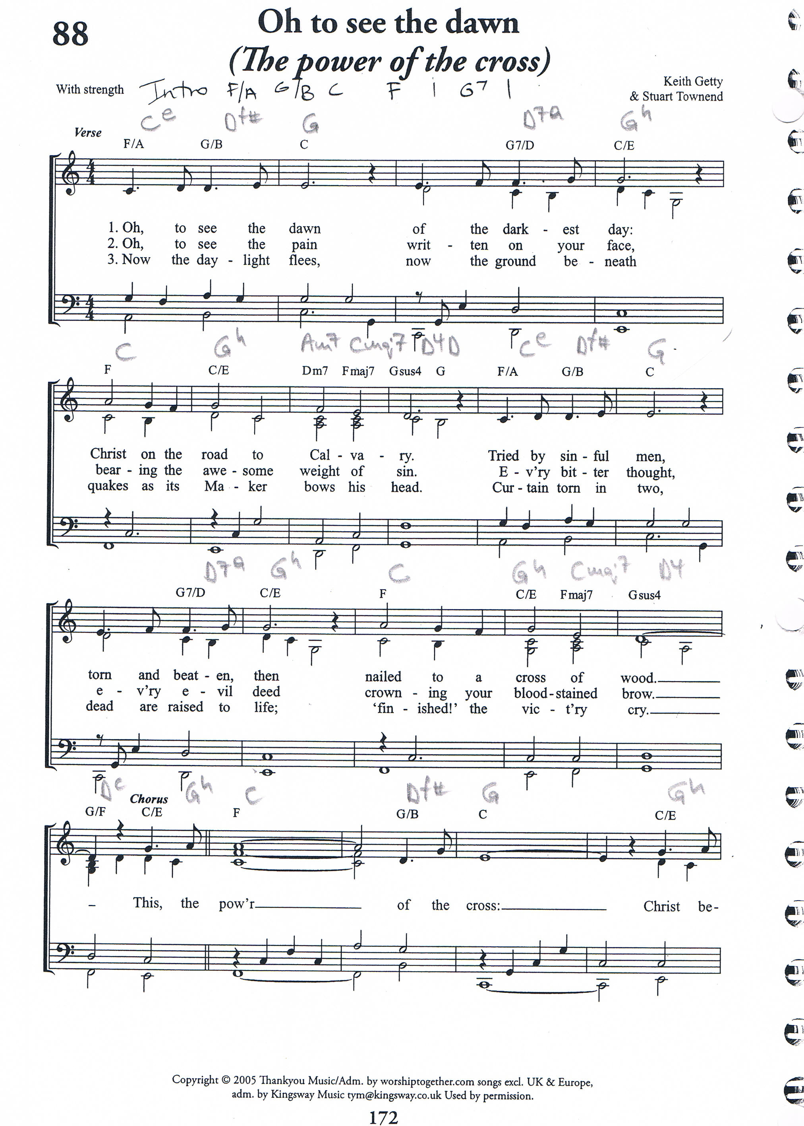
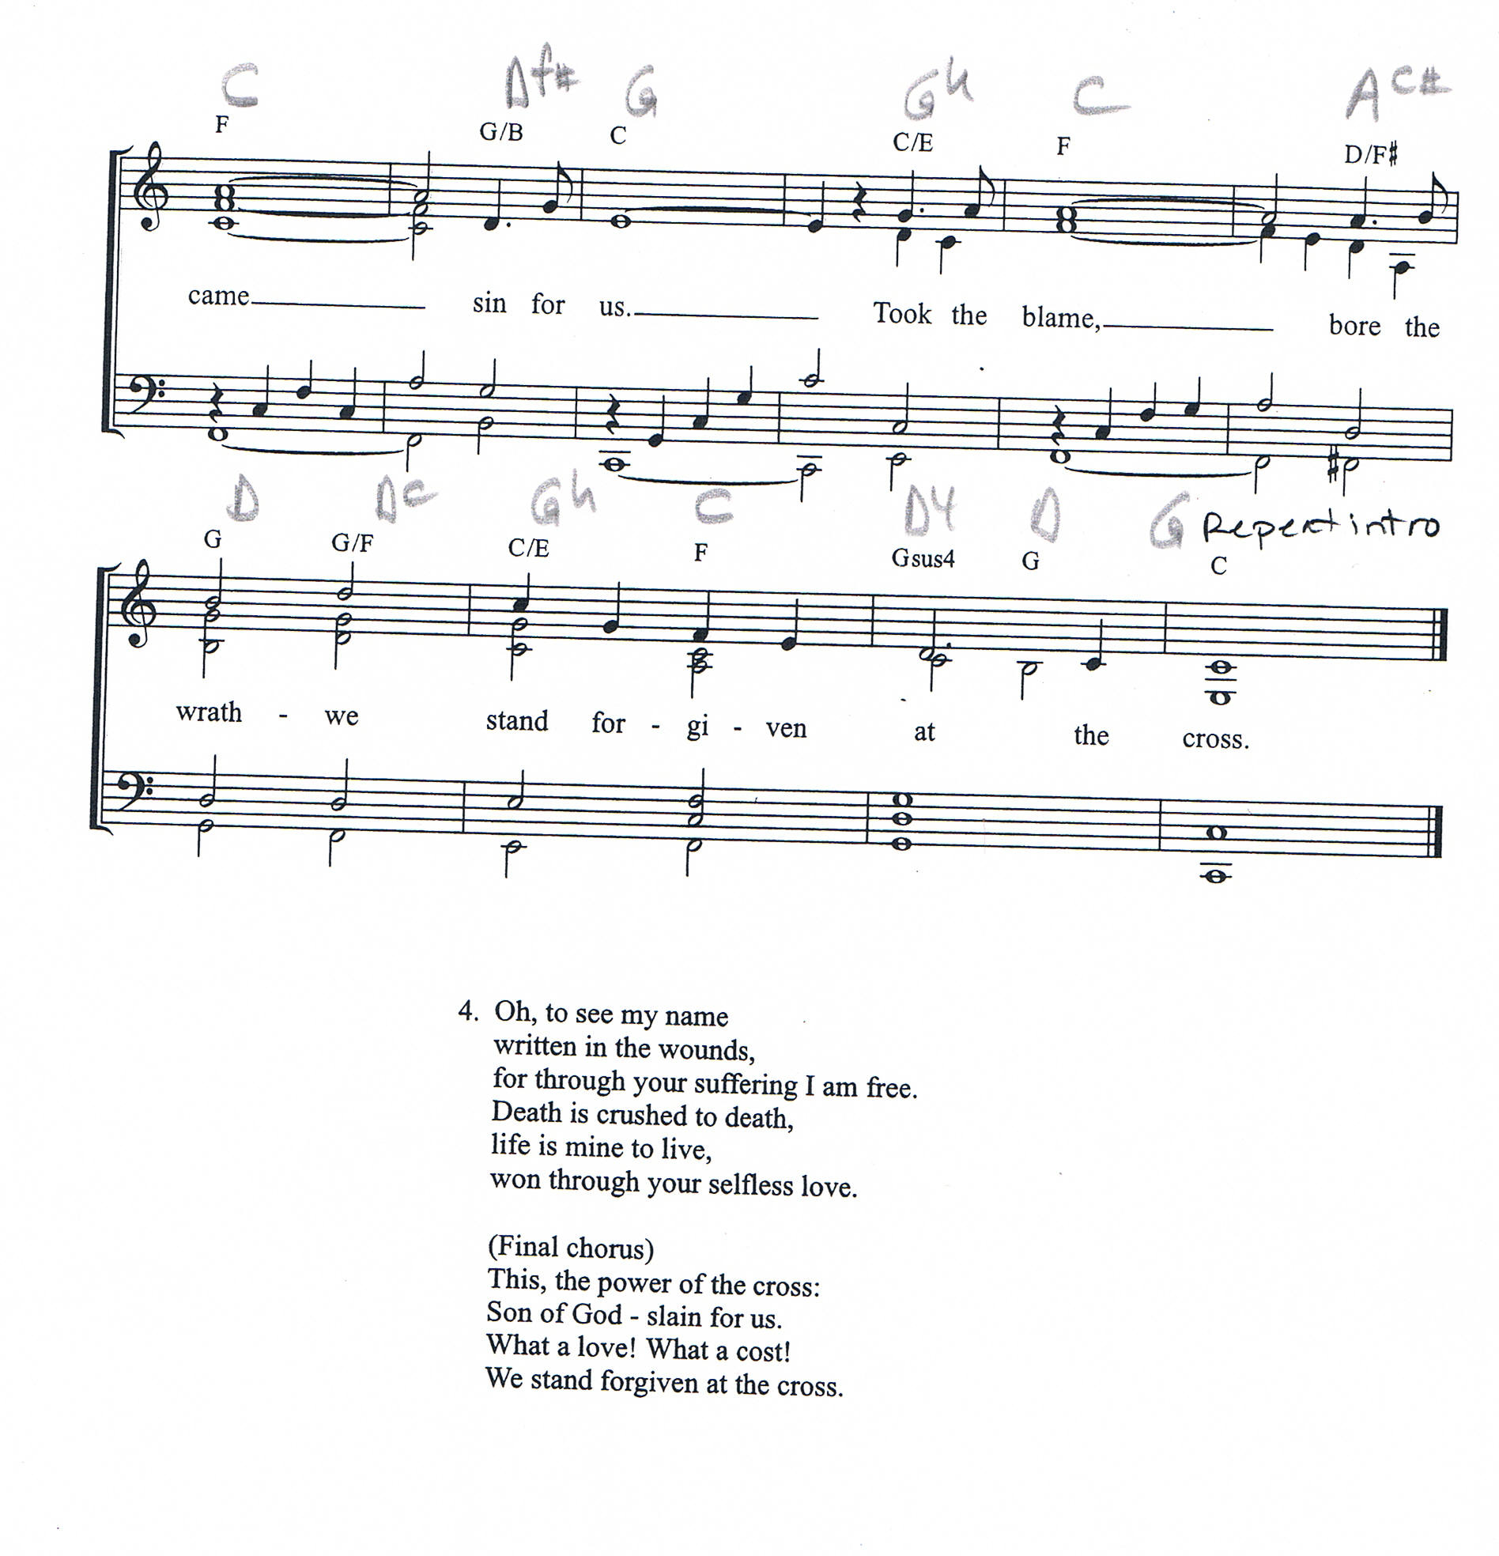
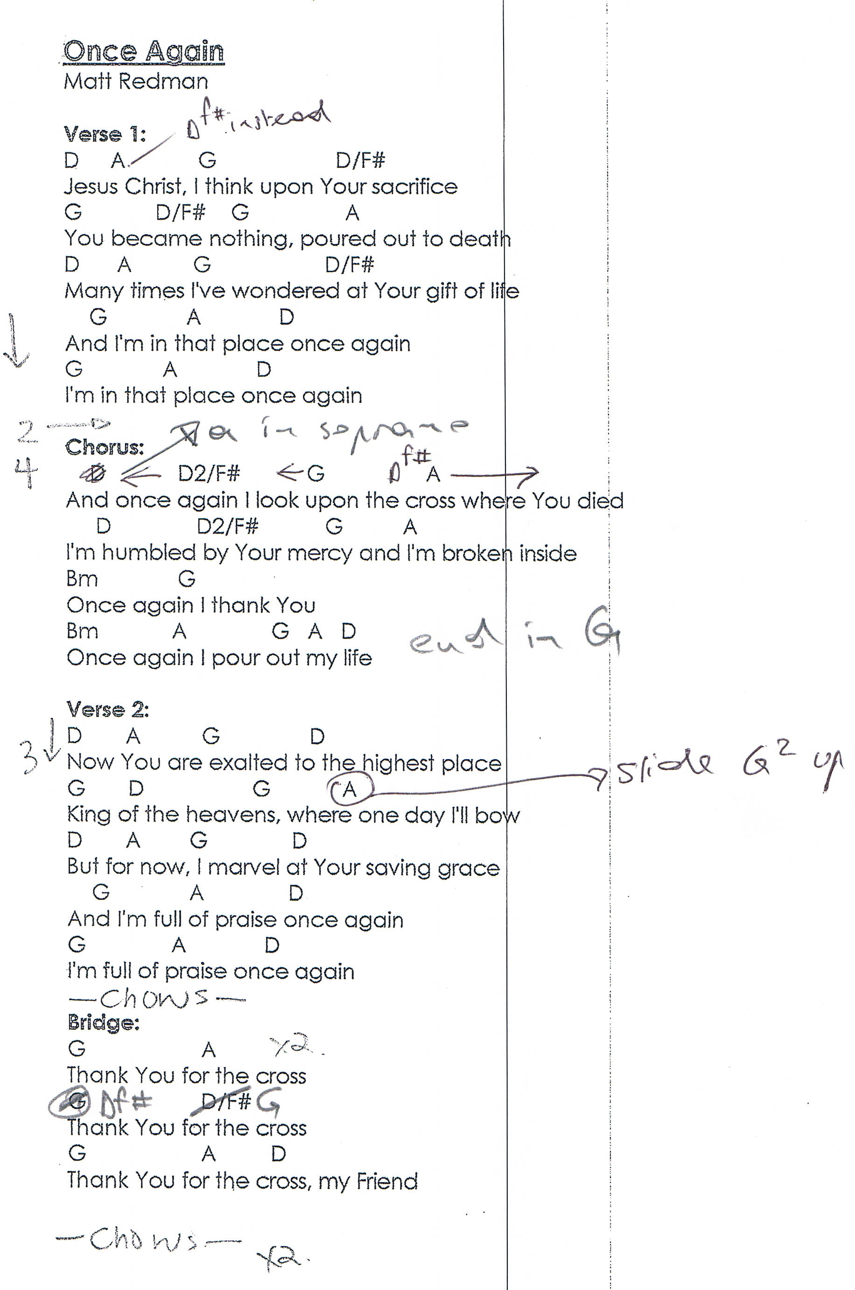
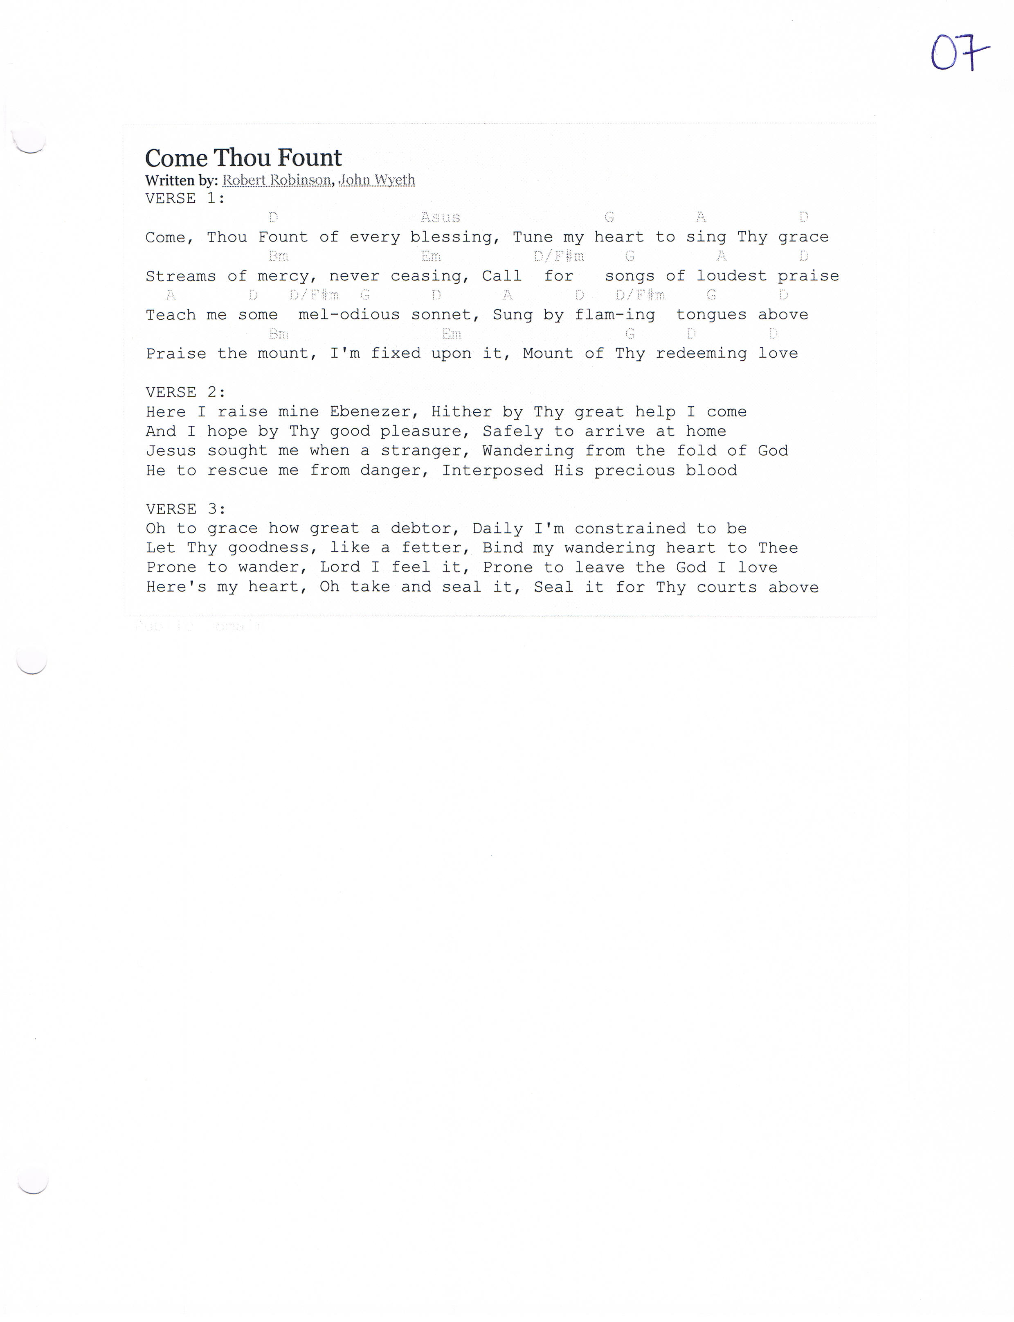
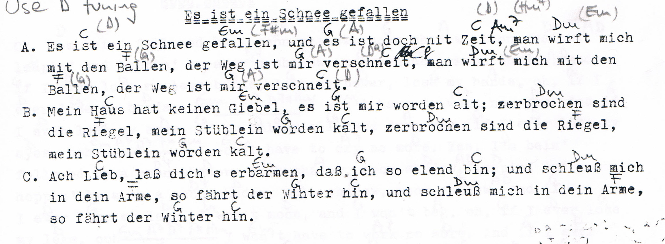
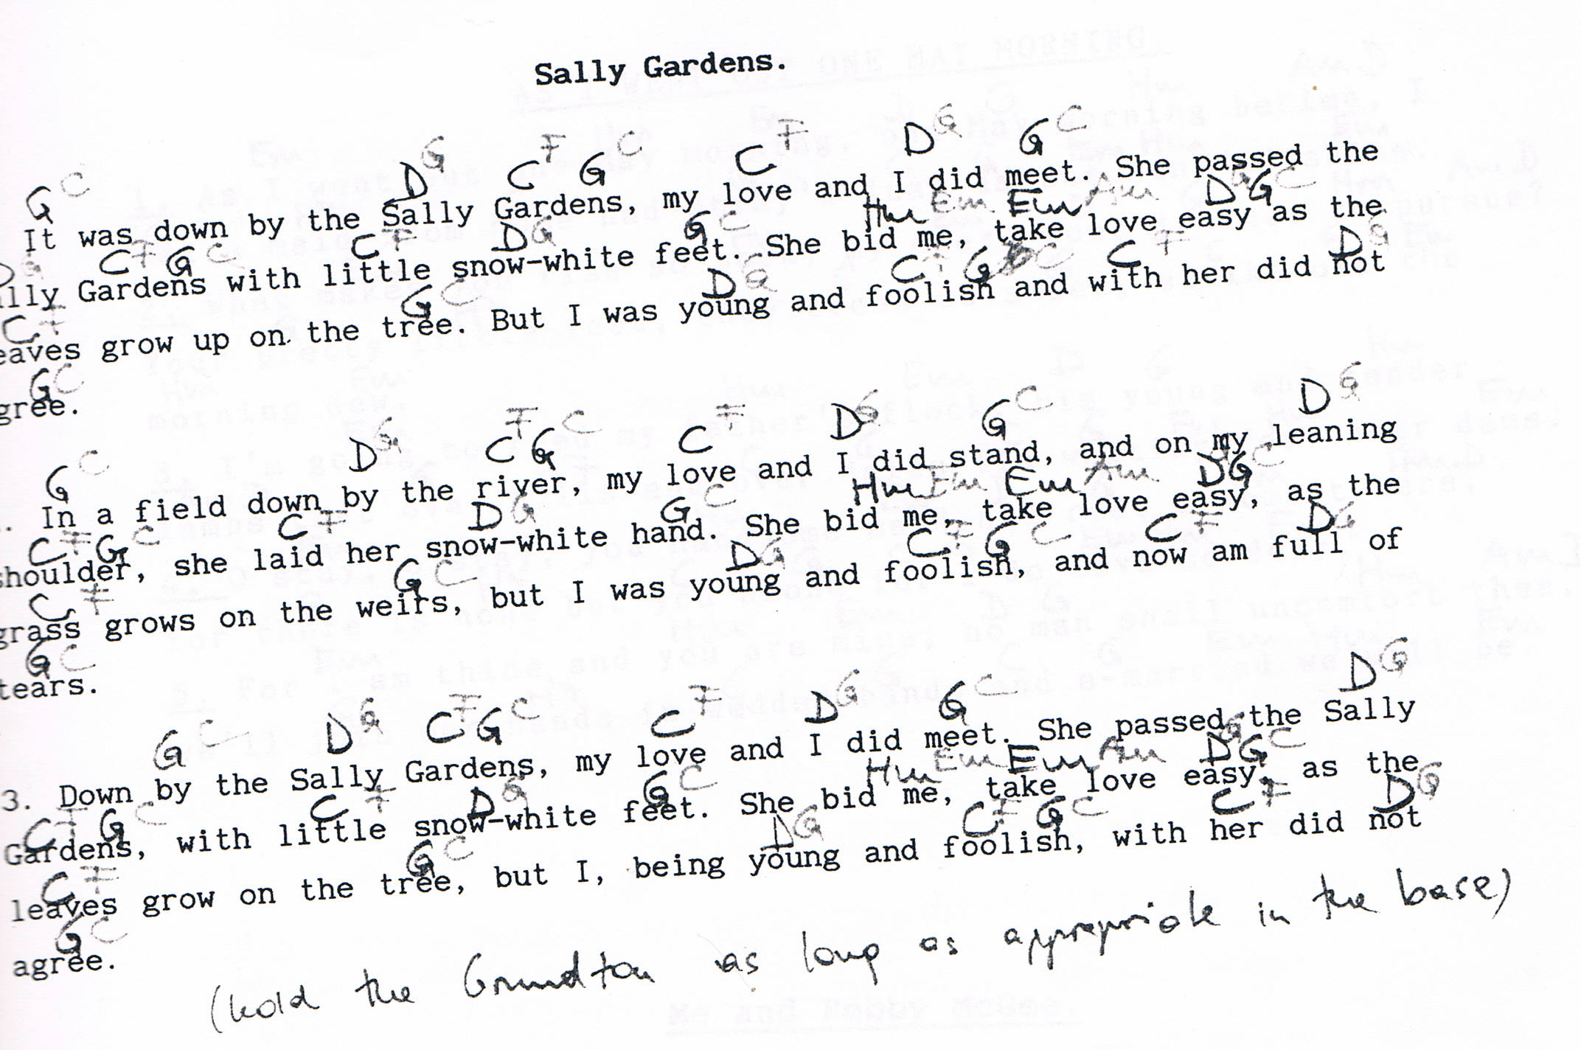
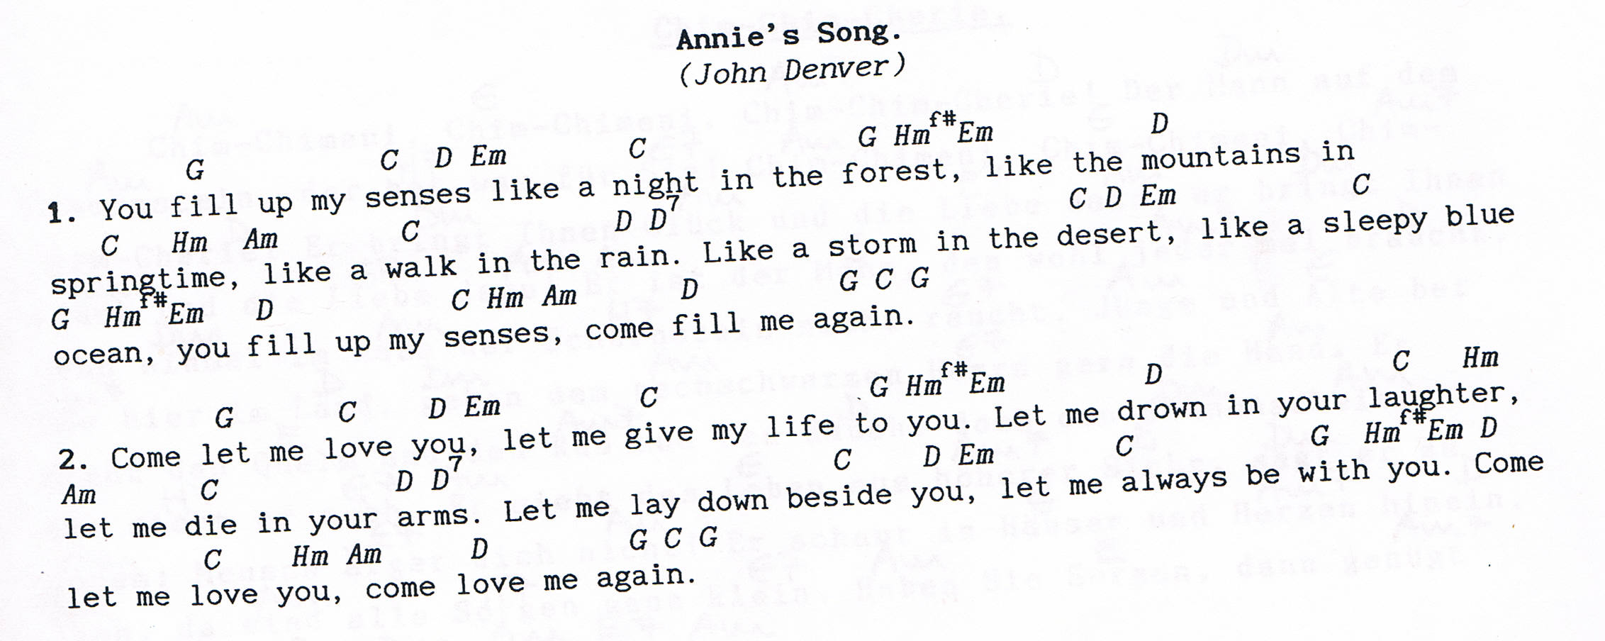
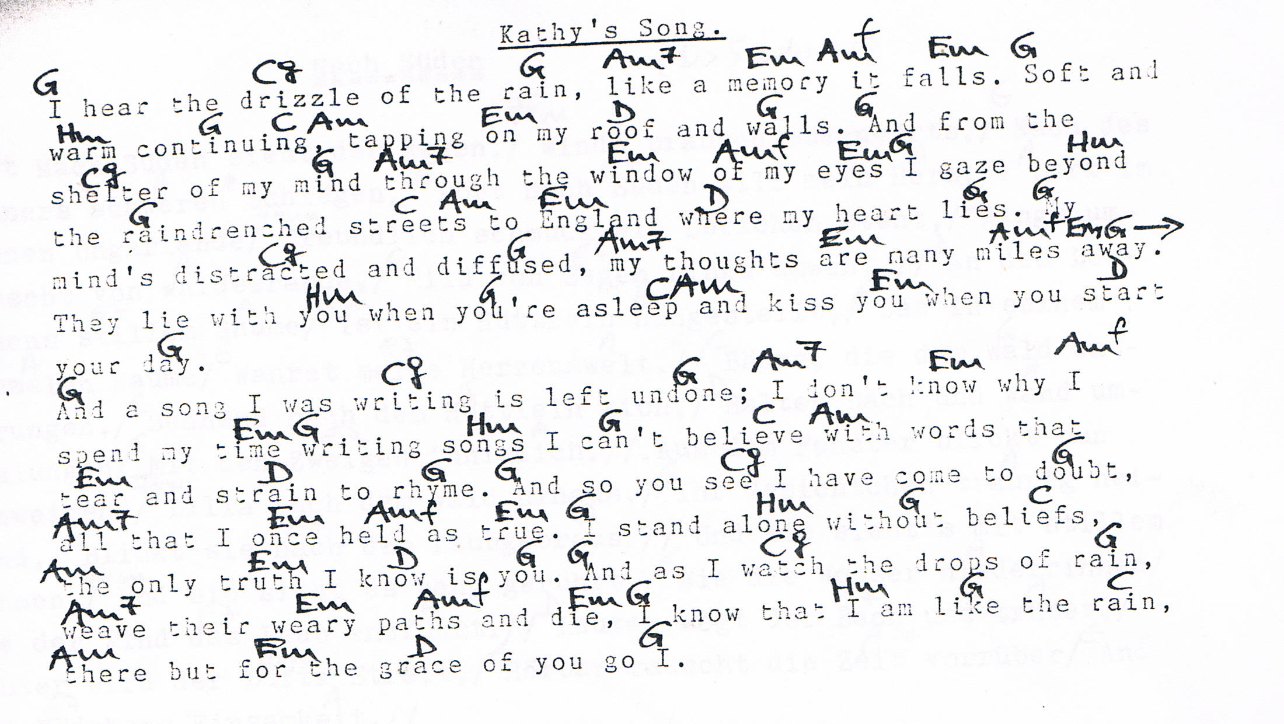

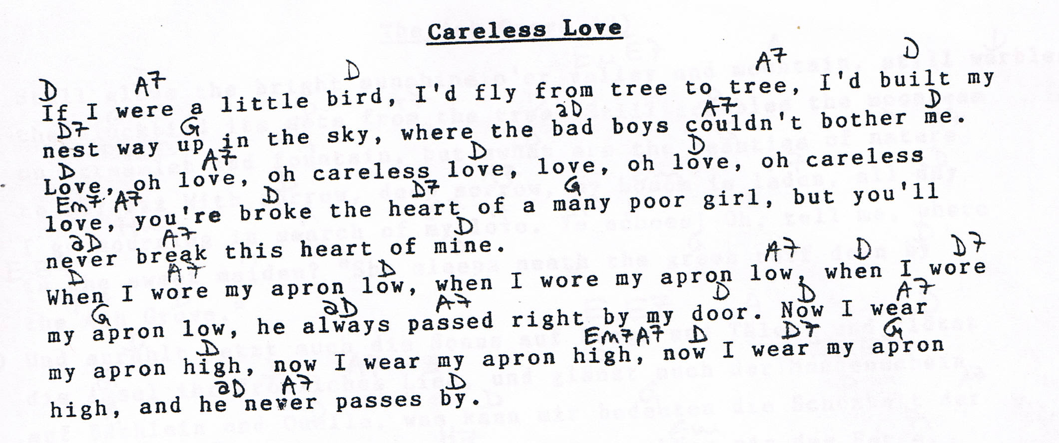

Winter Wind (by Patty Larkin)

D Bm
When the winter wind
A7 D
Blows cold upon my window
Bm A* A
And the mood I'm in is darker
D Em A7
Than the deep blue sea
[ Tab from: http://www.guitaretab.com/l/larkin-patty/10138.html ]
D Bm
I'm remembering
A7 D
Some time that we had long ago
E F
Scenes of you and me
G A7 D
Long before the winter wind

All along the lane
They've plowed a way for us to go
Through the ice and the snow
And the chill in the air

And if I should go
Far from the woodsmoke
Through the cold
Would you give me your warm hand to hold
In the winter wind

When the winter wind
Blows cold upon my window
Sun cuts like a diamond
Stringing crystals in the air

In the afterglow
My thoughts turn like the drifting snow
And find their way up to your door
In the winter wind

When the winter wind
Blows cold upon my window
And the mood I'm in is darker
Than the deep blue sea

I'm remembering
Some time that we had long ago
Scenes of you and medd
Long before the winter wind
--------------------------------------------------------------------|
-------------------3------------------------------------------------|
-------0---------0---0------------------------------3---------------|
-----4---4-0---4-------0------------2^4-2-0-------0-----------------|
---0---------2-----------2^4-2-0----------------5----------0^5------|
-0-------------------------------0----------0-5--------0^5------0---|
d

