**Instructions for the Android Accelerometer App**

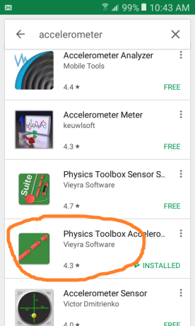

**Basic usage**

1. Download and install the app called “Physics Toolbox Accelerometer”.

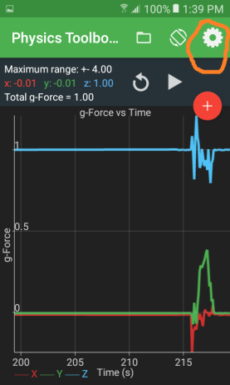

1. Tweak display settings
   1. Click on the settings icon.
   2. Uncheck “display g-force”. c. Scroll down to choose “thick line”.

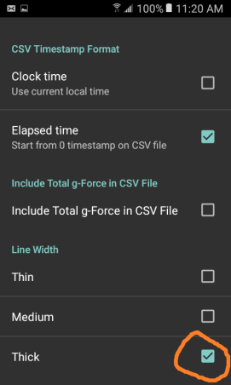

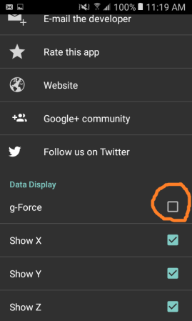

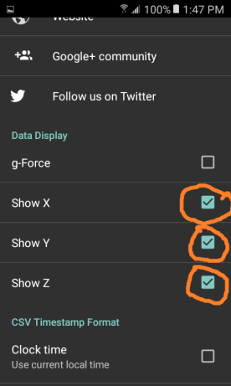

d. You can optionally choose which axes to display, depending on which experiment you are performing.

e. Choose “normal” for the sample rate.

f. You can switch between landscape and portrait mode, depending whether you prefer viewing the time axis ( landscape ) or the acceleration-values axis ( portrait mode) stretched out more. ( Both modes present 20 seconds of data at a time ).

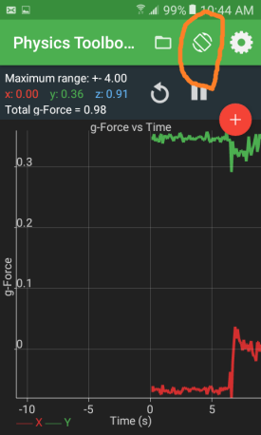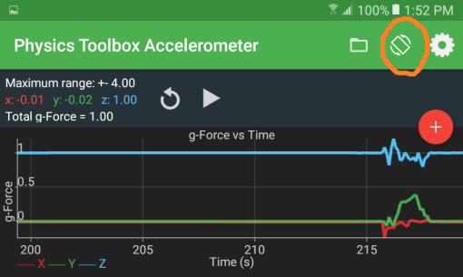

1. Live display of numerical values.

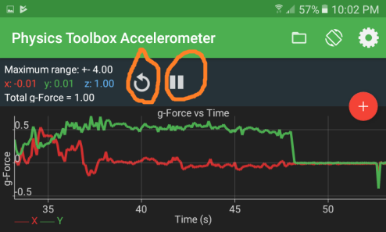The instantaneous values of acceleration for each axis are displayed in the upper left-hand corner. For static positions of your smartphone you can read off these values directly. For any other situations, use the record-to-file and analysis instructions that follow.

4. Stop-start and clear-display buttons.

The stop-start button only controls the on-screen display, not the save-to-file feature.

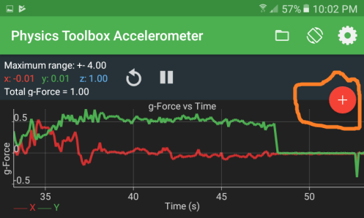

**Data analysis**

1. 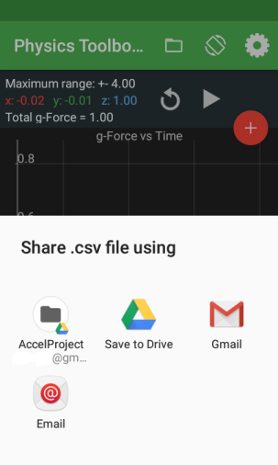The red button controls when the data starts to be recorded. If you clear the display just before initiating the data recording, then the display will be representing the data that is being recorded.

Once you end the recording, you can simply save the data to your phone’s hard disk. For further analysis, connect to a PC via USB or via your favorite sharing mechanism.

1. Initial data validation.
   1. 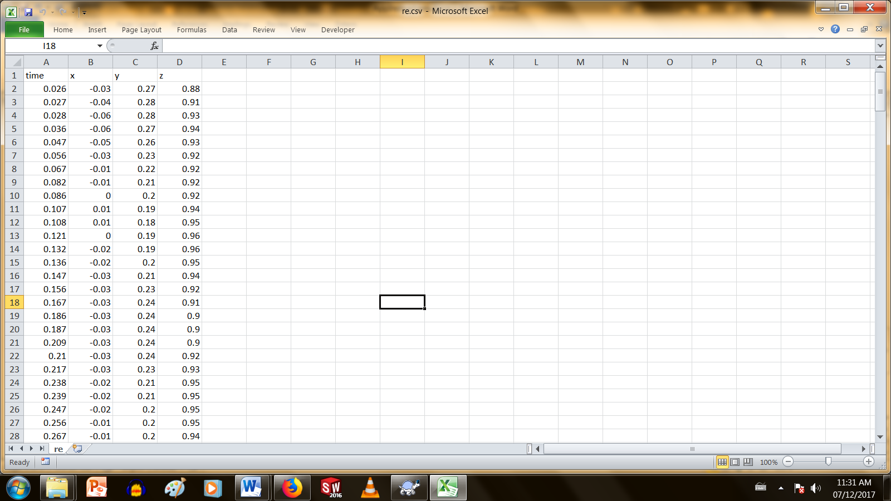Place your phone flat on a horizontal table top.
   2. Record-to-file for 1 second and then stop the recording.
   3. Save the file, transfer to your PC and open in Excel.
   4. The data should look something like as shown; x and y values close to zero, and z values close to 1.
   5. If you see weird looking number formats with semicolons in it, then close the file and follow the next section:

* If you used an email transfer, and the data appeared in the body of the message instead of as an attachment:

1. Select all the data, copy-paste into an empty text document ( via eg. Notepad )
2. Open the txt file from Excel

* If your data file fails to open correctly in Excel:

1. Open Excel without opening the .csv file itself.
2. Click on the tab **Data**, and choose ‘From Text’ in the banner.
3. Select your file ‘filename.csv’ and click **Import**.
4. Choose Delimited, then click **Next**.
5. Under the Delimeters heading, check the box Comma and click **Next**.
6. 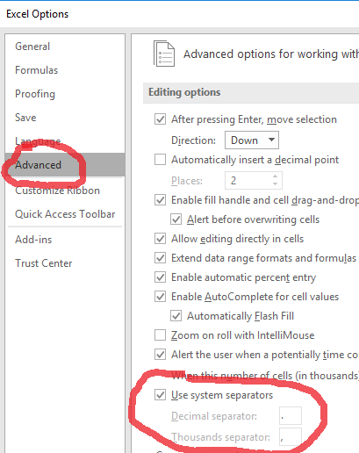and click **Finish**.

* If your phone is configured for French number format, but your PC uses English formats:
  1. Open File—> Options -->Advanced ; look under “editing options”
  2. Deselect “Use system seperators”.
  3. Change decimal separator to a comma, and thousands separator to *.
  4. File should now open correctly

3. Shortcut for plotting and finding average values.

* 1. As an example, open the sample data file AppData_Sample.csv
  2. Open AppData_StudentTemplate.xlsx
  3. Copy-paste the columns from AppData_Sample.csv into the template.
  4. The data will automatically be graphed
  5. Determine the average values of ax and ay when it plateaus (after 2.0 sec!)

To perform step **e.** - set the begin and end portions of the range for averaging. The average values for that range will be displayed

1. Other notes.
   1. The apps use units of “g”: An acceleration value of 1.0 means 9.8 m/s2 : Multiply all values ( the x, y, and z columns, not the time column! ) by 9.8 to get acceleration values in SI units.
   2. The first column is usually not time, but just an integer index. Divide these values by the sampling rate to get the actual time in seconds.