**Instructions for the iOS Accelerometer App**

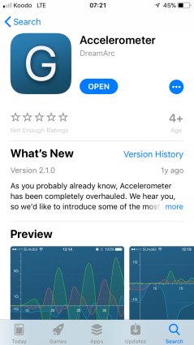

**Basic usage**

1. Download and install the app called “Accelerometer” by DreamArc:
2. Tweak the settings

a. Click on the settings icon: b. Make sure ‘**Remove gravity**’ is not selected:

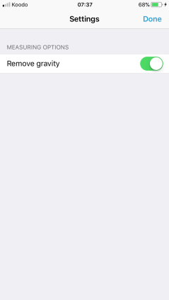

(IT SHOULD **NOT** SHOW GREEN!)

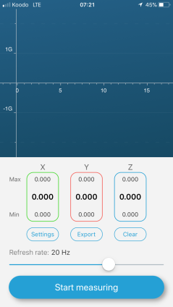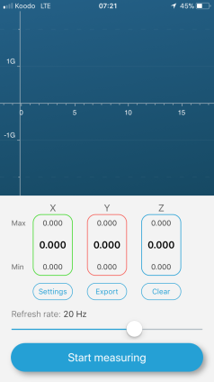

c. The sample rate can be modified by moving the slider:

For this exercise, select a sample rate of 3 Hz.

1. Live display of numerical values

The instantaneous values of acceleration for each axis are underneath the graph area. For static positions of your smartphone you can read off these values directly. For any other situations, use the record-to-file and data analysis instructions that follow.

1. Stop-start and clear-display buttons.

Select ‘**Start measuring**’ to begin recording data. To stop data collection, click ‘**Stop measuring**’.

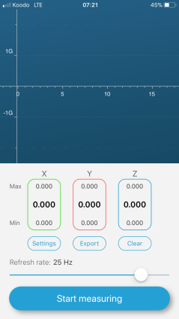 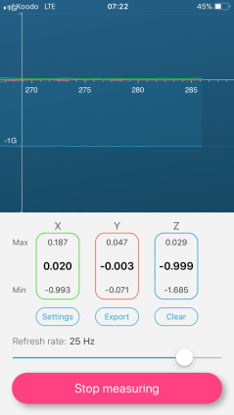

**Data analysis**

1. Once you end the recording, you can export the data (select **CSV** – comma separated values) for further analysis, using your favorite sharing mechanism:

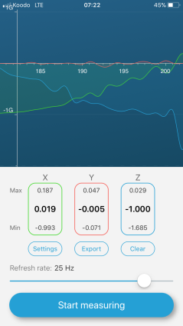 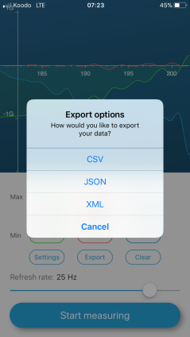 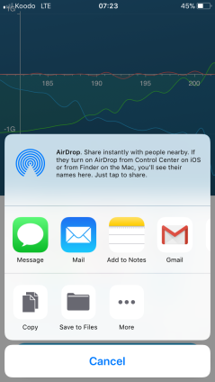

2. Initial data validation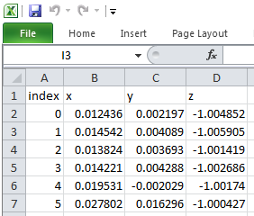

a. Place your phone flat on a horizontal table top.

b. Record for 1 or 2 seconds and then stop the recording.

c. Export the file to your PC and open in Excel.

d. The data should look something like as shown; x and y values close to zero, and z values close to -1.

* If you used an email transfer, and the data appeared in the body of the message instead of as an attachment:

1. Select all the data, copy-paste into an empty text document ( via eg. Notepad )
2. Open the txt file from Excel

* If your data file fails to open correctly in Excel:

1. Open Excel.
2. Click on the tab **Data**, and choose ‘From Text’ in the banner.
3. Select your file ‘filename.csv’ and click **Import**.
4. Choose Delimited, then click **Next**.
5. Under the Delimeters heading, check the box Semicolon and click **Next**.
6. Under the Column data format, choose General. Click **Finish**.
7. For phones in French number format, see further below.

* 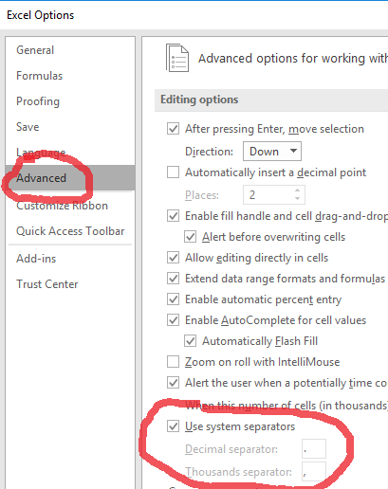If your phone is configured for **French number format**, but your PC uses English formats:
  + Open File—> Options -->Advanced ; look under “editing options”
  + Deselect “Use system seperators”.
  + Change decimal separator to a comma, and thousands separator to *.
  + File should now open correctly

3. “Student Template” : Shortcut for plotting and finding average values

1. As an example, open the sample data file AppData_Sample.csv
2. Open AppData_StudentTemplate.xlsx
3. Copy-paste the columns from AppData_Sample.csv into the template.
4. The data will automatically be graphed
5. Determine the average values of ax and ay for the data when it plateaus (after 2.0 sec!)
6. To perform step **e.** - set the begin and end portions of the range for averaging
7. The average values for that range will be displayed

Other notes:

1. The apps use units of “g”: An acceleration value of 1.0 means 9.8 m/s2 : Multiply all values ( the x, y, and z columns, not the time column! ) by 9.8 to get acceleration values in SI units.
2. The first column is usually not time, but just an integer index. Divide these values by the sampling rate to get the actual time in seconds.