Neural Networks (83695) — Final Project Report
Submitted by: Ziv Assoulin (ID 111111111), Student 2 (ID 222222222)

Part A — Spike-Train Analysis (neurodata.npy)
Data: injected stimulus current (pA) and the voltage responses (mV) of two neurons (spiny, aspiny), sampled at 50 kHz. The aspiny neuron is identified as the one with the higher firing rate.

Q1. Spiny and Aspiny Neurons
- Spiny neurons: have dendritic spines; typically excitatory (e.g. cortical pyramidal cells), use glutamate.
- Aspiny neurons: smooth dendrites, lacking spines; typically inhibitory interneurons (e.g. basket cells), use GABA, and often fire at higher rates.

Q2. Electrical Stimulus over Time
The stimulus is an injected current with two pulses: a short 50 pA calibration pulse (~10 ms, 0.005-0.015 s) used to estimate input resistance, followed by the main 150 pA, 1-second current step (1.02-2.02 s) that drives repetitive spiking. Current returns to 0 pA afterward.
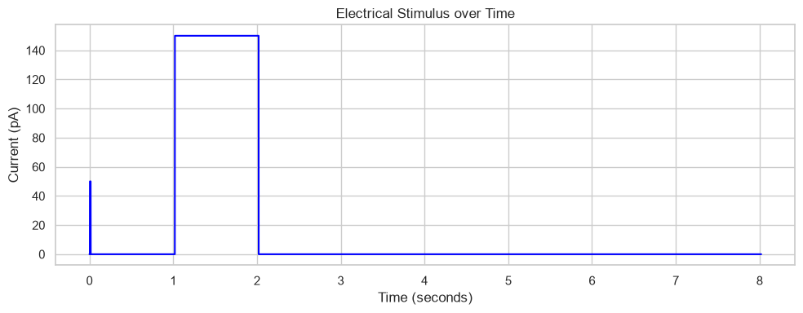
Figure A2. Injected stimulus current (pA) vs. time (s).

Q3. Electrical Activity of Spiny and Aspiny Neurons
Both neurons fire action potentials during the current step. The main difference is firing rate: the aspiny neuron fires much more frequently (91 spikes) than the spiny neuron (25 spikes) over the same 1-second step, consistent with the fast-spiking phenotype typical of many inhibitory interneurons.
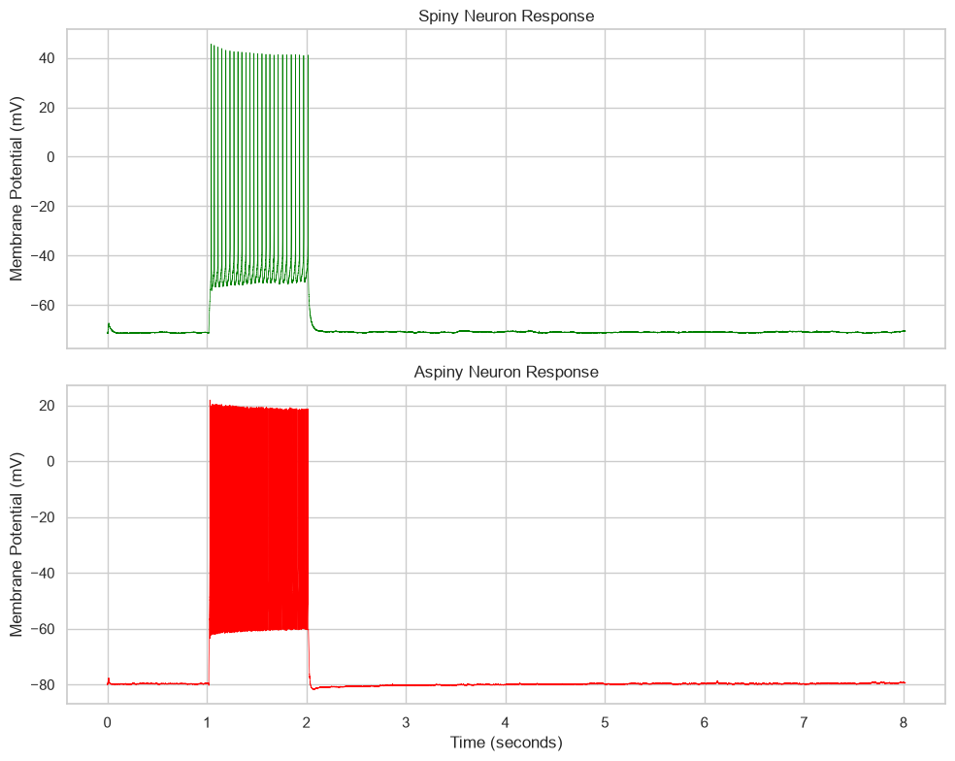
Figure A3. Membrane voltage (mV) vs. time (s) for the spiny and aspiny neurons.

Q4. Spike Trains and Action-Potential Threshold
Both neurons rest around -70 to -80 mV and their spikes peak well above 0 mV, so a threshold of -20 mV sits in an empty gap between the two. A sweep over thresholds from -50 to +4 mV confirms the detected spike count is exactly constant (25 for spiny, 91 for aspiny) across roughly -35 to +2 mV, so the exact value inside that range does not matter.
- Too low (e.g. -60 mV): falls inside the resting-potential noise band -> false positive spikes, inflated firing rate, corrupted ISI/CV statistics.
- Too high (e.g. +40 mV): exceeds some real spike peaks (aspiny peaks reach only ~22 mV) -> missed spikes, underestimated firing rate.
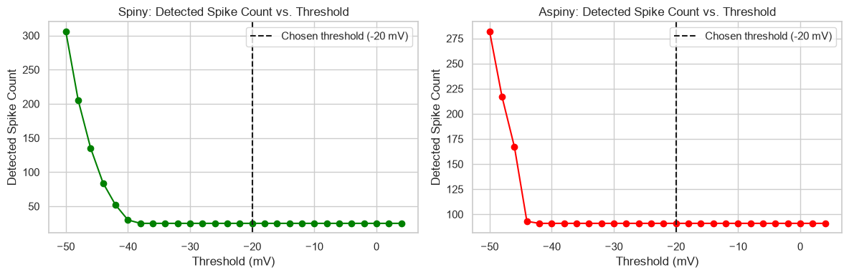
Figure A4a. Detected spike count vs. threshold sweep, confirming a stable plateau around the chosen -20 mV threshold.
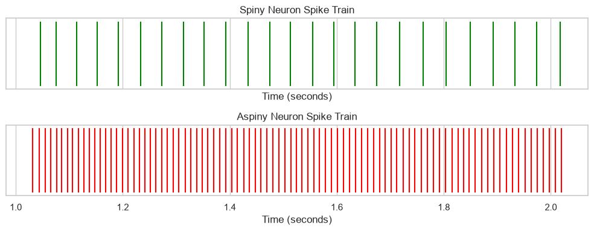
Figure A4b. Spike-train raster plots for the spiny and aspiny neurons.
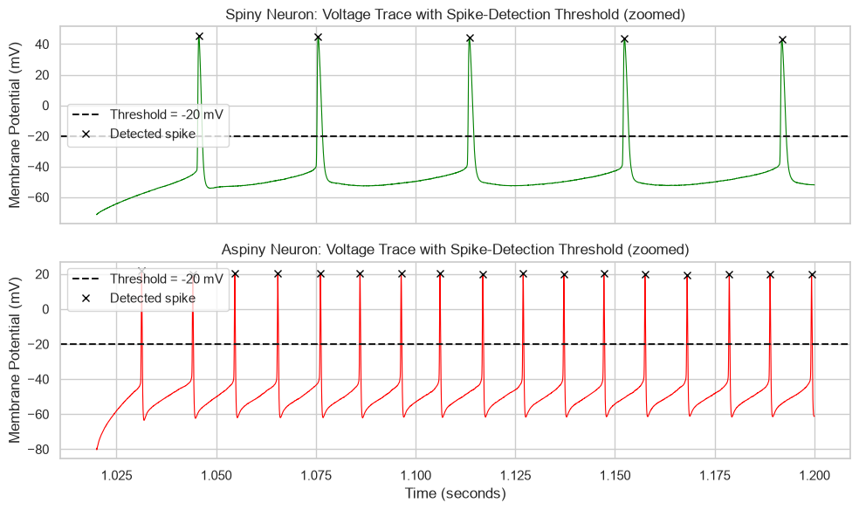
Figure A4c. Zoomed voltage trace with the -20 mV detection threshold and detected spikes marked.

Q5. Inter-Spike Intervals (ISI) and Coefficient of Variation (CV)
Neuron | CV | ISI range (ms) | n intervals | Firing pattern
Spiny | 0.070 | 29.9 – 44.8 | 24 | Pacemaker-like (CV ≪ 1)
Aspiny | 0.049 | 9.7 – 12.8 | 90 | Pacemaker-like (CV ≪ 1)

Both CVs are far below 1, so both neurons fire highly regularly during the stimulus (pacemaker-like, not Poisson). The aspiny neuron is even more regular despite firing ~4x faster. ISIs lengthen slightly and monotonically over the step -- spike-frequency adaptation -- which is the main source of the small variability captured by the CV.
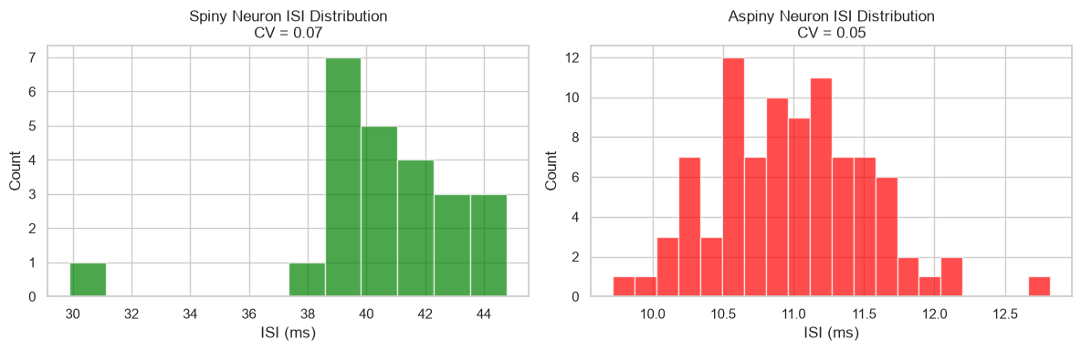
Figure A5. ISI distribution histograms (ms) for the spiny and aspiny neurons.

Q6. Time-Dependent Firing Rate
Two estimators are shown: a 50 ms-binned PSTH (spike count / bin width) and a Gaussian-kernel estimate (sigma = 50 ms). The kernel is continuous and insensitive to bin placement; sigma = 50 ms is short enough to resolve the onset/offset of the 1 s current step while long enough (relative to the 10-45 ms ISIs) to average over several spikes for a smooth estimate. Both methods agree closely, as expected given how regular (low-CV) the firing is.
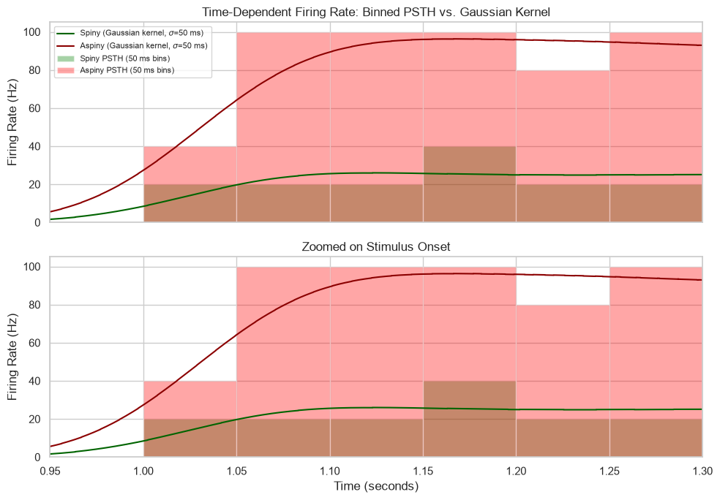
Figure A6. Time-dependent firing rate (Hz) vs. time (s): binned PSTH vs. Gaussian-kernel estimate.

Q7. Average Firing Rates and Probability Distributions
Average firing rate during the stimulus: spiny = 25.00 Hz, aspiny = 91.00 Hz. Gaussian distributions were built around these means with sigma_spiny = 15 Hz and sigma_aspiny = 20 Hz, chosen to give the two curves clear but partial overlap (about a third of the 66 Hz gap between the means).
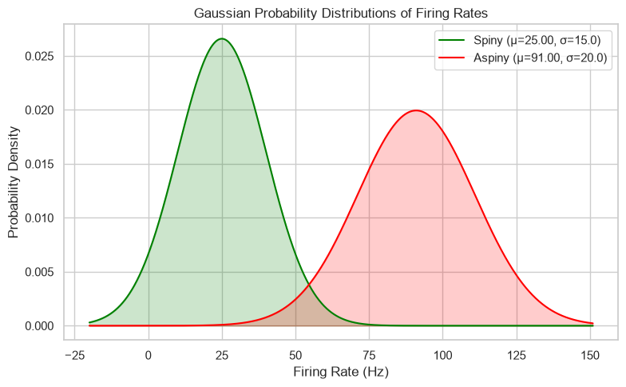
Figure A7. Gaussian probability distributions of firing rate (Hz) for spiny vs. aspiny neurons.

Q8. Neuron Classifier Based on Distributions
The classification threshold z = 54.59 Hz is chosen at the point where the two Gaussian pdfs cross (equal class-conditional density under equal priors), rather than the plain midpoint of the means. The classifier was evaluated on 1000 synthetic samples drawn from each Gaussian (2000 total).
Metric | Value
Accuracy | 0.974
Precision (Aspiny) | 0.976
Recall (Aspiny) | 0.972
Precision (Spiny) | 0.972
Recall (Spiny) | 0.976
F1 (Aspiny) | 0.974

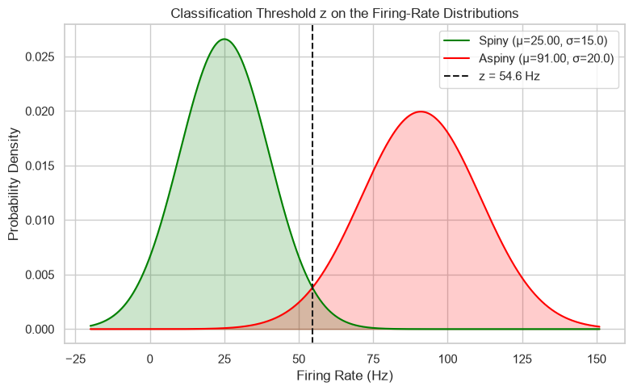
Figure A8a. Firing-rate distributions with the classification threshold z = 54.59 Hz marked.
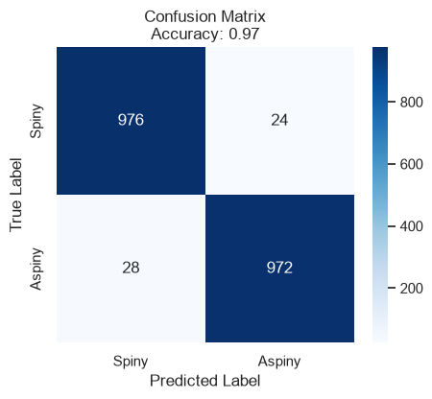
Figure A8b. Confusion matrix for the z-threshold classifier (rows: true label, columns: predicted label).

Q9. Likelihood Ratios
Rate (Hz) | log-LR (Aspiny/Spiny) | LR (Aspiny/Spiny) | Classification
25.00 | -5.733 | 0.0032 | Spiny
41.50 | -2.745 | 0.064 | Spiny
58.00 | 0.771 | 2.16 | Aspiny
74.50 | 4.817 | 123.6 | Aspiny
91.00 | 9.392 | 1.2e4 | Aspiny

LR = P(rate | Aspiny) / P(rate | Spiny); LR > 1 favors Aspiny, LR < 1 favors Spiny. The two rates nearest mu_spiny classify as Spiny, the two nearest mu_aspiny classify as Aspiny, and the middle rate (near the Q8 threshold z) sits at the decision boundary.
What could change these values:
- A shift in either neuron's true mean firing rate would move the distributions and could flip the LR sign for a fixed rate.
- A wider variance (more noise, shorter measurement window) increases overlap and pulls LR toward 1 over a broader range, making the two types harder to distinguish.
- Unequal class priors: LR alone ignores how common each neuron type is; the decision should then use the posterior odds (LR x prior ratio), not LR alone.
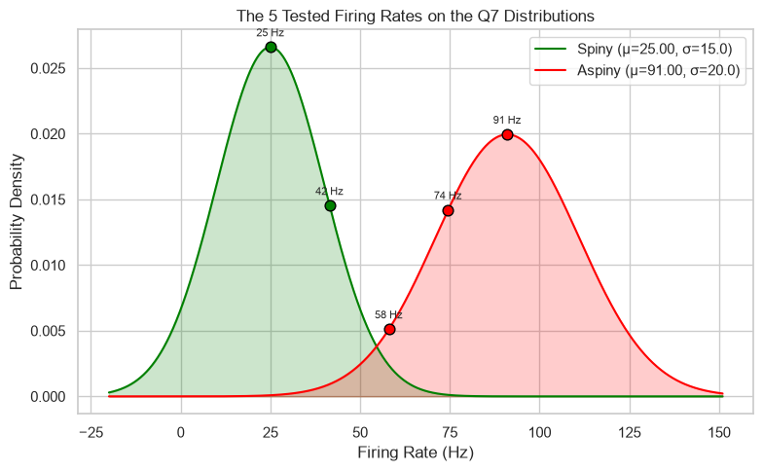
Figure A9. The five tested firing rates marked on the Q7 distributions, colored by classification.

Part B — Unsupervised Learning (feat_data.csv)
Data: 1424 neurons x 41 standardized numeric electrophysiological features (dendrite_type column used only for coloring/validation, never as an input feature). 700 spiny, 724 aspiny.

Q1.a. PCA to 3 Dimensions
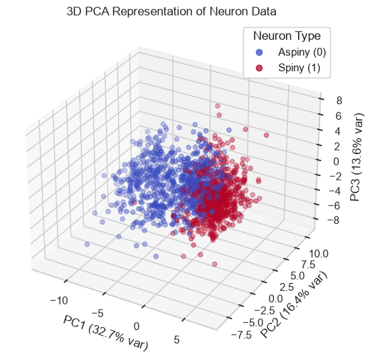
Figure B1a. PCA projection (PC1, PC2, PC3) colored by neuron type; 3D scatter plus pairwise 2D projections with % variance explained on each axis.
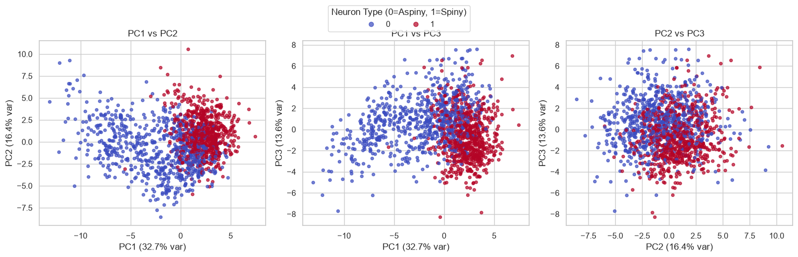
Figure B1a. PCA projection (PC1, PC2, PC3) colored by neuron type; 3D scatter plus pairwise 2D projections with % variance explained on each axis.

Q1.b. What Do the PCA Axes Represent?
Each principal component is a linear combination of the 41 standardized features, ordered by the amount of variance it captures: PC1 captures the most variance, PC2 the most remaining variance orthogonal to PC1, and PC3 the next. "Explaining the most variance" is not the same as "best separating spiny from aspiny" -- PCA is unsupervised and has no notion of the class label.

Q1.c. Do Some Axes Separate the Neuron Types Better?
Axis | % Variance Explained | 5-fold CV accuracy (single-axis classifier)
PC1 | highest of the three | 0.798
PC2 | — | 0.640
PC3 | — | 0.650

PC1 separates the two neuron types clearly better than PC2 or PC3: its 1D distribution shows the least overlap, and a logistic-regression classifier trained on PC1 alone reaches ~0.80 cross-validated accuracy vs. ~0.64-0.65 for PC2/PC3. This is because PC1 captures by far the most variance, and the biological spiny/aspiny distinction (spike width, adaptation, input resistance) happens to be one of the dominant sources of variance in this feature set.
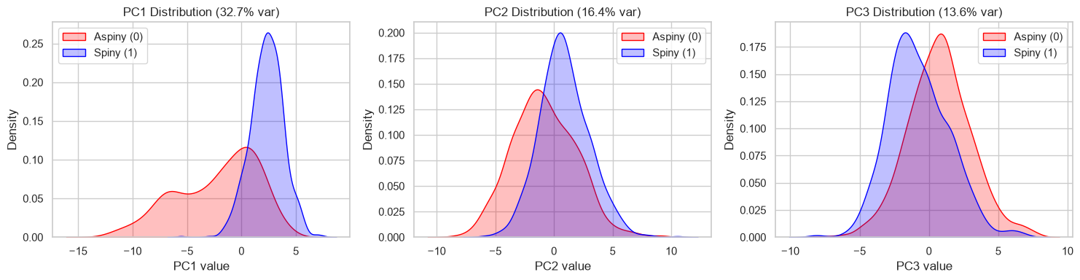
Figure B1c. Per-axis 1D density of PC1/PC2/PC3 values, split by neuron type.

Q1.d. PCA Axes Needed for ≤1% Reconstruction MSE
27 of the 41 components are needed to reach ≥99% cumulative explained variance, equivalently ≤1% mean-squared reconstruction error. Because the data is standardized (each feature has unit variance), PCA reconstruction MSE equals exactly the unexplained variance fraction -- verified directly via PCA.inverse_transform: k=24 -> 1.68% MSE, k=27 -> 0.97% MSE, k=30 -> 0.51% MSE, each matching the value predicted from 1 - cumulative variance.
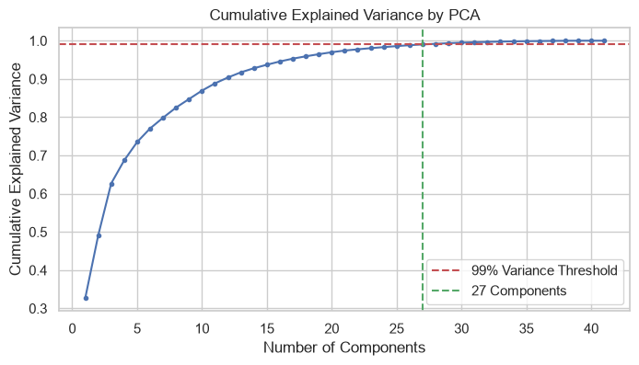
Figure B1d. Cumulative explained variance vs. number of PCA components, with the 99% threshold and the 27-component answer marked.

Q2. Autoencoder
Architecture: input(41) -> hidden(32) -> bottleneck(3) -> hidden(32) -> output(41), 3 hidden layers (32, 3, 32), activation = LeakyReLU (from the ID-parity rule: last-digit sum of the placeholder IDs is odd). Three variants were trained and compared: a standard AE, a denoising AE (Gaussian noise, factor 0.3, added to the input only; loss always computed against the clean target), and a weight-decay AE (L2 = 1e-3). Optimizer: Adam, lr = 0.005, batch size 32, 150 epochs.

Q2.a. Training and Validation MSE
Variant | Final train MSE | Final val MSE
Standard AE | 0.2912 | 0.3621
Denoising AE (noise=0.3) | 0.3061 | 0.3482
Weight-Decay AE (L2=1e-3) | 0.3179 | 0.3482

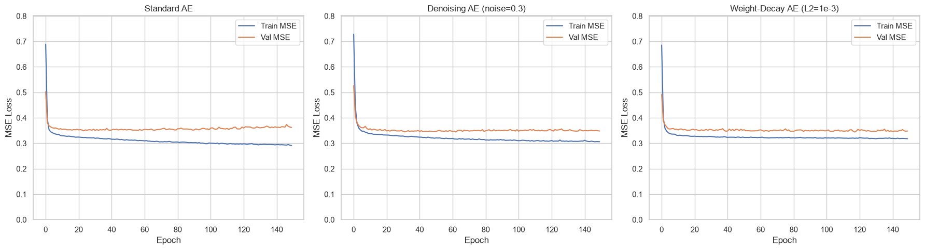
Figure B2a. Train and validation MSE loss vs. epoch, for each of the three autoencoder variants.
Train and validation MSE stay close together for all three variants (final gap ~0.03-0.07), so none shows strong overfitting given the model's small capacity (2,924 parameters) vs. the 1,139-sample training set. The Denoising and Weight-Decay AEs converge to a slightly higher train MSE than the Standard AE, as expected -- both trade a little training-set fit for a more class-relevant bottleneck (see Q2.c).

Q2.b. Low-Dimensional (Bottleneck) Representation
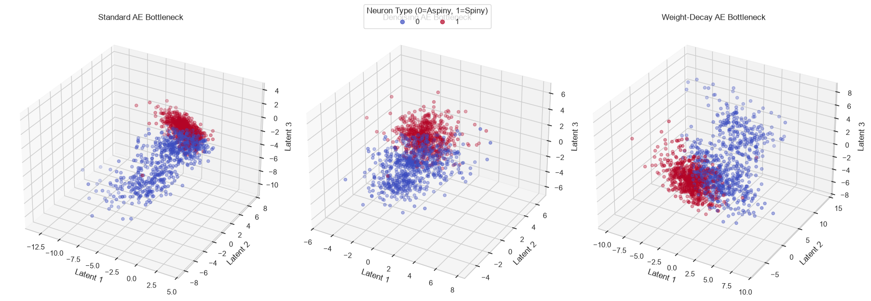
Figure B2b. 3D bottleneck scatter plots (Latent 1-3) for each autoencoder variant, colored by neuron type.

Q2.c. Autoencoder vs. PCA (Qualitative & Quantitative)
Representation | Silhouette score | 5-fold CV accuracy (LogReg)
PCA-3 | 0.2276 | 0.8680
Standard AE | 0.2408 | 0.8918
Denoising AE | 0.2637 | 0.8940
Weight-Decay AE | 0.2348 | 0.8834

Qualitatively, the AE bottlenecks show the two classes forming slightly more distinct blobs than the rigid, linear PCA projection, most visibly for the Denoising AE. Quantitatively, all three AE variants beat PCA-3 on both silhouette score and cross-validated linear-classifier accuracy; the Denoising AE is best on both metrics simultaneously and is carried forward to Q2.d/Q2.e.

Q2.d. Reconstruction Examples
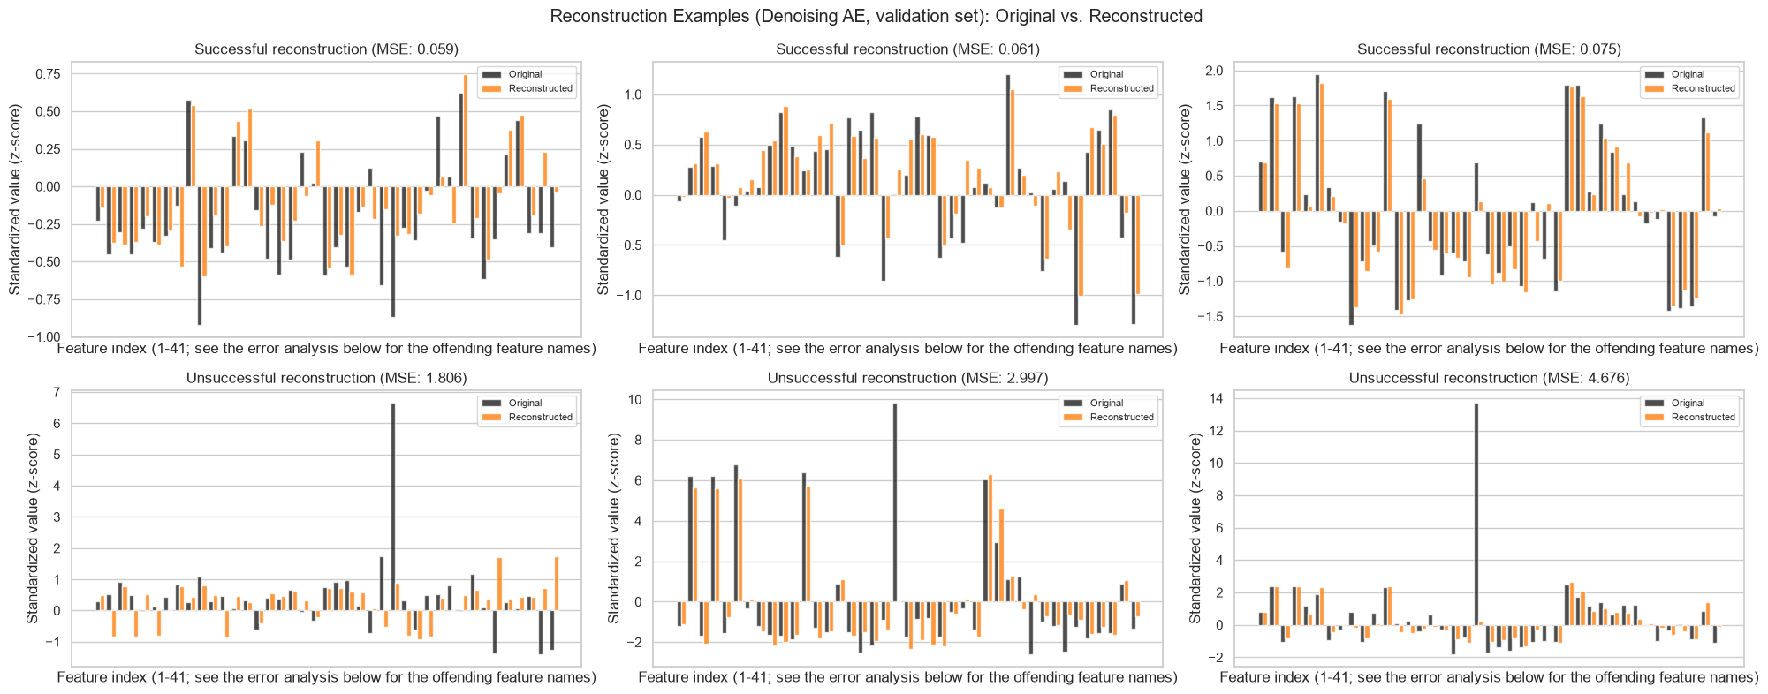
Figure B2d. Original vs. reconstructed feature values (z-scores) for the 3 best and 3 worst validation-set reconstructions (Denoising AE).
The worst reconstructions are dominated by a small number of features (notably latency, tau, and several threshold_v_*/trough_v_* spike-shape features) that account for most of the squared error. The worst-reconstructed samples also have a higher average |z-score| across all 41 features than the best-reconstructed samples or the validation-set average -- i.e., they are genuine statistical outliers. With only 3 latent dimensions to summarize 41 features, the network represents common, population-typical feature combinations well but regresses atypical neurons toward the "average" shape it has learned, losing exactly what makes them unusual.

Q2.e. Did the Autoencoder Learn a Better Representation?
Yes, modestly but consistently. All three AE variants beat PCA-3 on both silhouette score (0.228 -> 0.24-0.26) and 5-fold cross-validated classifier accuracy (0.868 -> 0.88-0.89); the best, the Denoising AE, raises accuracy to 0.894 and silhouette to 0.264. The gain is real but not dramatic: PCA already does well (0.868) because a single linear axis (PC1) already captures much of the spiny/aspiny distinction (Q1.c), leaving limited room for a nonlinear method to improve further.

