9. Program MULT (version 3)

9.1. Outline of the MULT calculations

The MULT program performs the angular integrations necessary to express the matrix elements of the multipole transition operators as a linear combination of radial integrals. Any amount of non-orthogonality between the orbitals may be present, leading to overlap factors in the matrix elements. The program can effectively reuse data obtained previously by creating a databank for angular coefficients. MULT is a new, completely revised and optimized version of the general program ZAP_NO (Zatsarinny 1996) and can be used in many other aspects of atomic-structure calculations. MULT can also be considered as a straightforward extension of the program MCHF_MLTPOL (Froese Fischer et al 1991) to the case of arbitrary orthogonal conditions between orbitals in the initial and final states. (In the following write-up, we try to keep the same notation as in MCHF_MLTPOL. The calculations of the angular integrals follow the method based upon the representation of configuration wavefunctions through Slater determinants. The details of the present approach can be found in the long write-up of the program ZAP_NO. Below we only provide a brief description of the present version, outlining the main modifications made in comparison to ZAP_NO.

9.1.1. Definitions

The program deals with the transition operators 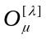for electric and magnetic transitions, which can be represented in tensor forms, respectively, as
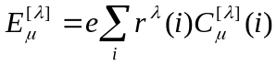 ( 9.1)
and
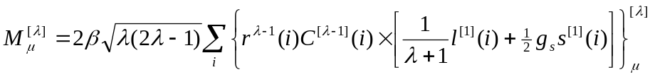. ( 9.2)
Here β=eħ/2mc is the Bohr magneton, g_{s} is the electron g-factor, and the summation is over the atomic electrons. In the Breit-Pauli approximation, the initial-state and final-state wavefunctions are superpositions of LS-configuration state functions, i.e.
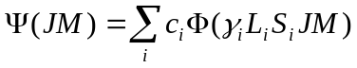. (9.3)
The dependence of the transition matrix elements on the magnetic quantum numbers can be found by applying the Wigner-Eckart theorem,
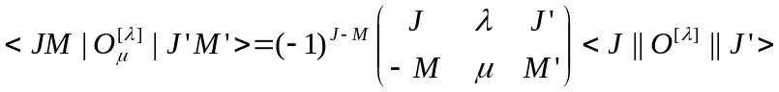, (9.4)
and the reduced matrix element (RME) 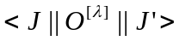 itself can be written as
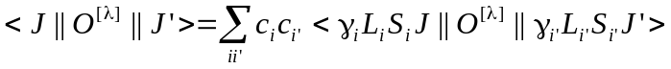. (9.5)
The operator 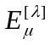 in (9.1) associated with the electric transition E^{λ} is completely spin-independent, and we can use the “uncoupling” formula for its reduced matrix elements
. (9.6)
The treatment of magnetic multipole transitions of any order is more complex. Usually, the magnetic operator (9.2) is split into two parts with different spin and spatial dependence:
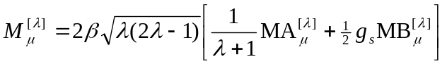, (9.7)
with
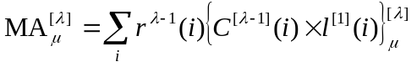 ( 9.8)
and
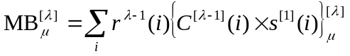. ( 9.9)
The uncoupling formulae are different for these parts :
(9.10a)
and
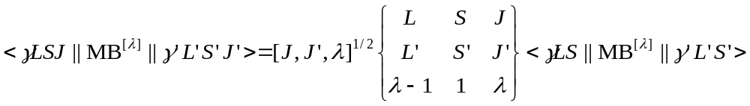. (9.10b)
The remaining problem is to evaluate the RME of the electric and magnetic multipole operator of any order between arbitrary LS coupled configurations. This is done in the present programs based upon the representation of configuration wavefunctions through Slater determinants. This allows us to introduce a completely unrestricted version of a non-orthogonal scheme.

9.1.2. Calculation of RME between LS configuration wavefunctions

The present procedure is based upon the expansion of the N-electron configuration wave function in terms of Slater determinants
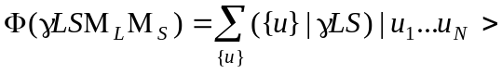 (9.11)
where ({u}|γLS) denotes the expansion coefficient, and the individual determinant ⎢u₁...u_{N}⟩ has the form
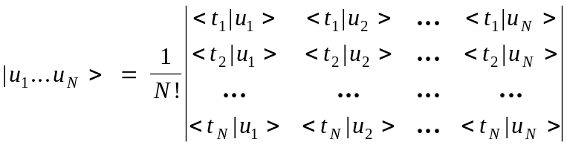 (9.12)
Here t=(r,s) represents the spin and position of the individual electrons and u stands for the one-electron quantum numbers, |u⟩ = | nlmμ⟩. Thus, the determination of matrix elements between CSFs is reduced to that of matrix elements between separate Slater determinants, which, in turn, are reduced to one-electron integrals between spin-orbitals in the nlmμ-representation. In comparison to the existing codes based upon the Racah technique, the resulting formula explicitly include the magnetic quantum numbers and contain additional summation over Slater functions and over all electrons but not shells. This increases considerably the number of operations required, and the speed of the calculations is much reduced. On the other hand, the final formulae are much simpler and more convenient for programming. The principal advantage, however, is that the nlmμ-representation procedure facilitates the straightforward extension to the case of non-orthogonal orbitals to be made in the most general way. The main problem here is to obtain the determinantal representation of arbitrary atomic wavefunctions, including configurations with several open shells. An effective way to solve this problem has been proposed in the program ZAP_NO. It is based upon the preliminary creation of tables of expansion coefficients for the individual shells. The determination of the coefficients for the CSFs is then reduced to the vector coupling of shell terms. This procedure is used in the present code. For details we refer the reader to the description of the program ZAP_NO.
When we get expansions (9.11) for the initial and final LS states, the total matrix elements for transition operators are reduced to matrix elements between Slater determinants. Consider a matrix element between two Slater determinants, |u_{1..} u_{N}> and |v_{1...} v_{N}>, for a transition operator 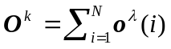, where 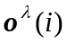 is the one-electron operator with multipole λ, acting on electron i. Define the determinant D_{uv}=det{<u_{i}|v_{j}>} of the matrix formed from all overlap integrals between the one-electron orbitals u_{i} and v_{j}, (i.j = 1,...,N), and let the D_{uv}(ρ,ρ') denote the first cofactors of the determinant D_{uv}, corresponding to the matrix of overlap integrals with orbitals u_{ρ} and v_{ρ’} deleted from the initial and final sets, respectively. Then, it can be shown [57] that
. (9.13)
This formula, in connection with irreducible tensor algebra, allows us to reduce the configuration matrix elements to one-electron matrix elements between spin-orbitals nlmμ, multiplied by overlap factors in the case of non-orthogonal radial orbitals. Applying the Wigner-Eckart theorem (9.4), the one-electron matrix elements in (9.13) can be reduced to one-electron RME. Here, however, we should consider two cases, one related to the electric and MA operators, and one to the MB operator. In the first case, we have no spin-dependence, and hence
(9.14)
For the MB operator (9.9), on the other hand, we should apply the formula for the matrix element of an irreducible tensor product [58] of two operators, which only depend on the variables of the first and second subsystem, respectively:
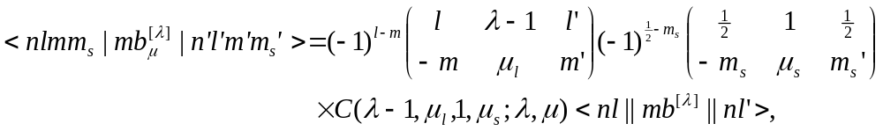 (9.15)
where C denotes a Clebsch coefficient. Furthermore, μ, μ_{l} and μ_{s} are magnetic numbers defined by the total magnetic numbers of the configurations under consideration: μ_{l} = M_{L}-M’_{L}, μ_{l} = M_{S}-M’_{S}, , μ = μ_{l} + μ_{s}. In our case of electric and magnetic transitions (9.1) and (9.2), the one-electron RME can be of three different types:
, (9.16)

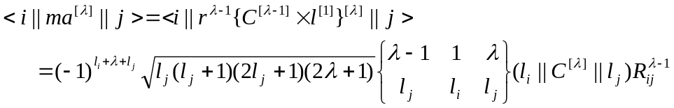, (9.17)
and
, (9.18)
where 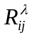is the radial transition integral
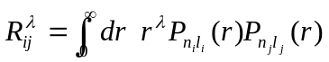. (9.19)
The present algorithm for the calculation of matrix elements consists of two independent steps: the determination of the determinantal representation for two input configuration wavefunctions with certain magnetic quantum numbers M_{L} and M_{S}, and the calculation of matrix elements between all Slater states obtained by the above formulae. Our final task is to obtain the reduced matrix elements for configuration wavefunctions, 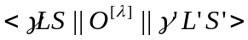. They are obtained on the basis of the calculated matrix elements 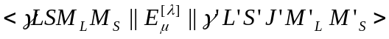 by a reciprocal application of the Wigner-Eckart theorem. The corresponding formulae can be obtained from eq. (9.14) and (9.15) by a straightforward replacing of one-electron quantum numbers by the total ones. Note that the amount of calculations in the present approach crucially depends on the number of Slater states involved, which, in turn, depends on the chosen quantum numbers M_{L} and M_{S}. In the present implementation, we use M_{L} = L and M_{S} = S, which guarantees a minimum number of relevant Slater states.

9.1.3. Output results

The MULT program provides, as a final result, the expressions for the reduced matrix elements of the electric and magnetic operators (9.1) and (9.2) in the form
, (9.20)
where a_{k} are the numeric coefficients which depend only on the angular symmetry of the configuration state functions involved, d^{k} is the corresponding radial integral dependent on the operator O under consideration, and D({nl},{n'l'}) is the overlap factor, which depends only on the sets of radial orbitals used in constructing the wavefunctions Φ and Φ', respectively. It should be emphasized that the coefficients a_{k} do not depend directly on the set of principal quantum numbers {n} and {n'}. They only depends on the orthogonality conditions imposed on the one-electron radial functions. For example, in the limiting case of orthogonal radial orbitals, the overlap factors are reduced trivially to factors 1 or 0, and we obtain the weighted sum of radial integrals d^{k}, which is ordinarily used in atomic structure calculations. In the case of intermediate orthogonality conditions, some D-factors disappear while others are simplified. Thus, once we have obtained the matrix element in the case of fully non-orthogonal orbitals, we can also obtain the matrix elements for all other configurations with the same angular symmetry and for all other orthogonal conditions, only by analyzing the overlap factors D({nl},{n'l'}) and replacing the set {n,n'} by the specific one. Such a scheme is realized in the present code. In large-scale calculations, this can lead to a considerable reduction of execution time, because in practical calculations the set of configurations contains many configurations with the same angular symmetry.
On the other hand, rather than record the angular coefficients for the given set of CSFs, we can save only the expansions for the matrix elements with different angular symmetries, supposing that all radial functions in the initial and final sets are non-orthogonal. These data may be considered as a data bank for angular coefficients. They allow us to obtain the matrix element expansions for any set of CSFs constructed with the angular symmetries included in the bank. For new symmetries, we only have to perform the additional calculations and the databank can be extended.

Line strengths, oscillator strengths and decay probabilities

The output coefficients (9.20) for separate configurations are then used in BSR_DMAT for calculation of line strengths, oscillator strengths and decay probabilities. The line strength for a given transition is defined as
(9.21)
Using the output data (9.20) we first obtain the 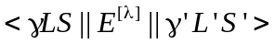, then include J-factor to obtain 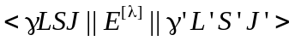 according (9.6), and finally include the configuration-mixing coefficients through summation (9.5). For magnetic transitions, the calculations are a little complicated due to two different J-factors (9.10a) and (9.10b). For transitions between multiplets (pure LS coupling), we may define
(9.22)
where we use the fact that 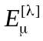 is spin independent and matrix elements are diagonal in S and M^{S} variable. The same can be applied to MA^{[λ]} operators, but not to MB^{[λ]}. For this reason, in LS coupling mode in BSR_DMAT program, I include only MA^{[λ]} operators (what can lead to incorrect results)
The transition probability can then be expressed as:
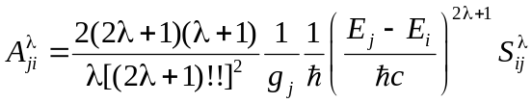. (9.23)
The oscillator strength (unitless) is related to the transition probability by
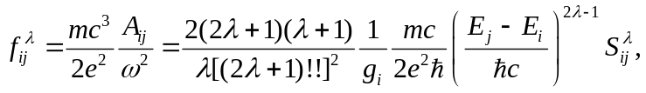 (9.24)
independent of the nature of the radiative transition. In the above expressions, where g_{i,j} is statistical weight for the lower and upper levels with energies E_{i} and E_{j}, respectively. [g= (2J+1) or g = (2L+1)(2S+1)] .

9.2. Structure and data flow

The block diagram of the program MULT, along with the data flow, is given in Fig. 9.1. The only input data files are c-files with a list of configuration state functions for the initial and final states involved. The MULT program considers only one type of transition operator in a single run. The type of the operator is given as E1,E2,…, M1,M2, …, where the first letter indicate if it is an electric or magnetic transition while the second letter defines the multipole index. The parameter E0 indicates the calculations of overlap matrix elements. Since MULT only requires a small number of input parameters, all of them must be defined in the command line as arguments.
The r_conf routine reads the input configuration lists in spectroscopic notation, decodes them to the internal 'integer' representation, and tests the CSFs as to the correctness of angular coupling, number of electrons, parity and AFTER conditions. r_conf also allocates (or reallocates) all main arrays with dimensions specific for the given partial wave. Then the CSFs are sorted according to their angular and configuration symmetries. At this stage the program also checks if this is a continuing calculation, i.e., whether there exists a relevant databank from some previous calculations. The program analyses the information contained in the databank and defines the subset of configurations that need additional consideration, or it decides that the information in the data bank is sufficient for the given input configuration lists.
In the next block, pre_detexp, the determinant expansions for all configurations are generated and recorded in the scratch file. This block is the main modification made in comparison to the previous version, ZAP_NO (Zatsarinny 1996). It avoids the large amount of recalculations of repeating determinant coefficients. The determinant expansion for a given angular symmetry is generated in the routine det_expn, on the basis of angular coupling coefficients, calculated in detc_sh, and the coefficients for determinant expansions of individual shells, stored in the blockdata blk_det.
The calculations of the full set of integral coefficients and overlap factors for the input angular symmetries are run in the block conf_loop. First, the routine det_mult computes the radial expansions for matrix elements between all Slater determinants involved. This information is accumulated in the module zoef_list. The cases of overlaps, zero-orbital or one-orbital difference in the Slater determinants under consideration are treated separately by the routines zno_overlap, zno_000, and zno_001, respectively. The routine rad_matr contains expressions for one-electron matrix elements in the nlmμ-representation (see section 9.1.2). The function idet_fact defines the corresponding overlaps factors 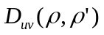 in the expression (9.12).
Fig. 9.1. Block diagram for the program MULT and data flow (see text).
MULT
r_conf
read arguments from command line

rewrite data from scratch file nui to mult_res
blk_det
pre_detexp - generate determinant expansions for all configurations
term_loop
record all det.expansions in scratch file nud
name1.c, name2.c, mult_bnk if any
det_mult
rad_matr
zoef_list
add_res
scratch file nui
det_expn
detc_sh
conf_loop - calculation of matrix elements
zno_001
zno_000
zno_overlap
coef_list
rename mult_res to mult_bnk
rewrite old data from mult_bnk to scratch file nui
idet_fact

Then, in the routine term_loop, the angular coefficients between two given angular symmetries are calculated on the basis of angular coefficients between the individual determinants involved (stored in module zoef_list) and determinant expansion coefficients, which are read from scratch file nud (see block pre_detesp). These data are accumulated in the module coef_list. When all determinants for the given angular symmetries are exhausted, the final angular coefficients are recorded by the routine add_res in the scratch file nui, and module coef_list is initialized to accumulate data from other matrix elements. The above calculations are repeated in the block conf_loop for all combinations of input angular symmetries.
Finally, the new data and data from previous calculations are stored in the file mult_res. This file then is renamed to the initial name mult_bnk. This procedure prevents loosing the data in the initial databank if an error occurs when running the MULT program. The format of the output databank is given in Section 9.5.
All calculations in MULT are carried out in full non-orthogonal mode, without specifying the principal quantum numbers for the orbitals involved. Instead, the positions of the corresponding shells in the configurations are used to specify the one-electron orbitals involved. Hence, the data obtained can be used further for all atomic states with the given angular symmetries. In the present version we also abandoned the creation of an additional list of angular coefficients for a specific set of one-electron orbitals. Instead, the matrix element for specific orbitals are calculated dynamically when the required transition data are generated.

  - Data files

name1.c | File type: formatted sequential input.  Created by user.  Description: contains configuration expansion for the initial state.
name2.c | File type: formatted sequential input.  Created by user.  Description: contains configuration expansion for the final state.
mult_bnk | File type: unformatted sequential output.  Written by program MULT.  Read by BRS_DMAT.  Description: databank for angular coefficients of the dipole operator.
mult.log | File type: formatted sequential output.  Written by program MULT.  Read by user.  Description: running information.

  - Input parameters

Main input parameters must be provided in the command line:
name1.c | name for c-file of initial state
name2.c | name for c-file of finall state
AA [E1] | character*2, type of operator and multipole index: E1,E2,..,M1,M2,…
AF_b [mult_bnk] name of the output data-bank

Last two parameters are optional. Examples for calling:

mult3 1.c 2.c
mult3 cfg.001 cfg.002 E2 mult_bnk_E2

Additional input options:

1. mult3 bsr kslp1=1 klsp2=10 AA=E1 AF_b=mult_bnk

This 'bsr' option orders calculation of dipole angular coefficients for all possible transitions between first 10 partial waves described in the target file (i.e., this file is required). For configuration expansions will be used cfg.001, cfg.002, cfg.003, … files.

2. mult3 ccc list_c=name AA=E2 AF_b=mult_bnk_E2

This 'ccc' option orders calculation of angular coefficients for all possible quadrupole transitions between the configuration expansions recorded in the input file name, where the file names given in the column form (one name in the line).

9.5. Structure of the dipole databank

Summary of the output records in the mult_bnk file.

- ktype,kpol

ktype - 'E' or 'M', for electric and magnetic transitions, respectively.
kpol - multipole index.

- Description of configuration symmetries (see MOD_symc.f90)
nsymc,lsymc
(LT_conf(i),i=1,nsymc)
(ST_conf(i),i=1,nsymc)
(no_conf(i),i=1,nsymc)
(ip_conf(i),i=1,nsymc)
(iq_conf(i),i=1,lsymc)
(ln_conf(i),i=1,lsymc)

- Description of angular symmetries (see MOD_symt.f90)
nsymt,lsymt
(IT_conf(i),i=1,nsymt)
(ip_term(i),i=1,nsymt)
(LS_term(i,:),i=1,lsymt)

- Description of done matrix elements
n = nsymt×(nsymt+1)/2
IT_OPER(1:7,1:n)
IT_OPER(.,ij) indicates the operators that have already been considered by the program for angular symmetries i,j such that ij = i×(i+1)/2+j, i > j.
IT_OPER(1:7,.) indicates the operators under consideration, in the same way as the input parameter oper (see section 6.3)

- Description of overlap determinants
ndet,kdet
for i = 1,ndet
kpd(i),ipd(i),jpd(i),npd(ipd(i)+1:ipd(i)+kpd(i))

ndet - total number of overlap determinants.
kdet - size of the npd array, containing the description of all overlap determinants.
kpd(i) - dimension of the i-th overlap determinant, kd.
ipd(i) - pointer on the i-th overlap determinant in array NPD, ip.
npd(ip+1:ip+kd) – contains description of the i-th determinant as NPD(.) = i₁*b_{d} + i₂, where b_{d} = 2¹⁵ – packing basis for overlap determinants; i₁,i₂ - pointers to shells in the involved in the involved configurations.

- Description of overlap factors

ndef,kdef
for i = 1,ndef
kpf(i),ipf(i),jpf(i),npf(ipf(i)+1:ipf(i)+kpf(i))

ndef - number of different overlap factors.
kdef - size of the NPF array, containing the description of all overlap factors.
kpf(i) - number of determinants in the i-th overlap factor, kd.
ipf(i) - pointer on the i-th overlap factor in array NPF, ip.
npf(ip+1:ip+kd) - contains description of the i-th overlap factor as NPF(.) = ipd*b_{f} + nd, where b_{f} = 16 - packing basis for overlap factors; ipd - pointer to the overlap determinant; nd - its power.

- C,ij,int,idf repeat up to the end of file

C – angular coefficient for matrix element between angular symmetries i and j, recorded as
ij = i×b_{c}+j, where b_{c} = 2¹⁵ – packing basis for configurations.
int – pointer on the relevant radial integral d(i1,i2) in the packing form
int = (itype*b+i1)*b+i2, where itype - type of integral;
i1,i2 – pointer on the involved orbitals; b = 10 – packing basis for orbital indexes;
itype = 0 - overlap
= 1 - 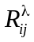 for electric multipole or 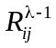 magnetic MA operator
= 2 - for magnetic MB operator
idf - pointer on the corresponding overlap factor.

9.6. Further development

- The mult4 version change the record 7 in mult_bnk:

C,ij,int,idf -> C,it,jt,int,idf

It allows more large cases to consider.

- The MPI version mult4_mpi is under development

REMARKS:

- Only one type of transition can be in the given mult_bnk.
- The <γ’L’S’||O^{[λ]}|| γLS> reduced matrix elements can be obtained from the <γLS||O^{[λ]}||γ’L’S’> matrix elements stored in mult_bnk by using the factor (-1)^{L+S-L-’S’}.
- The present package assumes the L + S coupling order. If one uses atomic wave functions with the S + L coupling order (as in the MCFH_ASP package by Froese Fischer et al (1997), for example), one needs to include the correction factors (-1)^{L+S-J} in both sides.
- The reduced matrix elements in the mult_bnk are presented as a linear combination of radial integrals, but not as a summation over weighted one-electron reduced matrix elements, as is done in the MCHF_MLTPOL program (Froese Fischer et al 1991).

