10. Program BSR_DMAT (version 3)

The BSR_DMAT program prepares the dipole matrix, d.nnn, for subsequent use in the BSR_PHOT program for photoionization calculations, or to perform the calculations of oscillator strengths between B-spline bound-state solutions. For completeness, BSR_DMAT also has the option to calculate oscillator strengths between MCHF solutions, and between B-spline bound states and MCHF solutions. Version 3 increased the output of different forms of the dipole matrix elements.

10.1.Dipole transition matrix

For photoionization calculations we need the D-files, which contain the dipole matrix elements between the initial state and the R-matrix solutions for a given partial wave. It is convenient to represent the dipole matrix elements by using the dipole transition matrix, which consists from the dipole matrix elements between the basis states. Suppose we have two sets of solutions of the Hamiltonian matrix in different bases. In our case, it can be either the configuration basis from the MCHF calculations, or a close-coupling B-spline expansion (7.2) from a BSR calculation. Then the matrix element for the given solutions a and b is
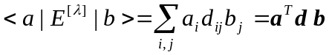, (10.1)
where {a_{i}} and {b_{i}} are the corresponding expansion coefficients in the respective bases. Once we generate the dipole transition matrix d , the matrix elements for any other solutions is simply defined by convoluting d with the corresponding expansion vectors. The logical structure of BSR_DMAT is such that it first generates the relevant dipole transition matrix, and then, if indicated, calculates the corresponding set of oscillator strengths. This enables us to use the same code for photoionization and bound-state calculations.
Consider the structure of the transition matrix in the B-spline representation. This structure is very similar to the structure of the Hamiltonian matrix considered in the write-up of the BSR_MAT program in Section 7. In the present close-coupling approach, the B-spline bound-state solution vector, c, can be written as
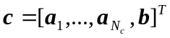 (10.2)
where each a_{i} is a column vector of B-spline coefficients for the given channel functions 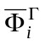
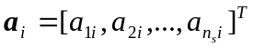 (10.3)
and b is the column vector of perturber coefficients
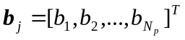, (10.4)
where N_{c} is the number of channels while N_{p} is the number of perturbers. Then the transition matrix d has the form
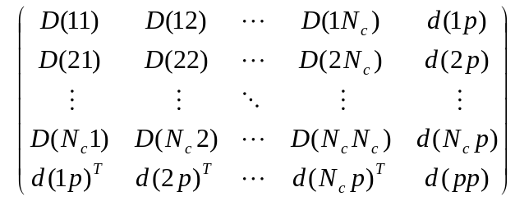 (10.5)
where d(pp) is an N_{p}×N_{p} matrix that comes from the bound-bound interaction, the d(ip) are the n_{s}×N_{p} matrices, representing the interaction between the i-th channel and the bound states, and the D(ij) are the n_{s}×n_{s} matrices for the channel-channel interaction. When we work with MCHF solutions, the transition matrix is reduced to the single last row, if the initial state is given in the MCHF representation, or simply to the d(pp) matrix, if both solutions are MCHF configuration expansions.
Each individual matrix element in (10.5) is expressed by the program MULT in the form
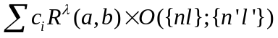 (10.6)
where the c_{i} are numeric coefficients that only depend on the angular symmetry of the CSFs involved, R^{λ} stands for the corresponding one-electron dipole integrals (9.17), and O({nl},{n'l'}) is the overlap factor which depends only on the orthogonality of the radial orbitals used in the construction of the basis CSFs. In general, the overlap factor is the multiplier of determinants of matrices consisting of one-electron overlaps between radial functions in the initial and final states (see eq. 7.8).
The B-spline orbitals can appear in the radial integrals R^{λ}, as well as in the determinant factors. To derive the final expression for the matrix elements in the B-spline basis, let us first simplify the overlap factors (7.8) by expanding them over those rows which contain one-electron overlaps with the B-spline orbitals. At most, there can be two such rows. The residual overlap determinants depend only on the known bound orbitals and they can be calculated in a standard manner. It is convenient to redefine the angular coefficients c_{i} by multiplying them by these residual overlap factors. As a result, the initial overlap factor O({nl},{n'l'}) in expression (10.6) is reduced to one-electron or two-electron overlaps of the form
, (10.7)
where |kl> stands for the radial function of the B-spline orbital
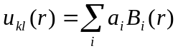 . (10.8)
Each term in (10.6) gives rise to some matrix in the spline basis. To elucidate the structure of these matrices, we introduce the following n_{s}×n_{s} matrices with elements
(10.9)
To describe the channel-bound interaction, we introduce the following vectors with elements
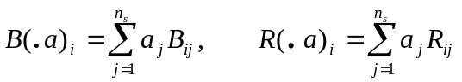, (10.10)
Finally, for bound-bound interaction we have
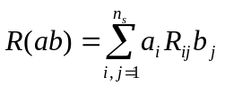. (10.11)
With this notation, table 10.1 represents the contributions of the different terms from the matrix element expression (10.6), which usually produces the angular integration codes, to the transition matrix (10.5), along with an indication of its structure.

Table 10.1. Contribution of different terms (without indication of angular coefficients) in the transition matrix. The symbols a,b stand for the bound orbitals, while the symbol k_{i} indicates the B-spline orbital in channel i.

Term | Contribution | Remarks
Channel-channel interaction
R(k_{i}, k_{j}) | R( • •) | banded matrix
⟨ k_{i}| a⟩ ⟨b | k_{j}⟩ R^{λ} | B( • a) •B( • b) * R^{λ} (or L) | Full matrix,  contribution due to non-orthogonality
⟨ k_{i}| k_{j}⟩ R^{λ} | B( • •) * R^{λ} | Banded matrix,
R^{λ}(k_{i},a) ⟨b | k_{j}⟩ | L( • a ) •B( • b) | full matrix,  contribution due to non-orthogonality
Channel-bound interaction
R^{λ} (k_{i},a) | R^{λ}( • a ) | vector
⟨ k_{i} | a⟩ R^{λ} | B( • a ) * R^{λ} | vector,  contribution due to non-orthogonality
Bound-bound interaction
R^{λ}( a, b) |  | scalar

10.2. Oscillator strengths and decay probabilities

For completeness of the description, we provide below the main formulae used in the present code for the calculation of radiative properties. The line strength for a transition between levels i and j is defined as
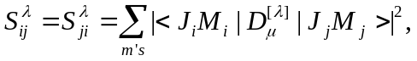 (10.12)
It is given in atomic units, which are 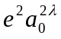 and 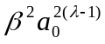 for electric and magnetic transitions, respectively. Here β=eħ/2mc is the Bohr magneton. The 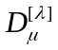 is either electric (9.1) or magnetic (9.2) operator with multipole index λ . The transition probability for transition i→j can be written as
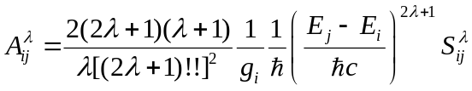, (10.13)
where g_{i} is the statistic factor for initial level i: g = (2S+1)(2L+1) for LS multiplets and g=(2J+1) for fine-structure levels. The first λ-factor = 4/3, 1/15, 8/4725 for λ = 1,2 3.
The oscillator strength (unitless) is related to the transition probability by
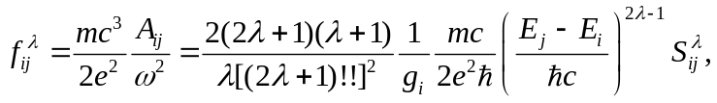 (10.14)
independent of the nature of the radiative transition. The above definition of oscillator strength is common in literature only for dipole operator. We may rewrite dipole λ=1 case in atomic units as
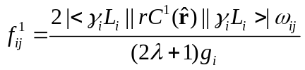 (10.15)
It is convenient to extend this expression to other electric multipoles and define
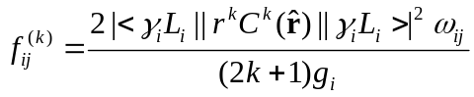 (10.16)
Here we will use symbol k for multipole index in parentheses to differ this definition from (10.14). That will provide different numerical values for k ≥ 2 and different relation between oscillator strengths and decay probabilities. This definition is convenient to use in calculation of polarizabilities.
The classical formula for the polarizability of a harmonic oscillator of frequency ω₀ is
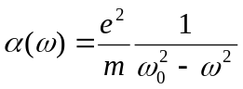 (10.17)
The dipole polarizability of an atom is equal to the sum of the polarizabilities of the "atomic oscillators",
in which each oscillator is represented with a weighting factor (strength) f(γJ,γ'J'):
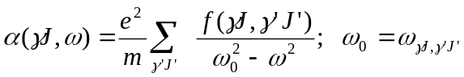 (10.18)
Using definition (3.9) for oscillator strengths, we may get following expansions for static multipole polarizability of state i
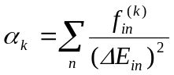 (10.19)
nonadiabatic polarizabilities
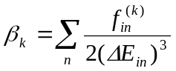 (10.20)
and higher-order nonadiabatic terms
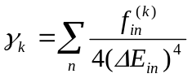 (10.21)

10.3. Structure and data flow

The block diagram of the program BSR_DMAT, along with the data flow, is given in Fig. 10.1. Since BSR_DMAT requires only a small number of input parameters, all of them must be defined in the command line as arguments. The input parameters for the BSR_DMAT program are the names of the c-files with a list of configuration state functions for the initial and final states involved, and the mode of calculation, ctype (see Section 10.4.) The input c-files may be the ordinary c-files from MCHF calculations, or cfg.nnn files generated in BSR calculations. The mode of calculation defines whether this is the generation of the transition matrix for subsequent photoionization calculations or the calculation of oscillator strengths between bound states. The ctype parameter also defines the representation format for the initial and final states, which can be in the LS or LSJ coupling schemes. BSR_DMAT reads a set of other input data files. All of them have default names, or names which are directly connected to the names of the input c-files.
First, the program read all input data related to the given case. It includes input parameters from the command line, subroutine read_arg, the list of configurations, read_conf, the list of LS terms involved, read_terms, the target states and channel information, routines read_target and read_channels, B-spline basis, define_splines, and the list of one-electron orbitals involved in description of the initial and final states, routine read_bsw. The orbitals in the initial and final sets are supposed to be non-orthogonal. All one-electron radial functions should be in the B-spline representation. They can be either the user-prepared name1.bsw files, or the bound.nnn files generated by the BSR_HD program (only in this case the program requires the target file with a description of the relevant close-coupling expansions). The above programs also generate all needed working arrays to keep the input information. These arrays are automatically allocated in accordance with the input data.
The read_conf routine also analyses the information contained in the databank mult_bnk, and determines whether the data bank contains all angular coefficients needed for the given case. If not, the program stops, suggesting to rerun MULT program. Note that the multipole index and the type of transition under consideration are defined in mult_bnk. As the next, step the program prepare DJ- or DJM-arrays connected the LS matrix elements with the fine-structure transitions, see Eq.(9.10).

BSR_DMAT
generate DJ_FACT or DJM_FACT arrays in the LSJ case
read arguments from command line (only!)
ctype2 = c,l,j,b
det_fact - processing the overlap factor
read_conf
read_channels
dmatrix
gen_matrix
D_matr - calculation of the transition matrix
read, one by one, the angular coefficients from mult_bnk
read_dets
cmdata
read_term
name1.c, name2.c; or cfg.nnn
name1.c, name2.c; or cfg.nnn
target
read_target
target
define_splines
knot.dat
d.nnn
zf_res
add_coef
merge_cdata
d_data
mult_bnk
gen_gf
read_arg

read_bsw
target.bsw or name1.bsw, name2.bsw
d_prep - prepare B-spline multipole arrays
d_out
ctype2 = p
dvec_out
dv.nnn
ctype2 = q
dd_out
dd_nnn_mmm
ctype2 = d
Fig. 10.1. Block diagram for the program BSR_DMAT3 and data flow (see text).

The routine D_matr controls the calculation of the transition matrix (10.5). First, the routine prepare all needed B-spline multipole arrays, which are related to the individual B-splines. Then the program reads all overlap factors O({nl},{n'l'}) from data bank in routine read_dets. These overlap factors are presented in the symbolic form, without indication of the specific one-electron orbitals involves. Then the program reads and processes all one-configurational matrix elements presented in the mult_bnk. First, it is determined if the given matrix elements is relevant to the given transition. If so, the overlap factor O({nl},{n'l'}) in expression (10.6) is reduced to one-electron or two-electron overlaps of the form (10.8) by the routine det_fact for specific one-electron orbitals. The integrals are then sorted according to their structure (see table 10.1) and stored in the module cmdata in different ordered blocks, routine add_coef. When all coefficients from mult_bnk are exhausted, or when all blocks are full, they are processed by gen_matrix to get the B-spline representation for specific integrals, routine d_data (this may require preliminary merging different blocks in the large-scale case, routine merge_cdata). The corresponding contributions are then added to the transition matrix (10.5), located in module dmatrix.
The next step of the calculation depends on the input mode. In photoionization calculations, the dipole matrix (10.1) is calculated on the base of the R-matrix solutions placed in the file rsol.nnn, and then is recorded in the file d.nnn. For calculations of oscillator strengths, however, the program calls the routine gen_gf for processing transitions between LS or LSJ states. The resulting line strengths, oscillator strengths, transition energies, and transition probabilities are recorded in the file zf_res (see section 10.6 below). The present version 3 also contain two additional output options ctype2=q and ctype2=d (see below section 10.5)

10.4 Input parameters

Input parameters must be provided in the command line. First four parameter are the mandatory position parameters. All other key-words parameters are optional.

name1.c or cfg.nnn | name of c-file for the initial state
name2.c or cfg.nnn | name of c-file for the final state
ctype1 | character, denotes the representation mode for the initial state:  c – initial state is defined by c-file from MCHF calculations  l - initial state is defined by l-file from MCHF calculations  j - initial state is defined by j-file from MCHF calculations  b - initial state is defined by bound.nnn file from BSR calculations
ctype2 | character, the same as ctype1, but for the final state. Thesemodes assume the calculation of oscillator strengths, with the output put in the file zf_res.  An additional modes:  p - the dipole transition vector for given initial state will be generated in the  output file d.nnn for subsequent photoionization calculations, BSR_PHOT.  q - the dipole transition vector for given initial state will be generated in the  output file dv.nnn for subsequent BSR_POL calculations.  d - the dipole transition matrix (10.5) will be generated in the output file  dd.nnn_mmm for subsequent TRM calculations..
gf (g|f) | defines output of gf- or f-values in zf_res file
mstates1 [0]  mstates2 [0] | if /= 0, restricts the number of initial/final states from the input files in calculations of oscillator strengths
istate1 [0]  istate2 [0] | if /=0, indicate specific initial/final state to be considered
ialfa [0] | if /=0, for dipole transitions, zf_res will contain additional information:  dipole matrix element, contribution of the given transition in the polarizability of the initial state, and the sum of all contribution for the initial state defined by istate1 parameter.
debug [0] | if \= 0, provides additional information in the bsr_dmat.log file.

10.5. Data files

name1.c or cfg.nnn  name2.c or cfg.nnn | File type: formatted sequential input.  Created by MCHF or BSR_CONF programs.  Read by routine read_conf.  Description: contains the configuration expansion for the initial and final states  after MCHF or BSR calculations.
name1.bsw or bound.nnn  name2.bsw or bound.nnn | File type: unformatted sequential input.  Created by MCHF(plus w_bsw utility) or BSR_HD programs.  Read by routine read_bsw.  Description: one-electron orbitals in the B-spline basis for the initial state  after MCHF or BSR calculations.
mult_bnk | File type: unformatted sequential input.  Written by program MULT.  Read by routines read_conf, d_matr.  Description: databank for the angular coefficients of the multipole operator.
target | File type: formatted sequential input.  Written by user and modified by BSR_PREP and BSR_CONF programs.  Read by routine read_target.  Description: contains description of the target states and scattering channels, optional.
knot.dat | File type: formatted sequential input.  Written by user.  Read by routine define_grid from BSPLINE library.  Description: input parameters that define the B-spline grid.
target.bsw | File type: unformatted sequential input.  Created by program BSR_PREP.  Read by routine read_bsw.  Description: target one-electron orbitals in the B-spline basis, optional.
pert_nnn.bsw | File type: unformatted sequential input.  Created by program BDR_PREP.  Read by routine read_bsw.  Description: perturber one-electron orbitals in the B-spline basis, optional.
rsol.nnn | File type: unformatted sequential input.  Created by program BSR_HD.  Used for ctype2=p,q,d  Description: R-matrix solutions for the partial wave nnn.
bsr_dmat.log | File type: formatted sequential output.  Written by program BSR_DMAT.  Read by user.  Description: running information.
zf_res | File type: formatted sequential output.  Written by program BSR_DMAT.  Read by user.  Description: oscillator strengths for the multipole operator given in mult_bnk.
d.nnn | File type: formatted sequential output.  Written by program BSR_DMAT.  Read by BSR_PHOT.  Description: dipole vector for the given initial state and R-matrix solutions in the partial wave nnn.
dv.nnn | File type: formatted sequential output.  Written by program BSR_DMAT.  Read by BSR_POL.  Description: dipole vector for the given initial state (no convolutions for the final states).
dd.nnn_mmm | File type: formatted sequential output.  Written by program BSR_DMAT.  Read by BSR_POL.  Description: dipole matrix between two partial waves.

10.6. Output of radiative data in zf_res.

The output format in zf_res is the same as in the MCHF Atomic Structure Package [52]. An example of output is given in Fig.10.2. Each transition is represented by a block, which consists of two empty lines as a delimiter, two lines with a description of the initial and final atomic states, one line with the transition energy in cm⁻¹ and Angstroms, and finally a line with the line strength, the oscillator strength, and the transition probability in the length form. For E1 transitions, there is an additional line with the results in the velocity form.
Each atomic state is represented by its spectroscopic label, its absolute energy in a.u., and the value of 2J, in case of a transition between LSJ states. The f-values are always for transitions from the lower to the higher state, whereas the transition probabilities are always reported from the higher to the lower state. The default output is the gf-values which does not depends on order of initial and final states (see parameter gf).
The file zf_res is opened in the BSR_DMAT program with access mode append. Hence, the results from different calculations can be accumulated.

-1 -37.77853956 1s(2).2s(2).2p(2)3P2_3P
-1 -37.48150929 1s(2).2s_2S.2p(3)2D3_3D
65187.63 CM-1 1534.03 ANGS(VAC) 1534.03 ANGS(AIR)
E1 S = 4.85375D+00 GF = 9.61141D-01 AKI = 1.81637D+08
6.44181D+00 1.27561D+00 2.41066D+08

-1 -37.48150929 1s(2).2s_2S.2p(3)2D3_3D
-1 -37.45433756 1s(2).2s(2).2p_2P.3p_3P
5963.23 CM-1 16769.43 ANGS(VAC) 16764.85 ANGS(AIR)
E1 S = 6.26544D+00 GF = 1.13495D-01 AKI = 2.99142D+05
1.17451D+00 2.12756D-02 5.60767D+04

2 -940.13842975 2p(2)3P2
2 -932.54958058 2p(4)3P2
1665544.77 CM-1 60.04 ANGS(VAC) 60.04 ANGS(AIR)
E2 S = 3.55924D-05 GF = 2.76118D-08 AKI = 1.70307D+04

0 -940.46450303 2p(2)3P2
2 -940.13842975 2p(2)3P2
71564.16 CM-1 1397.35 ANGS(VAC) 1397.35 ANGS(AIR)
M1 S = 1.80864D+00 GF = 5.23415D-06 AKI = 5.96024D+03

Fig. 10.2. Example of the output zf_res file with gf=g mode.

10.7. Output of dipole vector for R-matrix solutions - the d.nnn files.

Summary of the output records:

1. LT1,ST1,IP1,E1 – term and energy of the initial state.
2. LT2,ST2,IP2,nstate2 - term and number of final states.
3. (dl(i),dv(i),i=1,nstate2) – dipole matrix in length and velocity form.

10.8. Output of radiative data in dv.nnn.

Summary of the output records:

1. kpol,ktype - type of transition
2. E1,J1,IP1,Label1 – energy, J(L)-values, parity, and label of the initial state.
3. kdm2, nch2,npert2 – basis dimension, number of channels and number of perturbers
for final states..
4. (dl(i),i=1,kdm2) – dipole vector in length form.
5. (dv(i),i=1,kdm2) – dipole vector in velocity form.

The dipole vectors are obtained by convolution of total transition matrix (10.5) over the expansion coefficients of the initial states.

10.9. Output of the dipole matrix - the d.nnn_mmm files.

Has complicated records structure described in the RMATRIX1 manual (Berrington et al 1996)

